WCTRS RESEARCH NEWSLETTER
 | WORLD  CONFERENCE ON  TRANSPORT  RESEARCH  SOCIETY |  | SECRETARIAT OFFICE OF THE WCTRS  Institute for Transport Studied  The University of Leeds  Leeds, LS2 9JT England  Email: wctrs@leeds.ac.uk  Website: www. wctrs-society.com
June 24, 2021 |  | Volume 1, Issue 5
In this Issue  - Interview with Transportation Research Board (TRB) Executive Director, Mr. Neil Pedersen and Executive Committee Chair, Prof. Susan Shaheen  - Introduction to Topic Area G – Transport Planning and Policy  - Updates – Activities done by SIG A4  - WCTRS – Southeast Asia CAR Council  - WCTRS Announcement- Postponement of WCTR Montreal until 17th-24th July 2023  Useful Information and links  1. 8th Road Safety & Simulation International Conference 8th-10th June 2022  Abstract submission deadline: June 28, 2021  For details, visit: link  2. Disaster management: the effects and management of Covid-19 whilst looking at the future, June 30, 2021, by PIARC  For registration, visit: link  3. Urban Logistics Summer School, August 16 – 27, 2021  Registration deadline: July 1, 2021  For details, visit: link  4. Horizon Europe “Climate, Energy and Transport” (Cluster 5) Information days, July 5 & 6, 2021, by the European Commission  To watch the event live, visit: link  5. Annual Southern Africa Transport Conference, July 5-7, 2021, by IRF/SATC  For details, visit: link  6. IGU2022 Paris - Call for Abstracts "Legacy and impact of municipality investments and policies during COVID-19 in transport and their role in the recovery"  Abstract submission deadline: July 9, 2021  For details, visit: link  7. UMI 2021 - Call for Abstracts for 12th Research Symposium on Urban Transport  Abstract submission deadline: July 15, 2021  For details, visit: link  8. Eastern Asia Society for Transportation Studies (EASTS) Early Career Researchers Forum ‘Shaping more resilient transport professionals in the new normal and beyond’, September 10 – 11, 2021  Registration deadline: August 11, 2021  For registration, visit: link  9. Call for 6th CTRG Special Session Proposal  Submission deadline: August 31, 2021  For details, visit: link  10. The 1st Pharma Logistics Masterclass, September 7 – 11, 2021  Registration deadline: August 31, 2021  For registration, visit: link  11. The role of citizen participation in decision-making in transport and mobility - Call for Chapters for Edited Volume and Digital Workshop  Abstract submission deadline: September 1, 2021  For details, visit: link  12. Call for Papers: The International Conference on Dynamics in Logistics (LDIC 2022) in Collaboration with SIG B1  Full paper submission deadline (for publication): September 1, 2021  Abstract submission deadline (for presentation only): October 1, 2021  For details, visit: link  13. 1st International workshop on High Speed Rail socioeconomic impacts, September 14 – 15, 2021  For details, visit: link  14. 14th Transport Research Forum TRF 2021 organized by the University of Moratuwa on October 29, 2021  Abstract submission deadline: September 17, 2021  For details, visit: link  15. Call for Papers on High-Speed Rail, Equity, and Inclusion, by Asian Development Bank Institute (ADBI)  Abstract submission deadline: October 31, 2021  For details, visit: link  WCTRS society journals  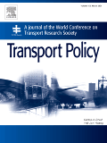  Transport Policy  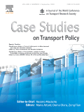  Case Studies in Transport Policy  WCTRS book series  For details, visit: link  Find us on  Visit us on  https://www.wctrs-society.com/  https://wctr2022.ca/  Email to us at  Editorial team of WCTRS Research Newsletter  Editor  Prof. Dr. Ashish Verma,  IISc Sustainable Transportation Lab (IST Lab), IISc Bangalore, India  ashishv@iisc.ac.in  Assistant editor  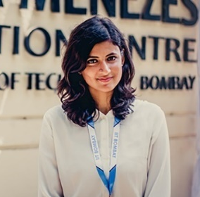  H. Gayathri,  Research Scholar, IST Lab, IISc Bangalore, India  gayathrih@iisc.ac.in | Interview with Transportation Research Board (TRB) Executive Director, Mr. Neil Pedersen and Executive Committee Chair, Prof. Susan Shaheen  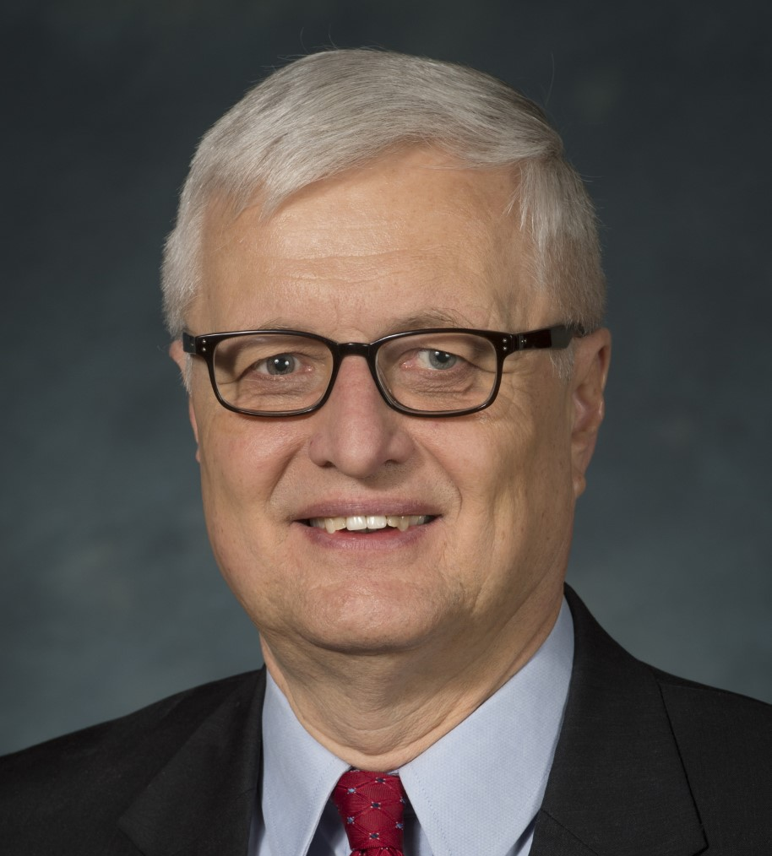  The WCTRS Research Newsletter Editorial team took a brief interview of Mr. Neil Pedersen, Executive Director, and Prof. Susan Shaheen, Executive Committee Chair, of Transportation Research Board (TRB), which is a key partner organisation of WCTRS.  Below is the full interview with Mr. Neil and Prof. Susan.  - What is TRB's vision on transport research and practice post COVID-19? How can it address the challenges faced post-COVID-19?  The COVID-19 pandemic had a major impact on the movement of passengers and goods when much of the world went into lockdown in Spring 2020. At the peak of the  pandemic, usage of modes such as public transit and airplanes dropped by as much as 70 to 90 percent, with other modes experiencing significant, but not as large reductions. At the same time, e-commerce activity doubled in many areas and telecommunications substituted for travel for many types of trips. Instead of commuting to an office five days a week, many white-collar workers worked from home (or teleworked), thus contributing to major travel reductions, especially to central business districts. There was a significant increase in use of active transportation modes, such as walking and bicycling, especially for shorter trips.  As the world has begun emerging from the pandemic in recent months, not all travel is returning to pre-pandemic levels. Use of public transit in particular has not recovered as much as use of private autos. It will be important that researchers both track shifts in trip patterns over time but also understand the underlying reasons for the shifts. Perhaps just as importantly it is key to understand the role of public policy in influencing these shifts. Many of the questions to be addressed include:  - How much dispersal of workplaces from central business districts or other changes in development patterns will take place post-COVID-19? What will be the changes in density and distribution of activities?  - Will commuters who shifted from public transit and other shared modes during the pandemic be willing to return to these modes? What will it take to convince them to do so?  - To what degree will work-from-home/telework replace commute trips to traditional workplaces?  - How much will telecommunications substitute for travel to other types of destinations, such as shopping, medical visits, education, and business meetings?  - What long-term changes are taking place in e-commerce? What is the future of brick and mortar stores and shopping malls?  - What will be long-term changes in auto ownership?  - How will public transit change to better meet the needs of its customers? Will it be able to better integrate with innovative mobility services and offer Mobility as a Service/Mobility on Demand?  - How will supply chains change in the future, so they are not as vulnerable to single sourcing of parts and other critical materials?  - How can the transportation-related social equity and justice issues exposed by the pandemic be addressed? How can accessibility be improved for underserved areas?  - How can public policy steer the shifts that are occurring to reduce undesirable impacts and help address broader policy goals such as economic vitality, climate change, and social equity?  There are many questions that will require research, so that policy and decisions can be based on facts and an understanding of the underlying factors affecting change. TRB intends to help address many of these questions through the research that it conducts itself, as well as through sharing of research results of others.  - Kindly brief us about TRB's, portfolio of activities being done, and how they can be beneficial to WCTRS members?  TRB offers a wide range of products and services that WCTRS members will find beneficial. TRB has approximately 8,500 members of its technical committees and research panels who provide expertise on almost any subject related to transportation. TRB’s premier event is the TRB Annual Meeting, which is held every January in Washington DC and attracts 14,000 transportation professionals, who attend several hundred sessions or workshops. TRB has 180 standing technical committees, which cover all modes and almost every discipline related to transportation. WCTRS members are encouraged to sign up to become a Friend of one or more committees at www.mytrb.org. TRB sponsors or co-sponsors approximately 50 conferences per year, puts on over 100 webinars per year, and publishes approximately 600 papers per year in its journal the Transportation Research Record. WCTRS members are encouraged to submit papers for peer review and consideration for publication. TRB also maintains the largest transportation research bibliographic database in the world, with over 1.25 million entries. It can be accessed at https://trid.trb.org/. TRB conducts four large research programs in highways, public transit, airports, and behavioral traffic safety, and it publishes over 100 research reports per year from these programs. TRB also conducts policy studies on behalf of the U.S. federal government, and these reports can be found on TRB’s website www.trb.org. TRB has partnership agreements with a number of international transportation organizations. Its international activities are coordinated through its International Coordination Council. TRB regularly updates the list of issues it is addressing through its Critical issues in Transportation document, which can be found at its publications webpage https://www.nationalacademies.org/trb/publications. TRB is also pleased to partner with WCTRS and several other organizations to sponsor the International Transport Forum (ITF) Pre-Summit Research Days each spring.  - What do you think could be ways by which the transportation sector in future can contribute to Livability and Quality of Life (QoL), considering that this was the focal theme of TRB-2021 Annual Meeting?  Considerable attention has been paid in the United States to the issue of transportation’s role in livability and quality of life, especially in recent years. The US Department of Transportation (USDOT) issued a “Livability in Transportation Guidebook” that says: “Livability in transportation is about using the quality, location, and type of transportation facilities and services available to help achieve broader community goals such as access to good jobs, affordable housing, quality schools, and safe streets.” The key to how the transportation sector can contribute to quality of life and livability is to envision, plan, design, and operate the transportation system to serve these broader goals. It requires that that transportation professionals work in partnership with communities to increase transportation choices, provide access to opportunity, improve safety for all users of the system, support economic vibrancy, improve public health, and identify ways that transportation can help meet the needs of the community. It also requires that transportation professionals think about how transportation can meet broader societal goals of supporting economic competitiveness, improving air quality, addressing climate change, and creating a more equitable society. It requires rethinking who is involved in planning and decision making to include those who are directly affected by transportation decisions. It requires that decision makers consider all these livability-related factors in making decisions. TRB continues to support efforts through its programs, activities, and research to change the processes and ways of thinking in the transportation profession, so quality of life and livability are the major outcomes that we achieve.  - A few words on TRB/WCTRS partnership  The Transportation Research Board (TRB) has forged a close working relationship with WCTRS through the International Coordinating Council. Professor Tae Oum now serves as a member of the Council, along with Professor Susan Shaheen. TRB’s International Coordinating Council concentrates on the evolution of an international perspective, practices, and research in all facets and services of all modes of transportation. The Council brings together experts from the TRB technical committees and external organizations to promote within the Technical Activities committee structure important issues affecting the safe and secure movements of goods and people in the United States and around the globe. The Council hosts sessions at the TRB annual meeting in January and joint workshops and sessions throughout the year.  Mr. Neil Pedersen, Executive Director, Transportation Research Board (TRB)  Prof. Susan Shaheen, Executive Committee Chair, Transportation Research Board (TRB)  Introduction to Topic Area G – Transport Planning and Policy  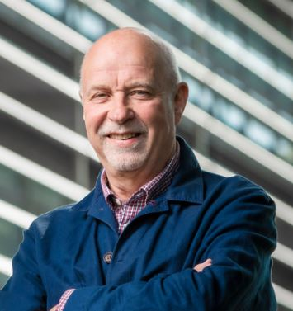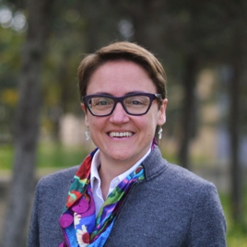  In this newsletter Topic Area G introduces the SIGs and reports on selected activities of the Special Interest Groups over recent months. Topic Area G comprises the following SIGs:  SIG G1: Governance and Decision-making Processes  Greg Marsden and Louise Reardon  SIG G2: National and Regional Transport Planning and Policy  Guenter Emberger, Yacan Wang and Takeru Shibayama  SIG G3: Urban Transport Planning and Policy  Stephen Ison and Maria Attard  SIG G4: Cultural and Social Issues in Transport  Helena Titheridge  SIG G6: Transport and Health  Haneen Khreis and Lawrence Frank  Recent SIG Activity:  SIG G1: Governance and Decision-making Processes has run a series of Webinars over the last 3 months, namely:  - Governance and Decision-Making Webinar Wednesday 19th May  ‘Multi-scalar Deliberative Transport Planning: “Empowerment without Autonomy” and Shifting Transport Institutions in London’, presentation by Rosalie Ray (Columbia University)  - Governance and Decision-Making Webinar Wednesday 14 April  ‘Roads, Runways and Resistance’ by Dr Steve Melia (UWE Bristol)  - Governance and Decision-Making Webinar Wednesday 26 March  ‘Cab aggregators in India – a regulatory dilemma’ by Dr Shalini Sinha (CEPT Ahmedebad)  An autumn webinar series on thematic topics is currently being planned.  SIG G2: National and Regional Transport Planning and Policy, has:  - Made a ‘Call for Abstracts’ to Mid-term Workshop, 27-29 September, 2021. Online: “Ensuring sustainable mobility in urban periphery and rural areas and remote regions”  - Undertaken Joint Research in the framework of WCTR COVID-19 TF  SIG G3: Published a Special Issue ‘Urban Transport Planning and Policy in a Changing World’ based on TIS ROMA Conference (WCTR Sessions), in Research on Transportation Business and Management Volume 39, June 2021.  Prof. Stephen Ison and Prof. Maria Attard, Topic Area Managers G, De Montfort University, Leicester, UK and University of Malta  (on behalf of all SIGs under TA G)  Updates – Activities done by SIG A4  ADBI-JARTS-IIT Learning Series on High-Speed Rail Session 1: Megaproject Governance and Innovation (3rd June 2021, 17:00 – 18:30 JST)  This ADBI-Japan Railway Technical Service (JARTS)-Indian Institutes of Technology (IIT), Kanpur and Madras session was the first in a learning series to examine key aspects of high-speed rail construction, operations and management.  The session explored megaproject governance and innovation, with a focus on megaproject experiences in India and the United Kingdom. The information on the session can be accessed at - https://www.adb.org/news/events/high-speed-railway-megaproject-governance-innovation  ADBI Featured Speaker Webinar: Greg Marsden on COVID-19 Era Travel Behavior and its Policy Implications in the United Kingdom (7th June 2021, 16:00 – 17:00 JST)  This webinar will feature Greg Marsden of the University of Leeds Institute of Transport Studies who will present findings from a longitudinal study of COVID-19 era travel behavior and policy in the United Kingdom. He will describe pandemic-driven macro-travel trends and behaviors in ten areas of England and Scotland. He will also discuss the implications of shifting work patterns for the economics of public transport and public policy. The information on the session can be accessed at - https://www.adb.org/news/events/adbi-featured-speaker-covid-19-travel-behavior-policy-implications-uk  Publications  Bugalia, N., S. Misra, A. Mahalingam, and K. E. Seetha Ram. 2021. Lessons from Global Experiences on High-Speed Rail Implementation. ADBI Policy Note. Tokyo: Asian Development Bank Institute.  https://www.adb.org/sites/default/files/event/703171/files/adbi-pn-high-speed-railway-megaproject-governance-innovation.pdf.  Dr. Nikhil Bugalia, Indian Institute of Technology, Madras, India  WCTRS – Southeast Asia CAR Council  EASTS (Eastern Asia Society for Transportation Studies) is the largest academic society of transport research in Asia and Pacific, and have the 19-member domestic societies: Australia, Cambodia, China, Hong Kong, Indonesia, Japan, Korea, Lao PDR, Malaysia, Mongolia, Myanmar, Nepal, New Zealand, Philippines, Singapore, Sri Lanka, Taiwan, Thailand and Vietnam. Most countries in Southeast Asia have their own academic society, in particular, Indonesia, Philippines and Thailand have very active societies, respectively.  In Indonesia, FSTPT (Forum Studi Transportasi Antar Perguruan Tinggi; Inter-University Transportation Studies Forum in English) organizes the annual conference from 1998. Transportation Science Society of the Philippines (TSSP) also organizes the annual conference from 1994 and publishes the Philippine Transportation Journal < http://ncts.upd.edu.ph/tssp/index.php/journals/>. In Thailand, Asian Transportation Research Society (ATRANS) holds the annual conference since 2008. EASTS provides the opportunity for join research among different societies as the International Research Group (IRG) and many IRG projects include the members from Southeast Asian countries. We expect to have more collaboration activities between WCTRS and EASTS including Southeast Asian countries.  Prof. Shinya Hanaoka, Tokyo Institute of Technology, Japan  WCTRS Announcement- Postponement of WCTR Montreal until 17th-24th July 2023  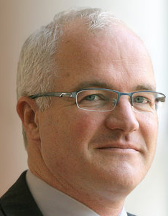  We would like to inform you about the very difficult decision we have come to which is to postpone our Montreal World Conference originally scheduled in July 2022 to 17th-24th (M-F) July 2023. Our decision was first and foremost taken with our focus on global academic exchange and the need to ensure, as far as we can, that all of our global scholars will have an equal opportunity to attend. Below we will brief you the following items:  (A) The process we took before reaching this final decision on conference postponement  The Montreal Conference Working Group (MCWG: Tae Oum, Greg Marsden, Catherine Morency, Martin Trepanier, Lori Tavasszy, Fusun Ulengin, Gopal Patil, Emma Pickering (minutes)) have met three times in order to assess and make decision on whether or not we should postpone the WCTRS Montreal World Conference from July 2022 to July 2023.  The MCWG members agreed that the Covid-19 Pandemic may not be fully controlled by Spring, 2022, especially in developing countries and regions, while the Scientific Committee’s call for papers/abstracts need to be out at least one year before the conference date. Thus, the postponement decision needed to be made before the end of May, 2021.  Our Montreal conference organizers (Catherine Morency; Martin Trepanier) pointed out:  - a fully hybrid conference (face-to-face and virtual format) will be very costly, and will be highly complex to schedule  - Montreal team has explored with the ‘Palais des Congrès for the possibility of postponing to 2023.  The WCTRS membership survey results (about 350 responded) conducted by our UK Secretariat (Greg Marsden/Emma Pickering) show that a significant percentage of the respondents may not be able to make their travel decision until spring 2022, and thus, they were not sure if they will submit abstract/papers in fall, 2021.  Based on the survey results, the MCWG decided that it is too risky to do the 2022 Montreal Conference as planned because of possible negative impacts on both conference registration and the society’s finance.  The final step was the Steering Committee’s Vote in April, 2021, in which the overwhelming majority of STC members approved the Conference Postponement decision.  Soon after, Prof. Catherine Morency, our Montreal Conference chair was able to secure the conference venue ‘Palais des Congrès for Monday 17th- Friday 21st July 2023.  (B) Intermediate WCTR Activities in 2022  Since Montreal Conference (July, 2023) is a long time without a formal WCTRS conference, the Montreal Conference Working Group (MCWG) and Scientific Committee (SCC) are actively discussing options for smaller conferences and workshops to launch in 2022. CARs (Country and Regional Reps) and WCTRS International Partner Organizations will be closely involved in these preparations. We will communicate shortly about the detailed plans for 2022 and look forward to meeting you during the WCTR Society’s 2022 conferences and workshops.  Thank you very much for your attention and cooperation.  Prof. Tae Oum, WCTRS President  Prof. Lori Tavasszy, WCTRS Scientific Committee Chair  Prof. Greg Marsden, WCTRS Secretary General  Prof. Catherine Morency, WCTRS Montreal Conference Chair
WCTRS RESEARCH NEWSLETTER
President  Tae OUM (University of British Columbia, CANADA)  Secretary General  Greg MARSDEN (Leeds, ENGLAND)  Secretary  Emma PICKERING (Leeds, ENGLAND) | Chair Scientific Committee  Lori TAVASSZY (tu Delft, NETHERLANDS)  Chair Editorial Board “Transport Policy”  Tae OUM ((University of British Columbia, CANADA)  Chair Editorial Board “Case Studies on Transport Policy”  Rosario MACARIO (Lisbon, PORTUGAL)
June 24, 2021 | Volume 1, Issue 5

