WCTRS RESEARCH NEWSLETTER
 | WORLD  CONFERENCE ON  TRANSPORT  RESEARCH  SOCIETY |  | SECRETARIAT OFFICE OF THE WCTRS  Institute for Transport Studied  The University of Leeds  Leeds, LS2 9JT England  Email: wctrs@leeds.ac.uk  Website: www. wctrs-society.com
October 6, 2021 |  | Volume 1, Issue 8
In this Issue  - Updates – Activities done by SIG B3  - Research Article  - WCTRS - Panamerican CAR council  - Online Course - Introduction to Road Safety Audits  - International Webinar on “Church Street First - Impact Assessment of Pedestrianizing an Urban Street in terms of Quality of Life”  Useful Information and links  1. 15th Aalto University Summer School on Transportation (ASTRA)-lectures now available online, with chance of 3ECTS for Graduate Students.  Graduate students wishing to obtain 3 ECTS should watch the 15 recorded lectures of the 2021 ASTRA summer school and completing an essay assignment related to these lectures.  Essay submission deadline: October 31, 2021  For details, visit: link  2. Call for Papers on High-Speed Rail, Equity, and Inclusion, by Asian Development Bank Institute (ADBI)  Abstract submission deadline: October 31, 2021  For details, visit: link  3. 2nd International Conference on “Transportation Infrastructure Projects: Conception to Execution” (TIPCE-2022)  Abstract submission deadline: January 15, 2022  For details, visit: link  4. Call for articles for a Special Issue of Travel Behaviour & Society: ‘Post-pandemic mobility’.  Full paper submission deadline: May 31, 2022  For details, visit: link  WCTRS society journals  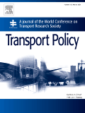  Transport Policy  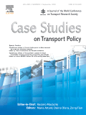  Case Studies in Transport Policy  WCTRS book series  For details, visit: link  Find us on  Wish to become a member of WCTRS?  Click here  Visit us on  https://www.wctrs-society.com/  https://wctr2022.ca/  Email to us at  Editorial team of WCTRS Research Newsletter  Editor  Prof. Dr. Ashish Verma,  IISc Sustainable Transportation Lab (IST Lab), IISc Bangalore, India  ashishv@iisc.ac.in  Assistant editor  H. Gayathri,  Research Scholar, IST Lab, IISc Bangalore, India  gayathrih@iisc.ac.in | Updates – Activities done by SIG B3  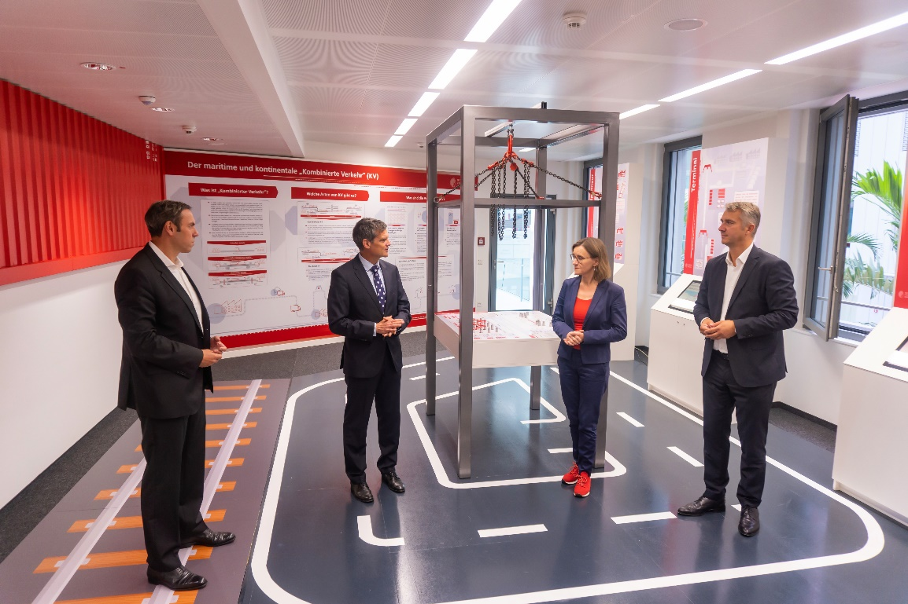  Picture from the opening ceremony  On August 30, 2021, we the Chair of Management and Logistics from the Technical University Darmstadt, under the direction of Prof. Dr. Ralf Elbert, ceremoniously opened our new "Innovation Lab Combined Transport" at the House of Logistics and Mobility (HOLM), Frankfurt am Main, Germany. With the operation of the lab, we pursue the goal of promoting diverse dialog with different people from the transport and logistics industry, but also from politics and society. In this way, we can transfer results and at the same time have the practical applicability of our solutions reflected, and new innovative fields of research identified.  In addition to basic information, we present our research results on increasing the productivity and efficiency of combined road/rail freight transport (CT). We also consider society's view of achieving climate targets and reducing other negative external effects (realized through traffic avoidance, traffic reduction, and modal shift to environmentally friendly modes of transport). To convey all this tangibly, selected tasks relating to CT are available at an interaction table. The corresponding solutions can be deepened thematically at the specific stations for forwarders, terminals, and CT operators. For this purpose, we have prepared our research results, especially for the touch screens at these stations. We are happy to explain the detailed functionality of our solution approaches in the meeting area, where we can carry out further simulation experiments and test new optimization procedures just like in a laboratory.  With our "Innovation Lab Combined Transport " at HOLM, we address several target groups simultaneously. Together with the companies involved in CT, we would like to increase the performance of CT further and, in doing so, involve both shippers and politicians in an inspiring way. We also want to inspire our students to develop, discuss, and test new ideas for CT here in the laboratory. There is also a particular interest in involving the members of SIG B3 "Freight Transport Operations and Intermodality". In addition to holding SIG meetings, it is planned to offer the members of SIG B3 a space in which they can present their research results.  Prof. Ralf Elbert, Technical University Darmstadt  Mr. Felix Roeper, Technical University Darmstadt  Putting the public back into public transport – the impact of Covid-19 – Research Article  The immediate impact of Covid-19 on the world’s transport operators from urban bus and metro systems to international airlines was a dramatic fall in ridership, and hence revenues. In the early stages of the pandemic, as many countries around the world imposed lockdowns and people were encouraged to work from home whenever possible, passenger traffic collapsed, typically by 80 to 95% of normal levels.  The immediate impact of Covid-19 on the world’s transport operators from urban bus and metro systems to international airlines was a dramatic fall in ridership, and hence revenues. In the early stages of the pandemic, as many countries around the world imposed lockdowns and people were encouraged to work from home whenever possible, passenger traffic collapsed, typically by 80 to 95% of normal levels. Despite some recovery during 2020, further waves of infection kept urban transport ridership at between an average of 30 and 60% of pre-pandemic levels well into 2021. Increasing restrictions on international travellers, from imposed quarantining to outright bans, reduced international air travel to less than 10% of normal passengers.  The effect of such a reduction in demand led to serious financial pressures on all operators. Whilst revenues fell, it was not normally possible to reduce levels of service by the same amount. For urban metros, for example, fixed costs account for up to 80% of costs and, although there are examples of complete system closures, operators were often encouraged to maintain service levels to provide for key workers and to ensure social distancing. Costs were also increased by the need to increase regular cleaning and sanitising of surfaces.  Against this background national and local governments provided financial support to enable services to be maintained. In the United Kingdom an initial GBP1billion package was agreed with Transport for London, support for the national rail network was agreed at an estimated cost of GBP4.3 billion for the first six months to September 2020, subsequently extended for a further year at an additional GBP3 to 5 billion. In the case of national rail this effectively turned the existing franchise system of private operators bearing revenue risk into management contracts with the government assuming the revenue risk. Similar packages provided for support of local bus services, largely run in the UK by private operators. Similar aid was given in many countries, and this included support for airlines.  In “Will Covid-19 put the public back in public transport? A UK perspective” Transport Policy, 103, 95-102 (https://doi.org/10.1016/j.tranpol.2021.01.005) I argue that although governments have provided funding to enable services to keep running during the pandemic, the length of the emergency and the slow speed of recovery threatens the ability to maintain this until demand returns to pre-pandemic levels or to a new equilibrium with lower peaks reflecting more flexible working patterns. This situation will require a more fundamental approach to long-term policy for transport as a whole and not just a mode-by-mode approach. Perhaps the era of the deregulated, competitive model for public transport will be replaced by one which focuses on the need to provide public service. This is also an opportunity for a move towards a holistic approach that addresses problems of provision such as the environmental impacts of transport, congestion and questions of transport justice such as accessibility to transport for all groups in society. Much remains to be done in designing such an inclusive transport system.  Prof. Roger Vickerman, University of Kent and Imperial College, London, UK  WCTRS - Panamerican CAR council  The Pan-American Society of Transportation and Logistics Research (PANAMSTR) is a non-profit organization created to promote education and research in transportation and logistics, national and international collaborations, exchange of ideas and research, and strengthen education and research capacity at the Pan-American level.  PANAMSTR gathers researchers, students, and professionals from educational and research institutions, agencies, and companies in transportation, with recognized importance in the sector, from the Americas, the Caribbean, and the Iberian Peninsula. The main objectives of the Pan-American Society of Transportation and Logistics Research are to:  - Organize the Pan-American Congress of Transportation and Logistics.  - Foster education and research on transportation and logistics.  - Organize events to foster exchange of ideas and research at the Pan-American level.  - Foster collaborative research activities among members.  The Pan-American Congress of Transportation and Logistics (PANAM) focuses on current topics of interest to transportation professionals, enabling transportation stakeholders to identify the issues that affect them and potential solutions, to design effective courses of action in a cooperative environment. The first PANAM took place in 1980, organized by the Mexican Association of Transportation Engineering. Since then, PANAM has been successfully organized every two years except PANAM XXI Lima, which was postponed due to the effects of the COVID-19 pandemic. Most of the PANAMs have taken place in Latin America (Mexico, Colombia, Brazil, Chile, Puerto Rico, Venezuela, Cuba, Ecuador, Peru). They have also been organized three times in Europe (in Spain and Portugal) and once in the United States. The next congresses will be held in Guayaquil (Ecuador) in 2023 and San Diego (United States) in 2025.  PANAMSTR has formal cooperation agreements with six leading research organization societies: Transportation Research Board (TRB, United States), Red Académica de Movilidad (RAM, Colombia), Sociedad Chilena de Ingeniería de Transporte (SOCHITRAN, Chile), Associação Nacional de Pesquisa e Ensino em Transportes (ANPET, Brazil); Foro de Investigadores de Transporte (FIT, Spain) and Chinese Overseas Transportation Association (COTA, US/China). Additional cooperation agreements are being pursued with other organizations. These agreements enable PANAMSTR to reach out to transportation practitioners, researchers, and policy makers to work together to advance transportation research and practice in Latin America and other countries. The PANAMSTR, as a member of the CAR Council, contributes to the dissemination of WCTR news and activities.  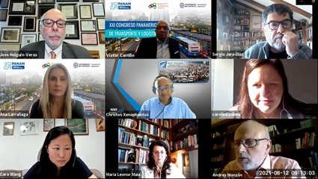  Virtual Meeting of PANAMSTR’s Research Organizations during the PANAM XXI in LIMA Perú  Prof. Jose Holguin-Veras, Rensselaer Polytechnic Institute, United States  Online Course – Introduction to Road Safety Audits – 9 –11 October 2021  Qatar Transportation and Traffic Safety Centre (University of Qatar) together with the International Road Federation and in collaboration with the World Conference on Transport Research Society (WCTRS) organize a three-day online training course that will look at Road Safety Audits and inspections comprehensively as an introduction to these tools.  Course Overview  Preventive risk assessment tools, such as road safety audits and inspections, are an effective and essential instrument to help road authorities reduce the number of crashes and casualties because design standards alone cannot guarantee road safety in all conditions. This course is free and open to everyone willing to deepen his or her knowledge and skills to enhance their technical and professional competence on Road Safety Audits.  Learning Outcomes  - How to focus on road deficiencies that lead to severe and fatal injuries;  - Identify the risks of a road network;  - Recognize the scope, benefits, resources and liability issues of Road Safety Audits;  - Understand which data sources are available to support recommendations for remedial measures;  - And much more!  For Registration or Further Information: https://irfnet.ch/event/online-training-introduction-to-road-safety-audits/  Dr. Wael Alhajyaseen, Qatar University  International Webinar on “Church Street First - Impact Assessment of Pedestrianizing an Urban Street in terms of Quality of Life”  SIG-H2 of World Conference on Transport Research Society (WCTRS)  Extensive dependence on motorized vehicles resulted in externalities including traffic congestion, road accidents, difficulties for active transport (walking and bicycling), air pollution, and noise pollution; thus, deteriorating one’s Quality of Life (QoL) and liveability of the city. Furthermore, the transport sector is identified as one of the major sources of air pollution that adversely impacts citizens’ health.  Therefore, the stakeholders and planners should focus on sustainable transport policy interventions considering a people-centric approach. Once such policy extensively considered in developed economies and now being explored for developing economies is ‘‘PEDESTRINIZING URBAN STREETS’’. Pedestrianization is essentially closing the road for traffic.  The Innovating for Clean Air (IfCA) programme is a joint initiative between India and UK to pilot air quality improvement initiatives in Bengaluru. Under the Clean Air Street initiative, Church Street in Bengaluru was closed for vehicular traffic every Saturday and Sunday from 10:00 AM to midnight for four months from 7th November 2020 till 28th February 2021. The Directorate of Urban Land Transport (DULT) was a primary partner along with IST Lab., IISc, Bangalore, and Catapult UK in implementing the Clean Air Street initiative. The focus of this study is to analyse the air quality and public opinion towards pedestrianizing an urban street. Both quantitative and qualitative studies are carried out to understand the impact of the initiative in terms of Quality of Life (QoL). From the studies' results, it is inferred that people were pleased about the initiative and suggested extending the pedestrianization beyond February 2021. The increase in the pedestrian footfall during the months of project duration indicates that more people became aware of the initiative. People were also aware that closing road for traffic improves air quality. People believed that they spend more time in the street, and a pedestrian-friendly environment improves their QoL. The outcomes of these studies suggest the importance of pedestrian-only streets, which would help stakeholders in planning and executing such sustainable transport strategies. These results were presented at the international webinar organized by SIG H2 Chair of WCTRS, Prof. Ashish Verma, on October 1, 03:00 PM-06:00 PM IST (UTC+5:30).  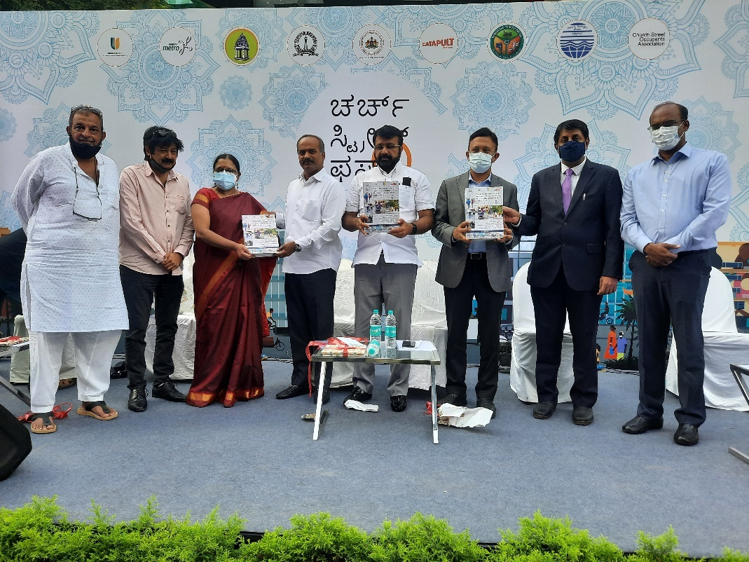  Unveiling the Church Street project report  Link to the report  Prof. Ashish Verma, SIG H2 - Chair, Indian Institute of Science, Bangalore, India
WCTRS RESEARCH NEWSLETTER
President  Tae OUM (University of British Columbia, CANADA)  Secretary General  Greg MARSDEN (Leeds, ENGLAND)  Secretary  Emma PICKERING (Leeds, ENGLAND) | Chair Scientific Committee  Lori TAVASSZY (tu Delft, NETHERLANDS)  Chair Editorial Board "Transport Policy"  Tae OUM ((University of British Columbia, CANADA)  Chair Editorial Board "Case Studies on Transport Policy"  Rosario MACARIO (Lisbon, PORTUGAL)
October 6, 2021 | Volume 1, Issue 8

