WCTRS RESEARCH NEWSLETTER
 | WORLD  CONFERENCE ON  TRANSPORT  RESEARCH  SOCIETY |  | SECRETARIAT OFFICE OF THE WCTRS  Institute for Transport Studied  The University of Leeds  Leeds, LS2 9JT England  Email: wctrs@leeds.ac.uk  Website: www. wctrs-society.com
January 13, 2022 |  | Volume 1, Issue 11
In this Issue  - Interview with Club of Rome Executive Committee member Prof. Yoshitsugu Hayashi  - Report on WCTRS SIGs Partner Event 6th Conference of Transportation Research Group of India (CTRG-2021)  - Conference Updates!  Useful Information and links  1. 2nd International Conference on “Transportation Infrastructure Projects: Conception to Execution” (TIPCE-2022)  Abstract submission deadline: January 15, 2022  For details, visit: link  2. all for Papers - Green Mobility in Smart Cities and Impact on Pollutant Emissions and Air Quality  Deadline for abstract submission: 17 January 2022  For details, visit: link  3. Call for papers for Special Issue of Transportation Research Part A: Policy and Practice- ‘Integration of passenger and freight transport’  Deadline for submission: 30 April 2022  For details, visit: link  4. Call for articles for a Special Issue of Travel Behaviour & Society: ‘Post-pandemic mobility’.  Full paper submission deadline: May 31, 2022  For details, visit: link  5. Publications by SIG A4-Handbook on High-Speed Rail and Quality of Life and Frontiers in High-Speed Rail Development  Both books are free to download.  For details, visit: link  WCTRS society journals  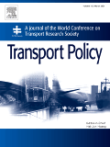  Transport Policy  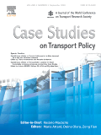  Case Studies in Transport Policy  WCTRS book series  For details, visit: link  Find us on  Wish to become a member of WCTRS?  Click here  Visit us on  https://www.wctrs-society.com/  https://wctr2022.ca/  Email to us at  Editorial team of WCTRS Research Newsletter  Editor  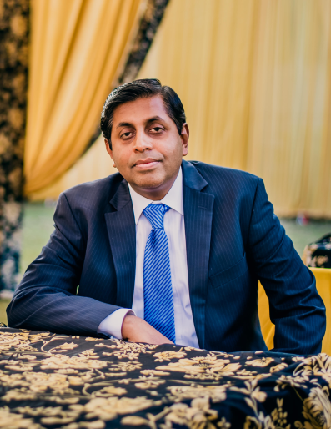  Prof. Dr. Ashish Verma,  IISc Sustainable Transportation Lab (IST Lab), IISc Bangalore, India  ashishv@iisc.ac.in  Assistant editor  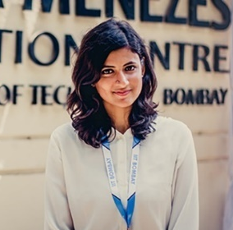  H. Gayathri,  Research Scholar, IST Lab, IISc Bangalore, India  gayathrih@iisc.ac.in | Interview with The Club of Rome Executive Committee member Prof. Yoshitsugu Hayashi  The WCTRS Research Newsletter Editorial team took a brief interview of the Executive Committee member of The Club of Rome & Ex-President of WCTRS, Prof. Yoshitsugu Hayashi.  Below is the full interview with Prof. Yoshitsugu Hayashi.  How do you value The Club of Rome association with WCTRS? With the experience so far, in what way do you feel the association is useful?  The Club of Rome was established in 1968 in Rome by Aurelio Peccei, a deep thinker businessman, as a thinktank for researching the serious global problems for human beings, which he called “The Problematique”. The year 2022 is the 50th anniversary of its 1st report “The Limit to Growth” published in 1972, warning the risk of collapse of the planet if we would trendily continue to consume natural resources because population growth would not be any more negligible compared to the capacity of the planet in 2030. Its warning has become true appearing as climate emergency.  The Club of Rome is a platform of diverse thoughts of leaders who identify holistic solutions to complex global issues, promote policy initiatives and act to enable humanity to emerge from multiple planetary emergencies. I joined the Club of Rome as one of the 100 full members in 2015 and am an executive committee member since 2020. I know about the club and how it is evolving.  The Club of Rome is very much talented in concept making and also have a very good Political access to the world leaders or their voices. The carbon neutral scheme discussed in COP26 in Glasgow was led by EU (European Union) in which our co-president of the Club, Sandrine Dixson-Decleve was also involved. It was politically accepted and shared with the Secretary General of UN. We are very much closely working with Political leaders or leading organizations.  At the same time, the Club of Rome is not that talented in analyzing or observing the real world in detail as we have only 100 full members. I am the only transport expert, which is also the case with many other disciplines. Thus, it is almost impossible for one expert to handle all the works related to his/her discipline.  On the contrary, WCTRS has a rich asset of researchers, each of whom is talented in different subfields of transportation or extending transportation to land use, to local environment, climate change, justice or equality. But the main areas of research are still very conventional. If both the organizations collaborate, WCTRS may get a stimulus from the Club of Rome and contribute to evidence-based analysis and identification of the real-world issues.  A good role model is late Dr. Rajendra K. Pachauri, Ex Chairperson of IPCC. He was an internationally recognized voice on environmental policy issues, and through his tireless leadership of the IPCC the issue of human-caused climate change became recognized as a matter of vital global concern. He gathered all the discipline people and requested to analyze and summarize the results on the whole climate change sphere and reported to the world. I recommend all the SIG chairs to follow his lines and deal the transportation issues from different angles, i.e., mobility, logistics, climate change and its causing disasters, and its related inferences or causes for behavioral change.  Kindly brief us about The Club of Rome and its portfolio of activities being done, and how they can be beneficial to WCTRS members?  The Club of Rome has certain impact hubs which institute a similar idea of WCTRS special interest groups. There are five hubs on 1) Planetary Emergency, 2) Emerging New Civilizations, 3) Reframing Economics, 4) Rethinking Finance, 5) Youth Leadership and Intergenerational Dialogues < https://www.clubofrome.org/ >. The hubs scope such kind of bigger frames of diversity.  WCTRS also has promoted SIGs successfully. Eight SIGs started at the 5th WCTR Yokohama in 1989. I particularly remember it because I worked as the scientific secretary of the conference. It was the idea of late Professor Marvin Manheim, the 1st WCTRS President then, that in such special purpose groups the members personally could understand each other and grow professionally. We have now more than 35 groups. Each group is active in holding seminars and publishing special issues of journals and Elsevier WCTRS book series.  We can establish a horizontal thinking task force in WCTRS, which links between many SIGs to jointly work with the Club of Rome hubs. This must stimulate WCTRS SIGs to promote more problem-oriented and strategic research to directly contribute to the world society because the Club of Rome always watches on-going critical global issues and acts politically.  We should extend the wings outside of today's WCTRS paradigm. It should be ambitious enough to give a very big power to WCTRS.  What do you think could be ways by which Club of Rome and WCTRS can collaborate and contribute to Sustainable Development and higher Quality of Life (QOL)?  It is important to promote happiness for humanities together with happiness for the planet in the planetary eco-system. We should have a balance between the two. But unfortunately, 20th century civilization directed reverse, leading to a more imbalanced world which is called Anthropocene, a new geological age of human dominance.  Human being’s unwise interventions have destroyed the balance of nature. Destroying the planet's nature or ecosystem is not only by the mechanism of machines or economic system, but rather more basically, by the way of thinking. The 20th century civilization was dominantly led by the Western way of thinking in which nature is existing outside of human beings and to be conquered. We should acknowledge different ways of thinking and different ways of living. In the Eastern Oriental way of thinking we human beings are a part of the nature which is too great for us to challenge.  I am much concerning about coexistence of sustainable development and quality of life (QOL) also. Under this concept, sustainable development is a gross idea of happiness for the planet or planetary ecosystem. Therefore, people aiming for QOL is a big topic to study and then we shall have to gather for every discipline.  One of the typical examples is cost benefit analysis. It was a remarkable invention when the British government decided to start COBA in 1972 because no scientific assessment system was there before. So, I very much appreciated how the new road or new railway would create more monetary benefit with the same investment. This seemed right at that time. But the objectives of people’s life now are not just money but QOL as a whole. Now all the government should change the project evaluation system from country GDP base to individual QOL base.  There are other issues where WCTRS can contribute. One of the examples is Carbon Neutrality issue. The movement of EU to regulate that only Electric vehicles are allowed may be wrong. We need to leave a room for new technologies beyond EV to appear. So, we should define rather a performance-based emission standard like Euro 1,2,3. WCTRS SIGs should scientifically examine such an issue and report timely to the society jointly with the Club of Rome hubs.  The original SIG on Environment established at 9th WCTR Seoul had promoted research and joint side events with NGOs in UNFCCC COPs since COP 15 Copenhagen in 2009. Although, at the beginning, transport was not recognized as an important area to protect climate change, it became a certain help for a group of NGOs and NPOs to appeal enough at COP 21 Paris and thereafter.  There are many issues related to transport such as climate change, air pollution, stopping excess motorization, car related tax and regulations, pricing systems to stop urban sprawl, countermeasures against pandemic, etc. This kind of contributions in various aspects can be collaboratively done with the Club of Rome, which they expect. This can be a topic of discussion in the new task force.  Prof. Yoshitsugu Hayashi, Executive Committee member, Club of Rome  WCTR Updates!  The current dynamics of the global Covid pandemic confirm that the decision to postpone the live WCTR to 2023 has been the right one. As the pause after the very successful 2019 WCTR in Mumbai would be too large, we are preparing an online WCTR in the week of 25-29 July 2022 (save the date!).  This online conference will be hosted by the university of Montreal. Instead of the usual open call for papers we are preparing for a series of high-level interactive seminars, organized by the leaders of our 32 Special Interest Groups (SIGs). These seminars will discuss new topics in all areas and will provide a rich menu for our members. Registration will also provide discounts for entry into the 2023 WCTR – therefore, we warmly recommend WCTR2022! Also, we will host open meetings for these SIGs, to kick-start the preparation for the 2023 Conference. We expect to launch our Call for Papers for the 2023 WCTR during Spring next year before the online conference. As successfully delivered after the 2019 WCTR more than 20 special issues were completed with the best conference papers. We would like to repeat this success and count on colleagues around the world to submit their work for WCTR 2023!  Prof. Lori Tavasszy, TU Delft, Netherlands  Report on WCTRS SIGs Partner Event 6th Conference of Transportation Research Group of India (CTRG-2021)  The 6th CTRG was held between 14th – 17th December 2021 in Tiruchirappalli, Tamil Nadu, India in which WCTRS-SIG C3, D3 and H2 were non-financial co-sponsors. The conference was organized jointly by Transportation Research Group of India (TRG) and National Institute of Technology (NIT) Trichy and was held with the intention to cover a wide spectrum of topics related to transportation of people and freight.  The conference was held in physical mode with large number of participants attended the conference physically with few international authors/speakers attending online. The conference invited papers from across the world under different themes. The themes comprised of areas such as Pavements & materials, traffic flow theory, transport planning, travel behaviour, sustainability, ITS, pedestrian and NMT. There were 120 oral presentations, 58 poster presentations by authors along with 12 doctoral symposium Poster Presentations.  Apart from technical paper presentations, the conference also had 10 keynote presentations, 4 special sessions, 6 executive courses and 4 discussion mode workshops. The executive courses were offered by experts of international repute and provided an excellent opportunity for doctoral students/ academicians/ researchers/ practitioners to develop insight and skill in relevant areas. The workshops conducted in the conference were aimed to provide directions for young researchers and discuss about possible actions to fill in the gaps between academia, government, and industries. The conference also had exhibition from the industry and government sponsors to facilitate interactions and collaborations between industry and academia.  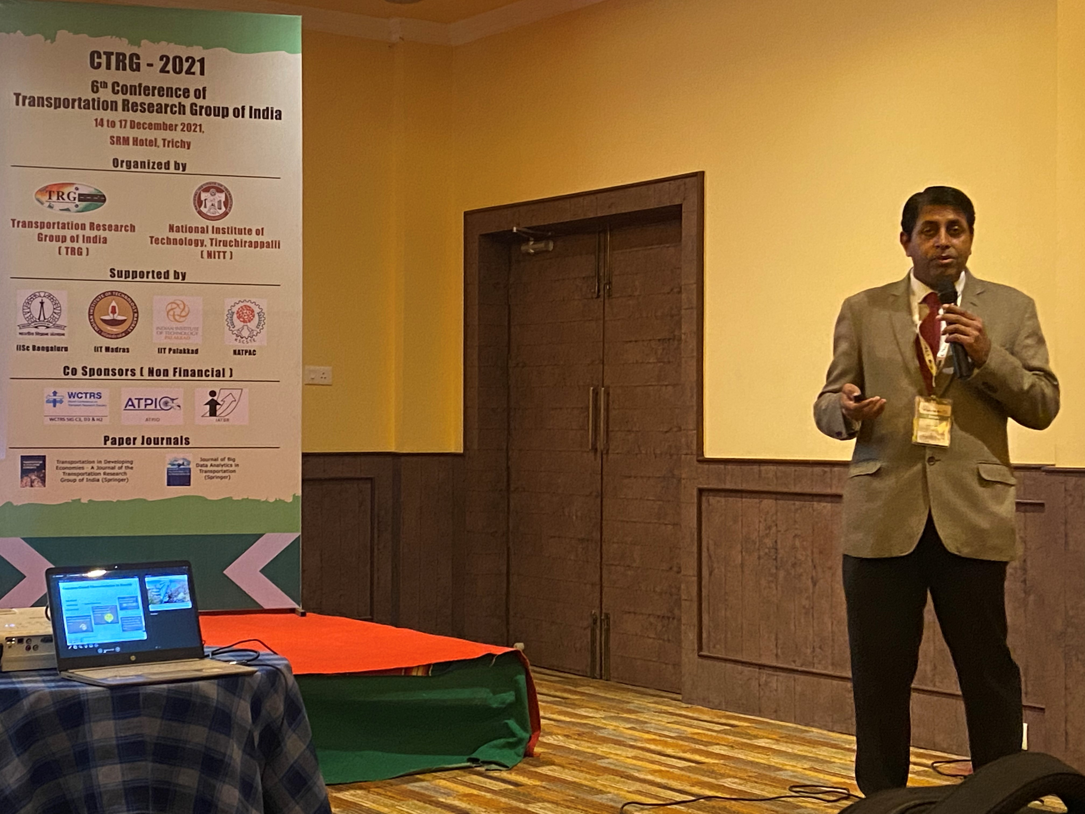  Prof. Ashish Verma, Professor, IISc Bangalore  Nipun Choubey and Gayathri Harihara Subramanian, Research Scholars, IISc Bangalore
WCTRS RESEARCH NEWSLETTER
President  Tae OUM (University of British Columbia, CANADA)  Secretary General  Greg MARSDEN (Leeds, ENGLAND)  Secretary  Emma PICKERING (Leeds, ENGLAND) | Chair Scientific Committee  Lori TAVASSZY (tu Delft, NETHERLANDS)  Chair Editorial Board "Transport Policy"  Tae OUM ((University of British Columbia, CANADA)  Chair Editorial Board "Case Studies on Transport Policy"  Rosario MACARIO (Lisbon, PORTUGAL)
January 13, 2022 | Volume 1, Issue 11

