WCTRS RESEARCH NEWSLETTER
 | WORLD  CONFERENCE ON  TRANSPORT  RESEARCH  SOCIETY |  | SECRETARIAT OFFICE OF THE WCTRS  Institute for Transport Studied  The University of Leeds  Leeds, LS2 9JT England  Email: wctrs@leeds.ac.uk  Website: www. wctrs-society.com
February 1, 2022 |  | Volume 1, Issue 12
In this Issue  - Update on SIG B3 activities  - Face mask mandates and risk compensation – Research article  - The Tale of Two Countries – Research article  - Membership of the WCTRS  Useful Information and links  1. Webinar: Pathways Between Transportation and Health  Date & time: Fri, February 4, 2022, 17:00 – 18:00 GMT  For details, visit: link  2. Two job openings at the University of Cambridge  Deadline for applying: 14 February 2022  For details, visit: job 1, job 2  1. Symposium on Transport and Covid19 in Low and Middle Income Countries on 22 February 2022  Time: Kampala, Uganda + Online; 8 am – 2 pm GMT  For registration, visit: link  2. Call for submissions: “Mobilities, accessibility and proximity” panel at the 2022 European Urban Research Association (EURA) Conference, 16-18 June in Milan, Italy  Deadline for abstract submission: 1 March 2022  For details, visit: link  3. Call for papers: Special Issue, "Application of MCDM in Logistics and Transportation Engineering" for Journal of Traffic and Transportation Engineering (JTTE) (English Edition)  Deadline for paper submission: 15 March 2022  For details, visit: link  4. Call for papers for Special Issue of Transportation Research Part A: Policy and Practice- ‘Integration of passenger and freight transport’  Deadline for submission: 30 April 2022  For details, visit: link  5. Call for articles for a Special Issue of Travel Behaviour & Society: ‘Post-pandemic mobility’.  Full paper submission deadline: May 31, 2022  For details, visit: link  6. Call for papers: Special Issue, “Challenges and Advances in decarbonising Transportation (CAT)” for Renewable & Sustainable Energy Reviews  Deadline for paper submission: 1 June 2022  For details, visit: link  7. Publications by SIG A4-Handbook on High-Speed Rail and Quality of Life and Frontiers in High-Speed Rail Development  Both books are free to download.  For details, visit: link  WCTRS society journals  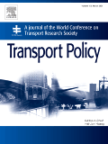  Transport Policy  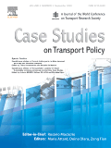  Case Studies in Transport Policy  WCTRS book series  For details, visit: link  Find us on  Wish to become a member of WCTRS?  Click here  Visit us on  https://www.wctrs-society.com/  https://wctr2022.ca/  Email to us at  Editorial team of WCTRS Research Newsletter  Editor  Prof. Dr. Ashish Verma,  IISc Sustainable Transportation Lab (IST Lab), IISc Bangalore, India  ashishv@iisc.ac.in  Assistant editor  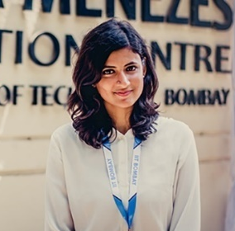  H. Gayathri,  Research Scholar, IST Lab, IISc Bangalore, India  gayathrih@iisc.ac.in | Update on SIG B3 activities  Ralf Elbert Felix Roeper  SIG B3 focuses on connecting researchers on an international scale to conduct collaborative research on the topic of “Freight Transport Operations and Intermodality”. In December 2021 and January 2022, SIG B3 has been organizing and finalizing the agenda for the upcoming WCTRS Online Conference in July 2022 with the SIG members.  During this year’s WCTRS Online Conference, the SIG will be holding two sessions on 27 July 2022. The first will be on “Climate Change - The role that freight transport can play to avoid emissions”, beginning with a short presentation by Prof. Dr. Thierry Vanelslander from the University of Antwerp, followed by a panel discussion. The second will be on “Digital Transformation - Possibilities and Potentials of Data Driven Planning for Combined Freight Transport”, beginning with a short presentation by Prof. Dr. Ralf Elbert from the Technical University of Darmstadt and followed by a panel discussion. Furthermore, in June, we will be holding a Summer Meeting to discuss the upcoming WCTRS Online Conference.  Our goal is to connect researchers from all over the globe. Being faced with different time zones, a plethora of social media and scheduling challenges, we plan to implement a central platform for SIG B3 in the upcoming months. On this platform, researchers will be able to collect and share knowledge centering on “Freight Transport Operations and Intermodality”, ask questions and discuss relevant topics and events, and keep our members up to date. This platform will also be helpful in organizing SIG activities.  We are planning on subdividing the platform into a wiki for collecting data and a forum for discussing ideas and topics. The wiki will include, for example, publications, journals, conference contributions, and conference dates. The forum will offer a central place for professional and technical exchange, for asking fellow researchers for expert input, and for discussing and organizing important upcoming events.  Prof. Ralf Elbert, Technische Universität Darmstadt  Felix Roeper M.Sc., Technische Universität Darmstadt  Face mask mandates and risk compensation: An analysis of mobility data during the COVID-19 pandemic in Bangladesh – Research Article  Zia Wadud Sheikh Mokhlesur Rahman Annesha Enam  Almost 180 countries of the world had recommended or mandated use of mask or face covering to contain the COVID-19 spread in the last 2 years. However, its potential risk compensation effect is little understood. Risk compensation arises due to an individuals’ tendency to maintain a somewhat constant level of risk in changing environments. In case of mask use this would translate to being less vigilant about other precautionary measures (e.g., hand washing, physical distancing, travelling) to reduce COVID-19 spread. Risk compensation can have important policy implications such as limited efficacy in case of full compensation and reverse impact in case of overcompensation. Therefore, we investigated the potential presence of risk compensation related to mask mandate in the context of Bangladesh – a densely populated, rapidly growing country.  The study used mobility at six types of different locations (e.g. retail and recreation, grocery and pharmacy, parks, transit stations, work and residences) as a proxy for risky behaviour. An intervention analysis was conducted with country wise mask mandate that was issued on July 21, 2020, as the intervention. First, six Auto Regressive Moving Average (ARMA) models were developed with mobility activities at six locations as the dependent variable using data from pre-mask mandate period (2 June to 21 July 2020). Second, the estimated models were used to predict the location specific activities to act as counterfactual. Finally, the predicted mobility activities were compared with the actual activities for the period 22 July to 28 July 2020 to test for any systematic differences. Additionally, we developed six separate time-series models that regressed daily COVID-19 cases on six types of mobility activities to (re)establish mobility as a valid proxy for the risk compensation behaviour.  The predicted activities obtained from the intervention analysis at different locations such as retail and recreation, grocery and pharmacy, parks and transit stations were found to be lower than the actual values in a statistically significant way. This can be observed from the figure where the predicted mobilities show consistently higher values from the actual activities (Figure 1). Deviation between the predicted and the actual values were found to be less drastic for workplace, though still statistically significant, – this might be because the workplaces were already operating at half capacity since May 31, 2020, and hence, the mask mandate in late July did not perturb the already mobile workplace at a large scale. On the other hand, homestays decreased since the mask mandate (results in main paper). The second set of regression results established statistically significant relationship between daily new cases and lagged mobility values.  These results indicate that the community mobility increased after the mandatory mask-use policy, revealing at least partial risk compensation. Quantification of the risk compensation effect remains an important avenue for further research.  Observed and model prediction mobility changes at transit stations and workplaces for the period between 2 June to 28 July 2020.  Reference: Wadud Z, Rahman SM, Enam A 2022. Face mask mandates and risk compensation: an analysis of mobility data during the COVID-19 pandemic in Bangladesh, BMJ Global Health; 7: e006803.  DOI: http://dx.doi.org/10.1136/bmjgh-2021-006803  Prof. Zia Wadud, University of Leeds, Leeds, UK  Dr. Sheikh Mokhlesur Rahman and Dr. Annesha Enam, Bangladesh University of Engineering and Technology, Dhaka, Bangladesh  The Tale of Two Countries: Modelling the Effects of COVID-19 on Travel Behaviour in India and Bangladesh  Eeshan Bhaduri Khatun Zannat Manoj BS  Zia Wadud Arkopal Goswami Charisma Choudhury  The coronavirus (COVID-19) pandemic has disrupted day-to-day activity patterns around the world. However, the extent of these changes varied substantially in different parts of the world, raising questions about the spatial transferability of the travel behaviour models to be used for transport planning decisions in the ‘new-normal’. A team of researchers from University of Leeds and Indian Institute of Technology Kharagpur conducted studies during the early phases of COVID-19 (March 2020 – May 2020) to analyze how COVID-19 impacted travel behaviour in India and Bangladesh, with particular focus on how the results varied from the other parts of the world and between the countries.  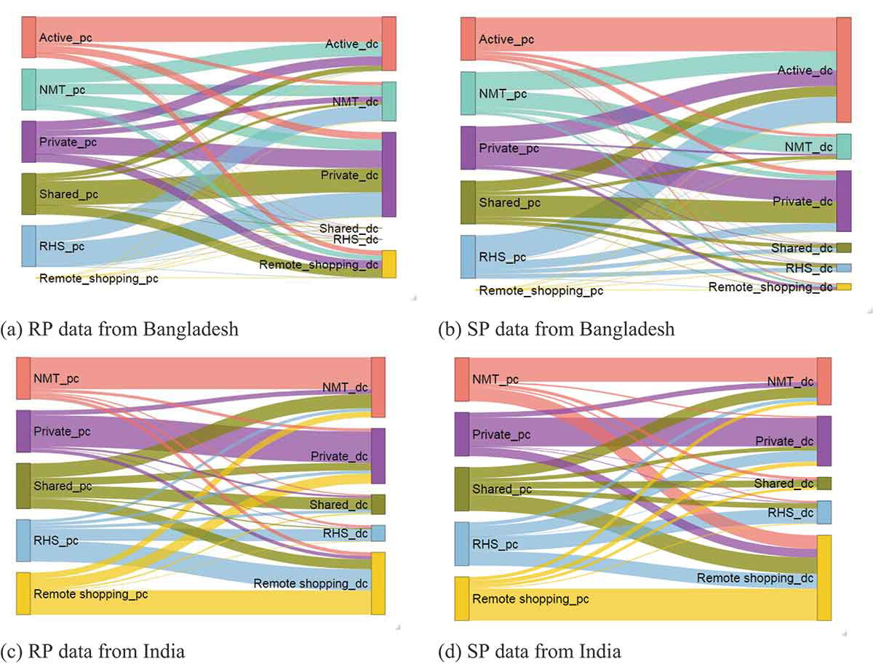  Inertia of different shopping mediums (pc=pre-COVID, dc=during-COVID)  In the first study [1], the team developed econometric models to quantify the effect of the socio-demographic characteristics of the travellers on the mode-specific trip frequencies before (January 2020) and during the early stages (March 2020) of COVID-19 spread in India. Multiple discrete choice extreme value (MDCEV) models have been developed based on 500+ online survey responses. Estimation results indicate a significant presence of inertia to continue using the pre-COVID modes with higher propensities to shift to virtual (e.g., working from home, online shopping, etc.) and private modes (e.g., car, motorcycle) from shared ones (e.g., bus and ride-share options). The extent of inertia was found to vary with the trip lengths and trip purpose (more in case of long commute trips). The results also demonstrated significant heterogeneity based on the respondent’s age, income, and working status.  The second study [2] focused on similarities and differences in shopping behaviour in India and Bangladesh using revealed (RP) and stated preference (SP) data. Joint modelling using RP and SP data enabled the team to understand how contextual factors like the number of people infected by COVID-19, the number of deaths, and different levels of government restrictions affected the shopping behaviour in these two neighbouring countries. Nested logit models have been developed using data collected from 317 and 498 households in Bangladesh and India, respectively. Results indicate that some contextual variables (number of affected people at the country level and the number of deaths at the division or state level) have a significant impact on shopping preference in both countries. However, in the case of Bangladesh, results indicate a lower propensity to shift to online shopping than India.  Comparison of the data and the model parameters of the two countries with substantial socio-cultural similarities provided insights into how differences in the state of e-commerce can lead to different inertia levels in continuing the pre-COVID behaviour. The findings also highlight that ‘one size does not fit all countries’ and different levels of interventions and/or restrictive measures are required in different countries to achieve the desired level of reduction of in-person travel to control the spread of the virus.  Reference:  [1] Bhaduri, E., Manoj, B. S., Wadud, Z., Goswami, A. K., & Choudhury, C. F. (2020). Modelling the effects of COVID-19 on travel mode choice behaviour in India. Transportation research interdisciplinary perspectives, 8, 100273.  DOI: https://doi.org/10.1016/j.trip.2020.100273  [2] Zannat, K. E., Bhaduri, E., Goswami, A. K., & Choudhury, C. F. (2021). The tale of two countries: modeling the effects of COVID-19 on shopping behaviour in Bangladesh and India. Transportation Letters, 13(5-6), 421-433.  DOI: https://doi.org/10.1080/19427867.2021.1892939  Mr. Eeshan Bhaduri, Research Scholar, Indian Institute of Technology, Kharagpur, India  Ms. Khatun Zannat, Research Scholar, University of Leeds, Leeds, UK  Mr. Manoj BS, Research Scholar, Indian Institute of Technology, Kharagpur, India  Prof. Zia Wadud, University of Leeds, Leeds, UK  Prof. Arkopal Goswami, Indian Institute of Technology, Kharagpur, India  Prof. Charisma Choudhury, University of Leeds, Leeds, UK  Membership of the WCTRS  The WCTRS is the only international society in transportation with a truly global network, bringing together over 1000 members from 67 countries to advance and exchange ideas and research across the transport sector.  Members connect through the Society's triannual World Conference, which provides a rich forum to present and discuss the latest in transport research and practice, and through the activities of the Society's Task Forces and 33 Special Interest Groups, each of which represents a specific area of interest and inquiry. Members under 35 years old are additionally invited to participate in the Young Researcher's Initiative activities, which include a one-day event at the World Conference where young researchers can present their work and take advantage of networking opportunities and discussions on career development.  As well as being able to access this global network through Society events and our exclusive membership database to make contacts and further research collaborations, WCTRS members also benefit from the Society's partnerships with other prominent transport organisations, such as the International Transport Forum, the Eastern Asia Society for Transportation Studies, and the Partnership on Sustainable, Low Carbon Transport. WCTRS and its partners exchange news and details of events, jobs, and publication opportunities and make this information available to members. All WCTRS members can obtain free online membership to the Society's two journals, Transport Policy and Case Studies in Transport Research, and have the opportunity to propose titles for publication in the WCTRS and Elsevier Transportation Book Series.  From academics, practitioners, and students to interested individuals, everyone is invited to join the Society and take part in its activities. Our current membership rates are USD 50 as standard, USD 30 for Members from the UN Least Developed Countries Category, and USD 20 for Students. These memberships will run until the next World Conference in Montréal, Canada, which will now occur Monday 17th-Friday July 21 2023. Transport Organisations who wish to support the Society can apply for Supporting Organisational Membership to access a number of promotional opportunities and memberships for up to two individuals.  If you have any questions about membership, do not hesitate to contact the WCTRS Secretary.  Prof. Greg Marsden, University of Leeds, WCTRS Secretary-General
WCTRS RESEARCH NEWSLETTER
President  Tae OUM (University of British Columbia, CANADA)  Secretary General  Greg MARSDEN (Leeds, ENGLAND)  Secretary  Emma PICKERING (Leeds, ENGLAND) | Chair Scientific Committee  Lori TAVASSZY (tu Delft, NETHERLANDS)  Chair Editorial Board "Transport Policy"  Tae OUM ((University of British Columbia, CANADA)  Chair Editorial Board "Case Studies on Transport Policy"  Rosario MACARIO (Lisbon, PORTUGAL)
February 1, 2022 | Volume 1, Issue 12

