WCTRS RESEARCH NEWSLETTER
 | WORLD  CONFERENCE ON  TRANSPORT  RESEARCH  SOCIETY |  | SECRETARIAT OFFICE OF THE WCTRS  Institute for Transport Studied  The University of Leeds  Leeds, LS2 9JT England  Email: wctrs@leeds.ac.uk  Website: www. wctrs-society.com
May 5, 2022 |  | Volume 2, Issue 1
In this issue  - About the Special Issue on “Shared Urban Mobility Systems in the Global South (SUMS)”  - International symposium on smart vehicle and mobility – SIG C1 Update  - COVID-19 Research article  - Membership of the WCTRS  Useful Information and links  1. Call for abstracts: 2nd International Workshop on High-speed Rail Socioeconomic Impacts, Online 13-14 Sept 2022  Abstract submission deadline: 15 May 2022  For details, visit: link  2. Call for papers: Special issue on Transportation Policies and Technologies for Vehicle Emission Reduction and Energy Efficiency in Frontiers in Future Transportation  Abstract submission deadline: 17 May 2022  For details, visit: link  3. Call for articles for a Special Issue of Travel Behaviour & Society: ‘Post-pandemic mobility’.  Full paper submission deadline: 31 May 2022  For details, visit: link  4. Urban Logistics Summer School 2022 from 16-26 August 2022, Antwerp, Belgium  Deadline: 1 June 2022  For details, visit: link  5. Call for papers: Special Issue, “Challenges and Advances in decarbonising Transportation (CAT)” for Renewable & Sustainable Energy Reviews  Deadline for paper submission: 1 June 2022  For details, visit: link  6. Publications by SIG A4-Handbook on High-Speed Rail and Quality of Life and Frontiers in High-Speed Rail Development  Both books are free to download.  For details, visit: link  7. Call for abstracts: International Workshop: Ambitiously decarbonizing Freight and Passenger Transport and supporting Nationally Determined Contributions (NDC)  Abstract submission deadline: 17 June 2022  For details, visit: link  8. Call for papers: Special Issue on Place-Based Decarbonisation  Paper submission deadline: 1 July 2022  For details, visit: link  WCTRS society journals  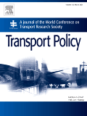  Transport Policy  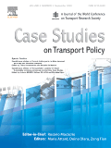  Case Studies in Transport Policy  WCTRS book series  For details, visit: link  Find us on  Wish to become a member of WCTRS?  Click here  Visit us on  https://www.wctrs-society.com/  https://wctr2022.ca/  Email to us at  Editorial team of WCTRS Research Newsletter  Editor  Prof. Dr. Ashish Verma,  IISc Sustainable Transportation Lab (IST Lab), IISc Bangalore, India  ashishv@iisc.ac.in  Assistant editor  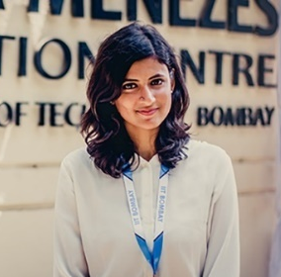  Dr. H. Gayathri,  Postdoctoral Researcher, IST Lab, IISc Bangalore, India  gayathrih@iisc.ac.in | About the Special Issue on “Shared Urban Mobility Systems in the Global South (SUMS)”  It is our pleasure to invite all of you to contribute your original manuscripts to the Special Issue (SI) in the Transportation in Developing Economies (TiDE) Journal, the official Journal of the Transportation Research Group (India). The SI is inviting articles in the broad area of "Shared Urban Mobility Systems in the Global South (SUMS)". The details of the aims and scope are available at https://www.springer.com/journal/40890  This SI intends to showcase research work being carried out by academicians and practitioners around the world, on relevant topics related to the developing economies, which include (but not limited to) -  (a) Mobility as a service (MaaS) and travel behavior  (b) Energy implications of shared urban mobility systems  (c) Last-mile connectivity and micro mobility systems  (d) Quality of service in shared transport  (e) Operations and management of shared urban mobility  (f) Impact of Covid-19 on shared urban mobility, and  (g) Innovative data and methods for analysing urban travel behavior  Details about the issue are available at Special Issue on Shared Urban Mobility Systems in the Global South (SUMS)  The call for papers is open until June 30, 2022.  Special issue editors  1. Charisma Choudhury, Institute for Transport Studies, University of Leeds, UK; Email: C.F.Choudhury@leeds.ac.uk  2. Zia Wadud, Center for Integrated Energy Research, University of Leeds, UK; Email: z.wadud@leeds.ac.uk  3. Bharath Haridas Aithal, Ranbir and Chitra Gupta School of Infrastructure Design and Management, Indian Institute of Technology Kharagpur, India; Email: bhaithal@infra.iitkgp.ac.in  4. Bhargab Maitra, Department of Civil Engineering, Indian Institute of Technology Kharagpur, India; Email: bhargab@iitkgp.ac.in  5. Arkopal Kishore Goswami (Corresponding/Lead Guest Editor), Ranbir and Chitra Gupta School of Infrastructure Design and Management, Indian Institute of Technology Kharagpur, India; Email: akgoswami@infra.iitkgp.ac.in  International symposium on smart vehicle and mobility – SIG C1 Update  Xiaopeng Li Zong Tian  The School of Vehicle and Mobility of Tsinghua University, in collaboration with Tsinghua University Press, China Intelligent Transportation Systems Association (ITS China), and the World Conference on Transport Research Society C1, held a virtual Symposium on Smart Vehicle and Mobility on April 8, 2022, to pique interest in a new generation of smart vehicle and mobility technologies and management. Nine renowned researchers participated in the event, including Mr. Li Chaochen (Chairman of the board of ITS China), Dr. Li Keqiang (Professor of Tsinghua University, Member of the Chinese Academy of Engineering), Dr. Jonas Eliasson (Director of Swedish National Transportation Administration, Member of the Royal Swedish Academy of Engineering Sciences), Dr. Deb Niemeier (Professor of Maryland University, Member of National Academy of Engineering USA), Dr. Gilbert Laporte (International member of National Academy of Engineering USA), Dr. Henry Liu (Professor of the University of Michigan) and Dr. Xiaopeng Li (Associate professor at the University of South Florida), to share their perspectives, exchanging ideas, and discuss the future development of the emerging industry.  Audience from all over the world, including USA, UK, Canada, Australia, Hungary, Italy, Germany, the Netherlands, France, Romania, Singapore, Malaysia, Chinese mainland, and Hong Kong, China, participated in this international symposium online via 3 live streaming channels, with a total of 7,750 viewers across the globe and a total of over 16,000 likes.  Also, Communications in Transportation Research (COMMUN TRANSPORT RES) presented the Best Paper Award to Jonas Eliasson (Director of Swedish National Transportation Administration) for ‘Efficient transport pricing–why, what, and when?’, and Journal of Intelligent and Connected Vehicles (JICV) awarded the Best Paper Award to Qing Xu, Jiangfeng Wang, Botong Wang, and Xuedong Yan for ‘Modeling and simulation of intersection quasi-moving block speed guidance based on connected vehicles’ in the symposium.  Feel free to watch the replay. Link: https://ukx.h5.xeknow.com/s/47OC22.  The symposium was hosted by Drs. Xiaobo Qu and Shuaian Wang, included a mix of welcome speeches, technical sessions, and the best paper and best editorial board awards for two well-developed new journals: Communications in Transportation Research and Journal of Intelligent and Connected Vehicles. Topics and discussions centered on ‘Efficient transportation pricing’, ‘Roadmap to cooperative & automated transportation’, ‘Rethink the safety challenge for highly automated vehicles’, ‘ETS-Data-sharing to advanced mobility’, and ‘The history, influence and recent research trends of vehicle routing problem’ explored both the development and value of new technologies from multiple perspectives and provided ways and platforms to publish and reproduce research works.  The symposium focused on the role of emerging technologies in promoting smart vehicle and mobility. In addition, it helped enhance the linkage between mobile communications and shared mobility which gradually opened up the smart city vein. In the mode of collaborative development of people, vehicles, roads, networks, and clouds, a series of breakthroughs in advanced technologies and system solutions will drive a comprehensive upgrade of the travel experience. Participants welcomed the opportunity to exchange views on planning and scheduling strategies with peers from the broad audience.  In the symposium, the host also announced that Tsinghua University and ITS China will co-host the journal of Communications in Transportation Research, and a signing ceremony has been arranged on 23 April 2022.  In his closing statement, Dr. Xiaobo Qu emphasized the importance of interdisciplinarity in transport and vehicle research, open science, and international collaborations. All sectors wish to strengthen the collaborations for a safer, sooner and greener transport system. The host highlighted: “When we collaborate, the science prevails”.  Communications in Transportation Research publishes peer-reviewed high-quality research representing important advances of significance to emerging transport systems. Since her first paper was published in Aug 2021, the journal has published 33 articles, with authors from 16 countries/regions (see Figure below). In the past 7 months, these articles attracted 108 citations from 25 countries/regions. Our journal has attracted citations from not only all major transportation journals but also other areas such as energy and computer science.  Journal of Intelligent and Connected Vehicles (JICV) publishes peer review research covering all aspects of intelligent and connected vehicles (ICVs) technology. It was selected as a Tier 1 top journal in the field of automotive engineering of China by Chinese Association for Science and Technology in January 2021. In 2022, the journal has received 28 citations, which are two times compared the discipline average. The editors predict to publish over 20 full length articles from 10 countries/regions. The journal is among the first transport/vehicle journals to enforce replication package. A dedicated promotional editor is in place to promote JICV papers on a one by one basis, via social media platforms (LinkedIn, Twitter, WeChat, EurekAlert!) and MailChaimp. All papers will be published in open access but no fee to our authors.  Prof. Xiaopeng Li, University of South Florida, Florida  Prof. Zong Tian, University of Nevada, Reno  A paradigm shift in urban mobility: Policy insights from travel before and after COVID-19 to seize the opportunity – Research article  Anurag Thombre Amit Agarwal  COVID-19 outbreak from contagious coronavirus disrupted human societies across the globe. The virulence and speed of the disease spread further led to policy paralysis across sectors forcing the adoption of lockdown. The transportation sector was among the first casualty of this intervention due to its nexus with the virus spread, leading to abrupt changes in mobility patterns in bustling urban cities.  Taking stock of this emergent issue for urban mobility, a web-based survey was conducted in urban cities of India during the different phases of lockdowns (20th March 2020 – 30th June 2020). The goal was to capture the mobility shift and the need for a safer and disaster-resilient public transport (PT) system with a particular focus on prescribing and testing a set of policies. In the pre-COVID-19 scenario, it was found that PT is the most preferred travel mode in densely populated tier-A cities; tier-B cities rely primarily on private modes (car, MTW) for their daily travel.  As a consequence of the lockdown, a free-fall was observed for travel. PT was shunned by respondents as these were considered the breeding ground for viruses and places where new norms like physical distancing were challenging to adopt.  The effect of telework (work/ study from home) guidelines had a dramatic impact on the primary activity trips; close to 60% of the respondents in both categories of cities were able to telework. However, the repercussions of this norm, isolation due to quarantine, and social distancing affected the mental well-being of the respondents (e.g., 80% of teleworking persons had experienced higher stress/ anxiety/ fear in both categories of cities).  As anticipated, the travel demand rose with the easing of lockdown restrictions. The survey results indicate ‘car’ appeal post-COVID lockdown at a pan-India level. Figure 1 illustrates the nature of mode shift among the respondents in tier-A and tier-B cities. To sum it up, the respondents preferred the least risky travel modes (car, MTW) over high-risk travel modes (PT, shared travel modes).  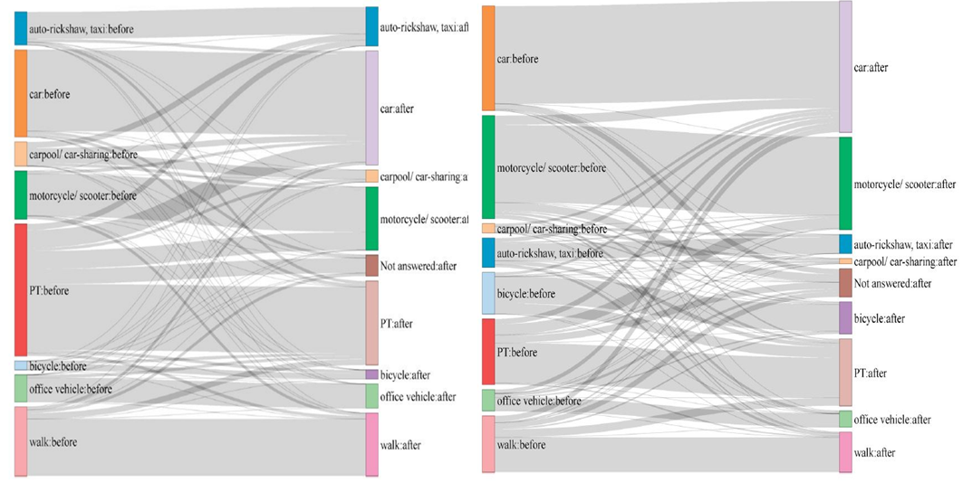  Tier-A Tier-B  (Megacities) (Million plus and < a million population cities)  Figure 1: Mode Switchers in Tier-A & B Cities  Along with this sentiment, the study captured the willingness to pay extra for traveling in a Personal Rapid Transit (PRT) system to reduce their chances of getting infected in the closed PT system, which reflected the need for sustainable and disaster-resilient PT.  Finally, the study proposed and evaluated policies that can be implemented in the short to long term using a multi-agent transport simulation framework (MATSim). In the short term; work-from-home is ideal for reducing travel demand. In the medium term; gaining the trust of PT users is crucial, and tailormade policies (e.g., discounting PT fare) are necessitated. For the long term; travel demand management techniques such as staggering work/ education days and investment in active travel modes are needed. The results of the simulation experiments promised to pave the way for implementation.  The COVID-19 pandemic has dramatically exposed the loopholes in urban mobility and our preparedness for disruptive events. It is an opportune time to reflect on the resilience of our transportation systems, especially public transport, and invest in the active travel modes for affordable, sustainable, and disaster-resilient urban mobility. It is a silver lining in the wake of this crisis, and it is prudent that we seize this opportunity.  Reference: Thombre, A., Agarwal, A. (2021). A paradigm shift in urban mobility: Policy insights from travel before and after COVID-19 to seize the opportunity. Transport Policy, 110, 335-353.  DOI: https://doi.org/10.1016/j.tranpol.2021.06.010  Prof. Akhilesh Kumar Maurya, Indian Institute of Technology, Guwahati, India  Membership of the WCTRS  The WCTRS is the only international society in transportation with a truly global network, bringing together over 1000 members from 67 countries to advance and exchange ideas and research across the transport sector.  Members connect through the Society's triannual World Conference, which provides a rich forum to present and discuss the latest in transport research and practice, and through the activities of the Society's Task Forces and 33 Special Interest Groups, each of which represents a specific area of interest and inquiry. Members under 35 years old are additionally invited to participate in the Young Researcher's Initiative activities, which include a one-day event at the World Conference where young researchers can present their work and take advantage of networking opportunities and discussions on career development.  As well as being able to access this global network through Society events and our exclusive membership database to make contacts and further research collaborations, WCTRS members also benefit from the Society's partnerships with other prominent transport organisations, such as the International Transport Forum, the Eastern Asia Society for Transportation Studies, and the Partnership on Sustainable, Low Carbon Transport. WCTRS and its partners exchange news and details of events, jobs, and publication opportunities and make this information available to members. All WCTRS members can obtain free online membership to the Society's two journals, Transport Policy and Case Studies in Transport Research, and have the opportunity to propose titles for publication in the WCTRS and Elsevier Transportation Book Series.  From academics, practitioners, and students to interested individuals, everyone is invited to join the Society and take part in its activities. Transport Organisations who wish to support the Society can apply for Supporting Organisational Membership to access a number of promotional opportunities and memberships for up to two individuals.  If you have any questions about membership, do not hesitate to contact the WCTRS Secretary.  Prof. Greg Marsden, University of Leeds, WCTRS Secretary-General
WCTRS RESEARCH NEWSLETTER
President  Tae OUM (University of British Columbia, CANADA)  Secretary General  Greg MARSDEN (Leeds, ENGLAND)  Secretary  Emma PICKERING (Leeds, ENGLAND) | Chair Scientific Committee  Lori TAVASSZY (tu Delft, NETHERLANDS)  Chair Editorial Board "Transport Policy"  Tae OUM ((University of British Columbia, CANADA)  Chair Editorial Board "Case Studies on Transport Policy"  Rosario MACARIO (Lisbon, PORTUGAL)
May 5, 2022 | Volume 2, Issue 1

