WCTRS RESEARCH NEWSLETTER
 | WORLD  CONFERENCE ON  TRANSPORT  RESEARCH  SOCIETY |  | SECRETARIAT OFFICE OF THE WCTRS  Institute for Transport Studied  The University of Leeds  Leeds, LS2 9JT England  Email: wctrs@leeds.ac.uk  Website: www. wctrs-society.com
November 1, 2022 |  | Volume 2, Issue 7
In this issue  - Call for Papers, 16th World Conference on Transport Research, Montreal (Canada), July 17-21, 2023  - WCTRs at the 50th European Transport Conference, in Milan (Italy)  - WCTRS Elsevier book series- Transportation Amid Pandemics: Lessons Learned from COVID-19  - SIG B3 Summer Sessions- WCTRS Virtual Meet 2022  - Registration is open for UIA Associations Round Table Europe 2022 in Rotterdam  - Membership of the WCTRS  Useful Information and links  1. Publications by SIG A4-Handbook on High-Speed Rail and Quality of Life and Frontiers in High-Speed Rail Development  Both books are free to download.  For details: Click Here  2. A new Transport Research and Education Network to help ESCAP member States achieve sustainable transport  For details: Click Here  3. 9th Sustainable Road Freight Workshop, (online & free)  Theme: Resilient transitions to net zero freight transport systems  For details: Click Here  4. 102nd TRB Annual Meeting  When: January 8-12, 2023  Where: Washington, DC  For Details: Click Here  5. Vacancy at Newcastle University - Professorship in Net Zero Maritime Systems  For Details: Click Here  6. SITRASS event on the economics of transport for development in Africa (in French language)  Theme: L'économie des transports au service du développement en Afrique  When: June 26- July 21, 2023  For Details: Click Here  7. Special Issue of  Transportation Research Part D: Transport and Environment on  “Policies and Technologies to Support Decarbonization of the Aviation Sector”  For details: Click Here  Paper submission deadline: December 1, 2022  8. Special Issue of Transportation Research Part D: Transport and Environment on “Green pathways for a connected and automated vehicle future”  For details: Click Here  Paper submission deadline: January 31, 2023  WCTRS society journals  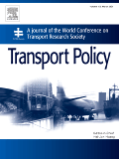  Transport Policy  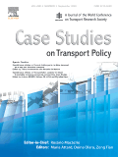  Case Studies in Transport Policy  WCTRS book series  For details, visit: link  Find us on  Wish to become a member of WCTRS?  Click here  Visit us on  https://www.wctrs-society.com/  https://wctr2022.ca/  Email to us at  Editorial team of WCTRS Research Newsletter  Editor  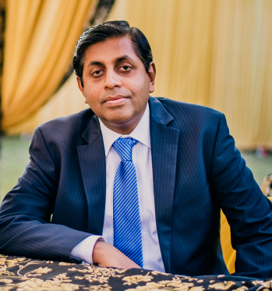  Prof. Dr. Ashish Verma,  IISc Sustainable Transportation Lab (IST Lab), IISc Bangalore, India  ashishv@iisc.ac.in  Assistant Editor  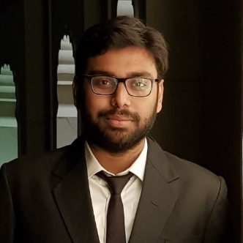  Mr. Aitichya Chandra,  PhD Scholar, IST Lab,  IISc Bangalore, India  aitichyac@iisc.ac.in | CALL FOR PAPERS  16TH WORLD CONFERENCE ON TRANSPORT RESEARCH, MONTREAL (CANADA), JULY 17-21, 2023  The World Conference on Transport Research Society (WCTRS) is happy to announce that the 16th World Conference will be held from July 17th to 21st in MONTRÉAL (Québec, CANADA) at the Palais des Congrès. The aims of the conference are to bring together experts in all areas of transport research from all parts of the world and to stimulate the exchange of ideas in the field of transport policy and practice.  Authors are invited to submit one or more full papers to the following topic areas:  Topic Area A: Transport Modes – General  Topic Area B: Freight Transport and Logistics  Topic Area C: Traffic Management, Operations and Control  Topic Area D: Activity and Transport Demand  Topic Area E: Transport Economics and Finance  Topic Area F: Transport, Land-use and Sustainability  Topic Area G: Transport Planning and Policy  Topic Area H: Transport in Developing and Emerging Countries  We offer a peer review of each paper to assess its potential for presentation, publication and the award of a prize. As with previous conferences, selected papers will be published in proceedings. In close cooperation with major scientific transportation journals, special issues will be prepared (typically more than 20), supporting publication of excellent papers. WCTRS support for publications is conditional on the outcome of the reviews and on presentation at the conference. The organisation is managed through EasyChair (https://easychair.org/). Detailed information on society membership, the content of each Topic Area and its Special Interest Groups (SIGs) is provided on the WCTRS website: https://wctrs-society.com/. Details regarding the Montreal conference will be posted on: http://wctr2023.ca. Information will be available about registration possibilities, opportunities for bursary awards, the Palais des Congrès venue, hotel reservations, travel and weather.  We are happy to announce a 1-month extension for submissions to the 16th WCTR conference. The deadline for paper submission is now extended to November 15th 2022. The revised dates are given below:  Important Dates  Deadline for submission of full papers: November 15th 2022  Notification of paper acceptance: February 1st 2023  Deadline for registration of presenting author: March 1st 2023  Deadline for submission of final papers for conference: May 1st 2023  Guidelines for submission  Papers should be submitted using the paper template and the EasyChair submission system. All details and instructions are available on the submission page: https://easychair.org/conferences/?conf=wctr2023. All correspondence related to this call can be addressed to wctr2023@cirrelt.ca.  We look forward to your contribution and participation in the next World Conference on Transport Research in Montreal 2023!  WCTRs at the 50th European Transport Conference, in Milan (Italy)  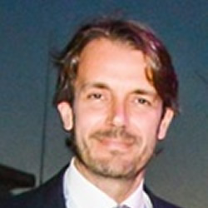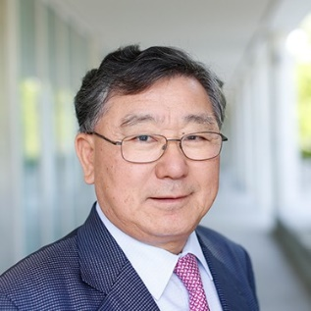  Prof. Pierluigi Coppola Prof. Tae Hoon Oum  The 50th edition of the European Transport Conference (ETC 2022), organized by the Association for European Transport (AET), was held on 7-9 September at the Politecnico di Milano, in Milan (Italy). After two years online, the return to an in-person conference was going to be a challenge but this year’s conference was a great success. Through about 250 scientific presentations and special sessions, participants had the opportunity to learn about recent studies and projects concerned with the uncertainty brought by the ongoing economic and geo-political changes, as well as by new travel behaviours and new technology (and data), striving for multidisciplinary approaches and teams bringing new perspectives to old problems in a changing World.  The 50th edition was also the occasion to strengthen the relations with other international organisations. In fact, a plenary session was organised with an invited keynote speech by Prof. Tae Oum, President of the World Conference on Transportation Research Society (WCTRs), who proposed a reflection on the future needs of research in the transport sector. “There is a need for formalizing multi-criteria infrastructure decision making framework”, claimed Prof. Oum, ”Due to an increasingly less reliance on the Benefit-Cost Analysis Framework (economic efficiency focus), equal weight ‘external’ economic costs and benefits is no more sufficient; the decision-making bodies have already abandoned it”.  AET could play an important role to develop new infrastructure decision making framework and the WCTRS president encouraged a cooperation among ETC Programme Committes (PCs) and the WCTR Special Interest Groups (SIGs) to support and get involved in such initiatives.  The 50th edition was a great networking opportunity, as well, for nearly 600 delegates from universities, companies and institutions from over 35 Countries around the world, to form professional relationships and discuss future research projects. Indeed, a forum, unique in the European context, where research meets professional practice, to discuss and learn about up-to-date topics such as, this year: the impacts of the climate emergency and COVID-19 on long term travel patterns; the future of the Cities and uncertainty of travel data.  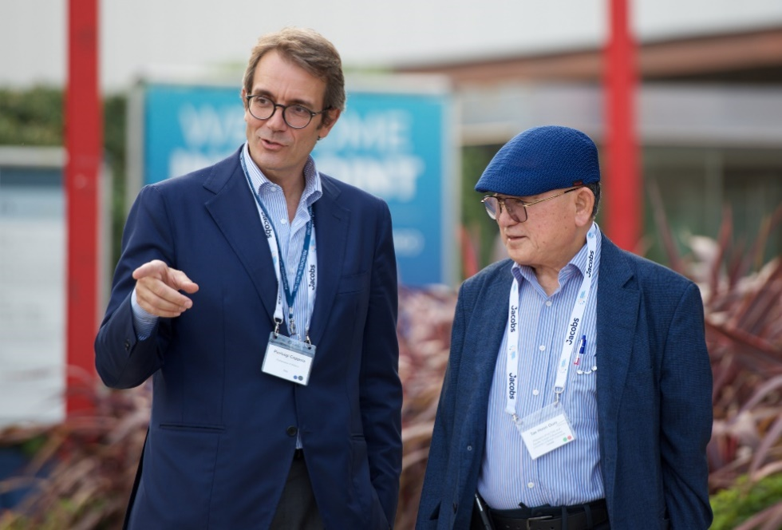  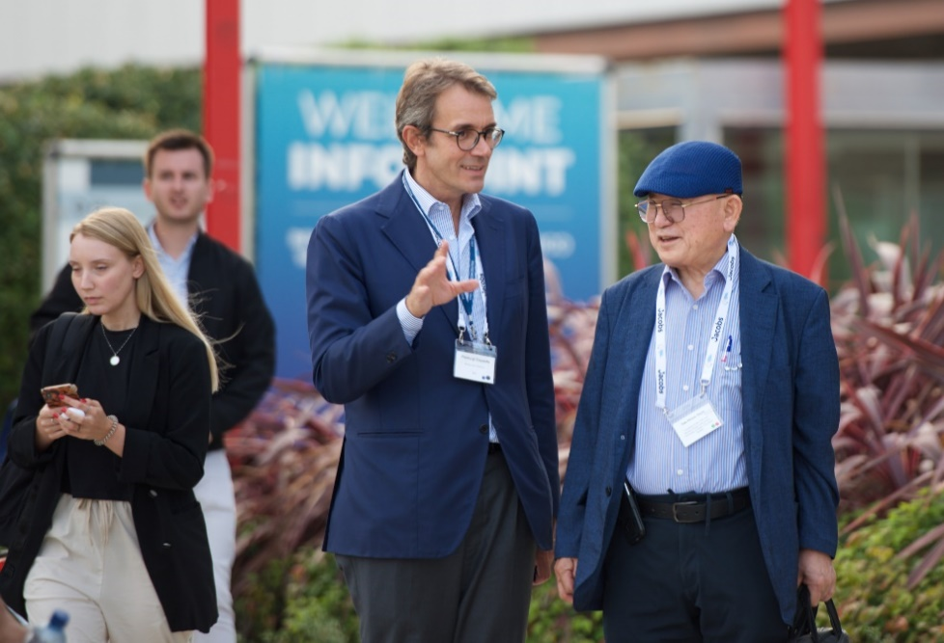  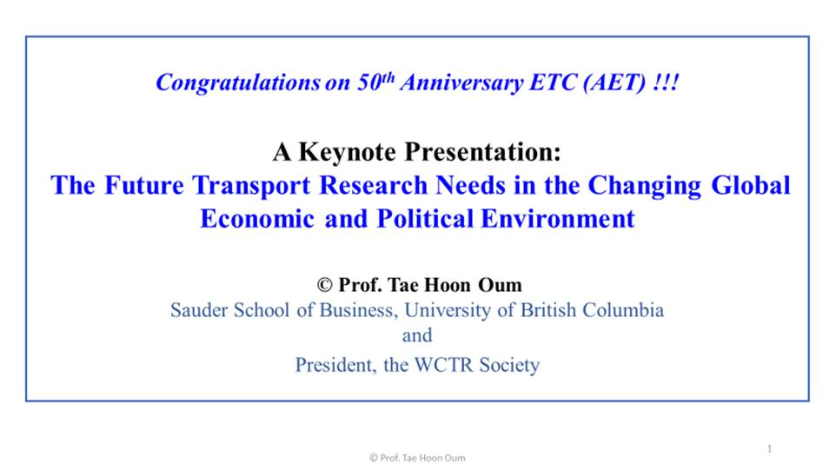  Prof. Pierluigi Coppola, Politecnico di Milano, Italy.  Prof. Tae Hoon Oum, University of British Columbia, Canada. President, the World Conference on Transport Research (WCTR) Society  WCTRS Elsevier book series- Transportation Amid Pandemics: Lessons Learned from COVID-19  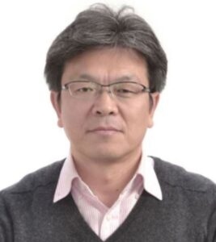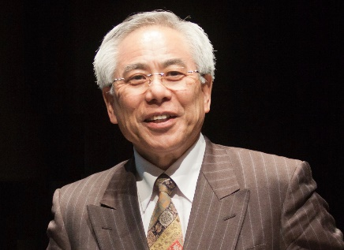  Prof. Junyi Zhang Prof. Yoshitsugu Hayashi  Transportation Amid Pandemics: Practices and Policies is the first reference on pandemics (especially COVID-19) in the context of transport, logistics, and supply chains. This book investigates the relationships between pandemics and transport and evaluates impacts of COVID-19 and effects of policy responses to address them. It explores how to recover from pandemics, reveals governance for immediate policy responses and future innovations, suggests strategies for post-pandemic sustainable and resilient development, shares lessons of COVID-19 policymaking across countries, and discusses how to transform transport systems for a better future. Transportation Amid Pandemics offers transport researchers and policymakers the scientific evidence they need to support their decisions and solutions against pandemics.  Key Features:  - Represents the collective efforts of the World Conference on Transport Research Society (WCTRS)  - Uniquely deals with intertwined issues of pandemics and transport  - Investigates both successful and problematic policy measures  - Emphasizes evidence-based policymaking from cross-sectoral and transdisciplinary perspectives  - Transfers lessons from the COVID-19 pandemic to future generations  Further Information: Elsevier Link  Prof. Junyi Zhang, Hiroshima University, Japan. Co-chair, WCTRS COVID-19 Task Force  Prof. Yoshitsugu Hayashi, Chubu University, Japan. Chair, WCTRS COVID-19 Task Force  SIG B3 Summer Sessions- WCTRS Virtual Meet 2022  How can we decarbonize freight transport and what role can freight transport play to avoid emissions? We were excited to shed some light on these important questions together with members of WCTRS SIG B3 “Freight Transport Operations and Intermodality” and TRB’s AT045 “Intermodal Freight Transport Committee”, international research and industry representatives from America, Europe and Asia-Pacific in two sessions at the WCTRS Virtual Meet 2022.  Alongside Prof. Ralf Elbert (Chair of SIG B3) and Jolene Hayes (Chair AT045), we welcomed Dr. Christoph Friedrich (TFG Transfracht), Thomas Jelenic (PMSA), Patrick Bertman (DB Cargo AG) and Dr. Sam Pournazeri (ICF team) for the first session. For the second session we were happy to welcome Prof. Dr. Wolrad Rommel (German-Kazakh University), Chris Xia (Flex-port Asia) and Peter Peng Ye (Maersk China). Both sessions featured an opening keynote by Prof. Thierry Vanelslander (University of Antwerp) on “How to Decarbonize Freight Transport” which offered an assessment of the status quo and formed a first perspective on necessary fields of action to effectively reduce emission values of freight transport.  Together with Prof. Vanelskander and the industry representatives, the speakers, and the audience, we identified and discussed the most promising initiatives to reduce emission in freight transport. Both sessions showed a clear need for zero emission technology, internalizing external costs and optimization of transportation modes. Further initiatives saw promise and necessity in long-term policies and clear guidelines as well as coordination of investments. The consensus among all participants was clear: to successfully steer freight transport into a more sustainable direction, it is necessary to have a multi-layered approach and make it a joint effort.  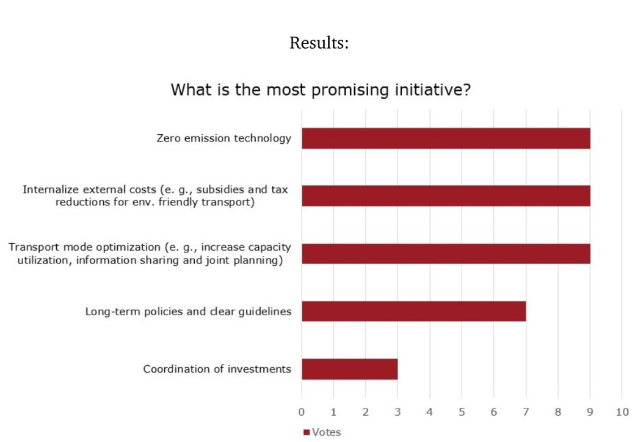  Prof. Ralf Elbert, University of Darmstadt, Germany. Chair, SIG B3.  Registration is open for UIA Associations Round Table Europe 2022 in Rotterdam  The Union of International Associations (UIA) cordially invites World Conference on Transport Research Society members to participate in its 16th Associations Round Table Europe at the Postillion Convention Center Rotterdam, Netherlands.  The UIA Associations Round Table Europe 2022 is an event designed for participants working in and with international associations, and we hope to see many of you in Rotterdam!  What you can expect:  - Presentations on common challenges by peers working in international associations and by experts  - Discussions in workshops and break-out rooms with the chance to ask in-depth questions and to share and exchange knowledge and experience  - UIA team members will moderate the sessions throughout, guiding and assisting the delegates  - Networking breaks, lunches, dinner  - Three exciting tours to discover Rotterdam  You are welcome to register any number of delegates; each of your delegates will need to register separately.  UIA is an independent non-profit research institute founded in 1907 which has documented and promoted the work of international associations for 115 years.  Register: To register go to https://uia.org/roundtable/2022/eu/register/  When: Thursday 24 & Friday 25 November 2022  Costs: Thanks to the support of Rotterdam Partners and sponsors and partners, the registration fee for Round Table Europe in Rotterdam is EUR 70.00 (plus 21% VAT).  Further Information: Please, see all the topics of the programme and the schedule at https://uia.org/roundtable/2022/eu/  Membership of the WCTRS  The WCTRS is the only international society in transportation with a truly global network, bringing together over 1000 members from 67 countries to advance and exchange ideas and research across the transport sector.  Members connect through the Society's triannual World Conference, which provides a rich forum to present and discuss the latest in transport research and practice, and through the activities of the Society's Task Forces and 33 Special Interest Groups, each of which represents a specific area of interest and inquiry. Members under 35 years old are additionally invited to participate in the Young Researcher's Initiative activities, which include a one-day event at the World Conference where young researchers can present their work and take advantage of networking opportunities and discussions on career development.  As well as being able to access this global network through Society events and our exclusive membership database to make contacts and further research collaborations, WCTRS members also benefit from the Society's partnerships with other prominent transport organisations, such as the International Transport Forum, the Eastern Asia Society for Transportation Studies, and the Partnership on Sustainable, Low Carbon Transport. WCTRS and its partners exchange news and details of events, jobs, and publication opportunities and make this information available to members. All WCTRS members can obtain free online membership to the Society's two journals, Transport Policy and Case Studies in Transport Research, and have the opportunity to propose titles for publication in the WCTRS and Elsevier Transportation Book Series.  From academics, practitioners, and students to interested individuals, everyone is invited to join the Society and take part in its activities. Transport Organisations who wish to support the Society can apply for Supporting Organisational Membership to access a number of promotional opportunities and memberships for up to two individuals.  WCTRS Membership - Free for 2022/2023  We are excited to share the decision of the Steering Committee that membership for WCTRS will be free of charge from July 2022 to mid-July 2023. Normally the period of membership is three years, running between our main conference. However, with Covid and the postponement of the Montreal face to face event to 2023 we will extend existing members' membership for one year. There will be no need to fill out any forms to extend membership, but we will shortly be in touch with final details in case anyone wishes to opt out.  We have announced the opportunity for non-members to join the society free for this coming year in the run up to Montreal. We hope this will be a great opportunity for more people to get involved in the Society and we will value your support in promoting this. More details will follow shortly.  When: July 2022 to mid-July 2023  Further Information: On the WCTRS website  If you have any questions about membership, do not hesitate to contact the WCTRS Secretary.  Prof. Greg Marsden, University of Leeds, WCTRS Secretary-General
WCTRS RESEARCH NEWSLETTER
President  Tae OUM (University of British Columbia, CANADA)  Secretary General  Greg MARSDEN (Leeds, ENGLAND)  Secretary  Helen ROBINSON (Leeds, ENGLAND) | Chair Scientific Committee  Lori TAVASSZY (tu Delft, NETHERLANDS)  Chair Editorial Board "Transport Policy"  Haijun HUANG (BeiHang University School of Economics and Management, CHINA)  Chair Editorial Board "Case Studies on Transport Policy"  Rosario MACARIO (Lisbon, PORTUGAL)
November 1, 2022 | Volume 2, Issue 7

