WCTRS RESEARCH NEWSLETTER
 | WORLD  CONFERENCE ON  TRANSPORT  RESEARCH  SOCIETY |  | SECRETARIAT OFFICE OF THE WCTRS  Institute for Transport Studied  The University of Leeds  Leeds, LS2 9JT England  Email: wctrs@leeds.ac.uk  Website: www. wctrs-society.com
December 1, 2022 |  | Volume 2, Issue 8
In this issue  - The “Young” activities of the Society in 2022  - Japanese aviation market performance during the COVID-19 pandemic  - WCTRS Elsevier book series- Transportation Amid Pandemics: Lessons Learned from COVID-19  - SIG B3 Freight Transport Operations and Intermodality - Updates  - Membership of the WCTRS  Useful Information and links  1. Publications by SIG A4-Handbook on High-Speed Rail and Quality of Life and Frontiers in High-Speed Rail Development  Both books are free to download.  For details: Click Here  2. A new Transport Research and Education Network to help ESCAP member States achieve sustainable transport  For details: Click Here  3. 9th Sustainable Road Freight Workshop, (online & free)  Theme: Resilient transitions to net zero freight transport systems  For details: Click Here  4. 102nd TRB Annual Meeting  When: January 8-12, 2023  Where: Washington, DC  For Details: Click Here  5. SITRASS event on the economics of transport for development in Africa (in French language)  Theme: L'économie des transports au service du développement en Afrique  When: June 26- July 21, 2023  For Details: Click Here  6. Special Issue of Transportation Research Part D: Transport and Environment on “Green pathways for a connected and automated vehicle future”  For details: Click Here  Paper submission deadline: January 31, 2023  7. Special Issue of Transportation Research Part A: Policy and Practice on “Pricing and Regulation in Road Transport”  For details: Click Here  Paper submission deadline: April 30, 2023  WCTRS society journals  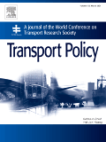  Transport Policy  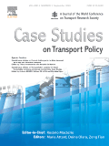  Case Studies in Transport Policy  WCTRS book series  For details, visit: link  Find us on  Wish to become a member of WCTRS?  Click here  Visit us on  https://www.wctrs-society.com/  https://wctr2022.ca/  Email to us at  Editorial team of WCTRS Research Newsletter  Editor  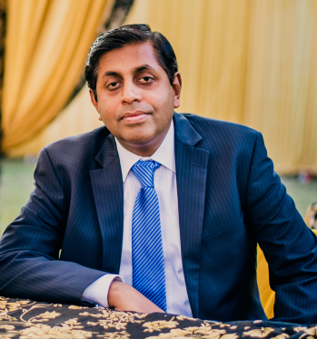  Prof. Dr. Ashish Verma,  IISc Sustainable Transportation Lab (IST Lab), IISc Bangalore, India  ashishv@iisc.ac.in  Assistant Editor  Mr. Aitichya Chandra,  PhD Scholar, IST Lab,  IISc Bangalore, India  aitichyac@iisc.ac.in | The “Young” activities of the Society in 2022  Dr. Laetitia Dablanc, University Gustave Eiffel, France  The World Conference on Transport Research Society has launched a number of Young initiatives, sometimes known as "Y" initiatives (https://wctrs-society.com/wctrs-y-initiative/). These initiatives provide opportunities for young members (including both those under 35 years of age on the first day of the next WCTR Conference (17 July 2023), and early career researchers, who completed their PhD less than four years prior to the first day of the conference) of the society to gain experience in academic activities, develop their professional profiles and skills, network with established transport academics and practitioners, and become familiar with the workings of the Society.  As the main conference event (WCTRS Montreal) got delayed due to the pandemic, the Y committee in charge of the organization of the Young conference (Sagar Patni, Antoine Robichet and Rajendra Baraiya) decided to participate in the virtual WCTRS conference that took place in July 2022, with two sessions for young members. Based on an extended survey made among all young members of the Society, it was decided to keep the theme of the virtual sessions as “career development.” It was targeted to provide insights pertinent to various topical transport research-related discussions spanning from career development, and networking to research issues, in order to discuss all the challenges faced by a young transport academic. Speakers were invited from different countries and expertise areas for the two virtual sessions. Also, speakers were chosen to cover different areas in the transportation field. Session 1 took place on Monday, 25 July 2022, 2-3:30 PM GMT with eminent panelists across the globe including Priyanka Alluri (Florida International University, USA), Prateek Bansal (National University of Singapore), Tom O'Brien (California State University, USA), and Varun Varghese (Hiroshima University, Japan). At the same time, Session 2 was held on Tuesday, 26 July 2022, 4-5:30 PM GMT, with panelists including Robert Ambunda (University of Namibia, Namibia), Xiaopeng Li (University of South Florida, USA), Bandhan Bandhu Majumdar (BITS Pilani, India) and Xilei Zhao (University of Florida, USA). This session was also in association with SLOCAT Partnership on Sustainable, Low Carbon Transport. Both sessions were very successfully attended by young researchers and early-career academics, with many Q&As to the seniors.  Now, the Y committee is amid planning for the next year’s main event, the Young Conference (17 July 2023) in Montreal. A call for papers has been launched. This event is at no fee but participants must attend the full WCTR. The Young conference is a one-day conference, organized on the first day of the WCTR and with specific submission and review processes, aimed at promising young transport researchers. The theme is ‘Imagining the Future: Sustainable and Resilient Transport’. Papers from all topic areas of the WCTRS (see the nine topics here) are considered. Moreover, we also offer a peer review of each paper to assess its potential for presentation. In fact, the best papers can also be channeled for consideration to the WCTRS Prizes. Finally, about 51 extended abstracts have been received which have already been sent out for reviews as of now where only high-quality submissions will be considered for the presentation at the main event.  Another activity of WCTRS-Y is the creation of networking resources for young WCTRS members (https://wctrs-society.com/wctrs-y-iii-young-online-facility/). This involves building and maintaining a social media presence, contributing to the WCTRS website, and generating mailing lists and a newsletter. The team (Ann Mary Varghese and Eeshan Bhaduri) is now busy promoting the 2023 WCTRS-16 in Montreal.  Ann Mary Varghese and Eeshan Bhaduri, and Laetitia Dablanc, leader of the Young initiative  Japanese aviation market performance during the COVID-19 pandemic - Analyzing airline yield and competition in the domestic market  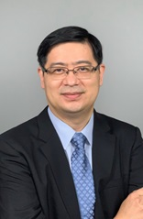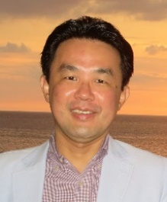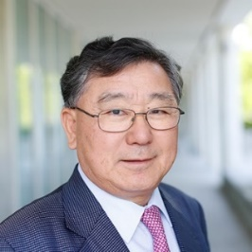  Prof. Xiaowen Fu Prof. Xiaowen Prof. Tae Hoon Oum  This study examines the implications of the major disruptions caused by the COVID-19 pandemic on airline competition and market growth in the Japanese aviation market. Specifically, this study focuses on the effect of the COVID-19 pandemic on airlines’ capacity, frequency, yield and competition using data from 2019 to 2020. Our empirical results found that the pandemic imposed significant negative effects on airline yield, scheduled seats and frequency. Such effects were different across mainline vs. regional routes, with full service airlines (FSAs) still maintaining much of their dominance. The two leading FSAs, namely Japan Airlines and All Nippon Airlines, actually strengthened their duopoly control in the markets, whereas the market share of the third-largest carrier, Skymark Airlines, shrank significantly towards the end of 2020. Regional routes’ sustainability has been further challenged to the extent that more resources may have to be allocated to maintain regional connectivity until sustainable recovery of travel demand. Entrant low cost carriers (LCCs) continue to put downward pressure on yield, but their contribution to overall market competition may be moderated by their affiliations with the two dominant FSAs under the so called airlines-within-airlines strategy. Affiliated LCCs could strengthen, instead of reducing, the dominance of the duopoly JAL and ANA over independent airlines in the Japanese domestic market.  It is well known that the COVID-19 pandemic caused significant disruptions to the aviation industry in virtually every aviation market. This study reveals another dimension in the impacts brought by the pandemic: many small or fringe airline competitors have seen their relative market power further reduced, thus that they may not be able to maintain sufficient competitive pressure on dominant airlines. Although this is probably not of high priority to regulators in the recovery stage of the aviation industry, in the medium to long term there is a need to re-assess market competition situation. Indeed, many large airlines in North America and Europe are returning to profitability and growth. Government should ensure that there are no entry barriers blocking independent entrants to the market to ensure healthy growth of the industry in the long term.  Reference: Kam To Ng, Xiaowen Fu, Shinya Hanaoka, Tae Hoon Oum, (2022). Japanese aviation market performance during the COVID-19 pandemic - Analyzing airline yield and competition in the domestic market, Transport Policy, Volume 116,  Pages 237-247, ISSN 0967-070X, https://doi.org/10.1016/j.tranpol.2021.12.006  WCTRS Elsevier book series- Transportation Amid Pandemics: Lessons Learned from COVID-19  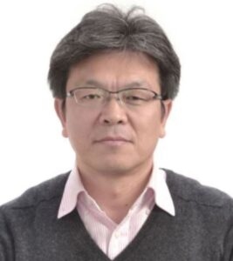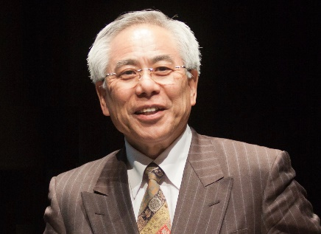  Prof. Junyi Zhang Prof. Yoshitsugu Hayashi  Transportation Amid Pandemics: Practices and Policies is the first reference on pandemics (especially COVID-19) in the context of transport, logistics, and supply chains. This book investigates the relationships between pandemics and transport and evaluates impacts of COVID-19 and effects of policy responses to address them. It explores how to recover from pandemics, reveals governance for immediate policy responses and future innovations, suggests strategies for post-pandemic sustainable and resilient development, shares lessons of COVID-19 policymaking across countries, and discusses how to transform transport systems for a better future. Transportation Amid Pandemics offers transport researchers and policymakers the scientific evidence they need to support their decisions and solutions against pandemics.  Key Features:  - Represents the collective efforts of the World Conference on Transport Research Society (WCTRS)  - Uniquely deals with intertwined issues of pandemics and transport  - Investigates both successful and problematic policy measures  - Emphasizes evidence-based policymaking from cross-sectoral and transdisciplinary perspectives  - Transfers lessons from the COVID-19 pandemic to future generations  Further Information: Elsevier Link  Prof. Junyi Zhang, Hiroshima University, Japan. Co-chair, WCTRS COVID-19 Task Force  Prof. Yoshitsugu Hayashi, Chubu University, Japan. Chair, WCTRS COVID-19 Task Force  SIG B3 Freight Transport Operations and Intermodality - Updates  SIG B3 focuses on connecting researchers on an international scale to conduct collaborative research on the topic of “Freight Transport Operations and Intermodality”. As such, in October and November, SIG B3 has been involved in planning a Special Session at the 6th Interdisciplinary Conference on Production, Logistics and Traffic (ICPLT) taking place from 21 to 22 March 2022 in Dortmund, Germany.  The ICPLT is jointly hosted by TU Dortmund and by TU Darmstadt, where SIG B3’s chair Prof. Ralf Elbert is professor at the Chair of Management and Logistics. The 6th ICPLT addresses interfaces of production, logistics and traffic and seeks solutions for economic, ecological and societal issues around transport as the essential link for production, logistics and society. The Special WCTRS-Session will address topics from maritime and rail transport as well as intermodal logistics. It will feature a number of highly interesting presentations from researchers prominent in their field. All members from SIG B3 and WCTRS are invited to join the conference. Find our more here.  At the same time, SIG B3 has initiated the planning and organization of their participation in the WCTR 2023 in Montréal. The Chair and Co-chairs of SIG B3 are in frequent contact about streamlining ideas and possibilities for the sessions and SIG Meeting. We are looking forward to informing our members very soon about what they can expect to see and hear at the World Conference in 2023.  Prof. Ralf Elbert, University of Darmstadt, Germany. Chair, SIG B3.  Membership of the WCTRS  The WCTRS is the only international society in transportation with a truly global network, bringing together over 1000 members from 67 countries to advance and exchange ideas and research across the transport sector.  Members connect through the Society's triannual World Conference, which provides a rich forum to present and discuss the latest in transport research and practice, and through the activities of the Society's Task Forces and 33 Special Interest Groups, each of which represents a specific area of interest and inquiry. Members under 35 years old are additionally invited to participate in the Young Researcher's Initiative activities, which include a one-day event at the World Conference where young researchers can present their work and take advantage of networking opportunities and discussions on career development.  As well as being able to access this global network through Society events and our exclusive membership database to make contacts and further research collaborations, WCTRS members also benefit from the Society's partnerships with other prominent transport organisations, such as the International Transport Forum, the Eastern Asia Society for Transportation Studies, and the Partnership on Sustainable, Low Carbon Transport. WCTRS and its partners exchange news and details of events, jobs, and publication opportunities and make this information available to members. All WCTRS members can obtain free online membership to the Society's two journals, Transport Policy and Case Studies in Transport Research, and have the opportunity to propose titles for publication in the WCTRS and Elsevier Transportation Book Series.  From academics, practitioners, and students to interested individuals, everyone is invited to join the Society and take part in its activities. Transport Organisations who wish to support the Society can apply for Supporting Organisational Membership to access a number of promotional opportunities and memberships for up to two individuals.  WCTRS Membership - Free for 2022/2023  We are excited to share the decision of the Steering Committee that membership for WCTRS will be free of charge from July 2022 to mid-July 2023. Normally the period of membership is three years, running between our main conference. However, with Covid and the postponement of the Montreal face to face event to 2023 we will extend existing members' membership for one year. There will be no need to fill out any forms to extend membership, but we will shortly be in touch with final details in case anyone wishes to opt out.  We have announced the opportunity for non-members to join the society free for this coming year in the run up to Montreal. We hope this will be a great opportunity for more people to get involved in the Society and we will value your support in promoting this. More details will follow shortly.  When: July 2022 to mid-July 2023  Further Information: On the WCTRS website  If you have any questions about membership, do not hesitate to contact the WCTRS Secretary.  Prof. Greg Marsden, University of Leeds, WCTRS Secretary-General
WCTRS RESEARCH NEWSLETTER
President  Tae OUM (University of British Columbia, CANADA)  Secretary General  Greg MARSDEN (Leeds, ENGLAND)  Secretary  Helen ROBINSON (Leeds, ENGLAND) | Chair Scientific Committee  Lori TAVASSZY (tu Delft, NETHERLANDS)  Chair Editorial Board "Transport Policy"  Haijun HUANG (BeiHang University School of Economics and Management, CHINA)  Chair Editorial Board "Case Studies on Transport Policy"  Rosario MACARIO (Lisbon, PORTUGAL)
December 1, 2022 | Volume 2, Issue 8

