WCTRS RESEARCH NEWSLETTER
 | WORLD  CONFERENCE ON  TRANSPORT  RESEARCH  SOCIETY |  | SECRETARIAT OFFICE OF THE WCTRS  Institute for Transport Studied  The University of Leeds  Leeds, LS2 9JT England  Email: wctrs@leeds.ac.uk  Website: www. wctrs-society.com
August 14, 2023 |  | Volume 3, Issue 4
In this issue  - WCTR 2023 Montreal in Numbers and Highligts!  - Rethinking Road Infrastructure in Developing Economies at WCTR2023 in Montréal  - Intermodal Innovation at WCTR2023 in Montréal  - Call for Papers: 9th International Conference on Dynamics in Logistics  - Call for Papers and Posters: European Aviation Conference (EAC), Luxemburg  - World Sustainable Transport Day  Useful Information and links  1. Publications by SIG A4-Handbook on High-Speed Rail and Quality of Life and Frontiers in High-Speed Rail Development  Both books are free to download.  For details: Click Here  2. A new Transport Research and Education Network to help ESCAP member States achieve sustainable transport  For details: Click Here  3. Clean Air Asia National Coordinator Advert  Theme: Clean Air Asia is looking for National Coordinators based in selected Asian countries who will support Clean Air Asia’s initiative to reduce emissions from the maritime transport sector  For Details: Click Here  4. Special Issue of Transportation Research Part A: Policy and Practice on “Resilience of Transportation systems under uncertainty”  For details: Click Here  Paper submission deadline: August 31, 2023  5. Special Issue of Transportation Research Part D: Transport and Environment on “Emerging Solutions and Policies for Transportation Electrification”  For details: Click Here  Paper submission deadline: September 30, 2023  WCTRS society journals  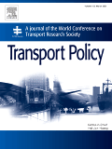  Transport Policy  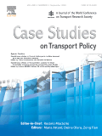  Case Studies in Transport Policy  WCTRS book series  For details, visit: link  Find us on  Wish to become a member of WCTRS?  Click here  Visit us on  https://www.wctrs-society.com/  https://wctr2022.ca/  Email to us at  Editorial team of WCTRS Research Newsletter  Editor  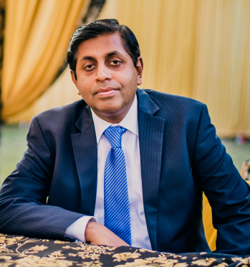  Prof. Dr. Ashish Verma,  IISc Sustainable Transportation Lab (IST Lab), IISc Bangalore, India  ashishv@iisc.ac.in  Assistant Editor  Mr. Aitichya Chandra,  PhD Scholar, IST Lab,  IISc Bangalore, India  aitichyac@iisc.ac.in | WCTR 2023 Montreal in Numbers and Highlights!  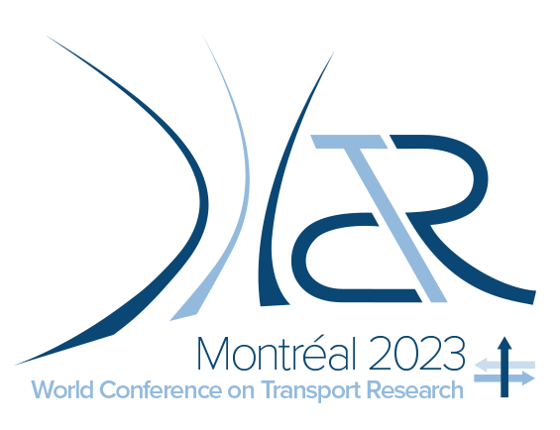  Some Numbers reflecting the WCTR 2023 in Montreal  - Authors: 2400  - Papers: 1000  - Sessions: 220  - Special Sessions: 170  - SIG Meetings: 30  - Panel Sessions: 140  Research Highlights of different Topic Areas (TA), from Micro to Macro  - Topic Area A (TA A):  - Data is the new oil, but it’s only good when it’s refined.  - Global challenges for maritime world  - Topic Area B (TA B):  - Local challenges of freight in urban planning.  - Topic Area C (TA C):  - Big data from vehicle telematics for automated performance measurements.  - Machine vision for automated traffic safety data collection and analysis.  - Topic Area E (TA E):  - Effect of social technical transitions, new technology policies, climate breakdown and volatile decision making.  - Social impacts: role of gender, impacts on workers and vulnerable users.  - Topic Area F (TA F):  - Dynamic charging infrastructure (ERS) could accelerate decarbonization.  - Revisit “Limits to Growth”: New normal for mobility in 21st Century.  - Topic Area G (TA G):  - Health impacts research needs infusion from medical sciences.  - Topic Area H (TA H):  - Opportunities for leapfrogging by developing countries: climate mitigation and resilience.  Prof. Lóri Tavasszy, Scientific Committee Chair, Delft University of Technology (TU Delft)  Rethinking Road Infrastructure in Developing Economies: A Sustainable Perspective at WCTR2023 in Montréal  Prof. Ashish Verma  The 16th World Conference on Transport Research (WCTR), which was held during 17th to 21st July 2023 in Montreal, witnessed a thought-provoking panel discussion on "Are traditional Urban Road Infrastructure interventions any more relevant in fast-growing Developing Economies? – Understanding from Sustainability lens". Renowned transportation experts from around the world convened to shed light on the pressing challenges and promising opportunities faced by developing economies in their pursuit of sustainable development. The panel discussion was expertly moderated by Prof. Ashish Verma, a distinguished professor from the Department of Civil Engineering at the Indian Institute of Science, Bengaluru. The following were the agenda points for the panel discussion:  - What is our understanding of current transport system development in Developing Economies, in particular, in the context of Sustainable Development?  - In relation to the above, how do you see the role of traditional road infrastructure measures from the lens of sustainability?  - What are the opportunities for developing economies to leapfrog to a more sustainable transport system learning from historical trajectory and experience of developed economies?  - What reforms in governance of transport and policy making can accelerate the sustainable growth for Developing economies?  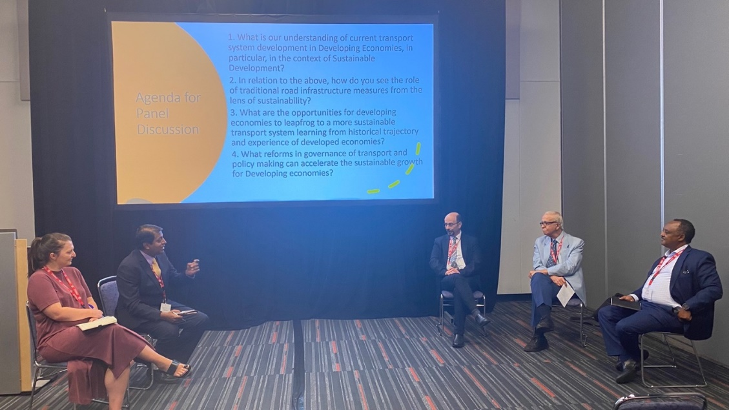  From left to right: Prof. Louise Reardon, Prof. Ashish Verma, Prof. Samer Madanat, Prof. Ali Huzayyin, Dr. Binyam Reja  Prof. Verma set the context for the discussion by highlighting the unique challenges faced by developing economies like BRIC, still in the early stages of their economic growth. He emphasized the need to control the surge in motorized private vehicles during this period and to avoid replicating the unsustainable trends (car ownership per 1000 population growth along with GDP per capita growth) observed in developed nations like the USA and UK. He saw this period as both challenging and full of opportunities - a time to learn from the experiences of others and make significant leaps towards sustainable transportation systems.  Prof. Ali Huzayyin from Cairo University, Egypt, shed light on the positives and negatives associated with infrastructural development. He underscored the importance of infrastructure in linking cities and connecting them to ports, thus facilitating economic growth and mobility for both public and private transport. However, he also raised concerns about the high cost of construction, which can divert funds from other crucial sectors.  Prof. Samer Madanat, representing New York University Abu Dhabi (he is also an Emeritus Professor at University of California Berkeley, USA), provided a critical perspective on the traditional road-centric transportation approach taken by developed economies. He drew attention to the historical trajectory of developed economies and the lessons that developing nations can learn. He argued that this approach is not sustainable and proposed a three-pronged strategy for a greener future: technology, operations and maintenance, and land use planning.  Prof. Louise Reardon, hailing from the University of Birmingham, UK, highlighted the importance of transportation in achieving all the United Nations Sustainable Development Goals. She pointed out that investing heavily in road infrastructure in developing economies could inadvertently encourage a culture of car ownership, leading to a vicious feedback loop. Instead, she stressed the need for a clear vision and policies that prioritize sustainable alternatives.  Dr. Binyam Reja, representing the World Bank, USA, brought attention to a critical question: Can the world afford for every individual in developing economies to own a car? He emphasized that as income of people rises, aspirations for car ownership also increase. However, Dr. Reja urged policymakers to focus on smart, efficient, and sustainable transport policies to avoid the environmental and social consequences of mass car ownership.  The panel discussion at the 16th WCTR concluded with a strong consensus on the pressing need to rethink road infrastructure in developing economies through a sustainability lens and the significance of developing economies learning from the successes and missteps of developed nations in forging a sustainable future. The discussions during the Q&A were enriched by participants from several developed and developing economies, like, Pakistan, India, Ecuador, Lebanon, African region, Hong Kong, USA etc.  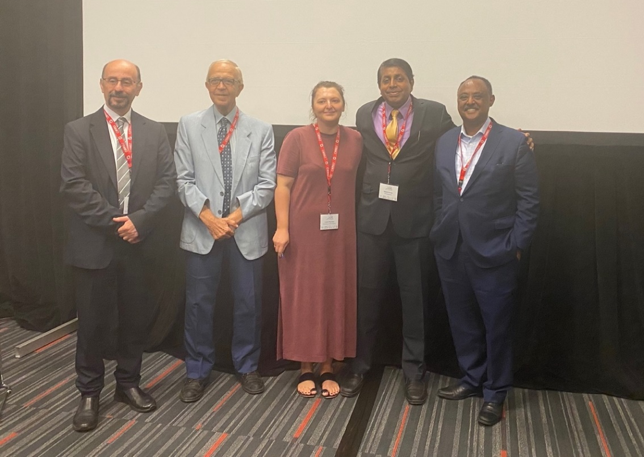  From left to right: Prof. Samer Madanat, Prof. Ali Huzayyin, Prof. Louise Reardon, Prof. Ashish Verma, Dr. Binyam Reja  For detailed report: Click here  Intermodal Innovation at WCTR2023 in Montréal  Prof. Ralf Elbert  The Special Interest Group B3 focuses on connecting researchers on an international scale to conduct collaborative research on the topic of “Freight Transport Operations and Intermodality”.  SIG B3 started into the World Conference on Transport Research in Montréal, Canada in July 2023 looking at five very interesting sessions covering topics about intermodal freight transport networks: from innovative ICT, the importance of terminals, resilience and flexibility in the face of disruptions such as Covid-19, as well as promising developments and challenges when it comes to successfully decarbonizing transport chains.  These successful sessions were complemented by two very special sessions. Organized by our Co-Chair Gunnar Stefansson from the University of Iceland, the first special session was titled “Electric, autonomous, and automatic transport and logistics operations” and talked about the challenges and opportunities which electric heavy trucks and autonomous driving offer together in transport networks.  The second special session was cooperative event organized together with the Transportation Research Board’s Intermodal Freight Transport Committee AT045: The session analyzed how to build and maintain the “right kind” of infrastructure for intermodal freight transport, and evaluated the impact of geopolitical developments and climate change. Two topically relevant presentations were followed by an invited talk by Eric Shen, member of AT045 and founder of Shen and Associates, LLC. who spoke about possibilities to address necessary shifts of freight transport in the US Southwest Region, and how to build and maintain resilient and sustainable transport infrastructure.  We are very happy about the successful conference and are looking forward to seeing everyone in Toulouse 2026!  Prof. Ralf Elbert, University of Darmstadt, Germany. Chair, SIG B3.  Call for Papers: 9th International Conference on Dynamics in Logistics (LDIC 2024), Bremen (Germany)  February 14 - 16, 2024  The 9th International Conference on Dynamics in Logistics (LDIC 2024) will be held in Bremen (Germany) from February 14 - 16, 2024 and will be accompanied by satellite events.  Dynamics of logistic processes and networks are at the heart of the conference. We invite empirical, theoretical, methodological, and practice-oriented contributions addressing the modeling, planning, optimization and control of processes in supply chains, logistic networks, production systems, and material flow systems and facilities.  LDIC 2024 provides a forum for the discussion of advances in that matter. The conference addresses scientists in logistics, operations research, engineering, and computer science. It aims at bringing together researchers and practitioners interested in dynamics in logistics.  Topics of interest include, but are not limited to the following within production, logistics, and supply chain management:  - Dynamics and complexity  - Modeling and optimization methods  - Uncertainty, risk, resilience, and performance  - Strategic decision making, auctions, games  - Multi-modal transportation networks  - Maritime logistics and port operations  - Sustainable and green logistics  - Urban logistics  - Humanitarian logistics, disaster management  - Smart production and material flow systems  - Digitalization, cyber-physical systems, and digital twins  - Artificial intelligence, data science, and IT platforms  - New work in logistics, human-machine interaction  Submission and Publication  Authors are invited to submit their contribution in one of the following formats:  - A full paper with up to ten pages – excluding author details and references – which will be considered for publication in Springer’s “Lecture Notes in Logistics”, one of the most downloaded Springer books, indexed by Scopus, Web of Science (ISI), ACM DL, DBLP. Full papers must contain original research, which must not yet have been published elsewhere. Full papers will be double-blind peer-reviewed.  - An abstract (for presentation only) with up to 250 words – excluding author details and references – which will appear in the Book of Abstracts that will be given to the participants at the conference.  The submission system – including author instructions and Springer’s template – is open on the conference website: www.ldic-conference.org/ldic-conference/call.  Deadlines for full papers:  - Submission of full papers: September 1, 2023  - Notification of review results: November 1, 2023  - Submission of revised full papers: December 1, 2023  - Publication of conference proceedings: May 2024  Deadlines for abstracts (for presentation only):  - Submission of abstracts: October 1, 2023  - Notification of acceptance: November 1, 2023  We look forward to welcoming you at the LDIC 2024 in Bremen, Germany.  The LDIC 2024 Conference Chairs:  - Michael Freitag  - Aseem Kinra  - Herbert Kotzab  - Nicole Megow  Contact: info@ldic-conference.org  Web: www.ldic-conference.org  Call for Papers and Posters  European Aviation Conference (EAC)-2023, Luxemburg  29th November – 1st December 2023  The European Aviation Conference (EAC) is delighted to invite academics, aviation practitioners, policymakers, and other stakeholders to submit contributions for the research activities at the 2023 European Aviation Conference: Research posters to be presented on the first two days and the dedicated Research Day (aka AMEC) on 1st December.  The European Aviation Conference (EAC) serves as a platform for diverse, high-quality research in air transport economics, transportation management and fields related fields in aviation. The Research Day shares the same overarching theme and is planned to be held on the last day of the EAC. Participation in the 2023 European Aviation Research Day is open to all researchers and practitioners.  Main topics of interest for submission include (but are not limited to):  - Air Cargo  - Aviation Policy  - Airline and airport economics and management  - Sustainable aviation  - Economic regulation  - Air Traffic Management  - Emerging business models in aviation  - The scope for drones  All topics within the aviation economics and management areas are welcome. Proposals from researchers at all levels, especially PhD students, are encouraged to submit their work. Selected presentations will be assigned a discussant (a fellow researcher) to provide comprehensive feedback to each other, promote research ties across universities and provide a platform for researchers to excel.  Important information for Abstracts and Papers:  All contributions will be subject to peer review. Full papers will be considered for publication in the Journal of Air Transport Studies (JATS) and the Journal of Air Transport Research Society upon invitation. Past papers presented at EAC were published in the Journal of Air Transport Management (JATM). The Virtual Special Issue Call will be announced closer to the conference date.  At least one author (presenter) must register.  ​The structured abstract (200-300 words) should include the following:  - Indication whether you are submitting a poster or a presentation  - Purpose of the research  - Design, methodology or approach  - Research (expected) findings  - Originality/contribution to the literature  - Relevant references (two to five references)  PhD students must state the name of supervisor(s), home and co-institution, and stage of PhD research to allocate a discussant specialised in the research field. Due to time constraints, the organisers may allocate them in a parallel session.  Submission: Please submit your abstract here specifying your stream (paper or poster - please use it as one of your keywords).  Important Deadlines:  - Submission of Abstracts: 15th September 2023  - Notification of Acceptance: 1st October 2023 (on a rolling basis)  - Submission of Full Papers: 15th November 2023  - Submission of Presentation slides: 25th November 2023  Registration:  Registration will be through the Ticketing Registration Page  Please note presenters must register by 15th October 2023 to be included in the final agenda and take advantage of the early bird fee.  Cancellation & Refund Policies:  Full refund is allowed for cancellations received on or before 15th October 2023 after deducting other related fees incurred in connection with such refunds, including costs of foreign exchange conversion. There will be no refund after 15th October 2023.  Liability:  The local organiser reserves the right to make changes, where deemed necessary, with or without prior notice to the parties concerned. By registering for the conference, you automatically agree to the Terms & Conditions to use all registration data given in this form for computerised conference handling, including the conference media distribution and news.  Organisers:  - Prof. Benny Mantin, the Luxembourg Centre for Logistics and Supply Chain Management (LCL), University of Luxembourg (local host)  - Dr Marina Efthymiou, Dublin City University (DCU) Business School, Ireland  - Dr Wolfgang Grimme, German Aerospace Center (DLR), Germany  - Prof. Andreas Papatheodorou, University of the Aegean and Hellenic Aviation Society, Greece.  - Dr Ane Elixabete Ripoll-Zarraga, Universitat Autònoma de Barcelona (UAB), Barcelona.  - The German Aviation Research Society (GARS) www.garsonline.de  More details: www.eac-conference.com  World Sustainable Transport Day  November 26, 2023  November 26, 2023, has been designated as World Sustainable Transport Day by the United Nations. Endorsed by the UN Group of Friends for Sustainable Transport, Global Supply Chain Classroom (GSCC) will co-organize the following events from July to November to celebrate World Sustainable Transport Day.  - Global Sustainability Supply Chain Student Competition  The Global Sustainability Supply Chain Student Competition is an event that invites postgraduate and undergraduate students from universities around the world to develop innovative solutions to real-world challenges facing global supply chains. Notably, the competition has received official endorsement from the UN Group of Friends for Sustainable Transport.  When: Registration for the competition is currently underway and will continue until September 29, 2023. The competition will commence on October 1, 2023, and will progress in three distinct rounds.  - Faculty Seminar - Incorporating Sustainability into Supply Chain Management Education in a Global Context  Topics:  - Adopting a cross-disciplinary approach to enhance supply chain sustainability education.  - Current status, challenges, and best practices of incorporating sustainability into supply chain management curriculum – perspectives from developed and developing countries.  Deliverable:  - Following the seminars; an international expert group will produce a set of recommendations to be presented to the UN Group of Friends for Sustainable Transport and the Principles for Responsible Management Education of the UN Global Compact.  When: 1st session - July 20 2023, (recordings are available for registered WCTR members)  - Global Class Tour - How supply chain sustainability is taught in different countries  Content:  - Faculty advisors for the student teams participating in the Global Sustainability Student Supply Chain Competition will be invited to observe classes offered by leading professors in this field from around the world to learn how they incorporate experiential learning, such as the global student competition, into their supply chain class to teach supply chain sustainability.  - Participants will be able to observe classes taught by leading professors.  When: September 2023  - Student Event - How global giants build sustainable global supply networks  Content:  - The program focuses on the sustainability practices of global corporate giants with vast supplier networks.  - It is aimed at providing students with a holistic view of suppliers' impact on a global business's overall sustainability performance.  - The program exposes students to leading practices employed throughout a global supply network, and how businesses work with their suppliers to promote sustainable practices.  When: August – September 2023  GSCC is offering complimentary registration to WCTR members for many of these events. Please contact GSCC at info@supplychainsdg.org or visit www.supplychainsdg.org for more information.
WCTRS RESEARCH NEWSLETTER
President  Tae OUM (University of British Columbia, CANADA)  Secretary General  Greg MARSDEN (Leeds, ENGLAND)  Secretary  Helen ROBINSON (Leeds, ENGLAND) | Chair Scientific Committee  Lori TAVASSZY (tu Delft, NETHERLANDS)  Editor-in-Chief for "Transport Policy"  Haijun HUANG, BeiHang University School of Economics and Management, CHINA  Editor-in-Chief for "Case Studies on Transport Policy"  Xiaowen FU, Hong Kong Polytechnic University, China
August 14, 2023 | Volume 3, Issue 4

