11th World Conference on Transport Research
Berkeley, June 2007

System Modeling and Implementation of the
Intermodal Airport Ground Access Planning Tool
Xiao-Yun Lu (Corresponding Author)
California PATH
University of California at Berkeley
Richmond Field Station, Bldg. 452
1357 S. 46th Street
Richmond, CA 94804-4648
Tel: (510) 665-3644
e-mail: xylu@path.Berkeley.edu
and
Geoffrey D. Gosling
Principal
Aviation System Consulting, LLC
805 Colusa Avenue
Berkeley, CA 94707-1838
Tel: (510) 528-8741
email: gdgosling@aol.com
Abstract
This paper describes the structure and implementation of the Intermodal Airport Ground Access Planning Tool (IAPT) that has been developed to provide an integrated analytical system to support airport ground access planning. The tool models the interaction between three components of the system: air passenger mode choice behavior, transportation provider competitive behavior (modeled as a generalized Nash game), and traffic conditions on the regional highway network, and generates measures of both system and connectivity performance. A graphical user interface allows users to define alternative projects, run the model, and display the resulting performance measures. This paper presents the approach to modeling the system interactions within the IAPT and mathematical representation of transportation provider behavior as a Nash game. It concludes with a brief discussion of the implementation of this modeling approach in the IAPT and the associated data requirements.
1. INTRODUCTION
This paper describes the modeling structure and implementation of the Intermodal Airport Ground Access Planning Tool (IAPT) developed as part of a research project titled A Combined Quantitative and Qualitative Approach to Planning for Improved Intermodal Connectivity at California Airports undertaken for the California Department of Transportation by the California Partnership for Advanced Transit and Highways (PATH) Program (Lu, et al., 2006). The IAPT is designed to provide an integrated analytical system to support airport ground access planning, with particular application to evaluating alternative strategies for improving intermodal connectivity at airports. A companion paper by Gosling and Lu (2007b) establishes the context for the development of the IAPT. It discusses the issues involved in planning for improved intermodal connectivity at airports and presents the findings of a number of case studies undertaken as part of the current project that have identified opportunities for improved intermodal connectivity at selected California airport. It describes the analysis needs for evaluating these potential opportunities and discusses the role of the IAPT in addressing these needs, including an overview of the modeling approach adopted. This paper presents a more detailed discussion of the initial implementation of the analytical components of the tool.
The planning process involved in improving intermodal connectivity in an airport ground access/egress system, or indeed implementing any transportation system improvement, can be viewed as being divided into three stages:
  - Strategic planning
  - Project implementation planning
  - Operational planning.
Since modeling requirements for each level of planning will differ in the details of the system included in the analysis, this project and thus the scope of the IAPT focuses on project implementation planning.
The primary objective of developing the IAPT is to provide a consistent way to predict the effect on the airport ground transportation system of implementing a wide range of potential projects to improve intermodal connectivity. The IAPT is designed to generate a broad range of airport ground access system performance measures to support the evaluation of proposed projects to improve existing intermodal connections at an airport or the introduction of new services. These performance measures are generated through a modeling framework that analyzes the behavior and interaction of three aspects of the airport ground access system: airport traveler access and egress mode choice, transportation provider service decisions, and the impact of airport ground access vehicle trips on the surface transportation network. This combined approach achieves a better representation of the dynamic interactions between the different components of the airport ground access system and thus more accurate representation of the system performance than previous models that have focused only on modeling airport traveler mode choice.
The response of airport travelers to changes in transportation service levels is modeled in the IAPT using a discrete choice model of airport ground access mode choice, while the competitive behavior of transportation providers in response to changing patronage levels is modeled using a generalized Nash game approach. The IAPT models the dynamic interaction between airport traveler mode choice and transportation provider behavior through an explicit feedback loop between the passenger model choice model and the transportation provider behavior model. The IAPT then calculates the vehicle trips resulting from the interaction between airport traveler and transportation provider decisions and generates a range of system performance measures, including the impacts of these trips on the traffic conditions on the regional highway network and measures of intermodal connectivity in the airport ground access system.
The remainder of this paper presents the details of the modeling framework implemented in the IAPT and is organized as follows: Section 2 describes the structure of the IAPT and modeling from a systems approach with several assumptions for system simplification; Section 3 presents the approach taken in modeling air passenger mode choice and discusses some of the issues that this needs to address; Section 4 discusses in detail the modeling of transportation behavior and its interaction with the mode choice model, and presents the mathematical analysis and algorithm for numerical implementation; Section 5 presents an overview of the implementation of the IAPT including a discussion of data requirements; and finally, Section 6 provides some concluding remarks and describes the current status of the IAPT development.
2. SYSTEM MODELING CONSIDERATIONS
2.1 Overall System Structure and Interactions
Figure 1 depicts the four main components of the airport ground transportation system and their interactions in the analytical part of the IAPT:
- Local government and airport authority decisions affect the system through airport ground access regulations for each mode, including fare and access regulations, fees charged to transportation providers, and revenue generation goals. These decisions are considered to have a unilateral effect on the system.
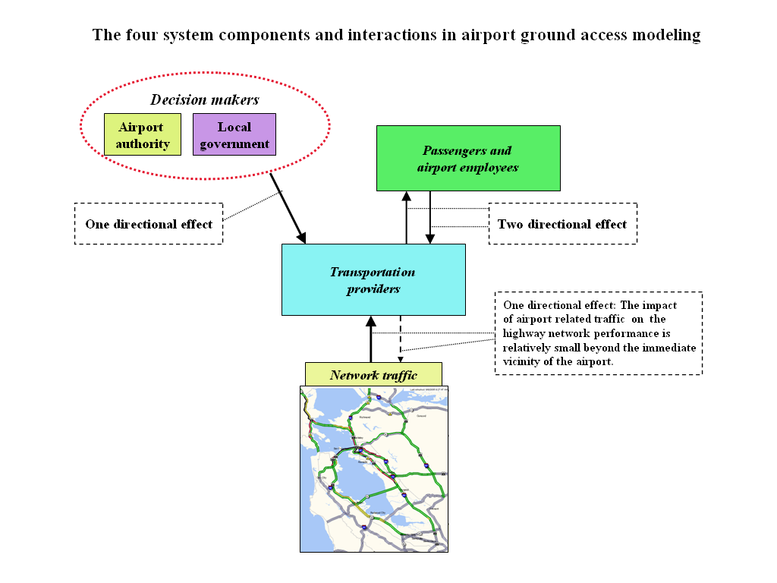
Figure 1. Overall System Structure
- Air passengers or airport employees determine the traffic flows in the system through their choice of access mode based on their preference for the different services and modes available. These choices are directly influenced by the service levels established by the transportation providers and in turn determine the ridership or patronage experienced by those providers.
- Transportation providers affect the performance of the system through their decisions on the service levels offered, including fares, service frequencies, service areas, and routes, within the constraints imposed by local government and airport authority policies and decisions. Internal interactions among transportation providers also affect the connectivity of airport ground access system, which is one of the main factors affecting passenger mode choice. Thus transportation provider decisions interact with airport traveler decisions in a two-way process. The current implementation of the IAPT only models this process as it affects fare or price changes, with other aspects of service level being considered exogenously to the modeling process through adjustment of the model input assumptions.
- Traffic conditions on the highway network directly affect the transportation providers and airport travelers through the airport access and egress travel times that they face, which are among the main factors affecting airport traveler mode choice. The IAPT treats the relationship between highway network traffic and airport ground access traffic as unidirectional in the sense that small changes in airport access mode use do not significantly influence network service levels.
2.2 System Simplification
The following discussion and mathematical modeling could apply to both air passenger and airport employees and to both access and egress trips. However, to simplify the modeling in this phase of the project, the IAPT development to date has focused only on air passenger access trips. To further simplify the problem for mathematical modeling, the following assumptions have been made:
Assumption 1: Total air passenger demand for the airport for any given time period is known from airport traffic statistics and forecasts. Zonal demand (the number of passenger trips from each origin or to each destination zone) can hence be determined from airport survey data.
Assumption 2: Full competition exists between modes but not between transportation providers within a given mode, as follows:
- All the providers within a mode collectively compete with other modes;
- Only pricing and operating frequency can be changed;
- Each mode knows the service levels of other modes;
- If one mode changes its pricing or service level, other modes make changes immediately in response.
These implications of this assumption are illustrated in Figure 2.
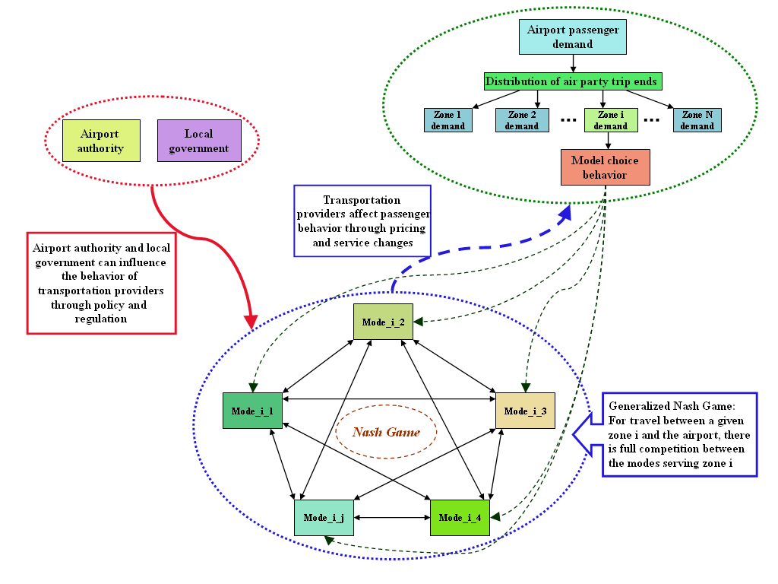
Figure 2. Competitive Behavior Between Modes
Assumption 3: A zone is abstracted as a node in the transportation network, termed the zone centroid. The transportation links within a zone are ignored although some zones may be geographically large.
This assumption is reasonable if a large zone has a low population density, which is usually the case. Under this assumption, the routing of passengers within a zone is ignored, which means that, as far as airport access/egress is concerned, a ground access or egress path connects the zone centroid to the airport.
Assumption 4: Air passengers have complete information about the available modes and services and will choose between the available access/egress paths.
Access/egress path: An access/egress path links each zone centroid with the airport and may use more than one service from more than one mode (including a single mode as a special case) such as:
- Private car to off-airport parking, shuttle bus to airport
- Rental car to airport, shuttle bus to terminal
- Private car to rail transit, shuttle bus from rail station to airport
- Local bus to rail transit, shuttle bus from rail station to airport
- Private car to on-airport parking, walk to terminal
- Taxi.
An access/egress service path may connect several stops or stations, as shown in Figure 3. There may be several access/egress service paths serving a given analysis zone. We designate a primary mode for each access/egress service path. Other modes linking a zone or the airport to the primary mode are termed secondary modes. For example, air passengers may use private car or bus (secondary modes) to access the nearest rail transit station to take the train to the airport. In each case, rail transit is considered as the primary mode for these two different access paths. The cost and time involved in using the secondary modes will of course affect the decisions of airport travelers whether to use a particular access/egress path and hence a given primary mode. Essentially, a one-to-one correspondence between a primary mode and access/egress path is implicitly assumed in the implementation. Shuttle vans, private cars and rental cars are assumed to use the access/egress path with the least travel time.
Hence, the air traveler choice of access or egress path is equivalent to selecting a primary mode and any relevant secondary modes.
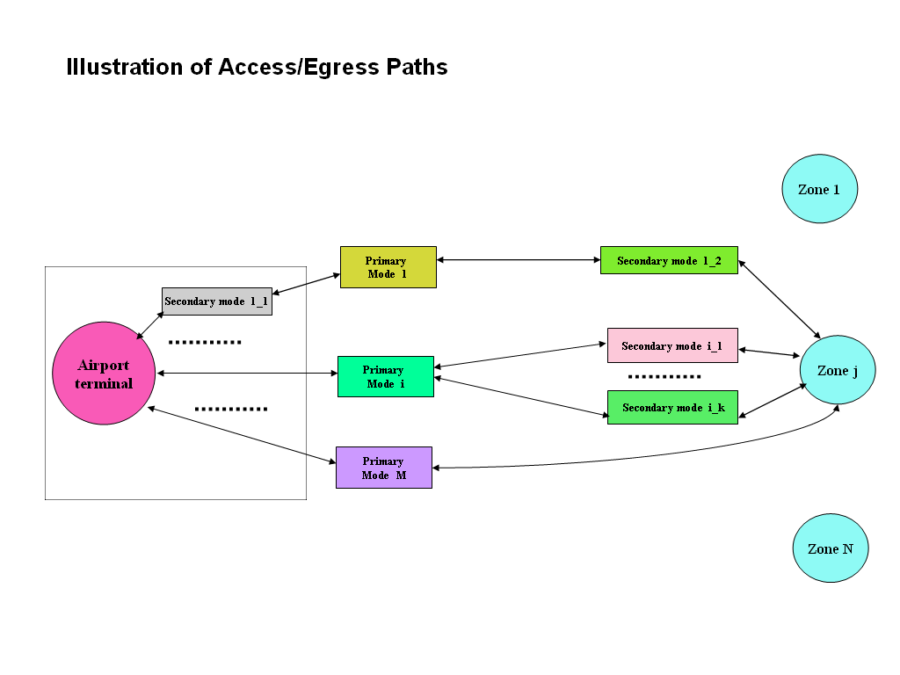
Figure 3. Illustration of Access/Egress Service Paths
Assumption 5: Although airport access and egress trips involve travel in opposite directions, often under different conditions, it is assumed that the transportation provider competition is between the primary modes serving access trips from a given analysis zone and that the mode use for access and egress trips between the airport and a given analysis zone is symmetrical.
Assumptions 4 and 5 greatly simplify the problem: the need to model travel choices at each node in the network is avoided. Instead, the competition can be considered among the primary modes serving the airport from a given zone. For the air passenger mode choice model considered later, stating that a travel party chooses mode is equivalent to saying that the travel party chooses the access/egress path with primary mode .
Assumption 6: The capital cost for each mode is fixed.
Under this assumption, profit of a transportation provider is mainly determined by the revenue and operating cost, where vehicle purchase costs can be represented by their amortized contributions to overall operating costs. Capital costs of capital-intensive modes such as rail transit systems are exogenous to the model, but must be considered in the overall evaluation of proposed projects by the model user.
Assumption 7: There is no limit on transportation provider capacity.
Each mode is assumed to have enough vehicles to ensure that its capacity is always above the demand. This means that the service provided for each zone can always satisfy the demand from that zone. This is reasonable because transportation providers typically serve many different zones and can adjust the supply (capacity) for each zone to meet the demand. It is also reasonable from a market economy viewpoint: there are always providers looking for business opportunities.
Assumption 8: Transportation providers in a given mode adjust fares by the same percentage for all zones.
The current version of the IAPT treats fare or price as the principal decision parameter that can be controlled by providers to affect the desired outcome in terms of patronage or profitability. The decision set is expressed as an allowed range of fare changes. This range may in practice be subject to several constraints. Local government or airport regulation may limit the ability of a provider to change rates, and of course the providers need to cover costs to stay in business. Taxi rates are fixed by local regulations and operators cannot change their price arbitrarily, although rates may be adjusted periodically. Similarly transit services adjust rates from time to time, but usually on a system-wide basis rather than for specific markets. Thus fare or price changes in the IAPT are assumed possible for the following seven modes: rental car, short term parking, long term parking, off-airport parking, scheduled airport bus, door-to-door van, and limousine.
3. MODE CHOICE MODELING
The traditional way of modeling the effect of proposed changes in a transportation system, such as improvements in transit service, focuses on modeling the change in traveler mode choice behavior in response to the proposed changes. The most widely used approach is to use a discrete choice model. The coefficients of the model are determined from survey data collected for the relevant region at a specific time. Such a model is static in the sense that it models the probability of a traveler choosing from among the available modes in that region at a specific time period. There are thus three issues to be considered in applying a mode choice model estimated on data collected at one point in time to a proposed change in the system in the future:
- Are the model coefficients stable over time?
- How will the providers of other transportation services react to the proposed change and adjust their service offerings?
- If the proposed change involves the introduction of a new mode or service that was not available when the data on which the model was estimated was collected, how can the mode choice model be modified to include the new mode or service?
It is common practice in such studies to ignore the first question and simply assume that the model coefficients are stable over time. The only way to address this issue is to estimate a series of models using data collected at different times with a similar survey instrument and an identical model formulation, and compare the resulting coefficients. As far as the authors of this paper are aware, this has never been attempted to date for airport ground access models and is beyond the scope of the current project, although an important issue for future research.
The second question has been addressed in the development of the IAPT modeling framework as discussed further below.
The answer to the third question involves adding a new alternative to the choice set in the mode choice model and defining a utility function for that alternative. As long as the travel time and cost terms have been defined in a consistent way in the utility functions for the existing modes and the same coefficient has been used for corresponding terms in each mode, then those model coefficients can be used (indeed should be used) for the continuous variables in the utility function for the new mode. The only issue that this leaves to resolve is the choice of an appropriate value for the alternative-specific constant in the utility function. Three approaches are possible. The first is to infer the value by judgment from the values of the alternative-specific constants of the existing modes by asking what difference in cost would make a traveler indifferent between the new mode and an existing mode if the travel and other times involved in using the two modes were identical. The second approach is to find a mode choice model that has been estimated for another airport where the new mode or service in fact was already available, and compare the alternative-specific constants for the various modes. The third approach is to perform a stated preference experiment in which respondents indicate which mode they would choose (or whether they would modify an existing choice) if the new alternative were available. The three approaches involve a progressively greater level of effort but provide a correspondingly more robust basis for modifying the model.
Previous attempts to develop analytical models of air passenger ground access mode choice have almost exclusively used a form of logit model. The earlier studies used a multinomial logit model while more recent studies have generally adopted a nested logit model in an effort to better account for the similarities between various modes and associated submodes. Past model development efforts have been summarized in a recent review of the relevant literature by Gosling et al. (2003) and discussed further by Gosling (2006). A number of subsequent studies and alternative approaches are discussed below.
Tam and Lam (2005) studied the mode choice pattern for ground access travel to Hong Kong International Airport using a survey of air passengers. Their results show that due to very low car ownership and relatively short travel distances to and from the airport, access is mainly by public transport such as bus and train or light rail. Arentze and Timmermans (2005) discussed the application of formal decision rules, termed parametric action decision trees, to explain travelers’ mode choices. According to the authors, using discrete choice models (such as the logit model) could limit the sensitivity of the model to changes in travel time and travel cost. This paper used a hybrid model to reduce such problems. It was claimed that the hybrid model produced realistic price elasticities of travel demand. Two recent papers by Outwater et al. (2003, 2004) describe a market segmentation modeling approach to predicting the effect on mode choice of introducing a new mode, in this particular case an improved ferry service. Stated-preference survey data were used to calibrate the model. Six attitudinal factors were identified: desire to help the environment, desire for time saving, need for flexibility, sensitivity to travel stress, insensitivity to transport cost, and sensitivity to personal travel experience. Three of these were used to partition the potential ferry-riding market into eight segments and develop demand estimates for each segment.
3.1 Multinomial Logit Model
The initial approach to modeling air passenger mode choice that has been implemented in the IAPT is based on the use of a multinomial logit model. This form of discrete choice model has been widely used in the past for airport access mode choice, as discussed by Gosling (2006), and has been adopted for models used in recent studies to evaluate the planned automated people-mover links at Oakland International Airport and San José International Airport discussed in Gosling and Lu (2007b). The explanatory variables included in the model and the detailed specification of the utility function for each mode will vary with the specific implementation of the IAPT, and will need to be defined from a mode choice model estimated for the airport in question. The design of the IAPT allows the user to easily change the variables and model coefficients in the mode choice model, as discussed by Gosling and Lu (2007a).
For the purposes of developing the transportation provider behavior modeling discussed in the following section, a mode choice model was initially adopted with the utility function for mode for an air party v with a trip end in zone $w$ given by
$U_{v}^{(i)}=ξ^{(i)}+a^{(i)}T_{w}+b^{(i)}h_{w}+c^{(i)}n_{v}^{(i)}p_{w}^{(i)}$ (3.1)
where the following notation is used:
i the mode index
$M_{w}$ the set of primary modes available for zone $w$, known;
$W$ the set of analysis zones for the airport, known
$w∈W$ is the analysis zone index
is the set of air parties
is the air party index
is the set of air party indices for air parties with trip ends in zone ; known
the set of all the zones $w$ connected to airport by primary mode i
$M$ the set of modes available at the airport, known
$U_{v}^{(i)}$ the utility function of primary mode for air party v
$a^{(i)}$ coefficient of travel time of primary mode in passenger mode choice utility function, obtained from mode choice modeling, uniform for all air parties and zones
$b^{(i)}$ coefficient of operational headway for primary mode in passenger mode choice utility function, obtained from mode choice modeling, uniform for all air parties and zones
$c^{(i)}$ coefficient of travel cost for use of primary mode in passenger mode choice utility function, obtained from mode choice modeling, uniform for all air parties and zones
$ξ^{(i)}$ alternative-specific constant for primary mode in passenger mode choice utility function, obtained from mode choice modeling, uniform for all air parties and zones
the unit price for given mode i and zone $w$
$n_{v}^{(i)}$ the number of times that the unit price for using mode i is incurred by the air passengers in air party v
headway for primary mode for service from zone $w$, known.
travel time for use of primary mode from zone $w$, known from transportation network data or airport ground transportation service data
The probability of air party v in zone choosing primary mode (access path) among the M_{w} modes available in the zone $w$ is
$P_{v}^{(i)}=\frac{e^{U_{v}^{(i)}}}{\sum_{k∈M_{w}}{e^{U_{v}^{(k)}}}}$ (3.2)
3.2 Nested Logit Model
As discussed by Gosling (2006), many of the more recent airport access mode choice models have made use of a nested logit structure. This avoids some of the limitations inherent in the multinomial logit model and allows for a better representation of secondary access mode choices, such as whether to park in on-airport or off-airport lots or how to access rail stations or scheduled airport bus stops. The following discussion summarizes the principal features of the nested logit model.
Suppose the M alternative modes are divided into disjoint nests $N_{1},\text{.}\text{.}\text{.},N_{s}$ and that a given mode i is included in the nest designed as nest m. The probability of mode i being chosen by air party v conditioned upon one of the modes in the nest $m$ being chosen is given by:
$P_{v}^{(i|m)}=\frac{e^{U(i)/{μ_{m}}}}{\sum_{k∈N_{m}}{e^{U(k)/{μ_{m}}}}}$ (3.3)
The marginal probability for nest m to be selected is
$P_{v}^{m}=\frac{{\left(\sum_{j∈N_{m}}{{\left(e^{U(j)}\right)}^{\frac{1}{μ_{m}}}}\right)}^{μ_{m}}}{\sum_{l∈S}{{\left(\sum_{k∈N_{l}}{{\left(e^{U(k)}\right)}^{\frac{1}{μ_{l}}}}\right)}^{μ_{l}}}}$ (3.4)
where the following notation is assumed:
$N_{m}$ is the set of modes in nest $m$
$S$ is the set of nests in the model at the same level as nest m
$P_{v}^{(m)}$ is the marginal probability that air party v will choose a mode in nest $m$ of the nested logit model structure (i.e. the probability that the chosen mode will be in nest m)
$P_{v}^{(i|m)}$ is the conditional probability that air party v will choose mode given that the air party has chosen nest $m$
is the nest coefficient, obtained from mode choice model estimation
By Bayes formula, the overall probability for air party v choosing mode is given by
$P_{v}^{(i)}=P_{v}^{(i|m)}P_{v}^{(m)}$ (3.5)
4. TRANSPORTATION PROVIDER BEHAVIOR MODEL
The competitive behavior of the transportation providers can be viewed as a Nash game, in which each player attempts to adjust their service levels to reach a point where they cannot further improve their position by taking a unilateral action. The equilibrium solution to this game in which each player is in such a position represents the optimal outcome for the providers. The use of a Nash game approach to model the competitive behavior of transportation providers in response to other factors such as network traffic levels and passenger mode choice has been adopted in a number of previous studies.
Evans (1987, 1990) studied the decentralization of the bus service in United Kingdom, which caused full competition between bus service providers. This research recognized the interactions between the transit providers and the passengers and the interactions among the transportation providers. The representation of these interactions was expanded further by Zubieta (1998) who presented a model for a deregulated transportation system with full representation of the urban network. Providers were restricted to a few private bus companies. Each was assumed to have exclusive rights to operate a particular transit line. The transit network with a small number of private transit agencies provided the urban mass transportation service. Full competition among the providers was based solely on the frequency of service, as the model considered a fixed origin-destination matrix of demand and fares were assumed constant. The solution was the Nash equilibrium point at which bus operators seek their individual profit maximization, whereas passengers minimized their individual expected travel time including in-vehicle time and waiting time. At equilibrium, marginal revenue should equal marginal cost for each operating company and, for each origin-destination pair, travel ‘strategies’ for passengers should be optimal. The effect of passenger response was considered with a typical transit network assignment model with a stochastic user equilibrium assignment based on elastic origin-destination demand, rather than the use of a discrete mode choice model. The performance index was based on the operating cost per unit time.
Lo, Yip and Wan (2004) incorporated the competitive behavior of transit services in an intermodal planning model using a nested logit approach. However, the competitive behavior between transit providers was considered in a static manner rather than a dynamic interaction between the transportation provider decisions and the passenger travel choices. The effect of the transportation provider behavior on passenger mode choice was reflected through the relationship between fare changes and ridership. Using their model, the authors studied the effect of fare changes on overall network congestion. A case study of travel between Hong Kong International Airport and the downtown area was used to illustrate the method.
The application of a Nash game to a transit system by Zhou et al. (2005) is the most sophisticated mathematical model of the dynamic interactions between different system components so far in the literature. The analysis considered three of the four components shown in Figure 1:
- The relationship between transportation providers and passengers: Two methods were proposed for this relationship. One was a mode choice model and the other was the Stackelberg leader-follower game, although only the former was used for analysis and algorithm development. Both approaches are different from that used by Zubieta (1998) for modeling the feedback (or response) from passengers. However, Stackelberg’s leader-follower game would overemphasize the function of the transportation providers. This would not be a fair game in the sense that one player in each party (the leader) could influence the decision making of the other player (the follower) but not vice versa, a restriction that is not allowed in a Nash game. In fact, except in the case of a monopoly, passengers should have at least as much influence on market share as the transportation provider in a customer driven market economy. It was therefore assumed that transportation providers could affect the behavior of passengers but could not control it.
- The relationships among transportation providers: The transit providers were assumed to have fixed operating frequencies but compete on price throughout the transit network. Correspondingly, passengers were also assumed to make a service choice among all the providers for a given origin and destination.
- A one-way relationship between transportation provider and passenger decisions and traffic conditions on the transportation network: Although the analysis included two-directional interactions between the transit operator price decisions and passenger flow on the transit network, in-vehicle travel times were assumed fixed for any route segment.
The approach adopted for the IAPT is mainly based on the work of Zhou et al. (2005). In our approach, we use fare or price as the decision parameter for the operation strategy of the transportation providers, and consider the effect of service frequency as a fixed but changeable factor in the implementation in IAPT. The network assignment problem has been greatly simplified by only considering airport access path choice and ignoring route choice on the transportation network.
4.1 Analytical Approach and Objective Function
The analytical approach to determining the solution to the Nash game for each of the modes involves finding the change in the service level offered by each mode that results in the Nash equilibrium. In the current version of the IAPT, which only considers price changes as a provider response to changing patronage, all prices for a given mode i are assumed to change by a constant proportion $x^{\left(i\right)}$. Hence for those prices that vary by analysis zone, the price in zone w after the change is given by:
$p_{w}^{(i,1)}=p_{w}^{(i,0)}⋅\left(1+x^{(i)}\right)$ (4.1)
In the Nash game, each player attempts to maximize their net operating revenue, defined as their total operating revenue less their variable operating costs (those costs that change with changing patronage levels). Thus the net operating revenue forms the objective function for the solution to the Nash game. The net operating revenue for mode $i$ for given zone $w$ is obtained as follows:
$u_{w}^{(i)}=u_{w}^{(i)}(p_{w}^{(i)},D_{\text{total}},P_{w}^{(i)})$ (4.2)
where $p_{w}^{(i)}$ is the price for trips from zone $w$ using mode $i$, is the total air passenger traffic at the airport, and is the proportion of total air passenger trips from zone $w$ using mode $i$. Thus the total net operating revenue for mode $i$across all the zones is given by
$u^{(i)}=\sum_{w∈W}{u_{w}^{(i)}(p_{w}^{(i)},D_{\text{total}},P_{w}^{(i)})}$ (4.3)
The proportion of air passenger trips using a given mode from each zone can be calculated from the mode choice model. The mode choice model predicts the probability of a given air party choosing each mode. Hence the number of air passengers using a given mode from a given zone is obtained from the sum across all the air parties with trip ends in that zone of the product of the probability of the air party choosing the mode and the number of air passengers in the party. The value of can then be obtained by dividing this number by the total number of air passengers in the sample of air parties being used for the analysis.
The objective function $u_{w}^{(i)}(p_{w}^{(i)},D_{\text{total}},P_{w}^{(i)})$ needs to include an estimate of the variable cost for transporting $D_{\text{total}}⋅P_{w}{\begin{aligned}\end{aligned}}^{(i)}$ passengers. The revenue calculation will vary by mode. Some modes charge a price per air party (e.g. taxi), other charge a price per passenger (e.g. scheduled airport bus). Shared-ride van services are special case, since they typically charge one fare for the first passenger and a discounted fare for each additional passenger from the same address. However, this can be treated as a combination of a price per air party and a price per passenger. Airport parking rates depend on the duration of the trip rather than the zone of trip origin, although the cost to the traveler of this mode includes the operating cost of the vehicle. Thus the price for airport parking is the same for all analysis zones, but the revenue calculation needs to consider the trip duration of each air party.
4.2 Nash Equilibrium
To solve for the Nash game equilibrium, linear optimizing is used to find subject to the constraints on the price variation such that:
(4.4)
holds for all . means to exclude $j$ from the set $M_{w}$.
According to the work of Haker (1991), the existence of a solution of a Nash game is guaranteed if the following three conditions hold:
- compactness of the feasible strategy set;
- continuity of the objective function;
- concavity of the objective function with respect to the decision variable as the decision variable of other modes are fixed.
Under proper coordinate transformation, one can prove that those conditions are satisfied with properly chosen decision parameters. Thus the existence of solution is guaranteed.
5. IAPT IMPLEMENTATION
The IAPT is been implemented in C++ in Microsoft Windows Visual Studio.net. The application programs have been built around a Graphical User Interface (GUI) which allows model users to easily define alternatives for a wide range of potential airport ground access planning projects, enter and update relevant data, run the model, and display the outcomes (system performance measures) for comparison in decision making. Figure 4 depicts the overall structure of the IAPT and corresponding data flows.
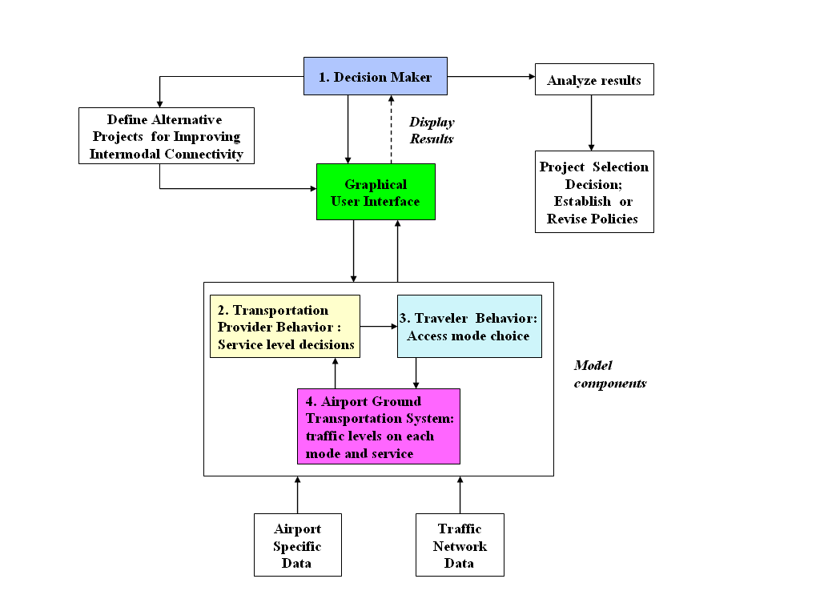
Figure 4. IAPT Structure
5.1 IAPT Structure
The two main parts of the analysis components comprise the traveler behavior and provider behavior models described above. A more detailed discussion of the design and functionality of the GUI is given in Lu et al. (2006) and Gosling and Lu (2007a).
The IAPT derives airport ground access system performance measures from the output of the mode choice and transportation provider behavior models for the equilibrium solution for each planning scenario. The performance measures include those for the system performance and connectivity. The system performance parameters include: vehicle trips, number of passengers, revenue, vehicle-hours of travel (VHT), vehicle-miles of travel (VMT), emissions, passengers/vehicle-mile and passengers/vehicle-hour. The connectivity performance parameters include: passenger waiting times, number of passenger transfers, and a combined measure of the value of traveler airport access time components and transportation provider costs termed the connectivity-production cost.
5.2 Data Requirements
Implementation of the foregoing modeling approach, as for any detailed modeling of an airport ground access system, requires a significant amount of data describing zone travel characteristics, the service levels of the many ground access modes serving the airport, and the transportation provider cost structure. To support the development of an initial version of the IAPT that has been implemented for the three primary commercial service airports in the San Francisco Bay Area (Oakland International Airport, San Francisco International Airport and San Jose International Airport), the following data were assembled:
(1) Air passenger survey data for each airport from a survey conducted by the Bay Area Metropolitan Transportation Commission (MTC) in August and early September 2001. The survey responses provide disaggregate information on the characteristics of a reasonably large sample of air parties, including: trip origin zone within the region using the MTC system of traffic analysis zones (TAZs), zone size, air trip duration, trip purpose (personal or business), city and state of residence, time of day of the access trip to the airport, household income in 2000 and the ground access mode used.
(2) Highway travel times and distances from each TAZ to the airport and to the nearest stop or station for fixed route modes such as rail transit or scheduled airport bus. Separate travel time data were obtained from the MTC regional transportation network analysis files for AM peak and off-peak travel. These travel times and distances were used both for access trips by private vehicles as well as for travel times on other highway-based modes, such as taxi and shared-ride vans.
(3) Transit fares and travel times from each TAZ to the airport and to the nearest stop or station for fixed route modes such as rail transit or scheduled airport bus. Separate travel time data were obtained from the MTC regional transit network analysis files for AM peak and off-peak travel. Since use of rail modes was modeled separately from transit bus, but these services were combined in the MTC regional transit network, it was necessary to develop separate estimates of travel times and costs for the regional rail modes and extract the transit bus travel times and costs from the MTC data.
(4) Ground transportation service data for access modes other than transit bus and rail at each airport. These data include fares or rates, service frequencies for scheduled modes, headways and travel times on shuttle buses used to access the airport terminal where necessary, and locations of stops or stations for fixed route modes.
(5) Capital and operating cost data for use in the ground transportation service provider modeling. Capital and operating cost data for each mode were assembled from a variety of sources, including operator reports to the California Public Utilities Commission, corporate financial statements, airport financial statistics, and government publications.
6. SUMMARY AND CONCLUDING REMARKS
This paper describes the modeling approach adopted in the development of the Intermodal Airport Ground Access Planning Tool (IAPT). Four main components of the overall system were considered in the design of the IAPT: (a) airport authorities and local governments that affect the system through policies and regulations; (b) air passengers and airport employees who affect the system through their choice of airport access and egress mode; (c) transportation providers that affect the system through their service characteristics, including fares, frequency, service area, routes and scheduled stops, and comfort levels; and (d) highway network traffic conditions which affect both providers and passengers through highway travel times. The competitive behavior of the transportation providers has been aggregated at the level of each mode using a Nash Game approach, i.e. all the providers in a given mode are assumed to collectively compete with other modes. Operating profit is used as the performance index to model transportation provider behavior. The decision parameters are the fare or price for a given operating frequency. These prices are allowed to change as a percentage of the baseline prices for those modes where the operators have the ability to set their own fares and prices. The problem is further simplified by assuming that travelers choose between access paths which comprise a composite set of modes instead of considering all the possible routes through the transportation network.
Since the implementation of this analysis approach is still underway, it is premature to draw any conclusions as to how well proposed the Nash Game approach represents the outcome of the feedback loop between the passenger mode choice and provider behavior shown in Figure 2.
Future development work on the IAPT beyond the current phase of the project will need to consider the effect of transportation providers changing both prices and other service levels, such as service frequency. The modeling will also need to be extended to include airport employee travel decisions.
References
Arentze, T. and Timmermans, H. (2005) ‘Parametric action decision trees: Incorporating continuous attribute variables into rule-based models of activity-travel behavior’. Paper presented at the 84th Annual Meeting of the Transportation Research Board, Washington, D.C., January 2005
Bazaraa, M.S., Sherali, H.D. and Shetty, C.M. (1993) Nonlinear Programming Theory and Algorithms, John Wiley & Sons, Inc.
Evans, A. (1987) A theoretical comparison of competition with other economic regimes for bus services, Journal of Transport Economics and Policy, 21, pp 7-36
Evans, A. (1990) Competition and the structure of local bus markets, Journal of Transport Economics and Policy, 24, pp 255-281
Gosling, G.D., with Cambridge Systematics, Inc. and SH&E, Inc. (2003) SCAG Regional Airport Demand Model: Literature Review, Prepared for the Southern California Association of Governments, Los Angeles, California
Gosling, G.D. (2006) Predictive reliability of airport ground access mode choice models, Transportation Research Record, 1951, pp. 69-75
Gosling, G.D., and Lu, X.Y. (2007a), ‘Modeling measures to improve intermodal connectivity at airports’. Paper #07-3335 presented at the 86th Annual Meeting of the Transportation Research Board, Washington, D.C., January 21-25, 2007
Gosling, G.D., and Lu, X-Y. (2007b), ‘Evaluation of opportunities to improve intermodal connectivity at California airports’. Paper presented at the 11th World Conference on Transport Research, Berkeley, California, June 2007
Harker, P.T. (1991) Generalized Nash games and quasi-variational inequalities, European Journal of Operational Research, 54, pp. 81–94
Lo, H.K., Yip, C-W. and Wan, Q.K. (2004) Modeling competitive multi-modal transit services: A nested logit approach, Transportation Research, Part C, Emerging Technologies, 12C(3-4), pp. 251-272
Lu, X.Y., Gosling, G.D., Shladover, S., Xiong, J. and Ceder, A. (2006) Development of a Modeling Framework for Analyzing Improvements in Intermodal Connectivity at California Airports, California PATH Working Paper UCB-ITS-PWP-2006-14, University of California, Berkeley (Available at http://path.berkeley.edu/~xylu/TO5406/Year_1_Report.pdf)
Outwater, M.L., Castleberry, S., Shiftan, Y., Ben-Akiva, M., Zhou, Y.S. and Kuppam, A. (2003) Attitudinal market segmentation approach to mode choice and ridership forecasting: Structural equation modeling, Transportation Research Record, 1854, pp. 32-42
Outwater, M.L., Modugula, V., Castleberry, C. and Bhatia, P. (2004) Market segmentation approach to mode choice and ferry ridership forecasting, Transportation Research Record, 1872, pp. 71-79
Tam, M.L. and Lam, W.H.K. (2005) ‘A study of airport ground access mode choice in Hong Kong’. Paper presented at the 84th Annual Meeting of the Transportation Research Board, Washington, D.C., January 2005
Zhou, J., Lam, W.H.K. and Heydecker, B.G. (2005) The generalized Nash equilibrium model for oligopolistic transit market with elastic demand, Transportation Research, Part B, Methodological, 39B(6), pp. 519–544
Zubieta, L. (1998) ‘A network equilibrium model for oligopolistic competition in city bus services’, Transportation Research, Part B, Methodological, 32B(6), pp. 413-422

