Domestic Aircraft Routing by Method of Inequality-Based Multi-objective Genetic Algorithm
Tung-Kuan Liu¹, Chi-Ruey Jeng²∗
¹ Associate Professor, Department of Mechanical & Automation Engineering, National Kaohsiung First University of Science and Technology, Taiwan, R.O.C.
² Doctoral Student, Department of Transportation and Communication Management Science, National Cheng-Kung University, Taiwan, R.O.C.

Prepared by: Chi-Ruey Jeng
Department of Transportation and Communication Management Science
National Cheng-Kung University
Tainan 701, Taiwan, R.O.C.
Email: bluehawk@seed.net.tw

Submitted to: 11th World Conference on Transportation Research (WCTR 2007)

Domestic Aircraft Routing by Method of Inequality-Based Multi-objective Genetic Algorithm
Abstract
This study proposes a method of inequality-based multi-objective genetic algorithm (MMGA) to solve the short-haul and quick turn-around aircraft routing problem. The proposed algorithm includes the following features: (1) method of inequality to confine genetic algorithm to search Pareto optimal set in region of interests with little computing effort, (2) an improved rank-based fitness assignment method to significantly increase the speed of fitness evaluation, and (3) a repairing strategy to relax the infeasible flight schedules to help reduce violations of solutions. The MMGA algorithm is successfully applied to solve the aircraft routing problems in a domestic airline company.
Key words: Method of inequalities, Genetic Algorithm, Multi-objective Optimization, Aircraft Routing
1. Introduction
Due to the enormous cost of acquisition and maintaining aircraft fleets, airlines spend a great deal of effort to developing their flight schedules to maximize their utilization by creating aircraft routings with as embedded little idle time as possible. Facing the dynamic and competitive environment, how to produce an efficient aircraft routing plan becomes the most important task to airlines.
Since the 1950s, the operations research (OR) community has developed a large number of computer models to aid in the solution of airline problems, e.g. fleet assignment, aircraft routing, yield management, etc. However, the airline schedule planning problem is too complex to be solved in a single decision model, the problem is traditionally divided into sequential sub-problems described as (1) schedule generation, (2) fleet assignment, (3) aircraft routing, and (4) crew scheduling. In this research, we focus on the aircraft routing problem only.
Aircraft routing is a sequence of flight legs, with the destination of one flight leg the same as the origin of the next leg in the sequence to generate a daily flight rotation that satisfies the market demand. A good routing plan must be profitable and allow each aircraft to regularly undertake different types of maintenance checks. Conventionally, aircraft routing is processed manually in two phases, schedule construction and schedule evaluation. In the schedule construction phase, a flight schedule is drafted according to various constraints. In the schedule evaluation phase, the draft schedule is adjusted repeatedly until all constraints are satisfied while also attaining all objectives. However, the whole scheduling process is very subjective, time consuming, and human decision is very easy mistaking and hard to training. Additionally, the schedule is difficult to adjust under dynamic environments. Therefore, more efficient aircraft routing methods are needed.
For the daily aircraft routing problem with fixed time-tabled flights and multiple aircraft types, a multi-commodity formulation is presented in Abara (1989). Introducing time window flexibility for the daily aircraft routing and scheduling problem, Desaulniers et al. (1997) used a multi-commodity network flow model involving continuous time variables and time window restrictions on these variables is solved by branch-and-price where the column generator is a time constrained longest path problem.
More recently, integer and linear programming have been proposed to address the aircraft routing problem (Clarke el al., 1997; Barnhart et al., 1998; Yu, 1998). These methods concentrate on the problems of single objective and stationary constraints but have natural limitations for real-world problems with multiple conflicting objectives and dynamic constraints. Most of those work are heuristic in nature and do not guarantee that an optimal aircraft routing solution will be determined.
The aircraft routing problem can be formulated as a multi-objective optimization problem due to each objective has a different definition of optimality. Since multi-objective genetic algorithms (MGAs) emerged as a promising method for its robustness in multi-objective optimization under dynamic constraints, it is used to solve the problem here. Several types of MGAs have been developed such as Multi-objective Optimization Genetic Algorithms (Fonseca and Fleming, 1993), Vector Evaluated Genetic Algorithms (Shaffer, 1985), and Nondominance sorting Genetic Algorithms (Srinivas & Deb, 1994). More details about GA and MGA can be found in Goldberg (1989), Gen & Cheng (1997), and Coello Coello (2000). Most MGAs formulate multiple objectives as a vector, and the set of Pareto optimal solutions, which are non-dominated solutions, are usually determined. However, in practical applications, admissible solutions are needed rather than a large amount of Pareto optimal solutions.
To deal with the problem of the usage of method of inequalities (MOI) in MGA, Liu et al. (1994) have proposed a method of inequality-based multi-objective genetic algorithm (MMGA). The multi-objective nature of control systems design is explicitly take into account in the MOI proposed by Zakian & Al-Naib (1973), and Zakian (1996), where design specifications, or objective requirements are given in the form of inequity. Unlike conventional multi-objective algorithms, the MOI seeks an admissible solution, which is not necessarily a Pareto optimal solution. Due to this fundamental difference, it is not readily apparent how multi-objective GAs should be used to solve inequalities formulated according to the MOI. The global search capability of MMGA can be exploited to find a solution of the inequalities. For the effective use of multi-objective genetic algorithms in the MOI, a MGA to the auxiliary vector index is proposed. The auxiliary vector index can restrict the MGAs to search the Pareto optimal set in the regions of interest with a smaller computing effort for decision-making under multiple conflicting objectives. For the application to the MOI, the search capability of an MGA is more important than the characterization of the Pareto optimal set when the problem has no solution. This study adopts MMGA to solve the short-haul aircraft routing problem. As well as the features mentioned above, a repairing strategy relaxes the infeasible flight schedules to accelerate the convergence.
The remainder of this paper is organized as follows. Section 2 shows the mathematical models. Section 3 then describes the methodology of MMGA. Next, Section 4 presents two experiment results and discussions. Conclusions are finally drawn in the last section.
2. Problem Formulation
This section describes the formulation of the aircraft routing problems. Let $α$, $β$, $ω$, and $γ$ denote the number of aircrafts, the maximal number of flights assigned to each aircraft, the number of airports, and the number of daily flights, respectively. Suppose that the set of $α$ aircrafts is C, and the set of $ω$ airports is P. The timetable, denoted as a set F, consists of $γ$ daily flights. All the elements in the set F are determined from the market demands, and can be validated using various factors, such as the number of aircraft, crew size, the laws and regulations. Hence, the value of $γ$ is bounded in the range: $1≤γ≤\text{αβ}$.
2.1 Definition of Flight Schedule
The flight schedule S can be denoted as a two-dimensional $α×β$ matrix. $S=\left\{s_{i,j}|s_{i,j}=({\hat{p}}_{i,j},{\bar{p}}_{i,j},{\hat{t}}_{i,j},{\bar{t}}_{i,j}), ∀s_{i,j}∈F, 1≤i≤α, 1≤j≤β\right\}$ Eq. (1)
where
$s_{i,j}$: the j^{th} flight assigned to the i^{th} aircraft
subscript i : a specific aircraft,
subscript j : a specific flight,
: origin of $s_{i,j}$, where ,
: destination of $s_{i,j}$, where ,
: departure time from ,
: arrival time in
2.2 Definition of Objectives
This study attempts to generate a feasible flight schedule S by MMGA to meet the requirements of ground turn-around time and flow balance. However, the requirements are often conflicting and violated for a given flight schedule S. Therefore, the violations and conflicting requirements must be resolved to generate a feasible solution to the current aircraft routing problem.
Considering the objectives of the aircraft routing problem, since each objective has a different definition of optimality, the objectives should not be combined into a single scalar. Additionally, a set of suitable weights to combine the objectives is difficult to find. Moreover, a set of weights may exist to make different solutions identical through a weighted-sum process. Therefore, the problem is formulated as a multi-objective optimization problem, defined as $Φ(φ_{1}(S), φ_{2}(S))$. The objectives considered are ground turn-around time and flow balance. Both objectives are constraints, if one flight schedule violates any of them, it will not be a feasible one. According to Gen & Cheng (1997), the infeasible solutions are handled by rejecting, repairing, penalizing, and modifying genetic operators. If the objective of ground turn-around time is modeled in the form of a hard constraint, then one candidate solution that violates the hard constraint is rejected. The rejecting strategy works well when the feasible region is convex. However, this strategy has limitations when the feasible region is nonconvex. Also, the chance to discover a better solution would be improved if the temporary solution can be repaired. Moreover, when a repairing strategy is applied, the optimum can be potentially reached since it can help across an infeasible region. Therefore, the objective is modeled in the form of soft constraint. Every element in the vector of multiple objectives denotes a violation of each objective $φ_{1}(S)$and $φ_{2}(S)$.
The ground turn-around time objective ensures that each aircraft has adequate ground turn-around time not less than the minimum ground turn-around time by regulation, denoted as , to be allowed for the subsequent flight. The evaluation function of this objective is defined as:
$φ_{1}(S)=\sum_{i=1}^{α}{\sum_{j=1}^{β−1}{x_{i,j}^{(1)}}}$ Eq. (2)
where $x_{i,j}^{(1)}=\begin{aligned}\left\{0\begin{matrix}\begin{matrix}\begin{matrix}\begin{matrix} & \end{matrix} & \end{matrix} & & & \text{if} ({\hat{t}}_{i,j+1}−{\bar{t}}_{i,j})≥T_{\text{GH}}\end{matrix} & & & \end{matrix} | \right.\end{aligned}$
The flow balance objective guarantees that the arrival airport of $s_{i,j}$ is the same as the departure airport of $s_{i,j+1}$ for each aircraft in S, for $1≤i≤α$, $1≤j≤β−1$. This objective reduces the extra cost of the nonprofit flight from ${\bar{p}}_{i,j}$to ${\hat{p}}_{i,j+1}$. The evaluation function of this objective is defined as:
$φ_{2}(S)=\sum_{i=1}^{α}{\sum_{j=1}^{β−1}{x_{i,j}^{(2)}}}$ Eq. (3)
where $x_{i,j}^{(2)}=\left\{\begin{matrix}0 & \text{if}{\bar{p}}_{i,j}={\hat{p}}_{i,j+1} \\ 1 & \text{otherwise}\end{matrix}\right.$
2.3 Definition of Admissible Bounds
The set of daily flights F is obtained from all airports, an optimal solution is hard to find since it does not always exist. The flights can be adjusted according to the suggestions from experts. Restated, some ranges of violations on both objectives are available. Instead of simply adopting the minimization or maximization form, the MOI is applied to let planners control the violation ranges. Therefore, the objectives are transformed into a set of inequalities by introducing admissible bounds (Zakian & Al-Naib, 1973; Zakian, 1996):
$φ_{i}(S)≤ε_{i},(i=1,2)$ Eq. (4)
where : an admissible bound for each objective $φ_{i}$
The admissible bound vector,$ε=(ε_{1},ε_{2})$, has two effects in a genetic algorithm: (1) concentrating on searching a solution in the regions of interest, and (2) reducing the inefficient searches by relaxing some constraints, regardless of whether the optimal solution exists or not.
The parameter values in $ε=(ε_{1},ε_{2})$ can be automatically adjusted according to the calculation results. This study was originally aimed to help planners in airline companies. For practical application, planners do not have to ensure that the values of all dimensions are within the admissible bound vector. Hence, an automatic tuning procedure is employed here. According to the properties in Liu et al. (2005), when there exists no utopian solution, the automatic tuning procedure can help planners focus on the solutions in the region of interest by tuning the admissible bound vector $ε$ to provide useful information for decision-making. The initial values of the admissible bound vector $ε=(ε_{1},ε_{2})$ are first automatically assigned in the following way. When considering the ground turn-around time objective, the value $k_{1}×α×T_{\text{GH}}$ can be first assigned, where $k_{1}$ represents the number of flight violations assigned to one aircraft; $α$is the number of aircrafts, and $T_{\text{GH}}$ denotes the ground turn-around time. Additionally, the flow balance objective can be achieved by assigning $k_{2}×α$, where $k_{2}$ denotes the number of flight violation assigned to one aircraft. Moreover, planners can further tighten the bounds, i.e. reduce the values of $ε=(ε_{1},ε_{2})$, to enhance the quality of solutions when the requirements of the flight schedule requirements change.
2.4 Definition of Auxiliary Performance Index Vector
In original formulations of multi-objective optimization, the set of admissible bounds are not considered. To make the admissible bounds be considered in multi-objective optimization, the auxiliary performance index is proposed. Equation (4) is transformed into the auxiliary performance index vector:
$Λ(S,ε)=(λ_{1}(S,ε_{1}),λ_{2}(S,ε_{2}))$ Eq. (5)
where
$$λ_{i}(S,ε_{i})=\left\{\begin{matrix}0 & \text{if }φ_{i}(S)≤ε_{i} \\ φ_{i}(S)−ε_{i} & \text{otherwise}\text{.}\end{matrix}\right.$$
The auxiliary performance index vector related to the inequalities is converted from the MOI problem to a multi-objective optimization problem. The multi-objective formulation using the auxiliary performance index vector is useful for MOI since the admissible bounds can be combined to all objectives. Therefore, each objective can be transformed to the form of inequalities.
2.5 Definition of Pareto Dominance and Pareto Optimal Solutions
Consider two auxiliary performance index vectors $Λ_{1}(S^{(a)},ε)$, $Λ_{2}(S^{(b)},ε)$ with $π$ objectives. According to the definition of Pareto dominance by Fonseca & Fleming (Fonseca & Fleming, 1993), ‘$Λ_{1}(S^{(a)},ε)$ dominates $Λ_{2}(S^{(b)},ε)$’ can be denoted as $Λ_{1}(S^{(a)},ε)≺Λ_{2}(S^{(b)},ε)$ if and only if the following relation
$(∀i)(λ_{i}(S^{(a)},ε_{i})≤λ_{i}(S^{(b)},ε_{i}))∧(∃i)(λ_{i}(S^{(a)},ε_{i})<λ_{i}(S^{(b)},ε_{i}))$ Eq. (6)
holds for all $1≤i≤π$, where $π$ represents the number of objectives.
A solution can be called a nondominated solution, or a Pareto optimal solution, if no other solutions exist to dominate it. Additionally, the set of Pareto optimal solutions is called a Pareto optimal set. Here, the Pareto optimal solutions of the auxiliary performance index vector are not the same with the ones of original objectives. The set of Pareto optimal solutions of the auxiliary performance index vector is the subset of the whole solution space that is restricted in the region of interest. If MOI does not have a solution, then the Pareto optimal set for the auxiliary performance index vector gives the designer helpful information to modify the admissible bounds so that a solution is obtainable.
2.6 Formulation of the Aircraft Routing Problem
As mentioned above, this problem comprises of multiple small-the-best objectives. Instead of combining these objectives into a single scalar, the aircraft routing problem with multiple objectives can be formulated as follows.
Minimize $λ_{k}(S,ε_{k}) ,$ $1≤k≤π$ Eq. (7)
subject to $s_{i,j}∈F,$$1≤i≤α, 1≤j≤β$
Also, the Pareto optimal solutions of the auxiliary vector performance index can be defined as follows. Consider a vector performance index $Λ(S,ε)$ with a decision vector $S$. A vector $S_{0}$ is said to be a utopian solution (or absolutely optimal solution) for the vector performance index $Λ(S_{o},ε)$ if and only if
$(∀k)(λ_{k}(S_{O},ε_{k})≤λ_{k}(S,ε_{k}) )∧(∃i)((λ_{i}(S_{O},ε_{i})<λ_{i}(S,ε_{i}))$ Eq. (8)
for all $1≤k≤π$ and all $S$.
A vector $S$ is said to be a Pareto optimal (or non-dominated) solution if and only if there exists no vector satisfying$Λ(\bar{S},ε)≺Λ(S,ε)$, where$\bar{S}≠S$.
3. Problem Solution
This section introduces three parts of the proposed algorithm. First, the improved rank-based fitness assignment method is adopted to perform multi-objective optimization. Second, a repairing strategy is adopted to handle infeasible solutions. Finally, the detailed steps of MMGA are described.
3.1 Nondominance Sorting and Improved Rank-based Fitness Assignment Method
Improved rank-based fitness assignment method was first proposed by Liu et al. (1994), and is adopted to calculate the fitness values of the solution in a multi-objective genetic algorithm. Two concepts, namely Pareto dominance (Fonseca and Fleming, 1993), and nondominance sorting and rank (Liu et al., 1994), are introduced to explain this method.
3.1.1 Nondominance sorting and rank:
Suppose that $Π=\left\{Λ_{1},Λ_{2},⋯,Λ_{i},⋯,Λ_{n}\right\}$ denotes a set of auxiliary performance index vector where $Λ_{i}=$($λ_{1}^{i},λ_{2}^{i},\text{.}\text{.}\text{.},λ_{j}^{i},\text{.}\text{.}\text{.},λ_{π}^{i}$) is an auxiliary performance index vector with π objectives. The method of nondominance sorting comprises of several steps. First, the auxiliary performance index vectors are ordered according to $\sum{λ_{j}^{i}}$, since solutions with lower $\sum{λ_{j}^{i}}$ are most likely to be nondominated solutions. Second, the nondominated and dominated solutions are gradually moved to the nondominated and the dominated sets, respectively. The solutions moved to the nondominated set in iteration k can be ranked as k. The nondominance sorting and rank process is finished when all auxiliary performance index vectors in $Π$ are removed. If all solutions are nondominated, then the solution with minimal summation $\sum{λ_{j}^{i}}$ are selected. The detailed steps of nondominance sorting for $Π=\left\{Λ_{1},Λ_{2},⋯,Λ_{n}\right\}$ are described as follows:
Step 1: Sort$Λ_{i}$in Π by the ascending values of$\sum{λ_{j}^{i}}$. Set the rank index, k, to 1.
Step 2: Let the temporary nondominated set Q and the temporary dominated set G be empty sets.
Step 3: Move$Λ_{i}$from Π to G if $Λ_{1}$dominates$Λ_{i}$for $2≤i≤n$.
Step 4: Move$Λ_{1}$from Π to Q.
Step 5: If $Π≠∅$, then sort$Λ_{i}$in Π by descending values of $\sum{λ_{j}^{i}}$, and go to Step 3.
Step 6: Set the ranks of all the elements$Λ_{i}$in Q as k. The rank of $Λ_{i}$ is expressed as $\text{Rank}(Λ_{i})$. Let$Π=G$, and increase the rank index by 1 ($k:=k+1\text{.}$).
Step 7: If $Π≠∅$, then go to Step 2.
3.1.2 Improved Rank-Based Fitness Assignment Method
To assign a fitness value to each candidate solution$Λ_{i}$, a function,$\text{fitness}(Λ_{i})$ is adopted to calculate the fitness based on the rank value of each candidate solution. The details of the improved rank-based fitness assignment method are listed as follows.
Input: $Π=\left\{Λ_{1},Λ_{2},⋯,Λ_{n}\right\}$, $Λ_{i}=(λ_{1}^{i},λ_{2}^{i},⋯,λ_{π}^{i})$
Output: The fitness values of $Λ_{\text{Rn}}$in the nondominance sorting set $Π_{R}=\left\{Λ_{R1}, Λ_{R2},⋯ , Λ_{\text{Rn}}\right\}$
Step 1: Perform nondominance sorting on$Π=\left\{Λ_{1},Λ_{2},⋯,Λ_{n}\right\}\text{.}$
The nondominance sorting set is denoted as $Π_{R}=\left\{Λ_{R1}, Λ_{R2},⋯ , Λ_{\text{Rn}}\right\}\text{.}$
Step 2: The fitness of Λ_{i} is given by the following linear function.
$\text{fitness}(Λ_{i})=\frac{2(f−1)}{n−1}(R_{\text{max}}+1−\text{Rank}(Λ_{i}))$ Eq. (9)
where
f : diversity parameter in MMGA, $1<f≤2$.
The value of $\text{Rank}(Λ_{i})$ is not greater than n, and $R_{\text{max}}$ denotes the maximal value of $\text{Rank}(Λ_{i})$. To enhance the diversity among all populations, the diversity parameter f is adopted to enlarge the variances between the individuals with different ranks. The fitness value, which can be used in MMGA of each flight schedule, can be calculated according to the improved rank-based fitness assignment method.
3.2 Repairing Strategy
Several methods have been proposed to handle infeasible solutions generated by a GA, which can not satisfy all the constraints in the optimization problems (Gen & Cheng, 1997). These methods can be classified into the following types.
- Rejecting strategy: Reject any infeasible solutions.
- Repairing strategy: Infeasible solutions can be transformed into feasible solutions using a specific procedure.
- Modifying genetic operator strategy: New genetic operators are adopted to transform infeasible solutions into feasible solutions.
4. Penalizing strategy: The fitness value of an infeasible solution is assigned a penalty value, reducing its fitness to reduce its chance of being preserved.
This study indicates that the flights assigned to each aircraft in random sequence by GAs may result in a temporary solution with high violation values, since some flights with earlier departure times are arranged after ones with later departure time. Such a solution could be repaired to reduce the number of violations on the ground turn-around time objective. Therefore, the repairing strategy is adopted to reorder all flights according to their departure times for each aircraft.
For instance, a flight with departure time 9:00 may be misplaced after a flight with arrival time 10:00. These conditions strongly violate the calculated objective functions. Performing a repairing procedure, i.e. ordering the flights according to their departure time, can help reduce the violations on the ground turn-around objective.
The violations of the solution can be partially repaired after performing the repairing procedure. Additionally, the Pareto optimal set of the flight schedules can be found easily.
3.3 MOI-Based Multiobjective Genetic Algorithm (MMGA)
As indicated in Fig. 1, the parameters of MMGA, such as population size n, maximal number of generation g, crossover rate$r∈[0, 1]$, and mutation rate $u∈[0, 1]$ are given first. Additionally, the admissible bound vector $ε=(ε_{1},ε_{2},⋯,ε_{π})$ is also needed. MMGA consists of several steps, namely chromosome encoding, repair, evaluation, selection, crossover, and mutation. Fig. 2 shows the encoding model of the chromosomes. Initial solutions are generated randomly. Each aircraft identifier is arranged in rows with the assigned flights in columns. In the repairing process, each candidate solution is repaired by the repairing strategy. Additionally, the chromosomes are measured according to Eq. (2) and Eq. (3), transformed with the auxiliary performance index vector as Eq. (5), and the fitness is calculated according to the improved rank-based fitness assignment method procedure. The selection process adopts the Roulette wheel selection method.
Fig. 1 Flowchart of MMGA
Fig.2 Chromosome encoding
For computing convenience, dummy flights are assigned to a chromosome (or a flight schedule) to give chromosome the same length of gene. The two-dimensional chromosome is translated into a one-dimensional string, as depicted in Fig. 3.
Fig. 3 Transformation of the original chromosome
The partial mapped crossover (PMX) (Gen & Cheng, 1997) is adopted in the crossover process. Since the problem of aircraft routing problem is a combinatorial problem similar to the traveling salesman problem (TSP), the chromosome encoding schemes in GA to solve these kinds of problems are generally the permutation representation. Each gene in a combinatorial problem can only exist once in all chromosomes. Therefore, a mapping relationship should be determined first when performing the crossover operation. Second, the duplicated genes should be replaced according to the mapping relationship. Via the PMX, the problem of infeasible offspring caused by redundant genes can be solved. A swap mutation is adopted in the mutation process. The processes continue to repair, evaluate, and calculate fitness values iteratively until that either the generation counter t reaches the maximum number of generation g or all the objectives are satisfied.
The detailed algorithm is described as follows:
Input: (1) A set of flight schedules $D^{(t)}=\left\{S_{1}^{(t)},S_{2}^{(t)},⋯,S_{n}^{(t)}\right\}$with population n in generation t.
(2) Two temporary sets of flight schedules: , .
(3) The admissible bound vector ε.
Output: A set of optimal flight schedules within meeting the requirements of admissible bounds.
Step 1: Determine the MMGA parameters: population size n, maximum number of generations g, crossover rate $r∈[0, 1]$, and mutation rate $u∈[0, 1]$.
Step 2: Determine the admissible bound vector $ε=(ε_{1},ε_{2},⋯,ε_{π})$.
Step 3: Let $t:=0$. Initialize the population D^{(t)}.
Step 4: Adopt the repairing strategy to adjust all chromosomes for the violation of time constraint violation.
Step 5: Evaluate the auxiliary perform index vector of each individual S^{(t)} in entire population n.
Step 6: Apply improved rank-based fitness assignment method to calculate the fitness of each individual S^{(t)}.
Step 7: If the number of current generation t reaches g, or all the objectives are satisfied, then stop the algorithm.
Step 8: Choose two individuals using the roulette wheel selection method.
Step 9: Perform crossover and mutation operations to generate the populations of next generation t+1 in the mating pool . The mutation operation randomly selects two flights in the chromosome and exchanges their positions.
Step 10: Adopt the repairing strategy for the chromosomes in.
Step 11: Evaluate the auxiliary performance index vector of each individual in .
Step 12:.
Step 13: Adopt improved rank-based fitness assignment method again to calculate the fitness of each individual in, and let $t:=t+1$. Go to Step 7.

4. Experiment Results
Since Taiwan domestic flights are mostly short-haul flights, typically less then one hour and quick turn-around. Also the markets are very competitive with buses, high-speed railway and other airlines, the aircraft routing problem become more complex. A MMGA-based system was implemented to address in this domestic aircraft routing problem, and was adopted to simulate two cases for a Taiwan domestic airline. Table 1 shows the airline timetable with 79 flights obtained from a real airline schedule. The flight routing network covers seven airports as shown in Fig. 4. The crossover rate, mutation rate, number of generations, population size, reproduction rate, and diversity maintenance parameter f, as obtained from experimental tests, are 1, 0.2, 5000, 100, 0.8 and 2, respectively. Here, the ground turn-around time T_{GH} is 25 minutes.
Table 1 Timetable used in case study
Flight # | Departure | Arrive | From | To | Flight # | Departure | Arrive | From | To
872 | 09:15 | 09:50 | HUN | TSA | 811 | 11:00 | 11:50 | TSA | KHH
878 | 19:00 | 19:35 | HUN | TSA | 803 | 07:50 | 08:40 | TSA | KHH
876 | 14:00 | 14:35 | HUN | TSA | 831 | 19:30 | 20:20 | TSA | KHH
874 | 11:20 | 11:55 | HUN | TSA | 8121 | 16:30 | 17:20 | TSA | KHH
842 | 22:00 | 22:50 | KHH | TSA | 805 | 08:40 | 09:30 | TSA | KHH
826 | 16:30 | 17:20 | KHH | TSA | 809 | 10:15 | 11:05 | TSA | KHH
806 | 08:10 | 09:00 | KHH | TSA | 837 | 21:30 | 22:20 | TSA | KHH
836 | 20:35 | 21:25 | KHH | TSA | 821 | 15:50 | 16:40 | TSA | KHH
828 | 17:30 | 18:20 | KHH | TSA | 815 | 13:10 | 14:00 | TSA | KHH
830 | 18:30 | 19:20 | KHH | TSA | 833 | 20:00 | 20:50 | TSA | KHH
824 | 15:30 | 16:20 | KHH | TSA | 823 | 17:05 | 17:55 | TSA | KHH
818 | 12:45 | 13:35 | KHH | TSA | 817 | 14:05 | 14:55 | TSA | KHH
810 | 09:30 | 10:20 | KHH | TSA | 829 | 19:00 | 19:50 | TSA | KHH
8128 | 18:00 | 18:50 | KHH | TSA | 807 | 09:30 | 10:20 | TSA | KHH
812 | 10:05 | 10:55 | KHH | TSA | 841 | 22:30 | 23:20 | TSA | KHH
816 | 11:50 | 12:40 | KHH | TSA | 825 | 18:00 | 18:50 | TSA | KHH
840 | 21:30 | 22:20 | KHH | TSA | 813 | 12:10 | 13:00 | TSA | KHH
838 | 21:00 | 21:50 | KHH | TSA | 839 | 22:00 | 22:50 | TSA | KHH
822 | 14:30 | 15:20 | KHH | TSA | 683 | 14:25 | 15:20 | TSA | KNH
814 | 10:55 | 11:45 | KHH | TSA | 681 | 10:40 | 11:35 | TSA | KNH
832 | 19:30 | 20:20 | KHH | TSA | 609 | 17:45 | 18:30 | TSA | MZG
820 | 13:40 | 14:30 | KHH | TSA | 607 | 13:10 | 13:55 | TSA | MZG
684 | 15:50 | 16:45 | KNH | TSA | 883 | 10:10 | 10:55 | TSA | TNN
682 | 12:05 | 13:00 | KNH | TSA | 895 | 18:35 | 19:20 | TSA | TNN
610 | 19:00 | 19:45 | MZG | TSA | 897 | 20:20 | 21:05 | TSA | TNN
608 | 15:00 | 15:45 | MZG | TSA | 891 | 15:45 | 16:30 | TSA | TNN
604 | 10:25 | 11:10 | MZG | TSA | 893 | 17:35 | 18:20 | TSA | TNN
884 | 09:00 | 09:45 | TNN | TSA | 887 | 13:05 | 13:50 | TSA | TNN
894 | 17:20 | 18:05 | TNN | TSA | 889 | 14:25 | 15:10 | TSA | TNN
892 | 16:00 | 16:45 | TNN | TSA | 853 | 09:05 | 09:55 | TSA | TTT
890 | 14:30 | 15:15 | TNN | TSA | 859 | 15:05 | 15:55 | TSA | TTT
896 | 18:55 | 19:40 | TNN | TSA | 857 | 13:35 | 14:25 | TSA | TTT
898 | 19:55 | 20:40 | TNN | TSA | 865 | 19:10 | 20:00 | TSA | TTT
886 | 11:25 | 12:10 | TNN | TSA | 861 | 16:25 | 17:15 | TSA | TTT
877 | 17:40 | 18:15 | TSA | HUN | 854 | 10:30 | 11:20 | TTT | TSA
873 | 10:20 | 10:55 | TSA | HUN | 852 | 09:10 | 10:00 | TTT | TSA
875 | 12:50 | 13:25 | TSA | HUN | 858 | 14:55 | 15:45 | TTT | TSA
835 | 20:40 | 21:30 | TSA | KHH | 860 | 16:25 | 17:15 | TTT | TSA
819 | 15:00 | 15:50 | TSA | KHH | 862 | 17:45 | 18:35 | TTT | TSA
866 | 20:30 | 21:20 | TTT | TSA

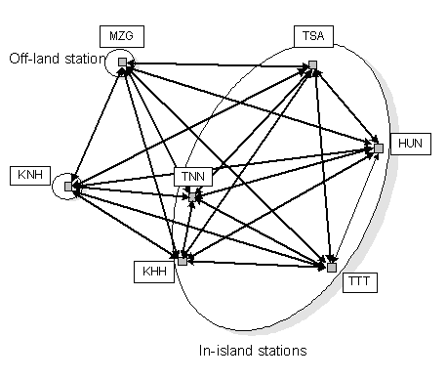
Fig.4 Routing network of all flights
As mentioned in Section II, the values of the auxiliary performance indices $ε_{1}$ and $ε_{2}$ can be assigned as $ε_{1}=k_{1}×α×T_{\text{GH}}$, and $ε_{2}=k_{2}×α$, where $k_{1}$ and $k_{2}$ are the number of available violations of the ground turn-around and flow balance objectives, respectively. Here, both $k_{1}$ and $k_{2}$ are set to 1.
4.1 Experiment One: Schedule Generated by MMGA
This case indicates that MMGA can solve the aircraft routing problems. Fig. 5 shows the aircraft routing solution with nine aircrafts which meets the objectives in the admissible bounds$Λ(S,ε)=(0,0)$. The horizontal axis is the flight operation time from 7:00 to 23:59. The vertical axis denotes different aircraft identities. Fig. 6 shows the convergence of the normalized value $λ_{1}(S_{i}^{(t)},ε_{1})$ and $λ_{2}(S_{i}^{(t)},ε_{2})$ from the population with the minimal fitness value in generation t. $λ_{1}(S_{i}^{(0)},ε_{1})$ is the value from the population with the minimal fitness value in the first generation. Two objectives seem to be stagnating between stages A and B. That is, this becomes a local optimal solution since the ground turn-around time constraint is satisfied while the flow balance objective is not. Considering the two conflicting objectives, the repairing process can relax the ground holding time constraint first. Consequently, at stage B, the violation on the ground turn-around objective increases, while the violations of the flow balance objective decreases. Both constraints decrease to zero at stage C. Finally, the program obtains an optimal solution for this case study at the 892th generation.
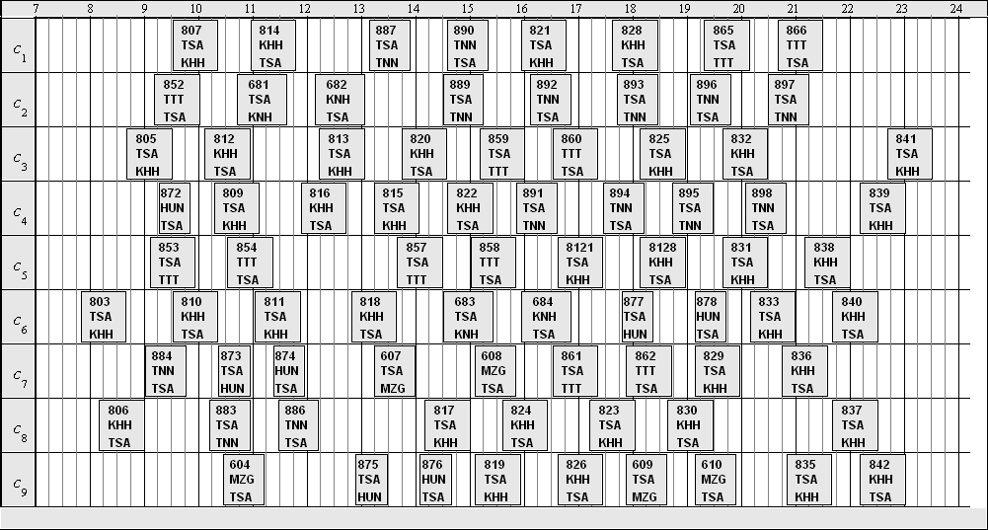
Fig.5 An aircraft routing solution with 9 aircrafts
Fig. 6 Convergence of the violations on ground turn-around and flow balance in normalized values
4.2 Experiment Two: Optimal Usage of Aircrafts
The case indicates that MMGA can help airlines deploy their aircraft utilization more effectively, thus reducing the operation cost of airlines. From the aircraft routing of case one, many time slots are empty, meaning that a flight schedule is possibly flown by fewer aircrafts for the same flight duties in case one. A common enhancement to the schedule is to increase the number of flights or decrease the number of aircrafts. This case reduces the number of aircrafts by two, to make seven aircraft. Therefore, $ε_{1}=1×7×\text{25}=\text{175}$, and $ε_{2}=1×7=7$, i.e. $ε=(ε_{1},ε_{2})=(\text{175},7)$. After the simulation, the auxiliary performance index vector $Λ(S,ε)=(\text{755},0)$is obtained, resulting in the schedule in Fig. 7.
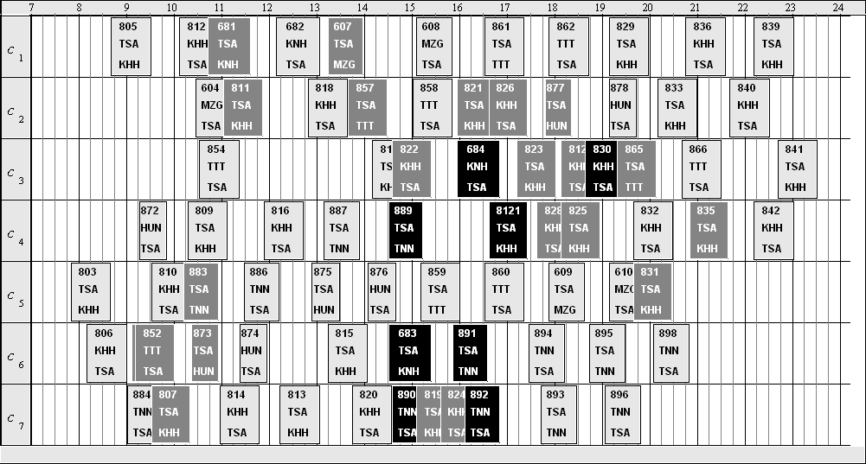
Fig. 7 An aircraft routing solution with 7 aircrafts
In Fig. 7, white rectangles denote valid flights; gray rectangles represent flights with inadequate ground turn-around time with respect to their previous flights, and black rectangles denote the flights whose origins are different to the destinations of their previous flights. Many gray and black rectangles overlap with their previous flights in Fig 7. Therefore, this aircraft routing solution is not only infeasible, but also difficult to adjust.
However, if 8 aircrafts are adopted for the same flight schedule S, then the values of$ε_{1}$and$ε_{2}$are$ε_{1}=1×8×\text{25}=\text{200}$, and$ε_{1}=1×8=8$. Therefore, $ε=(ε_{1},ε_{2})=(\text{200},8)$. Fig. 8 shows the new result with the auxiliary performance index vector $Λ(S,ε)=(\text{195},0)$. Additionally, after adopting a fine-tuning process, which automatically adjust the departure times of flights that violate the ground turn-around objective. Fig. 9 shows an example of the fine-tuning result, and indicates that only one flight violates the flow balance objective. If planners cancel the flight, then the airline can save a large amount of operation cost by deploying fewer aircrafts without canceling many flights. Additionally, planners can adjust the flight schedule manually to create feasible aircraft routing solutions.
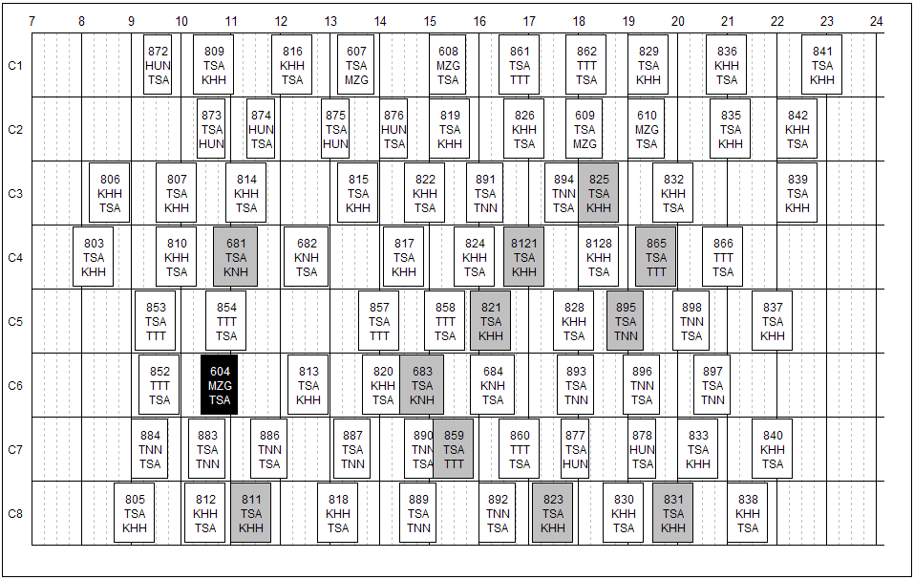
Fig. 8 An experimental result with 8 aircrafts
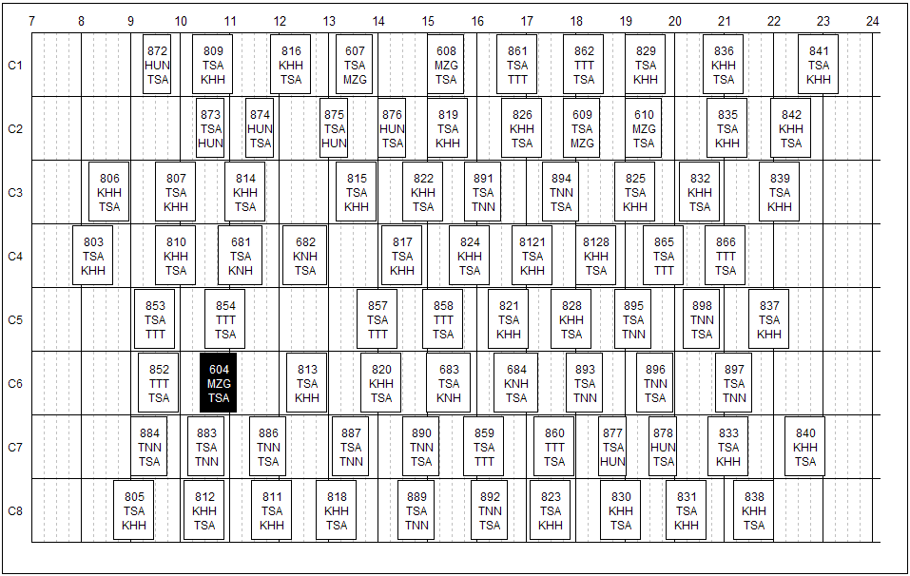
Fig. 9 A repaired experimental result with 8 aircrafts
5. Conclusions
Airline operations are in an environment that is difficult to predict. The terrible attacks events of September 11, 2001 and the subsequent wars in Afghanistan and Iraq, and more recently Severe Acute Respiratory Syndrome (SARS) had seriously impact on the whole world airline industry. In order to maintain the profitability, Taiwan domestic airlines clearly utilize their most expensive capital assets and their associated variable factors very efficiently just like low-cost carriers. How to make an efficient aircraft routing plan and keep airline fleets size more reasonable become a critical challenge to airlines.
This study has successfully adopted MMGA to solve the aircraft routing problem with conflicted multiple objectives. The effectiveness of the approach is largely owing to the MOI, improved rank-based fitness assignment method and repairing strategy. MMGA can help airlines develop their fleet utilization more efficiently, as demonstrated in two case studies. MMGA also can be adopted to solve the aircraft routing problem with multiple objectives under dynamic constraints. As well as changing in the admissible bound, a user can verify and modify the schedule to make it feasible.
References
Abara, J. (1989) ‘Applying integer linear programming to the fleet assignment problem’, Interfaces, 19(4), pp. 20-28.
Barnhart, C., Boland, N. L., Clarke, L. W., Johnson, E. L., Nemhauser, G. L., and Shenoi, R. G. (1998) ‘Flight string models for aircraft and routing’, Transportation Science, 32(3), pp. 208-220.
Clarke, L., Johnson, E., Nemhauser, G., and Zhu, Z. (1997) ‘The aircraft rotation problem’, Annals of Operations Research, 69, pp. 33-46.
Coello Coello, C. A. (2000) ‘An updated survey of GA-based multiobjective optimization techniques’, ACM Computing Surveys, 32(2), pp. 109-143.
Desaulniers, G., Desrosiers, J., Dumas, Y., Solomon, M. M., Soumis, F. (1997) ‘Daily aircraft routing and scheduling’, Management Science, 43(6), pp. 841–855.
Fonseca, C. M, and Fleming, P. J. (1993) ‘Genetic algorithms for multiobjective optimization: Formulation, discussion, and generalization’, Proceedings of the 5th International Conference in Genetic Algorithms, San Mateo, CA., USA.
Gen, M., and Cheng, R. (1997) Genetic Algorithms and Engineering Design, Jonh Wiley & Sons, New York, NY., USA.
Goldberg, D. E., (1989) Genetic Algorithms in Search, Optimization, and Machine Learning, Addison-Wesley Longman Publishing, Boston, MA, USA.
Liu, T. K., Satoh, T., Ishihara, T., and Inooka, H. (1994) ‘An application of multiobjective genetic algorithms to control system design’, Proceedings of the 1st Asian Control Conference, Tokyo, Japan.
Liu, T. K., and Ishihara, T. (2005) ‘Multiobjective genetic algorithms for the method of inequalities’, Control Systems Design - A New Framework, chapter 8, Ed. V. Zakian, Springer-Verlag, London, UK.
Shaffer, J. D. (1985) ‘Multiple objective optimization with vector evaluated genetic algorithms’, Proceedings of 1st International Conference on Genetic Algorithms, Hillsdale, NJ.,USA.
Srinivas, N., and Deb, K. (1994) ‘Multiobjective optimization using nondominance sorting in genetic algorithms’, Evolutionary Computation, 2(3), pp. 221-248.
Yu, G. (1998) Operations Research in the Airline Industry, Kluwer Academic Publishers, Boston, MA., USA.
Zakian, V., and Al-Naib, U. (1973) ‘Design of dynamical and control systems by the method of inequalities’, Proceedings of Institution of Electrical Engineers 1973, 120(11), pp. 1421-1427.
Zakian, V. (1996) ‘Perspectives on the principle of matching and the method of inequalities’, International Journal of Control, 65(1), pp.147-175.

 Corresponding author. E-mail address: bluehawk@seed.net.tw (Chi-Ruey Jeng)

