Maritime networking route optimisation
M. Catalani
Territorial System Department, Faculty of Economics , Naples Parthenope University, Via Medina 40, 80122 Naples, Italy

__________________________________________________________________________
Abstract
The objective of the paper, knowing the number of ports and ship fleet, is to optimises maritime transport routing of a containership, based on demand scheduling to each port of call ,using the expert system approach with owner utility function (McFadden 2000). All that need the operative cost of ships employed and their technical characteristics. The problem solution will be given, for each ship of the fleet, by routing of the ships , container movement for each port of call and transport cost. This paper proposes the use of methodology based on an expert system computation program with a random utility function operate in a maritime network mapped by geographical information system GIS ( Catalani 2001).

Keywords: Maritime; Networking; Route; Feeder; Optimisation

1. Introduction
The current trend for giant ships, as can be seen from the constant growth in size of ocean-going container ships, has led the shipping companies which own these ships, known as deep-sea craft, to select a limited number of stop-over ports where they can concentrate large amounts of merchandise. All this involves significant investment on the part of big deep-sea shipping companies in ever larger ships, which, by stopping at few ports, make it possible to cover a wide-ranging market, making use of local feeder services (Frankel E. 2005). In this way, it is possible to serve port terminals where one direct stop-over would not be economically advantageous or even practicable for geographical, technical, or commercial reasons, (distance from the main trade routes, shortage of infrastructures, shallow waters, modest quantities of containerisable cargo, etc.). The feeder service therefore, in the maritime container transport scenario, is a logistic activity where the main merchandise carrier is substituted, for a certain portion of the run, by one or more secondary transporters (Ronen D. 1983). With the progressive growth of the feeder service, increasing importance has been given to efficient planning of logistic activities and the resources used, as in this sector too, competition will be increasingly based on the quality of the services offered, especially punctual and frequent delivery. At the moment, container ships are being designed as container carriers of over 11,000 Teus called Malacca-max, named after the eponymous Maltese straight ( Frankel E. 2004) . This would lead to a fall in freight if old ships are not “scrapped” at the same time. The main aim of this paper is to put together an optimisation model for maritime routing, able to automatically manage a sea route optimizing the relative routine over short sea services (Catalani M. 2001). A secondary, but no less important aim is to calculate the parameters of the function to be used in the optimisation process, based on an investigation carried out at a number of shipping companies working in the area of feeder redistribution in the Mediterranean. A random parameters model or mixed logit model ( Mcfadden D. and Train K. 2000 ) based on agent Bayesian approach has been elaborated. Lastly, the final objective is also to map the feeder service by GIS (geographic information system) with the technical, logistic and operative data of a line (Catalani M. 1998).
2. The line operators in the Mediterranean
The main large shipping lines working in the Mediterranean, with their subsidiaries, are mainly Maersk, Hanjin, CP Ships, Neptune Orient Line and P&O NEDLLOYD (the latter two merged into a single society). There are also the Global Alliances (Grand Alliance, The New World Alliance, United Alliance, and CHKY Alliance). At the moment the hold capacity on the charter market is slightly higher than what the various ship owner groups offer(Sturmey, S.G.1967 and Frankel E.2005).
It is interesting to note how the main line operator, i.e. the Danish group Maersk - Sealand, can call upon a capacity almost double that of the second largest shipping company, the Italo-Swiss colossus MSC – Mediterranean Shipping Company. Going on the available data Alphaliner 2003 it is possible to group the characteristics of the feeder services into two macro sectors: Deep sea services and short sea services :

- Deep Sea services. For this service there are 106 operators, with 664 ships amounting to 2,337,505 Teus. Same with 62 direct services with 277 ships amounting to 507,689 Teus and others with 34 handling services with 301 ships to a total of 1,378,816 Teus.Lastly10 services which do not call at Mediterranean ports with 86 ships to a total of 451,000 Teus.
- Short Sea services. For this service there are 105 operators to a total of 233 ships, of which 60 are feeder services (common + dedicated)to a total of 122 ships, equal to 88,034 teus of total capacity; 45 “Short Sea” line services with a total 111 ships at 61,933 teus.
The average size of deep sea ships in direct service from the Mediterranean amounts to around 1,800 teus, while the ships that work in transhipment (one port of call) have an average capacity which is higher by 4,500 teus. The remaining ships which currently run in the Mediterranean, operating mainly on the Northern Europe-Far East routes and which do not call at any port in the Mediterranean, have an average capacity of 5,500 teus. The 3/4 of the world fleet operating “pendulum” services along the East-West and North-East routes serve the Mediterranean market including one or more ports of call of the Mediterranean Hub in their “port rotation”( Meersman H., van de Voorde E., Vaneslauder T. 2005). In the current scenario, with regard to the Mediterranean line services, previously referred to as “Short Sea” services, they tend to combine traditional volumes with pure feeder transhipment cargo, including one or more intermediate stopovers in the transhipment hub in the schedule. In this case the average capacity varies from 500 to 900 teus (Frankel E.1995).
3. Med port rotation
The main cost elements of a voyage is daily charter rate of the feeder ship (depending on the size, speed and type of the ship being chartered and the length of the voyage), expenditure at the various ports of call (variable from port to port and depending on the number of ports visited, as well as the size of the ship), bunker costs (depending on the speed of the ship and the length of the voyage) and insurance costs (depending on the size, age and the place where the ship was registered (Evans JJ. and Marlow PP 1990 and McConville J. 1999). Profits, however, depend on the number of Teus carried during the journey and the tariff negotiated with the Shipping Line for the transport based on the FIO for each stretch. This tariff is normally determined from an analysis of running costs for the service and the operating margin fixed by the operator himself. At the moment, the feeder charters in the Mediterranean are very much influenced by the excess of supply, and the profit margins per unit transported are minimum (Jansson, J.O. and Shneerson B.1987). The ideal structure of a feeder service will include in their “port rotation” a limited number of ports in the same geographical area, whose combined import and export volumes are able to maximise the use of available capacity. Such a system depends on feeder services that connect a Hub port with a maximum of 4 regional ports. A more complex structure is one that has 3 ships doing “butterfly” services, with trips of 21 days, operating on a double loop centring on the Hub port. The three ships do two stop-overs per week at the port of transhipment with one stop-over per week in each regional port included in the port rotation. This structure keeps up the weekly frequency, and with it the connections required, serving two different geographical areas at the same time, requiring 21 days' rotation. A typical example is the Adriatic–Middle Eastern services with the hub at Gioia Tauro or Taranto. In this case, the Adriatic loop is completed in around 9.5 days, while the Eastern loop takes around 11.5 days (Frankel E.2002).
The incidence of the transport cost on the final price of the merchandise transported varies significantly depending on the commodity categories transported; the degree of this incidence depends on the total value of the load transported. More detailed figures show the existence of cost variability for the various countries of origin of the products. In fact the merchandise has different prices even if the unit value of the cargo constitutes an important variable for an operator. Its oscillation can alter the potential market, especially for merchandise with a low unit value and very wide supply (Engelen , S, Meersman H, van de Voorde E. 2006). However, purely as an example, the IMF estimates that for the single stretches, the average cost is equal to around 6 % of the value of the world total; it appears greater for the developing countries (around 10 %) than for industrialised nations (5 %); while the cost of door-to-door transport can be estimated at around 20%, even allowing for the possibility of very anomalous situations. Knowing the incidence of transport on the unit cost of the cargo contributes to identifying the centres of highest cost. Furthermore, in all phases of the cycle, the transport intermediaries (shipping agents and forwarding agencies) need to be considered with the their costs; their incidence on the total door-to-door cost is around 8-10 %.
4 Transport costs and performance indicators
The total cost of a voyage assessed from the point of view of the affreighter (charter or feeder-operator) chartering the ship from a ship-owner is made up of seven variables with chartering, insurance, main and auxiliary fuel, berthing, port dues and general expenditure ( Russo F. 2001) :
$\begin{aligned}C_{T}=C_{\text{chart}}+C_{\text{ins}}+C_{\text{IFO}}+C_{\text{MDO}}+ \\ +C_{B}+C_{P}+C_{\text{ge}}=\end{aligned}$ (1)
$\begin{aligned}=C_{\text{chart}}∗T_{V}+C_{\text{ins}}∗T_{V}+C_{\text{IFO}}∗∗\text{IFO}∗T_{S}+C_{\text{MDO}}∗\text{MDO}∗T_{V}+ \\ +\sum{C_{\text{bi}}}∗T_{\text{pi}}+\sum{C_{\text{pi}}}+C_{\text{ge}}\end{aligned}$ (2)
where:
$C_{T}$ _{= total cost of transport}
$T_{V}$ = total voyage time as steaming, manoeuvring, operation and idle times (days);
$C_{\text{chart}}$ = chartering price of ship ($/day);
$C_{\text{ins}}$ = voyage insurance price ($/day);
$T_{S}$ = route timing (days);
$C_{\text{IFO}}$ = main fuel pricing ($/mtons);
IFO = main fuel consumption (mtons/day);
$C_{\text{MDO}}$= auxiliary fuel pricing ($/mtons);
MDO= auxiliary fuel consumption (mtons/day);
$T_{\text{pi}}$ = timing at ports (days);
$c_{\text{bi}}$ = berth dues ($/day);
$c_{\text{pi}}$ = port fees (variables from port to an other);
$C_{\text{gf}}$ = general expenditure (maintenance etc.).
When the total cost of a voyage is known, a particularly significant element is the relationship between this cost and the Teus actually carried by the ship. Described as C_{u}, the unit cost will be:
$C_{u}=\frac{\text{CT}}{\text{teus}}(\$/\text{Teu})$ (3)
This is the most common economic indicator in the seagoing container transportation sector and also the most significant from the point of view of an operator carrying out a feeder service, as it provides an average value for the cost sustained in transporting a single Teu.
The daily unit cost $C_{\text{ud}}$ is obtained by dividing the $C_{\text{ud}}$ by the length of the journey expressed in days:
$C_{\text{ud}}=\frac{C_{u}}{\text{teus}∗\text{giorni}}(\$/\text{Teu}∗\text{day})$ (4)
A transport productivity index Φ is calculated from the relationship between time sailing and the duration of the voyage as a whole (sailing time plus time in port):
Φ=$\frac{\text{Ts}}{\text{Tv}}$ (5)
5. Expert system and mixed logit integration
The aim of this paper is to analyse a model able to minimise the total transport costs in an open multi-port system served by a fleet of vessels. The model used is based on the expert system code approach ( Catalani M. 2001) . In particular, it will be possible to optimise the routing knowing the handling of containers in any port of call for each ship. The input data consists of many variables: distance, ship size, service frequency, daily fuel consumption, total daily running, total operative and sailing costs, cost/mile and mile/tonne. The model will be based on a cost utility function which will include only a few of ship running costs. This function will allow a calculation of the optimal loading plan of the ships involved on this route: the sum of the total transport cost of all ships will lead to the definition of the “Transport Plan’’. The output of the model will provide the route which minimises the total cost, and maximises container handling. This takes on particular importance in the case of small and medium-sized ships running short routes as a feeder service in the Mediterranean area ( Buxton,1971). This case leads us to consider the behaviour of an owner who must allocate ships operating in a multi-port system and minimise the total transport cost. All that needs to be considered is the operating cost of ships employed and their technical characteristics (Frankel E. 1997). Generally speaking, this approach is partially defined in the literature (Jansson and Shneerson, 1987), but it can be very complex if we consider the large number of variables involved. In our case, we have a port system (nodes) interconnected by routes (links) constituting the maritime network served by a fleet of vessels. We must consider the possibility for each ship to transport containers to each port along the route, minimising overall shipping costs (Zerby and Conlon, 1982). The solution to the problem is calculated for each ship of the fleet from: the timing and routing of the ships, container movement for each port of call and transport cost. The result of the application can be chosen from possibilities regarding routing and container unloading and/or loading. This exhaustive methodology entails a computer search of a large number of possibilities to find the optimal solution, which becomes difficult if the number of ports, variables and ships increases considerably. In contrast, this paper proposes the use of a methodology based on an “expert system”. This method allows us to find solutions in a limited domain with the same results as those obtained by human experts. The advantage of this choice, with computerised calculations, allows us to “grasp” the know–how of maritime logistic experts. The program, which will solve the problem of routing for a liner with many ports of call, requires the following operative phases:

- identification of the route and ports;
- knowledge acquisition in terms of container traffic
- formulation of logical rules for cost structure
- code of optimum problem solution

The coefficient of cost solving (utility function) as an input of the algorithm of the cost minimisation used, has been calculated using a mixed logit model such as Train K, also if the utility function uses only a few cost variables due to the implementation of a computerised program with a large extension of variables. The econometric model application evaluates agent behaviour as chartered operating in the Mediterranean area with different feeder ship sizes. In reality there are fifty-nine chartered feeder ships which main costs are : time charter , insurance, bunker and port fees. The charterer operates time by time with different cet feeder ship size. The main attributes of function utility for logit application are: size ( teu), service routing frequencies (numbers), route distance (miles), daily fuel consumption (tonnes), total days' voyage(days), general total cost of voyage (thousands of $), cost of transport per mile ($ / mile), fuel consumption per mile(mile/tonne). The model used is a Kernel logit model (mixed logit) well defined in the literature ( Mcfadden D.and Train K. 2000 ). This is one of the most important complete models developed by Daniel McFadden (1996) and later by Train and McFadden, (2000), Ben Akiva and Wolker ( 2002). Generally, the Bayesian procedure (Bhat 2000), and (Revelt D. and Train K.1998) establish that, under certain conditions, the mean of the Bayesian posterior is a classical estimator asymptotically equivalent to the maximum likelihood estimator (Train K,1998). Bayesian procedure considers charterer choices (repeated) from among J sizes of feeder ship in each of T time periods (Allenby G, 1997). The perceived utility from alternative J in period T becomes (Train K, -Sonnier G, 2003):

$U_{\text{njt}}=β^{'_{n}}x_{\text{njt}}+ε_{\text{njt}}$ (6)
where $ε_{\text{njt}}≃$ iid extreme value and $β_{n}$ $N(b,Ω)$. The vectors of variables $x_{\text{njt}}$ and parameters $β_{n}$ extend to K. Conditional on $β_{n}$ the probability sequence of choices being the product of standard logit formulas (Train K, 2003 ):

$L\left\langle y_{n} | β_{n}\right\rangle =\prod_{t}{}\frac{e^{β_{'n}^{'}x_{{\text{ny}}_{\text{nt}}}t}}{\sum_{j}{e^{β_{'n}^{'}x_{{\text{ny}}_{\text{nt}}}t}}}$ (7)
The unconditional probability is the integral of $L\left\langle y_{n} | β_{n}\right\rangle$ over all values of $β_{n}$ weighted by the density of $β_{n}$:

$P_{n}(y_{n}‖b,Ω)=\int{L(y_{n}}‖β_{n})g\left\langle β_{n} | b,Ω\right\rangle dΩ$ (8)

where g(.) is the multivariate normal density. This unconditional probability, called the mixed logit choice probability, is the product of logits mixed over a density of parameters (Train K, 2003). For Bayesian analysis, it is necessary to specify the prior on the model parameters. The prior on b is specified as normal with a sufficiently large variance that it is effectively flat from a numerical perspective (Agha M. and Branker D.S., 1997). Density is IW ($Ω$ $|$$K,\text{KI}$). With these priors, the joint posterior on $β_{n}∀_{n}$$,b,$$Ω$ is

$Α(β_{n},∀_{n},b,Ω|Y)α\prod_{n}{(L(y_{n}}|β_{n}g(β|b,Ω)\text{IW}(Ω|K,\text{KI})$ (9)

The code elaborated by Train (Train K,2003) considers a transformation of normals, defined parameters of chartered feeder vessels n as c_{n}, which is a vector with the same length $β_{n}$, Successively the parameters defined by c_{n}, = T($β_{n}$), where T is a transformation that depends only on$β_{n}$ and is weakly monotonic (such that $\frac{∂c_{n^{k}}}{∂β_{n^{k}}}0$for each element k, of c_{n}, and $β_{n}$).
The distribution of c_{n}, is determined by the transformation. Normally distributed $β_{n}$ are drawn as before, but then transformed to c_{n}, when enter utility. Utility is specified as

$U_{\text{njt}}=T(β_{n})'x_{\text{njt}}+ε_{\text{njt}}$ (10)

The chartered probability choice sequence given $β_{n}$is :
$L(y_{n}|β_{n})=\prod_{t}{\frac{e^{T(β_{n})^{'}x_{{\text{ny}}_{\text{nt}}}t}}{\sum_{j}{e^{T(β_{n})^{'}x_{\text{njt}}}}}}$ (11)
6. Routing networking analysis
Below is an example relating to the times and the costs of a typical voyage of a feeder ship, operating on a routing service in the eastern Mediterranean area ( Sturmey, S.G.1967 and Buxton,I.L. 1971)) . The charts below show the standard composition of data supplied by a feeder operator (charterer) on behalf of the line. The capacity of the ships examined varies from a minimum of 400 Teus (1 Teu as a standard capacity of 14 tons) to a maximum of 1000 Teus. The average capacity is equal to 650 Teus per ship. The database used includes the following division:
- Scheduling of the journey, rotation, activity per stop-over, arrival and departure times from each port in the rotation;
- Ship profile and container details of unloading /loading per port;
- Round trip costs;
- Port dues.
The analysis of the data shown in the following figures must be understood as purely descriptive of the model for costs which was used by the application below, and should not therefore be identified with the true situation. It needs to be pointed out, in any case, that “stevedoring” costs are not normally included, i.e. the shifting of containers in port, but only the costs of transport based on the FIO agreement (Free In – Free Out) between the feeder operator and the main line owner of the container. In Table 1 below, we show the schedule of a feeder ship.
In it, we show the schedule number, the port of call with relative dates of arrival, the start of operations, and departure with container movement such as unloading and loading.

Table 2 shows the ship profile representing the weight condition of the ship at departure from each individual port, defined in metric tonnes and teus, full or empty. Specifically, in Table 2 we show the names of ships, the port rotation list, and the quantity of containers loaded and unloaded.

Table 3 shows a summary of the overall subdivision of the main components of total round trip costs with the distance travelled, average speed, fuel consumption, manoeuvring, operational steaming, time charter cost, insurance, bunker and mooring fees, and cost per mile in $.

Table 4 shows the details of the fees paid at each port. Generally we have different dues for different ports.

Table 5 shows detailed container movements in the loading/unloading ports. As we can see, the details of containers transported on each link of routing are given here (Line) with indication of size, WGT, full or empty.
From ships data base elaboration ,more generally, from data base the total trip routings number are 140 and the main considerations deriving from the overall aggregated data analysed are:
- The number of voyages carried out by the same ship in the reference month varies from 1 to a maximum of 5.
- The cost of chartering the ship is equal to 64.07 % of the cost of the voyage.
- The bunker cost amounts to 11.27 % of the total cost.
- The port costs are 24.08 % .
- Insurance costs, however, account for the remaining 0.58 %.
- The average daily bunker consumption is around 11.61 tons per day while at sea.
- Average cruising speed is around 15 knots.
- The average navigation cost is US $ 6.55 per mile.
- The ship does 15.83 miles per bunker tonne
  - Routing optimisation application.
Based on data base available from feeder operators with different feeder ships size in the Mediterranean area, and after mixed logit calibration by maximum likelihood simulation of the utility cost function parameters, an application of a Train K. code ( Sonnier and Train 2001) with coefficients transformation of the above data has been attempted. More generally the results data estimates have been reported on table 6 below. The results evidence that it needs again to investigate on coefficients transformation.
It is essentially an exemplification of a proposed routing based on an expert system for maritime network routing in the Mediterranean area ( Russel S.J. and Norvig P. (1995). It makes use of a calibration model of McFadden's utility function as above. Essentially, the cost function calculation method (utility) uses a kernel logit model calibrated using a sample of 59 feeder ships operating in the Mediterranean, and chartered by the operator himself. The routing under examination takes into account the following ports :
- Istanbul
- Izmir
- Marmaris
- Pireus
- Saloniki
In these ports there are some containers for the same routing which must be transported. The variables that come into play in this problem, in addition to the distances between the ports, are also those concerning the cargo to be loaded onto the ship. Theoretically, to identify the best route able to optimise the merchandise distribution costs, it is necessary to assess an important number of combinations of different container flows combined with different pathways ( Erichsen, S. 1971). The criterion proposed is based on the following assumptions: we assume that we are in port with the ship empty; we have to decide which containers to load and how many (containers with the same destination are considered to be “equal”) and we must select the next node to be chosen. We can use one criterion and evaluate the best route. We can then change criterion and redo the calculation procedure. Finally, we will compare the best routes, as many as the number of different criteria and call this solution the relative best one. Here we define the following criterion, which includes: :
- routing with 5 links .With the increase in the number of stretches, there will be a relative excellent closer to the real excellent. With a sufficiently high number of stretches, there will be an absolute excellent, but the calculation of the excellent will be particularly difficult.
- the cost function to be minimised ( utility function) = (number of containers transported ) + (loading capacity of the ship) + ( distance between the first and the 5th port) +movement level.

This graphic representation of the area has been mapped using a geographic information system (GIS) with the Aegean and Marmara seas and the Greek and Turkish coastal areas (Affum K. J., Taylor M.A.1998). The map in the Figure 1 shows the five ports involved in this study

Figure 2 shows the best routing based on the previously identified parameters. The map shows the overall routing with different shades of colour to illustrate it better.

Figure 3 above shows the code assignment for containers to routing optimisation, with (for each port) the number of containers loaded and transported to each other destination port with the amounts unloaded for each port.
7. Conclusion
The model proposed in this paper is an example of how to implement an application based on an expert system strategy plus a mixed logit calculation of parameters to be used in the routing optimisation code. The model must be considered also as an extension of the paper presented at the 9th WCTR. The high level of data based on the feeder service allows us to implement many real models .Nevertheless the difficulty of code implementation has limited our ability to consider a higher number of variables than mixed logit calibration will allow. For a good calculation response, we will need all the parameters affecting routing cost which need to be taken into account such as ship size, voyage frequency, distance covered, total cost, cost per mile, bunker, chartering pricing etc . Nevertheless, the expert system application must be considered as a prototype to maritime transport.
The model has a high flexibility parameter that allows the updating (when cost factors are added or changed) or the adaptation (when the application has to represent different contexts) of the routing problem. The correctness of the solution is also related to the complexity of calculation of a great quantity of variables obtained from a simulated maximum likelihood and fitness value. In the model proposed, the value of the routing link equal to 4 or 5 was fixed (for a simple representation of the routing diagram), but more realistically, to simulate route planner behaviour, an extension to 6 – 7 is needed. As specified, all this significantly increases the complexity of calculation .
Finally, the application of output shows a net differentiation regarding the traditional planner ships’ assignment to the port system. It is particularly evident that the main routing link does not start with the nearest link, in terms of distance, from the departure port. The network is emphasised also distance, container movement and handling at ports. The trade-off between vessel size and the number of ports present in the network is evident. This analysis is substantially useful in the interaction of new modes of planner fleet capacity within the network. Despite the limitations that can be found in a symmetric maritime network geographical area of study, the application is interesting for route planning operations because it integrates the traditional optimisation approaches.
References
Affum K. J., Taylor M.A., (1998) Integration of Geographic Information Systems and models for transport planning and analysis .8th World Conference on Transport Research ,Antwerp
Agha M. and Branker D.S., (1997) Maximum likelihood estimation and goodness of it tests for mixtures of distribution, Journal of the Royal Statistical Society, volume 46, n. 3, London.
Ben Akiva e Walters (2002) Generalised random utility model. Mathematical social science 43. pp 303-343
Ben Akiva M. and Lerman S., (1985) Discrete choice analysis, The MIT Press Massachusetts Institute of Technology Cambridge, Massachusetts 02142.
Buxton,I.L.(1971) Engineering Economics and Ship Design ,The British Ship Research Association, Wallsend.
Cascetta E., (1998) Teoria e metodi dell’ingegneria dei sistemi di trasporto, UTET Torino.
McFadden D., (2000), “Disaggregate Behavioral Travel Demand’s RUM Side’’ – A 30 Year Retrospective, International Association for Travel Behavior (IATBR), Gold Coast, Queensland, Australia, 2 – 7 July 2000
Catalani M (2001) Liner optimisation route in a multi-port system. 9th World Conference on Transport Research, Seoul 22-27 July 2001
Catalani, M (1998) Management of containers terminals with geographical information systems: the port of Naples, Proceedings of the 8 th World Conference on Transport Research, Antwerp 12-17 July 1998.
Engelen , S, Meersman H, van de Voorde E (2006) Using system dynamics in maritime economics. an endogenous decision model for shipowners in the dry bulk sector. Maritime Policy and Managemen,33:2
Meersman H.van de Voorde Eddy, Vaneslauderer T.(2005) Ports as hubs in the logistic chain. International Transport Persoective/Leggate H. ed. London Routledge.
Erichsen, S.(1971) Optimum Capacity of Ships and Port Terminals, College of Engineering, University of Michigan.
Evans JJ and Marlow PB (1990)Quantitative methods in maritime economics. Fairplay Publications, London
Frankel E. (1997)“Transport System Modelling and Simulation”, International Marine Design Conference, IMDC-97, May 1997, New Castle-on-Tyne, U.K.
Frankel E. (2002)“The Challenge of Container Transhipment in the Caribbean”, International Association of Maritime Economists, Panama City, Panama, November 2002
Frankel E. (2004)“The Future of Containerization”, International Association of Maritime Economists Conference, Izmir, Turkey, July 2004.
Frankel E. (2005)Risk Management in Shipping”, International Association of Maritime Economists Conference, Limassol, Cyprus, June 23-25, 2005.
Frankel E.(1995)"Integrating Feeder Services into Global Liner Alliances", International Association of Maritime Economists Conference, December 15, 1995, MIT, Cambridge
Jansson, J.O. and Shneerson (1987) Liner Shipping Economics, Chapman and Hall ,London..
McConville J(1999) Economics of maritime transport. The institute of Chartered Shipbrokers, Witherby & Co LTD London
McFadden D. and Winston C., (1981) Joint estimation of discrete and continuos choices in freight transportation, Proceedings of the 1981 Meeting of the Econometric Society.
McFadden D., Train K.,(2000) Mixed NML models for discrete response. Journal of Applied Econometrics, John Wiley & Sons, New York
McFadden D., Winston C. and Boersh-Supan A., (1985) Joint estimation of freight transportation decisions under nonrandom sampling, in Daughety A.F., Analytical Studies in Transport Economics, Cambridge University Press.
Meersman Hilde,van de Voorde E,Vaneslaudern T
Russo F. 2001. Gioa Tauro container terminal. University of Reggio Calabria Editor
Sturmey, S.G.(1967) Economics and liner services. Journal of transport Economics and Policy.
Train, K (2001) A comparison of hierarchical Bayes and maximum simulated likelihood for mixed logit. Working paper, Department of Economics; University of California, Berkley,
Train, K (2003) Discrete Choices Methods with Simulation. Cambridge university Press, New York.
Train, K. (1998), ‘Recreation demand models with taste variation’, Land Economics 74, 230-239.
Zerby,J.A. and Conlon, R.M. (1982) Liner costs and pricing policies, Maritime Policy and management,9,3.

Table. 1
Ship's scheduling Med area
MED/ SERVICE
Current Schedule
Schedule No. 3125 2001
026 |  |  |  | Moves
Ports | Arrival | Start ops | Departure | Disch | Load
1 |  |  | 15 09 (08:00) |  | 199
2 | 17 ^{Mon} 09 (06:00) | 17 09 (08:00) | 17 09 (16:00) | 94 | 55
3 | 18 ^{Tue} 09 (06:00) | 18 09 (07:00) | 18 09 (16:00) | 62 | 110
4 | 19 ^{Wed} 09 (08:00) | 19 09 (09:00) | 19 09 (19:00) | 74 | 121
1 | 21 ^{Fri} 09 (02:00) | 21 09 (03:00) | 21 09 (21:00) | 265
SCHIP DETAILS
Intake |  |  |  |  |  | 400 Teus
Vessel capacity |  |  |  |  |  | 281 Teus
Deadweight |  |  |  |  |  | 4.100 Tons
Speed |  |  |  |  |  | 15 Knots

Table 2

Ship profile
M/v HH voyage N.26
TEUS  Port Rotation | LOADING |  |  | DISCHARGE |  |  | Ship’s profile
TEUS  Port Rotation | Full | Empty | WGT | Full | Empty | WGT | Full | Empty | WGT
1 | 280 |  | 3.727 |  |  |  | 280 |  | 3.727
2 | 70 | 14 | 1.091 | 139 |  | 1.796 | 211 | 14 | 3.022
3 | 110 | 31 | 1.663 | 80 | 8 | 945 | 241 | 37 | 3.740
4 | 132 | 35 | 1.791 | 86 | 11 | 1.340 | 287 | 61 | 4.191
5 |  |  |  | 287 | 61 | 4.191
TOTAL TRIP 590 80 (teus full / empty transported during voyage)
- Legenda: 1 = port 12 = port 23 = port 34 = port 4
NB: Ship profile represents condition of cargo in every ports represented in WGT, Teus Full or Empty-Loading / Discharging

Table 3
Summary of round trip costs
ship name | Voyage n° |  | Miles  travelled | Average  speed | Consume (tons) |  | Total  MT | Daily  Consumption mt
 |  |  |  |  | Main MT | Aux MT | Total  MT | Daily  Consumption mt
1 | 26 |  | 1.530 | 14,71 | 62,76 | 4,30 | 67,06 | 10,21
1 | 26 |  | Steaming D h m | Manoeuvring D h m | Operation D h m | Idle Times D h m | Total  Days
1 | 26 |  | 04/ 8.00 | 00/ 3.23 | 01/ 3.45 | 00/ 22.34 | 06/ 13.42
1 | 26 | US $ TC  x day | TC US $ | Insurance  US $ | Bunker US $ | Port dues  US $ | Mooring dues US $ | Total  US $
1 | 26 | 5.188 | 34.091,59 | 201.40 | 6.194.,94 | 11.734,25 | 321,52 | 52.543,70
1 | 26 | US $/ Mile | Mile/ mt | Cost subdivision%
 |  |  |  | Time charter | Insurance | Bunker | Port Charges
1 | 26 | 4,05 | 22,81 | 64,9% | 0,4% | 11,8% | 22,9%
Legenda: |  | TC  mt  Main MT  Aux MT  D h m | =  =  =  =  = | Time Charter  Metric Tons  Fuel main motor ( tonn)  Fuel auxiliary motors ( tonn)  Day hours minute |  | Steaming  Manoeuvring  Operation  Idle Times | =  =  =  = | Navigation time  Port manoeuvring  Handling Time  berth and off port time
Source : Shipping companies

Table 4

Port fees

RECAP - port dues
Ship Name | Voyage | Port | US$
1 | 26 | 1 | 1.201,55
2 | 26 | 2 | 1.458,32
3 | 26 | 3 | 3.800,11
4 | 26 | 4 | 1.274,28
--------------------- | ------------------------ | ----------------- | -----------------------------

Table 5
Detail of containers transported on routing
Pol | Pod | LOADING |  |  |  |  |  |  |  | DISCHARGE |  |  |  |  |  |  |  | MVS
Pol | Pod | 20 F | 40 F | TEUS | WGT | 20 E | 40 E | TEUS | WGT | 20 F | 40 F | TEUS | WGT | 20 E | 40 E | TEUS | WGT | MVS
1 | 2 | 49 | 45 | 139 | 1.796 |  |  |  |  |  |  |  |  |  |  |  |  | 199
1 | 3 | 33 | 17 | 67 | 784 |  |  |  |  |  |  |  |  |  |  |  |  | 199
1 | 4 | 36 | 19 | 74 | 1.147 |  |  |  |  |  |  |  |  |  |  |  |  | 199
1 | 1 |  |  |  |  |  |  |  |  |  |  |  |  |  |  |  |  | 199
Total |  | 118 | 81 | 280 | 3.727 |  |  |  |  |  |  |  |  |  |  |  |  | 199
2 | 3 | 3 | 5 | 13 | 145 |  | 4 | 8 | 16 |  |  |  |  |  |  |  |  | 159
2 | 4 | 1 | 2 | 5 | 48 | 6 |  | 6 | 13 |  |  |  |  |  |  |  |  | 159
2 | 1 | 36 | 8 | 52 | 869 |  |  |  |  |  |  |  |  |  |  |  |  | 159
Total |  | 40 | 15 | 70 | 1.062 | 6 | 4 | 14 | 29 | 49 | 45 | 139 | 1.796 |  |  |  |  | 159
3 | 4 | 7 |  | 7 | 122 | 1 | 2 | 5 | 10 |  |  |  |  |  |  |  |  | 172
4 | 1 | 47 | 28 | 103 | 1.474 | 24 | 1 | 26 | 57 |  |  |  |  |  |  |  |  | 172
Total |  | 54 | 28 | 110 | 1.596 | 25 | 3 | 31 | 67 | 36 | 22 | 80 | 929 |  | 4 | 8 | 16 | 172
3 | 1 | 68 | 32 | 132 | 1720 | 7 | 14 | 35 | 71 |  |  |  |  |  |  |  |  | 195
Total |  | 68 | 32 | 132 | 1720 | 7 | 14 | 35 | 71 | 44 | 21 | 86 | 1317 | 7 | 2 | 11 | 23 | 195
 |  |  |  |  |  |  |  |  |  |  |  |  |  |  |  |  |  | 265
Total |  |  |  |  |  |  |  |  |  | 151 | 68 | 287 | 4.063 | 31 | 15 | 61 | 128 | 265
Legenda: |  | 20 F = | Container 20' feet (full) |  |  |  |  |  |  | 20 E = | Container 20' feet (empty)
 |  | 40 F = | Container 40' feet (full) |  |  |  |  |  |  | 40 E = | Container 40' feet (empty)
 |  | WGT = | Weight Cargo tonn |  |  |  |  |  |  | Mvs = | Moves discharging/loading containers
 |  | POL = | Port of loading |  |  |  |  |  |  | POD = | Port of discharge
Source : Shipping companies

Table 6 (ex table 2)
Mixed logit model estimâtes coefficients transformations
Variables β | coefficients | t-statistics
Ship Dimension (TEU) | 1.0 | 1.8
Movement level | 10.0 | 2.1
Distance | 1.0 | 1.1
Daily consumption | 0.5 | 1.9
Simulated log likelihoods | -62.8915

Figure 1
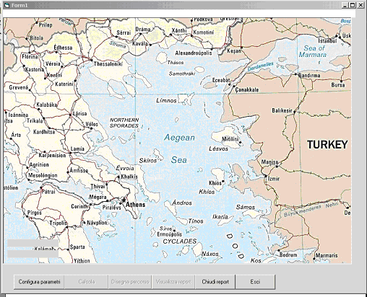
Fig. 1. GIS mapping of the network

Figure 2
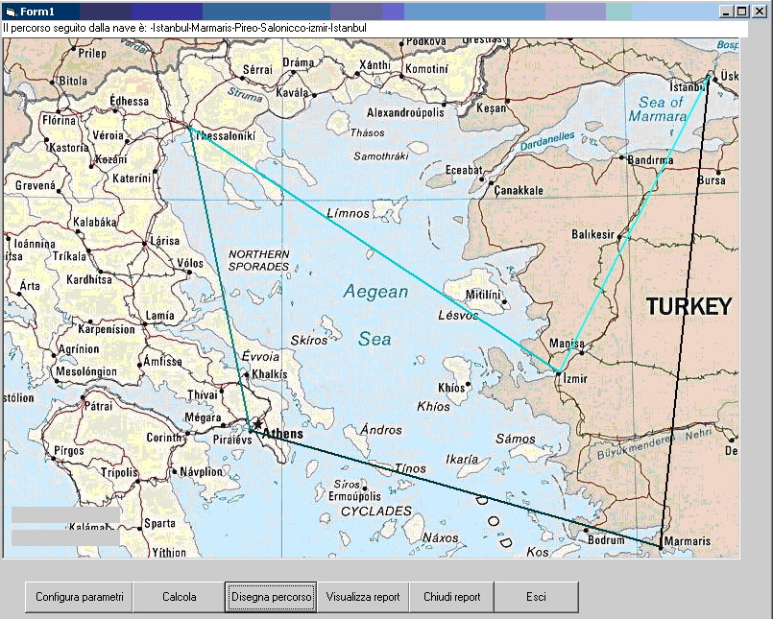
Fig. 2. Model Output

Figure 3
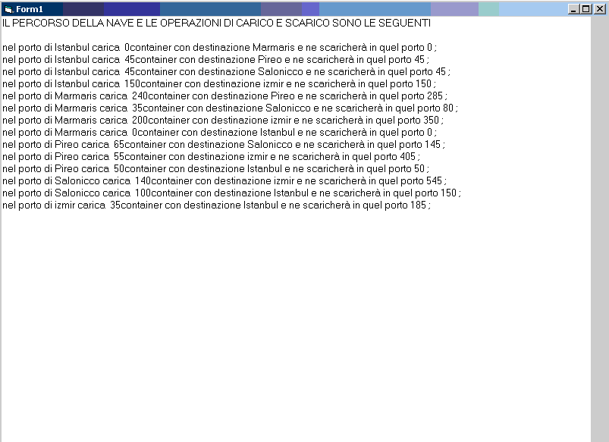
Fig. 3. Detail of routing and handling optimisation

Corresponding author. Tel. ++390815475314 E-mail address: : mauro.catalani@uniparthenope.it

