What Could Go Wrong with the High-Speed Rail Lines in South-West Europe?

AUTHOR: | Maria Price
TITLE: | DPhil Candidate
ORGANIZATION: | Transport Studies Unit  Oxford University Centre for the Environment

ABSTRACT
This paper offers an approach to measuring and determining the level interconnectivity of transport networks by looking at the high-speed railways in Spain which are part of the European Commission’s Priority Axis No3 of South-West Europe. The paper explores the development of the priority axis and measures its level of interconnectivity by using graph theory and the Geographic Information Systems (GIS) software MAPINFO. From the calculated measures, the paper assesses the level of interconnectivity in Spain and explains what could go wrong with the high-speed rail lines of South-West Europe. In its final section the paper draws conclusions from the study and offers recommendation for future research and policymaking.
The paper has strong academic and policy significance. It contributes to the research that has been carried out on the trans-European networks and in other modes of transport. This paper will help better understand the significance of interconnectivity in rail transport on a national and European level.

Introduction
In the past ten years, great emphasis and funding has been put towards developing a European rail network, which is believed will help reduce bottlenecks in road transport and air pollution in both road and air transport. Transport infrastructure development has always been seen as an essential pre-requisite of economic development. According to Mateo Turró, the Trans-European Networks (TENs) are a clear product of the Delors-Santer era in the 1990s. The idea came about when the European Commission was accused of failing to progress the Common Transport Policy (Turró, 1999). As a result the first transport corridors were defined in Crete in 1994 and later revised in Helsinki in 1997. Since then the TENs have been developing on a single-mode and regional basis. Today, however, there is new consideration for intra and inter-regional connectivity and operability of the TENs (White Paper 2001). In 2003 the Van Miert Group proposed 30 priority projects. The majority of the projects focus on developing a European Railways Network, which will consist of current and new lines, conventional and high-speed trains and passenger and freight transport. Despite this priority, the rail network is not thoroughly interconnected due to differences in infrastructure and operations throughout Europe.
The high-speed railway axis of South-West Europe, also known as the Priority Axis No 3 of the European Commission’s Trans-European Networks (See Map 1), is dedicated to improving the connectivity of the Iberian Peninsula by rail with the rest of Europe. This will be done through the construction of high-speed rail lines in Portugal and Spain and connections to the French high-speed rail network. Spain, Portugal and southern France have become hot spots for tourism and property investment in the last few years. The increased demand for accessibility has put pressure on the development of the region’s infrastructure. Furthermore, due to the increasing travel by air and road, policymakers are encouraging modal shift from road and air into rail travel, which can provide a more environmentally sustainable form of transport. However, the railways in the Iberian Peninsula face multifarious problems related to historic under-investment, limited capacity, few international connections, and non-standard operational and physical systems.
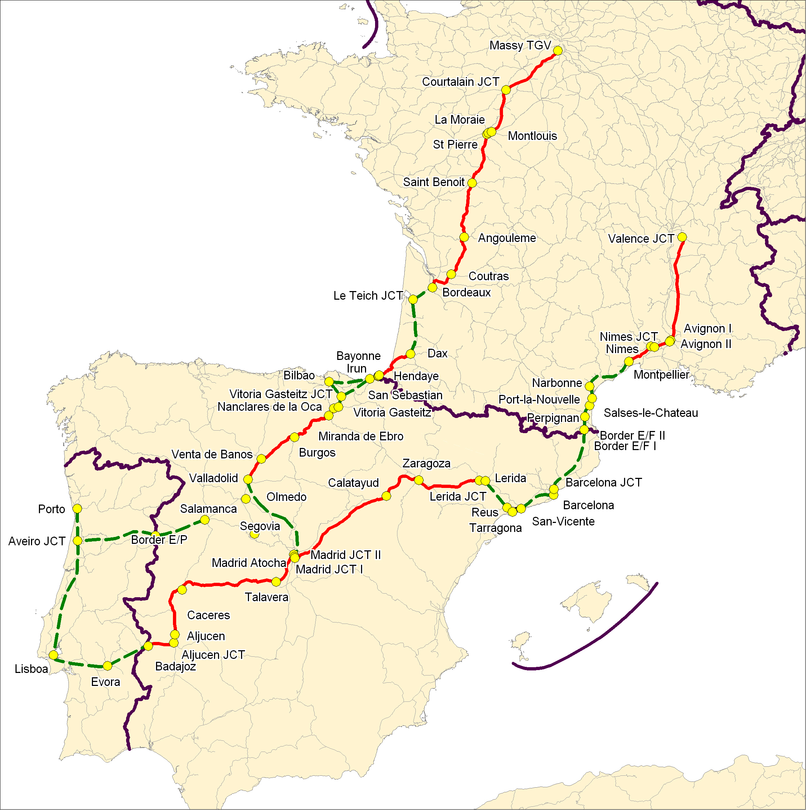
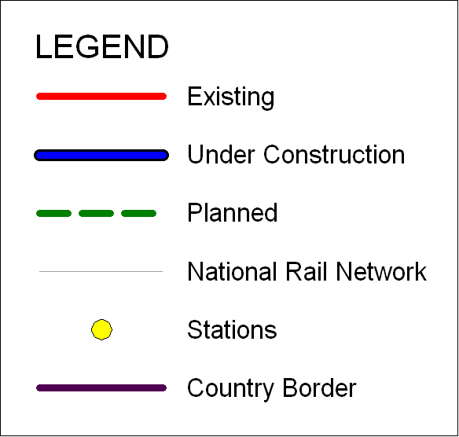
Map 1. Priority Axis No 3: High-speed railway axis of South-West Europe
The paper explores the development of the priority axis and measures its level of interconnectivity by using graph theory and Geographic Information Systems (GIS). From the calculated measures, the paper assesses the level of interconnectivity in the region of Spain and explains what could go wrong with the high-speed rail lines in South-West Europe. In its final section the paper draws conclusions from the study and offers recommendations for future research and policymaking. The paper defines interconnectivity as the ability for transport infrastructures to connect within a single mode at different scales (regional, national and European).

Background
The development of Priority Axis No3 of South-West Europe started in 1998 with the construction of the Madrid – Zaragoza – Lerida - Barcelona Line (See Map 1.). The link Madrid, Zaragoza and Lerida was opened in 2003.
As introduced above, the Priority Axis No3 connects the regions of France, Spain and Portugal. The axis passes through Languedoc-Roussillon region in France (Lyon, Nimes, Montpellier, Perpignan), crosses the French-Spanish border through a tunnel at Figueres, and continues into Spain to Barcelona, Taragona, Reus, Lerida, Zaragoza and Madrid. Madrid connects to the north with Segovia, Olmedo, Valladolid, Burgos, Vitoria, Bilbao in Spain and Dax, Bordeaux, and Tours in France. Madrid also connects to the west with Lisboa and Porto in Portugal. Most of the lines are expected to be completed by 2010 in Spain and 2015 in France. The differences in the timelines are due to ongoing negotiations and preliminary studies still being carried out in France. (Luxemburg, 2005)
Being located in the Iberian Peninsula, the high-speed rail lines of Spain is a peripheral network which connects a vast economic and social region which is isolated from the rest of Europe. In order to be socially and economically incorporated with the rest of Europe, the Iberian Peninsula requires a well interconnected transport network.
Regional Studies
Studies on the transport networks in the region have already been carried out by scholars such as Beuthe and Nijkamp, Bonnafous, and Gutierrez. Beuthe and Nijkamp (1999) are concerned that there is an ambition to develop the networks, but not evenly around Europe. They take a closer look at the peripheral countries and argue that they have poorer infrastructure and poorer quality of service due to given priority to the developing infrastructure in major cities and not rural areas. That means that when networks are developed on a European level, the networks in the cities will be further developed while, on the other hand, the networks in rural areas will be totally neglected, as peripheral states have to prioritise the allocation and choice of networks that need to be developed. Beuthe and Nijkamp use accessibility indicators to assess the peripheral regions, but they find it “unworkable to determine a single universally applicable indicator of accessibility.” A prime reason is that the peripheral states in different part of Europe share different priorities and concerns. The Nordic states are different from the Eastern States and the two are different from the Mediterranean states. However, they share a common aspect which is that the peripheral states are more restricted in their choices than the European states in the core. The authors carried a case study for 4 peripheral regions: including Portugal and Spain. They conclude that while Portugal is dependant on neighbouring states and strong sea links, Spain, on the other hand, is strongly affected by the demands of the tourist industry.
Bonnafous (2002, initially published in Transportation in 1987) takes a closer look at connectivity by examining the TGV links between the French provinces and the central city of Paris. He further analyses the TGV’s effect on society and economy in the regions it crosses. He studies the TGV link between Paris and Lyon (Rhone-Alps region) in the South East region. Since 1985, TGV has connected Paris with over 30 cities in the Southeast region, which share from 2 to 20 return services a day. The speed of the TGV is 270 Km/h. Due to its high speed, the rail link only connects the urban cities and provinces in the Southeast region.
Bonnafous’ study focuses on the behaviour of industrial enterprises when it comes to choosing a location; property business and town planning policies in the cities served by the TGV; and tourism in the regions served by the TGV. His conclusions were that the transport between Paris and the urban centres has improved with the introduction of the TGV, but it is not an indication that the connections between the cities have improved in the same rate. In fact he points out that the connection between the hubs has either remained unchanged or may have become worse. The justifications for his findings were that:
- Transport accessibility was not a major factor of consideration, but it could have been seen as a bonus to the economy of the region.
- Despite the established connections between Paris and the provinces, companies from both regions did not see it necessary to set up offices in the city or branch out in the provinces. However, provincial companies noted the advantage of the new connections.
- Finally, there was not enough statistical evidence to support any theory of TGV connectivity-based benefits.
The above study is helpful enough to explain the change in accessibility and mobility, but it does not explain the level of interconnectivity of the high-speed railways in the region.
Gutierrez looks at the issue of periphery and the connection of the Iberian Peninsula with the rest of Europe, or the connection of major cities on a national scale by using a geographic scale and accessibility indicators. As he points out “we analyse whether the new line will increase or reduce disparities between cities on international, national and corridor scales”. (Gutierrez 2001) For his analyses Gutierrez takes into account railways linking Spain with the rest of Europe (Portugal, France, Belgium, the Netherlands, Luxemburg, the United Kingdom, Germany, Denmark, Austria, Italy and Switzerland).
Unlike Gutierrez and Beuthe and Nijkamp, this paper puts the accessibility models aside and looks at the interconnectivity of the high speed rail lines in Spain by using graph theory and the help of GIS software MAPINFO. Graph theory is a concept that was developed in the 1960s and scholars tend to shy away from it as they find it limiting in its ability to measure traffic flows and travel time changes. However, it is very appropriate for this paper, which examines the interconnectivity of railways infrastructure. It offers a visual representation of transport interconnectivity in the form of graphs and maps.
Haggett and Chorley introduce the concept of networks under Kansky’s geographic definition of a network as “a set of geographic locations interconnected in a system by a number of routes” (Haggett and Chorley, 1969). The graphic representation of a network allows concentration on the links, the nodes and the regions through which it spreads without taking into consideration distance or direction. The implementation of graph theory is carried out through a series of equations, which assess the level if interconnectivity of the railway axis.
The idea to incorporate geographic software into the graph theory analyses was influenced by Affum and Taylor (1999). They describe new tools of connectivity analysis in three ways by embedding transport planning models in GIS, embedding GIS in the transport planning model, and linking GIS and the transport planning model through an interface. GIS can provide the spatial framework and many of the tools for the quantitative analysis and visualisation of the results of transport networks analysis.

Actual interconnectivity study
This section describes the data and the methodology for measuring and determining the level of interconnectivity through the use of graph theory. The data was derived from the DGTREN at the European Commission and from the Spanish Ministerio de Fomento. There are two groups of network data, showing the conventional lines today and the introduced high-speed lines. The interconnectivity analyses for the high-speed rail network will be carried out separately from the conventional rail network for two reasons: (1) in order to help provide a more clear comparison between the two types of networks; (2) the high-speed rail network is not yet complete, thus data on exact stations and their relation to the current national rail network are not yet finalized.
Graph theory is applied in the form of graphs or topological maps. Each graph consists of edges and vertices, and together they create circuits and cycles. For the interconnectivity measures, the links were referred to as edges (e) and the startnodes and endnodes were referred to as vertices (v). The circuit represents a path which originates and ends at the same vertex. A cycle represents a path or a series of paths that do not originate and end at the same vertex, but still offer some connection. The connectivity of a network depends on the number of circuits. The larger the number of circuits, the better the connectivity of the network. This measure is represented through the cyclomatic number equation which calculates the number of circuits within a graph (Bradford and Kent, 1977) and is expressed as:
$$U=e−v+s$$
Where u is the cyclomatic number, e is the edge, v are the vertices, and s is the number of sub-graphs (sections of the network), if such are present. The cyclomatic number for the high-speed rail network of the Priority Axis No3 was almost impossible to calculate due to the lack of circuits. The network showed only one circuit in North of Madrid link connecting Vitoria JCT – Bilbao, Bilbao – San Sebastian, and Vitoria JCT – San Sebastian (See Graph 1).
Madrid Atocha
Olmedo
Valladolid
Segovia
Venta de Banos
Burgos
Miranda de Ebro
Nanclares de la Oca
Vitoria Gasteitz
Vitoria Gasteitz JCT
Bilbao
San Sebastian
Irun
Graph 1. Network linear graph of Spain North of Madrid Link

Unlike the high-speed rail network, the already existing conventional national rail network showed 30 cycles (see Table 1) – in other words the stations on the conventional network are more interconnected than on the high-speed network.
NETWORK | e | v | s | u
CONVENTIONAL | 124 | 95 | 1 | 30
HIGH-SPEED | 31 | 31 | 1 | 1

Table 1. Cyclomatic number for conventional and high-speed rail lines in Spain

Once the cyclomatic numbers for the conventional national rail network and the high speed rail network are established and the edges and vertices are known, three equations can be used to measure the level of interconnectivity of the rail networks. These are: Alpha, Beta, and Gamma indices.
The Alpha Index is an equation that compares the observed number of circuits (u) against the maximum possible number of circuits for a given number of vertices. If the result amounts to 1, that means that the network is connected to its maximum number of circuits and vertices. It is very rare that a network would have an alpha index equal to 1, as this would mean redundancies in the links. However, the equation helps to prove that the closer the alpha index is to 1, the better interconnected is the network.
$$α=\frac{u}{2v−5}$$
For the purpose of this study, the alpha index was calculated for the existing network of conventional rail lines and for the newly introduced high-speed rail lines. The results were summarised in Table 2, and later digitised using the GIS software MAPINFO (See Map 3.). MAPINFO allowed for the results to be visually shown and for the network to be seen and interpreted more clearly, which helped to draw accurate and more thorough conclusions to its interconnectivity.

NETWORK | u | $$α=\frac{u}{2v−5}$$
CONVENTIONAL | 30 | 0.16
HIGH-SPEED | 1 | 0.02

Table 2. Alpha Indices for conventional and high speed network in Spain.

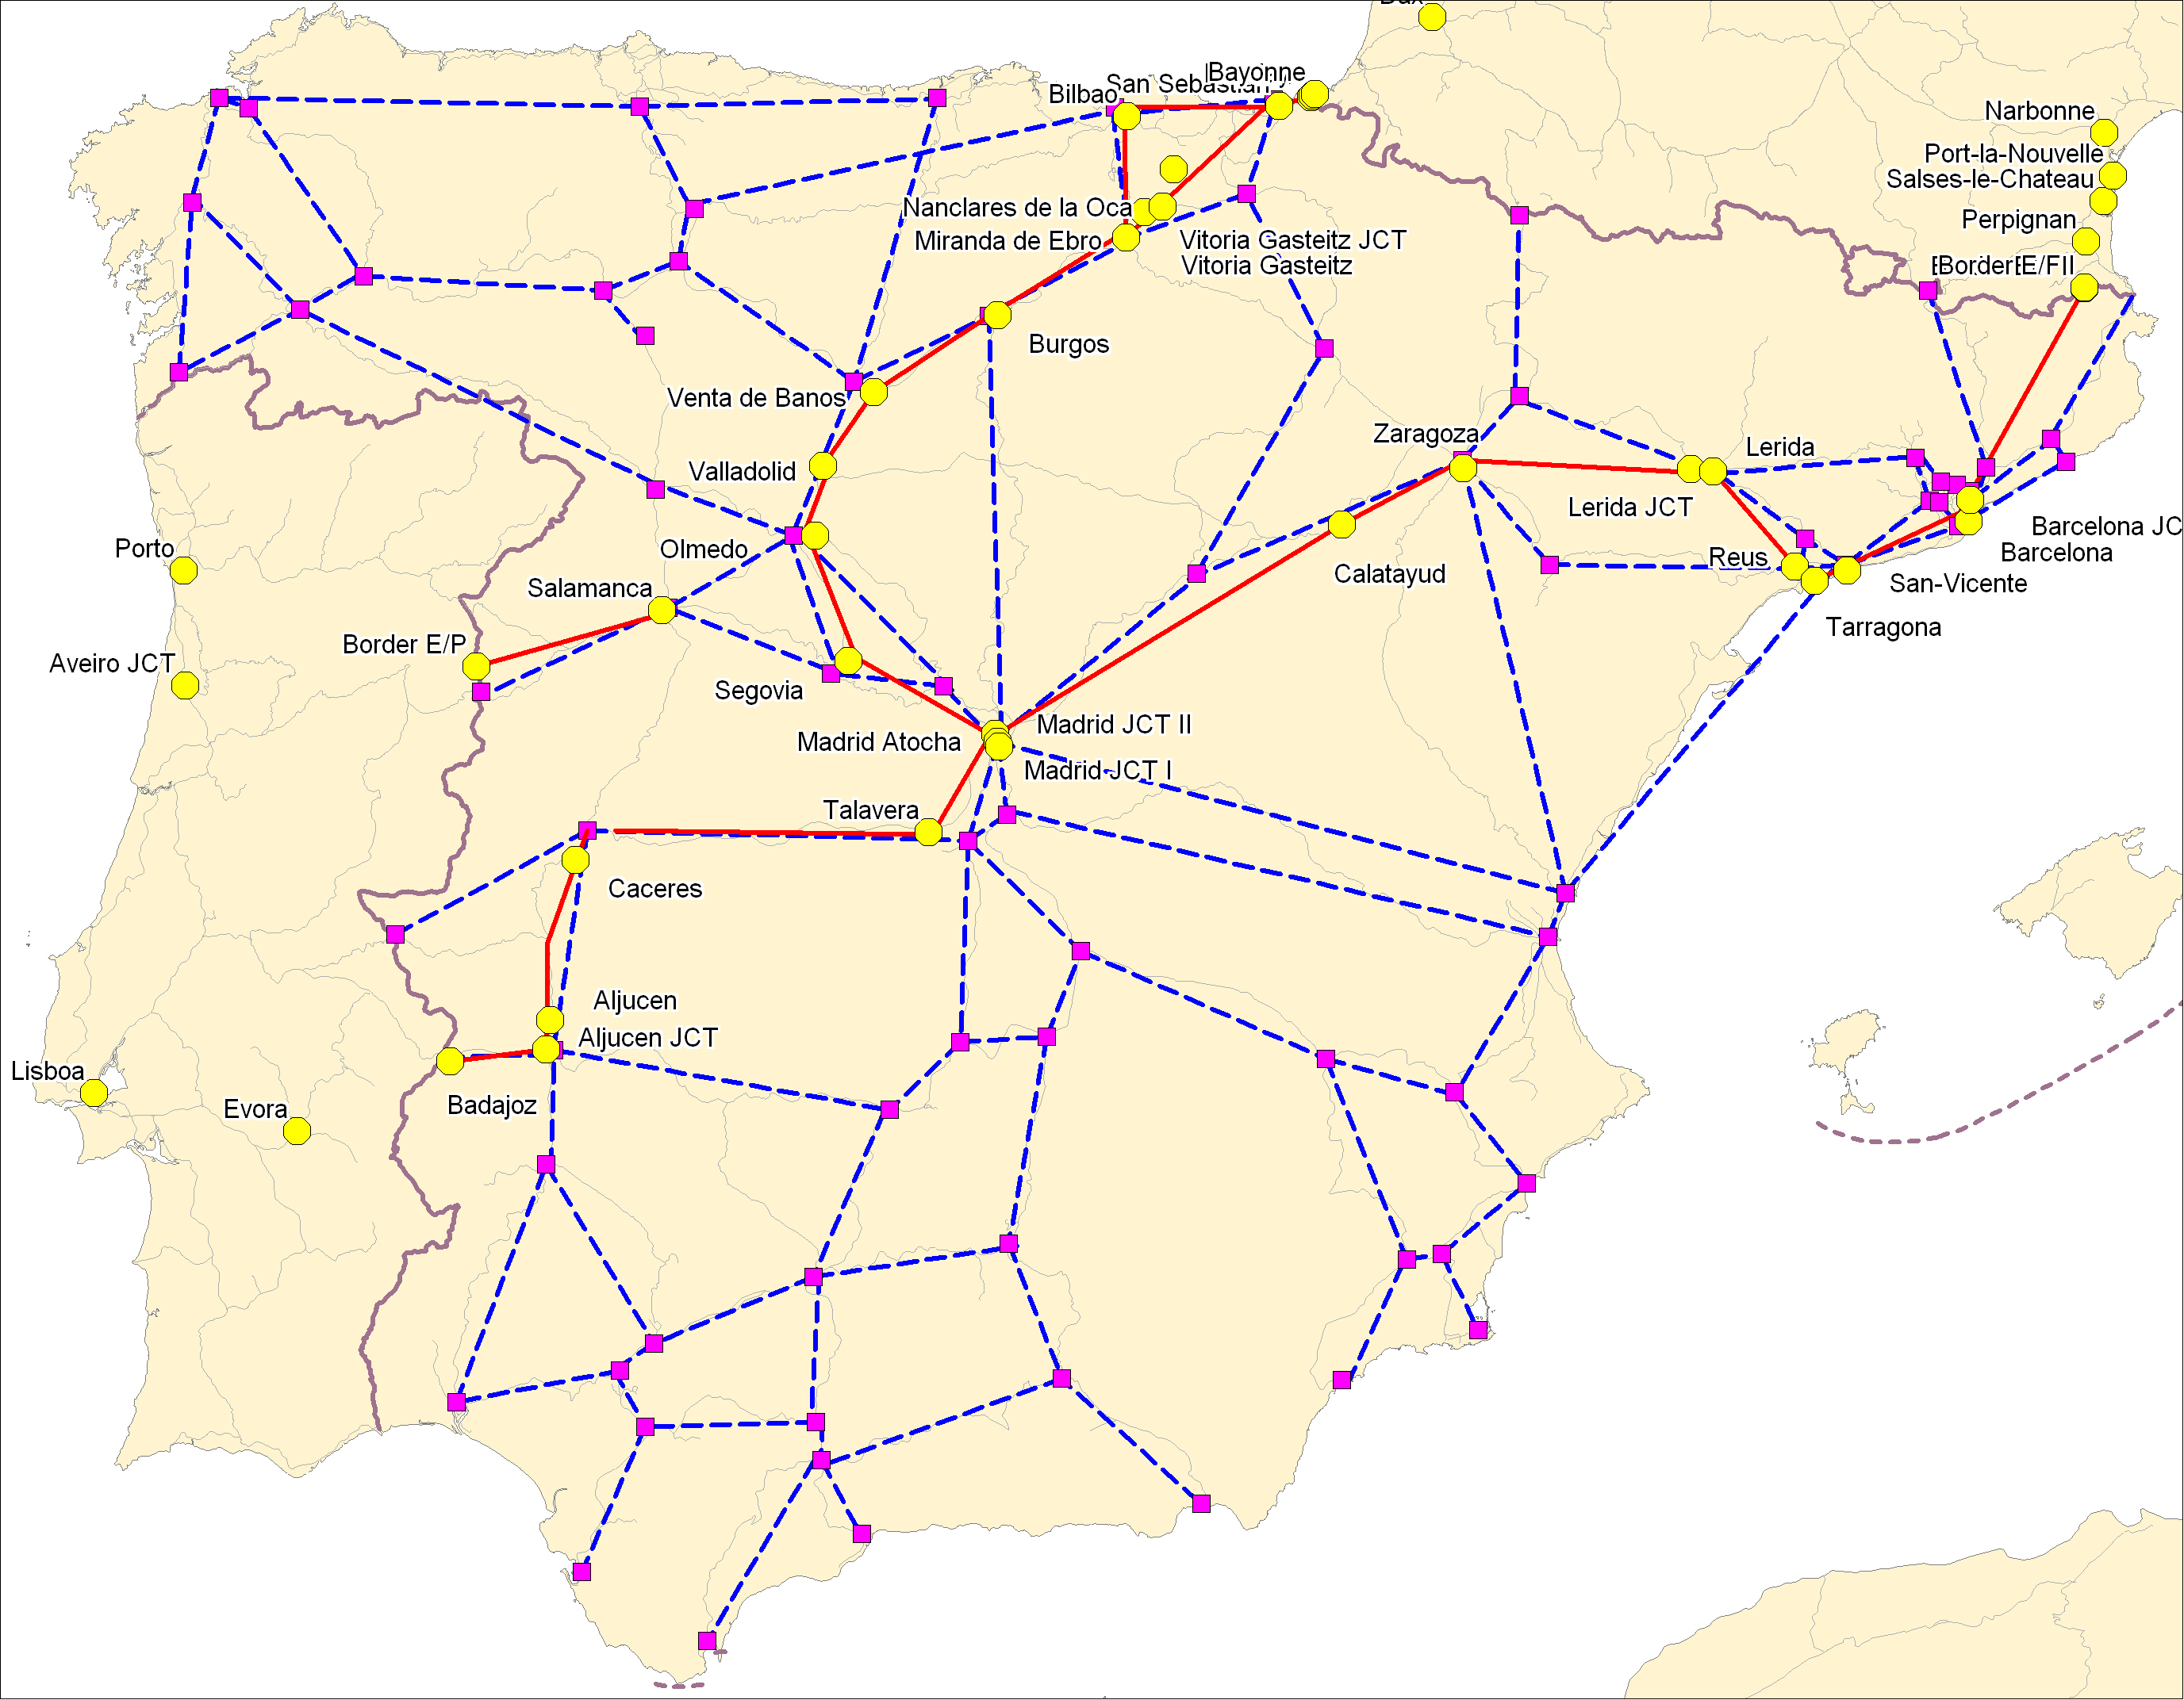
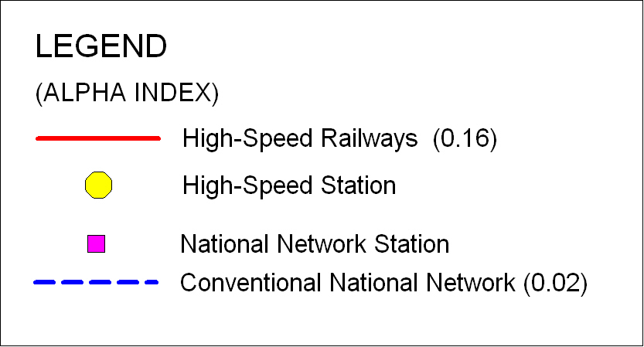

Map 2. Alpha Index for conventional and high-speed network in Spain.

The Beta Index is the second equation which measures the degree of interconnectivity of the network. The greater the number of edges, the greater the level of interconnectivity.
$$β=\frac{e}{v}$$

The Beta Index equation was applied again to the conventional rail network and to the high-speed rail network. The results of the Beta Index were measured against 1. The closer the Beta index is to 1, the better the interconnectivity of the network. The results of the Beta Indices for the conventional and high-speed lined in Spain were summarised in Table 3.

NETWORK | $$β=\frac{e}{v}$$
CONVENTIONAL | 1.3
HIGH-SPEED | 1

Table 3. Beta Indices conventional and high-speed rail network in Spain

The final equation is Gamma Index, which looks at the number of observed links compared to the maximum number of possible links. Like the previous two indices, the value of the gamma index is between 0 and 1. The closer the value is to 1, the more interconnected the network is.
$$γ=\frac{e}{3\left(v−2\right)}$$
The results of the gamma index are summarized in Table 4.

NETWORK | $$γ=\frac{e}{3\left(v−2\right)}$$
CONVENTIONAL | 0.44
HIGH-SPEED | 0.36

Table 4. Gamma Indices conventional and high-speed rail network in Spain

The expected results from the study were that the interconnectivity of the high–speed railway axis in Spain can be high and evenly distributed around the Iberian Peninsula as long as it is interconnected with the conventional national rail network.

Discussion of the results
The results of the study show that, as a peripheral state, Spain is not very well interconnected. Despite the high number of vertices and edges, the conventional and high-speed rail networks have very low alpha indices. That means that the observed number of cycles and circuits against the maximum possible number is as low as 16 percent for conventional rail lines and 2 percent for high-speed railways.
With regards to the Beta Index, the results showed that the degree of interoperability of the network in both conventional and high-speed lines is acceptably good. However, the conventional network shows 30 percent greater level of interconnectivity as a result of its more complex graphic structure.
The results from the final equation of Gamma Index show that the existing conventional network presents only 44 percent of the possible maximum network, and the high-speed rail network presents only 36 percent of the maximum possible network.
The graphic representation in the GIS software confirms that the high-speed rail network in Spain is a linear network with one circuit. Furthermore, it seems to overlap segments of the conventional rail network, giving the assumption that the high-speed rail infrastructure is interconnected if not integrated with the conventional rail infrastructure. That could mean that the rail network of Spain and subsequently of the Iberian Peninsula is expanded and complementary, allowing passengers to switch easily from one service to another. However, that is not the case. The edges and vertices of the high-speed rail network may run parallel or next to the existing conventional edges and vertices, but due to the ongoing negotiations and construction the high-speed network, it is too early to obtain concrete data on existing links between a high-speed and conventional integrated network. Therefore, at this point of the study one cannot assess the interconnectivity between the high-speed and conventional rail networks. What seems clear, however, is that the high-speed rail network is an international European network which will provide a connection and continuation to the overall European transport network. This also means that the Priority Axis No3 of South-West Europe is not only interconnected within its own network, but it is interconnected and expandable to other networks in the Iberian Peninsula, such as Priority Axis No19, aka High-Speed Rail Interoperability on the Iberian Peninsula, and Priority Axis No8, aka The Multimodal Axis Portugal – Spain – Rest of Europe.

CONCLUSION
An attempt has been made in this paper to assess the level of interconnectivity in the high-speed rail lines in Spain, as part of the Priority Axis No3 through the use of graph theory and GIS. Based on the calculations, the level of interconnectivity in Spain is acceptable, but weak around the Iberian Peninsula. The existing national rail network is more interconnected than the high-speed rail network because it shares more cycles and a more complex non-linear network. While the conventional network is more evenly spread around the Iberian Peninsula, the high-speed network focuses on major links connecting Spain with France and Portugal. Furthermore, there is no clear indication on the interconnectivity between the high-speed and conventional rail networks. What could go wrong is that the Priority Axis No 3 would concentrate transport infrastructure development and interconnectivity with the rest of Europe neglecting to interconnect with the national network. Due to the lack of circuits, the Priority Axis of South-West Europe is not self-sufficient and could not function as an independent network. Its interconnectivity depends on the axis interconnectivity with other axis of the Spanish and European transport network.
The study carries out simplistic analyses because it is concerned only with the nodes and their links, and seeks to measure the physical interconnectivity of the network. With additional data such as distance, time and population, the study can expand its evaluation into socio-economic interconnectity, accessibility and interoperability.
References
Affum, J. K. and Taylor, M. A. P. “Integration of geographic information systems and models for transport planning and analysis”. Pp.295-308. In Meersman, H., Van de Voorde, Eddy, Winkelmans, W. Transport Modelling Assessment. World Transport Research, 8th Conference.(1999). Pergamon.

Beuthe, M. and Nijkamp, P. (1999). New Contributions to Transport Analysis in Europe. Ashgate.

Bonnafous, A. (2002) The regional impact of the TGV. (pp.127-137). Found in Nash, C., Warman, M., Button, K., Nijkamp, P. 2002. Railways. Edward Elgar. (pp.480-490). Published in Transportation in 1987.

Bradford, M.G. and Kent, W.A. (1977). Human Geography. Theories and Applications. Oxford University Press.

Gutierrez, J. (2001). Location, economic potential and daily accessibility: an analysis of the accessibility impact of the High-speed line Madrid-Barcelona-French border. Journal of Transport Geography, 9 pp.229-242.

Haggett, P. and Chorley, R. J. (1969).Network Analyses in Geography. Edward Arnold. London.

Turró, M. (1999). Going Trans-European: Planning and Financing Transport Networks for Europe. Elsevier Science, Oxford.

“Trans-European Transport Network, TEN-T priority axes and projects 2005”. Luxemburg: Office for Official Publications of the European Communities, 2005.

