Influence of a new trunk bus route on the memory representation of residents and patronage

Katrin Dziekan, Royal Institute of Technology (KTH) Stockholm, Department of Transport and Economics, Division of Transportation and Logistics, Teknikringen 72, SE-10044 Stockholm/SWEDEN,
Phone: +46 (0) 8 790 79 77, Fax: +46 (0) 8 21 28 99, Email: katrin@infra.kth.se

Abstract
Trunk bus networks, applying some characteristics of rail systems, can help to enhance the simplicity of a public transportation system, thereby raising attractiveness of the system to its patronage. This paper investigates the effects of a new trunk bus line in the inner-city of Stockholm, Sweden on residents. The before-after evaluation study included structured telephone interviews of 121 residents and travel count data. Patronage increased by 10% two years after the implementation. People, especially the system users, found it easier to use the trunk bus than the former normal bus and their memory representation improved.

Keywords: public transport, memory representation, trunk bus system, residents, user perspective

Introduction
Bus networks are usually more difficult to understand than rail-bound public transport networks. Several studies have shown that people tend to prefer rail options for various reasons (Megel, 2001; Kottenhoff & Lindh, 1995; Schulz & Meinhold, 2003; Hass-Klau, Crampton, Biereth, & Deutsch, 2003; Stradling, 2002; Nossum, 2003). This phenomenon is called psychological rail bonus. As such, bus services become easier to use and more attractive to customers when features of rail-bound systems are adapted and applied to them. The successful implementation of Bus Rapid Transit (BRT) systems all over the world (Levinson et al, 2003) has already proven and supported this hypothesis. BRT is a bus-based mass transit “system” and requires coordination of a number of features including exclusive right-of-way lanes, rapid boarding and alighting, easy transfers, streamlined fare collection, clear route maps and other information, modal integration, clean vehicle technologies, marketing and customer service. Trunk bus networks have some elements of BRT.
A trunk bus strategy in metropolitan areas can include:
- Fast and direct connections parallel to the main traffic axis;
- High frequency of service;
- Long distances between stops;
- High accessibility, reliability and speed due to traffic prioritization;
- Large buses with high capacity;
- A clear network structure with few lines which are clearly differentiated (e.g., by color);
- Visible stops and routes within the urban area; and
- Well-designed information (e.g., maps similar to metro maps).
These elements are implemented to various extents in European trunk bus networks. In most cases, however, only a few of these features have been realized. Recent examples of trunk bus systems can be found in Germany. Hamburg introduced MetroBus in 2001 and patronage increased by 10%. Munich followed the good example in 2004 and in the same year, Berlin successfully restructured its whole trunk bus network. Reinhold & Krafft-Neuhäuser (2005) showed that in the case of Berlin, the metro buses attracted new customers and increased revenues.
In Copenhagen, the capital of Denmark, the “A-bus” concept (Nilas, 2003) was introduced in 2002: Six bus lines with an average headway of three minutes were called the “metro of the street.” The buses were branded red, instead of the traditional yellow color, as seen on the rest of the buses in Copenhagen. The implementation was accompanied by extensive information and marketing campaigns. Further, there was real-time information at the stops, displays onboard the buses, and improved bus priority schemes. Passenger numbers and satisfaction increased. About 90% of the travelers thought it had been easier to go by the trunk buses as compared to the former bus network (Sloth, 2004).
In Sweden, the three biggest cities have applied the trunk bus concept: Stockholm, Gothenburg, and Malmö. Stockholm, the capital of Sweden, with around 1.5 million inhabitants in the metropolitan area, offers an extensive public transportation system with commuter rail, light rail, subways, trams, ferries and buses. The trunk bus network in the inner city (see Figure 1) is a complement to the metro. Further, the lines were planned with the potential to be later upgraded to tram lines if permitted by passenger numbers and the city budget. In some cases, the trunk network lines even follow old tram routes that were discontinued in 1967.

Figure 1 about here

In Stockholm, buses were assigned to travel on main routes, distances between stops were increased to 400-500 meters, and service frequencies were set to 5-7 minutes throughout the day. Additionally, dedicated bus lanes were built along some segments of the routes, bus priority was implemented at several crossings, and bus stops were upgraded and enhanced. The roadways at the bus stops were made of red concrete in order to clearly indicate that this is a trunk route (Figure 2). Four lines with easy-to-remember one-digit numbers (1-4) were created. The standard colour of buses in Stockholm is red, but in order to make the trunk network buses more visible, these buses were painted blue. The brand-color blue is also used for all rail-bound traffic in Stockholm, such as subways, commuter trains and trams. Automatic next stop announcements are made on a digital display and over loudspeakers onboard the trunk buses. Furthermore, real-time departure information is displayed at every stop and new schematic maps showing the routes in the urban area were created.

Figure 2 about here

The first three trunk bus lines, implemented in stages between 1997 and 1999, were a success: Patronage increased up to 100% within a period of 5 years (Dziekan & Sedin, 2005; Dziekan, 2006). The fourth and last line – the Number 2 Line – was implemented later, in 2004. This paper describes the investigation of the implementation of this trunk bus line.

Research Questions and Hypotheses
A major question for transit planners is whether or not improvements in service, such as a trunk bus line implementation, increases patronage. Due to the success of the first three trunk bus lines in Stockholm, an increase in patronage can likely be expected for the fourth line as well. The first hypothesis is that ridership of the new line will increase in both sheer number of riders as well as in frequency of use.
Collecting data about what people know about this line is another approach. The term memory representation describes what people know and have in their minds about certain issues or things, such as a bus line. It includes not only cognitive maps as spatial representations of the environment (Kitchin & Freundschuh, 2000) but also other knowledge such as timetable knowledge. This knowledge serves as a basis for making travel mode choice, route choice or destination choices (Dziekan, submitted).
The level of acquisition of memory representations may vary for different groups of people. Studies of urban residents’ cognitive maps of their cities have found that there are differences in the cognitive maps depending mainly on which travel mode the person chooses. Appleyard (1970) found differences between people mainly using public transport and those who drive. Previous research seems to agree that familiarity with an environment influences the quality of the cognitive map and the knowledge about this particular environment (Gärling & Golledge, 2000; Gärling, Böök, & Lindberg, 1986; Gärling, Lindberg, & Mäntylä, 1983; Gärling, Lindberg, Carreiras, & Böök, 1986). Thus, experience with public transport systems influences the quality of the memory representation. Therefore, it is important to look at transit users and non-users separately when investigating memory representations and how they are influenced by trunk bus lines.
The second hypothesis is that the quality of the memory representation will be enhanced by the new trunk-bus concept. The assumption is that more people are aware of the option, due to the measures taken.
It is widely recognized that people’s perceptions of public transportation is generally pessimistic (Bonsall, Firmin, & Beale, 2004; Goodwin, 1997). Journey times and waiting times are usually overestimated while frequencies and network penetration are often underestimated (Lacy & Bonsall, 2001). Due to the real-time information installed at the trunk bus stops and presented on the transit information website people should be able to give more precise service frequency estimates after the trunk bus implementation.
From the planner’s perspective, it is desirable that the new line is easier to understand and to use by travelers. The third hypothesis is that the new trunk bus line is perceived as easier-to-use than the former bus line which ran along the same route.
In a study of exchange students (Dziekan, 2003) who had been in Stockholm for three months, it was shown that of these newcomers, 65% knew about the differentiation of red and blue (trunk bus) lines. Regarding the inner city trunk bus network, the most perceived differences were: more comfortable, larger, low-floor buses, real-time information displays at the stops, higher service frequency, alignment along main routes.
Which differences do residents freely associate? Before the implementation of Route Number 2, residents had already been experiencing the other blue trunk buses in other parts of the city. With the implementation of the last line they were more directly affected since it serves their residential area. Thus, the fourth hypothesis is that the freely associated differences between the normal buses and the trunk buses become more detailed and that people realize and acknowledge the measures undertaken for the trunk bus network.
Memory representations of transit users and non-users are different. Users tend to have more opportunities to test new lines and therefore, are familiar with frequency and route. They may also be able to name more differences and find it easier to use the new line due to their relative experience. The fifth hypothesis is that transit users know more about the new line than non-users. Users are expected to mention this route as the best route to an inner city destination more often, better estimate the service frequency, recognize more differences between the new trunk line and other lines, and find it easier to use.

Methods
In June 2004 a new trunk bus line, Line Number 2, replaced the old red bus line Number 46 in Stockholm. Before implementation, a residential area close to the future trunk bus line was selected for a before-after survey. This area in central Stockholm, containing mainly multiple story apartment buildings, was already well-served by transit. Residents of this area can access two different metro lines within 250-640 meters. The red bus line 46, in the before situation, and the trunk bus 2 in the after situation, passes the area and serves two stops (Jarlaplan and Tegnergatan). The walking distances to these stops are between 25 and 150 meters (see Figure 3).

Figure 3 about here

When checking knowledge it is necessary to ensure that people do not consult other sources for their answers, thereby producing bias. Thus, only direct interview methods like face-to-face or telephone interviews could be considered for this study of memory representations (Bortz & Döring, 1995; Lavrakas, 1993). The latter was chosen for reasons of cost and efficiency.
A repeated measurement was used. For the area, 399 telephone numbers were officially registered and accessible, and 279 of these numbers were randomly called in the before test phase. 27% of the people who answered the phone refused to participate in the study. Only people above the age of 15 were asked to answer the questions. Moreover, only people who had been living in the area for more than half a year were included in the sample because it was necessary that they have had enough time to familiarize themselves with the transit options in their area.
The computer-aided telephone interviews were conducted in January 2004 and October 2005 by four trained interviewers. The calls were made between 5pm and 9pm on weekdays. Each interview lasted between 10 and 25 minutes. In the before test the person who answered the telephone was asked to answer the questions. 197 persons agreed to participate in the after test and were contacted for the after interview. Finally 121 persons participated both in the before and the after test (response rate 60%). The loss of 83 persons consists of 45 persons who refused to participate, 34 persons who moved from the area, and 4 persons who passed away. The comparison of the characteristics of the drop out sample and the finally analysed sample showed no significant differences for the variables of gender, employment, level of education, mode choice for commute trips, car availability, and frequency of transit use. Only the age variable showed a significant difference. People in the remaining sample used in the after test were older on average than people in the drop out sample.
The structure of the interview was tested and improved in the two pre-tests. To make the route knowledge questions more straightforward, a scenario was introduced whereby the respondent was asked by a friend to give them a transit route from one point to another in Stockholm. In total, two such “how to get from A to B” route knowledge questions relevant were asked (see Table 1).

Table 1 about here

The frequencies of services during peak commute periods and on Sunday afternoons were asked for the bus line in question. If the respondent said he/she did not travel on these lines, he/she was instead asked to guess the frequency.
To determine user frequency, respondents were asked how often they use public transportation in Stockholm and when they last rode the bus line in question. Further, Automated Passenger Counting (APC) data was obtained from the transit authority for all lines in the trunk bus network.
People were asked in the interview if they know the “blue buses” (trunk buses) in Stockholm and if so, what do they think are the differences between these and the normal red buses?
In the after test a question concerning ease-of-use of the bus line was included as a post-hoc comparison of the trunk bus and the former bus line. The question was: ”How easy is it to travel by bus number 2 compared to the former bus, number 46?” The answer was formulated on a 5-grade scale: much more difficult, difficult, about the same, easier and much easier.

Results

Sample characteristics
Of the 121 people interviewed both before and after the implementation, approximately half were females (54%). The ages ranged from 22-89 years old in 2004 and were more or less equally distributed besides a slight overrepresentation of people between the ages of 55 and 60. Half of the respondents were employed full-time, 29% were pensioners, 15% worked part-time, and the remaining were students or unemployed. The majority of the sample held a university degree (82%) and 12% had completed an upper secondary education.
In the sample, only people who had been living for more than half a year in the selected residential area at the time of the before test were considered. Nearly a third of the sample (30%) had already been living in the area for more than 20 years, 48% between 5 and 20 years, 22% between 1 and 5 years, and 1% of the sample had moved to the area between 7-12 months ago. The car availability in the entire sample was 76% in the before and 79% in the after test.
Through a comparison with statistical data for the area from Statistics Sweden (SCB) it can be concluded that the sample is representative of the area in terms of age, gender, employment rate, and level of education. But the area is one of Stockholm’s wealthier areas whose residents have a higher level of education than the average person.
There were no significant differences in level of informing about public transportation in Stockholm between the before and the after tests. 23-32% of the respondents indicated that they receive information mainly through newspapers and through placards at stops and stations. The remembered information concerned: route changes, new timetables, and aspects about the new blue bus both in the before and after tests. Thus, there are no influences of information on the knowledge performance to expect.

Patronage
Several sources of data can be analysed by looking at patronage. There were three questions in the interview regarding frequency of transit use: general transit use frequency, travel mode to work and user frequency of the particular bus line. People were asked in the interview when they last rode the bus line in question (Number 46 / Number 2). Figure 4 shows the results. It was longer time ago that residents rode last time the new bus line number 2 than the former line. A significant drop in transit usage must be stated for both public transportation in general (paired sample t-test, 1% sign.) (Figure 5) and for public transportation as a choice for commuting (Figure 6).

Figure 4 about here

Figure 5 about here

Figure 6 about here

In the after test residents were using transit less often than in the before test. In January 2004 every fourth person acknowledged using transit more than 5 times per week, whereas in October 2005 only 17% of the residents were using transit so often.
The drop in the transit share for the way to work is significant (1% chi2). An in-depth analysis of the specific type of transit used showed that there was a significant drop in metro usage while bus usage remained constant.
Data from APC (see Figure 7) confirm the result that patronage on the new trunk bus line (Line 2) did not increase in the period from 2002 – 2004. But by 2005 patronage had increased on Line 2 by 10%. The patronage on the other trunk bus lines did not increase to the same extent. Between 2004 and 2005 the other lines even lost passengers, while the new trunk bus line was gaining passengers. Then, in 2006 Stockholm implemented a road pricing trial which increased overall transit patronage.

Figure 7 about here

Route knowledge
The investigated bus line (46/2) was the main line recommended by respondents for a trip to a well-known tourist destination (Figure 8). Almost every second person mentioned the bus line 46 in the before test. After the implementation of the trunk bus line 2, some still referred to it as bus line 46. Counting these answers as trunk bus line answers and summing up options 46 and 2 in the after test, about 55% of the people mentioned the trunk bus line. This difference is not significant but when looking at it after separating transit users and non-users, it becomes significant (for the users). It can be concluded that people who travel more than 2 days per week by transit recommend the bus more often than they did previously when bus 46 serviced the area.

Figure 8 about here

Figure 9 shows options named by respondents for traveling by public transportation from a square close to their living area, to an inner-city destination. 79% recommended bus 46 in the before test. Again, some respondents still mentioned line 46 in the after test. Adding this to the number who answered line number 2 indicates that 76% correctly mentioned the 46/2 bus line. The difference is not significant and even separated from non-transit users, there are no differences.

Figure 9 about here

Frequency estimate
Table 2 shows the correct frequencies (according to the timetable) and the estimated service frequencies of the bus line in question. They were underestimated in all cases and especially for Sunday service. The difference in estimates for peak hour service in the before and after tests is not significant but the difference for Sunday service reached a 10% significance level (paired sample t-test of the estimates).

Table 2 about here

For the subgroup of transit users, the results differed significantly (5% level, paired sample t-test) as can be seen in Table 3.

Table 3 about here

Residents underestimated the service in peak hours as well as on Sundays. In the latter case, estimates were worse than for the peak hours: respondents believed that the bus runs only twice during a period when it actually runs three times.
There were no differences in service frequency estimations for the before and after tests for the average resident. Whereas transit users estimated the service frequency of the trunk bus line more correctly in the after test, they came significantly closer to the real service frequency.

Ease-of-Use Perception
The distribution of the answers to the post-hoc ease-of-use perception is shown in Figure 10. The mean was 3.5, using the same 5-grade scale as described in the Methods section, and differs significantly from the mean category rated at 3 (one-sample t-test 1% level). Thus it can be concluded that people find it easier to travel on the new trunk bus line compared to the former ordinary bus line.

Figure 10 about here

Separated by transit usage, it can be stated that people who travel more than 2 days per week by transit perceive the trunk bus as significantly easier to use than the former bus line (one-sample t-test, 1% level) with a mean of 3.7. On the other hand, people who use transit rarely or never notice few or no differences between the two bus lines (mean: 3,2; not significant different from 3).

Recognized differences
In general it was found that the awareness level of the trunk bus network increased. 90% of those surveyed knew about it before the implementation of the fourth trunk bus line. This value rose to 96% in the after test (t-test sign. 1%). The number of people who mentioned free-associated differences between the red buses and the blue buses was almost the same in the before and after tests (N_{before} = 110; N_{after} = 103). On average, people listed two to three items in their answers. In the evaluation process, all answers were categorized by two people independently and then discussed in order to agree on a category structure. Figure 11 summarizes the results. The most remarkable differences mentioned, concerned the buses themselves. The blue trunk buses were perceived as larger with more space, longer, articulated, able to carry more passengers, more comfortable, nicer overall, accessible to people with disabilities and accommodating of baby carriages due to low-floor entrances, and equipped with on-board displays and announcements. It was also noted that the trunk buses offer a higher service frequency, run faster, travel on longer routes, and form a special trunk bus network.

Figure 11 about here

Comparison of mental representations between transit users and non- transit users
This section analyzes results to examine the fifth hypothesis regarding the memory representations of users and non-users. While above, the segmentation between transit users and non-users was used to explore the effect on the other hypotheses, this section studies the differences in the mental representations between people who use transit very frequently (more than 2 days per week) and those who rarely or never use transit.

Table 4 about here

Before the implementation of the trunk bus line both transit users and non-users recommended the existing bus line to the same extent. The new trunk bus line enhanced the recommendation rate by the transit users – they mentioned significantly more often than non-users the number 2 bus in the route knowledge questions. The service frequency estimate for the rush hours in the before situation was the same for users and non-users but in the after test, the non-user group underestimated the service frequency more often than did the users. For Sunday service the estimates differed significantly for users and non-users to the same extent in the before and the after tests.
Users, more than non-users also stated that it had become easier to use the new trunk bus line compared to the former bus line.
There were no differences between users and non-users in the awareness of the trunk bus network. Last, there were no significant differences between transit users and non-users in the extent to which they recognized differences between the blue and the red bus lines in Stockholm. The average number of recognized freely-associated differences decreased from the before to the after test for both groups. Even on a more detailed level, no significant differences were found.

Summary and Discussion
Patronage of the trunk bus line rose by 10% - a result that is similar to the reported success of trunk bus networks in other European cities. But it took two years for this increase to occur despite the fact that memory representations and awareness improved within just seven months after implementation. Thus, the trunk bus line had initial effects on customer perception before patronage impacts were seen. So an investment in a trunk bus line should be made with an eye to the long-term. It takes people some time to learn the new line.
The increase of patronage on the new line was lower than for the other trunk bus lines after their introduction. There are two possible explanations for this result. First, the former bus number 46 was already very attractive and there was not a large base of potential customers to tap. Second, fares were raised during this period and throughout the whole network, patronage remained static or decreased. A decrease in subway usage was found in this investigation while bus usage remained constant in 2004/2005. Usually, buses lose customers first when service attributes are degraded. Therefore, the constant traveler numbers could be interpreted as a pro-trunk-bus argument. This project did not include an analysis of network patronage changes. Therefore it was not possible to model the effects in a transit patronage model as for instance Peng et. al (1997) did.
Table 5 summarizes the results of all hypotheses.

Table 5 about here

Only transit users experienced a change in memory representation from the trunk bus implementation. They named the bus option more often in one of the two route knowledge questions and estimated the service frequency more correctly after the trunk bus implementation. But non-users did not change their estimations significantly. Here, a clear effect of usage can be seen. The real-time displays installed at the trunk bus stops supported enhanced memory representations and knowledge of service frequency.
The trunk bus was perceived as easier to use. Here again, this was more evident in the transit user. It should be mentioned that this was a post-hoc measurement and a before and after test with a standardized scale would have been more reliable. It is desirable to improve and develop a better method of measuring “ease-of-use” in future research.

The analysis of the listed differences between the trunk buses and the non-trunk buses were approximately the same in quality and quantity in the before and after tests. There was even a decrease in the number of mentioned differences in the after test. It might be that the residents already had an image in their minds about the trunk buses in the inner-city since there were already three trunk bus lines operating in Stockholm and this picture did not change much by the introduction of a trunk bus line near their residential area. Further, it is a difficult task to answer a free-association question and it might be hard for the people to come up with even more differences than they already mentioned in the before interview.

Transit users mentioned the trunk bus route to an inner-city destination more often than non-users, at least in one of the route knowledge questions. They also estimated the service frequency for the trunk bus on weekdays more correctly. Transit users found it easier to use the new line but when it came to perceived differences between the trunk bus lines and normal bus lines, users and non-users answered similarly.

Before and after the implementation of the last trunk bus line in Stockholm, no special marketing campaigns were done. This was positive for this study since effects of information or marketing regarding the trunk bus line can be excluded as influence on the responses. Nevertheless, it would be desirable to have increased marketing activities in the future in order to communicate the trunk bus network to people who do not currently use transit. The non-users do not have a good memory representation of the line and need information about it. The new trunk bus line enhanced the memory representation of existing transit users and it had an effect on the awareness level for the trunk bus network of residents in general. But this significant increase from 90 to 96% of publicity could also be to some extent a measurement artefact since people could have been sensitized by the before test.

A possibility for further research could be to replicate this investigation in other cities that plan to implement a kind of trunk bus network or equip a single bus line with rail-bonus features or other similar improvements in the public transport network. A more extensive test design including two control groups, one without treatment (the implementation) and one without before-test sensitization, could enhance the reliability and validity of the results. Further, it could be useful to test marketing effects on the non-users.
In general, the implementation of a trunk bus network with rail characteristics has increased bus patronage in the Stockholm inner city. In this paper first assumptions about what the success factors are were outlined. There is still a need for further studies to determine which characteristics are most important for creating an attractive bus network.

Acknowledgement:
This research was financed by VINNOVA – The Swedish Agency for Innovation Systems.

References
Appleyard, D. (1970). Styles and methods of structuring a city. Environment and Behavior, 2, 100-118.
Bonsall, P., Firmin, P., & Beale, J. (2004). Perception of Modal Attributes: How Accurate and How Susceptible to Change? Paper presented at the Annual Meeting Transportation Research Board, Washington, DC.
Bortz, J., & Döring, N. (1995). Forschungsmethoden und Evaluation für Sozialwissenschaftler (2 ed.). Berlin: Springer.
Dziekan, K. (2003). Easy to use public transport - Framework for analysis and development of simplicity, information and orientation. Interviews with exchange students in Stockholm (No. TRITA-INFRA 03-047). Stockholm: Royal Institute of Technology (KTH).
Dziekan, K. (2006). Die Erfolgsgeschichte der Blauen Busse in Stockholm/Schweden. Verkehrszeichen, 22(3), 25-29.
Dziekan, K. (submitted). What do people know about their public transport options? Investigating the memory representation of public transport through telephone interviews in a residential area of Stockholm/Sweden.
Dziekan, K., & Sedin, S. (2005). Customer reactions to the implementation of a trunk bus network in Stockholm. Paper presented at the 56th UITP World Congress, 5-9th June, Rome/Italy.
Goodwin, P. B. (1997). Mobility and car dependence. In T. Rothengatter & E. Carbonell Vaya (Eds.), Traffic & Transport Psychology (pp. 449-464). Amsterdam, New York, Oxford, Tokyo: Pergamon.
Gärling, T., Böök, A., & Lindberg, E. (1986). Spatial orientation and wayfinding in the designed environment - A conceptual analysis and some suggestion for postoccupancy evaluation. Journal of Architecture and Planning Research, 3, 55-64.
Gärling, T., & Golledge, R. G. (2000). Cognitive mapping and spatial decision-making. In R. Kitchin & S. Freundschuh (Eds.), Cognitive Mapping: Past, present and future (pp. 44-65). London, New York: Routledge.
Gärling, T., Lindberg, E., Carreiras, M., & Böök, A. (1986). Reference systems in cognitive maps. Journal of Environmental Psychology, 6, 1-18.
Gärling, T., Lindberg, E., & Mäntylä, T. (1983). Orientation in buildings: Effects of familiarity, visual access, and orientation aids. Journal of Applied Psychology, 68(1), 177-186.
Hass-Klau, C., Crampton, G., Biereth, C., & Deutsch, V. (2003). Bus or Rail: Making the Right Choice - A Financial, Optional and Demand Comparison of Light Rail, Guides Buses, Busways and Buslanes. Wuppertal: Bergische Universität Wuppertal, environmental & transport planning.
Kitchin, R., & Freundschuh, S. (Eds.). (2000). Cognitive mapping - Past, present and future. London, New York: Routledge.
Kottenhoff, K., & Lindh, C. (1995). The value and effects of introducing high standard train and bus concepts in Blekinge, Sweden. Transport Policy, 2(4), 235-241.
Lacy, D., & Bonsall, P. (2001). Misperception and mode choice. Paper presented at the WCTR, Seoul July 2001.
Lavrakas, P. J. (1993). Telephone Survey Methods - Sampling, Selection, and Supervision (2 ed. Vol. 7). London: Sage.
Levinson, H., Zimmerman, S., Clinger, J., Rutherford, S. G., Smith, R. L., Cracknell, J., et al. (2003). Bus Rapid Transit - Volume 1: Case Studies in Bus Rapid Transit. TCRP Report 90 No.
Megel, K. (2001). Schienenbonus: Nur ein Mythos? Bus oder Bahn im Regionalverkehr - Schemata und Präferenzen. Der Nahverkehr, 19(6), 20-23.
Nilas, C. (2003). Down-sizing, optimizing and re-branding: the A-bus concept. Paper presented at the 2nd UITP International Marketing Conference, Paris.
Nossum, Å. (2003). Public Transport: Travellers´Valuation of Time in the Oslo Region. Nordic Road & Transport Research(2), 16-18.
Peng, Z.-R., Dueker, K., Strathman, J., & Hopper, J. (1997). A simultaneous route-level transit patronage model: demand, supply, and inter-route relationship. Transportation, 24(2), 159-181.
Reinhold, T., & Krafft-Neuhäuser, H. (2005). Metrobus und Metrotram für den Metropolenverkehr - Konzept zur integrierten Optimierung des Berliner Nahverkehrs. Der Nahverkehr(7-8), 32-38.
Schulz, M., & Meinhold, C. (2003). Quantifizierung des Schienenbonus - Messung des Kundennutzens mittels Choice-Based-Conjoint-Analyse. Der Nahverkehr(6), 26-29.
Sloth, J. (2004). 100 år og hvad så? A-busser - Metro på gadeplan i Kobenhavn. Paper presented at the Århus Sporvejes conference, Århus.
Stradling, S. G. (2002). Transport User Needs And Marketing Public Transport. Municipal Engineer, ME 151(1 - Special Issue on Sustainable Transport Policy).
TABLES

Table 1: Route knowledge questions and their possible answers
Origin – Destination | Transit Routes | Walking Distance | Travel Time
Home –  Gamla Stan | Bus 46  Bus 43  Green metro line  Red metro line | 25m-150m  25m-150m  380m-640m  250m-590m | 10min  12min  5min  8min
Jarlaplan – Kungsträdgården | Bus 43  Bus 46  Metro (with a transfer) | 25m-150m  25m-150m  250m-640m | 7min  12min  12-15 min

Table 2: Average responses to the service frequency of the investigated bus line before and after implementation of the trunk bus line
 |  | Correct answer (min) | Estimate average (min) | Difference (percent)
Weekday Peak Hour | BEFORE | 5 | 6.6 | +32%
Weekday Peak Hour | AFTER | 5 | 6.5 | +30%
Sunday Midday | BEFORE | 8 | 14.0 | +75%
Sunday Midday | AFTER | 7.5 | 13.0 | +73%

Table 3: Average answers to service frequency separated after transit usage
 |  | Before (min) | Difference (percent) | After (min) | Difference (percent) | Sign.
Transit Users | Peak Hours | 6.5 | 30% | 5.7 | 14% | Sign.*
Transit Users | Sundays | 12.5 | 56% | 11.0 | 47% | Sign.*
Non-Transit Users | Peak Hours | 6.7 | 34% | 7.6 | 52% | n. sign.
Non-Transit Users | Sundays | 16.0 | 100% | 15.6 | 108% | n. sign.

Table 4: Results to all questions separated after transit usage
 |  | Transit user | Non-transit user | Significance
Mentioned 46/2 as route to tourist destination
 | Before | 53% | 43% | n. sign.
 | After | 63% | 45% | *
Mentioned 46/2 as route to inner-city destination
 | Before | 88% | 74% | n. sign
 | After | 43% | 59% | **
Service frequency estimate in minutes
Peak hours | Before | 6.5 | 6.7 | n. sign
 | After | 5.7 | 7.6 | **
Sunday | Before | 12.5 | 16.0 | **
 | After | 11.0 | 15.6 | **
Ease-of-use perception (average)
 |  | 3.6 | 3.2 | *
Knowledge of trunk bus network
 | Before | 92% | 90% | n. sign
 | After | 98% | 94% | n. sign
Recognized differences
 | Before | 90% | 90% | n. sign.
 | After | 100.0% | 94% | n. sign.
Recognized differences – average number of answers per person
 | Before | 2.7 | 2.1 | n. sign.
 | After | 2.1 | 1.7 | n. sign.
Paired sample t-tests * significant on the 5% level, ** significant on the 1% level

Table 5: Summary of results referring to the hypotheses
 | Expected impact of the implementation | Result
1) | Increased patronage | No, for the residents 7 months after implementation. In fact, there was a slight drop.  Yes, after 2 years, 10% higher patronage.
2) | Bus #2 more often recommended for route:
 | Home – Gamla Stan | Yes for the transit users by 4%  No for non-users
 | Jarlaplan - Kungsträdgården | No
 | More correct service frequency estimation | Yes for transit users: incorrect estimations dropped from 30% to 14% (peak hours) and from 56% to 47% (Sundays)  No for non-users
3) | Ease-of-use perception | Yes, easier for all; especially transit users
4) | Awareness level increases | Yes, from 90% to 96%
 | More freely-associated differences | No
 | More detailed differences | No
5) | Differences between users / non users:
 | Transit users mention the #2 bus to inner-city destinations more often | Yes
 | Transit users estimate the service frequency better | Yes
 | Transit users recognize more differences | No
 | Transit users find trunk bus easier | Yes

FIGURES

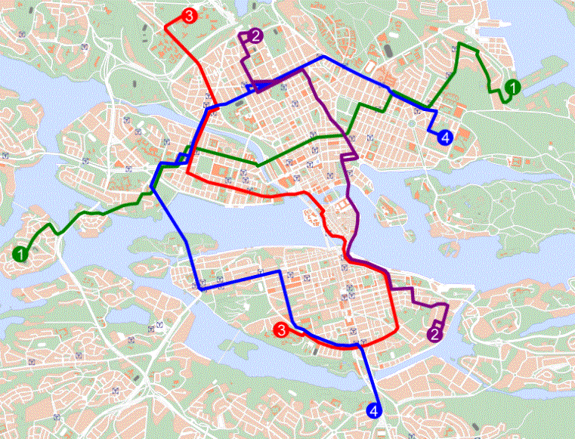
Figure 1: Routes of the trunk bus network in the inner city of Stockholm

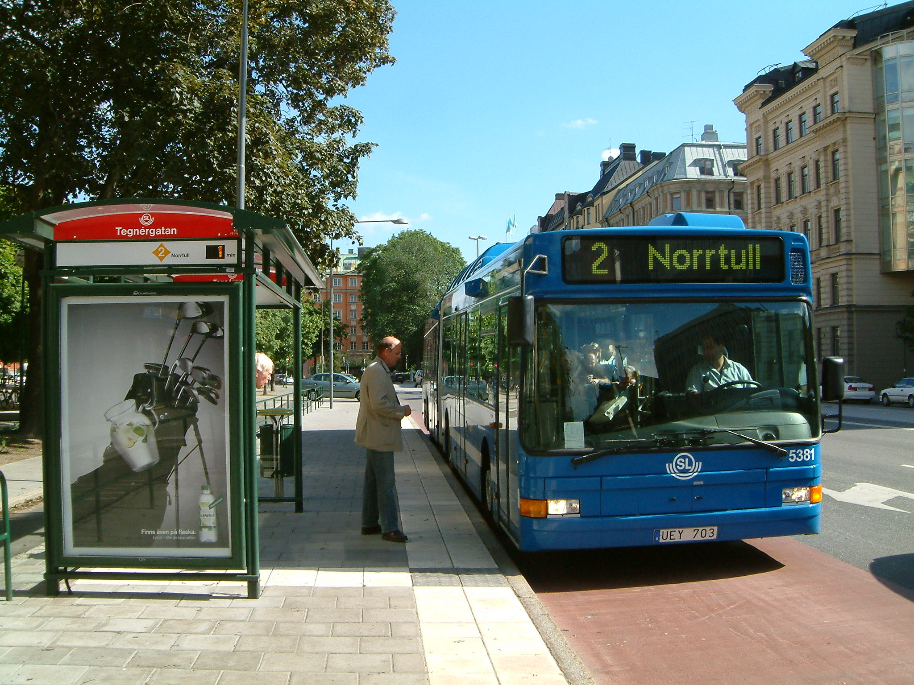
Figure 2: A typical bus stop in the trunk bus network with a real time information display and red concrete

Figure 3: Surveyed residential area marked on a map with transit connections

Figure 4: Time since the last ride on the bus Line 46 compared with Line 2

Figure 5: Stated user frequency of public transportation before and after the implementation of the trunk bus line

Figure 6: Modal split for commute trips during the winter before and after implementation of the trunk bus line

Figure 7: Patronage based on APC for the inner-city trunk bus network in Stockholm

Figure 8: Route knowledge from place of residence to a tourist destination (Home – Gamla Stan)

Figure 9: Route knowledge between a square close to residential area and inner city destination (Jarlaplan – Kungsträdgården)

Figure 10: Post-hoc ease-of-use evaluation compares trunk-bus line 2 with former bus line 46 (N=89)

Figure 11: Qualitative answers to differences between blue and red bus lines in the before and after test

