INTEGRATION OF HARD AND SOFT ITS ARCHITECTUREs
FOR LOCAL PUBLIC TRANSPORT

Francesco Russo, Agata Quattrone
Mediterranea University of Reggio Calabria
Dept. of Computer Science, Mathematics, Electronics and Transportation
francesco.russo@unirc.it, agata.quattrone@unirc.it

ABSTRACT

Many efforts are made in the world-wide in the last decade in order to improve the technological interoperability of Intelligent Transportation Systems (ITS).
In particular, are multiple the national processes of ITS integration that have been activated in the world. As regarding the hardware integration, with the definition of telematic reference Architecture. As regarding the software integration with the realization of some conceptual Reference Data Models in the specific field of Public Transport. Anyway, nothing has been tried for the simultaneous integration of hardware and software.
In this paper, starting from an analysis of:
- the European ITS Architecture and in particular of the section (KAREN Transit) which is entirely dedicated to the specific field of local Public Transport (hardware integration)
- the Reference Data Model called TRANSMODEL to structure and standardize the databases and the interoperability, at software level, of the ITS adopted by PT companies (software integration)
the main problems about standard coordination both hardware and software of ITS are treated and a possible approach for an integration, just for one aspect in the field of PT- Public Transport, of European ITS Architecture KAREN Transit with the standard TRANSMODEL is suggested.
PREFACE

The development of the Intelligent Transportation Systems (ITS) requires the cooperation of Agencies (institutions and companies) that historically have different and independent trends of development, and integration of hardware from heterogeneous technologies (sensors, systems of telecommunications, instruments of visual and sound interface etc.) and software, that mainly consist on the predisposition of database usable simultaneously from various applications at different levels. The two levels of integration, hard and soft, interact, increasing further the complexity.
All over the industrialized world the articulation of the skills in matter of transport has been defined in the years pre-telematic and then the problem to guarantee the coordination of all the system involved, and for each of them of all subsystem components, did not exist.
It is therefore topical to face the subject of the hardware and software interoperability of ITS and it is necessary to eliminate the obstacles to their development and their diffusion, creating the basic conditions for the market, an adapted context of development and a framework of unitary reference.
In the paper the three themes, in the following proposed, are developed.
An analysis of the European ITS Architecture specified by the European Commission within KAREN Project (Keystone Architecture Required for European Networks) and in particular of the section which is entirely dedicated to the specific field of local Public Transport (PT), for the interoperability at hardware level of the ITS adopted by PT companies (section 1). An analysis of a Reference Data Model called TRANSMODEL (European Reference Data Model for Public Transport) developed by the European Commission to structure and standardize the databases and the interoperability, at software level, of the ITS adopted by PT companies (section 2).
An initial summary analysis is made of the main problems of standard coordination of both ITS hardware and software in the field of public transport. Some solutions for an integration of KAREN Transit European ITS Architecture (hardware) with the standard TRANSMODEL (software) is proposed (section 3). Finally, some conclusive considerations are reported (section 4).

1. HARD INTEGRATION: THE KAREN PROJECT

As regarding the hardware integration, the definition of telematic reference Architectures carried out from many Countries in the three main areas of world-wide interest (1. United States, Canada and Latin America with the National ITS Architectures; 2. Japan and Asia-Oceania area with the promotion of ITS Architectures and Standardization; 3. Europe with the Reference ITS Architecture, for more see Russo and Quattrone 2007) has created the normative, economic and administrative context in order to activate a flexible and harmonic development of the ITS at national level.
The European Commission, which aims to facilitate the development and diffusion of the Intelligent Transport Systems and to create an only market for ITS services, in relation to necessary hardware integration previously cited, has become active, since the 1990s, in developing a Reference ITS Architecture, within the research programs on Telematic for Transports, with different projects. The last one, the KAREN Project (Keystone Architecture Required for European Networks) brings together all results.
The European Commission with the KAREN Project has delivered in September 2000 the first version of European ITS Architecture, that supplies an only reference framework for the development of ITS products and services in Europe.
1.1 Objectives

The main objectives of the KAREN Project are:
- to define fundamental requirements for an open and dynamic market of ITS systems in all Europe and in the rest of the world;
- to create the basis for broad approval, thereby removing obstacles to widespread implementation of ITS systems in Europe and hence to work together with all users to acquire or develop a convenient, compatible ITS system throughout Europe; to create a point of contact between operating in ITS field and the technologies producers that could be used in ITS systems;
- to be the guide for publics investments for the construction of necessary basic infrastructures to the development of ITS systems;
- to support the research in areas of development and eventual pilot projects.

1.2 General aspect and main Elements

The European Reference Architecture is structured in different documents dedicates to various architectural problematic.
The complete documentation is organized in three main sections:
- User Needs: the consolidated list of the necessities and requirements of the users of European ITS systems;
- Framework Architecture: the Telematic Architecture to support ITS systems, organized in four documents:
- European ITS Architecture Overview - that supplies suggestions and recommendations in order to effectively and correctly use of the several Architecture elements;
- European ITS Functional Architecture - the Functional Architecture that contains diagrams called Data Flow Diagrams (DFD) that describe the exchange of Data Flow between Functions (ITS technologies that contribute to satisfying of User Needs) Database and Terminators (agencies exteriors to the system but that interact with it), for all ITS areas developed;
- European ITS Physical Architecture - the Physical Architecture that, with some examples, describes the physical elements and their interactions, that is some of the possible physical break-ups of the functions;
- European ITS Communication Architecture - the Communications Architecture that supplies an analysis of the necessary interfaces of communication for the Architecture implementation, and a examination of the several opportunities and solutions offered from current and emerged technological market.
- Supporting Documents:
- European ITS Cost Benefit Study Analysis - a benefit and cost analysis related to the adoption of a European ITS Framework Architecture;
- Suggestions for a series of possible scenarios developed with the European ITS Framework Architecture;
- Analysis of the already existing standards, their state of definition and evolution.

1.3 KAREN Transit

European ITS Framework Architecture, within the Functional Architecture, dedicates an entire section about the specific field of Public Transport (her called KAREN Transit).
KAREN Transit corresponds to the Functional Area 4. Manage Public Transport Operations.
This Area shall provide functionality to enable the management of Public Transport. It shall include the following function:
- continuous real time monitoring of the vehicles;
- strategic planning, based on the information available on the database of all the services;
- scheduling of services;
- management of drivers and vehicles;
- real time control of the service evolution and the operability of the vehicles used for public transport, in order to guarantee the respect of the scheduling;
- generation of information that can be made available to travellers.
This Area have the following High Level Component Functions:
- 4.1 Monitor PT fleet: that shall provide continuous real time monitoring of the Public Transport vehicles progressing along their routes.
- 4.2 Plan PT Service: that shall perform the strategic planning of all the Public Transport services on the basis of all available information about the availability of resources and a record of historical data.
- 4.3 Provide PT Management: that shall provide operation management functionality by managing drivers, crew and vehicles. The Function shall continuously monitor the status of the infrastructure and vehicles and then deal with routine and non-routine maintenance.
- 4.4 Control PT Fleet: that shall provide functionality to enable the management of Public Transport. It shall include the scheduling of services and the generation of information that can be made available to travellers.
These functions shall consist of lower level Functions, as point out in the Functional Tree of Area 4 (Figure 1), and use four Databases, a whose short description is shown as follow:
- 4.1 Real Time PT Vehicle Status: that contains the last reported indicators of each Public Transport vehicle in the fleet.
- 4.2 Historical PT Vehicle Data: these provide the mean historical value indicators for average public transport vehicles in the fleet.
- 4.3 PT Service Plan: that contains the complete description of the schedule public transport services.
- 4.4 PT Route Static Data: that contains data about the inter-urban and urban road networks for use by the Manage Public Transport Area.
Between each of these Functions and Databases there are some Data Flows those enable the different architectural elements to exchange data with each other. However at this level the vast majority enable the Functions to exchange data with other Areas, Database and with the Terminators (entities exterior to the system but that exchange information with it). These Data Flows are contained in the highest level Data Flows Diagram for Area 4 (DFD 4). This is shown in the Figure 2, in which Functions are represented with rectangles, Databases with cylinders and Data Flows with arrows.

2. SOFT INTEGRATION: THE TRANSMODEL PROJECT FOR PUBLIC TRANSPORT

As regarding the software integration, the need for the integrated approach that enables a reliable exchange of information between different software products and the benefit that derives from the interoperability of applications were the starting points of our research in the field of data modelling for transport. In order to provide a solution to operators, authorities and software suppliers wishing to proceed towards an integrated system, it have been realized some conceptual Reference Data Models that provide a sound architectural frameworks for understanding the information needs of a transport company that uses ITS and for constructing an integrated information system to service end users with the information they require to run their business (see Russo and Quattrone, 2007).
In particular, in the field of Public Transport, the standard TRANSMODEL (European Reference Data Model for Public Transport), realized some years ago inside the Framework Programs of Technological Research and Development of the European Union, supply a reference model for the structured and standardized organization of database and to the interoperability at software level of ITS adopted from the companies, defining a common language in the PT system.
The standard is a conceptual data model for public transport, that provides a sound architectural framework for understanding the information needs of a PT company and for constructing an integrated information system to service end users with the information they require to run their business.
In particular, the Reference Data Model TRANSMODEL is suitable for designing database and interfaces with applications. A PT company may have one set of data in a central or distributed database, based on TRANSMODEL, to be used by all applications.
The exchange of the information between various applications of a telematic system realized with TRANSMODEL does not happen through interfaces "two to two". In such case is impossible automatically to carry out a multiple exchange of data between more applications, that it can happen only manually, involving problems of information incongruence and too much costs. Using TRANSMODEL instead the database of the PT company can simultaneously be made usable by all applications with standard interface instruments.
In alternative, the applications can continue to use theirs database and use realized interfaces ad hoc in order to exchange the data.

2.1 Objectives

A well planned information architecture offers many benefits to a PT company over and above better understanding and access to its valuable information resources.
In particular, in relation to service management and administration TRANSMODEL confers the following benefits for a PT company:
- More efficient service management;
- Reliable information that maximize the relationship between PT company and final user;
- Easy access to the important information for the management of several system modules;
- Better administration of the data from the operators;
- Accurate definition of the accessibility and therefore a more efficient protection of the data;
- Savings in terms of the system maintenance in long term;
- Savings in operative terms obviating redundant data collection.
In relation to hardware and software supply:
- Independence from hardware and software producers;
- Easy integration of adjunctive ITS modules and applications;
- Possibility to change the hardware platform.

2.2 General aspect and main Elements

In TRANSMODEL the formalism used for the conceptual definition of the data is the Entity/Relations type with the graphical representation in the UML-Unified Model Language.
The various domains are described through:
- entity (objects) present in a dominion;
- attribute (main property) of the entities;
- relations between the entities.
An entity is a thing or object of significance, whether real or imaginary, about which information needs to be known or held.
An attribute is any detail that serves to qualify, identify, classify, quantify or express the state of an entity. Some attributes are mandatory, some optional and others uniquely identify the entity.
Entities have relationships with other entities which also serve to qualify, identify, classify, quantify or express the state of an entity.
The entities are represented with rectangles, while the relations between they with lines. Such relations can be of various type, one to one, one to many, etc (Figure 3).
The data model describes elementary data needed for:
- Network description: The reference data model includes entity definitions for different types of points and links as the building elements of the topological network. Stop points, timing points and route points, for instance, reflect the different roles one point may have in the network definition. The line network is the fundamental infrastructure for the service offer, to be provided in form of vehicle journeys which passengers may use for their trips.
- Versions management: This part of the standard describes a way to handle data versions, i.e. data modifications, such as modifications of the planned service.
These elementary data are used in several functional domains as basic concepts.
The data model describes the information needs related to the following Functional Domains that represent several ITS module:
- Tactical planning (vehicle scheduling, driver scheduling, rostering);
- Personnel (driver) disposition;
- Operations monitoring and control;
- Passenger information;
- Fare collection;
- Management information and statistics.
The model, in its last version, takes into account two ulterior aspects:
- Multi-modal public transport operation;
- Multiple operators environment.

3. HARD AND SOFT INTEGRATION FOR PUBLIC TRANSPORT

Does not exist, neither to national and European level, some study that proposes a standard coordination both hardware and software of ITS for Public Transport and therefore that confirm the compatibility and an eventual integration between the European Reference Architecture KAREN (or its specifications at national level e.g. ACTIF, ARKTRANS, ARTIST, etc.) and the standard TRANSMODEL.
Therefore, the necessity to formalize the problem of integration of European Reference ITS Architecture KAREN Transit (or its specifications at national level) with the instrument of standardization TRANSMODEL is very topical.
It’s useful, for an innovative possible approach to the problem of hardware and software interoperability of ITS for PT, the definition of a standard that integrates the guidelines of KAREN Transit (that specify Functions and Data Flows and describe the content of the Databases) with those indicated from TRANSMODEL (that specify in the detail the content of the Database necessary to the Functions for the exchange of Data Flows).
In particular, within the Functional Architecture of KAREN Transit, the specification of the functions and content of Database and Data Flows with the formalism of TRANSMODEL are proposed.

3.1 KAREN Transit – TRANSMODEL integration approach

Starting from the guidelines suggested by both KAREN Transit and TRANSMODEL, it is possible a new approach to coordinates the Architecture and Reference Data Model main elements.
In particular, in this paper it is proposed a possible approach for the definition of an ITS System at functional level, using KAREN Transit and TRANSMODEL, that is developed in the following phases:
As regarding the hardware integration
- Definition of the Functional Architecture (Functions, Terminators, Type of Databases and description of Data Flows) with KAREN Transit.
As regarding the software integration
2. Specification, within the Functional Architecture defined with KAREN Transit, of the structure of the software functions and the content of databases and data flows with TRANSMODEL formalism.
Realized the Functional Architecture with this proposed approach, then is necessary to define the Physical Architecture with KAREN Transit grouping the functional Data Flows (whose content structure was specified with TRANSMODEL) in physical Data Flows.

3.2 Example of KAREN Transit – TRANSMODEL integration

In this section an example of Functional Architecture project of an ITS module for monitoring PT fleets is introduced, using the approach proposed in the previous section, that coordinates the reference instruments KAREN Transit and TRANSMODEL. In particular, in the first phase (section 4.2.1) the main Functions, referring to the guidelines of KAREN Transit, are defined; in the second phase one Database used by a selected Function is specified with the TRANSMODEL formalism (section 4.2.2).

3.2.1 Definition of the main Functions with KAREN Transit

A KAREN Transit Function 4.1 Monitor PT fleet is considered, belonging to the Area 4. Manage Public Transport Operations, the whose description in detail, as like contained in KAREN Transit, is reported as follow.
The High Level Function 4.1 Monitor PT fleet shall provide continuous real time monitoring of the Public Transport vehicles progressing along their routes. Data shall be available by means of a direct data and voice link to vehicles and their drivers. Any available vehicle indicators (e.g. travel time, number of passengers, diagnostic, etc.) shall be regularly observed and estimated, before being made available to other functions. Also special events detected by vehicles shall also be processed, e.g. emergencies, alarms, etc. Archiving functionality shall also be included. This Function shall provide the interface to vehicles for operators and other functions.
The Function shall consist of lower level Functions, as point out in the Functional Tree (Figure 1) and the DFD 4.1 (Figure 5).
In the Data Flow Diagram 4.1 it is moreover possible to notice that the lower level Functions exchange Data Flows between them and with Terminators and Databases. In particular the lower level Function 4.1.1 Estimate Vehicle Indicators for monitoring public Public Transport vehicle real time parameters (e.g. location, status, and occupancy) as well as fleet parameters (e.g. transportation demand), sends a Data Flow to the Database 4.1 Real Time PT Vehicle Status. This Database, as laid down by the KAREN Transit guidelines, must contain the last reported indicators of each Public Transport vehicle in the fleet. Each vehicle is identified by description of static characteristics such as type of vehicle, service number, driver, etc. The list of updated indicators associated to each vehicles includes as a minimum vehicle location and on-board equipment status. Other possible indicators can be whatever is necessary and/or available: number of passengers, engine parameters, weight of the vehicle, maximum speed, average stop time, delay, etc.
The Data Flow, from Function 4.1.1 Estimate Vehicle Indicators to Database 4.1 Real Time PT Vehicle Status, is identified by KAREN Transit with the string mpto_real_time_veh_indicators and contains the estimated vehicle indicators to be made available as the current data and to be stored in the real time archive.

3.2.2 Specification of Databases with TRANSMODEL formalism

In TRANSMODEL the domain of Operations monitoring and control, concerned all activities related to the actual transportation process, corresponds to the KAREN Transit function 4.1 Monitor PT fleet.
The main aspects those are taken into account in the TRANSMODEL domain of Operations monitoring and control are resumed in the following.
The supply basis for each operating day is known as a production plan, composed of the planned work of each available resource (e.g. vehicles and drivers). It includes for instance all dated journeys planned on the considered day, including occasional services.
The transportation control process supposes a frequent detection of the operating resources (in particular vehicle identification and location tracking). Such collected information is compared to the planned data (e.g. work plan for a vehicle or a driver), thus providing a monitoring of these resources.

The monitored data is used for:
- controlling the various resource assignments (e.g. vehicle assignment to a dated block);
- assisting drivers and controllers to respect the plan (e.g. schedule adherence, interchange control);
- alerting on possible disturbances (e.g. delay thresholds, incidents);
- helping the design of corrective control actions according to the service objectives and overall control strategy; the model describes a range of such control actions (e.g. departure lag);
- activation of various associated processes (e.g. traffic light priority, track switching),
- passenger information on the actual service (e.g. automatic display of the expected waiting time at stop points);
- follow-up and quality statistics.
In the field of this domain, the KAREN Transit lower level Function selected (4.1.1 Estimate Vehicle Indicators) is equivalent to the TRANSMODEL function Detecting and Monitoring.
TRANSMODEL defines an UML entity-relationship diagram (Figure 6) that identifies in detail which are the entities (in terms of network and service description) necessary to the function and the indicators that must be produced.
In particular, a list of these entities are reported in Table 1, distinguishing among terms for network and service description and indicators that the Function must send to the relative Database (in such case the KAREN Transit Database 4.1 Real Time PT Vehicle Status).
In this way is possible to specify not only the fundamental hardware elements of the Functional Architecture (KAREN Transit Functions) but also the characteristics of the software elements (Database with the TRANSMODEL formalism) used in the specific case by an ITS module for monitoring Public Transport fleets.
The proposed possible approach is general and could be used in order to specify the content of all the Databases used from the KAREN Transit Functions and the Data Flows exchanges between Functions and Databases.

4. CONCLUSIONS

In this paper, a general possible approach for the coordination of European ITS Architecture KAREN Transit with the standard TRANSMODEL is proposed.
In particular, it is suggested an approach just for one aspect that consist of the definition of the Functional Architecture (Functions, Terminators, Type of Databases and description of Data Flows) with KAREN Transit and the specification, within the Functional Architecture defined with KAREN Transit, of the structure of the software functions and the content of Databases and Data Flows with TRANSMODEL formalism.
Moreover, a practical example that describes this possible approach for the specific case of an ITS module for monitoring PT fleets is presented.
The example shown the general applicability of the approach.
It would be desirable the complete definition of a standard that integrate KAREN Transit with the TRANSMODEL Database and Data Flows specification.
It is possible if the general considerations, made in the example case, are extended to all the several TRANSMODEL functional domains that represent different ITS modules.
More in general, the same approach could be applied for the specification of Database pertaining to other Functional Areas of the European ITS Architecture KAREN, not only those previewed for Area 4 dedicated to Public Transport, adopting the formalism suggested by TRANSMODEL and in particular the efficient graphical Entity/Relations representation in the Unified Model Language-UML.
REFERENCES

Bourèe, K., (2001) ‘Transmodel: un modèle de données de référence pour les Transports Publics’, Colloque STI, Montréal.
Camus, R. and Tassan Zanin, L. (2000) ‘Modelli di dati per i servizi di Trasporto Pubblico’ in Russo, F. (ed) Modelli e Metodi per la programmazione dei servizi di trasporto pubblico locale: uno stato dell’arte, Angeli F., Milan.
Chen, K. and Miles, J.C. (1999) ITS Handbook 2000 Recommendations from The World Road Association (PIARC), Artech House, Boston, London.
EC-European Commission (2000) European ITS Framework Architecture.
EC-European Commission (2001) TRANSMODEL - The European Reference Data Model for Public Transport V5.0 (revised ENV 12896).
METL - Ministère de l’Équipement, des Transports, et du Logement-Direction des Transports terrestres (2003) TRANSMODEL in UML.
MIT - Ministry of Infrastructures and Transports (2003) ARTIST: ARchitettura Telematica Italiana per il Sistema dei Trasporti, V 1.
Russo, F. and Quattrone, A. (2005) L’integrazione delle strutture hard e soft nel trasporto pubblico locale: da KAREN a TRANSMODEL, ConvRC, Reggio Calabria, Italy.
Russo, F. and Quattrone, A. (2007) State of the art for hard and soft ITS Architecture for a transport system, Scientific book, Reggio Calabria, Italy.
Tab. 1 – TRANSMODEL Entities used in the Detection and Monitoring diagram
 | Entity
Functions | VEHICLE DETECTING
 | VEHICLE MONITORING
Network Description | LINK
 | PLACE
 | POINT
 | PARKING POINT
Service Description | VEHICLE
 | LOGICAL VEHICLE
 | JOURNEY PATTERN
 | TIMETABLED PASSING TIME
 | DATED PASSING TIME
 | DATED BLOCK
 | DATED VEHICLE JOURNEY
Indicators | MONITORED OPERATION
 | DETECTED OPERATION
 | MONITORED SPECIAL SERVICE
 | MONITORED VEHICLE JOURNEY
 | PASSING TIME
 | OBSERVED PASSING TIME
 | ESTIMATED PASSING TIME
 | TARGET PASSING TIME
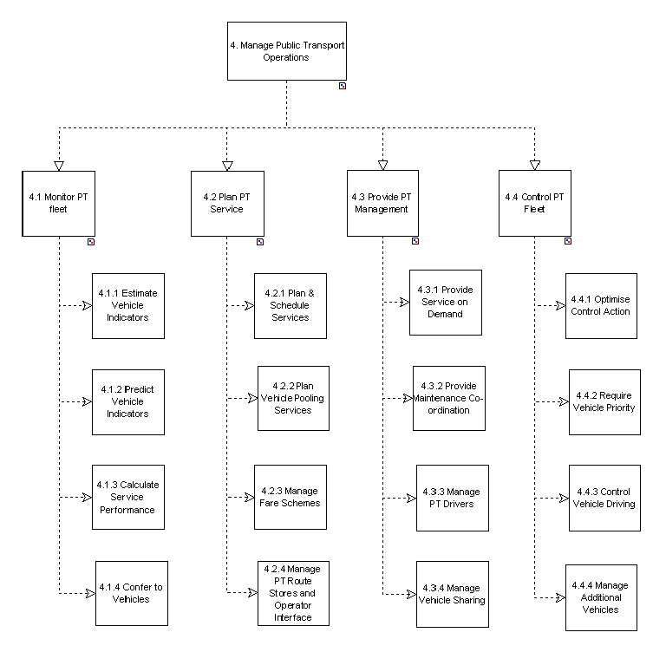
Fig.1 – Functional Tree of Area 4
Source: (EC, 2000)
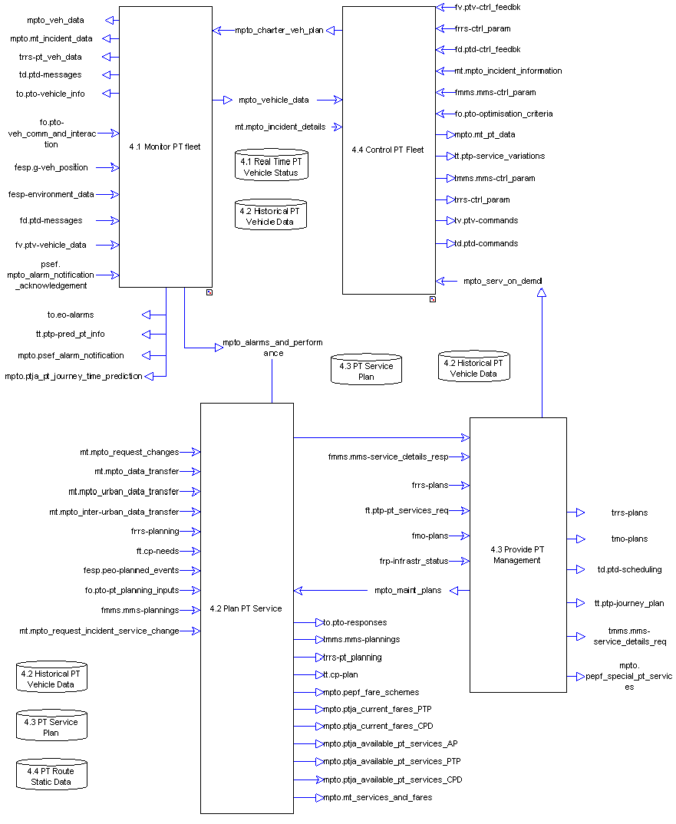
Fig. 2 – Data Flow Diagram of Area 4 (DFD 4)
Source: (EC, 2000)

POINT

# ID
o NAME

LINK
from
the start of
relationship
optional
end-name-1
end-name-2
mandatory
one
many
ENTITY
ATTRIBUTE
RELATIONSHIP
Conceptual modelling (relationships)

Fig. 3 – Conceptual modelling (relationships)
Source: (EC, 2001)
FUNCTIONAL ARCHITECTURE
Application
PHYSICAL ARCHITECTURE
Application
Application
KAREN - Transit
USER NEEDS
FUNCTIONS
DATA STORES

TRANSMODEL

Fig. 4 – Structure of the proposed approach
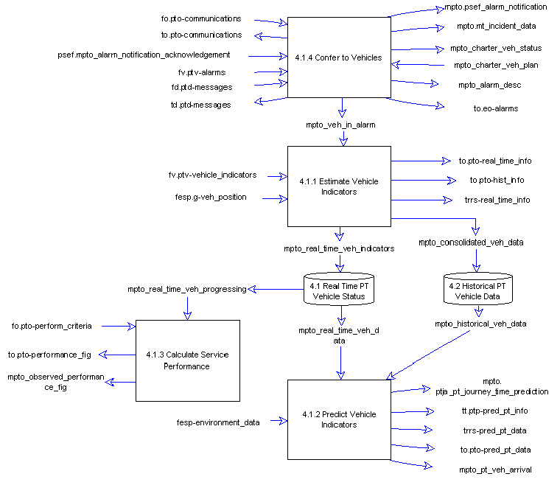

Fig. 5 – Data Flow Diagram DFD 4.1
Source: (EC, 2000)

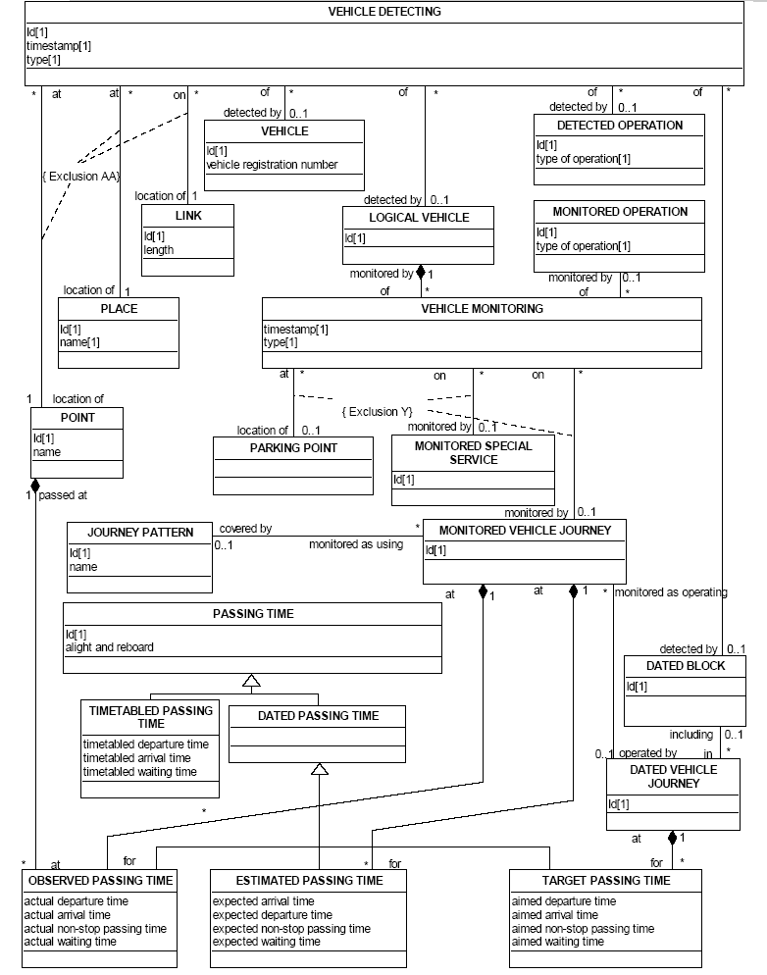

Fig. 6 – Detection and Monitoring diagram
Source: (METL, 2003)

