Case Study: Modal Shift of Short line Rail to Highways

R. Christopher Williams, Ph.D. (corresponding author)
Associate Professor
482A Town Engineering
Iowa State University
Department of Civil, Construction, and Environmental Engineering
Ames, Iowa 50011
Phone: 515-294-4419
Fax: 515-294-8216
Email: rwilliam@iastate.edu

Jason P. Bausano, Ph.D.
Product Development Engineer
SemMaterials, L.P.
6502 South Yale Avenue
Tulsa, Oklahoma 74133
jbausano@semgrouplp.com

Richard Stewart, Ph.D.
Professor and Director
University of Wisconsin– Superior
Transportation and Logistics Research Center
P.O. Box 2000
Superior, Wisconsin 54880

Libby Ogard
Research Associate
Prime Focus LLC
918 Fox River Drive
DePere, WI 54115
920-217-7222
logard@new.rr.com

Anthony Pagano, Ph.D.
Department of Managerial Studies
University of Illinois at Chicago
601 S. Morgan Street
Chicago, Illinois 60607

ABSTRACT
This paper considers the impact of freight modal shifts on pavement life if short line railroads are no longer considered economically viable. The area selected for this case study considers a branch line connecting Janesville, Wisconsin which is currently served by the Wisconsin and Southern Railroad (WSOR). The identification of current freight volumes on this rail segment and the corresponding trucking volumes, are estimated, if this rail traffic were diverted to nearby roads. A logistical flow analysis documents the increased truck movements by route if this rail line was lost. The current condition of the highway segments, which would be impacted by the potential line abandonment, is documented in terms of rutting, roughness, faulting, and cracking (alligator, transverse, and longitudinal). The pavement design method (1973 American Assocation of State Highway and Transportation Officials (AASHTO) avement design guide) currently used by the Wisconsin Department of Transportation, “WisPave”, was used to measure the pavements’ ability to handle the additional trucks on the highway in terms of structural number (SN) for flexible pavements and thickness for concrete pavements. The change in SN or thickness was evaluated to determine if the increase in truck traffic was enough to change the SN or thickness and to then evaluate the as built SN or thickness to determine if the pavement will meet the expectations of the new traffic.
INTRODUCTION
Class 1 Carriers are optimizing methods to handle growing global trade volumes, and focus on taking full advantage of their network capacity by running high utilization trains moving end to end across their network. The changes the Class 1 Carriers are implementing are having adverse impacts on short line and rural shippers; this group is seeing a reduction in services in many areas served by secondary railroads (short lines). Rural shippers, faced with limited options with declining rail service and limited car availability, and have taken their case to their local congressmen. (Stewart et al, 2006) These circumstances have resulted in the introduction of in new state truck size and weight legislation, throughout the Upper Midwest. On March 22nd 2006, Wisconsin passed into law AB 678 which raised truck gross vehicle weight (GVW) to 98,000 lbs for a number of product traditionally carried by short line railroads. This new legislation may have significant impact on highway pavement conditions.
This paper will assess the impact of modal conversion on pavement condition in Wisconsin by quantifying rail carload volume which may be diverted to truck volume if rail service continues to decline for rural shippers. Freight volumes diverted to highway modes were analyzed and the resulting impacts on pavement design and condition were assessed.
BACKGROUND
Short-line and Regional railroads are defined by Federal Railway Administration guidelines. Regional railroads operate at least 350 miles and must generate a minimum of $40 million dollars. Short Line railroads fall into two categories, typically local carriers operate 350 miles or less. Short Line Switching or Terminal railroads typically shuttle or transfer cars between Class 1 connections and local shippers. Frequently, short-line railroads are created when a Class 1 railroad puts up a segment of track for sale. This rationalization is often done because that rail line segment no longer meets the Class 1 carriers minimum volume threshold, business plan or network strategy. Today’s short segments can be tomorrow’s short-line railroads. Recent announcements concerning changes to certain short line routes and terminals make the question even more pressing. Additional rail freight demand, coupled with a decrease in line capacity could significantly impact the pavement in many rural and urban settings. This paper identifies the impact on pavements that could be expected as a result of additional freight traffic moving over the highways in the state of Wisconsin as a case study. This information is needed to help State Department of Transportation’s (DOT’s) evaluate how and where to support rail preservation. As part of an on-going research project, additional case studies in Michigan and Minnesota are underway to identify the impacts of abandoning short rail lines and the resulting increase in truck traffic on the highways.
Twelve freight railroads in Wisconsin offer key transportation services to customers in agriculture, manufacturing and other industries. The state of Wisconsin recognizes the importance of preserving short line railroads. Without adequate investments in railroad infrastructure, a greater amount of freight moves by truck, taking a toll on pavements that were not designed to accommodate this traffic and weight. Additional costs beyond pavement damage occur from the increased truck traffic including: air pollution, increased congestion, additional hazardous cargo on highways, higher freight rates and adverse economic impacts to businesses and communities.
Short rail lines are the life force of the transportation service in providing customers agricultural products, manufacturing, aggregates, and petroleum industries. Several case studies have been performed that consider the closure of short rail lines and their impact on the pavement performance and the cost’s associated with the increased traffic on pavement performance in terms of rehabilitation and maintenance (Leong et al, 2004a; Leong et al, 2004b; Cambridge Systematics, 2000; Cambridge Systematic, 2004; Babcock et al, 2004; Bitzen and Tolliver, 2001; Cambridge Systematics, 2000; Northwest Midwest Institute 2000; and Stewart et al, 2003).
RESEARCH OBJECTIVES
This research identifies current freight volumes on the rail segment(s) and the corresponding trucking volumes if this rail traffic were diverted to nearby roads. A logistical flow analysis was done and documents the increased truck movements by route if a rail line was lost. A comparison of the pavement structural design is included taking into account the increased traffic volumes.
CASE STUDY ROUTE SELECTION
The case study considers the closure of a short line railroad in southern Wisconsin. A modal shift from rail to highway would occur thus resulting in an increase in truck traffic on the highways. Figures 1 through 5 represent five primary routes that were identified based on surveys of shippers. Figure 1 illustrates the route identified from surveying shippers from Monroe to Madison, Wisconsin. Figure 2 shows the route from Monroe to Milwaukee, Wisconsin. Figure 3 shows the route from Monroe, Wisconsin to the Illinois Border. Figures 4 and 5 show the final two routes from Janesville to Madison, Wisconsin.
DATA COLLECTION
Relevant traffic flow data for the selected carriers were gathered. Data from shippers, railroads, and DOT’s were used, including but not limited to data on types of traffic (local, interline, overhead and/or international origins and destinations). Data related to pavements such as pavement thicknesses (hot mix asphalt (HMA), concrete, base, subbase), material characterization data, subgrade soil type, existing truck traffic, and the existing condition of the pavement was collected from the Wisconsin Department of Transportation (WisDOT). Typical subgrade modulus values (subgrade support value or modulus of subgrade reaction) was selected based on the American Association of State Highway and Transportation Officials (AASHTO) classification of the subgrade soil type (Huang 1993, p 327 and 365). The subgrade soil support values used were from a previous WisDOT research project (Testing Wisconsin Asphalt Mixtures for the AASHTO 2002 Mechanistic Design Procedure) in which the AASHTO soil designation was known. The subgrade support value was used in the WisPave pavement design guide simulations for flexible pavements and the modulus of subgrade reaction was used for rigid pavement design. WisPave was selected to perform the pavement simulations because WisPave is the pavement design software that pavement engineers in the state of Wisconsin use when designing their pavements. The WisPave software uses the 1973 AASHTO pavement design guide when designing flexible and rigid pavements.
LOGISTICAL FLOW OF NEW TRUCK FREIGHT
The least cost alternative highway routes for the logistical movement if a modal shift were to take place in each of the line segments was identified. Logistical decisions were based on origin destination pairs, travel time, truck operation parameters and other truck user costs. Data available from prior regional and national studies along with data gathered from on going research provided the benchmarks for logistical analysis. Modal conversion of freight and routing models were developed for the Mid-west Regional University Transportation Center (MRUTC) Twin Ports Intermodal Terminal Study (project 02-06) and elements of that methodology will be presented in this paper.
Freight modes may be influenced by a number of factors such as transportation cost, service, terms of payment, availability of trucks and drivers; quality, condition and availability of rail cars and trucks, and physical freight characteristics. Packaging requirements, physical plant/distribution center characteristics, origin and destination loading and unload characteristics are also often significant factors in mode selection.
PAVEMENT DESIGN
The objective was to assess the incremental pavement structural design due to modal shift from rail to truck in the selected case study. The design was based upon the flows generated in Figures 1 through 5. The diversion of freight is anticipated to occur over multiple routes and includes 32 pavement cross-sections (designs). One assumption inherent when using the WisPave pavement design software is that it does not take into account the current condition of the pavement structure; it assumes that it is a new pavement structure. The WisPave software does not take into account reliability and the change in present serviceability index which is used to trigger rehabilitation and maintenance activities.
To determine the additional number of trucks, the total tonnage during the most recent year of shipping on the railroad was measured and then divided by 48,000 lbs. While gross vehicle weight is limited to 80,000 lbs, it is assumed that the tare weight of the truck and trailer equipment averages 32,000 lbs. This will allow for the number of trucks to be estimated based on a straight tonnage conversion methodology. However, actual shipments may be somewhat higher based on specific order quantities or production limitations. It was calculated based on the above thought process, that there would be an annual increase of 19,077 trucks on the five routes listed above if the short rail line were abandoned. However, the trucks will be distributed along the routes according to the conversations with the various shippers and some assumptions when needed. It was assumed that the additional trucks would be a 3S-2 truck (class 10 truck). A class 10 truck has a total of six axles which includes one steering axle. Table 1 summarizes the traffic data in terms of average annual daily traffic (AADT), growth factor, AADT at design life, and percent trucks for each route and in some cases the county where the traffic level changed according to the Wisconsin Highway Traffic Volume Data manual. Included in Table 1 is the calculated new traffic if the short rail closes. The new traffic is equal to the AADT plus the 19,077 trucks times a factor which is to take into account the percentage of trucks that will take a specific route. Two simulations for each route were performed. The first simulation considers the existing traffic and a structural number or pavement thickness is computed and a second simulation is performed that considers the new traffic if the short line railroad closes and a a structural number or pavement thickness is computed. The structural number or pavement thickness from these two simulations are compared to the as built structural number or pavement thickness to verify if the pavement is adequately designed to meet the current and future traffic spectrum. This analysis was performed for 32 pavement sections on the five routes that were selected.
Typical (default) values for layer coefficients were selected when using the WisPave pavement design guide for the surface, base, subbase 1 and subbase 2. Tables 2 through 6 show the simulations for each route and pavement structure on that route. On the average the new structural number (SN) due to the increase in truck traffic is 0.021 units greater than the existing SN for flexible and composite pavements. For rigid pavements the new pavement thickness due to the increase in truck traffic is 0.044 inches greater than the existing pavement thickness. There is a tendency for the as built SN or pavement thickness to be over designed providing a much greater as built design versus the as designed pavement. For the flexible and composite pavements, the average SN for the as built versus the required SN is 0.493 units greater than the required SN. For rigid pavements the average as built pavement thickness is 0.183 inches greater than required pavement thickness. Since the majority of the pavements are over designed, an increase in traffic may not affect the pavement in term of rutting, cracking, or faulting. However, for those pavements that are under designed or designed at optimum, an increase in traffic may accelerate the damage to the pavements in terms of rutting and cracking for flexible pavements and cracking and faulting for rigid pavements. Nonetheless, 12 of the 32 pavement sections primarily on two of the five routes will experience a shorter life with the additional modal shift freight than their as built life.
This same methodology of developing traffic routes, collecting traffic data, pavement structure data, and subgrade data can be adopted for the 1986 and 1993 AASHTO pavement design guide, and the forthcoming AASHTO mechanistic-empirical pavement design guide. Any state that is anticipating a short line rail closure can determine their current traffic and calculate a structural number and then estimate the anticipated traffic increase and then calculate a new structural number to determine if the pavement is adequate in supporting the new traffic level.

CONCLUSIONS
Rural shippers are being faced with limited options with declining rail service and limited car availability, and have taken their case to their local congressmen. These circumstances are resulting in new state truck size and weight legislation being introduced throughout the Upper Midwest. This new legislation may have significant impact on highway pavement conditions.
The pavement conditions considered in this paper are the changes in SN and concrete pavement thickness due to the increase of truck traffic in the highway system in the state of Wisconsin. The results show that there is an increase in SN and concrete pavement thickness due to the increase in traffic on these routes. However, these pavements have as built SN’s or concrete pavement thicknesses greater than the existing and potential future SN’s or concrete pavement thicknesses. 12 of the 32 pavement sections primarily on two of the five routes will experience a shorter life with the additional modal shift freight than their as built life. Those pavements that are built at the optimum design, they should be monitored closely to determine if they will deteriorate quickly due to the increase in truck traffic. Furthermore, the greatest impact on reduced as built service life will occur on lower volume roadways.
REFERENCES
- Babcock, Michael W. and Sandersen, James, Should Short-line railroads upgrade their systems to handle heavy axle load cars?, September 2004.
- Bitzen, John and Tolliver, Denver D., North Dakota Strategic Freight Analysis Item IV: Heavier Loading Rail Cars, Upper Great Plains Transportation Institute, North Dakota State University, October 2001.
- Cambridge Systematics, Inc. Transportation Asset Management Guide, NCHRP Project 20-24(11), 2002.
- Cambridge Systematics, Statewide Multimodal Freight Flows Study for Minnesota, April 2000.
- Huang, Yang H. Pavement Analysis and Design. Prentice Hall, New Jersey. 1993.
- Leong, Dennis Lichtman, Liat , Russell, Robert, Wisconsin Department of Transportation, Economic Impact Analysis; Saulkville to Kiel Railroad Abandonment, October 2004a.
- Leong, Dennis Lichtman, Liat , Russell, Robert, Wisconsin Department of Transportation Economic Impact Analysis of Rail Service in Northern Wisconsin, December 2004b.
- MapQuest, http://www.mapquest.com, MapQuest, online, 2006
- Cambridge Systematics, Minnesota Department of Transportation Statewide Multimodal Freight Flows Study, April 2000.
- Northwest Midwest Institute, An Overview of Transportation Infrastructure and Services in the Northern Great Plains Regions, 2000.
- Pavement Information Files (PIF). Wisconsin Department of Transportation, 2006.
- Soil Survey of Dane County Wisconsin, United States Department of Agriculture, 1990.
- Soil Survey of Green County Wisconsin, United States Department of Agriculture, 1990.
- Soil Survey of Rock County Wisconsin, United States Department of Agriculture, 1990.
- Stewart, Richard, Wang, Xiubin, Sproule, William, Pasi, Lautala, Ogard, Libby, Evaluation of Shipper Requirements and Rail Service for Northern Wisconsin and the Upper Peninsula of Michigan, US Department of Transportation, University of Wisconsin-Superior, 2006.
- Stewart, Eggar, Ogard, Twin Ports Intermodal Freight Terminal Study, University of Wisconsin-Superior Transportation and Logistics Research Center. Midwest Regional University Transportation Center, 2003.
- Williams, R. Christopher, Robinette, Christopher; Bausano, Jason; Brekah, Tamar. Testing Wisconsin Asphalt Mixtures for the AASHTO 2002 Mechanistic Design Procedure. Forthcoming Final Report, April 2007.
- Wisconsin Department of Transportation. Wisconsin Highway Traffic Volume Data. 2005.
- Wisconsin Department of Transportation. Wisconsin Vehicle Classification Data. 2005.
- WisPave Version 2.4.1, Wisconsin Department of Transportation Pavement Engineering Software.
LIST OF TABLES
Table 1 Summary of Traffic Data 14
Table 2 BSE Route 1 Simulations 15
Table 3 BSE Route 2 Simulations 16
Table 4 BSE Route 3 Simulations 17
Table 5 BSE Route 1 Simulations 18
Table 6 BSE Route 2 Simulations 19

Table 1 Summary of Traffic Data
Table 2 Route 1 Simulations
Table 3 Route 2 Simulations
Table 4 Route 3 Simulations
Table 5 Route 4 Simulations
Table 6 Route 5 Simulations

LIST OF FIGURES
Figure 1 Badger State Ethanol Route 1, Monroe to Madison 21
Figure 2 Badger State Ethanol Route 2, Monroe to Milwaukee 22
Figure 3 Badger State Ethanol Route 3, Monroe to Illinois Border 23
Figure 4 Janesville Sand and Gravel Route 1, Janseville to Madison 24
Figure 5 Janesville Sand and Gravel Route 2, Janseville to Madison 25

Figure 1 Route 1, Monroe to Madison
Figure 2 Route 2, Monroe to Milwaukee
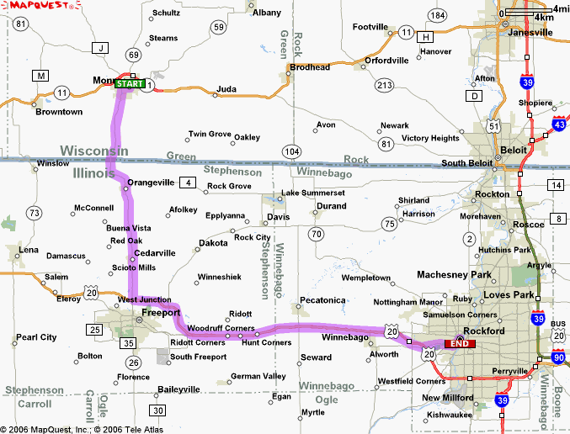
Figure 3 Route 3, Monroe to Illinois Border
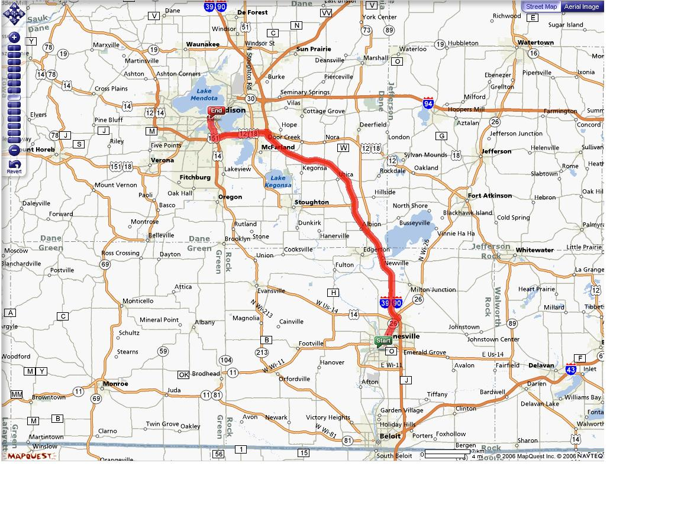
Figure 4 Route 4, Janesville to Madison
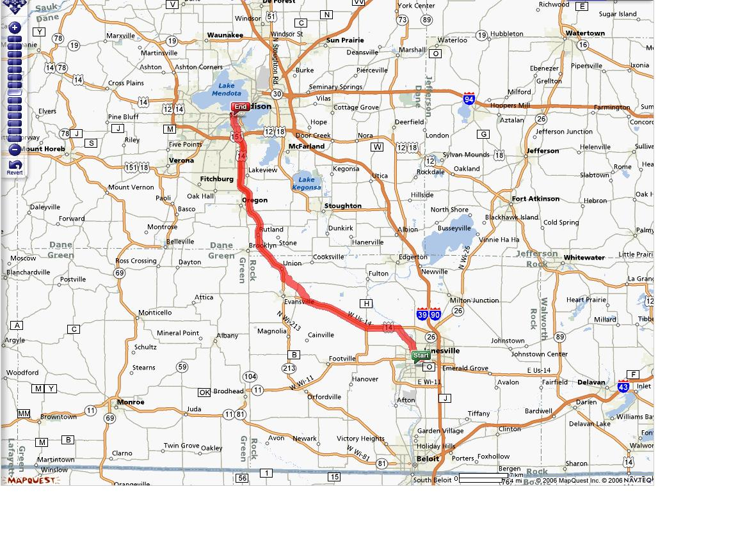
Figure 5 Route 5, Janesville to Madison

