Network methods for modeling collector truck routes

Hiroshi Tsukaguchi

Department of Civil Engineering
Ritsumeikan University
Nozi-highashi Kusatsu, Shiga 525-8577, Japan
Phone/Fax 81-77-561-2735
e-mail: tsukaguc@sc.ritsumei.ac.jp

and

Upali Vandebona

School of Civil and Environmental Engineering
University of New South Wales
UNSW Sydney NSW 2052
Phone 02 9385 5056
Fax 02 9385 6139
e-mail: u.Vandebona@unsw.edu.au

Network methods for modeling collector truck routes

by

Hiroshi Tsukaguchi and Upali Vandebona

Abstract

Delivery and collector trucks provide an important transport function. In recent times, developments in communication industry have provided efficient methods to deliver information and reroute drivers with ease. However, selection of the most efficient route is central to the productivity of the operation. Typically, analysts would view the routing issue as a traveling salesman problem where the objective is to minimize the total travel task performed by the truck drivers. This paper explains operational procedures observed in a case study in Japan and modelling lessons derived from the analysis of field data. Comparison of model results against actual operation is included.

1. Introduction

Delivery and collector trucks provide an important freight distribution function in urban areas. Task assignment for distribution trucks is influenced by technological changes. There is a growing interest in the effects of communications industry that provides information and reroute drivers with much more ease. Portable computer devices are also becoming commonplace for automating deliver tracking and log keeping activities. However, the method of selecting the service route is still a central issue in ensuring the efficiency of the operation. This project attempts to explore routing methods for collector trucks with the view of providing scope for development of better tools to assist dispatchers and truck drivers. The scope here is limited to collector truck operations although there are certain similarities with delivery truck work.

2. Problem description

The collector truck driver sets out to pickup parcels from various shippers in the allocated collection area. The driver responsibility is to repeat the sequence of drive to the site, park, walk to the shipper, accept packages and load the truck, for shipper after shipper until the list of allocated shippers is complete. The vehicle used for this function is generally a light commercial vehicle (Tsukaguchi et al. 1997).

The driver/operator task is complete only when the collection is delivered to the sorting depot.

Collector truck drivers and shippers have different working arrangements. Some shippers may organize pre-arranged times when outgoing parcels would be ready for pickup. Others may be flexible about the time of pickup. In Japan, where the data collection for this project was performed, some shippers still use the traditional method of placing a display board outside the site to indicate that a pickup service is required. On the other hand, there are shippers who make telephone requests to hail a truck.

Some elements of suitable mathematical techniques have been previously proposed by Daganzo and Hall (1993), Fisher et al. (1995) and Van der Bruggen et al. (1993). Analytical modelers would view the routing issue as a traveling salesman problem where the objective is to minimize the total travel task performed by the truck driver. For small number of nodes (shippers) the traveling salesman problem may be solved by an iterative procedure. But it is known that this method is computationally inadequate for general solutions. There are techniques reported in literature that may assist networks with up to about 75 nodes.

The objective of this research work is to identify an efficient method to assist drivers with the selection of the shipper sequence. To investigate the suitability of the proposed model for field applications, an attempt is also made to demonstrate the ability of this method to recreate truck operator objectives and route selection behavior observed in the field. The graphical method devised to compare alternative routes proposed by the model and the route manually selected by the operator provides a further contribution of this research project. Application of this comparison method has allowed further understanding of the operational behavior of collector truck operators.

3. Data collection

Observation data for this project is obtained in Osaka city in Japan, in a city zone named Semba. An on-board observer accompanied the driver with the consent of the freight handling company and recorded activities of the collection process. This was a time consuming process but provided useful information about driver-shipper relationships and operator behaviour. Anyhow, to overcome the low yield of data from the above method, a physical simulation was conducted using workers of the freight company. Six drivers and two dispatchers participated in this mock exercise.

4. The network solution

As mentioned earlier, the applicable network method is referred to as the traveling salesman problem. Travelling salesman is applicable when following three objectives are simultaneously enforced.

It is required to visit a preset number of nodes in a network. In the problem at hand, truck driver is expected to visit the assigned number of shippers (nodes) in the urban zone (network) allocated.

The trip ends where the trip started. Therefore the travel path forms a closed circuit. In our problem the driver trip begins and ends at the truck depot.

Effectiveness of the operation is measured by the inverse of a travel cost indicator such as total distance travelled. In the collector truck driver situation, analysts could obtain travel distances among nodes readily available from a street directory. It is observed that the operator preference is to use travel time as proxy for travel cost measure. This requires modelers to convert travel distances to travel times using feasible travel speeds in the urban zone and calibration with the operator experience.

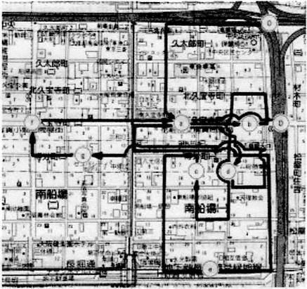

Figure 1. Network model of the collector truck journey

The difficulty of obtaining an efficient solution to the travelling salesman problem is well documented (Kruskal, 1956; Lawler et al. 1985). Thus it was decided to focus on obtaining an acceptable optimal solution, using a node swapping heuristic to minimize the relevant travel measure (travel time). In this method, a trial path is selected and then nodes in the sequence are swapped in a systematic fashion to explore whether a reduction in total travel time is possible. The method selected here is a rather simplistic tool compared to other complex methods found in literature.

5. Types of shippers

Now, let us look at the point of view of shippers. Some shippers can determine that they need the collector service everyday, based on their past experience. Some shippers may be happy with a daily collection with the flexibility given to truck driver as to the collection time. Others may prefer to come to an arrangement with the truck driver as to the times when the parcels are ready for collection. Certain busy shippers may find it prudent to have more than one pre-arranged collection time during the day.

Shippers who are less frequent users of this service are not visited everyday. It is not customary for these shippers to request a fixed time for collections. These shippers can lodge a request with the depot on the days they need service. As mentioned earlier, some shippers still use the traditional sign-board technique to announce the need of collection service. This is a rather convenient way for the shipper to attract the attention of a passing collector truck.

Of course the shipper can use the telephone to request a collection service. Telephone requests may be made because the shipper is an irregular user or a shipper regular who has already been served for the day.

Above observations allow us to classify shippers into three broad categories as shown in Figure 2. This classification is based on the frequency of service and timing arrangements.

Specified times
Unspecified times
Irregular
Daily
Frequency
Timing
Scheduled service shipper
Daily service shipper
Occasional service shipper

Figure 2. Three types of shippers

6. Truck operator behaviour

The survey revealed that driver tasks are anchored around scheduled service shippers. About 72% of shippers in this city zone belonged to the scheduled service category. Majority of scheduled services were during the hour starting at 5 pm. Thus, it is natural to see other shippers being looked after before this busy hour.

The driver has an interest in minimizing the total travel cost and the ability to return to the base as early as possible. However, the scheduled shippers late in the day make it quite difficult to finish the days work early. This however, provides some slack time during the day where drivers can use the time effectively to invest in customer relations. During the survey it was observed that some drivers repeatedly visit certain shippers outside the scheduled time windows. The aim of this process is supposedly to ensure delivery items are ready for collection at the scheduled time. It can be seen that this process is also for the long term benefit of both shipper and driver as this cultivates a mutually beneficial rapport between them.

Another relevant observation is that the driver may have to return to base during the day if the truck capacity is breached. Although this is an uncommon occurrence, it is generally likely to happen during particularly busy days. On such days, the drivers have to work extra hours to complete allocated tasks. Anyhow, network models (such as traveling salesman method) allow a return to the base only at the conclusion of the journey. On field, this would require a very large or infinite capacity truck to ensure that the driver need not be concerned with the capacity constraint. For the current modeling purpose however, it is assumed these intermediate returns to the base are unavoidable when that happens and the overall sequence of shippers served is not altered by this interruption.

7. Response to dynamic requests

Drivers leave the depot with a preliminary schedule prepared for them. The method of development of the preliminary sequence (of shippers to be served) provides an insight into the business acumen of the freight operator. A traveling salesman type solution would be suitable in minimising the travel cost of serving all shippers. However, it is noticed that the schedules prepared and paths followed by drivers tend to have noticeable differences compared to the optimum path solutions. It is noticed that the next shipper to serve is selected mainly based on the proximity to the current location. In 70% of occurrences, drivers opted to visit the shipper nearest to the current location. This may not be efficient transport, but is good business, as it allows the driver to cover as many shippers as possible during a given period of time. In other words, the sequence of shippers is based on a coverage maximisation in a temporal scale rather than a pure travel cost minimisation manner as stipulated by the traditional network analysis.

Additional shipper requests fed during the operation require the driver to amend the preliminary schedule. It is observed that the way these additional requests are treated has an interesting pattern. About 74% of such additional requests conveyed via the telephone was treated as the next shipper in the sequence. In some such situations however, it was possible for the driver to walk from the current parked position to the shipper. The lesson for the modeler is that the driver tendency is to clear these additional requests as soon as possible.

During the modelling process it is observed that treating additional requests as soon as possible has not much impact on the total time of work and has only little effect on the total travel distance.

For example, Figure 3 shows comparison of model outcomes and actual operation results. In the diagram, rule 1 refers to a network optimization model where additional requests are inserted to be served from where the driver is presently located or the immediately following pickup stop. Rule 2 refers to attempting to insert additional shippers to the remainder of the days work in a transport cost minimising manner. The sequences listed for zones A and zone C shows there is a reduction in work time feasible with rule 2 where additional requests are added to the rest of the days work to be handled in a transport cost minimising manner. However, for tasks shown for zones B and D there is no saving to be gained by adopting rule 2.

Comparison of sequences created by the model and actual operations reveal much about the operator objectives. For example, consider the operation for zone D in Figure 3. The analytical model is able to propose a sequence that results in less than half the distance covered by the driver in the real operation. Nevertheless, it is interesting to note that the real operation allowed the driver to complete the tasks somewhat earlier (and go home earlier) than what is possible by following the optimum path.

8. Conclusions

Comparison of real operations and model proposals has provided valuable insight into collector truck operator objectives. The truck driver has to balance efficiency requirements on one hand and nurturing the goodwill with shippers on the other. In other words, the operational efficiency is important, but preservation of business relationships is also important. A close examination reveals that drivers manage to handle these conflicting objectives in a logical manner by making prudent use of slack times of the operation.

Different expectations of various stakeholders related to collector truck operations is another revelation from this project work. For example, the following list is an attempt to identify main objectives of each stakeholder family.

Truck operator objective : Minimise working hours
Carrier objective : Minimise total cost
Shipper objective : Minimise storage time
Public sector objective : Minimise sum of truck km

Developing methods to balance these objectives is a further challenge to the analysts.

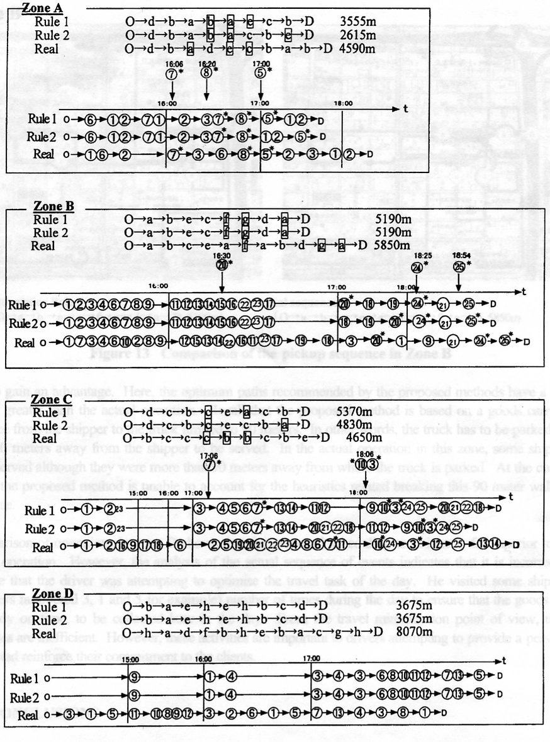
Figure 3. Comparison of model proposals and actual operation

References

Daganzo C F and Hall R W (1993) A routing model for pickups and deliveries: No capacity problems on secondary items, Transportation Science 27:4, 315-329.
Fisher M L, Tang B and Zheng Z (1995) A network flow based heuristic for bulk pickup and delivery routing, Transportation Science 29:1, 45-55.
Kruskal, J. B. On the Shortest Spanning Subtree of a Graph and the Traveling Salesman Problem, Proc. Amer. Math. Soc. 7, 48-50, 1956.
Lawler, E.; Lenstra, J.; Rinnooy Kan, A.; and Shmoys, D. The Traveling Salesman Problem: A Guided Tour of Combinatorial Optimization. New York: Wiley, 1985.
Tsukaguchi H, Li Y, Ohara F and Nishimura T (1997) A simulation model of deliver truck movement in Osaka CBD, Journal of the Eastern Asia Society for Transportation Studies, 2:6, 1803-1812.
Van der Bruggen L J J, Lenstra J K and Schuur P C (1993) Variable depth search for the single vehicle pickup and delivery problem with time windows, Transportation Science 27:3, 298-311.

