Bi-level Programming Model of

City Railway System Service Organization concerned Cargo Attributes

Yunling Yue
Modern Logistics Research Center
Graduate School at Shenzhen, Tsinghua University
P.R.China 518055
Telephone: +86-755-2603-6773
Email: winifred.yue@gmail.com

Lixin Miao #
(Leader). Professor & Director, Modern Logistics Research Center
Graduate School at Shenzhen, Tsinghua University
P.R.China 518055
Telephone: +86-755-2603-6775
Email: lxmiao@tsinghua.edu.cn

Chunhai Li
Modern Logistics Research Center
Graduate School at Shenzhen, Tsinghua University
P.R.China 518055
Telephone: +86-755-2603-6773
Email: lichunhai00@mails.tsinghua.edu.cn

# Corresponding author
Abstract:
Strategies to improve rail freight transportation system are often based on infrastructure developments, which is necessary but insufficient to change the modal split. So this paper proposes a study of an optimization model for dispatching rail freight services by using the infrastructures in an effective, rational and customers-oriented way. On the basis of demand estimation, the model determines the services supplied by each station by minimizing the total cost of the railway freight system. To classify the rail freight services, we first categorize cargos according to their attributes, and then define a service as a combination of a freight category and a marshalling yard direction. A bi-level programming model, in which the service choice problem with the objective of minimizing a cost function covering the process from customers to marshalling yards is dealt with as upper level problem whilst the demand distribution problem adopting a equilibrium model is dealt with as lower lever, is formulated by considering various practical constraints such as capacity of stations and trains. To solve this model, a heuristic algorithm is used to determine the near optimal solution. This model has been applied to Guangzhou hub railway system for the railway system optimization project. This case study is presented in the last of the paper.

Keywords: Railway System Planning, Service Choice Model, Bi-level Optimization, 0-1 Programming

1. INTRODUCTION

Railway industry is an important part of China's comprehensive transportation system. During the last decades, the international freight traffic has been characterised by a large increase in volume, and both railway mileage and traffic have increased rapidly (1), but the market share of railway transport has shown a falling tendency because of inadequacy of transport capacity and demand absorption of road transport (2).
Indubitably China's railway sector has undergone tough reforms over the past 20 years, but even more effort is still needed to meet the demands and expectations of consumers. Since the early 1980s (3), concentration of resources of rail freight system has been a necessary approach to reformation of rail transportation system because of its advantages in improving system utilization and decreasing railway cost.
Based on the idea of rail freight system resources concentration, a lot of cities have closed small stations and low capacity lines. Some cities just have one station at last. Albeit these infrastructure developments strategies are valid to eliminate the existing bottlenecks of the rail network, most shippers feel inconvenient to consign their freights to railway. So a modal shift can only be achieved by improving the overall service quality taking into account the needs of the shippers, such as frequency and time of transport. But if we open more stations just like the ones now in use, the history will go back to the century before reforming.
So we try to find a new way to design the stations distribution of the city railway and the services provided by each station for a balance between rail system resource concentration and shippers’ needs. Hence, we propose a study of an optimization problem for dispatching freight services by using the infrastructures in an effective, rational and customers-oriented way. A rail freight service choice model is constructed to solve this problem, and on the basis of demand estimation, it determines which stations will be retained and which services a station can serve.
We would define the freight service first. In fact, different type of goods needs different equipment and different service line to handle and specific allocation can bring more efficiency. So we classified all the cargos in different classes through their characteristics in inventory, transportation, load and unload process (4). And in a station, the freight which will be delivered to different marshalling yard will be processed in different service line. So a service category is defined by the combination of a cargo class and its marshalling yard, which means that if a station provides one service, then it can serve the corresponding cargos which will be delivered to the corresponding marshalling yard. Table 1 has listed the classification of all the freight.
TABLE 1 Categories of Freight
Category No. | Category of freight | Average weight per wagon (ton)
1 | Dry bulk (Non-Metallic Minerals, Coal) | 80
2 | Chemicals | 60
3 | Lumber, Leather, paper and wood pulp | 40
4 | Electrical appliances | 40
5 | Agricultural commodities, living goods | 60
6 | Containers | 60
7 | Food and drink, tobacco, drug | 50
8 | Liquid bulk (petroleum products, crude oil) | 60
9 | Munitions | 60
10 | Miscellaneous Freight, Parcel | 60
The number of service types is the production of the number of freight classes and the number of marshalling yards. For Guangzhou area, it is 20 because there are just two marshalling yards.
Based on the classification of the services supplied by all freight stations, a bi-level programming model, in which the service choice problem with the objective of minimizing a cost function covering the process from customers to marshalling yards is dealt with as upper level problem whilst the demand distribution problem adopting a equilibrium model is dealt with as lower lever, is formulated by considering various practical constraints such as capacity of stations and trains.
In the operation of station, a task is defined as a consigning process from a batch of goods appearing in the station to this batch of goods departing from the corresponding marshalling yard.
The following assumptions are necessary in the problem formulation:
1) All the labours and equipments are shared by all the stations in the area.
2) Each customer chooses the nearest station providing this kind of service to consign their goods.
3) There are no other physical restrictions of station, except their capacity.
4) No stations can decline the demands of consignation.
5) The demand of rail freight transportation will be stable and little changeable after the rearrangement of the services supplied by each station.
This paper is organized in the following way. In Section 2, the notations are defined. Section 3 gives us analysis about the railway transportation system. Section 4 describes the problem formulation. Section 5 discusses the proposed heuristic algorithm for the solution of the formulated bi-level programming problem. The result for the Guangzhou area problem is carried out in Section 5 too. Conclusions are drawn in Section 6.

2. NOTATIONS

Sets
The set of service category
The set of station
The set of customers
The set of marshalling yards
The set of necessary constrains about service providing decision, if , then station must provide the service of category
The set of necessary constrains about service providing decision, if , then station can not provide the service of category

Constants
Number of service types
Number of freight stations
Number of customers
Upper bound of service number provided by a given station
Number of marshalling yards
Upper bound of number of services provided by a given station
Lower bound of number of services provided by a given station
Upper bound of number of stations providing a given service
Capacity of each station, where
The smallest distance of two stations providing a same kind of services
Average weight of a carriage freight in category , where
Distance from each customer to each station, where,
Distance between two stations, where ,
The maximum carriage number of a train batch for delivery between rail stations and marshalling yards

Decision Variables
If station provide the service of category , ; otherwise, , where ;
If customerchoose stationto consign freight in category, ; otherwise, , where ; ;

Random Variables (describing the steady state of the system)
Demand of service category from customer , where ; .
Demand of service category consigned to station , where ;
The city transportation cost

Other Variables
Number of trains between freight station and marshalling yards, where .
Number of trains between all freight stations and all marshalling yards
The sum of all station operating cost

Functions and Operations
Expectation of the random variable
Smallest integer no smaller than the real number y

3. ANALYSIS OF THE RAIL TRANSPORTATION SYSTEM

This section considers the rail transportation system as a multi-echelon system: Freight stations are lower-echelon facilities experience direct shipper demand, which accept cargos from consigners and give cargos to consignees. In the other hand, to satisfy their freight transport requirement, they must load and unload cargos and deliver each batch of wagons to probable higher-echelon facility (the “marshalling yards”) to marshal the cargo wagons into trains in the backbone network.
To construct the rail freight service choice model, we involve a new cost model to simulate the cost of rail transportation system considering the three stages: stage from consigners to freight stations or from stations to consignees, stage inside each station, and stage between freight stations to marshalling yards. The whole cost of the rail freight system is the sum of the cost in the three stages.

Analysis of the Customer
First we introduce a freight flow distribution model of customers. The demand processes of each service category at the customers are assumed to be independent Poisson processes.
has been notated as demand of service category from customer , where ; , so it means the number of service category delivered by customer in a time interval of length , starting in the steady state. Now
 | , | (3.1)
When a batch of freight need to be consign, customer will choose a suitable station providing this kind of service, to minimize the transportation cost between customers and stations. And the transportation cost is the mass weight of cargoes and their corresponding distances between stations and customers.
So the freight transport demand from consigners are assigned using the equilibrium method, then the objective function
(3.2)
Obviously freight of one service type can only choose one station, so if the two batches of freight are in same service type, the cost from customer to station are the same. If customer chooses stationto consign freight of service type of, then.

Analysis of the Station
We have inferred that all freight stations load and unload cargos, to fill all the cargos into several wagons and arrange all the wagons into several trains to deliver them to marshalling yards by locomotives. We know the average cost of one train. So we will use the number of the trains between freight stations and marshalling yards to calculate the railway system cost in the time interval . For the process in the freight stations, we use the average cost per ton of a service type and the weight of every service type processed by freight stations in the time interval to calculate the second stage cost. Now,
 | , | (3.3)
 |  | (3.4)
For the demands of freight in different service types from different customers are independent, so
 | , | (3.5)
Then convert truck tonnages to number of trucks based on the constants average weight per wagon in the table 1, and use the maximum number of wagons a locomotive can drag to calculate the train numbers between each station and each marshalling yard.
(3.6)

4. MODEL FORMULATION

In this section, the rail freight service choice model will be formulated. For under each rail freight system service solution (for instance, Central Station provides service of transporting chemicals into the north direction marshalling yard, and so on), customers would make their decision on how the service supplier distribute and how can they save money. So after an equilibrium phrase between their inclination and the actual condition, there would be a balance. And how good is this given service solution depend on the decisions of customers and the demands of the freight services. So this is a typical bi-level programming problem.

The Upper Level Model

The upper level model is formulated as:
(4.1)

Subject to

(4.2)
(4.3)
(4.4)
(4.5)
(4.6)
(4.7)
(4.8)
(4.9)
(4.10)
(4.11)
(4.12)

The objective function (4.1) intends to minimize the sum of the cost in three stages in the whole railway transportation and city transportation system. In the upper level model, is dependent on the station choice of each customer, which is solved by the lower level model, but others are all calculated based on the result of decision variables in lower level model.
The model is subject to several constraints. Constraint (4.2) is the assumption of these decision variables. Constraint (4.3) and constraint (4.4) are combination of policy constraints and physical constraints. Some stations must provide some services such as munitions, and in contrast some station can not provide some services because of their circumstances or conditions. Constraint (4.5) is a physical constraint. Each category must be served by at least one station. Another two physical constraints (4.6) and (4.7) promises that number of stations providing the same service is no more than and the number of services provided by the same station is no more than .
Constraint (4.8) can assure the nearest two stations providing a same service is still farther than , and constraints (4.10) promises that the number of services provided by each station is no less than . Another constraint (4.11) illustrate that all the stations can not be charge with the tasks exceeding its capacity. And constraints (4.9) and (4.12) give us the calculating method of and which are used in the objective functions.

The Lower Level Model

The lower level model is formulated as:
(4.13)
Subject to
(4.14)
(4.15)
(4.16)

In the lower level model, the objective function (4.13) intends to make the whole customer group choose the nearest available station to consign freight in this service type. The model is subject to only three constraints. Constraint (4.14) is a physical constraint. Each service type must be provided by one station at least. A binary constraint (4.15) defines the decision variable for the lower level model. Constraint (4.16) promises each freight station just deal with freight no more than its capacity.

5. METHODOLOGY AND RESULTS

Due to the size of these problems (hundreds of variables and constraints), a heuristic algorithm is adopted to obtain the near optimal solution for the upper level problem while the lower level problem can easily get a solution in any searching method.
In the heuristic algorithm, the thought of greedy searching has been adopted. In the searching process, each time choose the category which has the most percentage of the average freight quantities in the follower problem, and then fully search in the definition area of service choice solutions in this service type, justify the availability through the constraints and terminate this step by verifying conditions. If the searching process is not as soon as designed before, remount to the solution before level by level.
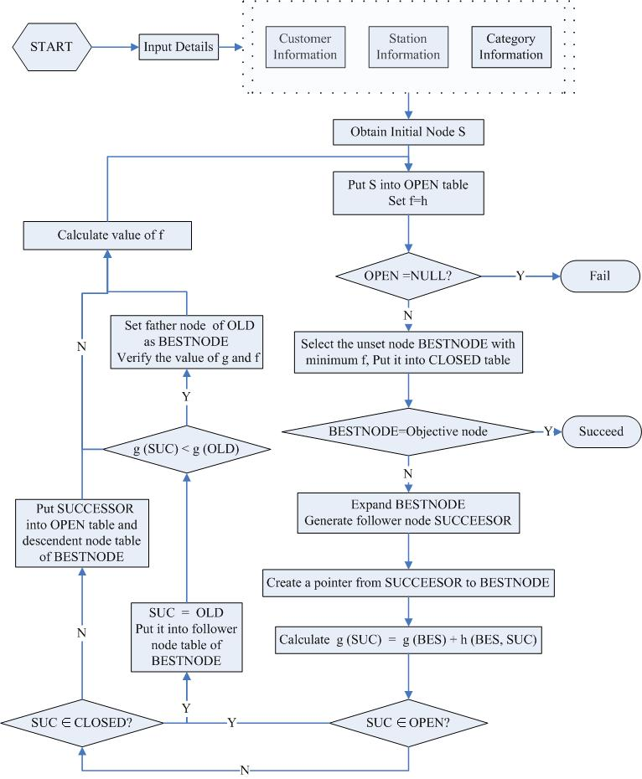
FIGURE 1 Flowchart of the proposed heuristic algorithm.

Set all the nodes (including the initial node S, temporary chosen node BESTNODE and so on) save a positive number whose number sequence in binary system denote a distribution solution of one service type. So the length of the number sequence in binary system must be 200 for the Guangzhou project, and each byte is equal to the value of . is the category number. Therefore the service choice result of one category will be decided as soon as a node is fixed. Then set function f to be an evaluation function which is defined as the whole transportation cost of this category.
We follow our sequence in the previous section by first O-D Survey of all the big rail freight producers or providers, second analyzing all the statistics and simulating the stochastic processes, then programming and computing. Subsequently, we discuss rearrangement of service choice in the rail transportation system of Guangzhou area.
To investigate the rail freight service demand, we divide Guangzhou area into 20 zones, and each one is supposed to be a source of freight traffic. The quantities of freight in different category with different marshalling yard direction consigned by customers in different zone are listed in the table 2 and table 3.

TABLE 2 Zonal freight tonnage (in Jiangcun marshalling yard direction)
Category | No.1 | No.2 | No.3 | No.4 | No.5 | No.6 | No.7 | No.8 | No.9 | No.10
Nansha | 48856 | 180 | 61 | 1810 | 1158 | 120 | 1216 | 131 | 342 | 0
Panyu | 130 | 1798 | 180 | 236 | 13966 | 835 | 11304 | 0 | 1608 | 0
Huangpu | 88907 | 21084 | 1244 | 0 | 3480 | 3684 | 25479 | 6435.4 | 289 | 13364
Haizhu | 0 | 358 | 466 | 171.4 | 1396 | 1115 | 1907 | 66.7 | 40 | 0
Yuexiu | 22967 | 12962.5 | 1651.4 | 19374 | 153857 | 55643.6 | 3709.7 | 104323.5 | 3584 | 2834
Liwan | 84207.4 | 40085.49 | 1317 | 4 | 58296 | 5920 | 44916 | 6476.8 | 393.78 | 324
Tianhe | 1470.4 | 2566 | 1260 | 7378 | 5066.4 | 837 | 3268 | 26.7 | 0 | 16
Luogang | 0 | 5402 | 60 | 0 | 294 | 1630 | 7466 | 40 | 0 | 0
Baiyun | 14419 | 63861.1 | 17373 | 1533 | 186429.6 | 43390 | 165922.9 | 148385 | 5237.9 | 3816
Conghua | 182 | 3219 | 0 | 0 | 174 | 116 | 595 | 0 | 60 | 218
Zencheng | 249 | 2047 | 0 | 0 | 1241 | 120 | 1318 | 0 | 0 | 0
Huizhou | 5274 | 120 | 0 | 4732 | 945 | 0 | 360 | 0 | 0 | 0
Dongguan | 6304 | 4619 | 0 | 2732 | 6482 | 3894 | 3496 | 0 | 0 | 0
Shenzhen | 0 | 5568 | 0 | 0 | 379 | 60 | 11422 | 0 | 0 | 0
Zhongshan | 120 | 1141 | 178 | 94 | 5708 | 120 | 13045.3 | 1116.48 | 55 | 0
Foshan | 6462.45 | 29359.32 | 2321.4 | 2417.76 | 14743.3 | 50069.5 | 220518.3 | 21931.8 | 445 | 0
Qingyuan | 0 | 421 | 0 | 0 | 300 | 236 | 540 | 0 | 0 | 0
Jiangmen | 0 | 240 | 0 | 0 | 876 | 626 | 2822 | 0 | 0 | 0
Shantou | 21749 | 7446 | 369 | 4448 | 53391 | 1165 | 9356 | 189 | 0 | 6173
Huadu | 0 | 0 | 0 | 0 | 0 | 0 | 10099 | 0 | 0 | 0

Table 2 lists all the zonal freight tonnage in Jiangcun marshalling yard direction, including the demand where customers of this zone play as a consigner and a consignee. It means that the zonal freight tonnage is the sum of the demand tonnage of the zone as both generation and destination. Below is Table 3, Zonal freight tonnage in the direction of West Sanshui mashalling yard.

.
TABLE 3 Zonal freight tonnage ( in West Sanshui marshalling yard direction)
Category | No.1 | No.2 | No.3 | No.4 | No.5 | No.6 | No.7 | No.8 | No.9 | No.10
Nansha | 61 | 297 | 0 | 0 | 118 | 0 | 1324 | 0 | 178 | 0
Panyu | 420 | 1492 | 0 | 0 | 876 | 61 | 2007 | 1937 | 60 | 0
Huangpu | 0 | 0 | 0 | 1692 | 4309 | 0 | 60 | 0 | 0 | 0
Haizhu | 429.6 | 3079 | 58 | 116 | 571 | 55.5 | 1265 | 68935.1 | 298 | 50
Yuexiu | 31997.6 | 9057 | 60 | 0 | 1302.4 | 2400 | 29529 | 0 | 0 | 2696
Liwan | 0 | 477 | 0 | 0 | 120 | 0 | 2057 | 0 | 0 | 0
Tianhe | 0 | 61 | 60 | 0 | 0 | 0 | 354 | 0 | 0 | 0
Luogang | 2152 | 1379 | 0 | 60 | 3122 | 593 | 6135 | 353 | 240 | 0
Baiyun | 60 | 0 | 0 | 0 | 0 | 0 | 420 | 0 | 0 | 0
Conghua | 60 | 180 | 0 | 0 | 240 | 0 | 60 | 0 | 0 | 0
Zencheng | 0 | 60 | 0 | 0 | 240 | 2400 | 960 | 0 | 0 | 0
Huizhou | 180 | 118 | 0 | 0 | 234 | 0 | 679 | 0 | 0 | 0
Dongguan | 0 | 0 | 0 | 0 | 0 | 0 | 7708 | 0 | 0 | 0
Shenzhen | 120 | 659 | 0 | 0 | 1724 | 0 | 563 | 2307.6 | 0 | 0
Zhongshan | 936 | 3077 | 101 | 113 | 2444 | 1341.3 | 227268.2 | 613.6 | 298 | 0
Foshan | 0 | 0 | 0 | 0 | 0 | 0 | 0 | 0 | 0 | 0
Qingyuan | 60 | 0 | 0 | 0 | 720 | 0 | 420 | 0 | 0 | 0
Jiangmen | 0 | 0 | 0 | 0 | 0 | 0 | 0 | 0 | 0 | 0
Shantou | 0 | 0 | 0 | 0 | 0 | 0 | 0 | 0 | 0 | 0
Huadu | 0 | 60 | 0 | 0 | 61 | 0 | 0 | 0 | 0 | 0

Now we can see the service choice result of Guangzhou project.
TABLE 4 Service choice result
Rail Station | Provided Services
Rail Station | Jiangcun Marshalling yard Direction | West Sanshui Marshalling yard  Direction
Dalang | 2, 3, 4, 5, 6
North Guangzhou | 1, 9
East Guangzhou
Huangpu | 1, 7
Jiangcun | 7, 8 | 2, 3, 5, 7, 8, 9
Sanyanqiao | 7, 9
Shipai | 2, 5
Shiweitang |  | 1, 3, 6, 9, 10
Tangxi | 7, 9
Xiayuan | 2, 9, 10 | 1, 3, 4, 9
Compared with situation before, we can calculate how much the rail freight service choice model can improve the rail transport in the three stages.

TABLE 5 Criteria of Service choice model solution
 | Service Number | Mass Weight | Train Number
Situation Before | 120 | 6.22E+08 | 1866
Optimized Solution | 35 | 6.97E+07 | 1369

6. CONCLUSION

The developed model provides decision-makers with the information bellowed:
- The selection of the optimal set of rail stations. Like the East Guangzhou station in the Guangzhou project, it needs to be closed for no service it need to supply.
- The selection of the optimal set of services supplied by each station ( if, then station provide the service of category).
This study presented a new idea in the railway freight service concentration. In order to rearrange the service allocation, a bi-level programming model has been formulated. A heuristic algorithm was adopted for the solutions of the upper level models. This paper has also performed an actual example to illustrate the model solution and analyze the value of this new idea about service allocation optimization.

REFERANCE

(1) Security analyst Homepage. Oriental Negotiable Securities Corporation
http://cnfol.hn8868.com/1333/060630/1908963,00.php. Accessed June 30, 2006.

(2) Introduction of Programs Homepage. The World Bank
http://web.worldbank.org/external/projects/main?pagePK=64283627&piPK=73230&theSitePK=40941&menuPK=228424&Projectid=P003571. Accessed April 17, 2001.

(3) Eric Burgeat. Documentation of the Abstracts and Suggestion of China Rail Reforming Seminal: China Rail reforming, Promote the Competition. OECD China.

(4) Ma K.M., Miao L.X. Study on the Freight Arrangement Optimization in Guangzhou. May 2006, PP 18-20

(5) Yang, H., Bell, M. G. H., 1998. Models and Algorithms for Road Network Design: A Review and Some New Developments [J]. Transport Reviews 18：257~27.

(6) Assad A A. Models for Rail Transportation [J]. Trans. Res., 1980, 14A

(7) P. Guglielminetti, J.-P. Leyvraz, R. Rivier. Freight transport planning: an optimisation model for the transalpine rail network. Conference paper STRC 2001 Session Networks

