Intermodal Containerized Shipping in Foreign Trade: Regional Accessibility Advantages in the United States

Jean-Claude Thill
Department of Geography and Earth Sciences
University of North Carolina at Charlotte
9201 University City Boulevard
Charlotte NC 28223
jfthill@uncc.edu

Hyunwoo Lim
Department of Geography
State University of New York at Buffalo
105 Wilkeson Quad, Buffalo, NY 14261
hwlim@buffalo.edu

Abstract
Intermodalism has become one of the most significant transformations of freight transportation in the United States over the past two decades. The space-time articulation of transfers from one mode to another has enabled shippers to fully realize the respective time and costs advantages of various modes. With intermodalism, new significant nodes have emerged on the transportation map of the nation. The opportunity to take advantage of intermodalism when shipping manufactured goods overseas may provide an essential competitive edge to a company or to an entire region. The change in the freight accessibility map of the United States imputable to intermodal infrastructures has so far not been studied. With the help of a geographic information system, this paper analyzes this transformation in the United States by mapping integral place accessibility measures of five-digit zip code areas with respect to ports of entry for manufactured goods, especially containerized freight. The performance of the intermodal freight network is evaluated by comparing accessibility measures based on the highway network and on the intermodal network, respectively, with respect to clusters of container ports on the East Coast, the West Coast, and the Gulf Coast of North America. The paper discusses regional winners and losers in the new national freight transportation system.
Keywords: intermodalism, freight network, accessibility measure, geographic information system, international trade

1. Introduction

Being comprised of an array of modes that are physically distinct from one another, traditional transportation systems depend on effective connections and coordination among them. With the steady increase in interstate and international trade and the growing pressure to reduce logistics cost, the integration of shipments across modes, or intermodalism, has become a prominent expression of logistics and supply chain management in advanced economies (Dwyer, 1994; Slack 2001).
The United States Congress recognized the common challenges that all modes of transportation face and addressed them in the 1991 Intermodal Surface Transportation Efficiency Act (ISTEA). With its commitment to a national intermodal transportation system working to support an efficient national economy, ISTEA has been called revolutionary because it granted unprecedented power and means to state and local governments to solve their specific transportation problems and to support planning and management systems that enable modal networks to work more seamlessly (Dwyer, 1994).
It can be said that the goal of any transportation system is to grant access to facilities rather than mobility (O'Sullivan et al., 2000). Accessibility represents how easily any economic opportunity can be reached from a particular location, using a particular transportation system (Dalvi and Martin, 1976; Koenig, 1980). Therefore, in order to evaluate the performance of a transportation system, it is necessary to devise some measure of effectiveness of the system in moving people to places they wish to go and in shipping goods where they are in demand. To this day, most of the research related to the development of accessibility measures has been confined to the urban-metropolitan context based on street networks (Hanson and Schwab, 1987; Helling, 1998). However, very little attention has been paid to accessibility on an intermodal freight network.
As a more or less tightly integrated process, intermodalism brings interconnectivity to the transportation system at large (Rietveld, 1997; van Geenhuizen, 2000), which in turn becomes a central element shaping the modal choice of shippers. With intermodalism, trans-shipment at the nodes where on can transfer from one modal network to another is unavoidable. This operation can be costly to the shipper but extensive standardization, institutional coordination, and synchronization of schedules at trans-shipment terminals has dramatically contributed to lowering the barrier to intermodal service (van Geenhuizen, 2000). All things considered, the intermodal solution is economically viable only in situations where a reduction of the generalized impedance on modal segments (particularly line-haul legs) compensates for the additional costs of trans-shipment.
When the scale of interest encompasses the entire nation, it becomes crucial to understand the structure of the intermodal network, including the connection and coordination among different modes. Intermodal freight shipment includes new vehicle, container, and cargo handling technologies such as just-in-time inventory tracking and management systems. Therefore, sound methods of measuring and portraying freight trip movement are necessary to reflect these new freight logistics technologies and new transportation infrastructures (Southworth and Peterson, 2000).
It has been argued by various authors (e.g., Roson and Soriani, 2000; Priemus and Konings, 2001; Rodrigue, 2004) that the integration of logistical and distribution networks through intermodal processes has triggered a transformation in the economic significance of places and spaces at all geographic scales. The mutation is much broader that the load centers where modal networks interconnect, however. It can be anticipated that the erosion to trans-shipment impedances resulting from better technologies and management practices lead to an improvement of accessibility throughout the broad areas served by the network, although their magnitude may be quite variable on the basis of location. This process of “space-time convergence” entails a contraction of space well documented in the literature in relation to improvements to the physical transportation infrastructure of a region or continent (Spiekermann and Wegener, 1994; Bruinsma and Rietveld, 1998). The concept of accessibility is perfectly suited to capture the perceived economic attractiveness of locations based on the potential use of freight transportation and logistical systems.
Enhancements to the efficiency of the transportation system translate into reductions in the impedance and cost of freight shipping, and broad economic development effects have been amply documented and studied in the literature (e.g., Banister and Berechman, 2001). Whether a region can take advantage of these conditions to develop its economy depends on many factors that remain ardently debated to this day. The seamless development of freight transportation services and infrastructures has become an important factor of economic competition between regions (Capieri and Leinbach, 2006). In a recent paper, Lim and Thill (2007) have used regional accessibility as a generalized measure of locational advantages tied to the domestic freight transportation system to study regional competitive advantages. The authors showed that, for the purpose of domestic interregional containerized trade, the advent of intermodal networks has enhanced accessibility nationwide. Furthermore, they established that intermodalism has been instrumental in reducing the gap between regions with the highest and the lowest accessibility to the domestic market, thus providing a platform for some regions that are locationally disadvantages to overcome the tyranny of distance and more effectively compete on the domestic market.
In this paper, we seek to extend the analysis of Lim and Thill (2007) to overseas export activities. Specifically, we evaluate the efficiency gained by U.S. regions in their export to other continents as the U.S. freight transportation system embraced intermodalism as an alternative to door-to-door highway transportation to North American sea ports. The case of containerized freight traffic is examined because it is closely associated with contemporary forms of integration between rail shipping and trucking and most manufactured goods reach their overseas markets in containerized form. Through a comparison of maps of gravity-type accessibility measures developed on the North American highway and intermodal networks, respectively, the performance of the rail-trucking logistical combination is evaluated from an infrastructure policy perspective. Our first research question pertains to whether the efficiency of the domestic ground freight transportation is enhanced by intermodal operations. Next, we analyze specific modalities of accessibility gains. In particular, we are interested in determining whether accessibility gains exhibit an organized spatial pattern across the United States, and whether the resulting geography of logistical advantages differs on the basis of the maritime gateway through which exported cargo would transit. For the purpose of the latter question, container ports are grouped in three clusters, Pacific Coast, Atlantic Coast, and Gulf Coast.
The rest of this paper is organized as follows. Section 2 describes the intermodal freight transportation network used as the backcloth for the regional accessibility study. Processing and manipulation of this network are also presented in this section. The concept of accessibility, its implementation, and other modeling issues are discussed in Section 3. Accessibility maps and their comparison are introduced in Section 4. Conclusions are drawn in Section 5.

2. The North American Intermodal Network

The intermodal network data used in this research is obtained from the Center for Transportation Analysis (CTA), Oak Ridge National Laboratory (ORNL). The CTA intermodal network was originally constructed to simulate freight shipments reported in the 1997 Commodity Flow Survey (CFS). It is composed of independently constructed single-mode networks for highway, rail, and waterborne shipping, which are connected by a set of intermodal terminals (Peterson, 2000). This network is customized to fit the more specific purposes of the present accessibility research. The main features of this network are presented below.

2.1. Terminal transfer model

Mode-specific sub-networks are connected with one another at appropriate transfer locations (terminals or load centers) where containers are off-loaded from one mode and loaded onto another, as shown in Figure 1. Access to a terminal gate from a modal sub-network is represented in the database by unidirectional modal links. Modal terminal links are duplicated if shipping is allowed in the incoming and outgoing directions. These links have endpoints that serve as modal entry and exit points of the terminal facility (Peterson, 2000; Southworth and Peterson, 2000). All the processes and costs involved in the transfer of shipments within a terminal are captured by logical links.

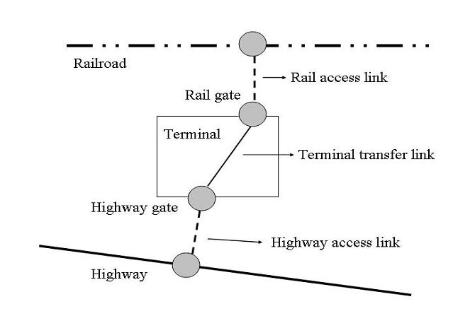
Figure 1. Terminal transfer model

2.2. Link impedance

Collecting detail shipping cost information is a task that is clearly beyond the scope of this research. Instead, we adopt the approach implemented by CTA to estimate impedances for each traversable element of the intermodal network, namely line-haul links, terminal access links, and logical terminal links.
All line haul links in the CTA network have their own “native” impedances derived from the mileage, the modal attributes, and the urban/rural functional class of the corresponding links in the real-world shipping network. For each shipping mode, the impedance value is normalized so that approximately one impedance unit corresponds to shipping one mile on a link under the best possible conditions for this mode. For example, native impedances are assigned to highway links based on several link attributes such as distance, functional class (whether urban or rural), speed, presence of a toll, and the truck route designation. Highway impedances typically range from 0.9 times the link mileage for rural interstates to 5 times the mileage for two-lane urban streets or unpaved rural roads. Rail impedances are primarily determined by the “main line class,” an evaluation of line importance by the annual traffic volumes (Southworth and Peterson, 2000). For instance, “A-main” lines are assigned an impedance equal to the link mileage, while the impedance of lower-traffic branch-lines is four times the mileage.
To ensure that shipment route and mode characteristics recorded in the 1997 CFS are effectively simulated, mode-specific link impedances are weighted by the relative cost of shipping by each mode (modal impedance). Validation of modal route choices conducted by CTA on 1997 CFS shipment data suggests the equivalence of one line-haul highway mile to 3.5 miles by rail for generic cargo. Peterson (2005) points out however that, when it comes to shipping containerized merchandise, rail and highways are more closely competitive than for general cargo and bulk freight. Therefore, the modal impedance of rail on a line-haul link is taken to be 1/2, while that of truck shipping is set to 1.
Empirically validated impedances are also assigned to terminal access links, terminal links, and kinks connecting rail lines (Peterson, 2000).

2.3. Data preparation

In order to perform the large number of origin-destination routing operations required for accessibility analysis and to obtain a reasonable minimum path cost matrix, the original intermodal network database is modified as follows.

2.3.1. Modes of transportation

Transportation modes to be included in the intermodal network are limited to truck and rail shipping. This represents a minimal loss of information on intermodalism since waterways carry only a small share (1% in values and 5% in tons) of the domestic intermodal freight traffic according to the 1997 CFS. Therefore, waterway links including oceanic, inland, and Great Lakes routes are removed from the original intermodal network database. For-hire truck network links are also removed because they are the exact duplicate of the private truck network links in the original intermodal network data. The resulting intermodal network is composed of two primary sub-networks, namely the national highway network and national rail network. Finally, only the 401 truck-rail terminals equipped to handle containers are maintained in the network. Other trans-shipment terminals are not relevant to this research.

2.3.2. Zip code centroids as shipment origins

The contiguous United States is comprised of 31,906 five-digit zip codes as of year 2000. These zip code areas are taken to represent possible shipment points. For the purpose of estimating accessibility measures, it is necessary to compute minimum transportation costs from zip code centroids taken as shipment origins to sea ports taken as potential destinations in order to calculate the accessibility measures. To reduce the computational burden of applying shortest-path procedures to all possible origin-destination pairs and calculating accessibility measures for all locations, 6,572 zip code centroids are selected to serve as origins.

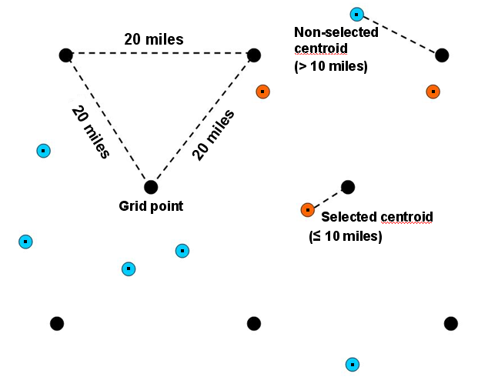
Figure 2. Systematic point sampling

Since five-digit zip code centroids are not distributed evenly across the country, random point sampling may result in few sample points where zip code centroids are sparse and an unnecessarily large number of points in densely population sections of the country. Therefore, a sampling scheme similar to systematic unaligned sampling (Figure 2) is used to ensure the selection of a similar number of points from any given fixed-size local area. A regular triangular grid with a 32-kilometer mesh is laid over the contiguous United States; zip code centroids that are closest to a grid point and within 16 kilometers of it are selected as part of the spatial sample of shipment origins. It should be noted that this sampling process does not affect the substance of our accessibility analysis. It leads to a geographic resolution consistent with the continental scope of the analysis.

2.3.3. Sea port terminals

A total of 34 sea ports within the contiguous U.S. are treated as potential export gateways from each originating zip code. Each of these ports had a containerized export traffic over 1,000 twenty-foot equivalent units (TEU) in 2003 (Table 1). Of the many terminals that may compose a port, the one with the largest berth area or the container facility is taken to represent the location of the gateway. In addition, neighboring sea ports whose respective container terminals are less than 5 miles apart are merged together. For example, Los Angeles/Long Beach and Philadelphia/Camden are merged according to this rule.

Table 1. Container exports and imports (in 1,000 TEUs) at U.S. sea ports in 2003

Port | Total | Export | Import
Los Angeles/Long Beach, CA | 7,875 | 1,745 | 6,010
New York, NY | 2,803 | 838 | 1,965
Charleston, SC | 1,250 | 529 | 721
Savannah, GA | 1,124 | 529 | 595
Norfolk, VA | 1,093 | 460 | 633
Oakland, CA | 1,064 | 548 | 517
Houston, TX | 933 | 483 | 450
Tacoma, WA | 931 | 337 | 594
Seattle, WA | 815 | 329 | 486
Miami, FL | 764 | 336 | 428
Port Everglades, FL | 423 | 236 | 187
Baltimore, MD | 307 | 115 | 192
New Orleans, LA | 237 | 139 | 98
Portland, OR | 210 | 147 | 63
Gulfport, MS | 204 | 94 | 110
Wilmington, DE | 195 | 29 | 166
Palm Beach, FL | 140 | 106 | 34
Jacksonville, FL | 113 | 72 | 42
Philadelphia/Camden, PA-NJ | 110 | 16 | 95
Boston, MA | 93 | 34 | 58
New Port News, VA | 80 | 32 | 48
Chester, PA | 73 | 28 | 44
Wilmington, NC | 72 | 28 | 44
San Diego, CA | 53 | 9 | 44
Freeport, TX | 50 | 23 | 28
Richmond, VA | 41 | 20 | 21
Port Bienville, LA-AL | 25 | 23 | 2
Fernandina Beach, FL | 12 | 8 | 5
Gramercy, LA | 7 | 1 | 6
Galveston, TX | 6 | 2 | 5
Tampa, FL | 6 | 3 | 2
Lake Charles, LA | 4 | 4 | 0
Portland, ME | 2 | 1 | 2
Gloucester City, NJ | 1 | 1 | 0
Source: Port Import Export Reporting Service (PIERS)

In addition, a significant portion of U.S. exports are shipped overseas through Canadian seaports. It is estimated that 2,358,000 metric tons (or $9.221 billion) were transshipped via Canada in 2000 (Maritime Administration, 2002). In terms of value, this transshipped traffic is equivalent to 6.5 % of the trade handled by U.S. ports. A majority of this traffic originates in the industrial Midwestern states. For the purposes of this study, the three largest container ports of Canada, namely Vancouver, Montreal, and Halifax, are considered as potential gateways for U.S. exports. Direct communication with the three Canadian port authorities revealed that Vancouver’s share of containerized export business originating in the U.S. is about 2%; in Montreal, this percentage is about 45%, and 30% in Halifax.

2.3.4. Connecting centroids to the network

A network database needs to be connected to a set of origins and destinations to enable routable traffic, which is not done in the original CTA network database. Creating an access link from a zip code centroid to a highway link is straightforward, because highway network is assumed ubiquitous and to be accessible from anywhere. This is accomplished by connecting a centroid to the nearest highway link in a perpendicular way (crow-fly path). Native impedance on highway access links is computed as the link mileage times the impedance rate of 5 units per mile. In addition, a factor is applied to account for the circuity of real access links compared to the crow-fly distance. A circuity factor of 1.2 is applied to road connectors. Modal impedance is also factored in the computation of final connector impedances.

3. Methodology and Research Design

3.1. Formulation of the accessibility measures

Accessibility is a place-specific property related to the relative location of a place of interest within a space or territory of reference. This concept can be defined as the attractiveness of the place in question, taking into account the trade and interaction opportunities offered by other locations and the impedances to reach them on a transportation network (Hanson and Schwab, 1987; Bruinsma and Rietveld, 1998). The gravity-type potential accessibility measure formulated in equation (1) is the most common implementations of the accessibility concept:

(1)

where $A_{i}$ is the measure of accessibility at location , is the set of all potential destinations, $M_{j}$ is the mass of economic opportunities available at potential destination , and $f(c_{\text{ij}};β)$ is the impedance function of shipping cost $c_{\text{ij}}$with coefficient .
The accessibility measure $A_{i}$ is calculated at selected five-zip centroids in the U.S. denoted as $i$ which serve as origin locations. The sampling process involved in selecting these centroids is discussed in Section 2.3.2. The set of destinations includes all seaport terminals with container facilities in North America. Section 2.3.3 presented the approach to selecting destination gateways. The number of containers exported in 2003 (in 1,000 TEUs) serves as a proxy for the mass $M_{j}$ of economic attractiveness available at U.S. seaport terminal (see Table 1). For Canadian ports, only the portion of 2003 exported containers that is estimated to have originated in the U.S. is of relevance. We apply the U.S. shares reported in Section 2.3.3 to the overall traffic to arrive at a suitable estimate of economic attractiveness. Specification of the impedance function $f(c_{\text{ij}};β)$is discussed in Section 3.2.

3.2. Impedance function and its parameterization

The potential accessibility measures are calculated for the sample of 6,572 zip code centroids selected to represent the entire contiguous United States. The implementation is done in TransCAD 4.5 and ArcGIS. It is well known that the parameterization of accessibility models conditions their empirical validity (Kwan, 1998; Thill and Kim, 2005). However, the literature on freight transportation systems provides limited guidance in this respect since no flow distribution study has been conducted using an intermodal network like the one used here. Furthermore, there are no published freight traffic flow data at the 5-digit zip code level that could serve to establish the appropriate specification of these models. An alternate approach involving three different scenarios is adopted here to identify suitable impedance functions and model parameters.

In this research, the exponential function $f(c_{\text{ij}})=\text{exp}(−{βc}_{\text{ij}})$ is used to model the deterrence effect of the transportation cost on potential freight flows. The exponential function is useful in handling the “self-potential” problem that happens when $i=j, c_{\text{ij}}=0$. Since the transportation cost decay parameter cannot be statistically estimated without empirical freight data, three alternate values are assumed for$β$, each one being consistent with a hypothetical, though close to realistic, scenario. This permits us to conduct a sensitivity analysis of results to the assumptions made to specify the accessibility model. The first scenario assumes a high transportation cost decay effect on freight flows. Specifically, the direct effect of the economic opportunities at a sea port is discounted by 95% at a shipping cost of 1000 which roughly represent shipping containers to a sea port 1000 miles away including 450 units of unloading cost. In the second scenario, shipping costs are assumed to have less impact on the magnitude of potential freight flows: the effect of the economic opportunities on flow attraction is discounted by 90% at a shipping cost of 1000. Finally, the third scenario assumes a rather small response of potential freight flows to shipping cost: the effect of the economic opportunities is discounted by 75% at a shipping cost of 1000. The resulting three parameters are 0.0030, 0.0023, and 0.0014, respectively.

3.3. Measuring the impact of intermodal networks on accessibility improvement

Alternate gravity-type accessibility measures are computed based on the highway network and on the intermodal network described earlier in this paper. Measures derived on the basis of the national highway network are taken as a baseline against which the reality of intermodal containerized freight shipping is compared. When accessibility is modeled on the intermodal network, the least-impedance shipping route from a given origin to a given destination is either an all-highway route or a combination of highway and rail links, depending on the respective route impedances and transfer impedances. Therefore, intermodal accessibilities cannot be less than highway accessibilities computed under the same model parameterization. Discrepancies between the intermodal and highway accessibilities, referred to as “accessibility gain” from this point onward, can be attributed to the benefit of technological and institutional enhancements tied to intermodalism. Such absolute accessibility gain is computed at each sampled location as , where is the intermodal accessibility and is the accessibility estimated according to equation (1) on the highway network. The relative accessibility gain is derived from the latter by dividing the absolute gain by the highway accessibility at each zip code location.
Accessibility indices computed for 6,572 zip code centroids are interpolated into two-dimensional continuous surfaces by the inverse distance weighted (IDW) method, where the power parameter is chosen to minimize the root mean squared error of interpolated values to original sample values. One of the advantages of interpolated surface maps is that accessibility scores are represented continuously over space. This is more consistent with the reality than a choropleth map that would assign the values from the centroids to the entire area within the zip code boundary. A drawback of this visualization technique is the smoothing of very localized values. Maps of absolute and relative accessibility gains are also interpolated by the IDW method.

3.4. Segmentation of sea ports by coast lines

It is conventional to segment North American ports in three groups according to the coastline they are on: the Pacific Coast, the Atlantic Coast, and the Gulf Coast. Historically, this segmentation made a lot of sense because ports on the same coast tended to have overlapping hinterlands on the continental U.S., while hinterlands of ports on different coasts displayed little overlap with each other. Conversely, ports tended to have rather diversified forelands. Nowadays, it is well known that sea ports have established overseas trade partnership that tend to be focused on one or two global regions. For example, more than 90% of the containers handled in Los Angeles/Long Beach originate from or are shipped to Asia and Oceania. In the case of Miami, more than 60% of the containers traffic is to/from Central and South America. Table 2 illustrates this point for a broader set of sea ports. On the hinterland side, however, as the overland freight cost dropped thanks to better rail service and intermodalism, it became possible to ship through ports across the entire North American continent depending on the global location of trading partners or type of commodities (Helling and Poister, 2000). The most cost effective route for shipping out of Pittsburgh to East Asia may be through Los Angeles instead of through the port of New York/New Jersey. Mini- and micro-landbridge services (Taaffe et al., 1996; O'Reilly, 2005) have brought a greater degree of competition for business over the entire continental U.S. between ports on different coasts.

Table 2. Percentage of containerized cargo handled at U.S. ports in 2001 by region of origin/destination (originally in tons)

Port | Europe | Middle East & Africa | Asia & Oceania | Central & South America | Total
Long Beach, CA | 3.41 | 0.38 | 93.39 | 2.82 | 100.00
Los Angeles, CA | 5.26 | 1.31 | 90.30 | 3.13 | 100.00
Oakland, CA | 13.51 | 1.21 | 83.35 | 1.93 | 100.00
Seattle, WA | 2.60 | 0.61 | 95.26 | 1.53 | 100.00
Tacoma, WA | 0.21 | 2.09 | 97.70 | 0.00 | 100.00
New York/New Jersey | 40.84 | 8.00 | 36.19 | 14.97 | 100.00
Charleston, SC | 47.42 | 8.70 | 27.10 | 16.78 | 100.00
Norfolk, VA | 45.66 | 8.28 | 34.05 | 12.02 | 100.00
Savannah, GA | 21.41 | 7.90 | 63.07 | 7.61 | 100.00
Miami, FL | 20.34 | 2.20 | 12.54 | 64.92 | 100.00
Port Everglades, FL | 4.59 | 0.00 | 0.66 | 94.75 | 100.00
Houston, TX | 52.70 | 12.85 | 6.56 | 27.89 | 100.00
Source: Maritime Administration (MARAD) Annual Import Export Waterborne Databank and Statistics

In the present analysis, surfaces of accessibility and accessibility gains are created for each of the three groups of ports based on coast lines so that different components of competition between ports can be addressed separately.

4. Accessibility Analysis

The analysis will proceed by looking at each coastal group of ports and finally all ports together. Due to space limitations, the emphasis will be on the results for the scenario entailing an intermediate sensitivity of freight flows to impedances (Scenario 2). Differences exhibited by the other two scenarios will be mentioned where applicable.

4.1. Accessibilities to Pacific Coast ports

Descriptive statistics of gravity accessibility measures (Table 3) show that intermodalism tends to increase accessibility to Western ports nationwide, and more so when impedance decay is lower since long-haul shipments contribute more towards shaping accessibility. It also has the effect of slightly reducing the discrepancy in accessibility between locations across the nation. Accessibility gains are usually small and without great disparities across the data set. Relative accessibility gains are large on average and display a greater range of values as gains induced by intermodalism tends to be higher where highway accessibility is worse. Overall, evidence suggests that intermodalism helps in overcoming the tyranny of distance by being disproportionately more beneficial to geographically peripheral regions. With intermodalism, Pacific Coast ports can grow and diversify their business geographically by offering competitive shipping services even to exporters located in locationally disadvantaged areas.

Table 3. Descriptive statistics of accessibility and accessibility gain with respect to Pacific Coast ports under different scenarios of sensitivity to shipment impedances

Scenario | Accessibility | Count | Minimum | Mean | Maximum | Std. Dev. | Coeff. Var.
1  ($β$ =  0.0030) | Highway accessibility | 6572 | 0.05 | 35.66 | 460.87 | 67.46 | 1.89
1  ($β$ =  0.0030) | Intermodal accessibility | 6572 | 0.44 | 36.08 | 460.87 | 67.27 | 1.86
1  ($β$ =  0.0030) | Absolute gain | 6572 | 0.00 | 0.42 | 5.04 | 0.56 | 1.33
1  ($β$ =  0.0030) | Relative gain (%) | 6572 | 0.00 | 46.68 | 888.23 | 111.06 | 2.38
2  ($β$ = 0.0023) | Highway accessibility | 6572 | 0.67 | 78.61 | 680.98 | 117.03 | 1.48
2  ($β$ = 0.0023) | Intermodal accessibility | 6572 | 3.50 | 80.34 | 680.99 | 116.06 | 1.44
2  ($β$ = 0.0023) | Absolute gain | 6572 | 0.00 | 1.73 | 13.27 | 2.07 | 1.19
2  ($β$ = 0.0023) | Relative gain (%) | 6572 | 0.00 | 29.60 | 450.13 | 61.10 | 2.06
3  ($β$ = 0.0014) | Highway accessibility | 6572 | 18.72 | 266.60 | 1,174.41 | 242.25 | 0.91
3  ($β$ = 0.0014) | Intermodal accessibility | 6572 | 49.32 | 276.60 | 1,174.44 | 235.02 | 0.84
3  ($β$ = 0.0014) | Absolute gain | 6572 | 0.00 | 10.00 | 56.54 | 12.06 | 1.20
3  ($β$ = 0.0014) | Relative gain (%) | 6572 | 0.00 | 14.88 | 171.57 | 26.22 | 1.76

Figure 3 shows the distribution of continuous accessibilities to Pacific Coasts ports based on the highway network under Scenario 2. Accessibilities are highest in California and the rest of the West Coast; they fall fairly regularly towards the East Coast. The surface of accessibility on the intermodal network (Figure 4) exhibits a very similar spatial pattern. Accessibility maps under the other scenarios show that accessibilities drop faster away from the West Coast as the impedance decay is steeper.
As can be seen on Figure 5, the gain in accessibility to Pacific Coast ports shows a very distinct spatial pattern. Gains are minimal in the western half of the country, a result that should not be a surprise since intermodal solutions are seldom competitive with trucking over shorter distances. What may be more of a surprise is the large range of distances over which intermodalism appears to not improve on highway-based accessibility: this is noticeable even beyond 1500 miles from the Pacific Coast. The advantage of intermodalism in reaching Pacific Coast ports becomes patent for Midwestern locations and any other areas further east. The highest gains are recorded in the direct vicinity of inland load centers in Northern Minnesota and Western New York according to the accessibility model. Asian exports of these two regions through Pacific Coast ports may experience a significant boost from the emergence of intermodal solutions.
When accessibility gains are considered in relation to the baseline trucking situation (Figure 6), Northeastern states (particularly Maine) are the great beneficiaries of the establishment of intermodal freight shipping networks.
When the impedance decay is either lower or higher than for Scenario 2, the same general spatial trends appear. In particular, the Rustbelt region experiences the greatest gains in absolute accessibility, while the Northeast fares best in relative term.
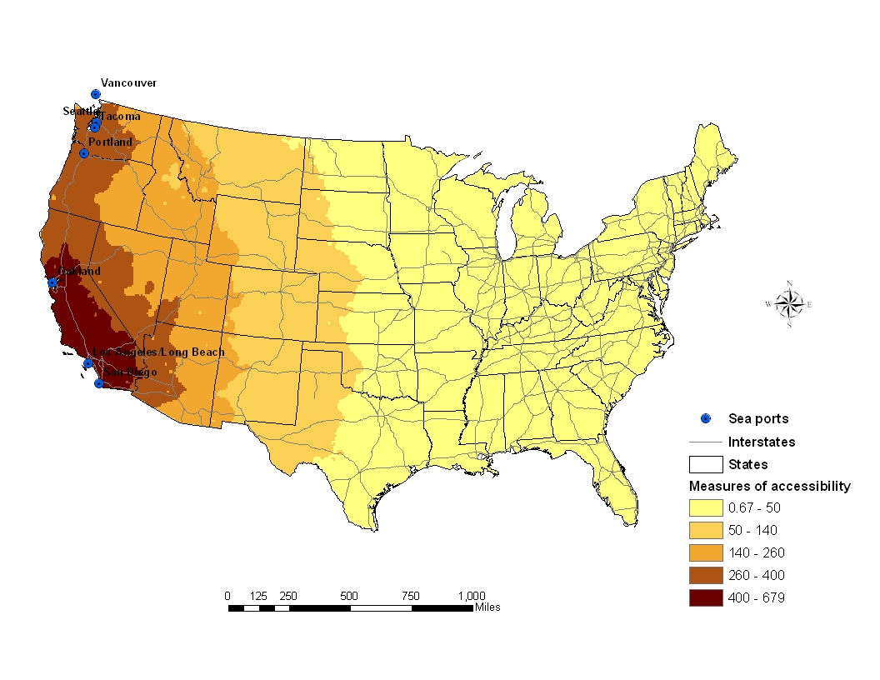

Figure 3. Surface of highway accessibility to Pacific Coast ports (in 1000 TEUs): Scenario 2; $β$ = 0.0023
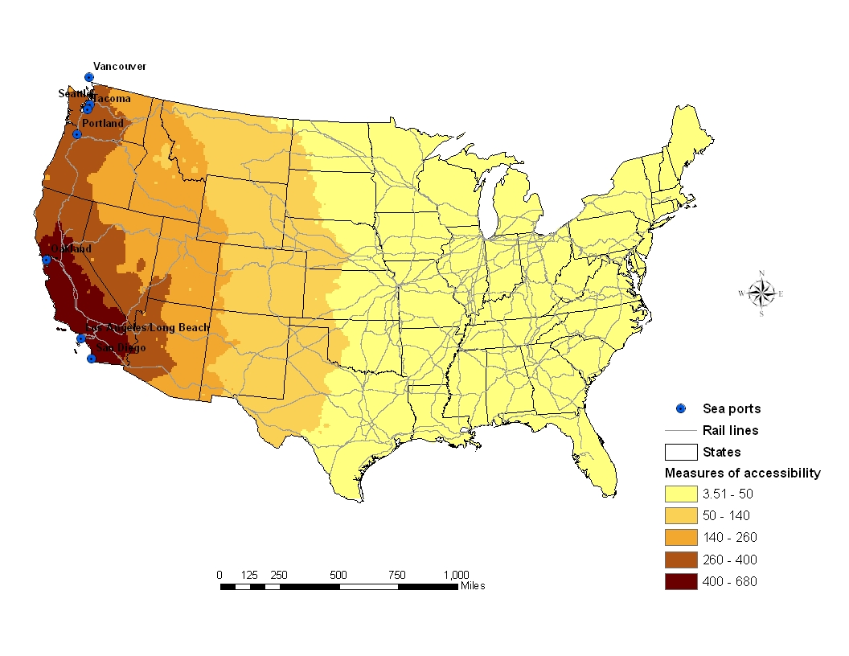
Figure 4. Surface of intermodal accessibility to Pacific Coast ports (in 1000 TEUs): Scenario 2; $β$ = 0.0023

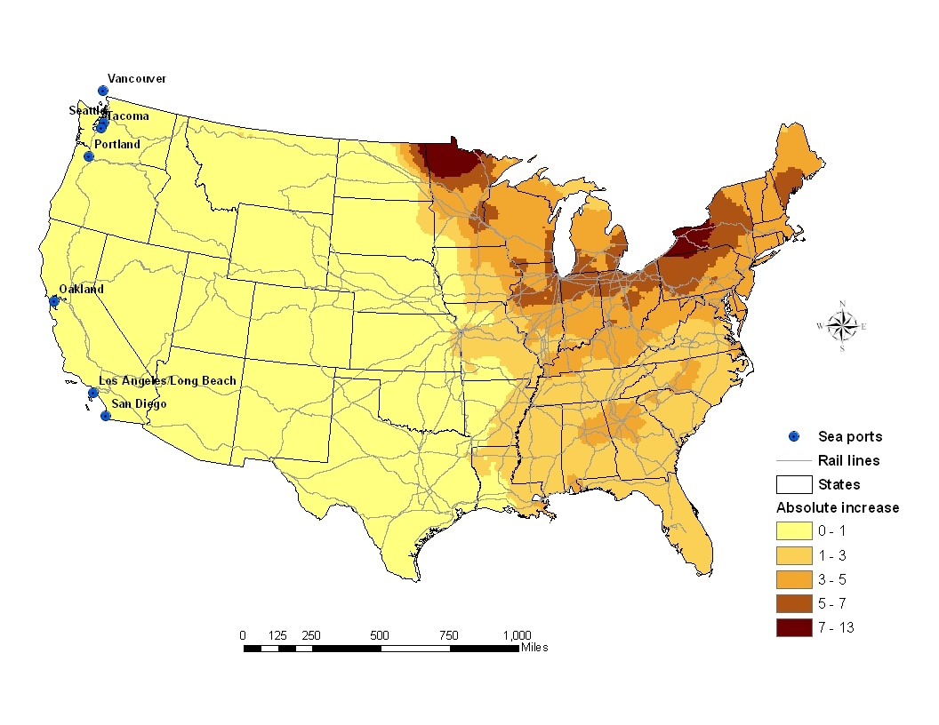
Figure 5. Surface of absolute accessibility gain to Pacific Coast ports (in 1000 TEUs): Scenario 2; $β$ = 0.0023

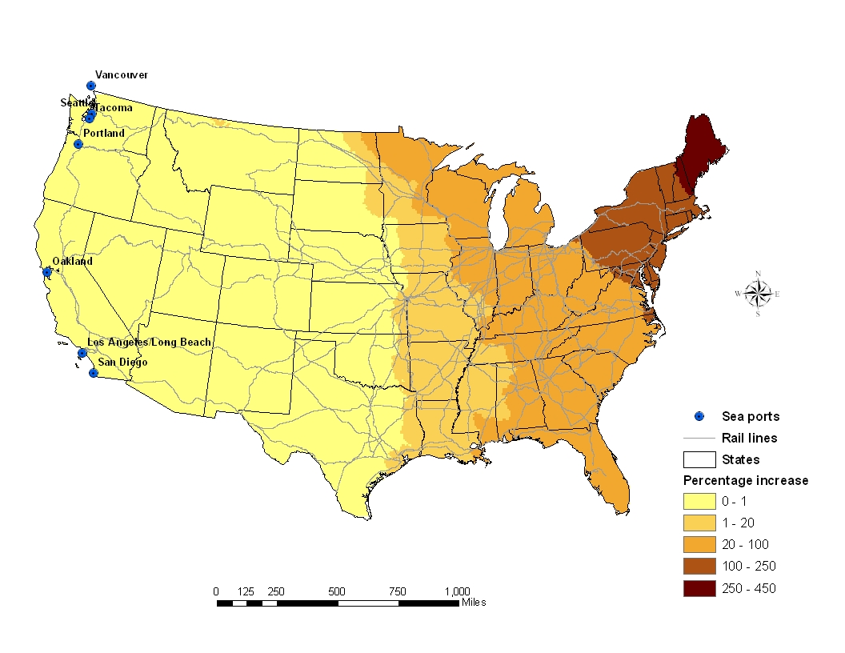
Figure 6. Surface of relative accessibility gain to Pacific Coast ports (in 1000 TEUs): Scenario 2; $β$ = 0.0023

4.2. Accessibilities to Atlantic Coast ports

Descriptive statistics of gravity accessibility measures (Table 4) show that intermodalism tends to increase accessibility to Atlantic ports nationwide; it is all the more the case when $β$ is small because long-haul shipping are more common and contribute more significantly towards place-specific accessibility. It also has the effect of slightly reducing the discrepancy in accessibility between locations across the nation. Accessibility gains are usually small and without great disparities across the data set. Relative accessibility gains are large on average and display a greater range of values as gains induced by intermodalism tends to be higher where highway accessibility is worse. Overall, evidence suggests that intermodalism helps in overcoming the tyranny of distance by being disproportionately more beneficial to geographically peripheral regions. With intermodalism, Atlantic Coast ports can grow and diversify their business geographically by offering competitive shipping services even to exporters located in locationally disadvantaged areas. Interestingly, while average accessibilities to Atlantic ports are better than to Pacific ports, average relative gains are consistently higher for the latter and so are the coefficients of variation. This suggests that Pacific Coast ports are in a better position to capitalize on intermodal services to enhance accessibility to potential customers and that their competitive position vis-à-vis their East Coast competitors is strengthened as a result of increased reliance of intermodalism.

Table 4. Descriptive statistics of accessibility and accessibility gain with respect to Atlantic Coast ports under different scenarios of sensitivity to shipment impedances

Scenario | Accessibility | Count | Minimum | Mean | Maximum | Std. Dev. | Coeff. Var.
1  ($β$ =  0.0030) | Highway accessibility | 6572 | 0.08 | 66.39 | 351.64 | 86.32 | 1.30
1  ($β$ =  0.0030) | Intermodal accessibility | 6572 | 0.40 | 67.48 | 351.64 | 85.82 | 1.27
1  ($β$ =  0.0030) | Absolute gain | 6572 | 0.00 | 1.09 | 6.51 | 1.07 | 0.98
1  ($β$ =  0.0030) | Relative gain (%) | 6572 | 0.00 | 34.73 | 478.53 | 73.56 | 2.12
2  ($β$ = 0.0023) | Highway accessibility | 6572 | 1.00 | 139.70 | 573.62 | 150.57 | 1.07
2  ($β$ = 0.0023) | Intermodal accessibility | 6572 | 3.26 | 143.06 | 573.62 | 148.82 | 1.04
2  ($β$ = 0.0023) | Absolute gain | 6572 | 0.00 | 3.36 | 18.84 | 2.98 | 0.88
2  ($β$ = 0.0023) | Relative gain (%) | 6572 | 0.00 | 23.58 | 278.60 | 45.44 | 1.92
3  ($β$ = 0.0014) | Highway accessibility | 6572 | 24.60 | 416.56 | 1,128.17 | 306.38 | 0.73
3  ($β$ = 0.0014) | Intermodal accessibility | 6572 | 49.88 | 430.58 | 1,128.17 | 297.00 | 0.68
3  ($β$ = 0.0014) | Absolute gain | 6572 | 0.00 | 14.01 | 64.60 | 12.74 | 0.91
3  ($β$ = 0.0014) | Relative gain (%) | 6572 | 0.00 | 12.61 | 122.58 | 21.55 | 1.71

Maps of accessibility to Atlantic Coast ports (Figure 7) are largely the mirror image of the corresponding maps for the West Coast. Accessibilities are highest along the East Coast and uniformly decrease towards the West. When assuming a lower impedance decay effect, overall accessibilities are somewhat higher across the entire country.
The map of absolute accessibility gains (Figure 8) reveals interesting patterns that highlight a departure in how container shipping and logistics may impact business decision in an intermodal world in comparison to trucking. As expected, gains are minimal along the Atlantic seaboard and through most of the Southeast, over a depth from the coast line of 500-750 miles. Through the rest of the country, we observe a patchwork of medium to high accessibility areas. High accessibilities are concentrated in regions surrounding inland load centers, such as by Albuquerque NM, Amarillo TX, Denver CO, Kansas City KS, Dubuque IA, Minneapolis MN, and a few others. European exports of these rather well delineated regions (through Atlantic Coast ports) and possibly also their Asian exports following a mini-landbridge route through Atlantic Coast ports may experience a significant boost from the emergence of intermodal solutions.
Relative accessibility gains (Figure 9) show a clear sorting from the East to the West, with highest values recorded in the Pacific Northwest (thus mirroring the peak relative gain with respect to Pacific Coast ports found in Maine).
Once again, qualitatively similar observations can be made under the other two scenarios of impedance decay. It should be noted however that, when decay is less pronounced, regional peaks of accessibility gains are less marked and less expansive geographically.
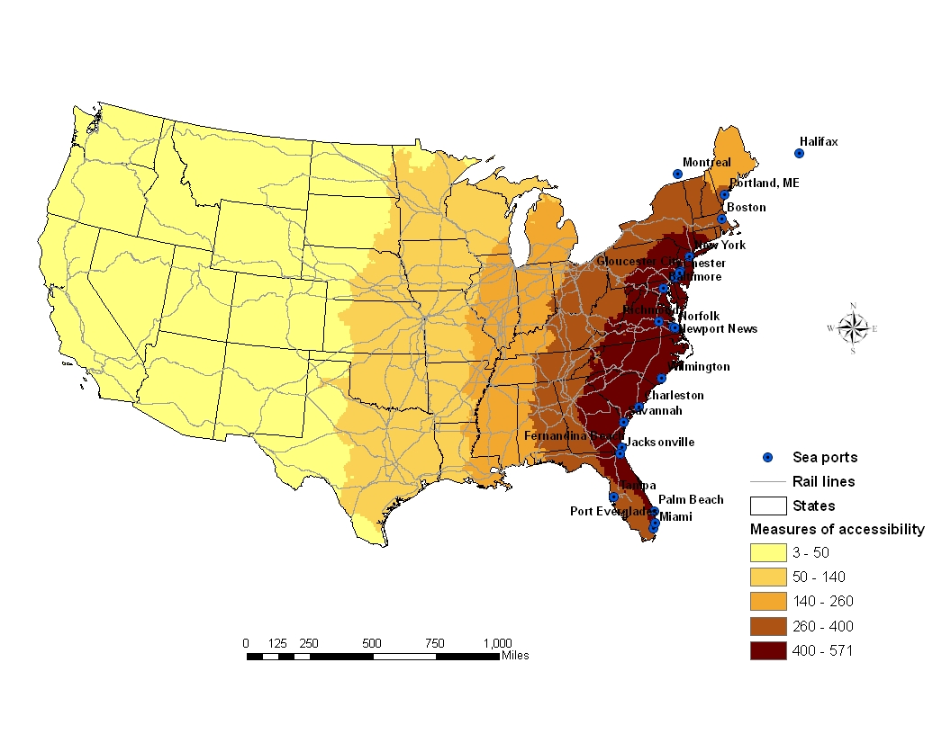
Figure 7. Surface of intermodal accessibility to Atlantic Coast ports (in 1000 TEUs): Scenario 2; $β$ = 0.0023
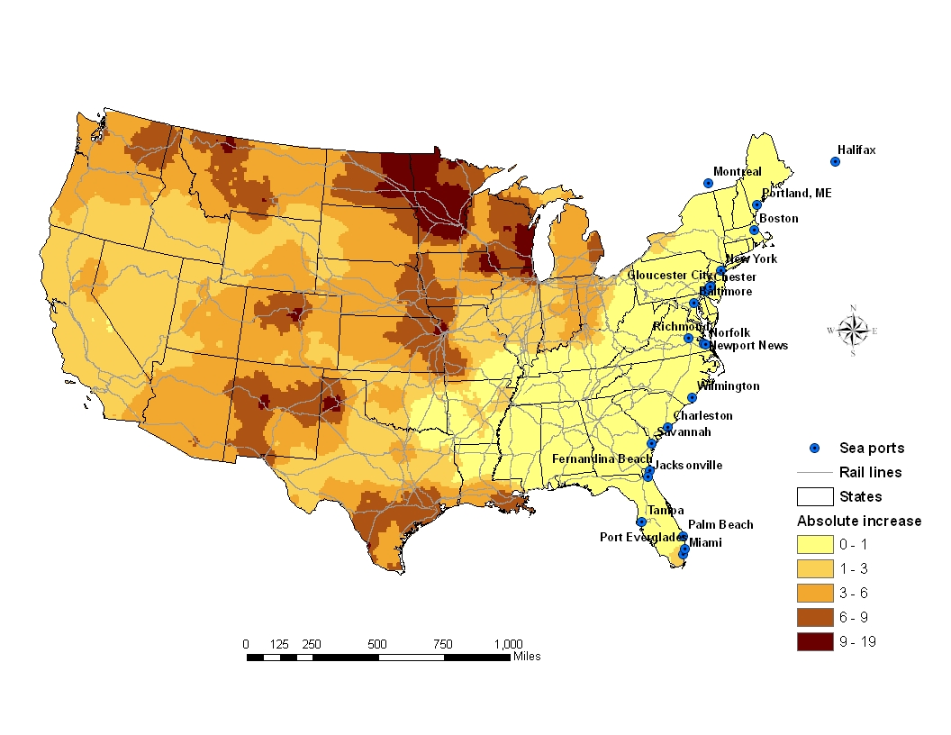
Figure 8. Surface of absolute accessibility gain to Atlantic Coast ports (in 1000 TEUs): Scenario 2; $β$ = 0.0023

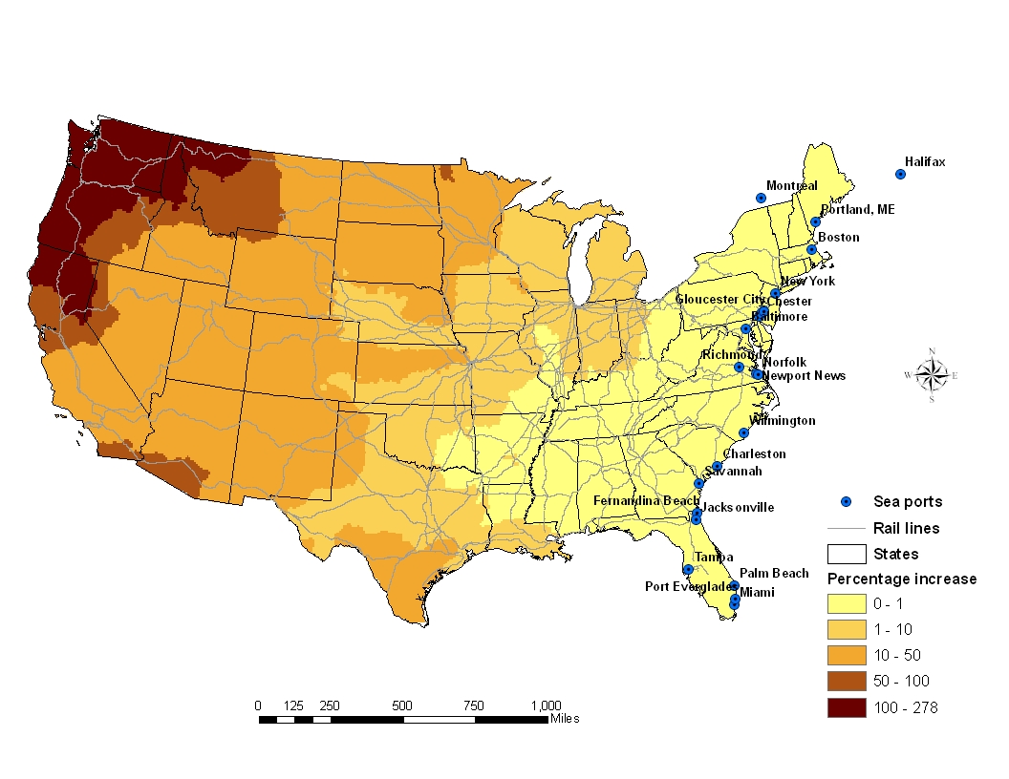
Figure 9. Surface of relative accessibility gain to Atlantic Coast ports (in 1000 TEUs): Scenario 2; $β$ = 0.0023

4.3. Accessibilities to Gulf Coast ports

Descriptive statistics of gravity accessibility measures (Table 5) show that intermodalism tends to increase accessibility to Gulf ports nationwide; it is all the more so when $β$ is small because long-haul shipping are more common and contribute more significantly towards place-specific accessibility. It also has the effect of slightly reducing the discrepancy in accessibility between locations across the nation. Accessibility gains are usually small and without great disparities across the data set. Relative accessibility gains are large on average and display a greater range of values as gains induced by intermodalism tends to be higher where highway accessibility is worse. Overall, evidence suggests that intermodalism helps in overcoming the tyranny of distance by being disproportionately more beneficial to geographically peripheral regions. With intermodalism, Gulf Coast ports can grow and diversify their business geographically by offering competitive shipping services even to exporters located in locationally disadvantaged areas. The fact that average relative gains in accessibility to Gulf Coast ports and associated coefficients of variation are consistently lower than their equivalent for Atlantic or Pacific Coast ports suggests that Gulf ports are not in as strong a competitive position as ports on the East or West Coast to capitalize on intermodal services to enhance accessibility to potential customers. Of all three port groups, intermodalism appears to grant the strongest competitive advantage to West Coast ports.

Table 5. Descriptive statistics of accessibility and accessibility gain with respect to Gulf Coast ports under different scenarios of sensitivity to shipment impedances

Scenario | Accessibility | Count | Minimum | Mean | Maximum | Std. Dev. | Coeff. Var.
1  ($β$ =  0.0030) | Highway accessibility | 6572 | 0.09 | 18.16 | 141.27 | 23.85 | 1.31
1  ($β$ =  0.0030) | Intermodal accessibility | 6572 | 0.18 | 18.88 | 141.27 | 23.54 | 1.25
1  ($β$ =  0.0030) | Absolute gain | 6572 | 0.00 | 0.72 | 6.26 | 0.97 | 1.35
1  ($β$ =  0.0030) | Relative gain (%) | 6572 | 0.00 | 25.04 | 149.09 | 32.69 | 1.31
2  ($β$ = 0.0023) | Highway accessibility | 6572 | 0.74 | 37.87 | 207.03 | 38.97 | 1.03
2  ($β$ = 0.0023) | Intermodal accessibility | 6572 | 1.29 | 39.66 | 207.03 | 38.11 | 0.71
2  ($β$ = 0.0023) | Absolute gain | 6572 | 0.00 | 1.78 | 12.75 | 2.19 | 1.23
2  ($β$ = 0.0023) | Relative gain (%) | 6572 | 0.00 | 18.45 | 103.89 | 23.38 | 1.27
3  ($β$ = 0.0014) | Highway accessibility | 6572 | 11.11 | 108.24 | 342.09 | 70.46 | 0.65
3  ($β$ = 0.0014) | Intermodal accessibility | 6572 | 15.67 | 113.50 | 342.09 | 67.43 | 0.59
3  ($β$ = 0.0014) | Absolute gain | 6572 | 0.00 | 5.26 | 27.96 | 5.80 | 1.10
3  ($β$ = 0.0014) | Relative gain (%) | 6572 | 0.00 | 10.67 | 55.80 | 13.03 | 1.22

Maps of accessibility to Gulf Coast ports (Figure 10) show a regular pattern of concentric arcs centered on the Gulf Coast with decreasing magnitude as shipping distance increases that is consistent with the expectations. Similar geographic patterns are found in highway and intermodal accessibilities. The gradient of the accessibility surfaces is highest toward western states as the highway and intermodal networks is less dense in this direction. Gradients are also higher when a higher freight cost decay is assumed.
As was already noted for access to the East Coast, the map of absolute accessibility gains (Figure 11) reveals very interesting patterns. As expected, gains are minimal along the Gulf seaboard and 500-750 miles inland from the Gulf ports concentration. Through the rest of the country, we observe a patchwork of medium to high accessibility areas. High accessibilities are concentrated in regions surrounding inland load centers, such as by Western New York, Cleveland OH, and Denver Co, and particularly the Upper Great Lakes. All these inland centers of economic activity can take advantage of intermodal container shipping services on landbridge routes transiting through the Gulf ports to other parts of the world. The emergence of this intermodal North-South corridor as an export route for the industrial heartland of the U.S. is rather opportune as it offers a significant relief opportunity for East-West routes that are increasingly congested.
Relative accessibility gains (Figure 12) show a clear sorting from the South to the North, with highest values recorded in the Pacific Northwest and the northern reaches of midwestern and northeastern states.
Once again, qualitatively similar observations can be made on absolute and relative accessibility surfaces under the other two scenarios of impedance decay.

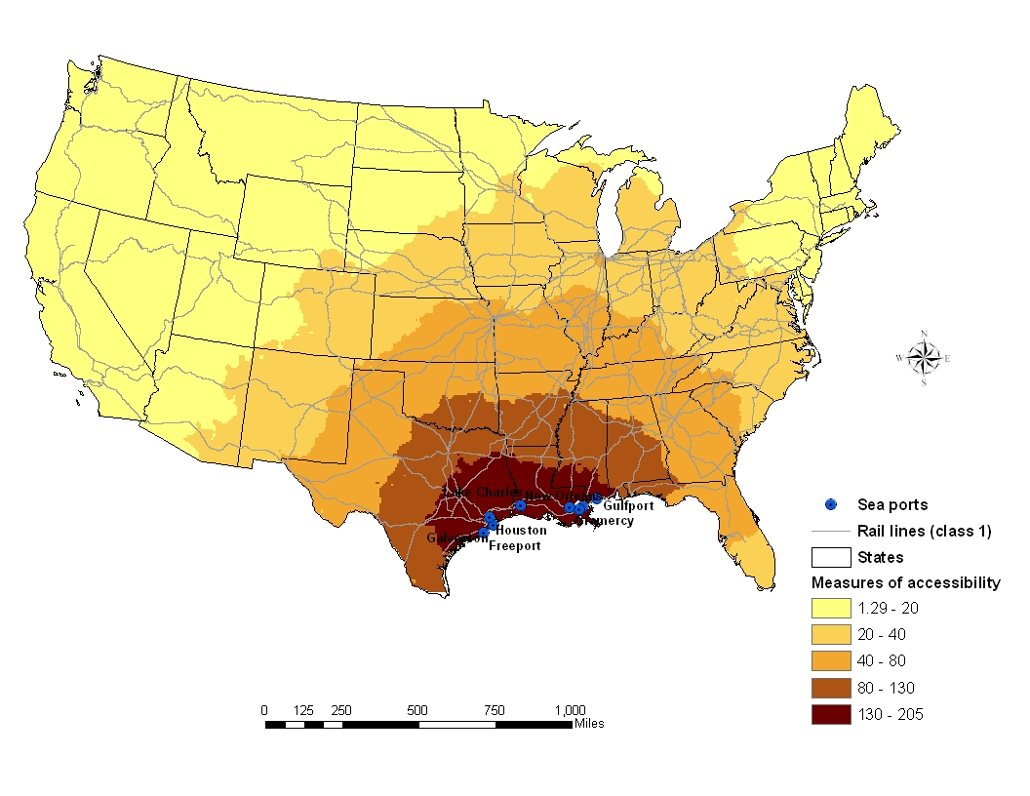

Figure 10. Surface of intermodal accessibility to Gulf Coast ports (in 1000 TEUs): Scenario 2; $β$ = 0.0023

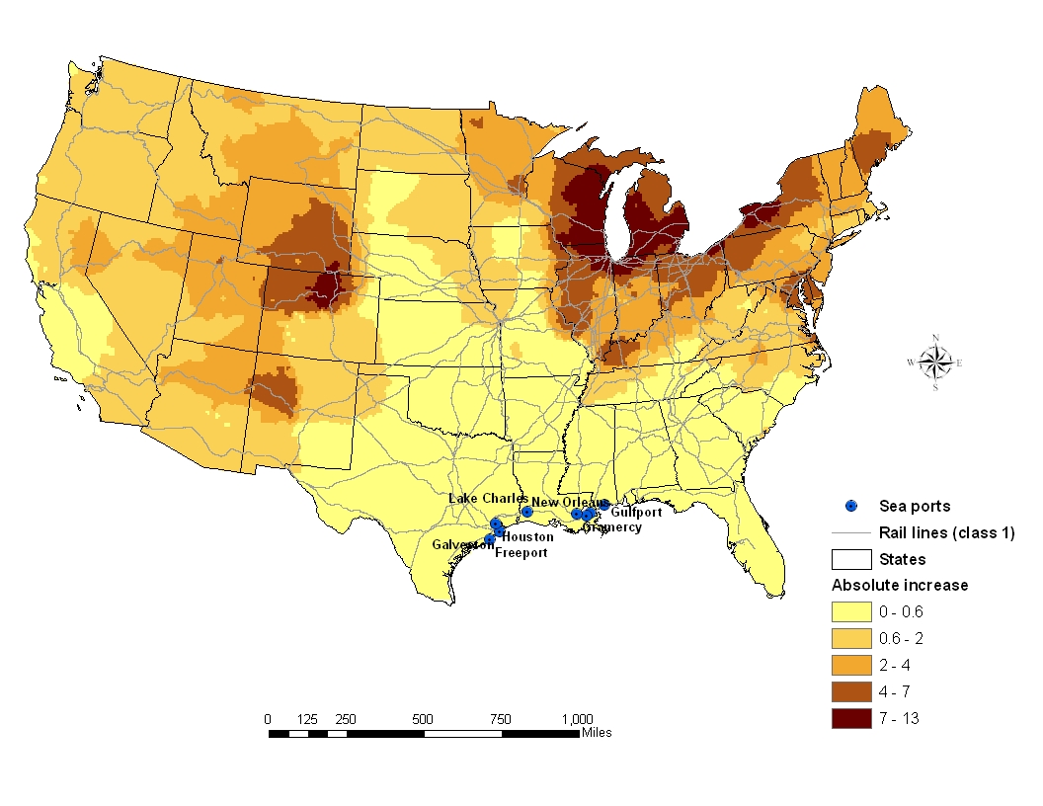

Figure 11. Surface of absolute accessibility gain to Gulf Coast ports (in 1000 TEUs): Scenario 2; $β$ = 0.0023
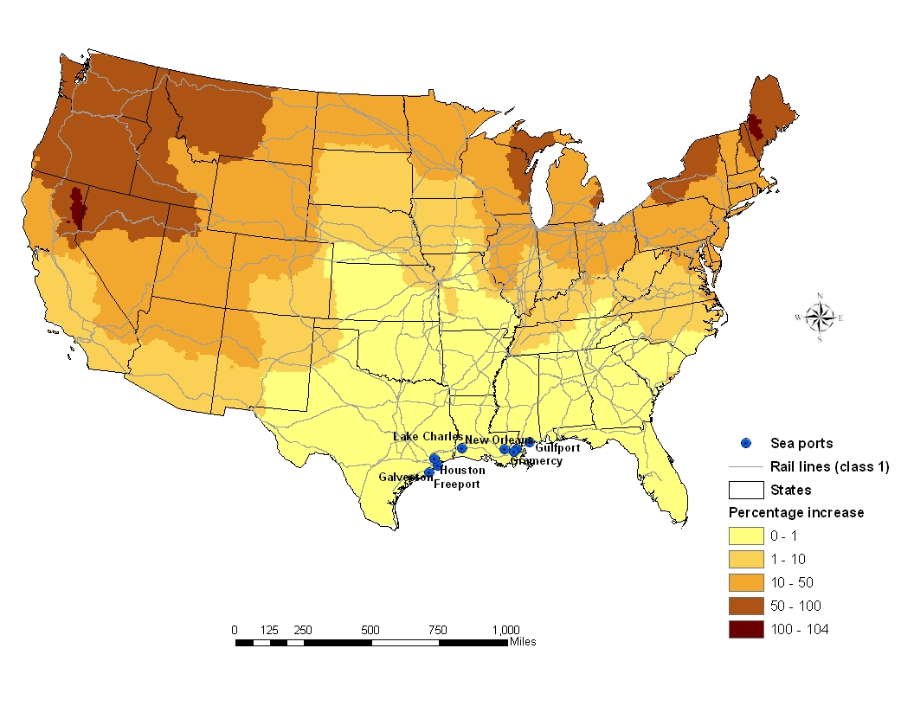

Figure 12. Surface of relative accessibility gain to Gulf Coast ports (in 1000 TEUs): Scenario 2; $β$ = 0.0023
4.4. Accessibilities to all ports

Maps of accessibility to all North American ports (Figures 13 and 14) show a geographic pattern formed of the composition of the maps depicting accessibility to each of the three port segments. Overall, accessibility to container ports is high all along the Atlantic seaboard, from Boston MA to Miami FL. It is also high along the Pacific coast, from Seattle WA to San Diego CA. The middle section of the country suffers from worsening accessibility conditions are distance from the coast lines increases. Very similar patterns are in place for trucking or intermodal service.
As far as access to export any port facilities for export to any part of the globe, whether through landbridge service or not, it is clear from Figure 15 that the Great Lakes region is the primary beneficiary of intermodal container shipping services. A few other locations also fare well, including Denver CO, Kansas City KS, and Albuquerque NM. These are all regions that are rather remote from main overseas export gateways and are in close proximity to one or more major inland load centers. Many other inland regions are hardly in a position to take advantage of the innovations that have projected intermodalism to the forefront of freight shipping because they are away from intermodal transfer facilities. When it is examined relatively to accessibility afforded by trucking services, intermodal accessibility has experienced the greatest improvements in upper Midwestern states, most notably Wisconsin, Minnesota, and North Dakota (Figure 16).
When $β$ takes a smaller value, the broad patterns of spatial distribution of accessibility depicted by Figures 13 and 14 remains, except than the accessibility depression in the middle section of the country is less pronounced. In addition, areas of large absolute accessibility gains cover a large portion of the U.S. territory, including Maine, western Montana, and parts of Washington state.

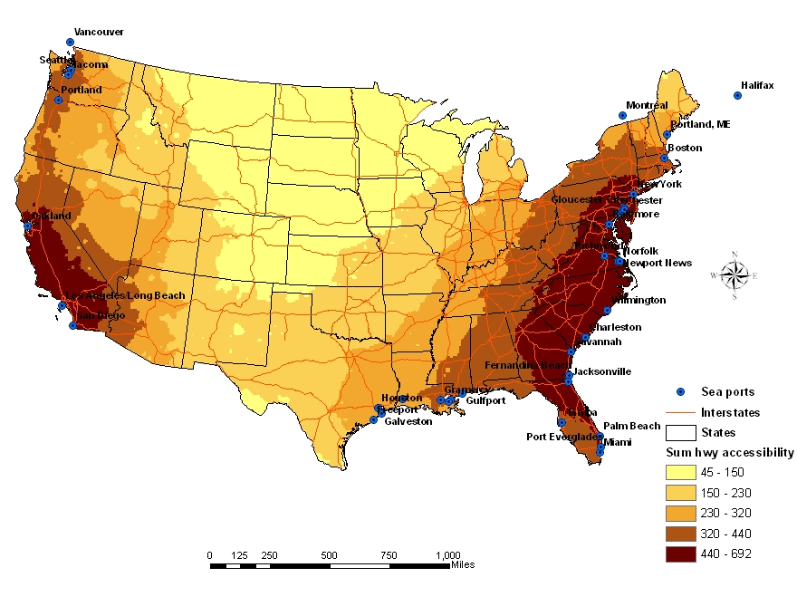
Figure 13. Surface of highway accessibility to all ports (in 1000 TEUs): Scenario 2; $β$ = 0.0023

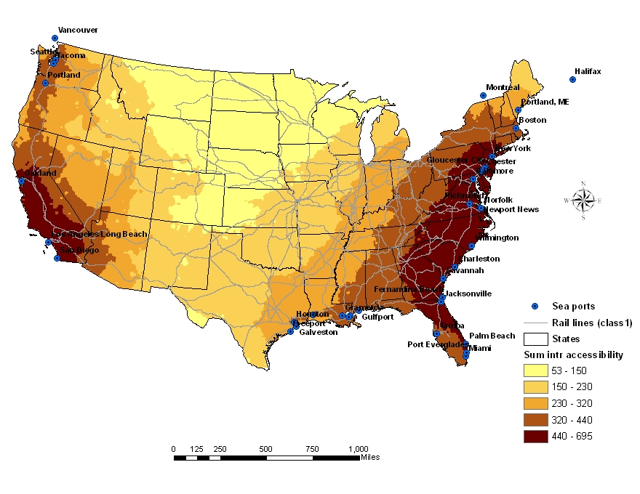

Figure 14. Surface of intermodal accessibility to all ports (in 1000 TEUs): Scenario 2; $β$ = 0.0023

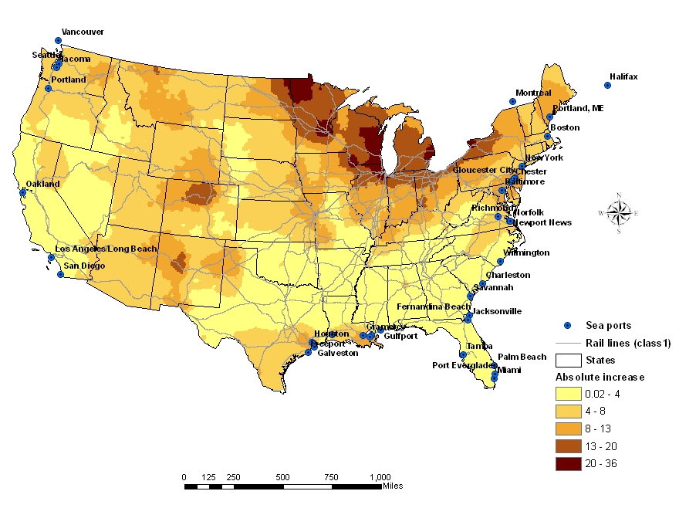
Figure 15. Surface of absolute accessibility gain to Gulf Coast ports (in 1000 TEUs): Scenario 2; $β$ = 0.0023

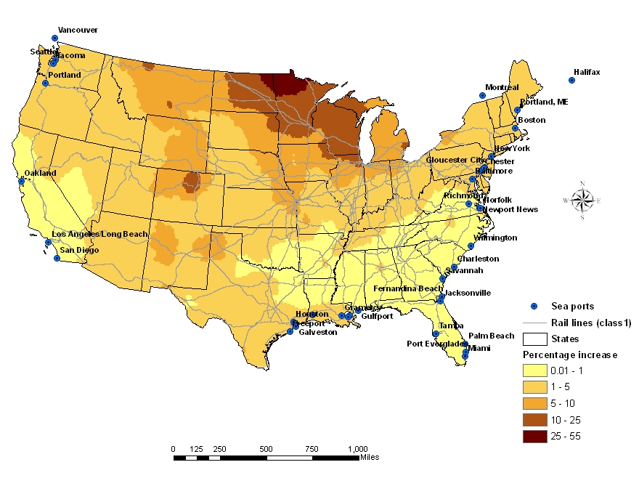
Figure 16. Surface of relative accessibility gain to Gulf Coast ports (in 1000 TEUs): Scenario 2; $β$ = 0.0023
5. Conclusions

In this paper, we explored the regional variation of potential impacts of freight intermodalism on accessibilities to North American sea ports across the contiguous United States. Gravity-type accessibilities to three groups of sea ports are calculated on five-digit zip code centroids under three different parameterizations of shipping impedance decay effects.
The analysis reveals that the resulting measures vary greatly across the country according to a clear spatial pattern, and they are also very sensitive to the impact of friction on the transportation network. It is found that the implementation of intermodal networks reduces the gap of accessibility among regions by providing better connections to sea ports. This parallels the results in Lim and Thill (2007) for domestic goods movement. The benefit of intermodalism in terms of freight cost savings can be greater in remote places to sea ports, given low enough shipping cost decay effects and proximity to intermodal infrastructures. This enables the land-bridge operations where containers are transported overland and shipped through a port depending on the location of the global trading partners. Pacific ports appear to be in a better position to use intermodalism to their advantage and increase their business with customers that otherwise may not export or may do so through other gateways. Intermodalism has opened new foreign markets for companies located some distance from America’s gateways for export to other continents.
From the observations based on the experiments reported in this paper, it can be said that intermodalism can promote a decentralization of economic activities by evening out accessibilities to export gateways. Intermodalism cannot be seen however as a silver bullet capable of erasing the logistical disadvantages of geographic peripherality; the “tyranny of geography” (Vickerman, 1998) remains powerful. This inevitably results in greater competition between ports that can extend their hinterland further and more effectively beyond reaches that were previously economically forbidding. On the other hand, this new competitive environment can imply increasing uncertainty for the individual port and its local economy (Weisbrod, 1996).
This research has assumed away several important factors that shape logistical costs of export. Impedances validated on the 1997 CFS data suffer from drawbacks that deserve to be mentioned. The per-kilometer shipping cost usually declines with shipping distance, which is not reflected in the current application for calculating the minimum path cost matrix. Given the long-haul cost advantage of rail over trucking, it can be anticipated that greater accessibility gains would be identified, although their spatial expression remains to be established. Furthermore, congestion on the national transportation systems, particularly in the freight corridors leading to major sea ports is a factor that may affect some of the conclusions of this research.

References

Banister, D., and Berechman, Y. (2001) ‘Transport investment and the promotion of economic growth’, Journal of Transport Geography, 9, pp. 209-218.
Bruinsma, F., and Rietveld, P. (1998) 'The accessibility of European cities: theoretical framework and comparison of approaches', Environment and Planning A, 30, pp. 499-521.
Capieri, C., and Leinbach, T.R. (2006) 'Freight transport, seamlessness, and competitive advantage in the global economy', European Journal of Transport and Infrastructure Research, 6(1), 23-38.
Dalvi, M.Q., and Martin, K.M. (1976) 'The measurement of accessibility: some preliminary results', Transportation, pp. 517-42.
Dwyer, L. (1994) 'Intermodalism and ISTEA: the challenges and changes', Public Roads, 58, pp. 1-4.
Hanson, S., and Schwab, M. (1987) 'Accessibility and intraurban travel', Environment and Planning A, 19, pp. 17-42.
Helling, A. (1998) 'Changing intra-metropolitan accessibility in the U.S.: evidence from Atlanta', Progress in Planning, 49, pp. 55-108.
Helling, A., and Poister, T.H. (2000) 'U.S. Maritime ports: trends, policy implication, and research needs', Economic Development Quarterly, 14(3), pp. 300-315.
Koenig, J.G. (1980) 'Indicator of urban accessibility: theory and application', Transportation, 9, pp. 145-172.
Kwan, M.P., Murray, A.T., O'Kelly, M.E., and Tiefelsdorf, M. (2003) 'Recent advances in accessibility research: representation, methodology and application', Journal of Geographical Systems, 51, pp. 29-138.
Lim H., and Thill, J.-C. (2007) 'Intermodal freight transportation and regional accessibility in the United States', Environment and Planning A, forthcoming.
Maritime Administration (2002) U.S. Exports and Imports Transshipped via Canada and Mexico 2000. Office of Statistical and Economic Analysis, Maritime Administration, Washington, D.C., URL: www.marad.dot.gov/marad_statistics.
O'Kelly, M.E., and Horner, M.W. (2003) 'Aggregate accessibility to population at the county level: U.S. 1940-2000', Journal of Geographical Systems, 5, pp. 5-23.
O'Reilly, J. (2005) 'East side story: Ocean's new direction', Inbound Logistics.
O'Sullivan, D., Morrison, A., and Shearer, J. (2000) 'Using desktop GIS for the investigation of accessibility by public transport: an isochrone approach', International Journal of Geographical Information Science, 14, pp. 85-104.
Peterson, B.E. (2000) Commodity Flow Survey Multimodal Network Documentation, Center for Transportation Analysis, Oak Ridge National Laboratory, Oak Ridge, TN.
Peterson, B.E. (2005) Personal communication, Center for Transportation Analysis, Oak Ridge National Laboratory, Oak Ridge, TN.
Priemus, H., and Konings, R. (2001) 'Dynamics and spatial patterns of intermodal freight transport networks', in Brewer, A.M., Button, K.J., and Hensher, D.A. (eds) Handbook of Logistics and Supply-Chain Management, Pergamon, Amsterdam, pp. 481-499.
Rietveld, P. (1997) 'Policy aspects of interconnectivity in networks', in Capriani, C., and Rietveld, P. (eds) Networks in Transport and Communication: A Policy Approach, Avebury, Aldershot, pp. 177-192.
Rodrigue, J.-P. (2004) 'Freight, gateways and mega-urban regions: the logistical integration of the Bostwash corridor', Tijdscrift voor Economische en Sociale Geografie, 95, pp. 147-161.
Roson, R., and Soriani, S. (2000) 'Intermodality and the changing role of nodes in transport networks', Transportation Planning and Technology, 23, pp. 183-197.
Slack, B. (2001) 'Intermodal transportation', in Brewer, A.M., and Button, K.J., and Hensher, D.A. (eds) Handbook of Logistics and Supply-Chain Management, Pergamon, Amsterdam, pp. 141-154.
Southworth, F., and Peterson, B.E. (2000) 'Intermodal and international freight network modeling', Transportation Research C, 8, pp. 146-166.
Spiekermann, K., and Wegener, M. (1994) 'The shrinking continent: new time-space maps in Europe', Environment and Planning B, 21, pp. 653-673.
Taaffe, E.J., Gauthier, H.L., and O'Kelly, M.E. (1996) Geography of Transportation, Prentice Hall, Englewood Cliffs.
Thill, J.-C., and Kim, M. (2005) 'Trip making, induced travel demand, and accessibility', Journal of Geographical Systems, 7, pp. 229-248.
van Geenhuizen, M. (2000) 'Interconnectivity of transport networks: a conceptual and empirical exploration', Transportation Planning and Technology, 23, pp. 199-213.
Vickerman, R. (1998) 'Accessibility, peripherality and spatial development: the question of choice', in Reggiani, A. (ed) Accessibility, Trade and Locational Behaviour, Ashgate, Aldershot, pp. 79-93.
Vickerman, R., Spiekermann, K., and Wegener, M. (1999) 'Accessibility and economic development in Europe', Regional Studies, 33, pp. 1-15.
Weisbrod, R.E. (1996) ‘Port trends: growth, technology, and sustainability’, The Journal of Urban Technology, 3(2), pp. 5-11.

The magnitude of transshipment through Mexico is negligible; this traffic is not taken into consideration in this study.
The coefficient of variation is computed as the ratio of the standard deviation to the mean.

