Managing mobility during road works
Track: C2 Traffic Operations, Control, & Management

Drs. G.B.G. (Gordon) de Munck – senior advisor

Dr. J.H.T. (Hans) Kramer – senior advisor

Ministry of Transport, Public Works and Water Management
Directorate-General for Public Works and Water Management (RWS)
AVV Transport Research Centre

Postbus 1031
3000 BA Rotterdam
T +31 (0) 10 282 56 72
F. +31 (0) 10 282 50 14
E. gordon.de.munck [a] rws.nl
I. www.rws-avv.nl

11th World Congress on Transport Research
June 24-28 - University of California, Berkeley

Abstract

A major scheme of works is carried out on the Dutch highways these years. A target of a maximum of 6% added congestion because of the road works was set for 2006. Besides that, the aim is to keep inconvenience for the public at a minimum. To achieve the second goal, a program of mobility management is developed. This program includes the offer to use cheap or free public transport during the road works. The first two experiences showed a decrease in road traffic during the works and an increase in public transport ridership. In the case of the Amsterdam Zuidoostpas, even more people used public transport than the car to commute from home to work on some days. In more projects public transport was and will be used to reduce the road traffic during the works. This paper will discuss the different aspects of managing mobility by using alternative transport. The paper will focus on one hand on the process (communication to the public, involvement of employers) and on the other hand on the achieved results (temporal modal shift, sustainable results, goodwill) with the examples of the approach in three projects.

Introduction

During two years (2006, 2007) a major scheme of works is carried out on the Dutch highways. Beside the regular maintenance works, there is a program of about 200 extra works to be carried out in 2006, another extra 200 in 2007 and a little over 100 in 2008. This will involve renewing a total of 1300 kilometres of roads with a total investment of € 600 mln. for (overdue) maintenance works.
A target of a maximum of 6% added congestion because of road works is set for 2006 and guarantee the flow of traffic on the national road network. Besides that, the aim is to keep inconvenience for the public (the users of the national road network) at a minimum and - by doing so – become the most public-oriented government enforcement organisation. To achieve both goals, a program of mobility and traffic management is developed by Rijkswaterstaat (RWS / Directorate-General of for Public Works and Water Management). This program includes - amongst other measures - the offer to use public transport free or for a reduced price during road works. Other measures include e.g. the use of user-friendly communication and actual information, temporary extra lanes on alternative routes and incident management. This paper will mainly focus on the achievements of mobility management in three different projects and approaches. First a short introduction to mobility management during road works is made.

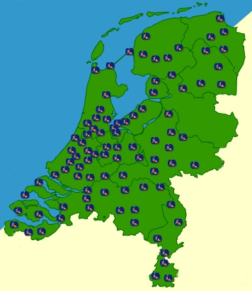

In 2006 and 2007 you will frequently come across road works o nthe Dutch roads. The quality of the roads and the infrastructure will be considerably improved over the next two years. This will involve maintenance to existing roads, bridges and viaducts and also road widening and new road construction. There will be roadworks in almost all Dutch provinces (see the map of the Netherlands).

Roadworks at night and during weekends
To reduce congestion due to roadworks as much as possible a great deal of the work on the road will be carried out at night, during the weekends and in the summer holiday period in July and August. The government will deploy extra manpower where necessary to keep the traffic moving. Diversions will be signposted and the hard shoulder will be temporarily available to help reduce delays.

Plan for delays and hold-ups
Most road works will involve fewer or narrower lanes. Remember that in these situations a reduced maximum speed limit will apply, thus giving priority to the safety of the road workers and road users.

Plan your journey
Don’t let hold-ups surprise you, there’s nothing more annoying than unexpected delays. All the important road projects for the coming year are mentioned in this folder, with the appropriate dates when the work will take place. For more detailed information please visit our website: www.vanAnaarBeter.nl
Figure 1 Advertisement for Roadworks 2006

Managing Mobility in theory

Mobility Management is about organising smarter opportunities to travel. Influencing behaviour is the most important part of mobility management. It affects the demand side of mobility, by offering attractive alternative ways to travel. In contrast to traffic management, which affects more the supply side; offering alternative routes during the trip.

Most of the road works are carried out during the night or in weekends, when traffic is less than 80% of the normal capacity. Offering a suitable alternative by public transport is often not possible during the night and not necessary as well. In the weekends however, extra congestion might occur for example due to (sport) events, special opening hours or weather influences. Coordination about major events is done by municipalities and RWS and put in a database for all events and road works to prevent problems.

However, not all work can be done during the night or weekends. Some works require a longer and fiercer disruption. The question then arises what should be done: working for a longer period of time in the weekends e.g. every weekend for 20 weeks or close the entire motorway for a couple of weeks in a holiday period. Both systems are used now in the Netherlands, although there is a tendency towards the ‘short-and-fierce’ alternative. Recent examples of that are the closure of the N50 between Zwolle and Kampen, and the A9 near Amsterdam, which were completely remodelled in 10-12 weeks time.

Road works are divided in 5 different categories, ranging from no noticeable delay till major disruption for lots of people (see table 1). In case of Class 3 or 4 projects, mobility management should be thought of as a means of reducing traffic during the works. In categories 2 and 3 it could well be used for image and offering the road users an alternative to the congested road.

Category | Disruption | Delay | Example 2006
Class 0 | None |  | No change in speed limit. Shifted lanes. Work on shoulders.
Class 1 | Few | Seconds or minutes.  No congestion. | Limited speed (70 or 90 kph) Shifted lanes
Class 2 | Limited | Less than 10 minutes due to congestion or detour | Ramp / exit closed
Class 3 | Large | 10 – 30 minutes due to congestion or detour / alternative route | Closure in weekend,  A16 Brienenoord
Class 4 | Fierce | More than 30 minutes delay due to congestion or alternative route | A29 Heinenoord  Very exceptional
Table 1 Categories of roadworks

Figure 2 shows some of the measures for managing mobility that can be taken and their advantages and disadvantages in case of road works.
Measure | Advantage | Disadvantage
Existing public transport | Makes use of existing alternatives. Making car user acquainted with public transport. | Depending on availability in terms of capacity and routes; extra costs for new users; competition with normal users.
New public transport services | Control of routes and schedule | Expensive, usually no sustainable effects
Vanpool / Carpool | Use of existing infrastructure, making car user acquainted with alternative | Limited flexibility for the users. Depending on the availability of infrastructure
Cycling / Walking | Cheap and easy. Can be combined with public transport to make it more attractive | Only short distances and sometimes infrastructure needed
Telework / e-work / Coordination of work and opening hours | Cheap, with chances of sustaining effects | Not possible for all kinds of work. Depending on employer
Coordination of holiday periods | Already existing practice | Only possible during holiday periods. Depending on availability construction personnel
Figure 2 Mobility Management options

Managing mobility in practice: the Amsterdam examples

The A10 orbital motorway around Amsterdam is one of the busiest motorways in The Netherlands. Due to the intensive use of the motorway, large road works were necessary and a lot of traffic problems were expected during these road works. In 2003 - to deal with the expected problems - RWS, together with the other road authorities, developed a coherent package of measures, consisting of traffic management and mobility management measures. The measures were accompanied by a large publicity campaign to inform road users. A research program was initiated to measure the effects of the road works and the management measures. The evaluation showed that the integrated approach was effective. The project was a good example for other similar road works.

Outcome of the evaluation was that during these large scale road works the majority of the travellers would still choose the car as the main means of transport. If necessary, the route is changed first, then the departure time and then the mode.

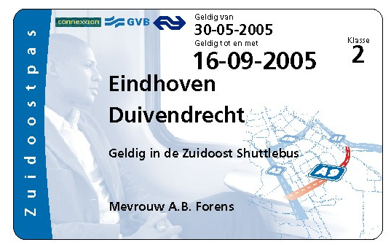
Figure 3 Zuidoostpas

Learning from the experiences of the A10West a new project was set up at the end of 2004: From the end of May until begin September 2005 major reconstruction works were carried out on the A9 Gaasperdammerweg motorway, which is the main access road to several major office locations in the south-eastern part of Amsterdam. However just like the A10West case, most of the ramps of the A9 were to be closed during the works.
In order to achieve a substantial reduction of peak hour traffic, authorities and major employers engaged to instate a ‘Mobility Broker’ that was to offer commuters a competitive alternative for using their car.
Employers in the affected area were urged to invest the costs equivalent to one labour hour for each employee in location accessibility during the period of the road works.

Eventually 17.000 employees had a dedicated public transport travel pass (the so-called ‘Zuidoostpas’) at their disposal. This pass also gave access to a shuttle bus service between train stations and the offices. The ‘Zuidoostpas’ was paid for by employers and governmental organisations and offered free to their employees. A dedicated fiscal ruling by the Treasury Department prevented tax problems.
Huge efforts were put in communication and personal marketing in order to seduce employees, while taking away mental and practical barriers, to leave the car behind and commute congestion-friendly. Employees got a Personal Travel Advice and the traffic situation could be monitored online through a number of webcams.

In order to evaluate the results of this package, an on-line questionnaire was sent to almost 14.000 employees twice, at the beginning and after the end of the maintenance works. Response was very high, being representative but also – and more importantly - indicating high involvement.

Mode (%) | before | During I | During II | after
Car | 58 | 40 | 46 | 55
Motor | 3 | 2 | 3 | 3
Moped / bike | 6 | 8 | 6 | 6
Public Transport | 29 | 47 | 41 | 31
Carpool | 3 | 2 | 2 | 3
Other | 1 | 1 | 2 | 2
Total | 100 | 100 | 100 | 100

Table 2 modal split before, after and during the road works on the A9 Gaasperdammerweg motorway

More than half of the employees used the ‘Zuidoostpas’ at least once. A large number of these employees (3700) changed from car to public transport for the period of the road works. Several hundreds of those used park & ride facilities near to their home, which proves the importance of a chain approach when considering the introduction of alternative travel options. The ‘Zuidoostpas’ fully met expectations from the authorities and contributed to the reduction of hindrance for the employees involved. Employees highly appreciated the measures taken.

After the end of the road works the Zuidoostpas lost its validity. Although most of the employees returned to their former means of transport, some employees structurally switched to public transport. The public transport share of the modal split increased 7%.

The ‘Zuidoostpas-experience’ proved to be successful in several ways: as an intensively used and highly appreciated alternative travel option for the employees involved, resulting to a substantial reduction of peak hour traffic; but also as a result of effective collaboration between public authorities and private agencies and companies, i.e. employers.

In 2006 the same approach was used when major repairs and engineering works had to be carried out on the A10 South, issuing a A4-A10 South Pass to people who worked in the vicinity of the A4 and A10 South. This had again great effects of the mobility measures in changing how those people traveled to and from work during the period of the road works. The share-of-use of public transit in commuting was nearly twice as great during the road works as it was before the period of the road works (from 23% to 43%). Simultaneously, the share of automobile usage during the road works decreased significantly (from 61% to 42%).

The road works and/or the issuing of the A4-A10 South Pass did not lead to a single, all-encompassing change in travel and departure times. A substantial proportion of the A4-A10 South Pass holders who continued to use their automobiles during the road works used an alternate route to get to work. The group of motorists who normally traveled to work via the A4 and/or A10 South decreased by 25%. And 10% of the pass holders coordinated their vacation with the road works.

The effectiveness of the mobility measures that were implemented to augment and support the A4-A10 South Pass varies by measure. That relates to the following measures:
· A special A4-A10 South shuttle
· Reduced parking rates at P+R car parks managed by the railways and car park operator Q-Park
· Free public-transit bicycles
· Personal travel advice
· Dynamic travel information
A large majority of the pass holders were familiar with those measures, and a third felt that the services offered added value. The group of pass holders who actually took advantage of the measures was limited, however.

The traffic analysis carried out by the North Holland Regional Public Works and Water Management department showed that the volume of traffic in the morning rush hour and the evening rush hour was 15% and 11% lower, respectively, than in the reference period (summer 2004). The contribution that the package of mobility measures made to that reduction was substantial. The measures led to a reduction of 5% in the volume of traffic, which represents half of the intended reduction. It should be noted that the reduction would not have been greater than 15% if all the pass holders who used the A4 and/A10 South before the road works had chosen another mode of travel or an alternate route. It is therefore reasonable to conclude that the measures were effective.

From best practice to experiment: Free or cheap trains in weekends

The unequalled success of the two projects in 2003 and 2005 in Amsterdam led to the start of a project (and process) called OV-pas (lit: public transport pass) for the major road works in 2006 and 2007. This also came as a challenge to many of the regional departments of RWS. Not only was it hard to copy the ideas of the Amsterdam examples like offering a complete package instead of just offering free transport, also this had to be done in a very short time. The projects in Amsterdam were projects that took months of preparation and included a full package for the set target group; the employees of companies in the affected area.
Most road works however do not affect one specific area, but only trouble the flow on a specific piece of motorway. Hence it is harder to find a target group and to offer it a suitable alternative to their car.

During three weekends in March and April 2006 the A58 motorway into Zeeland was closed for maintenance work. As the alternative route was a detour of almost 50 km and the congestions was expected on the other roads, an alternative was needed. And an alternative was found as parallel to the motorway there is a trainline.
Because of the short time for preparation – the plan to use public transport as an alternative came in February – a simple plan was made: just ‘buy’ the trainservices for the three weekends and make them free. As this was the first time RWS had done this, it attracted a lot of attention in mainly the local media, resulting in full trains.

During this experiment the trains transported 2.5 times more passengers than on a normal day in the weekend. Twenty percent of the people would otherwise have gone by car, 40% would not have made the trip at all, but made it, because it was free. But attracting 20.000 passengers, who otherwise never would have taken the train and got reacquainted by the service in this way, is a big gain for mobility management. Almost all the people using the train for the first time in months would like to take the train more often in the near future.
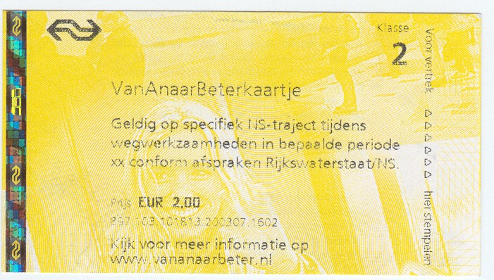
Figure 4 VanAnaarBeterkaartje, for use on a certain section of the rail network during road works in weekends

This encouraged the Dutch Railways (NS) to work together with RWS during the rest of 2006. It resulted in an agreement to offer cheap train tickets of 2 euros during road works in weekends. The so-called vanAnaarBeterkaartje (figure 4) was used in over 20 projects now. The projects this year might not have had a direct effect on the amount of traffic, but did in most cases people rethink their options. Also the media was enthusiastic about the way RWS acted and the measures taken were highly appreciated. This resulted in newspapers shifting their view from blaming RWS for the road works towards a more neutral view, also involving the behaviour of motorists and the role employers could play in mobility management.

From experiment to other alternatives

Although most of the work is carried out in weekend or nights, there are still works that need to be carried out during a longer period of time. Examples of these projects are the A29 Heinenoordtunnel in June 2006 and the reconstruction of the N50 between Zwolle and Kampen in October and November 2006. The first project a maintenance work during three weeks, the other a complete reconstruction taking almost six weeks.

In both cases a solution like in Amsterdam was not possible; there was no real ‘target group’ inside the commuters as their origins and destinations were more scattered throughout the region. The A29 Heinenoordtunnel project south of Rotterdam was a very exceptional project, with predicted delays of more than 30 minutes during morning rush hour, even in the holiday period. As there is no train service parallel to that motorway, a solution had to be found with the regional bus company. A deal was made to offer special tickets with reduced fares to people taking the bus, from the islands south of the tunnel all the way to the city centre of Rotterdam (thanks to a cooperation with the local transport company). Again this attracted attention from the media and also the bus company made a real effort to promote their product.

As congestion turned out to be worst than expected for most motorists, with the buses driving by on a dedicated lane, more and more people tried the bus every day for commuting, shopping and other activities. This resulted in 1.6 times more users of the bus services than on a normal weekday. Every day around 400 people who otherwise would have taken the car, took the bus. Afterwards the bus company had an extra growth in ridership of around ten percent.

Similar effects were seen during a 6 week total closure for reconstruction works on the N50 between Zwolle and Kampen. In this case, cheaper train tickets (day-return, weekly and monthly passes) were offered for trips on the parallel rail line together with the use of city transport in Zwolle. Almost 40% of the users of this offer were people who were not used to using public transport for that trip. A substantial part of this had otherwise taken the car. Around 250 to 300 car users switched to public transport on a daily basis. This resulted in a better flow of traffic for cars, but also of public transport busses on the parallel roads. Another remarkable fact in this research was the use of park and ride facilities; more than 10 percent of the people who switched from car to train during these weeks, used the car to get to the train station, whereas only 2-3% of the ‘normal’ train passengers do that regularly.

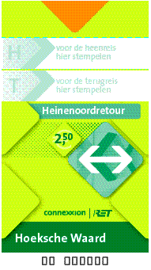
figure 5 Heinenoordretour, used for cheaper bus travel during road works on the A29 Heinenoordtunnel

Conclusion and perspective

The use of mobility management during road works started with some great results. Fifteen of the larger projects were successfully carried out with the help of mobility management (see map). Especially the free or cheap alternative transport options were for many a reason to leave their car at home and try public transport. And in the cases that not that many used the alternative it was still an alternative that was appreciated by the road users (and the media).

The dynamic process with many different projects is now being summarised and abstracted to a general approach for the possibilities of mobility management, looking further than just alternative transport. The road works made it possible to try different options and make mobility management and it’s effects also more known in the organisation.

Although it seems easy to offer an alternative there is more to it than just renting a bus. Learning from the different experiences we can say that the product offered to the road user should always be a customised solution. But still it is a quantitative and qualitative assessment of costs and benefits; sometimes something that is easy to use and promotes public transport, sometimes a tailor-made solution that has considerable impact on the commuting scheme.

In 2007 and 2008 RWS will continue to initiate and promote public-oriented actions to keep the nuisance of road works at a minimum. Experiments with mobility management will furthermore involve license-plate registration, e-work and park and ride facilities. All aiming to make the road user travel smart and rethink their possibilities.

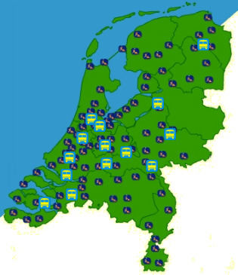
Figure 6 Road works in the Netherlands

References and further readings

AVV (2002) Evaluatie Mobiliteitsmanagement A10 West, Rotterdam, maart 2003
AVV/ KpVV (2006) Mobiliteitsmanagement is het organiseren van slim reizen, Rotterdam, maart 2006
AVV (2006) Evaluatie OV-pas A29 Heinenoordtunnel, Rotterdam, september 2006
AVV (2006) Evaluatie mobiliteitsbeïnvloedende maatragelen A4/A10, Rotterdam, december 2006
AVV (2006) Evaluatie OV-pas N50 Zwolle – Kampen, Rotterdam, december 2006
Bootsma, Gerben, Henk Taale and Henk Schuurman (2006) Evaluation of Mobility and Trafic Management during roadworks on the A10 West Motorway
Ministerie van Verkeer en Waterstaat (2006) Handreiking Mobiliteitsmanagement, DGP/MDV 29 maart 2006
Rijkswaterstaat (2001) Aan de slag met Mobiliteitsmanagement bij Wegwerkzaamheden, Rijkswaterstaat Directie Zuid-Holland. Rotterdam, december 2001
Rijkswaterstaat (2005) Evaluatie Zuidoostpas groot onderhoud A9 Gaasperdammerweg, Rijkswaterstaat Regionale Dienst Noord Holland, december 2005
Rijkswaterstaat (2006) Evaluatie gratis treinvervoer Zeeland, Rijkswaterstaat Regionale Dienst Zeeland, Middelburg, mei 2006

