A Study of Road Traffic Congestion in selected Corridors
of Metropolitan Lagos, Nigeria.
By

Joshua A. Odeleye
Principal Staff Development Officer
Nigerian Institute of Transport Technology,
P.M.B 1148,Zaria, Nigeria
Tel: 234-803-5905619
E-mail: joshuaodeleye@yahoo.com
and

Iyiola Oni (Ph.D)
Senior Lecturer, Transportation Geography
Department of Geography
University of Lagos
Akoka, Yaba, Lagos, Nigeria.
Tel: 234-803-4180800
E-mail: iyiolaoni@yahoo.com
Abstract

Road traffic congestion is a global phenomenon that bedeviled the cities of the world today. One of the significant negative impacts of this phenomenon on socio-economic well being of any city is the unpredictability of travel times, over time and space. Consequently, this research aimed at identifying the diverse pattern of road traffic congestion in relation to human and road traffic environment contributory factors in the study area. This is with a view to recommending cost effective and sustainable policy options for a better and enhanced intra-urban mobility in metropolitan Lagos.

This work adopted the combination of quantitative and qualitative research techniques in collection of useful empirical data. Some of the primary data collected include the commuters perception of road traffic congestion in the study area, the spatial pattern of road traffic bottleneck points, traffic management institutional problems, travel time in selected corridors, the disequilibrium in demand and supply of road traffic management infrastructure, as well as commuters coping strategies in congestion. Furthermore, data on human and environmental contributory factors to traffic congestion in the study area were acquired through a structured questionnaire, focus group discussions, interviews, participants-observer method and field survey.

In addition, secondary data on the vehicular composition and road traffic congestion intensity on Lagos roads, the relationship between the road geometry and congestion pattern, the operational characteristics of road traffic management agencies on selected Lagos corridors were presented and analysed. These data were analysed using Statistical Package for Social Sciences (SPSS) Software. Consequent the adoption of Analysis of Variance (ANOVA), a statistical tool used to examine the degree of variation in commuters’ perception of road traffic congestion in the study area. Also, graphs, maps and Arc View Geographic Information Systems (GIS) were used to depict graphically the pattern and features of the phenomenon, in the study area. Finally, these data were used to validate the traffic management theory of “Predict and Provide, Predict and Prevent”, as it applies to the study area.

Some of the highlights of the findings of this work are: traffic bottleneck points, which are crucial to efficient traffic management, are clustered in metropolitan Lagos. More than 50% of travel times are spent at identified traffic bottleneck points on Lagos roads. Car traffic dominance on Lagos roads is a crucial problem in traffic management over time and space in Lagos. Also, the disequilibrium in traffic volume and infrastructure supply is a challenge of traffic management and infrastructural investment in Lagos. The unruly behavioural tendency of motorists, such as disregard for traffic rules and regulations, as well as some noticeable human activities like street trading, on-street bus stops and parking, pedestrians crossing are pronounced and inhibited the traffic flow in Lagos. Others include poor institutional arrangement, contradiction in traffic management operating schedule and traffic congestion build-up pattern.

From transportation planning perspective, the policy implications of these findings, as it relates to enhancing a more vibrant, competitive and creative metropolitan, through an improved access to spatially located urban resources in the study area, engendered the recommendation of sustainable urban transport planning policy options like Transit Oriented Development (TOD), introduction of Bus Rapid Transit (BRT), modal integration, inter alia, in place of the ever growing personal mobility, that is, car vehicular traffic in metropolitan Lagos.

Introduction
Cities across the world are bedeviled with environmental maladies in different sub-sectors of the urban system. For instance, in the transportation sub-sector, road traffic congestion, air and noise pollution, and accident negatively affect the aesthetic of the urban environment. According to Auclair (1999) rating of transportation negativities in major cities of the world, the adverse effects of road traffic congestion was rated at 54.5%, while ineffectual public transportation system, air and noise pollution were rated 54.8% and 59.4% respectively. However, road traffic congestion is expected to be worst at 61.3% than public transportation and air pollution in the nearest future.

World Bank (2001) also noted the increasing pressure on urban transport systems in most developing countries. This is as a result of motor vehicle ownership and use which is growing at a faster rate than population, with vehicle ownership annual growth rates of between 15% or 20% in most developing countries. More so, the average distance traveled per vehicle has been on increase in most cities of the world. Ironically, these growths in traffic have continually exceeded the capability of authorities in developing countries to increase road space, hence the consequential impediments to the efficient working of the urban economics in most cities in developing countries.

Also, UNCHS (1998) asserted that travel speeds in cities are decreasing and the travel environment for pedestrians and people-powered vehicles are deteriorating in developing countries, due to the inefficiency of the entire road transport system. Of the sixteen developing country cities with populations of more than 4 million studied, five major cities in this group (Bucharest, Jakarta, Kinshasa, Lagos and Manila) experienced an average one-way journey to work of about one and quarter hours or more (UNCHS Global Urban Indicators Database, 1998).

This urban challenge, that is, road traffic congestion is, however, expected to aggravate in the nearest future particularly in developing countries, as a result of the projected world urban population explosion, in which about fifty percent of the world population is expected to live in cities by mid 21st century (World Bank, 1999). This projection justified the need for scientific enquiry into the generic characteristics of road traffic congestion, a social disorder, as it affects travel pattern in metropolitan Lagos.

Research Problem
The city of Lagos, a renowned world fast growing city, has over the years been experiencing problem of road traffic congestion. This problem has consequently rendered the city immobile over time and space. The ubiquity of road traffic congestion in metropolitan Lagos reduces accessibility to spatially located urban resources and land uses. Thus, impacts negatively on the socio-economic growth and development of the city. Road traffic congestion in Lagos is synonymous with the pronounced problems of longer transit time between locations, and waiting time at bus stops, high cost of transportation, excessive energy consumption and its attendant effects of air and noise pollution.

This problem persists, as the road capacity seems to be failing at accommodating additional traffic (demand for travel) by the surging Lagos population. The adverse effect of this is that the city is comparatively less competitive in socio-economic activities such as commerce and trade, education and tourism. Since the problem of road traffic congestion in metropolitan Lagos roads seems multi-faceted, there is need for multi-dimensional scientific enquiry into its causes, spatial dimension and characteristics; the underlining factors as well as the institutional approach to road traffic management activities in Lagos, so as to unclog traffic on metropolitan Lagos roads.

Research Questions
The magnitude of the problem as highlighted above necessitates the quest into the background information and the generic characteristics of road traffic congestion in Lagos as follows:
- What is the characteristic of the vehicular composition on selected Lagos roads?
- What is the intensity of road traffic congestion in selected corridors?
- What is the structure of the traffic management institutions in Lagos?
- What is the spatial dimension and characteristics of traffic bottlenecks on selected Lagos corridors?
- What are the commuter’s perceptions of road traffic congestions and coping strategies been adopted by them in metropolitan Lagos?
- What are the capacity and features of traffic management infrastructure provided on selected Lagos corridors?
- What solution(s) would be ideal for a congestion free urban environment in Lagos?

Aim
The aim of this study is to analyze succinctly the diverse patterns and causes of road traffic congestion on selected metropolitan Lagos corridors.

Objectives
The objectives are to:
- identify the vehicular composition and volume on selected corridors of Lagos and outline its spatio-temporal effects on traffic flow in the metropolis.
- determine the hierarchy of road traffic congestion on selected corridors of Lagos
- examine the institutional arrangement for road traffic management in Lagos.
- examine the geographic spread of road traffic bottlenecks in the study area.
- identify commuters coping strategies and general perception of road traffic congestion in metropolitan Lagos
- audit the adequacy or otherwise of road traffic infrastructure in relation to effective traffic control and management in selected corridors within metropolitan Lagos.
- proffer feasible solution for new designs and countermeasures to road management, towards a free road traffic system in metropolitan Lagos.

Justification of study
Over the years, capacity expansion has been regarded as a major panacea to minimization of road traffic congestion in metro Lagos. Ironically, the construction of new roads and expansion of old ones by successive administrations in Lagos has never ameliorated the problem. Demand has always superceded supply, because vehicular volume, human population in Lagos have continue to increase over the years.

This however, corroborated Drew (1968) assertion that traffic engineer has only limited influence on traffic variables. According to Drew (1968), road engineer can add traffic lanes so as to reduce the rate of flow per lane; speed limits can also be set to discourage high speeds. In addition, traffic signals can be erected to alternate the right-of-way between conflicting streams. But Drew (1968) added that the engineer influence in road environment is limited by factors like traffic demand, vehicular capacities, and driver performances to mention a few.

This assertion further justifies the need for an enquiry into the relevance of this scenario in Lagos, so as to highlight appropriately the generic characteristics and peculiarities of this phenomenon in the study area. This is with a view to curtailing the problem of traffic congestion across Lagos, inasmuch as mobility is regarded an essential citizen right in any society (Whitelegg, 2006).

The Study Area
Lagos metropolis is located in southwestern Nigeria. The boundaries of the area is the territory within latitudes 6°23 N and 6°41°N and longitude 3°9°E and 3’28E. Metropolitan Lagos, however, constitute less than 2.5% of Nigeria’s total land area of 923,768km²; meanwhile, Lagos accommodates over 6% of Nigeria’s total population of 1991 National Census. The metropolitan area accounted for the seventeen out of the twenty local government areas in Lagos State (Fig 1).

Lagos, occupies a pre-eminent position based on all urban indicators, most especially demography. It should be noted that all other cities are relatively small in terms of commercial, industrial and trading activities in comparison to Lagos. Demographically, the density of Lagos is much higher than other cities in Nigeria. According to Taiwo, (2005), while Nigeria’s population density is 100 persons per square kilometre (psk) that of Lagos is about 2,400 persons/ km² with annual population growth rate of between 5.0 to 5.5%.

Fig 1: Metropolitan Lagos
In terms of transportation, Lagos area is naturally endowed with navigable creeks, lagoons and water body that are suitable for urban transit services. It also has rail line that links the commercial southern part of the city with the dormitory settlement of the North. As a result, Lagos has the potential of benefiting from a seamless transportation system. Ironically, road transport dominates more than 90 percent of all intra -urban movement (Oni, 2004).

According to Taiwo (2005) there are about 2,600 km of roads in Lagos. These roads are frequently congested with over 1 million vehicles on a daily basis. Lagos has about the highest national vehicular density of over 222 vehicles/km against country average of 11/km. The major identified corridors with predominant heavy vehicular traffic are Lagos- Abeokuta road, the Lagos-Badagry road axis and the Ikorodu road, (Fig 1).

Theoretical/Conceptual Framework and Literature Review
The theory of “predict and provide”, “predict and prevent” as postulated by Goodwin (1997) is synonymous with problem of urban traffic management. According to Goodwin (1997) the axiom was: first we forecast how much traffic there will be, and then we build enough road space to accommodate it. This was the axiom, according to Goodwin (1997) that aided the rapid and huge expansion of road capacity, which eventually produced the national network of motorways in England. This is a process of meeting the travel demand by supply of additional road infrastructures. However, the flaw of this programme anywhere in the world is that it has never kept pace with traffic growth.
Conceptual Framework
Road traffic congestion is imminent when users of a particular facility begin to interfere with other users, due to the limited capacity of the infrastructure. (Buton, 1982; Sadiq, 1999, Varaiya, 2005). Again, traffic congestion on a freeway sets in once the density of vehicles exceeds a certain critical number. Since the addition of a single car to a road that has already reached its saturation level will result in “dead-weight”, that is road traffic congestion. Above the dead weight, both vehicle speed and vehicle flow will drop precipitously thereby making travel time between two points on the road in question to become unpredictable. Other related problems include fluctuating transportation cost, excessive fuel consumption as well as aggravated auto-induced pollution. This are noticeable phenomenon on Lagos roads.

Ogunsanya (2002) conceptualised traffic congestion as when urban road network could no longer accommodate the volume of traffic using it. This situation is usually caused by rapid growth in motorization with less than corresponding improvements in the road network and related facilities. However, Roth (1999) agreed that traffic congestion usually result in a situation whereby too many cars are occupying the same amount of road space available during a given time. In the same vein, Ortuzar and Wilumsen (1990) stated that one of the most important features of transport supply is congestion. In other words, the higher the numbers of new roads provided as panacea to congestion, the higher the demand for travel. Consequent to these past studies, road traffic congestion in this paper is conceptualized as vehicular traffic impediment to free movement of persons and/or goods from one location to the other in an urban environment.
There are two prominent types of road traffic congestion identified by Mkhize, (2005), namely: recurring and non-recurring congestion. The former result from over saturation of the road capacity by vehicles of various sizes, while the latter is as a result of happenings such as multiple accidents, disabled vehicles, and natural disasters to mention a few.

Nevertheless, traffic management according to Tiwari, (2005) is a cost-effective measure of countering road traffic congestion in any given urban traffic environment. Traffic management as explained by Alshuler (1979) is the art of optimizing the use of a fixed network of streets and highways. Traffic Management Systems (TSM) was highly recognized in the 1970s in United States of America. Hence, Alshuler (1979) advised against roads capacity expansion by construction in congested corridors, which was in the fifties an acclaimed technical strategy for curbing road traffic congestion in United States of America.

The three distinct separate purposes of traffic management are maximization of vehicle-carrying capacity, the maximization of people-carrying capacity, and the promotion of amenity and safety by assigning some roadway space predominantly or exclusively for pedestrian use. But, until recently according to Alshuler, (1979), virtually all traffic engineers have viewed their main task as maximization of vehicle-carrying capacity on any given road.

Literature Review
Road traffic congestion has undauntedly posed challenges to cities of the world. However, it has a remarkable antecedent in history. According to Mumford (1961) as soon as the increase of population created a demand for wheeled traffic in Rome, the congestion became intolerable. Also, Wachs (2002) asserted that Charles II of England issued a famous edict in 1660 banning standing carriages, wagons, and horse from the streets of Westminster and London. This is as a result of traffic congestion, noise and air pollution created by the wheel chariots. These evidently ascertained the fact that auto-sclerosis preceded the automobile era of the 19th century.

Nevertheless, road traffic congestion in cities is regarded as an evidence of economic buoyancy. For example, Webber (2000) asserted that despite universal complaints and many proposed remedies, it seems that there is still no cure for traffic congestion. As a mirror on city’s economic vitality and the pace of its social life, congestion is a built-in attribute of the prosperous metropolis. Since, heavy traffic volumes are positive index of a city’s range of opportunities and the richness of her resident .Hence, cities with little traffic are considered as stagnant ones. The city with but little traffic is a city that may be stagnating. Although congestion is an intrinsic attribute of successful cities, it also has a lethal attribute like other vexing city problems, since congestion is self-limiting.

Road Traffic Congestion in Lagos
By world standard, Lagos is the largest metropolitan centre in Nigeria with about 12 million people. It is relatively small in size, but its traffic problems are greater than those of cities many times its size. The traffic situation is already making Lagos almost an unlivable city, with increasing traffic delays and air pollutant level, (Mabogunje 1968). Again, Adalemo (1981) and Olukoju (2003) explicitly portrayed the transportation related problems of Metropolitan Lagos, of which road traffic congestion is one, to her emergence as a major commercial and transportation centre not only in Nigeria but the entire West Africa region.

Also, Ogunsanya, (2002) explained that traffic congestion is a chaotic situation that is observable in virtually all streets in metropolitan Lagos. Most urban congestion problems in Lagos are caused by the sub-optimal manner in which the roads are used. For example, roadside and on-road parking, roadside trading and total disregard of traffic regulation by road users are significant human contributions to the traffic problem.

The identified gaps in literature in this paper, are the inability of past studies to emphasize the practical implications of a clustered network of traffic bottlenecks to efficient traffic management in Lagos. Secondly, past studies also failed to highlight the adverse effects of exclusive motorization of an urban traffic environment with private cars.

Research Methodology
Three kinds of surveys were conducted in this study. Firstly, a questionnaire-based survey was carried out in order to have a full grasp of commuters’ perception and understanding of its socio-economic implications in metropolitan Lagos. Secondly, an activity –based trip survey of the study area was carried out to audit road traffic infrastructure in the study area. Lastly, personal interviews were conducted, held at various locations among road transport stakeholders in the study area.

Data Source and Collection Strategy
Data on the general perception of commuters on road traffic congestion issues were collected through questionnaire administration. Based on the formula for sample size by Kulanthayan (2004), the sample size for this study was determined at 400. A total of 50 questionnaires were administered among identified five different age brackets, that is 18-48 years and above. This age bracket represents mostly the working class in the study area. Equal representations of questionnaire were administered using stratified random sampling across age brackets the eight designated traffic management zones of Lagos. Issues addressed by the questionnaire include commuter perception of road traffic congestion in Lagos, commuter’s assessment of traffic officials and other road users, commuters’ coping strategies, commuters’ identification of bottlenecks, and the spatial-temporal pattern of congestion in commuters’ routes to mention a few.

Furthermore, a comprehensive observatory survey of congested commuters’ routes in the study area was carried out as a way of auditing and identifying qualitatively the infrastructural characteristics and composition of the road traffic environment, the average travel time at peak and off-peak period in the selected corridors of Ikorodu Road, Third Mainland Bridge, Lagos-Abeokuta Expressway, Apapa-Oshodi Expressway, and Lagos-Badagry Expressway.

Data on average travel time on congested selected corridors were collected using Stopwatch to record peak period travel time over a period of three weeks on each of the selected corridors, while the off peak period travel time was used as control time. After the first three -week experiments on each of the selected corridors, random travels on these routes were conducted to revalidate acquired data on travel time.

Secondary data on the vehicular traffic volume on the selected corridors, generated from the 12 hour traffic count by the Lagos Urban Transport Project (LUTP,2002), was used to depict the traffic composition and vehicular pattern as well as their implications on traffic control and management. The selected corridors were chosen as a result of their socio-economic importance and geographical attributes of traversing the four cardinal points of metropolitan Lagos. Again, a ten year newly registered vehicles by types data was used to depict the growth trend in various types of vehicles in Lagos. Data on geometrical size of selected road retrieved from the archival of road maintenance department was also used to determine the volume capacity ratio of the selected roads in the study area.

Also, data on the institutional structure, responsibilities and activities of traffic management agencies at formal and informal levels were collected from various publications. In addition, participant observation, and executive interviewing were used to gain insight into the activities of the identified road traffic management organizations, as regards their experience and perception of the problem on Lagos roads. These data was used to determine the extent of operational co-ordination among the identified agencies. The identified agencies include Lagos Metropolitan Area Transport Authority (LAMATA), Lagos State Traffic Management Authority (LASTMA), and National Union of Road Transport Workers (NURTW) Federal Road Safety Commission (FRSC).

Statistical Analysis
Qualitative data were analysed using the Statistical Package for Social Sciences (SPSS) Software. For instance, Analysis of Variance (ANOVA) was employed to examine the relationship between the identified variables namely: commuters perceived health implications of traffic congestion; commuters adopted coping strategy in traffic congestion, road pricing policy option. Also, Pearson correlations were used to determine the relationship between the road geometry and congestion pattern on selected corridors.
Volume/Capacity Ratio (V/C), a process whereby the designed traffic capacity of a given road is compared with the actual traffic volume within a given period, was also deployed in this paper to determine the congestion level on selected Lagos corridors. The standardized capacity volume of 2000 cars per hour on a two or three lane highway in both directions as recommended by Buton (1982), were used to determine the spatial variance in vehicular volume and consequent congestion pattern on selected Lagos roads.

The benchmark for analysing the local cost implication of traffic congestion on the selected roads is the national minimum wages of N7000.00.Every minute lost in congestion was equated to a minimum loss of 73 kobo per individual/ day by the city’s economy on a given road.

According to Rietveld and Stough (2005) institutions are social structure that guides behaviour. Hence, this paper examined the roles of traffic management institutions in Lagos in generating and integrating scientific knowledge in the metropolitan development policies and programmes that favours a sustainable urban transport in Lagos. Finally, Arc View Geographic Information System (GIS) was used to depict the cluster nature of traffic bottlenecks on selected Lagos corridors.

Results and Discussions
Traffic congestion and Vehicular composition of Lagos roads
The results of traffic count surveys carried out in three different studies revealed a uniform result of higher numbers of car traffic relative to other types of vehicular traffic on Lagos roads (Fig 2).

Fig 2: Predominance of Cars Traffic in Lagos
The trend is further revalidated in Table 2. The planning implication of this pattern is that every bit of road infrastructure supply by the authority, are for moving cars carrying few people at the expense of the public. The implication of this trend, if not reversed, would be an unsustainable utilization of public space in metropolitan Lagos.

Table 1: Trends of newly registered vehicles by type and year of registration in Lagos State (1992-2002).
Vehicle Types | 1992 | 1993 | 1994 | 1995 | 1996 | 1997 | 1998 | 1999 | 2000 | 2001 | 2002
Salon/Station Wagon | 33666 | 36286 | 31064 | 20249 | 22082 | 12511 | 10529 | 12104 | 27729 | 112600 | 127446 | 40569.636
Pick-up, Van, Litcar | 2078 | 3608 | 2327 | 1025 | 1163 | 345 | 367 | 361 | 341 | 1269 | 1876 | 1341.818
Lorry/Truck | 863 | 1157 | 960 | 766 | 634 | 237 | 358 | 344 | 494 | 4016 | 4791 | 1329.091
Minibus | 5321 | 6682 | 7447 | 4941 | 4138 | 1580 | 1573 | 1920 | 3175 | 14529 | 15469 | 6070.455
Omnibus | 900 | 1209 | 1369 | 527 | 605 | 305 | 36 | 98 | 256 | 552 | 833 | 608.182
Tanker | 124 | 306 | 157 | 18 | 3 | 9 | 5 | 7 | 1 | 16 | 12 | 59.818
Tractor | 54 | 79 | 45 | 23 | 6 | 16 | 5 | 13 | 29 | 41 | 46 | 32.455
Trailer | 330 | 314 | 56 | 5 | 13 | 6 | 6 | 9 | 16 | 53 | 88 | 81.455
Tipper |  |  |  |  |  |  |  |  |  | 20 | 59 | 39.500
Total | 43336 | 49641 | 43425 | 27554 | 28644 | 15009 | 12879 | 14856 | 32041 | 133096 | 150620
Source: Lagos State Digest of Statistics.
Road Traffic congestion pattern on selected Lagos roads
Since road traffic congestion on urban roads is a function of traffic volume, Table 1 shows variations in traffic volume and congestion levels on different corridors and sections in metropolitan Lagos. Table 2 shows that more than 80 percent of the roads in the study area are heavily congested, going by the 2000 vehicles per hour benchmark.

Table 2: 12 Hours Traffic Count on Selected Roads in Metropolitan Lagos
Roads |  | Nos. of vehicles in both direction  (12 hours traffic counts) | Nos. of vehicles in both direction p/hour | Average volume/capacity v/c ratio
1. | Third Mainland Bridge | 180,902 | 15,075 | 7.5:1
2. | Carter Bridge | 22,962 | 1,914 | 0.9:1
 | Eko Bridge | 90,130 | 7,511 | 3.7:1
4. | Western Avenue | 87,190 | 7,266 | 3.6:1
5. | Murtala Mohammed Way | 1,302 | 1,085 | 0.5:1
6. | Herbert Macaulay Way | 33,458 | 2,788 | 1.3:1
7. | Ojuelegba – Mushin | 14,983 | 1,249 | 0.6:1
8. | Ikorodu Road. | 117,303 | 9,775 | 4.8:1
9 | Agege Motor Road | 28,245 | 2,354 | 1.1:1
Again, applying the WBCSD (2004) traffic congestion categorization, extreme congestion is predominant on the Third Mainland Bridge, Eko Bridge, Western Avenue and Ikorodu road, But it is rather severe congestion on Agege Motor road. It should be noted that as Carter Bridge attains its congestion peak, the Ojuelegba-Mushin corridors only records slight congestion. But, there is no congestion on Murtala Mohammed way.

These identified corridors in Tables 2 and 3 are the corridors that serve as the major link between the sprawling northern part which serves mostly as the dormitory settlement; and the southern part where the central business district is located. The graphical illustration of this is as presented in Figure 3.
Table 3: Road Traffic Congestion Pattern on selected Lagos roads.
Average Traffic Volume/Capacity Ratio |  | Technical Interpretations | Corridors
(i) | Less than 0.6 | No congestion | Muritala Mohammed Way
(ii) | 0.6 to 0.8 | Slight congestion | Ojuelegba-Mushin
(iii) | 0.8 to 1.0 | Congestion | Carter Bridge
(iv) | 1.0 to 1.2 | Severe Congestion | Agege Motor Road
(v) | Greater than 1.2 | Extreme Congestion | 3rd Mainland bridge, Eko Bridge, Western Avenue, Ikorodu Road.

Fig III: Road Traffic Congestion Pattern along Selected corridors of Lagos.
Table 4 shows vehicular traffic volume, and road geometry on selected corridors in the metropolis. It also detailed the relationship between traffic congestion and road traffic environmental characteristics (i.e. numbers of lanes and road width) in metropolitan Lagos.
Table 4: Vehicular traffic volume and geometric dimension of selected Lagos corridors.
Road | Nos of vehicles in 12 hours  traffic counts | Nos of vehicles P/hr | Average Traffic  Volume/Capacity Ratio | Nos of Lanes | Road width
Third Mainland Bridge | 180,902 | 15,075 | 7.5:1 | 3 x 2 | 10.95m x 2
Ikorodu Rd | 117,303 | 9,775 | 4.8:1 | 5 x 2 | 18.25m x 2
Agege Motor Road | 28,245 | 2,354 | 1.1:1 | 2 x 2 | 7.3m x 2

Table 5 shows an inverse relationship between the vehicular volume, the road width and/or lanes. The implication of this finding is that, since road traffic congestion is a function of vehicular volume, and space on a given corridor, therefore, road width and /or lane expansion can never be a cost-effective solution to resolving problem of traffic congestion in an urban environment. In other words, the wider the road width, the heavier the traffic volume in an urban environment.

This result is consistent with the work of Eckhard and Thomas (2004), roadway geometrics or the characteristics of the adjacent environment has been used to explain transportation externalities like road accidents, and traffic congestion among others. It is thus deduced that, notwithstanding the size of the roads or numbers of the lanes on the roads in the study area, road traffic congestion would persist if the volumes of car traffic on these roads were not properly checked.
Table 5: The correlation matrix of lanes and width of selected roads
and congestion pattern in selected Lagos corridors.
Correlation Matrix | Lanes | Width of the Road | Congestion
Lanes Pearson Correlation  Sig. (2 –tailed)  N | 1.000  .  7 | .496  .257  7 | -.026  .957  7
Width of the Road Pearson Correlation  Sig. (2-tailed)  N | .496  .257  7 | 1.000  .  7 | -.700  .080  7
Congestion Pattern Pearson Correlation  Sig. (2-tailed)  N | -.026  .957  7 | -.700  .080  7 | 1.000  .  7

Institutional Structures and Road Traffic Management in Lagos.
The multi agencies structure of road traffic management institutions in the study area is presented in Fig 4.This organisational structure revealed that more than 90 per cent of traffic management institutions in Lagos are formal organizations owned and funded by different tiers of government in Lagos. However, less than 10 per cent of the traffic management institutions are owned by private and social organizations like bus operator unions, companies, schools, Non Governmental Organisations (NGOs), and Community Based Organisations (CBOs).

It was observed that these agencies often times pursue individual corporate objectives, rather than collective objective of enhancing mobility and free flow of traffic in Lagos.
The ownership structure of these institutions jeopadised proper supervision and co-ordination of their activities by any central institute, which could have allowed for the generation and integration of ideas on sustainable urban transport development and planning in Lagos.
The uncoordinated nature of these institutions also hampered their operating schedule on the roads. For instance, their work hour schedule is usually between 7.00 a.m and 6.00 p.m. Meanwhile the early peak period in Lagos often begin as early as 6.00 a.m while the evening peak period usually commence by 5.00 p.m. and sometime extend to the later part of the night. In other words, their work hour schedule contradict traffic congestion build-up pattern.

Hence the need for a coordinated involvement of the informal sector i.e. private institutions and community based organizations in traffic planning and management, as a way of minimizing bureaucracy in the study area. Informal institutions, according to Rietveld and Stough (2005) underpin the success of the Alameda Corridor Transportation Authority (ACTA) in the United States. In the same vein, Muhlrad (2005) regarded bureaucracy as one of the problems that retard the progress of traffic safety institutions in most countries of the world.

Fig IV: Road Traffic Congestion Management and Institutional Arrangement in Lagos
The Spatial Pattern of road traffic bottleneck
The regular interference of on-street bus stops to traffic flow on highways, which often resulted in traffic bottlenecks, is identified by respondents to the questionnaire as a major challenge to traffic management across metropolitan Lagos. Fig 5 shows the spatial dimension of the traffic bottlenecks points in the study area.

Fig V: Spatial pattern of road traffic bottleneck on Lagos Roads
Traffic congestion prone period on Lagos roads
The two major peak periods identified by respondents’ during which traffic congestion usually reach critical point are morning and evening as shown in Fig 6 .

Fig VI: Traffic Peak Periods on Lagos Roads
Travel time on selected corridors of Lagos
Table 6 shows the frequencies of respondents’ perception of travel time in Lagos. About 46 % of respondents agreed that journey to work on Lagos roads usually lasted more than one hour. However, 31 per cent of the respondents agreed that travel time is unpredictable on Lagos roads. It is thus deduced that, as a result of traffic congestion, journey time on Lagos roads could be longer than necessary, notwithstanding the distance traveled.

Table 6: Travel Time to Work
 | Frequency | Percent | Valid Percent | Cumulative %
Indifferent | 36 | 11.6 | 11.6 | 11.6
< 1 hour | 32 | 10.3 | 10.3 | 21.9
> 1 hour | 146 | 46.9 | 46.9 | 68.8
Not predictable | 97 | 31.2 | 31.2 | 100.00
Total | 311 | 100.0 | 100.0

The ‘F tests’ for the response rates by the socio-economic characteristics of respondents as presented in Table 7 shows that the response rate differences between the different age group, gender, and car owners are highly significant (F[1,310]=30.692,p <0.000). This implies that differences as large as those observed could occur solely by chance less than 1 time in 100. In other words, respondents generally perceived that road traffic congestion contributes immensely to longer travel time in the study area. Although, respondents’ perception of travel time within the occupational group statistically differs (F[1,310]=.004,p<0.952).This result is not statistically significant, at the Tukey’s q-test 5% significant level. It is however, deduced that this could be as a result of the diversity in the types of respondents’ jobs, which may likely dictate the individual travel commencement time in the study area.

Table 7: ANOVA table of travel time in congested corridors according to respondents socio-economic characteristics.

Variables | Sum of Squares | Df | Mean square | F | P
Age Between Groups  Within Groups  Total | 32.178  450.413  482.592 | 1  309  310 | 32.178  1.458 | 22.076 | 0 .000
Gender Between Groups  Within Groups  Total | 7.025  70.724  77.749 | 1  309  310 | 7.025  .229 | 30.692 | 0 .000
Occupation Between Groups  Within Groups  Total | 3.756E-03  317.823  317.826 | 1  309  310 | 3.756E-03  1.029 | .004 | 0 .952
Car Ownership Between Groups  Within Groups  Total | 2.024  128.734  130.759 | 1  309  310 | 2.024  .417 | 4.859 | 0.028

In addition, one of the important findings of the field survey that corroborated table 6 is that more than 50% of travel times at peak periods in metropolitan Lagos are spent at traffic bottleneck points on the selected corridors as shown in Table 8.For example, an average of fifty minutes is required by commuters to traverse Ikorodu road, a distance of 22kilometre, at peak periods. However, this same journey could be done within twenty minutes or less at off peak periods. As a result, commuters who ply this route lose on daily basis an average of thirty minutes in road traffic congestion. The minimum financial implication of this to the urban economy is approximated at twenty-one naira, ninety kobo per trip.
The minimum total monetary value of man hour lost of four individual least paid worker commuting to work in Lagos, as a result of road traffic congestion in selected corridors as shown in Table 8 is about N102.10K/hour.This is relatively equivalent of 1US Dollar. This is on a high side in a country where about 71 percent of the population lives on 1 US Dollar per day (EarthTrends). Road traffic congestion in Lagos thus, impacts negatively on economic growth and consequently aggravates urban poverty.

Table 8: Travel Time Duration on Selected Metropolitan Lagos Corridors
Roads | Distance  (KM) | Average peaks period Travel Time(Mins) | Average Off-Peaks Period Travel Time (Mins) | Time Wasted in congested Traffic (Mins) | *Monetization of Wasted time in congested corridors/Person
Lagos-Abeokuta Expressway | 41 | 80 | 30 | 50 | N36.46
Ikorodu Road | 22 | 50 | 20 | 30 | N21.90
Lagos-Badagry Expressway | 33 | 60 | 20 | 40 | N29.20
Apapa-Oshodi Expressway | 43 | 40 | 20 | 20 | N14.60

* The current exchange rate is approximately Naira 125 to 1 US Dollar.

Zonal Variation in Traffic Delay Causative Factors in Metropolitan Lagos
There are zonal variations in factors responsible for road traffic congestion in Lagos. This is found as one of the reasons responsible for the unpredictability of transit time in Lagos (Table 9). For instance, Table 9 shows that the priority areas of traffic management needs in Victoria Island and Ikoyi areas are intersections and junctions’ control. But in Lagos Island area, on-street parking and trading activities constituted major problem in the area. As a result, it deserves priority attention in traffic management and planning of the metropolis.
Table 9: Zonal Variation in Traffic Congestion Causal Factors in Metropolitan Lagos
TM Zones | Bad Road | On-street  Bus/S | Street  Trading | On-Street Parking | Intersection  Junctions | Pedestrian  Crossing | Touting | Road  Accidents | Disable  Trucks | Police  Check Points | Police  Check Points
Zone1 (Lagos ISLD Div) | √ | √ | √ | √ | √ | √ | √ | √ | X | √ | √
Zone 2 (Ikeja Div) | X | √ | √ | √ | √ | √ | √ | X | √ | X | X
Zone 3 (Lagos Mainland Div) | √ | √ | √ | √ | √ | √ | √ | X | √ | X | X
Zone 4 | √ | √ | √ | √ | √ | X | √ | X | √ | X | X
Zone 5 (Badagry Div) | √ | √ | √ | √ | √ | √ | √ | √ | √ | √ | √
Zone 6( Agege Div) | X | √ | √ | √ | √ | √ | √ | X | √ | X | X
Zone 7 (Ikotun Div) | √ | √ | √ | √ | √ | X | √ | √ | √ | √ | √
Zone 8 (Ikorodu div) | X | √ | X | X | √ | √ | √ | √ | √ | X | X

KEY
1. √-Intense
2. X-Not Intense
Table 10 identifies some of the critical traffic points on the selected corridors within metropolitan Lagos. Since most of the factors that are responsible for conflicting movement at these locations are as a result of human activities, land-use disorderliness and disregard for traffic regulation, among others, as shown in (Table 9).The deployment of traffic management techniques as recommended in Table 10 would alleviate and reduce reasonably travel time at these locations across the metropolis.

Table 10: Traffic Management Techniques for Critical Traffic Points in Metropolitan Lagos.
Selected Corridors | Critical Traffic Points | Recommended Traffic Management Techniques
1) Ikorodu Road | Ojota/Ogudu, Ojota/Oregun, Mile 12, Alapere, Anthony Interchange | * Ramp metering  * Traffic-actuated signal systems;  * On-Street Parking Prohibition;  * Truck Loading Restriction  * Channelisation  * Access Control  * Exclusive lanes for High-Occupant  Vehicles (HOVs)  * Reserved regular travel lanes in the  predominant flow direction (‘with-  flow lanes”)  * Reserved regular travel lanes in the  off-peak direction (“contra-flow  lanes”)
2) Lagos-Abeokuta  Expressway | Meiran, Ijaiye, Kollington, Iyana-Ipaja, Abule-Egba, Cement, Ikeja, Bolade
3) Lagos-Badagry  Expressway | Festac Junction, Iyana-Iba, Okokomaiko, Alaba Junction, Orile
4) Apapa-Oshodi  Expressway | Commercial Avenue, Warehouse, Trinity, Cele, tin Can Island, General Motors, Iyana-Isolo, Oshodi, Bus Stop

The Commuters coping strategies in traffic congestion in Lagos
Traditionally commuters usually adopt series of strategies to cope with congestion. For example, Raney (2000) identified departure time, work schedule change, and work/ lifestyle change as some of the major types of coping strategies often been adopted by commuters. Table 11 shows early morning wake up time as a popular coping strategy among commuters in Lagos. About 88 per cent of respondents agreed to early morning wake up as a coping strategy against traffic congestion (Table 11).

Table11: Wake-up time and Congestion in Study Area

Responses | Frequency | Percent
Yes | 275 | 88.4
No | 3 | 1.0
Indifferent | 33 | 10.6
Total | 311 | 100.0

Table 12 reveals that the response rate differences between the different age group, gender, and car owners are highly significant (F[4,310]=17.372,p <0.05).This implies that differences as large as those observed could occur solely by chance less than 4 times in 100. It should be noted that most commuters in Lagos subscribe to early wake-up strategy as a reasonable option out of traffic congestion at peak periods. However, respondents’ perception of wake-up time within the occupational group, as a viable strategy against congestion, is not statistically significant at the Tukey’s q-test 5% significant level (F[4,310]=.355,p>0.05). Consequently, it is deduced that this could be as a result of the likelihood of flexibility in respondents’ individual occupational demand in the study area.
Table 12: ANOVA Test of respondents’ wake-up time according to socio- economic characteristics

Variable | Sum of Squares | Df | Mean square | F | Sign. P
Age Between Groups  Within Groups  Total | 89.308  393.284  482.592 | 4  306  310 | 22.327  1.285 | 17.372 | 0 .000
Gender Between Groups  Within Groups  Total | 11.988  65.761  77.749 | 4  306  310 | 2.997  215 | 13.964 | 0.000
Occupation Between Groups  Within Groups  Total | 1.468  316.359  317.826 | 4  306  310 | .367  1.034 | .355 | 0.841
Car Ownership Between Groups  Within Groups  Total | 19.846  110.913  130.759 | 4  306  310 | 4.961  .362 | 13.688 | 0.000

Perceived Health Implications of Traffic congestion on commuters in Lagos
Table 13 shows the commuters perceived health implications of road traffic congestion in metropolitan Lagos. For instance, 55 percent of the respondents agreed that stress is a major adverse effect of road traffic congestion. This is followed by 15 percent, who agreed that feeling feverish is a common post traffic congestion experience among Lagos commuters. Nonetheless, 9 percent of the respondents perceived high blood pressure as a greater challenge of road traffic congestion in Lagos. Meanwhile, respiratory disorder and dehydration are perceived by 8 and 4 percents respectively as noticeable commuting related health problems in Lagos. This result is in tandem with findings already reported by Ogunsanya (2002), WHO (2004); and Tiwari (2005).
Table 13: The Commuters perceived health implications of Traffic Congestion in Metropolitan Lagos

Index | Frequency | Percentage Distribution
Stress | 172 | 55
High Blood Pressure | 29 | 9
Respiratory Disorder | 24 | 8
Feverish Condition | 47 | 15
Dehydration | 10 | 4
Indifferent | 28 | 9
Total | 310 | 100%

The perception on the adverse health implication of road traffic congestion by respondents is statistically significant at the Tukey’s q-test 5% as presented in Table 14 (F[1,310]= 28.602,p <0.05).In other words, the differences in health implications of road traffic congestion among commuters in Lagos, notwithstanding social status, could only solely by chance at less than 1 in 310.
Table 14: ANOVA Test of perceived health implications of congestion according to respondents socio-economic characteristics.

Variable | Sum of Squares | Df | Mean square | F | Sign.P
Age Between Groups  Within Groups  Total | 13.693  468.899  482.592 | 1  309  310 | 13.693  1.517 | 9.024 | 0 .003
Gender Between Groups  Within Groups  Total | 6.589  71.162  77.749 | 1  309  310 | 6.587  .230 | 28.602 | 0.000
Occupation Between Groups  Within Groups  Total | .108  317.718  317.826 | 1  309  310 | .108  1.028 | .105 | 0.746
Car Ownerships Between Groups  Within Groups  Total | 9.731  121.028  130.759 | 1  309  310 | 9.731  .392 | 24.844 | 0.000

Respondents’ perception of traffic light in effective traffic management.
Respondent’s preference for traffic light as a sustainable and cost-effective tool for traffic management is as shown in Table 15.It reveals that more than 78 percent of respondents preferred the installation of traffic light on Lagos corridors. Only 11 and 10 percent disagree and indifferent respectively.
Table 15: Preference for traffic light
Responses | Frequency | Percent
Yes | 244 | 78.5
No | 35 | 11.3
Indifferent | 32 | 10.3
Total | 311 | 100.0
The perception of the respondents preference for traffic light in traffic control, relatively to the activities of the traffic management personnel in the road traffic environment of Lagos is statistically significant (Table 16) (F[2,310]=26.122,p <0.05).This implies that differences as large as those observed could occur solely by chance at less than 2 times in 100.It is noted by respondents that installation of traffic lights at strategic locations in place of ubiquitous traffic officials, would ease traffic congestion more on Lagos roads.

Table 16: ANOVA Test of respondents’ preference for traffic light.
Variable | Sum of Squares | Df | Mean square | F | Sign. P
Age Between Groups  Within Groups  Total | 69.988  412.603  482.592 | 2  308  310 | 34.994  1.340 | 26.122 | 0.000
Gender Between Groups  Within Groups  Total | 10.886  66.863  77.749 | 2  307  310 | 5.443  .217 | 25.074 | 0.000
Occupation Between Groups  Within Groups  Total | 1.079  316.748  317.826 | 2  307  310 | .539  1.028 | .525 | 0.592
Car Ownership Between Groups  Within Groups  Total | 11.133  119.626  130.759 | 2  307  310 | 5.566  .388 | 14.332 | 0.000

Respondents’ perception of introduction of road pricing mechanism on Lagos roads
Commuters’ preference for road pricing a means to ease traffic congestion in Lagos as shown in Table 17 reveals that about 46 per cent of respondents agreed to opt for public buses instead of their private cars, if toll road mechanism is introduced in Lagos. Another 25 percent opted for taxis, while 19 percent of respondents’ would rather car pool instead of paying toll in metropolitan Lagos.

Table 17: Road Pricing on Lagos Roads
Variables | Frequency | Percent
Car pool | 59 | 19.0
Taxis | 79 | 25.4
Buses | 144 | 46.3
Indifferent | 29 | 9.3
Total | 311 | 100.0

The perception of the respondents, if users pay mechanism such as road pricing is introduced on Lagos roads, is statistically significant particularly within the car owners group (F[3,310]=102.228,p<0.05) is presented in Table 17.This implies that differences as large as those observed could occur solely by chance at less than 3 times in 100.In other words, car owners on Lagos roads would abandon their cars for public transport options, consequently reduce the numbers of trips they make daily by private cars, if road pricing mechanism is introduced in metropolitan Lagos.

Road Traffic Infrastructure Audit on Selected Lagos Corridors
Table 18 shows the traffic management infrastructure auditing on selected corridors in metropolitan Lagos. It was observed that traffic management procedure in Lagos is predominantly manual. There is paucity of deployment of sophisticated traffic management technologies, such as automated traffic control light at critical junctions and intersections in Lagos. Rather, the multi-agencies traffic management personnel poorly manage intersections and junctions.

Table18: Road Traffic Infrastructure Audit on Selected Lagos Corridors
Types of infrastructure | Traffic  Light | Road  Signs | Road  Marking  & panting | Bus Priority lanes | Pedestrian  Crossing facilities | Ramp  metering | CCTV | ATC  Facilities | Manual  Intersections traffic control | Off Street  Parking Facilities | Remarks
Lagos –Abeokuta Expressway | 1 | 2 | 3 | 1 | 1 | 1 | 1 | 1 | 3 | 1 | Inadequate infrastructure cum deficiency in manual traffic control aggravate congestion
Ikorodu Road | 1 | 2 | 3 | 1 | 3 | 1 | 1 | 1 | 3 | 2 | Automation of traffic control operation will complement available infrastructure
Lagos-Badagry Expressway | 1 | 2 | 3 | 1 | 2 | 1 | 1 | 1 | 3 | 3 | Investment in road infrastructure will enhance traffic flow
Apapa-Oshodi Expressway | 1 | 2 | 3 | 1 | 1 | 1 | 1 | 1 | 3 | 3 | Combination of manual and automated operations will enhance traffic flow

KEY
- Not Available
- Available but inadequate
- Available but Deficient
- Available and Efficient

Research Findings
(i) Car traffic is dominant on Lagos roads (Table 1 and fig 2).
(ii) Traffic congestion in Lagos is a function of traffic volume, road geometry and environment. (Tables 2, 3,4 and 5).
(iii) There is spatial differential in road traffic congestion pattern on Lagos roads. (Tables 2,3 and Fig 3).
(iv) The exclusive formalization of traffic management agencies is a challenge to proper traffic management operations in Lagos. (Fig 4).
(v) More than 50% of travel time is spent at the identified traffic bottleneck points on Lagos roads. ( Table 8).
(vi) Traffic bottleneck points are clustered in metropolitan Lagos ( Fig 5).
(vii) Commuters in Lagos perceived adoption of coping strategies as ways of minimizing the adverse effects of traffic jams.( Tables 11 and 12).
(viii) Lagos commuters perceived stress as a major health implication of traffic congestion. (Tables 13 and 14).
(ix) The preference for traffic lights as an effective traffic management tool is positive among commuters in Lagos. (Tables 15 and 16).
(x) Commuters in Lagos experience two peak periods on journey to and from work. (Fig 6).
(xi) Disequilibrium in traffic volume and travel demand relative to road infrastructure supply is a challenge to traffic management in Lagos.(Table 18).
(xii) There are spatial differences in traffic congestion causal factors in metropolitan Lagos. (Table 9).
Contribution to Knowledge
Road traffic congestion in Lagos is enervating (Woof, 2007). As revealed in past studies, it has continued to defy every solutions, strategies, and countermeasures introduced by the authorities over the years (Mabogunje,1968;Onakomaiya1979; Odeleye,2001; Ogunsanya, 2002;Oni,2004;Adalemo, 2005) Notably, the introduction of Odd and Even numbers strategy, massive construction of fly-over in the 70s, expansion of width of existing roads to mention a view, have never succeeded in unclogging traffic on Lagos highways.

However, this study established that one of the major reasons why the problem of road traffic congestion in Lagos persists is as a result of the clustered nature and spatial spread of traffic bottlenecks on Lagos highways. The close proximity of these bottleneck points necessitate a Stop and Go driving experience among motorists. For example, a distance of less than a kilometre exists between two bottlenecks.

Conclusion
This paper has firmly established that road traffic congestion is a social problem that required a holistic approach in metropolitan Lagos. Additionally, the inertia of spatial planning in metropolitan Lagos is a serious problem, which has allowed and encouraged the clustered nature of road traffic bottlenecks on major highways in Lagos. This is consequent to the inability of the authorities to check land-use abuses. The inability of the authority to accomplish sustainable transportation planning, town planning articulation and integration along the major corridors of Lagos, contributes immensely to the clustered nature of the road traffic bottleneck points as revealed in this study.

Therefore, prioritization of supply of and investment in sustainable public transport infrastructure such Bus Rapid Transit, bus lane, separation of pedestrians/two wheeler traffic from vehicular traffic, introduction of users pay mechanism at peak period, strict enforcement of traffic regulation as well as integration of town planning activities with transport infrastructure planning and supply in Lagos, would minimize the level of trauma and disappointment individual and businesses are experiencing, as a result of congestion, in Lagos today.

Notwithstanding the proven capability of the above listed traffic management measures at curtailing congestion in any urban environment, however, the challenge before the Lagos authority prior investing in any of these measures, especially BRT, is that the authority should be prepared to contain reactions from traditional commercial bus operators and motorists. For example, a Bus Rapid Transit lane that narrow the travel path for private car owners, and which is not efficient enough to attract private car owners to park and ride, would lead to a serious protest and agitation from this class of the society.

References

Adalemo, I. A (2005), ‘From Fishing Village to Sprawling Metropolis: The growth and spatial expansion of Lagos, Nigeria’. Keynote Address presented at the National Conference on the Lagos Region titled Planning and Management of Lagos Environment, Geography Dept., University of Lagos, Nigeria

Adalemo,I.A (1981), ‘The Physical Growth of Metropolitan Lagos and Associated Planning Problems’, in Oyeleye, D.A (ed) Spatial Expansion and Concomitant Problems in the Lagos Metropolitan Area (An Example of a Rapidly Urbanising Area),Lagos. University of Lagos Press, Nigeria.

Alshuler,A (1979) The Urban Transportation System: Politics and Policy Innovation. Massachusetts Institute of Technology Press, USA.

Auclair, C. (1999), ‘Measures of Travel Time in Cities’. Urban Age, World Bank, USA.

Buton, K. J. (1982), Introduction to Transport Planning. Hutchinson, United Kingdom.

Clifton, K. J. and Handy, S. L. (2003) ‘Qualitative Methods in Travel Behaviour Research’ in Stopher P. and Jones P. (ed). Transport Survey Quality and Innovation. Pergamon, London.
Downs, A. (2004) ‘Why Traffic congestion is here to Stay…and Will Get Worse’. Access, Fall, Nos. 25

Drew,R.D (1968) Traffic flow Theory and Control. McGraw-Hill Inc., USA.

Eckhard, N. and Thomas, I. (2004) ‘Spatial Nested Scales for Road Accidents in the Periphery of Brussels’. IATSS Research, 29 (1).

EarthTrends (Undated)The Environmental Informal Portal,www.earthtrends.wri.org

Florian, M. (1999), ‘Untangling Traffic Congestion’. OR/MS Today.

Goodwin, P. B. (1997) ‘Solving Congestion’. Inaugural Lecture for the Professorship of Transport Policy University College, London. http://www.cts.ucl.ac.uk/tsu/pbginau.htm.

Kulanthayan, S, Raha A.R,Law,T.H, Radin Umar R.S (2004) ‘Seat Belt Use Among Car Users in Malaysia’. IATSS Research 28 (1).
Lagos State Government Digest of Statistics (2003), Central Office of Statistics, Ikeja, Lagos.
Lagos Traffic Management Action Study (1976), MRT Consulting Engineers (Nigeria) Ltd.
Lagos Urban Transport Project (LUTP) Report (2002).Lagos State Government, Lagos.
Lea-deluw-Osot (1973) Traffic Improvement Plan for Lagos Metropolitan Area. Lagos State Ministry of Works and Planning.
Mabogunje, A. L. (1968), Urbanization in Nigeria. African Publishing Corp. N.Y.

Mumford,L (1961)The city in History. Its Origins, Its Transformation and Its Prospects. Harcourt, Brace and Wood, Inc, New York.
Mkhize, S (2005), ‘e- Mobility: South Africa Freeway Management.’ Paper presented at the South Africa Society for Intelligent Transportation Systems (SASITS) Conference, Cape-Town, South Africa. www.sasits.org

Muhlrad, N (2005) ‘Integrated Road Safety Management: Inter-sectoral Policies and Institutional Organization’, in Tiwari,G, Mohan,D and Muhlrad,N (ed.) The Way Forward: Transportation Planning and Road Safety, Macmillan India Ltd.

Odeleye, J. A. (2001), ‘Managing Road Traffic Congestion in a Megacity: Case of Metropolitan Lagos, Nigeria’, in Ming Sun (ed) Proceeding of International Conference of Postgraduate Research in the Built and Human Environment, University of Salford UK.

Ogunsanya, A. A. (2002), ‘Maker and Breaker of Cities’. The Fifty-nineth Inaugural Lecture of University of Ilorin, Nigeria.

Onakomaiya, S. O. (1979), ‘Through Traffic in Three Cities:A Comprehensive Analysis’. Nigerian Geographical, Vol. 22.

Olukoju, A (2003) Infrastructure Development and Urban Facilities in Lagos, 1861-2000.French Institute for Research in Africa, Ibadan, Nigeria.

Oni, S. I. (2004), ‘Urbanization and Transportation Development in Metropolitan Lagos’,in Adejugbe M. O.A ( ed.) Industrialization, Urbanization and Development in Nigeria 1950 – 1999, Concept Publications Limited, Lagos, Nigeria.
Ortuzar J.de D and Willumsen, N. (1990), ‘Modeling Transport, Wiley Publishers (NY), USA.

Raney, E.A (2000), Modelling Individual’s Consideration of Strategies to Cope with Congestion. No 490, UCTC Reprint, USA.

Rietveld, P and Stough, R.R (2005) ‘Institutional Dimensions of Cross-Border Transport’. IATSS Research, 29 (2).

Roth, G (1999), ‘Combating Congestion with Cash’. Urban Age, (Fall)

Sadiq, O. M. (1999), ‘Traffic Congestion’.Paper presented at the Workshop on Urban Transportation and Traffic Management,University of Lagos, Nigeria.

Taiwo,K (2005) The Case of Lagos: Air Quality Improvement Project. A Seminar paper presented at Lagos Metropolitan Area Transport Authority (LAMATA), Lagos, Nigeria.

Tiwari, G (2005) ‘Urban Safety and Mobility’,in Tiwari,G, Mohan,D and Muhlrad,N (ed.), The Way Forward: Transportation Planning and Road Safety. ,Macmillan India Ltd.

Ubogu, R. E. (1980), ‘Multiple Solutions to Traffic Congestion: Possible Application to Lagos Metropolitan Area’. West African Economic 1(1).

United Nations Centre for Human Settlement (HABITAT), (1993), Provision of Travel way Space for Urban Public Transport in Developing Countries.
United Nations Centre for Human Settlement (HABITAT), (1998), Habitat Debate.
United Nations Centre for Human Settlement (UN-HABITAT), (2004), Economic Instruments and Regulatory Measures for the Demand Management of Urban Transport. Nairobi ,Kenya
Varaiya, P. (2005), ‘What we‘ve Learned About Highway Congestion’, Access, 27,

Wachs, M. (2002), ‘Fighting Traffic Congestion with Information Technology: Issues in Science and Technology’, (www.rff.org).

Webber, M. .M. (2000) ‘Autonomous decongestants’, Access,17

Whitelegg, J. (2006) Editorial. World Transport Policy and Practice.12 (2).

World Bank (1999) Sustainable Transport: Priorities for policy Reform, Washington DC,USA.
World Bank (2001) Cities on the Move: A World Bank Urban Transport Strategy Review(Draft Document,October17,2001) Washington DC , USA.

(WBCSD) World Business Council for Sustainable Development (2004), Mobility 2030: Meeting the challenges to sustainability. The Sustainable Mobility Project Full Report, Switzerland.

WHO (World Health Organization) (2004) World Report on Road Traffic Injury Prevention, Peden, M. Scurfield, R, Sleet, D, Mohan, D, Hyder, A. A, Jarawan, E and Mathers, C (ed),World Health Organization, Geneva.

Woof, M. (2007),’Contra flow’, World Highways, 16(1).

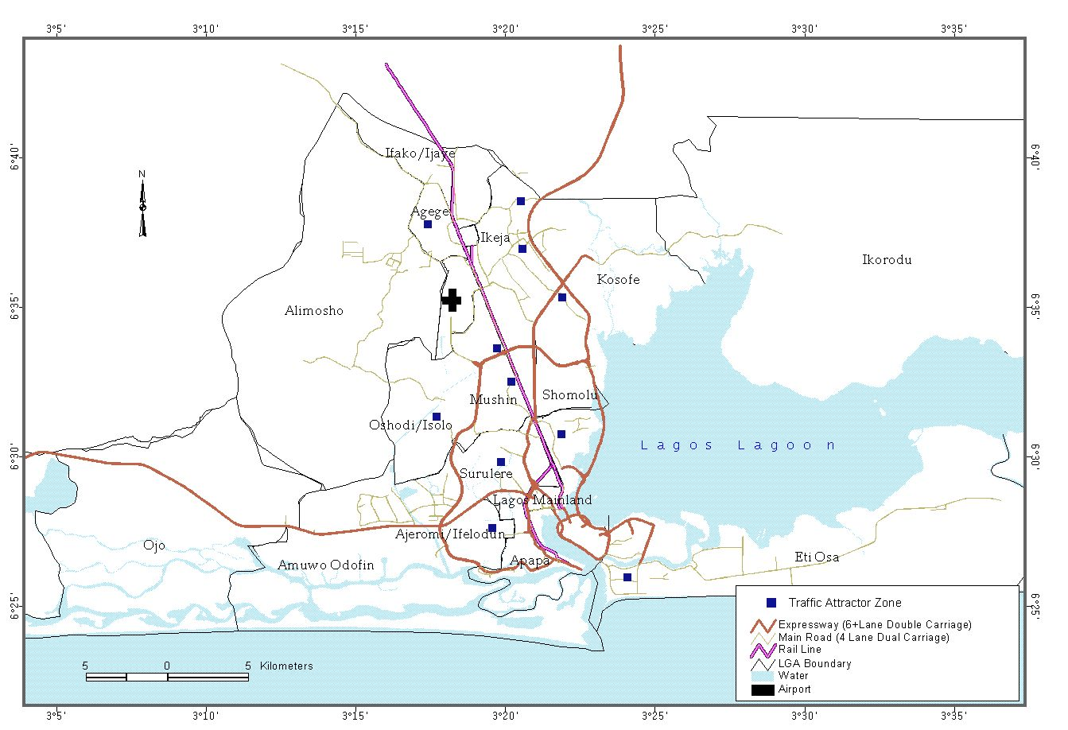

Fig I: Metropolitan Lagos

0
100000
200000
300000
400000
500000
600000
Dalandasah (1989)
Oni, S. I. (1992)
LUTP (2002)
Variables
FIG. II : PREDOMINANCE OF CARS TRAFFIC IN LAGOS
Cars
Others

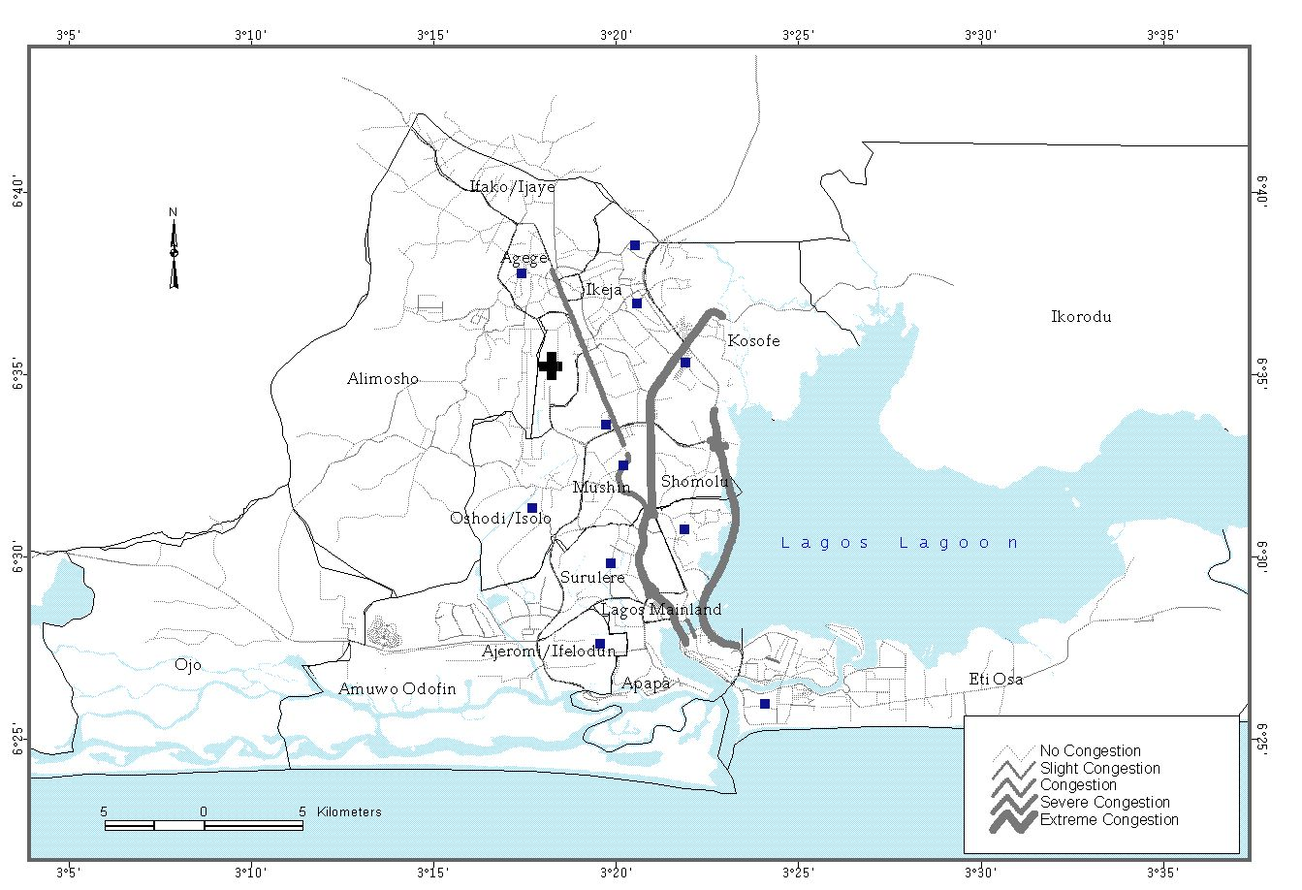

Fig III: Road Traffic congestion Pattern on selected corridors of Lagos.

Fig IV: Road Traffic Congestion Management and Institutional Arrangement in Lagos

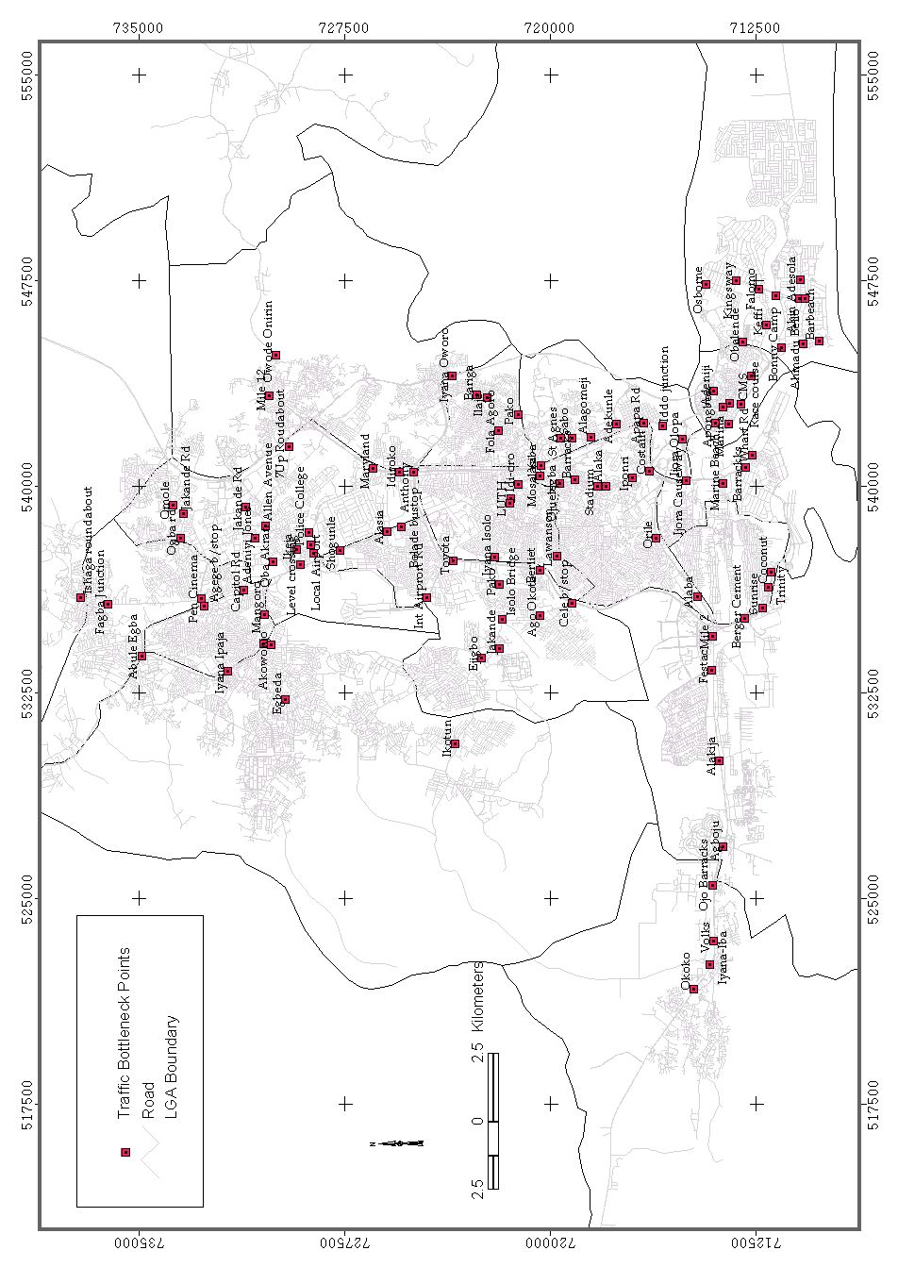
Figure V: Spatial pattern of road traffic bottleneck on Lagos Roads
Fig VI: Traffic Peak Periods On Lagos Roads

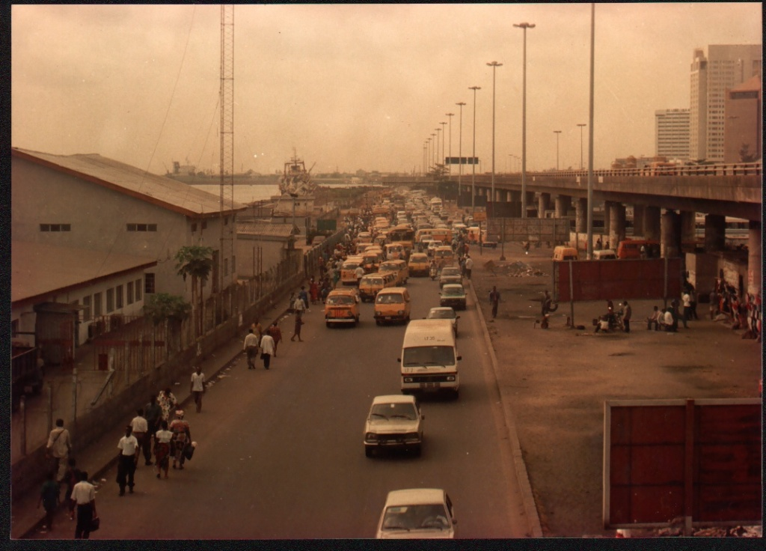
Fig V 1I: Traffic Congestion View of CMS, Lagos at Morning Peak Period.

