Increasing Bottleneck Capacity
through Provision of Bottleneck Location Information

Jian Xingª, Hideki Takahashi^{b} and Toshio Takeuchi^{c}

ª Expressway Technology Center
3-7-2 Kasumigaseki Chiyoda-ku, Tokyo 100-0013, Japan

^{b} Central Nippon Expressway Company Limited
3-9-18 Shin-yokohama Kohoku-ku, Yokohama 222-8503, Japan

^{c} East Nippon Expressway Company Limited
3-3-2 Kasumigaseki Chiyoda-ku, Tokyo 100-8979, Japan
Increasing Bottleneck Capacity
through Provision of Bottleneck Location Information

Jian Xingª, Hideki Takahashi^{b} and Toshio Takeuchi^{c}

ª Expressway Technology Center
3-7-2 Kasumigaseki Chiyoda-ku, Tokyo 100-0013, Japan

^{b} Central Nippon Expressway Company Limited
3-9-18 Shin-yokohama Kohoku-ku, Yokohama 222-8503, Japan

^{c} East Nippon Expressway Company Limited
3-3-2 Kasumigaseki Chiyoda-ku, Tokyo 100-8979, Japan

Abstract
More than 50% of congestion occurs in uninterrupted flow sections of sag or upgrade slope and tunnel entrance on intercity expressways in Japan. Based on the result of several experiments by providing bottleneck location information with simple variable message sign, this study aims to evaluate the effect of the variable message sign on increase of bottleneck capacity. As a result, observed queue discharge rate is increased by 5-15%, which could recover 25% to nearly 90% of capacity drop from pre-queue breakdown flow to queue discharge flow depending upon bottleneck. A mechanism is described from the viewpoint of drivers’ behavior. The increase of pre-queue breakdown flow rate could also be expected sometimes.

Key Words: Traffic congestion; variable message sign; queue discharge rate; pre-queue breakdown flow rate; bottleneck capacity

1. Introduction

Traffic congestion has been an important social issue in all over the world. It will result in great economic loss due to time delay and environment deterioration. In Japan, chronic congestion in urban areas and weekend and holiday congestion on intercity expressways is not an unusual scene. Cost-effective measures need to be considered to reduce congestion due to recent budget restriction though widening might be a more effective way.
It is widely known that sags, i.e. change in vertical alignment, or tunnel entrances in road sections of uninterrupted flow on Japanese intercity expressways would become bottleneck in capacity that frequently causes traffic congestion. More than 50% of congestion occurs in the uninterrupted flow sections of sag or upgrade slope and tunnel entrance on intercity expressways. Researches and investigations on the bottleneck phenomenon of multilane expressway started from early 1980s (Koshi, 1986; Koshi et al., 1992; Xing et al., 1995; Okamura et al., 2000), which have revealed the mechanism of congestion occurrence, capacity drop, and relationship between bottleneck capacity and drivers’ behavior, etc. The bottleneck capacity of two-lane expressways has also been explored recently (Yoshikawa et al., 2006). At a high level of traffic flow before occurrence of congestion, there exists a difference of travel speed between outer lane and inner lane, eventually causing an increase in use of the inner lane. The resultant inequality of lane utilization results in a breakdown of traffic flow in the inner lane of multilane expressway while flow of the outer lane remains below its capacity, thus decreasing the directional section capacity. Once congestion occurs at a bottleneck, capacity would drop from pre-queue breakdown flow rate to lower queue discharge rate during congestion. Similar studies have also been carried out in North America and Europe and similar results confirmed in merging and lane drop sections (for example, Hurdle et al., 1983; Banks, 1990; Hall, 1991).
The queue discharge rate is more influenced by drivers’ behavior. The capacity drop is mainly caused by insufficient acceleration around and downstream of a bottleneck because drivers could hardly notice the bottleneck location or the end of congested queue, and therefore it is difficult for them to accelerate sufficiently as expected (Koshi et al., 1992). Based on this consideration, the discharge flow rate is expected to increase by properly providing information on bottleneck location or end of congestion queue around the bottleneck to activate drivers’ behavior. Some experimental studies have shown an increase of the queue discharge rate by providing such information (Yamada et al., 2003; Saito et al, 2005), but evaluation of the direct comparison of the queue discharge rate before and after the provision of the bottleneck location information is not quite reasonable because they have not taken into account the dependency of queue discharge rate on the time caught in congested queue behind a bottleneck. In additions, no mechanism for it has been analyzed.
Based on the results of several experiments by providing bottleneck location information with LED variable message sign (Photo 1) to reduce traffic congestion, this study aims to (1) evaluate the effect of the increase of discharge flow rate for two-, four- and six-lane expressway in consideration of relationship between the queue discharge rate and the time caught in the queue, and (2) suggest a mechanism for it from the viewpoint of drivers’ behavior. It also tries to (3) examine the possibility of increase of pre-queue breakdown flow rate by similar experiment but with different message.

2. Bottleneck capacity

It is well known that bottleneck capacity consists of two types: breakdown flow rate (or capacity just before congestion) and queue discharge rate (or capacity during congestion). Occurrence of congestion or breakdown is assumed for a traffic condition when 5-min space mean speed drops below 40km/h and it continues for over 15 minutes. In this study, two capacities are defined as follows:

- Breakdown flow rate: a traffic flow rate above which breakdown of free flow occurs, which is the maximum flow rate that can pass through a bottleneck. This paper uses 15-min flow rate immediately before the 5-min space mean speed drops below 40km/h as measured immediately upstream of the bottleneck;
- Queue discharge rate: an average flow rate during congestion; in other words, it is an average flow rate over the whole duration of congestion covering from the occurrence of congestion (roughly under 40km/hr on intercity expressways) to the end of congestion.

Figure 1 shows a typical example of variation of 5-min traffic volume and average speed at a bottleneck of sag. It is seen that traffic flow breaks down when the volume reaches a certain level. The level is called here the breakdown flow rate. From the time of breakdown, a congested queue, having much lower speed, is formed upstream of the bottleneck. The flow rate downstream of the bottleneck is determined by the flow rate discharged from the congested queue. When congestion occurs, bottleneck capacity drops from breakdown flow rate to lower queue discharge rate.
Sag is likely to become a bottleneck because drivers tend to drop their speed unconsciously at sag due to gradual increase of gradient, as they cannot notice the existence of sag. Tunnel entrance would also likely become a bottleneck because drivers tend to reduce their speed before entering a tunnel due to the darkness inside tunnel.
Below are some bottlenecks where capacity analysis and variable message sign (VMS) experiments were conducted in the study:

- BN-1: Kibijima Sag, IB of Tokaihokuriku Expressway (one-lane section)
- BN-2: Yaita Sag, IB of Tohoku Expressway (two-lane section)
- BN-3: Motohachiouji Sag, OB of Chuo Expressway (two-lane section)
- BN-4: Yamato Sag, OB of Tomei Expressway (three-lane section)
- BN-5: Hanazono Sag, OB of Kanetsu Expressway (three-lane section)

Table 1 demonstrates a result of average breakdown flow rate and average queue discharge rate of the above five bottlenecks with one to three lanes in one direction obtained from one-year vehicle detector data. As seen from the table, the capacity value varies with bottlenecks. It would be affected by drivers’ behavior, platooning characteristic, lane utilization and road alignment around the bottleneck.

2.1 Breakdown flow rate

Average breakdown flow rate is about 1,220veh/h, 2,900-3,300veh/h and 4,800-5,400veh/h respectively for one-lane, two-lane and three-lane section in one direction.
The capacity of two-lane expressway is lower than the average capacity per lane of multilane expressway because platoons tend to be formed in long single lane section of two-lane expressway. Drivers also tend to keep a larger spacing than on multilane expressway because no vehicles will cut in the single lane section. The capacity of multilane expressway, on the other hand, is also much lower than those traditionally accepted partially due to characteristics of lane use. The inequality of lane use results in a breakdown of traffic flow at first in the inner lane of multilane expressway while flow of the outer lane remains below its capacity, thus causing lower capacity of total lanes in one direction. Figure 2 shows a typical relationship between directional flow rate and lane utilization for both two-lane and three-lane expressways. For two-lane section, flow rate in the inner lane increases with directional flow rate, and the inner lane carries more traffic than the outer lane when the flow rate is higher than 1,500veh/h. At high flow rate of more than 2000-2500veh/h, it carries about 60% to nearly 70% of total directional traffic in the inner lane, about 20-30% higher than in the outer lane. After breakdown of the free flow, the utilization of the inner lane drops to 50-57%. Similarly, the percentage of flow rate of lane 3 of three-lane section is about 40-45%, about 10% higher than that of lane 2 and 20% higher than that of lane 1.
The breakdown flow rate is also affected by time of day and weather condition. Figure 3 shows, as an example, a comparison of distributions of breakdown flow rate observed in daytime and dusk of fine days and in daytime of rain condition. The distributions for other conditions are omitted due to limited sample size. It is seen that the breakdown flow rate varies even for the same time of day and weather condition and it is highest in daytime, followed by that in dusk of fine day and that in daytime of rain condition. Drivers tend to take longer spacing in rain and this brings about lower capacity value.

2.2 Queue discharge rate

Once congested queue is formed behind a bottleneck, average queue discharge rate drops to about 1,060veh/h, 2,500veh/h and 4,150-4650veh/h respectively for one-lane, two-lane and three-lane section in one direction. The average capacity drop is about 10-20% depending upon the bottleneck.
Similar to the breakdown flow rate, the queue discharge rate is also affected by time of day and weather condition. Figure 4 illustrates a comparison of the distributions in different groups of time of day (daytime/dusk/nighttime) and weather (fine/rain). The queue discharge rate on fine days is highest in daytime, followed by that in dusk, and is lowest in nighttime. There is little difference between dusk and nighttime in rain condition. As for weather conditions, fine days yield higher values than rain days. Even for the same time of day and weather condition, the queue discharge rate varies within a certain range.
It is also known that the queue discharge rate varies with the time spent in the congested queue (TIQ) (Koshi et al., 1992). Figure 5 shows a similar relationship between the queue discharge rate and TIQ (Nakatani et al., 2005). As seen from the figure, the queue discharge rate decreases with TIQ when TIQ is shorter than about 30 minutes. The queue discharge rate still shows a slight decrease trend as TIQ increases even for TIQ > 30 minutes. The transition time of 30 minutes here is the time that drivers’ behavior changes from free flow state to congested state. The transition time may vary in value depending on the bottleneck and drivers’ behavior. Drivers tend to loosen their tension to follow vehicles ahead as they have been caught in the congested queue. It is more apparent when TIQ is longer than the transition time. The decrease of drivers’ car following tension could be explained by slow acceleration of the discharge flow from the bottleneck. Another reason for the slow acceleration is due to difficulty in realizing the exact location of the bottleneck or end of queue. As a result, approximately 2km is needed for departing vehicles to accelerate from 20km/h to 60km/h (Koshi et al., 1992). The relationship between the queue discharge rate and TIQ also depends on the bottleneck. It is used in the study to evaluate effect of provision of bottleneck location information on increase of the queue discharge rate as described in Section 3.

3. Increasing queue discharge rate by provision of bottleneck location information and speeding advice message with VMS

Once congestion occurs, bottleneck capacity is determined by queue discharge rate around a bottleneck. There is a capacity drop after breakdown of free flow. Queue discharge rate is about 10-20% lower than breakdown flow rate. The lower capacity or queue discharge rate is attributed to slow acceleration from the bottleneck, which again is caused by the decrease of drivers’ car following tension and difficulty in realizing the exact location of a bottleneck or end of congested queue. Since the drivers cannot realize that they are leaving the queue, they tend to follow the vehicles ahead with the same behavior as they have been doing in the queue. Based on this consideration, it might be possible to make drivers accelerate fast by just informing them of the exact location of the bottleneck or end of queue with VMS in order to increase the queue discharge rate.
Table 2 illustrates the messages displayed during congestion in some experiments conducted on Japanese expressways comprising one-lane, two-lane and three-lane section. The message is the location of the end of queue and speeding advice. Two VMSs are usually used to display “Congested queue ends 500m ahead!” at the upstream location and “End of congested queue! Speed up, please!” or simply “Speed up, please!” at the downstream location. Figure 6 shows an example of VMSs and messages displayed during congestion at bottleneck of sag. The paired VMSs are usually set 300-500m apart. In some cases, only one VMS is used to display “End of congested queue!” and “Speed up, please!” alternately. It is better to set the single or downstream VMS near the start point of discharging flow from the congested queue. The message of VMS is only displayed at the bottleneck section during congestion where the bottleneck remains and downstream of which no congestion is confirmed within a section of more than 10km. If the bottleneck changes, the VMS would be switched off. No safety problems were found in the experiments and other similar ones.
Table 3 describes the effect of provision of bottleneck location information and speeding advice message with VMS on increase of queue discharge rate. It also shows breakdown flow rate, capacity drop and recovery rate obtained from the experiments. As shown in the table, one-day observation was conducted for each bottleneck. All the capacity values were observed at the targeted bottlenecks with no congested queues in the downstream section of more than 10km. When bottleneck changes, no observations are included in the capacity values of Table 3. Since the queue discharge rate varies with TIQ, the effect of the VMS is evaluated by comparing the queue discharge rate of the same TIQ between with and without VMS. The queue discharge rate without VMS is obtained from the regression equation as shown in Figure 5. It is seen from Table 3 that through provision of bottleneck location information and speeding advice message with VMS, the queue discharge rate increases by about 15%, 12-14% and 5-7% respectively for one-lane, two-lane and three-lane section. Considering the capacity drop of 13-28%, the capacity drop could be recovered by 25% to nearly 90% with VMS depending upon the bottleneck. Figure 7 demonstrates a comparison of the queue discharge rate with TIQ between with and without VMS. It is clear that queue discharge rate could be increased by provision of bottleneck location information and speeding advice message with VMS.
The statistical tests (F-test and t-test) were also applied on the two groups of observations with and without VMS, and it is confirmed that the mean discharge flow rate with VMS is significantly higher than that without VMS for different time of day and weather condition with enough data sample.
Figure 8 shows distribution of queue discharge rate without VMS for different time of day (daytime/dusk/nighttime) on fine weather condition obtained from three-year detector data and observations with VMS from the experiments. It is seen that the observed queue discharge rate with VMS corresponds to more than 80-percentile value of the distribution of the queue discharge rate without VMS, also indicating a possible effect of VMS on the discharge flow.
The mechanism of increasing the queue discharge rate with VMS can be considered as follows. Since drivers cannot realize that they are leaving the queue, they just follow the vehicles ahead with the same behavior as they have been doing in the queue. This results in the lower capacity or queue discharge rate. Drivers’ car following behavior is activated through provision of the exact location of bottleneck or end of queue and speeding advice messages with VMS to accelerate more actively than the case of without VMS, and therefore, the queue discharge rate is increased. Figure 9 demonstrates, as an example, a comparison of time headway distribution (PDF: probability density function and CDF: cumulative distribution function) between with and without VMS for total two lanes. It is seen that the time headway distribution with VMS shifted to left of that without VMS and percentage of long headway vehicles decreased. This means average time headway decreased and queue discharge rate increased with VMS.
According to estimation for a congestion with duration of 5 hours and maximum queue length of 50km on a three-lane section in one direction, 5% increase in queue discharge rate would reduce duration of congestion by 15%, maximum queue length by 18% and total time loss by 44%.

4. Increasing breakdown flow rate by provision of bottleneck location information and speed drop warning message with VMS

Since breakdown flow rate determines the occurrence of congestion, it is important to increase it so as to avoid occurrence of congestion. The purpose of the section is to examine the possibility of the increase of pre-queue breakdown flow rate by similar experiment as the queue discharge rate but with different message.
As aforementioned, drivers tend to drop their speed unconsciously at bottleneck of sags due to gradual increase of gradient, as they cannot notice the existence of sag. The speed drop brings about a deceleration shock wave in a big platoon and causes the vehicles behind in the big platoon to reduce their speed to a large extent and sometimes even to complete stop. Congestion usually occurs when the next platoons come before the shock wave disappears. Therefore, it might be possible to inform drivers of the bottleneck information and also to warn them of the speed drop with VMS so as to increase the breakdown flow rate and to mitigate congestion. The message is “Upgrade ahead!” and “Be careful of speed drop!” that is displayed on a single VMS or paired VMSs.
Figure 10 shows a comparison of observed breakdown flow rates with VMS and the cumulative distribution function without VMS obtained from three-year detector data. In daytime of fine days, the observed breakdown flow rates with VMS are all higher than 70-percentile value without VMS, and in daytime of rain condition, an observed capacity value with VMS corresponds to about 65-percentile value without VMS. A high flow rate of 3,788veh/h is also observed, exceeding the maximum breakdown flow rate ever observed in three years without VMS. Finally, bottleneck shifted from the targeted sag to another downstream sag on that day. Therefore, it is seen from the observations with VMS that the increase of breakdown flow rate could be expected possibly sometimes. Nevertheless, it is still difficult to say that VMS will definitely increase the breakdown flow rate since the observed flow rates with VMS are within 60-80-percentile value without VMS. This is because a few vehicles with a speed drop could lead to a deceleration shock wave in a big platoon and finally to occurrence of congestion even if most of the drivers follow the messages on VMS. More observations need to be done to further examine the effect.

5. Summary and conclusions

More than 50% of congestion occurs in uninterrupted flow sections of sag or upgrade slope and tunnel entrance on intercity expressways in Japan. Based on the result of several experiments with VMS, this study has evaluated the effect of VMS on increase of bottleneck capacity of both queue discharge rate and pre-queue breakdown flow rate.
The queue discharge rate is evaluated by comparing it between with and without VMS in consideration of time caught in the congested queue since the queue discharge rate may vary with the time in the queue. It is found that by providing information on bottleneck location with VMS, the queue discharge rate is increased by 15%, 12-14% and 5-7% respectively for two-lane, four-lane and six-lane expressway. The 5-15% increase of the queue discharge rate could recover 25% to nearly 90% of the capacity drop depending upon the bottleneck. According to estimation, even the least 5% increase in queue discharge rate could reduce duration of congestion by 15%, maximum queue length by 18% and total time loss by 44%. The paper also suggests a mechanism for the effect from the viewpoint of drivers’ behavior. The increase of queue discharge rate is attributed mainly to activation of the drivers’ behavior around and downstream of bottleneck with VMS because, otherwise, they would follow the vehicles ahead with the same behavior as they have been doing in the queue due to the difficulty in realizing that they are leaving the queue.
Similar experiments have also been conducted to examine the possibility of increase of the pre-queue breakdown flow rate by informing vehicles of the bottleneck information and also by warning them of speed drop at sag or upgrade section, and it is found that the increase of breakdown flow rate could be expected sometimes but not always. It would be a future subject how to increase the pre-queue breakdown flow rate with the cost-effective VMS.

References

Banks, J.H. (1990) ‘Flow processes at a freeway bottleneck’, Transportation Research Record 1287, pp. 20-28

Hall, F.L. and Agyemang-Duah, K. (1991) ‘Freeway capacity drop and the definition of capacity’, Transportation Research Record 1320, pp. 91-98

Hurdle, V.F. and Datta, P.K. (1983) ‘Speeds and flows on an urban freeway: some measurements and a hypothesis’, Transportation Research Record 905, pp. 127-137

Koshi, M. (1986) ‘Capacity of motorway bottlenecks’, Journal of JSCE, Vol.371 / IV-5, pp. 1-7

Koshi, M., Kuwahara, M. and Akahane, H. (1992) ‘Capacity of sags and tunnels on Japanese motorways’, ITE Journal. Vol.62 No.5, pp. 17-22

Nakatani, R., Minagata, T., Sato, H. and Ichikawa, M. (2005) ‘Evaluation on effect of provision of speed increase advice message by LED sign in consideration of time spent in queue’, Proc. of the 25th JSTE Annual Conference, pp. 173-176

Okamura, H. and Watanabe, S. (2000) ‘An empirical study on the capacity of bottlenecks on the basic suburban expressway sections in Japan’. Proc. of the 4th International Symposium on Highway Capacity, pp.120-129

Saito, Y., Xing, J., Nonaka, Y., Ishida, T. and Uchiyama, H. (2005) ‘An experimental study on mitigation of expressway traffic congestion with LED information board’, Proc. of the EASTS (CD-ROM), Vol.5, pp. 919-928

Xing, J. and Koshi, M. (1995) ‘A study on the bottleneck phenomena and car-following behavior on sags of motorways’, Journal of JSCE, Vol.506 / IV-26, pp. 45-55

Yamada Y., Abe S. and Nagase H. (2003) A study on congestion antidote using LED board, Proc. of the 23rd JSTE Annual Conference, pp. 205-208

Yoshikawa, R., Mizukami, H., Xing, J., Yoshii, T. and Kitamura, R. (2006) ‘Bottleneck capacities of two-lane expressways’, Proc. of the 5th International Symposium on Highway Capacity and Level of Service, pp. 239-248

VMS car VMS board
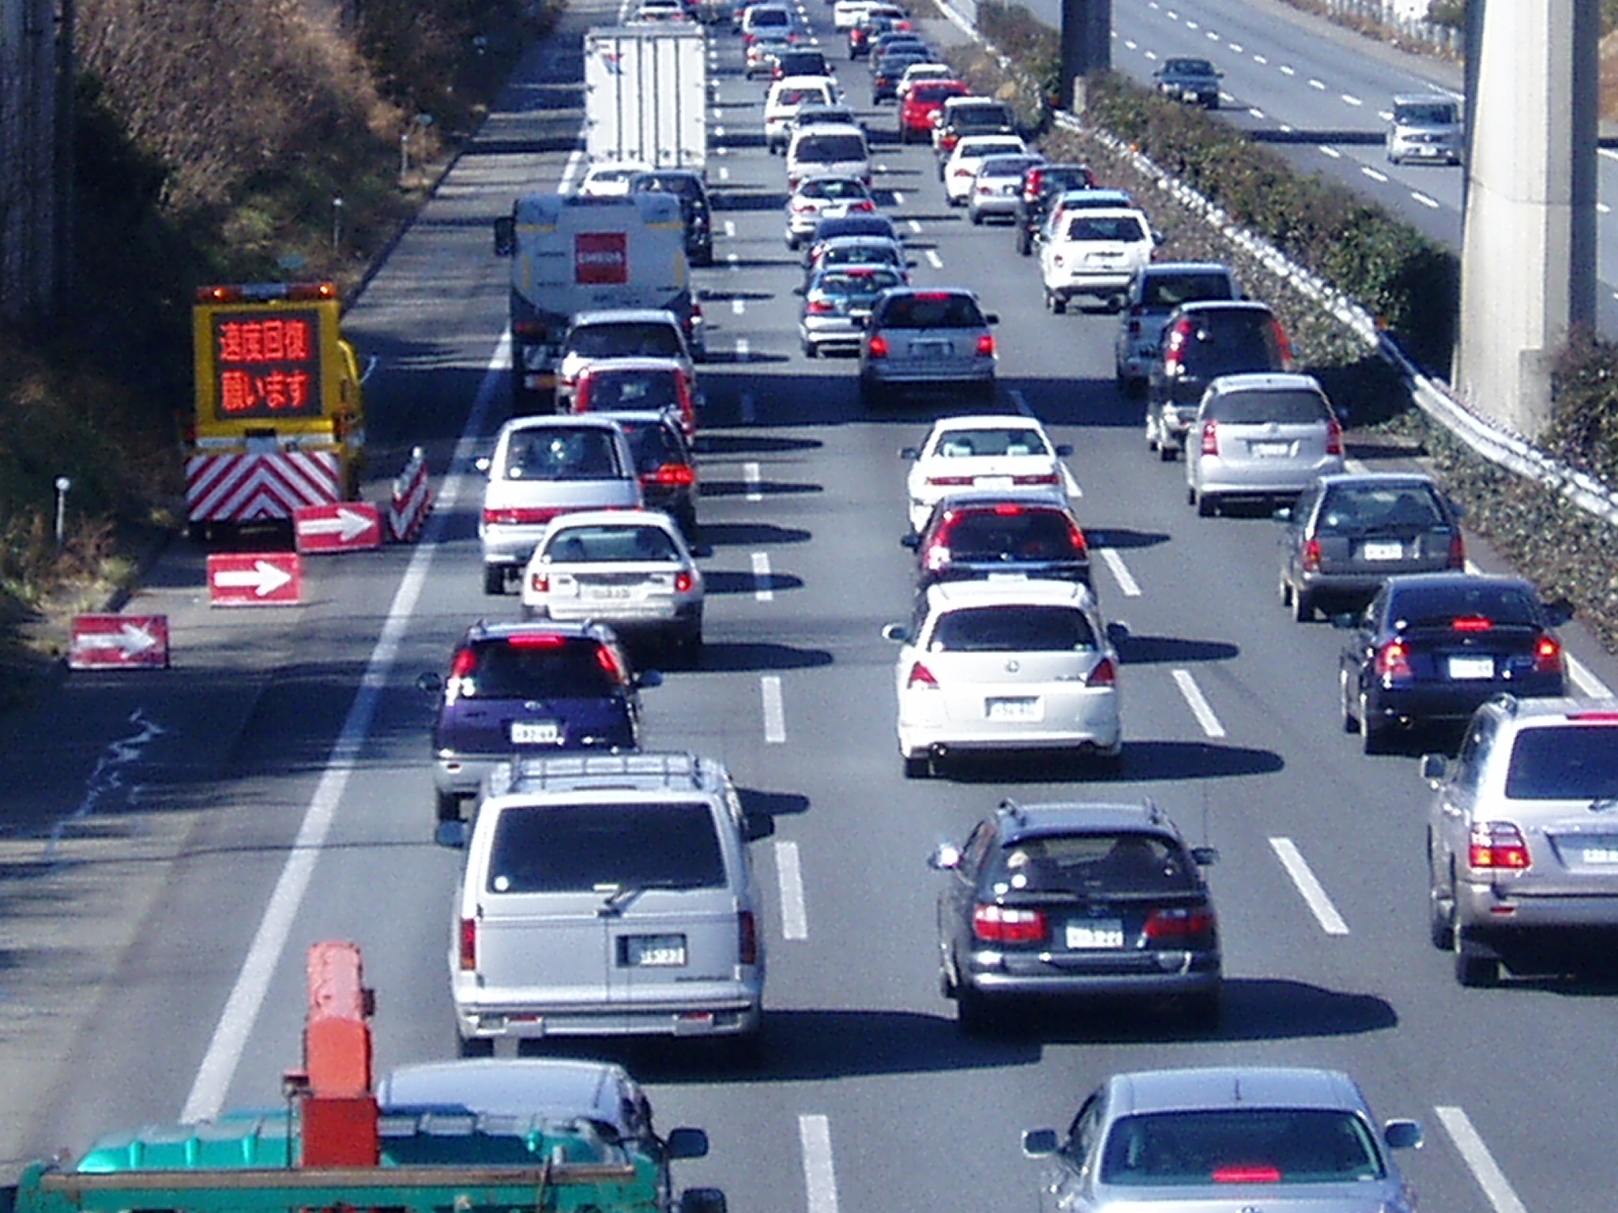
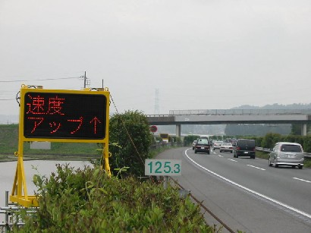

Photo 1. LED variable message signs used for displaying bottleneck location information

Breakdown flow rate
Queue discharge rate

Time
Figure 1. Definition of breakdown flow rate and queue discharge rate
(119.7kp Inbound of Tohoku Expressway, Nov. 7, 2004)

Table 1. Observed capacity of some bottlenecks

Bottleneck | No. of lanes  in one direction | Breakdown flow rate  (veh/h) | Queue discharge rate  (veh/h) | Capacity drop
BN-1 | 1 | 1,220 | 1,060 | 13.1%
BN-2 | 2 | 2,920 | 2,455 | 15.9%
BN-3 | 2 | 3,290 | 2,580 | 21.6%
BN-4 | 3 | 5,440 | 4,660 | 14.3%
BN-5 | 3 | 4,855 | 4,140 | 14.7%
Note: The capacity values are obtained from one-year vehicle detector data.

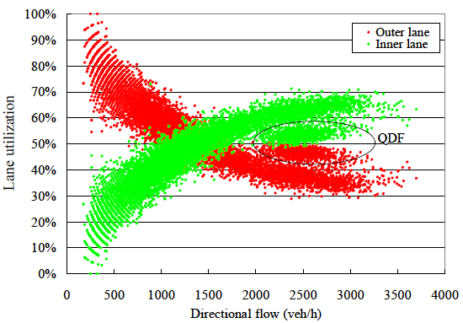
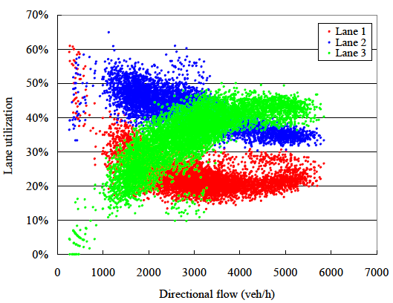
(1) Two-lane section
(2) Three-lane section

Figure 2. A typical example of lane utilization on two- and three-lane section

Figure 3. Observed distributions of breakdown flow rate(BN-2, 3-year data)

Figure 4. Observed distributions of queue discharge rate (BN-2, 3-year data)

Figure 5. Queue discharge rate and time spent in congested queue (BN-1)

Table 2. Messages displayed during congestion

Bottleneck | The number of the LED information boards |  | Display message
BN-1 | 2  (300m apart) | Downstream | End of congested queue!
BN-1 | 2  (300m apart) | Upstream | Congested queue ends ahead!
BN-2 | 1 |  | End of congested queue  ⇔ Speed up!
BN-2 | 2  (500m apart) | Downstream | End of congested queue  ⇔ Speed up!
BN-2 | 2  (500m apart) | Upstream | Congested queue ends 500m ahead!
BN-3 | 1 |  | Congested queue ends 1km ahead!
BN-4 | 2  (300m apart) | Downstream | Speed up!
BN-4 | 2  (300m apart) | Upstream | Congested queue ends 300m ahead!
BN-5 | 2  (500m apart) | Downstream | Speed up!
BN-5 | 2  (500m apart) | Upstream | Congested queue ends 500m ahead!
⇔: Alternate display

Direction of flow
Head of the queue
Congested queue ends 500m ahead!
End of congested queue!
⇔ Speed up!

Bottleneck of sag

Figure 6. An example of VMSs and messages displayed during congestion at bottleneck of sag

Table 3. Effect of provision of bottleneck location information and
speeding advice message on increase of queue discharge rate

Figure 7. Comparison of queue discharge rate between w/ VMS and w/o VMS
(Fine/daytime)

Note: Lines show cumulative distribution without VMS;
Arrows show observed queue discharge rate with VMS.
w/o VMS

Figure 8. Queue discharge rate: cumulative distribution w/o VMS
and observations w/ VMS (BN-2)

Figure 9. Comparison of time headway distribution between w/ VMS and w/o VMS
(BN-2, each with 20-min data)

w/o VMS

Note: Lines show cumulative distribution without VMS;
Arrows show observed breakdown flow rate with VMS.

Figure 10. Breakdown flow rate: cumulative distribution w/o VMS and observations w/ VMS (BN-2)

