TEMPORAL COORDINATION IN REGIONAL TRANSIT NETWORKS
A “what to” approach

Domenico Gattuso
Professor, DIMET, Mediterranea University of Reggio Calabria,
Feo di Vito, 89060, Reggio Calabria (Italy),
Tel. +39.0965.875218, Fax +39.0965.332646, domenico.gattuso@unirc.it

Antonella Polimeni
PhD, DIMET, Mediterranea University of Reggio Calabria,
Feo di Vito, 89060, Reggio Calabria (Italy),
Tel. +39.0965.875357, Fax +39.0965.875360, antonella.polimeni@unirc.it
Abstract

In order to reduce the externalities due to the excessive use of private transport, such as environmental and congestion costs, it is necessary to increase the users’utility in using public transport, especially in terms of temporal costs. To achieve it, the paper proposes a methodology for generating synchronized timetables of public transport services at interchange nodes, in order to minimize users’transfer times. The proposed procedure is based on a “what to” approach, by defining a constrained objective function. To solve the problem, a resolutive algorithm is also presented and applied to a real network, by using an auto-produced software.

Keywords: temporal integration, synchronization, genetic algorithm.

1. Introduction

In general, an user that wants to move from an origin to a destination chooses, among different transport modes, the modal alternative that involves lower disutility values in terms of temporal and monetary costs.
Users that opt for private transport, can enjoys a “door-to-door” service, that is a service in which they can decide both the time and the place of departure of their trip. In other words, the service supplied by private transport is always available in time and space.
On the other hand, users that choose public transport, can not decide the time and the place of departure, because the service is available only at specific schedules (i.e. the departure times of the runs supplied) and at specific points (i.e. the vehicle stops on the network). Furthermore, many times, the connection between an origin and a destination, especially over large areas, are not direct and users are made to transfer from a line to another one during the same trip. In other words, passengers often have to use an intermodal transit service, consisting of main and feeder lines connecting at different interchange nodes and, therefore, they may need one or more transfers to complete their journey.
Obviously, the penalties due to the early/late departure with respect to the users’target times, the waiting times spent at the boarding stops, the access/egress times spent by passengers to reach the available stops and, above all, the transfer times spent to pass from a line to the interconnected one, contribute towards increasing users’disutility.
Concerning this, the integration process of different transit services is considered one of the most useful operational tools in order to reduce some of the disadvantages involved by public transport.
In particular, synchronizing the timetables of one or more transit services (temporal coordination) can contribute to reduce the waste of time connected with transfer operations between services operating at the same interchange point (connection node), thus controlling the disutility values perceived by users.
Obviously, the application of an integration process is more effective in the case of extra-urban transit networks because of the medium/low frequencies. In fact, while in urban services a missed connection at an interchange node does not involve great disadvantages because, in few minutes, another run of the missed line will serve the same stop, in extra-urban transit networks, such as regional services, if a passenger misses a connection, he will wait for a longer time before boarding another run of the same line, because the lower frequencies of the service.
In this paper, after a brief reference to the state of the art on temporal integration of public services, the proposed methodological approach for generating synchronized timetable in regional transit networks is presented. In particular, the attention is focused on the procedure and the resolutive algorithm, based on genetic algorithm. Finally, the results of an application to a real public transport network are presented.

2. State of the art on temporal integration in transit networks

Nowadays, the issues related to temporal integration process are treated in a marginal way, and the methodological and modelling literary contributions are quite meagre.
They are deeply different one another and the first difference among all the studies concerns their application contexts: some of these pay attention to urban contexts, others to extra-urban services, on which the paper focus for the above-mentioned reasons.
Apart from the context, both the kinds of studies can be also grouped in relation to the model used. In fact, some of these studies analyze the problem from a static point of view, by considering schedule depending only on transport demand. Others uses dynamic models (Chowdhury, 2000; Chowdhury and Chien, 2001; Dessouky et alii, 1999; Dessouky et alii, 2002), by coordinating the timetables in relation to the real traffic conditions, which the ITS system can record; in this case, it is possible to predict vehicle arrival times and update the demand in real time, so that the dispatching of vehicles at transfer stations can be determined dynamically in order to improve transfer efficiency.
Within the static models, another sub-classification can be made: some studies pay attention to maximize the number of simultaneous arrivals of runs at the interchange nodes (Ceder, 1986, 2001; Ceder and Tal, 2001; Fleurent et alii, 2004) because the greater this number is, the higher the probability of connections is; others focus on the importance of designing synchronized timetables that can satisfy demand requirements as much as possible (Coppola, 2005; Gundaliya et alii, 2001; Nuzzolo et alii, 2003; Russo, 2000; Wong and Leung, 2004).
In figure 1, a classification of temporal integration models is proposed.

3. Proposed methodological approach

The aim of this work is to elaborate a methodological approach based on an iterative modelling procedure, for generating optimal transit timetables; in other words, the objective is to supply a modelling procedure for identifying the optimal departure times from the origin terminal of a given number of runs belonging to different lines, in order to synchronize their arrival/departure times at the transfer nodes of the transit network and to assure a functional temporal coordination of the supplied services.
It is important to underline that, though the advantages of a timetable synchronization can have some positive consequences on the operator’s perspective in terms of supplied service effectiveness and efficiency, this work focuses on the importance of generating synchronized timetables, matching vehicle schedule times with user target times, by analyzing the integration process solely from the user’s perspective.
The proposed methodological approach is summarized in figure 2.
It is based on a bi-level procedure that, at the first level, defines the distribution of the flow among the minimum cost paths and calculates the number of transferring users and then, at the second level, determines the departure times of the runs from their origin terminals, in order to maximize the synchronization at the interchange nodes.

3.1 First Level

The procedure starts with the definition of transport supply and demand systems, both specified temporally. In particular, as far as supply is concerned, a run-based supply model (diachronic graph) has been used in order to explicitly take into account the service timetable; concerning transport demand, the temporal specification is achieved by distributing the demand in relation to the user target times, i.e. the desired departure times (DDT) from the original and the desired arrival times (DAT) at destination.
After defining supply and demand, the methodology continues with the definition of the minimum cost paths, i.e. the paths for which the disutility function is minimum. The disutility function of each path is assumed to be dependent on different temporal shares:
in which:
- t_{a/e} is access/egress time;
- t_{ear} is early penalty time;
- t_{lat} is late penalty time;
- t_{b} is on-board time;
- t_{tr} is transfer time;
- β_{i} are model parameters, whose values in disutility/hour, for home-work trips, are summarized in table 1 (Nuzzolo et alii, 2003).
To find the minimum paths, a recursive algorithm based on a limited-depth-tree, subject to certain constraints has been used; in particular, the algorithm finds out the x best solutions, which satisfy the following criteria:
- the maximum number of transfers n_{tr,max} is fixed, in order to avoid that during the same journey the user can choose a path with more than n_{tr,max} transfers:
n_{tr,max} = k
- the total travel time of the selected minimum paths has to be lower than m times total travel time spent by users who leave from the same point of departure and reach the same destination by car, following the minimum path existing between the same O/D pair by using an individual transport mode:
t_{bus}/t_{car} < m
- the differences between scheduled and desired user departure or arrival times have to be lower than a fixed threshold because, for great differences the user will not derive any advantage from the use of public transport because of great early or late penalties:
/DDT-τ/ < t₁; /DDA-τ/ < t₂
- the paths can not contain loops;
- each origin-destination pair has to be connected by one path at least, that satisfy the previous criteria.
After defining the set of minimum disutility paths, the probability of choosing a given path can be calculated by means of random utility theory and, in particular, by applying a Multinomial Logit Model:
$p_{j}=\frac{\text{exp}({V_{j}}/θ)}{\sum_{k∈I}{\text{exp}({V_{k}}/θ)}}$
In order to study the interaction between supply and demand, a dynamic assignment model is used which, unlike a static assignment model, assigns transport demand by distinguishing the flows for each run of each line. In this way, it is possible to know the transferring flow from one run to another.

3.2 Second Level

At the second level of the procedure, the departure times of the runs of the network are optimized. To achieve it, a temporal coordination procedure is applied. It is based on a what to approach and, thus, on the definition of a constrained objective function.

a. Variables
Defined the departure time of the runs in the initial configuration of the system, the variables of the problem are the variations S, expressed in minutes, of the departure times with respect to the starting configuration.
Consequently, the variables vector of the problem can be written as:
S = (S₁, …S_{i}, …, S_{C})
where C is the total number of the runs supplied in the network.

b. Objective Function
Given the transferring flows (outputs of the assignment model), the proposed procedure is based on the optimization of an objective function, whose analytic formulation can be written as:
where:
- S is the vector of the variations of the departure times of the runs from their orini terminal, expressed in minutes;
- i e j are two generic runs stopping at the interchange node n;
- ΔT_{ij_n} is the transfer time spent by a single user to transfer from run i to run j at the node n;
- f_{ij_n} is the number of users transferring from run i to run j at the node n.
The objective function is connected directly with the vector of the variables because the transfer time at the generic interchange node depends on the times of departure/arrival of interconnected runs at the interchange node and, thus, it also depends on the departure times from the origin terminal.
where:
- ω_{i} e ω_{j} are the departure time of runs i and j from their origin terminal (input data);
- S_{i} e S_{j} are the variations, in minutes, with respect to the initial values, of the departure times of the runs i e j;
- t_{i}^{o-n} e t_{j}^{o-n} are the travel time of the runs i and j from the origin terminal to the interchange node (note that the travel time has been assumed a deterministic value, because in case of extra-urban trips, it can be assumed independent on congestion phenomena).

c. Constraints
The objective function is subject to the following constraints:
- the runs can not depart before a certain schedule (ω*), depending on the operator’s choices:
ω > ω*
- transfer times have to be included in a given range [ΔT_{ij,min_n}, ΔT_{ij,max_n}], variable for each interchange node, in relation to the numbers of runs stopping at the node:
ΔT_{ij,min_n} < ΔT_{ij _n} < ΔT_{ij,max_n}
Concerning this, it is worth underlining that each interchange node has a level of importance, depending on the number of the runs stopping at the node itself; therefore, the transfer time of the nodes served by a high number of runs has to be included in a small range (in order to maximize temporal coordination as much as possible); on the contrary, the transfer time of the nodes served by a small number of runs can be included in a larger range (because they can be considered less important than the previous ones).
In short, the problem can be summarized by means of the following formulation:
$$\begin{aligned}\left\{\underline{S}=\underset{\underline{S}}{\text{min}}\sum_{N}{\sum_{i}{\sum_{j≠i}{\left({ΔT}_{{\text{ij}}_{n}}⋅f_{{\text{ij}}_{n}}\right)=\underset{\underline{S}}{\text{min}}\sum_{N}{\sum_{i}{\sum_{j≠i}{\left[\left(ω_{j}±S_{j}+t_{j}^{o−n}\right)−\left(ω_{j}±S_{j}+t_{j}^{o−n}\right)\right]⋅f_{{\text{ij}}_{n}}}}}}}} | \right.\left\{s\text{.}a: | \right.\left\{ω≥ω∗ | \right.\end{aligned}$$

By solving this problem, it is possible to calculate the schedule of all the runs from their origin terminals; defined these departure times, it is quite easy to determine the transfer times spent by users at each interchange node and, thus, the value of the objective function.

4. Resolutive algorithm

To solve the problem, the use of a Genetic Algorithm (GA) is proposed. It is a programming technique (Goldberg, 1989; Mitchell, 1998; Pavone, 2004) that mimics biological evolution as a problem-solving strategy. The input to the GA are a set of potential solutions to the problem and a metric, called fitness function, that allows each candidate to be quantitatively evaluated. The initial set of potential solutions may be solutions already know (for example the timetable of the service in the actual configuration) and the aim of GA is to improve them, but they can also generated at random.
The GA is articulated into successive steps (figure 3):
- Selection: it consists in selecting the individuals to be copied over into the next population, on the basis of the best values of the objective function;
- Cross-over: it consists in choosing two individuals to swap some parts of their code, producing artificial “offspring” that can be better or worse combinations of their parents (figure 4);
- Mutation: it consists in altering randomly parts of the code of an individual, in hopes of improving their fitness for the next generation (figure 5).
In the specific case, the selection depends on the fitness function ff that has the following analytic formulation:
The probability that the individual i is selected can be calculated as:
$${\text{pr}}_{i}=\frac{{\text{ff}}_{i}}{\sum_{j}{{\text{ff}}_{j}}}$$
in which ff_{i} is the fitness function of the individual i and ff_{j} is the fitness function of the generic individual j.
The number of elements of each individuals is just the number of the variables of the problem and, thus, the number of the runs supplied.

4.1. An auto-produced computational program

The application of the genetic algorithm to the problem of synchronizing the departure time of the runs is not easy because the computational costs are quite expensive. In order to speed up the calculation, an auto-produced computational program has been realized (figure 6).
It follows all the steps of the proposed methodological approach and the temporal coordination procedure described in the previous chapters and it requires input data about nodes (real and centroids), links (real and connectors), lines, runs, demand and constraint on transfer times.
Before finding the solution, the program needs the definition of some parameters for the minimum cost paths (maximum number of transfers, minimum and maximum transfer time, maximum variation of the departure/arrival times from the target times of the users) and for the genetic search (number of elements of each individual, range of variation of the variables, number of individual to reproduce, percentage of mutation and cross-over).
By applying the program, the main outputs are:
- the vector of the variables, i.e. the variation of the departure time of the run from their origin terminal;
- the tree of the shortest paths for each origin-destination pair;
- the value of the objective function.

5. Application to a real network

In order to evaluate the goodness of the proposed procedure, the approach has been applied to a real transit network, supplied by a transport company operating in Reggio Calabria (Italy, Figure 7).
The experimentation has been made under the following hypotheses:
- rigid transport demand;
- dynamic assignment model;
- O/D matrix related to the morning peak (06.00-08.00).
According to the procedure, the application needs the definition of the supply and the demand of transport. Concerning the supply, it has been specified temporally, by using a topological line-based representation and by specifying the timetables, in terms of departure times from the origin terminal and schedules at the stops.
It consist of 30 zones (and thus 30centroid nodes), 31 lines and 35 runs (in the reference period). A schematization of the service is represented in figure 8. In table 2 a synthetic description of the lines is reported.
The evaluation of the demand has been carried out by using information from the company about the tickets and by means of apposite surveys and flow counts.
In order to define the demand congruently with the supply, the O/D matrix has been segmented in many time slices; the O/D matrix related to the reference period 06.00-08.00 is reported in table 3. The target times of the users (table 4) has been defined on the basis of the starting of the most important activities in each zone (i.e. the opening of schools, university, hospitals, shops, etc.).
In order to apply the temporal coordination procedure, some parameters for the shortest paths (table 5) and genetic (table 6) search has been defined.
During the simulation, the great dimension of the network has needed the definition of four different levels of importance of the nodes and, thus, for different ranger for the transfer times (table 7).
By applying the procedure implemented inside the program, the vector of the timetable decreases quickly during the first iterations before reaching the best solution after 10 iterations. The optimal solution, which could be a local optimum (because genetic algorithm is an heuristic method that does not guarantee the reaching of the absolute optimum), allows the reduction of the value of the objective function of the 60% more or less. The trend of the objective function is reported in figure 9, while the results of the procedure and thus the new timetable are reported in table 7.

6. Conclusions

In this work, a methodological procedure and the resolutive algorithm for synchronizing timetables has been presented. For larger networks, the use of the algorithm is possible only by using a suitable auto-produced computational program. The goodness of the procedure has been tested on the network served by a public transport company of Reggio calabria (Italy).

References
- Ceder A (1986). ‘Methods for Creating Bus Timetables’. Transportation Research 21A: pp. 59-83.
- Ceder A., Tal O. (1999). ‘Designing maximal synchronization for bus timetables’. TRB 1999.
- Chowdhury S. (2000). Intermodal transit system coordination with dynamic vehicle dispatching. PhD Thesis, Faculty of New Jersey Institute of Technology.
- Chowdhury S., Chien S. (2001). ‘Optimization of transfer coordination for intermodal transit networks’. TRB Paper N.01-0205, Washington, D.C., 2001.
- Coppola P. (2005). ‘Network design model for generating transit timetable’. European Transport Conference 2005.
- Dessouky M., Hall R., Nowroozi A., Mourikas K. (1999). ‘Bus dispatching at timed transfer transit stations using bus tracking technology’. Transportation Research – Part C, pp.187-208.
- Fleurent C., Lessard R., Séguin L. (2004). ‘Transit Timetable Synchronization: Evaluation and Optimization’. CASPT 2004.
- Gattuso D., Polimeni A. (2006). ‘Un approccio modellistico per il coordinamento temporale di servizi di trasporto collettivo’, in Ferrari P., Cepolina E.M. Didattica e Ricerca nell’Ingegneria dei Trasporti. Franco Angeli, Milano, Italia, pp. 170-178.
- Gattuso D., Polimeni A., (2006). ‘A methodological approach to optimize temporal integration between regional public transit lines’, in Proceedings of the EWGT2006 Joint Conferences. Politecnico di Bari, pp. 411-418.
- Goldberg D.E. (1989). Genetic Algorithms in Search, Optimization and Machine Learning. Addison-Wesley.
- Mitchell M. (1998). An introduction to Genetic Algorithms. The MIT Press.
- Nuzzolo A., Russo F., Crisalli U. (2003). Transit network modelling. The schedule-based dynamic approach. Franco Angeli, Milano, Italia.
- Nuzzolo A., Russo F., Crisalli U. (2003). ‘Transit timetable setting using the schedule-based approach’, in Transit Network Modelling: The schedule-based dynamic approach. Franco Angeli, Milano.
- Pavone G. (2004). Progetto dell’offerta dei sistemi di trasporto stradale urbano. Tesi di dottorato. Università Mediterranea di Reggio Calabria
- Russo F. (2000). Metodi per la progettazione di componenti organizzative dei sistemi di trasporto. Quaderno didattico, Università Mediterranea di Reggio Calabria.
- Wong R.C.W., Leung J.M.Y. (2004). ‘Timetable Synchronization for Mass Transit Railway’. CASPT 2004.

Table 1 – Attributes and parameters of the disutility function
Access/Egress | t_{a/e} | β_{a/e} (disutility/h) | 7,39
Early penalty | t_{ear} | β_{ear} (disutility/h) | 3,96
Lateness penalty | t_{lat} | β_{lat} (disutility/h) | 4,12
On board | t_{b} | β_{b} (disutility/h) | 2,42
Transfer | t_{tr} | β_{tr} (disutility/h) | 2,42

Table 2 – Description of the lines
Line Code | Name | Description
11 | 01_1 | Platì - Bovalino - Reggio Calabria
63 | 01_1/R | Reggio Calabria - Bovalino - Platì
12 | 01_2 | Platì - Bovalino
14 | 02_1 | S.Luca - Bovalino
64 | 02_1/R | Bovalino - S.Luca
15 | 02_2 | S.Luca - Bovalino - Siderno - Roccella
61 | 02_3 | S.Luca - Bovalino - Siderno
17 | 02_4 | Bovalino - Siderno
19 | 03_1 | Careri - Bovalino
18 | 03_2 | Careri - Bovalino - Siderno
21 | 04_1 | Natile - Bovalino
24 | 06_1 | Condofuri S. - Condofuri M. - Melito - Reggio Calabria
25 | 06_2 | Condofuri M. - Melito - Reggio Calabria
26 | 06_3 | Condofuri S. - Condofuri M.
27 | 07_1 | Bruzzano - Brancaleone - Bovalino - Locri - Siderno
28 | 07_2 | Brancaleone - Bovalino - Locri - Siderno
30 | 08_1 | Ferruzzano S. - Bovalino
32 | 09_1 | S.Agata - Casignana - Bianco - Bovalino - Locri - Siderno
65 | 09_1/R | Siderno - Locri - Bovalino - Bianco - Casignana - S.Agata
33 | 09_2 | S.Agata - Casignana - Bianco - Bovalino - Locri
34 | 09_3 | Casignana - Bianco - Bovalino - Locri - Siderno
36 | 10_1 | Samo - Bianco - Bovalino - Locri -Siderno
37 | 10_2 | Samo - Bianco - Africo
39 | 10_4 | Samo - Bianco
40 | 11_1 | Portigliola - Locri - Siderno
42 | 11_2 | Portigliola - Locri
44 | 12_1 | Gerace - Locri
45 | 12_2 | Gerace - Locri - Siderno
46 | 12_3 | Gerace - Locri - Siderno
49 | 13_1 | Antonimina - Locri
66 | 13_1/R | Locri - Antonimina

Table 3 – O/D Matrix (06.00-08.00)
 | 1 | 5 | 6 | 7 | 8 | 11 | 12 | 13 | 14 | 15 | 16 | 17 | 18 | 19 | 20 | 21 | 23 | 25 | 26 | 27 | 28 | 29 | 30 | 31 | 32 | 34 | 35 | 38 | 39 | 40 | TOT
1. Reggio Cal. | 0 | 0 | 0 | 0 | 0 | 0 | 0 | 0 | 0 | 0 | 0 | 0 | 0 | 0 | 0 | 0 | 0 | 0 | 0 | 0 | 0 | 0 | 0 | 0 | 0 | 0 | 0 | 0 | 0 | 0 | 0
5. Melito P.S. | 8 | 0 | 0 | 0 | 0 | 0 | 0 | 0 | 0 | 0 | 0 | 0 | 0 | 0 | 0 | 0 | 0 | 0 | 0 | 0 | 0 | 0 | 0 | 0 | 0 | 0 | 0 | 0 | 0 | 0 | 8
6. Condofuri S. | 8 | 0 | 0 | 0 | 12 | 0 | 0 | 0 | 0 | 0 | 0 | 0 | 0 | 0 | 0 | 0 | 0 | 0 | 0 | 0 | 0 | 0 | 0 | 0 | 0 | 0 | 0 | 0 | 0 | 0 | 20
7. Amendolea | 33 | 20 | 0 | 0 | 0 | 0 | 0 | 0 | 0 | 0 | 0 | 0 | 0 | 0 | 0 | 0 | 0 | 0 | 0 | 0 | 0 | 0 | 0 | 0 | 0 | 0 | 0 | 0 | 0 | 0 | 53
8. Condofuri M. | 37 | 60 | 0 | 0 | 0 | 0 | 0 | 0 | 0 | 0 | 0 | 0 | 0 | 0 | 0 | 0 | 0 | 0 | 0 | 0 | 0 | 0 | 0 | 0 | 0 | 0 | 0 | 0 | 0 | 0 | 97
11. Brancaleone | 9 | 5 | 0 | 0 | 0 | 0 | 0 | 0 | 0 | 0 | 0 | 0 | 0 | 0 | 0 | 0 | 0 | 0 | 0 | 0 | 0 | 0 | 0 | 0 | 0 | 0 | 0 | 0 | 0 | 0 | 14
12. Bruzzano Z. | 0 | 0 | 0 | 0 | 0 | 0 | 0 | 0 | 0 | 0 | 0 | 0 | 0 | 0 | 0 | 0 | 0 | 0 | 0 | 0 | 0 | 0 | 0 | 0 | 0 | 0 | 0 | 0 | 12 | 0 | 12
13. Ferruzzano S. | 0 | 0 | 0 | 0 | 0 | 0 | 0 | 0 | 0 | 0 | 0 | 0 | 0 | 0 | 0 | 0 | 0 | 0 | 0 | 0 | 0 | 0 | 0 | 0 | 0 | 0 | 0 | 0 | 0 | 0 | 0
14. Ferruzzano M. | 0 | 0 | 0 | 0 | 0 | 0 | 0 | 0 | 0 | 0 | 0 | 0 | 0 | 0 | 0 | 0 | 0 | 0 | 0 | 0 | 0 | 5 | 0 | 0 | 0 | 0 | 0 | 0 | 0 | 0 | 5
15. S.Agata B. | 0 | 0 | 0 | 0 | 0 | 0 | 0 | 0 | 0 | 0 | 0 | 0 | 0 | 0 | 0 | 0 | 0 | 0 | 0 | 0 | 0 | 0 | 0 | 0 | 0 | 0 | 0 | 0 | 24 | 17 | 41
16. Samo | 0 | 0 | 0 | 0 | 0 | 0 | 0 | 0 | 0 | 0 | 0 | 0 | 0 | 0 | 0 | 0 | 0 | 0 | 0 | 0 | 0 | 0 | 0 | 0 | 0 | 0 | 0 | 0 | 34 | 15 | 49
17. Caraffa B. | 0 | 0 | 0 | 0 | 0 | 0 | 0 | 0 | 0 | 0 | 0 | 0 | 0 | 0 | 0 | 0 | 0 | 0 | 0 | 0 | 0 | 0 | 0 | 0 | 0 | 0 | 0 | 0 | 17 | 7 | 24
18. Bianco | 21 | 0 | 0 | 0 | 0 | 0 | 0 | 0 | 0 | 0 | 0 | 0 | 0 | 0 | 0 | 0 | 0 | 0 | 0 | 0 | 0 | 18 | 0 | 0 | 0 | 0 | 0 | 0 | 75 | 30 | 144
19. Crocefisso | 0 | 0 | 0 | 0 | 0 | 0 | 0 | 0 | 0 | 0 | 0 | 0 | 0 | 0 | 0 | 0 | 0 | 0 | 0 | 0 | 0 | 0 | 0 | 0 | 0 | 0 | 0 | 0 | 13 | 8 | 21
20. Africo | 0 | 0 | 0 | 0 | 0 | 28 | 0 | 0 | 0 | 0 | 0 | 0 | 18 | 0 | 0 | 0 | 0 | 0 | 0 | 0 | 0 | 18 | 0 | 0 | 0 | 0 | 0 | 0 | 55 | 10 | 129
21. Casignana | 0 | 0 | 0 | 0 | 0 | 0 | 0 | 0 | 0 | 0 | 0 | 0 | 0 | 0 | 0 | 0 | 0 | 0 | 0 | 0 | 0 | 0 | 0 | 0 | 0 | 0 | 0 | 0 | 16 | 14 | 30
23. S.Luca | 0 | 0 | 0 | 0 | 0 | 0 | 0 | 0 | 0 | 0 | 0 | 0 | 0 | 0 | 0 | 0 | 0 | 0 | 0 | 0 | 0 | 143 | 0 | 0 | 0 | 0 | 0 | 0 | 70 | 67 | 280
25. Careri | 0 | 0 | 0 | 0 | 0 | 0 | 0 | 0 | 0 | 0 | 0 | 0 | 0 | 0 | 0 | 0 | 0 | 0 | 0 | 0 | 0 | 46 | 0 | 0 | 0 | 0 | 0 | 0 | 10 | 9 | 65
26. Natile | 0 | 0 | 0 | 0 | 0 | 0 | 0 | 0 | 0 | 0 | 0 | 0 | 0 | 0 | 0 | 0 | 0 | 0 | 0 | 0 | 0 | 105 | 0 | 0 | 0 | 0 | 0 | 0 | 0 | 0 | 105
27. Benestare | 0 | 0 | 0 | 0 | 0 | 0 | 0 | 0 | 0 | 0 | 0 | 0 | 0 | 0 | 0 | 0 | 0 | 0 | 0 | 0 | 0 | 34 | 0 | 0 | 0 | 0 | 0 | 0 | 15 | 7 | 56
28. Bovalino S. | 0 | 0 | 0 | 0 | 0 | 0 | 0 | 0 | 0 | 0 | 0 | 0 | 0 | 0 | 0 | 0 | 0 | 0 | 0 | 0 | 0 | 0 | 0 | 0 | 0 | 0 | 0 | 0 | 12 | 7 | 19
29. Bovalino M. | 0 | 0 | 0 | 0 | 0 | 0 | 0 | 0 | 0 | 0 | 0 | 0 | 0 | 0 | 0 | 0 | 0 | 0 | 0 | 0 | 0 | 0 | 0 | 0 | 0 | 0 | 0 | 0 | 136 | 115 | 251
30. Bosco | 0 | 0 | 0 | 0 | 0 | 0 | 0 | 0 | 0 | 0 | 0 | 0 | 0 | 0 | 0 | 0 | 0 | 0 | 0 | 0 | 0 | 13 | 0 | 0 | 0 | 0 | 0 | 0 | 0 | 0 | 13
31. Ardore | 0 | 0 | 0 | 0 | 0 | 0 | 0 | 0 | 0 | 0 | 0 | 0 | 0 | 0 | 0 | 0 | 0 | 0 | 0 | 0 | 0 | 0 | 0 | 0 | 0 | 0 | 0 | 0 | 19 | 10 | 29
32. Platì | 0 | 0 | 0 | 0 | 0 | 0 | 0 | 0 | 0 | 0 | 0 | 0 | 0 | 0 | 0 | 0 | 0 | 0 | 0 | 0 | 0 | 203 | 0 | 0 | 0 | 0 | 0 | 0 | 0 | 0 | 203
34. Portigliola | 0 | 0 | 0 | 0 | 0 | 0 | 0 | 0 | 0 | 0 | 0 | 0 | 0 | 0 | 0 | 0 | 0 | 0 | 0 | 0 | 0 | 0 | 0 | 0 | 0 | 0 | 0 | 0 | 14 | 15 | 29
35. Antonimina | 0 | 0 | 0 | 0 | 0 | 0 | 0 | 0 | 0 | 0 | 0 | 0 | 0 | 0 | 0 | 0 | 0 | 0 | 0 | 0 | 0 | 0 | 0 | 0 | 0 | 0 | 0 | 0 | 45 | 0 | 45
38. Gerace | 0 | 0 | 0 | 0 | 0 | 0 | 0 | 0 | 0 | 0 | 0 | 0 | 0 | 0 | 0 | 0 | 0 | 0 | 0 | 0 | 0 | 0 | 0 | 0 | 0 | 0 | 0 | 0 | 9 | 8 | 17
39. Locri | 0 | 0 | 0 | 0 | 0 | 0 | 0 | 0 | 0 | 0 | 0 | 0 | 0 | 0 | 0 | 0 | 0 | 0 | 0 | 0 | 0 | 0 | 0 | 0 | 0 | 0 | 0 | 0 | 0 | 34 | 34
40. Siderno | 0 | 0 | 0 | 0 | 0 | 0 | 0 | 0 | 0 | 0 | 0 | 0 | 0 | 0 | 0 | 0 | 0 | 0 | 0 | 0 | 0 | 0 | 0 | 0 | 0 | 0 | 0 | 0 | 32 | 0 | 32
TOTALE | 116 | 85 | 0 | 0 | 12 | 28 | 0 | 0 | 0 | 0 | 0 | 0 | 18 | 0 | 0 | 0 | 0 | 0 | 0 | 0 | 0 | 585 | 0 | 0 | 0 | 0 | 0 | 0 | 608 | 373 | 1825

Table 4 – Users’ Target Times
Centroide | DDT (hh.mm)
1 | 09.00
5 | 07.55
8 | 08.00
11 | 08.00
29 | 07.45
39 | 07.55
40 | 08.00

Table 5 – Parameters for the definition of the shortest path
Parameter | Value
n_{tr} | < 3
t_{bus}/t_{car} | < 2
/DDT-τ/; /DDA-τ/ | < 120 min
ΔT_{tr,min}; ΔT_{tr,max} | = f (number of runs at the node)
Loop | No

Table 6 – Parameters for the genetic search
Parameter | Valore
Individual | (S₁, S₂, …, S_{i}, …, S_{n})
Range S_{i} | [-60’; +60’]
N. individuals initial population | 20
N. iterations | 15
N. selections | 5
Percentage mutations | 60%
Percentage cross-over | 80%
Objective function | 0

Table 7 – Range of transfer times
Number of runs | ΔT_{min} (min) | ΔT_{max} (min)
0÷4 | 0 | 40
5÷9 | 0 | 30
10÷19 | 0 | 20
20÷50 | 0 | 10

Table 7 – Results of the procedure
ID_line | Name_linea | Run | Variation | Initial Schedule | Optimized Schedule
11 | 01_1 | a1 | 0.48 | 5.35 | 6.23
11 | 01_1 | a2 | 0.48 | 6.30 | 6.30
63 | 01_1/R | b/R | 0.36 | 5.50 | 6.26
12 | 01_2 | c1 | 0.48 | 8.05 | 8.53
12 | 01_2 | d1 | 0.48 | 6.52 | 7.40
14 | 02_1 | b1 | 0.48 | 5.27 | 6.15
14 | 02_1 | b2 | 0.48 | 8.20 | 9.08
64 | 02_1/R | b1/R | 0.36 | 7.15 | 7.51
15 | 02_2 | c | 0.48 | 7.00 | 7.48
61 | 02_3 | d2 | 0.48 | 6.40 | 7.28
17 | 02_4 | e1 | 0.48 | 6.55 | 7.43
17 | 02_4 | e2 | 0.48 | 7.35 | 8.23
19 | 03_1 | b1 | 0.36 | 6.10 | 6.46
19 | 03_1 | b2 | 0.36 | 7.55 | 8.31
18 | 03_2 | a | 0.48 | 6.37 | 7.25
21 | 04_1 | a | 0.48 | 6.44 | 7.32
24 | 06_1 | a | 0.48 | 6.22 | 7.10
24 | 06_1 | b | 0.48 | 6.30 | 7.18
25 | 06_2 | c | 0.48 | 6.47 | 7.35
26 | 06_3 | d1 | 0.54 | 7.10 | 8.04
27 | 07_1 | a | 0.48 | 6.08 | 6.56
28 | 07_2 | b | 0.54 | 6.44 | 7.38
30 | 08_1 | a | 0.42 | 6.02 | 6.44
32 | 09_1 | f1 | 0.48 | 6.27 | 7.15
65 | 09_1/R | f1/R | 0.54 | 7.40 | 8.34
33 | 09_2 | sc1 | 0.48 | 6.34 | 7.22
34 | 09_3 | sc3 | 0.36 | 7.00 | 7.36
36 | 10_1 | a | 0.36 | 6.40 | 7.16
37 | 10_2 | b | 0.48 | 7.19 | 8.07
40 | 11_1 | a | 0.48 | 6.46 | 7.34
42 | 11_2 | c | 0.48 | 7.25 | 8.13
44 | 12_1 | f1 | 0.48 | 7.10 | 7.58
45 | 12_2 | sc1 | 0.48 | 6.50 | 7.38
46 | 12_3 | sc2 | 0.48 | 7.20 | 8.08
49 | 13_1 | f1 | 0.48 | 6.45 | 7.33
66 | 13_1/R | a1/R | 0.42 | 7.30 | 8.12

TEMPORAL INTEGRATION
STATIC
DYNAMIC
DEMAND-ORIENTED
MAXIMUM SYNCHRONIZATION
Ceder (2003). Public Transport Timetabling and Vehicle Scheduling
Ceder, Tal (1999). Designing synchronization into bus timetables
Fluerent et alii (2004). Transit timetable synchronization: evaluation, optimization
Russo (2000). Metodi per la progettazione di componenti organizzative dei sistemi di trasporto
Nuzzolo et alii (2003). Transit network modelling. The schedule-based dynamic approach
Wong, Leung (2004). Timetable Synchronization for Mass Transit Railway
Coppola (2005). Network design model for generating transit timetables
Gundaliya et alii (2001). Optimal design of bus transit network using genetic algorithm

Chowdhury (2000). Intermodal transit system coordination with dynamic vehicle dispatching
Chowdhury, Chien (2001). Optimization of transit coordination for intermodal transit networks
Dessouky et alii (1999) Bus dispatching at timed transfer transit stations using bus tracking technology
Dessouky et alii (2002). Real-time control of buses for schedule coordination at a terminal
URBAN
EXTRA-URBAN
…
…

Figure 1 – Classification of temporal integration models
Set of minimum paths

Supply model

Demand
(O/D Matrix)

Temporal Coordination Procedure (GA)

Schedules

Transfer times

Dynamic Assignment
Order criteria

Objective function

Link Flows
Test

End
Yes
No

Selection criteria
1° LEVEL
LLO
2° LEVEL
Figure 2 – Elaboration procedure
Selection
Crossover
Mutation
Yes
No
Test
End
Initial population
Population at iteration k
Figure 3 – Genetic Algorithm process

Individual A
3
6
2
0
1
4
9
7
5
8
Individual B
4
7
3
1
2
5
0
8
6
9
New Individual
3
6
2
1
2
5
0
8
6
9

Figure 4 – Cross-over operator
Initial Individual
3
6
2
0
1
4
9
7
5
8
New Individual
3
6
2
0
1
4
9
8
5
8
Figure 5 – Mutation operator
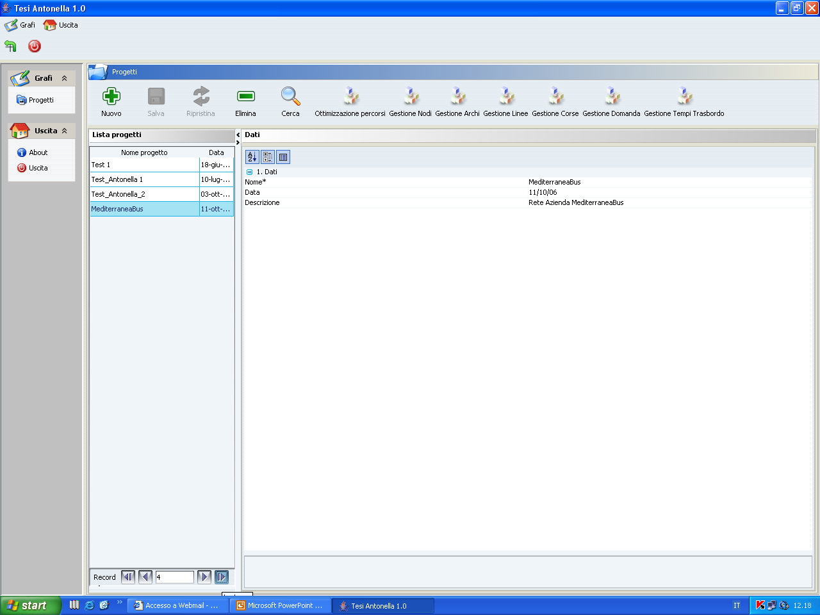
Figure 6 – The auto-produced computational program
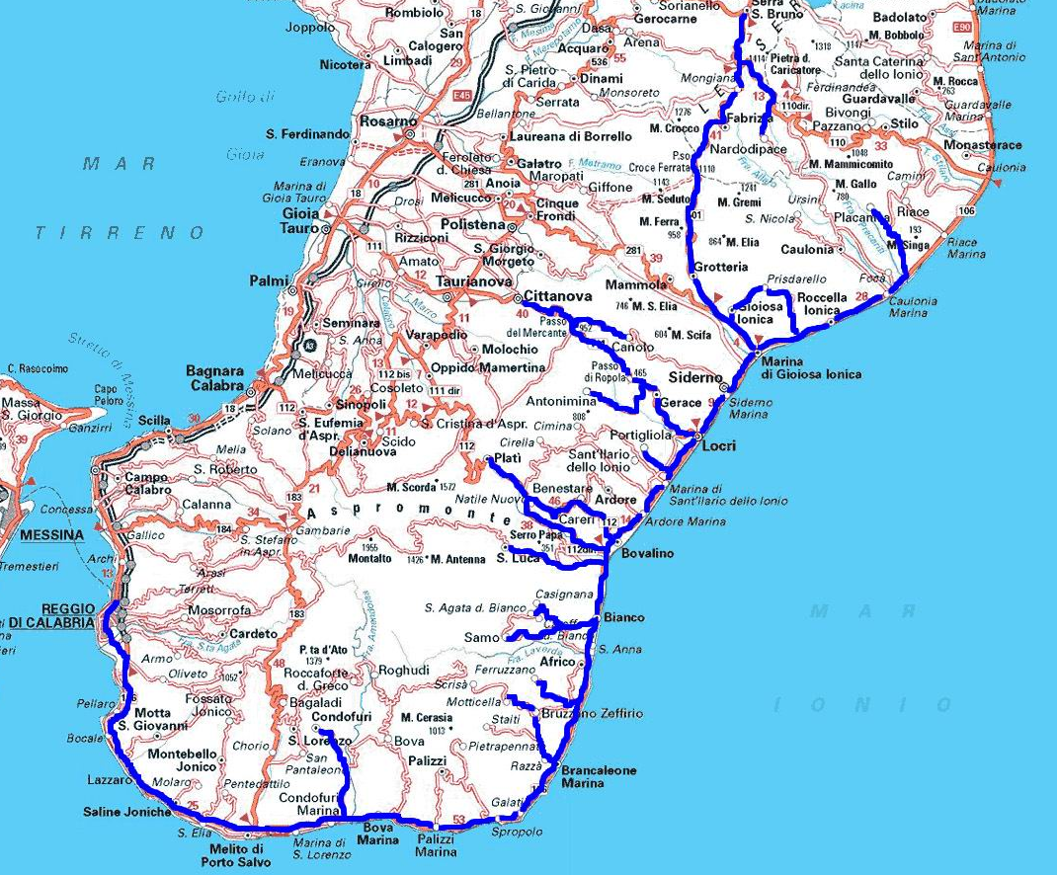

Figure 7 – Served area

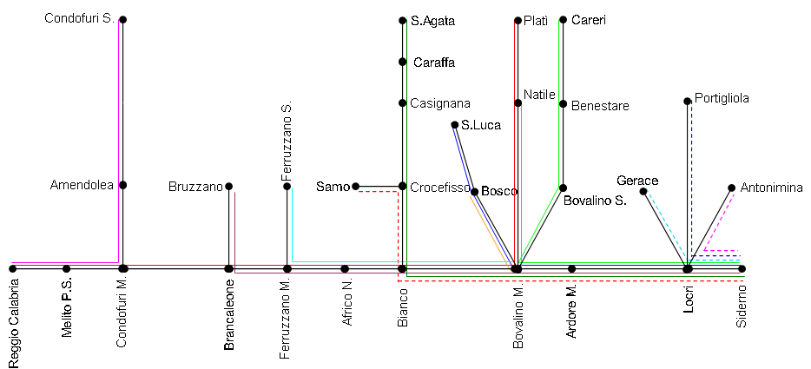
Figure 8 – Schematization of the lines

Figure 9 – Trend of the objective function
3.229 users⋅min
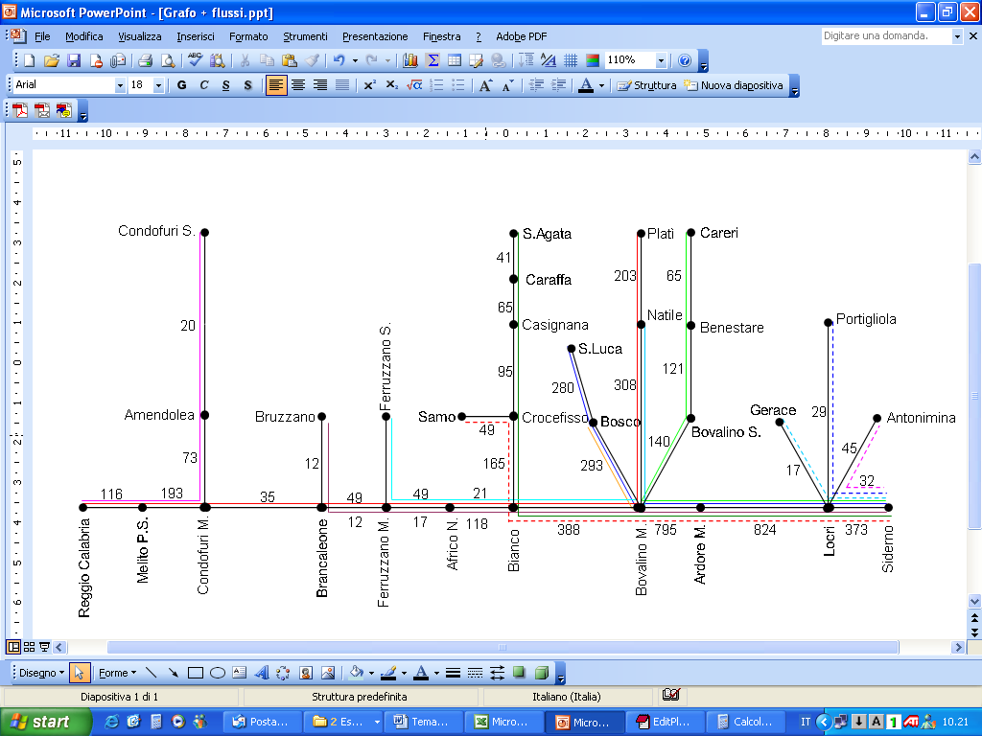
Figure 10 – Link flows

