A METHODOLOGICAL APPROACH COMBINING MACRO, MESO AND MICRO SIMULATION MODELS FOR TRANSPORTATION ANALYSYS

Dr. Jaume Barceló⁽¹⁾, Dr. Jordi Casas⁽²⁾, Mr. David García⁽³⁾ and Mr. Josep Perarnau⁽³⁾

⁽¹⁾ Universitat Politècnica de Catalunya, Barcelona, Spain, jaume.barcelo@upc.edu
⁽²⁾ Universitat de Vic, Passeig de Gràcia 12, 3er 1ª, 08007 Barcelona, Spain, casas@aimsun.com
⁽³⁾ TSS-Transport Simulation Systems, Passeig de Gràcia 12, 3er 1ª, 08007 Barcelona, Spain (david,josep)@aimsun.com
A METHODOLOGICAL APPROACH COMBINING MACRO, MESO AND MICRO SIMULATION MODELS FOR TRANSPORTATION ANALYSYS

Jaume Barceló⁽¹⁾, Jordi Casas⁽²⁾, David García⁽³⁾ and Josep Perarnau⁽³⁾

⁽¹⁾ Universitat Politècnica de Catalunya, Barcelona, Spain, jaume.barcelo@upc.edu
⁽²⁾ Universitat de Vic, Passeig de Gràcia 12, 3er 1ª, 08007 Barcelona, Spain, casas@aimsun.com
⁽³⁾ TSS-Transport Simulation Systems, Passeig de Gràcia 12, 3er 1ª, 08007 Barcelona, Spain (david,josep)@aimsun.com

ABSTRACT

Macro, meso and micro approaches have traditionally grown up independently to provide answers to specific problems in traffic and transportation analysis, however, a proper analysis of complex networks, as in the case of corridor analysis, asks for an integrated combination of the three approaches. Macro travel demand models are usually based on the user equilibrium and are static in nature, while simulation approaches emulate traffic flow dynamics. Mesoscopic approaches are based on simplified flow models with explicit treatment of intersections and allow modeling large networks with high computational efficiency adding the dynamic dimension to strategic planning. Microscopic approaches modeling the individual dynamics of each vehicle by means of car-following, lane changing and other models, consistent with traffic flow theory, incur in higher computational costs but allow a very detailed analysis appropriated for operational planning. A methodology combining macro, meso and micro raises consistency problems on the network representation, the time dependent paths and on achieving dynamic user equilibrium. This paper discusses these problems, proposes a solution based on a combination of computer and traffic modeling and presents computational results to check experimentally the consistency of meso and micro models.

INTRODUCTION

Urban travel demand and mobility analysis for transport planning has evolved into a well established methodology, commonly referred to as the four step model. In this methodology after the data collection on land use, socioeconomic data, travel demand and transportation infrastructure, the modeling process consists of

- The Trip Generation and Attraction models
- The Trip Distribution Models
- The Modal Split Models
- And a final step assigning the demand to the network, a process usually based on a User Equilibrium Assignment Model.

The increasing complexity of transportation systems has long asked for deeper transport analysis abilities, enabling the analysts to extend the capability of the strategic planning to a detailed analysis of the potentially conflicting areas identified at the upper macro level proper of strategic planning. This implies the establishment of links between the strategic long term transport planning and the short term tactical operational planning or, in other words, addition of a fifth step to the four step process, continuing the analysis with a detailed insight into a smaller zone using microscopic simulation. A friendly way of doing this, as depicted in Figure 1, consists of:

    - Opening a window in the strategic planning model, for the sub-areas where potential traffic conflicts (bottlenecks, congestions….) have been identified and
    - Zooming in to continue conducting a more detailed operational analysis with the appropriate models, i.e. a microscopic simulation model.

The convenience of linking strategic transport planning and tactical operational planning led to development of interfaces between transport planning software, such as EMME/2 and microscopic simulation software such as AIMSUN, opening communication links between strategic and operational planning tools. The interface between AIMSUN and SATURN is another such example.
Figure 1

However, the communication between two modeling approaches based on different modeling paradigms, by means of interfaces exchanging files, is usually hindered by the limitations imposed by file exchange. These limitations can be efficiently overcome by an actual full integration implying a unique common network representation, shared by planning and operational approaches, that is, by static user equilibrium and a dynamic simulation model. This has clear methodological advantages over other software implementations given that it ensures the consistency of the network representations proper of the various models integrated (i.e. node-link for macro planning models, detailed geometry for microscopic traffic simulation models) and it enables consistent definitions of the demand to be shared (OD matrices, centroids, connectors…). Additionally a full integration guarantees the synchronization of models that is the direct and immediate translation to any other models of changes in one of them. Model synchronization is hard to achieve with interfaces, assuming it is possible, and usually becomes a source of inconsistencies hard to detect.

The extended use of these combined approaches has recently raised an increasing demand for the addition of dynamic capabilities to the planning processes, however, the inclusion of the time dimension in traditional traffic modeling approaches based on the concept of equilibrium has resulted in complex analytical models, whose computing performance is suitable for large networks only through simplifying assumptions that compromise their quality.

This led to consideration of a different modeling paradigm: the mesoscopic models; to fill the gap between the upper level aggregated user equilibrium approach used in the macroscopic models and the lower level fully disaggregated approach of the microscopic models. Mesoscopic models describe in a simplified way the flow dynamics, and implement a heuristic dynamic equilibrium that can computationally succeed in the analysis of large networks.

That makes available to practitioner three complementary approaches each one playing a well defined role in transportation analysis as far as each one has unique characteristics to answer appropriately certain questions that the others cannot answer as effectively. Consequently the discussion is not whether one approach is better or more appropriate than the other, or if there is a unique approach that can replace satisfactorily all others, but that which is the most appropriate use of each approach and how these can then work together in a common framework, if possible, generalizing the macro-micro interfaces to a combination of meso and micro, in a new methodological framework in terms of a dynamic medium term planning, and short term dynamic operational analysis.

The full integration of the three approaches depicted in Figure 2 makes possible a richer transport analysis methodology, where starting at the macro level with a very large model of a region or a metropolitan area the analyst, after conducting a transport planning analysis, windows into a large sub area (possibly the whole area spanned by the model) to get a deeper insight accounting for the dynamic effects of time dependencies of traffic phenomena. The dynamic analysis may reveal potential conflicts in smaller sub areas requiring a further detailed analysis, namely when one should account for ITS applications, like adaptive control strategies, for which microscopic simulation is the suitable model.

Figure 2

The architecture proposed in this paper provides a computer modeling framework that enables the efficient combination of the three traffic modeling approaches overcoming the consistency problems already mentioned, namely when time dependent paths of vehicles traveling across the network from origins to destinations must be taken into account.

This modeling framework makes available to the user in an integrated way all the modeling tools for complete corridor analysis, as depicted in figure 3, Alexiadis 2007, starting at the upper level with the Regional Travel Demand, based on the four steps process, which provides a primary version of OD matrices than can be further refined/adjusted using additional information to estimate peak spreading and adjust for shorter time intervals from available link flow counts. The refined trip matrices are input into the dynamic models, meso, micro or both, depending on the purposes, along with the management strategies whose performance is to evaluate according with the selected measures of performance. The logical diagram of the enriched methodological process, depicted in Figure 4, consists of the following stages:

- Start the analysis at the upper macro level to conduct the strategic transport planning analysis of a large regional or metropolitan area. This stage will usually be based on the classical four step approach that, if supported by an appropriate software platform according to the guidelines described above, will allow the analyst to:
  - Import the digital map of the transportation infrastructure under study from a GIS into the working area of the planning software to edit the model of the network
  - Accede to the zoning and related land use socioeconomic information in the GIS
    - Estimate the Generation/Attraction models
    - Estimate the total demand and the demand for peak hours, if required by the study, in terms of the trip or Origin-Destination Matrices.
  - Construct and apply the Trip Distribution and Modal Split models, forecast the demand according to the expected changes in the generation/attraction capabilities derived from changes in Land Use, population growth and other factors
  - Conduct the traffic assignment analysis based on the user equilibrium models.
- Identify the sub-areas where potential conflicts may arise; these will become the problem areas whose deeper analysis will be conducted by microscopic simulation.
- In the case of a full integration the next methodological step after identifying a problem area consists of defining graphically a window encircling the sub-network spanning the problem area, as depicted in Figure 5.
- The full integration of the macro and micro approaches allows an automatic generation of the microscopic simulation model of the selected sub-network
- To conduct simulation experiments with the microscopic simulation model of the sub-network it is necessary to generate the local, or traversal, Origin-Destination Matrix from the global Origin-Destination Matrix from 1.2.2
- If link flow counts are available in the modeled sub-area, the quality of the estimated traversal OD matrix can be improved by adjusting the matrix from the measured link counts. This can also be the basis for a time slicing of the demand, splitting and adjusting the original matrix into sub-matrices for shorter time periods,
- The adjusted and time sliced OD matrix is then input to the microscopic simulation model to conduct the simulation experiments for the detailed analysis of the potential conflicts in the selected problem network.
- The results of the simulation experiments are analyzed and compared to draw conclusions on the problems identified or on the comparison of scenarios proposing alternative solutions to the conflicts identified.
- If the analysis of the simulation is acceptable the study is finished, otherwise changes in the models have to be done and the process iterates accordingly.

Figures 4 and 5

THE INTEGRATED SOFTWARE PLATFORM

The integrated modeling environment proposed in this paper solves the integration issues on basis to a software architecture that combines both computer and transport modeling. The computer modeling is based on an extensible object model providing a unique representation to all system entities shared by all transport models, as depicted in the conceptual scheme at the bottom of Figure 6. That means that each entity is characterized by a unique set of attributes and each traffic model accedes to the attributes that it needs. This information is stored in a common unique database and it is shared by all traffic models. This software architecture has been implemented in AIMSUN NG, 2006. The system becomes in this way an integrated environment enabling the direct exchange of information among various transport models. Transport Planning, mesoscopic simulator and microscopic simulator, among other applications exchange the information directly in this way, each one using the information that needs and modifying the stored information accordingly, all the data have a common storage and the type of network representation depends only on which subset of data is used.

Figure 6: Conceptual architecture of the integrated environment and the Extensible Object Model

This allows simultaneous network level representations as those depicted in figure 7(a). On the left there is the view of the link node representation of a network, as required by a static user equilibrium assignment, the window shows part of the attributes of a selected link, some of them representing data for a microsimulation, or for the mesoscopic, such as the Jam Density, and others, such as the volume-delay function included in the graphic, to be used in the user equilibrium assignment at macro level. On the right of the figure is depicted the microsimulation mode of the same network, where the window shows the details of the turning movements and timing allocated to one of the phases of the selected signalized intersection. This multilevel network approach made possible by the proposed computer modeling allows conducting the static equilibrium assignment, the mesoscopic simulation or the microscopic simulation simultaneously executing each model on its window.

Figure 2(b) depicts the case in which on the left window has been executed the user equilibrium assignment, link colors visualize the expected level of service after the assignment, the central window visualizes similar results for a given time interval from a mesoscopic simulation, and on the right window a microscopic simulation is being executed, and the corresponding animated view visualizes the individual vehicles, queues at intersections, etc.

Figure 7: (a) An example of multilevel network representation: node-link (left), detailed geometry (right). (b) An example of multilevel network representation: traffic assignment (left), mesoscopic simulation (centre), microscopic simulation (right)

Macro, meso and micro approaches to traffic modeling although sharing some common concepts are based on different types of network representations. All them share in common the demand model in terms of an Origin-Destination Matrix whose entries represent the number of trips from the selected origin to the chosen destination, for a given time period and trip purpose; origins and destinations being represented in the model in terms of artificial nodes, or centroids, where traffic flows are generated and sunk. The differences in demand representation lay in that, for macro approaches usually based on static user equilibrium, the demand matrix is unique for all the time horizon considered, while in the meso and micro approaches the demand matrix is usually split in a set of matrices for smaller time period spanning the whole temporal horizon, to approximate better the time varying traffic demand. Centroids are connected to the model of the physical network in terms of dummy arcs or connectors, how connectors are connected to links or nodes of the network model determine the demand behavior, therefore a first task to ensure the consistency of the demand representation in the three approaches calls for ensuring that the centroids and their connections are the same at the three levels.

Macro and meso approaches are based respectively on link node and extended link node network representations, with nodes modeling intersections and links modeling the transportation infrastructure, while microscopic modeling to traffic networks requires an explicit and detailed modeling of the road sections, intersections, roundabouts and so on. Road sections at macro and meso levels, are therefore represented in terms of abstract oriented arcs, whose characteristics are defined in terms of numerical attributes, i.e. capacity, number of lanes, associated volume-delay function, or speed density relationship in the extended link node, etc; while at microscopic level lanes must have a width, and other additional numerical attributes are necessary, as for example the speed limits on the section, although macro and meso, or meso and micro, can share some of the numerical attributes. At macro level nodes representing intersections include a detailed definition of the allowed turnings, but no information on signal setting at signalized intersections, or specific give way or stop rules at unsignalized intersections as far as they do not account for signal control, while meso and micro approaches need all the information concerning phasing schemes and time settings at controlled intersections as they deal explicitly with signal control, as well as information on give ways and stops at unsignalized intersections to model traffic behavior in a suitable way in these cases. That means, usually, that when moving form the upper aggregated level of network representation of macro approaches to the lower level of meso and micro there is missing information that should be additionally provided to ensure the model consistency at the corresponding lower level, and when moving in the opposite direction, from the fully disaggregated lower microscopic to the upper aggregated levels meso or macro, the appropriate aggregation rules must be defines to ensure a unique way and keep the models consistent.

The proposed architecture provides a computer model that enables the efficient combination of the three traffic modeling approaches overcoming the already mentioned consistency problems, namely when time dependent paths of vehicles traveling across the network from origins to destinations must be taken into account as in the case of hybridizing meso an micro approaches, Burghout 2004.

ACHIEVING A DYNAMIC TRAFFIC ASSIGNMENT

From an analytical point of view dynamic traffic assignment has been usually related to the concept of the dynamic user equilibrium problems. Our approach is based on the two alternatives proposed by Friesz et al. 1993, one based on a generalization of Wardrop’s fist principle of static traffic assignment, in which users try to optimize their route based on the current information, this approach describes the evolution of flows when users make route choice decisions based on experienced travel times, and it is usually known as a reactive or en-route assignment, it does not achieve a day-to-day equilibrium pattern, therefore it is considered a dynamic traffic assignment principle and not a true equilibrium. The second is based on a generalization of Wardrop’s principle stated in the following terms: If, at each instant in time, for each OD pair, the flow unit costs on utilized paths are identical and equal to the minimum instantaneous unit path cost, the corresponding flow pattern is said to be in dynamic traffic equilibrium. This approach, also known as preventive assignment, can be interpreted in terms of an approximation to a process by which travelers combine the experienced travel times with conjectures to forecast the temporal variations in flows and travel costs, the dynamic equilibrium problem can then be formulated in the space of path flows h_{k}(t), for all paths k∈ K_{i}, the set of feasible paths for the i-th OD pair at time t. The path flow rates in the feasible region Ω satisfy at any time t∈(0,T) the flow conservation and non-negativity constraints:
$Ω=\left\{h\left(t\right)|\sum_{k∈K}{h_{k}\left(t\right)}=g_{i}\left(t\right)\text{,i}∈{\text{I;h}}_{k}\left(t\right)≥0\right\}\text{ for almost all t}∈\left(\text{0,t}\right)$ (1)
where I is the set of all OD pairs in the network, T is the time horizon, and g_{i}(t) is the fraction of the demand for the i-th OD pair during the time interval t. The approaches assume that the optimal user equilibrium conditions can be defined as, Friesz et al. 1993, a temporal version of the static Wardrop user optimal equilibrium conditions, which can be formulated as:

$\begin{aligned}s_{k}\left(t\right)\begin{aligned}\left\{=u_{i}\left(t\right){\text{ if h}}_{k}\left(t\right)>\text{0 } | \right.\end{aligned} \\ \end{aligned}$ (2)
Where s_{k}(t) is the path travel time on path k determined by the dynamic network loading. Friesz et al. 1993, show that these conditions are equivalent to the variational inequality problem consisting on finding h*∈Ω such that:

$\left[S\left(h^{}\right)\text{,h}−h^{}\right]≥\text{0,}∀h∈Ω$ (3)

This problem is usually solved numerically discretizing the time horizon T into discrete time periods $t=1,2,\text{.}\text{.}\text{.},\left|\frac{T}{Δt}\right|$ of length Δt, corresponding to equilibrium flows according to (1) and (2) where the feasible flows h_{k}(t) are the solution of the discretization of (3):

$\sum_{t}{\sum_{k∈K}{s_{k}\left(t\right)}}\left[h_{k}\left(t\right)−h_{k}^{}\left(t\right)\right]≥0$ (4)
Where $K=\underset{i∈I}{}K_{i}$is the set of all paths for all OD pairs. According with this formulation Florian et al., 2001state that a dynamic traffic assignment model consists of two main components,:

- A method to determining the path dependent flow rates on the paths on the network, and
- A Dynamic Network Loading method, which determines how these path flows give raise to time-dependent arc volumes, arc travel times and path travel times

This computational framework can be implemented in practice in various ways, depending on whether the path selection is based on a direct numerical solution of the variational inequalities for the dynamic user equilibrium, or on a stochastic route choice model, and on whether the dynamic network loading is implemented analytically or based on a simulation mechanism. We propose two heuristic approaches, Figure 8:

- Implement the route choice on basis to Friesz dynamic user equilibrium conditions solving them numerically, and perform an approximate network loading mechanism based on a mesoscopic traffic simulation, and
- Implement the route choice on basis to a discrete stochastic route choice model, and base the Dynamic Network Loading mechanism on microscopic simulation with AIMSUN, Barceló and Casas 2006.

Figure 8 Conceptual framework for the computational implementation of Dynamic Traffic Assignment

An efficient computational implementation of this conceptual approach requires that the analytical part of the process, that is the path calculation and selection is implemented independently of the dynamic network loading process selected to implement the heuristic part of the Dynamic Traffic Assignment. In other words when the network consistency holds for the meso and micro representation the path calculation based on time dependent link costs must be the same and the only difference will lay on the values of the arguments of the link cost functions that will be provided respectively by the mesoscopic traffic simulation or the microscopic traffic simulation used for the Dynamic network Loading.

The software architecture conceptualized in Figure 6 allows such common calculation of shortest paths given that network representations share the same object model and model database and vehicles can be unique and the same for meso and micro, if meso model is based on an approach that individualizes vehicles, then path calculation can be carried out by a common “shortest path server” and are the same at both levels. The conceptual approach for dynamic traffic assignment proposed in Figure 8 has been implemented in terms of a “Dynamic Traffic Assignment Server” whose conceptual structure is depicted in Figure 9. The implementation of the “Dynamic Traffic Assignment Server” is based on the software architecture presented in Figure 6, exploiting the common network representation for meso an micro approaches that makes possible to compute common shortest paths based on link cost functions evaluated in terms of current link costs or link cost accounting for stored values from previous iterations. Link costs are then updated after the dynamic network loading mechanism which can either be based on a mesoscopic or a microscopic simulation approach depending on the selected approach.

Figure 9: Conceptual architecture of the “Dynamic Traffic Assignment Server”

This way of combining the simulation approaches overcomes the consistency problems appearing when the Mesoscopic simulator and the microscopic simulator are two independent pieces of software. The integration of Meso and Micro simulators has been analyzed in detail by Burghout (2004), and Burghout et al. (2005), in the case of MIME and MITSIM. The integration has to solve in that case the consistency problems in route choice and network representation, traffic dynamics, traffic performance for micro and meso models and communication and data exchanges.

The algorithms implemented in the computational framework look for the equilibrium conditions in two alternative ways, either solving numerically the variational inequalities (4) using an ad hoc version of MSA algorithm or by means of a heuristic approach to equilibrium by means of a preventive dynamic assignment based on repeating the simulation scheme a number of times and defining a link cost function including predictive terms, in which the path costs $\tilde{S_{k}}\left(h^{l+1}\right)$ are the arguments of the route choice function used at iteration l+1 to split the demand $g_{i}^{l+1}$among the available paths for OD pair i. In the computational experiments discussed in this paper a simplified version consisting of a link cost function defined as:

$c_{\text{it}}^{k+1}={λc}_{\text{it}}^{k}+\left(1−λ\right){\tilde{c}}_{\text{it}}^{k}$ (5)

Where $c_{\text{it}}^{k+1}$is the cost of using link i at time t at iteration k+1, and $c_{\text{it}}^{k}$and ${\tilde{c}}_{\text{it}}^{k}$correspond respectively to the expected and experienced link costs at this time interval from previous iterations. This computational framework for a heuristic algorithm to compute dynamic equilibrium extends the one explored by Liu et al. 2005, whose microscopic approach is based on Paramics.

Discrete Route Choice Models

In the proposed network loading mechanism based on microscopic simulation vehicles follow paths from their origins in the network to their destinations. So the first step, at each time interval of each iteration in the simulation process, is to assign a path to each vehicle when it enters the network, from its origin to its destination. This assignment, made by a path selection process based on a discrete route choice model, will determine the path flow rates. The simulation experiments reported in this paper have been implemented in AIMSUN selecting the Logit, and C-Logit route choice functions from the default route choice functions available in the simulator, Cascetta et al., 1996; Ben-Akiva and Bierlaire, 1999). Detailed results can be found in Barcelo and Casas 2004.

Dynamic User Equilibrium Based Route Choice

This corresponds to the alternative described above, implementing the path choice as defined in (2) by the dynamic version of Wardrop’s user equilibrium principle, solving the variational inequalities (4). Computationally this means to apply an iterative method similar to those proposed by Fukushima 1992, or Wu 1991, after preliminary computational experiences with projection methods we have used an ad hoc version of the Method of Successive Average (MSA) derived from Florian et al. 2002, and Mahut et al. 2003, 2004. In our case the method of the successive averages (MSA is applied to each O-D pair i ∈ I and time interval t, determines the path input flows$h_{k}^{t}(n)$, k ∈ K_{i} assigned to path k of O-D pair i ∈ I at interval t in iteration n. The initialization procedure consists of an incremental loading scheme that successively assigns partial sums of the demand for time interval t onto dynamic shortest path. That is, the first demand increment,$g_{i}^{1}$, i ∈ I is loaded onto a new dynamic shortest path based on the initial cost function, it means based on free flow travel times. With the network loading of the first interval, the link travel times are updated and then a new dynamic shortest path is computed for the second interval assigning the second demand increment$g_{i}^{2}$, i ∈ I and so on.

After the initialization and up to a pre-specified maximum number of iterations, N, the time dependent link travel times after each loading are used to determine the new set of dynamic shortest paths that are added to the current set of paths.

The algorithm to determine the volume assigned as input flow to each path in the set is function of the number of iteration n: $h_{k}^{t}(n)$, where $s_{k}^{t}(n)$is the experienced travel time of path k of O-D pair i ∈ I at interval t in iteration n and $u_{i}^{t}(n)$is the length of the shortest path of O-D pair i ∈ I at interval t in iteration n.
At each iteration n:

- when n ≤ N:
$h_{k}^{t}(n)=\frac{g_{i}^{t}}{n}$, for k ∈ K_{i}, i ∈ I, all t
- when n > N: only the shortest path among used paths is identified and the path input flow rates are redistributed as follows:

$h_{k}^{t}(n)=\left\{\begin{matrix}h_{k}^{t}(n−1)\left(\frac{n−1}{n}\right)+\frac{g_{i}^{t}}{n},\text{if} s_{k}^{t}(n−1)=u_{i}^{t}(n−1) \\ h_{k}^{t}(n−1)\left(\frac{n−1}{n}\right) ,\text{ otherwise}\end{matrix}\right.$,
for k ∈ K_{i}, i ∈ I, all t

In this algorithm the determination of the input flow assigned to each path in the set is function of the number of iteration n and the pre-specified maximum number of iterations, N. However, taking into account the possibility of repeating shortest paths from an iteration to next to keep a maximum of N different shortest paths a proper implementation of the algorithm requires that the number of iterations n is defined by O-D pair and time interval.

THE MICRO AND MESO APPROACHES

The microscopic simulation approach used, as implemented in AIMSUN, Barceló and Casas 2004, Barceló et al. 2005a, is a route based microscopic simulation in which, vehicles are input into the network according to the demand data defined as an O/D matrix (preferably time dependent) and travel across the network following specific paths in order to reach their destination. In the route based simulation new routes are to be calculated periodically during the simulation, and a Route Choice model is needed, when alternative routes are available to determine how the trips are assigned to these routes.

The mesoscopic simulation model, Barceló et al. 2005b, is based on an event scheduling approach, as in Burghout 2005, and Mahut et al. 2004. A computationally efficient solution when the simulation is not based on tracking individual vehicles all the time, but in describing approximately their trajectories in the links. This means that only the generations of new vehicles, the entrance of a vehicle into a link, or the transfer of a vehicle from one link to the next according to the turning movements at intersections, are the events of interest that must be taken into account. The approach taken is based on a simplified dynamics of individual vehicles to embed the mesoscopic simulator in the integrated environment of AIMSUN NG and integrate it with the microscopic simulator. Links are split in two parts, the running part, where vehicles are not yet delayed by the queue spillback at the downstream node, where the capacity is limited by stop, give way or traffic lights and the queue part, as shown in Figure 10, as in MEZZO, Burghout 2005, and other simulators.

Figure 10 Link model

Nodes are modeled according to a queue server approach, to account explicitly with traffic lights and the delays that they cause, and the interactions between traffic flows at intersections. Individual vehicle dynamics in the running part is approximated by a simplified car following model compatible with the macroscopic speed-density relationship on the link. This speed is used to estimate the earliest time at which the vehicle could exit the link, unless it is affected by the queue spill back when reaching the border between the running part and the queue part, the vehicle dynamics is then ruled by the queue discharging process, that determines the time at which the event “exit the link” (and “enter the next link”) will occur. The boundary between the running part and the queue part is dynamic according to the queue spillback and queue discharge processes. A similar approach had been adopted in an earlier version of a mesoscopic simulator, PACKSIM, developed by Barceló and Grau 1994.

The dynamics in the running part of the link has been modeled in terms of the safe to stop approach to car-following models to describe the dynamic of leader-follower couples, Gerlough and Huber 1975, (see also Mahut 1999a and 1999b). Assuming steady state conditions, if vehicles in the running part of the link are traveling at the same average speed and one accepts the simplifying hypothesis that vehicles have similar breaking capabilities. It can be easily proven that in this case the basic car-following model in which reaction time equals sensitivity times the stimuli, depending on the hypothesis on the sensitivity coefficient lead to the well known speed-density relationships of the Greenshields and Greenberg type:

$u\left(k\right)=u_{f}\left(1−\frac{k}{k_{j}}\right)\text{ or }u\left(k\right)=u_{c}\text{ln}\left(\frac{k_{j}}{k}\right)$ (9)

Where u_{f} and u_{c} are the free flow speed and speed at capacity respectively, and k_{j} is the jam density. This model can be complemented after the empirical evidence that there are two limiting densities K_{min} and K_{max} which represent respectively the minimum and maximum densities where the speed is still a function of the density, Del Castillo and Benitez, 1995. This simplified model, consistent with the basic assumptions of traffic flow theory can be used to model flow dynamics at the running part of the link and schedule the events arrival and exit to a link.

With respect to the queue part we assume that the boundary moves at the queue clearance wave speed according with Akçelik’s model, Akçelik 1999:

$v_{x}=\frac{v_{n}q_{n}L}{\text{1000}v_{n}−q_{n}L}$ (10)

Where v_{n} the maximum queue discharge speed, and q_{n} maximum flow discharge are intersection dependent parameters that are a function of the signal timings in the case of signalized intersections. Akçeliks model’s also estimate the queue discharge speed, that will be the speed of vehicles in the queue and therefore will determine the link exit time depending on their position in the queue as:

$v_{s}\left(t\right)=v_{n}\left[1−e^{−m_{v}\left(t−t_{r}\right)}\right]$ (11)
Where v_{s}(t) is the queue discharge speed at time t since the start of the displayed green period for the corresponding phase at the traffic light, t_{r} is the vehicle start response time (or reaction time at stop), and m_{v} is an intersection dependent parameter. This model has been empirically validated with AIMSUN microscopic simulator in the benchmark proposed by Akçelik at the Highway capacity Committee Half year meeting in Truckee in 2001, Akçelik 2001.

COMPUTATIONAL RESULTS

Achieving Dynamic Equilibrium with the Micro approach

No formal converge proof can be given for the proposed heuristic stochastic dynamic assignment algorithm, since the heuristic network loading process based on microscopic simulation does not have an analytical form. A set of simulation experiments has been designed and conducted to explore empirically whether the described assignment process, depending on how it is implemented, can be associated to a heuristic realization of a preventive or a reactive dynamic assignment, assuming that a proper selection of a route choice model with the right values for the parameters, depending on the model, should lead to the realization of some equilibrium. The progress towards equilibrium has been estimated using the Rgap function (12). Florian et al. 2001, Janson, 1991, that estimates at time t the relative difference between the total travel time actually experienced and the total travel time that would have been experienced if all vehicles had the travel time equal to the current shortest path:

${\text{RGap}}^{t}(n)=\frac{\sum_{i∈I}{\sum_{k∈K_{i}}{h_{k}^{t}(n)s_{k}^{t}(n)}}}{\sum_{i∈I}{g_{i}^{t}u_{i}^{t}(n)}}$ (12)
Where u_{i}(t) are the travel times on the shortest paths for the i-th OD pair at time interval t, s_{k}(t) is the travel time on path k connecting the i-th OD pair at time interval t, h_{k}(t) is the flow on path k at time t, g_{i}(t) is the demand for the i-th OD pair at time interval t, K_{i}, is the set of paths for the i-th OD pair, and I is the set of all OD pairs. The experienced travel time of each path k $s_{k}^{t}(n)$ are calculated as the sum of the travel time experienced of all vehicles assigned at interval t in iteration n, when those vehicles reach their destination, so $s_{k}^{t}(n)=\sum_{v∈F_{k}^{t}(n)}{{\text{tt}}_{v}(n)}$, where $F_{k}^{t}(n)$ is the set of vehicles assigned to path k at interval t in iteration n. And then calculate the current shortest path $u_{i}^{t}(n)$ as$u_{i}^{t}(n)=\underset{k∈K_{i}}{\text{MIN}}\left\{s_{k}^{t}(n)\right\}$.In other words, the experienced travel time is the actual travel time experienced by vehicles departing at the same time interval upon arrival at destination and requires gather additionally the experienced travel time of all vehicles.

Computational rests have been conducted with networks of various types and sizes, Barcelo and Casas 2006, the figure 11a depicts the time evolution of the Rgap function for the logit route choice function, and the figure 11b depicts the plot of the RGap versus GEH index of all replications using the logit route choice model for the network of the city of Preston in UK which has 415 links (road sections), 165 intersections and 33 Origin-Destination Centroids The cloud of points that are in the area of the acceptable RGap and GEH index represent 70% of the experiments in which the logit route choice was used.

Figure 11: (a) time evolution of the Rgap function for the logit route choice function; (b) RGap versus GEH index

The cloud of points that are in the area of the acceptable RGap and GEH index represent 70% of the experiments in which the logit route choice was used. The GEH index for n pairs of (observed-simulated) values is calculated by the following algorithm:

For i = 1 to n calculate

$$\begin{aligned}{\text{GEH}}_{i}=\sqrt{\frac{2{\left({\text{ObsVal}}_{i}−{\text{SimVal}}_{i}\right)}^{2}}{{\text{ObsVal}}_{i}+{\text{SimVal}}_{i}}} \\ {\text{ If GEH}}_{i}≤{\text{5 Then GEH}}_{i}=1 \\ {\text{ Otherwise GEH}}_{i}=0 \\ \text{ Endif}\end{aligned}$$
Endfor
$\begin{aligned}\text{ Let GEH}=\frac{1}{n}\sum_{i=1}^{n}{{\text{GEH}}_{i}} \\ \text{If GEH}≥\text{85\% then ACCEPT the model} \\ \text{otherwise REJECT the model} \\ \text{ Endif} \\ \end{aligned}$
It needs to be noted that the GEH statistic is an “intuitive” and “empirical engineering” measure, not necessary a measure that a professional statistician would recognise or deign to use. The criterion of 85% or 80% has been established by practitioners as a rule of thumb FHWA (2003).

Achieving Dynamic Equilibrium with the Meso approach

Computational tests have been conducted with networks of various types and sizes we present here one example with the regional network of the State of Hessen in Germany. The network, depicted in Figure 12 consists of the motorways and primary highways with a total length of 1511 Km, 4282 links, 493 intersections, 312 of them signalized, and 245 Centroids representing Origins and Destinations. Highlighted in red is an example of a path between and OD pair for a time interval.

Figure 12

The Figure 13 depicts the evolution of the Rgap function for an one hour time horizon split into four intervals of 15 minutes each. The final Rgap achieved smaller than 0.3 % prove the quality of the results.
Figure 13

Testing the Meso-Micro consistency

The preliminary prototype of mesoscopic simulator has been initially tested against AIMSUN microscopic simulator in order to check both the quality of the results and the consistency between both simulators. We summarize in what follows some of the preliminary results obtained with the network of the city of Preston described in the previous section.

Two sets of computational experiments have been conducted to check the consistency of the link travel times which is critical to compute shortest paths, if mesoscopic and microscopic link travel times are consistent one should expect paths will be consistent, given that as far as the DTA is independent of the network loading, as illustrated in Figure 14, and the travel times are consistent in both approaches, then link costs computed by cost functions defined in the DTA server should be the same, and therefore the shortest path computed by the DTA server will be the same for both approaches as well as the path flow rates computed by the MSA or the stochastic route choice, given that they are also computed in the DTA server. Consequently the second set of computational experiments has the goal of checking the consistency of the path costs.

Figure 14: Time series of five minutes meso and micro link travel times of two congested links and 1 hour simulation time for two independent replications

Figure 14 and Table 1 depict the results for two congested links. The simulations have been replicated two times for each model, meso and micro. Replications are independent and the similarity between the time series of five minute records of link travel times produced by each replication has been established on basis to a statistical comparison in terms of Theil’s inequality coefficients, Theil 1966.

The values for the global U coefficients less that 0.2 show an acceptable level of similarity. The low values of U_{m}, the bias proportion coefficient reveal that there is no systematic error induced by the meso with respect to the micro approach and the values of U_{s}, the variance coefficient, show that in some cases it would be desirable a better correspondence between the variability of the meso with respect to the variability of the micro, although on the other hand this slight discrepancy is quite understandable given that the meso smoothes out the variability of the results.

Similar results have been expected when comparing path travel times. The Figure 15 depicts two examples of paths from two origins to a common destination. The paths have been selected to account for scenarios in which congestion is building at the end of the path along the simulated time horizon.
Figure 15

The graphics in Figure 16 display the time variability of the path travel times on both paths for the meso and the micro simulations. The path travel time displayed in this case is the average of the two replications with each approach. Travel times have been computed for all vehicles departing from origin in the same time interval when they arrive at the destination. The table 2 with the Theil’s coefficients show that although the time series are acceptably similar at the global level, as the U coefficient shows, the bias and variance coefficients are not that good, but this should be expected as far as the meso model smoothes out the travel times, but the orders of magnitude are quite similar, namely for uncongested conditions.

Figure 16: Time series of path travel times for the two selected paths

CONCLUSIONS

The integrated software environment presented in this paper has proved to provide an efficient computer modeling solution to the problem of consistent network representation shared by various traffic modeling approaches based on different modeling paradigms as the macro, meso and microscopic approaches. This computer modeling solution enables a transport analysis methodology based on the exchange of information between the various modeling levels. On the other hand it provides a consistent basis for a common calculation of shortest paths based on the concept of Dynamic Traffic Assignment Server that makes meso and micro approaches compatible. The consistency of such compatibility has been proved by the preliminary computational experiments presented in the paper.

REFERENCES

AIMSUN NG, 2006, User Manual, TSS-Transport Simulation Systems, Barcelona, Spain.

Akçelik R. (1999) Fundamental relationships for traffic flows at signalised intersections,
ARRB Transport Research, Research Report ARR340.

Akçelik R. and Besley M. (2001) Microsimulation and Analytical methods for Modeling Urban Traffic, Conference on Advanced Modeling Techniques and Quality of Service in Highway capacity Analysis, Truckee, California. (Available from http://www.aatraffic.com)

Alexiadis, V. Role of Simulation in Corridor Management, presented at TRB2007 Simulation Workshop, Washington, January 2007.

Barceló J. and Grau R. (1994) The CARS Demand Responsive Traffic Control System: Recent Improvements and Experiences, Seventh International Conference on Road Traffic Monitoring and Control, Conference Publication IEE No. 391, April 1994.

Barceló J. and Casas J. (2004) Methodological Notes on the Calibration and Validation of Microscopic Traffic Simulation Models, Paper #4975, 83rd TRB Meeting, Washington.

Barceló J. (2005a) Dynamic Network Simulation with AIMSUN, in Simulation Approaches in Transportation Analysis: Recent Advances and Challenges, Edited by R. Kitamura and M. Kuwahara, Kluwer

Barceló, J. Casas, J. García, D. and Perarnau, J. (2005b) Methodological notes on combining macro, meso and Micro Models for Transportation Analysis, Pare presented at the Workshop on Modeling and Simulation, Sedona.

Barceló J. and Casas J. (2006) Stochastic heuristic dynamic assignment based on AIMSUN
Microscopic traffic simulator, Paper #06-3107 presented at 85th Transportation Research Board 2006 Annual Meeting, Transportation Research Records No. 1964, pp. 70-79.

Ben-Akiva M. and Bierlaire M. (1999) Discrete Choice Methods and Their Applications to Short Term Travel Decisions, in: Transportation Science Handbook, Kluwer.

Burghout W. (2004) Hybrid microscopic-mesoscopic traffic simulation, Doctoral Thesis,
Royal Institute of technology, Stockholm, Sweden.

Burghout W., Kotsopoulos H. and Andréasson I. (2005) Hybrid Mesoscopic-Microscopic
Traffic Simulation, Proceedings of the 83rd TRB Annual Meeting.

Cascetta E., Nuzzolo A, Russo F. and. Vitetta A (1996) A Modified Logit Route Choice Model Overcoming Path Overlapping Problems, in: Proceedings of the 13th International Symposium on Transportation and Traffic Flow Theory, Pergamon Press

Del Castillo J.M. and. Benitez F.G (1995) On the functional form of the speed-density relationship I: general theory, Transportation Research 29B, 5, pp. 373-389.

FHWA (2003), Guidelines for applying Traffic Microsimulation Software.

Florian M., Mahut M. and Tremblay N. (2001) A Hybrid Optimization-Mesoscopic Simulation Dynamic Traffic Assignment Model, Proceedings of the 2001 IEEE Intelligent Transport Systems Conference, Oakland, pp. 120-123.

Florian M., Mahut M. and Tremblay N. (2005) Application of a Simulation-Based Dynamic
Traffic Assignment Model, Simulation Approaches in Transportation Analysis, Edited by R. Kitamura and M. Kuwahara, Kluwer, 2005)

Friesz T., Bernstein D., Smith T., Tobin R. and Wie B. (1993) A variational inequality
formulation of the dynamic network user equilibrium problem. Operations Research, 41:179-191.

Fukushima M. (1992) Equivalent differentiable optimization problems and descent methods
for asymmetric variational inequality problems, Mathematical Programming 53, pp. 99-110.

Gerlough D.L. and Huber M.J. (1975) Traffic Flow Theory, TRB Special report 165.

Janson B. N. (1991) Dynamic Assignment for Urban Road Networks, Transpn. Res. B, Vol.
25, Nos. 2/3, pp. 143-161.

Liu H.X, Ma W., Ban J.X. and Mirchandani P. (2005) Dynamic Equilibrium Assignment
with Microscopic Traffic Simulation, Paper presented at the 8th International IEEE Conference on Intelligent Transportation Systems.

Mahut M. (1999a) Speed-maximizing car-following models based on safe stopping rules. Transportation Research Board, 78th Annual Meeting, January 10-14, 1999.

Mahut M. (1999b) Behavioural Car Following Models. Report CRT-99-31. Centre for Research on Transportation. University of Montreal. Montreal, Canada.

Mahut M., Florian M. and Tremblay N. (2003) Traffic Simulation and Dynamic Assignment
for Off-line Applcations, presented at the 10th World Congress on Intelligent Transportation Systems, Madrid.

Mahut M., Florian M., Tremblay N., Campbell M., Patman D. and McDaniel Z.M. (2004) Calibration and Application of a Simulation based Dynamic Traffic Assignment Model, Proceedings of the 83rd TRB Annual Meeting.

Theil H. (1966) Applied Economic Forecasting, North-Holland,

Wu J.H. (1991), A Study of Monotone Variational Inequalities and their Application to Nertwork Equilibrium Problems, Ph. D. Thesis, Centre de Recherche sur les Transports, Université de Montréal, Publication #801.

TABLES

Theil’s coefficients 1st link
U | U_{m} | U_{s} | U_{c}
0.15 | 0.15 | 0.31 | 0.53
Theil’s coefficients 2nd link
U | U_{m} | U_{s} | U_{c}
0.18 | 0.012 | 0.048 | 0.94

Table 1 Theil’s coefficients for the comparison of travel times on Links 1 and 2

U | U_{m} | U_{s} | U_{c}
0.06803551 | 0.3831886 | 0.2406892 | 0.3887101

U | U_{m} | U_{s} | U_{c}
0,068 | 0,018 | 0,62 | 0,375

Table 2 Theil’s coefficients for the comparison of travel times on the selected paths
FIGURES

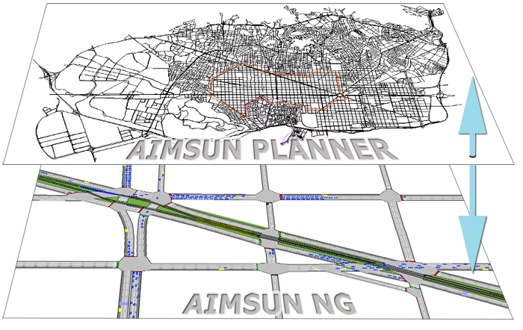
Figure 1

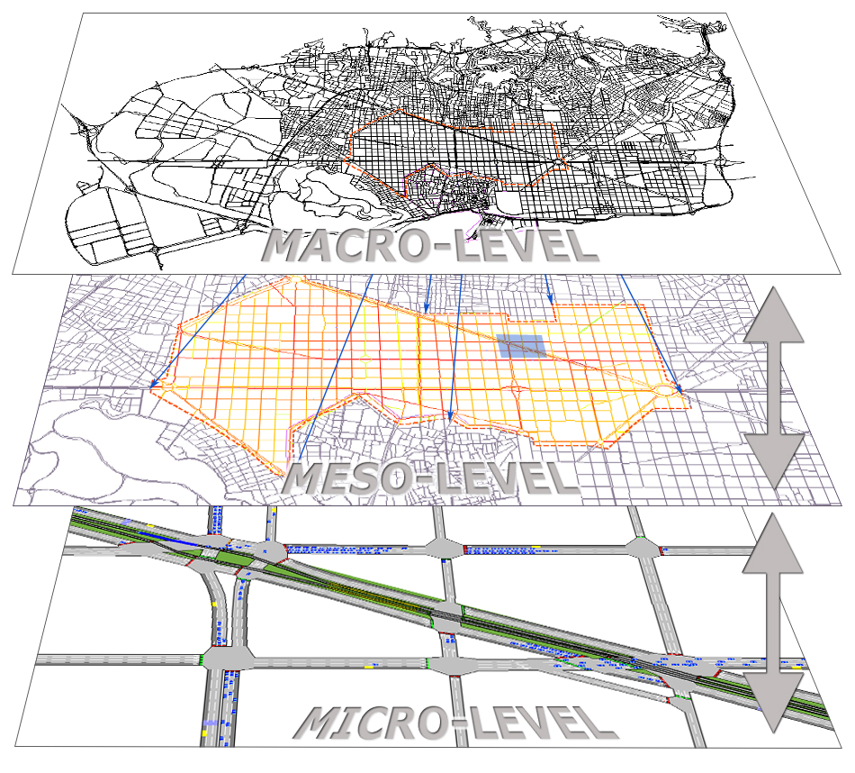
Figure 2: From Macro to Meso and Micro

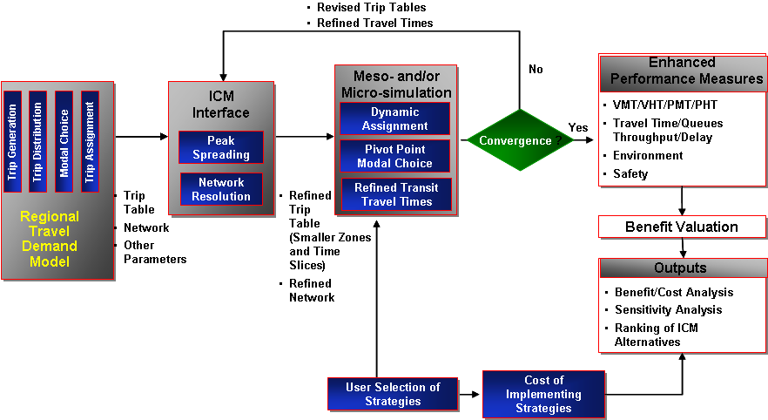

Figure 3: Integrated Analysis Metodology

MACRO LEVEL: TRANSPORT PLANNING MODEL OF A REGIONAL OR METROPOLITAN AREA
IDENTIFICATION OF CRITICAL SUBAREAS OF INTEREST
WINDOWING INTO THE SELECTED SUBAREA
AUTOMATIC GENERATION OF SUBAREA MESO OR MICRO MODEL
AUTOMATIC GENERATION OF SUBAREA TRAVERSAL OD
ADJUSTMENT OF THE SUBAREA TRAVERSAL OD
INPUT TO MESO OR MICRO MODEL AND SUBAREA SIMULATION AND SIMULATE
ANALYSIS OF THE SIMULATION RESULTS
ACCEPT OR REVISE
RESULTS
ACCEPT
Figure 4: Conceptual diagram of the
methodological process combining
MACROóMESO⇔MICRO Approaches

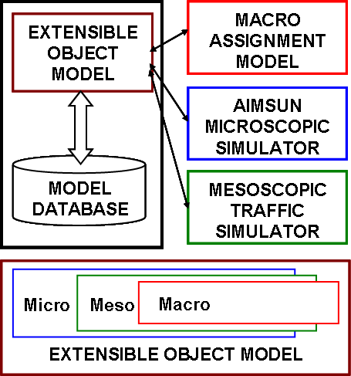

Figure 6: Conceptual architecture of the integrated environment and the Extensible Object Model

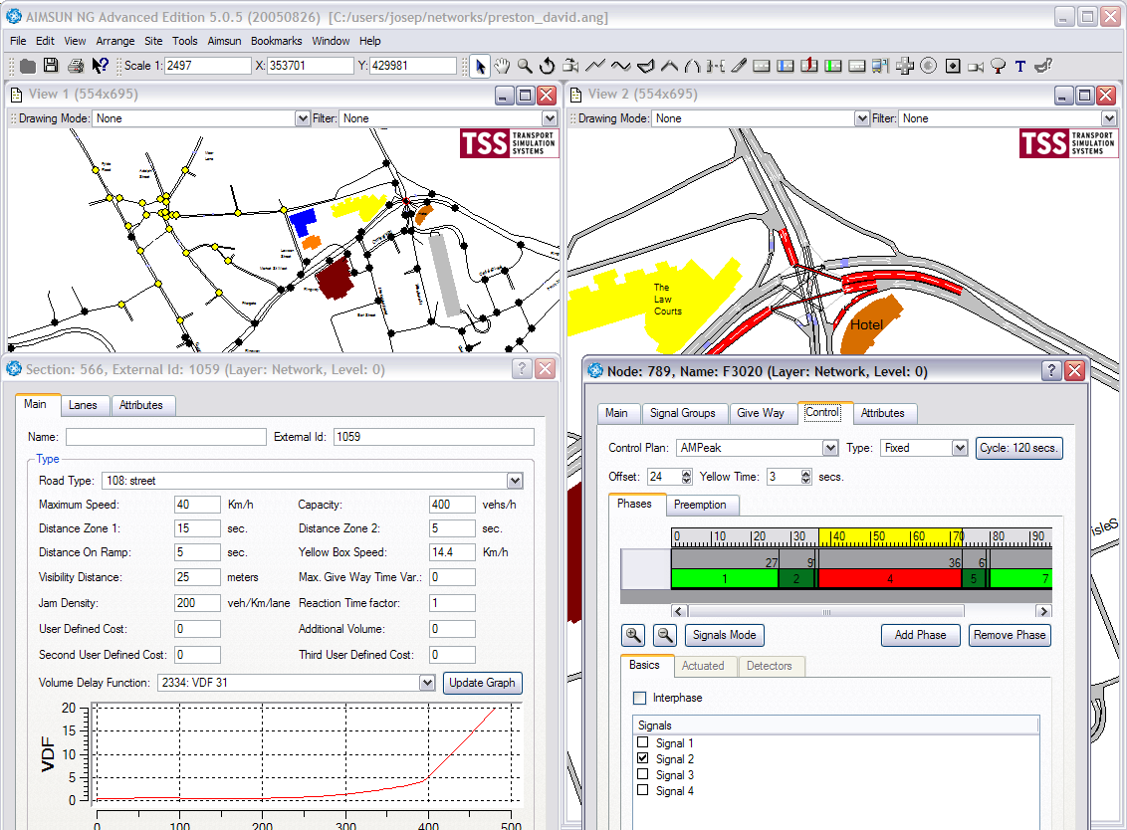
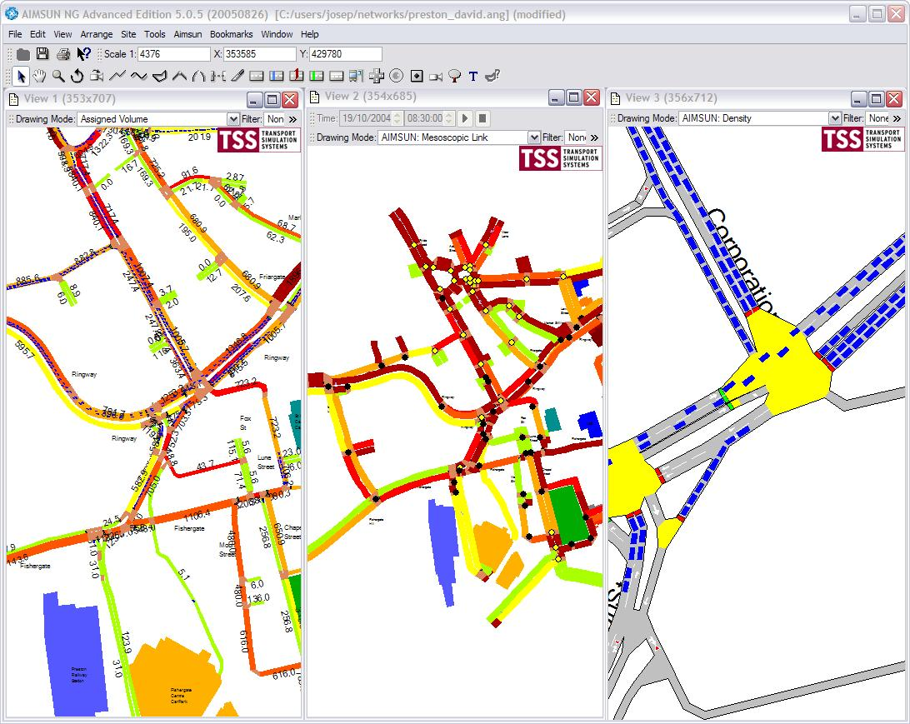
Microscopic parameters
Macroscopic parameters
Mesoscopic parameters

(a) (b)

Figure 7: (a) An example of multilevel network representation: node-link (left), detailed geometry (right). (b) An example of multilevel network representation: traffic assignment (left), mesoscopic simulation (centre), microscopic simulation (right)

Figure 8

Figure 9:

Link (i,j) Running Part
Link (i,j) Queue Part
Node i
Flow direction
Node j
Moving boundary

Figure 10

Figure 11a Figure 11b

Figure 11

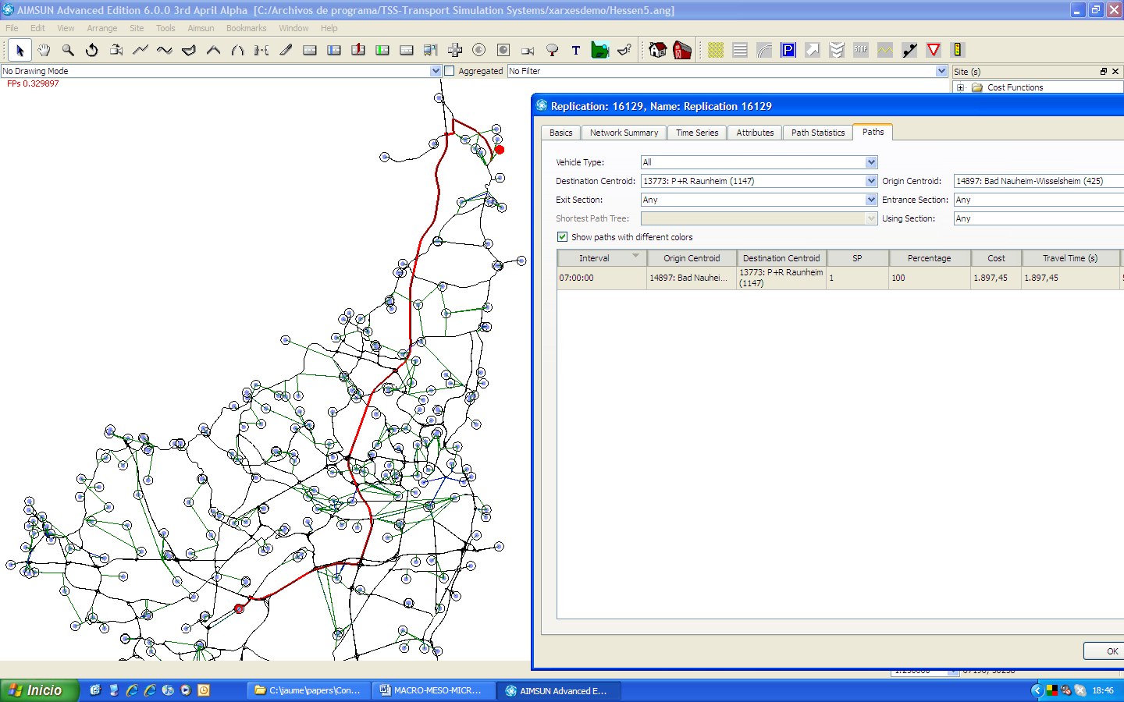

Figure 12

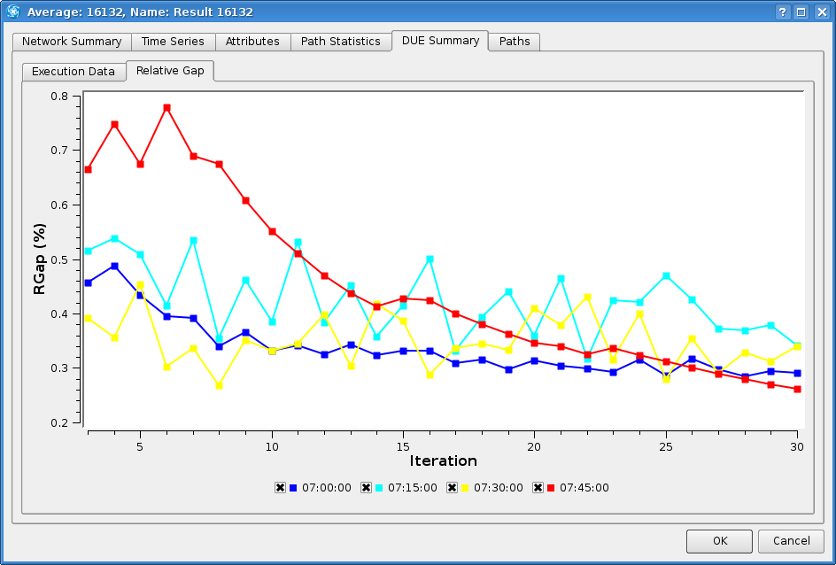

Figure 13

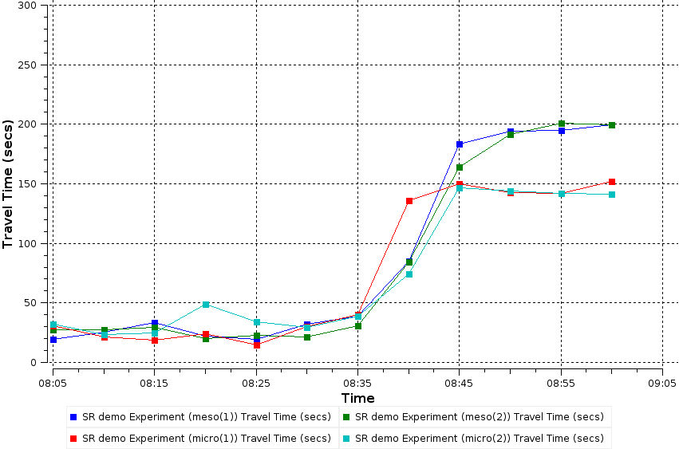
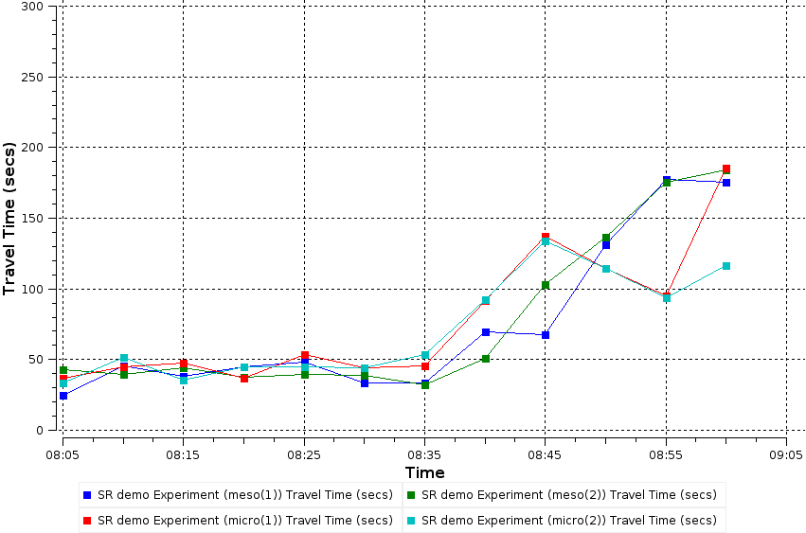

Figure 14

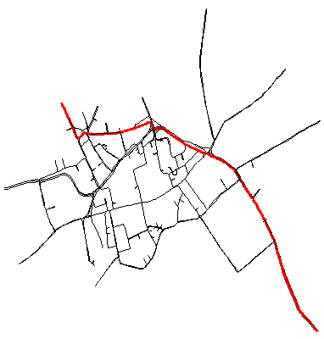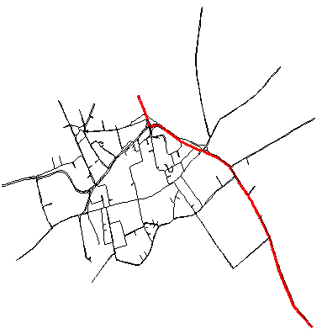

Figure 15

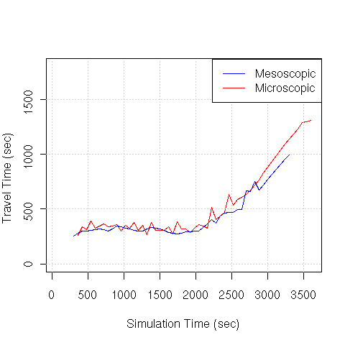
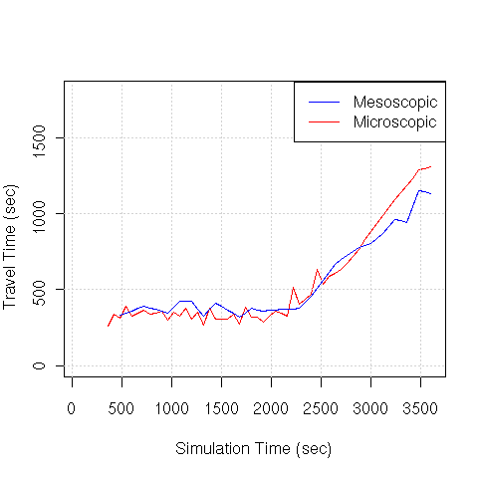

Figure 16

