The relationship between
travel time variability and road congestion

Jonas Eliasson
WSP Analysis & Strategy
Professor Transport Systems Analysis,
Centre for Transport Studies, Royal Institute of Technology
jonas.eliasson@wspgroup.se

2006-04-27
To be presented at WCTR 2007

Abstract
During the last few years, increasing attention has been paid to the problem of travel time variability caused by congestion on urban roads. Several countries have decided or are considering to include the cost of travel time variability in their cost-benefit analyses, including the UK, Holland and Sweden.
Travellers’ valuations of travel time variability has been investigated in several studies. However, studies that try to provide quantitative methods to forecast travel time variability (or rather, effects on variability of various investments or policy measures) are still rather scarce. The present study is an attempt to develop such a method.
Using data from Stockholm’s automatic camera system for travel time measurements, the relationship between congestion levels and travel time variability is investigated. We show that there is a stable and typical relationship between the relative standard deviation of travel time (standard deviation divided by travel time) and the relative increase in travel time (travel time divided by free-flow travel time). Using this, we estimate a function that can be used to predict how changes in congestion affect the standard deviation of travel time. This function has been used together with standard traffic assignment software (emme/2) to forecast the socioeconomic benefit of reduced travel time variation caused by a proposed road investment (the western bypass in Stockholm).
We also investigate the distribution of travel times across days, given a certain road and a certain time of day. It turns out that when congestion gets severe, travel times are approximately normally distributed. For low levels of congestion, the travel time distribution is skewed: most days, the travel time is roughly equal to the free-flow travel time, while it for a few days is longer – perhaps due to incidents or random disturbances.

Introduction
As congestion problems are growing more severe in urban regions, the problem of unpredictable travel times is receiving increasing attention. In many cases, this problem is seen as worse than the increased travel time in itself. Investments in infrastructure, or other transport policies, are often motivated by the need to reduce unexpected delays and unreliable travel times.
Since travel time variability affect people’s utility and their travel behaviour, it seems natural to try to include these phenomena in cost-benefit analyses (CBA). In fact, several countries consider doing this or have already. Holland has introduced “reliable travel times” as a goal for transport policy, and is well under way to introduce travel time variability in their CBA methodology (Kouwenhoven, 2005; Hamer et al., 2005). In the UK, there is ongoing work to introduce travel time variability in all types of impact analysis, including CBA (Department for Transport, 2004).
Travellers’ valuation of travel time variability has been investigated in several studies (see e.g. Hamer et al., 2005, or Eliasson, 2004, for surveys). However, studies that try to provide quantitative methods to forecast travel time variability (or rather, effects on variability of various investments or policy measures) are still rather scarce. The present study is an attempt to develop such a method. The task at hand is analogous to developing volume-delay functions: just as volume-delay functions describe the relationship between traffic volume, capacity and travel time on a link, our intention is to try to develop a function that describe the relationship between travel time, free-flow travel time and the standard deviation of travel time.
The study focuses exclusively on car trips in central urban areas. However, it is most likely that the phenomenon of travel time variability is relevant also in other settings – long-distance trips, public transit trips etc.

About travel time variability
Travel time variability is the random, day-to-day variation of the travel time that arises in congested situations even if no special events (such as accidents) occur. If congestion is severe, this variation may be significant. The unreliability means that many travellers must use safety margins in order not to be late. In some cases, the margin will turn out to be insufficient, and the traveller will be late nevertheless. In the former case, an additional disutility (beyond that measured by pure mean travel time) arises since effective travel time can be said to be greater than actual mean travel time. In the latter case, the lateness will cause some sort of additional disutility. The social loss causes by the travel time variability is the sum of those two disutilities.
There are several ways to quantify travel time variability. We will use two similar measures: the standard deviation of travel time (denoted σ) and the difference between the 90- and 10-percentile, scaled by the factor 2.56 (denoted s). If the travel time is normally distributed, the measures will coincide, and as long as it is symmetrically distributed they will only differ by a scale factor. But s, unlike σ, isn’t sensitive to what’s happening beyond the 90th percentile, at the far right tail of the distribution. This means that s won’t capture occasional incidents, for example. As will be shown later, the distribution of the travel time will tend to be symmetrically distributed once congestion gets severe, and hence σ and s will coincide. The main advantage with using s during estimation is that the estimated relationship between congestion and travel time variability will be more precisely estimated, since s is not sensitive to occasional, “rare” incidents. Some of these apparent “incidents” may also be measurement errors or various “irrelevant” disturbances (from our perspective), such as road work etc.

Valuing travel time variability
Many valuation studies assume a (reduced-form) utility function on the form
u = αt + βc + γσ
where t is travel time, c travel cost and σ is the standard deviation of travel time (α, β and γ are parameters to be estimated). This is usually called the “mean-variance” approach.
There are also studies that estimate schedule delay costs directly, i.e. the additional costs travellers encounter when they start earlier to reduce the risk of being late and the occasional “lateness penalty” when the travel time turned our to be longer than expected. Scheduling delay costs can either be estimated on their own or together with estimation of a valuation of travel time variability. Good discussions of how these two approaches relate to each other can be found in Small et al. (1999), Bates et al. (2001) and Noland and Polak (2002).
The main advantage with the mean-variance approach is that it is relatively straightforward to introduce variability into forecasting models and CBA methodology. All that is required is aggregate estimates of the mean travel time and its standard deviation. The scheduling delay approach, on the other hand, requires information on the distribution of preferred arrival times and solving the problem of choosing the optimal departure time (given preferred arrival times etc.).
The question of proper valuation of travel time variability is not the main focus of the current paper. The main motivation for it, however, is that it currently seems that the most tractable way of introducing travel time variability in cost-benefit analyses is using the mean-variance approach (or a variant thereof) – and hence, a way to forecast travel time variability is needed.

Data
The data we will use comes from the automatic travel time measurement system in Stockholm. Travel times are measured continuously through a camera system, where pictures of number plates are taken when vehicles enter and leave each link. The number plates are then matched together, and the travel time for each vehicle is calculated. Each period of 15 minutes, the median travel time on the link is calculated (after a filtering process to weed out various sorts of errors). The median is used rather than the average in order not to let vehicles stopping along the link (buses, shoppers) affect travel time measurements.
Travel times are measured on 92 streets and roads in and around central Stockholm. On 41 of these links, measurements worked properly during the period we studied. All the links can be characterised as “urban” roads, i.e. they are neither highways nor small, “local” streets. Typically, they have two lanes in each direction (sometimes only one) – remember that Stockholm is a European city, and, compared to e.g. typical U.S conditions, even fairly large urban roads are narrow and seldom have more than two lanes. Around two thirds of the links have a speed limit of 50 km/h, and the rest have 70 km/h. Traffic volumes vary between 15 000 and 50 000 vehicles per day (summing both directions). Lengths vary from 300 meters to 5 km, so most links also contain a few intersections, mostly signalled.
We used data from Monday-Thursday during the period September 1 – November 29 2005. For each link, we calculated average travel time and the standard deviation of the travel time for each 15 minutes period between 6.30 and 18.30 – hence, each link produced 48 “observations” of mean travel time and standard deviation (there are 48 quarters between 6.30 and 18.30).
That we split the day into 15 minute-periods is an implicit assumption that this is the relevant “time resolution” that travellers base their decisions on. In general, the more coarse this “time resolution” is chosen, the larger will the calculated variability be (and vice versa). Our choice is essentially only motivated by intuition: it seems reasonable that most travellers will “know” the variations in (expected) travel conditions on a 15-minutes basis. Investigating this further would certainly be worthwhile.

Investigating travel time variability
Before we present estimation results, it is useful to get some “qualitative” feel for the standard deviation.
The diagrams below show mean travel time (red) and 10- and 90-percentiles for a few links. A striking feature is the large variation of travel time – the 10% “best” days, travel times are close to free flow even during rush hours, while the 10% “worst” days, travel times may be twice as long than average travel times (or more), and at least four times as long as the 10% “best” days.
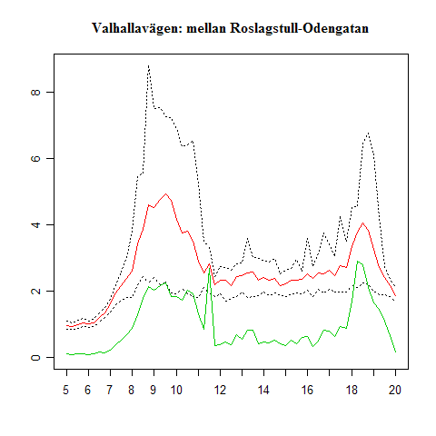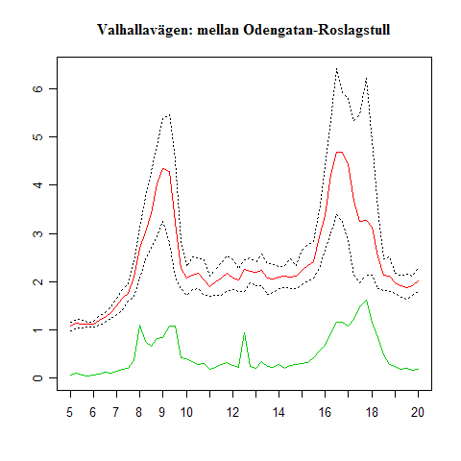
Figure 1. An example of travel times: Valhallavägen (two directions). Red is average travel time, black dotted lines are 10- and 90-percentiles of the travel time. Green is the standard deviation (σ).
The example below (showing the same link in two directions) shows that travel time variability does not have to be high even if congestion is. During afternoon rush hours on the right pane, the variability is very high, while it is fairly low during morning rush hours on the left pane.
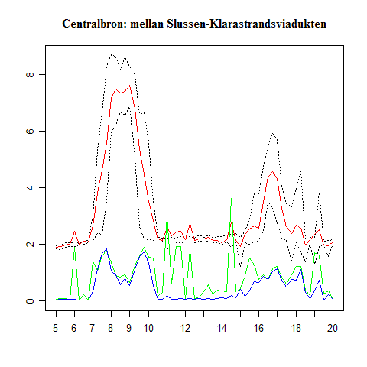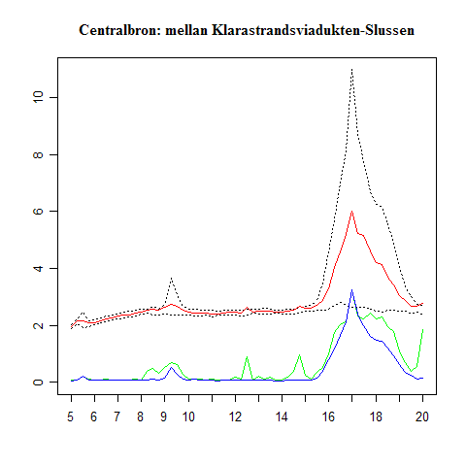
Figure 2. Another example of travel times: the Central bridge (two directions). Red is average travel time, black dotted lines are 10- and 90-percentiles of the travel time. The green, jagged line is the standard deviation (σ) and the blue, less jagged line is s, the (scaled) distance between the 90- and 10-percentile.
This particular link was also chosen to show the difference between σ and s. In particular on the left pane, σ is apparently disturbed by various large outliers – due to e.g. measurement errors or incidents. Although the data has been checked as far as possible to correct it, it is hard to weed out all outliers – especially in a study of this type, where it is the variation itself that we want to study. But from the figure, it is apparent that s is more “stable” than σ, and it should come as no surprise that the estimated relationships for s show higher significance than those for σ.
From the figures above, it seems apparent that there is a relationship between congestion (i.e., travel time longer than the free-flow travel time) and travel time variability. The diagrams below show relative standard deviation (σ divided by free-flow travel time) on the y-axis vs. relative increase in travel time (actual travel time divided by free-flow travel time) for 26 links. Each “dot” is one 15-minute period between 6.30 and 18.30.
Figure 3. Relative standard deviation vs. relative increasein travel time for 26 links.
Apparently, the variability increases when congestion increases. Moreover, the standard deviation seems to be roughly proportional to the relative increase in travel time. But the proportional factors (the slope of the “line” in each pane) seem to differ between links – quite naturally. Estimating that slope and trying to explain why it differs is one of the main tasks of this study, but before we show estimation results, we need to digress a little and investigate the distribution of travel times, and how variability is affected by queue build-up and dissipation.

The distribution of travel times
An interesting question is how travel times are distributed over multiple days. That is, if you measure the travel time on a certain link at a certain time of day several days - what will the distribution of these measurements look like? In particular: is it skewed or symmetric? The answer to this has implications for how stated choice experiments are formulated, and may also have implications for whether the standard deviation is an appropriate measure to use for CBA.
An initial guess might be that the distribution of travel times might be “skewed to the right”, i.e. deviations “upwards” – longer travel times than the median – is more common and/or larger than deviations “downwards”. It turns out that this is only partially correct. It is only when congestion is low that the travel time distribution is (appreciably) skewed – and when congestion is low, so is the travel time variability, so those cases are of less importance anyway. In summary, it is more fair to say the travel times are, in fact, symmetrically distributed as long as travel time variability is so high that it actually matters. Only when travel time variability is low will it be (appreciably) skewed. The rest of this section is devoted to show this.
The pictures below show a few examples of cumulative distributions of travel times. Every “dot” shows a certain 15-minute period a certain day. The red line shows a cumulative normal distribution with the same mean and standard deviation. “fm” means AM peak (8.00-9.00 AM) and “em” means PM peak (5.00-6.00 PM).
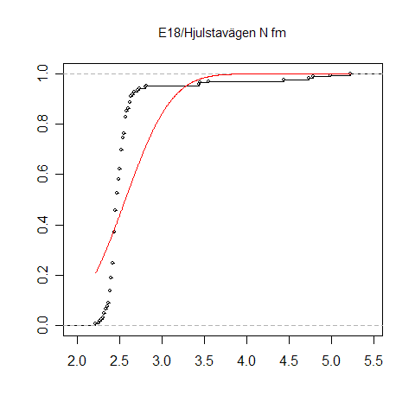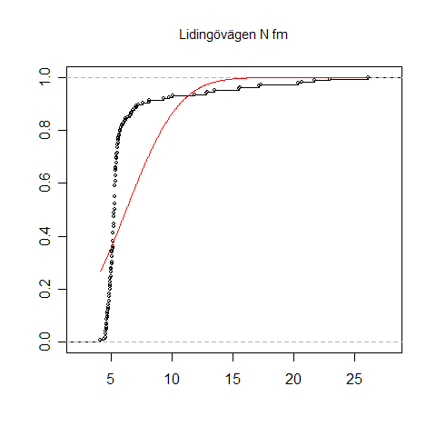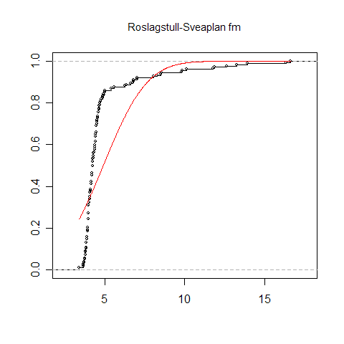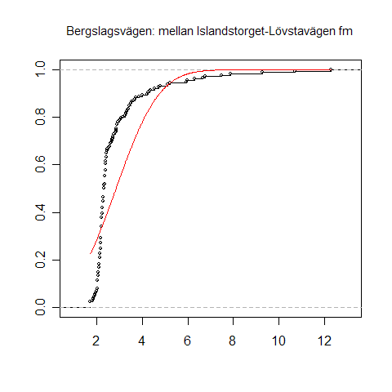
Figure 4. Examples of skewed travel time distributions (travel time in minutes on the x-axis, cumulative frequency during 1 rush hour on the y-axis).
These links are typical examples of links with low congestion. Most days, travel times are just a little above free-flow travel time, only getting longer in a few cases. Then, on the other hand, the travel time may be considerably longer – in some cases three or five times as long as the free-flow travel time. One may hypothesize that these cases are due to accidents, road work or bad weather (snow, heavy rain etc.). From the travellers’ viewpoint, travel time is “almost deterministic” – the travel time will be the same 90-95% of the trips. Only for the remaining 5-10%, the travel time will be longer.
Below, the same type diagram is shown for a few links with high congestion. That congestion is high is immediately visible from the cumulative distributions – the free-flow travel times are the left-most tail of the distribution. Just as before, the red line shows a cumulative normal distribution with the same mean and standard deviation.
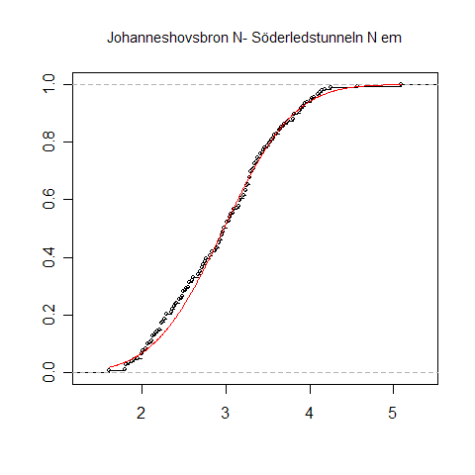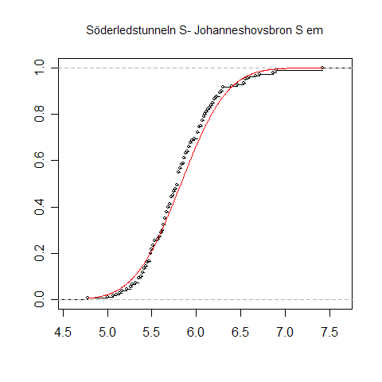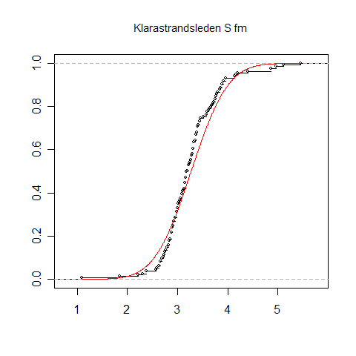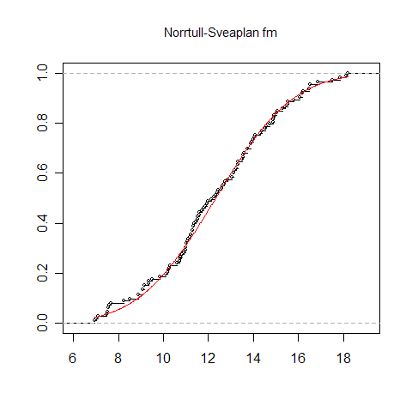
Figure 5. Examples of normally distributed travel times.
These travel time distributions are clearly almost exactly normally distributed. From a travellers’ viewpoint, the main difference is that travel times are clearly random – very different from day to day. (Interestingly, traffic volumes do not vary much – typically a few percent from day to day.)
The figures above give anecdotic support for the statement that travel time distributions are skewed for moderate levels of congestion (and variability), while it tends to be symmetrically distributed (normally, to be precise) for high levels of congestion (and variability).
To show this more formally, we need to use a formal skewness measure. We use the standard definition of skewness: S = E([X-m]³)/σ³ (m is the mean and σ the standard deviation). If S is 0, then the distribution is symmetric. If S is negative, it is skewed to the left, and vice versa for positive S.
The diagram below shows (on the y-axis) the skewness for the travel times during 1 hour periods between 5 AM and 9 PM for 41 links. The skewnesses are plotted against the relative increase in travel time (actual travel time divided by free-flow travel time) – a measure of congestion.
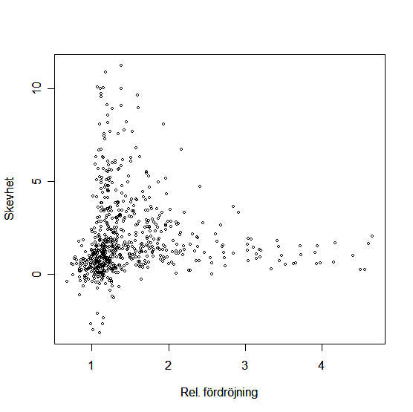
Figure 6. Skewness of travel time distribution (y-axis) vs. relative increase in travel time (x-axis)
Clearly, the travel time may be symmetrically distributed even for low levels of congestion – but there are lots of examples of skewed distributions. But when congestion gets high, the travel time distributions is nearly always basically symmetric.
This is a convenient result, since we are primarily interested in congested conditions (since that is when variability gets high). Had the travel time distribution been highly skewed, the standard deviation of travel time is a less intuitive measure, which has implications for the design of the stated preference valuation experiments.
This also underscores another point – that it is often useful (both for valuation and forecasting purposes) to differ between “day-to-day variability” and “incident-related variability”. They have different sources, are valued differently and distributed differently. In reality, the total variability can be viewed as coming from two “juxtaposed” sources of variability – one (mostly normally distributed) variability arising from the inherent randomness of congested traffic, and one arising from occasional incidents (where the frequency of incidents is typically Poisson distributed).

Variability during queue buildup and dissipation
In a working paper, Bates (2003) studied how the variability on highways changed during the day. The results indicated that variability was higher during queue build-up than during queue dissipation. An explanation could be that the build-up phase is a more deterministic phenomenon, while dissipation is inherently more random. Moreover, the time the dissipation takes will vary depending on the traffic volume the particular day, so will vary more across days. Both factors would mean that the travel time variability should be higher during the time after the absolute traffic peak than before it, all else being equal.
In our material, the same phenomenon is often visible – though not always. In the diagram below, relative increase in travel time is plotted (x-axis) versus relative s (s divided by free-flow travel time) (y-axis). Colours show time of day: black circles are observations through 8.45, red circles through 9.45, and then green circles.
Figure 7. Relative travel time variability (y-axis) vs. relative increase in travel time (x-axis) for different 15-minute timer periods.
Relative variability is roughly proportional to relative increase in travel time (which can be interpreted as “congestion”). But during queue dissipation – from 9.00, when the red circles start – the variability is higher than during queue build-up, although the congestion is the same. During mid-day (from 10.00 onwards), both congestion and variability are negligible.
In the diagram below, we have also shown the afternoon peak. Dark blue circles denote queue build-up (15.30-17), light blue circles queue dissipation (17-18.30). The same phenomenon can be seen: the variability increases with increasing congestion, and then decreases again with decreasing congestion, but at a higher level. Mid-day (green) and evenings (purple) , both congestion and variability are negligible.
Figure 8. Relative travel time variability (y-axis) vs. relative increase in travel time (x-axis) for successive 15-minute time periods.
The diagrams below show more examples (all from the morning peak). The phenomenon is not always as apparent, but enough important to be accounted for during estimation.
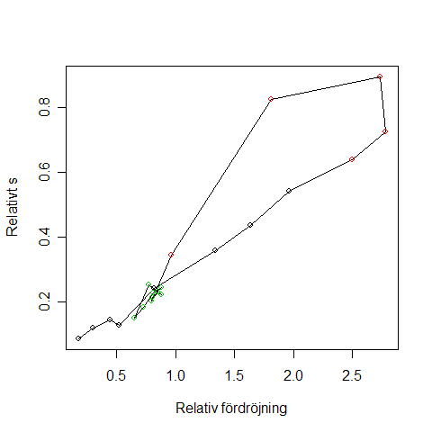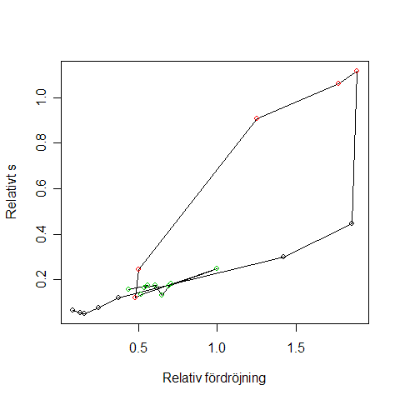
Figure 9. Relative travel time variability (y-axis) vs. relative increase in travel time (x-axis) for successive 15-minute time periods.

Estimation results

Functional form
As was illustrated above, there is a positive correspondence between variability and “congestion” (measured as relative increase in travel time throughout). It turns out that modelling this correspondence with a log-log function works best (in terms of R²) – we also tried linear and long-linear functions. A log-log function also has the desirable property that the standard deviation is guaranteed to be positive when we use the estimated relationship for forecasting.

s or σ?
As mentioned earlier, estimations work better (in terms of R² and parameter significance) when using s (the difference between the 90th percentile and the 10th percentile, scaled to coincide with the standard deviation if the distribution is normal) as a dependent variable then when using the standard deviation σ. This seems to depend on the fact that σ is sensitive to outliers in the far right tail of the distribution – which may be due to rare, occasional incidents, or due to measurement errors; it is virtually impossible to tell. Since s and σ “should” coincide for high congestion and variability (and mostly do), it is an attractive option to use s as a measure of the variability rather than the standard deviation. s can also be viewed as a “proxy” for the standard deviation, that is less sensitive to measurement errors and “irrelevant” incidents (road work, say).
Figure 10. Standard deviation compared to s.
When choosing between s and σ as dependent variable, one should also take into account how the valuation of travel time variability has been measured. Almost all studies are stated preference studies. Few, if any, of these studies present something about the “far right tail of the distribution” to the respondents. For example, Eliasson (2003), Börjesson (2006) and van Amelsfort (2005) present a “travel time interval” (a 95% confidence interval in the two former studies) to the respondents. Other studies (e.g. Hollander, 2005) show a number of “sampled” travel times, assumed to be drawn from an underlying distribution. Generally speaking, such a sample will not describe how rare or how long the travel times at the “far right tail” are, since it will be impractical to make the “sample” sufficiently large. Hence, from a valuation perspective based on stated preference studies, it is not really possible to distinguish between s and σ.

Model variables
Variables that were tried in the estimation but eventually were excluded because they were insignificant were.
- number of intersections on the link
- free-flow travel time (although it is included in the “congestion measure”)
- number of lanes
- “emme/2-classification” – a classification of all links describing its size and function
- the “degree of distortion” of the link, as coded in the emme/2. This is used in the volume/delay functions, and describes factors as curvature, parked cars, intersection types etc.

Estimation results for the best estimated model is presented below. The dependent variable is log(s). Using log(σ) instead changes very little in terms of parameter estimates, but decreases R² and t values. Included variables are:
- travel.time: mean travel time
- rel.incr.tt: relative increase in travel time, i.e. travel time divided by free- flow travel time minus 1
- length: length of the link in kilometres
- tod.xx: dummy variable for “time of day”. The parameter for mid-day is zero, while dummy parameters are estimated for “before AM peak” (6.45-8.30), “after AM peak” (8.45-9.45), “before PM peak” (15.45-16.45) and “after PM peak” (17.00-18.30).
- speed70: dummy variable for the speed limit. The parameter for speed limit 50 km/h is zero.

Estimate Std. Error t value Pr(>|t|)
(Intercept) -2.09792 0.03189 -65.779 <2e-16 ***
log(travel.time) 1.20343 0.02872 41.908 <2e-16 ***
log(rel.incr.tt) 0.50512 0.01357 37.210 <2e-16 ***
log(length) -0.31331 0.02395 -13.082 <2e-16 ***
tod.after.pm 0.24342 0.03345 7.277 4.94e-13 ***
tod.after.am 0.26322 0.03485 7.552 6.55e-14 ***
tod.before.pm 0.11102 0.03261 3.405 0.000676 ***
tod.before.am 0.17694 0.02840 6.230 5.69e-10 ***
speed70 0.24220 0.02734 8.860 <2e-16 ***
---
Signif. codes: 0 '***' 0.001 '**' 0.01 '*' 0.05 '.' 0.1 ' ' 1

Residuals:
Min 1Q Median 3Q Max
-2.95125 -0.26701 -0.00995 0.24866 2.24819
Residual standard error: 0.4313 on 1938 degrees of freedom
Multiple R-Squared: 0.8064, Adjusted R-squared: 0.8056
F-statistic: 1009 on 8 and 1938 DF, p-value: < 2.2e-16

The relationship between the travel time variability (measured by s) and the explanatory variables can be written approximately as
$$s=\text{const}∗\text{travel}\text{.}{\text{time}}^{1\text{.}2}∗\sqrt{\frac{\text{travel}\text{.}\text{time}}{\text{freeflow}\text{.}\text{traveltime}}−1}$$
where the constant depends on the length of the link, whether the queues are building up or dissipating (note that these dummy parameters are virtually equal for AM and PM peak!) and on the speed limit. The variability tends to be zero for low congestion (the square root becomes zero), grows a little faster than proportionally to the travel time for moderate levels of congestion, and then grows approximately as (travel time)^{1.7} for high congestion levels (travel.time/freeflow.traveltime >> 1).
Below, the residuals for each link is plotted versus the relative increase in travel time.
Figure 11. Residuals from the estimation vs. relative increase in travel time for 26 links.
The estimated relationships works fairly well for all the links except three – the three to the right on the second row from below. The three links belong together – they belong to a complicated and very congested set of intersections where the main northern highways enter the inner city (the links are Sveaplan-Norrtull, Sveaplan-Roslagstull and Roslagstull–Sveaplan, for those familiar with the geography). It is unclear what makes these links stand out.

Are travel times on adjacent links correlated?
An interesting question is whether the travel times on adjacent links are correlated. More precisely: if the travel time on a certain link at a certain time of day is higher than usual – will the travel time on another, adjacent link tend to be higher or lower than usual, or is it unaffected?
The question is interesting in its own right, but becomes particularly important when we want to compute the (forecasted) travel time variability for a whole trip, and not just on a single link. Let t_{ij} and t_{jk} be the (random) travel times on link (i,j) and (j,k), and let the corresponding standard deviations be σ_{ij} and σ_{jk}. The standard deviation for the whole (two-link) route is
$σ_{\text{ik}}=\sqrt{σ_{\text{ij}}^{2}+σ_{\text{jk}}^{2}+2\text{Cov}\left(t_{\text{ij}},t_{\text{jk}}\right)}$
Hence, if travel times are uncorrelated, then – and only then – we can just add the variances to get the variance for the whole route.
There are several arguments that suggest that travel times on adjacent links should be positively correlated. If the variability of the travel times stems from variations in the traffic volume, then the same underlying variability source will affect both links similarly. The same is true for incident-related variability. A third argument is that a queue that builds up on one link will tend to “spill over” onto previous links.
But there are also arguments that suggest that travel times on adjacent links might be negatively correlated. A link that lies “downstream” from a bottleneck (an overloaded intersection, typically) will get lower traffic flow those days when the bottleneck is more than usually overloaded. This will lead to higher travel times upstream from the bottleneck but lower travel times downstream from the bottleneck – and hence, negatively correlated travel times.
In our material, there are five pairs of adjacent links. The diagrams below show two examples of how the covariance of two of the five pairs varies across the day. As it turns out, three of the five pairs have positively correlated travel times (one of which is shown to the left), one pair has negatively correlated travel times (shown to the right), and one pair has positively correlated travel times during the morning peak, but negatively correlated travel times during the afternoon peak.

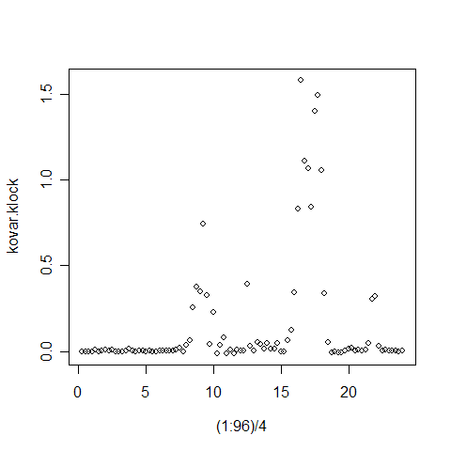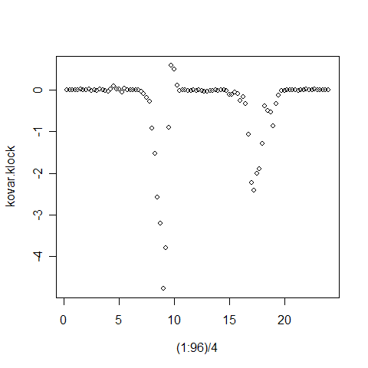
Figure 12. Relative covariance (y-axis) across the day (hours are shown on x-axis).
The pair with negatively correlated travel times fits the hypothesis above: the second link in the pair lies downstream from a bottleneck where several highly congested links meet in a roundabout.
So how large is the covariance? Most importantly: if we skip the covariance term when computing the variance for entire routes, and only sum link variances, how large might the error be? The question is important since it would be essentially intractable to compute covariances for each pair of links in the whole network – especially since our data is limited.
The diagrams below show the correct standard deviation for a pair of adjacent links on the x-axis, and the root of the summed link variances on the y-axis – that is, what we get if we omit the covariance term from the formula above. Dots on the straight line is a perfect fit; dots below the line mean that the total standard deviation for the link pair is underpredicted if the covariance term is omitted.

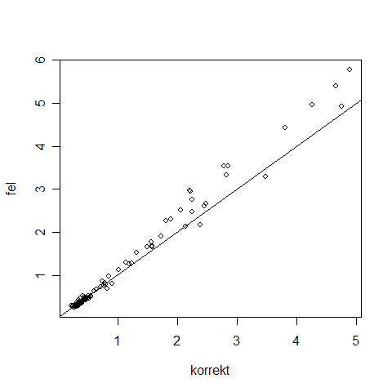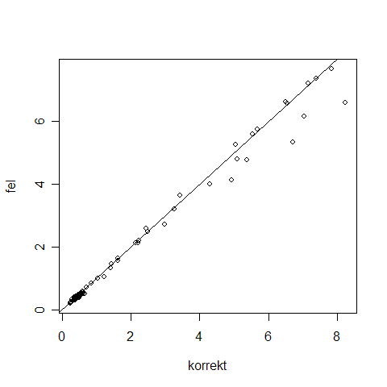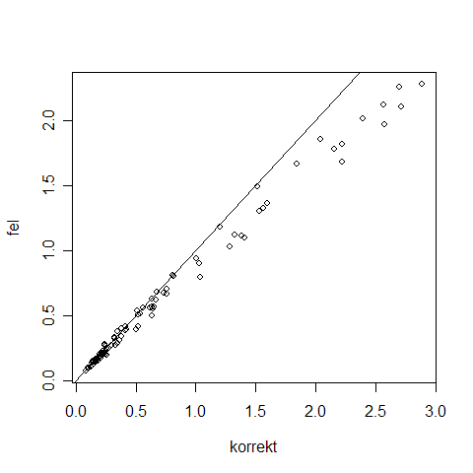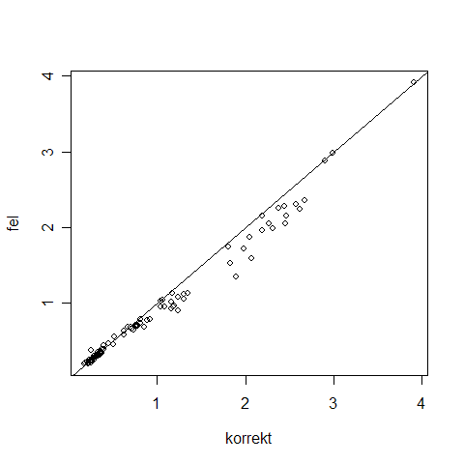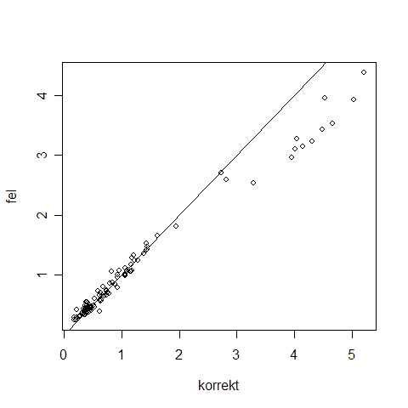
Figure 13. True standard deviations (x-axis) vs. what you get if you drop the covariance term from a link pair (y-axis).
In most cases, the standard deviation is moderately underpredicted when the covariance term is omitted. The table below show the percentage error during morning and afternoon peak hours for the five link pairs.
 | AM peak | PM peak
Roslagstull-Odengatan and Odengatan-Lidingövägen | -12% | -8%
Same, other direction | -11% | -16%
Islandstorget-Brommaplan and Brommaplan-Stora Mossen | -5% | -10%
Same, other direction | 12% | 19%
Sveaplan-Odengatan and Odengatan-Sergels torg | 6% | -17%

The error typically lies around 10%. Since the error is sometimes positive, sometimes negative, the error should tend to be smaller than that when several link variances are summed. This should mean that the error that occurs when link variances are summed without the covariance term should be tolerable.

Case study: the value of variability reduction
The western bypass is a planned major road investment in Stockholm. During the spring of 2006, we conducted the cost-benefit analysis of the bypass. It was decided by the National Road Administration that travel time variability should be included into the CBA, as a test before a decision to include it in standard CBA.
The formula above was implemented as an Emme/2 macro, using travel times and free-flow travel times from the Emme/2 network as input.
Since this was only a test, and there was a pressing time limit, a few simplifications were made. First, all vehicles were assumed to have the same value of time. Second, only conditions during morning peak were considered, and this was then scaled to a value for the entire day. This consumer surplus of reduced variability W was then calculated using rule-of-a-half:
$$W=\text{λθ}\sum_{\text{ij}}{\frac{T_{\text{ij}}^{0}+T_{\text{ij}}^{1}}{2}\left(σ_{\text{ij}}^{1}−σ_{\text{ij}}^{0}\right)}$$
where T_{ij} is flow between the OD pair (i,j), 0 and 1 refer to the situations with/without the investment, λ is the value of time and θ is the scale factor from morning peak hour to the entire day. Calculating σ_{ij} for OD pair (i,j), we assumed that standard deviations were independent across links.
We arrived at the results shown below, using a valuation of variability where one minute standard deviation was worth 0.9 minutes of travel time, and a value of time that was 66 SEK/h. Two alternatives for the western bypass was considered, one a bit further to the west, and one closer to the city centre.

Net present values | Alt. 1 (west) | Alt. 2 (east)
Producer surplus | 333 | 243
Budget effects | 1764 | 1773
Travel time | 20 973 | 21 677
Travel cost | 1971 | 2480
Freight costs | 1148 | 1257
Emissions | 643 | 1612
Traffic safety | 1018 | 1561
Investment costs (incl. marg. cost of public funds etc.) | -19570 | -19570
Maintenance | -3232 | -3031
Reduced travel time variability | 2912 | 3420
Total benefits excl. reduced variability | 24 632 | 27 583
Total benefits incl. reduced variability | 27 544 | 30 177
Net present value ratio incl. reduced variability | 0,26 | 0,41
Net present value ratio incl. reduced variability | 0,41 | 0,54
Table 1. Costs and benefits of a western bypass, net present values.
What is interesting about this table in the present context is that the value of reduced travel time variability is quite significant – about 15% of the total value of travel time savings. Thus, it seems that it would be worthwhile to continue the work of including travel time variability into CBAs, at least in urban contexts.

References
Abdel-Aty, M. R. Kitamura and P.P Jovanis (1995) Investigating effects of travel time variability on route choice using repeated-measurement stated preference data. Transportation Research Record 1493, 39-45.
van Amelsfort, D.H. (2005) Valuation of uncertainty in travel time and arrival time: some findings from a choice experiment. Presented at the European Transport Conference, 2005.
Arnott, R., A. de Palma, R. Lindsey (1990) Departure time and route choice for the morning commute. Transportation Research 24A, 209-228.
Arup, Bates, J., Fearon, J. and Black, I. (2004) Frameworks for Modelling the Variability of Journey Times on the Highway Network. Department of Transport, UK, dft_econappr_pdf_610439.
Bates (2003) Travel time variability. Working paper presented at the European Transport Conference, 2003.
Bates, J., J. Polak, P. Jones, A. Cook (2001) The valuation of reliability for personal travel. Transportation Research 37E, 191-229.
Black, I.G. and J.G. Towriss (1993a) Demand effects of travel time reliability. Centre for Logistics and Transportation, Cranfield Institute of Technology.
Black, I.G. and J.G. Towriss (1993b) Demand effects of travel time reliability. Final report prepared for London Assessment Division, UK Department of Transport.
Börjesson, M. (2006) Departure time modelling: applicability and travel time uncertainty. PhD Thesis, KTH, Stockholm.
Chen, A., J. Zhaowang and W. Recker (2001) Travel time reliability with risk-sensitive travellers. Working paper UCI-ITS-WP-01-9, Institute of Transportation Studies, University of California, Irvine.
Cohen, H. and F. Southworth (1999) On the measurement and valuation of travel time variability due to incidents on freeways. Journal of Transportation and Statistics, Dec. 123-131.
Eliasson, J. (2004) Car drivers’ valuations of travel time variability, unexpected delays and queue driving. European Transport Conference, 2004.
Frith, B.A., Sutch, T.E., Lunt, G., and Fearon, J. (2004) Updating and validating parameters for incident appraisal model INCA. TRL Project Report PPR 030; Department for Transport, UK.
Hamer, R., de Jong, G., Kroes, E. and Warffemius, P. (2005) The value of reliability in transport. Provisional values for the Netherlands based on experts’ opinion. RAND Europe.
Hollander, Y. (2005) The attitudes of bus users to travel time variability. Presented at the European Transport Conference, 2005.
Kouwenhoven, M., Schoemakers, A., van Grol, R., and Kroes, E. (2005) Development of a tool to assess the reliability of Dutch road networks. Presented at the European Transport Conference, 2005.
Lam, T. and K. Small (2001) The value of time and reliability: measurement from a value pricing experiment. Transportation Research 37E, 231-251.
Nagel, K. and S. Rasmussen (1995) Traffic at the edge of chaos. In Artificial Life IV: Proceedings of the Fourth International Workshop on the Synthesis and Simulation of Living Systems.
Noland, R. B. and Polak, J. W. (2002), Travel Time Variability: A Review of Theoretical and Empirical Issues, Transport Reviews, 22 (1), pp. 39-54.
Noland, R., K. Small, P. Koskenoja and X. Chu (1998) Simulating travel reliability. Regional Science and Urban Economics 28, 535-564.
Rietveld, P., F.R. Bruinsma and D.J. van Vuuren (2001) Coping with unreliability in public transport chains: A case study for Netherlands. Transportation Research 37E, 539-559.
Small, K. (1982) The scheduling of consumer activities: work trips. American Economic Review 72, 172-181.
Small, K. A., Noland, R., Chu, X. & Lewis, D. (1999), Valuation of Travel-Time Savings and Predictability in Congested Conditions for Highway User-Cost Estimation, NCHRP Report 431, Transportation Research Board, U.S.
Small, K., C. Winston and J. Yan (2001) Uncovering the distribution of motorists’ preferences. Unpublished working paper (personal correspondence), dated Dec. 26, 2001.
Wardman, M. (2001) A review of British evidence on time and service quality valuations. Transportation Research 37E, 107-128.

Throughout, we are only talking about “similar” days – say, Mondays through Thursdays (the distribution of traffic across the day on Fridays is actually quite different from other weekdays).

