A PROTOTYPE COMPUTER PROGRAM FOR
MICROSCOPIC SIMULATION MODEL CALIBRATION AND VALIDATION

Byungkyu “Brian” Park, Ph.D
Assistant Professor
Center for Transportation Studies
Department of Civil Engineering, University of Virginia
351 McCormick Road P.O. Box 400742
Charlottesville, VA 22904-4742
Tel: 434-924-6347
E-mail: bpark@virginia.edu

and

Jongsun Won
PTV America, Inc.,
1128 NE 2nd Street, Suite 204
Corvallis, OR 97330, USA
Phone: 541-754-6836
E-mail: jwon@ptvamerica.com

April 2007

Accepted for Presentation and Publication at the WCTR 2007 Conference

ABSTRACT

Microscopic traffic simulation models have been widely accepted and applied in various transportation engineering and planning practices especially for the past decades. This is in part because they are cost effective, safe, and fast. To achieve high fidelity and credibility of a traffic simulation model, model calibration and validation is of utmost importance.

A recent study developed a systematic procedure for microscopic simulation model calibration and validation. The procedure consists of feasibility testing of potential ranges of various parameters and optimization of parameter set using field measured data such as travel time or queue length. In addition, the procedure was rigorously tested with several case study networks including an isolated actuated signalized intersection, a corridor of signalized intersections, and a freeway segment and the results were very promising. However, most of practitioner traffic engineers felt that the procedure is too technical for them to use in practice.

This paper presents development of a prototype computer program that can easily implement the procedure of microscopic simulation model calibration and validation for a microscopic simulation model network coded in both VISSIM and CORSIM. The program is written in a Visual Basic .NET program and bundled with a Microsoft Excel program for easy of use. The structure and general implementation guidelines of the program are explained in this paper.

Key words: Microscopic Traffic Simulation, Calibration and Validation, Visual Basic .NET, MS Excel, VISSIM, CORSIM
Introduction

Microscopic traffic simulation models have been widely used in the evaluations of various traffic operations and management strategies including geometry design, traffic signal timing plans, ramp metering, route guidance, etc. It is generally accepted that the success of such evaluations depends on the quality of the microscopic simulation model that is used in the evaluations – in other words, whether or not the model used was well-calibrated and validated.

To achieve adequate reliability within microscopic simulation model environment, it is important that a rigorous calibration and validation procedure take place before the models are used. Changes to the parameters during calibration should be justified and defensible. Calibration efforts are done to achieve reasonable correspondence between field data and simulation model output. More and more transportation researchers and practitioners have realized the importance of model calibration and have spent significant time and effort to demonstrate the validity of their models. The recent development of a systematic procedure for microscopic simulation model calibration and validation by Park and Qi (2004) significantly enhanced the-state-of-the-practice in the microscopic simulation model calibration and validation. However, the procedure developed was not readily usable by practitioner traffic engineers. This is partly because no user friendly computer program that conducts the procedure is available. In addition, Park and Won (2006) demonstrated that the procedure can be effectively calibrate and validate microscopic simulation models, CORSIM and VISSIM, via four case studies.

The purpose of this paper is to develop a prototype program that conducts the systematic procedure of microscopic simulation model calibration and validation so that it can be used by traffic engineers in conducting microscopic simulation model calibration and validation.

Microscopic Simulation Model Calibration and Validation Procedure

Since the prototype program implements the previously developed microscopic simulation model calibration and validation procedure by Park and Qi (2004), this section provides a brief description of the procedure. Readers who wanted to access to the entire procedure should refer to Park and Qi (2004). Figure 1 shows flowchart of the procedure.

Simulation Model Setup
Simulation model setup includes defining study scope and purpose, site selection, measure of effectiveness (MOE) determination, data collection and network coding.

Initial Evaluation
This step is to test whether default calibration parameters in the simulation model is sufficient to represent field conditions or not.

Initial Calibration
Initial calibration step consisted of three steps: (1) identify calibration parameters and their acceptable ranges, (2) conduct statistical experimental design and generate reasonable number of parameter sets, and (3) implement multiple runs with each parameter set.

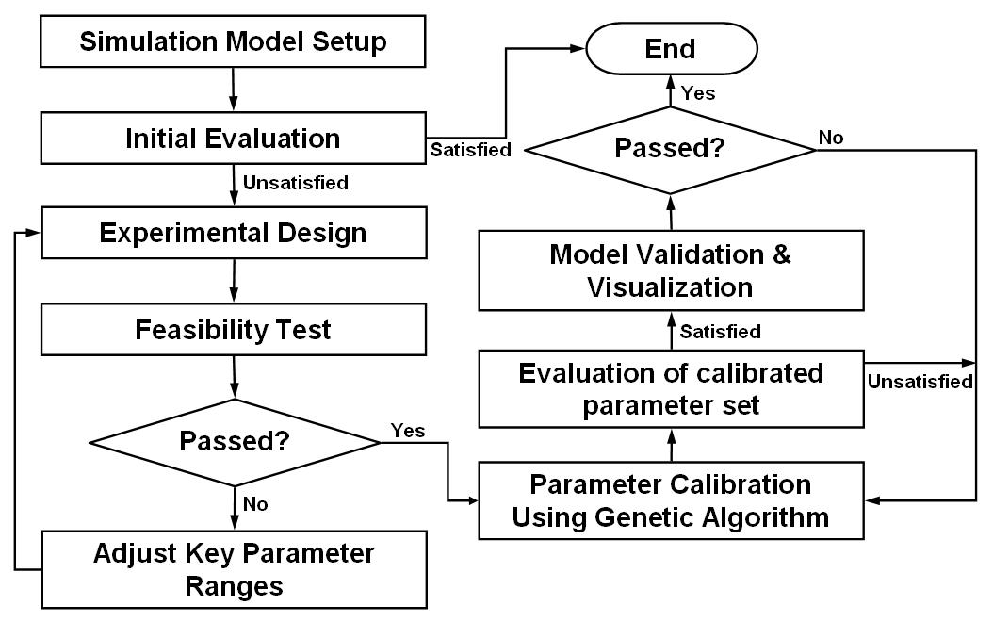
Figure 1. Calibration and Validation Procedure Flow Chart [Modified from Park and Qi (2004)]

Feasibility Test
This step is to verify whether the distribution of simulation results from previous multiple runs includes field data. If the distribution includes the field data, then it is determined as the acceptable range. Otherwise, modifications on the existing parameter sets need to be conducted to adjust either the ranges or the list of parameters.

Parameter Calibration Using Genetic Algorithm
This step is to find an optimal calibration parameter set using a genetic algorithm (GA) optimizer. During the GA optimization, multiple runs were conducted for each feasible parameter set to consider the variability of simulation results. Each individual fitness value was calculated by comparing field data and simulation results using Equation 1.

$\text{FV}=\frac{\left|{\text{TT}}_{\text{Field}}−{\text{TT}}_{\text{Sim}}\right|}{{\text{TT}}_{\text{Field}}}$ (Eq. 1)
where
$\text{FV}$ = Fitness value
${\text{TT}}_{\text{Field}}$ = Average field-measured travel time
${\text{TT}}_{\text{Sim}}$ = Average travel time output from multiple simulation runs with same parameter set

Evaluation of the Parameter Set
Once the GA finds an optimal calibration parameter set, multiple runs (e.g., 100 runs) with the calibrated parameter set are conducted to compare the performance of the simulation model with field data. Thus, a distribution of calibrated simulation model outputs is compared with field data. A visualization testing is also conducted.

Validation and Visualization
In order to validate the calibrated simulation model, it is desirable to collect a new set of data under different condition (e.g., new traffic signal timing plan, new traffic volume, etc.). Thus, in this case study, the data collected on different day was used as a new data set. Again, multiple runs (e.g., 100 runs) are to be made and a distribution of simulation model outputs is compared with validation field data. If field data falls within the 95 percentile range of the model output distribution, the calibrated model is considered to be valid. In addition, visualization testing is also conducted for a few selected runs (e.g., 25th, 50th and 75th percentile runs).

Development of the Prototype Program

A prototype calibration and validation program was developed which implements the calibration and validation procedure for VISSIM and CORSIM simulation models. The prototype program is developed using a Microsoft Visual Basic .NET and bundled with a Microsoft Excel program for easy of use.

The program allows the users to:

- Conduct multiple runs for specific simulation model.
- Display simulation outputs in histogram format.
- Generate experimental design for the calibration parameter combinations using Latin Hypercube Design (LHD).
- Conduct multiple runs for the combinations of parameter sets from the experimental design.
- Generate X-Y plot of performance measure versus each calibration parameter that can be used for feasibility test.
- Optimize selected calibration parameters using a genetic algorithm (GA).
- Watch animations of simulation models for the visualization purpose.

Implementation of the Prototype Computer Program

It is noted that this program can be downloaded from http://faculty.virginia.edu/brianpark/SimCalVal/CalibrationProgram/. In order to run this program, a computer must have the following specifications and programs installed.
- Windows XP Professional
- CORSIM 5.1
- VISSIM 4.1
- Microsoft Excel

The remainder of this section provides the implementation of the program for calibrating and validating CORSIM microscopic simulation program.

1. Selecting a Simulation Model

Choose to run the CORSIM simulation model by clicking on CORSIM.

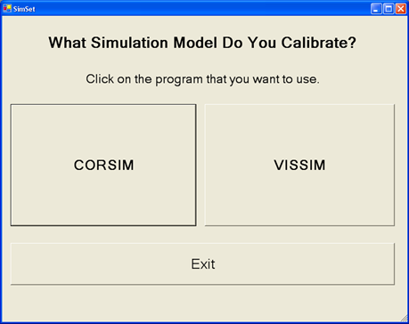

2. Running the Default Procedure

The DEFAULT option enables an evaluation of the “Default” Model, whereas the CALIBRATION option conducts the Calibration Procedure. Choose to start with the RUN DEFAULT procedure.

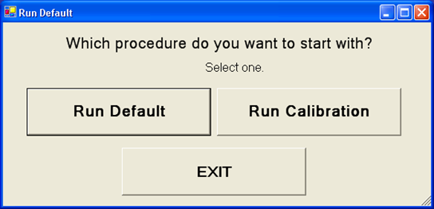

3. Number of Simulations, Location of Files

For the Parameter Range Selection, first choose the number of multiple runs that user wants to make with the default model. Enter this number in the first blank space. Next, define the location of the simulation input file. For example, CORSIM: *.trf. Third, define the location of the executable simulation program in the last blank space.

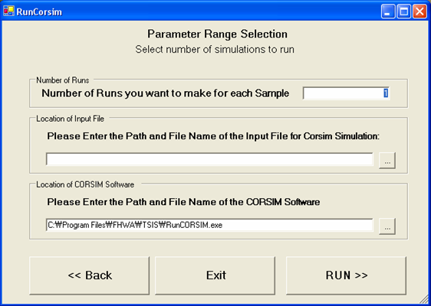

4. CORSIM Calibration

Continue with the Parameter Range Selection by using the pull down menu to choose the link of interest. The travel time output value for each of the runs can be seen in the center white space. The VIEW HISTOGRAM button will display the output distribution of the travel time. After viewing the histogram, click on START CALIBRATION to calibrate the model.

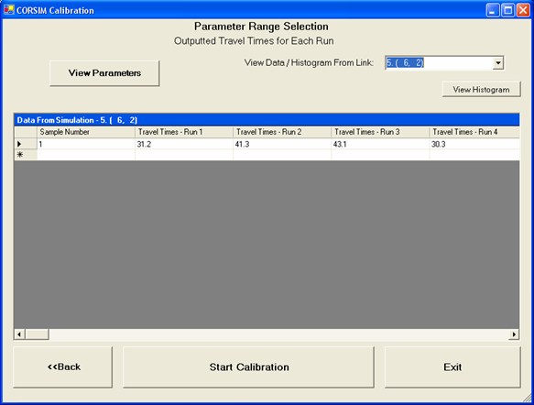
5. Drawing Histogram

The histogram for Travel Time outputs, usually based on 100 simulation runs, will be displayed. Check “yes”, type the field-measured travel time value, and click the button on the right side. User can also use the BACK and EXIT buttons on top for navigating back through the program or exiting completely.

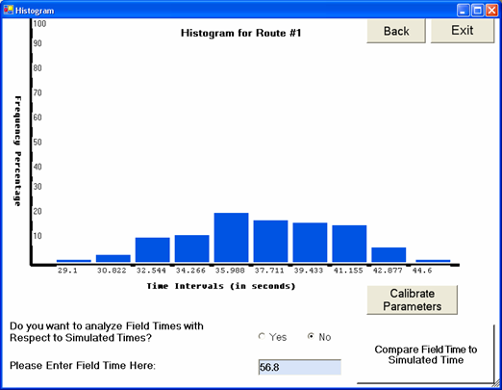

6. Parameters to Test

Select all the parameters that need to be calibrated by marking the box next to the appropriate parameter. When finished, click the OK button to continue to the next step.

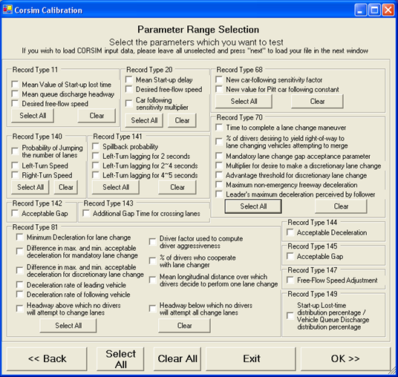
7. Parameter Range Selection

The “activated” or white boxes indicate that the parameter was selected on the previous screen; the others remain gray and “inactive”. Enter in the determined minimum and maximum value for each of the selected parameters. For Record Type 145 and 149, unless user selects any specific type, it uses the same value for the two parameters. Use the value for driver type 1 for the parameters that take a distribution format. Next, indicate the number of samples user wishes to test. Lastly, click OK when user is satisfied with everything.

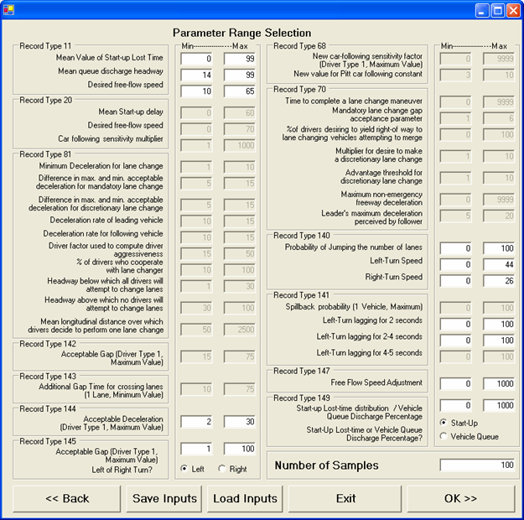

8. Number of Simulations and Location of Files

For the Parameter Range Selection, first choose the number of multiple runs user wants to make with the default model. Enter this number in the first blank space. Next, define the location of the simulation input file. For example, CORSIM: *.trf. Third, define the location of the executable simulation program in the last blank space.

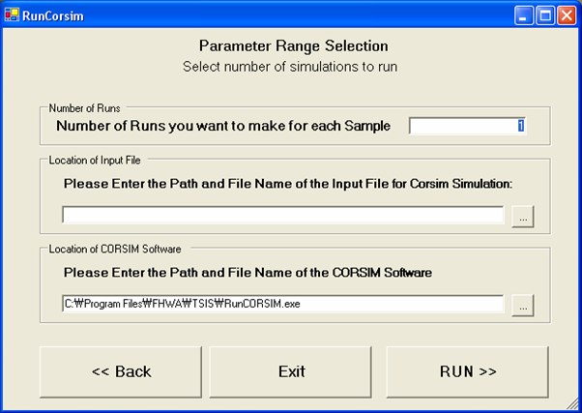

9. Travel Times

Use the pull down menu to select the desired link. The data from the selected link will be displayed in a table. Click on VIEW HISTOGRAM to see the distribution of the travel time output.

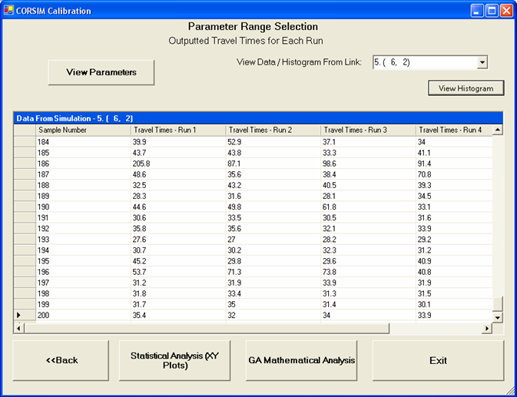

10. Drawing Histogram II

The BACK and EXIT buttons help user to go back to previous options or exit the program. A histogram of average travel time outputs, in this case based on 200 runs, is shown. Choose YES to analyze field times with respect to simulated times and then enter in the desired field-measured travel time value in the space provided. When finished, click the COMPARE FIELD TIME TO SIMULATED TIME button to continue.

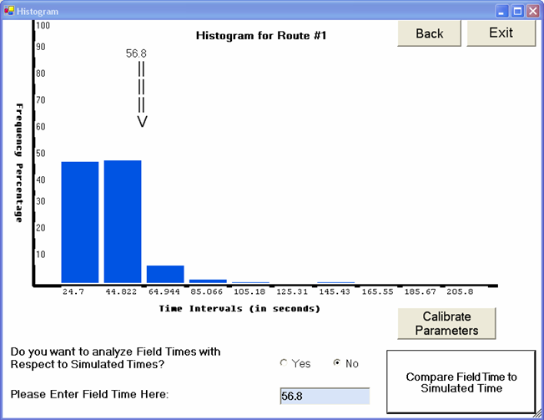

11. Travel Times

Is the set of ranges acceptable? If no, click on the STATISTICAL ANALYSIS button to adjust the ranges. If yes, select the GA MATHEMATICAL ANALYSIS button to start the calibration.

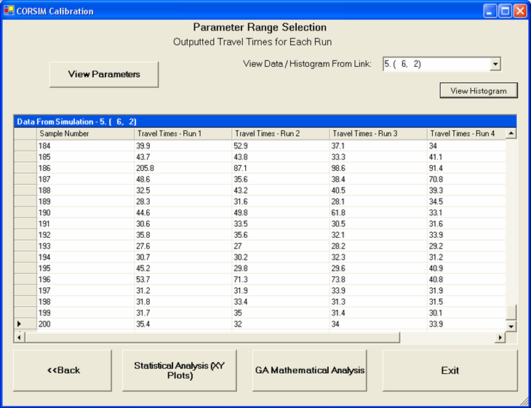

12. CORSIM Calibration

Copy the location information that appears in the space provided and then click on the STATISTICAL ANALYSIS button to start parameter range adjustment.

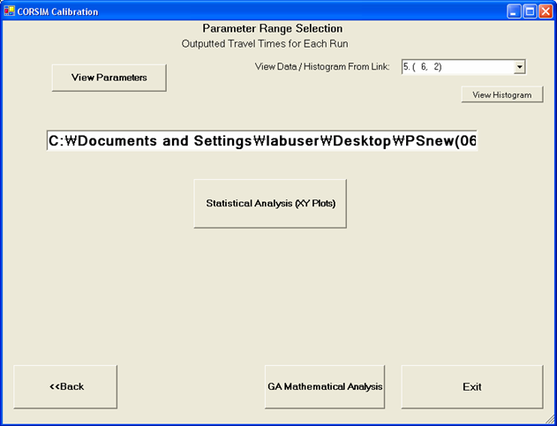

13. Statistical Analysis – Excel

Select the START button. Note: if user cannot load the Excel program, please check the security level again and make sure it is “LOW”. To do this, follow the instructions presented here.

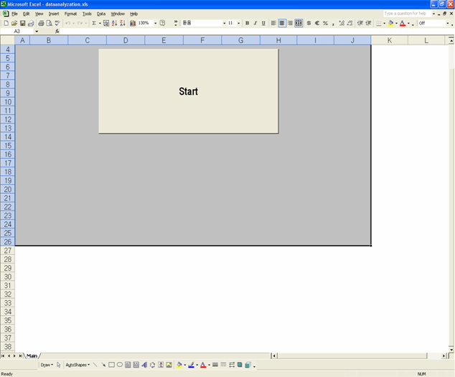

14. Excel Security Adjustment

To set the security level to the necessary LOW level, open the TOOLS menu, select MACRO, and then select SECURITY.

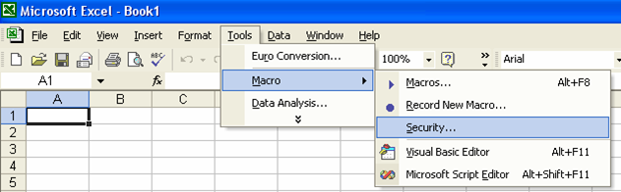

15. Security Levels

User will now have a screen similar to this. Choose the LOW setting under the SECURITY LEVEL tab. Once LOW is chosen, click OK for the changes to take effect.

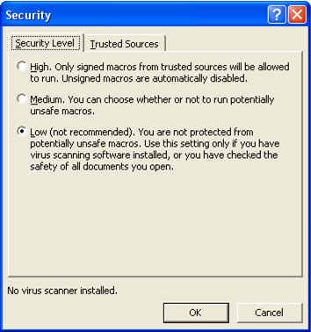

16. Find File Folder

Use the white space to paste the location information that was copied in a previous window. Then choose the simulation model name that user is currently calibrating. In this case, it would be CORSIM. When done, click the RUN button.

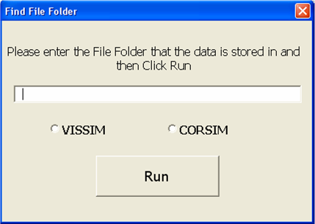

17. Histograms, Times, and Plots

Use the three buttons to implement what user wishes to do. VIEW HISTOGRAMS will show the histograms of travel time data. ENTER FIELD TIMES will present field travel time value on the histogram. MAKE X-Y PLOTS will create X-Y plots of travel time data and each parameter value.

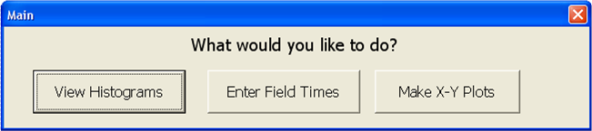

18. Parameter Selection for CORSIM

Select the calibration parameters that user wants to generate an X-Y plot from. For example, the X value could be Travel Time and the Y value may be the Parameter Value. When finished, click the RUN button to generate the X-Y plots.

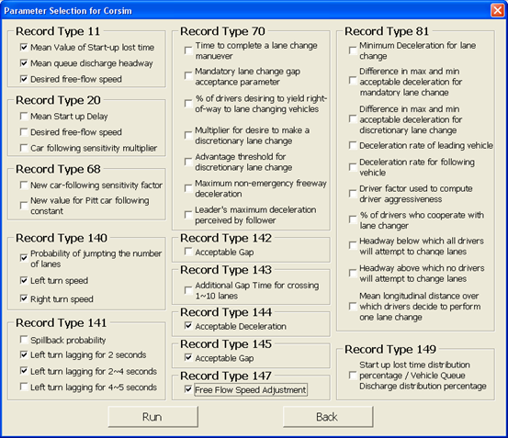

19. Starting the Calibration Procedure

In order to start the calibration procedure, user needs to specify four items. First, the number of generations; second, the field travel time; third, the link identification number; and fourth, the number of populations. When asked for the information, type it in the DOS window.

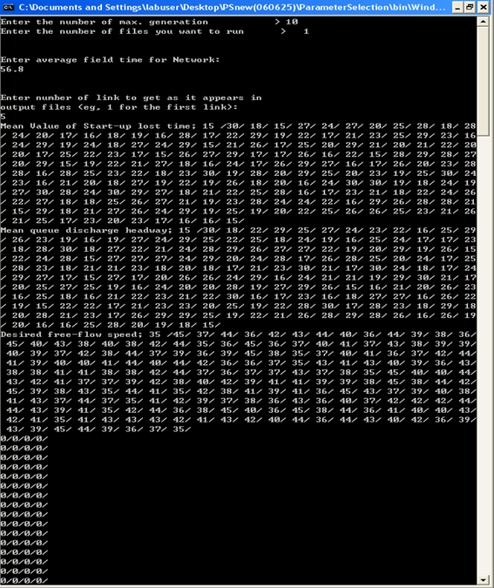

Interested readers can find the handbook written for the microscopic simulation model calibration and validation procedure as well as several case studies implementing the procedure and the prototype program at http://faculty.virginia.edu/brianpark/SimCalVal/.

Conclusions

This paper presented the development and implementation guidelines of the proposed prototype program that conducts microscopic simulation model calibration and validation. The program was written in a Microsoft Visual Basic .NET and bundled with a Microsoft Excel program. The implementation guidelines shown in this paper presented an overview of what the program can provide in microscopic simulation mode calibration and validation.

Acknowledgments

Authors would like to thank several undergraduate research assistants including Matt Mehalso, Matthew Duesterberg and Michael F. Roseberry who helped the development of prototype program and the implementation guidelines.

References

Park, B., and Qi, H. Development and Evaluation of a Calibration and Validation Procedure for Microscopic Simulation Models. VTRC 05-CR1. Virginia Transportation Research Council, Charlottesville, 2004.

Park, B., and Won, J. Simulation Model Calibration and Validation: Phase II:
Development of Implementation Handbook and Short Course. VTRC 07-CR5. Virginia Transportation Research Council, Charlottesville, 2006.

