AUTOMATED CALIBRATION ASSISTANCE TOOLS FOR MICROSCOPIC TRAFFIC SIMULATORS

Prof. Dr. J. Barceló⁽¹⁾, Mr. J. Perarnau⁽²⁾ and Dr. A. Torday⁽²⁾

⁽¹⁾ Universitat Politècnica de Catalunya, Department of Statistics and Operations Research, Campus Nord, Module C5, Jordi Girona Salgado 1-3, 08034,Barcelona, Spain, jaume.barcelo@upc.edu

⁽²⁾TSS-Transport Simulation Systems, Passeig de Gràcia 12, 3er 1ª, 08007,Barcelona, Spain (Josep,Torday)@aimsun.com

AUTOMATED CALIBRATION ASSISTANCE TOOLS FOR MICROSCOPIC TRAFFIC SIMULATORS

J. Barceló⁽¹⁾, J. Perarnau⁽²⁾ and A. Torday⁽²⁾

⁽¹⁾Dept. of Statistics and Operations Research, Universitat Politècnica de Catalunya, jaume.barcelo@upc.edu
⁽²⁾TSS-Transport Simulation Systems, Passeig de Gràcia 12, 3er 1ª, 08007, Barcelona, Spain (Josep,Torday)@aimsun.com

Abstract

Simulation is a useful technique to provide an experimental test bed to compare alternate system designs, replacing the experiments on the physical system by experiments on its formal representation in a computer in terms of a simulation model. Simulation may thus be seen as a sampling experiment on the real system through its model. The reliability of this decision making process depends on the ability to produce a simulation model representing the system behaviour closely enough for the purpose of using the model as a substitute of the actual system for experimental purposes. This reliability is established in terms of the calibration and validation of the model. Calibration to set up the right values of model parameters and validation to determine the quality of the model are established on basis to the comparison analysis between the observed output data from the actual system and the output data provided by the simulation experiments conducted with the computer model, usually cumbersome and time consuming tasks based. Random search techniques based on specific multi-step Monte Carlo procedures in which target values are specified for the output objective variables of interest (i.e. observed flows and speeds) and adjustment of parameter values by means of Simultaneous Perturbation Stochastic Algorithms provide a support to assist the analysts in these tasks. This paper presents a calibration approach based on these concepts and the computational results from some case studies.

Introduction

Simulation is a technique that can be seen as a sampling experiment on a dynamic real system through a computer model formally representing it. Simulation assumes that the evolution over time of the system’s model imitates properly the evolution over time of the modeled system and thus samples of the observational variables of interest are collected from which, using statistical analysis techniques, conclusions on the system behavior can be drawn. The reliability of this decision making process depends on the ability to produce a simulation model representing the system’s behavior closely enough for the purpose of using the model as a substitute of the actual system for experimental purposes.

The process of determining whether the simulation model is close enough to the actual system is usually achieved through the validation of the model, an iterative process involving the calibration of the model parameters and comparing the model to the actual system behavior and using the discrepancies between the two, and the insight gained, to improve the model until the accuracy is judged to be acceptable. Validation is therefore concerned with determining whether the conceptual simulation model (as opposed to the computer program) is an accurate representation of the system under study. The calibration process has the objective of finding the values of these parameters that will produce a valid model. Model parameters must be supplied with values. Calibration is the process of obtaining such values from field data in a particular setting.

The question on whether a model is valid or not can be formulated in terms of whether model results faithfully represent reality, a question for which statistical techniques provide a quantified answer. Quantification that, according to Rouphail 2003, can be formally stated in the following terms: the probability that the difference between the “reality” and the simulated output is less than a specified tolerable difference within a given level of significance:
P{ |”reality” - simulated output | ≤ d } > α

Where d is the tolerable difference threshold indicating how close the model is to reality, and α is the level of significance that tells the analyst how certain is the result achieved. In this framework the analyst perception of the reality relays on the information gathered through the data collection and the subsequent data processing to account for uncertainties. The available data and its uncertainties will determine what can be said about d and α.

Calibration and validation of simulation models is still a major challenge in the use of simulation for practical purposes, namely in the case of microscopic traffic simulation models that combine the high level of uncertainty of the modeled system with a large number of parameters, some of them accounting for behavioral aspects of the vehicle-driver system. Consequently calibration and validation has attracted the attention of researchers in recent years Barceló and Casas 2004, Rouphail 2003, Hourdakis et al. 2003, Toledo et al. 2003. The increasing use of microscopic traffic simulation for traffic analysis has led governmental agencies as the Federal Highway Administration to elaborate reports, FHWA 2003, recommending the following four-step strategy for calibration and validation:

- Error Checking – The coded transportation network and demand data are reviewed for errors. This step is necessary to weed out coding errors before proceeding with calibration.
- Capacity Calibration – An initial calibration is performed to identify the values for the capacity adjustment parameters that cause the model to best reproduce observed traffic capacities in the field. A global calibration is first performed, followed up by link specific fine-tuning. The Highway Capacity Manual can be used as an alternative source of capacity target values, if field measurements are infeasible.
- Route Choice Calibration – If the microsimulation model includes parallel streets, then route choice will be important. In this case a second calibration process is performed, but this time with the route choice parameters. A global calibration is first performed, followed by link specific fine-tuning.
- Performance Validation – Finally, the overall model estimates of system performance (travel times and queues) are compared to field measurements of travel times and queues. Fine-tuning adjustments are made to enable the model to better match the field measurements.
The methodological diagram in figure 1, a further elaboration of the proposal in Velasco 2004, proposes a refinement of this four step methodology and provides the framework for the computer assisted calibration procedure object of this paper. Step 1 in this methodology is the data collection process, that has to be appropriately designed and conducted balancing the objectives of the simulation study and the available technologies. Steps 2, 3 and 4 correspond in this case to the Error Checking, Capacity Calibration and Route Choice Calibration of the FHWA proposal.
Figure 1
Error Checking
Manual error checking is a cumbersome and an error prone task when done manually for large networks. Most of the available commercial traffic simulation software provide advanced user friendly Graphic User Interfaces with flexible and powerful graphic editors to assist analysts in the model building process, this reduces the number of errors but does not eliminate them at all and what is worse the remaining network coding errors are the most difficult to find visually or manually and at the same time the ones having more influence in the model response, i.e. the network connectivity ensuring that there are paths from every origin to every destination, parameters governing the dynamics of vehicles at turnings or the queue discharging processes at intersections and so on.
A static network checker could be conceived as a tool designed to analyze the topology of the network representation to automatically identify network coding errors as for example: missing road section parameters (speed limits in the section, number of lanes, capacity…), the connectivity of the networks either in terms of connections between the sections and their lanes to origin and destination nodes, on with respect to the existence of feasible paths between all centroids representing origin and destination zones in the network, etc.

Figures 2 and 3 present an example on how this topological analyzer works. The detailed geometric representation proper of a microscopic simulator is translated in terms of a graph explicitly accounting for turning movements. The solution proposed in our case is a link-node representation in which a link that connects two nodes models both a section and a turning movement, as depicted in the lower part of figure 2. Therefore, each road section of the microscopic model is split into as many links as there are turning movements.
Figure 2.Translation of the microscopic network for the topological analysis
Figure 3 depicts a network with some examples of connectivity problems, inconsistent section data or missing timings in a signalized intersection, detected by the static network checker after conducting the topological analysis. On the top of the figure the snap shot on the left shows a dialogue with the checking options and on the right the warning and error window. By selecting the message the implied network entity (section, intersection, centroid….) is highlighted in red as shown in the picture. Examples of messages are:

- It warns the analyst against a wrong value of the capacity attribute of the section (“Section id 1031 has capacity 0”)
- Not all lanes of a section are connected to a node (“Not all the lanes at the end of the section id 656 are connected (node id 768)
- An entrance section is not connected to any centroid
- There is no path connecting two centroids
- Sinal id 1112: Signal 2 is never green in node 1104

Figure 3 Checking the Network connectivity

A dynamic network checker would be a tool designed to identify those “errors” that can only be detected during the simulation, that is model inconsistencies making the vehicles behaving improperly in a blatant fashion leading to grid locks, as for example in the case of a signalized intersection with a traffic light always red by a mistakenly definition of the control plan, or situations in which reductions of capacity at turnings in intersections by incorrect settings of those parameters governing queue discharges, or inappropriate specifications of give way or lane change parameters, stopping the vehicle at certain positions unacceptable long times.

The purpose of the Dynamic Network Checker is to detect these types of problems within a running simulation, identify the network locations where these problems arise and provide a diagnosis to guide the analyst in identifying what causes the problem. Figure 4 highlights on the left the dialogue to activate the Dynamic Network Checker and the options on the functions to check, on the right it is displayed the case where a vehicle is stopped longer than an amount of time specified by the analyst by the value of the parameter Maximum Stopped Time. The vehicle cannot perform the turning movement and thus is blocking the lane.

Figure 4 Detecting a Stopped Vehicle with the Dynamic Network Checker

Static and Dynamic Network Checkers are the core tools of an assisted Error Checker utility to implement the first set of run tests in the Step 2 of the proposed calibration procedure.

Capacity Calibration: Monte Carlo Stochastic Design Improvement
Corresponds to the Step 3 in the proposed assisted calibration procedure of Figure 1, two procedures have been defined and tested. The first one has been implemented via a specific multi-step Monte Carlo procedure, called Stochastic Design Improvement or Model Improvement. Figure 5 depicts the conceptual model of this assisted-calibration process. For a set of selected output variables (i.e. Flows, Speeds,...) the analyst specifies the target values of these variables variable to take.

The Model Improvement procedure finds the values of the Design Input variables, that is the parameters to calibrate, that produce the nearest-to-target values for the Output Objective variables. It is an iterative Monte Carlo Simulation process, i.e. it consists of a concatenation of several results of a sequence of replications of the simulation each one corresponding to a different experiment definition. At each run, those values of input variables producing the minimum distance to target are used to update the distributions of the design variables for the successive iteration. The distance to target variable can be defined, for example, in terms of the Euclidean distance:
$d_{j}=\underset{i∈{\text{Run}}_{j}}{\text{min}}\sqrt{\sum_{k=1}^{N_{\text{rep}}}{{\left(y_{k}^{i}−y_{k}^{}\right)}^{2}}}$ (1)
Or any other performance index, where $y_{k}^{i}$is the value of the k-th output variable over the i-th replication and $y_{k}^{}$ is the target value for this variable.

The process woks according with the following logic:

- Specify a goal (target values) for output variables.
- Start generating a meta-model using initial values of input variables. In other words, use the initial values of input variables to simulate each replication with the specific sampled value.
- Compute distance between outputs and target for all samples.
- Identify sample closest to target.
- Use input values corresponding to this sample and go to step (2).
- Proceed until model is sufficiently close to target.
Figure 5 Assisted-Calibration model.
There are two types of input variables:

- Design
- Free stochastic variables

The design variables are those variables corresponding to the model parameters to calibrate. For these variables the interval of variability, upper and lower values, and the initial values have to be specified. Target output variables could be all those variables measured by detectors whose values are input as an auxiliary file for comparison purposes. Once this file has been defined the calibration parameters that the analyst wants to calibrate can be defined via a XML configuration file edited with any XML editor or even any text editor. Examples of AIMSUN 2006, Barceló and Casas 2006, input parameters to calibrate are the following:

- Reaction time
- Simulation Step
- Reaction Time at Stop Behavior
- Queuing Up Speed
- Queuing Leaving Speed
- Percent Overtake
- Percent Recover

Route Choice
- Path updating frequency
- Number of data collection intervals
- Capacity weight
- User Defined Cost
- Initial number of shortest paths K-SPs
- Max number of routes to keep
- Max number of routes (Integer)
- Route choice probability function
- Alfa Factor (Proportional route choice))
- Scale factor (Logit and C-Logit route choice)
- Beta factor (C-Logit route choice)
- Gamma factor (C-logit route choice)

In the following example a XML Configuration file is defined in which the target output variables are defined as “realdataset” and includes 5 items:

- Number of runs to be done.
- Number of replications for each run.
- Description of the current calibration “project”.
- The route choice model to be used.
- A list with the parameters/variables that are going to be used to perform the calibration.

All variables have been set to Design, that means that all them will be used to achieve the lower distance to the real data.

<project name="project1">
<runs>5</runs>
<replications>5</replications>
<description>This is test</description>
<routechoice type="Logit"/>
<realdataset>67164</realdataset>
<inputvariables>
<variable name="Simulation Step" type="Design">
<limits left="0.01" right="2"/>
<parameters a="0.5" b="0.7"/>
</variable>
<variable name="Reaction Time at Stop" type="Design">
<limits left="0.1" right="10"/>
<parameters a="1.5" b="1.7"/>
</variable>
<variable name="Queuing Up Speed" type="Design">
<limits left="0.1" right="10"/>
<parameters a="0.5" b="1.7"/>
</variable>
<variable name="Queuing Leaving Speed" type="Design">
<limits left="0.1" right="10"/>
<parameters a="3.5" b="4.7"/>
</variable>
<variable name="Capacity weight" type="Design">
<limits left="0" right="50"/>
<parameters a="5" b="10"/>
</variable>
<variable name="Scale factor" type="Design">
<limits left="0" right="100"/>
<parameters a="55" b="65"/>
</variable>
</inputvariables>
</project>

Figure 6 Example of a Stochastic Design Improvement using two target variables.
For example if the design variable is the parameter “Simulation Step”. Then the process will start sampling from 0.5 and 0.75, and for each run the process will adjust the parameters parameter within the defined domain (0.2-1). It is also possible to define some free stochastic input variables. For example the parameter as the Reaction Time at Stop, governing the queue discharge process, can be a free stochastic input variable, then the assumed statistical distribution for this parameter must be defined. Figure 6 depicts an example of the process evolution in the case of the two parameters mentioned.

Route Choice Calibration by Simultaneous Perturbation Approximation Method

Although the results achieved with Monte Carlo Stochastic Design Improvement were quite promising, we realized that the degree of “blindness” in the trial and error search process led to a number of unproductive simulation experiments, therefore to implement Step 4 in the procedure described in Figure 1 we decided to experiment another method for the adjustment of the parameters, the selected method was the Simultaneous Perturbation Stochastic Approximation (SPSA) algorithm developed by Spall, Spall 1998 and Spall 2003. A recursive optimization algorithm that does not depend on direct gradient information of measurements but on an approximation to the gradient formed from generally noisy measurements of a loss function. It does not require the detailed knowledge of the functional relationship between the parameters being adjusted and the loss function being minimized. Th approaches based on gradient approximations require only conversion of the basic output measurements to sample values of the loss function which does not require full knowledge of the system input-output relationships. The gradient approximation used has been:

$g_{k}(θ_{k})=\frac{y(θ_{k}+c_{k}Δ_{k})−y(θ_{k}−c_{k}Δ_{k})}{2c_{k}}\left[\begin{matrix}Δ_{k1}^{−1} \\ Δ_{k2}^{−1} \\ ⋮ \\ Δ_{\text{kp}}^{−1}\end{matrix}\right]$ (1)
where $Δ_{\text{ki}}$ is the ith component of the $Δ_{k}$ vector, that is the simultaneous perturbation vector. And the loss function the RMS error function measuring the distances between the N observed flows at the detection station in the network and the N simulated flows:

$L(θ)=\sqrt{\frac{\sum_{i}{(y_{i}^{\text{sim}}−y_{i}^{\text{obs}})^{2}}}{N}}$ (2)

The gradient approximations $g\left(θ\right)=\frac{∂L\left(θ\right)}{∂θ}$are built from noisy measurements of L(θ):
y(θ) = L(θ)+ε
where ε is a random error function satisfying certain conditions, Spall 2003. The basic unconstrained SPSA algorithm is in the general recursive form:

$θ_{k+1}=θ_{k}−a_{k}g_{k}\left(θ_{k}\right)$ (3)

Where $g_{k}\left(θ_{k}\right)$ is the simultaneous perturbation estimate of the gradient g(θ) at the iterate $θ_{k}$ given by (1) based on the measurements of the loss function. The essential part of (3) is the two-sided gradient approximation (1) formed by randomly perturbing the components of $θ_{k}$with the mean-zero random perturbation vector:
$Δ_{k}={\left[Δ_{k1},Δ_{k2},\text{.}\text{.}\text{.}\text{.},Δ_{\text{kp}}\right]}^{T}$ (4)

The main convergence conditions of the SPSA algorithm, Spall 2003, require that:
- The scalar nonnegative gain coefficients a_{k}>0 and c_{k}>0 must satisfy:
For a_{k} and c_{k} →0 : $\sum_{k=0}^{∞}{a_{k}}=∞\text{ and }\sum_{k=0}^{∞}{\frac{a_{k}^{2}}{c_{k}^{2}}}<∞$
- Iterate boundedness condition: $\underset{k≥0}{\text{Sup}}\left\|θ_{k}\right\|<∞$
- Measurement noise: the ratio of measurement to perturbation must be such that:

$E\left[{\left(y{\left(θ_{k}±c_{k}Δ_{k}\right)}/{Δ_{\text{ki}}}\right)}^{2}\right]$ (5)

Is uniformly bounded over k and i.
- Statistical properties of the perturbations: the {Δ_{ki}} are independent for all k, i, identically distributed for all i at each k, symmetrically distributed about zero and uniformly bounded in magnitude for all k, i.

Conditions 1, 3 and 4 govern the gains a_{k} , c_{k} and the random perturbations Δ_{k}, the square summability in condition 1 balances de decay in a_{k} against c_{k} to ensure that the update in moving $θ_{k}$to $θ_{k+1}$is well behaved. Spall probes that an important and very simple distribution that makes perturbations Δ_{k} satisfy condition 3 is the symmetric Bernouilli ±1 distribution.

The basic SPSA algorithm can be stated in the following form, Spall 2003:

Step 0: Initialization and coefficient selection
Set counter index k = 0
Pick initial guess $θ_{0}$and nonnegative coefficient a, c, A, α and γ in the SPSA gain sequences:
$a_{k}=\frac{a}{{\left(k+1+A\right)}^{α}}\text{ and }c_{k}=\frac{c}{{\left(k+1\right)}^{γ}}$ (6)
Practically effective and theoretically valid values for α and γ are 0.602 and 0.101 respectively, a, c and A may be determined based on practical guidelines, se Spall 2003 for details.
Step 1: Generation of the simultaneous perturbation vector
Generate by Monte Carlo a p-dimensional random perturbation vector Δ_{k} where each of the p components of Δ_{k} are independently generated from a zero-mean probability distribution satisfying condition 3.
Step 2: Loss function evaluation
Obtain two measurements of the loss function based on the simultaneous perturbation around the current $θ_{k}$
$$y\left(θ_{k}+c_{k}Δ_{k}\right)\text{ and }y\left(θ_{k}−c_{k}Δ_{k}\right)$$
With the current c_{k}, a_{k} and Δ_{k} (i.e. run two simulation experiments with the corresponding values of the parameters to be calibrated).
Step 3: Gradient approximation
Generate the simultaneous perturbation a approximation to the unknown gradient$g_{k}\left(θ_{k}\right)$ according to:
$$g_{k}\left(θ_{k}\right)=\frac{y\left(θ_{k}+c_{k}Δ_{k}\right)−y\left(θ_{k}−c_{k}Δ_{k}\right)}{2c_{k}}{\left[Δ_{k1}^{−1},Δ_{k2}^{−1},\text{.}\text{.}\text{.}\text{.},Δ_{\text{kp}}^{−1}\right]}^{T}$$
Remark: it is sometimes useful to average several gradient approximations at $θ_{k}$, each formed from an independent generation of Δ_{k} if the noise effects ε_{k} are relatively large (In our experiments we have averaged the gradient approximation from 3 independent generations of Δ_{k})
Step 4: Update θ estimate
Using: $θ_{k+1}=θ_{k}−a_{k}g_{k}\left(θ_{k}\right)$
Step 5: Termination test
If $\left|L\left(θ_{k}\right)−L\left(θ_{k+1}\right)\right|≤φ$ (where φ is an acceptable error bound) then stop
Otherwise set the iteration counter k←k+1, update a_{k} and c_{k} and repeat from Step 1

A test case has been conducted with the Lausanne downtown network, Figure 7, (80x80 OD pairs, 1,351 Links, 241 nodes, 16,437 veh/h). The algorithm has used observation from 19 traffic detectors in order to calculate the loss function where $θ=(\text{scale}\text{factor})'$, that is the parameter of the route choice model to be calibrated. The function is known to be not convex with multiple local minima. The study achieved a minimum in iteration 16, with a scale factor of 15.9. The figure 7 depicts the performance of the SPSA algorithm in this case.

Figure 7

Figure 8
Conclusions

The paper describes the generic components of a Computer Assisted calibration procedure for microscopic traffic simulation model and illustrates its use as implemented in the microscopic traffic simulator AIMSUN presenting computational examples of the results achieved with several networks.

References

AIMSUN 5.1, 2006, User Manual, TSS-Transport Simulation Systems, Barcelona, Spain.

Barceló J. and Casas J. (2006) Stochastic heuristic dynamic assignment based on AIMSUN Microscopic traffic simulator, Paper #06-3107 presented at 85th Transportation Research Board Annual Meeting, Transportation Research Records, No. 1964, pp. 70-79.

Barceló J. and Casas J. (2004) Methodological Notes on the Calibration and Validation of Microscopic Traffic Simulation Models, Paper #4975, 83rd TRB Meeting, Washington.

FHWA (2003), Guidelines for Applying Traffic Microsimulation Software.

Hourdakis J., Michalopoulos P.G. and Kottommannil J. (2003) Practical Procedure for Calibrating Microscopic Traffic Simulation Models, Transportation Research Record, 1852, pp. 130-139

Rouphail N. M., and Sacks J. (2003) Thoughts on Traffic Models Calibration and Validation, paper presented at the Workshop on Traffic Modeling, Sitges, Spain, June 2003.

Spall, J. C. (1998) An Overview of the Simultaneous Perturbation method for Efficient Optimization, Johns Hopkins APL Technical Digest, Volume 19, No. 4, pp. 482-492.

Spall, J.C. (2003) Introduction to Stochastic Search and Optimization: Estimation, Simulation and Control, John Wiley Interscience.

- Toledo T., Koutsopoulos H.N., Davol A., Ben-Akiva M.E., Burghout W., Andréasson I., Johansson T. and Lundin C. (2003) Calibration and Validation of Microscopic Traffic Simulation Tools: Stockholm Case Study, in Transportation Research Record 1832, pp. 65-75.

Velasco, L. M. (in Spanish) (2004) Calibración de Parámetros Básicos Vehiculares para Flujo Interrumpido en Modelos de Simulación Microscópica, Master Thesis, Pontificia Universidad Católica de Chile, Escuela de Ingeniería.

FIGURES

Figure 1

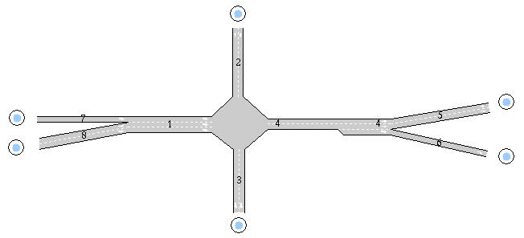

Figure 2

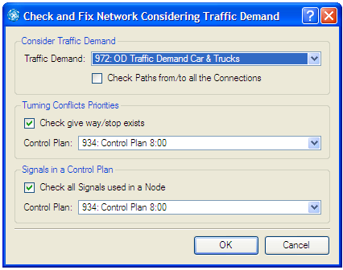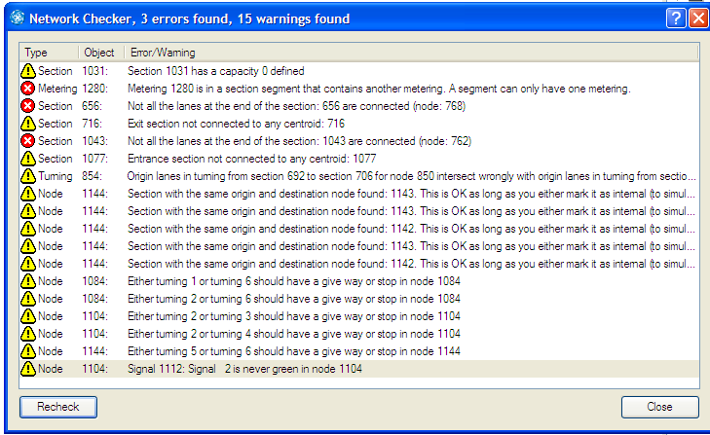
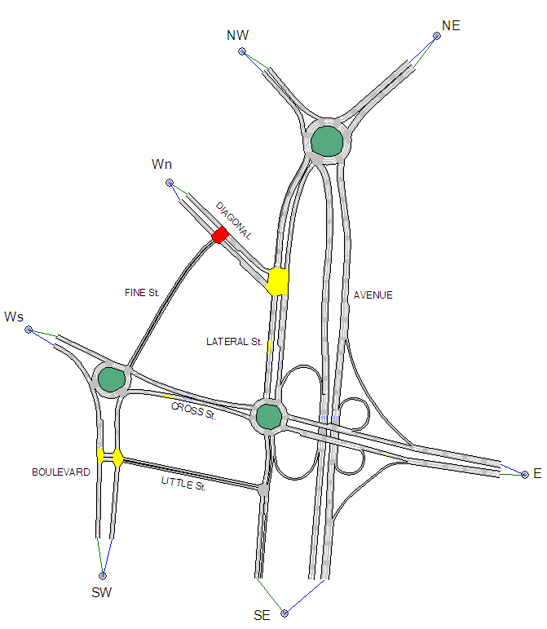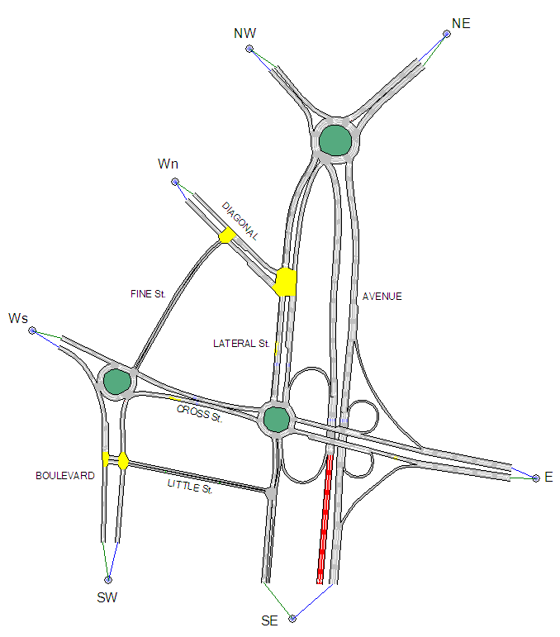

Figure 3

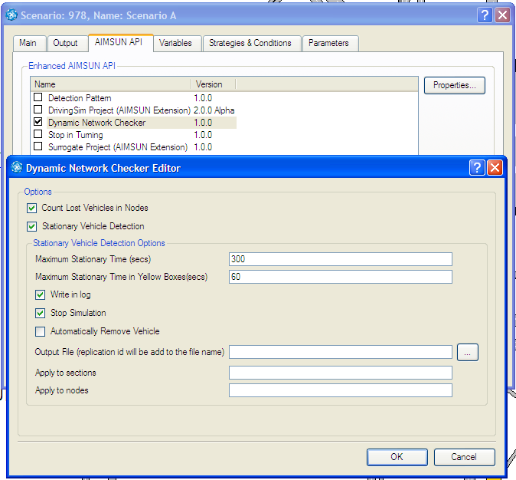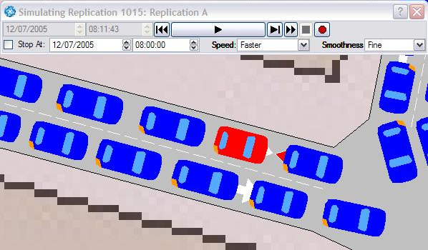

Figure 4

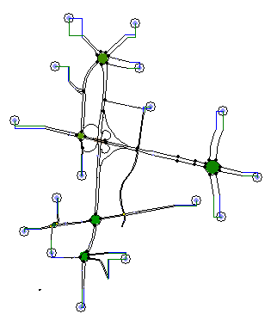
AIMSUN simulation.
.
.
.
.
.
.
Free Stochastic
Input Variables
(Background Noise)
Design Intervals
Stochastic Output Variables with Defined Target Values (Real Data Sets).

Stochastic
Design Variables
Free Stochastic
Output Variables
.
.
.
Design Targets
Figure 5

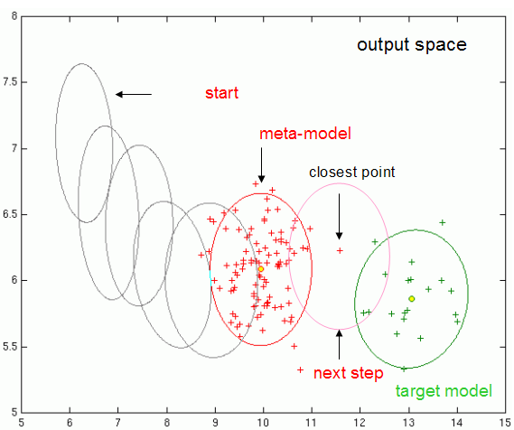

Figure 6

Figure 7

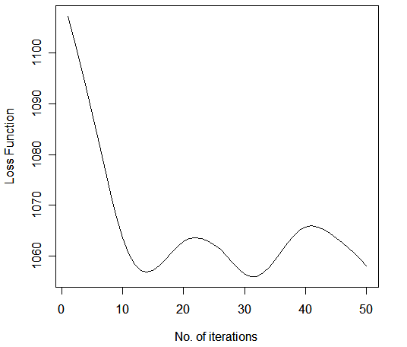

Figure 8

