Title before: “What are the main features of traffic participant agents in multi agent simulations? – an impact assessment example of the effectiveness of CO₂-emission trading schemes in the transport sector”

Multi Agent Simulation in Transport
Assessing Impacts of Policy Instruments to
Reduce CO₂ Emissions in Germany

Patrick Jochem
University of Karlsruhe, Institute for Economic Policy Research (IWW) and
PhD-Scholarship Student of the German Federal Environmental Foundation (DBU)


Institute for Economic Policy at University of Karlsruhe, P.O. Box 6980, D-76128 Karlsruhe, Germany,
Tel: ++49 (0)721 608 4226, Fax: ++49 (0)721 608 8923, email: jochem@iww.uni-karlsruhe.de
Multi Agent Simulation in Transport
Assessing Impacts of Policy Instruments to
Reduce CO₂ Emissions in Germany

Abstract

Knowing the possible impacts of Global Warming the European Union decided to join in the Protocol of Kyoto and to abate 8 % of its CO₂ emissions until 2010 compared to 1990. For that a European Trading Scheme (ETS) for CO₂ certificates was implemented. So far, the transport sector, who contributes around 28 % of the European CO₂ emissions (+ 32 % since 1990), has been exempted from the ETS. This article shows that multi agent models are suitable to handle an impact assessment of policy instruments to reduce CO₂ emissions in the transport sector in introducing a prototype model and its preliminary output for the German transport sector.

Key words: CO₂ emission trading, Germany, multi-agent, multi-agent-modeling.

Introduction
The most recent IPCC (Intergovernmental Panel on Climate Change) report shows that the increase of global average surface is very likely due to the observed increase in anthropogenic greenhouse gas concentration (IPCC, 2007). Additionally the former Chief Economist of the World Bank, Sir Nicolas Stern, advised against the huge costs arising in the end of this century resulting from global warming. He alerted, investing 1 % of the GDP today in reducing carbon dioxide (CO₂) emissions would prevent us from losses from more than 20 % of GDP for adaptation cost and remaining damage cost in some decades.

In the Protocol of Kyoto Germany has pledged within the burden sharing of the EU to cut 21 % of its CO₂ emissions until 2010 with respect to the base year 1990. Up to now, Germany has already reduced its emissions by about 17 %. The sectors which have already contributed include industry processes (-4.5 %), energy generation and transformation
(-12.1 %), manufacturing and construction (-35 %) (particular due to the breakdown of the industry in the former DDR), as well as other sectors (a. o. households) (-21.0 %). One exception is the transport sector, which has actually increased its emissions by 8.2 % – from 158.1 in 1990 up to 171 Mio. t/a in 2004. But emissions start to decline as only aviation and freight road traffic still maintain its fast increasing growing rate (Ziesing, 2006). Hence the portion of national transport on the overall CO₂ emissions in Germany increased from below 16 % up to 19 % in 2004 (see figure 1). This increase is beside huge raises in national aviation however mainly caused by an almost constant amount of CO₂ emissions by passenger cars (especially due to the expansion of passenger car density in the eastern part of Germany) and road freight transportation (+20 %) due to eastward enlargement of the European Union, where Germany move more and more in the centre of important flows of trades.
Insert Figure 1 about here
For this reason it is desirable (both for fairness and for ecological efficiency) that traffic participants should also contribute to the national (and international) emission target. Since it is unlikely that traffic participants would reduce their CO₂ emissions voluntarily, the legislature should assist. One possibility among others could be an incorporation of the transport sector into the European Trading Scheme (ETS); but its design is so far vague. Furthermore an interesting question is which policy instrument (taxes, prohibitions, charges etc.) or design of certificate market is the most efficient and most suitable with respect to impacts on traffic participants.
For this question road transportation is most crucial, as it contributes 92.3 % to the overall CO₂ emissions from transportation. These can be diminished by a higher efficiency, substitution of fuels by fuels based on renewable energies, or by changes in the modal split (UBA, 2003).
Most studies forecast a further increase in emissions of transport at last till 2010 (BMU, 2000, p. 60). Considering the long term (necessary) CO₂ emission targets for industrialised nations as Germany (around -30 to -40 % until 2030 with respect to 1990 (Enquête Kommission, 2002) or -80 % until 2050) the actual CO₂ emissions in the transport sector are considerably too high – particularly when looking at the high potentials of emission reductions (especially in road traffic) (BMU, 2006, p. 25).
Thus there is an imperatively need for action, which besides technical innovations need to be political supported. Policy instruments for reducing CO₂ emissions could be distinguished in regulatory (obligations, commandments, and prohibitions), informatory, voluntary (among others self obligations), and economic policies (taxes, charges, and certificates). How far these instruments could be economically legitimised might be evaluated by criteria compiled by Rennings et al. (1997), i.e. aim- and system conformance, cost efficiency, as well as institutional controllability. Certificates may convince particularly with respect to three of those criteria: the actors are free in decision (system conformance), actors with low marginal abatement costs have the highest incentive to reduce their emissions and innovative behaviour is rewarded (cost efficiency), and the aim is precisely reached (aim conformance). However, empirically these theoretical advantages may emerge as drawbacks when transaction costs arise, information veiled and tactical considerations are exerted. Additionally with institutional controllability there is up to now no experience in Europe with trading certificates in this topic (Stronzig et al., 2003).

The remainder of the paper is organized as follows. After illustrating the German transport sector the following section motivates the implementation of emission trading. Afterwards essential composition options for trading with certificates in the transport sector are defined. In addition, possible starting points for a trade with certificates in the transport sector will be worked out. Finally, after a short look on a desired architecture of a multi agent model, a prototype model with its preliminary outputs is presented and in the following conclusion the essential results are summarised.

The German transport sector and policy instruments for reducing CO₂ emissions
Accounting the above depicted raising high share of road traffic in emissions of CO₂ (see figures 1 and 2) other traffics are (firstly) neglected in the following. This is also true when including direct emissions and emissions from energy allocation – especially for the train, as road traffic still contributes 92 % of the CO₂ emissions in the transport sector (see figure 2).
Insert Figure 2 about here
Besides the freight road transport, aviation also contributes to the rising emissions in the transport sector. Its CO₂ emissions increased by 73 % between 1990 and 2003 in the EU-25 despite a fundamental improved efficiency of aircrafts (EEA, 2005). The forecast, that this emissions will double in the following decade deteriorate the problem significantly (Eyres et al., 2004 und Wit et al., 2005), especially as impacts from emissions in the tropopause are twice to four times effective as emissions in the lower troposphere (IPCC, 1999). Notwithstanding the implementation of a policy instrument in aviation is highly questionable by virtue of the possibility to evade to other countries for refuelling (Wit et al., 2005 and Wit and Dings, 2002).

History and outlook on road traffic
In the nineties the improvement of specific fuel consumption in cars caused by progresses in engine mechanics were excelled by trends towards higher motorised and heavier cars, additional conveniences, higher limit demands in other pollutants, as well as a increase in performance (“upsizing”). Therefore and due to the high enhancement in the freight road transport, emissions of CO₂ caused by road traffic in Germany increased by 5.4 % between 1990 and 2004.
Insert Figure 3 about here
But there is a very different development in freight and passenger road transportation. While the emissions of the former increased due to eastward enlargement of the European Union, where Germany move more and more in the centre of important flows of trades, by about 20 %, whereas the latter decreased by 4 %. Hence the proportion of CO₂ emissions caused by motorised individual traffic on road traffic decreased from 72 % in 1990 to 68 % in 2004.
Until 2020 the development of the future emissions of CO₂ caused by road traffic in Germany was estimated by the emission estimation model TREMOD (Ifeu, 1999) for a trend scenario and by EWI and Prognos (2005). The TREMOD model estimated increasing kilometres travelled by car by around 25 % between 2000 and 2020. Zumkeller et al. (2005) stated that car motorization will still increase, but mileage in road transport will stay constant or even decrease. As cars become more and more efficient a decrease in energy consumption appears reasonable (see figure 3). Furthermore as usage of new fuels with less CO₂ emissions (bio-fuels, gas, etc.) is increasing, overall emissions in road traffic will significantly decrease (see figure 4). Only the TREMOD model (Diaz-Bone et al., 2001) forecasts a further increase of CO₂ emissions caused by road traffic – even though efficiency gains in passenger cars below 5.7 oz CO₂ per mile are assumed to be technical feasible and realistic for new cars in 2020.
Insert Figure 4 about here

Why emission trading?
As already depicted the aim reduction of CO₂ emissions in the transport sector could be archived by a few instruments (among others emission trading). To what extend the composition of arrangements is economically authorised can be (hypothetically) pre-proved, according to Rennings et al. (1997, p. 20) in the style of Grossekettler (1991). This evaluation of policy instruments can be accomplished by virtue of four criteria as aim conformance, system conformance, cost efficiency, and institutional controllability.

A short comparison of instruments
Whereas the past politics in Europe concentrated primarily on regulations, fees, and taxes (e.g. fuel tax, a supplementary “Eco-Tax” for fuel and energy in Germany as well as taxes on passenger cars) today informational and voluntary instruments become more and more important. So e. g. the Association of European Automakers (ACEA) assured voluntarily to reduce the average CO₂ emissions to 8 oz per mile (these emissions are obtained in the new European driving cycle without consideration of the consumption for air-conditioning and further electric consumer as steering boosters, seat heater, etc.) for new authorised cars till 2008. Similar self commitments are also disposed from Japanese and Korean automakers. But these commitments are far from being fulfilled, thus the Council of EU-Ministers passed a low act which regulates CO₂ emissions for new sold cars of 6.8 oz per mile till 2012. All of those previous instruments show however certain weaknesses especially when concerning the warranted reduction aim of the Protocol of Kyoto.
Taxes do not formulate any aim and self commitments have deficits in formulating absolute aims; they can only formulate specific aims. Covenants in environmental issues which are based on specific aims contain a risk concerning the ecological achievement of this aim: since an unexpected high action level – say unexpected growth in macroeconomic, sectoral or corporate specific way – may lead to unscheduled ecological surplus loads, even if complied with specific target values. Additional is the ACEA agreement applied only to new licensed cars; this causes a long time lag until the self commitment penetrated the whole market. The environmental effectiveness is also jeopardised as self commitments are normally not legally binding. If the aim is failed it is impossible to achieve it by mandatory instruments. Furthermore their instrumental design is not exposed thus effectiveness remains vague; and additionally information of accumulated costs are hardly available – not to mention open to the public. Thus recapitulating the process is highly intransparent and doubtful.
Instruments in police law curtail actors in their technical options to lower emissions. The outcome of this is inefficiency. Police law is rather well employed in acute averting a danger, what is completely wrong in the slow growing problem of climatic change, where CO₂ lingers and accumulates in the atmosphere over a long period. Furthermore it evenly distributes thus there is no local or regional hot spot.
Economic instruments such as taxes and certificates do not restrict the choice between different prevention options but consistently price the utilisation of the nature. On this price every emission source can orientate itself. They can choose to pay taxes (to buy certificates) or to invest in measures to avoid emissions. Normally it is also linked with a high flexibility in time: emitters can optimal accommodate the point in time of their investments to their specific conditions (e.g. in enterprise or household). Indeed with a fiscal solution the ecological effect is difficult to calculate and therefore a precision landing on the default aim is hardly possible (as information about prevention costs in an economy are unknown or/and a changing business environment – as e.g. the rate of economic growth and of technical progress – couldn’t be foreseen). A further adjustment of taxes seems to be essential. By contrast a solution with certificates assesses the amount of greenhouse gas emissions and leaves the certificate price undefined.
An advantage of all economic instruments is their affability to innovations. Every emission reduction, which can be implemented with lower costs than the obtained certificate price (respectively tax rate), is a possibility for the emitters to higher their gains. For that reason a dynamic incentive to search for new competitive possibilities to reduce emissions arises.
However, transportation is characterised by an extreme high number of mobile emission sources. Measurements and controls – as assumption for aim conformance of all these emission points – would guide to massive costs for administration and therefore let the system of an emission trade slide to the end. These high costs (transaction costs) are often used to argument against an implementation of trade with certificates in the transport sector (see e.g. Brockmann et al., 1999, pp 100). This argumentation assumes however implicit that a regime with certificates always asses on the emission source. This is however not necessary as CO₂ emissions are strongly dependent on fuel demand, which remains to be controlled.

Implemented policy instruments for reducing CO₂ emissions in Germany
Since 1985 the tax on cars depends on their pollutant category. A further instrument is implemented in April 1999: The Eco-Tax (“Ökosteuer”) was introduced, which increases fuel by 3.07 €-Cent per liter (0.15 US$ per Gallon) and it was increased by further 3.07 €-Cent each January until 2003 (up to 15.35 €-Cent per litre (0.76 US$ per Gallon) fuel).
In 2005 a toll for heavy vehicles (>12 t) on federal highways between 0.19 and 0.29 US$ per mile (dependent on axis-thrust-loads and pollutant category) was implemented. In the next years the average value from 0.26 US$ will be raised to 0.31 US$ per mile which should be accompanied by a simultaneous decreasing of taxes of carriers. Additionally all fuels in 2007 have to be without sulphur according to the recently passed Energy Tax Law (“Energiesteuergesetz”). This includes an organic fuel quota law, which specifies a quota of organic fuel in diesel (which has a stake in fuels for transportation of about 28 %) of 4.4 % and in liquid fuel for spark-ignition engines of 2 %. These quotas will rise in the following years. Additionally organic fuel will be taxed. Only organic fuels of the second generation (“Biomass-to-Liquid Fuel”) will be out of taxes. Since November 2004 the estimated CO₂ emissions per kilometer has to be displayed for all sold cars. Thus for fuel consumption and hence CO₂ emissions exists not yet any strong limitation in contrast to many other pollutants (NO_{X}, particles, CO, HC).
Additionally some informatory instruments were used to change the modal split. Zinn et al. (2003) and Hunecke et al. (2005) showed that this shift is not possible with monetary instruments only, as households do not react accordingly to higher fuel prices (low elasticity of demand). Only with strong price raises and only with respect to the long run shows empirical effects. Due to this fact instruments should be differentiated on the diverse road user types (Schubert, 2004). Thus when a (open) certificate market is implemented, side subsidies from the transport sector to other sectors are realistic outcomes, as willingness to pay is very high in the transport sector (price elasticity of demand is very low).

As depicted above, certificate trading scheme in the transport sector convinces by virtue of aim conformance, system conformance, and cost efficiency. Especially with regard to the “fair” reaching of the forced aim argues for its implementation. But as reactions (e. g. exorbitant fuel prices) and unexpected avoiding behavior of participants (e. g. shortages of organic oil in supermarkets) could be so extremely differential a simulation of the market remains necessary before introducing the instrument. For this multi-agent based models are highly convenient, as they could be calibrated very differentiated and individual. Furthermore they can cope with (in passenger transport often recognized) subjective biased cognitions and non-rational decisions. But before starting to establish a model, the design of the trading scheme should be clarified.

Configuration options of the certificate market in the
transport sector
In the Protocol of Kyoto a national limit for emissions was accepted by more than 150 states. The way how this aim is achieved by the participating states is optional. The European Union decided for a certificate trading scheme (ETS) for selected sectors. So far the transport sector is neglected and if it should be included, its design remains at first unclear. In the following three basic configuration options with their associated implications are presented.

Up- vs. downstream
There are some possible starting points concerning a possible certificate market in the transport sector. Although a certificate market should asses directly on the matter, which output should be reduced, in this object any point of the energy flow might be chosen as fuel consumption is direct correlated with the CO₂ emissions (Heister et al., 1991, pp. 59). Thus the energy flow goes from fuel production (upstream) via fuel trading (midstream) till the fuel consumption by the consumer (downstream).
Hence it is possible to distinguish between the polluter of CO₂ emissions (user of the vehicle) and that person group, which is assessed by this trading system. The costs can be passed from one level of the energy flow chain to the next, in surcharging incurred costs of the certificate trading until the customer and thus the polluter has to pay. One essential difference is the amount of transaction costs caused by certificate trading as the number of participants significantly differs. In the case of imperfect markets in one of the intermediary trade levels, it is however possible that the fiscal impulse will be influenced by strategic behaviour of the market actors (e.g. renounce to shift, if a subsidy is passed from one sector to another). This is alleged from the German electricity market.

Open vs. Closed
In a closed system trade will only take place within the national sovereign territory of Germany and a traffic-specific reduction target (cap) has to be achieved only within the transport sector. Therefore no exchange with other sectors is possible, what undermines the actual advantage of the certification trading, to avoid there, where the avoiding costs are low, whereby macroeconomic costs in this system are minimised. Furthermore high price raises of certificates are probable, which are in an open system due to certificate trade or through Flexible Instruments of the Protocol of Kyoto (as CDI and JI) strongly improbable. A little shady side of the open approach is hidden in the low price elasticity of consumers in the transport sector what probably lead to a buyer position in such a trading system.

Absolute vs. Specific Budget
The absolute budget (formulated and given in t CO₂ equivalents) should be converted to a specific limit, if this is easier implemented to the market. This is e.g. true when absolute budgets cause legal problems (“curtailing the freedom of profession“). This jeopardy exists especially in a closed trading system if a polluter has high abatement costs and operates in a certificate market less liquid than others. Converting absolute to specific limits (given in t CO₂ equivalents per activity unit as e.g. vehicle miles) occurs according to the given budget and the charging of vehicle specific dates (kilometric performance, consumption etc.). But a specific reduction aim is always not as aim-conform as an absolute budget, as sector growth can outweigh the reduction efforts by far. For that reason in the United Kingdom a so called “Gateway Construction” construction (a forwarding agency, which buys correspondent certificates) between the sector with specific limits and all other markets are implemented, to take care of the sector cap.

Starting points for emission trading in the transport sector
As depicted above there are many possible starting points for an emission trading in the transport sector. They could be sorted according the three dimensions of market participants, energy consumption of modes, and mobility purposes.
The participants of the transport market have three levels for their actions:
- In the level of producers all for mobility required products were offered,
- in the level of distributors all products were forwarded from producers to consumers, and
- in the level of consumers the products were used for the needs in mobility.
Regarding the process of energy consumption three factors do eminent influence CO₂ emissions:
- The energy source which fuels the vehicle,
- the vehicle and accordingly the mean of transport itself, and
- the kind of service which is realised by order of a third party.
In the purpose of transport one can mainly distinguish between
- freight transport and
- passenger transport (which may have additionally some sub-purposes as holiday, business etc.).
Insert Table 1 about here
Thus one can classify a passenger (or freight) transport in nine clusters (in table 1 an example).
On the next step the different actors on the energy flow chain (upstream / downstream) are classified. Refineries are the only actors assigned to the upstream. To the downstream car drivers, car buyers, and customers can be identified. All the other actors are assigned to the midstream (see figure 5).
Insert Figure 5 about here
Each of these approaches can be implemented in open and closed systems as well as absolute and specific budgets. Thus there are (at least) 36 possibilities to design a trade with certificates in (one of) the transport sector. From this variety it is easy to exclude some approaches from the further consideration by considering different reasons.
In literature on emission trading models generally two different variants for the first allocation can be found: auction and free allocation (grandfathering). Both methods can be applied in the European ETS, but at least 5 % should be auctioned. In the auction case CO₂ emitters bid for the amount of certificates required for their emissions of e.g. their production process. The company, biding the highest price for the auctioned certificate, gains it. In grandfathering however the state does allocate the certificates based on a certain allocation formula. This formula can be orientated on historical emissions (considering early actions) or on certain efficiency standards.
Whereas the auction is crucial assessed in political acceptance and under the constitutional principle of property rights, the free allocation contains the risk to narrow the market, in shortening the traded emission volume, compared with the auction. Further supervened emitters might be largely discriminated in the grandfathering option (Koschel et al., 1998, pp. 58).

Interestingly although the transport sector seems to become a net payer of the certificate system, objective to this must not occur, as abatement costs are very low in transport. This according an appraisal of the partial equilibrium model PRIMES where average abatement costs of CO₂ emissions in 2010 compared to 1998 are 95 US$ for industry, 34 US$ for the service sector, 33 US$ for the power sector, 185 US$ for households, and –137 US$ per ton for transport (CE Delft, 2006). According to this abatement is favorable and cheap in the transport sector especially when considering the low additionally capital costs of 15 % compared with the additional fuel price savings (-35 %). However, comfort, image and safety issues are certainly neglected in this calculation – what explains the negative value of abatements costs. An example (without safety risks) is the new Volkswagen POLO BlueMotion with a surcharge of about 650 US$ for saving of about 0.003 gallons per mile – after about 37,000 miles (with German diesel prices of about 5.9 US$ per gallon) the additional investment should be balanced without considerations of rising fuel prices.
Thus for households prestige and other reasons play a leading part in the decision of purchasing new cars, as empirical price elasticities tend to be substantially smaller than the income elasticities of demand – a carbon tax would have very limited effects. Goodwin et al. (2004) conclude that the price-elasticity of total transport demand can be -0.6 in the long run and the income-elasticity of demand is a factor 1.5 to 3 higher. One reason for relative low price elasticity is that buyers of new cars generally only consider the first three years of fuel savings, and not the fuel savings over the entire lifecycle (NRC, 2002; Annema et al., 2001).

Multi-agent modeling of German transportation
This chapter presents a multi agent-based approach to the simulation of the transportation sector. The concept of multi agent-based simulation seeks to overcome some of the weaknesses of conventional modeling approaches by building a simulation from a player’s perspective which helps to integrate aspects like individual player strategies, imperfect information or subjective decisions. The approach of agent-based simulation draws on the concepts of several disciplines such as economy/game theory, social and natural sciences and software engineering (Wooldridge, 2002). The variety of approaches to agent-based simulation has led to a variety of definitions concerning the term “agent”. One definition which is often quoted in the field of multi-agent systems or distributed artificial intelligence is given by Wooldridge and Jennings (1995) stating that agents are characterized by autonomy (ability to operate on its own), social ability (ability to interact with other agents), reactivity (ability to respond to a perceived environment) and pro-activeness (ability to act on its own initiative in order to reach envisaged goals). However, a review of multi agent-based simulation platforms shows that the agents used in these simulations in many cases apply weaker definitions of the term “agent” (Drogoul et al., 2002).
One crucial factor in the modeling of transportation is the decision whether the model should be net based or behavior oriented. Especially the first alternative (net based models) is popular in transportation. In the German-speaking part of Europe especially Axhausen (ETH, Zurich) and Kai Nagel (TU Berlin) modeled and successfully simulated route choice, congestions and bottle necks in local networks. Up to now most multi agent based models in the central Europe transport sector are net based. This count e.g. for MOBITOPP, ILUMAS, MATSIM, VISEM, DynaMIT, DynaSMART, LEGO, FAMOS, MITSIM, and TRANSIMS.

Conceptual framework of a multi-agent model
It is obvious that not all questions in traffic behaviour are dependent on net decisions. This is also true for modeling an impact assessment on households of political instruments to reduce CO₂ emissions caused by the German transport sector, the topic of this issue. Thus a behavioral approach is adequate and the focus should be seen in modeling modal split decisions and reaction functions of households and companies and how they may handle (differently) the implemented policy instruments.
Insert Figure 6 about here
These reaction functions are in general not so easy to estimate as all individuals react different to the policy instruments and factors of influence are so manifold. Additionally in Germany no significant (real) price raise in the last decades happened, where one can calibrate the model (see figure 6). There are often more serious problems in households whereby individuals change their mileage. Furthermore types of household, of region and of attitude react different; thus some cluster may react in the same (similar) way. For that reason in the developed multi agent model one can handle these individual reactions – at least with a clustered meso-model and an error term in the reaction function.
A model to be developed should consider passenger as well as freight transportation. The corresponding agents are presented in the following paragraph.

Main necessary agents and their features
As already mentioned for an impact assessment of policy instruments in the transport sector a behavior based model will be adequate. For an overview it could be advisable to separate the issues in different markets. For abating CO₂ emissions in the transport sector four markets are relevant: In the short term traffic participants can reduce their CO₂ emissions in changing their personal modal split or in reducing their mileage. As it is evident, that persons use different decision habits for long and short trips, it is reasonable to distinguish between long (1) and short (2) distance markets. In the long run traffic participants may also change their investment strategy (as e.g. buying more sparing cars(3)). Furthermore the CO₂ certificate market (4) should not to be forgotten. Furthermore some agents, which operate on these markets should be considered. There are first of all households, which demand for long and short distance trips as well as new vehicles and thus they ask for CO₂ certificates. The carriers as well as some companies operate similar. Different agents are car maker, which have as main task in the model to produce cars. For these cars also public transport operators as well as car sharing are main customers demanding new vehicles. Finally further agents are fuel companies which distribute and sell fuels for suitable prices P_{f} (see figure 7). As stated above, these agents personate a suitable starting point for the emission trading scheme in the transport sector.
But for the reaction patterns of the households the main influences on decisions regarding their traffic behaviour are questionable. In Germany some studies detected attitudes as main influences (Hunecke et al., 2002, Götz et al., 2003, Zinn et al., 2003, Hunecke et al., 2005). These studies also segmented participants according their attitudes and expectations. Certainly there are many regressors responsible for those decisions. For Germany there is representative panel data for most “objective” parameters as income, distance to work, distance to the next bus, tram and train stop, many car features, characteristics of the household, etc.. But often variables of their pure attitudes are neglected. These could be estimated in looking to their trip diaries, where every trip is quoted with length in time and space, purpose etc..
Insert Figure 7 about here
For companies it is also important to look at their attitude to environmental issues. When they have a environmental report (according ISO 14,000), some patents in ecological issues or a sustainability report, it is evident, that they are sensible to ecological inventions (Seijas Nogareda and Ziegler, 2006). Thus besides market share environmental attitudes should be considered for haulier, carrier, train operator and carmakers. For the latter an easy proxy could be also the average fuel consumption of their sold fleet which is publicized each year in Germany. All features should be by econometrically and theoretically well founded.

Preliminary results by a prototype model
For a first view a prototype java based model is designed and accomplished, which includes only different households as traffic participants and a preliminary open CO₂ certificate market with an absolute reduction aim. The households are already based on empirical data, but the CO₂ reduction path (amount of certificates) and the duration (10 years) are at first hypothetical. In this prototype model only basic structures are considered (see figure 8 and 9). In doing so the idea is, that initially households emit CO₂ when using their passenger car, which (as well as direct emissions from households for energy) is up to now neglected in the ETS. Individual impacts to households through an implementation of a CO₂ certificate market are in the focus of this model. So far household can either abate CO₂ emissions in reducing their mileage by passenger car or in buying more efficient cars. Through they buy fuels they force fuel companies to buy certificates on the CO₂ exchange. The resulting CO₂ price is marked up to the fuel price of the next day (see figure 8).
Insert Figure 8 about here
Global parameters are days (1-264 per year), years (1-10), households (1-50,000), fuel types (super 95, super plus 98, gasoline 91 and diesel), fuel companies (1-3), and vehicles in households (1-6).
Insert Figure 9 about here
The root of the model consists of a loop which represents an average exchange market day and which is repeated 264 times a year (figure 9). In those days traffic participants arrive at the petrol pump and take a look to the actual prices. According to this they might adjust their mileage. Once a year they decide whether to buy a new (or used) car or remain driving the old one (see equations 3 to 6). In the evening fuel companies consider to buy certificates or not. In doing so they are free of the amount – except the last day in the year where they have to balance their account of certificates (trading period is a year). When fuel companies sell their certificates the CO₂ certificate price of the other markets (industry and energy) decline (excess on certificates); if they buy certificates this will higher the price for the others (shortage of certificates); and if no transaction is conducted the CO₂ price from the EEX (European Energy Exchange) remains constant. This correlation is simplified by
co2PriceTransp_{t} = zDemand_{t} ۰ 0.001 (1)
This surplus of the CO₂ price is added to the fuel price for the next day.
Households are defined by the following attributes: household types (small household with employee (1-2 persons), small household without employee (1-2 persons, a. o. retired persons), household with children and household without children and more than one adult), region types (more than 100,000 inhabitants and housing in the city centre, more than 100,000 inhabitants and housing in the suburbs, 20,000 – 100,000 inhabitants, 5,000 – 20,000 inhabitants and below 2,000 inhabitants); they differ with respect to their share of leisure trips (based on mileage), and according their specific reaction function (which is based on the former attributes; see equation 2). The vehicles are defined by their specific fuel type (super, gasoline or diesel), their specific fuel consumption, year of construction, mileage (in the base year) and their cylinder capacity. The CO₂ market shows specific constant base fuel prices, CO₂ prices (from EEX), specific CO₂ prices resulting through the additional trading of the transport market and a dropping rate depicting the reduction of CO₂ certificates per year. Furthermore fuel companies have a determined constant sale share (1: 0.4; 2: 0.4 and 3: 0.2) and a self determined daily certificate demand.
Inputs into the model are transport panel data from a mobility survey (German Mobility Panel (GMP), Zumkeller et al., 2004), which include some characteristics of more than 20,000 traffic participants as mileage, income, distances to train, tram, and bus, children, cars, etc.. For the first period in the model the CO₂ emissions of 175 households from the panel are calculated (their CO₂ demand) in multiplying their yearly mileage by the corresponding specific emission value for fuel. In this prototype model the CO₂ certificate supply in the first period is 2 % higher than the calculated CO₂ demand of the 175 households. This supply decreases every period by 2 %. Before reaction functions of households (price elasticities) has been calculated by a linear regression dependent on the different household and region types. The coefficients of the regression are used to design the reaction functions, which are equipped with a further equal distributed error term afterwards to underline there individuality.
Reaction functions of the fuel companies aim at a daily balance of their CO₂ budget. One company balances without any deviation, the other two deviate with the terms and . Thus one company underestimate and the other overestimate the certificate demand on the beginning of the year and slowly notice the misinterpretation. In the next year this is vice versa. Furthermore they knew the reduction aims for the next year (number of certificates) and they estimate the (low) reduction efforts by the households thus they adopt their amount of bought certificates earlier to the future scarcity.
Every day households can adopt their mileage according the fuel prices confronted (which include the CO₂ prices). This is done according the following reaction function which is the outcome of an OLS-Regression with the GMP data of all repeaters.
(2)
With hhConst (type of household), rtConst (type of city/country) and normConst (“normal” behaviour in the accounting period or exceptions as holiday, illness or car in garage) according table 2. ε is a equally distributed error term between –0.2 and 0.2.
Insert Table 2 about here
Besides this daily mileage change once a year the household wondering whether to buy a car. In doing so he decides for purchasing a new car according the following Logit model.
newCar_{n,i,k} = -3.347186 + 0.4098371۰ ln(22۰mileage_{n,i,k}) + 0.0000796 ۰ cc_{n,i} + 0.3464239۰ (n + 103 – yoc_{n,i,k})^{½} – 0.0886111۰business_{n,i,k} + ε | (3)
If newCar>0, than a new car is purchased this year, if not the household keep its car. cc is the cylinder capacity and yoc, the year of consumptions. The Boolean variable ‘business’ shows whether the considered car is mainly used for business trips (1) or not (0). ε is again a equally distributed error term between –0.2 till 0.2. If the household decided to buy a (second hand or a really new) car, the new year of construction is determined according to:
yoc_{i,k,n,t} = – 2.257545 + 0.4312058 ۰ (yoc_{n,i,k,t-1} – n – 103) + 0.0003543 ۰ (22۰mileage_{n,i,k}) + 0.0004222 cc_{n,i} + 103 + n | (4)
Where the regressand yoc_{n,i,k,t} is the year of construction of the new vehicle (for the next periods) and the regressor yoc_{n,i,k,t-1} is the year of construction of the “old” car in this period. The specific fuel consumption of the new car is determined according to:
fuelConsumption_{n,i,k,t} = 4.611647 – 0.0702151۰ leisureShare_{n,i} – 0.0000506 ۰ cc_{n,i,k} + 0.4626268۰ fuelConsumption_{n,i,k} – 0.0863185۰ business_{n,i,k} | (5)
The corresponding cylinder capacity is calculated according to …
cc_{n,i,k,t} = 667.3129 + 127.057 ۰ fuelConsumption_{n,i,k,t} (6)
All those equations are results from statistical regressions with the GMP data.
Insert Figure 10 about here
Running the prototype model shows different model outputs as the error term leads to sensible outcomes. The preliminary output can be described by the CO₂ demand resulting from the fuel demand of the households, the CO₂ supply (thus the number of certificates allocated to the transport sector), the exchanged CO₂ certificates and the corresponding CO₂ certificate price. In the following example the certificate price may increase in ten years to about 130 US$ per t CO₂. This is due to the amount of certificates bought by the fuel companies (figure 11).
Insert Figure 11 about here
Surcharging the whole amount of 130 US$ per t CO₂ to the fuel price means a surplus of about 1.2 US$ per gallon fuel. This means an average surcharge for the next 10 years of about 1.7 % p.a. for German fuel prices which shouldn’t change the mileage of households as long as their attitude persists as in this business as usual scenario. Recapitulating one can say, that the impact of the decisions of household is small in the business as usual case. One can argue that the certificate system is only for getting the transport sector to pay for their emissions and not to really abate. Further political instruments should be developed which could be assessed in further multi agent-based models.

Conclusions
Due to the dangers from global warming and the commitments from the Protocol of Kyoto, policy instruments to reduce CO₂ emissions in the German transport sector are nowadays inescapable. This is especially true as the transport sector is the only sector which rose its CO₂ emissions in the last decade and contributes almost a fifth of the German emissions. New instruments should be considered as so far existing instruments have fallen far short of reaching a crucial trend in reversal of emissions caused by transportation though abatement possibilities are especially in road transportation at hand. One “new” instrument is an emission trading scheme including the transport sector. As a result of the direct connection between emissions and fuel consumption, the emission trade has not to approach essential to the emission source – here vehicles – which lighten its implementation.
The emission trading scheme convince in three (system and aim conformance and efficiency) of four criteria (institutional controllability). An open up stream model charging the fuel trader and an absolute reduction aim is at first favoured.
It was shown that a behaviour based multi agent model is convenient to handle this impact assessment. This multi agent model should include the following agents: households, hauliers, carriers, car makers, public transport operators, car sharing, and fuel companies.
Furthermore a prototype model (working partly with empirical data) was shown and applied. The results confirmed firstly the expected CO₂ prices for a trading scheme in the level of 0.25 today US$ per gallon and might arise up to 1.20 US$ per gallon when CO₂ certificate prices quintuple.. The model shows that if attitudes of traffic participants persists the mileage and fuel consumption remain constant and the transport sector will act as a net payer in the emission trading – reduction of other sectors will be paid on the petrol pump. Recapitulating, the impact in the business as usual scenario is rather small and further political instruments should be implemented and scrutinized in multi agent simulation models.
Further research insists especially in developing the prototype model. Furthermore as many features of traffic participants could not be quantitative determined additional questionnaires would be desirably.

References

Annema, J.A., Bakker, E., Haaijer, R., Perdok, J., and Rouwendal, J. (2001) ‘Stimuleren van verkoop van zuinige auto’s: de effecten van drie prijsmaatregelen op de CO₂-uitstoot van personenauto’s’, final report, Bilthoven.
BMU (Federal Ministry for environment, natural conversation, and reactor safety) (2006) Nationaler Allokationsplan 2008-2012 für die Bundesrepublik Deutschland, Berlin.
BMU (Federal Ministry for environment, natural conversation, and reactor safety) (2000) Nationales Klimaschutzprogramm, Berlin.
Brockmann, K.L., Stronzik, M., and Bergmann, H. (1999) Emissionsrechtehandel – eine neue Perspektive für die deutsche Klimapolitik nach Kioto, Springer, Heidelberg.
CE Delft (2006) ‘Cost effectieness of CO2 mitigation in transport’, final report, Delft.
Destatis (German Statisitcal Federal Agency) (2006) Preise, Wiesbaden. http://www.destatis.de/download/d/preis/jahr_ab_1948.pdf
Deutsches Verkehrsforum (2006) ‘Die Energie- und Emissionsbilanz des Verkehrs’, final Report, Berlin.
Diaz-Bone, H., Hartmann, U., Höpfner, U., Stronzik, M., and Weinreich, S. (2001) ‘Flexible Instrumente der Klimapolitik im Verkehrsbereich’, final report, Heidelberg.
Drogoul, A., Vanbergue, D., and Meurisse, T. (2002) ‘Multi-Agent Based Simulation: Where are the Agents?’, in Sichman, J.S., Bousquet, F., and Davidsson, P. (ed) Multi-Agent-Based Simulation II: Third International Workshop, MABS 2002, Bologna, Italy, July 15-16, 2002, LNCS Series, Springer, Heidelberg.
EEA (European Environment Agency) (2005) ‘Climate change and a European low-carbon energy system’, EEA report 1/2005, Copenhagen.
Enquête Komission (2002) ‘Nachhaltige Energieversorgung unter den Bedingungen der Globalisierung und der Liberalisierung’, final report, BtgsDs 14/9400, Bonn.
EWI (Institute for Energy Industry on the University of Cologne) and Prognos (2005) ‘Die Entwicklung der Energiemärkte bis zum Jahr 2030’, final report, Cologne/Basel.
Eyers C.J., Addleton, D., Atkinson, K., Broomhead, M.J., Christou, R., Elliff, T., Falk, R., Gee, I., Lee, D.S., Marizy, C., Michot, S., Middel, J., Newton, P., Norman, P., Plohr, M., Raper, D., and Stanciou, N. (2004) ‘AERO2K global aviation emissions inventories for 2002 and 2025’, final report, Farnborough. http://www.cate.mmu.ac.uk/reports_aero2k.asp.
Goodwin, P., Dargay, J., and Hanly, M. (2004) ‘Elasticities of road traffic and fuel consumption with respect to price and income: a review’, Transport Reviews, 24 (3), pp. 275-292.
Götz, K., Loose, W., Schmied, M., and Schubert, S. (2003) ‘Mobilitätsstile in der Freizeit. Minderung der Umweltbelastungen des Freizeit- und Tourismusverkehrs’, final report, Berlin.
Grossekettler, H. (1991) ‘Zur theoretischen Integration der Finanz- und Wettbewerbspolitik in die Konzeption des ökonomischen Liberalismus’, in Boetcher, E., Herder-Dorneich, P., Schenk, K.-E., and Schmidtchen, D. (ed) Jahrbuch für Neue Politische Ökonomie, 10, Mohr Siebeck, Tübingen.
Heister, J. and Michaelis, P. (1991) Umweltpolitik mit handelbaren Emissionsrechten, Kieler Studien 237, Mohr, Tübingen.
Hunecke, M., Schubert, S., and Zinn, F. (2005) ‘Mobilitätsbedürfnisse und Verkehrsmittelwahl im Nahverkehr’, Internationales Verkehrswesen, 57 (1+2), pp. 26-33.
Hunecke, M., Tully, C.J., and Bäumer, D. (2002) ‘Mobilität von Jugendlichen. Psychologische, soziologische und umweltbezogene Ergebnisse und Gestaltungsempfehlungen’, final report, Opladen.
IFEU (Institute for energy and environmental research) (1999) ‘Immissionsbezogener Wirkungsvergleich für Kraftfahrzeuge mit Otto- und Diesel-Antrieb’, final report, Heidelberg.
IPCC (Intergovernmental Panel on Climate Change) (ed.) (1999) Aviation and the Global Atmospher’, Cambridge University Press, Cambridge.
Koschel, H., Brockmann, K.L., Schmidt, T.F.N., Stronzik, M., and Bergmann, H. (1998) Handelbare SO₂-Zertifikate für Europa, Heidelberg.
NRC (National Resource Council) (2002) ‘Committee on the Effectiveness and Impact of Corporate Average Fuel Economy (CAFE) Standards’, Washington DC.
Rennings, K., Brockmann, K.L., Koschel, H., Bergamnn, H., and Kühn, I. (1997) Nachhaltigkeit, Ordnungspolitik und freiwillige Selbstverpflichtungen, Physica, Heidelberg.
Schubert, S. (2004) ‘Freizeit-Mobilitätsstile in Deutschland’, Forum Raumentwicklung, 1, pp. 15-17.
Seijas Nogareda, J. and A. Ziegler (2006), Green Management and Green Technology ? Exploring the Causal Relationship, ZEW Discussion Paper No. 06-040, Mannheim.
Stronzik, M., Bühler, G., and Lambrecht, U. (2002) ‘Ansatzpunkte für einen Emissionshandel im Verkehrssektor’, Zeitschrift für Energiewirtschaft, 26(3), pp. 193-208.
UBA (Umweltbundesamt) (2003) ‘CO₂-Minderung im Verkehr’, final report, Berlin.
Wit, R.C.N. and Dings, J.M.W. (2002) ‘Economic incentives to mitigate greenhouse gas emissions from air transport in Europe’, final report, Delft. http://www.ce.nl/pdf/02_4733_10_rep.pdf
Wooldridge, M. (2002) An Introduction to Multi Agent Systems, John Wiley & Sons, Chichester.
Wooldridge, M., and Jennings, N. R. (1995) ‘Intelligent Agents: Theory and Practice’, Knowledge Engineering Review, 10(2), pp. 115-152.
Ziesing, H.-J. (2006) ‘Trotz Klimaschutzabkommen: Weltweit steigende CO₂-Emissionen’, DIW Wochenbericht, 35, pp. 486-498.
Zinn, F., Hunecke, M., and Schubert, S. (2003) ‘Zielgruppen und deren Mobilitätsbedürfnisse im Nahverkehr der Ballungsräume sowie im ländlichen Raum’, final report, Dortmund.
Zumkeller, D., Chlond, B., and Ottmann, P. (2005) ‘Car Dependency and Motorization Development in Germany’, final Report, Karlsruhe.
Zumkeller, D., Chlond, B., Kuhnimhof, T., and Ottmann, P. (2004) ‘Panelauswertung 2004’, interim report, Karlsruhe.

Appendices

Tables

Table 1: Levels of actions and exemplary actor groups for passenger transport.
Level of action | Producer | Distributor | Consumer
Level of products | Producer | Distributor | Consumer
Fuel / energy source | Refinery operator | Fuel operator | Car driver/ carrier
Vehicle/ mean of transportation | Car maker | Car dealer | Car customer
Transport service | Bus, tram or  rail operator/ carrier | Shipper, car sharing | Service customer

Or layouted:
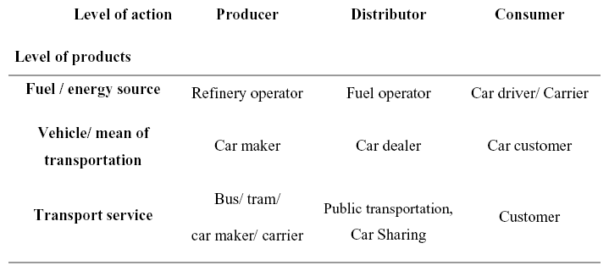

Table 2: Factors of the reaction function of households
HH-Typ/  Raumtyp/Norm | hhConst | rtConst | normConst
0 | – | – | 0
1 | -0.518491 | 0.1931093 | -0.000157221
2 | -0.920595 | 1.478599 | –
3 | -0.4106846 | 0.5619931 | –
4 | -1.57978 | -0.3157597 | –
5 | – | 0 | –

Captions to illustrations

Illustrations:

Figure 1: CO₂ emissions in sectors in 1990 and 2004 in Germany
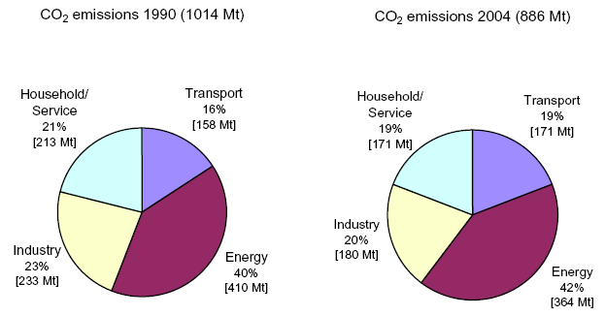
Source: Ziesing (2006)

Figure 2: German CO₂ emissions of passenger and freight transportation in 2004 (204 Mt).
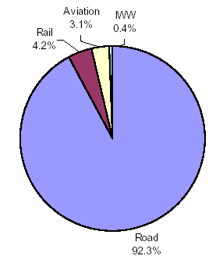
Source: Deutsches Verkehrsforum, 2006.

Figure 3: Development of energy consumption of road traffic in Germany between 1995 – 2030.
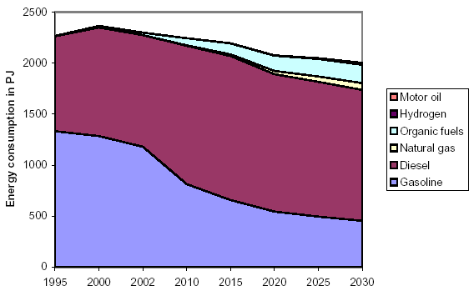
Source: EWI and PROGNOS, 2005

Figure 4: Development of CO₂ emissions of road traffic in Germany between 1995 and 2030.
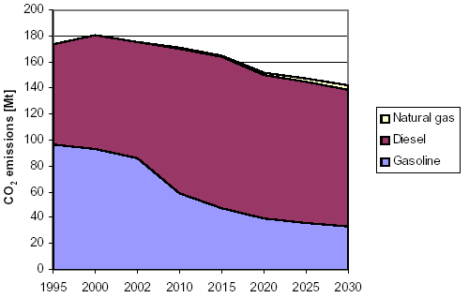
Source: EWI and Prognos, 2005

Figure 5: Up- and downstream approaches in the energy flow chain.
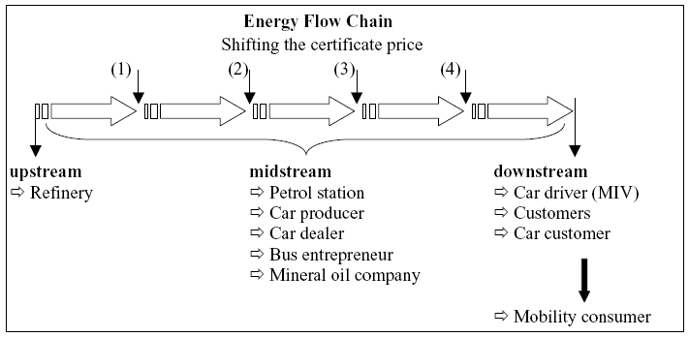

Figure 6: German fuel prices from 1950 to 2005 in real terms.
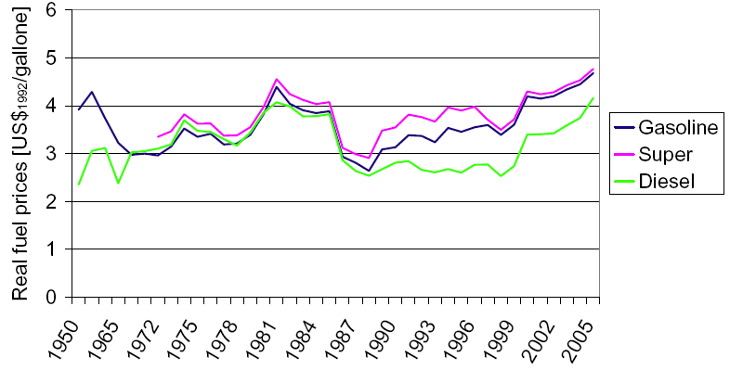
Source: Destatis, 2006

Figure 7: Sketch of a multi agent model for evaluating policy instruments to reduce CO₂ emissions in the transport sector.
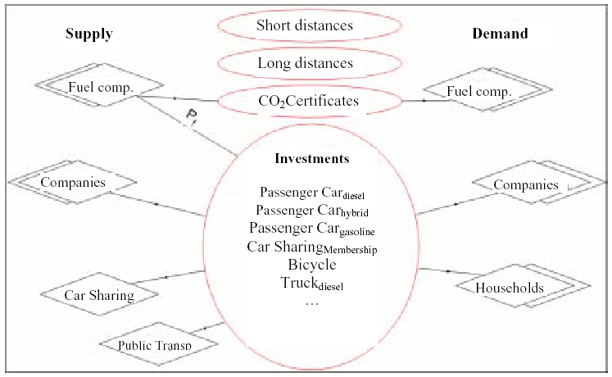

Figure 8: Class diagram of the prototype model.
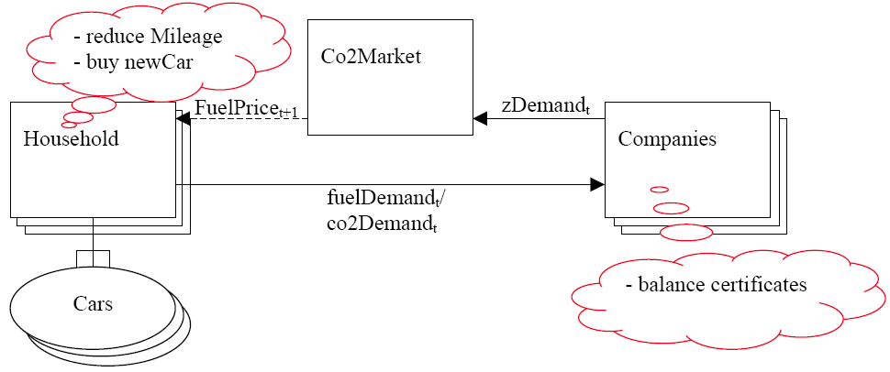

Figure 9: Flowchart of the prototype model.
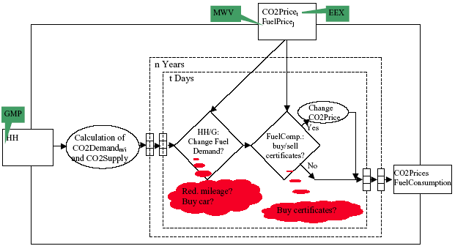
GMP (German Mobility Panel), MWV (German Economic Association of Petroleum),
EEX (European Energy Exchange)
Figure 10: Simulation results: reactions of households facing limited CO₂ certificates in periods 1 to 10.
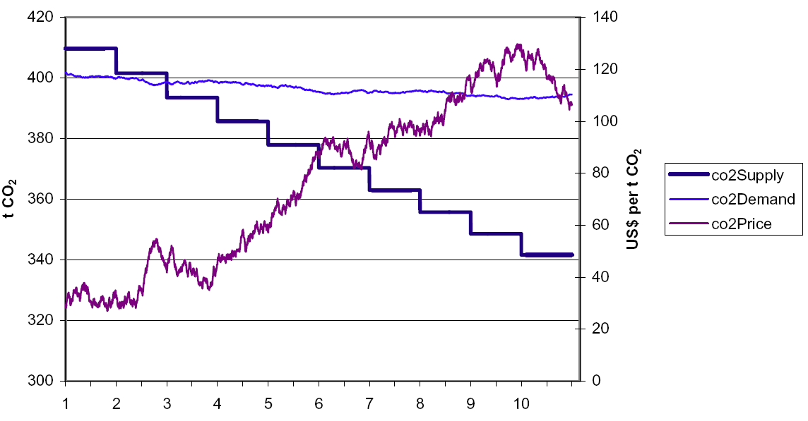

Figure 11: Simulation results: reactions of households facing limited CO₂ certificates in periods 1 to 10.
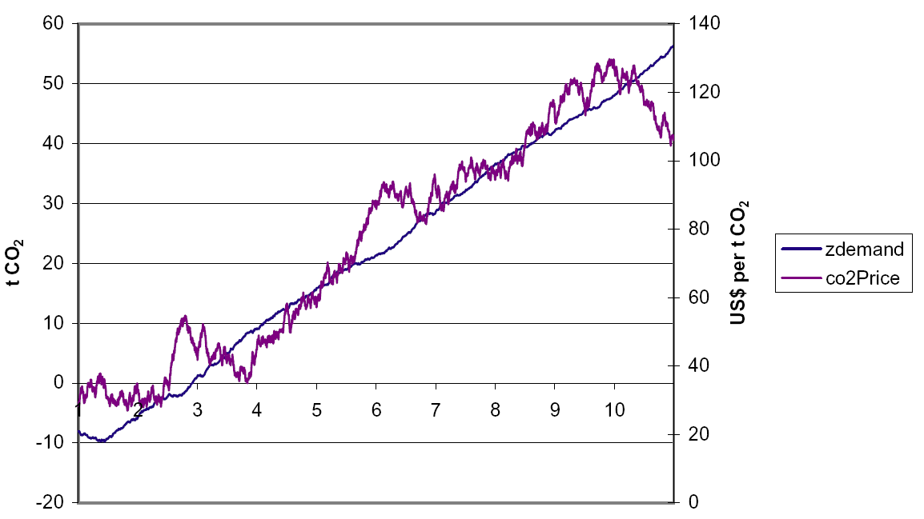

Endnotes:

These CO₂ emissions of the transport sector in classification of energy balances are calculated – according to the accounting directive of the Kyoto Protocol – on the basis of the sales of Diesel fuel and fuel for spark-ignition engines for transport in Germany (Ziesing, 2006).

