Combined Fuzzy Logic based Mode Choice and
Microscopic Simulation Model for Transport Policy Evaluation

Madhu ERRAMPALLI
PhD Student
Graduate School of Engineering, Gifu University,
1-1, Yanagido, GIFU 501-1193, JAPAN
E-mail: k3812105@edu.gifu-u.ac.jp
Tel: +81-58-293 2446, Fax: +81-58-230 1528

Masashi OKUSHIMA
Research Associate
Department of Civil Engineering, Gifu University,
1-1, Yanagido, GIFU 501-1193, JAPAN
Tel: +81-58-293 2446, Fax: +81-58-230 1528

and

Takamasa AKIYAMA
Professor
Department of Civil Engineering, Gifu University,
1-1, Yanagido, GIFU 501-1193, JAPAN
Tel: +81-58-293 2443, Fax: +81-58-230 1528
Abstract

The main objective of this paper is to provide a basis to combine mode choice model with microscopic traffic simulation model to evaluate various transport policies. In this study, fuzzy reasoning has been considered in all the traffic models namely mode choice, car-following, lane change and route choice models and they are appropriately calibrated and validated using the observed data from the city of Gifu, Japan. To demonstrate the applicability and suitability of the proposed combined fuzzy logic based mode choice and microscopic traffic simulation model, appropriate public transport and parking restriction policies have been considered. The various combinations of policies have been tried and evaluated to determine most suitable policy for one bus route in the city of Gifu. The estimated results shows that traffic models with fuzzy reasoning are able to predict driver behaviour more realistically compared to traditional/standard models. By comparing the evaluation parameters for without and with policies, the effectiveness of policies has been assessed.
Key Words: microscopic traffic simulation; mode choice; fuzzy logic; public transport and parking restriction policies;

1. Introduction

1.1 Microscopic Traffic Simulation

Traffic congestion is regarded as one of the major problems in the urban areas and environmental pollution and accidents are deduced out of that. The most critical, sustainable and cost effective way to tackle traffic congestion on our cities roads is to shift travel from private cars to public transport (BusVic, 2005). The transport policies such as Travel Demand Management (TDM) especially encouraging public transport system are most appropriate to manage such situation (Pendyala et al, 1997). Before implementing any transport policy, it is prudent to assess their expected impacts and benefits. In this direction, microscopic simulation analysis has received higher attention in the last two decades, because they try to analyze each and every individual vehicle/driver behavior in a given time interval more precisely and realistically compared to any other method (Barcelo and Casas, 2002). Though it is considered as most suitable for this purpose, its accuracy and validity mainly depends on the quality of the underlying models of driver behaviour in it.
In the recent past, many microscopic simulation models have been developed (Algers et al, 1997) and they mostly adopted probabilistic or mechanistic approach in traffic models to capture drivers’ decisions (Hidas, 2002). However, these approaches do not incorporate the uncertainties of driver perception and decisions (Wu et al, 2000). With such limitations, the results related to impacts of various transport policies can not be estimated realistically. Hence, there is an urgent need of considering these issues while calibrating the traffic models of microscopic simulation for the evaluation of various transport polices. Several approaches have recently become popular in attempting to overcome these problems, including those based on Artificial Intelligence (AI). Out of these AI techniques, fuzzy logic allows to introduce quantifiable degree of uncertainty into the modeling process in order to react to natural or subjective perception of real variables (Wu et al, 2000).

1.2 Motivation and Objectives of the Study

Recent motorization has substantially deteriorated urban travel in terms of increasing number of private vehicles on the roads and reducing the share of public transport. Many a times, transport policies give more emphasis to private vehicles. Especially in the medium sized cities, people have a strong perception that car is the most suitable mode compared to existing public transport system and continuously thinking of owning and using a car. Normally in these cities, bus alone comprises the public transport and policies related to public transport have direct influence on the private vehicles as well and any changing trends of car owner behaviour also have an impact on public transport/bus. As both car and bus share the network, the network conditions also have strong influence on these modes especially on the user while choosing his mode for his trip. In this regard, identifying a suitable transport policy which can generate the shift to public transport and tackle congestion is a primary concern for the researchers and authorities. In that process, analysing mode choice behaviour is considered to be most critical in evaluating especially public transport related policies for urban road network as these policies are expected to influence mode choice behaviour of the individual. In general, microscopic traffic simulation considers three traffic models namely car-following, lane change and route choice models. Hence, mode choice behaviour under various transport policies cannot be estimated with these models. Therefore, microscopic simulation model has to be necessarily combined with mode choice model to analyse driver behaviour and enable to evaluate wide range of transport polices. In future, this will also enables to analyse and assess the impact on the network incase of introduction of new modes such as community bus, LRT etc.
The main objective of this paper is to provide a basis to integrate mode choice model with microscopic simulation model to evaluate various transport policies. The integration of mode choice with the microscopic traffic simulation model is proposed mainly, because in reality, drivers are sensible in changing their modes under the influence of different transport policies. In this study, fuzzy reasoning has been considered in all the traffic models namely mode choice, car-following, lane change and route choice models and they are appropriately calibrated and validated from the observed data. The city of Gifu, Japan has been considered for this purpose and these traffic models have been validated separately in detail. To demonstrate the applicability and suitability of the proposed fuzzy logic based microscopic simulation, public transport and parking restriction policies have been considered and evaluated for one bus route in the city of Gifu. In the present study, the following three types of policies have been considered:
- Priority bus lanes and signal priority for bus i.e. private vehicles would be changing their lanes when ever they find bus coming on priority bus lane and in case of red signal, it would be turned to green (extending green or curtailing red time phasing) so as to avoid the bus to stop at intersection
- On-street parking restriction i.e. parking on kerb-side has been restricted especially on bus routes
- Bus service level i.e. increasing frequency of bus on particular bus route to reduce waiting time
A comparison between estimated values from simulation model and observed data has been carried out to assess the validity of developed simulation model. The effectiveness of policies has been assessed by comparing evaluation parameters for without and with policies. The various combinations of policies have also been tried and evaluated to determine optimum policy. A display system has also been developed to demonstrate and appraise the results more realistically in terms of animation of vehicular movements and representing congestion graphically for various transport policies.

1.3 Expected Outcome and Organisation of Paper

This paper mainly provides methodology to consider mode choice behaviour for the microscopic simulation model. It also gives the processes involved to consider fuzzy logic and its necessity in traffic models of microscopic simulation model. This paper is expected to help the readers in understanding the significance of the fuzzy logic technique in such kind of traffic analysis. This may also help the readers to understand the procedure to evaluate typical public transport policies and the importance of various evaluation parameters. In the next section, a brief description about microscopic simulation and traffic models involved along with brief literature review has been presented. The integration of mode choice model with fuzzy logic based microscopic simulation model has been discussed in Section 3 along with calibration and validation of traffic models. In Section 4, the evaluation results from various public transport and parking restriction policies have been dealt. Finally, Section 5 gives the concluding remarks along with future scope of the work.

2. Review of Microscopic Traffic Simulation Model

2.1 Background

The problems related to congestion and incident management, signal control optimization, public transport priority, etc. cannot be solved by traditional tools based on analytical methods due to complexity of urban road transport system. On the other hand, microscopic simulation allows to model the whole system in its complexity and to evaluate various traffic management alternatives in order to determine the optimum solution for any traffic scenario (Hidas, 2002). In the last two decades, many microscopic simulation models have been developed by many researchers around the world. A comprehensive review of more than two dozens of models has been carried out as a part of the SMARTEST project (Algers et al, 1999). In the research point of view, several microscopic simulation models have become popular recently, such as MITSIM (Yang and Koutsopoulos, 1996), AIMSUN (Barcelo and Casas, 2002), ARTEMiS (Hidas, 2002), DRACULA (Liu et al, 2006), FLOWSIM (Wu et al, 2000), CORSIM, INTEGRATION (Rakha and Crowther, 2003) etc. In the recent past, various commercial softwares are also become popular interms of microscopic analysis of vehicle behaviour, display of animation in three dimension and many more advanced features. They are mainly VISSIM (PTV), PARAMICS (Quadtone) etc. However, the details of the inbuilt mechanism of underlying models are not been accessible in the available literature. The further refinements are still going on to improve microscopic simulation models in terms of computational performance, accuracy of the underlying models in representing realistic traffic flow, analyze various policies related to ITS applications etc.

2.2 Components of Microscopic Simulation Model

A microscopic simulation model involves series of modules executed in every pre-defined time interval (time based) or when certain events occur (event based) which finally leads to explain every individual’s behaviour on the network from their origin to destination. It would be mainly emphasizing on route to be followed, acceleration/deceleration and lane changing behaviour on a link. A driver starts his trip by choosing a route to reach the destination and while traveling on links he take decisions to accelerate/decelerate and lane change. The microscopic traffic simulation model basically uses the data including network, vehicular, driver characteristics and time wise origin-destination (OD) data. Simulation starts with loading of these data along with simulation parameters (time interval, total intervals etc.) and an iterative procedure is initiated with pre-defined time interval step size. The major tasks performed in each of the iteration include: update signals and shortest paths, generate vehicles at appropriate node, update vehicles’ acceleration rates and lane change decisions, advance vehicles to new positions etc (Yang and Koutsopoulos, 1996). Out of these, vehicle routing and vehicular movement are considered to be major and important for a microscopic simulation model. The traffic models namely car-following model, lane change model and route choice model are mainly used for these purposes. The state-of-art of these models has been explained in the subsequent sections in brief.

2.2.1 Car-following model
A fundamental component of any microscopic simulation model is considered to be car-following model, which mainly describes the movement of individual vehicles within a platoon based on leader vehicle characteristics and movement. The significant research work to analyse car-following behaviour has started first at General Motors (GM) laboratories in 1958 (Chandler et al, 1958, Herman et al, 1958 and Gazis et al, 1959). The simulation models such as MITSIM had adopted the formulation of GM model. In 1981, Gipps identified some parameters in the GM model which has no obvious connection with characteristics of the driver and he had empirically calibrated and validated his model with observed data on the field (Gipps, 1981). The simulation models such as AIMSUM, DRACULA etc. had adopted this formulation. Subsequently in 1998, Hidas developed a model based on desired spacing which is assumed to be linear function of speed (Hidas, 1998). The simulation models such as ARTEMiS had adopted this formulation. The microscopic traffic simulation model developed by authors had adopted both Gipps and Hidas formulations considering the advantages in them for different situations (Errampalli et al, 2005a and 2005b).
These models have basically considered that deterministic relationship exists between the action of a vehicle and the reaction of the vehicle that follow. Kikuchi and Chakroborthy have assumed that the reactions of a driver perhaps not based on a deterministic one-to-one relationship, but on a set of vague driving rules developed through experience and accordingly fuzzy inference rules and appropriate reasoning techniques have been incorporated in their model (Chakroborthy and Kikuchi, 1999). This model seems to be suitable for urban conditions, but not at all the situations such as parking vehicle presence at curb side, consideration of desired speed etc. In the same direction, Wu et al (2000) have developed fuzzy logic based microscopic car-following model for FLOWSIM. This model appears to be more suitable for motorways and may not be able to describe congested urban network conditions.
By reviewing these formulations, it can be said that deterministic models have ignored human approximations, hence they fall short in explaining important car-following characteristics. Existing fuzzy logic based models are also not suitable in explaining every possible situation of congested urban network. Hence, there is a high need of a model which is able to consider fuzzy logic and describe possible urban congested environment such as parked vehicles etc.

2.2.2 Lane change model
The main purpose of the lane change model in microscopic simulation is to determine the current lane considering the present situation and aim of an individual. Lane change process is initiated if the driver has some purpose and objective such as take turn at next intersection if the current lane doesn’t allow the intended turn, increase its speed and traffic management measures such as bus lane policy etc. Hence, a driver would be continuously thinking in every time interval whether it is necessary to change lane and whether it is feasible to change lane. The feasibility would be generally checked based on the gap available in the target lane (Hidas, 2002). Usually these models assume that driver estimate these values accurately. But in reality, there are many uncertainties, approximations and perceptions involved.
It can be observed from the literature that the lane change behaviour has been described under safe conditions only (Gipps, 1986). Hidas (2002) found that this assumption has a serious limitation to deal congested and incident affected conditions and subsequently proposed a courtesy lane change (forcible and cooperative). Moreover many models have adopted deterministic approaches to find out the feasibility in a target lane. Hence, they have ignored human behaviour and approximations involved in making the decision by driver. Existing fuzzy logic models such as FLOWSIM considered human behaviour and approximations, but can not be applicable for every urban congested situation to consider courtesy lane change. In 2006, the authors have developed a lane change model based on fuzzy logic to overcome such kind of limitations. In this, about five different purposes and six different influencing variables have been considered to estimate the lane changing decisions. This model is able to consider human approximations and also able to describe possible urban congested environment such as courtesy lane change (Errampalli et al, 2006).

2.2.3 Route choice model
Route choice model is used to capture driver’s route choice decisions under the given circumstances. In general, driver would be selecting a route which has low travel time and this is generally determined using shortest path algorithm. As there are some differences exist in each of the driver, randomness factor has been considered in some of the models and probability of each route would be determined by driver. In MITSIM and AIMSUN, a multinomial logit model has been considered to determine the best route. All these models assume that drivers are supplied with crisp information related to each and every link in the network. In reality, drivers use perceived times in choosing the suitable route to their destination. There are some uncertainties involved which are unable to address under the traditional probabilistic methods. Fuzzy logic technique can overcome these limitations in route choice behavior of the individual driver in choosing their route to their destination.
Though fuzzy logic has been exhaustively used in route choice modelling, but rarely implemented in any existing microscopic simulation models. Recently, authors had made an attempt to compare the different routes available between origin and destination using possibility theory and implemented in the route choice model in their microscopic traffic simulation (Errampalli et al 2005a and 2005b).

2.3 Mode Choice Behaviour

The above mentioned three traffic models are generally considered in a microscopic simulation model to simulate vehicular behaviour on the network. As the transport policy changes, it is expected that some of the drivers who are currently using their own vehicles may change to public transport. This kind of change or behaviour has to be critically modelled and integrated with the simulation model in case of wide range of transport polices are to be considered. For this, mode choice model has to be necessarily integrated with simulation model. In this direction, PCATS/DEBNetS, a micro-simulation model system had been developed recently by Kitamura et al (2000). PCATS (Prism-Constrained Activity-Travel Simulator) is a system of behavioural models that simulates an individual’s daily activity and travel, while DEBNetS (Dynamic Event Based Network Simulator) is micro-meso scale simulator of network flow. PCATS generates activities and travel using a host of model components, including activity type choice models, activity duration models, and mode-destination choice models. DEBNetS simulates individual vehicles' movements by using flow-density relationships.
These two simulators are integrated to form a demand forecasting and policy analysis tool for regional transportation planning. Vehicle trips generated by PCATS are fed to DEBNetS along a continuous time axis. Combining the mode choice behaviour with network simulator is successfully carried out in PCATS/DEBNetS (Kitamura et al 2000). But, the microscopic individual vehicular movements have not been considered and also the approximations involved in traffic models have been ignored. Hence, there is a high need to consider microscopic behaviour of individual movement and approximations involved in all traffic models to represent the driver/vehicle behaviour more realistically and enable to evaluate wide range of transport policies.

3. Combined Fuzzy Logic Mode Choice and Microscopic Simulation Model

3.1 Model Structure

Recently, a microscopic simulation model has been established to evaluate transport policies by the authors (Errampalli et al, 2005a and 2005b). In that, fuzzy logic has been considered in route choice model only. Subsequently, lane change model has been modified by considering fuzzy reasoning approach (Errampalli et al, 2006) and after that car-following model with fuzzy logic also implemented (Errampalli et al, 2007). In the present study, fuzzy reasoning approach has been proposed to be considered in mode choice modelling and a methodology has been proposed to integrate with existing fuzzy logic based microscopic simulation model. Basically, microscopic simulation involves series of acts/decisions taken by driver in every time interval based on current situation. Because the human factor is involved, there is high possibility of involving approximations and fuzziness in the decisions. The proposed microscopic simulation based on fuzzy logic (contains all the traffic models with fuzzy logic) is expected to consider these approximations involved in the perceptions and decisions of the driver. This proposed research methodology is expected to eliminate many limitations in the past models and also bring a significant improvement towards developing a realistic microscopic simulation model. In the Figure 1, the main processes involved in the present combined mode choice and microscopic simulation model have been given in the form of flow chart.

* with fuzzy logic; ** HGV - Heavy Goods Vehicle
Figure 1: Flow Chart for Combined Mode Choice and Simulation Model

As shown in the above figure, the two basic components involved in this model and they are vehicle generation and movement. Firstly, vehicles would be generated on the network from the vehicular, OD and network data. Time headways between the vehicles at all origin nodes have been estimated by assuming exponential distribution to generate vehicles on the network. As the poison distribution is generally used for low congestion condition (Yang and Koutsopoulos, 1996), the exponential distribution has been adopted and the headways are randomly drawn to generate vehicles. Route choice model is applied to estimate appropriate route to his destination for car based on the current traffic conditions. If the generated vehicle is a car, then the mode choice model would be applied to see whether the driver is going to change his mode based on the present traffic condition or not. If the driver selects bus, he will be assigned to available bus. Secondly, vehicular movements would be estimated from the traffic models such as car-following and lane changing models. The formulations involved in mode choice modelling based on fuzzy reasoning have been described along with calibration and validation process in the section 3.5 in detail. Where as the details of car-following lane change and route choice model based on fuzzy logic can be found in the previous publication of the authors (Errampalli et al, 2006, 2005a and 2005b). However, a brief description of these models has been given in the subsequent sections.
3.2 Fuzzy Logic based Traffic Models for Microscopic Simulation

3.2.1 Route choice model with fuzzy logic
In the present simulation model, it is assumed that route travel time is a fuzzy number and driver choose his route based on possibility index, which represents possibility of choosing route. To compare the possibility indexes of all available routes, it is necessary to have a fuzzy goal, G (Akiyama and Nomura, 1999 and Akiyama, 2000). All the available routes would be compared with goal function and routes would be ranked based on possibility indexes. The methodology to rank the fuzzy numbers (route travel time in the present study) has been proposed by Dubios and Prade by defining appropriate logical measures and one of the measures is Possibility measure. In the present study, this possibility measure has been considered to rank the available routes. In general, fuzzy goal and route travel time are considered as triangular fuzzy numbers and μ_{G}, μ_{A} and μ_{B} are fuzzy membership functions for fuzzy goal, travel time for route A and route B respectively as shown in Figure 2. The possibility measure, POS(G≥A) which means possibility that G is greater or equal to A, has been defined by considering membership functions, μ_{G}(x) and μ_{A}(x) of fuzzy sets G and A, as sup⋅ min {μ_{G}(x), μ_{A}(x)} (Dubios and Prade, 1980 and 1983). In other words, highest point of minimum values of μ_{G}(x) and μ_{A}(x) functions and also referred as intersecting point of fuzzy goal and route travel time curves as shown in Figure 2. The more explanations can be found in the literature (Zadeh, 1983 and Dubios and Prade, 1980 and 1983). Subsequently, the measure POS(G≥A) has been considered as possibility index for Route A in the present study.

Figure 2: Fuzzy Goal and Possibility Index for a Route

Possibility indexes for the available routes would be separately calculated using the fuzzy goal as shown in Figure 2. From the figure, it can be observed that possibility index is high for route B compared to route A, even though the travel time of route A is shorter than route B (t_{A}<t_{B}) as the fuzziness of route B is comparatively more than route A. Based on the possibility measure approach, the possibility indexes for all the available routes have been calculated and finally driver selects the route, which has the maximum possibility index. More details can be found in the previous publication of the authors (Errampalli et al, 2005a and 2005b).

3.2.2 Car-following model with fuzzy logic
The acceleration of vehicle is estimated based on leader vehicle behaviour and surrounding circumstances by using car-following model. From the acceleration, vehicle position on the network would be updated in every time interval. In the past studies based on fuzzy logic, only relative speed (RSP), relative distance (RDS) and leader vehicle acceleration rate (LAR) have been considered (Chakroborthy and Kikuchi, 1999 and Wu et al, 2000). On urban roads, parking on kerb side can be generally observed at many places. Because of this, partial lane change process may occur on the links as shown in the Figure 3. The speed would be reduced as the vehicle slightly use adjacent lane and this will make other vehicles traveling on adjacent lane also slow down in presence of parked vehicles along road side and some times vehicles try to change lane to avoid this area. In that case, it is assumed that vehicle movement would also be influenced by lateral obstructing distance in case of parked vehicle presence as shown in Figure 3.
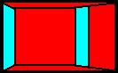
Partial Lane Change
Condition
(reduced speeds,
unwanted lane changes etc.)
Lateral obstructing distance
On-Street Parking occurring area
Path of vehicle

Figure 3: Vehicle Behavior under Partial Lane Change Process

It is essential to consider lateral obstructing distance as a input variable to describe the above said partial lane change behaviour. In the present model, another three important input parameters have been considered comparing to existing models to account for the description of other possible urban situations. They are: difference in desired and current speed (DSD), lateral obstructing distance (LOD) and aggressiveness of driver (AGS). The LOD, the lateral distance from the edge of carriageway (from the parked vehicle) is mainly to take care of the situations where the presence of parked vehicle is there along the curb. The output parameter is acceleration rate of follower vehicle (ACR). The ACR and LAR has been classified into five triangular fuzzy sets incorporating linguistic description namely strong deceleration (STD), light deceleration (LTD), no action (NAC), light acceleration (LTA) and strong acceleration (STA). The RSP has been classified into five fuzzy sets and they are negative big (NB), negative small (NS), zero (ZER), positive small (PS) and positive big (PB). The RDS has been classified into five fuzzy sets and they are very small (VSL), small (SML), medium (MED), big (BIG) and very big (VBG). The DSD and LOD have been classified into three fuzzy sets and they are SML, MED and BIG. And AGS has been classified into three fuzzy sets and they are low (LOW), MED and high (HGH).
After creating the membership functions of all variables, appropriate fuzzy rule base consist of 85 rules has been formulated to determine the decision of driver in terms of acceleration. A typical fuzzy rule for the car-following in natural language has the following form:
Rule No-73: if relative distance (RDS) is medium (MED) and lateral obstructing distance (LOD) is medium (MED), then acceleration rate (ACR) is light deceleration (LTD)
The above rule means, in case of relative distance and lateral obstructing distance are medium, the reaction of the driver should be light deceleration. The car-following behaviour in partial lane change situation is possible to describe by applying such rule by considering lateral obstructing distance variable. For each input/output variable, the parameters have been appropriately and logically calibrated to determine the shape of membership’s functions (Errampalli et al, 2007).

3.2.3 Lane change model with fuzzy logic
In this model, it is proposed to consider total five types of lane changing purposes. They are: speed advantage, turn at next intersection, type of bus lane policy, presence of bus at bus stop and presence of parked vehicles along kerb-side. The motivation for lane changing varies based on the purpose and it is clearly different from each other and considers different input variables for different purposes. The input variables considered are Speed Advantage (SPA), Feasibility Level (FSL), Distance to Leader Vehicle (LVD), Necessity Level (NCL) and Distance to follower vehicle (FVD). The input variable, SPA is the difference between current speed and desired speed of subject vehicle or current speed of subject and leader vehicle. FSL is defined as gap available in the target lane. LVD is the gap between subject and leader vehicle. NCL is the distance remaining to location of target of lane change. And finally, FVD is gap between subject and follower vehicle. The output variable considered here is the intention of lane change (LCN). After that, a fuzzy rule base has been formulated to determine the output variable for each purpose separately. A total of 54 fuzzy inference rules have been formulated for all purposes. A typical fuzzy rule for lane change in natural language has the following form:
Rule No-47: if leader vehicle distance (LVD) is low (LOW) and feasibility (FSL) is medium (MED), then intention of lane change (LCN) is high (HGH)
The above rule means, in case of low distance between subject and leader vehicle and the feasibility in the target lane is medium, then the intention of lane change is high. This rule is mainly helpful when the bus stopped at bus stop or vehicle parked along road side, the subject vehicle would consider the intention of lane change is high in case of feasibility is medium. As lane changing is a more sophisticated activity only three fuzzy sets as triangular membership function are used for each of input and output variables for the sake of simplicity. They are: Low, Medium and High (Errampalli et al, 2006).

3.3 Validation of Fuzzy Logic based Microscopic Simulation Model

3.3.1 Target network
After formulation and calibration, the next step is validation of the developed simulation model. A part of Gifu city network has been considered for this purpose as shown in Figure 4 and it consists of 60 nodes and 204 links.
Bus Service Level (increase in frequency is proposed for
this Bus route)
On-street Parking Restriction Policy is proposed
Priority Bus Lane and Signal Priority for Buses assumed for these 3 links
Mode choice behaviour considered for this Bus Route
Option 1

Option 2

Option 3

Chusetsu Street

Figure 4: Considered Network of Gifu City

In the present model, three vehicle types (cars and heavy goods vehicles as private vehicles and buses) have been considered. The OD data for private vehicles has been used from the trip distribution tables which were created from the car trip survey carried out in 2001 for Gifu city, Japan. Bus generation data has been created from the bus time table available with Gifu Bus Company.

3.3.2 Comparison of link flows
The vehicle movements have been estimated for three hours (from 06:00 to 09:00) using the developed microscopic simulation model and calculated peak hour link flows from 07:00 to 08:00. After the thorough investigation, the observed peak hour link flows in the field for certain links of the Gifu city network have been obtained from the reliable sources. These values have been used to validate the present simulation model. The comparison between observed and simulated hourly link flows has been plotted as shown in Figure 5 for about 115 links spreading through out the network.

Figure 5: Observed and Simulated Peak Hour Link Flows

From the statistical analysis, it has been found that R² is 0.78 with root mean square error (RMSE) value is about 194 veh/hr as shown in the Figure 6. An attempt has also been made to assess the impact of fuzzy logic in traffic models of microscopic simulation. For this, fuzzy logic has been considered separately for each of the model and estimated RMSE value for peak hour link flows. The results have been presented in Figure 6.

Note: RC - Route Choice; LC - Lane Change; CF - Car-following;
Figure 6: Comparison of RMSE Value for Hourly Link Flows

From the above figure, it can be observed that RMSE value for hourly link flows is 260 veh/hr in case of no fuzzy logic considered in any of the traffic models. In this case, all the models adopted standard/traditional approaches. By incorporating fuzzy logic in route choice has brought down the RMSE value to 211 veh/hr, thus improving accuracy of the simulation model. This result clearly shows that fuzzy logic based route choice model which considers human behaviour and fuzziness in choosing a route looks more logical than selecting a shortest route for his trip by traditional method. And considering fuzzy logic in lane change and car-following has further reduced the RMSE value to 208 veh/hr and 194 veh/hr respectively. From these results, it can be concluded that incorporation of fuzzy logic has significantly improved the accuracy in estimating results. Incorporation of fuzzy reasoning in these models might have caused improved speeds thus increased hourly flows and rectified the problem of under prediction of the link flows in case of standard modelling. Therefore, it can be said from the above comparisons of R² and RMSE values, the developed simulation model based on fuzzy logic is able to predict vehicular movements with fair amount of accuracy.

3.4 Display System

A display system has been developed as part of fuzzy logic based microscopic traffic simulation to view the vehicular movements simultaneously. For this purpose, MS Visual Basic 6.0 software has been used. This display system was mainly developed to understand and appraise the current traffic situation by viewing the animation of vehicular movements at any given location as shown in Figure 7.

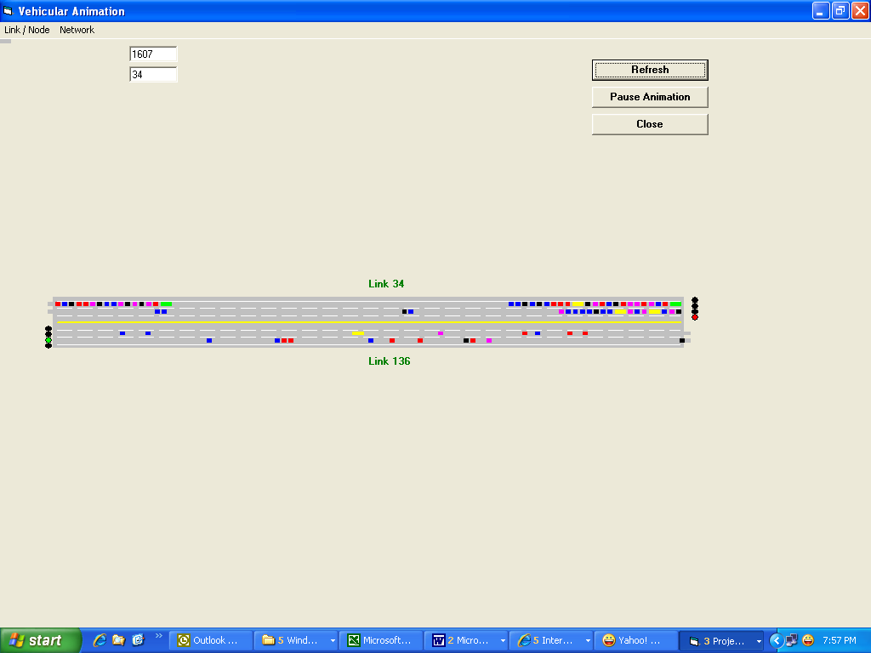
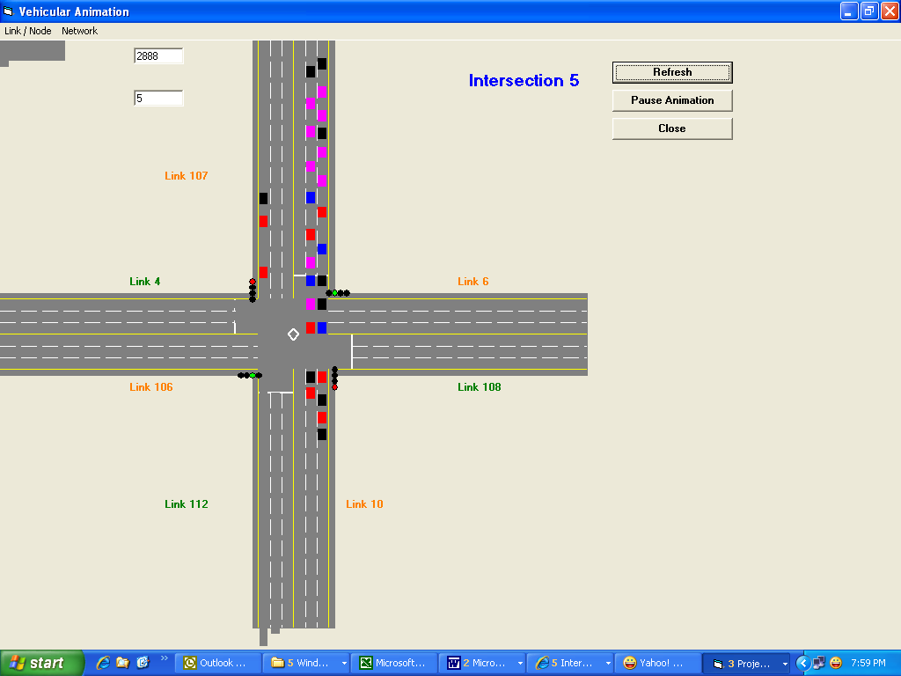
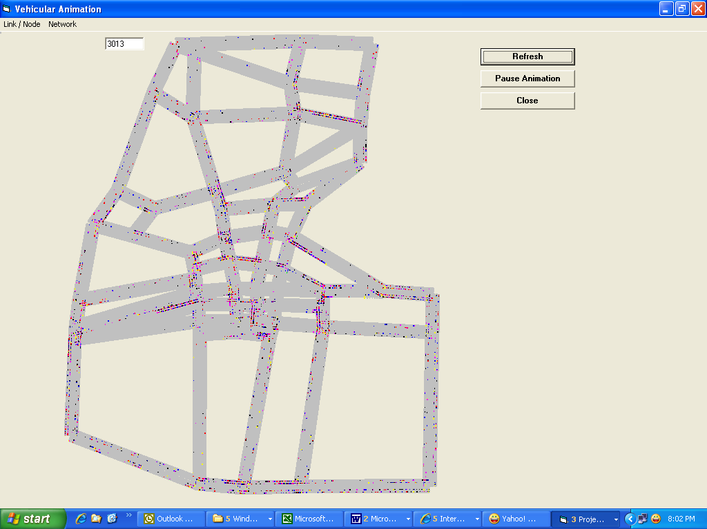
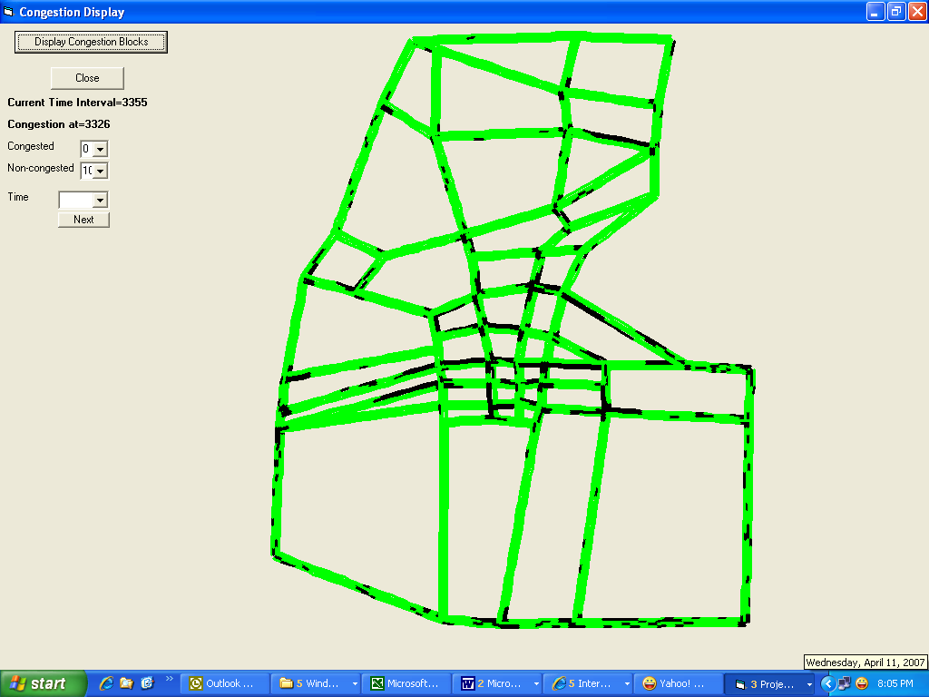
Vehicular animation for link
Vehicular animation for Intersection
Vehicular animation for Entire Network
Congestion Display for Entire Network

Figure 7: Screen Shots of Display System
It can be seen in the above figure that the display system has been created to visualize the vehicular animation mainly for individual link, individual intersection and whole network. The interested link or intersection has to be specified through the input interface menu to view the vehicular movements. A provision has also been given to display the vehicular movements and congestion for the entire network as shown in Figure 7. The system will highlight and estimate congested blocks (100 meter length section with one lane width which has density more than critical density i.e. 50 veh/lane/km) and display on the screen simultaneously. This feature can be considered as unique and one of the advantageous points of proposed microscopic simulation model. From this result, one can visualize the amount of congestion occurring on a network at any given point of time and accordingly appropriate decisions can be taken to manage the traffic.

3.5 Integrating Fuzzy Logic Mode Choice Model with Microscopic Simulation

3.5.1 Background
As it is discussed in earlier sections, mode choice behaviour is influenced by many transport policies and it has to be necessarily considered to evaluate the impacts of policy more realistically. Mode choice model estimates the mode for a particular trip based on certain inputs. In general, mode choice models are usually developed by considering travel time and travel cost. It has been evident from the past studies that other factors may also strongly influence the choice of mode like waiting time and walking time which are considered as access time rather than only journey time and cost (Errampalli et al, 2004). Traditionally, logit model is considered to develop mode choice model and results from this might be accurate when the input variables have been exactly perceived by an individual. In reality, there is lot of approximations involved in perceiving the input and there is always a human error exist while taking decisions. Under these situations, there is a high chance that mode choice predictions might be deviated from real behaviour. On the other hand, it has already been reported that fuzzy logic, a technique considers the approximations and human perceptions, is able to estimate the reaction/decisions of the driver more realistically (Mizutani and Akiyama, 2000).

3.5.2 Necessity of fuzzy reasoning for mode choice modelling
In the present model, the influencing variables namely travel time by car and bus, travel cost by car and bus and access time for bus have been considered as input variables. Based on the input, probability of choosing the bus and car would be estimated using a set of fuzzy inference rules. The Fuzzy reasoning would be considered as appropriate technique because of the following reasons:
- All the above mentioned input variables are not crisp values and hence, they can not be estimated exactly by an individual. In reality, there is a fuzziness involved in all of them.
- Every decision of driver (i.e. choosing a mode) has fuzziness and moreover human approximations are involved in it.
- The inference system between input and output possesses high non-linearity.
- Rule base (IF...THEN…. rules) with fuzzy reasoning has close resemblance of human knowledge and behaviour as they use linguistic terms and they are also capable of handling complicated situations using certain rules.
- To handle such situations, the standard rule base would become so large and not applicable for some situations. In case of addition of any new input variable, this rule base becomes more complicate. On contrast, rule base with fuzzy reasoning simplifies the rules by making the variables into groups using linguistic terms.
In this study, mode choice model has been proposed to consider fuzzy reasoning by reviewing these factors.

3.5.3 Formulation of mode choice model with fuzzy reasoning
Fuzzy reasoning is an application of fuzzy set theory to ordinary reasoning. The fuzzy reasoning process is summarized with three elements namely implication from inference rules, integration of conclusions and defuzzification (Takihi et al, 2002). The popular implications are min-max-gravity operation and product-sum-gravity operation. The min-operation would be clipping off the fuzzy set and the implication result becomes flat and same for some values of mode choice decision. But, the mode choice decision corresponding to the truth from antecedent condition can not be constant and vary across different values. The product-operation considers this effect and the implication result would be scaled across the values of mode choice decision so that every decision has different weightage from each other. In mode choice, drivers respond to small change in the variables and need to consider the influence of all inference rules in the conclusion. The sum operator is able to consider the implication results simultaneously by summing and consider all implications into conclusion so that even small implication is considered in mode choice decision. For defuzzification, center of gravity of the distributed area is often considered as a representation in conclusion (Takihi et al, 2002). Since min-max-gravity method generates undesirable non-linearity, product-sum-gravity has been proposed to many applications in the practical fields and might provide better performance and easy to tune besides its simplicity and low computations (Takihi et al, 2002 and Kim, 2002). Therefore, the “product-sum-gravity” operation is considered as appropriate and implemented in fuzzy reasoning to produce the practical mode choice model in the present study.
In this study, a primitive mode choice model has been proposed to estimate the mode choice behaviour of the individual by considering three influencing variables. They are travel time difference between bus and car (TTD) in minutes, travel cost difference between bus and car (TCD) in Yens and access time for bus (ACT) in minutes. Access time is considered as the time required to reach bus stop for an individual by walking and this would be zero for car users. The output variable is probability of choosing bus (PRB). For variables TTD and TCD, five fuzzy sets with triangular membership functions i.e. NB, NS, ZER, PS and PB have been considered. Where as, for input variable ACT and output variable PRB also, five fuzzy sets with triangular membership functions i.e. VSL, SML, MED, BIG and VBG have been considered. A typical shape of membership functions has been shown in Figure 8.
0
μ
a b c d e
+ve Big
Zero
-ve Big
1
Membership Level
+ve Small
-ve Small
-50
-10
0
5
20
-150
-100
0
50
200
1
3
5
7
9

Figure 8: Fuzzy Sets and Linguistic Description for Variables in Mode Choice Model

After creating the membership functions for all variables, appropriate fuzzy rule base (consists of 30 rules) has been formulated to estimate the probability of choosing mode and the part of the rules have been presented in Figure 9.

Figure 9: Part of Inference rules for Mode Choice Model

From the above figure, the rule number R-25 says, if travel time is difference is positive big and travel cost difference is positive big between bus and car, then the probability of choosing bus is very small. Because, both time and cost are more for bus, the driver’s bus choosing probability is very less and probability for car becomes very high.

3.5.4 Calibration and validation of mode choice model with fuzzy reasoning
For the purpose of calibration and validation of present fuzzy logic based mode choice model, person trip survey data which was collected in 2001 in Gifu city has been used. About 2868 samples have been selected who have the access for both car and bus modes. Out of these, 2008 samples have been used for calibration and remaining 860 samples have been used to validate the developed mode choice model. Using the fuzzy inference rule base, the parameters for each membership functions have been logically calibrated to determine the shape of membership functions and the calibrated parameters can be found in Figure 8. For demonstrating the accuracy and effectiveness of fuzzy reasoning approach, mode choice model has also been developed by logit model and the results from logit model also given in the Table 1. In that table, estimated results have been compared with observed data for both logit model and fuzzy reasoning approach.
Table 1: Calibration Result for Fuzzy Logic based Mode Choice Model
Observed Samples | Estimated Samples
Observed Samples | Mode | Car | Bus | Total
Observed Samples | Car | 1642 (1794) | 159 (7) | 1801
Observed Samples | Bus | 5 (202) | 202 (5) | 207
Observed Samples | Total | 1647 (1996) | 361 (12) | 2008
Prediction Accuracy = 100*[1642+202]/2008 = 92% (100*[1794+5]/2008 = 90%)
Note: values in parenthesis represents logit model results

In the above table, it can be seen that 1801 samples observed as choosing car and 207 samples observed as choosing bus. But the fuzzy logic based mode choice model estimated as 1647 samples choose car and 361 samples choose bus where as 1996 and 12 samples choose car and bus respectively in case of logit model. By using fuzzy logic based mode choice model, 1642 sample choosing car and 202 samples choosing bus has been correctly classified, where as 1794 and 5 samples are correctly classified under car and bus respectively with logit model. Subsequently, prediction accuracy values from fuzzy logic model (about 92% i.e. 100*[1642+202]/2008) and logit model (about 90% i.e. 100*[1794+5]/2008) have been calculated and presented in the Table 1. Though the fuzzy logic improved the overall accuracy by 2% over logit model, the 202 bus samples out of 207 samples are correctly classified with fuzzy logic, where as it is only 7 in case of logit model.
The calibrated mode choice model has been validated using different sample set (860 samples) which are not used for calibration to assess the accuracy of present mode choice model. Using the developed mode choice model, the results have been estimated and compared with the observed data and the same has been presented in Table 2.
Table 2: Validation Result for Fuzzy Logic based Mode Choice Model
Observed Samples | Estimated Samples
Observed Samples | Mode | Car | Bus | Total
Observed Samples | Car | 660 (711) | 54 (3) | 714
Observed Samples | Bus | 6 (143) | 140 (3) | 146
Observed Samples | Total | 666 (854) | 194 (6) | 860
Prediction Accuracy = 100*[660+140]/860 = 93% (100*[711+3]/860 = 83%)
Note: values in parenthesis represents logit model results

In the above table, it can be seen that, 660 sample choosing car and 140 samples choosing bus has been correctly classified by fuzzy logic based mode choice model, where as 711 and 3 samples are correctly classified under car and bus respectively with logit model. The prediction accuracy is 93% from fuzzy logic model where as it is 83% by logit model. About 140 bus samples out of 146 samples are correctly classified with fuzzy logic, where as it is only 3 in case of logit model. From the above tables, it can be observed that logit model is more biased towards car. This phenomenon has been eliminated in case of fuzzy logic thus model becomes more realistic. It can be clearly observed from the results that fuzzy reasoning approach is able to predict the mode choice of an individual more accurately compared to logit model.

3.5.5 Combining fuzzy logic mode choice model with microscopic simulation
The developed mode choice model based on fuzzy logic has been combined in microscopic simulation model to estimate mode choice behaviour under different transport policies during their evaluation process. The processes involved in this have been given in flow chart as shown in Figure 10.
Car
Mode Choice Model
Fuzzy Logic based Microscopic Traffic Simulation Model
Car
Bus
Current Travel time data
generate car on the network
generate bus on the network

Figure 10: Processes in combined Mode Choice and Microscopic Simulation Model
During the vehicle generation stage the mode choice model is applied if the vehicle is car as shown in the above figure. This model takes the input of current travel time data from the output of microscopic simulation model. Then finally, it estimate the mode choice decision of the driver and the chosen vehicle would be generated and fed into the network and the vehicular movements of that vehicle would be estimated by the microscopic simulation model. These processes would be continuously carried out in every simulation interval for a given time duration to estimate the network situation under different transport policies.

4. Transport Policy

4.1 Background

To demonstrate the applicability and suitability of the proposed fuzzy logic based microscopic traffic simulation, various transport policies have been selected. The policies have been widely considered from various fields mainly related to physical changes on the road and infrastructure (bus lanes and signal priority), enforcement (parking restriction) and public transport operation (bus frequency). These policies are evaluated separately and various combinations have been tried among them to estimate the optimum beneficial policy. The details of these policies and results estimated have been given in the subsequent sections.

4.2 Description of transport policies

4.2.1. Option 1: Priority Bus Lane and Signal Priority for Bus
In this option, priority bus lanes have been assumed to be introduced in some of the links on the Chusetsu Street to ensure high quality of service for buses as shown in Figure 4. This policy is introduced on the left lane of link 51, 65 and 75 from north to south directions only as shown in the figure. Under the priority bus lane policy, private vehicles are permitted to use bus lane provided that they give no hindrance to the traveling buses in the bus lane and give priority to the buses. The private vehicles have to change their lane to ordinary lane if they observe any bus coming from their back. A private vehicle which is traveling on a bus lane keeps on checking the gap between its’ own vehicle and its’ follower vehicle and it changes to ordinary lane if the follower vehicle is bus and close to it. Then it follows lane change model to carry out the required lane change to ordinary lane. At the same time, signal priority for bus is also introduced for link 51, 65, 75, 153, 167 and 177 as shown in the Figure 4. Under this option, when ever bus is identified near intersection, signal would be turned to green (extending green or curtailing red time phase) so as to avoid the bus to stop at intersection.

4.2.2. Option 2: On-street Parking Restriction
Presently, parking on kerb side has been observed on many streets especially on the Chusetsu Street. Because of this, partial lane change process is occurring on the links as shown in the Figure 3. In that case, vehicle movement would be influenced by lateral obstructing distance. The speed would be reduced as the vehicle slightly use adjacent lane and this will make other vehicles traveling on adjacent lane also slow down. And some times vehicles try to change lane to avoid this area. To improve such situation, on-street parking restriction policy has been proposed to be implemented on the link 51, 65 and 75 as shown in Figure 4. As the lateral obstructing distance has been considered in car-following and lane change of the present fuzzy logic based microscopic simulation model, the partial lane change behaviour has become possible to describe.

4.2.3 Option 3: Bus Service Level Policy
Under this option, the bus frequency has been proposed to increase to reduce waiting time of passengers thus improving the quality of travel by bus. The frequency has been increased for the selected bus route as shown in Figure 4 on Chusetsu Street. Presently there are 4 buses running in peak hour in this route and under this option, it is assumed that 8 busses in that one hour would run. This policy has practical problems and basically involves investment cost for the extra buses. Hence, it may not be appropriate even though it generate benefits as they may get compensated by these extra investment costs, thus nullifying the actual benefit generated by this option. However, to observe the quantity of benefits under this option, an attempt has been made as a research point of view.
By applying proposed combined fuzzy logic based mode choice and microscopic simulation model, the various combinations have been tried by considering above three options and estimated various evaluation parameters. The following section presents the detailed discussion on the evaluation result and the selection of optimum case, which gives various benefits considering possible factors.

4.3 Evaluation Results

The developed simulation model has been applied to estimate results by including and excluding these policies and compared among these policies. The evaluation measures considered in the present study namely total network travel time, numbers of vehicles using bus route and average network speed in peak hour (i.e. 07:00 hrs - 08:00 hrs) have been estimated and the same has been given in tabular form for different policy options in Table 3. Average network speed is assumed as the ratio of total distance traveled and total travel time in one hour duration. To know the influence of the policies on not only selected bus route but also on other parts of the network, it is necessary to have evaluation measures namely total travel time and average network speed. By analyzing these, the impact of the policy on the far region along with the applied region can be assessed.

Table 3: Estimated Evaluation Parameters under Different Policy Options
Transport Policy Option | Total Network Travel Time (Hrs) | Number of Vehicles Using Bus Route | Average Network Speed (km/hr)*
Existing | 19338 | 6470 | 13.88
Option 1 | 19401 | 7662 | 13.84
Option 2 | 18746 | 7527 | 14.32
Option 3 | 18589 | 7816 | 14.44
Option 1 & 2 | 19439 | 7965 | 13.81
Option 2 & 3 | 18812 | 7547 | 14.27
Option 1 & 3 | 18913 | 7779 | 14.19
Option 1 & 2 & 3 | 19309 | 7509 | 13.90
Note: Option 1: Priority Bus Lane & Signal Priority for Bus;
Option 2:On-street Parking Restriction; Option 3: Bus Service Level
* ratio of total distance travel and total travel time by all the vehicles in peak hour

From the table, it can be observed that Option 2 (on-street parking restriction), Option 3 (bus service level), Option 2 & 3 and Option 1 & 3 have reduced total travel time. Where as Option 1 (combined priority bus lane and signal priority for bus) has slightly increased the total travel time. Combining Option 2 with Option 1 and also combining Option 3 with Option 2 has not brought any significant change on total travel time compared to original option. The average network speed also follows the same trend and the speed increased for the above said options. Though the Option 3 and combinations of it have reduced the total travel time compared to other options, considering the fact of extra investment cost involved, Option 2 is considered to be most beneficial in terms of total travel time and average network speed. In case of number of vehicles using bus route, the combined Option 1 & 2 has more compared to all other options. However, Option 1 alone is able to increase the number of vehicles using bus route significantly. From the result, it can be said that combining the options have very insignificant impact on the network in terms of total travel time, average network speed and number of vehicles using bus route compared to individual options.
To observe and compare the result more microscopically, OD travel times for buses and cars between Node 1 and Node 51 (selected bus route) have been considered as an evaluation parameter in the present study. This parameter has been compared to estimate most beneficial and optimum policy in terms of user and operator point of view. The OD travel time (OD pair 1-51) for bus and car have been estimated under different options and the comparison of results has been shown in Figure 11.

Note: Option 1: Priority Bus Lane & Signal Priority for Bus;
Option 2:On-street Parking Restriction; Option 3: Bus Service Level
Figure 11: OD Travel Time under Different Policy Options

From the above figure, it can be seen that bus OD travel time has significantly reduced for Option 1 (combined priority bus lane and signal priority for bus). The bus OD travel time has further reduced by combining Option 1 with Option 3 (bus service level). Where as, all the options have increased car OD travel time significantly. But, Option 1 has the low increment in car OD travel time compared to other policy options. The insignificant impact has been found in case of Option 3 combined with Option 2 (on-street parking restriction) and car OD travel time has no significant impact incase of combining Option 1 with Option 3, thus nullifying the impact of Option 3. The travel time has increased when the Option 2 has combined with Option 1. In terms of bus travel point of view, the bus lane with signal priority policy alone is bringing the significant improvement by reducing the travel time. The car travel has low increment in case of combined priority bus lane and signal priority for bus. In terms of bus and car travel point of view, the combined priority bus lane and signal priority for bus policy has judiciously adjusted the travel by reducing bus travel time and slight increment in car travel time. The situation is same for car OD travel time and slight reduction in bus travel observed for combining Option 1 and Option 3, hence it can be concluded from the above result that there is no need to combine these policies and combined priority bus lane and signal priority for bus policy alone can bring required benefits and as such bus service level policy involves extra investment costs as discussed in previous section.
Subsequently, driver’s behaviour towards their mode choice have also been analysed under these policies for selected bus route as shown in Figure 4. The percentage of drivers changed their mode under various policies have been estimated and a comparison has been presented in Figure 12.

Note: Option 1: Priority Bus Lane & Signal Priority for Bus;
Option 2:On-street Parking Restriction; Option 3: Bus Service Level
Figure 12: Mode Change under Different Policy Options

It can be observed from the figure that percentage of drivers changed their mode from car to bus is varying from 3-14% for different policies and their combinations. About 14% of drivers have changed their mode for combined Option 1 & 3 as these options are mainly focusing on public transport improvements, hence the drivers have considered to change their mode after significant improvement was found in bus travel under these options. And around 6% of drivers changed their mode from car to bus under the individual policy of priority bus lane and signal priority for bus, on-street parking restriction and bus service level. Where as, under all other combinations of policy options, only about 3-4% of drivers have changed their mode. The on-street parking restriction and combined on-street parking restriction and bus service level has improved bus travel on the selected bus route and at the same time car travel time increased as shown in Figure 11. Even though, car travel time increased compared to existing condition, drivers have not changed mode because they might have changed route before changing mode. This phenomenon can be seen from this result. Hence, percentage of car drivers who have changed their mode is low. It is evident from the result that even though increasing frequency is not that effective than on-street parking restriction policy. It is evident from the Figure 11 that priority bus lane with signal priority policy has substantially reducing the travel time for bus and slight increment in car, it has also caused significant mode change from car to bus. In case of all policies applying simultaneously, the significant number of drivers is also changing their mode to bus and this percentage is around 4% as shown in Figure 12.
To visualize the impact of the policies on the bus route and other parts of the network, congestion on the network has been estimated. For this purpose, the links have been further divided into 100 meter sections in each lane. A section can be marked as congested if the density of vehicles is more than the critical density (50 veh/lane/km). From the previous results, it can be observed that the priority bus lane with signal priority policy is expected to give considerable benefits, so it is decided to present the congestion level at 08:00 hrs for exiting and priority bus lane with signal priority policy conditions and the same have been shown graphically in Figure 13.
Before
After
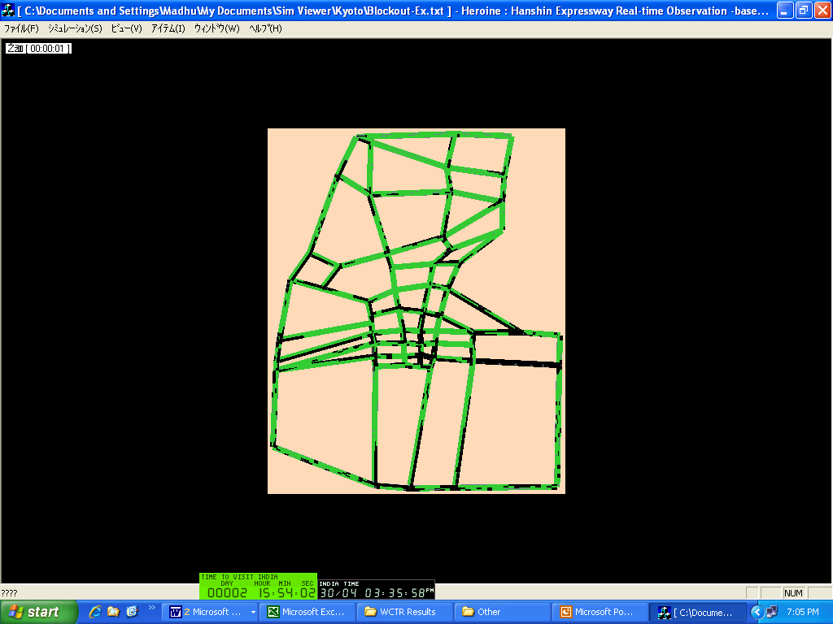
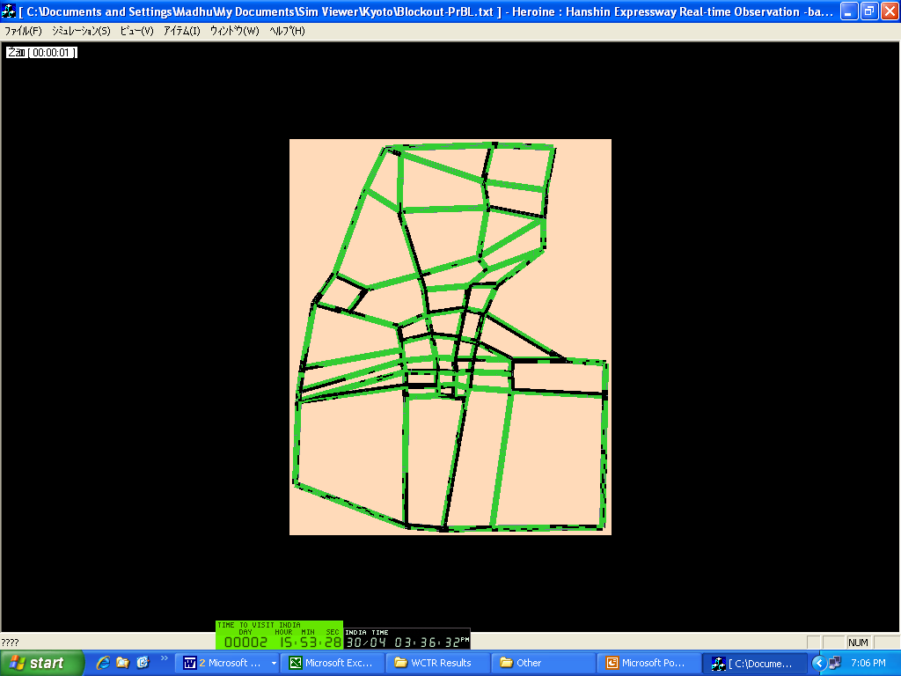
8:00 AM
8:00 AM
Non-priority links got Congested

Congestion reduced

Congested blocks = 802
Congested blocks = 736

Figure 13: Congestion before and after Priority Bus Lane and Signal Priority
From the above figure it can be understood that priority bus lane with signal priority policy has reduced congestion significantly on link 51 and 65 and also on cross street links associated with those links. The total congested blocks have also reduced from this policy to about 736 as it was about 802 for exiting situation. The highest number of congested blocks is reduced for priority bus lane and signal priority for bus compared to any other case. By reviewing all the results above, it can be concluded that priority bus lane with signal priority policy is judiciously adjusting total travel time and network speed. It has also increased number of vehicles using bus route and improved travel by bus and car. Though the priority bus lane with signal priority policy combined with bus service level policy has improved travel by increasing network speed, it involves investment cost and as such bus travel time has not reduced significantly. This priority bus lane with signal priority policy had also made the significant car users to change their mode to bus compared to other options. By considering all these factors, it can be said that priority bus lane with signal priority policy is expected to bring optimum benefits out of all considered options and seems to be more reasonable and beneficial in user and operator point of view.

5. Concluding Remarks

In this study, a combined fuzzy logic based mode choice and microscopic simulation model has been developed and tried to evaluate different transport policies. The main summary of findings from this study has been given as below:
- Mode choice model has been integrated with microscopic simulation model to account the driver reactions in terms of changing mode under different transport polices. With this, proposed microscopic simulation model can be used for evaluation of wide range of transport polices.
- Fuzzy logic has been implemented in all the traffic models namely mode choice, route choice, car-following and lane change models. As these models have used fuzzy reasoning approach, they can be easily calibrated with minimum efforts and extended for other cities as well.
- It can be concluded from the results that traffic models with fuzzy reasoning seems to be estimating driver behaviour more realistically and overcame the problem faced by standard modelling.
- In the present study, priority bus lane and signal priority for bus (option 1), on-street parking restriction (option 2) and bus service level (option 3) have been considered for evaluation and also various combinations among them have also been tried. It has been found that priority bus lane with signal priority policy would bring optimum benefits out of all considered options and seems to be more reasonable and beneficial in user and operator point of view.
In this study, various issues involved and methodology to consider fuzzy logic in each of the traffic models have been discussed in detail. It is expected that the proposed methodology would improve accuracy in the results thus the effective implementation of polices. The authorities responsible for implementation of various transport policies can use the proposed methodology and estimate most beneficial policy more realistically. In future scope of this study, it is proposed to consider mode choice behvaiour explicitly by considering socio-economic parameters in the model. Along with that, it is proposed to consider commuters’ behaviour related to information provision and various PT policies such as bus location system etc.

References

Akiyama, T. (2000) ‘Extended traffic assignment models with fuzzy travel time’, Proc. 4th AFSS, Japan, 1, May-Jun 2000, pp. 587-592.
Akiyama, T. and Nomura, T. (1999) ‘The proposal of fuzzy traffic assignment models’, Journal of EASTS, 3(6), pp. 263-277.
Algers, S., Bernauer, E., Boero, M., Breheret, L., Di Taranto, C., Dougherty, M., Fox, K., and Gabard, J. (1997) ‘Review of micro-simulation models’. Smartest Project deliverable D3. Leeds, UK.
Barcelo, J. and Casas, J. (2002) ‘Dynamic network simulation with AIMSUN’, Proc. International Symposium on Transport Simulation, Yokohoma, Japan, August 2002.
Brackstone, M. and McDonald, M. (1999) ‘Car-following: A historical review’, Transportation Research F, 2, pp 181-196.
BusVic. (2005) ‘Public Transport Mode Shift - the Key to Tackling Congestion in our Cities Main purpose is to evaluate transport policies’, Report submitted to Victorian Competition and Efficiency Commission Inquiry into Managing Transport Congestion, Bus Association Victoria, December 2005.
Chakroborty, P. and Kikuchi, S. (1999) ‘Evaluation of general motors based car-following models and proposed fuzzy inference model’, Transportation Research C, 7, pp 209-235.
Chandler, R. E., Herman, R. and Montroll, E. W. (1958) ‘Traffic dynamics: studies in car following’, Operations Research, 6, pp. 165-184.
Dubios, D. and Prade, H. (1980) Fuzzy sets and systems: Theory and applications, Academic Press Inc., New York.
Dubios, D. and Prade, H. (1983) ‘Ranking fuzzy numbers in the setting of possibility theory’, Information Sciences, 30, pp. 183-224.
Errampalli, M., Reddy, T. S., and Ravi Shekar, CH. (2004) ‘Modelling mode choice for metropolitan cities of second order in India’, Proc. TRANSPO 2004, IIT, Chennai, India, February 2004, pp. 407-416.
Errampalli, M., Okushima, M. and Akiyama, T. (2005a) ‘Microscopic simulation model considering public transport policy’, Journal of EASTS, 6, pp. 2718-2733.
Errampalli, M., Okushima, M. and Akiyama, T. (2005b) ‘Evaluation of Bus Lane Policy by Microscopic Simulation Model’, Proc. 4th ITS Symposium, Tokyo, Japan, December 2005, pp. 187-192.
Errampalli, M., Okushima, M. and Akiyama, T. (2006) ‘Lane change modelling with fuzzy logic in microscopic traffic simulation’ Proc. SCIS & ISIS, No. FR-GR-2, Tokyo, Japan, September 2006, pp. 919-924.
Errampalli, M., Okushima, M. and Akiyama, T. (2007) ‘Fuzzy logic based microscopic traffic simulation’, under preparation.
Gazis, D. C., Herman, R. and Potts, R. B. (1959) ‘Car following theory of steady state traffic flow’, Operations Research, 7, pp. 499-505.
Gipps, P. G. (1981) ‘A behavioural car-following model for computer simulation’, Transportation Research B, 15, pp. 105-111.
Gipps, P. G. (1986) ‘A model for the structure of lane-changing decisions’, Transportation Research B, 35(5), pp. 107-120.
Herman, R., Montroll, E. W., Potts, R. B. and Rothery, R. W. (1959) ‘Traffic dynamics: analysis of stability in car following’, Operations Research, 7, pp. 86-106.
Hidas, P. (1998) ‘A car-following model for urban traffic simulation’, Traffic Engineering + Control, 39(5), pp. 300-305.
Hidas, P. (2002) ‘Modelling lane changing and merging in microscopic traffic simulation’, Transportation Research C, 10, pp. 351-371.
Kikuchi, S. and Chakroborty, P. (1992) ‘Car-following model based on a fuzzy inference system’, Transportation Research Record 1365, TRB, pp. 82-91.
Kim, B. J. (2002) ‘Design of fuzzy PD+I controller for tracking control’, Proc. American Control Conference, Alaska, USA, May 2002, pp. 2124-2129.
Kitamura, R., Fujii, S. Yamamoto, T. and Kikuchi, A. (2000) ‘Application of PCATS/DEBNetS to regional planning and policy analysis: Micro-simulation studies for the cities of Osaka and Kyoto, Japan’, Proc. European Transport Conference, Cambridge UK, 2000, pp. 199-210.
Liu, R., Van Vliet, D and Watling, D. (2006) ‘Microsimulation models incorporating both demand and supply dynamics’, Transportation Research A, 40, pp.125-150
Mizutani, K. and Akiyama, T. (2000) ‘A descriptive hybrid model of modal choice with using fuzzy reasoning’, Proc. 4th AFSS, 2000, 1, May-Jun 2000, pp. 593-598.
Pendyala, R. M., Kitamura, R., Chen, C. and Pas, E. I. (1997) ‘An activity-based microsimulation analysis of transportation control measures’, Transport Policy, 4(3), pp. 183-192.
PTV Ltd (2007) http://www.english.ptv.de/cgi-bin/index.pl
Quadstone Paramics Ltd. (2007) http://www.paramics-online.com/index.php
Rakha, H. and Crowther, B. (2003) ‘Comparison and calibration of FRESIM and INTEGRATION steady-state car-following behavior’. Transportation Research A, 37, pp. 1-27.
Tai, H. P., Akiyama, T. and Okushima, M. (2003) ‘Development of combined modal split/traffic assignment model with fuzzy logic’, Proc. EASTS, 4, pp. 663-677.
Takihi, Y., Okushima, M. and Akiyama, T. (2002) ‘Application of inflow control method with fuzzy logic for urban expressway’, Proc. SICS & ISIS, Tokyo, Japan, September 2002.
Tanaka, K. (1997) An introduction to fuzzy logic for practical applications, Spinger-Verlang, New York.
Wu, J., Brackstone, M. and McDonald, M. (2000) ‘Fuzzy sets and systems for a motorway microscopic simulation model’, Fuzzy Sets and Systems, 116, pp. 65-76.
Wu, J., Brackstone, M. and McDonald, M. (2003) ‘The validation of a microscopic simulation model: a methodological case study’, Transportation Research C, 11, pp. 463-479.
Yang, Q. and Koutsopoulos, H. S. (1996) ‘A microscopic traffic simulator for evaluation of dynamic traffic management systems’, Transportation Research C, 4(3), pp.113-129.
Zadeh, L. A. (1999) ‘Fuzzy sets as a basis for a theory of possibility’, Fuzzy Sets and Systems, 100, pp. 9-34.

