The technical and economic benefits of data fusion for real-time monitoring of freeway traffic
Preliminary results and implications of a study with simulated data
Dr. Ir. J.W.C. van Lint (corresponding author)
j.w.c.vanlint@tudelft.nl
Tel. +31 15 2785061
Fax +31 15 2783179
Transportation and Planning Department
Faculty of Civil Engineering and Geosciences
Delft University of Technology
Stevinweg 1, P.O. Box 5048,
2600 GA Delft, the Netherlands

Professor Dr. Ir. S.P. Hoogendoorn
S.Hoogendoorn@citg.tudelft.nl
Transportation and Planning Department
Faculty of Civil Engineering and Geosciences
Delft University of Technology
Stevinweg 1, P.O. Box 5048,
2600 GA Delft, the Netherlands

Submitted for publication and presentation for the 11th World Congress on Transport Research, 24-28 June 2007

Summary
A large part of the Dutch freeway network is equipped with dual inductive loops placed about every 4-500 meters apart. In the foreseeable future it is likely that this infrastructure bound monitoring system will be gradually replaced (and partially rendered obsolete) by a new floating-car data (FCD) monitoring system or possibly other non-intrusive sensors. In this paper we assess whether it is possible to facilitate such a shift with a combination of a first order (LWR) traffic flow model and an extended Kalman filter (EKF), which is able to integrate data from different sensors, and translate these into a most probable estimate of the state in a traffic network.
On the basis of synthetic data this paper illustrates that such a gradual shift is not only possible but even advantageous. First of all there is a large overall gain in the quality of the sensor data by simply using the LWR-EKF model – this is true even in case just loops are used. Secondly, fusing FCD with loop data dramatically improves both performance and robustness of the monitoring system as compared to using loop data only. This is true for all sensor combinations we tested under all degrees (0 – 50%) of randomly missing data. The increase in performance, however, decreases quickly with higher percentages of FCD. Based on hypothetical but realistic assumptions on the costs of traffic sensors, it appears that there are many combinations of sensors which are efficient in terms of costs and performance. The “optimal” monitoring system (in terms of costs and performance) combines a few loops with a moderate percentage (2-4%) of floating car data and uses the LWR-EKF algorithm to maximize the information contained in the available data.
Although these are preliminary results on a simple freeway corridor, they justify a larger scale study into efficient network-wide traffic data fusion algorithms.

Introduction
The research questions addressed in this paper arose from a broad discussion within the Dutch Ministry of Transport, Public Works and Water management in the past few years, concerning the future of traffic monitoring in the Netherlands and particularly on freeways. The current monitoring system on the Dutch freeways consists of inductive loops located (on the largest part of the network) about every 500 meters. It is reasonable to expect that in the next 10-15 years a large part of the Dutch (and probably EU and US) car-parc will be equipped with a new generation of in-car navigation and control systems, which enable two-way communication (vehicle-vehicle and vehicle – infrastructure and vice versa), and hence pave the way to a new generation of traffic monitoring systems. In some parts of the world these floating car data based monitoring systems are already operational, e.g. the Vehicle Information and Communication System (VICS) in Japan, which was set up by both government and private companies, and which will likely provide 35 million Japanese car-drivers with online traffic information in 2007 (Ministerie van Economische Zaken, 2006). Based on these expectations the main research questions are
- Is it possible to gradually shift from infrastructure based monitoring to floating car data while maintaining an accurate and reliable monitoring system?
- Is there quantitative evidence for an optimal mix of loops and floating car data (or any alternative data) in terms of accuracy, reliability and costs (both investment and maintenance)?
In this paper both questions are addressed on the basis of a preliminary experiment with simulated data. In the next sections first the methods and models used in this experiment will be discussed. Next, the experimental setup will be explained and finally the results of these experiments will be discussed. The paper closes with a discussion, conclusions and recommendations for further research.

Traffic state estimation and data fusion
Effective (dynamic) traffic management (DTM) strongly depends on the reliability and accuracy with which one can deduce the current state of a traffic system. However, data from a multitude of different sensors do not necessarily mount up to coherent and meaningful information on the state in a traffic network. Data from different sensors, such as camera’s, induction loops, or in-car GPS/GSM devices, are typically characterized by different formats, semantics, temporal and spatial resolution and accuracy, and also greatly differ in availability and reliability both as a function of location, time and circumstances (Van Lint, 2004, Van Lint et al., 2005).
In many fields of science, such as robotics, medical diagnosis, image processing, air traffic control, remote sensing and ocean surveillance (see e.g. (Yager, 2004, Aarabi and Dasarathy, 2004, Sohn and Lee, 2003, Piella, 2003, Xiong and Svensson, 2002, Varshney, 1997, Hall, 1992)), the de facto method for state-estimation is multi-sensor data fusion, a technique by which data from several sensors are combined to provide comprehensive and accurate information. The available data fusion algorithms (see (Linn and Hall, 1991) for an overview) range from low level (sensor level) to high level inference (at network level), and provide users with increasingly aggregated and comprehensive information on the state of a system. Using similar arguments as in (Kikuchi et al., 2000, Dailey et al., 1996), data fusion generally leads to
- Increased confidence and accuracy: unreliable and or inconsistent information due to errors can be converted to consistent information with a lower error rate
- Reduced ambiguity: joint information from multiple sensors reduces the set of hypotheses about the current state of the system
- Increased robustness: one sensor can contribute information where others are unavailable, inoperative, or ineffective
- Enhanced spatial and temporal coverage: one sensor can work when or where another sensor cannot
- Decreased costs, because
  - a suite of “average” sensors can achieve the same level of performance as a single, highly-reliable sensor and at a significantly lower cost.
  - less sensors may be required to obtain a complete picture of the system state.
With these arguments in mind, data fusion is an obvious solution for dealing with data from traffic sensors and translating these into meaningful information. As argued in (Wang and Papageorgiou, 2005), the obvious choice for a traffic data integration tool on freeway corridors (and networks) is a macroscopic traffic flow model (TFM) which is kept in sync with real-time measurements from traffic sensors by means of Extended Kalman Filters (EKF – also other, more generic filter paradigms may be applied, such as Unscented KF or Particle Filters). The TFM of choice in (Wang and Papageorgiou, 2005) is a second order Payne-type model. In our approach, however, we will use a simpler, first order traffic flow model for this purpose.

Methodology: LWR Model and the Extended Kalman Filter

The LWR Model
The basic tool in this exercise is a first order traffic flow model (Lighthill and Whitham, 1955). It is based on the only exact law of traffic flow theory “conservation of vehicles” (CoV), and a (static and certainly not exact) equilibrium equation which connects traffic flow q(x,t) to traffic density k(x,t) and determines the kinemative wave speed C(x,t) with which changes in density (e.g. queue spill-back) propagate over a road.
In eqn q(x,t) = Q^{e}(k(x,t)) depicts this static equilibrium equation, often referred to as fundamental diagram. The main assumption is that traffic is considered homogeneous over space and stationary over time on small regions in (x, t). As a result, a third traffic variable mean speed u(x,t) (m/s) can be deduced from flow and density as follows
which is often referred to as the continuity equation. Discretized, the LWR model can be expressed in state-space form for a single road segment (cell) i as follows
process equation:
in which t now denotes discrete time, and and denote the flow (flux) of vehicles in and out of this segment of length Δx_{i}. These fluxes can be calculated with a Gudunov solver (Lebacque, 1996), which assigns to these fluxes the minimal flow requested in demand (i-1) and supply (i+1) cells. Note that this scheme heavily depends on the fundamental diagram parameters, introduced below (for details on the Godunov demand-supply scheme we refer to (Lebacque, 1996)). The static model output equation also equals this fundamental diagram, which by definition of flow continuity (flow equals density x mean speed) provides an estimate of both flow and mean speed on each cell.
measurement equation(s)
In the experiment below we use a slightly adapted version of Daganzo’s triangular fundamental diagram (Daganzo, 1997), in which speed decreases linearly with increasing density in non-congested conditions and quadratically in congestion. As a result, the free branch of the Q^{e}(k) relationship is parabolic (Figure 1).
with

The LWR model and the Extended Kalman Filter
Equations - constitute a discrete nonlinear state space system. Given we have actual observations with which we can calculate the error eqn makes, the extended Kalman filter (EKF) (Simon, 2006) provides a straightforward solution to estimate (in the least squares sense) the (unobserved) traffic densities in eqn . Given the nonlinear mapping from state (densities) to output (speeds, flows) the EKF requires local linearization (around the current state) to “translate” this output error to an error in the state estimate, and adjust the latter accordingly. That local linearization not necessarily leads to an unrealistic traffic flow model is shown in (Munoz et al., 2006), who describe and calibrate a linear version of the LWR model and conclude this linearized version in fact reproduces approximately the same phenomena as the original model. Besides maintaining an estimate of the mean state, the EKF also provides an estimate of the error covariance around this mean. Details on the EKF algorithm can be found in many textbooks (e.g. (Simon, 2006)). Here we just highlight the main issues, tailored to our application.

Initialization and assumptions on the uncertainty in model and measurements
First we initialize both the traffic state z (which depicts the vector of all N cell densities) and the error covariance P by a large diagonal matrix which reflects the fact that we initially make large errors and that we have no prior knowledge on any cross correlations between different segment states.
Secondly we need to make some (strong) assumptions on the uncertainty (the noise) in both model and measurements. We assume all noise structures are zero mean Gaussians, independent and stationary (no time-dependency). In (Wang and Papageorgiou, 2005) it is argued that the COV equation is noise free, since COV is an exact law. The law itself may be exact, however, as in our case the fluxes are calculated with the same fundamental diagram is used for the output, there is inherently noise in the resulting cell densities, due to errors in calculating these fluxes. The noise structures used are
Now for t=1,2, … recursively apply the following time and measurement updates.

The prediction step (time update)
(a) predict state
in which f() reflects the discrete COV function in eqn , solved with the Gudunov scheme. Note that it is straightforward to include the boundary demands in the state as well, in case these are (partially) unobserved.
(b) predict error covariance
in which F denotes the derivative of f() to the densities around the last estimate.
Calculating this derivative is straightforward, but is nonetheless more involved than may appear at first look. In the Gudunov scheme the fluxes in and out of a cell depend on the regime (congested or free) of demand and supply cells. As a result a derivative needs to be calculated for each possible combination of regimes in the current cell and its demand and supply cells.

The correction step (measurement update)
In the correction step model predictions are corrected with actual observations, given such an observation is available on one or more of the cells:
(a) Set t = t+1
(b) Calculate prediction error
in which y_{t} depicts a measurement and g() the measurement equation(s)
(c) Calculate Kalman gain (correction factor)
in which G is the derivative of the measurement equation to the state, that is
and subsequently
(d) Correct state
(e) Correct error covariance
The so-called Kalman Gain K_{t} in eqn can be interpreted as follows
Thus, what the algorithm effectively does is that it recursively updates with a factor K_{t} which balances (a) the uncertainty in the traffic state (densities) predicted by the model and (b) the total uncertainty (noise) in the measurement equation (which is also a function of the errors in the state estimation P_{t|t-1}), proportional to the sensitivity of the model output to changes in the state. For example, large model uncertainty (P) and small measurement uncertainty (W) imply large state corrections, given the output changes rapidly with the traffic state. This is for example the case with speeds when densities are a fraction larger than the critical density (see Figure 1).
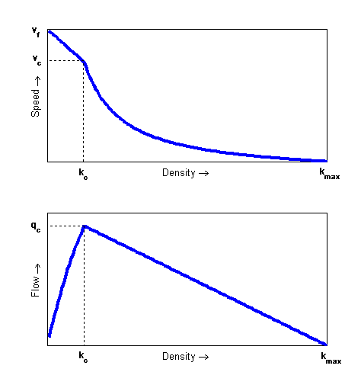
Figure 1: speed-density (top) and flow density (bottom) relationships used

Experimental setup

Freeway stretch and simulated data
The data used in this experiment is produced by the freeway microscopic traffic simulator FOSIM (Dijker, 2002), which has been developed by the Delft University of Technology for the Dutch Ministry of Transport, Public Works and Water Management and has been extensively calibrated and validated to match traffic operations on Dutch freeways. FOSIM allows the analyst to simulate traffic and collect data (flows and harmonic mean speeds) from inductive loops, and detailed data of individual vehicles, from which floating car data can be emulated.
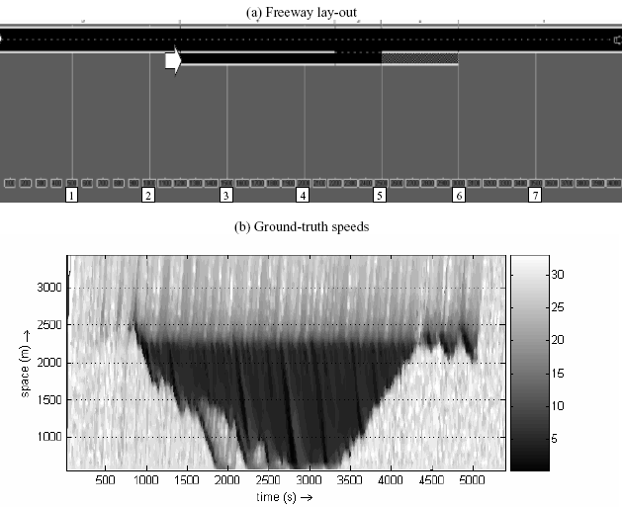
Figure 2: Simulation setup in FOSIM: (a) three kilometer two-lane freeway with an onramp half-way. The numbers in squares in the bottom depict locations for inductive loops, the block arrows depicts a permanent single loop which measures traffic volume at the onramp; (b) space-time contourplot of resulting speeds of demand scenario (dark colors depict low speeds)
In this experiment we simulated traffic operations on a three km two-lane freeway stretch with an onramp about halfway as shown in Figure 2(a), where the white text blocks with numbers 1 to 7 depict possible locations for inductive loops. As space discretization for LWR model we subdivide this stretch into 30 segments of 100 meters. For demonstration purposes we consider one traffic scenario in which traffic demand upstream and at the onramp gradually increases until the capacity of the bottleneck (upstream the on ramp) is reached and inevitable congestion sets in. Figure 2(b) shows a space-time contour plot of the resulting speeds.

Monitoring options
A (fictitous) traffic manager is asked to equip this freeway stretch with a monitoring system which is accurate and robust (with respect to sensor failure) in terms of reconstructing these ground-truth speeds at the lowest possible price. At the onramp entry a single inductive loop is already available due to a ramp metering installation. The additionally available monitoring options are any combination of the following:
- 1 to 7 dual inductive loops at locations 1 to 7 in Figure 2(a), where the scenarios we will test are 1 loop at location 1 (effectively measuring upstream demand); 3 loops at locations 1, 4, and 7 and 7 loops at all available locations.
- A subscription to a commercial floating car data service whith a garantueed percentage of equipped vehicles (1% in peak hours is roughly equivalent to about 60 vehicles). The choices are subscriptions of 0, 2, 4, 6, 8 en 10% equipped vehicles.

Dual inductive loops collect one-minute average harmonic mean speeds, and one minute volume counts, while the FCD service provides the average speed of vehicles present on segments of 100 meters along the freeway every 15 seconds. If no probe report is available in a segment during a 15 second time period, no data is transmitted. We assume there is no time delay due to data communication in either FCD service or loop detection system. From current practice it is known that both types of sensors may produce unreliable data (or even none at all). To test the robustness of each monitoring system to missing data, each must be tested at increasing amounts of sensor failure, which is done by randomly omitting 0%, 10%, 20%, 30%, 40% and 50% of the available measurements (both loops and FCD). The next section will outline the various data fusion scenarios tested in this study

Data fusion scenarios, assumptions and setting of LWR-EKF parameters

Base data fusion scenario
The first and base data fusion scenario is one in which the available speeds from loops and FCD service are simply averaged for each cell. Speeds from loops are assigned to the cell the loop is installed in, or to two adjacent cells, in case the loop is exactly at the boundary between these. FCD data is assigned to the cell on which the vehicle transmitting its speed was driving. On cells were no measurements are available a simple combination of interpolation and smoothing between the available measurements is used to fill in the gaps. The routine works as follows. Given a measurement U(i,p) is missing (where p denotes a 15 second time interval and i the cell index), we can apply in the spatial direction
In which i_{a} is the first downstream cell for which in time period p a measurement is available. In the time direction we apply the following procedure:
In which
is an exponential forecast, with the smoothing parameter α∈[0,1]. Setting α=0.3 provided – under all circumstances – a practical balance between tracking and smoothing. The gap is now filled with the minimum of both interpolates (implying the maximum constraint on mean speed, that is

Four model-based data fusion scenarios
There are four additional data fusion scenarios, which all involve the LWR-EKF algorithm for fusing the available data. The distinction between these four is in
- Using only speeds versus using both flows and speeds. Note that in the “just speeds” scenarios case also flows from the loop at location 1 are used (for traffic demand)
- Using the “normal” versus the “augmented” LWR-EKF algorithm, where in the augmented case also the four parameters of the fundamental diagram are jointly estimated with the traffic state. Note that in both cases we assume that all model parameters are equal for each cell. As in (Wang and Papageorgiou, 2005), below we will assume the fundamental diagram parameters can be modeled as a random walk, that is
In sum, there are 5 data fusion scenarios, each of which is tested against 18 possible sensor combinations (6 percentages FCD x 3 induction loop configurations) and 6 degrees of missing data. The total amount of simulation runs is hence 5 x 18 x 6 = 540. Table 1 briefly summarizes these.
Table 1 Summary of data fusion scenarios
Data fusion scenario | State-estimator used | Data | Sensors | Missing data (%) | Total simulations
1 (base) | none | Speeds | 18 combi’s | 0,10,20,30,40,50 | 108
2 | LWR-EKF | Speeds | idem | Idem | 108
3 | LWR-EKF augmented state | Speeds | idem | Idem | 108
4 | LWR-EKF | Speeds+flows | idem | Idem | 108
5 | LWR-EKF augmented state | speeds+flows | idem | Idem | 108
 |  |  |  |  | 540

Parameter settings
In this study two sets of parameters are important.
- parameters used in the LWR model and particularly the fundamental diagram (eqn )
In data fusion scenarios 2 and 4 (the non-augmented case, see Table 1), the following parameter settings for free and critical speed, and critical and jam density are used:
In scenarios 3 and 4 these are used as initial (startup) values (the parameters are adapted along with the state)
- (noise) parameters of the EKF procedure which govern the weight and speed with which the model state is corrected to the observed data
Since it is our aim to fuse measurement data, while preserving as much information contained in these as possible, the output noise (for speeds and flows) needs to be set equal or preferably smaller than the process noise. Since there are possibly two sources of speed available (loops and FCD), a choice needs to be made on the noise level in each of these. Although the induction loops provide a harmonic speed average of all (or at least most) passing vehicles, the underlying assumption that harmonic time mean speed equals the actual space mean speed is that traffic is considered both stationary over the observation period and homogeneous on the cell on which the loop is located. On the other hand, although the FCD reports provide “true” space mean speeds, these speeds reflect the mean of a (small) random sample of passing vehicles. A reasonable assumption therefore is that both measurements have the same noise level which we set to 1 km/h. Finally for the augmented LWR-EKF algorithm, we need to set noise levels for the fundamental diagram parameters. Below all noise settings are summarized:

Performance measures of monitoring scenarios: costs versus benefits
In terms of benefits we calculate the root mean of squared error (RMSE) of all estimated cell speeds during the entire simulation time T for each of the 540 data fusion scenarios:
As a measure for accuracy we calculate the mean RMSE value over all (6) missing data percentages, resulting in 540/6=90 performances:
For a reliability measure we look at the average rate with which the RMSE increases under increasing percentages of missing data. We do this by calculating for each monitoring scenario the following least-squares regression line
in which the gradient UR is considered a measure for robustness (the smaller it is, the more robust a system is considered). Note that under these definitions a monitoring system can be inaccurate (high PERF) but still robust (small UR) and vice versa.
Finally, for calculating costs we use hypothetical numbers, which are approximately in the same order as in Dutch practice. The yearly costs for induction loops are 10k€ per loop + 20 k€ fixed (central ICT facilities), whereas a subscription to the FCD service costs 2k€/km/year per %FCD, which in this case equals 6k€/year per % equipped vehicles. As a combined measure for the costs and benefits CB_{j} of each data fusion scenario j the product of total costs and performance of a particular data fusion scenario and monitoring system is calculated relative to the best and worst possible combinations:
A high value of CB_{j} hence hence reflects a very efficient system, which combines high performance with low costs.

Results
Figure 3, Figure 4 and Figure 5 show the performance and robustness of all data fusion scenarios listed in Table 1. Below first the results on performance and robustness are discussed; next these results will be combined with the associated costs of each monitoring system, on the basis of which the main research questions in this paper will be addressed.

Performance and robustness
There are a number of observations to be made from Figure 3, Figure 4 and Figure 5. The first and most important one is that in all cases, data fusion scenarios 2, 3, 4, and 5 (the ones using the LWR-EKF algorithm) outperform the base scenario. This implies that including a traffic model and an adaptive filtering technique (and thus knowledge on the dynamics of traffic) significantly improves the value of data which comes from whatever type of monitoring system under whatever degree of data failure. Off course since the underlying data is generated by an microsimulation model (FOSIM), this does not provide any guarantee these data are representative of actual traffic conditions. Nonetheless, the data do represent highly stochastic and complex traffic operations, which are reconstructed significantly better with a simple macroscopic traffic model and the EKF algorithm than by just averaging and interpolating. It is reasonable to expect that also with real data, the LWR-EKF algorithm would improve data reconstruction.
Secondly, the performance graphs in Figure 4(a), (b), Figure 5(a) and (b) clearly show that combining floating car data with loop data dramatically improves performance. Even with just 2% equipped vehicles, a monitoring system with just three inductive loops outperforms one with seven loops and no FCD, and performs only slightly worse than the one with seven loops and 2% FCD.
Another interesting result is that the differences between the performance of the 4 LWR-EKF data fusion scenarios under different monitoring combinations are small. In all cases the performance improves in a very similar convex way with increasing FCD percentages (compare the left graphs in Figure 4(a), (b), Figure 5(a) and (b)). Thus, counter-intuitively, there does not seem to be a large gain in performance or robustness by using additional flows (additional to the ones used for traffic demand!), nor does augmenting the traffic state with the model parameters improve performance more than marginally (in some case performance is even worse). A plausible explanation of both phenomena may be that performance is measured only in terms of estimated cell speeds. Since we specifically chose the EKF noise parameters such that most weight is put on the measurements, it makes sense therefore that these speed measurements also have the largest impact on performance. This means that in both the normal and augmented LWR-EKF case state corrections will be large en fast in favor of the (speed) measurements. Another reason why the additional flows do not provide additional performance gain may be attributed to the “first order” nature of the LWR model. Neither flows nor speeds are governed by spatial dynamics and differ in their dependence on the state (densities) only by a factor k. Effectively, both flow and speed measurements steer the traffic state in approximately the same direction.
A fourth point is that, as said above, all performance graphs in Figure 3, Figure 4(a), (b), Figure 5(a) and (b) are approximately convex curves. This implies that the improvement in performance decreases with increasing percentages FCD. From 0% to 2% the improvement is dramatic (in the order of 40%), while from 6 to 8% FCD the gain is only marginal. This is even true in the base scenario.
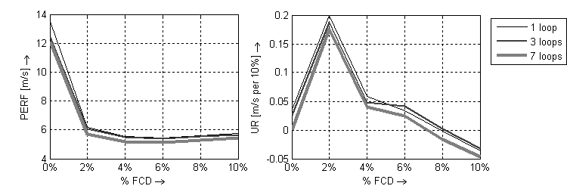
Figure 3: Performance (left) and robustness (right) of data fusion scenario 1 (base scenario)
A final result is that in data fusion scenarios 2-5 almost in all cases the measure for UR (right graphs in Figure 4(a), (b), Figure 5(a) and (b)) is relatively small (on average not more than 10% RMSE lost for every 10% added missing data) and in a few cases (those with zero % FCD) even negative, implying that in those cases the RMSE would even decrease with larger % of missing data. The latter off course is not that meaningful, since in those cases also the average performance is low. From our results it appears that with FCD percentages of 2% and higher, performance decrease is in the worst case proportional to the degree of missing data, which provides some evidence that the LWR-EKF data fusion scheme is robust and provides for a graceful degradation of performance under increasing degrees of missing data.

(a) Data fusion scenario 2: “normal” LWR-EKF algorithm
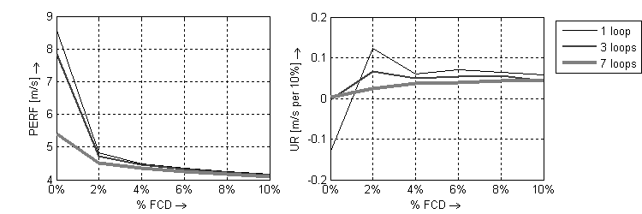
(b) Data fusion scenario 3: “augmented” LWR-EKF algorithm
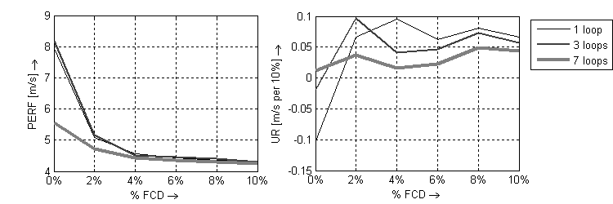
Figure 4: Performance (left) and robustness (right) of data fusion scenarios 2 & 3 in which only speeds from loops are used as a function of the percentage floating car data (FCD)

Answering the research questions
In the introduction two main research questions were posed. Based on the results above these will be answered below.

Is it possible to gradually shift from infrastructure based monitoring to floating car data while maintaining an accurate and reliable monitoring system?
The results above indicate that at least in our experiment this is clearly possible. Gradually moving from a monitoring system with 7 inductive loops and 0% FCD to a system with just one loop and 10% FCD even leads to a gradual improvement in both accuracy and reliability, particularly when the data fusion is done with an adaptive traffic flow model such as the LWR-EKF algorithm described in this paper.

Is there quantitative evidence for an optimal mix of loops and floating car data (or any alternative data) in terms of performance and costs (both investment and maintenance)?
To answer this question Table 2 ranks three selections of the evaluated data fusion / monitoring systems by the CBj measure, which indicates the efficiency of each system. The first interesting observation is that the best performing combination is ranked among the 10 least efficient systems. This system (ranked nr 81) offers a 4.1 RMSE performance but at a very high price. Secondly, the top 10 ranked systems all combine 1 induction loop with a low percentage of FCD. This confirms the answer to the first question: a new and detailed generation of floating car data will improve traffic monitoring and all possible applications which use these traffic data largely.

(a) Data fusion scenario 4: “normal” LWR-EKF algorithm
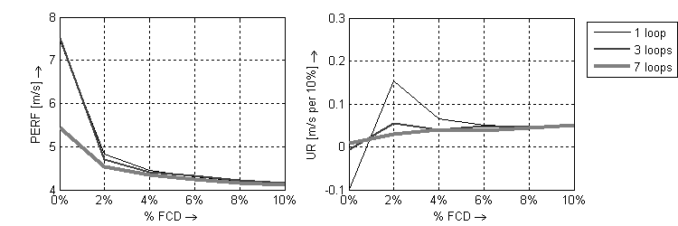
(b) Data fusion scenario 5: “augmented” LWR-EKF algorithm
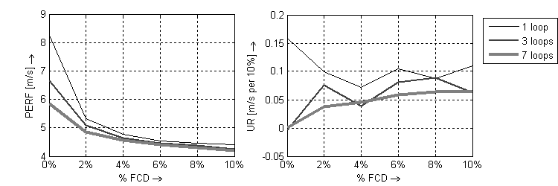
Figure 5: Performance and costs of data fusion scenarios 4 & 5 in which both speeds and flows from loops are used as a function of the percentage floating car data (FCD)
Table 2 also provides a list of “average” efficient monitoring systems. Compared to the top 10 ranked systems, the main difference is in price for which a slight improvement in quality is obtained. For example, compare the system ranked 1 with the system ranked 41. The latter offers an increase in performance of 11% (RMSE 4.31 vs 4.83) but costs more than twice as much (90kE vs 42 kE). Finally Table 2 also overviews the 10 least efficient systems, which are either very expensive or perform very bad. Tellingly, all base case scenarios in which no traffic model is used are ranked between 81 and 90..
In sum, there is no clear cut answer to the question above, since this depends on how performance and costs are valued. Nonetheless, based on Table 2, there certainly is a case for depicting monitoring systems optimal which combine a few loops with a small percentage FCD (2-4%) by means of a simple traffic flow model as the one used here.
Table 2: ranking of data fusion scenarios
Rank | Scenario | % FCD | No. Loops | CB | RMSE | Total Cost
most efficient data fusion scenarios
1 | 4 | 2 | 1 | 96% | 4,83 | € 42.000
2 | 2 | 2 | 1 | 96% | 4,84 | € 42.000
3 | 3 | 2 | 1 | 96% | 5,08 | € 42.000
4 | 5 | 2 | 1 | 95% | 5,32 | € 42.000
5 | 4 | 0 | 1 | 95% | 7,45 | € 30.000
6 | 3 | 0 | 1 | 94% | 7,94 | € 30.000
7 | 4 | 4 | 1 | 94% | 4,44 | € 54.000
8 | 2 | 4 | 1 | 94% | 4,48 | € 54.000
9 | 3 | 4 | 1 | 94% | 4,55 | € 54.000
10 | 5 | 0 | 1 | 94% | 8,24 | € 30.000
“average”efficient data fusion scenarios
41 | 3 | 10 | 1 | 87% | 4,31 | € 90.000
42 | 2 | 0 | 3 | 87% | 7,83 | € 50.000
43 | 5 | 10 | 1 | 87% | 4,40 | € 90.000
44 | 1 | 0 | 1 | 86% | 13,50 | € 30.000
45 | 1 | 4 | 3 | 86% | 5,48 | € 74.000
46 | 3 | 0 | 3 | 86% | 8,19 | € 50.000
47 | 4 | 8 | 3 | 86% | 4,21 | € 98.000
48 | 2 | 8 | 3 | 86% | 4,23 | € 98.000
49 | 5 | 8 | 3 | 85% | 4,39 | € 98.000
50 | 3 | 8 | 3 | 85% | 4,40 | € 98.000
least efficient data fusion scenarios
81 | 2 | 10 | 7 | 76% | 4,10 | € 150.000
82 | 4 | 10 | 7 | 76% | 4,10 | € 150.000
83 | 1 | 0 | 3 | 75% | 12,40 | € 50.000
84 | 1 | 10 | 3 | 75% | 5,66 | € 110.000
85 | 5 | 10 | 7 | 75% | 4,20 | € 150.000
86 | 3 | 10 | 7 | 75% | 4,26 | € 150.000
87 | 1 | 6 | 7 | 74% | 5,12 | € 126.000
88 | 1 | 8 | 7 | 70% | 5,29 | € 138.000
89 | 1 | 10 | 7 | 66% | 5,44 | € 150.000
90 | 1 | 0 | 7 | 52% | 12,08 | € 90.000

Conclusions and Recommendations
In this preliminary study we assessed the performance on a single freeway stretch of different data fusion scenarios and combinations of monitoring systems under increasing degrees of missing data. Below the main findings are summarized
- A gradual shift from infrastructure based monitoring (inductive loops) to an FCD based monitoring system is not only possible but even advantageous, given intelligent tools are used to fuse these data. The LWR-EKF algorithm described in this paper is a simple and robust example of such a tool.
- There is a large gain in using an adaptive traffic flow model to fuse data from different sensors (in our case loops and floating car data). This is true for all sensor combinations we tested under all degrees (0 – 50%) of randomly missing data.
- Fusing FCD with loop data dramatically improves both performance and robustness to missing data as compared to using loop data only.
- The increase in performance, however, decreases quickly with higher percentages of FCD. In our example, moving from 0 to 2% FCD improves the RMSE about 40%, an increase from 6 to 8% improves performance not more than marginally
- Based on hypothetical but realistic assumptions on the costs of traffic sensors, it appears that there are many combinations of sensors which perform approximately equal. The costs, however, differ largely. The “optimal” monitoring system (in terms of costs and performance) combines a few loops with a moderate percentage (2-4%) of floating car data and the above mention LWR-EKF algorithm to maximize the information contained in the available data.
This paper only addressed the simple case of a single freeway stretch. Further research is needed (and ongoing) to extend these results to (freeway) corridors and networks.

Acknowledgement
This work is sponsored by the ICIS Data fusion project (http://www.icis.decis.nl/), the Netherlands.

References
AARABI, P. & DASARATHY, B. V. (2004) Robust speech processing using multi-sensor multi-source information fusion – an overview of the state of the art. Information Fusion, 5, 77-80
DAGANZO, C. F. (1997) Fundamentals of Transportation and Traffic Operations, Oxford, UK, Elsevier Science Ltd.
DAILEY, D. J., HARN, P. & LIN, P.-J. (1996) ITS Data Fusion. Washington State Transportation Commission, Department of Transportation and the U.S. Department of Transportation, Federal Highway Administration.
DIJKER, T. (2002) FOSIM (Freeway Operations SIMulation).
HALL, D. L. (1992) Mathematical techniques in multi-sensor data fusion, Norwood, Massachusetts, Artech House, Inc.
KIKUCHI, S., MILJKOVITC, D. & VAN ZUYLEN, H. J. (2000) Examination of Methods that Adjust Observed Traffic Volumes on a Network. Transport Research Record, 1717, 109-119.
LEBACQUE, J. P. (1996) The Gudunov Scheme and what it means for First Order Traffic Flow Models. IN LESORT, J. B. (Ed.) Proceedings of the 13th International Symposium on Transportation and Traffic Theory. Lyon, France.
LIGHTHILL, M. & WHITHAM, G. (1955) On Kinematic Waves II: A theory of traffic flow on long crowded roads. Proc. R. Soc, A 229, 317-345.
LINN, R. J. & HALL, D. L. (1991) A Survey of Multi-sensor Data Fusion Systems. Proceedings of the SPIE - The International Society for Optical Engineering. Orlando, Florida.
MINISTERIE VAN ECONOMISCHE ZAKEN (2006) ITS in Japan. Trendwatchers voor innovatie en Technologie (TWA network). Tokyo.
MUNOZ, L., SUN, X., HOROWITZ, R. & ALVAREZ, L. (2006) A Piecewise-Linearized Cell Transmission Model and Parameter Calibration Methodology. 85th Transportation Research Board Annual Meeting. Washington, D.C., The National Academies.
PIELLA, G. (2003) A general framework for multiresolution image fusion: from pixels to regions. Information Fusion, 4, 259-280
SIMON, D. (2006) Optimal State Estimation: Kalman, H-infinity, and Nonlinear Approaches, New York, John Wiley & Sons.
SOHN, S. Y. & LEE, S. H. (2003) Data fusion, ensemble and clustering to improve the classification accuracy for the severity of road traffic accidents in Korea. Safety Science, 41, 1-14
VAN LINT, J. W. C. (2004) Reliable Travel Time Prediction for Freeways, PhD Thesis. TRAIL Research School. Delft, The Netherlands, Delft University of Technology.
VAN LINT, J. W. C., HOOGENDOORN, S. P. & VAN ZUYLEN, H. J. (2005) Accurate Travel time Prediction with State-Space Neural Networks under Missing Data. Transportation Research Part C: Emerging Technologies, 13, 347-369
VARSHNEY, P. K. (1997) Multisensor data fusion. ELECTRONICS & COMMUNICATION ENGINEERING JOURNAL, 245-253.
WANG, Y. & PAPAGEORGIOU, M. (2005) Real-time freeway traffic state estimation based on extended Kalman filter: a general approach. Transportation Research Part B, 39, 141–167.
XIONG, N. & SVENSSON, P. (2002) Multi-sensor management for information fusion: issues and approaches. Information Fusion 3, 163-186
YAGER, R. R. (2004) A framework for multi-source data fusion. Information Sciences, 163, 175-200

