Bivariate traffic relations: A space-time modeling approach
Yiannis Kamarianakis∗, Poulicos Prastacos
Regional Analysis Division, Institute of Applied and Computational Mathematics, Foundation for Research and Technology, Vasilika Vouton, GR 71110, Heraklion Crete, Greece

Abstract

Research on speed-flow-density relationships usually focuses on homogeneous road segments. This article aims at exploring these relationships at the macro setting of a road network based on time series observations collected from various measurement sites (spatial time series). For that purpose, we use tools from spatial statistics/econometrics, namely systems of dynamic equilibrium correction equations in space and time. Such models not only reproduce a static equation but also depict short-term dynamics. Moreover, the road network’s topology is incorporated in the modeling stage through specification of a weighting matrix. The adopted methodology is illustrated through the investigation of the flow-occupancy relationship in space and time. In the application, we use an extensive data set that corresponds to one month’s data, collected from major arterials of the road network of Athens, Greece.

Keywords: Bivariate traffic relations, space-time modeling, equilibrium correction

1. Introduction

It is well accepted that distinct roadways accommodate different levels and patterns of vehicular flow, by virtue of their design. Traffic flow is described in terms of three parameters: the mean speed υ, the traffic flow rate q, and the traffic density k. The functional relationship between these three parameters is called Fundamental Diagram. The equilibrium relationship that associates them is q= υ k. Accordingly, the fundamental diagram is defined clearly if a function between two of the three parameters is defined. Since the bivariate functional relations between q, υ and k are directly related to the important problem of estimation of road capacity, research on these issues dates back to Schaar (1925).
Two general approaches for stating speed-flow-density relationships may be distinguished. The classical approach has been a purely mathematical one. Firstly, an analytical expression containing several parameters is proposed and then the values of these parameters are estimated by fitting the expressions to traffic data. Finally, an interpretation of the parameters in terms of properties of traffic flow is sought, in order to provide the analytical expression with a phenomenological meaning. The famous speed–density models of Greenshields (1935), Greenberg (1959), Underwood (1961) and Drake (1967) have been derived in such a manner.
The second approach that may be called phenomenological or behavioral is based on assumptions about the driver behavior with respect to some traffic variables. The early procedures for estimating the capacity and those derived from car-following models belong to this approach. For some recent studies of that kind, the reader is referred to Kockelman (1998, 2001). Del Castillo and Benitez (1995a, 1995b) presented a methodology that combines both general approaches in a study of the speed density relationship.
In contrast to the previously mentioned approaches that investigate the q-υ-k bivariate functional forms in homogeneous road segments, the methods presented in this paper can be applied in a larger scale that allows inference even for a whole road network. Based on the existing amount of traffic flow data which nowadays is large and of good quality, the models developed here are purely statistical and do not incorporate theoretical rationales such as hydrodynamic, car-following, etc. That is, instead of building a theoretical framework and then test it empirically with real world data (a significant amount of such research has been proven to encounter severe limitations), we let data to speak-up first and play a more decisive role in the modeling process.
Traffic measurements are usually collected from loop detectors that provide traffic counts at constant time intervals. Consequently, these datasets are in the form of spatial time series. For data of that kind, one is interested in estimating multivariable relationships in space and time; that is detecting possible equilibria between traffic variables and estimating their adjustment speed after a shock (short run dynamics). Under the assumption that a sufficiently large number of measurement sites exist at the network under study so that the researcher is allowed to ignore potential inferential biases due to their position, conjectures of that kind can be achieved via Dynamic Space Time models and their equilibrium correction formulation. Thus, this research presents a modeling strategy that allows for the examination of

- Long-term traffic flow dynamics for the whole network: The equilibrium relationships between υ- q, υ- k and/or q-k in the road network.
- Short-term dynamics of the network: Equilibrium’s speed of adjustment after a shock.
- Long-term dynamics for each measurement location: Location specific equilibria.
- Short-term dynamics for each measurement location: How fast the location-specific equilibrium is approached after a shock in this location or how fast the location-specific equilibrium is approached after a shock in a neighboring location.

The aforementioned model class and the subsumed models that fit better on the needs of our problem, together with technical details on estimation and model selection are presented next. The third section contains a detailed numerical illustration; the proposed methods are performed on a month’s data taken from eleven loops located at major arterials of the city of Athens. The last section is devoted to some concluding remarks.

2. Dynamic space-time models and their equilibrium correction formulation for bivariate traffic relations

2.1 The general first-order model

Past and present observations of traffic variables in a road network can be related via a dynamic model in space and time. One may encounter such models in the econometrics literature as “serial and spatial autoregressive distributed lag models”. The interested reader can find an introduction to distributed lag models at Greene (1997). Elhorst (2001) presents a detailed treatment of first order Dynamic Space-Time models and their equilibrium correction formulation. For the moment, we also consider first order models, which relate present observations to the instant past. Presented in vector form for a cross-section of observations at time t the general first order model is of the form shown below :

$y_{t}=μ+{αy}_{t−1}+β_{0}{\text{Wy}}_{t}+β_{1}{\text{Wy}}_{t−1}+γ_{0}x_{t}+γ_{1}x_{t−1}+δ_{0}{\text{Wx}}_{t}+δ_{1}{\text{Wx}}_{t−1}+ε_{t}$. (1)

A variable with subscript t-1 denotes its serially lagged value, and a variable pre-multiplied by W denotes its spatially lagged value. $y_{t}$ denotes a $n×1$ vector consisting of one observation of the dependent variable for every measurement location (i=1,..,n) at time t; $x_{t}$ denotes a $n×1$ vector of the explanatory variable (for reasons of simplicity, only one regressor is considered at the moment). $μ,α,β_{0},β_{1},γ_{0},γ_{1},δ_{0},δ_{1}$ are the response parameters and $ε_{t}$ is a $n×1$ normally distributed vector containing the error terms with $E\left(ε_{t}\right)=0$ and $E\left(ε_{t}ε_{t}^{'}\right)=σ^{2}I_{n}$. $W=\left\{w_{\text{ij}}:∀i,j=1,\text{.}\text{.}\text{.},n,w_{\text{ij}}≥0\right\}$ denotes an $n×n$ matrix describing causality relations related to the spatial arrangement of the measurement locations. Thus, $w_{\text{ij}}>0$ reflects that a change in traffic conditions close to i is expected to affect traffic conditions close to j. Since no measurement location can be viewed as a neighbor of itself, weight matrices have zero diagonal elements. We put more emphasis on the different forms that a spatial weight matrix can take, in the next subsection.
The general model depicted in (1) relates current observations of let’s say average speed at site i to the immediately previous ones taken from that location, to current and previous linear combinations (that are explicitly defined through the rows of the weight matrix) of measurements that correspond to neighboring sites, to past and current observations of let’s say average density at site i, and to past and current combinations of densities that correspond to neighboring sites. The plausibility of the proposed model is straightforward but it should be underlined that we are not expected to be able to estimate the general form accurately because of multicollinearities; one should estimate suitable sub-models in order to make inference. For example, it should be expected that the two terms corresponding to spatially weighted densities are highly correlated with current and past observations of densities; if this is confirmed, we should better drop one of the two pairs of variables out of the model.

2.2 The spatial weight matrix

Weight matrices as the one in equation (1) have been implicitly assumed in short term traffic forecasting models. In studies of that kind, measurements taken from upstream measurement locations (only) are supposed to have explanatory power for the ones taken from downstream sites thus resulting to the implicit adoption of a lower diagonal weight matrix (see for example Stathopoulos and Karlaftis, 2003). Kamarianakis and Prastacos (2002, 2003) have explicitly assumed such a matrix while using Space-Time ARIMA methods for short-term forecasting in urban networks. To clarify things, we present part of a hypothetical network and the weight matrix that corresponds to equal weights to nearest upstream neighbors. In figure 1 one may recognize the tree structure of a road network with dots representing measurement locations and arrows the direction of flow.

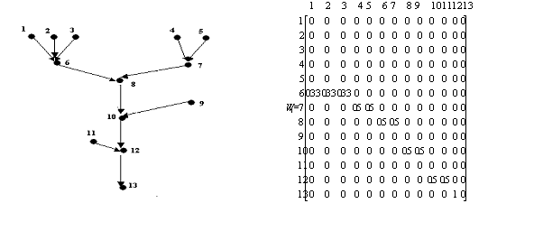
Figure 1. Measurement locations at a road network and the spatial weight matrix that corresponds to equal weights for nearest upstream neighbors.

It is important to keep in mind that all subsequent analyses are conditional upon the choice of the spatial weight matrix and that there are plenty of choices for its form. For example, a researcher may drop the assumption that only upstream locations are causal to downstream ones and take the k-nearest neighbors or the neighbors that lie at a predefined distance regardless of being upstream or downstream. Another option that seems rational when urban networks are under investigation is the adoption of two weight matrices; one corresponding to upstream causalities and one for downstream ones. Such matrices can be part of a threshold autoregressive model where traffic conditions are divided into homogeneous regimes. Hence, one will be able to estimate the relative explanatory power of upstream/downstream locations to the traffic conditions of a reference location.
As noted in the previous subsection, one strategy is to assign equal weights to all neighbors of a measurement location, considering that the useful information on the evolution of our response given from its neighbors is of equal quantity across them; a second approach is to assign weights proportional to inverse distance, treating favorably the closer neighbors. For forecasting applications, weights can be proportional to the cross-correlations of measurements that correspond to different locations. Nonzero elements of each row will correspond to coefficients of a vector autoregressive model where the vector contains measurements from the reference site and all its “neighbors”. We should finally note that in the vast majority of spatial modeling applications, rows of the spatial weight matrix are standardized to sum to one.

2.3 The equilibrium correction formulation

Let’s start from the first order serial autoregressive distributed lag model (a sub-model of (1) with no spatial dependencies)

$y_{t}=μ+{\text{ay}}_{t−1}+γ_{0}x_{t}+γ_{1}x_{t−1}+ε_{t}$ (2)
which can be equivalently reformulated as
$y_{t}=\frac{μ}{1−α}−\frac{α}{1−α}{Δy}_{t}+\frac{γ_{0}+γ_{1}}{1−α}x_{t}−\frac{γ_{1}}{1−α}{Δx}_{t}+\frac{1}{1−α}ε_{t}=\hat{μ}+\hat{a}{Δy}_{t}+\hat{b}x_{t}+\hat{c}{Δx}_{t}+u_{t}$.
(3)
Now short-run dynamics have been added to the static equation. That is equation (3) not only contains the static long run equilibrium relationship between y and x in the whole network but also captures short-run dynamics of how equilibrium is approached. $\hat{b}$ reflects the long-run effect of y with respect to x, while $\hat{c}$ reflects the short-run immediate response of y to a change in x.
Long-run dynamics of each location’s equilibria while taking into account their spatial arrangement within the network are given after reformulating the equation

$y_{t}=μ+α{\text{Wy}}_{t}+{βx}_{t}+γ{\text{Wx}}_{t}+ε_{t}$ (4)
to
$y_{t}={\left(I_{N}−αW\right)}^{−1}μ+\left[β{\left(I_{N}−αW\right)}^{−1}+γ{\left(I_{N}−αW\right)}^{−1}W\right]x_{t}+u_{t}$. (5)

Via this formulation, observations from a measurement site are not only influenced by its local conditions, but also by those of its neighbors depending on the structure of the spatial weight matrix. Furthermore, the impact of these conditions is not necessarily uniform across spatial units.
In order to assess both (spatially dependent) long and short-term dynamics for each location one has to manipulate the general first order equation (1) to take the form

$\begin{aligned}\left(I−αL−β_{0}W−β_{1}W\right)y_{t} \\ μ−\left(α+β_{1}W\right){Δy}_{t}+\left(γ_{0}+γ_{1}\right)x_{t}+\left(δ_{0}+δ_{1}\right){\text{Wx}}_{t}−γ_{1}{Δx}_{t}−δ_{1}{WΔx}_{t}+ε_{t}\end{aligned}$. (6)
This equation entails a static equilibrium relation between y and x and describes how this equilibrium is approached after a change on the levels of the explanatory not only at the location of interest, but at neighboring influential locations as well.
In order to illustrate equilibrium correction modeling we present a simple example. Following Greene (1997), we examine the relation between flow and occupancy at a single location. Empirical findings suggest that a linear model of squared occupancies on flows fits observed data quite well. Let $y_{t}$ stand for observed flows at time t and $x_{t}$ for squared occupancies. If the level of $x_{t}$ has been unchanged for many periods prior to t, the equilibrium value of $E\left[y_{t}\right]$ (assuming it exists) will be

$\bar{y}=a+\sum_{i=0}^{∞}{β_{i}\bar{x}}=a+\bar{x}\sum_{i=1}^{∞}{β_{i}}$ (7)

where $\bar{x}$ is the permanent value of $x_{t}$. For this to be finite, we must have $\left|\sum_{i=0}^{∞}{β_{i}}\right|<∞$. Consider now the effect of a ten percent change in $\bar{x}$ occurring in period s (e.g. due to an accident, construction works e.t.c.). Prior to the shock in occupancies, flows had reached equilibrium. The path to the new equilibrium might appear as shown in figure 2. The short-run effect is the one that occurs in the same period as the change in $\bar{x}$. This is $β_{0}$ in the figure; this is the short-run multiplier. The differences between the old equilibrium D₀ and the new one D₁, is the sum of individual period effects. That is the total effect is equal to $β=\sum_{ι=0}^{∞}{β_{i}}$; β is the equilibrium multiplier.

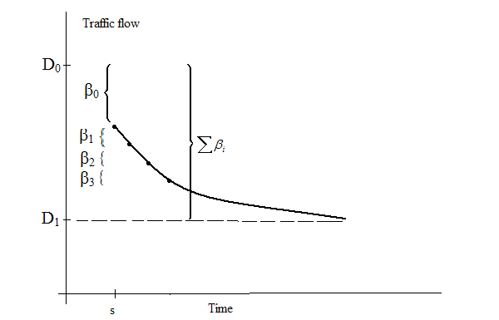

Figure 2: Lagged adjustment of traffic flow equilibria.

2.4 Technical details

The serial lagged dependent variable among regressors causes the OLS estimators to lose their unbiasedness property. The spatial-econometrics literature has shown that the inclusion of a spatial lag of the dependent variable on the right hand side of the equation not only makes the OLS estimator to lose its unbiasedness but it loses its consistency as well. The most commonly suggested method to overcome this problem is estimation via maximum likelihood (see Anselin, 1988, pp. 181-182). Elhorst (2001) provides the (conditional upon the vector of first observations) log-likelihood function of the general first order model given by equation (1):

${\text{Logf}}_{Y_{T},Y_{T−1},\text{.}\text{.}\text{.},Y_{2}|Y_{1}}=−\frac{1}{2}n\left(T−1\right)\text{log}\left(2{\text{πσ}}^{2}\right)+\left(T−1\right)\text{log}\left|I−αW\right|−\frac{1}{2σ^{2}}\sum_{t=2}^{T}{ε_{t}^{'}ε_{t}}$ (8)

Thus, if one wants to test against different model generating formulations through Wald, Lagrange multiplier or likelihood ratio tests and a spatial-lag model lies among the ones tested, he/she should estimate all of them via maximum likelihood. To facilitate maximum likelihood estimation of the α coefficient that reflects instantaneous spatial association in (1) and to ensure invertibility of the matrix $\left(I−αW\right)$, Ord (1981) demonstrates the following requirement

$\frac{1}{ω_{\text{min}}}<α<\frac{1}{ω_{\text{max}}}$ (9)

where ω_{min}, and ω_{max} are the minimum and maximum characteristic roots of the spatial weight matrix W.
Elhorst (2001) provides a general condition so that the general space-time process (1) is stationary in time:

$\left|\left(αI+β_{1}W\right){\left(I−β_{0}W\right)}^{−1}\right|<1$. (10)

He also describes in detail stationarity conditions on restricted models. These restrictions are captured by the log-likelihood functions in that these functions are not defined for parameter values that do not satisfy these conditions.

2.5 Systems of space-time equations

Speed, volume, density and their corresponding spatial lags are jointly dependent (endogenous) variables, that is one is dependent to the other and vice-versa. A critical assumption of the ordinary least squares method (OLS) is that regressors are uncorrelated with the residual. When current endogenous variables appear as regressors in other equations (endogenous variables depend on each other), this assumption is violated and the OLS parameter estimates are biased and inconsistent. In such cases, a system of structural equations is needed to adequately describe the observed values.
To comply with the above, one should formulate a system of equations that jointly characterize the evolution of traffic variables. As an illustrative example, we present a system of equations in space and time that incorporates both equilibrium and short-run dynamics for current volumes $y_{t}$ and densities $x_{t}$:

$\begin{aligned}y_{t}=μ_{1}+a_{1}y_{t−1}+β_{1}{\text{Wy}}_{t}+γ_{1}x_{t}+δ_{1}{\text{Wx}}_{t}+ε_{1t} \\ x_{t}=μ_{2}+a_{2}x_{t−1}+β_{2}{\text{Wx}}_{t}+γ_{2}y_{t}+δ_{2}{\text{Wy}}_{t}+ε_{2t}\end{aligned}$ (11)

In (11) current volumes and densities are jointly dependent and both depend on the (also endogenous) spatial lags. The errors in the two equations can be correlated and their covariance matrix can be used for extra estimation precision. Using only terms that correspond to previous time-periods one may formulate a model that can be used for short term forecasting purposes.

$\begin{aligned}y_{t}=μ_{1}+a_{1}y_{t−1}+β_{1}{\text{Wy}}_{t−1}+γ_{1}x_{t−1}+δ_{1}{\text{Wx}}_{t−1}+ε_{1t} \\ x_{t}=μ_{2}+a_{2}x_{t−1}+β_{2}{\text{Wx}}_{t−1}+γ_{2}y_{t−1}+δ_{2}{\text{Wy}}_{t−1}+ε_{2t}\end{aligned}$ (12)

The reader should note that in this case there is a single forecasting model irrespective of the number of loop detectors.
In the double-equation system (11) there are four endogenous variables, namely current volumes and densities and the corresponding spatial lags. Estimation of such systems pertains to the use of instrumental variables, which should be at least as many as the endogenous variables in the system. There are two methods of estimation of the unknown coefficients that take into account error covariance in the system, three stage least squares (3SLS) and full information maximum likelihood. For details regarding methods of estimation in systems of equations like (11) the interested reader is referenced to Greene (1997, chapter 15) or Hamilton (1994, chapter 9); Anselin (1984, chapters 6 and 7) presents a treatment that focuses in spatial regression models.

3. The application

3.1 The study area and the data analyzed

The urban area of Athens, the capital of Greece, has an area of 60 km² and a population of approximately four million people. Total daily demand for travel is about 5.5 million trips with about 1 million occurring during the 2-hour peak period. A set of 88 loop detectors has been installed by the Ministry of Environment and Public Works at major roads of the Athens network to measure traffic volume and road occupancy. Measurements take place every 90 seconds and are immediately transmitted to the Urban Traffic Control Center where they are used by the Siemens MIGRA traffic control system to adjust street lights timing and stored in databases for further analysis, see Kotzinos (2001). An indicator of data quality ranging from 1 to 3 is transmitted as well since often electronic or system failures result in measurements that might not be accurate.
The dataset used for the illustration of the methodology consists of observations that correspond to eleven loop detectors (figure 3). For all loops, traffic direction is towards the center of the city. A typical period –in terms of traffic flow- was selected to be studied: from February 11 2002, to March 10, 2002. Observations corresponding to weekends were discarded since traffic flow patterns differ significantly these days. The initial dataset contained a time series of 21210 observations for every loop detector. To ease implementation and smooth out noise, averages over five consecutive 90-second intervals were taken, thus resulting in a total of 4242 observations per detector, 192 measurements per day for each loop.
Observations from loop detector seven are depicted at figure 4. A sinusoidal pattern can be observed in both volumes and occupancies, the higher part corresponding to morning until afternoon when congestion occurs and the lower part corresponding to the night hours. There is also a sign of dependence between the level of both variables and their variation. These findings hold in general for every measurement location of our study.

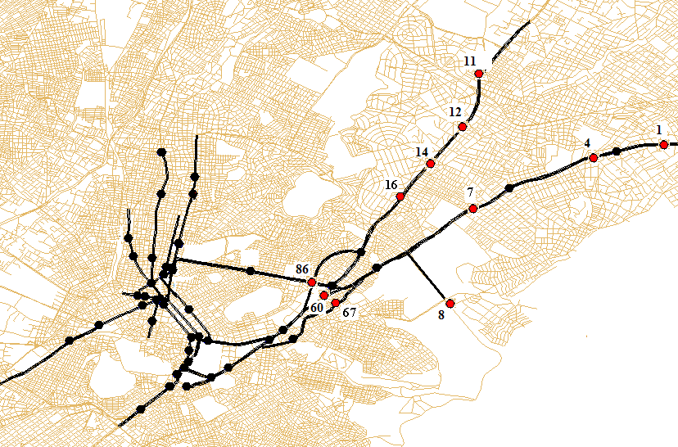
Figure 3. Loop detectors at the Athens road network. The ones used in this study are
highlighted with different color and a label.

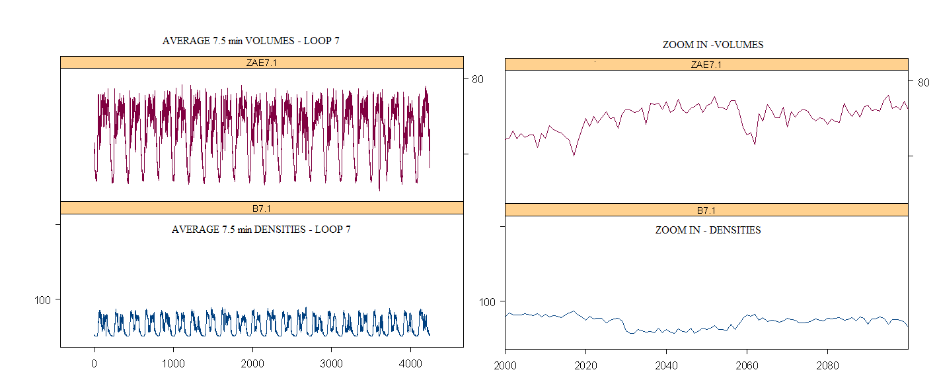
Figure 4. Evolution of volumes and densities through time for loop detector 7

3.2 Preliminary data investigation

The first step of the analysis was to investigate the flow-occupancy relationship for each loop detector separately. Seeking for an optimal linear model that best describes the relation, we applied the nonparametric method proposed by Young et al. (1976). Essentially, this method seeks for optimal transformations that need to be applied to a pair of variables so that their relationship becomes linear; the criterion used is maximization of R². For all loops, we observed that a polynomial of third order is better suited for occupancies. For volumes, results were not easily interpretable though; see for example figure 5, which displays the nonparametric smoothing spline transformations for loop seven. We continued via using the parametric method proposed by Box and Cox (1964). The Box-Cox method was applied to volumes given that they had to be expressed as third order polynomials of occupancies. In any case, no deviation from the original scale was indicated.
We thus performed linear regressions of third order polynomials of occupancies (explanatory part) to observed volumes, for each loop. Results are presented at table 1; figure 6 depicts some volume-occupancy scatterplots together with the polynomial regression curves. What one first observes from the R² statistics is the very satisfactory fit of the third order polynomial curves to the observed flow-occupancy relationships (except for loop 67) and the closeness of the R² of the regression when compared with the maximum R² that can be achieved from a nonparametric transformation of volumes and occupancies (last column). One should also note the similarity of regression coefficients for loops located at the same road. Regression errors were found to be both heteroscedastic and autocorrelated; that is one expects different levels of error on the prediction of volumes, at different levels of occupancies. Moreover the observed errors differ significantly from the i.i.d. regression hypothesis, displaying short term dependencies of large size. Heteroscedasticity and autocorrelation properties are directly related to the fact that both volumes and occupancies display larger variation at their high levels (mean dependent variation) and are time dependent variables. For normally distributed errors, these properties make the ordinary least squares estimators to lose their efficiency property. Given the size of our sample this is not a significant problem; what is important in our case is that our estimations continue being unbiased.

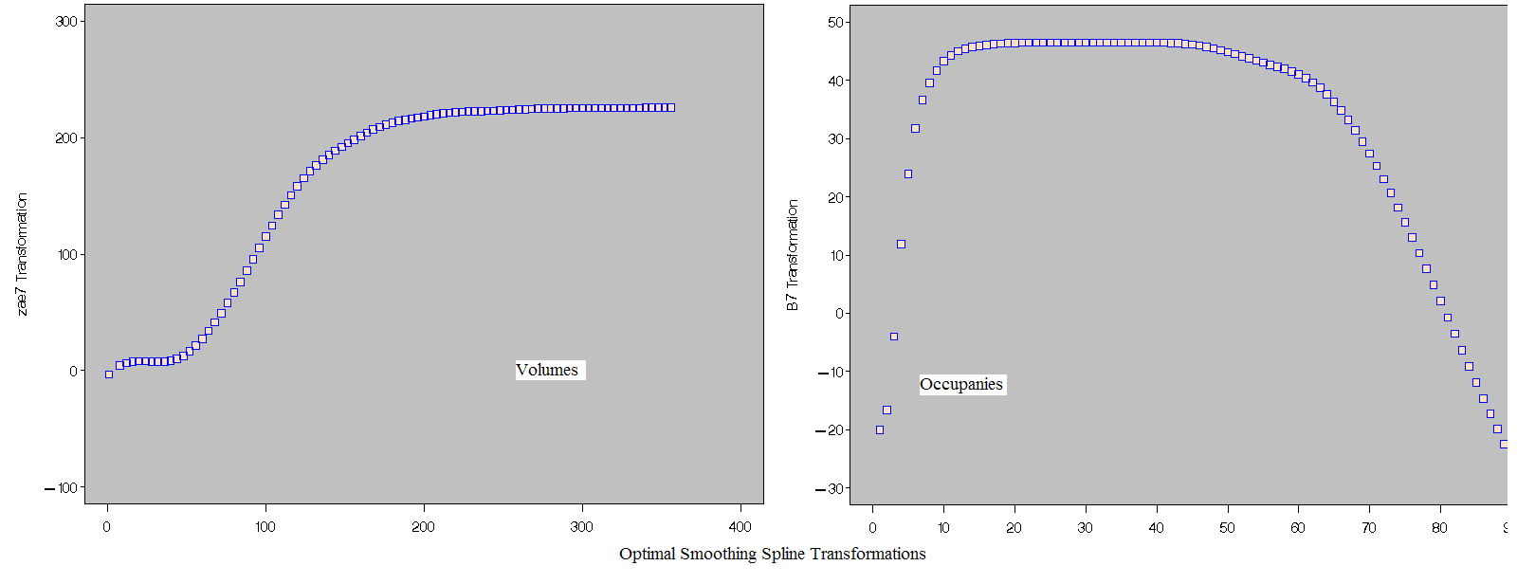
FIGURE 5.Transformations that linearize the relationship between volumes and occupancies.

 | INTERCEPT | LINEAR | QUADRATIC | CUBIC | REG R² | RMSE | Outliers  Num. | SM. SPL. R²
Loop 1 | 5.517  (0.2) | 5.1  (0.036) | -0.139  (0.0014) | 0.0011  (148 E-7) | 0.89 | 5.56 | 21 | 0.93
Loop 4 | 5.84  (0.19) | 4.7  (0.03) | -0.12  (0.001) | 0.009  (484 E-7) | 0.91 | 5.11 | 7 | 0.96
Loop 7 | 6.22  (0.178) | 4.38  (0.028) | -0.1  (0.001) | 0.0006  (983 E-8) | 0.93 | 4.62 | 0 | 0.947
Loop 8 | -0.553  (0.226) | 3.855  (0.037) | -0.062  (0.0013) | 0.0003  (128 E-7) | 0.96 | 4.82 | 4 | 0.96
Loop 11 | 4.54  (0.177) | 6.485  (0.035) | -0.2  (0.0018) | 0.0018  (242 E-7) | 0.95 | 4.68 | 24 | 0.96
Loop 12 | 9.95  (0.2) | 3.475  (0.03) | -0.08  (0.0011) | 0.0005  (979 E-8) | 0.83 | 5.74 | 0 | 0.933
Loop 14 | 7.735  (0.22) | 4.2  (0.043) | -0.1  (0.0015) | 0.0006  (136 E-7) | 0.86 | 5.62 | 6 | 0.9
Loop 16 | 4.2  (0.19) | 4.46  (0.03) | -0.1  (0.0012) | 0.0006  (127 E-7) | 0.95 | 4.12 | 12 | 0.95
Loop 60 | 2.12  (0.1) | 1.7  (0.01) | -0.046  (0.0005) | 0.0003  (404 E-8) | 0.84 | 2.26 | 14 | 0.86
Loop 67 | 2.13  (0.26) | 1.74  (0.03) | -0.04  (0.0008) | 0.0003  (64 E-7) | 0.55 | 6.087 | 0 | 0.59
Loop 82 | 2.741  (0.1) | 0.85  (0.01) | -0.015  (0.0004) | 0.0001  (363 E-8) | 0.83 | 2 | 1 | 0.84

Table 1. Third order polynomial regression of volumes on occupancies.

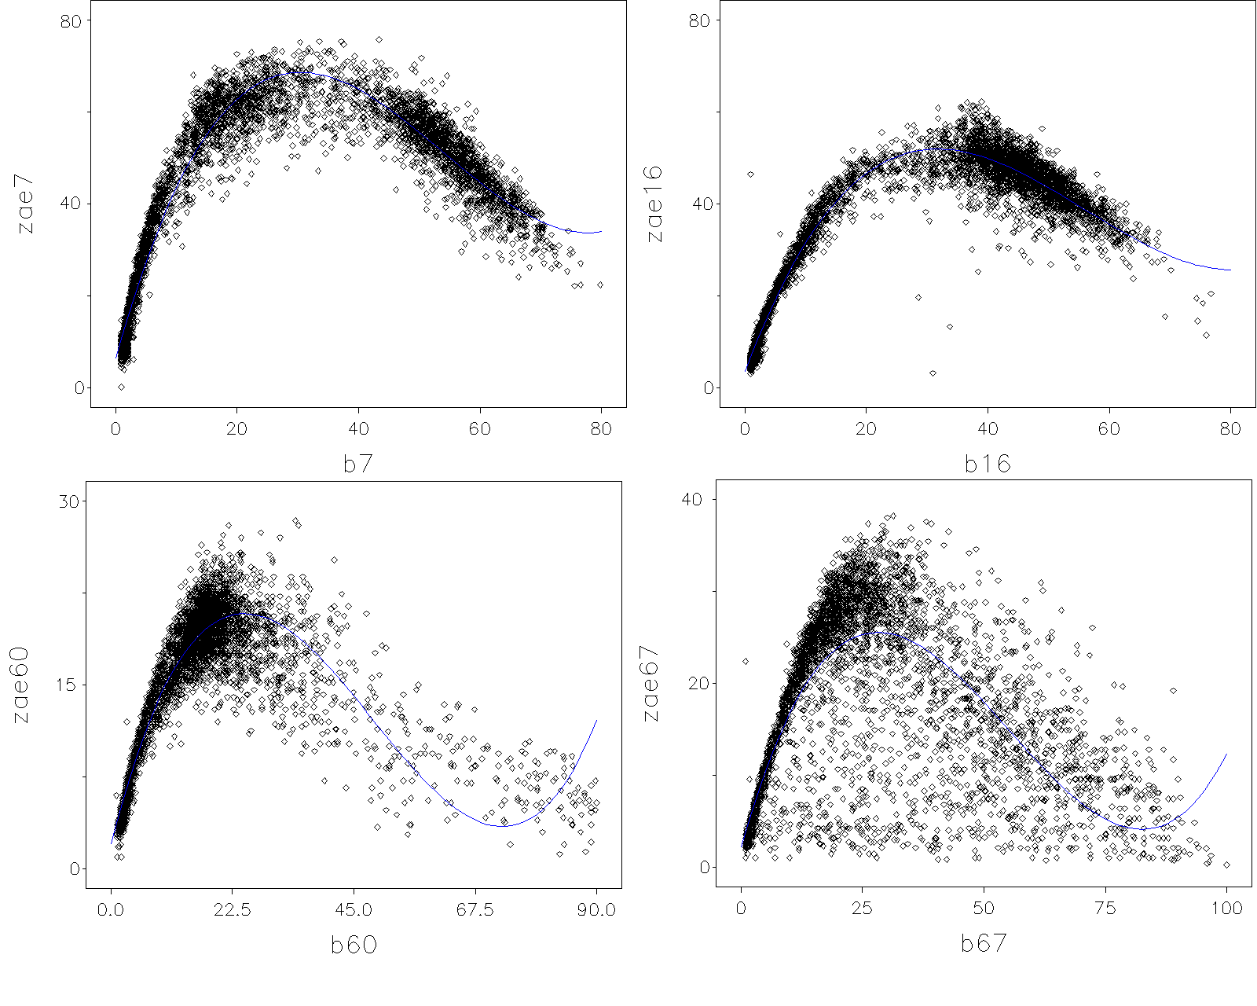
Figure 6. Occupancy-Volume scatterplots and third-order regression curves for four loops of the study.

3.3 Model fitting

The first step of the modeling stage was the construction of a weight matrix that reflects causality relations in the set of the eleven loops of the study. To simplify the analysis, we adopted the hypothesis of “upstream causality”; that is traffic conditions at upstream locations are causal to what we observe downstream and not vice-versa. For comparative purposes, we constructed two spatial weight matrices; the first contained only the nearest upstream neighbors for loops 4, 7, 12, 14 and 16. The second one contained all upstream neighbors with equal weights (figure 7). Each pair of spatial lags of volumes and occupancies –$\left(W_{1}y_{t},W_{2}y_{t}\right),\left(W_{1}x_{t},W_{2}x_{t}\right)$- contained almost perfectly correlated variables (Pearson correlation >0.97 for both cases) and because of that, modeling results were practically the same with either matrix. The modeling results presented next, correspond to the choice of the first weight matrix.

$W_{1}=\begin{matrix}\text{loop} & 1 & 4 & 7 & 8 & \text{11} & \text{12} & \text{14} & \text{16} & \text{60} & \text{67} & \text{86} \\ 1 & 0 & 0 & 0 & 0 & 0 & 0 & 0 & 0 & 0 & 0 & 0 \\ 4 & 1 & 0 & 0 & 0 & 0 & 0 & 0 & 0 & 0 & 0 & 0 \\ 7 & 0 & 1 & 0 & 0 & 0 & 0 & 0 & 0 & 0 & 0 & 0 \\ 8 & 0 & 0 & 0 & 0 & 0 & 0 & 0 & 0 & 0 & 0 & 0 \\ \text{11} & 0 & 0 & 0 & 0 & 0 & 0 & 0 & 0 & 0 & 0 & 0 \\ \text{12} & 0 & 0 & 0 & 0 & 1 & 0 & 0 & 0 & 0 & 0 & 0 \\ \text{14} & 0 & 0 & 0 & 0 & 0 & 1 & 0 & 0 & 0 & 0 & 0 \\ \text{16} & 0 & 0 & 0 & 0 & 0 & 0 & 1 & 0 & 0 & 0 & 0 \\ \text{60} & 0 & 0 & 0\text{.}\text{33} & 0\text{.}\text{33} & 0 & 0 & 0 & 0\text{.}\text{33} & 0 & 0 & 0 \\ \text{67} & 0 & 0 & 0\text{.}5 & 0\text{.}5 & 0 & 0 & 0 & 0 & 0 & 0 & 0 \\ \text{86} & 0 & 0 & 0\text{.}\text{25} & 0\text{.}\text{25} & 0 & 0 & 0 & 0\text{.}5 & 0 & 0 & 0\text{.}\text{25}\end{matrix}$ $W_{2}=\begin{matrix}\text{loop} & 1 & 4 & 7 & 8 & \text{11} & \text{12} & \text{14} & \text{16} & \text{60} & \text{67} & \text{86} \\ 1 & 0 & 0 & 0 & 0 & 0 & 0 & 0 & 0 & 0 & 0 & 0 \\ 4 & 1 & 0 & 0 & 0 & 0 & 0 & 0 & 0 & 0 & 0 & 0 \\ 7 & 0\text{.}5 & 0\text{.}5 & 0 & 0 & 0 & 0 & 0 & 0 & 0 & 0 & 0 \\ 8 & 0 & 0 & 0 & 0 & 0 & 0 & 0 & 0 & 0 & 0 & 0 \\ \text{11} & 0 & 0 & 0 & 0 & 0 & 0 & 0 & 0 & 0 & 0 & 0 \\ \text{12} & 0 & 0 & 0 & 0 & 1 & 0 & 0 & 0 & 0 & 0 & 0 \\ \text{14} & 0 & 0 & 0 & 0 & 0\text{.}5 & 0\text{.}5 & 0 & 0 & 0 & 0 & 0 \\ \text{16} & 0 & 0 & 0 & 0 & 0\text{.}\text{33} & 0\text{.}\text{33} & 0\text{.}\text{33} & 0 & 0 & 0 & 0 \\ \text{60} & 0 & 0 & 0\text{.}\text{33} & 0\text{.}\text{33} & 0 & 0 & 0 & 0\text{.}\text{33} & 0 & 0 & 0 \\ \text{67} & 0 & 0 & 0\text{.}5 & 0\text{.}5 & 0 & 0 & 0 & 0 & 0 & 0 & 0 \\ \text{86} & 0 & 0 & 0\text{.}\text{25} & 0\text{.}\text{25} & 0 & 0 & 0 & 0\text{.}5 & 0 & 0 & 0\text{.}\text{25}\end{matrix}$

Figure 7. The two weight matrices used

At the previous subsection, when modeling took place for each detector separately, it was shown that volumes can be well represented by third order polynomials of occupancies. In the “pooled-loop” case where we examine models of the form

$y_{t}=a+{\text{bx}}_{t}+ε_{t}$ (13)

and $y_{t},x_{t}$ are vectors of observations at time t corresponding to a set of loops, this is not the case. Due to high correlation (Pearson’s r >0.95) between pooled occupancies and pooled squared occupancies and much higher correlation of occupancies with volumes (Pearson’s r =0.45) than with squared occupancies (Pearson’s r =0.29) one should estimate models (1), (2), (4) with occupancies as the explanatory variable and not with squared occupancies or both.
To assess long and short run dynamics for the whole network based on the single equation models of section 2.3, one has to estimate equation (2). However, pooled occupancies and serially lagged pooled occupancies are so much correlated (Pearson’s r >0.97) that the specified regression model (2) would be susceptible to multicollinearity symptoms; the most important of these is that small changes in the data can produce large swings in the parameter estimates. There is no problem however for direct estimation of a slightly modified version of (2) via maximum likelihood:

$y_{t}=μ+αy_{t−1}+bx_{t}+c{Δx}_{t}+ε_{t}$. (14)

Estimation results and model fit statistics are displayed in table 2. To illustrate stability of the estimations we depict results for the whole dataset that contains measurements for one month (first row), for the last 75 percent of the observations with respect to time (second row) and for the last 50 percent of the observations. The constant term is highly significant thus, it seems that our deviation from Elhorst’s (2001) model is justified. The R² statistic indicates that the model explains approximately 93% of the data variability, which is very satisfactory.

 | $\hat{μ}$ | $$\hat{α}$$ | $$\hat{b}$$ | $\hat{c}$ | R² | AIC | SBC | Stand. Error
Eq. (14) | 1.004  (0.05) | 0.956  (0.0015) | 0.02  (0.001) | -0.15  (0.003) | 0.933 | 286508 | 286543 | 5.21
Eq. (14)  75% | 0.988  (0.06) | 0.956  (0.0016) | 0.02  (0.0016) | -0.14  (0.003) | 0.9325 | 200573.5 | 200607 | 5.23
Eq. (14)  50% | 0.988  (0.07) | 0.957  (0.0019) | 0.019  (0.0019) | -0.136  (0.004) | 0.9329 | 142904 | 142936 | 5.19

Table 2. Maximum likelihood estimates, standard errors (in parentheses) and model fit statistics for model (14).

On the other hand, it appears that the estimated models violate the assumptions of independent errors and constant variance. The Durbin’s h test for residual autocorrelation in the presence of lagged dependent variables (Durbin, 1970) indicates the presence of statistically significant autocorrelation. Table 3 contains estimated residual autocorrelations up to lag 48 for the model that correspond to full data –notice that since we model eleven loops, y_{t} is a vector of dimension 11, thus lag11 in our case corresponds to first order residual autocorrelation with respect to time. As evident from table 3, first order residual autocorrelation is the only “really” significant one; the significance of the remaining autocorrelations is mostly related to the magnitude of the dataset. The Portmanteau Q-tests and Lagrange multiplier tests for ARCH disturbances, which are not presented here, are also statistically significant indicating heteroscedasticity. A reason for that is that the variability in the traffic conditions differs significantly across loop detectors.

To  Lag | Chi-Square | DF | Pr>ChiSq | Autocorrelations
6 | 999.73 | 6 | <.0001 | 0.116 | 0.053 | 0.044 | 0.036 | 0.04 | 0.017
12 | 5711.72 | 12 | <.0001 | 0.029 | 0.033 | 0.058 | 0.067 | -0.3 | 0.032
18 | 6034.4 | 18 | <.0001 | 0.045 | 0.038 | 0.021 | 0.026 | 0.026 | 0.041
24 | 6440.85 | 24 | <.0001 | 0.032 | 0.02 | 0.05 | 0.05 | 0.041 | 0.021
30 | 6616.47 | 30 | <.0001 | 0.029 | 0.033 | 0.014 | 0.019 | 0.008 | 0.035
36 | 6831.52 | 36 | <.0001 | 0.035 | 0.026 | -0.001 | 0.033 | 0.034 | 0.022
42 | 6910.26 | 42 | <.0001 | 0.015 | 0.019 | 0.012 | 0.022 | 0.016 | 0.016
48 | 7546.83 | 48 | <.0001 | 0.029 | 0.104 | 0.017 | 0.028 | 0.023 | 0.018

Table 3. Autocorrelation check of residuals for model (14).

Violation of the independent errors assumption has three important consequences for ordinary regression. First, statistical tests of the significance of the parameters and the confidence limits for the predicted values are not correct. Second, the estimates of the regression coefficients are not as efficient as they would be if autocorrelation was taken into account. Third, since the ordinary regression residuals are not independent, they contain information that can be used to improve the prediction of future values. We can solve this problem by augmenting the regression model with an autoregressive model for the error term, thereby accounting for autocorrelation but we do not pursue estimation further since we estimated (14) just for to compare results with the ones that we obtain from a system of space-time equations.
Volumes, occupancies and the change in occupancies relative to the previous time period in equation (14) are jointly endogenous variables. To take endogeneity into account we formulate the following system:

$\begin{aligned}y_{t}=μ_{1}+a_{1}y_{t−1}+β_{1}x_{t}+γ_{1}{Δx}_{t}+ε_{1t} \\ x_{t}=μ_{2}+a_{2}x_{t−1}+β_{2}y_{t}+γ_{2}{Δy}_{t}+ε_{2t}\end{aligned}$ (15)

The first equation in (15), as in (14), expresses current volumes as linear combinations of the immediately previous observations of volumes, current measurements of occupancies and the difference in occupancies from the current to the previous period. In the second, current occupancies are expressed as linear combinations of immediately previous observations of occupancies, current observations of volumes and the difference in volumes from the current to the previous period.

Eq. 15 | μ₁ | α₁ | β₁ | γ₁ | R² | Stand. Error
SysR²: 0.85 | 1.197  (0.05) | 0.976  (0.0015) | -0.014  (0.0016) | -0.4  (0.0075) | 0.93 | 5.364
 | μ₂ | α₂ | β₂ | γ₂ | 0.93
 | 2.85  (0.128) | 0.966  (0.0036) | -0.057  (0.004) | -2.32  (0.05) | 0.7 | 12.54
Eq.15 -75% | μ₁ | α₁ | β₁ | γ₁ | R² | Stand. Error
SysR²:0.858 | 1.185  (0.06) | 0.974  (0.0016) | -0.012  (0.0019) | -0.384  (0.0085) | 0.93 | 5.365
SysR²:0.858 | μ₂ | α₂ | β₂ | γ₂ | 0.93 | 5.365
SysR²:0.858 | 2.97  (0.16) | 0.969  (0.0045) | -0.064  (0.005) | -2.44  (0.064) | 0.678 | 13.22
Eq.15-50% | μ₁ | α₁ | β₁ | γ₁ | R² | Stand. Error
SysR²: 0.86 | 1.18  (0.071) | 0.975  (0.002) | -0.013  (0.002) | -0.37  (0.01) | 0.93 | 5.3
SysR²: 0.86 | μ₂ | α₂ | β₂ | γ₂ | 0.93 | 5.3
SysR²: 0.86 | 3.03  (0.196) | 0.964  (0.005) | -0.06  (0.006) | -2.5  (0.085) | 0.67 | 13.34

Table 4. 3SLS estimates, standard errors (in parentheses) and model fit statistics for model (15).

Coefficient estimation via 3SLS and model fit statistics are depicted at table 4. The instrumental variables used for estimation are the temporal and spatiotemporal lags of volumes and occupancies $\left(y_{t−1},x_{t−1},{\text{Wy}}_{t−1},{\text{Wx}}_{t−1}\right)$. Again, to point out model stability we estimated the same models for the last 75 percent and the last 50 percent of the dataset; the reader should observe that the standard errors of estimation slightly increase as the magnitude of the dataset decreases but the coefficients remain practically unchanged.
Table 4 indicates that both current volumes and occupancies are very strongly related to their immediate past; an increase in occupancies has a negative effect to volumes and vice-versa. The coefficient that corresponds to occupancies in the first equation of (15) is negative, in contrast with the estimations for the single equation model (14); moreover it seems that the effect of a change in occupancies was underestimated from (14). Model fit statistcs continue being satisfactory. The first column at table 4 depicts the system weighted R² statistics whereas the previous to last column contains the R² statistics that correspond to each equation separately, when estimated via 2SLS.
Suppose our estimates were obtained from a large dataset of loop detectors that represents unbiasedly traffic conditions in the network under study and a researcher wants to have an idea on the long and short term volume-occupancy dynamics at an “average” location far from any detector. Using the estimated coefficients one can estimate these dynamics supposing essentially that the unknown location is an “average” one in terms of traffic conditions.
To assess the extent of spatial dependencies in the network under study we first estimate the single-equation model (16) which resembles (4) and (6):

$y_{t}=μ+{αy}_{t−1}+{βx}_{t}+γ{\text{Wy}}_{t}+δ{\text{Wx}}_{t}+ε_{t}$ (16)

The choice of this model form is justified as follows. Model (4) ignores short-term dependencies which appear to be the most significant explanatory factor as evident from (14) and (15); due to that, residuals are very highly autocorrelated if one estimates (4). (16) relates currently observed volumes on a measurement site with the previously observed ones, current occupancies observed at the same site, a weighted sum of volumes observed at neighboring sites and a weighted sum of occupancies observed at neighboring sites. Maximum likelihood coefficient estimates and model fit statistics lie at table 5. Equality of goodness of fit statistics for (14) and (16) is mainly attributed to the common presence of the autoregressive term. As evident from table 6, residual autocorrelation displays a similar pattern in (14) and (16) and the same holds for heteroscedasticity.

 | μ | α | β | γ | δ | R² | AIC | SBC | Stand. Error
Eq. (14) | 1.365  (0.06) | 0.96  (0.0014) | 0.003  (0.015) | -0.0113  (0.0015) | 0.013  (0.0017) | 0.93 | 289230 | 289274 | 5.367
Eq. (14)  75% | 1.344  (0.07) | 0.96  (0.0017) | 0.004  (0.018) | -0.011  (0.0018) | 0.0125  (0.002) | 0.93 | 202292 | 202334 | 5.366
Eq. (14)  50% | 1.3  (0.083) | 0.961  (0.002) | 0.003  (0.002) | -0.01  (0.002) | 0.011  (0.0024) | 0.93 | 144077 | 144117 | 5.32
Table 5. Maximum likelihood estimates, standard errors (in parentheses) and model fit statistics for model (16).

To  Lag | Chi-Square | DF | Pr>ChiSq | Autocorrelations
6 | 424.87 | 6 | <.0001 | 0.114 | 0.048 | 0.031 | 0.025 | 0.031 | 0.021
12 | 2682.46 | 12 | <.0001 | 0.037 | 0.024 | 0.066 | 0.068 | -0.293 | 0.014
18 | 2834.18 | 18 | <.0001 | 0.036 | 0.045 | 0.017 | 0.028 | 0.034 | 0.031
24 | 2967.56 | 24 | <.0001 | 0.029 | 0.012 | 0.051 | 0.022 | 0.036 | 0.019
30 | 3047.5 | 30 | <.0001 | 0.025 | 0.034 | 0.019 | 0.004 | 0.005 | 0.035
36 | 3164 | 36 | <.0001 | 0.04 | 0.025 | -0.016 | 0.031 | 0.033 | 0.021
42 | 3222.31 | 42 | <.0001 | 0.023 | 0.019 | 0.024 | 0.021 | 0.015 | 0.018
48 | 3546.17 | 48 | <.0001 | 0.019 | 0.108 | 0.019 | 0.030 | 0.018 | 0.015

Table 6. Autocorrelation check of residuals for model (16).

Volumes, occupancies and their spatial lags are jointly endogenous variables. To account for endogeneity we estimate model (11) via 3SLS using the same instrumental variables as in (15). Results are depicted at table 7. The coefficient that corresponds to the spatial lag of volumes is double relative to the one in (16), whereas the coefficient that corresponds to the spatial lag of occupancies is less than half compared to the one in (16).

Eq. 11 | μ₁ | α₁ | β₁ | γ₁ | δ₁ | R² | Stand. Error
SysR²: 0.92 | 1.534  (0.06) | 0.936  (0.0015) | -0.025  (0.0017) | 0.005  (0.0018) | 0.0034  (0.002) | 0.9277 | 5.42
 | μ₂ | α₂ | β₂ | γ₂ | δ₂ | 0.9277
 | -0.6  (0.1) | 0. 8444  (0.0024) | 0.047  (0.003) | 0.089  (0.0024) | 0.02  (0.003) | 0.8345 | 8.61
Eq.11 -75% | μ₁ | α₁ | β₁ | γ₁ | δ₁ | R² | Stand. Error
SysR²:0.918 | 1.48  (0.073) | 0.937  (0.0018) | -0.023  (0.002) | 0.05  (0.002) | 0.0017  (0.002) | 0.9277 | 5.42
SysR²:0.918 | μ₂ | α₂ | β₂ | γ₂ | δ₂ | 0.9277 | 5.42
SysR²:0.918 | -0.532  (0.12) | 0.844  (0.003) | 0.0497  (0.004) | 0.087  (0.003) | 0.018  (0.003) | 0.8317 | 8.64
Eq.11-50% | Μ₁ | α₁ | β₁ | γ₁ | δ₁ | R² | Stand. Error
SysR²:0.917 | 1.45  (0.086) | 0.94  (0.002) | -0.022  (0.002) | 0.048  (0.0025) | 0.003  (0.003) | 0.928 | 5.377
SysR²:0.917 | μ₂ | α₂ | β₂ | γ₂ | δ₂ | 0.928 | 5.377
SysR²:0.917 | -0.53  (0.142) | 0.843  (0.003) | 0.0486  (0.004) | 0.087  (0.0034) | 0.02  (0.004) | 0.829 | 8.71

Table 7. 3SLS estimates, standard errors (in parentheses) and model fit statistics for model (11).

Finally, we provide 3SLS estimates for the forecasting system (12). The reader should notice that the estimates that correspond to the temporally lagged observations of volumes, occupancies and their spatial lags are very close to the estimates in table 7 (table 8). That happens because current observations regarding every variable of our system are very strongly correlated with their corresponding temporally lagged values.

Eq. 12 | μ₁ | α₁ | β₁ | γ₁ | δ₁ | R² | Stand. Error
SysR²: 0.914 | 1.49  (0.06) | 0.94  (0.0014) | -0.02  (0.0015) | 0.044  (0.0015) | 0.0044  (0.002) | 0.93 | 5.31
 | μ₂ | α₂ | β₂ | γ₂ | δ₂ | 0.93
 | -0.47  (0.095) | 0. 8487  (0.0024) | 0.045  (0.0027) | 0.083  (0.0023) | 0.02  (0.002) | 0.8378 | 8.51
Eq.12 -75% | μ₁ | α₁ | β₁ | γ₁ | δ₁ | R² | Stand. Error
SysR²:0.912 | 1.44  (0.071) | 0.942  (0.0017) | -0.02  (0.0018) | 0.043  (0.0017) | 0.003  (0.002) | 0.93 | 5.31
SysR²:0.912 | μ₂ | α₂ | β₂ | γ₂ | δ₂ | 0.93 | 5.31
SysR²:0.912 | -0.4  (0.11) | 0.848  (0.003) | 0.047  (0.003) | 0.082  (0.003) | 0.018  (0.003) | 0.835 | 8.54
Eq.12-50% | Μ₁ | α₁ | β₁ | γ₁ | δ₁ | R² | Stand. Error
SysR²:0.912 | 1.418  (0.083) | 0.944  (0.002) | -0.02  (0.002) | 0.04  (0.002) | 0.004  (0.002) | 0.93 | 5.275
SysR²:0.912 | μ₂ | α₂ | β₂ | γ₂ | δ₂ | 0.93 | 5.275
SysR²:0.912 | -0.4  (0.136) | 0.847  (0.003) | 0.046  (0.0039) | 0.082  (0.0032) | 0.019  (0.003) | 0.832 | 8.61

Table 8. 3SLS estimates, standard errors (in parentheses) and model fit statistics for model (12).

4. Conclusions and directions for further research

Based on current advances in space-time modeling, this work demonstrates a methodology that allows for extracting useful information from traffic variables collected from numerous locations of a road network. We have demonstrated how one may estimate both long and short-term dynamics in bivariate traffic relations and how one can assess effects of changes in traffic conditions at a reference location to neighboring ones.
It should be underlined that the proposed models are conditional upon the choice of a spatial weight matrix that reflects spatial dependencies, that is causal relations between neighboring sites. Until now, in all spatial modeling applications these matrices were exogenously defined resulting in some arbitrariness in the modeling stage. In subsection 2.2 we explore the possible forms that an exogenously defined spatial weight matrix may take according to a researcher’s inferential needs. We also mentioned a way that allows an endogenous definition for the spatial weights.
To illustrate the proposed method we performed a detailed numerical application using volume-occupancy measurements collected from various locations of an urban network. We first analyzed each measurement site separately and that allowed us to observe a great degree of variation in the volume-occupancy relation due to each location’s specific characteristics. Next, we proceeded to the space-time modeling stage where the reader may notice some difficulties encountered and how they can be circumvented.
Traffic variables are characterized by a periodic pattern. A next step in this research should be the adoption of a regime switching methodology that allows for different long and short-term dynamics when traffic conditions fall into different regimes. We should finally note that special forms of the proposed models –the ones with no contemporaneous spatio-temporal dependencies- can be used for short-term forecasting. A general first order system that can be used for that purpose is equation (12), and it is straightforward to define higher order models. The main advantage of this approach in short term traffic forecasting is that one uses a single model to forecast observations taken from various locations. There is a clear resemblance of equation (12) and the Space Time Arima models used by Kamarianakis and Prastacos (2003, 2005).

Acknowledgements

This work was partially supported by the LIAISON project (IST FP6 511766). The authors would like to thank professor A. Kanas for his valuable comments and N. Loulakis for his help with the dataset of the application.

References

Anselin, L. (1988) Spatial Econometrics: Methods and models, Kluwer.
Box, G., Cox, D. (1964) ‘An analysis of transformations’, Journal of the Royal Statistical society Series B, pp. 389-398.
Del Castillo, J.M., Benitez, F.G. (1995a) ‘On the functional form of the speed-density relationship – I:
General theory’, Transportation Research part B, 29, pp. 373-389.
Del Castillo, J.M., Benitez, F.G. (1995b) ‘On the functional form of the speed-density relationship – II: Empirical investigation’, Transportation Research part B, 29, pp. 391-406.
Drake, J.S., Schofer, J.L., May. A.D. (1967) ‘A statistical analysis of speed-density hypotheses’, HighwayResearch Record, 156, pp. 53-87.
Durbin, J. (1970) ‘Testing for serial correlation in least-squares regression when some of the regressors are lagged dependent variables’, Econometrica, 38, pp. 410-421.
Elhorst, J.P. (2001) ‘Dynamic models in space and time’, Geographical Analysis, 33, pp. 119-140.
Greenberg, H. (1959) ‘An analysis of traffic flow’, Operations Research, 7, pp. 79-85.
Greene, W.H. (1997) Econometric Analysis (third edition), Prentice Hall.
Greenshields, B. D. (1935) ‘A study in highway capacity’, Highway Research Board Proceedings, 14, pp. 448- 477.
Haining, R. (1978) ‘Estimating spatial interaction models’, Environment and Planning A, 10, pp. 305-320.
Hamilton, J.D. (1994) Time Series Analysis, Princeton University Press.
Kamarianakis, Y. (2003) ‘Spatial time series modeling: A review of the proposed methodologies’, REAL working paper series, REAL 03-T-19, available from www.uiuc.edu/unit/real.
Kamarianakis, Y., Prastacos, P. (2005) ‘Space-time modeling of traffic flow’, Computers & Geosciences, 31, pp. 199-133.
Kamarianakis, Y., Prastacos, P. (2003) ‘Forecasting traffic flow conditions in an urban network:
Comparison of univariate and multivariate approaches’, Transportation Research Record No 1857, pp.74-84.
Kockelman, K.M. (1998) Changes in the flow-density relation due to environmental, vehicle, and driver characteristics. Transportation Research Record 1644. pp. 47-56.
Kockelman, K.M. (2001) ‘Modeling traffic’s flow-density relation: Accommodation of multiple flow
regimes and traveler types’, Transportation, 28, pp. 363-374.
Kotzinos, D. (2001) Advanced Traveler’s Information Systems, Ph.D. dissertation, Technical University of Crete, Chania, Greece.
Ord, J.K. (1981) ‘Towards a theory of spatial statistics: A comment’, Geographical Analysis, 13, pp. 91-93.
Rivers, D., Vuong, Q. (2002) ‘Model selection tests for nonlinear dynamic models’, The Econometrics Journal, 5, pp. 1-39.
Schaar, (1925) ‘Die leistungsfahigkeit einer strabe fur den kraftverkehr’, Verkehrstechnik, 23.
Stathopoulos, A., Karlaftis, M.G. (2003) ‘A multivariate state space approach for urban traffic flow modeling and prediction’, Transportation Research Part C, 11, pp. 121-135.
Underwood, R.T. (1961) ‘Speed, volume and density relationships’, Quality and theory of traffic flow, Yale Bureau of Highway Traffic, New Haven, Connecticut, pp. 141-188.
Young, F.W., de Leeuw, J., Takane, Y. (1976) Regression with qualitative and quantitative variables:
an alternating least squares approach with optimal scaling features, Psychometrika, 41, pp. 505-529.

 Corresponding Author. Tel.: +30 2810 391771; fax: +30 2810 391761. E-mail addresses: kamarian@iacm.forth.gr, poulicos@iacm.forth.gr.
In contrast with Elhorst (2001) there is an intercept term in (1). Its importance wiil be evident in the application.
Multicollinearity appears when the explanatory variables in a regression model are too highly intercorrelated to allow precise analysis of their individual effects. The interested reader may consult Greene (1997) chapter 9 for this issue.
Alternatively weights could be proportional to inverse distance from the reference location.
In threshold autoregressive models different coefficients apply to different values of a reference variable with respect to a threshold. With respect to equation (1) one may have time as a reference variable and estimate two different forms that correspond to congested traffic and free flow.
For a detailed treatment on tests for model selection, see Greene (1997) chapter 11. The aforementioned tests apply for nested hypotheses. Elhorst (2001) encountered difficulties and did not provide clear results when non-nested models had do be compared in model selection procedures. It seems that a recent paper by Rivers and Vuong (2002) enlightens that area.
The total number of loops located at streets with direction towards the center of Athens is thirty six. Twenty five of them provided data of high quality at the period of our study; the eleven loops we use are a subset of these twenty five.
SAS/STAT PROC TRANSREG (Morals algorithm) used on that purpose.
The Box-Cox method uses maximum likelihood to find an optimal power transformation of the response variable. It not only provides transformations that linearize a relationship but it homogenizes variance as well. In our application we observed that variance levels of volumes were significantly different at different occupancy levels.
Regressions were performed after statistically significant outliers were identified and deleted (Table1 column 8).
“Downstream causality” is expected to hold when traffic is at the stage of congestion. One may estimate the explanatory power of upstream versus downstream locations for a reference site at different states of traffic, via adopting two weight matrices (one for upstream and one for downstream locations) and a regime switching methodology where the change in regime depends on time and/or the levels of traffic variables. In regime switching models (see chapter 22 of Hamilton, 1994), the estimated coefficients differ when some variables fall into different regimes; the authors plan to adopt this methodology in a future article.
Marquardt’s algorithm used on that purpose.
The Swartz Bayesian Criterion (SBC) and Akaike’s Information Criterion (AIC) are penalized likelihood statistics that indicate model fit. The less their value the better model fit is for models that refer to the same datasets. The standard error estimate at the last column of table 2 corresponds to the square root of the residual variance.
The adopted approach is similar to the one in Haining (1978).
Heteroscedasticity Q and LM tests are omitted at this point for space economy.

