Modeling Travel Time Distributions on a Road Network

Santiago Arroyo
SETEC International
M.S.E. Princeton University
Address: Calle 111 # 4 – 75
Bogotá, Colombia
sarroyo@alumni.princeton.edu

Alain L. Kornhauser
Princeton University
Address: Dept. of ORFE
E-407, Engineering Quad.
Princeton University
Princeton, NJ 08544
Phone: (609) 258-4657
Fax: (609) 258-1563
alaink@princeton.edu

ABSTRACT:

In this paper, recently available data obtained from drivers using in-vehicle route guidance systems is used to empirically analyze the behavior of travel times on the US road network. Different distributions are fitted to these travel times and it is concluded that the lognormal model provides the better fit. Then, by analyzing the correlation between travel times on eight consecutive links, the common assumption of independence between arcs is rejected. Finally, Reciprocal Gamma distributions, which have been proven to represent the infinite sum of correlated lognormal distributions, are used to address the issue of convoluting the travel time distributions.
INTRODUCTION

The empirical analysis reported herein is the first stage of a larger effort whose long-term objective is to substantially improve the ability to Estimate Time of Arrival (ETA) in real-time throughout the North American highway system. Given this improved ability, both fleet operators and the general public will be able to choose routes of travel based on ETA in addition to the range of route choice currently available. It is the premise of this effort that improving ETA requires that the computational means of assessing routes evolve from the current practices based on deterministic linear networks. It maintains that given any current location, the ETA to a fixed destination is more properly described by a probability distribution and that any route choice decision is best made by comparing the probability distribution associated with each of the discrete choices. For example, the choice of which way to go at the fork ahead should be based on the comparison of the probability distribution associated with each of the options. In this way, the user can properly tradeoff the various subtleties of risk and reward. This is especially true when time of arrival is an important consideration. One way may be usually faster, but experience on rare occasions, intolerable delays, while the other way may take longer but be much more reliable. This paper addresses the fundamental aspects of this stochastic optimal routing problem by an empirical study of the probability distribution of travel times in some representative segments of the US highway network. To this end, data gathered by GPS software Copilot® is fitted to several theoretical distributions. Additionally, travel times on several consecutive links of a path are also modeled, analyzing its correlations. The desire is to validate or cast doubts over the hypothesis of travel time independence between links, which is one of the basic assumptions generally contained in most stochastic routing algorithms.

SECTION 1—THE STOCHASTIC SHORTEST PATH PROBLEM

Algorithms like Djisktra, Bellman-Ford and its variations have proven to be efficient on calculating the shortest paths on complex road networks of linear-deterministic-single objective type (Zhan, 1998). Current travel and in-vehicle route guidance software implement them rapidly enough to react in real time. Finding a shortest path in terms of deterministic costs, like distance, tolls, turning penalties, etc. can be useful when the objective is not to minimize travel time but some other user utility function (financial cost, miles driven). However, when a driver does want to minimize the time it takes to go from point A to point B, the deterministic nature of the network becomes unrealistic. Costs on the arcs are now probabilistic because of factors such as traffic volume, weather, road conditions and incidents, among others. Additionally, as a result of traffic volume, costs can also be time-dependent, where traffic patterns during the day affect the travel times on the links.
Classic algorithms are not suitable then to handle time-dependence and randomness of travel time. Furthermore, the notion of a “shortest” path becomes inadequate, since the additive principle of arc lengths is no longer valid. The problem now has to focus on establishing proper probability distributions for each segment of the network, finding effective ways of “adding” (convolving) distributions to obtain ETA distributions for entire paths, or group of paths, and to determine appropriate utility functionals (functions of functions, instead of function of scalars) that appropriately compare these path distributions to yield implementable decisions at the next network bifurcation point.
Pallotino and Scutella (Pallotino, 1998) present a fairly complete recollection of classical shortest path algorithms, as well as some new developments that incorporate the random nature and time-dependence of link costs. For the links and paths analyzed and presented on this paper, no time dependence was found, so the study limits to link costs as probability distributions.

Section 1.1—The Random Arc Cost Perspective

When network arc costs such as travel time are considered to be random variables, the assumption is that these costs can be described by probability density functions and a realization of the travel time comes from this function. This function can be stationary (independent of time of day) or its parameters can themselves be function of time of day. Therefore, on the road network, each link will not have a fixed travel time associated to it but a probability distribution of this travel time. Similarly, any path through this network will have an associated travel time probability density function that is some accumulation of the travel time distributions of the arcs that comprise the path. Finally, travel time, from a specific location at a specific time, to a particular point, also has an associated probability distribution that is some moderation of the travel time distribution of “all” possible paths from the current location at “any” time in the future to the destination.
Accordingly, to talk about a “shortest” or “fastest” path becomes awkward since the problem is now to compare probability distribution functions instead of scalars. A simple and somewhat effective approach is to take the shortest path in terms of the scalar expected travel time, where the cost on each link is now the expected time. The network then becomes deterministic and any of the classical algorithms can be used. The key issue is to notice that defining the shortest path this way implies that the utility function of the driver is the expectation.
Although this objective is quite reasonable, drivers' utilities are obviously not the same, and other factors come into play that can make path planning more accurate and useful. For example, a user would like to choose the path exhibiting the highest probability of arriving at the destination before a specific time. Or a user might prefer a path that has a lower variance in travel time or even a combination of low variance and low expected travel time. Evidently, with these utility functions, reducing the network to a deterministic one is not appropriate and an analysis of the properties of the travel times is necessary. Once the probabilistic properties of the travel times are established, algorithms for stochastic networks can be used.
One of these algorithms is dominance pruning. It relies on the concept of stochastic dominance, which in terms of road networks states that the travel time distribution of a path dominates the distribution of another path with the same origin and destination if and only if the cumulative probability function is uniformly greater or equal to that of the other path (Wellman, 1995). In this sense, if, say, path 2 dominates that of path 1, the latter would then be pruned as long as the utility of the driver is non-increasing with respect to travel duration.
While it is important to study the stochastic shortest path problem from a theoretical basis, one is too easily enticed to incorporate independence and stationary assumptions because they tend to reduce the stochastic problem to a deterministic problem. Unfortunately, the independence assumption has never been appropriately justified nor studied and it is well known that travel time varies by time of day. Thus, an appropriate first step is to properly characterize real travel-time distribution on real arcs of the national network.

SECTION 2—EXAMINATION OF TRAVEL TIME DATA

In order to understand how the data was gathered, it is important to explain the in-vehicle route guidance system Copilot® and its road network. This product, developed by ALK Technologies, Inc., is a route guidance system for PCs and PDAs that contains all road information on North America, Western Europe and Australia. It helps the user find the best path from A to B in the network, using impedance for the travel time approximation, and, when attached to a GPS receiver, reacts in real time when the user deviates from the chosen path.
The road network in Copilot® is naturally represented by a set of nodes and arcs, where a node can be thought as an intersection or branching point, and an arc is a road segment that connects two intersections. The network contains approximately 5 million nodes and 30 million arcs in the US. Additionally, the arcs are separated in different levels according to road type, making the system more efficient. For example, if the driver wants to go from Miami to New York, there is no point in checking all the local roads in North Carolina, since it is clear that in this area the safest bet is to drive on an interstate. Arcs like the latter belong to a basic level (Level 3), while local roads are on the lowest level (Level 0), which contains all 30 million arcs. Hence, the routing algorithms move in between levels, making the process of checking different links simpler and faster.

Section 2.1—Data Collection

The data collected comes from individual drivers who are commercial users of the Copilot® software, and who willingly sent the data of their travel trips. Copilot® is able to record every 3 seconds the position of the driver as well as its heading and speed. Each measurement contains the following items: Vehicle ID, Location (Latitude and Longitude), Heading, Speed, Date and Time (in Universal Time units).
However, this data was not collected between nodes, as they were defined previously (branching points), but rather between “monuments”. Monuments are midpoints of only certain arcs in the Level 1 network (interstates, highways and secondary roads). In total, there are around 280,000 monuments in the US, which were originally created to build the road network. This constrains the analysis to arcs on Level 1, but it should provide an initial assessment of the travel time random properties.
Evidently, by using monuments, the network is defined differently than the classic road network, since the nodes in the network are not intersections but midpoints of road segments, and the arcs are the segments connecting these midpoints. This presents an additional problem, since assigning a distance to these segments means that the exact path traveled between the monuments must be known. However, the data for these monuments is easier to tract and manipulate because of its smaller size. In addition, if measures were to be taken at regular nodes, assigning a time stamp would present a major drawback, since it is not known if the driver is moving or not. When taking the time between midpoints of links, these measurements already have embedded in them whatever happened in the intersections between the monuments. Of course, there is also uncertainty of movement at the monuments, but this error is lower since the probability of not moving at a monument is lower than at an intersection.
For the purpose of this study, data was collected between May 1, 2000 and April 22, 2004, being May 1, 2000 the day when the government of the United States decided to stop degrading Global Positioning System accuracy. For this time span, 1,608,430 monument to monument (m2m) times were obtained, which were distributed over 171,973 m2m pairs. Only 1,818 (1.06%) of these pairs had more than 100 observations and 35,236 (20.49%) had more than 10 observations, being 1,273 the maximum number of observations for a single m2m pair. Furthermore, all the m2m pairs with a reasonable number of observations belong to interstates or major highways. Although it is a future goal to extend the analysis to road types that present more intriguing properties due to congestion and signalized intersections, data availability is currently too constrained for doing so, and the analysis presented in this paper can be applied once more data becomes readily available.

Section 2.2—Data Bias and Sources of Error

It is rare that a data point matches perfectly the road traveled. On one part, this is due to the inaccuracies inherent to GPS systems. On the other hand, there are errors in the alignment of the network that come from deviations on the road layout as well as from approximating road segments by straight lines. Therefore, each data point is associated or “snapped” to a link in function of its proximity to the link and heading difference; conflicts will naturally arise when data points are equidistant to two or more links, like intersections and branching points. Nevertheless, since monuments are midpoints of links, this shouldn't represent a big issue in the analysis.
In addition to this approximation, the data points for monuments are not recorded exactly when the driver is passing through a monument, since the three second precision is too big to capture this. However, by means of interpolation and using the data points immediately before and immediately after the monument, one is able to obtain an approximation of the time when the driver passes by it. Yet, not all links have two data points to interpolate with, but one. In this case, extrapolation using a simple speed formula can be used to find the time at the midpoint of the link. Nevertheless, both cases assume constant speed, which is rather a strong assumption.
Finally, both a geographical and user bias are present in the data set. Since the data that is being analyzed is sent willingly by Copilot® users, the sample is biased towards these users and not the entire population. Furthermore, since ALK, Inc. is Princeton based, a great percent of these users are Princeton students and costumers that have a personal of professional liaison with the company. Therefore, most of the data received comes from the Princeton area, and in a more general sense, from the Northeastern region of the US. This limits the analysis towards other parts of the country, since most of the m2m pairs that have sufficient data are from the mentioned region. Additionally, since Copilot® is a PDA product, most of its users are business executives, professional workers and students. Then, the analysis will end up giving the travel behavior of this sample of the population, which might differ from other type of drivers.

SECTION 3—DISTRIBUTION FITTINGS ON A SINGLE ARC

Since the goal is to analyze arcs with a large number of observations, most of these arcs will be located in the Northeast region. In addition, all m2m pairs that have 1,000 or more observations are interstates or main highways, which is a natural consequence of the definition of monuments as well as the amount of data that can be extracted with current computational resources.
The m2m pair that contains the maximum number of observations (1,273) corresponds to monuments A and B displayed in Figure 1. It is natural to consider the road that connects A and B as the arc, which corresponds to a 1.74 mile long segment of I-295 in New Jersey, an interstate that stretches from the Delaware Memorial Bridge to the Trenton area.

FIGURE 1

Figure 2 presents the histogram and empirical cumulative distribution function for the data. Although most of it is concentrated around low values of travel time, there are still some points with large values. However, the nature of these values is unknown. There is nothing in the data that will indicate what happens to the driver in between the two monuments; it can be that he was delayed by traffic, he stopped at some place or that he took a different path than the one assumed previously. And while data points that belong to the first case are clearly pertinent to the distribution analysis, points that belong to the other ones are true outliers and should be removed from the sample. This issue would need further exploration, since there is no quantitative way to differentiate between them. Several paths can be taken: take the whole sample and try to fit a distribution to it; divide the sample into two groups (low values and high values) and fit a distribution to each one; or remove the outliers arbitrarily and fit a distribution to the remaining sample. For the purpose of this study, a rather arbitrary procedure is established to do the latter:
1. Take the sample and find its median.
2. Obtain the standard deviation with respect to the median.
3. Remove the highest travel time value and repeat step 2.

FIGURE 2

The behavior of the standard deviation obtained by repeating step 2 is characterized by a steep decrease of the standard deviation when the first points are removed, followed by an asymptotical behavior towards a constant value. The points before the start of this asymptote are removed, in what is defined as the “knee” of the curve. By doing this, 14 (1.10%) out of the 1273 points are removed.
Then, several distributions are fitted, with parameters estimated by Maximum Likelihood. The results of the fittings in terms of the density and cumulative functions are shown on Figure 3. It is clear that all of the distributions fail to reproduce the high concentration of points around the median as well as the heavy right tail. Generalized Hyperbolic distributions, used recently to model stock prices, were used to confront this problem, since in theory they present these desired characteristics (Eberlein, 2002). Nevertheless, the results were not better than the ones obtained for the classic distributions.

FIGURE 3

To compare all the distributions, Table 1 gives L1, L2, Kolmogorov-Smirnov (KS) and Anderson-Darling (AD) statistics. While the L1, L2 and Kolmogorov-Smirnov measures give a general idea of the difference between the empirical and theoretical distributions, the Anderson-Darling statistics gives more importance to the tails of the distribution. This is clear from the difference in the definition of the KS and AD statistics:

$$\begin{aligned}\text{KS}=\underset{x∈R}{\text{max}}\left|F_{\text{emp}}(x)−F_{\text{est}}(x)\right| (1) \\ \text{AD}=\underset{x∈R}{\text{max}}\frac{\left|F_{\text{emp}}(x)−F_{\text{est}}(x)\right|}{\sqrt{F_{\text{est}}(x)(1−F_{\text{est}}(x))}} (2)\end{aligned}$$

where F_{emp}(x) is the empirical c.d.f. and F_{est}(x) is the value obtained from the estimated theoretical distribution.
As it can be seen from both the figures and the table, the lognormal distribution does the best job in fitting the distribution, having lower statistics. However, the fit is far from perfect, since it cannot reproduce the heavy tail behavior described by the empirical distribution, a rather important and desirable feature to model. Still, the lognormal model provides a good enough approximation that will also be beneficial when modeling the travel time behavior of a path.
Several other individual links are also modeled, including the previous link in the opposite direction, as well as a link on US1 near New Brunswick NJ. For all, the lognormal distribution provides the better approximation, as can be seen in Table 1. As mentioned before, the choice of these links comes from the availability of the data. Once computational capability is sufficient to sustain the burden of extracting information for nodes rather than monuments, a similar analysis, with its additional challenges, can be made to links at a more local level.

TABLE 1

SECTION 4—DISTRIBUTION FITTINGS ON A PATH

Since the objective of analyzing the travel time distribution on a path is to obtain this distribution by means of the individual distributions of the links comprising it, it is necessary to begin by exploring the relationship between the distributions of these links. It has already been established that the lognormal distribution does the better job at approximating these distributions, but given this, the question on how to “add” or “convolute” these distributions still remains. This indeed is an open question on the field of statistics, since closed formula have only been derived to convolute some distributions, like an exponential and a normal distribution, two Poisson distributions, and two normal distributions with mean zero, among others (Bock).

Section 4.1—The Issue of Independence

Intuitively, it is rather obvious that travel time distributions on a path are not independent. If a driver is a fast driver, his travel time will be low on all segments of the path, while if the driver is a slow driver, the travel time will be high. According to this driver behavior hypothesis, then, for each driver the travel time on one link will be undeniably correlated to the travel time on the next link, unless there is some exogenous factor that makes him change his travel behavior. For example, if there is a link where all drivers are forced to slow down because of congestions or weather conditions, then the travel time on the link is going to be very similar for both the slow and fast drivers. In this case, the correlation between the travel time on link and the previous link will be lower.
A question also arises when the links examined are not consecutive. Taking an initial link l₁, its travel time is correlated to the travel time in link l₂ of the path, as explained before. But what is the correlation between l₁ and l₁₀₀, this latter being the hundredth link on the path? Intuition would say that as the driver is moving through the path, the correlation decreases. If the driver is 100 links away from the link he started on, it is not expected that his travel time on this link is correlated to the travel time on the initial link. However, this correlation might actually depend on the path. A fast driver will be a fast driver along any path no matter where he is, unless the same exogenous conditions mentioned before do not let him. This is more valid if the path is along an interstate, since congestion is less probable on this type of road, making travel times measured more dependent on driver behavior than on actual travel conditions.
The longest path obtained that has sufficient amount of data is comprised of eight links along Interstate 295 and it is displayed on Figure 4. This interstate surrounds the Trenton area in New Jersey and only 434 drivers used it, which is significantly lower than the number of observations we obtain for the link on I-295 analyzed previously (1,273), which corresponds to link 2 on the path.

FIGURE 4

The analysis on independence is done by first setting link 1 as the initial link and obtaining the correlation of travel times between this link and all the others. This is displayed on Figure 5. It can be seen on the plot that all the correlations are positive and above 0.5 for all the links, except for link 4. This lower value can be explained by noticing that link 4 is the closest one to the Trenton urban area, where congestion most likely will be present. Therefore, driver behavior would be more homogenous on this area.

FIGURE 5

In general, positive correlation exists, which agree with the driver behavior hypothesis. Hence, independence between the time distributions on the links cannot be assumed.

Section 4.2—Reciprocal Gamma Distributions and Asian Options

In order to address the issue of fitting travel time distributions to a path, the reciprocal gamma distribution must be defined first. If X is a gamma random variable with cumulative distribution F(x;α,β), then the continuous random variable Y=1/X is a gamma reciprocal random variable described by the following density and cumulative distribution functions:

$\begin{aligned}f_{R}(y;α,β)=\frac{f(1y;α,β)}{y^{2}} (3) \\ F_{R}(y;α,β)=1−F(1y;α,β) ∀y>0 (4)\end{aligned}$

Since the best distribution that can be obtained to describe the travel time on a link is lognormal and the objective is to find a distribution for a path comprised of several links, a procedure to convolute the distributions of the links must be obtained. On a similar vein, on their research on Asian options, Milevsky and Posner (Milevsky, 1998) proved that, under certain conditions, the sum of correlated lognormal distributions converges to a reciprocal gamma distribution.
A call option is a financial instrument that entitles the holder to buy a block of shares in a given company at any time during a stated interval. It is characterized by the price at which the option holder can buy the block of shares, called the strike price. If at the end of the interval, the price of the stock is higher than the strike price, the option holder makes a profit since he can buy the stock at the strike price and sell it at the market price. Hence, the option price is a function of the stock price and its payoff is max{S-K,0}, where S is the stock price and K is the strike price.
In general option theory, stock return is modeled as risk neutral geometric Brownian motion with drift:
$$S_{t}=S_{0}\text{exp}[(r−q−12σ^{2})t+σB(t)] (5)$$
where:
$B(s+t)−B(s)\text{\sim }N(0,σ^{2}t) (6)$,
r is the interest rate, q is the dividend yield and σ is the volatility. This process implies that the total return from the stock is lognormally distributed.
For Asian options, the payoff is defined as max{S_{av}-K,0}, where S_{av} is the average price of the stock during the life of the option, that is:
$$S_{\text{av}}=\frac{S_{1}+S_{2}+\text{.}\text{.}\text{.}+S_{n}}{n} (7)$$
and S_{i} are the stock prices observed at n instants during this life. Since the average price of the stock is a sum of stock prices, it is no longer a lognormal distribution but a sum of lognormal distributions. Milevsky and Posner prove that this sum of lognormal distributions can be modeled by a reciprocal gamma distribution, where α and β are defined by r, q and σ.

Section 4.3—Path Travel Time Distribution

For the path distribution, if lognormal travel time distributions describe the different segments of the path, it is uncertain how their parameters relate to the reciprocal gamma distribution, if it can be obtained from their sum. Not all the links of the path are governed by the same random process, as opposed to Asian options, where all the stock returns follow the same Brownian motion process. However, reciprocal gamma distributions are an attractive possibility on modeling these distributions since the distributions on the links are correlated and the best candidate to model each distribution is the lognormal distribution.
Figure 6 presents the fittings on the path for the Reciprocal Gamma distribution as well as other classic distributions. As expected, the best fit is obtained from the Reciprocal Gamma distribution. The statistics are slightly lower than those of the lognormal distribution (Table 1), which indicates a better fit both at the body and at the tail of the distribution.

FIGURE 6

From the data for the whole path, α=413.99 and β=374770.1 are obtained, but, as mentioned, their relation with the parameters of the individual lognormal distributions (μ,σ) is unknown. At this point of the research, it is difficult to say how one can obtain the reciprocal gamma distribution from the individual lognormal distributions, since the distribution for each link has different parameters.
Nevertheless, a brief descriptive analysis can be made to obtain some simple but useful results. On one hand, the first part of Table 2 summarizes descriptive statistics for the different links, considering all points and not just the ones from drivers who traverse the whole path. On the other hand, taking only the 423 drivers that traverse the whole path (after removing outliers), the means and standard deviations presented on the bottom part of the same table are obtained.

TABLE 2

There is only a difference of few tenths of a second between the mean travel times of the reduced and the complete samples. This is not the case for the standard deviations. Since the lognormal distributions for the individual links are defined by the mean and the standard deviation of the logarithm of the time, the distribution for the path would be determined by the parameters of the bottom half of the table. In practice however, it is desirable to use as much data as possible and not just simply the sample from drivers who traverse the whole path. This is another issue that needs further exploration, since the reciprocal gamma distribution obtained comes only for this reduced selection of drivers, but the objective is to use the whole sample of drivers to generate it.
To this extent, it can be said that using the total sample of drivers to calculate the mean of the path is not far fetched. Table 3 displays the means obtained for the travel time on the sub-paths of the path as obtained from the data as well as if the mean times of the links comprising them are added. Although as the number of links is increased this difference also increases, the relative error is stable (with a maximum of 8 seconds for a travel time of 8 minutes between links 1 and 5).

TABLE 3

However, for the standard deviation, the situation is not as simple. Clearly, the standard deviation for a path is neither the sum of the standard deviation of its links, nor its minimum or maximum. Using the covariance between the travel times of the drivers that traverse the path leads to equally unsuccessful results. Additionally, in practice, only data for each individual link is available, so there would not be any data for the covariance. The only thing noticeable is an increasing linear pattern on the standard deviation as links on the path are added (Table 3).

SECTION 5—CONCLUSIONS AND FURTHER RESEARCH

The empirical analysis presented in this paper poses further questions that need to be addressed on a deeper mathematical scope. Several issues remain open and present themselves as topics that need to be addressed individually.
First, there is the dilemma of labeling a data point as an outlier. Research is required to devise a strategy that can identify the nature of the outlier from the data. This of course is an ideal, since the only tools at hand are the data itself and it would imply an additional methodology of obtaining the data points and validating them. On the other hand, a more rigorous and mathematically sound approach to characterize or remove these outliers should be developed, with the possibility of considering the outliers as part of the distribution.
Second, although the first step of characterizing the distribution of travel times on a path as reciprocal gamma proved successful, a more rigorous approach is needed to obtain the relationship between the parameters of the lognormal distributions of the travel time on the individual links and the parameters of the reciprocal gamma distribution. This is indeed a complex problem, since there is no current research that has successfully answered this question and the closest approach was developed pricing Asian options.
Finally, the results presented concern mostly travel times on “easy” links like highways and interstates, where travel times tend to be smoother. It is clear than the ultimate goal is to extend this analysis to other types of roads, where congestion and disruptions present additional difficulties in modeling travel times by distributions that are easy to manipulate. To do this, however, an efficient process that gathers sufficient data needs to be implemented, since the current process represents a great computational burden that constrains the size of data collected.
What results from this study is an initial characterization of travel time on interstates and highways. It was shown that the lognormal distribution does the best job in approximating travel time distributions on individual links, while the reciprocal gamma distribution is the most appropriate for the travel time on a path.

REFERENCES

- Bock, R.K. ‘Convolution’, The Data Analysis Brief Book, rkb.home.cern.ch/rkb/AN16pp/node38.html. Accessed March 15, 2004.
- Eberlein, E. and K. Prause. (2002) ‘The generalized hyperbolic model: financial derivatives and risk measures’, Mathematical Finance-Bachelier Congress 2000, pp. 245-267
- Milevsky, M.A. and S.E. Posner. (1998) ‘Asian Options, the Sum of Lognormals, and the Reciprocal Gamma Distribution’, Journal of Financial and Quantitative Analysis, 33, 1998, pp. 409-422
- Pallottino, S. and M. Scutella. (1998) ‘Shortest path algorithms in transportation models: classical and innovative aspects’, Equilibrium and Advanced Transportation Modeling, pp. 245-281
- Wellman, M.P., M. Ford and K. Larson. (1995) ‘Path Planning under Time-Dependent Uncertainty’, Proceedings of the 11th Conference on Uncertainty in Artificial Intelligence, Montreal, Canada
- The White House, Office of the Press Secretary ‘Statement by the President Regarding The United States' Decision to Stop Degrading Global Positioning System Accuracy’, www.ngs.noaa.gov/FGCS/info/sans_SA/docs/statement.html. Accessed April 3,2004.
- Zhan, F.B. and C.E. Noon. (1998) ‘Shortest Path Algorithms: An Evaluation Using Real Road Networks’, Transportation Science, 32, 1998, pp. 65-73
List of Tables

- Distribution fitting statistics for 2 links and a path.
- Descriptive statistics for links of the path on I-295.
- Descriptive statistics for sub-paths of the path on I-295.

List of Figures
- I-295 near Trenton NJ
- Travel time distributions for I-295 link (a) Histogram (b) c.d.f.
- Distribution fittings for I-295 link (a) Density (b) c.d.f.
- Path on I-295.
- Correlations between links’ travel times for path on I-295.
- Distribution fittings for I-295 path (a) Density (b) c.d.f.
TABLE 1 Distribution Fitting Statistics for 2 Links and a Path

 | AD | KS | L1 | L2
I-295 Direction 1
Normal | 0.306 | 0.0790 | 0.0361 | 0.00183
Lognormal | 0.196 | 0.0647 | 0.0279 | 0.00112
Gamma | 0.216 | 0.0695 | 0.0306 | 0.00134
Weibull | 0.981 | 0.1163 | 0.0680 | 0.00591
I-295 Direction 2
Normal | 0.288 | 0.0725 | 0.0346 | 0.00161
Lognormal | 0.207 | 0.0568 | 0.0262 | 0.00092
Gamma | 0.232 | 0.0620 | 0.0290 | 0.00113
Weibull | 0.901 | 0.1187 | 0.0662 | 0.00585
US1 Direction 1
Normal | 0.420 | 0.1305 | 0.0609 | 0.00518
Lognormal | 0.232 | 0.0815 | 0.0348 | 0.00170
Gamma | 0.273 | 0.0984 | 0.0435 | 0.00265
Weibull | 0.321 | 0.1331 | 0.0698 | 0.00663
US1 Direction 2
Normal | 0.159 | 0.0587 | 0.0260 | 0.00088
Lognormal | 0.133 | 0.0336 | 0.0143 | 0.00028
Gamma | 0.134 | 0.0376 | 0.0178 | 0.00038
Weibull | 0.220 | 0.0853 | 0.0336 | 0.00016
I-295 Path
Normal | 0.233 | 0.0501 | 0.0187 | 0.00056
Lognormal | 0.170 | 0.0402 | 0.0142 | 0.00034
Reciprocal Gamma | 0.153 | 0.0369 | 0.0130 | 0.00028
Gamma | 0.191 | 0.0435 | 0.0156 | 0.00040
Weibull | 0.554 | 0.0971 | 0.0538 | 0.00368

TABLE 2 Descriptive Statistics for Links of the Path on I-295

Link | Observations | Mean  Time (secs) | St. Dev. Time (secs) | Mean log(Time) | St. Dev. log(Time)
All drivers that traverse each link
1 | 1124 | 93.58 | 7.25 | 4.54 | 0.0762
2 | 1259 | 73.46 | 5.37 | 4.29 | 0.0713
3 | 1251 | 118.19 | 8.68 | 4.77 | 0.0709
4 | 1132 | 103.31 | 8.74 | 4.63 | 0.0811
5 | 802 | 97.68 | 5.90 | 4.58 | 0.0599
6 | 842 | 117.00 | 7.90 | 4.76 | 0.0651
7 | 807 | 91.19 | 5.70 | 4.51 | 0.0613
8 | 735 | 218.19 | 13.27 | 5.38 | 0.0592
All drivers that traverse the whole path
1 | 423 | 93.77 | 7.62 | 4.54 | 0.0783
2 | 423 | 73.60 | 5.92 | 4.30 | 0.0743
3 | 423 | 118.21 | 8.08 | 4.77 | 0.0658
4 | 423 | 101.94 | 16.61 | 4.62 | 0.0924
5 | 423 | 98.32 | 7.24 | 4.59 | 0.0678
6 | 423 | 117.28 | 7.73 | 4.76 | 0.0639
7 | 423 | 91.51 | 6.03 | 4.51 | 0.0635
8 | 423 | 218.14 | 13.26 | 5.38 | 0.0589

TABLE 3 Descriptive Statistics for Sub-paths of the Path on I-295

Sub-path (Links) | Observations | Mean from data (secs) | St. Dev. (secs) | Mean from sum of links (secs) | Difference
1-2 | 1096 | 167.58 | 17.77 | 167.04 | -0.32%
1-2-3 | 1065 | 284.75 | 21.41 | 285.23 | 0.17%
1-2-3-4 | 922 | 387.83 | 26.66 | 388.54 | 0.18%
1-2-3-4-5 | 613 | 477.95 | 26.68 | 486.22 | 1.73%
1-2-3-4-5-6 | 527 | 596.20 | 28.77 | 603.22 | 1.18%
1-2-3-4-5-6-7 | 477 | 687.21 | 32.63 | 694.41 | 1.05%
1-2-3-4-5-6-7-8 | 423 | 907.45 | 45.16 | 912.60 | 0.57%

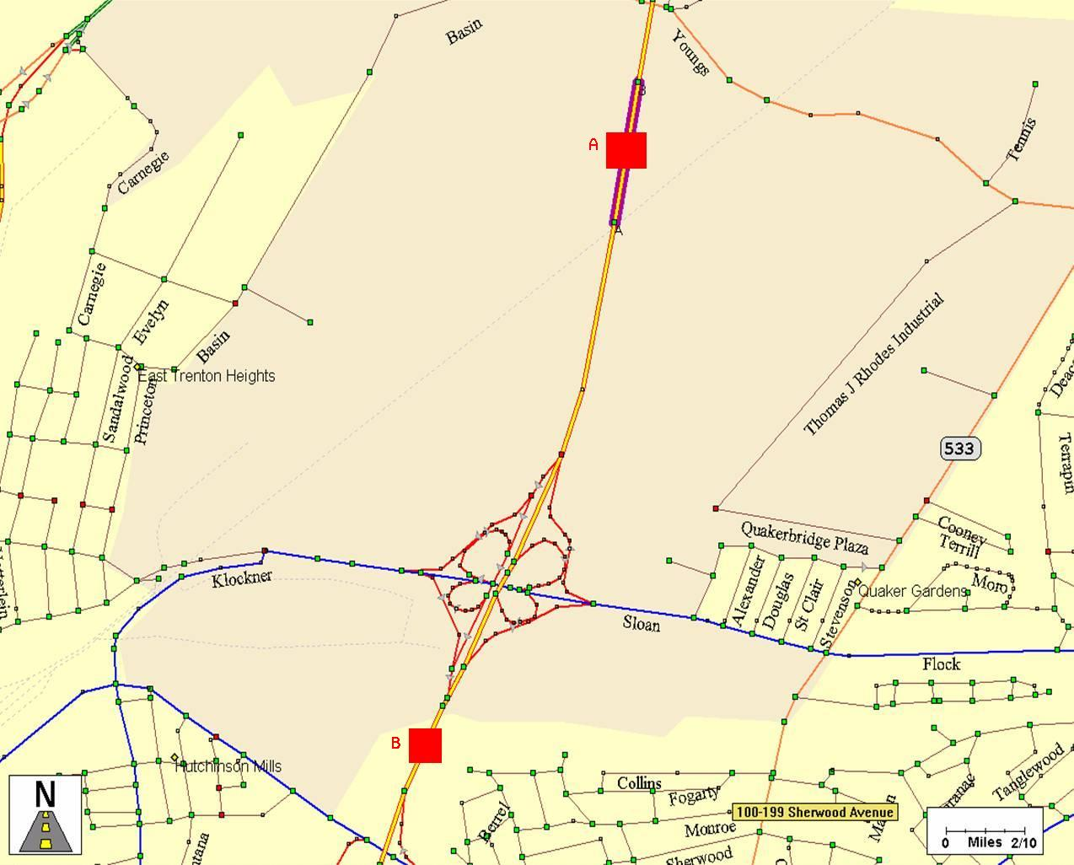

FIGURE 1 I-295 near Trenton NJ.
(a)
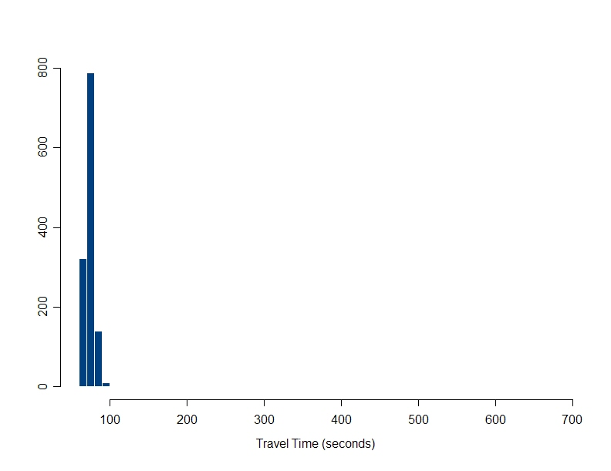

(b)
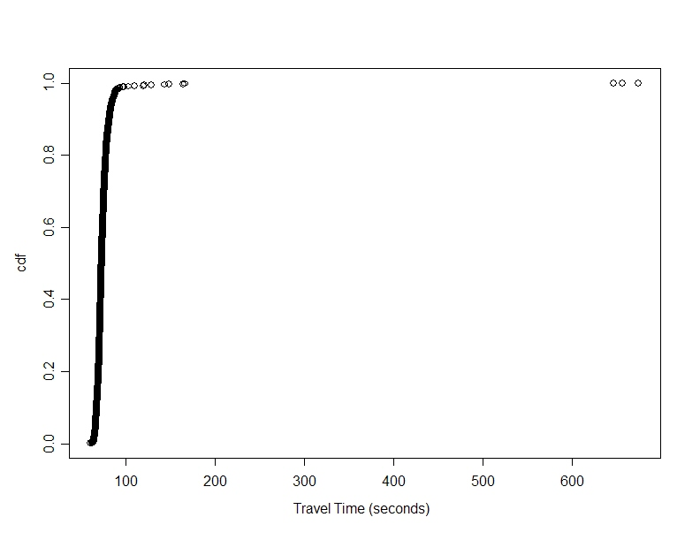
FIGURE 2 Travel time distributions for I-295 link (a) Histogram (b) c.d.f.
(a)
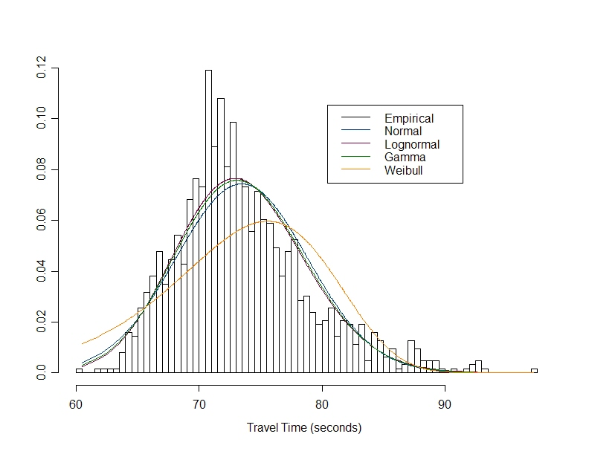
(b)
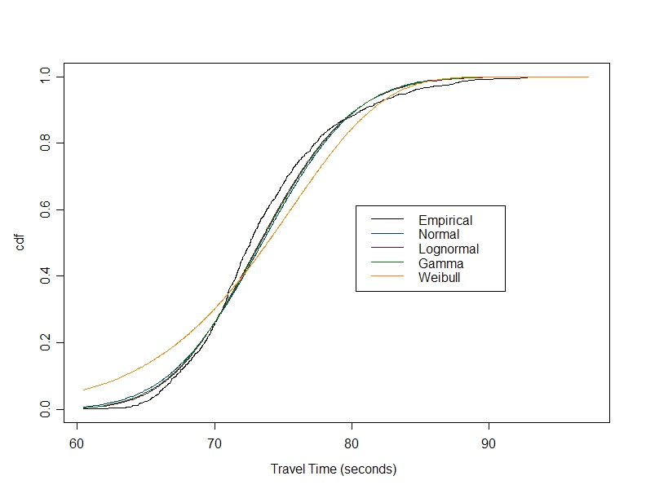
FIGURE 3 Distribution fittings for I-295 link (a) Density (b) c.d.f.
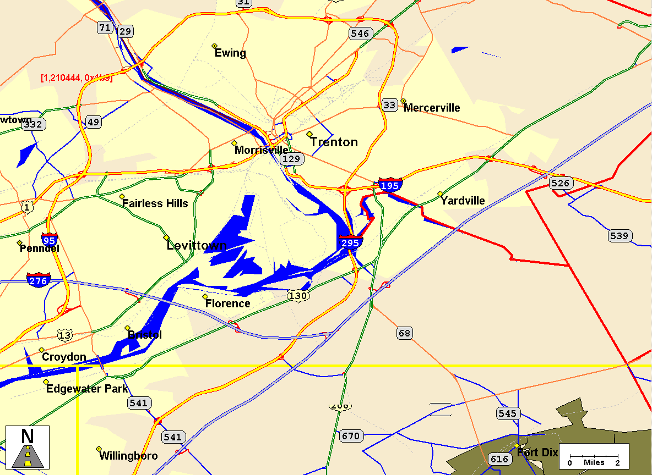
Start
End
Link 7
Link 8
Link 6
Link 5
Link 4
Link 3
Link 2
Link 1

FIGURE 4 Path on I-295.
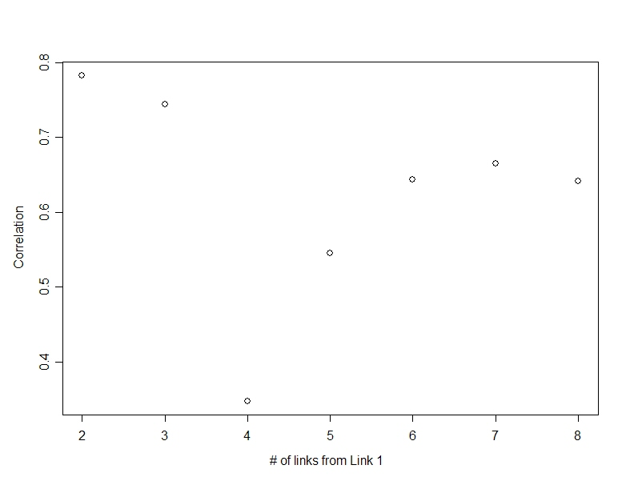
FIGURE 5 Correlations between links’ travel times for path on I-295.
(a)
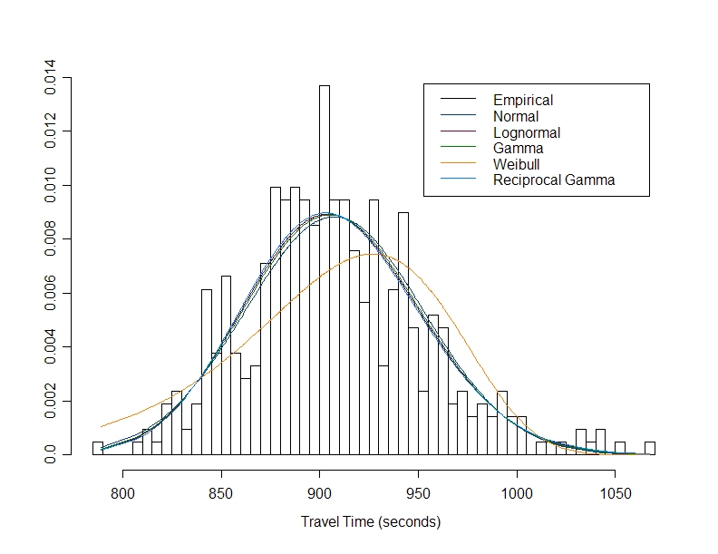
(b)
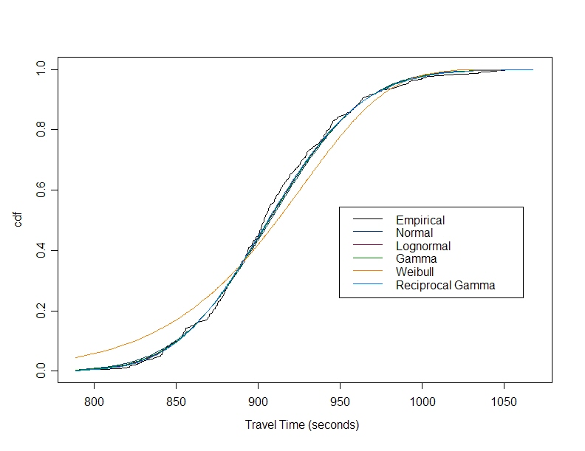
FIGURE 6 Distribution fittings for I-295 path (a) Density (b) c.d.f.

