Modeling Benefits of Incident Management Systems with the ITS Options Analysis Model (ITSOAM), a Tool for Economic Analysis

Jean-Claude Thill, Department of Geography and Earth Sciences, University of North Carolina at Charlotte, Charlotte, NC 28223, USA

Jun Yan, Department of Geography and Geology, Western Kentucky University, Bowling Green, KY 42101, USA

Abstract.
The scarcity of good benefits evaluation tools for ITS deployments at the programming stage is a known hindrance for ready deployment of new ITS infrastructures. In many states, capital planning and programming procedures require that projects with an ITS content compete for scarce resources with projects whose approach lies with the traditional capacity-increase philosophy. This paper presents a Windows-based modeling tool dubbed the ITS Options Analysis Model (ITSOAM) to evaluate the benefits of a broad selection of ITS deployment elements. Developed for the New York State Department of Transportation (NYSDOT), the model serves as a sketch planning tool and has limited data requirements, which makes it a tool suitable for use at the programming stage of the department's capital investment plan. The paper will briefly present the tool’s requirements and capabilities and the modeling design approach of the entire system. The central part of the paper will focus on the evaluation of benefits of deploying selected elements of an Incident Management System (IMS), namely variable message signs, detection and surveillance devices, and highway emergency local patrols. Results of several scenarios are introduced, with an emphasis on the sensitivity of model results to key parameters such as the traffic diversion rate, reduction in detection time, response time, and clean-up time.
1. INTRODUCTION
Over the past two decades, tasks of development and management of capital transportation programs have become increasingly complex in the United States. On the one hand, more stringent federal mandates have been enacted by successive transportation authorization bills starting with the 1991 Intermodal Surface Transportation Efficiency Act (ISTEA). Programmatic decisions have also been rendered more complex by calls for greater accountability in public investment and a climate of extreme competition for scarce public resources.
Before-and-after evaluation studies of a number of ITS field operational tests and other deployments have substantiated the favorable payoff of investments in ITS technology when it was still untested (Field Trials Consortium, 1990; Apogee/Hagler Bailly, 1998; USDOT, 2007; Maccubbin et al., 2005). ITS benefits assessment is not a straightforward matter and continues to pose significant challenges. At the December 1997 kick-off meeting of the ITS Deployment Analysis System (IDAS), Southworth identified the primary challenges as follows:
- ITS technologies are still evolving;
- ITS technologies bring new quantifiable benefits and costs;
- Benefits accrue at different geographic scales and over different time frames;
- Current methods for quantifying benefits and costs of traditional transportation alternatives are not standardized;
- Separating ITS benefits from benefits of other strategies may be difficult;
- While some benefits go to direct users of the ITS technology, others are indirect.
A decade later, these points remain acutely pertinent. The persistence of these challenges, the limitations of traditional evaluation approaches, and the fact that a number of recognized benefits of ITS do not match the conventional categories of measure of efficiency (mobility, safety, and environment) (Brand, 1995, 1998; Bristow et al., 1997; Hatcher et al., 1998; Gillen et al., 1999) tend to place ITS technologies at a disadvantage with projects whose approach is in line with the traditional capacity-increase philosophy. Indeed, capital planning and programming procedures in place at many transportation agencies require that projects be prioritized on the basis of their costs effectiveness or of benefit/cost ratios within the overall scope of stated program goals.
This paper reports on an ITS benefits evaluation toolbox designed and developed for the New York State Department of Transportation’s (NYSDOT) capital programming effort. The system, known as the ITS Options Analysis Model (ITSOAM), is implemented as a computer-based decision system composed of a set of sketch planning tools intended to assist engineers, planners, and other policy and decision makers in their strategic activities, in particular for screening worthy ITS projects at the corridor level.
This rest of this paper is composed of following sections. The second section reviews the evaluation of benefits of transportation projects encompassing ITS elements as it is practiced at the programming level. The scope and functionality of the ITSOAM modeling framework are discussed in Section 3, as well as the principles common to models of benefits evaluation. Greater detail on the models of delay, safety and environmental benefits is discussed in Section 4. This section also features a sample ITSOAM session evaluating the benefits of such deployment during a single incident. Conclusions are presented in the final section.

2. Benefits Evaluation FOR PROGRAMMING PURPOSES
In Europe, the DRIVE I and II initiatives defined a framework of guidelines for the evaluation of ITS-oriented projects. The EVA study (Bobinger et al., 1991) identified a set of criteria for baseline evaluation and recommended a variety of evaluation techniques. This tradition of evaluation continues to be found in European policy and planning studies such as in the KAREN project for the establishment of a European ITS Framework Architecture (Chevreuil et al., 2000). In North America the groundwork for examining ITS-related benefits was established by the National ITS Architecture Study (Lockheed Marietta Federal Systems, 1998). Most of this work focused on the benefits of the Architecture rather than the benefits of ITS user services per se.
The intended end-use of evaluation results imposes significant variability in the modeling and data complexity of ITS benefits evaluation methodologies. Broad-based, long-term, national studies such as ITS America's ITS National Investment and Market Analysis study (Apogee, 1997) and the Transport Research Laboratory’s ITS technology study (Perrett and Stevens, 1996) attempt to strategically assess future benefits of ITS throughout a nation, and therefore, use a macro-modeling approach. Benefits evaluation for use at the programming, planning, and scoping levels of the capital improvement process is increasingly marked by a need for explicit analytical or numerical modeling and for disaggregate data. The scope of the evaluation task (corridor versus metropolitan, statewide, or even national) also influences the methodological approach to ITS benefits evaluation. Three primary approaches to the quantitative evaluation of ITS benefits are usually identified, namely sketch planning analysis, travel demand modeling, and traffic simulation (TransCORE 1998), which are supplemented by emission inventory models (such as MOBILE and EMFAC) (Hagler Bailly Services, 1998) and hot spot models (Wunderlich, 1997) for environmental benefits assessment.
The four-step travel demand modeling approach is very attractive to the planning community due to their prevalence in the metropolitan transportation planning process and to the similarity of its outputs to those presently used for the evaluation of non-ITS strategies. The IDAS tool developed jointly by the Oak Ridge National Laboratory and Cambridge Systematics (2002) is built on a library of travel demand models customized to capture the information-sensitivity of travelers evolving in the environment supported by ITS strategies. The evaluation of ITS benefits with a four-step model proceeds by characterizing each ITS strategy by a set of parameters used in one or more of the modeling steps. The data intense nature of this approach precludes it from being directly used for programming or strategic planning purposes in institutional sessions, particularly in small to medium size metropolitan areas or in more rural areas.
Macroscopic and microscopic traffic simulation tools provide delay and speed outputs by tracking vehicle flows from section to section on the network, and the ensuing congestion. A broad range of ITS freeway and arterial management strategies can be simulated with these tools through the dynamic adjustment of volume and capacity inputs, along with other parameters (Kang and Gillen, 1989; Gardes et al., 1990; Glassco et al., 1996).
Sketch planning analysis differs from the previous approaches in that it does not attempt to model behaviors and processes. Instead, it incorporates a more or less elaborate set of statistical relationships and rules capturing the essence of an ITS-enabled system in terms of its characteristics and measures of effectiveness. They typically consist of a series of look-up tables stored in a database or spreadsheet computer application. Examples include comprehensive systems such as Screening Analysis for ITS (SCRITS) (SAIC, 1999), EMFITS (Dunn Engineering Associates, 2004), as well as the Planning and Analysis for Integrated Intelligent Transportation Systems (PLANiTS) decision tool (Kanafani et al., 1993; Khattak and Kanafani, 1997) based on case-based reasoning, the Freeway Service Patrol evaluation methodology developed by Skabardonis et al. (1995, 1998) and other case-specific tools (e.g., Maas, 1998). Sketch planning methods can incorporate outputs generated by more process-oriented models such as travel demand models and traffic simulators. They are capable of capturing the broad characteristics of most ITS strategies at the programming or planning stages of the capital improvement process. They are most definitely not intended for detailed analysis.
It should be pointed out that several more computationally intensive analytical frameworks bring together the evaluation capabilities specific to travel demand models, traffic simulation techniques, and emission and safety models (Volpe National Transportation Systems Center, 1995; Wunderlich, 1997). This approach has the advantage to allow for the iterative computation of interactions between the different points of impact of ITS elements (trip generation, route planning, etc.), for the interactive working of ITS elements, the multiplicity of geographic and time scales at which benefits accrue, as well as the diversity of groups of individuals to which benefits accrue.

3. The ITSOAM Framework

3.1. Scope and Features

The scope of the ITSOAM decision system as well as its functionality evolved from an extensive outreach effort among ITS stakeholders within NYSDOT (including traffic and safety engineers and ITS coordinators) and the state’s transportation planning community. The system is intended for primary use by NYSDOT engineers in charge of the coordination of ITS operations in the Department’s eleven regions and, secondarily, by NYSDOT and MPO planners, in screening worthy highway-oriented ITS projects at the corridor level. It is a sketch-planning analysis tool. The functionality of the decision system rests on a handful of principles:
- Compatibility with NYSDOT goals. Only ITS elements requiring public capital investment are considered. Benefits of interest fall into four main categories: delay reduction, safety enhancement, emission reduction, and fuel savings.
- Compatibility with evaluation tools and processes currently in use at NYSDOT and New York State MPOs for conventional capital projects.
- As a planning and programming tool, ITSOAM evaluates individual ITS market packages, or even elements thereof, rather than ITS systems components. Benefits are evaluated at the scale best suited for the planning of ITS elements under consideration, i.e., at the corridor, sub-region, or facility-level. System-wide impacts (such as induced travel demand, temporal and modal shifts) are not taken into account.
- ITSOAM is self-contained and usable “on the fly.” The toolbox contains default settings on ITS requirements and impacts that can be modified as needed to reflect local conditions of the transportation systems. It does not require that travel demand and traffic models be accessed.
- Sensitivity analysis is supported by the decision system.
By design, the decision system built on these requirements differs from other operational sketch-planning tools both in terms of complexity and predictive accuracy.
A total of ten different clusters of ITS elements are targeted for evaluation by ITSOAM (Table 1). Variable message signs (VMS, including speed display boards and parking management systems), information kiosks, highway advisory radio (HAR), and non-subscription information services (world wide web, commercial television and radio, fax reports, phone services) are the primary NYSDOT-supported clusters of ITS elements that disseminate information to travelers. These elements directly enable travelers to modify their travel decisions (whether, where, along what route, and when to go) in response to travel conditions brought to their attention. The information content of these elements comes from a variety of information collection devices via a traffic management center (TMC). In some instances, such as with speed display boards, the information is collected, stored and consumed locally, without any intervention of a TMC.

Table 1. Targeted ITS Elements.
Cluster | Number of elements
Variable message signs | 14
Highway advisory radio | 12
Information kiosks | 1
Other non-subscription information services | 3
Detection sensors and surveillance devices | 1
Highway emergency local patrol | 1
Adaptive ramp metering | 1
Adaptive traffic control system | 1
Road weather information system | 1
Weigh-in-motion | 1

Information dissemination elements do not only differ on the basis of their physical systems, but more important from the perspective of benefits evaluation, they may also differ by their information content and their potential users. For instance, kiosks often provide non-real-time information or wide area real-time information (e.g., weather conditions in a multi-county region) and are used by motorists with limited familiarity with the area (non-commuters). On the other hand, information disseminated by VMS and HAR is typically real time; it is received and used by all motorists, irrespective of their travel purpose. Finally, non-subscription information services are also available for use by all groups of travelers, but often prior to the initiation of a trip. Information received before the start of a trip may lead a traveler to reconsider the decision to travel, or to adjust departure time, travel mode, or the route followed.
Variable message signs may be activated for a variety of purposes and in a variety of situations, all of which involve the display of real-time information for the benefit of motorists. Six main instances are recognized by ITSOAM, such as non-recurrent events related to traffic incidents on or around the roadway, special event traffic, hazardous weather conditions, etc.
The nature and magnitude of benefits generated by a VMS deployment is expected to depend on the nature and information content of the messages displayed. For instance, the information content of traffic delay messages displayed on VMSs has been found to influence drivers' en route diversion behavior (Khattak et al., 1993, Madanat et al., 1995), which is one of the principal mechanisms through which user benefits materialize. Accordingly, the decision system must be sensitive to the information content of posted messages. Five information treatments are recognized for several ITS technologies, such as VMS and HAR, in ITSOAM.
The combination of multiple situations in which VMS can be effectively deployed and of the variety of information types to post produces a total of 14 elements (Table 2) to be evaluated by the decision system. Similarly, information services that do not require a fee-based subscription can be evaluated under three different scenarios of non-recurrent congestion, traffic incident, scheduled event with or without capacity reduction.

Table 2. VMS Elements.
 | Information Type
 | Traffic condition |  |  | Speed advisory messages | Parking space availability
 | Limited descriptive information | Detailed information | Detailed prescriptive information | Speed advisory messages | Parking space availability
Non-recurrent events |  |  |  | - | -
Scheduled non-recurrent events with capacity reduction |  |  |  |  | -
Scheduled non-recurrent events without capacity reduction |  |  |  | - | -
Hazardous weather conditions | - | - | - |  | -
Scheduled recurrent events | - | - | - |  | -
Facilities related | - | - | - |  | 

Information collection elements provide information to the TMC, which is in turn disseminated to travelers, traffic control and emergency management officers, and others. The evaluated elements include closed circuit television (CCTV), inductive loops and other traffic surveillance devices, incident detection algorithms, weather sensors, and highway emergency local patrols (HELP). In fact, HELP services play a rather complex role. On the one hand, roving HELP response vehicles receive incident-related information captured by others sources and processed by the emergency management center. With the quick on-site response enabled by this information, HELP directly impacts system efficiency by reducing the duration of traffic disruptions. They also detect incidents and thus serve as information collection units.
Several targeted elements build on the functionality of information collection and dissemination elements to enhance systems performance and efficiency, most notably ramp metering and adaptive traffic control systems. Other elements that can be evaluated in ITSOAM include Road Weather Information Systems (RWIS) and weigh-in-motion scales.

3.2. Principles of Benefits Models
The principle under which ITSOAM operates is the comparison of conditions of the transportation system with some ITS element deployed to baseline conditions (no ITS elements deployed) in terms of a few key performance metrics. The differences on the performance measures between the two situations are the benefits of the ITS element being evaluated. Three types of input data are required to implement benefits models:
- Domain knowledge contains traffic data stored in institutional databases as well as standard DOT notions such as calibrated flow-speed relationships, road networks and their attributes, historical data series (incident frequency by type, characteristics of different categories of delay, information on different categories of incidents, etc.).
- Constants characterize the ITS element to be deployed, its use, market penetration, and perception by travelers, as well as their interaction with the rest of the transportation system. ITSOAM incorporates values compiled from the relevant literature on simulation and operational test results.
- Variables contain the technical specifications of the specific deployment of the ITS element being evaluated (number of information kiosks, number of metered ramps, etc.).
The benefits evaluation model is a modular Windows-based application programmed in Visual Basic. Data inputs are either default values stored in the application’s database or information supplied interactively by the user through dialog boxes.
While benefits evaluation is aimed at supporting decisions to deploy systems consisting of multiple elements (say, an incident management system or a freeway management system), it is desirable for economic performance analysis to consider the case of each ITS element separately, and evaluate their benefits independently of other elements. With a clear understanding of the relationship between all the elements to be affected by this particular deployment, interactions between elements in a system can be captured and double-counting errors minimized. The ITSOAM benefits evaluation modules follow this approach and subsequently implement the heuristic model proposed by Klein (1993) to statistically estimate the combined benefits of a system deployment.
Benefits derived from the deployment of an ITS element are often related through a web of complex processes. ITSOAM deals exclusively with benefits of each element that are deemed quantifiable and large enough. For the sake of consistency with established NYSDOT programming goals and procedures, only the following classes of benefits are evaluated: travel time, safety, emissions and fuel consumption, vehicle operation costs, and maintenance costs. Each class of benefits is quantified by means of several metrics, which are applicable to different ITS elements. The reader is referred to Thill and Rogova (2001) for further information.
Different families of models are used to compute each benefit metric for broad functional classes of ITS elements. However, for most ITS elements, models estimating travel time, safety, and environmental/fuel benefits are linked by a common structure (Figure 1). Logical links relate the delay/VMT models, on the one hand, to the safety and environmental models, on the other hand. The delay/VMT models not only estimate travel time benefit metrics, but also predict key measures of traffic operation before and after deployment (speed, volume, etc.) for input in the safety and environmental models.
While the objective of benefits analysis is to forecast benefits over the expected life of the investment (10, 20, or 30 years), ITSOAM starts with considering a much shorter time frame. In case of non-recurrent conditions, benefits are estimated at once for each event that triggers a disturbance of the operational conditions of the transportation system. This event may be a car crash, a football game, or some other incident affecting travel demand or supply. For recurrent conditions, benefits are estimated per unit of time of operation of the ITS element, say one hour or one day. Expansion to annualized estimates is the next logical step.

Figure 1. Logical Links between Delay/VMT, Safety, and Environmental Models.
Delay/VMT Models
Emission and Fuel Consumption Models

Safety Model

For recurrent traffic disturbance, expansion to generate annualized estimates is conducted in a four-stage process depicted in Figure 2. First, event types relevant to the ITS technology to be deployed are identified. The analyst must compile a database of parameters and variables characterizing each event type. This information then serves to parameterize the benefits evaluation models. With proper parameterization, these models are used in stage two to estimate the benefits associated with the deployment of a particular ITS element during a single event. In stage 3, the analyst defines a set of expansion factors, allowing for the derivation of annualized benefits in the final stage. Expansion factors can be drawn from the annual frequency distribution of events of each type. Annualized benefits can be calculated as the sum of benefits specific to events of each type, which are weighted by the corresponding expansion factor. A similar process is followed for recurrent conditions.
Expansion over the lifetime of the investment follows the customary approach of discounting benefits in present-value terms. ITSOAM assumes no future change in the demand for travel.
Figure 2. Expansion Process.
Event type
Event-specific
Benefits
Delay
Safety
Annualized
Benefits

Delay
Safety
IV.
II.
I.
Expansion factors
III.
i

4. Models for Incident Management Elements

4.1. Deployments, Benefits, and Models
Let us consider the traffic situation created by a non-recurrent, unscheduled event on a roadway, such as a car crash or a disabled vehicle. This situation is modeled as a simplified highway corridor presenting two route choices to be considered by travelers: the first represents the route where the incident disrupting the normal traffic pattern occurred, while the second is a composite alternative representing all the other routes travelers could divert to (Figure 3).

Figure 3. Corridor Modeled during a Non-recurrent Event.
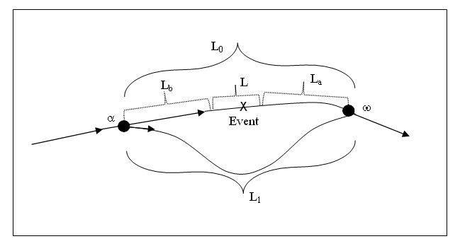
Several of the elements listed in Table 1 are often advocated as tools to alleviate the impact of this incident on system efficiency. These include information collection elements (detection sensors and surveillance devices), information dissemination elements (VMS, HAR, information kiosks, and other non-prescription information services), and highway emergency local patrols (HELP). All three ITS clusters can be evaluated independently of one another in ITSOAM, or together as part of a single comprehensive IMS deployment.
The primary mechanism through which these elements operate is by reducing the congestion and travel time (aggregate delay) of motorists on the highway network as a result of successful diversion of motorists notified on the upcoming incident along other routes, earlier detection and verification of the existence and characteristics of the incident, and/or earlier response to this incident. Delay reduction may in turn curtail fuel consumption and mobile emissions. In addition, the ensuing modifications of traffic conditions are expected to cut the rate of secondary accidents on the corridor affected by the incident, while the rate of primary accidents on alternate routes may also be affected. Hence, the logical structure connecting delay, safety, and environmental benefits models illustrated in Figure 1 is applicable to these cases.

4.2. Delay Model
Let us define the duration T of an incident as the time elapsed between the incident occurrence and the moment of complete traffic flow restoration. Following established practice (Ozbay and Kachroo, 1999), the incident event can be decomposed on the timeline in five main phases (Figure 4): 1. Incident detection; 2. Incident verification; 3. Incident response; 4. Incident clearance; 5. Queue dissipation. The total incident duration encompasses the first four phases: , where is the time lapsed between the occurrence of the incident and the moment police or emergence services are notified, is the time necessary for verification and validation of the information pertaining to the occurrence of an incident, is the time necessary for emergency vehicles to arrive at the scene of the incident, and is the clean-up time. We follow the convention of pooling together the verification and response times because the verification task may be assigned to the responding vehicle, particularly if no remote verification system (such as CCTV) is in place.

Figure 4. Phases of an Incident.
Time
line
Incident Occurrence
Incident Cleared
Restoration
to ‘Normal’
Traffic Flow
Detection

time
Verification

time
Response

time
Clearance time
Queue

dissipation

Because a queue may have built up during the incident, return to normal traffic conditions may be delayed until the queue has dissipated. This component of the incident duration is calculated by the delay model, while all the other components of the incident duration are constants pre-set by the system or customized by the analyst to fit local circumstances. The delay model incorporates detection, response, and clearance time values that prevail in the absence of deployment of ITS elements (baseline situation). ITS elements designed to impact incident duration are built into the treatment through a series of rates that discount one or more components of the incident duration parameter.
The benefit metric selected to quantify the performance of an incident management element from a mobility perspective is the reduction in expected user delay on all roads due to non-recurrent congestion, expressed in dollars. It is computed as the change in overall user delay on the impacted corridor (Figure 3) after deployment of the targeted ITS elements compared to the pre-deployment situation. Overall delay is defined as the aggregate increase in travel time resulting from the reduction in capacity induced by the incident. This framework is sketched in Figure 5. The delay model is discussed in full detail in Thill and Rogova (2005). A brief overview is provided here. Individual travel time in the impacted corridor is modeled with the following four components:
- The traversal time on sections L_{b}, L, and L_{a} of the roadway with reduced capacity (Figure 3); it is computed with the standard BPR speed-flow equation;
- A delay associated with the merging of traffic on blocked lanes (if any) with traffic traveling on free lanes on section L_{b} on the modeled corridor (merge delay);
- A delay associated with the dissipation of vehicle queues formed upstream of the scene of the incident (section L_{b} in Figure 3) (queue delay); and
- A delay associated with the decision to exit the highway corridor upstream of the incident location ( at exit α in Figure 3) and to divert to an alternate route L₁ before returning to the targeted corridor an entrance ω (diversion time); it is computed with the standard BPR speed-flow equation.
The computation of the merge delay is based on a conventional model developed for ramp design (Drew, 1968; Gartner et al., 1980). This delay is a function of the current traffic flow on the highway and of the merging capacity. Queue delay is computed with a deterministic queue model similar to queuing diagrams used in many incident delay studies and evaluations of incident management programs (Morales, 1986; Lindley, 1987; Al-Deek and Kanafani, 1993; Al-Deek et al., 1998; Ozbay and Kachroo, 1999).
The detection, response, and clearance time components of the incident duration are critical parameters of the delay model. Most detection and surveillance systems (at the exception of CCTV) aim at reducing incident duration by cutting down the time lapsed between the occurrence of the incident and its reporting to the traffic management center or emergency services (detection time). Closed-circuit television (CCTV) is commonly used with automated detection systems to verify that an incident has actually occurred, to ascertain the location of the incident, as well as its severity. In addition, CCTV can supply digital video images to a video image-processing algorithm that serves to detect the occurrence of an incident. CCTV deployed without other surveillance devices is expected to cut down the verification time, but not the detection time. A HELP deployment reduces the expected response time and clean-up time. Because of their regular patrol on pre-defined beats, tow trucks may be first to detect the occurrence of an incident, thus reducing the detection and verification time of the incident. ITSOAM incorporates default values for each of these impacts that are derived from actual field evaluations around the United States. See Thill (2005) for detail on the parameterization of each evaluation module.
The VMS-induced rate at which traffic diverts to an alternate route to avoid the bottleneck associated with the modeled incident is also a critical parameter of the delay model. By cutting back incoming traffic on the targeted highway, several components of the overall delay can be contained, most singularly the queue delay. A side-effect of traffic diversion, however, maybe that congestion is displaced to the secondary arterial system.
The rich parameterization of ITSOAM enables the analyst to conduct an analysis of sensitivity of systems performance to conditions and circumstances. Figure 6 summarizes the multiple effects that can be analyzed with ITSOAM, along with the nature of the impacts that are anticipated.
The role of the delay model in ITSOAM is twofold: first, it estimates a delay-related measure of effectiveness; in addition, this model predicts key measures of traffic operation before and after deployment (traffic speed and traffic volumes) that are inputs of the safety and environmental benefits models. Each model compares the before- and after-deployment situations and imputes to the ITS element(s) being evaluated any changes that may be forecasted.
Figure 5. Delay Modeling Framework.
Overall Travel Time
without Capacity Reduction (No Incident)
Overall Travel Time
with Capacity Reduction (Incident)
traversal time
merge delay
queue delay
diversion time
Benefit Metric
Reduction in expected user delay on all roads due to non-recurrent congestion, expressed in dollars

Overall Travel Time
without Capacity Reduction (No Incident)
Overall Travel Time
with Capacity Reduction (Incident)
traversal time
merge delay
queue delay
diversion time
B
A
S
E
L
I
N
E

D
E
P
L
O
Y
M
E
N
T

I
T
S

E
L
E
M
E
N
T
Overall Delay
Overall Delay

Figure 6. Selected Control Parameters and their Impact on Expected Delay Benefits of IMS Deployment.
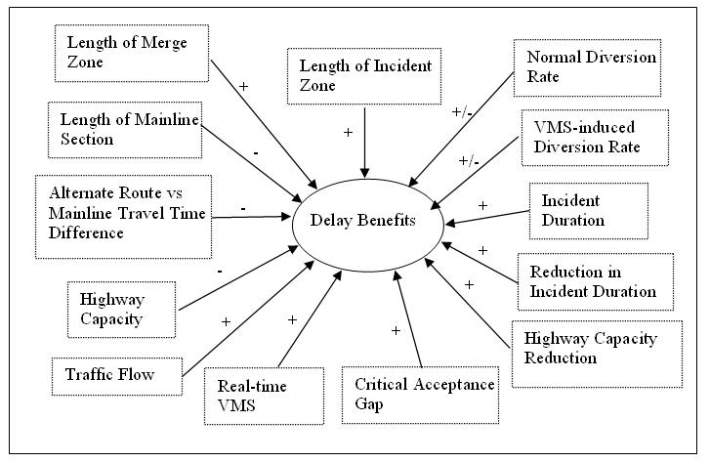

4.3. Safety Model
The benefit metrics selected to quantify the performance of deploying an incident management element against a safety goal are:
- Reduction in expected cost of primary accidents on all roads due to non-recurrent congestion;
- Reduction in expected cost of secondary accidents on all roads due to non-recurrent congestion.
VMS, HELP, and detection and surveillance systems are expected to reduce secondary accidents by curtailing the period during which hazardous driving conditions associated with the reduced capacity around the incident site exist. Furthermore, the reduction in detection and verification time achieved by deploying an ITS element may allow emergency vehicles to reach the incident site more promptly. If the incident is an accident with injury, the faster arrival of emergency vehicles on site may reduce the severity of the injuries. Outcomes associated with injury trauma are indeed critically dependent on time. As noted by Stewart (1990), "pre-hospital immediate care seeks to apply supportive measures, and it must do so quickly, within what is called the 'Golden Ten Minutes'." Research on the determinants of accident fatalities (Evanco, 1996) has identified a highly significant relationship between fatality and accident notification time. From this relationship, any anticipated reduction in detection and response time can be translated into an expected change in the likelihood the accident involves fatalities. This translates into primary safety benefits.

Figure 7. Framework of the Safety Benefits Model.
Benefit Metrics

Reduction in expected cost of primary accidents on all roads due to non-recurrent congestion, expressed in dollars
Reduction in expected cost of secondary accidents on all roads due to non-recurrent congestion, expressed in dollars
Safety Constants, by Facility Type and Area Type

Average comprehensive cost of accidents, by accident type
Frequency distribution of accidents, by type

Infrastructure and Behavioral Parameters

Length of main corridor
Length of diversion route
Accident rate
Area type
Facility type
Etc.
Delay Model Components

Traversal time
Merge delay
Queue delay
Diversion time
Delay Model Outputs

Traffic flow on impacted corridor
Traffic flow on alternate route

Vehicular accidents being traffic-related events, key inputs of the safety model are estimated by the delay model. With traffic volumes on main and alternate routes generated by the delay model, the safety benefits models estimate the expected number of primary and secondary accidents by severity (fatality, injury, property damage only) on main and alternate routes. Many studies have been conducted to establish a statistical relationship between accident occurrence and roadway parameters (Ceder and Livnech, 1982; Al-Deek et al., 1998). The expected number of secondary accidents is estimated by a simplified relationship between accident rates and traffic volume, which is integrated over the duration of the incident. In our treatment, the relationship is parameterized differently for freeways and arterials. The model of primary accident cost reduction is based on a model calibrated by Evanco (1996). The overall framework of the models is depicted in Figure 7. Economic valuation is obtained by applying average accident cost factors by facility type and area type.
Figure 8 summarizes the multiple effects of control parameters on safety performance of IMS elements that can be analyzed with ITSOAM, along with the nature of the impacts that are anticipated.

Figure 8. Selected Control Parameters and their Impact on Expected Safety Benefits of IMS Deployment.
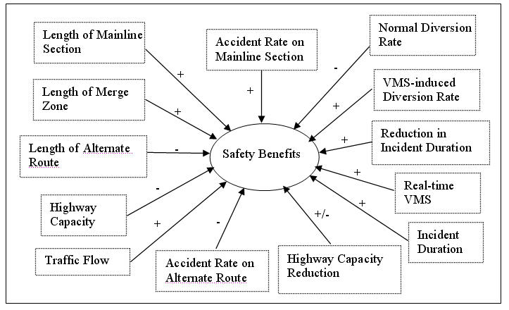

4.4. Environmental Benefits Model
The benefit metrics selected to quantify the performance of deploying an incident management element against an environmental goal are:
- NOx emission reduction associated with a change in mean traffic speed;
- VOC emission reduction associated with a change in mean traffic speed;
- CO emission reduction associated with a change in mean traffic speed;
- Reduction in fuel consumption associated with a change in mean traffic speed.
Aggregate reduction of harmful vehicle emissions and fuel consumption can be linked to a change in mean traffic speed per unit of time and to a reduction of the duration of the episode of reduced capacity. Emission and fuel consumption of a vehicle are highly dependent on its mode of operation on a given trip. Stop-and-go conditions typical of congested traffic lead to higher levels of emissions and higher fuel consumption. By their expected impact on incident duration and traffic diversion rates, VMS, HELP, and incident detection and surveillance systems are anticipated:
- To reduce the time period over which a vehicle is caught in congested and unsteady traffic, as well as
- To reduce the number of motorists whose travel conditions are affected by the incident.
Consequently a reduction in total vehicle emissions and fuel consumption is expected, although a large rate of traffic diversion may result in greater VMT and higher emission.
Since aggregate vehicle emissions and fuel consumption are directly related to traffic conditions the environmental benefits model incorporates several outputs of the delay model. The framework of the model is depicted in Figure 9. It is consistent with the general principles outlined in Goodman et al. (1996). Emission factors and fuel consumption rates are applied to traffic volumes as a function of the current traffic speed derived from the applicable travel time-traffic flow relationship. Default factors are applied to traffic in idle mode. Emission factors are estimated generated by a customized version of EPA's MOBILE 5B model by county and facility type.
Figure 10 summarizes the multiple effects of control parameters on environmental performance of IMS elements that can be analyzed with ITSOAM, along with the nature of the impacts that are anticipated.
Figure 9. Framework of the Environmental Benefits Model.
Benefit Metrics

NOx emission reduction associated with a change in mean traffic speed
VOC emission reduction associated with a change in mean traffic speed
CO emission reduction associated with a change in mean traffic speed
Reduction in fuel consumption associated with a change in mean traffic speed, expressed in dollars
Environmental Constants, by Facility Type and Area Type

VOC, NOx, CO emission factors
Fuel consumption factors

Infrastructure and Behavioral Parameters

Length of main corridor
Length of diversion route
Area type
Facility type
Etc.
Delay Model Components

Traversal time
Merge delay
Queue delay
Diversion time
Delay Model Outputs

Traffic speed on main corridor

Traffic speed at merging point

Queue delay

Traffic speed on diversion route

Figure 10. Selected Control Parameters and their Impact on Expected Environmental Benefits of IMS Deployment.
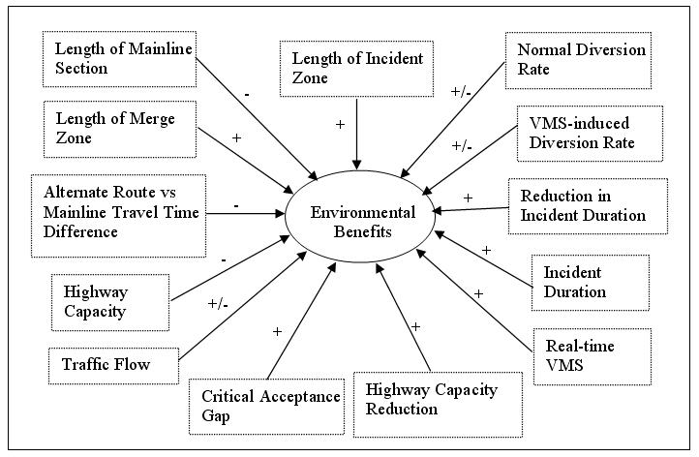

4.5. Sample ITSOAM Evaluation Session
To illustrate the use of ITSOAM, let us consider the deployment of HELP on an urban freeway corridor in Albany County, NY, and assess the delay, safety, and environmental benefits accrued as a result of this deployment in case of an incident on a local freeway. The hypothetical scenario is described by the four inputs screens displayed in Figure 11. The user of the system has full control over all the parameters of the model. ITSOAM contains many recommended default values (in black in the input windows), but the user is free to override them to better capture the local situation under evaluation. Entries that appear in blue in the input windows correspond to parameters for which NYSDOT has developed standards used as default throughout the agency’s planning and operation work appear in blue in the input windows; they too can be customized on the fly by the system user. Entries highlighted in red are project-specific and must be supplied by the user for each run of ITSOAM.
The user may choose to evaluate benefits for a single value of the three key control parameters (reduction in detection time, response time, and clearance time) or to conduct an analysis of sensitivity of the model results to the value assumed for each of these parameters. The latter option is illustrated here. It produces a series of curves displaying benefits as a function of the reduction in clearance time enabled by HELP deployment. See Figures 12 and 12. In this sample illustration, all benefits happen to increase almost linearly with the reduction in clearance time.
Standard outputs of ITSOAM include a text file reproducing all the input data of the current evaluation session, as well as the estimated benefits for a single value of the detection, response, and clearance times rate or for values of one of these parameters within the range specified by the user, if a comparative analysis is performed. Graphic windows are produced only when sensitivity analysis is requested by the user.

Figure 11. Sample Data Input Frames of ITSOAM for Modeling Benefits during a Single Non-Recurrent Event.

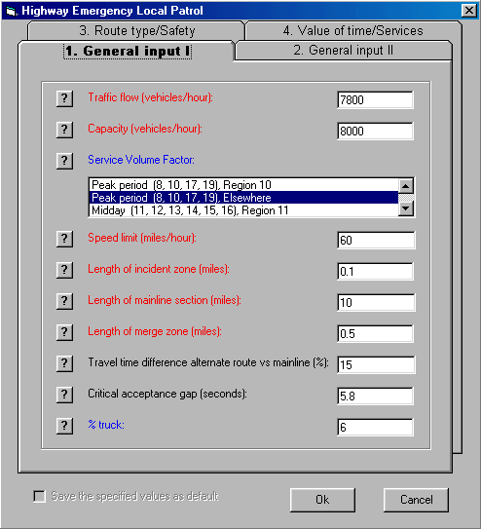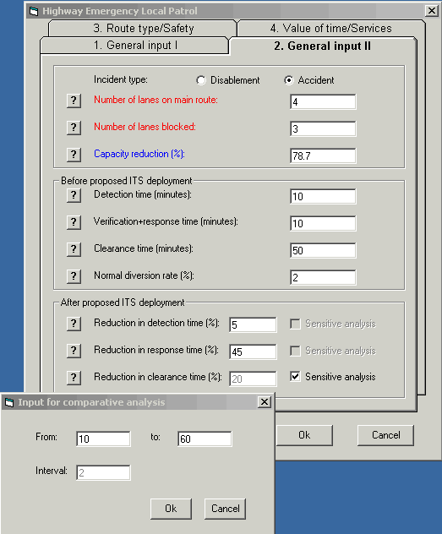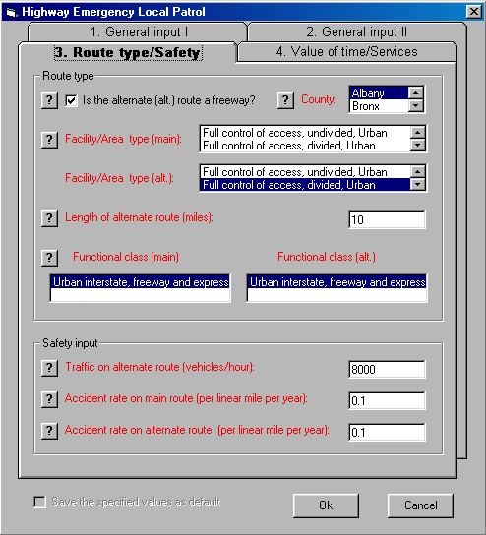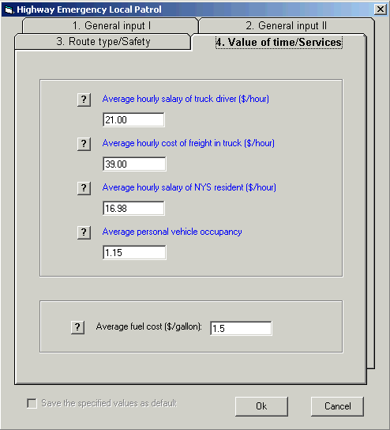

Figure 12. Sample Output of ITSOAM: Delay Reduction and Safety Benefits for a Single Incident Event.

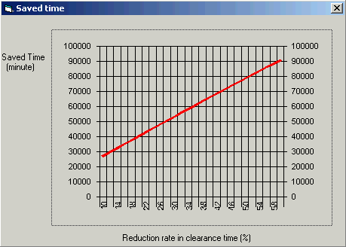
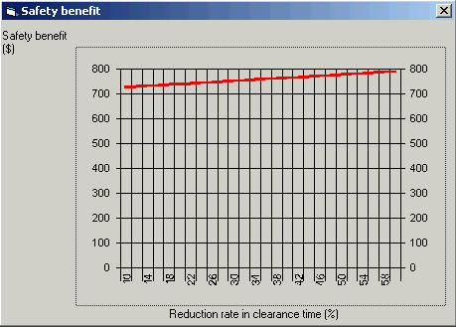

Figure 13. Sample Output of ITSOAM: Emission and Fuel Consumption Benefits for a Single Incident Event.
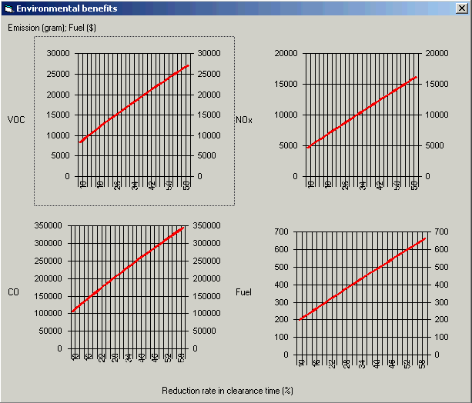

5. Conclusions
This paper presented the case of the evaluation of benefits of alternative ITS projects at the programming stage a capital improvement effort. The ITSOAM computer-based decision system is a sketch-planning tool intended to meet the needs of New York State ITS coordinators without unduly sacrificing the quality of the benefit and cost estimates. While the decision system relies on various models commonly used for the evaluation of transportation projects devoid of ITS content, each model has been customized to capture the essence of ITS elements to be evaluated. The flow of information between system components is at the center of the design philosophy of ITSOAM. From a users’ perspective, access and response to information define the success of many ITS deployments. In this respect, the decision system presented in this paper differs from conventional economic evaluation methodologies.
A requirement of the system design was to keep data inputs to a minimum. To this end, the framework is independent of travel demand modeling and network analysis. ITSOAM instead incorporates a number of default values derived from earlier evaluation studies. The trouble is that data quantity and data quality are deficient in many areas. Over time, as more post-deployment studies are completed, the data infrastructure available to planners will become more solid, more reliable, and more diverse. With better data, the value of sketch planning tools like ITSOAM will be even greater tomorrow.
Though ITSOAM is a simple tool of economic evaluation, they serve a critical role in the planning process. They enhance the capability of transportation engineers and planners in sorting ITS elements on their likely return on investment and in discarding projects of little economic worth. These planning tools also help in creating a leveled playing field between conventional capital improvement projects and projects involving ITS deployment by enabling a more solid justification of expected benefits and costs within the current goal-oriented decision process of the funding agency.

ACKNOWLEDGEMENTS
Funding for this research was provided by the New York State Department of Transportation through its contract research program project on "Intelligent Transportation Systems
Benefits and Costs." The authors wish to acknowledge the support provided by NYSDOT staff and Technical Working Group members, who participated in the project.

REFERENCES
Al-Deek, H., and Kanafani, A. (1993) ‘Modeling the benefits of advanced traveler information systems in corridors with incidents’, Transportation Research Part C, 1(4), pp. 303-324.
Al-Deek, H.M., Ishak, S.S., and Radwan, A.E. (1998) ‘Impact of traffic diversion with ATIS on travelers’ safety’, Computers and Industrial Engineering, 34 (2), pp. 547-558.
Al-Deek, H., Khattak, A.J., and Thananjeyan, P. (1998) ‘A combined traveler behavior and system performance model with advanced traveler information systems’, Transportation Research Part A, 32(7), pp. 479-493.
Apogee Inc. (1997) ITS National Investment and Market Analysis, ITS America, Washington, D.C.
Apogee/Hagler Bailly (1998) Intelligent Transportation Systems- Real World Benefits, Federal Highway Administration, US DOT, Washington, D.C.
Bobinger, R., Flowerdew, A., Hammond, A., Himanen, V., Keller, H., Kill, H., and Serwill, D. (1991) EVA – Manual, Evaluation Process for Road Transport Informatics, DRIVE Project V1036, Final Report, Munich, Germany.
Brand, D. (1995) ‘Criteria and methods for evaluating intelligent transportation system’, Transportation Research Record, 1453, pp. 1-15.
Brand, D. (1998) ‘Applying benefit/cost analysis to identify and measure the benefits of intelligent transportation systems’, Transportation Research Record, 1651, pp. 23-29.
Bristow, A.L., Pearman, A.D., and Shires, J.D. (1997) ‘An assessment of advanced transport telematics evaluation procedures’, Transport Reviews, 17(3), pp. 177-205.
Cambridge Systematics (2002) IDAS - Intelligent Transportation Systems Deployment Analysis System, Federal Highway Administration, US Department of Transportation, Washington, D.C.
Ceder, A., and Livnech, M. (1982) ‘Relationships between road accidents and hourly traffic flow—1. Analysis and interpretation’, Accident Analysis & Prevention, 14(1), pp. 19-34.
Chevreuil, M., Winder, A., Berthelot, O., Gaillet, J., Bossom, R.A.P., Franco, G., and Avontuur, V. (2000) European ITS Framework Architecture. Cost Benefit Study Report, European Communities, Brussels, Belgium.
Chung, E., Rosalion, N. (1999) Effective Incident Detection and Management on Freeways, AARB Transport Research, Research Report 327, Melbourne, Australia.
Drew, D. (1968) Traffic Flow Theory and Control, McGraw-Hill.
Dunn Engineering Associates (2004) ITS Planning/Project Scoping Guidance and Methodologies. Supporting Documentation – Manual for the Use of the Evaluation Model for Freeway ITS Scoping (EMFITS V 3.0), Dunn Engineering Associates and Eng-Wong Taub and Associates, New York State Department of Transportation, Albany, NY.
Evanco, W.M. (1996) The Impact of Rapid Incident Detection on Freeway Accident Fatalities, Report No. WN 96W0000071, Mitretek, McLean, VA.
FHWA (1997) Freeway Management Handbook. FHWA-SA-97-064, U.S. Department of Transportation, Washington, D.C.
Field Trials Consortium (1990) Guidelines for Field Trials of Road Transport Informatics Systems. Final report, CEC, Brussels, Belgium.
Gardes, Y., and May, A.D. (1990) Traffic Modeling to Evaluate Potential Benefits of Advances Traffic Management and In-vehicle Information Systems in a Freeway-Arterial Corridor. Working Paper UCB-ITS-PRR-90-3, California PATH Program, Institute of Transportation Studies, University of California, Berkeley, CA.
Gartner, N.H., Gershwin, S.B., Little, J.D.C., and Ross, P. (1980) ‘Pilot study of computer-based urban traffic management’, Transportation Research-B, 14, pp. 203-217.
Gillen, D., Li, J., Dahlgren J., and Chang, E. (1999) Assessing the Benefits and Costs of ITS Projects: Volume 1 Methodology, UCB-ITS-PRR-99-9, California PATH Program, Institute of Transportation Studies, University of California, Berkeley, CA.
Glassco, R.A, Proper, A.T., Salwin, A.E., Wunderlich, K.E. (1996) Transportation Systems Benefits Using Traffic Simulation Modeling, MTR-96W0000054, Mitretek, Federal Highway Administration, McLean, VA.
Goodman, T., Huang, X.P., Mergel, J., and Little, C. (1996) ‘Evaluation structure for emissions and fuel consumption impacts of ITS deployments’, Proceedings of the annual meeting of ITS America 6th (1996), vol. 2, ITS America, Washington, DC, pp. 788-798.
Hagler Bailly Services (1998) Assessing the Emissions and Fuel Consumption of Intelligent Transportation Systems, EPA 231-R-98-007, U.S. Environment Protection Agency, Washington, D.C.
Hatcher, S.G., Bunch, J.A., and Roberts, D.L. (1998) ‘Incorporating intelligent transportation systems into major investment studies. Conceptual issues and challenges’, Transportation Research Record, 1651, pp. 8-16.
Kanafani, A., Khattak, A., Crotty, M., and Dahlgren, J. (1993) A Planning Methodology for Intelligent Urban Transportation Systems, Working Paper UCB-ITS-PRR-93-14, California PATH Program, Institute of Transportation Studies, University of California, Berkeley, CA.
Kang, S., and Gillen, D. (1989) Assessing the Benefits and Costs of Intelligent Transportation Systems: Ramp Meters, UCB-ITS-PRR-99-19, California PATH Program, Institute of Transportation Studies, University of California, Berkeley, CA.
Khattak, A.J., Schofer, J.L., Koppelman, F.S. (1993) ‘Commuters' enroute diversion and return decisions: Analysis and implications for advanced traveler information systems’, Transportation Research. Part A, Policy and Practice, 27(2), pp. 101-111.
Klein, L.A.(1993) ‘Calculating the benefit of multiple element traffic management architecture’, In Proceedings of the Vehicle Navigation and Information Systems (VNIS) Conference, New York, IEEE, pp. 267-270.
Lindley, J. (1987) A methodology for quantifying urban freeway congestion’, Transportation Research Record, 1132, pp. 1-7.
Lockheed Marietta Federal Systems (1998) National ITS Architecture. ITS Implementation Strategy, Federal Highway Administration, Washington, D.C.
Maas, G.C. (1998) ‘Estimating benefits of ITS Technology in incident management: The case of Northern Virginia’, paper presented at the 77th Annual Meeting of the Transportation Research Board, Washington, D.C.
Maccubbin, R.P., Staples, B.L., Mercer, M.R., Kabir, F., Abedon, D.R., and Bunch, J.A. (2005) Intelligent Transportation Systems benefits, Costs, and lesson Learned: 2005 Update, FHWA-OP-05-002, Mitretek Systems, Federal Highway Administration, Washington, D.C.
Madanat, S.M., Yang, C.Y.D., Yen, Y.M. (1995) ‘Analysis of stated route diversion intentions under advanced traveler information systems using latent variable modeling’, Transportation Research Record, 1485, pp. 10-17.
Morales, J.M. (1986) ‘Analytical procedures for estimating freeway traffic congestion’, Public Roads, 50(2), pp. 55-61.
Ozbay, K., and Kachroo, P. (1999) Incident Management in Intelligent Transportation Systems. Artech House, Norwood, MA.
Perrett, K.E., and Stevens, A. (1996) Review of the Potential Benefits of Road Transport Telematics. TRL Report 220, Crowthorne, UK.
SAIC (1999) User's Manual for SCRITS, SCReening Analysis for ITS. http://www.fhwa.dot.gov/steam/scrits.htm, Federal Highway Administration, U.S. Department of Transportation, Washington, D.C.
Skabardonis, A., Noeimi, H.,Petty, K. Rydzewski, D., Varaiya, P.P., and Al-Deek, H. (1995) Freeway Service Patrol Evaluation, Working Paper UCB-ITS-PRR-95-5, California PATH Program, Institute of Transportation Studies, University of California, Berkeley, CA.
Skabardonis, A., Petty, K., Varaiya, P.P., Bertini, R. (1998) Evaluation of the Freeway Service Patrol (FSP) in Los Angeles, Working paper UCB-ITS-PRR-98-31, California PATH Program, Institute of Transportation Studies, University of California, Berkeley, CA.
Southworth, F. (1997) ITS Benefits Assessment: A Conceptual Overview, http://www-cta.ornl.gov/cta/research/idas/benefits/INDEX.HTM, accessed June 27, 2002.
Stewart, R.D. (1990) ‘Pre-pospital care of trauma’, in McMurtry, R.Y., and B.A. McLellan, editors, Management of Blunt Trauma, Williams and Wilkins, Baltimore, MD, pp. 23-29.
Thill, J.-C. (2005) The ITS Options Analysis Model (ITSOAM) User’s Guide, New York State Department of Transportation, Albany, NY.
Thill, J.-C., and Rogova, G. (2002) ‘Benefits evaluation of basic information dissemination services’, Transportation Research Record, 1774, pp. 60-70.
Thill, J.-C., and Rogova, G. (2005) The ITS Options Analysis Model: Technical Documentation – Version 4.091405, New York State Department of Transportation, Albany, NY.
TransCORE (1998) Integrating Intelligent Transportation Systems within the Transportation Planning Process: An Interim Handbook, Federal Highway Administration, U.S. Department of Transportation, Washington, D.C.
USDOT (2007) Evaluation, ITS Joint Program Office, U.S. Department of Transportation, http://www.its.dot.gov/eval/eval.htm, accessed April 30, 2007.
Volpe National Transportation Systems Center (1995) Intelligent Transportation Systems Impact Assessment Framework: Final Report, Federal Highway Administration, U.S. Department of Transportation, Washington, D.C.
Wunderlich, K. (1997) ‘An evaluation framework for real-time mode shift benefits assessments’, ITS Journal, 3(4), pp. 271-286.

It is assumed that there is no over-saturation at the time of the incident. In other words, capacity is large enough to accommodate the current traffic flow so that no queue has developed. IMS cannot be considered effective congestion management tools under conditions of pre-existing over-saturation. A more effective strategy would then entail closing the freeway affected by the incident.

