GIS-based real-time traveler information system for Hong Kong

Mei Lam Tam
Research Fellow
Department of Civil and Structural Engineering
The Hong Kong Polytechnic University
Hung Hom, Kowloon, Hong Kong, China

William H.K. Lam
Chair Professor
Department of Civil and Structural Engineering
The Hong Kong Polytechnic University
Hung Hom, Kowloon, Hong Kong, China

Abstract

This paper presents a Real-time Traffic Information System (RTIS) in Hong Kong. It is developed jointly by Autotoll Limited (Autotoll) and the Hong Kong Polytechnic University. The RTIS aims to provide update, reliable travel time estimates as well as to communicate the latest traffic information and advisories to the road users via a GIS (geographic information system) website portal. The travel times, in RTIS, are estimated by integration of real-time and off-line traffic database. The real-time traffic data adopted for RTIS are the Autotoll tag records that are being used for electronic toll collection in Hong Kong; whereas the off-line traffic database consists of the link travel time estimates and their variance-covariance relationships generated from a traffic flow simulator. To address the shortcomings of the current state-of-the-art algorithms, an enhanced data filtering algorithm is proposed for Hong Kong RTIS. The travel time estimates are displayed on the GIS-based RTIS website portal and updated once every five-minute interval. Observation surveys are carried out in Hong Kong urban areas to collect observed data for calibration of the algorithm parameters and for validation of the RTIS estimates.

1. Introduction

On-line traffic information is one of the crucial components that affect road user’s travel decisions. By the provision of effective traffic information to road users, it is not only to assist drivers in making better travel decisions, but also enhance the effectiveness and efficiency of road traffic facilities. Particularly, in the event of traffic incidents, drivers might avoid traffic congestion and/or delays, through consulting means of traffic advisory devices such as variable message signs (VMS) or cellular phones and the internet, in accessing relevant traffic incident and guidance information. Drivers are then able to make their route choice decisions based on a combination of the received estimated travel times/speeds and their own driving experience.

There are several techniques for real-time travel time data collection for Advance Traveler Information Systems (ATIS) development, including electronic distance-measuring instruments, electronic license plate matching, cellular phone tracking, automatic vehicle identification (AVI), automatic vehicle location, and video imaging techniques. Liu and Haines (1996) and Turner (1996) have compared different data collection techniques and summarized their advantages and disadvantages. It was found that, in general, AVI is a proven technology for providing area-wide real-time travel time data. The accuracy of travel time and speed data is high and operating cost is low. The AVI technology is suitable for annual, daily and real-time monitoring and for incident detection.

Different countries use different methods to disseminate real-time traffic information to road users. Most of them disseminate the real-time traffic information by VMS or geographic information system (GIS)-based internet tools while some provide specific information to their users through wireless communication. For example, the TrafficScan system in Singapore uses global positioning system (GPS) installed on taxis to give information on their location and speed as they ply major roads. The data collected is processed to give average traffic speeds along the roads and is displayed on the website portal (www.onemotoring.com.sg). In Japan, roadside beacons are used to collect travel speeds on roads. The congestion levels and the traffic information are displayed on roadside panels and available at the internet (www.vics.or.jp) .In the UK, the Highways Agency collects traffic data using detection loops along their highway system and put live travel information on their website (www.realtime-traffic.info). In addition, Trafficmaster, a journey management company in the UK, derives traffic information from a network of nationwide sensors and disseminates them to paid users through screen or speech-based receivers. In the US, there are several travel time forecasting systems with the use of AVI data, such as TranStar system in Houston (http://traffic.houstontranstar.org), the TransGuide system in San Antonio (Southwest Research Institute, 1998), and the Transmit system in the New York/New Jersey metropolitan area (Mouskos et al., 1998). AVI data are collected from roadside tag readers and toll booths for estimating vehicle travel times and speeds and disseminating the information to the travelling public through the internet. Moreover, in California, Bay Area ATIS testbed (Khattak et al., 1992) has been underway to study automobile-related technologies ATIS for relieving traffic congestion and improving mobility in the Bay Area. In the testbed, AVI technologies have been deployed together with the use of loop detectors and video cameras for the collection of travel data. However, all of them are mainly confined to the freeway systems in US.

In Hong Kong, real-time traffic information is available at website portal (http://traffic.td.gov.hk/selection_e.htm) in which images are provided from closed-circuit television (CCTV) camera located at strategic roads and road junctions in the urban areas. Also, an ATIS prototype, Journey Time Indication System (JTIS), provides current traffic conditions in terms of travel times via displays on three gantry signs near major roads along Hong Kong harbour side. The estimated journey times are calculated by using speed detection cameras, which captured spot speeds on routes, installed at the approach roads to the three cross-harbour tunnels and in-vehicle GPS units installed on buses. The displays are updated at five-minute intervals. However, the coverage of JTIS is limited to the major approach roads to the three cross-harbour tunnels in Hong Kong Island (http://jtis.td.gov.hk/X_RTIS/JTIS_Seg_Webpage/RoadTrafficV2.asp?T=1&C=2).

This paper presents a GIS-based real-time traffic information system (RTIS) specifically for the whole strategic road network of Hong Kong. In the RTIS website portal, users can acquire real-time traffic information such as average traffic speed and travel time on major roads in Hong Kong. The shortest travel time paths can also be obtained on-line by users for selected origin-destination (O-D) pairs. The on-line travel times, in RTIS, are estimated and updated based on the real-time traffic data, the off-line travel time forecasts and the variance-covariance relationships between road links. Real-time Autotoll tag data, which are a kind of AVI data in Hong Kong, are adopted in the proposed RTIS. The travel time is estimated on the basis of the journey time of those vehicles equipped with electronic tags at tunnel toll-gates. The off-line travel time forecasts and the corresponding variance-covariance matrices are obtained by a traffic flow simulator (see below for description). On the basis of these real-time and off-line traffic data, the current traffic conditions on Hong Kong major roads can be updated in the RTIS website portal at five minute intervals. Survey studies for a major road network in Hong Kong urban area are presented in this paper to calibrate the algorithm parameters and validate the RTIS performance.
The remainder of the paper is structured as follows. Background of the RTIS development is presented in the next section. The framework of the RTIS is given in the third section. The proposed data filtering algorithm and on-line updating process are then described in the forth section. The fifth section presents the RTIS calibration and validation. The real-time travel speed estimates and the shortest path travel time displayed in the GIS-based website portal are shown in the sixth section. Finally, conclusions are given together with recommendations for further study.

2. Background of Hong Kong RTIS development

Lam et al. (2002) have developed an off-line traffic forecasting system for short-term travel time forecasting and empirical validation of the forecasting results has also been reported (Lam et al., 2005). In this system, a traffic flow simulator (TFS) has been calibrated for short-term forecasting of travel times by making use of the Hong Kong Annual Traffic Census (ATC) data. The ATC is a collection of traffic-related data of the year at about 150 locations with permanent automatic traffic detectors. A unique feature of the TFS is the use of the variance-covariance information of link travel times and traffic flows in the estimation process. Based on these short-term traffic forecasting results at ATC detector locations (Lam et al., 2006), the TFS can be used to estimate the off-line mean link travel times and the variance-covariance relationships between road links for the whole territory of Hong Kong.

Using these off-line travel time estimates, a website portal called SpeedOnRoad, has been developed by The Hong Kong Polytechnic University to provide Hong Kong traffic information via the internet. Website users can access various types of traffic information, such as traffic speed, the shortest path and corresponding travel time of a selected O-D pair and zone-to-zone travel time information at selected areas during different peak hour periods.

The off-line short-term travel time forecasting system is useful to travellers for pre-trip planning. However, the current traffic conditions have not yet been incorporated in the off-line system and hence travellers are unable to access current traffic information on real-time basis whilst they are travelling on roads. There is a need to provide update and reliable travel time estimates for the whole Hong Kong territory. In view of this, an on-line traffic information system has been proposed specifically for Hong Kong, namely; Real-time Traffic Information System (RTIS). This paper presents various aspects of the proposed RTIS including the framework of RTIS, data filtering algorithm, on-line updating process, calibration of the algorithm parameters and validation of the RTIS estimates.

3. Framework of RTIS

RTIS for Hong Kong has been recently developed by The Hong Kong Polytechnic University in collaboration with Autotoll Limited (Tam and Lam, 2006a; 2006b). The purposes of the RTIS are to provide update, reliable traffic information as well as to communicate the latest traffic information and advisories to the road users. Travel times/speeds are easily updated in RTIS once every five minutes, by making use of real-time traffic data and results of the off-line travel time forecasting system. The real-time traffic data are Autotoll tag records that are being used for electronic toll collection in Hong Kong, whereas the off-line estimates are the mean travel times by link and the link travel time variance-covariance matrices.

In Hong Kong, there are two types of toll-booths in the toll area of road tunnels. The first type of these toll-booths is Autotoll lanes which are mainly for vehicles installed with Autotoll tags, whereas the second type of toll-booths is manual toll lanes for other vehicles without Autotoll tags. There are about 550,000 licensed vehicles in Hong Kong since September 2006. Over 210,000 of these cars have been installed with Autotoll tags to enable toll charge payments at ten road tunnels or links in Hong Kong. The market penetration of Autotoll tags is around 40%. The locations of the tolled tunnels/links are shown in Fig. 1. Autotoll tag data are collected at the toll-gates of these ten tunnels/links. The times of vehicles passing through the tunnels/links toll-gates are automatically recorded, processed and transmitted to the central computer system together with the identification information of these vehicles. Based on the tag time records, the travel times of vehicles passing between consecutive tunnels/links are computed at five-minute intervals.
[Fig. 1]

Fig. 2 shows the framework of the proposed RTIS which consists of both off-line and on-line travel time estimation components. As Autotoll tag travel time data are collected from the vehicles passing through consecutive tunnels, it is necessary to filter out the outlier observations because vehicles may make stops or detour between two tunnels. The valid real-time traffic data and the offline estimates by TFS are then integrated for on-line travel time updating at five-minute intervals. The deliverables of RTIS are speed maps, the shortest path and corresponding travel time of a selected O-D pair, which can be displayed on website and/or 3-G cellular phones.
[Fig. 2]

4. Real-time travel time estimation

4.1. Data filtering algorithm for RTIS

AVI tag readers provide time stamps at which vehicles pass successive monitoring stations or checkpoints. Data that are gathered by these readers require some form of filtering in order to remove outlier observations. The outlier observations may be due to stops or detour takings by vehicles. Since these vehicles would experience a travel time that is atypical, these observations should therefore be removed from the data set of valid observations to avoid producing erroneous travel time estimates. Recently, a data filtering algorithm has been proposed by Dion and Rakha (2006) to filter AVI travel time data in low levels of market penetration. Their algorithm utilizes a series of filters to identify valid data within a dynamically varying validity window.

Similar to Dion and Rakha (2006)’s algorithm, the proposed data filtering algorithm for RTIS is designed for real-time travel time estimation using AVI data, particularly for Hong Kong. The RTIS data filtering algorithm considers the travel times as invalid any observed travel time that falls outside a validity range that is determined based upon the following five factors: (i) smoothed average journey time and journey time variation in previous and current time intervals; (ii) average journey time and journey time variation in current time interval; (iii) number of consecutive intervals without any valid data; (iv) number of consecutive data points outside the validity window and (v) sequence of vehicle entry and exit times from the path. Assuming that travel time is lognormal distributed, the validity travel time window is computed as
(1)
where t_{Ai} and t_{Bi} are the detection times of vehicle i at tunnels A and B, is the smoothed average travel time of the tunnel pair AB at time interval k, is the smoothed travel time standard deviation and n_{σk} is the standard deviation multiplier at time interval k.

The five factors for determination of the validity travel time window are described as follows:
- Smoothed average journey time and journey time variation in previous and current time intervals
The smoothed average travel time between tunnel pair AB for a given time interval k, , is based on the average travel time in the previous interval k-1 and the smoothed average travel time in previous interval.
(2)
Similarly, the smoothed travel time variance for the current time interval,, is calculated by Eq. (3).
(3)
where is the number of valid observations in the previous time interval k-1. The exponential smoothing factor α_{k} varies depending on the number of observations in the time interval k based on the value attributed to a sensitivity parameter β_{k}.
(4)
where β_{k} is defined as
(5a)
(5b)
ν is a weighting factor.

- Average journey time and journey time variation in current time interval
The estimated average travel time for the current time interval between AB, , the estimated travel time variance for the current time interval, , are calculated by Eqs. (6)-(7).
(6)
(7)
where ξ is a predetermined parameter. It should be noted that the variance of travel times within an interval is calculated against the smoothed average travel time rather than the average travel time. This calculation allows for a better tracking of the changes in traffic conditions.

The parameters n_{a} and n_{b} in Eqs. (4) and (7), are counters for the number of consecutive observations above or below the validity window limits. The values for both parameters are determined by processing the travel time data in the order they are received. For instance, the reception of an observation above the validity window results in n_{a} being incremented by one. The value of n_{a} is: (a) increased to two if the following observation is again above the validity range; (b) reset to zero if the following observation is valid; and (c) reset to zero and n_{b} is incremented by one if the following observation is below the validity range.

- Number of consecutive intervals without any valid data
The standard deviation multiplier n_{σk} within each time interval k is based on the number of intervals with zero observations.
(8)
where n_{0k} is the number of preceding time intervals without observations, λ_{k} is a parameter representing a minimum standard deviation multiplier to be considered, and β_{σ} is a sensitivity parameter. The minimum standard deviation multiplier is defined as
(9a)
(9b)
where ω is a weighting factor, λ_{max} is the maximum standard deviation multiplier to be considered, d_{AB} is the distance between AB and s_{AB} is the minimum travel speed of the path between AB. The standard deviation multiplier n_{σk} increases with the number of preceding intervals without any valid data until a maximum size of 2λ_{k} is reached.

- Number of consecutive data points outside the validity window
In order to search for trends of increasing or decreasing travel times outside the validity window, the algorithm considers the n^{th} of the n consecutive points outside the validity window are valid, provided that all these observations are either above or below the validity window. In the RTIS solution algorithm, it is considered that three consecutive data points should be fall within fifteen minutes; otherwise they will not be classified as successive points. It is a reasonable assumption that most of the vehicles will arrive at the destination within a short duration after clearance of traffic congestion/incident occur along the path. This criterion is adopted to avoid the inclusion of very long or short travel times due to lack of valid data between the consecutive data above or below the validity window.

- Sequence of vehicle entry and exit times from the path
The speed of vehicles on the same path can be varied due to different driving behaviour even within the same time interval. However, the differences in vehicle travel times should be varied within two to three standard deviations. If a vehicle i enter a path earlier than another vehicle i-1 but exit the path after vehicle i-1, it is reasonable to indicate that this vehicle i may have stopped along the path and so its travel time should be eliminated from the valid dataset. Thus, an additional criterion shown in Eq. (10) is set to ensure that the valid travel times should not exceed a user-defined difference relative to the smoothed average travel time of the vehicles that travel on the same path during the same time interval.
(10)
where γ is the multiplier of standard deviations varies from two to three.

The RTIS data filtering algorithm provides a dynamic travel time window which handles both stable and unstable traffic conditions and functions properly with Hong Kong Autotoll tag data on real-time basis. Applications of the proposed filtering algorithm to three datasets of observed travel times, that were collected at a selected path during AM peak, off-peak and PM peak periods on a typical Friday in May 2006, demonstrate the ability of the proposed algorithm to correctly track the underlying average roadway travel times, while resulting with lowest mean and maximum estimation errors in comparison with that of the three existing AVI travel time estimation algorithms: TranStar, TransGuide and Transmit systems (Chan et al., 2007). It should be noted that, in this study, the parameters adopted in the RTIS data filtering algorithm are calibrated using the empirical data collected from surveys in Hong Kong.

4.2. On-line updating process for RTIS

The real-time traffic information banked in the proposed RTIS is updated on the basis of off-line results and real-time valid Autotoll tag data. Unlike the other state-of-the-art algorithms, the RTIS algorithm can estimate the travel times on the links either with or without real-time traffic data. The on-line updating process for RTIS is outlined as follows:

Step 1: Obtain the mean travel times and the variances of travel times on the predetermined paths from the valid real-time data.

Step 2: Compute the weighted path travel time from tunnel A to tunnel B at time interval k by the combination of the off-line and the real-time path travel time data with the use of a weighting factor, .
(11)
where is the off-line path travel time from A to B at time interval k and is the average travel time between A and B obtained by the filtered AVI data. The weighting factor at the time interval k is calculated by Eq. (12). It should be noted that if there is no valid real-time data at the current time interval k, is then set to be the weighted path travel time for tunnel pair AB at previous time interval k-1. It should be noted in practice that real-time data may not be adequate to cover all locations of the study area, the use of the off-line travel time data is therefore important for providing area-wide coverage of travel time estimates.
(12)
where ϕ is a predetermined parameter to be calibrated by the empirical data.

Step 3: Estimate the real-time mean link travel times on the predetermined paths, , based on the updated path travel time and the off-line link travel time estimates. Assuming the proportions of link travel times on the paths that obtained from the off-line system are constants, the real-time link travel times can be estimated using the updated path travel time. In future study, GPS data will be incorporated into the system to update the proportions of link travel times on the paths so as to obtain more accurate travel time estimates on the links of the paths.

Step 4: Update the off-line variance-covariance matrix of link travel times by the travel time variances obtained from the valid real-time data. The updated variance-covariance matrix of link travel times is , where is the updated variance of the travel times corresponding to the links with real-time data, is the updated travel time covariance of the links with and without real-time data, is the updated travel time covariance of the links without and with real-time data, and is the travel time variances corresponding to the links without real-time data obtained from the off-line system.
Step 5: Estimate the mean travel times on the links without real-time traffic data using Eq. (13) based on partial valid real-time data and the updated variance-covariance matrices of link travel times (Bell, 1991; Lam et al., 2002).
(13)
where and are the mean link travel times obtained in the off-line system with respect to the locations without and with real-time data.

5. RTIS calibration and validation

The Hong Kong road network is used as the study network for calibration of the algorithm parameters and validation of the RTIS estimates in reality. The two-way paths between Tai Lam Tunnel (TLT) and Western Harbour Crossing (WHC) and those between Tate’s Cairn Tunnel (TCT) and Eastern Harbour Crossing (EHC) are selected for journey time estimation. The locations of these two selected two-way paths are illustrated in Fig. 3. The distance of the road sections between TLT to WHC is approximately 21 km with average free-flow speed of 82 km per hour, whereas that between TCT and EHC is around 12 km with the average free-flow speed of 75 km per hour. Floating car surveys are conducted to collect the observed travel times on each of the paths during morning peak (07:30-09:30) and evening peak (17:00-19:00) periods of two typical weekdays on 25 and 26 October 2006, respectively. The results of individual test car travel times on the paths between TLT and WHC are used to calibrate the algorithm parameters in the data filtering algorithm and the on-line updating process for RTIS. Based on the calibrated parameters of RTIS algorithm, the average travel times estimated by RTIS are then validated against the individual test car travel times on the paths between TCT and EHC.
[Fig. 3]

The journey time estimates from TLT to WHC and vice versa are compared with the observed travel times obtained from the floating car survey on 25 October 2006. The estimation results are evaluated in terms of two measures of performance; namely, the mean absolute error (MAE) and the maximum absolute error (MaxAE) so as to determine the accuracy of the RTIS. It can be seen in Table 1 that the MAEs are less than one minute for all the two survey periods for the paths between TLT and WHC, and the MaxAEs are found to be less than three minutes. In terms of percentages, all the relative errors are less than 15%. Based on the estimation results, it can be shown that the RTIS is well calibrated with small MAEs and MaxAEs.
[Table 1]

The calibrated RTIS algorithm is then used to estimate the journey times for the two-way paths between TCT and EHC for RTIS validation. The MAEs of the travel time estimates on these two-way paths, shown in Table 2, are around one minute; whereas the MaxAEs are within two minutes. Moreover, the maximum relative errors are less than 20%. The results show that the RTIS can provide accurate average travel time estimates on this path. The cumulative frequency distribution of the absolute errors at five-minute intervals for the two-way paths in both directions is also depicted in Fig. 4. It can be seen that the absolute errors of 90% travel time estimates are within 1.8 minutes and almost 70% of travel time estimates with absolute errors less than one minute during the four-hour survey period. The results of the RTIS validation are satisfactory; however, it is clear that the accuracy and the reliability of the RTIS travel time estimates should be further enhanced by improving the algorithm and integrating with other real-time traffic data such as GPS data.
[Table 2]
[Fig. 4]

6. GIS-based RTIS website portal

In order to disseminate up-to-date geo-referenced traffic information to road users, a GIS-based website portal is developed for presentation of the RTIS results. In this website portal, the users can access to various traffic information such as average traffic speed on road links, the shortest path for a selected O-D pair together with the corresponding path travel time. The link speed information is derived from the link length and the link travel time estimates. Such traffic information is updated at five-minute intervals and the latest results are shown on the website portal. Fig. 5 illustrates the average speed information in the Hong Kong road network during 12:55-12:59 on 24 November 2006. In addition, query function is provided so that the users can obtain information such as the average traffic speed on a particular road link. Users can also choose their origin and destination from the text bars or click on the map at the portal to search for the corresponding shortest path. The shortest path of the specified O-D pair is displayed on the map together with the major roads along this path and the path travel time. Fig. 6 illustrates the shortest path from an origin (Siu Luk Yuen) to a destination (Quarry Bay) together with the path travel time information at the interval of 13:15-13:19 on 24 November 2006.

[Fig. 5]
[Fig. 6]

The RTIS has been subscribed by Hong Kong Transport Department. A traffic speed map for the main routes in Kowloon and New Territories South areas has been launched on Transport Department’s website since mid-January 2007 (http://rtis.td.gov.hk/rtis). Moreover, the speed map is being extended for showing the traffic speed on the main roads in Hong Kong Island North and it is expected to be completed in May 2007.

7. Conclusions

In this paper, a GIS-based real-time traffic information system (RTIS) for Hong Kong has been presented. A novel solution algorithm has been developed for estimating the current travel times in Hong Kong by integration of both the real-time AVI data and the off-line travel time estimates. In the RTIS, an enhanced data filtering algorithm has been proposed for addressing the shortcomings of the current state-of-the-art algorithms. RTIS calibration and validation have been carried out by using the empirical data collected from two floating car surveys during the morning and evening peak periods on 25 and 26 October 2006. The observed travel time data of the paths between Tai Lam Tunnel and Western Harbour Crossing were used for calibration of the algorithm parameters, whereas those of the paths between Tate’s Cairn Tunnel and Eastern Harbour Crossing have been compared against the RTIS average travel time estimates. The validation results are satisfactory with the average absolute errors of about one minute, and the maximum absolute error of the travel time estimates for the selected two-way path is within two minutes.

Enhancement of the RTIS algorithm will be carried out by using GPS data to update the off-line travel time estimates. In addition, sensitivity tests will be conducted to investigate the effects of other factors such as location, level of service, and weather on the RTIS estimates. Supplementary car journey time surveys will be conducted to measure travel times on alternative major paths in other urban areas of Hong Kong during different time periods. The RTIS travel time estimates will also be validated by road type for the whole strategic road network of Hong Kong. Further study is being carried out to disseminate the RTIS results to public via 3-G cellular phones.

Acknowledgements

The work described in this paper was collaborated with Autotoll Limited and jointly supported by research grants from the Research Committee of The Hong Kong Polytechnic University (Project Nos. 1-ZE10 and 1-BBZG).

References

Bell, M.G.H. (1991) ‘The Estimation of Origin-Destination Matrices by Constrained Generalised Least Squares’, Transportation Research B, 25(1), pp. 13-22.

Chan, K.S., Tam, M.L., Tam, M.L. and Lam, W.H.K. (2007) ‘Using Automatic Vehicle Identification Data for Estimating Current Travel Times in Hong Kong’. Proceedings of the 86th Annual Meeting of Transportation Research Board [CD-ROM], 21-25 January 2007, Washington, D.C., USA.

Dion, F. and Rakha, H. (2006) ‘Estimating Dynamic Roadway Travel Times Using Automatic Vehicle Identification Data for Low Sampling Rates’, Transportation Research B, 40(9), pp. 745-766.

Khattah, A., Al-Deek, H., Yim, Y. and Happ, R. (1992) Bay Area ATIS Testbed Plan. PATH Research Report UCB-ITS-PRR-92-1. Institute of Transportation Studies, California PATH Program, University of California at Berkeley.

Lam, W.H.K., Chan, K.S. and Shi, J.W.Z. (2002) ‘A Traffic Flow Simulator for Short-term Forecasting of Travel Times’. Journal of Advanced Transportation, 36(3), pp. 265-291.

Lam, W.H.K., Chan, K.S., Tam, M.L. and Shi, J.W.Z. (2005) ‘Short-term Travel Time Forecasts for Transport Information System in Hong Kong’. Journal of Advanced Transportation, 39(3), pp. 289-305.

Lam, W.H.K., Tang, Y.F., Chan, K.S. and Tam, M.L. (2006) ‘Short-term Hourly Traffic Forecasts using Hong Kong Annual Traffic Census’. Transportation, 33(3), pp. 291-310.

Liu, T.K. and Haines, M. (1996) Travel Time Data Collection Field Tests – Lessons Learned. Report FHWA A-PL-96-010, US Department of Transportation.

Mouskos, K.C., Niver, E., Pignataro, L.J. and Lee, S. (1998) Transmit System Evaluation. Final Report. Institute for Transportation, New Jersey Institute of Technology, Newark, New Jersey, June 30, 1998. <http://www.itsdocs.fhwa.dot.gov/JPODOCS/REPTS_TE/6Y401!.pdf> Accessed November 13, 2006.

Southwest Research Institute (1998) Automated Vehicle Identification Model Deployment Initiative - System Design Document. Report prepared for Texas Department of Transportation, TransGuide, San Antonio, Texas, January 23, 1998. <http://www.transguide.dot.state.tx.us/mdi/AVI_SDD.pdf> Accessed November 13, 2006.

Tam, M.L. and Lam, W.H.K. (2006a) ‘Application of Information Technologies for Development of Real-time Traveler Information System in Hong Kong’. Proceedings of the Joint International Conference on Computing and Decision Making in Civil and Building Engineering, 14-16 June 2006, Montreal, Canada, pp. 3784-3793.

Tam, M.L. and Lam, W.H.K. (2006b) ‘Development of Real-Time Traveler Information System for Hong Kong’. Proceedings of the 8th Asia-Pacific Intelligent Transport Systems Forum and Exhibition 2006 [CD-ROM], 10-13 July 2006, Hong Kong.
Turner, S.M. (1996) ’Advanced Techniques for Travel Time Data Collection’. In Transportation Research Record: Journal of the Transportation Research Board, No. 1551, TRB, National Research Council, Washington, D.C., pp. 51-58.
Table 1.
Errors of the travel time estimates of the selected paths between Tai Lam Tunnel (TLT) and Western Harbour Crossing (WHC)
 | From TLT to WHC |  | From WHC to TLT
25 October 2006 (Thursday) | MAE (min) | MaxAE (min) | MAE (min) | MaxAE (min)
AM Peak (07:30-09:30) | 0.92  (5.50%) | 1.88  (11.85%) | 0.93  (5.45%) | 1.99  (10.90%)
PM Peak (17:00-19:00) | 0.77  (4.68%) | 1.69  (10.77%) | 0.79  (4.84%) | 2.42  (14.59%)
Note: The relative errors are shown in brackets.

Table 2.
Errors of the travel time estimates of the selected paths between Tate’s Cairn Tunnel (TCT) and Eastern Harbour Crossing (EHC)
 | From TCT to EHC |  | From EHC to TCT
26 October 2006 (Friday) | MAE (min) | MaxAE (min) | MAE (min) | MaxAE (min)
AM Peak (07:30-09:30) | 0.49  (3.91%) | 1.70  (13.03%) | 0.56  (5.25%) | 1.62  (13.99%)
PM Peak (17:00-19:00) | 0.89  (8.16%) | 1.72  (15.08%) | 1.17  (10.15%) | 1.94  (16.26%)
Note: The relative errors are shown in brackets.

Captions to illustrations

Fig. 1. Locations of tunnels/links with Autotoll system in Hong Kong

Fig. 2. Framework of the proposed RTIS

Fig. 3. Location of the selected paths for surveys

Fig. 4. Cumulative frequency distribution of the absolute errors at five-minute intervals on the paths between Tate’s Cairn Tunnel and Eastern Harbour Crossing

Fig. 5. Speed map in RTIS website portal

Fig. 6. Shortest path and corresponding path travel time for a particular O-D pair

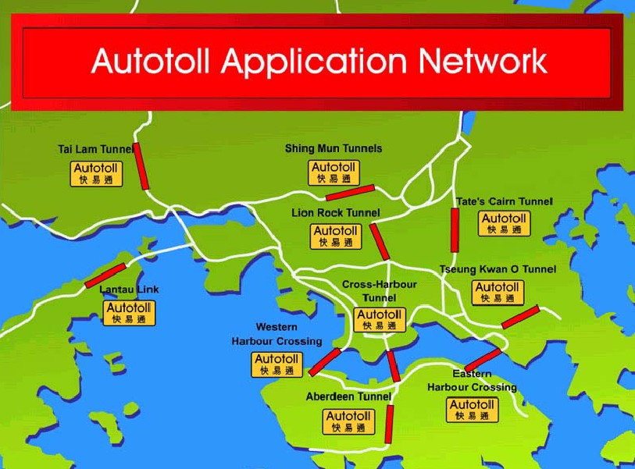

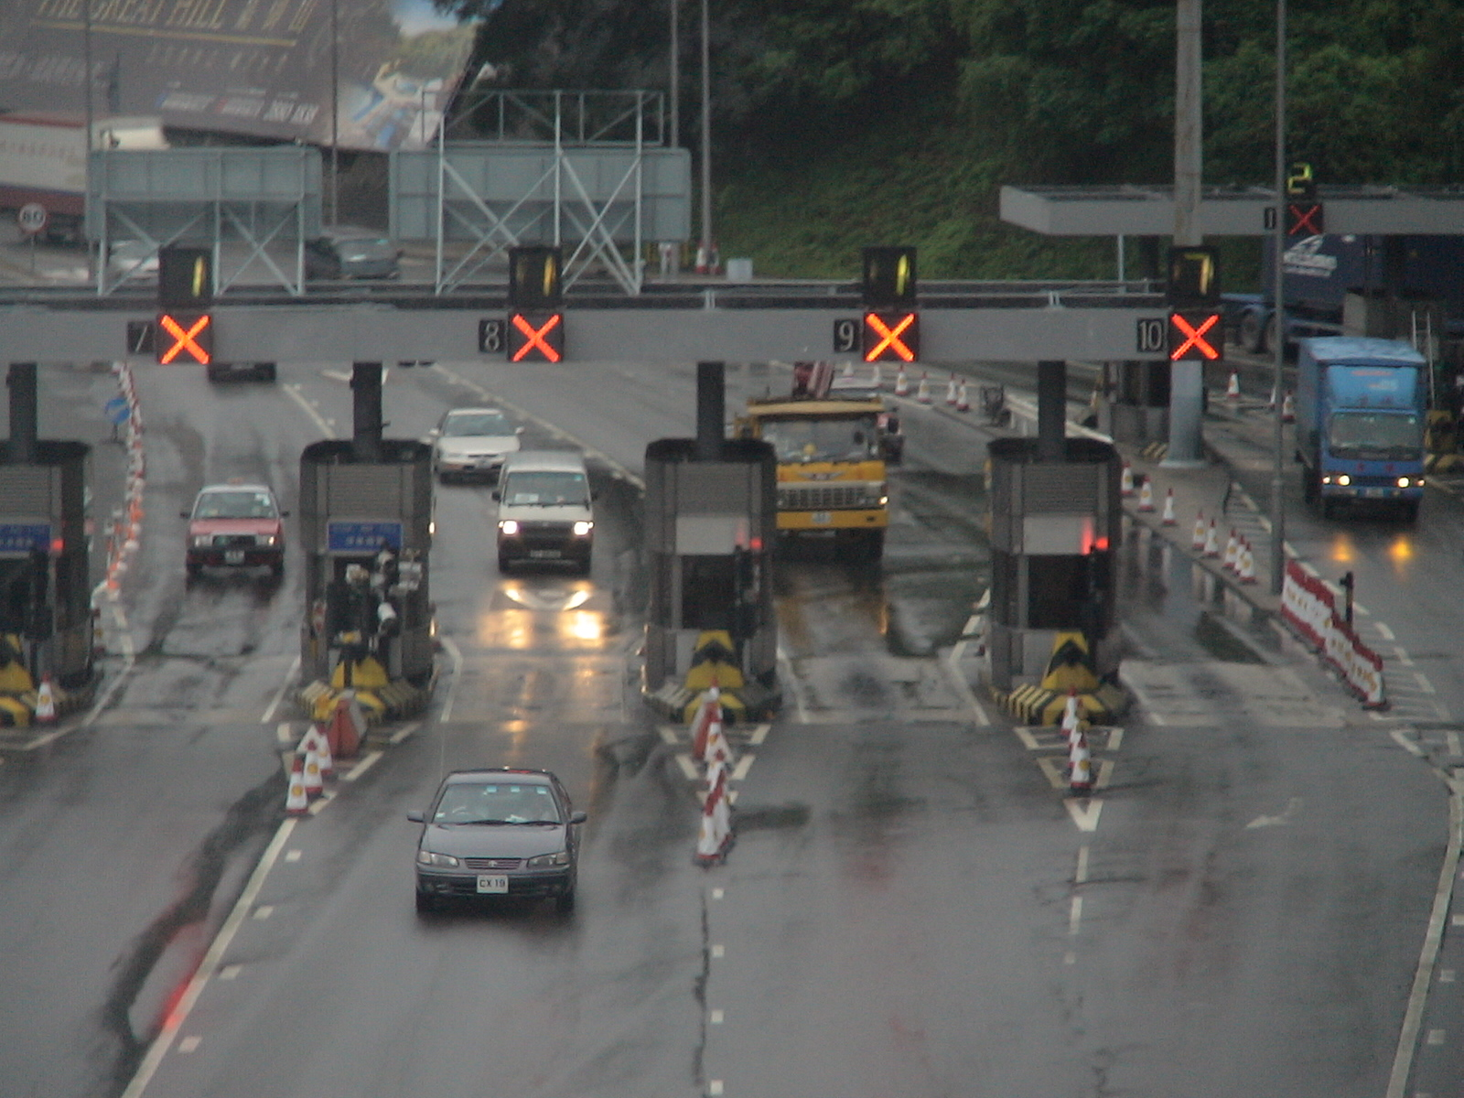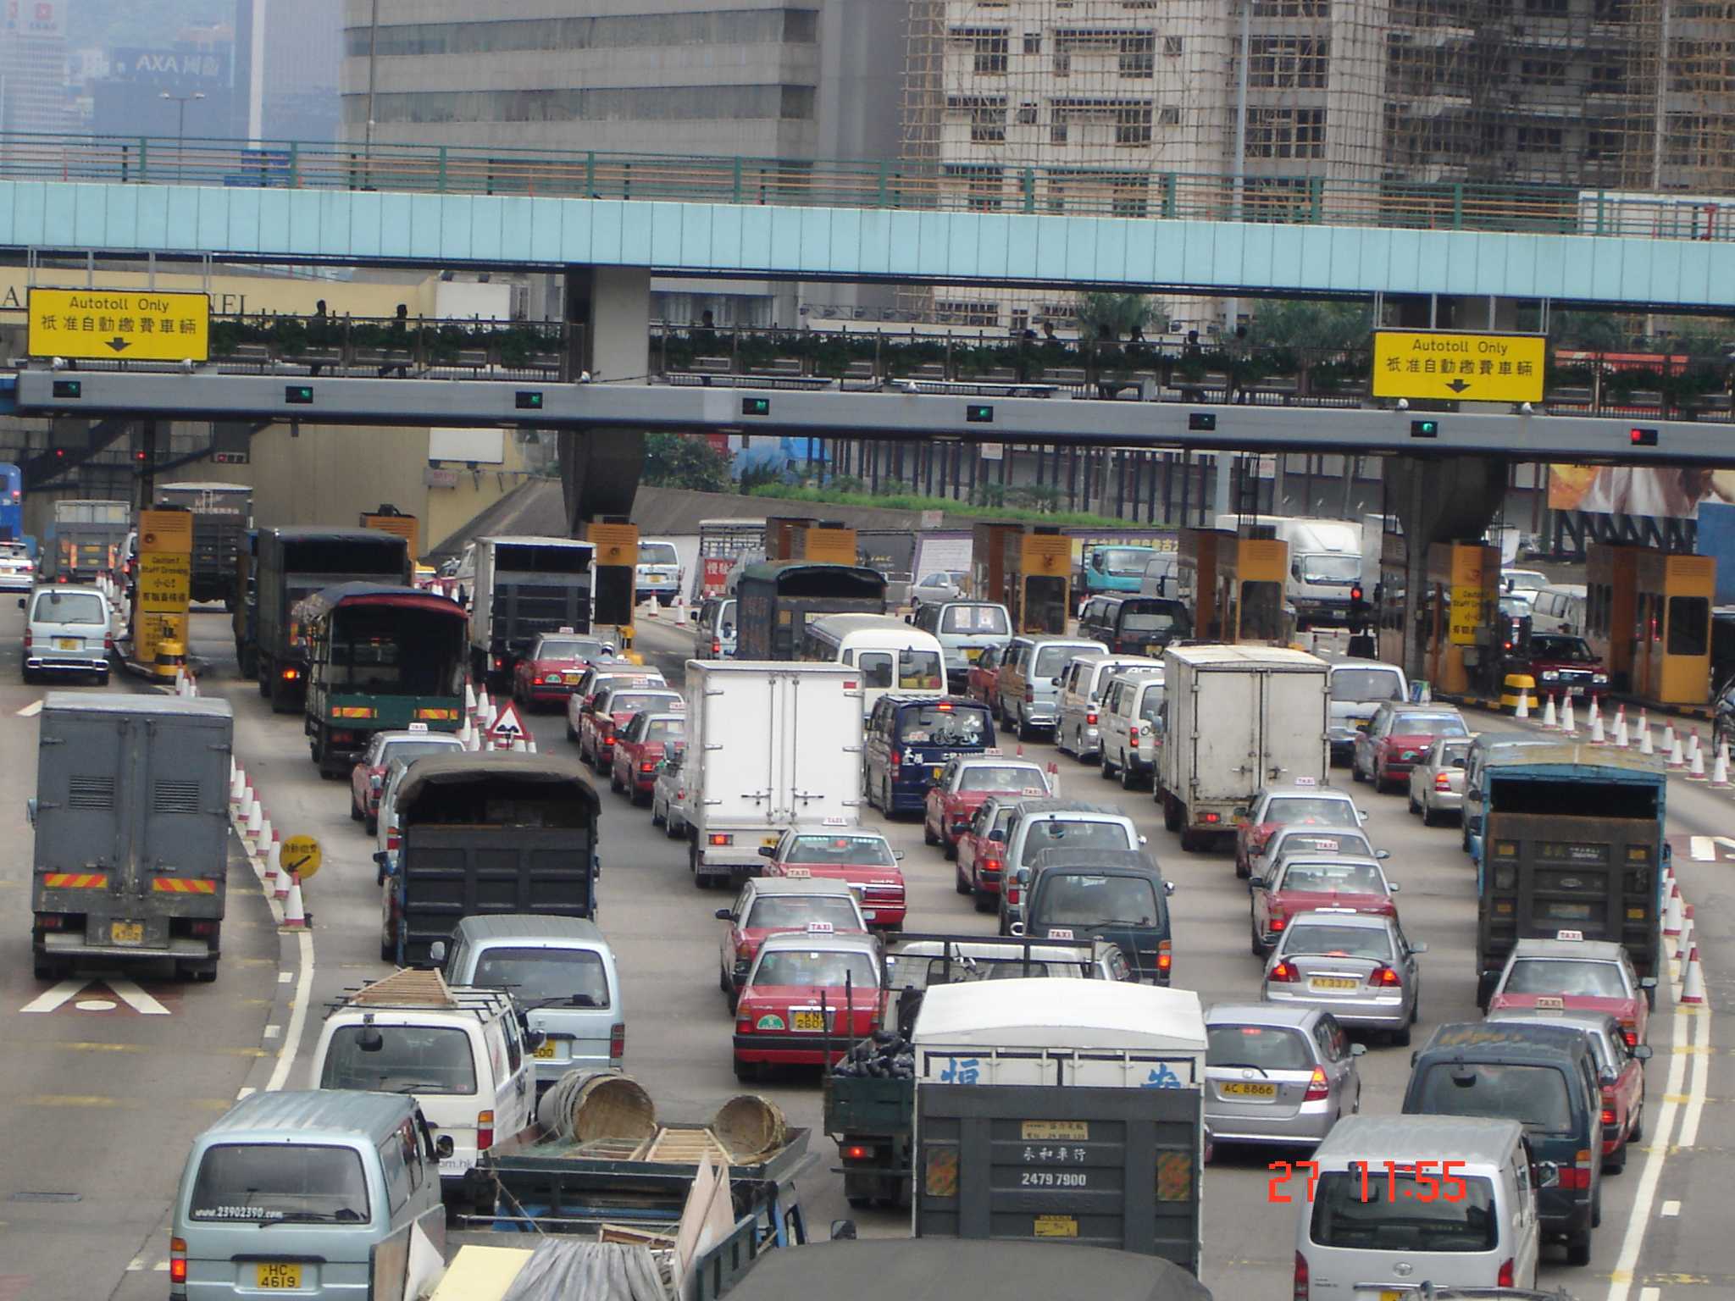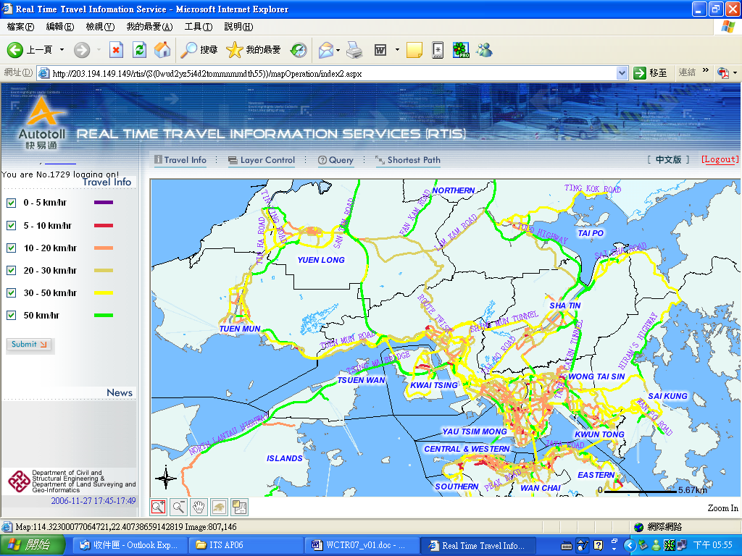
RTIS Website Portal (updated once every 5 minutes)
Off-line estimates*
On-line Updating Process
* Off-line results consist of the mean travel time by link and the link travel time variance-covariance matrices.
Data Filtering Algorithm
Real-time Autotoll tag data (i.e. AVI data)
Valid real-time Autotoll tag data
Historical Annual Traffic Census Data and Tunnel Counts
Traffic Flow Simulator (TFS)

90%
68%
100%

