THE ROLE OF TRAVEL TIMES - REPRESENTATION OF A DEMAND DERIVED FROM ACTIVITY PARTICIPATION

Joly Iragaël
Transport Institute (LET), University of Lyon 2, Lyon, France,
iragael.joly@let.ish-lyon.cnrs.fr

Theme Area : D1 – Transport Demand Modelling - passenger and freight

WCTR, 2007, I. JOLY – The role of travel times – Representation of a demand derived from activity participation

Abstract:
The paper exams the relationships between travel and activity times, in 7 travel surveys from 4 French and 3 Swiss cities, observed at two different periods. First, we test proportional assignment of total daily available time to activities (including transport). Second, proportionality is tested between (1) daily travel time of a given purpose with respect of the daily activity duration and (2) the trip time associated to the duration of the activity at destination. Only daily leisure time and daily travel time are fixed proportion of total daily available time. At disaggregated level, the trip duration do not show proportionality with activity duration. Finally questioning the proportionality and the linear adjustment, we regress the travel time budgets using duration models. This methodology is particularly adapted to the duration analysis and leads to non-linear relation between travel time and activity times. Leisure and shopping activities exhibit increasing and convex travel time intensities.

KEY WORDS: activity-based analysis, time use, travel time

Acknowledgements: this research was sponsored by the French PREDIT. The author would like to thank Vincent Kaufmann and the LASUR team for their help on the cities selection and on the urban and transport policies comprehension.

Preferred citation: Joly I., (2007), The role of travel times – Representation of a demand derived from activity participation, Paper presented at the Word Conference on Transport Research, Berkeley, June 2007.

1. Introduction
Many studies have analysed travel times and activity times. For example it seems natural to observe a positive correlation between travel time and the time of activity at a given destination. The search for simplified representations of travel times began with the stability hypothesis in the 1970’s, known as the “Travel-Time Budgets paradigm” (Goodwin, 1981), the “Brever law” (Hupkes, 1982), or the “Zahavi’s hypothesis” (Zahavi, 1979). Less restrictive hypotheses have been proposed on travel times. One of them assumes that a travel time intensity can characterise activity times, therefore making travel times fully determined by activity times. It has been examined at the daily level on time expenditures. Kitamura et al. (1992) test the “principle of proportional assignment” (Beckmann and Golob, 1972). Under this principle, each activity time represents a fixed proportion of the total available time. “The ratio of the amounts of time assigned to two activities is invariant regardless of the total amount of time available” (Kitamura et al., 1992, p.135). Their results support that total daily travel time is proportional to the amount of daily available time.
More generally, concerning specifically activity, relationships between travel time and activity duration have been analysed and estimated in different estimation frameworks, such as linear model, structural equations model, duration model, etc (Van Wissen and Golob, 1991; Hamed and Mannering, 1993; Golob and McNally, 1997; Goulias et al. 1998; Kitamura, Chen and Narayanan 1998, Ma and Goulias 1998; Levinson, 1999; Lu and Pas, 1999; Joly, 2006). Some propose an equivalent concept to proportionality: travel time intensity. Under this hypothesis, travel time assigned to activity participation is related to activity duration, with the proportional form representing a particular case of the possible relationships.
In this context, Dijst and Vidakovic (2000) and Schwanen and Dijst (2002) propose and analyse travel-time ratio for work activities. Estimating a structural equations model for the activities duration Van Wissen and Golob (1991), Golob and McNally (1997), Lu and Pas (1999) analysed relationships between travel time and activity duration. Some estimators can be interpreted in terms of travel time intensities for different activity types. For example, Golob and McNally (1997, p. 185) obtained a travel time intensity for maintenance that indicates that one hour of out-of-home maintenance activity requires on the average 7.8 minutes of travel time.
Studies on urban mobility have shown that spatial characteristics have a significant effect on mobility and travel time (Timmermans et a. 2002). Then, we propose to explore time use deduced from numerous households mobility surveys, in search for distinct relationships between activities duration and the travel time associated.

This paper presents results of a comparative study of Swiss and French daily travel times based on mobility surveys data of seven cities (Bern, Geneva, Grenoble, Lyon, Rennes, Strasbourg and Zurich) observed at two different dates. The cities chosen were guided by the disposability of the data and the following criterions:
- The form and spread of the peri-urbanisation process
- The level of equipment in heavy network of public transport
- The transport and urban policy managing the car accessibility
Swiss cities are clearly more transit and pedestrian oriented in terms of infrastructure, transport networks and transport policy. In French cities, transport policies, such as restriction of automobile access to the centre and limitation of parking facilities, appeared relatively recently in comparison to Swiss.
Socio-demographic characteristics of individuals and household and indicators of their mobility on a given weekday are collected. Using, starting and stopping times and the types of activities at the origin and destination, the one-day out-of-home activities diary can be deduced from the first to the last trip of the day.
We focus on the relationships between travel and activity times (work, shopping, leisure). Following Kitamura et al. (1992), we test the proportional assignment paradigm, where daily available time is proportionally allocated to different activities with fixed proportions (which may vary across individuals). Furthermore, we test the proportionality of daily travel times for each purpose type with the daily activity times. It clearly indicates that travel times are influenced by duration of activities.
Subsequently, the paper observes travel time ratio of work, leisure and shopping activity type. A linear model is estimated for the travel time associated to each type of activity. It supports a discussion on identification and transferability of regularities in the travel time with respect to socio-demographic variables between the seven cities.
The final section presents estimations realised in the duration model framework, for the two national samples, including dummies variables for cities fixed effect. Models for the travel time budgets are built and lead to non-linear estimates of the travel time intensities. Gain in quality of adjustment between the linear model and the duration model is finally discussed.

Section 1: Representation of the travel time and activity duration relationships
The travel times measures considered in the paper are:
- the individual daily travel time expenditures (or the daily travel time budget),
- the daily sum of travel times associated to a given purpose (or the daily travel time budget for the activity type i),
- the trip time.
Travel time budgets are calculated as the daily sum of the travel time on all the trips during the day, regardless of the purposes and the transport mode.
Following Goodwin (1982), the term “budget” is used to introduce the rationality, that is supposed in the process of allocation of time to travel. Three measures of travel times can be distinguished:
- the travel time cost of a trip, or the time it takes to reach a localisation given the transport system and the urban structure;
- the travel time expense, corresponding to the time associated to the decision to participate to an activity;
- the travel time budget, or the time rationally allocated by individuals to travel.
The travel time budgets can be viewed as the solution of the competition for the scarce resource of time between activities.
The study of trip time appears to be more complicated, because it is related to the decision to participate in or to renounce an activity. The aggregate measure of time at the daily level permits us to reduce the complexity of the activity behaviour.

1.1. Independence of the Travel Time Budgets
Depending on data, previous studies of travel times budgets have used numerous definitions and calculations. The early studies in the 1970’s could only calculate daily travel time on car or motorised trips for work (Szalai, 1972; Zahavi, 1973, 1979; Hupkes, 1981; van der Hoorn, 1979). With higher quality of mobility data collection, travels time and travel time budgets are now calculated for all modes and all purposes.
The analysis of travel time budgets within the past decades leads to the distinction of two hypotheses. The first suggests stability in time and space of the travel time budget. A travel time budget of one hour per day is supposed to be a relatively good approximation of the mean travel time budget observed in cities from different country and different time frames. Considering the various urban situations observed, this “strong hypothesis of stability” of travel time budget gains sense. Regardless of the economic development, the level of infrastructure, the urban context, etc., the travel time budget remains approximately the same, whether in African villages or European, American, and Japanese cities and agglomerations (see Schafer and Victor, 2000, for an actualisation of this observation).
Indeed, this assumption is irrelevant at a disaggregated level. Analyses of travel time budget at an individual level reveal numerous relationships between travel time budget and other variables, such as socio-demographic attributes, mobility characteristics, or urban contexts (for a review of these effects, refer to Chen and Mokhtarian, 2005; Joly, 2005). The question of the regularity of these relationships constitutes the “weak hypothesis of regularity” of travel time budgets. Depending on the data and methodologies, variables affect travel time budget on different ways. Nevertheless, some relationships appears relatively stable between studies, as for example, the negative effect of the presence of children under 5 years, the weekly cycle of travel time budget lower on Monday than Friday, etc.
The dimensions that can be introduced at the daily level limit the search for regularities in travel time budget. For example, the mode of transport or the urban context of activity participation locations is difficult to describe easily at the daily level. Furthermore, some dimensions exceed the daily level, as the planification of activity participation over weeks or months.
Here, we pay special attention to the relationships of travel time budget with activity time budgets. The consideration of the daily process of travel time allocation appears to be an interesting approach to adapt and to test proposition of the microeconomics theory of the allocation of time, which principally considers the competition between activities for the daily available time (or on longer periods) (Jara-Diaz, 2003).

1.2. Proportional assignment, travel time ratio, and travel time intensity hypotheses
Analyses of the relationships between travel time and activity time have produced three distinct concepts.
First, the proportional assignment of available time to travel has been proposed by Beckmann and Golob (1972). It has been revisited and empirically studied by Kitamura et al. (1992), based on Dutch and Californian time use surveys. The daily travel time, as any other daily time of activities, is supposed to represent a certain proportion of total daily available time. The activity times are calculated excluding associated travel time and the total available time is 24h less work duration.
It leads to the calculation of the following ratio:
$$\frac{{\text{ATB}}_{j}}{T}=f\left(X,β\right)$$
where ATB_{j} is the time budget of an activity j, T is the daily total available time. This proportion is supposed to depend on X, variables and β, parameters. Under the hypothesis of proportional assignment, this ratio is a constant, depending on the individual’s characteristics and other variables.

Second, the travel time ratio is proposed by Dijst and Vidakovic (2000). They suggest that the participation to an activity of a given location is the result of the trade-off between travel and activity time. Individuals participate to activities that satisfy an acceptable ratio. The travel time ratio is supposed to reflect this trade-off and is expected to exhibit regularities.
The travel time ratio is computed for an activity participation, as the ratio of the total associated travel time (round trip) to the sum of the trip time and activity duration at the destination:
$$τ_{a}=\frac{T_{t}}{T_{t}+T_{a}}$$
Where the travel time ratio for activity a is noted τ_{a}, T_{t} indicates the travel time and T_{a} denotes the activity duration. For the 1998 Dutch National Travel Survey, the mean travel time ratio for a visit to the work place is 0.105. It corresponds to a commuting time of 3.5 minutes an hour spent working (or 28 minutes for an 8 hours workday).

Third, the travel time intensity of an activity then represents the supplementary of travel time implied by an increase in activity duration of a given type. It can be found in certain models interpretations, as in Golob and McNally (1997), Lu and Pas (1999), or in other microeconomics models. To our knowledge, Chen and Mokhtarian (2006) are the first to proposed a “price time of activity” in a microeconomic time allocation model.
A general formulation can be:
$${\text{TTI}}_{j}=\frac{Δ{\text{TT}}_{j}}{{ΔT}_{j}}≃\frac{∂{\text{TT}}_{j}}{∂T_{j}}$$
Where the travel time intensity of the activity type j (TTI_{j}) is the relative variation (or the derivative) of the travel time associated to an activity type j with respect of the duration T_{j} of the activity of type j.
Most of the models that estimate the travel time on activity duration lead to interpret estimators in terms of travel time intensity.

1.3. The models
Following Kitamura et al. (1992), the test of proportionality of time budgets with respect to the total available time (24h – work time) consists of the test of the θ coefficient in the following form:
$$t_{j}=T^{θ}X_{1}^{β1}X_{2}^{β2}\text{.}\text{.}\text{.}$$
The ratio of time budget, t_{j}, on available time, T, is a fixed proportion, if θ = 1. This proportion is depending on the X attributes of individuals. The test is performed on the OLS estimates of the logarithmic model:
$$\text{ln}t_{j}=θ\text{ln}T+β_{1}\text{ln}X_{1}+β_{2}\text{ln}X_{2}+β_{3}\text{ln}X_{3}+\text{.}\text{.}\text{.}+ε$$
Kitamura et al. (1992) performed this test using the national time use surveys of Netherlands 1985 and California 1988. Results do not support proportionality for non-travel activities times. Proportionality is tested for daily travel times, commute times and travel time for non-work activities. The tests conclude to a proportional assignment of travel time to available time. Work time is introduced in the regressors set. It leads to a positive correlation between commute and work time. Finally, it suggests that travel time budgets are not stable, because of the variations of the travel time for non-work activity.
The stability of proportionality seems to be preserved by an adjustment mechanism between the travel times for the non-work activities and the commute times.

Schwanen and Dijst (2002) calculate travel time ratio for commute trips by doubling the home-to-work travel time. In Dutch NTS 1998, the mean travel time ratio is 0.105 and the median is 0.085. A majority of individuals then possess a travel time ratio lower than 10% for work activity. This ratio is relatively stable with respect to the socio-demographics attributes. The travel time ratios are higher for the peri-urban residents.
But, the test of the travel time ratio principle is invalid at the daily time allocation level. This concept is valid at the episode activity level. It focuses on the travel time associated with an activity participation and duration. It raises the question of the definition and measure of the travel time for an activity in a non-unique purpose chain of trips.
First, keeping the daily level of the time allocation process, we propose adaptation of the travel time ratio. We calculate the ratio on the basis of the time budgets of an activity and the part of the daily travel time budget associated to this purpose. It is only an approximation of the travel time ratio at the daily level that underestimates or overestimates the daily travel time for a given purpose. Underestimation will appear if the chain of trips is for only one purpose, because our calculation then excludes the trip back home. Overestimation could appear if the travel time associated to an activity in a chain is mostly explained by the other activities in the chain.
The travel time ratio is transform by logarithm and proportionality between travel time and activity time is tested. Then, to test for an activity type, j, the proportionality between the daily sum of travel time associated to the purpose j, TTB_{j}, and the sum of the activity time, TB_{j}, the model is the following:
$$\text{ln}{\text{TTB}}_{j}=θ_{j}\text{ln}{\text{TB}}_{j}+β_{1}\text{ln}X_{1}+β_{2}\text{ln}X_{2}+β_{3}\text{ln}X_{3}+\text{.}\text{.}\text{.}+ε$$
where, θ_{j} is the coefficient to be tested for the activity type j.

1.4. Non-linear assignment
The log-logistic model is one of the forms that allow for non-linear relationship. Test of the θ parameter in the model above will indicate the particular case of proportional assignment. Quality of adjustment can be gain by taking into account the non-normal distribution of duration data. In this objective the duration model framework is used to model the travel time budgets. Furthermore, this model estimate a flexible functional form of interaction between modelled time and covariates. Complete presentation of the duration model estimation theory can be found in Kalbfleich and Prentice (1980), Lawless (2003), Hosmer and Lemeshow (1999), Allison (1995).
The duration model framework assumes a log-linear model form. The logarithm of the duration (T) is estimated by:
lnT= g(X,β) + σε
where X is the covariable matrix, β is the column vector of parameters associated to covariables and ε denotes the error term which distribution is supposed to be known (for example, usual distribution are normal, logistic or extreme value distribution). The error distribution choice will imply a particular time distribution.
Usual specification of the covariables transformation function g(.) is:
g(X, μ β) = μ+Xβ
It leads to an easy interpretation of coefficients in terms of variations of the conditional expected value: E[lnT | X].
Assuming the error distribution, we can deduce the time density and distribution functions (f(t) and F(t)):
$$f(t)=\underset{Δ→0^{+}}{\text{lim}}\frac{P\left(t≤T<t+Δ\right)}{Δ}$$
and
$$F(t)=P(T≤t)=\int_{0}^{t}{f(u)\text{du}}$$
Interpretation of the duration model estimations is particularly interesting in terms of survival time or survival probability and hazard rate. The survival function is given by the following probability:
$$S(t)=\text{Pr}[T>t]=1−F(t)$$
It corresponds to the probability of an activity duration to exceed a given time t, and depends on the assumed distribution function of the error term. The hazard rate is given by the following conditional probability:
$$h(t)=\underset{Δ→0^{+}}{\text{lim}}\frac{P\left(t≤T<t+Δ |T>t\right)}{Δ}$$
The hazard rate corresponds to the conditional probability of interruption of the temporal process at date t+Δ, given it has lasted to time t. The hazard can be interpreted as the rate of variation of the survival curve.
The model estimations reveal an interesting interpretation in the median survival time variations with respect to covariables and especially here with the activity duration covariables. Depending on the assumed distribution of error term, median survival time and its derivative with respect of covariables can be deduced. For the classical Weibull model (Weibull distribution for time and extreme value distribution for error term), the median survival time is given by:
$$t_{\text{50}}=\frac{{\left(\text{ln}(2)\right)}^{σ}}{\text{exp}\left(−Xβ\right)}$$
where σ is the parameter of the Weibull distribution.
The median survival time corresponding to the exponential distribution is obtained by setting σ =1.
For the loglogistic distribution, the median is given by:
$$t_{\text{50}}=\frac{1}{\text{exp}\left(−Xβ\right)}$$
The duration model is applied to the travel time budget. Results produces estimates of the impact of covariables (including activity daily time budgets) on travel time and permits to deduced estimated travel time intensity for each activity type.

Section 2: Data

2.1. Enquête-Ménage Déplacements and Microrecencement National Suisse
The mobility surveys exploited in this study concern three Swiss cities (Bern, Geneva and Zurich) and four French cities (Grenoble, Lyon, Rennes and Strasbourg) each observed at two time periods. The Swiss data are from the Swiss national mobility survey (Microrecencement National Suisse) conducted in 1994 and 2000. The French data originates from the local mobility surveys of each city (Enquête-Ménage Déplacements).
Restrictions on the availability of the data limit the choice of the cities. The Swiss chosen cities were subject to a local oversampling in the Swiss national survey. The French cities were chosen for their survey periods, which resemble those of Switzerland.
The question of comparability of the different surveys arises regarding survey methodologies and the definition and measure of indicators. Table 1 presents the objectives and the convergence of the methodologies through a series of questions (who is surveyed, where, when, etc).
The French data are constituted of the 8 local mobility surveys, that all follow the unified CERTU methodology. At least 1,500 households are questioned by at-home interview on their composition, motorisation level, mobility and certain local themes.
Swiss information is from the NTS, where 10 regions were oversampled to ensure sufficient information for local analyses. 16,570 households in 1994 and 27,918 in 2000 were questioned using CATI methodology, on their composition, motorisation level, mobility and several local themes.
Divergences appear in the person interviewed. Swiss surveys concentrate only on a reference person older than six years old (2 persons of reference for households with 4 members). Conversely, in French surveys, mobility of all members are recorded. Swiss interviews are realised during the entire year, while French interviews are only performed between October and May. Swiss surveys include weekends and long distance trips realised at the national level, while French surveys exclusively consider trips on workdays and exclude trips that exit the perimeter of study.
A number of operations were then executed to extract information on the same type of mobility.

2.2. Data handling and variable descriptions
In order to ensure comparability, the handling of the data consists in reproducing in Swiss data the conditions of the French CERTU methodology on the following directions.
Zone adaptation
First, Swiss perimeters have been constructed to correspond to the French perimeters. Second, each perimeter is divided into 3 zone types: centre, suburban and peri-urban, based on the definition given by Jemelin and Kaufmann (2002). For the French cities, centre zones are composed of communes with more than 5,000 inhabitants per square kilometre and with more than 100,000 inhabitants. Suburban communes possess at least 50% of the residential capacity in collective buildings and are in continuity with a centre commune. The other communes of the perimeter are peri-urban. For Swiss cities, the classification is an adaptation of the one of the Federal Office of Statistics (Office Fédéral de la Statistique, 2000), which defined centre as an attraction point of the commute trips. The suburban type is defined on the type of buildings and is continuous with centre. The peri-urban zone is composed of the remaining communes (French municipalities).
Purposes adaptation
Swiss and French surveys focus on distinct purposes classifications. To be comparable the purposes are grouped into a simple distinction: work, shopping/services and leisure activities.
Trips selection
Certain trips were systematically excluded from the data sample. Hence, we only preserve mobile persons on workdays that do not exit the perimeter, nor perform trips for professional purposes. Special attention was made to correct or exclude errors on the timing of trips in order to keep only full time diaries.
Table 2 specifies the sample sizes for each city and date.

Section 3: Results
Estimations have been realised for each sample, but to gain space, only results concerning estimations based on the two Swiss and French samples are presented here.

3.1. Test of the proportional assignment of daily available time
The test of proportional assignment of available time is performed through Stepwise OLS estimations, constrained to include the total daily available time as an explanatory variable. The logarithm of daily time budgets for work, shopping, leisure and transport are regressed on the logarithm of daily total time available and dummy variables for sex, class of age, professional status, residential location, household structure, day of trip, driver licence, motorization, and dummies for cities crossed with periods. Separate regressions were performed for each city sample resulting in the same conclusions as in tables 3 and 4. Proportional assignment hypothesis is rejected for work and shopping activities, with high level of significance, in all cities. However, time budgets for leisure and travel seems to be a fixed proportion of available time in French cities. Only the sample of Grenoble 1992 does not support the hypothesis. The hypothesis is rejected at 10% level of significance in Grenoble 1992 and accepted at 5% or less in other French samples.
For the global Swiss national sample, estimations indicate that the proportional assignment hypothesis is rejected, for all activities. Conversely, the tests realised on each city samples indicates that the proportional assignment hypothesis is accepted for the shopping activity for the samples of Bern 1994 and 2000, Geneva 1994, and Zurich 1994 and 2000. The proportional assignment of time to leisure activity is also only valid for the Bern 2000 and Zurich 2000 samples.
The qualities of adjustment are weak, as it is usually the case for linear model of activity duration. By construction of the total time available, the R² is relatively high for the work time budget.

3.2. Test of proportionality between travel and activity times
A look on the results of estimations indicates that the daily travel times associated to a purpose is not a fixed proportion of the daily time of the associated activity type (Tables 5 and 6). There is no proportionality at the daily expenditure level between the daily time budget of an activity and the daily travel time associated.
The last step in the search for proportionality and regularities is at the trip level. The travel time for the work, shopping and leisure activities are analysed. Estimations of the logarithm of the trip time to an activity participation are realised on the logarithm of the activity duration and the other socio-demographic variables. Stepwise OLS are performed for each activity type on each city sample and on the two national samples, results of which are presented in tables 7 and 8.
R² are comparable with other studies, about 0.20. The tests reject proportionality for the three trip purposes. The activity time effect on trip time are positive and weak for work and leisure (respectively, 0.08 and 0.09). For shopping, a 1% increase of shopping time implies a 0.18% of trip time.
Individuals, household and trip characteristics are significant variables. We find regular results for most of them: higher work trip time for man, for non-motorised person, for public transport users, centre inhabitant; lower work trip time for households member with children, for driver licence holder; lower shopping trip time for worker, for no child households member, for the young, for driver licence holder and on Monday. Few regularities appear in the trip time for leisure. Only the negative effect of worker and the positive effect of age above 50 are significant.

3.3. Non-linear Transport intensity – Duration model
Duration model estimation of the travel time budget produces non-linear travel time intensity associated to activity duration. The derivative of the predicted median value of travel time budget depends on the distribution adopted. Hence, the first step is to perform a non-parametric estimation of the travel time budgets. The lifetable method is known to be a suitable way to explore the distribution of the duration process. Figures 1 and 2 present the survival function and the hazard rate and its confidence interval estimated in the different cities. The hazard rates appear to be non-monotonic, given that the confidence limits follow this form in most of the samples.
To complete the graphical conclusions on the hazard form, likelihood ratio test is used to select the distribution of the duration. Only nested distributions can be tested with the LR test. Then, table 9 shows the LR tests for Weibull, log-normal and generalised gamma distributions, for the Lyon 1995 sample. The gamma distribution gives the best adjustment, with estimates of distribution parameters indicating non-monotone hazard.
Nevertheless to estimate the travel time intensity, we use the log-logistic distribution. This distribution is non-monotonic too. We can not test this distribution in the LR test, because log-logistic distribution is not nested in the generalised gamma. However, the likelihood of the loglogistic model is higher than in the other models, it seems to give the best adjustment. Furthermore, the log-logistic distribution permits to deduce easily the derivative expression of the predicted median duration, by opposition with the lognormal or gamma functions. This distribution is non-monotonic too.
The covariables set are constituted through an adaptation of the set of socio-demographic variables resulting from the Stepwise selection process performed in semi-parametric methodology of the Cox model. This methodology is known to be a suitable way to estimate the covariable impacts on hazard. The Cox models were performed for each city sample, leading to 14 results tables not presented here.
Regularities in covariable effects appear through all the cities: male, worker and motorised persons have lower hazard rate, hence higher travel time budget. Older persons have lower travel time budget. Travel time budget on Friday are lower. Conversely, some variables have opposite effect between French and Swiss cities: young have lower hazard in French cities, but higher in Swiss. And the effect of the presence of child is unclear.

Finally, the loglogistic estimations are performed using the non-parametric results relative to the distributions choice and the semi-parametric results on the covariables selection. Estimates for the two national samples, with dummies for cities and dates are given by table 10.
Most of the significant estimates are similar to those obtained in the Cox models. Gender and professional status have positive effect on travel time budget or are insignificant. The days of the week have similar effect between French and Swiss samples. Travel time budget are higher on Friday and lower on Monday. Coefficients of the classes of age have the same sign. Older person have lower travel time budget. Residential location appears to have opposite effects: central location reduces travel time budget in Swiss cities, but increases travel time budget in French cities. The presence of children has significant negative effect in French cities and insignificant effect in Swiss cities. Male singles are characterised by opposite effect on travel time budget between French and Swiss cities. The driver licence dummy has a positive effect only in French cities. Motorization has no significant effect.
The dummies for cities indicate that travel time budget of Lyon 1995 and Strasbourg 1997 are the highest in the French sample. In the Swiss sample, Zurich and Bern 2000 have the highest travel time budget.

Figures 3-5 illustrate the predicted median travel time budget and the travel time intensities calculated at the mean of the French sample as function of each activity time budget. The travel time intensity is increasing and convex with the shopping and leisure daily time budgets. Hence, travel time budget increase more than proportionally with the time spend in leisure and shopping activity. Leisure appears more intensive in terms of travel time than shopping. Conversely, the travel time intensity for work is constant. Travel time for work increases linearly with work duration.

Section 4: Conclusion
We test the three paradigms: proportional assignment of daily total available time; proportionality between daily activity time and the travel time associated; and proportionality between trip time and the activity duration at destination.
The proportional assignment of daily available time is only valid for leisure and transport activities. The tests of the proportional relationship between daily travel time given a purpose and daily activity time indicate that proportionality is not valid, regardless the type of activity. Finally, the proportionality hypothesis is rejected between trip time and activity time at the destination. The log-log models estimated indicate a significant effect of activity duration on travel time, but in a non-linear form.
Using the duration model, to estimate travel time budget, we theoretically gain in quality of adjustment. Duration model take into account the fact that travel time budgets are characterised by a non-normal distribution. The log-logistic distribution appears to give the best adjustment in the two national samples. On the one hand, this non-monotonic hazard form raises the question of the management of high travel time budget. Joly (2006) shows that the decreasing hazard concerns about 20% of the sample of Lyon in 1995. This temporal dynamic can characterise the representative process of travel time management. The decreasing hazard part then questions the classical vision of travel time as a cost, that individuals want to reduce. On the other hand, this form can result from unobserved heterogeneity. Certain variables not included in the model, could explain why these persons with travel time budget greater than 100 minutes, have a decreasing conditional probability to stop travelling, given their travel time budget is already of 100 minutes. Determinant of the residential location choice, or the modal choice, or exceptional conditions could lead to special travel time management and make particularly high travel time budget acceptable.
Subsequently, we deduce travel time intensities from estimates of the activity time budgets, for French cities. Shopping and leisure times are associated with increasing travel time intensities, with daily duration of activity. Conversely the travel time intensity associated with the daily work duration is nearly stable. This result echoes results of Dijst and Vidakovic (2000). They find that travel time ratio for commute is a fixed proportion of the time devoted to work at destination (work duration plus commute time).
To gain robustness, the eventuality of heterogeneity between individuals needs to be included in this study. Furthermore, the definition of the travel time associated to the activity pursued, is problematic. Future task will be to analyse the time of trips chain in relation with the duration of the activities performed.

References
Allison, P. D. (1995) Survival analysis using SAS – A practical guide, SAS Publishing.
Beckmann, M.J. and Golob T.F., (1972) “A critique of entropy and gravity in travel forecasting”, in Newell, G.F. (ed.), Traffic Flow and Transportation, American Elsevier, New York, p. 109-117.
Dijst, M. and Vidakovic, V. (2000) “Travel Time Ratio: the key factor for spatial reach”, Transportation, 27(2), p. 179-199.
Golob, T.F. and McNally, M.G. (1997) “A model of activity participation and travel interactions between household heads”, Transportation Research Part B, 31(3), p. 177-194.
Goodwin, P.B. (1981) “The usefulness of travel budgets”, Transportation Research Part A, 15(1), p. 97-106.
Goulias, K.G., Brög, W. and Erl, E. (1998) “Perceptions in mode choice using the situational approach: a trip by trip multivariate analysis for public transportation”, The 77th Annual Meeting of Transportation Research Board, Washington, 11-15 January, 21 p.
Hamed, M. and Mannering, F. (1993) “Modelling travellers post-work activity involvement : toward a new methodology”, Transportation Science, 27(4), p. 381-394.
Hosmer, D.W. and Lemeshow, S. (1999) Applied survival analysis, New York, John Wiley and Sons, 386 p.
Hupkes, G. (1982) “The law of constant travel time and trip-rates”, Futures, February, p. 38-46.
Jara-Díaz, S.R. (2003) “On the goods-activities technical relations in the time allocation theory”, Transportation, 30(3), p. 245-260.
Jemelin, C. and Kaufmann, V. (2002) Pratiques et images des transports: une typologie des comportements modaux à Rennes Métropole, EPFL, Lausanne.
Jemelin, C., Kaufmann, V., Barbey, J., Klein, T. and Pini, G. (2006) Politiques de transport et inégalités sociales d’accès – Analyse comparative de huit agglomérations européennes, Research report for the PREDIT 3.
Joly, I., Ovtracht, N. and Thiebaut, V. (2006) La croissance des budgets-temps de transport en question : nouvelles approches, Research report for the PREDIT.
Joly, I. (2006) “Stability of regularity of the daily travel time in Lyon? Application of a duration model”, International Journal of Transport Economics, XXXIII, vol. 3, p. 369-400.
Joly, I. (2005) L’allocation du temps au transport – De l’observation internationale des budgets-temps de transport aux modèles de durées, Ph.D. thesis, University Lyon 2.
Kalbfleisch, J.D. and Prentice, R.L. (1980) The statistical analysis of failure time data, New York, John Wiley & Sons, 439 p.
Kitamura, R., Chen, C. and Narayanan, R. (1998) “The effects of time of day, activity duration and home location on traveller’s destination choice behaviour”, 77th Annual Meeting of the Transportation Research Board, Washington, 11–15 January, 25 p.
Kitamura, R., Robinson, J., Golob, T.F., Bradley, M., Leonard, J. and van der Hoorn, T. (1992) A comparative analysis of time use data in the Netherlands and California. Report UCD-ITS-RR-92-9, Institute of Transportation Studies, University of California, June, p. 127-138.
Lawless, J.F. (2003) Statistical models and methods for lifetime data. John Wiley and Sons, New York.
Levinson, D.M. (1999) “Space, money, life-stage, and the allocation of time”, Transportation, 26(2), p. 141-171.
Lu, X. and Pas, E. (1999) “Socio-demographics, activity participation and travel behaviour”, Transportation Research Part A, 33(1), p. 1-18.
Ma, J. and Goulias, K.G. (1998) “Forecasting home departure time, daily time budget, activity duration and travel time using panel data”, The 77th Annual Meeting of Transportation Research Board, Washington, 11-15 January, 29 p.
Mokhtarian, P.L. and Chen, C. (2005) “TTB or not TTB, that is the question: a review and analysis of the empirical literature on travel time (and money) budgets”, Transportation Research Part A, 38(9/10), p. 643-675.
Schafer, A. and Victor, D.G. (2000) “The Future mobility of the world population”, Transportation Research part A, 34, 171-205.
Schwanen T. and M. Dijst, (2002), “Travel-time ratios for visits to the workplace: the relationship between commuting time and work duration”, Transportation Research Part A, 36(7), p. 573-592.
Timmermans, H., Waerden, P., Alves, M., Polak, J., Ellis, S., Harvey, A.S., Kurose, S. and Zandee, R. (2002) “Time allocation in urban and transport settings: an international, inter-urban perspective”, Transport Policy, 9(2), p. 79-93.
Van Wissen, L.J., Golob, T.F. and Meurs, H.J. (1991) “A simultaneous dynamic travel and activities time allocation model”, Working paper, n°21, The University of California Transportation Centre, 17 p.
Zahavi, Y. (1979) The ‘UMOT’ Project. the U.S. Department of Transportation and the Ministry of Transport of Federal Republic Of Germany, Report DOT-RSPA-DPB-2-79-3, 267 p.

Table 1 : Comparison of French and the Swiss survey methodologies
 | Enquêtes-Ménages Déplacement | Microrecencement National
Survey | Local Mobility (agglomeration) | National Mobility (oversampling of 10 cantons)
Methodology | Unified CERTU methodology  At-home interview | CATI
Object : | Household equipment, mobility behaviour, and opinions on transport policy and local themes | Household equipment, mobility behaviour, and trip with a night out-of-home, and air trip, opinions on Swiss transport policy
Sample size | Minimum of 1,500 households | (1994) : 16,570 households, then 18,020 reference persons  (2000) : 27,918 households then 29,407 reference persons
Who ? | All members older than five | Persons of reference older than six (2 persons in households with four or more members)
Which trips ? | All trips realised the day before the survey (workdays) | All trips realised the day before the survey (workdays or weekend)
When ? | A workday of reference chosen in several months (October to May) | A day of reference chosen in the whole year
Where ? | The survey perimeter represents the agglomeration (defined by the entrepreneur) | The Swiss national country

Table 2 : Samples sizes

 | Trips |  |  | Individuals
City | Before correction | After correction | % of deletion | Before correction | After correction | % of deletion
Grenoble 2001 | 26004 | 24978 | -3,95 | 5916 | 5288 | -10,62
Grenoble 1992 | 15672 | 13924 | -11,15 | 3992 | 3257 | -18,41
Lyon 1985 | 32819 | 29235 | -10,92 | 8959 | 7240 | -19,19
Lyon 1995* | 50057 | 47152 | -5,80 | 12902 | 11063 | -14,25
Rennes 2000 | 33059 | 31743 | -3,98 | 8392 | 7476 | -10,92
Rennes 1991 | 27054 | 24757 | -8,49 | 7151 | 6127 | -14,32
Strasbourg 1988 | 18776 | 17103 | -8,91 | 4442 | 3668 | -17,42
Strasbourg 1997 | 25426 | 23126 | -9,05 | 5531 | 4661 | -15,73
Bern 1994 | 5718 | 5048 | -11,72 | 1575 | 1335 | -15,24
Bern 2000 | 6319 | 5457 | -13,64 | 1628 | 1348 | -17,20
Geneva 1994 | 1516 | 1397 | -7,85 | 388 | 353 | -9,02
Geneva 2000 | 9196 | 8100 | -11,92 | 2236 | 1919 | -14,18
Zurich 1994 | 6530 | 5903 | -9,60 | 1793 | 1574 | -12,21
Zurich 2000 | 8893 | 7954 | -10,56 | 2317 | 2010 | -13,25
Total | 267039 | 245877 | -7,92 | 67222 | 57319 | -14,73

* For the database of Lyon 1995, trips and timings were verified by Joly (2006). This first correction step explain the low correction level of Lyon 1995, relatively to the other samples.

Table 3 : Tests of the proportional assignment of total available time
(French cities)
 | Work TB / T | Shopping TB / T | Leisure TB / T | Travel TB / T
R² | 0.73 | 0.076 | 0.09 | 0.1063
N. of significant variables | 21 | 15 | 17 | 29
Test statistics  (P-Value) | 92284.7  (<0.0001) | 54.53  (<0.0001) | 0.05  (0.81) | 1.69  (<0.193)
TB: Time budget T: Total time available
Table 4 : Tests of the proportional assignment of total available time
(Swiss cities)
 | Work TB / T | Shopping TB / T | Leisure TB / T | Travel TB / T
R² | 0.70 | 0.23 | 0.23 | 0.06
N. of significant variables | 13 | 16 | 20 | 20
Test statistics  (P-Value) | 15622.9  (<0.0001) | 21.44  (<0.0001) | 6.28  (0.0123) | 51.52  (<0.0001)
TB: Time budget T: Total time available

Table 5: Tests of the proportionality of the daily travel times for a purpose
with respect to activity time budget (French cities)
 | Daily TT for Work/ Work TB | Daily TT for Shopping / Shopping TB | Daily TT for Leisure / Leisure TB
R² | 0.062 | 0.253 | 0.142
N. of significant variables | 26 | 25 | 26
Test statistics  (P-Value) | 6069.09  (<0.0001) | 18021.5  (<0.0001) | 13151.2  (<0.0001)
TT: Travel time TB: Time budget

Table 6 : Tests of the proportionality of the daily travel times for a purpose
with respect to activity time budget (Swiss cities)
 | Daily TT for Work/ Work TB | Daily TT for Shopping / Shopping TB | Daily TT for Leisure / Leisure TB
 | TTB / Work | TTB / Shopping | TTB / Leisure
R² | 0.038 | 0.147 | 0.144
N. of significant variables | 19 | 12 | 11
Test statistics  (P-Value) | 1553.28  (<0.0001) | 3989.09  (<0.0001) | 2156.69  (<0.0001)
TT: Travel time TB: Time budget

Table 7: Regression of the time trip given work, leisure and shopping purposes (Swiss sample)
Variable | Trip time for Work | Trip time for Shopping | Trip time for Leisure
Intercept | 2.232 *** | 2.013 *** | 2.472 ***
Log Work time | 0.036 ***
Log Shopping time |  | 0.042 ***
Log Leisure time |  |  | 0.022 **
Male
Worker |  | -0.107 *** | -0.299 ***
Suburban |  |  | 0.048 **
Monday |  | -0.054 **
Tuesday | 0.071 ***
Friday | 0.113 *** |  | 0.122 ***
Couple with 3 children | -0.376 ***
Male single no child | 0.036 **
Male single 1 child |  | 0.087
Female single no child |  |  | 0.045 *
Age < 19 |  | -0.234 ** | -0.123
18 < Age < 35 |  |  | -0.059 **
49 < Age <65 |  |  | 0.052 *
Age > 66 | 0.108 ** |  | 0.122 **
Driver Licence | -0.039 | -0.071 ***
0 car | 0.039 *
3 cars | 0.161 ** | -0.149
Walk | -0.661 *** |  | -0.213 ***
Bicycle | -0.343 *** |  | -0.117 *
Motorcycle | -0.109
Public transport | 0.829 *** | 1.169 *** | 0.849 ***
Car | 0.107 * | 0.394 *** | 0.129 ***
Other |  | 0.275 * | 0.950 ***
Bern 94 |  | -0.221 *** | -0.123 ***
Bern 00 |  | -0.057 *
Geneva94 |  |  | -0.093
Geneva00 | 0.083 *** | 0.056 *
Zurich 94 |  | -0.157 *** | -0.145 ***
Zurich 00 | 0.046 ** | -0.053 * | 0.079 ***
R² | 0.31 | 0.24 | 0.17
Proportionality F Test | 15,873.8 *** | 11,961.5 *** | 7,958.31 ***

Table 8: Regression of the time trip given work, leisure and shopping purposes (French sample)
Variable | Trip time for Work | Trip time for Shopping | Trip time for Leisure
Intercept | 2.213 *** | 1.753 *** | 1.997 ***
Log Work time | 0.088 ***
Log Shopping time |  | 0.187 ***
Log Leisure time |  |  | 0.091 ***
Male | 0.129 *** | 0.085 ***
Worker | - | -0.031 *** | -0.096 ***
Centre | 0.055 *** | 0.050 *** | 0.054 ***
Peri-urban |  | -0.018 *** | -0.079 ***
Monday |  | -0.027 *** | -0.049 ***
Tuesday |  |  | -0.034 ***
Thursday | 0.028 ***
Friday | 0.023 ** | -0.021 ***
Couple with no child |  | 0.044 ***
Couple with 1 child |  |  | 0.028 *
Couple with 2 children | -0.026 ** | -0.028 ***
Female single no child | 0.060 *** | 0.063 *** | 0.069 ***
Female single 1 child |  |  | 0.049 **
Male single no child |  |  | 0.078 ***
Male single 1 child |  |  | 0.199 ***
Age < 19 | -0.175 *** | -0.104 *** | -0.189 ***
18 < Age < 35
34 < Age < 50 | -0.021 *** |  | 0.021
49 < Age <65 |  |  | 0.096 ***
Age > 66 |  |  | 0.165 ***
Driver Licence | -0.082 *** | -0.049 *** | -0.037 ***
High income |  |  | 0.041 ***
0 car | 0.089 *** | 0.044 *** | 0.026 *
1 car | -0.021 *** | 0.026 *** | 0.023 **
Walk | -0.650 *** | -0.304 *** | -0.263 ***
Bicycle | -0.283 *** | -0.220 ***
Motorcycle | -0.167 *** | -0.168 ***
Public transport | 0.563 *** | 0.474 *** | 0.664 ***
Car |  | -0.081 *** | 0.122 ***
Other | 0.374 *** | 0.189 *** | 0.608 ***
Grenoble 01 |  | 0.01999 | -0.089 ***
Grenoble 92 | -0.105 ***
Lyon 85 | 0.047 *** | 0.036 ***
Lyon 95 | 0.108 *** | 0.124 *** | 0.081 ***
Rennes 00 | 0.108 *** |  | -0.030 ***
Rennes 91 | -0.119 *** | -0.077 *** | -0.048 ***
Strasbourg 88 | -0.136 *** | -0.169 ***
Strasbourg 97
R² | 0.21 | 0.21 | 0.19
Proportionality F Test | 51,176.7 *** | 49,305.5 *** | 46,149.4 ***

Table 9 : Loglikelihoods and LR tests
Models | Loglikelihood
 | Swiss Sample | French Sample
Weibull | -9587.08 | -54824.51
Log Normal | -9310.61 | -51999.94
Generalised Gamma | -9269.36 | -51858.53
LogLogistic | -9164.85 | -51648.07
Model 1 vs model 2 | Test statistics
 | Swiss Sample | French Sample
Weibull vs GG | 635.44 *** | 5931.96 ***
Log N vs GG | 82.5 *** | 282.82 ***

Table 10: Loglogistic estimations on the two national samples
 | French Sample | Swiss Sample
Parameter | Estimation | Estimation
Intercept | 3.767 *** | 3.901 ***
Work time budget | 0.0001 *** | 0.0003 ***
Shopping time budget | 0.0019 *** | 0.0008 ***
Leisure time budget | 0.0014 *** | 0.0013 ***
Male | 0.093 *** | -0.062
Worker | 0.114 *** | -0.007
Centre | 0.045 *** | -0.078 ***
Suburban | 0.009 | -0.069 ***
Peri-urban | - | -
Monday | -0.093 *** | -0.119 ***
Tuesday | -0.039 *** | -0.047 *
Wednesday | -0.059 *** | -0.113 ***
Thursday | -0.028 *** | -0.109 ***
Friday | - | -
Couple 0 child | 0.016 | -0.027
Couple 1 child | -0.066 * | 0.105
Couple 2 children | -0.076 ** | 0.113
Couple 3+ children | -0.014 | 0.026
Male single 0 child | -0.145 *** | 0.197 **
Male single 1 child | -0.015 | 0.168 *
Female single 0 child | -0.068 * | 0.071
Female single 1 child | -0.033 | 0.054
Age < 19 | 0.014 | 0.546 ***
18 < Age < 35 | 0.256 *** | 0.166 ***
34 < Age < 50 | 0.159 *** | 0.162 ***
49 < Age < 65 | 0.106 *** | 0.149 ***
Age > 64 | - | -
Driver licence | 0.059 *** | 0.019
High income | -0.015
Low income | -0.023
Medium income | -
Non car | 0.051 | 0.022
1 car | 0.044 | -0.049
2 cars | 0.053 | -0.039
3 cars | 0.063 | 0.027
4 cars and more | - | -
Bern 94 |  | -0.232 ***
Bern 00 |  | -0.034
Geneva 00 |  | -0.048 *
Geneva 94 |  | -0.172 ***
Zurich 94 |  | -0.153 ***
Zurich 00
Grenoble 01 | -0.003
Grenoble 92 | -0.137 ***
Lyon 85 | -0.079 ***
Lyon 95 | 0.050 ***
Rennes 00 | -0.143 ***
Rennes 91 | -0.228 ***
Strasbourg 88 | -0.085 ***
Strasbourg 97 | -
Scale | 0.393 | 0.457
LogLikelihood | -51648.07 | -9164.85

Figures 1 (a to f): Survival curves, hazard curves and hazard’s confidence limits
for Swiss travel time budgets
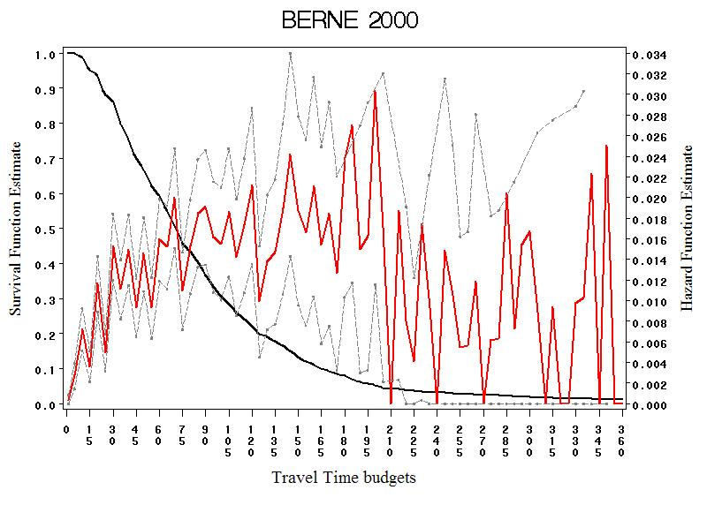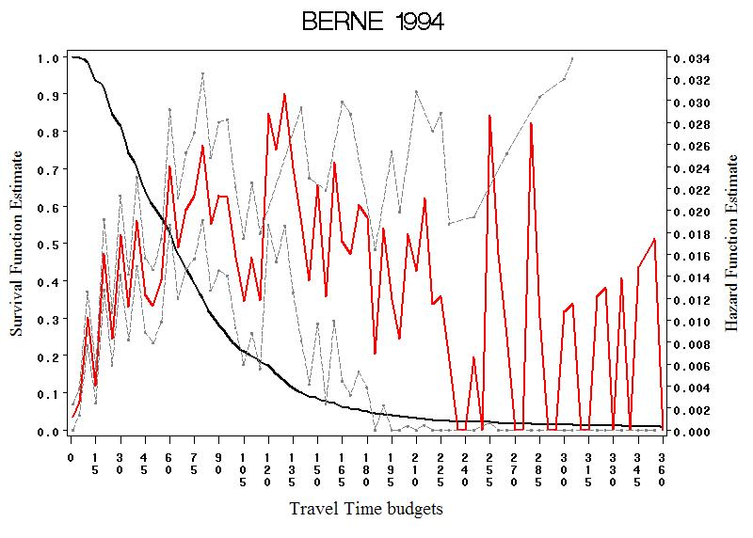
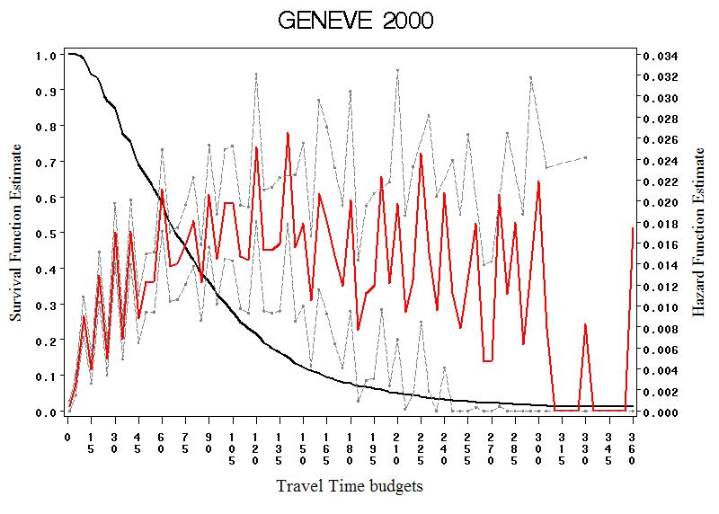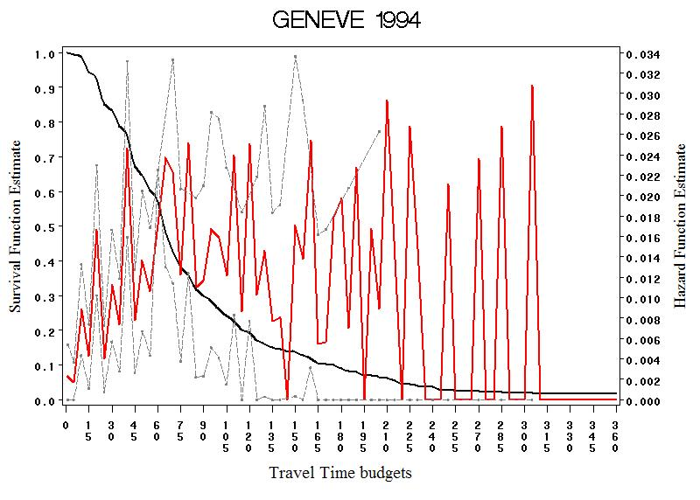
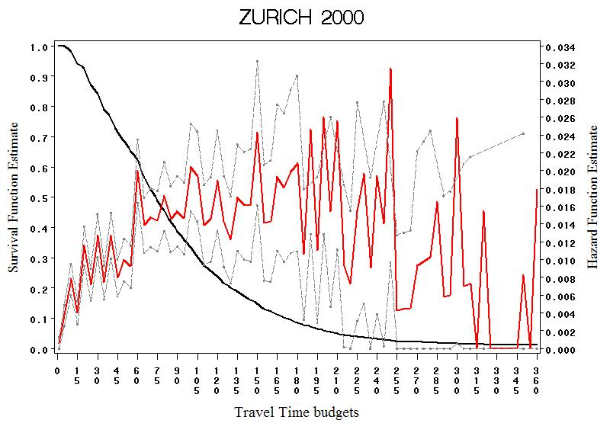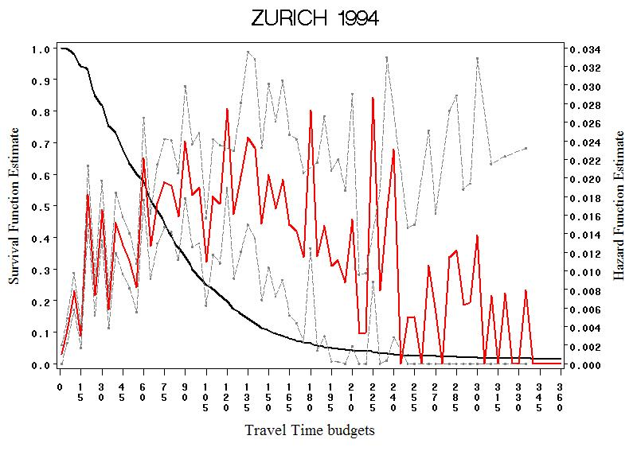

Figures 2 (a to h): Survival curves, hazard curves and hazard’s confidence limits
for French travel time budgets
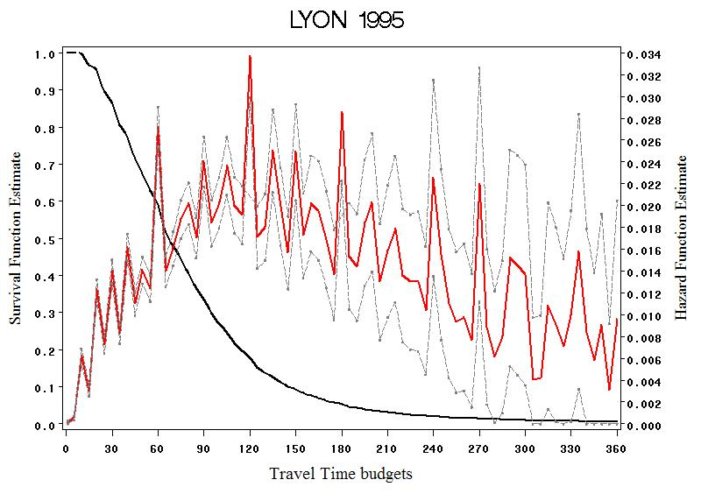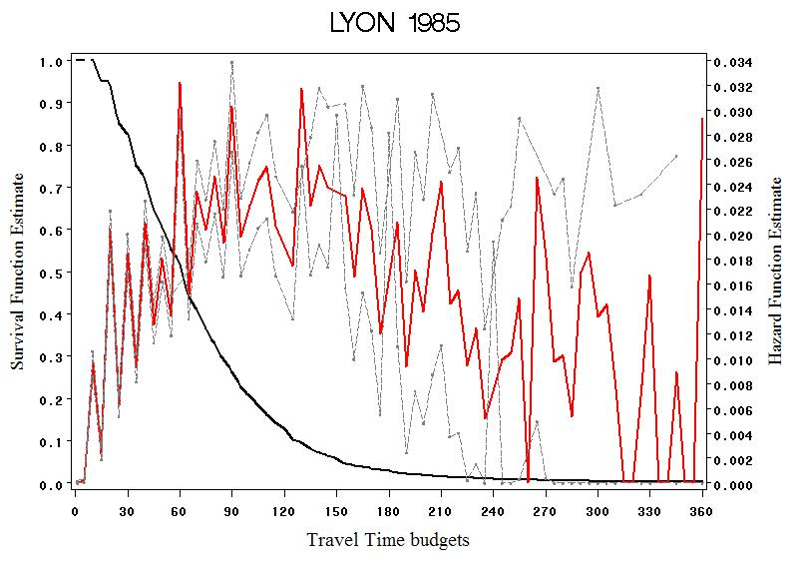
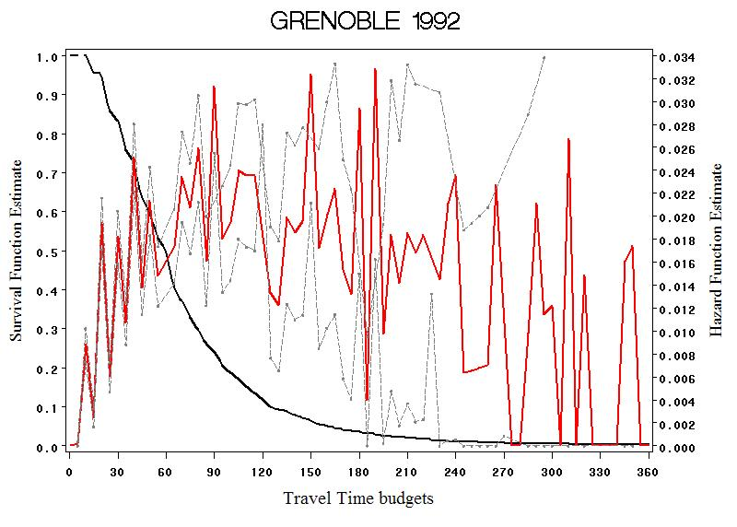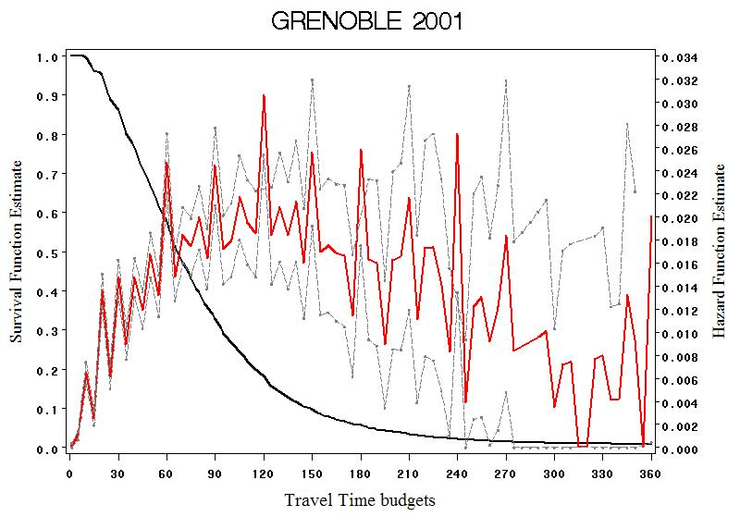
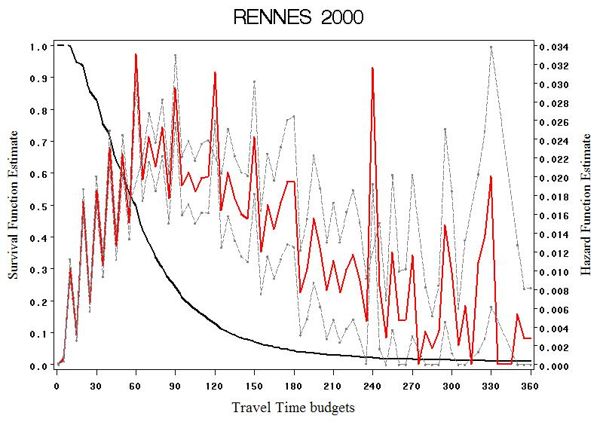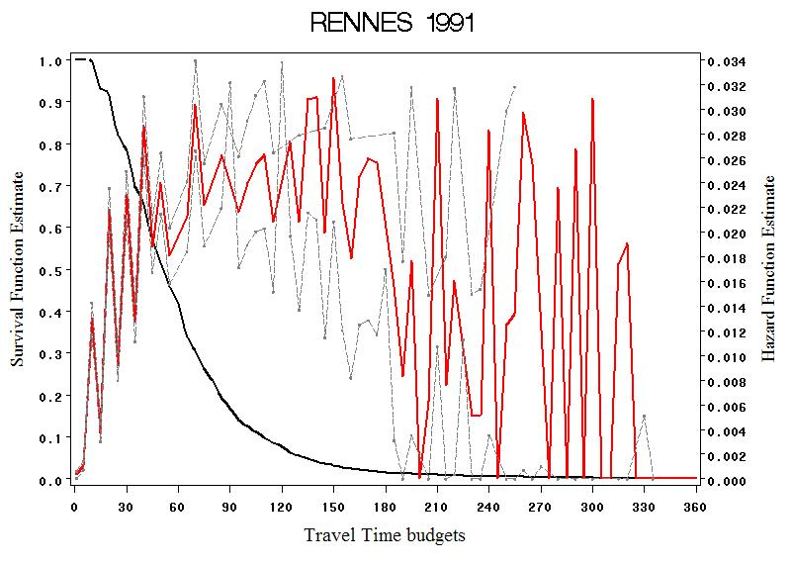
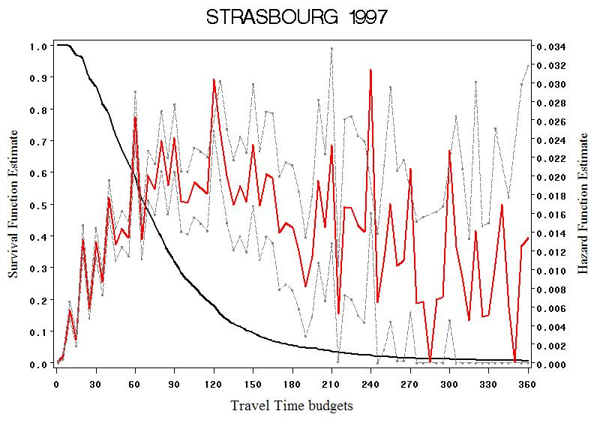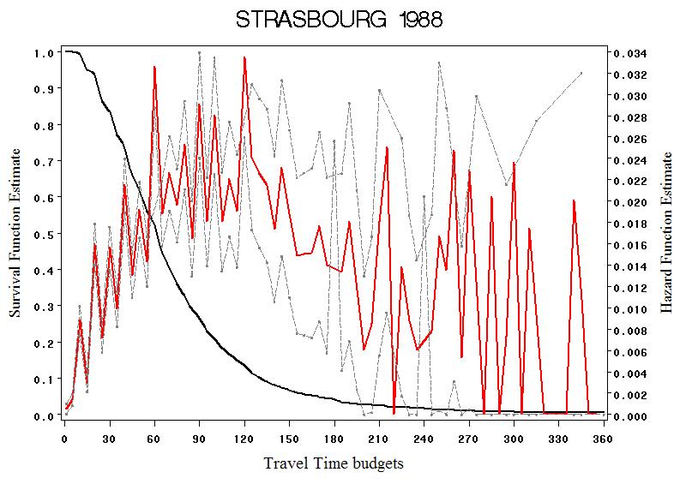

Figure 3: Median expected daily travel time and travel time intensity
given the Shopping daily time (French sample)
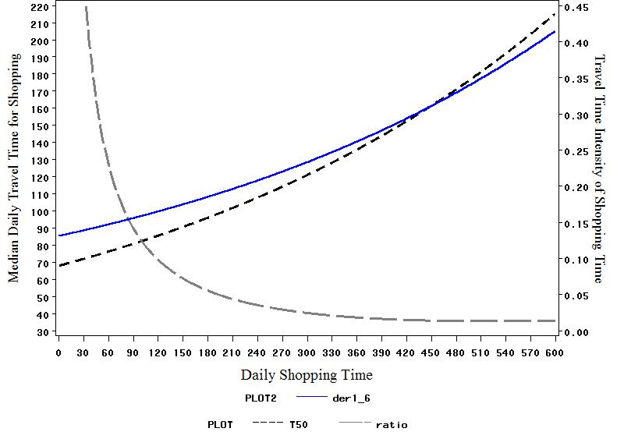
TT intensity
Median predicted TT
TT Ratio
Figure 4: Median expected daily travel time and travel time intensity
given the Leisure daily time (French sample)
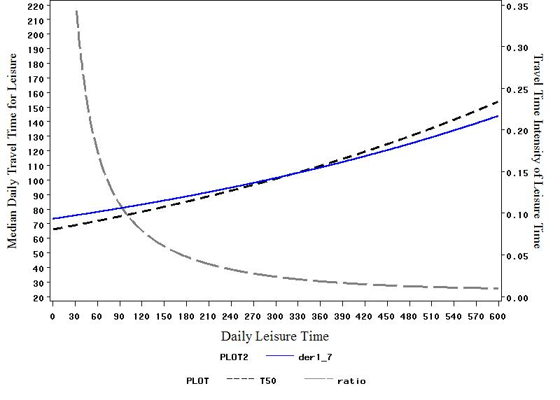
TT intensity
Median predicted TT
TT Ratio
Figure 5: Median expected daily travel time and travel time intensity
given the Work daily time (French sample)
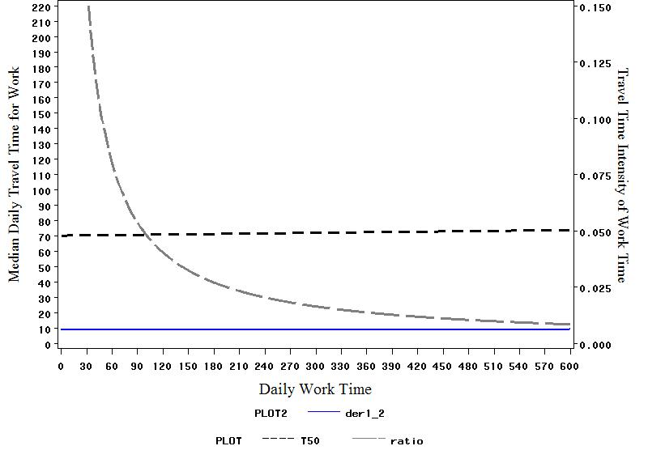
Median predicted TT
TT Ratio
TT intensity

