Microscopic modeling of long-distance passenger transportation in a longitudinal perspective
submitted for the 11. World Conference on Transport Research Society (WCTRS)
June 24-28, 2007, in Berkeley, California

Dr.-Ing. Wilko Manz
Managing Partner, STRATA GmbH
Rintheimer Hauptstraße 56, 76131 Karlsruhe, Germany
Tel +49 700 2255 7872, Fax +49 98 123 97, manz@strata-gmbh.de

Prof. Dr.-Ing. Dirk Zumkeller
Director, Institute for Transport Studies, University of Karlsruhe
Kaiserstraße 12, 76131 Karlsruhe, Germany
Tel +49 721 608 2251, Fax +49 721 608 6777, zumkeller@ifv.uni-karlsruhe.de

Abstract
The demand for long-distance passenger transportation is heterogeneous in two respects: On the one hand, its distribution over time is dictated by a pronounced seasonality; on the other hand, there is an extremely uneven distribution of demand throughout the population. For the very first time, a model for long-distance passenger transportation in Germany has been successfully developed on the basis of longitudinal data. This model represents demand in a differentiated manner both in terms of its distribution over time and in terms of its customer and user groups. This paper documents some of the key findings in the field of long-distance passenger transportation demand, presents the implemented concept of the microscopic modeling of long-distance passenger transportation in a longitudinal perspective and describes a concrete application.

Introduction and problem description
In recent years, the deregulation of the long-distance transportation market has resulted in a series of changes in supply. For example, the advent of low-cost carriers initiated a sustained transformation of the air transportation market. Due to the emergence of such novel transportation offers, the passenger transportation market is becoming increasingly complex. Demand segments are being displaced and additional demand is being created by new offers. Furthermore, long-distance transportation is still continuing to witness growth in demand: Increasing travel distances are making long-distance transportation more international thus contributing to a rise in global networking. The long-term consequences of this development on the market and how the providers of transportation services need to adjust to these changes are the challenges faced by the transportation market today.
At the same time, the progressive diversification of supply and demand is leading to continuous change in the market structure, to which the parties involved, such as service providers, transportation planners, political authorities as well as transportation researchers, need to react. This trend is making increasing demand on the information provided by the transportation market. In order to be able to develop economically sustainable offers, transportation service providers require continuous up-to-date and reliable information as well as verifiable projections. Moreover, political strategists need reliable medium-term and long-term projections in order to be able to plan infrastructure development in an adequate manner. Knowledge about existing and projected travel demand is a fundamental element in these planning processes.
In particular, telematics service providers and traffic managers require differentiated spatiotemporal projections concerning the travel demand situation to be expected. Existing data sources can not meet these demands.
For road traffic, the fluctuations of weekly and annual demand can be measured using permanent traffic counts. However, based on the overlap with the flows of daily traffic in the cross-sections measured, the share of long-distance traffic can not be delimited in a suitable manner.
Statistics on air traffic are almost exclusively restricted to long-distance traffic, the problem being that this kind of statistics do not differentiate between the journeys of the population of a certain region and those of incoming travelers. Nevertheless, the causes of the variation recorded can, for example, be traced back to features of the home base of the travelers, since school holidays and public holidays have a significant impact on fluctuations in demand.
The product development by transportation suppliers calls for a differentiated knowledge of the demand structures with regard to user preferences and customer sensitivities. For example, representative surveys on long-distance traffic usually provide too little information on individual persons and almost no background information on the motives for making a certain modal choice (Youssefzadeh (2003)). As a result, survey data that enable an adequate differentiation of the persons behind demand and that define suitable groups of customers are required.
For that purpose, it is necessary not to select the travel event as the object to be investigated, but instead, to place the traveler in the foreground. This requires methods which can take the behavior of persons over a period of time into account thus enabling a differentiated characterization of these persons. For that purpose, it is necessary to document the actual behavior of the same persons in different decision-making situations. This is only possible if individuals are observed over longer stretches of time.
The above-mentioned requirements for the projection of long-distance passenger transportation necessitate a corresponding compilation and model concept which is able to depict the impact of modified framework conditions and measures on demand, to illustrate the variation of demand over time and, furthermore, to enable forecasts to be made concerning individual customer and user segments.
A microscopic model for long-distance passenger transportation in Germany has been developed and implemented based on the information provided by a research project for the very first time. The latest findings regarding the structure of demand for long-distance transportation and a model concept which meets the above-mentioned requirements are presented below. Last but not least, an exemplary application is described.

Observation in a longitudinal perspective
Surveys in a longitudinal perspective (Kasprzyk, D.; Duncan, G.; Kalton, G.; Singh, M. P. (1989)) which record the transportation behavior of persons over a longer time period provide invaluable information about the variation of demand over time (Zumkeller, D., Madre J.-L.; Chlond, B.; Armoogum, J.; (2006)). Based on such survey data, it also becomes possible to develop suitable longitudinal models to depict the variance of demand, e.g. within the course of a week or over a whole year (cf. Error: Reference source not found). Furthermore, the use of a microscopic model approach also makes it possible to retain the consistency in the travel behavior of an individual over time.
(figure 1)
Furthermore, longitudinal data provide much more information on the individual person and his/her behavior. Since long-distance journeys are rare events for individual persons, sufficient information can only be gained by observing individuals over longer time periods (Chlond, Last, Manz, Zumkeller (2006)). These more extensive data are meaningful for being able to carry out differentiated analyses regarding the behavior and the corresponding preference structures, and they are helpful for the purpose of achieving a meaningful classification into customer segments. For example, travel service providers rely on finely tuned customer segmentation, since they are required to adapt their offers to their customers’ requirements in a targeted manner.
For example, longitudinal data make it possible to analyze variations in the choice behavior of individual persons over a certain time period and to derive interrelationships with the household and the individuals therein (Axhausen (1998)). Thus, this is the only way in which one can analyze whether a person displays monomodal behavior by using the same mode for every trip or whether we are dealing with multimodal users which alternate between different modes. Such customer and/or user segment-specific information is therefore of fundamental importance for assessing the effects of measures taken. For example, both person subgroup examples display different probabilities of changing to a certain mode when implementing infrastructural and political measures (Manz 2005).
Panel and longitudinal surveys have already proven themselves as significant instruments in various sectors of transportation planning and provide new perspectives, particularly in changing markets (Golob, T; Kitamura, R.; Long, L. (1997)). However, in the context of long-distance passenger transportation, the use of data from the longitudinal perspective still requires substantial development.

Cyclicality and heterogeneity in long-distance passenger transportation
In the framework of the multi-year INVERMO⁽¹⁾ research project with regard to long-distance passenger transportation⁽²⁾ in Germany, information on the travel behavior of persons was collected over longer periods of time using a comprehensive, multi-stage survey method. For details concerning survey methods, sample sizes and reporting periods see Chlond, Last, Manz, Zumkeller (2006). One of the objectives of this project was to measure the temporal variation of demand and its influencing factors in order to utilize them in a forecasting model. Another main focus was the analysis of customer and/or user-specific groups in order to be able to take into account the different requirements of these segments. Three key results regarding demand for long-distance passenger transportation are presented below.
(figure 2)
Demand for long-distance passenger transportation is characterized by a strong weekly cycle (cf. Error: Reference source not found). While business trips reach their highest share of total travel mid-week, private travel with less than four overnight stays is mainly limited to weekends. For holiday trips, the greatest part of outbound and return trips consists on Saturdays, corresponding with the usual day of arrival in holiday apartments and hotels.
Furthermore, a marked seasonal demand cycle can be observed. Business trips mainly take place in the first and fourth quarters, whereas demand for them significantly decreases over the holiday period in the summer months. For all other private travel, there is a more or less constant demand throughout the year, with slight peaks in demand in the early summer and towards the end of the year. This can be ascribed to the circumstance that family celebrations, such as birthdays, are evenly distributed throughout the year and the typical weekend getaway in the form of a city trip is less influenced by the season and the weather than holiday trips, for example.
As was to be expected, the most marked variation in demand can be observed in holiday travel (cf. Error: Reference source not found). The distinctive peaks occur during the school holidays at Easter, during the summer holidays and at Christmas. For each German federal state, the six-week summer school holidays start at a different date during the period from June to August. Therefore, the demand for holiday transportation in Germany shows a less pronounced peak during the summer months than what - in terms of the significance of this time of year - would be expected.
Public holidays hold a special place in terms of the demand for transportation. According to the day of the week, bridging days lead to different set-ups which trigger additional demand in specific weeks and on specific days of the week.
(figure 3)
Another particularity of the heterogeneity of demand for long-distance transportation lies in its distribution within the German population. It can be ascertained that only approximately 10% of the inhabitants of Germany are responsible for just under 50% of the trips taken. Conversely, approximately 50% of the population only account for about 10% of all travel. Around 20% of the population does not embark on any long-distance trips in an average year.
Error: Reference source not found illustrates the heterogeneity of demand in the form of summation lines differentiated according to the purpose of travel.
(figure 4)
Furthermore, the survey data have shown that approximately 60% of the population that is mobile in terms of long-distance travel uses the same modes in the course of their long-distance travel over a year, i.e. they display monomodal behavior. Correspondingly, 40% of the mobile population displays multimodal behavior and alternates between various modes over time. Table 1 demonstrates that especially the multimodal person subgroups make a higher-than-average contribution to transportation demand.
(table 1)
Moreover, longitudinally-oriented findings on long-distance passenger transportation show that additional interrelationships need to be taken into account for this transportation segment and are presented below. Thus, the usual conceptual models for predicting everyday travel can not be applied to long-distance travel.

Model expansion in a longitudinal perspective
Up to now, there have not been any suitable and holistic representations of aggregated travel patterns for long-distance passenger transportation in Germany. Federal German transport master plan (Planco Consulting GmbH (2005)) uses a macroscopic approach which is mainly oriented towards modeling everyday traffic. Since long-distance passenger transportation only has a share of 1.3 percent of all trips traveled⁽³⁾ , it is only of limited importance to the overall number of trips so that this procedural method is justified for the compilation of general demand matrices. However, the selected approach is unsuitable for taking into consideration the differentiation of long-distance transportation as a special sub-segment in terms of modeling its variation over time and user and customer-specific aspects.
These requirements led us to choose a microscopic model approach (Hägerstrand, T. (1970)). In this kind of approach, individual households, persons and their travel are generated and represented as simulated data records, such as in Figure 5.
(figure 5)
A conclusive aggregation of the simulated data records can generate the same information as the one obtained by using a macroscopic model.
The computational effort required for a microscopic model is determined by the number of households and persons to be simulated, whereas for a macroscopic approach, the details of the spatial division and therefore the zones to be computed are material. Therefore, in general, microscopic models require a higher computational effort than models based on a macroscopic approach. The disadvantage of a greater computational and memory effort is offset by a series of benefits as follows:
- Comprehensive plausibility verification with regard to the behavior of the simulated households and travel becomes possible. By using restrictions, such as a household-specific financial budget, the consistency of the modeled behavior can be verified on the basis of individual data records.
- The model is not imposing any limitation to the amount of homogenous groups; furthermore it is possible to consider variations within these groups. Thus, it becomes possible to incorporate the heterogeneity of the population into the model.
- A restriction to a few, homogenous groups of persons is unnecessary; all the households generated can be assigned individual features. In this manner, it becomes possible to allow the heterogeneous situation within the population to be incorporated into the model in a more detailed manner.
- The influence of measures on demand can be modeled very well, since the households and their individual framework conditions can be analyzed and individual preferences for certain types of behavior can be taken into account.
A decisive advantage of the microscopic approach can be seen with regard to modeling the variation in demand over a year. The information pertaining to the longitudinal perspective allows numerous analyses to be carried out in relation to households being bound to school and company holidays or the dependence of the traveling dates of one person’s journeys. The microscopic approach enables a consistent simulation of long-distance travel demand for single generated households over an entire calendar year.
Furthermore, the simulated microscopic data records allow for the comprehensive segmentations of user groups to be taken into account. For example, the behavior of frequent and infrequent travelers or of groups having different modal preferences can be modeled in a differentiated manner.
The implementation of the microscopic simulation is carried out by using the stochastic method of the “Monte Carlo method” (Hengartner, W. Theodorescu, R. (1978)).

The extended model concept
In general, travel demand models are subdivided into the following four stages: trip generation, trip distribution, mode choice and traffic assignment (Ortúzar, J. de D.; Willumsen, L. G. (1990)). By taking into consideration the longitudinal perspective as well as specific attributes of long-distance traffic, the level of traffic generation is extended by four sequentially arranged stages (stages 1a to 1d in Figure 6).
(figure 6)
In the first step (Step 1a), households and persons are generated and assigned features which were defined as relevant to mobility, such as income, age and level of education. Subsequently, additional variables are introduced, describing a person’s modal orientation and captivity. These data were collected in the framework of the INVERMO survey and enable the simulation of a person in a longitudinal perspective over several journeys to be assigned a consistent mode choice.
The classical behaviorally homogeneous groups in a trip chain model can not be applied to long-distance transportation, since the trip generation in this field is determined by other factors. The following household related parameters are used as the explanatory variables in the step of journey generation in relation to long-distance travel: household income, car ownership and personal characteristics, such as highest level of education and age (Manz (2005)). Table 2 depicts the explanatory variables employed and their characteristics.
(table 2)
The journey generation is carried out in Step 1b. For that purpose, the number of journeys to be undertaken in the course of one calendar year is assigned to the households and to each person. A separate set of data is created for each of these journeys and provided with additional attributes and variables in the subsequent steps.
In Step 1c of the simulation, a type of journey is simulated. The usual differentiation of long-distance journeys takes place according to the purpose of travel in the following categories: business and holiday travel (with four or more overnight stays) and private travel (with up to three overnight stays). However, the structure of demand shows that a further sub-division is necessary. For example, the travel purpose ‘visiting friends and relatives’ makes up an approximate 30% share of all long-distance journeys and displays different features in terms of distance of travel, duration of stay, destination of travel and travel dates than does holiday and other private travel. Since this kind of travel to the same destinations takes place repeatedly, a reinforced routine can, for example, be assumed as the cause for specific forms of behavior. Therefore, a differentiation is made between the four purposes of travel, namely business, holiday, visits and other private journeys.
In addition to these extended travel purposes, other decisive criteria for sub-dividing long-distance travel were identified as follows: duration of stay (without overnight stays, with up to nine overnight stays, 10 to 16 as well as more than 16 overnight stays) as well as the organization of the journey (Mundt, P (1998)) (privately-organized travel, booked package tour, organized package tour). The duration of stay is decisive for the determination of distance distributions and the selection probability of certain travel destinations. Due to combined booking for the means of transportation and lodging, package tours and group tours obey different principles than privately organized journeys. These results correspond to the experience gained from other studies (Hubert, J. P.; Potier, F (2003)). Therefore, in the simulation, the journeys are classified according to the duration of stay, the type of travel organization (privately organized journey, package tour, group travel) as well as with reference to the destination according to domestic travel and journeys abroad. Over all we differentiate 20 different types of journeys.
Finally, attributes are assigned to each type of travel for the journeys involved. In the subsequent steps, these attributes display an additional explanatory influence, for example, the number of persons traveling and the amount of luggage. Both of these factors have a significant impact on the mode choice in Step 6. The data for supplementing travel with features were compiled within the framework of evaluations and used in the form of travel-specific distributions.
In the ensuing Step 1d, an exact day and date of travel is compiled. This takes place by means of a two-step process (cf. Figure 7). At first, each journey is assigned to a specific calendar week of the year. In this context, the type of journey, the dependence of households on school holidays, public holidays, the dates of school holidays and seasonal demand profile are used as determinants for the individual types of travel. Subsequently, the day of the week for departure is set, taking into account the duration of stay and, if applicable, the day of the week of a public holiday and bridging days and the starting date of the school holidays, respectively. Furthermore, in the process for the sequential simulation of travel dates, the selection probability of specific weeks for private travel is reduced, if there already is a simulated trip of the same type immediately before or after it, in order to achieve a consistent distribution of journeys over the course of the year. This is possible, since all the journeys of a household and of a person are sequentially executed and subsequent to the determination of each date of travel, the probability distribution is updated taking into account the previously simulated dates of travel. The foundations of this procedure are the analyses of the longitudinal data from the INVERMO project.
(figure 7)
The destination choice (Step 2) takes place with the help of opportunity choice models using the attractiveness of each target zone and the resistance between origin and destination zone.
Within Europe, the spatial distribution of the destinations was classified into approximately 3,500 NUTS3 regions. Within Germany, the 440 NUTS3 regions were additionally refined to represent NUTS5 (approximately 13,000 communes). Destinations outside of Europe are handled at the NUTS0 level.
(table 3)
In total, ten different models of destination choice for various travel purposes, duration of stay and seasons were estimated (Table 3). Separate models specific to travel purpose are required, since travel purpose-specific attractiveness is used. For example, visits are classified according to the population figures in a zone, whereas holiday journeys, in addition to the type of spatial structure (6 categories) involved, are classified according to the following additional features: coast/lake, mountainous regions/low mountain ranges and climatic factors.
The distinction between journeys with and without overnight stays is necessary, since the estimation parameter for specific variables varies greatly between these types of journeys.
For holiday journeys, a similar effect can be observed depending on the duration of stay involved: In principle, journeys involving more overnight stays exhibit longer travel distances. If the duration of stay for a journey abroad amounts to less than 10 days, 95% of the travel destinations lie within Europe. For journeys involving 10 days of stay and more, the share of journeys to European destinations amounts to merely 79%.
The seasonality of the destination choice is taken into consideration for holiday journeys by means of specific models geared towards the six months that include the summer and the six months that include the winter, respectively. In this manner, the seasonal variations for winter sports-related journeys can also be taken into account.
The orientation towards the longitudinal perspective requires additional adaptations as far as the mode choice in Step 3 is concerned. Our objective is to be able to depict the above-mentioned results for mono- and multimodality in long-distance passenger transportation by guaranteeing a homogenous mode orientation for all the journeys undertaken by one person in the course of a year.
For that purpose, the persons polled in the surveys were interviewed regarding their mode orientation using 11 items. This allowed deriving measures of preference for certain modes in longitudinal perspective. Even if this approach was not able to capture the entire range of the empirically measured monomodality, it does represent a first step with regard to modeling a more consistent choice decision over time periods within simulations. Please refer to Manz (2005) for a more detailed description.
Prior to the route choice, the microscopic travel data records are aggregated to mode-specific origin-destination matrices. These matrices can then be assigned to traffic networks using standard procedures. Thereby, the access and egress journey parts of air travelers are taken into account for the land-based modes.

Model evaluation
Overall, a model has emerged which, from the authors’ perspective, is suitable for portraying the complexity of demand in long-distance passenger transportation. The approach selected is able to depict the variation in demand in a longitudinal perspective and can react to measures and changes in general conditions.
The microscopic approach offers a multitude of possibilities for user segmentation. In that context, analyses for certain modes were already carried out and user profiles were generated and analyzed. Nevertheless, there still remains great potential for research in this field. Additional work regarding user segmentation in long-distance transportation has been planned in order to meet the increased requirements with regard to customer segmentation in the travel economy.
By differentiating between 20 different types of journeys, a meaningful foundation for a destination choice was developed that takes into account the special features of different long-distance travel patterns. A comparison between the artificially generated matrix and European travel statistics shows that the large-scale distribution of the modeled volumes is confirmed by the statistics and results from the survey data. However, individual regional particularities, especially in the cultural field, can not be portrayed by the models used without additional adjustments. For that purpose, it is planned to extend the opportunity choice models by culture-influenced factors. Furthermore, the currently dynamically expanding regions in Eastern Europe are also making high demands on the updating of the models. At the same time, the availability of data and statistics for these regions is poor.
The multinomial approach (Ben-Akiva, M; Lerman, S. (1985)) for modeling modal choice behavior in a longitudinal perspective has proven to be simple and robust. However, it has weaknesses with regard to the accuracy of depiction in a longitudinal perspective. At present, work is being carried out on advanced as well as on new approaches for taking into acount the requirements imposed by the longitudinal perspectives on model architecture. Among other things, two-step approaches with pre-determined specifications of the relevant choice set are being tried out (Last, J.; Manz, W. (2003)).
The implemented model has already proven its value in a number of applications. For example, this model has helped to depict the impact of the different school holiday regulations for the German federal states on the demand for long-distance transportation and the utilization of tourist facilities over the summer months. In a regional application case, the effect on travel behavior of a new high-speed train station in a suburban area was depicted.

Application
On behalf of the German Federal Ministry of Transport, Building and Urban Affairs, STRATA GmbH, Karlsruhe together with PTV AG, Karlsruhe made a forecast for the 2005 summer months regarding the most critical days for traffic congestions on the German highway network in order to forecast the days with peak traffic and to inform households about potential bottlenecks days before their envisaged trip to begin.
This specific question can only be depicted using a longitudinal model approach which, on the one hand, can depict the variation in demand and, on the other hand, can show the interdependence between school holiday regulations and public holidays and the related demand in long-distance travel. Due to the new set-up of school holiday schedules in the sixteen German federal states every year, model approaches based on measuring data from permanent traffic counts are not suitable for depicting the impact of new set-ups.
In order to solve the above-mentioned problem, an evaluation of the simulated data records was carried out for each individual day during the summer using the model previously introduced. By means of the day-specific aggregation of all the arriving and returning traffic for all types of purposes, day-specific origin-destination matrices for long-distance passenger transport were compiled.
To track everyday mobility, PTV AG determined individual demand matrices for working days, weekends, public holidays and bridging days, while at the same time also adjusting freight transportation to the respective daily situation.
In order to determine the demand for incoming and transit transportation from abroad, the respective school holidays in neighboring countries were taken into account. For that purpose, the model concept with its seasonal distribution and dependence on school holidays was applied to the foreign countries. In order to determine the share of travel abroad and the travel destinations, national statistics from neighboring countries and the European Union were consulted and individual matrices for foreigners were compiled.
The matrices regarding long-distance passenger transportation, everyday travel and freight transportation and traffic flows from abroad are superimposed with day-specific matrices of overall traffic and assigned with the help of PTV’s VISUM software. The net assignment results in a day-specific load for each network element and for each direction of travel. In an exemplary manner, Figure 8 depicts the road network load with reference to the German federal state of North Rhine-Westphalia on the second Saturday of the school summer holidays. This represents a superimposition of the traffic of the inhabitants of and visitors to North Rhine-Westphalia on the specific day (arriving and returning journeys).
(figure 8)
A weighting procedure was used for the visual processing of the extensive data. This weighting procedure takes the existing network attributes (number of lanes, speed, etc.) into account and thus determines the load on the network element. Based on the network load, the areas at risk of congestion were determined using pre-defined threshold values for areas in the network prone to congestion.
Prior to the forecast, a number of days from the previous year were simulated and the simulation results were compared to the data of permanent traffic counts at different cross sections in the autobahn network.
The results were graphically processed and published on the Internet by the German Federal Ministry of Transport, Building and Urban Affairs. In that manner, interested travelers could already gather information on the traffic situation expected on different days in the main travel season prior to embarking on a trip.

Outlook
Working with longitudinal data is relatively new in the field of transportation planning. Accordingly, not all questions can be answered in a comprehensive manner for the time being. Therefore, there is a large potential for research in relation to the development of longitudinal models. The approach described above already shows the advantages of a longitudinal perspective, such as the depiction of variance of travel behavior in the course of a week or over the course of a year.
Furthermore, the microscopic approach enables something that was not possible up to now, namely to make a distinction between user segments in terms of long-distance transportation. Microscopic approaches are thus significantly more suitable for meeting the requirements of the transportation market according to a fine differentiation of various groups. For that purpose, longitudinal data once again play a key role, since they provide the main information for this advanced segmentation.
In the context of those segmentations, it must be borne in mind that journeys are dependent events in a longitudinal perspective. Corresponding references to suitable statistical procedures can be found in Hautzinger, H. (1996). Transferring such procedures to long-distance passenger transportation represents an advanced approach for improving the statistical quality of suitable data, if available, and opens up additional potential for development.
One of the great challenges for longitudinal modeling also lies in the availability of suitable data. Panel and longitudinal surveys have been established in other areas of transportation research. However, for long-distance travel such data are hardly available so far. The surveys in the context of the INVERMO project are an exception to this rule. They have allowed for a longitudinal modeling with the advantages presented in this paper to be realized for the first time. The results of the project recommend applying these procedures beyond the borders of the Federal Republic of Germany (e.g. within the context of the EU).

Acknowledgements
The INVERMO project was funded by the German Ministry of Research and Education (FE No. 19 M 9832 A0). The project was handled in cooperation with the University of Karlsruhe, Deutsche Bahn AG (German Rail), Lufthansa German Airlines and TNS Infratest.

References
Axhausen, K,W. (1998) Can We Ever Obtain the Data We Would Like to Have? in Gärling, T; Laitila, T; Westin, K (ed) Theoretical Foundations of Travel Choice Modeling, Pergamon, Oxford.
Axhausen, K,W. (2003) Defining the scope of a long-distance survey, in Axhausen, K,W.; Madre, J.-L.; Polak, J.W.; Toint , Ph. (eds.) Capturing Long Distance Travel, 7-26, Research Studies Press, Baldock.
Ben-Akiva ME, Lerman S (1985) Discrete Choice Analysis: Theory and Applications to Travel Demand. MIT Press, Cambridge.
Chlond, B.; Last, J.; Manz, W.; Zumkeller, D. (2005) Die intermodale Vernetzung von Personenverkehrsmitteln unter Berücksichtigung der Nutzerbedürfnisse (INVERMO) (The intermodal linking of passenger transport modes considering user needs), Final Report, Karlsruhe.
Chlond, B.; Last, J.; Manz, W.; Zumkeller, D. (2006) ‘Long-distance travel in a longitudinal perspective – The INVERMO approach in Germany’, Conference paper presented at the TRB Annual Meeting, Washington 2006.
Forschungsgemeinschaft Urlaub und Reisen e.V. (2006), Die Reiseanalyse, Kiel
Golob, T; Kitamura, R.; Long, L. (1997), Panels for Transportation Planning, Kluwer Academic Publishers, Boston.
Hägerstrand, T. (1970) What about people in Regional Science?, Paper of the Regional Science Association 24, 7-21, Pennsylvania.
Hautzinger, H. (1996) Design and Analysis of Travel Surveys, in Stopher, P;Lee-Gosselin, M. Understanding Travel Behaviour in an Era of Change, Pergamon, Oxford.
Hengartner, W.; Theodorescu, R. (1978) Einführung in die Monte-Carlo-Methode, Carl Hanser Verlag München, Wien.
Hubert, J.P.; Potier, F. (2003) What is known? in Axhausen, K,W.; Madre, J.-L.; Polak, J.W.; Toint , Ph. (eds.) Capturing Long Distance Travel, 7-26, Research Studies Press, Baldock.
Kasprzyk, D.; Duncan, G.; Kalton, G.; Singh, M. P. (1989) Panel Surveys, John Wiley & Sons, Inc.
Last, J.; Manz, W. (2003) Unselected Mode Alternatives: What drives Modal Choice in long-distance Passenger Transport, 10th International Conference on Travel Behaviour (IATBR), Lucerne.
Manz, W. (2005) Mikroskopische längsschnittorientierte Abbildung des Personenfernverkehrs (Microscopic modelling of long-distance passenger transport considering longitudinal aspects), Diss., Institute for Transport Studies, University of Karlsruhe, ISBN 3-9804741-7-8.
Mundt, P. (1998) Einführung in den Tourismus, Oldenbourg, München.
Ortúzar, J. de D.; Willumsen, L. G. (1990), Modelling Transport, John Wiley & Sons, Ltd.
Planco Consulting Gmbh et al (2005), Methodenstudie zur Prognose der deutschlandweiten Verkehrsverflechtung 2020, Final Report, Essen.
Youssefzadeh, M. (2003) Long-Distance diaries today: Review and critique, in: Axhausen, K,W.; Madre, J.-L.; Polak, J.W.; Toint , Ph. (eds.) Capturing Long Distance Travel, 27-44, Research Studies Press, Baldock
Zumkeller (2002) Von der Mono- zur Multimodalität im Personenfernverkehr: Wie wenige reisen wie viel?, Deutscher Straßen- und Verkehrskongress München 2002, 218-224, Kirschbaum Verlag Bonn.
Zumkeller, D., Madre J.-L.; Chlond, B.; Armoogum, J.; (2006) Panel Surveys, paper presented for the Costa Rica Conference 2004, August 1-6, 2004, In: Stopher, P., Stecher, Ch. (Hrsg): Travel Survey Methods. Quality and Future Directions, Elsevier Oxford/ Amsterdam.

Tables
Mode | Share of the population | Share of long-distance journeys | Yearly mileage in long-distance travel
Monomodal persons
road | 37 % | 43 % | 9,500 km
rail | 5 % | 2 % | 6,600 km
air | 6 % | 1 % | 14,600 km
Multimodal persons
road+rail | 8 % | 13 % | 13,800 km
road+air | 17 % | 28 % | 27,300 km
rail+air | 2 % | 2 % | 24,000 km
road+rail+air | 5 % | 11 % | 33,600 km
Immobile persons
immobile | 20 % | ~ 0 % | 0 km
Table 1 Mono- and multimodal long-distance travelers and corresponding travel demand with reference to a one-year period (Source: Zumkeller (2002))

Variable | Levels
Net household income per month | (1) 750 EURO and less  (2) 751 – 1,500 EURO  (3) 1,501 – 3,000 EURO  (4) more than 3,001 EURO
Level of education | (1) Hauptschulabschluss [primary education]  (2) Realschulabschluss [secondary school]  (3) Abitur [secondary school with university entrance qualification]
Car ownership | (1) no car available  (2) at least one car available
Age | (1) 14-60 years  (2) 60+ years
Table 2 Variables used in the journey generation for holiday and private purposes

Purpose | Business journeys | Holiday journeys | Visiting friends and relatives | Other private journeys
Duration | With/without overnight stays | Up to 9/ 10 and more overnight stays | With/without overnight stays | With/without overnight stays
Season | - | Summer/ winter season | - | -
Table 3 Differentiation of the destination choice models according to parameters

Footnotes
- The INVERMO joint project (The intermodal linking of passenger transport modes considering user needs) was carried out with the participation of the Institute of Transport Studies of the University of Karlsruhe, Deutsche Bahn AG and Deutsche Lufthansa AG. Among other things, a panel survey in a longitudinal perspective using a three-step survey approach was carried out in the framework of the project (cf. Chlond, B.; Last, J.; Manz, W.; Zumkeller, D. (2006)). Based on this extensive survey of the demand for long-distance travel, the objective of the project was to estimate the potential of intermodal services in long-distance passenger transportation.
- In many surveys, long-distance travel is not uniformly defined. In the context of the INVERMO project, the following definition was used to delimit long-distance passenger transportation: All journeys of a person travelling at least 100 km one-way, not including daily commuting between place of residence and work (Chlond, Last, Manz, Zumkeller (2005), see also Axhausen (2003)).
(3) Individual calculations based on the German mobility panel (cf. Chlond, B.; Last, J.; Manz, W.; Zumkeller, D. (2005)).

Captions
Figure 1 Cross-sectional versus longitudinal approach
Figure 2 Weekly cycle of demand for long-distance passenger transportation (Source: INVERMO)
Figure 3 Yearly cycle of demand during the holiday season (Source: INVERMO)
Figure 4 Heterogeneous distribution of long-distance travel by purpose in the population (Source: INVERMO)
Figure 5 The principle of simulated data records in a microscopic model
Figure 6 Modules of the longitudinal model approach
Figure 7 Modeling of day-specific travel distributions
Figure 8 Forecast for the flow bundles of road travel on the first Saturday of the school summer holidays in North Rhine-Westphalia [Source: PTV AG / STRATA GmbH]
(figure 1)
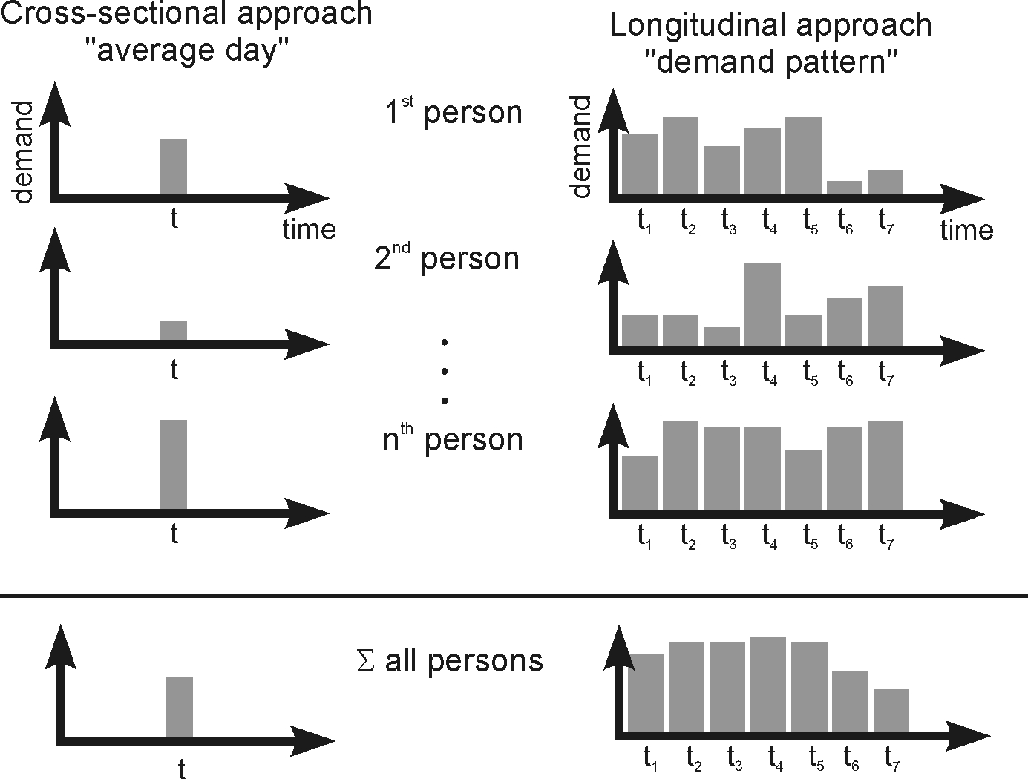
(figure 2)
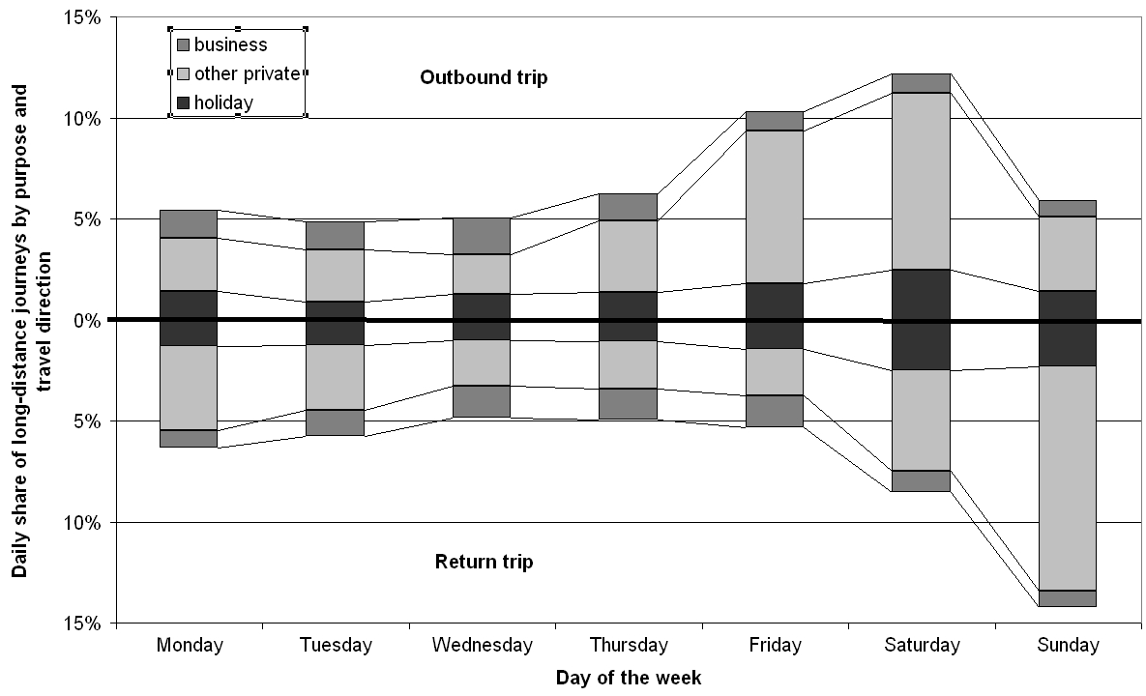
(figure 3)
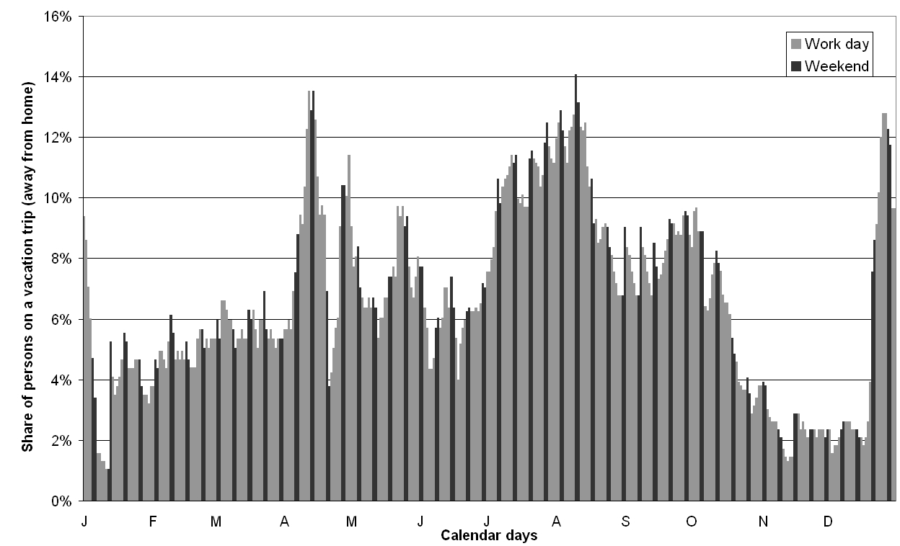
(figure 4)
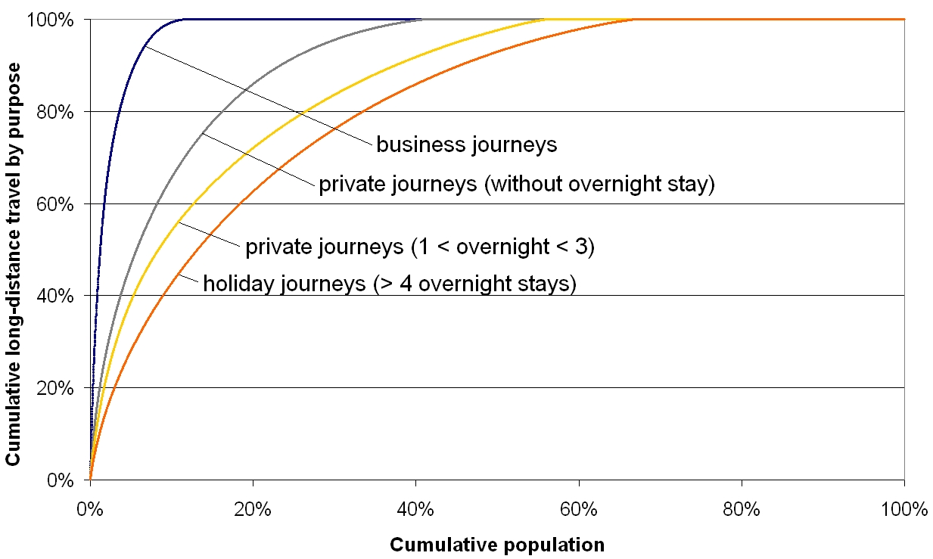
(figure 5)
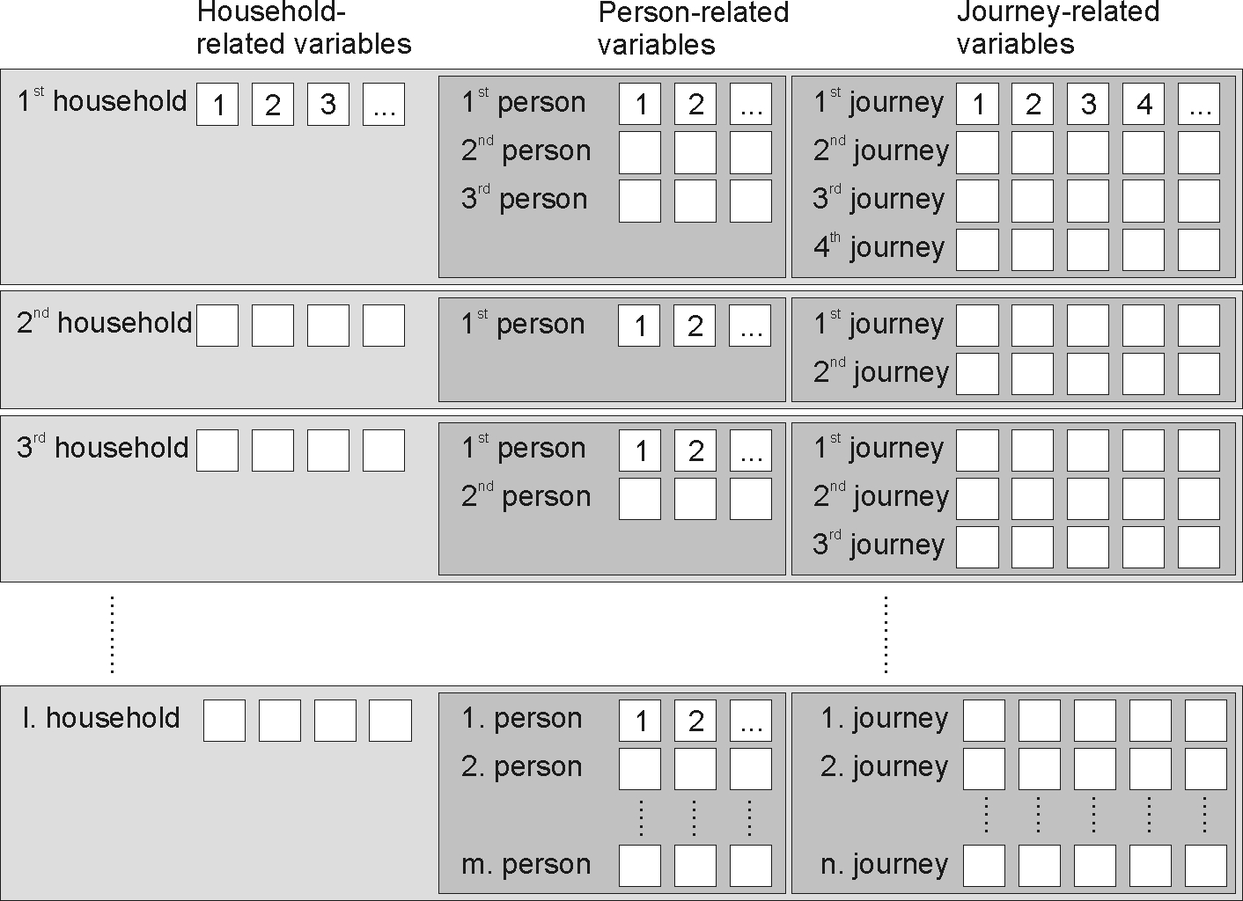
(figure 6)
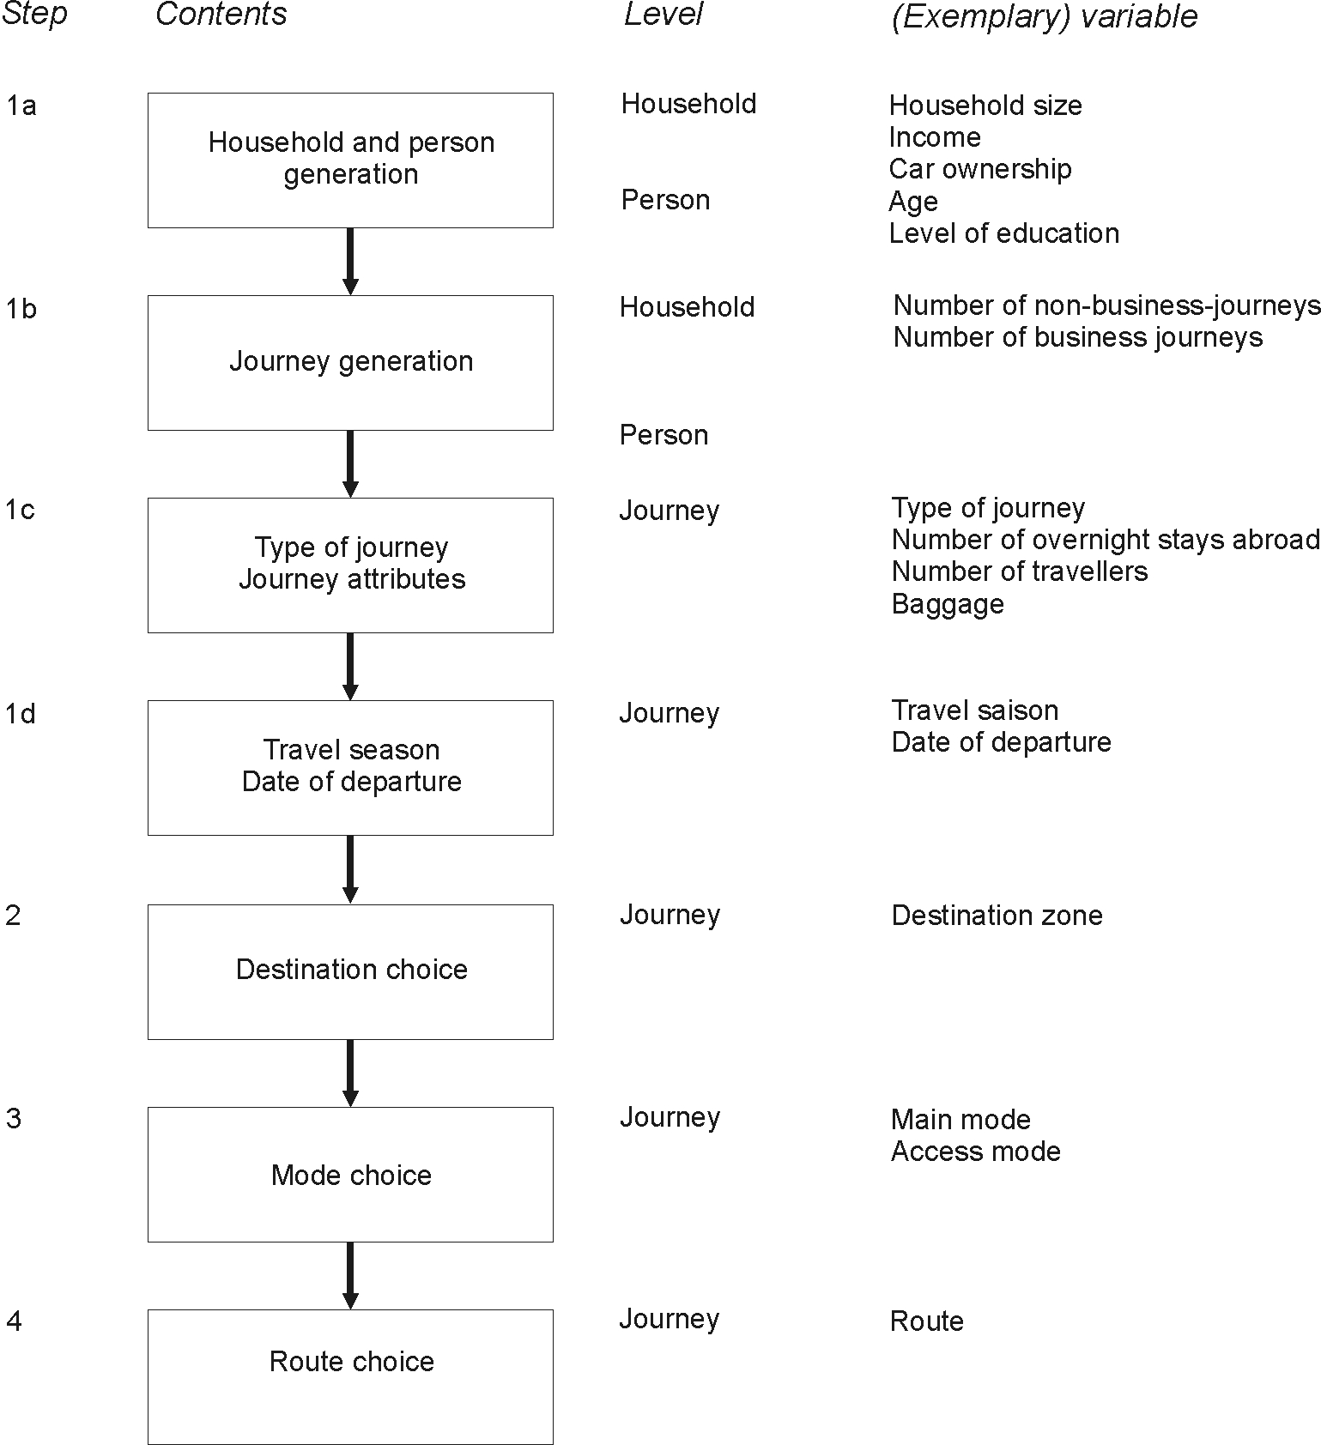
(figure 7)
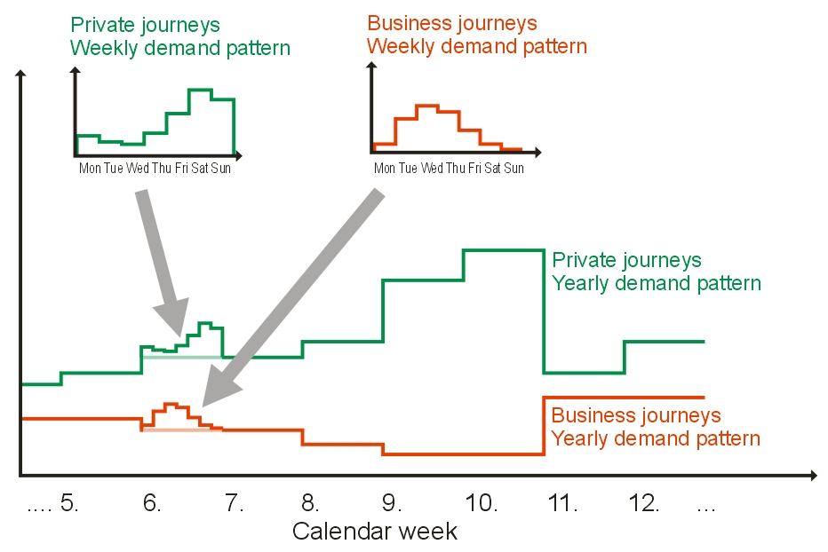
(figure 8)
