Systems Thinking approaches
for the integration of land-use and transport

– From railway station development
to accessibility planning in urban regions –

Paper
to be presented at the World Conference on Transport Research
University of California, Berkeley, June 24-28 2007

Track D 2
Integrated Land Use-Transportation-Activity Modeling

Munich, 30/04/2007

Gebhard Wulfhorst

Professor, Department of urban structure and transport planning

TUM Technische Universität München, Arcisstraße 21, D-80333 München

Phone: +49/(0)89/289-22449; Fax: +49/(0)89/289-23840

gebhard.wulfhorst@tum.de

Abstract
Land-use and transport are related to each other in a dynamic, non-linear system. Railway stations represent urban places and transport nodes that can play a key role in integrated land-use and transport planning. However, ongoing measures of station development often disregard the complex interactions due to lacking methodological instruments. The objective of this contribution is to highlight the key characteristics, the interest and the limits of Systems Thinking approaches (Sensitivity Model/Systems Dynamics) for integrated land-use and transport planning. Systems Thinking methods enable to clarify regional strategies and local implementation measures. If the missing spatial dynamics can be overcome and if the coupling with behavioral aspects can be improved, perspectives are expected for fostering innovative methods as precious basics for successful planning processes.

Problem and research questions

The context of land-use and transport interaction

Land-use and transport are related to each other in a dynamic, non-linear system. Figure 1 is showing a basic scheme of the interactions between land-use, transport and activities on the long-term and short-term level of mobility.

As a basic element in long-term mobility decisions, location quality is mainly influenced by accessibility in terms of transport offer quality and urban structure. Urban development takes place with a certain delay in time depending on these location qualities as well as on urban potentials and on planning and realization processes (cooperation). On a short-term level in mobility decisions, the local and regional spatial structure largely is influencing every day activities and travel behavior (activity program, destination choice, mode choice, route choice) – some of the aspects are also directly influenced by transport offer itself. In summary, realized travel demand is negatively playing on transport offer quality (congestion …) that only can be improved by external investment or management in operation.

However, there is no direct, linear and automatic link between the different structure elements. Change in structure is always due to processes and decisions of actors. The adequate representation of these dynamic interactions often is missing in land-use and transport planning due to lacking empirical knowledge and lacking methodological instruments.

The challenging problem is, that in general there are relatively few decisions in long-term mobility behavior like location choice that impact very strongly the multitude of every day mobility decisions. In pragmatic approaches, therefore scenarios are often used for different possible futures of location development.

Figure 1: Land-use and transport interaction scheme
(source: Wulfhorst 2003, based on Wegener. Fürst 1999)

Accessibility can be seen as a key element in land-use and transport dynamics. On the one hand, accessibility is playing on long-term location choices; on the other hand it largely influences short-term trip destinations and trip distances. Accessibility is a function of territorial structure and transport supply. As a geometric (a) and economic (b) definition it can be stated that accessibility is “the more or less easiness with which one can reach a location (a) to perform an activity (b).” The following formula sums up this definition (see figure 2). At the same time, accessibility can not be addressed directly by planning; it is only by playing on the transport supply quality and/or the functional structure of the locations concerned (density, functional mix) that accessibility can be influenced.

With Ai = Accessibility to destinations D from point i
Dj = Activity destinations at points j
cij = Generalized costs (time and prize of the trip)
β = factor of perception (willingness to pay …)

Figure 2: Accessibility as a function of territorial structure and transport supply (adopted from Crozet, 2006)

According to that, the “law of central places” (Bökemann, 1982) says that the closer (in space and time) a location is to the centre, the higher are urban density, functional diversity as well as rents and land value (see figure 3). The gradient α of the logarithmical function is depending on the quality of transport supply. With innovations in transport (as well as in communication) this gradient diminishes so that differences in location quality tend to be reduced (accessibility via the internet for example).
Figure 3: Law of central places (Bökemann 1983)
Even if high motorization rates today as well as information and communication technologies seem to enable access for everybody anywhere, the value of centrality keeps being relevant to economic, ecologic and social prosperity of urban regions (hub-function of metropolitan regions).

Challenges in railway station development

Figure 4: The station as node and place (Bertolini, Spit, 1998)

Railway stations represent central places in the urban structure as well as important interfaces within the transport system.
As multi-modal transport nodes stations are enabling interconnections within the railway network and necessary links between the railway system and the other transport modes. All transport networks are based on arcs and nodes, but in general it is the nodes that are essential for the overall quality and performance of the transport system. For a successful development of railway stations as transport nodes, it seems to be important to consider both spatial/physical interconnection and organizational interconnection.
At the same time, railway stations are considered as important, privileged places within the urban fabric. In general, urban places are described (Bökemann, 1982) by their location and delimitation, property rights and permissions of use, supply in infrastructure (communication, energy, transport) and natural location factors. The location quality and potentials for usage are depending on many factors that – partly – result of public authorities decisions.
The various impacts between land-use development in the station surroundings, marketing of station buildings and intermodal interconnection of the different traffic systems however, are scarcely considered in the development of concepts and in the planning process. The different stakeholders working together in station development try to optimize their proper benefits: real estate profitability, traffic management, city development. But the representation of dynamic interactions (like the effects of improvements in transport infrastructure or intermodal services on location development or the effects of realizing housing or business developments near the stations on mobility patterns) often fail because of missing empirical knowledge and missing methodological instruments.

Research Questions

The key research questions that arise from this context are concerning the impact estimation of different measures within an integrated approach of land-use and transport. On a local level, like for the specific example of railway stations, the objective is
  - to estimate the interactions between land-use in station surroundings, the functional use of the station building, the intermodal quality of the transport node as well as the relevant effects on rail transport demand;
  - to develop suitable methodological instruments in order to estimate and illustrate the dynamics of these interactions and effects.

Transposed to a larger scale, on the important level of urban regions, the challenge is to integrate the different aspects of transport supply, accessibility, territorial development and travel demand within a system of feedback mechanisms. From a methodological point of view it is interesting to assess the potentials and the limits of Systems Thinking approaches to the integration of land-use and transport.
  - How can Systems Thinking models contribute to understand and represent the quantitative and qualitative interactions between land-use and transport with respect to the system behavior of integrated concepts?
  - Is it possible to differentiate between on one hand the potentials of urban qualities and transport supply as well as on the other hand individual behavior or public decision taking processes of specific actors (e.g. location choice, location development)?

Methodological approach

Systems Thinking: a modeling reference
Systems Thinking can be regarded as an appropriate methodological basis for dealing with land-use and transport interaction. Systems Thinking mainly consists in a systemic approach to complex problems that is taking in account (see Richmond, 2001)
  - elements (variables) and impacts (relations) within an interlinked dynamic system over a period in time,
  - quantitative and qualitative interactions as well as
  - structure (stock) and process (flow) variables.
Systems in this way are analyzed from an outside point of view. Systems behavior can be estimated over a period in time by consideration of interactions, feedback and loops.

Application of Systems Thinking theory to station development
There have been different empirical studies by the author about land-use and transport interaction at railway stations. The investigations show that there are considerable interdependencies within the “system” of station development. The single cause-and-effect links between specific measures, however, are difficult to identify. In real world examples, mostly a multitude of single measures is mixed within a set of measures according to the local situation.
Two specific methods (Sensitivity Model: Vester, 1980, 2000; System Dynamics: Forrester, 1969, Sterman, 2000) have been used and adopted to railway stations in order to identify interactions between land-use in the station surroundings, functionality of the station building, intermodal qualities and related impacts on travel behavior (Wulfhorst, 2003).
Both modeling techniques have been applied to one specific case study on railway station development in Germany (Weinheim an der Bergstraße).

Further development on the level of urban regions
The general experiences and findings in Systems Thinking modeling on the local level of station development have been transposed to the scale of urban regions.
Within the French-German research cooperation Bahn.Ville Systems Thinking models have been established for the key aspects of regional railway development, urban development on the regional level as well as for the railway station as node and place (Bahn.Ville 2005).
In an enlarged perspective the findings have been assessed and applied to a European research and development project on the integration of transport and urban form in the European region of Strasbourg, within a Marie-Curie Fellowship funded by the European Commission (TRANSFORMES).
In the following, details of these approaches, basic results and assessments on the local level as well as a perspective on the regional scale are given.

Sensitivity Model

Model concept and results
The causal structure of station development as a systems model has been worked out by a workshop process with about 20 experts of various disciplines and stakeholders. The participants have contributed to establish a relevant set of variables, a cross-impact-matrix as well as a general causal-loop-diagram using the “Sensitivity Model” (Vester) by a Delphi-approach.
The “Sensitivity Model” used here is a method of systems analysis based on the qualitative linkage between the variables of a system. The interactions are represented by a network of simple feedback structures for the general system. More detailed scenarios can be built up according to specific questions. On the scenario level, simulations can be done by qualifying the variables as fuzzy sets and linking the elements by table functions. The Sensitivity Model and the System Tools software have been developed by Frederic Vester (Vester 1980; 2000).
On the base of the model framework and together with stakeholders and actors concerned with the case study project in Weinheim, detailed model assumptions for the system behavior over time have been developed.
The interactions and feedback mechanisms between location quality, urban development in the station surrounding, functional use of the station building, intermodal quality and other important variables have been defined. For simulation purposes a specific system model has been elaborated with 10 variables. Each of these variables is qualified on a fuzzy scale from 0 to 30 by linguistic descriptions. The interactions between the different elements of the system are transmitted by table functions indicating the changes for the target variable in function of the state of the source variable (see Figure 5). There are structure variables that accumulate the change in state over time and flow variables that do not accumulate the changes over time (Figure 6).

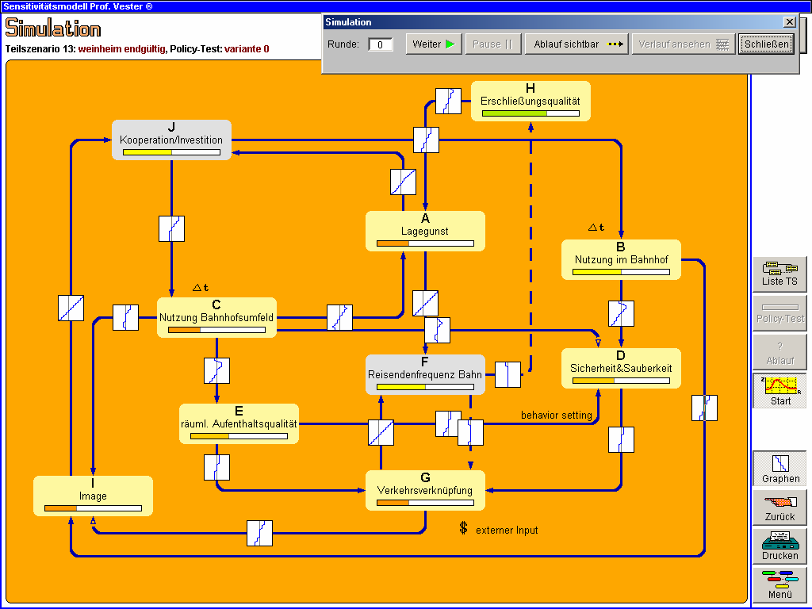

Figure 5: Simulation structure in the Sensitivity Model environment “System Tools” (Wulfhorst, 2003)

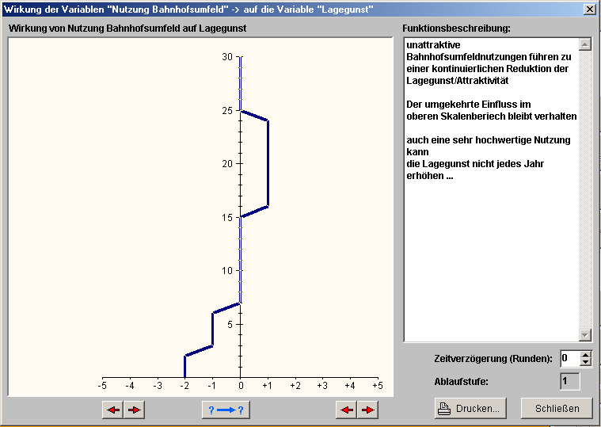

Figure 6: Characteristics of the table functions describing the impact that a source variable has on the target variable (Wulfhorst, 2003)

For three different scenarios of development the results of the system behavior over time have been generated by this tool. A basic example of the generated charts is given in Figure 7.

Figure 7: Example for the output of the simulation on system behavior / variables

Assessment of the Sensitivity Model approach
The Sensitivity Model approach enables a clear and useful structure for model development, especially on the framework level.
The qualitative character of the variables (fuzzy-scales from 0 to 30) as well as the functional relations by table functions can be elaborated transparently.
There are powerful tools available for analyzing the role of variables in the system and feedback-loops as well as cause-effect trees. Appropriate scenarios (sub models) can be developed for specific questions.
Restricted qualitative simulation is possible on the level of these sub models – so that only parts of the whole system can be run. There is no spatial dynamics foreseen in the tool.
Sensitivity Modeling in this form consequently is suitable for structuring a (new) topic, and formulation of hypothesis. It also can be used for global, interactive system analysis. The strength of the approach lies in the communicative potential that is generated by the different steps of the model. Integration of stakeholders into the model development and assessment becomes realistic, so that alternative options and scenarios of decisions as well as their impact on the system behavior could be analyzed and discussed by the responsible actors.
Qualitative prognosis (of policies) is possible, but no detailed quantitative results can be produced. These limitations are the reason for having developed a System Dynamics simulation model for the same case study (Weinheim) – based upon the framework model for railway station interaction.

System Dynamics Approach

Model concept
The “System Dynamics” approach is based on the assumption that the dynamic behavior of a system can be represented by a stock-flow-structure. The value of stocks changes over time depending from inflow and outflow. Theses flows are a function of the level of relevant stocks and of the value of secondary variables (converter) – see Figure 8.

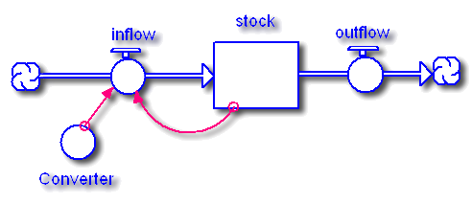
Figure 8: Basic stock-flow diagram of the system dynamics approach
(Richmond, 2001)

In these models variables need to be quantified and interactions are calculated by difference equations. The definition of equations can be elaborated as relationships for incoming variables by analytical or graphical equations like table functions (see Figure 9).
The main questions considered here affect the impacts of land use and transport node quality on mobility behavior and the use of public transport. Integrating the expert model framework structure (see chapter 3.1) and empirical knowledge drawn from respective investigations (e.g. Arndt, Wulfhorst, 2001) allowed to set up and qualify the relevant cause-and-effect-links.

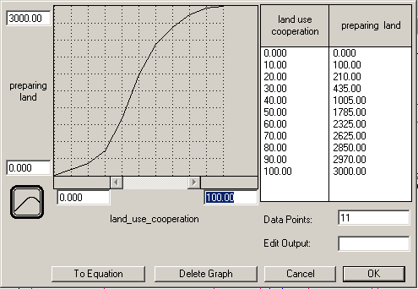

Figure 9: Example for a graphical table function (Wulfhorst, 2003)

The overall model structure integrates different specific processes for land-use development in the station surrounding, functional use of the station building itself, intermodal quality as well as a simple travel demand model (HLSV, 2000). Emphasis has been put on keeping the model relatively small and simple.
The model structure of the “Land Use and Transport at RAilway Stations (LUTRAS)” model is given in Figure 10. It has been developed in the STELLA/iThink toolkit. This model compromises 7 different sectors that describe in detail the relevant elements and interrelationships.

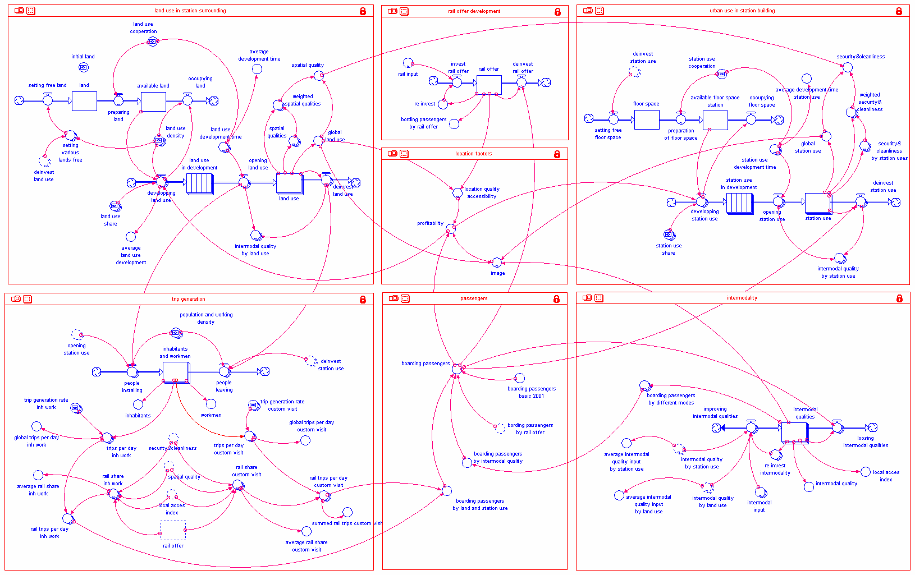
Figure 10: LUTRAS model structure (Wulfhorst 2003)

Figure 11: Sector of land-use in the station surrounding (Wulfhorst 2003).

The sector “land use in station surrounding” (Figure 11) is describing the processes of land-use development. Location choice and by this parameter land-use development is depending on the existing urban potential (“land available”) as well as on economic interest (“profitability” – in sector location factors). These items and the specific characteristics of land-use development like functional mix or density are relying on land-use cooperation (planning rights, financing/funding …), location quality/accessibility and image.
This segment is clearly showing the stock-flow structure that is based on the assumption that there is deterministic behavior of the system – in the way that a given state of a certain variable “automatically” conducts to a change in inflow/outflow of a stock variable (quantitative accumulation over time). With the implemented functionality of arrays it becomes possible to specify different characteristics on several “layers” for one given variable (for example different functions in the land-use development process). Also qualitative interactions can be integrated (e.g. by defining variables on a relative scale and linking variables by graphical table functions, see Figure 9).
For example detailed specifications on functional mix and urban densities have been integrated by these arrays. The values of land use share allocated to the urban potential have been given by a table, as well as indicators of urban density – these values can be edited by the user (see Figure 12).

Urban Function  [use] | Functional Mix  [land use share]  in [%] | Urban Density  [land use density] in [m² floor space by m² land]
Housing  [habitation] | 10 % | 0,6
Shopping and service facilities  [shopping_services] | 20 % | 1,4
Gastronomic use  [gastronomy] | 15 % | 1,4
Hotel and Tourism  [hotel] | 40 % | 2,5
Office Buildings(Technology/Public)  [office] | 15 % | 2,0
Figure 12: Model indicators for functional mix and urban density in the Weinheim case study (Wulfhorst 2003)

Selected modeling results
Simulation of the system behavior over time is realized by a time dependent numerical integration using Euler’s Method or Runge-Kutta approximations for solving the difference equations.
The model shows instructive results according to the aim of representing the cross-disciplinary and feedback effects of different measures in station development. For three different scenarios integrated effects on location development, station development, intermodal quality as well as on the use of the railway system (number of boarding passengers) have been generated (see Figure 13).

Figure 13: Graph of results for a given scenario at Weinheim station (Wulfhorst 2003)

Especially the synergies between the different measures of land-use development, functional use of the station building and intermodal qualities on travel behavior can be made clear. In the case that only the station building itself is revitalized the additional boarding rail passengers are very few (< +1%), the upgrading of intermodal qualities and the urban development of the station surrounding contributes to about + 6% each. In an integrated program, however, where all the three different concepts are realized, nearly 15% more rail passengers can be expected (see Figure 14).
Variations in functional mix and related urban densities also play on rail frequencies. While a mono-functional land-use development in housing would only contribute to about 9 % additional rail passengers, an intense service mix in hotel, gastronomy, shopping and services could bring about 16 % more rail passengers.
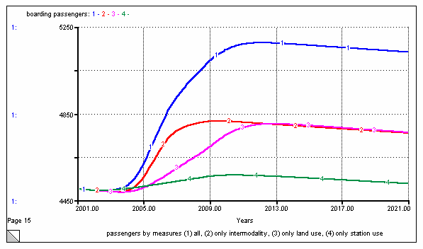
Figure 14: Synergies between different, integrated measures on mobility behavior

Assessment of the System Dynamics Approach
The System Dynamics approach consists in an open environment for software development, the development process, however, in contrast to the Sensitivity model, is poorly structured. The development of a basic model structure is fast, what takes time and needs the relevant data is filling the functions, testing and calibrating. An advantage is the high flexibility within the definition of relations, the capacity of simulation is „only“restricted by data. System analysis tools, however, are less performing. The model platform is lacking transparency; communicating the model thus becomes difficult. The simulation is oriented to integrate the global system as a whole, but there is no spatial dynamics.
System Dynamics approaches in consequence are suitable for quantitative simulation of system behavior over time, if the model functions can be given and the relevant date is available. It is less suitable for interactive communication and system analysis.

Applications of Systems Thinking methods on the level of urban regions
The model concept has been transposed and adopted to the important scale of the urban region within the French-German research cooperation Bahn.Ville, focusing on transit-oriented development and intermodality (Wulfhorst et al., 2003; www.bahn-ville.net). Some interesting knowledge and experience have been generated: On a general level, the interaction schemes have been adopted to the three specific aspects
- Bahn – development of competitive public transport offer on a regional level
- Ville – location development in the station surroundings / along the axis
- . “Station” – station development in intermodality / functional use
For each of the sub-systems a causal model framework has been developed and visualized. This method improved general understanding, fruitful discussion with experts as well as the assessment of selected measures.

In a strategic way Systems Thinking elements have been applied in a project on the integration of transport and urban form in the European region of Strasbourg, within a Marie-Curie Fellowship funded by the European Commission (TRANSFORMES; www.insa-strasbourg.fr/transformes). It enabled to clarify regional strategies and local implementation measures as well as the relevant methodological issues in integrated modeling and planning processes.

Within the TRANSFORMES project, a reference grid has been deducted as a conceptual framework, from scientific knowledge and by best-practice analysis of urban regions like Zuid-Holland, Freiburg, Basel and Geneva, Montpellier, Barcelona or Chicago. Its elements can be regarded as a general orientation and evaluation grid for the integration between urbanism and transport on the scale of European regions.

Sustainable Development as an approach to ensure quality of life for the generations of today and tomorrow is regarded as a common value. Important aspects are the integration issues between different disciplines, spatial levels, times, organizational structures and an adapted methodological framework (Figure 15).

Figure 15: Reference Grid for the integration of land- und and transport in urban regions

Conclusions

Realizing integrated land-use and transport strategies needs anticipation – or simulation of a model representing the related system. Instruments allowing the estimation and evaluation of the decision’s effects in a system over time, concerning multi-criteria objectives have to be developed further.

Systems Thinking approaches could be of high interest for strategic planning in land-use and transport. On a methodological level it was found that System Thinking approaches enable a global systems analysis and specific simulations of systems behavior over time – if the necessary knowledge and data are available for the relevant relations. The methods are found to be appropriate to the complex interactions between land-use and transport. System Dynamics is more adopted to quantify detailed variables; Sensitivity Modeling enables interactive proceeding more easily.
In any case, it has to be considered that even detailed system models only can represent both an abstract and an extract from reality. Attention should therefore be paid to include system models in a larger environment opening the system to exogenous decisions and effects, and to judge the degree of detail of the model compared to the data needed.
In consequence, Systems Thinking methods can be seen as fruitful instruments in order to support decision-making in complex situations like urban and transport planning. The modeling approach itself should be conceived as a part of the decision taking process, helping to assess the consequences and impacts of different policies, strategies or measures.
Further research and development is needed in coupling different Systems Thinking approaches with classic models in spatial or transport planning.

However, there are specific limits and restrictions in the application of classical Systems Thinking models.

Firstly, there is a lack of spatial dynamics. In order to efficiently benefit from these methods on a regional scale, spatial dynamics have to be integrated. It should be verified if these limitations can be overcome be linking system dynamic algorithms to geographical information systems or to implement fine spatial zoning in system dynamics environment by the array functionality.

Secondly, and this is the more crucial point, spatial development, choices in long-term mobility decisions, like location choice are not deterministic. The decision taking process respects a basic structure of potentials – but individual choices take place on a second level. Accessibility as a possibility for an activity for example does not oblige to realize the trip!
“Today, there is still an important lack of knowledge, a lack of methodological approaches that take in account adequately the spatial choice process: „Most critical, is our lack of a good, implementable theory of spatial choice, with respect to both location choices (homes, employment, etc.) and activity destination choice. The over-reliance on „spatial interaction“ models in which distance (or even a loosely defined „accessibility“ term) is the primary explanatory variable for location or destination choice – and the fact that this reliance has not changed substantially in over forty years of modeling - is indicative of a significant lack of deep understanding of spatial decisions processes. This is very troublesome, to say the least, given that the raison d‘être of integrated models is to model spatial processes.“ (Miller, 2006).

That is – among other reasons – why an integrated land-use and transport model project in France (MobiSIM) changed from a system dynamics approach (ATN 2002) to a multi-agent modeling platform Monism SMA (ANT 2006).

The challenge is to integrate causal loop structure, the basic understanding of motivations, interactions and feedback … as well as the findings on individual choice behavior to assumptions defining agents, private households, firms and public authorities (multi-agent modeling). Models have to take in account both dimensions - deterministic and probabilistic sets. Then, perspectives can be expected for fostering innovative methods as precious basics for sustainable planning processes.

References
ARL Akademie für Raumforschung und Landesplanung (1999): Die Region ist die Stadt. Gemeinsame Jahrestagung 1998 der Akademie für Raumforschung und Landesplanung und der Deutschen Akademie für Städtebau und Landesplanung. Forschungs- und Sitzungsberichte, Band 206, Hannover

Arndt, K.; Wulfhorst, G. (2001): Step+ - Wirkungsuntersuchungen zur Bahnhofsentwicklung im RMV. In: Stadt-Region-Land, Heft 70, Institut für Stadtbauwesen der RWTH Aachen, S. 79-84

ATN Application de Techniques Nouvelles (2002) : Simulation de scénarios d’évolution prospective de la mobilité urbaine à 20 ans – Application à l’Aire Urbaine de Lyon. Report to « Ministère de l'Équipement et du Logement, DRAST », Paris, 3. Oktober 2002

ATN Application de Techniques Nouvelles (2006) : Plateforme de simulation pour l’étude prospective de la mobilité urbaine des agglomérations françaises et européennes MobiSim SMA. Report to Ministère de l’Equipement, des Transports, de l’Aménagement du Territoire, du Tourisme et de la Mer, DRAST, 20/07/2006

Bahn.Ville (2005): Enseignements du projet Bahn.Ville – développement d’un urbanisme orienté vers le rail et intermodalité dans les régions urbaines allemandes et françaises. Final report (Broschure) – www.bahn-ville.net

Bertolini, L.; Spit, T. (1998): Cities on Rails. The redevelopment of railway station areas. E & FN Spon. An imprint of Routledge. London and New York

Cervero, R. et al. (2004): Transit-oriented development in the United States: Experiences, Challenges, and Prospects. TCRP REPORT 102. Transportation Research Board

Crozet, Yves (2006): Du coût généralisé à l’accessibilité : un nouvel horizon pour les politiques de mobilité urbaine? 6ème séminaire francophone de socio-économie des transports. Athènes, 4 et 5 mai 2006

Forrester, Jay W. (1961): Industrial Dynamics, Waltham, MA: Pegasus Communications.

Forrester, J. W. (1969): Urban Dynamics. Pegasus Communications, Waltham, MA.

FGSV (2005): Hinweise zur Standort- und Verkehrsentwicklung. Ausgabe 2005. FGSV-Verlag, Köln

FGSV (2006): Hinweise zu regionalen Siedlungs- und Verkehrskonzepten. Ausgabe 2006. FGSV-Verlag, Köln

HLSV Hessisches Landesamt für Straßen und Verkehrswesen (Hrsg. 2000): Integration von Verkehrsplanung und räumlicher Planung, Heft 42 – 2000 Teil 2: Abschätzung der Verkehrserzeugung

Kunzmann, K. R. (2004): An Agenda for Creative Governance in City Regions, DISP 158, p. 5-10

Lehner, F. (1963): Siedlung, Wohndichte und Verkehr. In: Schriftreihe für Verkehr und Technik, Heft 17, Erich Schmidt Verlag

L’Hostis, Alain; Wulfhorst, Gebhard (2006). Travel Demand Management
by accessibility planning and location choice. European Transport Conference 2006, Strasbourg

Meadows, D. H.; Meadows, D. L.; Randers, J.; Behrens, W. W. (1972)
The Limits to Growth. New York: Universe Books.

Miller, Eric J. (2006): Integrated Urban Modelling: Some Theoretical Considerations. In: Stadt Region Land - Heft 81 – Tagungsband AMUS 2006, RWTH Aachen

Richmond, B. (2001): An introduction to Systems Thinking. Stella Software Guide. High Performance Systems, Inc., Hanover, NH

Sterman, John T. (2000): Business Dynamics. Systems Thinking and Modeling for a Complex World. Irvin/Mc Graw Hill

TDM Encyclopedia (2005): Accessibility - Defining, Evaluating and Improving Accessibility. http://www.vtpi.org/tdm/tdm84.htm, Updated May 9, 2005

Vester, Frederic (2000): Die Kunst vernetzt zu denken. Ideen und Werkzeuge für einen neuen Umgang mit Komplexität, Deutsche Verlags Anstalt, Stuttgart

Vester, Frederic; von Hesler, Alexander (1980): Sensitivitätsmodell, hrsg. vom Umlandverband Frankfurt

Wegener, M. (1998): Das IRPUD Modell: Überblick. http://irpud.raumplanung.uni-dortmund.de/irpud/pro/mod/mod.htm.

Wegener, Michael; Fürst, F. (1999)
Land-Use Transport Interaction: State of the Art. Deliverable 2a of the project TRANSLAND (Integration of Transport and Land Use Planning) of the 4th RTD Framework Programme of the European Commission. Berichte aus dem Institut für Raumplanung Nr. 46, Universität Dortmund, November 1999

Wulfhorst, G. (2003): Flächennutzung und Verkehrsverknüpfung an Personenbahnhöfen – Wirkungsabschätzung mit systemdynamischen Modellen. Bericht 49 des Instituts für Stadtbauwesen und Stadtverkehr. RWTH Aachen

Wulfhorst, G. (2004): TRANSFORMES: Cross-border strategies for integrating land-use and transport development in the Strasbourg region, Conference Paper, European Transport Conference, Strasbourg, 10/2004, 22 p.

