A SOCIO-ECONOMIC CHARACTERIZATION MODULE FOR MICROSIMULATION BASED LAND USE-TRANSPORTATION
MODEL

M. S. Mir¹, Sameer Gupta² & K. V. Krishna Rao³

¹ Research scholar, Civil Engineering Department, IIT Bombay, Powai, Mumbai, India- 400076 (mshafi@iitb.ac.in)

² B. Tech. Student, Civil Engineering Department, IIT Bombay, Powai, Mumbai, India- 400076(sameer_gup@iitb.ac.in)

³ Professor, Civil Engineering Department, IIT Bombay, Powai, Mumbai,
India- 400076(kvkrao@civil.iitb.ac.in)

Abstract
It is necessary to have the complete information of all the decision making units on their socio-economic attributes which influence the choice process. Collecting/procuring such enormous data is practically not possible. Towards this end the work presented in this paper involves development of a socioeconomic characterization (SEC) module for Mumbai Metropolitan Region (MMR), which successfully assigns socioeconomic characteristics to the individuals using Monte Carlo technique, based on the observed distributions of each of the characteristics. Populations are evolved in time by developing a cohort demographic model (CDM). The paper concludes with suggesting a framework for a complete microsimulation based travel demand model in the developing countries’ context.

Key words: Microsimulation, Land Use-Transport Model, Monte Carlo Technique, Socio-economic Characteristics.

- Introduction
The cities of developing countries are struggling with the problems of urban sprawl and traffic congestion. These challenges are the result of prevalent economic boom in these regions. Serious need is felt for providing massive transportation related infrastructure. Land use transport models that could test the various transport and land use policies and help in decision making are not at hand. The model must describe the causal relationships between socioeconomic and transport system characteristics as well as trip-making behaviour. Only then can the model be used to forecast the effects of future changes in the performance of the transportation system. Micro-analytic approach is the most appropriate approach, in achieving the said objective where the decisions of individual units are logically interpreted, incorporated and integrated into an unified modeling environment. However, micro data, i.e. data at individual or household level, is either not available or not allowed to retrieve from government records, in many developing countries like India. Therefore need is to generate synthetic micro data from the generally available accessible aggregate data (Moeckel et al 2003). So synthetic population has to be generated that is equivalent to and represents our real population.
In the present study a conscious effort has been made to develop a socioeconomic characterization module in order to simulate the socio-economic attributes, internally within the model, without deviating much from the reality. The aim is to define the choice processes in terms of the decisions of individuals, with all the possible outcomes linked to the characteristics of the relevant decision making unit. The module consists of a cohort survival based demographic model (CDM) and a socioeconomic characterization (SEC) model. The cohort survival model evolves the populations through time and gives us population estimates of various sub-regions of Mumbai Metropolitan Region (MMR) at different points in time. Then the SEC model simulates the socioeconomic characteristics of each individual and his/her household at these points in time like household size, age, gender, income, number of workers, car ownership etc, using Monte Carlo microsimulation technique. These simulated socioeconomic factors will be used as inputs to the land use and the transportation modules in a comprehensive microsimulation based land use-transport model. The module has been initially developed at the sub-regional level and not at zonal levels. The main reason for doing so is that the socioeconomic, travel and other required data, collected during the year 2005, by Mumbai Metropolitan Region Development Authority (MMRDA), through their World Bank funded Comprehensive Transportation Study (CTS), has not been made available yet. The suggested framework for the comprehensive model will be presented towards the end in this paper.

- Study Region and Data
The Mumbai Metropolitan Region (MMR) of Maharashtra State, India has been selected as study region for forming the land use transport model. A city like Mumbai which is the commercial and financial capital of India, generating about 5% of India’s GDP and contributing over one third of the country’s tax revenues would be an ideal study region for the development of an operational integrated land use transport model in a microsimulation framework. The Mumbai Metropolitan Region (MMR) covers an area of about 4355 square kilometers, contains 1500 sq km of developable area and supports an overall density of 1300 persons per sq km. With rapid urbanization and industrialization during the last three decades in MMR, the population has increased from 9.9 million in 1981 to 18.9 million in 2001. Out of that 17% live on island, 60% in suburbs and New Mumbai The population of Mumbai Metropolitan Region (MMR) grew at less than 3% per annum during 1991-2001 whereas the vehicles have grown at over 7% per annum contributing to over 50% of cars. The MMR consists of Greater Mumbai district and parts of Thane and Raigarh districts. It has been divided into 7 geographical sub-regions, as shown in Table.1, for the development of the SEC module at sub regional level (TRANSFORM II 2005). The Table 2 shows the population growth in MMR from 1971 to 2001 (MMRDA 2005b) and Fig. 1 shows its delineation into sub regions and their land use composition (MMRDA 2005a).
Census data forms the fundamental data for the development of this module especially Cohort Survival component of it. The reason being its monogamy in the collection of such data, its high reliability (compared to other sources) and large sample (100%) data set. It is uniformly available for all urban areas in India (thus makes model potentially operational in other regions). The demographic information is got from the 2001-Census of India and various other sources. Since the socioeconomic data was available only for Thane city, the socioeconomic characterization model has also been tested for Thane city only. This city forms a part of North Eastern sub region of our study area. The household interview survey data for Thane city was collected in 2001, by Maharashtra State Road Development Corporation Limited (MSRDC) as a part of Elevated Mass Rapid Transit System (MRTS) for Thane. The survey data contained a sample of 3500 households, representing around 1.5% of the total no of households in the city.

3. Sub Regional Cohort Demographic Model (CDM) for MMR
A number of methods are available in literature for population estimates and projections e. g. Cohort Survival method, Ratio method, Trend Extrapolation method, Urban Growth Rate Differential method etc. A combination of two or more of these methods is also recommended. Data availability is the main factor on which the choice is based. Linear and exponential extrapolation models are generally considered as simple models while as Cohort demographic models as complex ones (Smith and Sincich 1992; Smith 1997). The simple models are not based on an explanation of the causes of the population change, i.e., birth, mortality, and migration but on some assumption about the relation of the speed of growth to time or to the population level itself (Oppenheim 1980).
In this study the Cohort Survival approach has been used to evolve the population of various age groups, initially at sub region levels. The model not only gives population levels at different points in time but we can also project the census population to the base year stage, which is 2006, from Census year of 2001, quite accurately and at a relatively disaggregate level. The developed model is calibrated initially on 7 sub regions of MMR. The cohort demographic model (CDM) will take into consideration the effects of births, aging and intra-migrations.

3.1 Methodology
The population has been broken down into 13 age groups, spanning 5 years (T=5). The population falling in each age group has been proportioned on the basis of data obtained from literature (Mukhopadhyay 2001).

Birth Component
The age group of females with child bearing age was decided based on the available data of the MMR areas of Thane and Raigarh districts and also of Greater Mumbai (Registrar of births and deaths 1984). Females between 16 and 50 years are considered as fertile, i.e., age group 4 to age group 10. The birth rates for the 2001 population was calculated by assuming the same ratio of total births to total population as that in 1981. The total births for five years were worked out which is our time-step. The age-wise birth rates have been assumed same for Thane and Raigarh district due to almost similar urbanization characteristics of the two districts. Whereas for Greater Mumbai it is different. The birth rates are calculated after adjusting for mortality of infants at birth.
Birth rate $b_{i}=\frac{\text{Births}}{p^{0_{i}}}$ (1)
Where p⁰_{i} = total population of group i, male and female, for base year

Aging Component

The total number of deaths in 2001 for the sub regions falling in three districts have been separately proportioned into different age groups by equating the ratio of total deaths/total populations of 1981 with that of 2001. The survival rates of age groups of sub regions falling in each of the three districts have different values.
Survivorship rate $s_{i+1,i}=1−\frac{\text{Deaths}}{p^{0_{i}}}$ , (2)
P⁰_{i} = Total population in group i, in base year of 2001

Migration Component

Migration is an important factor responsible for the population evolution in a commercial city like Mumbai. As can be seen in Table 3 migration has contributed 16.8 percent to the increase in population in 1981-91 and it was 47% between 1971-81 (MCGM 2005). The migration into the seven sub regions from outside and vice versa has been considered here. The cross migration data has not been included as no part of that data is available for any period of time. As we know that it is the availability of employment opportunities in MMR that have attracted people from around the country especially from other parts of Maharashtra. The data is available only for the total number of people migrating into MMR. The migrant share of a particular sub region is worked out by considering its employment potential. Table 4 gives the distribution of employment opportunities in MMR (Economic Census 1998; MMRDA 2003)). The number of people migrating into a sub region has been considered to be proportional to its employment potential. The migration rates are different for adult and children, worked out on the same principle.
Table 5 shows how the migrants are distributed among the 07 sub regions of MMR. The worked out migrants are for the 5 years immediately preceding year 2001.
Migration rate m_{i} = $\frac{M^{i}}{P^{i}}$ , (3)
M^{i} = Migration level and p_{i} = Population of age group
The population levels at any time ‘n’ are given by equations (4) and (5)
X^{n} = (4)
Where D^{i} = $\left[\begin{matrix}m_{1}^{i} & 0 & 0 & b_{4}^{i} & b_{5}^{i} & b_{6}^{i} & b_{7}^{i} & b_{8}^{i} & b_{9}^{i} & b_{\text{10}}^{i} & 0 & 0 & 0 \\ s_{\text{21}}^{i} & m_{2}^{i} & 0 & 0 & 0 & 0 & 0 & 0 & 0 & 0 & 0 & 0 & 0 \\ 0 & s_{\text{32}}^{i} & m_{3}^{i} & 0 & 0 & 0 & 0 & 0 & 0 & 0 & 0 & 0 & 0 \\ 0 & 0 & s_{\text{43}}^{i} & m_{4}^{i} & 0 & 0 & 0 & 0 & 0 & 0 & 0 & 0 & 0 \\ 0 & 0 & 0 & s_{\text{54}}^{i} & m_{5}^{i} & 0 & 0 & 0 & 0 & 0 & 0 & 0 & 0 \\ 0 & 0 & 0 & 0 & s_{\text{65}}^{i} & m_{6}^{i} & 0 & 0 & 0 & 0 & 0 & 0 & 0 \\ 0 & 0 & 0 & 0 & 0 & s_{\text{76}}^{i} & m_{7}^{i} & 0 & 0 & 0 & 0 & 0 & 0 \\ 0 & 0 & 0 & 0 & 0 & 0 & s_{\text{87}}^{i} & m_{8}^{i} & 0 & 0 & 0 & 0 & 0 \\ 0 & 0 & 0 & 0 & 0 & 0 & 0 & s_{\text{98}}^{i} & m_{9}^{i} & 0 & 0 & 0 & 0 \\ 0 & 0 & 0 & 0 & 0 & 0 & 0 & 0 & s_{\text{10},9}^{i} & m_{\text{10}}^{i} & 0 & 0 & 0 \\ 0 & 0 & 0 & 0 & 0 & 0 & 0 & 0 & 0 & s_{\text{11},\text{10}}^{i} & m_{\text{11}}^{i} & 0 & 0 \\ 0 & 0 & 0 & 0 & 0 & 0 & 0 & 0 & 0 & 0 & s_{\text{12},\text{11}}^{i} & m_{\text{12}}^{i} & 0 \\ 0 & 0 & 0 & 0 & 0 & 0 & 0 & 0 & 0 & 0 & 0 & s_{\text{13},\text{12}}^{i} & s_{\text{13},\text{13}}^{i}+m\end{matrix}\right]$ (5)
Where i = 1,2,3,….,7 (No. of sub-regions)

The matrices representing birth, survival and migration rates of 02 sub regions, over unit time period (5 years), is shown in equations (6a) and (6b). Matrices for rest of the 05 sub regions are obtained on similar lines, but are not shown due to restrictions on the length of paper.
$D^{1}=\left[\begin{matrix}0\text{.}\text{0011} & 0 & 0 & 0\text{.}\text{0492} & 0\text{.}\text{3896} & 0\text{.}\text{3975} & 0\text{.}\text{1693} & 0\text{.}\text{0482} & 0\text{.}\text{0079} & 0\text{.}\text{0001} & 0 & 0 & 0 \\ 0\text{.}\text{9786} & 0\text{.}\text{0011} & 0 & 0 & 0 & 0 & 0 & 0 & 0 & 0 & 0 & 0 & 0 \\ 0 & 0\text{.}\text{9988} & 0\text{.}\text{0011} & 0 & 0 & 0 & 0 & 0 & 0 & 0 & 0 & 0 & 0 \\ 0 & 0 & 0\text{.}\text{9988} & 0\text{.}\text{0361} & 0 & 0 & 0 & 0 & 0 & 0 & 0 & 0 & 0 \\ 0 & 0 & 0 & 0\text{.}\text{9983} & 0\text{.}\text{0361} & 0 & 0 & 0 & 0 & 0 & 0 & 0 & 0 \\ 0 & 0 & 0 & 0 & 0\text{.}\text{9961} & 0\text{.}\text{0361} & 0 & 0 & 0 & 0 & 0 & 0 & 0 \\ 0 & 0 & 0 & 0 & 0 & 0\text{.}\text{9961} & 0\text{.}\text{0361} & 0 & 0 & 0 & 0 & 0 & 0 \\ 0 & 0 & 0 & 0 & 0 & 0 & 0\text{.}\text{9954} & 0\text{.}\text{0361} & 0 & 0 & 0 & 0 & 0 \\ 0 & 0 & 0 & 0 & 0 & 0 & 0 & 0\text{.}\text{9954} & 0\text{.}\text{0361} & 0 & 0 & 0 & 0 \\ 0 & 0 & 0 & 0 & 0 & 0 & 0 & 0 & 0\text{.}\text{9916} & 0\text{.}\text{0360} & 0 & 0 & 0 \\ 0 & 0 & 0 & 0 & 0 & 0 & 0 & 0 & 0 & 0\text{.}\text{9916} & 0\text{.}\text{0361} & 0 & 0 \\ 0 & 0 & 0 & 0 & 0 & 0 & 0 & 0 & 0 & 0 & 0\text{.}\text{9865} & 0\text{.}\text{0361} & 0 \\ 0 & 0 & 0 & 0 & 0 & 0 & 0 & 0 & 0 & 0 & 0 & 0\text{.}\text{9865} & 1\text{.}\text{3228}\end{matrix}\right]$ (6a)

$D^{2}=\left[\begin{matrix}0\text{.}\text{0011} & 0 & 0 & 0\text{.}\text{0559} & 0\text{.}\text{3716} & 0\text{.}\text{4054} & 0\text{.}\text{1724} & 0\text{.}\text{0483} & 0\text{.}\text{0079} & 0\text{.}\text{0010} & 0 & 0 & 0 \\ 0\text{.}\text{9937} & 0\text{.}\text{0011} & 0 & 0 & 0 & 0 & 0 & 0 & 0 & 0 & 0 & 0 & 0 \\ 0 & 0\text{.}\text{9992} & 0\text{.}\text{0011} & 0 & 0 & 0 & 0 & 0 & 0 & 0 & 0 & 0 & 0 \\ 0 & 0 & 0\text{.}\text{9992} & 0\text{.}\text{0134} & 0 & 0 & 0 & 0 & 0 & 0 & 0 & 0 & 0 \\ 0 & 0 & 0 & 0\text{.}\text{9992} & 0\text{.}\text{0134} & 0 & 0 & 0 & 0 & 0 & 0 & 0 & 0 \\ 0 & 0 & 0 & 0 & 0\text{.}\text{9983} & 0\text{.}\text{0134} & 0 & 0 & 0 & 0 & 0 & 0 & 0 \\ 0 & 0 & 0 & 0 & 0 & 0\text{.}\text{9983} & 0\text{.}\text{0134} & 0 & 0 & 0 & 0 & 0 & 0 \\ 0 & 0 & 0 & 0 & 0 & 0 & 0\text{.}\text{9977} & 0\text{.}\text{0134} & 0 & 0 & 0 & 0 & 0 \\ 0 & 0 & 0 & 0 & 0 & 0 & 0 & 0\text{.}\text{9977} & 0\text{.}\text{0134} & 0 & 0 & 0 & 0 \\ 0 & 0 & 0 & 0 & 0 & 0 & 0 & 0 & 0\text{.}\text{9954} & 0\text{.}\text{0134} & 0 & 0 & 0 \\ 0 & 0 & 0 & 0 & 0 & 0 & 0 & 0 & 0 & 0\text{.}\text{9954} & 0\text{.}\text{0134} & 0 & 0 \\ 0 & 0 & 0 & 0 & 0 & 0 & 0 & 0 & 0 & 0 & 0\text{.}\text{9930} & 0\text{.}\text{0134} & 0 \\ 0 & 0 & 0 & 0 & 0 & 0 & 0 & 0 & 0 & 0 & 0 & 0\text{.}\text{9930} & 0\text{.}\text{9889}\end{matrix}\right]$ (6b)
The base year (2001) population levels are shown in equations (7a-7g) (Registrar General, Census of India 2001).
${\left(P^{1}\right)}^{0}=\begin{aligned}\left[\text{1276851} | \right]\left[\text{1550164} | \right]\left[\text{1263745} | \right]\left[\text{1282808} | \right]\left[\text{1061500} | \right]\left[\text{964459} | \right]\left[\text{878438} | \right]\left[\text{800042} | \right]\left[\text{630979} | \right]\left[\text{510848} | \right]\left[\text{497658} | \right]\left[\text{366006} | \right] \\ \end{aligned}$,${\left(P^{2}\right)}^{0}=\begin{aligned}\left[\text{128600} | \right]\left[\text{156120} | \right]\left[\text{127275} | \right]\left[\text{129193} | \right]\left[\text{106910} | \right]\left[\text{97141} | \right]\left[\text{88470} | \right]\left[\text{80571} | \right]\left[\text{63553} | \right]\left[\text{51451} | \right]\left[\text{50127} | \right]\left[\text{36866} | \right] \\ \end{aligned}$,${\left(P^{3}\right)}^{0}=\begin{aligned}\left[\text{449919} | \right]\left[\text{546199} | \right]\left[\text{445280} | \right]\left[\text{451993} | \right]\left[\text{374033} | \right]\left[\text{339856} | \right]\left[\text{309521} | \right]\left[\text{281884} | \right]\left[\text{222346} | \right]\left[\text{180004} | \right]\left[\text{175373} | \right]\left[\text{128976} | \right] \\ \end{aligned}$,${\left(P^{4}\right)}^{0}=\begin{aligned}\left[\text{107594} | \right]\left[\text{130619} | \right]\left[\text{106485} | \right]\left[\text{108090} | \right]\left[\text{89447} | \right]\left[\text{81274} | \right]\left[\text{74019} | \right]\left[\text{67410} | \right]\left[\text{53172} | \right]\left[\text{43046} | \right]\left[\text{41939} | \right]\left[\text{30842} | \right] \\ \end{aligned}$,
${\left(P^{6}\right)}^{0}=\begin{aligned}\left[\text{27570} | \right]\left[\text{33470} | \right]\left[\text{27286} | \right]\left[\text{27697} | \right]\left[\text{22920} | \right]\left[\text{20826} | \right]\left[\text{18967} | \right]\left[\text{17273} | \right]\left[\text{13625} | \right]\left[\text{11030} | \right]\left[\text{10747} | \right]\left[\text{7903} | \right] \\ \end{aligned}$, ${\left(P^{7}\right)}^{0}=\begin{aligned}\left[\text{23545} | \right]\left[\text{28583} | \right]\left[\text{23302} | \right]\left[\text{23653} | \right]\left[\text{19574} | \right]\left[\text{17785} | \right]\left[\text{16198} | \right]\left[\text{14751} | \right]\left[\text{11636} | \right]\left[\text{9420} | \right]\left[\text{9177} | \right]\left[\text{6750} | \right] \\ \end{aligned}$ (7a-7g)

3.2 Results of Population Estimates
On running the CDM model, we get the population estimates at 5 year time steps as shown for two sub regions in Tables 6 and 7. The Estimates for rest of the sub regions are not shown here, again due to restrictions on the length of paper. The population estimates are found to be consistent with the available estimates by MMRDA Planning Division and SRC (Special Review Committee). The current estimates are on the lower side but deviations are within 5% (MMRDA 2005a; TRANSFORM I 2005).

4. Sub Regional Socioeconomic Characterization Module for MMR
The outcome of the choice decisions made by individuals will depend on their own socioeconomic characteristics and the characteristics of the choice set. The approach used by Beckman et al. (1996) for developing synthetic baseline population uses iterative proportional fitting technique (IPF). The IPF estimated the proportion of households in a zone with a desired combination of demographic attributes. Public use microdata samples (PUMS) were used as input and local aggregate data were used as row and column totals. The technique is used to generate persons and households with sets of attributes both in the TRANSIMS project (Los Alamos National Laboratory 2003) and land use, transport and environmental planning model, UrbanSim (Waddell 2002). In the land use transport model of the State of Oregon in the United States the households go through demographic transition including ageing of members, birth, deaths, new household formation and household dissolutions (Hunt et al. 2001). Ton and Hensher proposed a procedure in which a household is described by socio-economic and demographic characteristics and a weight (that gets modified through time) representing its contribution to the total population (Ton and Hensher 2001). The transition probabilities are functions of various location and socio-economic factors. Many of the current modeling systems like ‘the integrated land use, transportation, environment (ILUTE) microsimulation modeling system (Miller 1996) and ‘a learning based transport oriented simulation system,’ ALBATROSS (Arentze and Timmermans 2000) synthesize individuals and households as actors. This has become possible mainly due to the availability of more powerful computers that have overcome former barriers to handle large data bases (Salomon et al. 2002).
Using the household survey data of Thane city, a preliminary analysis has been done to understand the various interactions and patterns within the study area and by cross-classifying the data with respect to several groups of variables. The motivation for fixing five years as time interval for age-groups is based on the minimum time interval at which cohort survival model could forecast the population and on the assumption that 5 years is the minimum time interval during which a significant change in socioeconomic status of an individual/household can be observed.

4.1 Variable States and Interdependencies
The socioeconomic variables and their states considered in the simulation process are depicted in Table 8. The decisions about the number of states of each variable have been hugely influenced by the nature of data available. Development of cumulative probability distributions of the socioeconomic characteristics conditional upon certain variables and depending on the problem specification, are required for Monte-Carlo simulation. For this purpose household interview survey data has been cross-classified by the set of variables which have been hypothesized to be influencing the response variable. Fig. 2 shows the interdependencies of these socioeconomic variables.
It is important to determine the reasonable relationships between the selected variables. The features of the persons are sampled in the order in which they influence each other. Since every step of the simulation refers to the already selected features, the result obtained becomes quite realistic. The gender of a person will be influenced by household size, which in turn will influence his/her age-group. Number of school going children are taken to be influenced by their age. Working or not-working will vary with age group and gender, which in turn, along with age-group, will influence the income level of the individual. It has been observed in Indian societies that; males constitute major part of employed persons as compared to females. Although income level of a person also depends upon other factors like education level and occupation of a person, but that data is not available to be taken it into account. Number of vehicles owned will mainly depend upon the income level of the individual. House-ownership will be influenced by household size and also the household income.

4.2 Monte-Carlo Simulation
The population levels that are obtained for various age groups at subregional levels are converted to household numbers using the average household size of the subregions. Monte-Carlo simulation is carried out by obtaining the probabilities (p) and the cumulative probabilities (P) of the outcomes from the sample data. In this methodology, a random number (RN) drawn from uniform distribution between 0 and 1 is compared with the cumulative probabilities. If the random number value lies in between the cumulative probability values P_{m} and P_{m+1}(i.e, if P_{m}< RN < P_{m+1}), then the result is agreed to be (m+1)th outcome. If this process is continued for sufficiently large number of times, the distribution of the outcomes obtained from the simulation will represent the distribution observed in the sample. This process of generation of socio-economic characteristics using random numbers is explained as a flow chart in Fig. 3.
IPF demands very high standards in terms of reliability of initial input data for the cells of the matrix. In developing countries like India, detailed micro data, like PUMS in the US, are not available. Monte Carlo simulation makes it possible to generate any number of characteristics. The household survey data gives one dimensional information and with the Monte Carlo technique synthetic multidimensional data are obtained from these single-dimensional distributions (Wilson and Pownall 1976). Fig.4 shows the simulation procedure adopted for the socioeconomic characterization. As can be seen from this figure, it is the households that are picked up, first, from the subregions and not the heads of the households. This is done due to three reasons. Firstly, the assumption that the size of household depends on age and/or gender of the household-head is ill founded, secondly, the travel related and other choice decisions are not based on decisions of only household-head and thirdly, it seems simpler and logical to start the simulation by picking the households and determining their sizes. A household size is determined by generating a random number and comparing its value with the cumulative probability distribution obtained from the observed data. Depending upon that information then each member of the household is characterized with his/her gender, age group, whether educated or not, employed or unemployed, income level and vehicle ownership. After all the members of a household are simulated the income and vehicle ownership at household level is estimated. This is done by simply summing the income and vehicle ownership levels of all the members of household. House-ownership will predominantly depend upon the household size and the income level of the household. Here only two categories of the housing tenure have been considered due to non availability of detailed data. The categories are owned-house and rented-house.
After all these characteristics of a household and its members are determined, another household is picked up from the subregion. The process continues till all the households in the subregion are characterized. The model then outputs the distributions of the various household features like income-level, vehicle-ownership, house-ownership, number of workers and number of school going children and also the person features like gender, age-group, school-going, working or non-working, income-level and vehicle-ownership. Now another subregion of the study area is selected and the process is continued. All the subregions are expected to use their own data and so the outputs are expected to be unique for each subregion. But here, since we are having only the data of Thane city available with us, so all the subregions are going to give quite the same outputs.

4.3 Testing the Model
In order to ensure that the Monte Carlo simulation is reproducing the observed distributions, the model is validated on the study area of Thane and the simulated and observed values of probabilities of each attribute of socio-economic characteristic is compared for consistency. A code has been developed in C++ to simulate the above characteristics. For testing of the model, the code has been used to simulate 10,000 households with 40,730 individuals. All the socioeconomic attributes have been simulated for these individuals for the base year of 2001. A comparison between observed and simulated probability distributions has been presented in Fig.5. Not much difference has been observed between the observed and simulated values.
From the above comparison, it can be seen that the developed model has shown a reasonably good level of performance. It can create synthetic population with socioeconomic characteristics very much close to that of real population. Although the model contains certain limitations, but most of these limitations are as a result of lack of data. Once the data from the Comprehensive Transportation Study of MMR (CTS) becomes available, the model will be revised and made a comprehensive one.

5. A Framework for Microsimulation Based Land Use-Transportation Model
Essentially microsimulation is the reproduction of a macro process by many micro processes (Moeckel et al 2003). In recent years microsimulation has found new interest because of its flexibility to model processes that cannot be modeled in the aggregate (Clarke 1996). In the field of transportation systems analysis, microsimulation, which simulates the dynamic behaviour of individual agents explicitly over both time and space, is increasingly being used from the last decade or more. Microsimulation frameworks are applied to model urban travel behaviour, in which the temporal, spatial and modal distributions of trips in an urban area are predicted (Arentze & Timmermans 2000; Axhausen 1990; Bradley & Bowman 1998; Goulias & Kitamura 1992; Spear 1994). Other transportation-related microsimulation applications include auto ownership (Bonsall, 1982), residential location choice (Mackett 1985, 1990; Miller, Noehammer, & Ross 1987; Wegener 1983) and demographic evolution (Kitamura & Goulias 1991). ). Some frameworks (Moeckel, et al. 2002; Hunt and Abraham 2005; Waddell 2005 etc) are continuously evolving. Also it is increasingly felt that the dynamic evolution of urban systems must be explicitly captured so as to properly estimate the future states (Miller et al. 2004). This is all the more important in the context of developing countries like India where there is immense heterogeneity in social setup of the urban society and where the cities are evolving and expanding at an alarmingly rapid pace. Thus it becomes inevitable to adopt a microsimulation approach to modeling such systems (Miller 1996). It is believed that microsimulation may prove to be the most computationally efficient, practical approach to modeling highly complex urban systems. From the literature it can be understood that all the developed microsimulation frameworks have been developed for urban systems of developed countries and the development of an operational microsimulation model of land use and transport, in the developing countries’ context remains a challenge.
The ultimate goal towards which the present effort is directed is the development of a comprehensive microsimulation based land use travel demand model that fits the requirements of developing countries and that is operational and transferable. Also, in most cases, in developing countries, only travel demand models have been developed and used to help in decision making. If land use models are developed and a framework is established by which these developed land use models can easily be integrated/connected to the already existing travel demand models then both the land use and travel scenarios could be tested without having to develop new travel demand models. The suggested broad framework consists of a compact module called socioeconomic characterization module that assigns socioeconomic characteristics to decision making units (persons and households) and moves through time and to which all other modules are integrated. The other modules are the land use module and transport module. The PECAS (Production, Exchange and Consumption Allocation System) structure is used to develop the land use module. It uses an aggregate, equilibrium structure with separate flows of goods, services, labour and space going from production to consumption based on variable technical coefficients and market clearing with exchange prices. Flows among zones are allocated using nested logit models based on exchange prices and transport (dis)utilities. These flows result in travel demands that are loaded to networks to get congested travel (dis)utilities. The exchange prices for space, determined in the activity allocation module of PECAS, generate new quantities of space in the space development module (Hunt et al. 2005). The Transport module is formed by models like car availability, departure time choice, destination choice, mode choice and route choice. The socio economic characterization module forms the most important module in that it forms a building block for the comprehensive, microsimulation-based land use transport modeling framework.

6. Summary and Conclusions
A cohort demographic model (CDM) for MMR was developed which gave population estimates of 07 sub regions at different points in time (in 5 year time steps). The results of population estimates are evaluated by comparing with available estimates from other agencies. The population in the sub regions is characterized socio-economically by developing a socioeconomic characterization model (SEC). The SEC model is run with the available Thane city data that constitutes 1.5% of city’s population. Towards the end a framework for a complete microsimulation based travel demand model in the developing countries’ context is suggested.
The developed Cohort survival model gives population results that are quite consistent with the population projections made by some other agencies like MMRDA Planning Division and Special Review Committee (SRC). The current estimates are on the lower side but deviations are within 5% of the simulated values. The SEC model shows a reasonably good level of performance. It can create synthetic population with socioeconomic characteristics very much close to that of real population. It is high time to develop a comprehensive microsimulation based land use travel demand model that fits the requirements of developing countries. The suggested framework allows an easy integration/connection of developed land use models with the already existing travel demand models. The socio economic characterization module forms the most important module in that it forms a building block for the overall framework.
The module needs to be further refined, evolved and made comprehensive, which will form the future course of action. House ownership can be individual house and apartments, both owned and rented. Also in MMR we have a large population living in chawls and slum dwellings. That has not been taken care of. It has been assumed that children above 5 years and below 15 years attend school, but in MMR about 48% of the population lives in slums and many of the children in slum don’t attend schools. Data regarding the income level of household was missing. Due to which the vehicle ownership, which mainly depends on the income level of household and number of working members, has been assumed to be dependent on income level of individuals. Vehicle ownership of individuals is then added up to get the vehicle ownership of household. An important part of future work is to make the SEC model dynamic. The simulation can give forecasts at one year intervals as well once the SEC model itself moves in time i.e. becomes dynamic. The land use data needs to be disaggregated to raster data by GIS technique to create addresses for the simulated households.
Although, the model contains certain limitations, but most of these limitations are as a result of lack of data. Once the data from the Comprehensive Transportation Study of MMR (CTS) becomes available, the model will be revised and made a comprehensive one.

References
Arentze, T., Timmermans, H., 2000. ALBATROSS-A Learning Based Transportation Oriented Simulation System. Eindhoven: European Institute of Retailing and Services Studies.
Axhausen, K.W., 1990. A Simultaneous Simulation of Activity Chains. Iin P.M. Jones (ed), New Approaches in Dynamic and Activity-based Approaches to Travel Analysis, 206-225, Avebury, Aldershot.
Beckman. R.J., Baggerly, K.A., and McKay, M.D., 1996. Creating Synthetic Baseline Populations. Transportation Research, 30(6), 415-429.
Bonsall, P.W., 1982. Microsimulation: its application to car sharing. Transportation Research A, 15, 421-429.
Bradley, M., and Bowman, J.L., 1998. A system of activity-based models for Portland Oregon. Travel Model Improvement Program. Washington, DC: Department of Transportation, May.
Clarke, G.P., 1996. Microsimulation of Urban and Regional Policy Analysis. European Research in Regional Science 6. London: Pion.
Economic Census, 1998. Economic Census All-India Report. Ministry of Statistics and Programme Implementation, Central Statistical Organisation, New Delhi, India.
Goulias, K. G., & Kitamura, R., 1992. Travel demand forecasting with dynamic microsimulation. Transportation Research Record, 1357, 8–17.
Hunt J. D., Abraham J. E. 2005. Design and Implementation of PECAS: A Generalized System for Allocating Economic Production, Exchange and Consumption Quantities. In Gosselin, M.L. and Doherty, S., (ed) Integrated Land-Use and Transportation Models, Behavioural Foundations. ISBN 0-08-044669-8, Hardbound, July 2005. www.elsevier.com/locate/ISBN/0080446698
Hunt, J.D., Donnelly, R., Abraham, J.E., Batten, C., Freedman, J., Hicks, J., Costinett, P.J., Upton, W.J., 2001. Design of a Statewide Land Use Transport Interaction Model for Oregon. In: WCTR Society (ed): 2001 WCTR Proceedings. Seoul: WCTR Society.
Kitamura, R., and Goulias, K.G., 1991. MIDAS: a travel demand tool based on a dynamic model system of household demographics and mobility.’ Projectbureau Integrale Verkeer-en Vervoerstudies. The Netherlands: Ministerie van verkeer en waterstaat.
Los Alamos National Laboratory, 2003. Population Syntheziser. TRANSIMS-LANL,http://www.ccs.lanl.gov/transims/downloads.shtml (Downloadable).
Mackett, R. L., 1985. Micro-analytical Simulation of Locational and Travel Behaviour. Proceedings PTRC Summer Annual Meeting, Seminar L: Transportation Planning Methods, London: PTRC, 175–188.
Mackett, R. L., 1990. Exploratory analysis of long-term travel demand and policy impacts using microanalytical simulation. In P. Jones, (ed) Developments in dynamic and activity-based approaches to travel analysis.384–405. Aldershot: Avebury.
Miller, E.J., 1996. Microsimulation and Activity-Based Forecasting. In Texas Transportation Institute, (ed) Activity-Based Travel Forecasting Conference, June 2–5, 1996 Summary, Recommendations, and Compendium of Papers, Washington, DC: Travel Model Improvement Program, US Department of Transportation and U.S. Environmental Protection Agency, 151–172.
Miller, E.J., Hunt, J.D., Abraham, J.E., and Salvini, P.A., 2004. Microsimulating Urban Systems. Computers, Environment and Urban Systems, 28, 9-14.
Miller, E.J., 2001. Integrated Land Use, Transportation, Environment (ILUTE) Modelling System. http://www.ilute.com/ (accessed on 24th June, 2006).
Miller, E.J., Noehammer, P.J., and Ross, D.R., 1987. A micro-simulation model of residential mobility. Proceedings of the International Symposium on Transport, Communications and Urban Form, Volume 2: Analytical Techniques and Case Studies. 217-234.
MMRDA, 2005a. Report on future population estimates of MMR. MMR Demography Volume-III, MUTP, through LEA International Ltd. Canada and LEA Associates South Asia Pvt. Ltd, India. December 2005.
MMRDA, 2005b. Report on MMR Land Use. MUTP, through LEA International Ltd. Canada and LEA Associates South Asia Pvt. Ltd, India, December 2005.
MMRDA, 2003. Population and Employment Profile of Mumbai Metropolitan Region http://www.mmrdamumbai.org/ (accessed on 10-10-2006).
Moeckel, R., Spiekermann, K. and Wegener, M., 2003. Creating a Synthetic Population. Paper presented at the 8th International Conference on Computers in Urban Planning and Urban Management (CUPUM 2003), Sendai, May 27-29, 2003.
Moeckel, R., Schurmann C., Wegener M., 2002. Microsimulation of Urban Land Use. Presented in 42nd European Congress of the Regional Science Association, Dortmund, Aug 27-31, 2002. University of Dortmund (accessed on 17-03-2006). http://www.ilumass.de/content/teilproj/IRPUD_Dortmund/IRPUD_ERSA.pdf
Mukhopadhyay, J. K. and Aiyar, S., 2001. Statistical Outline of India 200-2001. For Tata services limited, Department of Economics and Statistics. Bombay House, Mumbai.
MCGM (Municipal Corporation of Greater Mumbai), 2005. Mumbai City Development Plan 2005-20025. Also see http://www.mcgm.gov.in/
Oppenheim N., 1980. Applied Models in Urban and Regional Analysis, Prentice-Hall, Inc., Englewood Cliffs.
Registrar General, Census of India, 2001. Series 28: Maharashtra: Provisional Population Totals. 2A Mansingh Road, New Delhi.
Registrar of births and deaths, 1984. Annual Vital Statistics of the Maharashtra 1981. Government of Maharashtra, Government Central Press, Bombay.
Salomon, I., Waddell, P., Wegener, M., 2002. Sustainable life styles? Microsimulation of household formation, housing choice and travel behaviour. In black, W.R., Nijkamp, P. (ed) Social Change and Sustainable Transport. Bloomington, Indiana University Press.
Smith, S. K., 1997. Further thoughts on simplicity and complexity in population Projection Models. International Journal of forecasting, 13, 557-567.
Smith, S. K. and Sincich, 1992. Evaluating the forecast accuracy and bias of alternative population projections for states. International Journal of Forecasting, 8, 495-508.
Spear, B.D., 1994. New approaches to travel demand models, a synthesis of four research reports (DOT-T-94-15). Washington, D.C.: U.S. Department of Transportation.
Ton, T., Hensher, D.A., 2001. Synthesising Population data: The Specification and Generation of Synthetic Households in TRESIS2.0. In WCTR Society (ed) 2001 WCTR Proceedings. Seol, WCTR Society.
TRANSFORM, 2005. Base year population estimates for MMR area. Transportation study for the Region of Mumbai, Report on Demography: Volume II, LEA International Ltd. Canada and LEA Associates South Asia Pvt. Ltd, India, December 2005.
TRANSFORM 2005. MCGM population estimates for Base Year 2005. Transportation study for the Region of Mumbai, Report on Demography: Volume I, LEA International Ltd. Canada and LEA Associates South Asia Pvt. Ltd. India, December 2005.
Waddel, P., 2005. OPUS-An Open Platform for Urban Simulation. International Conference on Computers in Urban Planning and Urban Management, CUPUM 2005, London.
Waddell, P., 2002. UrbanSim: Modelling Urban Development for Land Use, Transportation and Environment Planning. Journal of the American Planning Association, 68(3), 297-314.
Wegener, M., 1983. The Dortmund Housing Market Model: A Monte-Carlo Simulation of a Regional Housing Market. Arbeits, paper No. 7. Dortmund: Institut fur Raumplanung, Universatat Dortmund.
Wilson, A.G., Pownall, C.E., 1976. A new representation of the urban system for modeling and for the study of micro-level interdependence. Area, 8, 246-254

Table 1. Sub Regions of Mumbai Metropolitan Region (MMR)*
S. No. | Sub Region | Sub-Sub Region
1 | Greater Mumbai Municipal Corporation | Mumbai Island City  Greater Mumbai-Western Suburbs  Greater Mumbai-Eastern Suburbs
2 | North Western Region | Mira Bhayander  Vasai  Navagarh Manikpur  Nallaspora  Virar
3 | North Eastern Region | Thane  Bhivandi Nizampur  Kalyan Dombivali  Ambernath  Kulgaon-Badlapur  Ulhas Nagar
4 | Navi Mumbai Region | Navi Mumbai Municipal  Corporation
5 | Neral Karjat Region | Karjat  Matheran  Khopoli
6 | Panvel - Uran Region | Panvel  Uran
7 | Pen - Alibagh Region | Pen  Alibagh
*[Source: TRANSFORM II 2005]

Table 2. Growth of population in Mumbai Metropolitan Region (MMR)*
Sub-regions of MMR | Population
Sub-regions of MMR | 1971 | 1981 | 1991 | 2001
Greater Mumbai | 5,970,575 | 8,243,405 | 9,925,891 | 11,914,398
North Western Region | 30,594 | 34,940 | 400,042 | 989,956
North Eastern Region | 625,644 | 1,441,685 | 2,549,580 | 3,828,141
Navi Mumbai Region | + | + | 318,447 | 703,947
Neral Karjat Region | 21,549 | 36,022 | 69,651 | 89,340
Panvel Uran Region | 39,218 | 52,241 | 76,761 | 217,254
Pen Alibagh Region | 23,667 | 28,823 | 37,877 | 49,694
Urban MMR | 6,711,247 | 9,837,116 | 13,378,249 | 17,792,730
Rural MMR | 1,080,341 | 1,254,676 | 1,156,115 | 1,201,111
Total MMR | 7,791,588 | 11,091,792 | 14,534,364 | 18,993,841
*[Source: MMRDA 2003]

Table 3. Migration Trends in Greater Mumbai
Year | Net Migration (in Mn) | Net Migration as % of decade increase
1951 | 0.95 | 79.7
1961 | 0.60 | 51.8
1971 | 0.89 | 48.7
1981 | 1.07 | 47.0
1991 | 0.28 | 16.8
*[Source: MCGM 2005]

Table 4. Employment in MMR (1998)*
S. No. | Sub Region | ≥ 16 years | < 16 years | Total
1 | Greater Mumbai Municipal Corpn. | 2585573  (0,9847) | 40175  (0.0153) | 2,625,748  (0.7661)
2 | North Western Region | 96469  (0.9583) | 4198  (0.0417) | 100667  (0.0294)
3 | North Eastern Region | 542197  (0.9882) | 6453  (0.0118)) | 548650  (0.1601)
4 | Navi Mumbai Region | 85467  (0.9723) | 2435  (0.00650) | 87902  (0.0256)
5 | Neral Karjat Region | 13449  (0.9725) | 381  (0.0275) | 13830  (0.00404)
6 | Panvel - Uran Region | 37189  (0.9931) | 260  (0.0069) | 37449  (0.0109)
7 | Pen - Alibagh Region | 12877  (0.9930) | 91  (0.0070) | 12968  (0.0038)
*(Source: Economic Census 1998; MMRDA 2003)

Table 5. Distribution of Migrants Among Sub Regions
S. No. | Sub Region | Proportion of Migrants | Total Migrants | ≥ 16 years | <16 years
1 | Greater Mumbai Municipal Corpn. | 0.7661 | 286924 | 282534 | 4390
2 | North Western Region | 0.0294 | 11011 | 10552 | 459
3 | North Eastern Region | 0.1601 | 59962 | 59254 | 708
4 | Navi Mumbai Region | 0.0256 | 9588 | 9322 | 266
5 | Neral Karjat Region | 0.0040 | 1513 | 1471 | 42
6 | Panvel - Uran Region | 0.0109 | 4082 | 4054 | 28
7 | Pen - Alibagh Region | 0.0038 | 1423 | 1413 | 10

Table 6. Greater Mumbai Sub Region Population Estimate (sub region 1)
S. No. | Age | Population  2001 | Population Estimates
S. No. | Age | Population  2001 | 2006 | 2011 | 2016 | 2021 | 2026 | 2031
1 | 0-5 | 1276851 | 1053769 | 1230361 | 1389329 | 1557263 | 1585357 | 1458760
2 | 6-10 | 1550164 | 1277024 | 1053909 | 1230044 | 1389015 | 1556922 | 1585167
3 | 11-15 | 1263745 | 1549694 | 1277196 | 1054049 | 1229727 | 1388701 | 1556581
4 | 16-20 | 1282808 | 1307906 | 1594275 | 1332578 | 1100364 | 1267360 | 1432092
5 | 21-25 | 1061500 | 1316125 | 1350317 | 1636804 | 1386470 | 1146124 | 1303792
6 | 26-30 | 964459 | 10692177 | 1350420 | 1393801 | 1680736 | 1441737 | 1193701
7 | 31-35 | 878438 | 991734 | 1122955 | 1384747 | 1437379 | 1724894 | 1497374
8 | 36-40 | 800042 | 903279 | 1019781 | 1154603 | 1420058 | 1482031 | 1770461
9 | 41-45 | 630979 | 816100 | 925152 | 1044612 | 1182615 | 1450822 | 1521957
10 | 46-50 | 510848 | 644120 | 832497 | 947434 | 1070040 | 1211310 | 1482363
11 | 51-55 | 497658 | 521917 | 654266 | 844878 | 965144 | 1090436 | 1234322
12 | 56-60 | 366006 | 504152 | 533071 | 664677 | 857467 | 983069 | 1111204
13 | >60 | 830900 | 382020 | 498685 | 530710 | 658445 | 848481 | 976146
Total |  | 11914398 | 12360017 | 13442885 | 14608267 | 15934723 | 17177244 | 18123918

Table 7. North Western Sub Region Population Estimate (sub region 2)
S. No. | Age | Population  2001 | Population Estimates
S. No. | Age | Population  2001 | 2006 | 2011 | 2016 | 2021 | 2026 | 2031
1 | 0-5 | 128600 | 106169 | 121509 | 135170 | 149219 | 151103 | 137951
2 | 6-10 | 156120 | 128669 | 106226 | 121529 | 135195 | 149248 | 151147
3 | 11-15 | 127275 | 156135 | 128738 | 106283 | 121549 | 135221 | 149278
4 | 16-20 | 129193 | 128904 | 157738 | 130748 | 107950 | 122898 | 136759
5 | 21-25 | 106910 | 130406 | 130433 | 159217 | 132660 | 109544 | 124157
6 | 26-30 | 97141 | 108030 | 131632 | 131975 | 160715 | 134588 | 111161
7 | 31-35 | 88470 | 98103 | 109096 | 132791 | 133451 | 162134 | 136451
8 | 36-40 | 80571 | 89346 | 99075 | 110173 | 133962 | 134934 | 163569
9 | 41-45 | 63553 | 81052 | 90021 | 99825 | 111004 | 134833 | 136125
10 | 46-50 | 51451 | 63950 | 81536 | 90700 | 100581 | 111841 | 135712
11 | 51-55 | 50127 | 51763 | 64196 | 81826 | 91161 | 101099 | 112413
12 | 56-60 | 36866 | 50270 | 52074 | 64444 | 82116 | 91624 | 101619
13 | >60 | 83679 | 37084 | 49535 | 51462 | 63555 | 80956 | 90464
Total |  | 1199956 | 1199956 | 1321809 | 1416142 | 1523118 | 1620027 | 1686804

Table 8. Socioeconomic variables and their states
S. No. | Characteristics | Number of Categories
1 | Number of members in a household | 10 (1,2,3,4,5,6,7,8,9,10)
2 | Gender | 2 (Male, Female)
3 | Age Group | 13 (<5 yrs, 6-10, 11-15, 16-20, 21-25, 26-30, 31-35, 36-40, 41-45, 46-50, 51-55, 56-60, >60)
4 | Monthly income of an individual | 8 (<2000, 2001-5000, 5001-10,000, 10,001-15,000, 15,001-20,000, 20,001-30,000, 30,001-40,000, >40,000)
5 | Car ownership | 4 (0, 1, 2, 3)
6 | Scooter ownership | 4 (0, 1, 2, 3)
7 | Cycle ownership | 4 (0, 1, 2, 3)
8 | House Ownership | 2 (1,2)

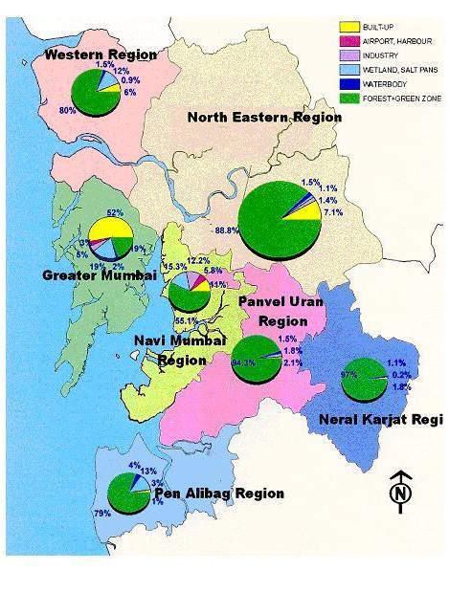

Fig. 1. Sub-regional land use composition of MMR in 2001
[MMRDA, 2006]

Fig. 1. Sub-regions of MMR and their land use composition in 2001[MMRDA, 2006]

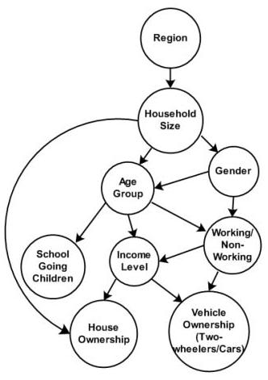

Fig. 2. Interdependency of socioeconomic variables

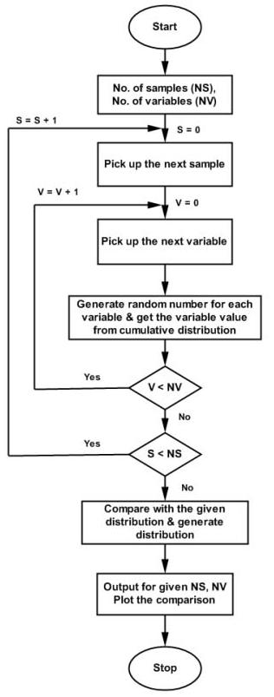

Fig. 3. Random number generation and Monte Carlo process

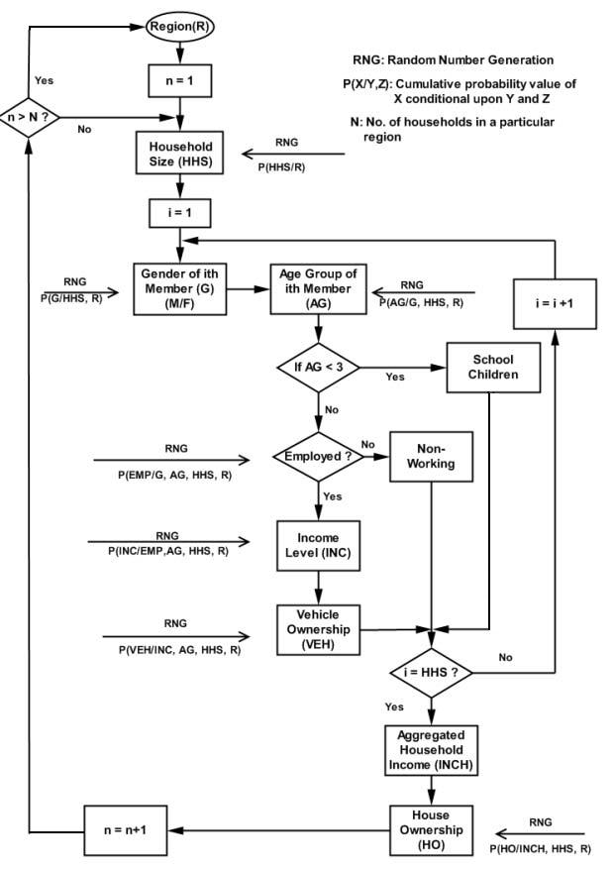

Fig. 4. Microsimulation of socioeconomic characteristics
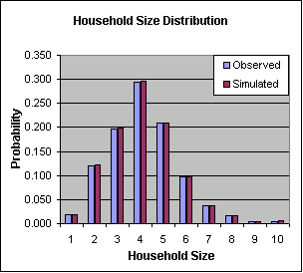
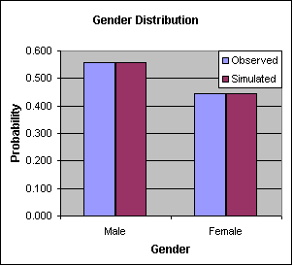
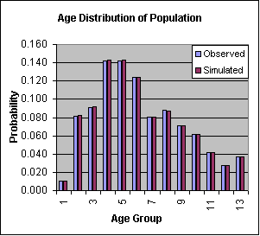
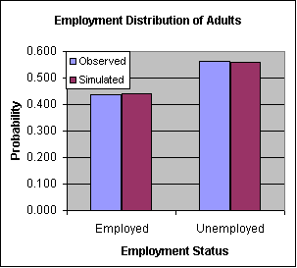
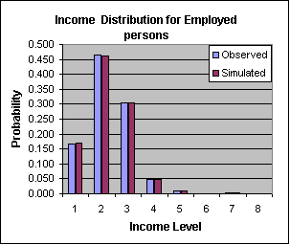
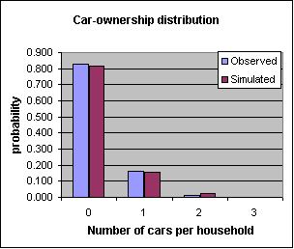

Fig. 5. Simulated and observed values of socio-economic variables

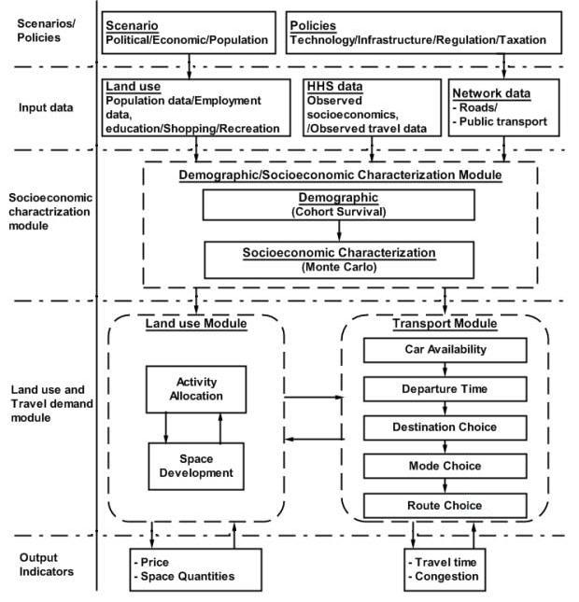

Fig. 6. Suggested Land Use Transport Model Framework

