Effects of Comfort, Safety and Infrastructural Measures on Travelers’ Willingness to Walk and Cycle

Peter van der Waerden & Harry Timmermans
Urban Planning Group, Eindhoven University of Technology
PO Box 513, 5600 MB Eindhoven, the Netherlands

Abstract

This paper describes some research findings concerning travelers’ willingness to walk and cycle related to changes in infrastructure. Ten different measures regarding pedestrian and bicyclist infrastructure were investigated. Almost 630 respondents filled out an on-street questionnaire. It appears that travelers react differently on the suggested infrastructural measures. The measures ‘Give priority’, ‘Introduction of right of way’, ‘Build a tunnel’, ‘Build a bridge’, and ‘Put streetlamps’ may increase the willingness of travelers to walk and to cycle. The introduction of differences in heights can decrease the willingness to walk and to cycle. The reactions on the investigated planning measures depend on the respondents’ age and gender.

Introduction

Environmental problems caused by motorized traffic have resulted into a new interest in non-motorized travel modes (e.g., Rodrígues & Joo, 2004; Plaut, 2005). With a variety of planning measures planners continuously try to improve the urban slow traffic network and to stimulate the travel modes walking and cycling. Examples of planning measures are placement of traffic lights, give priority at traffic lights, and building a bridge for slow traffic modes. An important question in this context is ‘How will travellers react to planning measures in terms of their willingness to walk and cycle?’. According to Porter et al. (1999) the answer to this question is important for practitioners with limited technical resources for planning purposes. Information concerning factors influencing the decision to walk or bicycle, and the implementation of this information in forecasting methods is still limited. Also Wardman et al. (2001) suggest that more research on specific cycling improvements such as advanced stop lanes, innovative roundabouts, and facilities shared with pedestrians is required.
The aim of the study reported in this paper is to find out whether particular planning measures will change individuals’ willingness to walk or cycle. The suggested planning measures cover comfort, safety, and traffic flow related aspects. The results of the study can be used to evaluate these measures in view of agreed planning goals.
The remainder of the paper is organised as follows. First, attention will be paid to previous studies for non-motorized travel modes. Next, the adopted research approach is explained. This section is followed by a description of the data collection. The analyses section is divided into two parts: i) effects of planning measures on the use of travel mode and ii) the relation between users’ reactions and their personal characteristics. The paper ends with some conclusions.

Non-motorized travel modes

Traditionally, the design of infrastructure for pedestrians and cyclists focuses on safety, convenience and attractiveness (e.g., TRB, 2000). Attention is paid to pavement, lighting, width, horizontal curvature and vertical alignment. In an optimal design the infrastructure has to be smoothly paved, well lighted, sufficiently wide, and as flat and straightforward as possible. For example, Noble and Smith (1992) suggest the following characteristics: short as possible (direct routes) with the ends inter-visible, layout and planting should not provide hiding places, segregation between pedestrians and cyclists, and gradient not higher than 8 percent. Leake (1997) gives the following major requirements with respect to the design of pedestrian and cyclist facilities: minimum travel distance, avoid steps and uphill gradients, provision of seating (benches and seats), and good quality of pavement (smooth and good grip). This approach might be denoted as the ‘engineers approach’.
In several cases, the optimal infrastructure cannot be designed because of local circumstances. A lack of space, the necessity of crossing a canal, the location of buildings, and the presence of hills are just some examples that forces designers to be creative in their design of infrastructure. Not only physical circumstances influence the design of infrastructure but also aesthetic reasons (see Figure 1). For example, Carmona et al. (2003) argue that the design of footpaths has to be ‘in sympathy with the local context’ to ensure an attractive development in which clearly defined spaces, landscape and buildings dominate. Blake (1999) introduced the term ‘critical curve’ to discuss the differences between a ‘dull’ straight path and an attractive curved path. These two examples illustrate the designers’ point of view as a reaction on the engineers’ point of view.

Figure 1: Example of a special designed path for pedestrians and cyclists

The number of studies that focus on the willingness to walk and cycle is much more limited than those that are dealing with route choice of non-motorized travel modes. Regarding walking, Painter (1996) studied the influence of street lighting on crime, fear and pedestrian street use, after dark. One of the facilities was a footpath. The study provided consistent evidence that lighting improvements reduces crime, incivilities and fear at night. It also increases pedestrian street use after dark. Wardman et al. (2001) focus on street surface and gradient, the provision of cycle ways, the charge for the use of cycle ways, and journey time when investigating the attractiveness of cycling for current cyclists. The characteristics were incorporated into a stated mode choice experiment. It appeared that cyclists were sensitive for differences in pavement with regard to value of cycle time, and that cyclists would be prepared to pay for street improvements.

Research approach

Using on-street interviews, respondents were asked to point out if in general, they are willing to walk or cycle more or less when a certain planning measure would be implemented. Two different questionnaires were developed: one for pedestrians and one for cyclists. Based on the respondents’ experiences with a special designed pedestrian and bicycle path close to the University campus (see Figure 1), respondents received one of the questionnaires. In general, the respondents are familiar with the suggested planning measures. The following ten planning measures related to non-motorized infrastructure were investigated: placement of traffic lights at dangerous crossings, give priority to pedestrians/cyclists at traffic lights, furnishing foot/bicycle paths with vegetation, create height differences in the foot/bicycle path (see figure 2), introduce give right of way at crossings, build a tunnel for pedestrians/cyclists to cross a main road, build a bridge for pedestrians/cyclists to cross a main road, put benches on foot/cycle paths, put roundabout in walk/cycle routes, put streetlamps on foot/cycle paths. The respondents could state their reaction in terms of increase of mode use, no change in mode use, and decrease of mode use.

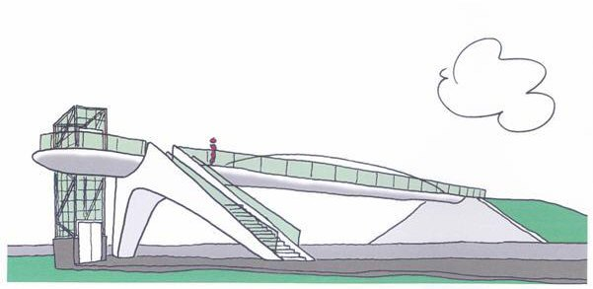

Figure 2: Example of height differences in non-motorized infrastructure

The Data

The data were collected by means of an on-street questionnaire (Figure 3). In November and December 2003 questionnaires were distributed among students and employees of the Eindhoven University of Technology, The Netherlands. In total 628 respondents completed the questionnaire.

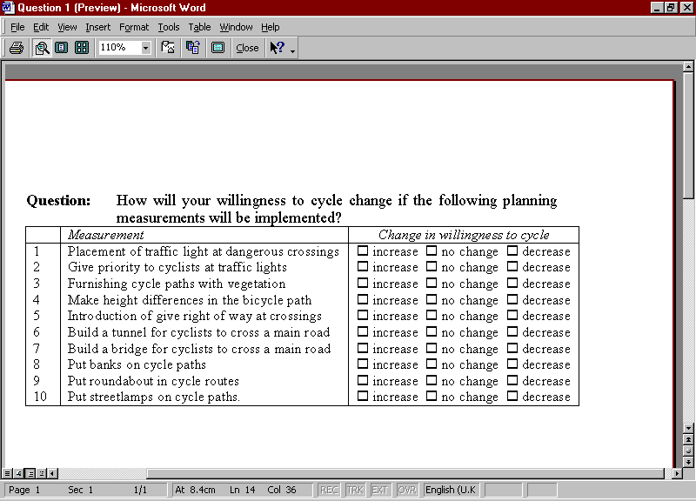
Figure 3: Part of the bicycle specific questionnaire

Table 1 presents the distribution of the respondents across the type of the questionnaire and travel mode for commuting to the university, and across the personal characteristics gender and age. With respect to the personal characteristics gender and age, the composition of the sample was as expected. There were more male respondents than female and more respondents older than 20 years than younger than 20 years. The distribution is according to what one can expect at a technical university: a high percentage of male students and a high percentage of young people.

Table 1: Personal characteristics of the respondents
Characteristic | Levels | Absolute | Percentage
Type of questionnaire | Pedestrian  Bicycle | 367  261 | 58.4  41.6
Travel mode for commuting | Non-motorized mode¹  Motorized mode | 399  227 | 63.7  36.3
Gender | Female  Male | 142  484 | 22.7  77.3
Age | 20 year and younger  21 year and older | 268  358 | 42.8  57.2
¹ Include both walking and cycling

The use of non-motorized travel modes

The first part of the analyses consists of an analysis of the evaluation scores for each planning measure (Table 2 and Table 3). The distribution across the evaluation scores shows that the influence of the suggested planning measures on the willingness to use the investigated travel modes will be different.
Several planning measures (give priority, introduction of right of way, build a tunnel, build a bridge, and put streetlamps) may result in increased walking and cycling. Only the implementation of differences in heights can decrease the use of both travel modes. The placement of traffic lights, the construction of vegetation, and the placement of benches may not change the use of both travel modes. The construction of roundabouts in the travel paths can result in a different change in mode use. Pedestrians indicate that the measure might decrease walking, while cyclists indicate that the measure may increase the use of the bike. Another remarkable finding is the influence of vegetation along and benches on the travel path. Both pedestrians and cyclists may not change the use of travel mode after implementation of these planning measures.

Table 2: Changes in the use of travel mode ‘Walk’ (percentages)
Measure | Change
Measure | Increase | No change | Decrease
Placement of traffic light at dangerous crossings | 36.3 | 58.5 | 5.2
Give priority to travellers at traffic lights | 68.7 | 30.0 | 1.4
Furnishing travel paths with vegetation | 35.1 | 60.5 | 4.4
Make height differences in the travel path | 6.5 | 29.4 | 64.0
Introduction of give right of way at crossings | 61.0 | 36.2 | 2.7
Build a tunnel for travellers to cross a main road | 57.8 | 31.1 | 11.2
Build a bridge for travellers to cross a main road | 55.6 | 34.9 | 9.5
Put benches on travel paths | 14.8 | 80.6 | 4.6
Put roundabout in travel routes | 11.2 | 58.7 | 30.1
Put streetlamps on travel paths | 61.6 | 36.8 | 1.6

Table 3: Changes in the use of travel mode ‘Bicycle’ (percentages)
Measure | Change
Measure | Increase | No change | Decrease
Placement of traffic light at dangerous crossings | 29.5 | 59.4 | 11.1
Give priority to travellers at traffic lights | 70.5 | 29.5 | -
Furnishing travel paths with vegetation | 18.8 | 76.2 | 5.0
Make height differences in the travel path | 3.8 | 28.7 | 67.4
Introduction of give right of way at crossings | 63.8 | 35.4 | 0.8
Build a tunnel for travellers to cross a main road | 65.1 | 28.7 | 6.1
Build a bridge for travellers to cross a main road | 47.9 | 39.5 | 12.6
Put benches on travel paths | 4.2 | 89.3 | 6.5
Put roundabout in travel routes | 30.9 | 56.8 | 12.4
Put streetlamps on travel paths | 70.1 | 29.5 | 0.4

Use and personal characteristics

To get insight into the relation between the individual evaluation scores and the personal characteristics of the respondents, ordinal regression models were estimated. The ordinal regression model is specifically developed for ordinal data where the distances between categories are unknown (e.g., Long & Freese, 2003). The ordinal regression model is commonly presented as a latent variable model. Defining y* as a latent variable ranging between -∞ to ∞, the structural model is:

y*_{i =} x_{i} β + ε_{i} (1)

Where,
x_{i} represents a vector of physical characteristics for respondent i;
β represents a vector of regression coefficients.

The measurement model divides y* into J ordinal categories, where the cut-points τ₁ through τ_{J-1} are estimated.

y_{i}=m, if τ_{m-1} =< y*_{i} < τ_{m} for m=1,2,…..,J (2)

The cut-points τ₀ and τ_{J} are set to -∞ and ∞ respectively. The probability of an observed outcome (y) for a given value of attribute vector x is the area under the curve (a normal or logistic distribution) between a pair of cut-points.

Pr(y=m|x) = F(τ_{m} – xβ) – F(τ_{m-1} – xβ) (3)

Where,
F() is a logistic cumulative distribution function.

In this study, τ₁ represents the cutting point between the response classes “Increase” and “No change”, while τ₂ represents the cutting point between “No change” and “Decrease”. Negative effects of the dependent variables increase the probability of the first or second response class, thus decreasing the probability for a decreasing use.
The results of the model estimation process are presented in Table 4 (for pedestrian infrastructure) and 5 (for bicycle infrastructure). For each planning measure a model is estimated with the travellers’ response as dependent and the travellers’ characteristics as independent variables. Investigated characteristics are travel mode for commuting, age and gender. Only the base characteristic levels are presented. The estimated model was tested against a model with all coefficients equal to zero (null-model) using the Log-likelihood Ratio Statistic (LRS). The LRS-value indicates that the estimated model performs significantly better than the null model (Ortúzar & Willumsen, 2001). Only models that outperform the null model are presented.

Table 4: Estimation results of the ordinal regression model for Pedestrians, significant models only
Measure | Cutting points |  | Travel mode  Non-motorized¹ | Age  20 year and younger¹ | Gender  Female¹
Measure | Increase-No change | No change-Decrease | Travel mode  Non-motorized¹ | Age  20 year and younger¹ | Gender  Female¹
Give priority | 0.653 | 4.209 |  | -0.818
Vegetation | -0.694 | 3.102 |  | -0.612
Height differences | -2.300 | -0.174 |  | 0.713
Right of way | 0.347 | 3.504 |  | -0.551
Tunnel | 0.312 | 2.123 |  |  | 0.880
Benches | -1.732 | 3.227 | 0.651
Streetlamps | 0.290 | 3.969 |  |  | -1.638
¹ Parameter for other attribute level is set to zero because it is redundant

Regarding the evaluation of pedestrian planning measures, it appears that age is the most influential characteristic. A negative parameter means that younger respondents are more willing to walk than older respondents when the planning measure is implemented. This holds for the measures ‘Give priority’, ‘Vegetation’, and ‘Right of way’. The opposite is found in the case of ‘Height differences’, where the positive sign indicates that younger respondents are less willing to walk than older respondents when differences in height are created in infrastructure. The effects of gender are as expected. The parameters indicate that female respondents are more willing to walk if streetlamps are implemented and are less willing to walk when a tunnel is built. The positive sign for the effect of commuting mode indicates that the willingness to walk of respondents who use a non-motorized travel mode for commuting decreases.
Figure 4 shows an example of the probability of willingness to walk when walking receives more priority at traffic lights. The cumulative predicted probabilities from the logistic model are calculated using the following formula:

$$P_{j}=1/(1+e^{−(α_{j}−β_{x})})$$

Where, P_{j} is the cumulative probability of behavioral change j;
α_{j} is the estimated parameter of cutting point j;
β_{x} is the estimated parameter of characteristic x.

The probabilities for the individual score can be calculated by subtracting, using the equation:

Prob(score=j) = prob(score less than or equal to j) – prob (score less than j)

Figure 4: Probabilities of behavioral changes, Give priority

Table 5: Estimation results of the ordinal regression model for Cyclists, significant models only
Measure | Cutting points |  | Travel mode  Non-motorized¹ | Age  20 year and younger¹ | Gender  Female¹
Measure | Increase-No change | No change-Decrease | Travel mode  Non-motorized¹ | Age  20 year and younger¹ | Gender  Female¹
Give priority | -0.039 | -² |  |  | -0.880
Height differences | -2.734 | -0.222 |  |  | 0.797
Right of way | -0.535 | 3.795 |  |  | -0.711
Streetlamps | 0.907 | 5.697 |  |  | -1.331
¹ Parameter for other attribute level is set to zero because it is redundant
² No observations of the answer category ‘decrease’ available
In the context of bicycle infrastructure, only gender influences the change in willingness to use the bicycle. A negative parameter indicates that the willingness to bicycle of females will increase when a planning measure is implemented. The opposite holds for a positive parameter.

Conclusions

The study described in this paper aims to contribute to the existing literature on the influence of infrastructure on the willingness to use non-motorized travel modes. In total ten different planning measures are investigated. It appears the planning measures ‘Give priority’, ‘Introduction of right of way’, ‘Build a tunnel’, ‘Build a bridge’, and ‘Put streetlamps’ can increase the willingness to walk and cycle. Some differences in the degree of the reactions exist between the two travel modes. The introduction of differences in heights can decrease the willingness to use both travel modes. The willingness to cycle may change more than willingness to walk as a consequence of the investigated planning measures. The reactions to certain planning measures mainly depend on age and gender of the respondent.
The results of this study indicate that the effect of infrastructural measures on traveler’s willingness to walk or cycle differs by measure. Some measures such as creating height differences or putting benches are not preferable when stimulation of non-motorized travel modes is the planning goal. Also attention has to be paid to the different user groups (in terms of age and gender). For example, school routes with a majority of young pedestrians have to be designed with special attention to priority, vegetation, and right of way. Walking routes to shopping centers (many female users) have to be designed without tunnels and with streetlamps. Priority, right of way, and streetlamps are preferable in cycling routes to shopping centers.
The data are collected using a stated preference experiment. This way of data collection gives the researcher the opportunity to define and control all kind of planning measures including not yet existing measures (e.g., Ortúzar & Willumsen, 2001). A basic with stated preference data collection concerns the uncertainty of real changes in respondents’ behaviour. The actual changes in respondents’ mode choice behaviour can be part of future research.
The study explicitly focuses on comfort, safety and other infrastructure related measures to stimulate walking and cycling. Of course, other aspects such as changes in personal responsibilities and abilities, and spatial arrangement of activities have to be considered also.

Literature

Blake, B.J. (1999) An Introduction to Landscape Design and Construction, Gower Publishing Limited, Hampshire.
Carmona, M., Heath, T., Oc, T. & Tiesdell, S. (2003) Public Spaces – Urban Spaces: The Dimension of Urban Design, Architectural Press, Oxford.
Dixon, L.B. (1996) Bicycle and Pedestrian Level-of-Service Performance Measures and Standards for Congestion Management Systems, Transportation Research Record 1538, 1-9.
Leake, G.R. (1997) Planning for Pedestrians, Cyclists and Disabled People. In: C.A. O’Flaherty (ed.) Transportation Planning and Traffic Engineering, Arnold, London.
Long, J.S. & Freese, J. (2003) Regression Models for Categorical Dependent Variables using Stata, Stata Corporation, College Station, Texas.
Noble, J. & Smith A. (1992) Residential Roads and Footpaths: Layout Considerations. HMSO, London.
Painter, K. (1996) The Influence of Street Lighting Improvements on Crime, Fear and Pedestrian Street Use, after Dark, Landscape and Urban Planning 35, 193-201.
Plaut, P.O. (2005) Non-Motorized Commuting in the US, Transportation Research Part D 10, 347-356.
Porter, C., Suhrbier, J. & Schwartz, W.L. (1999) Forecasting Bicycle and Pedestrian Travel: State of the Practice and Research Needs, Transportation Research Record 1674, 94-101.
Ortúzar, J. de D. & L.G. Willumsen (2001) Modelling Transport, Third Edition, John Wiley & Sons, West Sussex, England.
Rodrígues, D.A. & Joo, J. (2004) The Relationship between Non-Motorized Mode Choice and the Local Physical Environment, Transportation Research Part D 9, 151-173.
TRB (2000), Highway Capacity Manual 2000 (CD-ROM), Transportation Research Board of the National Academies, Washington DC, USA.
Wardman, M., Page, M. & Tight, M. (2001) Cycling and Urban Mode Choice. Proceedings of the 9th World Conference on Transport Research, Seoul, Korea.

