A MODEL TO EVALUATE the Response AND travel MOTIVATIONS to visit TOURIST DESTINATIONS IN DISASTROUS REGIONS

By

Vasantha Wickramasinghe, M.Eng.
Graduate School of Engineering, Hokkaido University
Kita-13, Nishi-8, Kita-ku, Sapporo 060-8628, JAPAN
Tel. +81-11-706-6822, Fax. +81-11-706-6206
E-mail: vasantha@eng.hokudai.ac.jp

Shogo Naka, M.Eng.
Graduate School of Engineering, Hokkaido University
Kita-13, Nishi-8, Kita-ku, Sapporo 060-8628, JAPAN
Tel. +81-11-706-7276, Fax. +81-11-706-6206
E-mail: naka-s@eng.hokudai.ac.jp

Shin-ei Takano, Ph.D.
Graduate School of Engineering, Hokkaido University
Kita-13, Nishi-8, Kita-ku, Sapporo 060-8628, JAPAN
Tel. +81-11-706-6205, Fax. +81-11-706-6205
E-mail: shey@eng.hokudai.ac.jp

Submitted for Presentation at the 11th World Conference on Transportation Research (WCTR), Berkeley, California, USA, 2007

A model to evaluate the response and travel motivations to visit tourist destinations in disastrous regions

Vasantha Wickramasinghe, Shogo Naka and Shin-ei Takano
Graduate School of Engineering, Hokkaido University, Japan

Abstract: Tourism is one of the most dynamic and fastest growing global industries. However, it is fragile and vulnerable to external fluctuations due to the people driven nature of the industry. Tourist industry is more susceptible to disasters. Recently, it has encountered many spiked decreases due to various sudden calamities. Knowledge regarding the state of risk acceptance and travel motivations of tourists would better enable the tourist industry to recover after such calamities. This paper presents a model to evaluate the risk acceptance and travel motivations of Japanese travelers to visit tourist destinations in disastrous regions. The results conclude that Japanese travelers are risk averse, and highly concerned with safety.

Key words: Calamity, Conjoint Analysis, Disastrous Regions, Japanese Travelers, Market Segmentation, Travel Motivations

1. INTRODUCTION

Tourism is one of the most dynamic and fastest growing global industries. It is an industry which transforms economies around the world (Goeldner and Ritchie, 2003; WTO). Tourism benefits economic activities in terms of generating tourist income and employment opportunity. International tourist arrivals increased by 5.5% from 766 million in 2004 to 808 million in 2005. Worldwide international tourist receipts reached US$ 682 billion in 2005 (UNWTO World Tourism Barometer, 2006). Forecasts of international tourist arrivals predict a steady value approaching 1.6 billion by year 2020 (WTO). Furthermore, tourism induced employment contributes a high share of total employment in tourism oriented countries; by the year 2001, 207 million jobs were attributed globally to tourism, and an estimated 260 million jobs are estimated to be reached by 2011 (WTTC, cited in Goeldner and Ritchie, 2003). This information shows the tourism industry to be a major contributor to the world economy. Tourism is however fragile and vulnerable to external influences as it is highly sensitive to human motivations and significantly impacted by environmental fluctuations.

Disasters, either natural or human related, have recently been especially disturbing. Volcanoes, earthquakes, tsunami, floods, cyclones, outbreaks of epidemic diseases, etc., are among the most common natural disasters. Terrorism, political and economic crisis, road traffic accidents, wide spread of negative publicity, etc., are common human-involved disasters. Figure 1 shows the occurrence of both natural and human-involved (e.g. international terrorism) disasters globally for the last couple of decades. Both are increasing in numbers and damage intensity. In either case, tourism is intensely affected similar to all other industries. Disasters are rarely predictable or avoidable, and the devastation caused and fear of potential injury has led to massive declines in tourist industry. Therefore, the tourist industry must be prepared to overcome the effects of disasters through anticipation, reaction, and recovery.

Figure 1: Occurrence of natural and human-involved (International Terrorism) disasters

Past records of international tourist arrivals indicate sudden decreases at each time a major disaster occurs; notable is the 9.4% reduction in international tourism to Asian regions during the period of SARS and the IRAQ war (WTO). Moreover, the September 11th, 2001 terrorist attack in the United States emphasized the vulnerability of the tourism industry to unexpected disasters. Figure 2 provides evidence for declining tourist arrivals under two circumstances, i.e., decline in tourism due to terrorism (e.g. Sri Lanka) and decline due to a natural disaster (e.g. Okushiri Island, Japan). These examples establish a direct correlative effect between tourism and disasters which signals the need to prioritize consideration of disasters in tourism planning. The imminent hurdle after a disaster is to restore tourist arrivals to a maximum. Tourism presents a particular problem as it is a people-driven industry, in which destination choices are made purely on emotive factors. Evidence shows that recovery is complicated in the tourist industry due to the poor logic of tourists’ risk perception. Research that informs the travel industry about levels of risk acceptance and motivating factors affecting the choice of destination can better equip tourism professionals to implement successful preventative and remedial measures in relation to disastrous regions.

In order to arrive at a final destination choice, tourists consider and weigh multiple characteristics of destinations. The complexity of the process increases in proportion to the heterogeneity of tourists. Therefore, knowledge on tourists’ background and their preference for various conditions are important for tourism planning, decision making and strategic development after a disaster. This research aims to develop a framework within which the risk acceptance level and travel motivations of a typical tourist to visit tourist destinations in disastrous regions are evaluated. In that, a model to evaluate the disaster risk acceptance level and travel motivations of Japanese outbound travelers to visit destinations in disastrous regions is presented in this paper. The Japanese are frequent outbound travelers, ranked 10th in international outbound tourists according to WTO ratings in 1999 and they are familiar with natural disasters due to the geographical location of the country. Therefore, Japanese travelers provide an ideal sample for model formulation. The importance of the study is due to the increasing number of both natural and human-involved disasters and steadily increasing tourists number around the world and the resultant economic activity upon which many countries depend.

Figure 2: Effect of disasters to International and domestic tourist arrivals

2. Literature Review

2.1 Travel Motivations
Knowledge of travel motivations and the criteria for destination selection is of great importance in foreseeing future travel patterns (Jang and Cai, 2002). Travel motivations can be classified into two distinct categories: ‘push’ and ‘pull’ factors (Graham, 1981). ‘Push’ factors include cognitive processes and socio-psychological motivations that predispose people to travel (Chon, 1989). ‘Pull’ factors consist of tangible and intangible cues of a specific destination which drive travelers towards particular travel experiences, i.e. natural and historic attraction, cuisines, hospitality, recreation facilities and market image of the destination (Sirakaya et al., 1997). Many studies on travel motivations have attempted to find ‘push’ and ‘pull’ motivation factors for different settings such as nationalities (e.g. Cha et al., 1995; Heung, 2001; Jang and Wu, 2006; Zhang and Lam, 1999), destinations (e.g. Chio, 1999; Jang and Cai, 2002; Kozak, 2002) and events (e.g. Lee, 2000; Nicholson and Pearce, 2001). Ultimately, it can be summarized that common motivation ‘push’ factors are ‘knowledge-seeking’, ‘relaxation’, and ‘family togetherness’ while common motivation ‘pull’ factors include ‘natural and historical environment’, ‘cost’, ‘facilities’ and ‘ease-of-access’. Few tourism studies have included ‘destination safety’ when evaluating travel motivations. The available literature does not focus on the ‘push’ and ‘pull’ motivation factors for a tourist destination with fluctuating environment or external conditions (e.g. natural and human-involved disaster risk). Even though unjustified, a disaster directly affects ‘pull’ factors specific to a destination and indirectly the ‘push’ factors (Santana, 2003). Focusing on the travel motivations and disaster risk acceptance of Japanese outbound travelers to visit destinations with external and internal fluctuations, this paper addresses the current lack of research and proposes a model that helps to predict and prepare for the changes in tourist traffic to destinations in disastrous regions.

2.2 Application of Conjoint Analysis in Tourism Studies
A tourist destination can be conceptualized as a set of attributes similar to any product or service (Mallou et al., 2004). Tourists trade-off destination attributes to arrive at a final destination choice. The process leading to the ultimate decision of a particular travel destination is complex (Lam and Hsu, 2006). Conjoint analysis is a proven methodology for analyzing the consumer preference (Green and Srinivasan, 1990). In the context of tourism, the basic goal of conjoint analysis is to characterize the structure of tourists’ preference for a destination in terms of destination specific attributes (Mallou et al., 2004). A detailed explanation on the application of conjoint analysis for marketing research is found in Green and Srinivasan, (1990). Although the conjoint analysis is used successfully in marketing research studies, application in tourism is minimal. Lonial et al. (2000) suggested that conjoint analysis could be successfully utilized in the area of tourism; it is yet largely unexploited as a tourism management tool.
Thyne et al. (2006) used conjoint analysis to understand the importance of different tourist attributes, i.e. nationality, age and type of tourists (independent backpackers versus bus tours), for developing the host preference for various types of tourists. Suh and Gartner, (2004) used conjoint analysis to analyze the preferences of international urban travelers bound for Seoul, Korea and attempted to identify the relationship between preference and expenditure for destination attributes and activities. The results concluded that near origin (Japan) travelers tend to give more preference to ‘tangible’ attributes (e.g. shopping) while travelers from distant origins (Europe and North America) highly valued ‘intangible’ attributes (e.g. local culture). The ability to produce a model which simulates the traveler preference for a destination is the main advantage of conjoint analysis in tourism research studies.

2.3 Market Segmentation
The heterogeneity of tourists influences the acceptance of destination attributes. Market segmentation is a useful tool in tourism studies (Cha et al., 1995; Jurowski et al., 1993; Sung et al., 2000). Segmentation of tourists, understanding their characteristics, and evaluating risk acceptance for tourist destinations in disastrous regions is a powerful marketing tool for enhanced promotion of the tourist industry and for rapid recovery after a disaster. When conjoint analysis is used to measure traveler preference for a tourist destination, two segmentation approaches are recognized: priori segmentation and posteriori segmentation (Mallou et al., 2004). Priori segmentation initially identifies a subject sample based on demographic, geographic or psychographic characteristics followed by an analysis conducted separately for selected subgroups. In posteriori segmentation, conjoint analysis is performed for each subject followed by cluster analysis to group subjects based on individual utility values. The latter approach enables subjective identification of tourist groups defined by their preferences for destinations. Mallou et al., (2004) performed conjoint analysis to characterize Spanish adult travelers based on preference for hypothetical destinations with different attribute combinations; cluster analysis was then used to identify the segment groups. The primary aim of this study is to segment Japanese outbound travelers based on responses which reflect acceptance levels of travel to disastrous regions.
3. Methodology

3.1 Questionnaire Development
The questionnaire was developed based on a comprehensive review of travel motivation literature (Cha et al., 1995; Heung et al., 2001; Kozak, 2002; Zhang and Lam, 1999) and with guidance from travel experts. Fourteen ‘push’ and 24 ‘pull’ travel motivation factors specific to select tourist destinations were listed. Selection of the most appropriate factors is essential for the accuracy of the conjoint model which was used in the analysis. Moreover, breaking down the selected factors into mutually independent levels is the core of conjoint analysis (Ozmen, 2006). In that context, ‘Destination Attraction (DEA)’, ‘Geographical Proximity (GEP)’, ‘Activities and Events (ACE)’, and ‘Disaster Risk and Threats (DRT)’ were selected as the most pertinent ‘pull’ factors out of 24 to minimize the workload for the respondents. Together with the questionnaire, each respondent was given a show card which clarifies the four most pertinent factors and their respective levels as shown in Figure 3.

Figure 3: Attributes and Levels used in Conjoint Analysis

The conjoint portion of the questionnaire included hypothetical destination profiles obtained from the fractional factorial design. The full factorial design could have included 3x3x2x3=54 alternative hypothetical conjoint profiles leading to an unfeasibly complex study. For practical applicability, using the fractional factorial design, they were ultimately diminished into nine profiles. The ‘push’ and ‘pull’ factors which were not considered for the conjoint part of the questionnaire were evaluated using statements with five-point Likert scale ranging from ‘not at all important (1)’ to ‘extremely important (5)’. In addition, basic demographic factors (e.g. gender, age, and marital status), foreign travel experiences, travel motivations, and a set of 15 tourist destinations with different characteristics to evaluate the ‘Willingness To Travel (WTT)’ of the respondents were included in the questionnaire. A pilot study was conducted among 28 university students to test the validity of the instrument.

3.3 Data Analysis
Collected data was analyzed in five steps. Initially, the sample was profiled by socio-demographic and travel behavior characteristics. Next, ‘push’ and ‘pull’ travel motivations were graded on terms of their importance. Thirdly, using conjoint analysis, attribute importance and the part-worth utility value of each attribute level were evaluated. Then, cluster analysis was used to segment the tourists based on individual part-worth utility values obtained from above analysis. The demographic and travel characteristics of each cluster group were summarized. Next, the response of typical Japanese travelers to visit each destination was assessed with the 15 selected tourist destinations. Then, three tourist destinations were selected among 15 and traveler preference was explained with the logic of trading-off attributes to attain the final destination choice. A total analysis process was performed using the SPSS (Statistical Package for Social Science) program.

Using conjoint model and Likert statement analysis, the effect of disaster risk on tourism planning and the effect of travel motivations on the final destination choice were obtained. With these outcomes, a framework was built which should prove useful in overcoming a post disaster tourism crisis. A cluster analysis using individual utilities confirmed the heterogeneity of tourists and explained the driving motives for selecting tourist destinations in disastrous regions.

4. RESULTS

4.1 Demographic and Travel Characteristics of Respondents
Among 480 distributed questionnaires, 363 (75.6%) were returned. Out of that, 347 (95.6%) questionnaires were used for the analysis and 16 (4.4%) were discarded due to incomplete responses. The socio-demographic and travel characteristics of the sampled Japanese travelers were profiled and are presented in Table 1. Male respondents (53.9%) were moderately higher than females (46.1%) and over 70% of respondents were in the age group between 18-44 years. The marital status expressed an equal share among married (48.8%) and un-married (51.2%) respondents. Regarding the travel characteristics nearly 84% of the respondents were found to have foreign travel experiences with 93.4 % having visited as tourists. Over 70% of the tourists have traveled one or more times during the last 5 years. The most popular source of travel information was travel books and guides (39.6%) followed by travel agents and airlines (29.6%) and next the media (18.1%).

Table 1: Socio-demographic profile and travel characteristics of survey respondents (N= 347)

4.2 The importance of ‘push’ and ‘pull’ travel motivations

‘Push’ and ‘pull’ travel motivations are exclusively based upon foreign experienced Japanese travelers. The importance of ranking the mean value of both ‘push’ and ‘pull’ travel motivations to select a tourist destination is presented in Table 2. The first-ranked ‘push’ motivation is ‘enjoying scenic beauty’ with a mean value of 4.42 followed by ‘seeing something different’ (4.41) and ‘visiting cultural and historical importance’ (4.33). The least important ‘push’ motive is ‘experiencing post-disastrous events’ with a mean value of 2.40, preceded by ‘enjoying nightlife’ and ‘seeking adventure’. This expresses that attraction of the destination (i.e. natural or cultural and historical environment) is considered first among ‘push’ motives. Whether a destination is ‘free from terrorism threats’ (4.67) is considered maximally among ‘pull’ motives followed by ‘political stability’ (4.60) and ‘free from epidemic diseases’ (4.53). The least important ‘pull’ motive is ‘availability of post-disastrous landmarks’ (2.43), preceded by ‘interesting nightlife and entertainment’ and ‘adventurous activities’. From these results, it is clear that Japanese outbound travelers consider safety and security a high priority when selecting a travel destination. Based on mean values of top ‘pull’ motives (4.67 to 4.53) being significantly higher than that of ‘push’ motives (4.42 to 4.33), it can be concluded that ‘pull’ motives more strongly impact the final destination choice decision. The mean scores of the least preferred ‘push’ and ‘pull’ motives being less than the neutral point of three; it appears that Japanese outbound travelers are not motivated by post-disastrous attractions.

Table 2: Rankings for the importance of ‘push’ and ‘pull’ travel motivations (N= 289)

4.3 Conjoint Analysis
Results of the conjoint analysis technique extract two indices: part-worth utility value of each attribute level and relative importance of each attribute. By means of the SPSS conjoint, the relative importance and individual part-worth utility values were calculated as shown in Figure 4.

Figure 4: Conjoint model outcome results

With regard to the attribute ‘destination attraction’, the corresponding part-worth utility values demonstrate that the level of ‘cultural and historical’ is the most highly preferred, followed by ‘natural’ with the least preferred being ‘post-disastrous ’. The range between the maximum and minimum utility values of this attribute is found to be the widest. The least preferred utility value is obtained as a negative value for the ‘moderate’ level of the attribute ‘disaster risk and threats’ while the levels ‘almost nil’ and ‘mild’ emerge as positive elements. The utility values for the levels of other two attributes (i.e. geographical proximity, and activities and events) are found to be insignificant. The relative importance of the four attributes indicate that the Japanese outbound travelers consider ‘destination attraction’ (42.59%) to be the most desirable although the level of ‘post-disastrous’ is considered as to be avoided. Even though the relative importance of ‘disaster risk and threats’ (35.60%) is less than ‘destination attraction’, it influences final destination choices. The utility value of the level ‘almost nil’ in the attribute of ‘disaster risk and threats’ being highly positive proves that the destination should be safe and free from threats. The results conclude that Japanese outbound travelers consider ‘destination attraction’ simultaneously with ‘safety’ to attain the final destination choice decision. The attributes ‘geographical proximity’ (15.18%) and ‘activities and events’ (6.64%) are of low significance. Japanese travelers prefer short and medium distance visits. Surprisingly, activities and events are not among their major concerns.

Once the part-worth utility values from conjoint analysis outcome are available, the ‘Total Utility Value (TUV)’ of a destination can be calculated by summing up the respective utilities on all the attributes from which a destination is described as shown in Equation 1.
(1)

U(X_{ij}) Total utility of an alternative
m number of attributes
k_{i} number of levels in j^{th} attribute
u_{ij} utility associated with j^{th} level of the i^{th} attribute
X_{ij} dummy variable that take on 1 if the j^{th} level of the i^{th} attribute is present or 0 otherwise
TUV is a number which represents the overall preference value that a traveler places on a destination. A low TUV indicates a low preference and vice-versa.

4.4 Segmentation of Japanese Outbound travelers
Segmentation perfectly extracts the homogenous groups with similar individual utility values. This study uses k-means cluster analysis to segment Japanese outbound travelers using individual part-worth utility values. Figure 5 shows the part-worth utility values of the attribute levels for the obtained two clusters: Cluster 1 and Cluster 2. The least utility value of each attribute is considered as zero. Cluster 1 emphasizes ‘destination attraction’ while Cluster 2 emphasizes ‘disaster risk and threats’; the clusters are therefore named ‘Eco-Seekers’ and ‘Safety-Seekers’ respectively.

Figure 5: Part-worth utilities of attribute levels for the two clusters

The demographic and travel characteristic profiles of each cluster group were identified using cross-tabulation. Table 3 presents the profiles of two clusters with respective demographic and travel characteristics of the respondents. Chi-square statistics was used to determine statistical significance among two cluster groups. The results revealed that two clusters were significantly different in age, civil status and number of foreign excursions during the last five years.

Comparing the two clusters by ‘age’, Cluster 1 is comprised of a majority of respondents in the 35-54 year age group while Cluster 2 is comprised of a majority of respondents in the 18-34 year age group. The largest group in Cluster 2 is between 25 to 34 years (34.33%). This group indicates the highest rate of risk avoidance response. In Cluster 1, the responses for ‘destination attraction’ do not markedly reduce with age while in Cluster 2, the state of risk acceptance increases with age. On the variable of civil status, most of the Cluster 1 married travelers prefer ‘destination attraction’ than do singles. On the other hand, in Cluster 2, single and married travelers who consider ‘safety’ are equally distributed. It is observed that Cluster 2 includes more experienced travelers than Cluster 1 and that Cluster 1 has the highest percentage of ‘no travel experience’ travelers during the last five years. Therefore, it can be concluded that younger Japanese travelers with foreign travel experience within the past five years are less likely to accept the risk and threats associated with disasters than older Japanese travelers who have had minimal foreign travel experience in the same time frame.

Table 3: Demographic and travel characteristics of the two clusters of Japanese Outbound Travelers
4.5 Diagnosis Analysis
The conjoint model allows comparison between calculated preference levels and actual preference levels of destinations. To effect a comparison study for this research, respondents were presented with 15 existing tourist destinations with different brand images in order to directly evaluate WTT and previous travel experiences. With the guidance from tourist experts, each destination was assigned with the most appropriate attribute levels for calculation of TUV. Table 4 indicates the combination of attribute levels of these 15 destinations.

Table 4: Tourist destinations with assigned levels of attributes
The average WTT to a destination is defined as the ‘Traveler Preference Score (TPS)’ of that destination. The calculated TUV and the TPS were plotted in Figure 6. A high correlation coefficient indicates a high goodness-of-fit value of real data and calculated data. The correlation coefficient (R) between TUV and TPS is 0.82, showing that TUV expresses the TPS for a particular tourist destination. Based on these results, a model can be prepared for predicting the TPS with varying destination attributes and levels.

Figure 6: Total Utility Value versus Traveler Preference Score for Japanese Outbound Travelers

The positioning of 15 destinations against TPS and TUV illustrates travel decisions are made by weighing ‘destination attraction’ phenomenon and ‘disaster risk and threats’ phenomenon. The results reveal markedly low preference values for each of the three destinations (Jakarta in Indonesia, Galle in Sri Lanka, and Phuket in Thailand) which were recently affected with the 2004 Indian Ocean tsunami, and for Beijing, China where anti-Japanese sentiment exist recently. The calculated TUVs are also low for those destinations, with the exception of China. On the other hand, high TPSs and high TUVs are obtained for safe and attractive destinations (Rome in Italy, Sydney in Australia, and Hawaii in USA). The TPSs for New York and Los Angeles in USA and Bali in Indonesia are relatively low. This justifies the conclusion that the September 11th terrorist attacks in USA and the 2002 bomb blast in Bali influenced the low TPS. These results confirm the accuracy of the conjoint model developed in this study.

To explain the trading-off of attributes that occurs in the process of destination selection, a model was proposed and applied to three existing tourist destinations: Rome-Italy, Galle-Sri Lanka and Hawaii-USA. Attribute levels for those three destinations are defined in Table 5.

Table 5: Attribute levels of three selected tourist destinations
Figure 6 shows Rome and Hawaii are competitive destinations among Japanese travelers. Galle, Sri Lanka, which was totally devastated by the 2004 Indian Ocean tsunami and has suffered from the civil war since 1983, is given the lowest TPS rating by the respondents. Assuming that changes of destination characteristics will take place as projected in Table 6, the variation in TPS is predicted for Hawaii and Galle.

Table 6: Hypothetical attribute levels of three selected tourist destinations

Through these changes, the TUV reaches a new value; a new TPS is obtained by using the regression model in Figure 6. The comparison of pre-positions and post-positions of selected destinations is shown in Figure 7. According to the new TUV, Hawaii got the least TPS among the three destinations; the change of attribute level from ‘almost nil’ to ‘moderate’ in ‘disaster risk and threats’ makes the TPS drop by 0.92. On the other hand, in Galle-Sri Lanka, the attribute level ‘post disastrous’ in ‘destination attraction’ is changed to ‘cultural and historical’ while the level ‘moderate’ in ‘disaster risk and threats’ is changed into ‘mild’. As a result, the TPS increases by 1.61, thereby exemplifying the logic of trading-off attribute levels and the variation in TPS accordingly.

Figure 7: Total Utility Value versus Traveler Preference Score for three selected tourist destinations

5. DISCUSSION

The main objective of this study was two-fold: to delineate travel motivations and to evaluate the state of risk acceptance of Japanese outbound travelers. Secondary objectives were segmentation of Japanese outbound travelers based on individual utility values to obtain homogenous clusters, understanding the logic behind the trading-off attribute levels to attain the final destination choice decision, and validating the model developed in the study by applying it to existing tourist destinations. Conjoint analysis which is a proven consumer preference evaluation tool was used in the study.

Results showed the first-ranked ‘push’ motivation was ‘enjoying scenic beauty’ followed by ‘seeing something different’ and ‘visiting cultural and historical importance’ while the least preferred was ‘experiencing post-disastrous events’ . Based on these results, characteristics of destination attractiveness is the most influential ‘push’ motivating factor. Among ‘pull’ factors, ‘free from terrorism threats’, was the most influential, followed by ‘political stability’ and ‘free from epidemic diseases’. The least preferred ‘pull’ factor was ‘availability of post-disastrous landmarks’ Obviously, Japanese outbound travelers consider ‘safety’ and ‘security’ highly motivating when selecting a travel destination. In summary, Japanese outbound travelers value characteristics of destination attractiveness while they avoid disaster risks and are highly concerned with safety and security.

Significant travel motivations for selecting a tourist destination in a disastrous region were also assessed using conjoint analysis. By means of SPSS conjoint, the relative importance values of attributes from which a destination is defined and the part-worth utility value of each attribute level were calculated. The conjoint outcome also indicated that the most influential travel motivation of Japanese outbound travelers is ‘destination attraction’. Even though the relative importance of ‘disaster risk and threats’ was lower than ‘destination attraction’, it also highly influences the final destination choice. The results of conjoint analysis conclude that Japanese travelers consider ‘destination attraction’ simultaneously with ‘safety’ to attain the final destination choice. Therefore, destination management should include strategies not only to improve destination attraction but also the safety of the destination.

The results obtained from the conjoint model coincided with the results of ‘push’ and ‘pull’ travel motivations of the Likert statement analysis. This proves the conjoint analysis can be used successfully to evaluate travel motivations. Furthermore, the conjoint methodology is based on stated preference data (i.e. evaluate the travel motivations based on hypothetical destination conditions). These hypothetical destinations cover all possible attribute combinations from which entire characteristics of a typical tourist destination can be described. Current approach minimizes the biases of past studies which used revealed preference data specific to nationalities, destinations or events etc. Therefore, the motivation factors identified through the conjoint technique are more reliable than existing techniques.
Segmentation was performed with cluster analysis to extract the homogenous traveler groups using individual part-worth utility values obtained from the conjoint model. The obtained two clusters: Cluster 1 and Cluster 2, highlighted attributes ‘destination attraction’ and ‘safety’ respectively; age, civil status and amount of foreign excursions during the last five years were statistically significant. Results concluded that travelers between age 25-34 years and travelers who have had frequent foreign travel experience during the last five years are reluctant to accept ‘disaster risk and threats’ than older Japanese with little foreign travel experience. In general, married travelers are attracted to the destination environment. This clustering technique is more reliable than existing techniques because the utility values used for the clustering are derived from stated preference data. A shortcoming of this study however, is the number of respondents in each cluster was inadequate to represent all Japanese outbound travelers.

The validity of the proposed conjoint model was proved by applying it to existing tourist destinations. A low preference was indicated for destinations in which disasters occurred recently while a high preference was observed for destinations with natural or cultural and historical attraction. The destinations were concentrated into demarcated clumps which illustrated the influence of attributes ‘destination attraction’ and ‘disaster risk and threats’. By changing destination attribute levels to a hypothetical state in future with regard to three existing destination profiles, the logic of trading-off attribute levels and related traveler preference changes were exemplified. By means of this approach, the level of risk acceptance can be evaluated under various scenarios and conditions.

Although the conjoint model was successfully applied in this study, the accuracy could be further improved by choosing the attributes and levels which would most accurately describe the destination. There were however limitations in the number of attributes and levels that could be used in the study. Thus, the quantity of attributes and levels in this study were insufficient to describe destinations with a higher degree of accuracy. In future studies, it would be advisable to use advanced conjoint techniques (e.g. Adaptive Conjoint Analysis or Choice Based Conjoint) to allow for more attributes and levels. Figure 6 illustrates the TPS values are distributed in a narrow range between 5 and 8. This could be due to lack of consistency in selecting destinations from the least preferred to the most preferred for the questionnaire. It is however, difficult to select destinations satisfying the above conditions in a group with varying demographic and travel profiles.

6. CONCLUSION

This paper focuses on an underdeveloped research area: the state of disaster risk acceptance of Japanese outbound travelers and the logic of trading-off destination attributes to attain final destination choice decisions. This paper presents a model whereby the structure of tourists’ preference for a destination can be characterized and utilized for more effective tourism industry management.

It can be concluded that, among destination attributes Japanese travelers’ trade-off destination attraction and disaster risk and threats when choosing their final destination. Knowledge on the trading-off mechanism of traveler preference can guide tourism planners in developing destination management strategies that incorporate destination attraction as well as appropriate levels of safety precautions. Also, knowledge of fluctuation in traveler preference is important to implement effective marketing strategies to attract tourists after a sudden calamity. This paper proposes a methodology based on the TUV by which to evaluate traveler preference fluctuation for any given destination.

The model in the study not only identifies significant attributes and levels, but also the optimum combination of attribute levels to attract a maximum number of tourists. Furthermore, the potential levels to which the current attribute levels have to be changed in order to exceed TPSs of competitive destinations can be evaluated. This model serves as a guide to obtain marketing advantages regardless of a disaster. Another advantage is that benefit-cost analysis can be performed to incorporate appropriate policy measures. In other words, the amount of money to be allocated for changing destination condition to the optimum attribute level and the maximum benefits (i.e. increment in TPS) can be weighed for policy implications.

The calculated TUV for a particular tourist destination can be used as an indicator to categorize the tourist destinations globally; thereby, contributing as a more reliable information source for tourists. How to utilize information sources in a more ‘user-friendly’ manner through a graphical representation which facilitates information gain for qualitative judgment of a destination is a subject for further research. In addition, comparison between repeated and potential international travelers (first time visitors) would be a valuable tool for tourism planners to use in strategic policy planning and marketing promotions to attract first time visitors.

In conclusion, Japanese outbound travelers avoid the risks associated with disastrous regions, and are more concerned with safety when reaching the final destination choice. Conjoint analysis technique is applicable to evaluate the significant travel motivations and the results can be extended for segmentation and traveler preference calculations. The unique contribution of this study is that the proposed model, as opposed to the factor-cluster method commonly used in travel motivation studies, offers an alternative and highly predictive tool to be used in tourism management.

REFERENCES

- Cha, S., McClearly, K.W. and Uysal, M. (1995) ‘Travel motivations of Japanese overseas travelers: A factor-cluster segmentation approach’, Journal of Travel research, 34 (1), pp.33-39
- Choi, W.M., Chan, A. and Wu, J. (1999) ‘A qualitative and quantitative assessment of Hong Kong’s image as a tourist destination’, Tourism Management, 20 (3), pp. 361-365
- Chon, K.S. (1989) ‘Understanding recreational travelers’ motivation, attitudes, and satisfaction’, The Tourist Review, 44 (1), pp.3-7
- Goeldner, C.R. and Ritchie, J.R.B. (2003) Tourism: Principles, Practices, Philosophies, 9th ed. NY: John Wiley & Sons, Inc.
- Graham, D. (1981) ‘Tourism Motivation: An Appraisal’, Annals of Tourism Research, 8 (2), pp. 187-219
- Green, P. and Srinivansan, V. (1990) ‘Conjoint Analysis in Marketing: new development and implications for research and practice’, Journal of Marketing, 54 (October), pp. 3-19
- Heung, C.S.V., Qu, H. and Chu, R. (2001) ‘The relationship between vacation factors and socio-demographic and traveling characteristics: the case of Japanese leisure travelers’, Tourism Management, 22 (3), pp. 259-269
- Jang, S. and Cai, L. (2002) ‘Travel motivations and destination choice: a study of British international market’, Journal of Travel and Tourism Marketing, 13 (3), pp.111-133
- Jang, S. and Wu, C.E. (2006) ‘Seniors’ travel motivation and the influential factors: An examination of Taiwanese seniors’, Tourism Management, 27 (2), pp. 306-316
- Jurowski, C., Uysal, M. and Noe, F. (1993) ‘U.S. virgin islands national park: A factor-cluster segmentation study’, Journal of Travel and Tourism Marketing, 1 (4), pp.3-31
- Kozak, M. (2002) ‘Comparative analysis of tourist motivations by nationality and destinations’, Tourism Management, 23 (3), pp.221-232
- Lam, T. and Hsu, C.H.C. (2006) ‘Predicting behavioral intention of choosing a travel destination’, Tourism Management, 27 (4), pp. 589-599
- Lee, C.K. (2000) ‘A comparative study of Caucasian and Asian visitors to a Cultural Expo in an Asian setting’, Tourism Management, 21(2), pp.169-176
- Lonial, S., Menezes, D. and Zaim, S. (2000) ‘Identifying purchase driving attributes and market segment for PCs using Conjoint and Cluster Analysis’, Journal of Economic and Social Research, 2 (2), pp. 19-37
- Mallou, J.V., Prado, E.P and Tobio, T.B. (2004) ‘Segmentation of the Spanish domestic tourist market’, Psicothema, 16 (1). pp. 76-83
- Nicholson, R.E. and Pearce, D.G. (2001) ‘Why do people attend events: A comparative analysis of visitor motivations at four South Island events’, Journal of Travel Research, 39 (4), pp. 449-460
- Ozmen, I., Yasit, B. and Sezgin, O. (2006) ‘A Conjoint Analysis to determine the preferences for some selected MBA programs’, RELIEVE 12 (1), available from: http://www.uv.es/RELIEVE/v12n1/RELIEVEv12n1_7.htm [cited 16/11/2006]
- Santana, G. (2003) ‘Crisis Management and Tourism: Beyond the Rhetoric’, Journal of Travel & Tourism Marketing, 15 (4), pp. 299-321
- Sirakaya, E., Sheppard, A.G. and McLellan, R.W. (1997) ‘Assessment of the relationship between perceived safety at a vacation site and destination choice decisions: Extending the behavioural decision-making model’, Journal of Hospitality and Tourism Research, 21 (2), pp. 1-10
- SPSS (2005) SPSS ConjointTM 14.0, (Chicago, IL: SPSS, Inc.)
- Suh, Y.K. and Gartner, W.C. (2004) ‘Preferences and trip expenditures- a conjoint analysis of visitors to Seoul, Korea’, Tourism Management, 25 (1), pp. 127-137
- Sung, H.Y., Morrison, A.M. and O’Leary, J.T. (2000) ‘Segmenting the adventure travel market: from the North American industry providers’ perceptive’, Journal of Travel and Tourism Marketing, 9 (4), pp.1-20
- Thyne, M., Lawson, R. and Todd, S. (2006) ‘The use of conjoint analysis to assess the impact of the cross-cultural exchange between hosts and guests’, Tourism Management, 27 (2), pp.201-213
- World Tourism Organization (WTO) Web site: http://www.world-tourism.org/
- World Tourism Organization (2006) ‘UNWTO World Tourism Barometer’, 4 (1), January, 2006
- World Travel & Tourism Council (WTTC) Web site: http://www.wttc.org/
- Zhang, H.Q. and Lam, T. (1999) ‘An analysis of Mainland Chinese visitors’ motivations to visit Hong Kong’, Tourism Management, 20 (5), pp. 587-594

LIST OF FIGURES

Figure 1: Occurrence of natural and human-involved (International Terrorism) disasters 19
Figure 2: Effect of disasters to International and domestic tourist arrivals 20
Figure 3: Attributes and Levels used in Conjoint Analysis 21
Figure 4: Conjoint model outcome results 22
Figure 5: Part-worth utilities of attribute levels for the two clusters 23
Figure 6: Total Utility Value versus Traveler Preference Score for Japanese Outbound Travelers 24
Figure 7: Total Utility Value versus Traveler Preference Score for three selected tourist destinations 25

LIST OF TABLES

Table 1: Socio-demographic profile and travel characteristics of survey respondents (N= 347) 26
Table 2: Rankings for the importance of ‘push’ and ‘pull’ travel motivations (N= 289) 27
Table 3: Demographic and travel characteristics of the two clusters of Japanese Outbound Travelers 28
Table 4: Tourist destinations with assigned levels of attributes 29
Table 5: Attribute levels of three selected tourist destinations 30
Table 6: Hypothetical attribute levels of three selected tourist destinations 31

Source: "EM-DAT: The OFDA/CRED International Disaster Database www.em-dat.net - Université Catholique de Louvain - Brussels - Belgium"

Source: Patterns of Global Terrorism; U.S. Department of State

Figure 1: Occurrence of natural and human-involved (International Terrorism) disasters

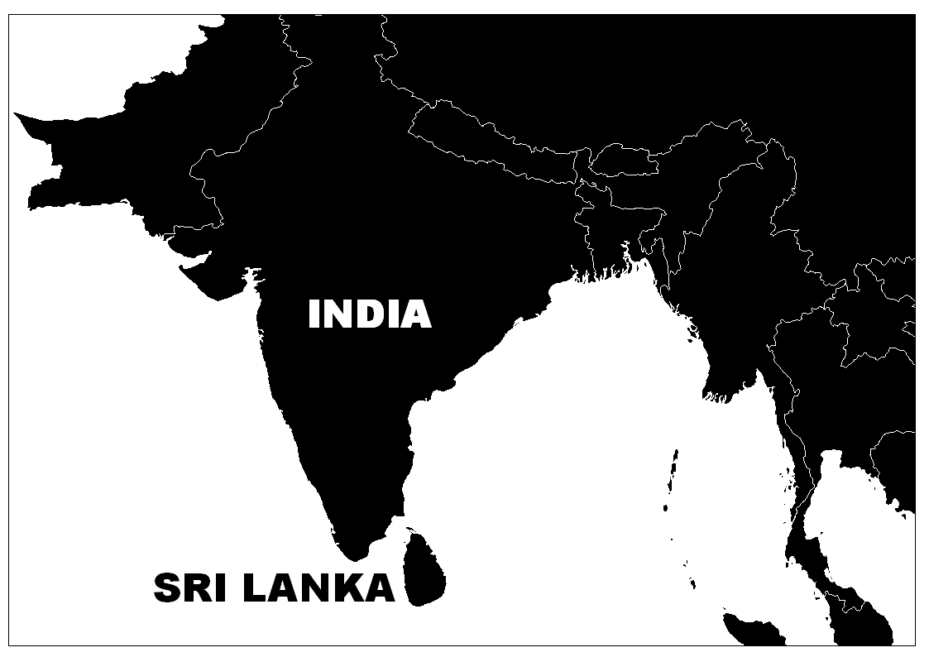
Civil War
Central Bank Bomb Attack
31st January, 1996
Katunayake Int. Airport Bomb Attack
24th July, 2001
Source: Sri Lanka Tourist Board

Hokkaido Nansei-Oki Earthquake
12th July, 1993

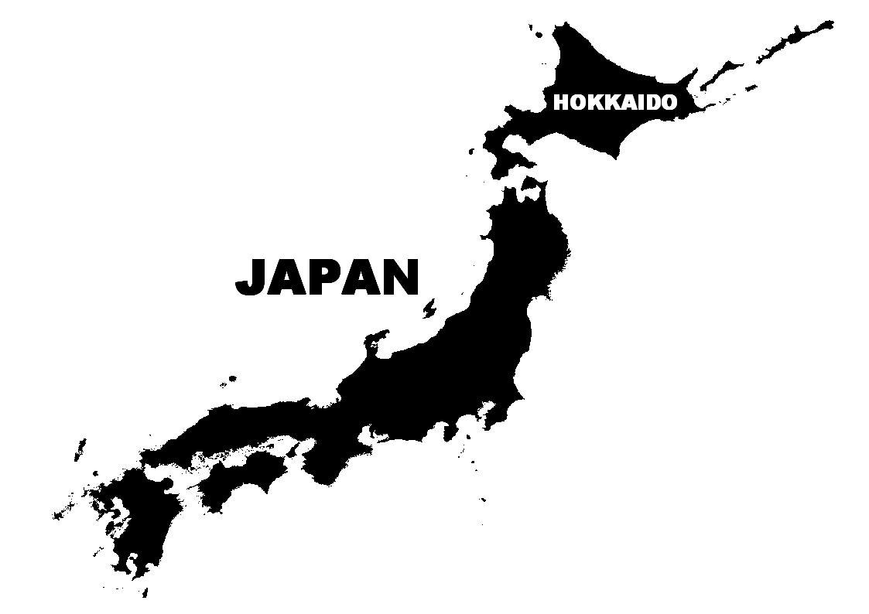
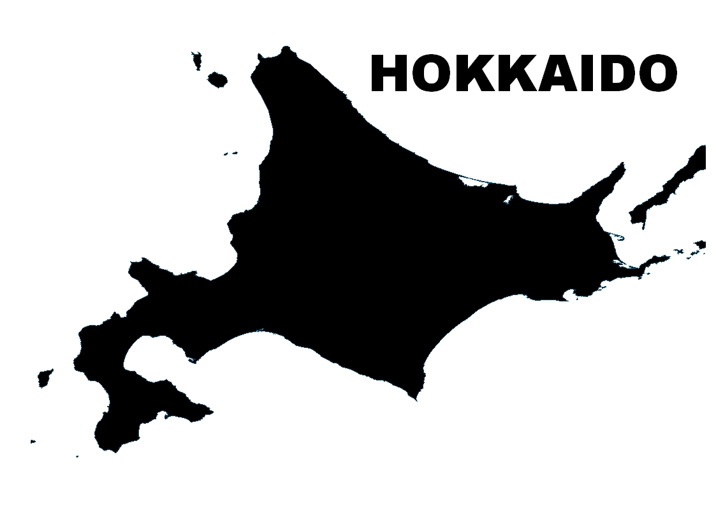
OKUSHIRI ISLAND

Source: Sightseeing Promotion Bureau, Hokkaido, Japan

Figure 2: Effect of disasters to International and domestic tourist arrivals

SHOW CARD

ATTRIBUTES AND LEVELS
- Destination Attraction (DEA)
This is the setting of the destination.
Level 1: Natural (e.g. national parks, waterfalls, mountains, beaches, scenic beauty, etc.)
Level 2: Cultural & Historical (e.g. museums/galleries, heritage sites, indigenous people etc.)
Level 3: Post-disastrous (e.g. left outs after natural disasters; volcanic eruptions, earthquake,
tsunami, floods, hurricanes or human-involved disasters; war cemetery, etc.)

- Geographical Proximity (GEP)
This indicates the travel time between origin and the destination country
Level 1: Short distance (flight time less than 5 hrs excluding transit time)
Level 2: Medium distance (flight time 5-10 hrs excluding transit time)
Level 3: Long distance (flight time more than 10 hrs excluding transit time)

- Activities and Events (ACE)
This indicates festivals or events (cultural/musical concerts, sports activities, religious events, etc.) at the destination
Level 1: Often (more than 10 famous activities per year)
Level 2: Rarely (less than 10 famous activities per year)

- Disaster Risk and Threats (DRT)
This indicates the risk due to major and devastating natural and human involved disasters or threats.
(natural disasters: volcanic eruptions, earthquakes, hurricanes, floods, epidemic diseases etc. ;
human involved: Terrorism (eg.wars), threats, political and economic crisis etc.)
Level 1: Almost Nil (frequency of occurrence is once in 100 years)
Level 2: Mild (frequency of occurrence is once in 50 years)
Level 3: Moderate (frequency of occurrence is once in 30 years)

Figure 3: Attributes and Levels used in Conjoint Analysis

(a) Part-worth utility value of each attribute level
CONSTANT= 4.9724 N=277
Destination
Attraction
Geographical
Proximity
Activities & Events
Disaster Risk & Threats

(b) Relative importance of each destination attributes
Destination
Attraction
Geographical
Proximity
Activities & Events
Disaster Risk & Threats

Figure 4: Conjoint model outcome results

^{1,2,3,4} The attribute level having the least part-worth utility value is considered as zero

1
1
2
2
3
3
4
4
SAFETY
N=134
SEEKERS
N=143
SEEKERS
E
C
O

Figure 5: Part-worth utilities of attribute levels for the two clusters

1
9
8
7
6
5
4
3
2
14
13
15
11
12
10

Figure 6: Total Utility Value versus Traveler Preference Score for Japanese Outbound Travelers

Galle (Pre)
Sri Lanka
Galle (Post)
Sri Lanka
Rome- Italy
Hawaii (Post) USA
Hawaii (Pre) USA
0.92
1.61

Figure 7: Total Utility Value versus Traveler Preference Score for three selected tourist destinations

Table 1: Socio-demographic profile and travel characteristics of survey respondents (N= 347)

Characteristics | Description | Count | Percent (%)
Gender | Male | 187 | 53.9
Gender | Female | 160 | 46.1
Age | 18-24 years old | 79 | 22.8
Age | 25-34 years old | 101 | 29.1
Age | 35-44 years old | 72 | 20.7
Age | 45-54 years old | 56 | 16.1
Age | 55-64 years old | 30 | 8.6
Age | 65 years old and above | 9 | 2.6
Marital status | Married | 169 | 48.8
Marital status | Un-married | 177 | 51.2
Foreign Travel Experience | Already | 289 | 83.3
Foreign Travel Experience | Still not | 58 | 16.7
No. of visits to foreign country as a Tourist* | Zero time | 19 | 6.6
No. of visits to foreign country as a Tourist* | 1 time | 64 | 22.1
No. of visits to foreign country as a Tourist* | 2-5 times | 130 | 45.0
No. of visits to foreign country as a Tourist* | 6-10 times | 46 | 15.9
No. of visits to foreign country as a Tourist* | More than 10 times | 30 | 10.4
No. of visits to foreign country as a Tourist in last 5 years** | Zero time | 82 | 30.4
 | 1 time | 68 | 25.2
 | 2 times | 48 | 17.8
 | 3-5 times | 53 | 19.6
 | more than 5 times | 19 | 7.0
Main source of information for foreign travel** | Travel agents/ airlines | 80 | 29.6
Main source of information for foreign travel** | Media (travel brouchers/TV/magazines/internet) | 49 | 18.1
Main source of information for foreign travel** | Friends/relatives/business associates | 30 | 11.1
Main source of information for foreign travel** | Travel books/ guides | 107 | 39.6
Main source of information for foreign travel** | Others | 4 | 1.5
* ‘Count’ and ‘percent’ is based on Foreign Experienced Japanese Travelers (N=289)
** ‘Count’ and ‘percent’ is based on tourists only (N=270)

Table 2: Rankings for the importance of ‘push’ and ‘pull’ travel motivations (N= 289)

 | Rankª | Items | Mean (Std.dev.^{b})
‘Push’ Motivations Most important | 1 | Enjoying scenic beauty | 4.42 (0.694)
 | 2 | Seeing something different | 4.41 (0.745)
 | 3 | Visiting cultural and historical importance | 4.33 (0.809)
Least important | 1 | Experiencing post-disastrous events | 2.40 (1.078)
 | 2 | Enjoying nightlife | 2.61 (1.208)
 | 3 | Seeking adventure | 3.05 (1.238)
‘Pull’ Motivations Most important | 1 | Free from terrorism threats | 4.67 (0.693)
 | 2 | Political Stability of the destination | 4.60 (0.730)
 | 3 | Free from epidemic diseases | 4.53 (0.737)
Least important | 1 | Availability of post-disastrous landmarks | 2.43 (1.092)
 | 2 | Interesting nightlife and entertainment | 2.83 (1.256)
 | 3 | Adventurous activities | 2.98 (1.199)
ª Importance rankings were based on mean scores measured on a Likert-scale from 1-‘not at all important’ to 5-‘extremely important’
^{b} Standard deviation

Table 3: Demographic and travel characteristics of the two clusters of Japanese Outbound Travelers

 | Cluster 1 | Cluster 2 |  | Cluster 1 | Cluster 2
 | (n=143) | (n=134) |  | (n=143) | (n=134)
Demographic Profile |  |  | Travel Profile
Gender |  |  | No. of visits to foreign country
Male | 49.7 | 50.0 | as a Tourist in last 5 years*
Female | 50.4 | 50.0 | Zero time | 35.1 | 26.6
Age* |  |  | 1 time | 19.9 | 29.7
18-24 yrs | 15.4 | 18.7 | 2 times | 16.8 | 19.5
25-34yrs | 25.9 | 34.3 | 3-5 times | 19.1 | 19.5
35-44yrs | 23.8 | 21.6 | more than 5 times | 9.1 | 4.7
45-54yrs | 21.7 | 13.4 | Main source of information
55-64yrs | 9.8 | 9.0 | for foreign travel
above 65 | 3.5 | 3.0 | Travel agents/ airlines | 29.8 | 29.7
Civil Status* |  |  | Media | 22.9 | 14.8
Single | 37.1 | 48.5 | Friends/relatives | 7.6 | 14.1
Married | 62.9 | 51.5 | Travel books/ guides | 38.2 | 40.6
 |  |  | Others | 1.5 | 0.8
*chi-square p < 0.05
Note: percentages may not add to 100% due to rounding errors

Table 4: Tourist destinations with assigned levels of attributes

City | Country | DEA | GEP | ACE | DRT
Sydney | Australia | Natural | Medium | Often | Almost Nil
Beijing | China | Cultural & Historical | Short | Rarely | Moderate
Cairo | Egypt | Cultural & Historical | Long | Rarely | Mild
Paris | France | Cultural & Historical | Long | Often | Mild
Berlin | Germany | Natural | Long | often | Mild
Hawaii | USA | Natural | Medium | Often | Almost Nil
Jakarta | Indonesia | Post disastrous | Medium | Rarely | Moderate
Bali | Indonesia | Natural | Medium | Often | Moderate
Rome | Italy | Cultural & Historical | Long | Often | Almost Nil
Galle | Sri Lanka | Post disastrous | Medium | Rarely | Moderate
Geneva | Switzerland | Natural | Long | Rarely | Almost Nil
Phuket | Thailand | Post disastrous | Medium | Rarely | Moderate
New York | USA | Cultural & Historical | Long | Often | Moderate
Los Angeles | USA | Cultural & Historical | Long | Often | Mild
London | UK | Cultural & Historical | Long | Often | Mild
DEA: Destination Attraction; GEP: Geographical Proximity; ACE: Activities and Events; DRT: Disaster Risk and Threats

Table 5: Attribute levels of three selected tourist destinations

Destination Features | Destination
Destination Features | Rome-Italy | Hawaii-USA | Galle-Sri Lanka
DEA | Cultural & Historical | Natural | Post Disastrous
GEP | Long | Medium | Medium
ACE | Often | Often | Rarely
DRT | Almost Nil | Almost Nil | Moderate

Table 6: Hypothetical attribute levels of three selected tourist destinations

Destination Features | Tourist Destination
Destination Features | Rome-Italy | Hawaii-USA | Galle-Sri Lanka
DEA | Cultural & Historical | Natural | Cultural & Historical
GEP | Long | Medium | Medium
ACE | Often | Often | Rarely
DRT | Almost Nil | Moderate | Mild

