External Validation of the Consideration Set Model of the Parking Simulation Suite Pamela

Peter van der Waerden, Harry Timmermans & Aloys Borgers
Urban Planning Group, Eindhoven University of Technology
PO Box 513, 5600 MB Eindhoven, The Netherlands

Abstract

In this paper, an external validation test of the parking consideration set model which is part of the parking simulation suite Pamela is described. The model was originally developed on the basis of stated choice data, collected in the city of Veldhoven, The Netherlands. The validation concerns a comparable city, Veghel. Model predictions are compared with observed behavior. It appears that in both cities the estimated parking consideration set model outperforms the null model. In Veldhoven, the model predicts 63.6 of the cases correctly. For Veghel this percentage is equal to 55.9 percent.

Introduction

To describe customers travel and parking choice behavior in the context of shopping trips, the Eindhoven Urban Planning Group has developed a parking simulation suite called Pamela (Van der Waerden et al. 2002). Pamela consists of a set of models which describe a variety of travel decisions (including destination, mode, and parking choice) from the moment an individual decides to leave home for shopping until he/she completes the shopping activity and leaves the parking facility. These models cover the generation of consideration sets of parking facilities (defining the set of parking facilities in the respondents’ choice set when choosing the car), the combined choice of destination, mode and parking lot (defining the destination to visit, the mode to use, and the bike stand or parking to put the chosen transport mode), the adaptation of parking choice behavior (defining the adapted choice when a parking facility is fully occupied), and the duration of parking. The sub-models were estimated using stated and revealed data of weekly and non-weekly shopping trips of residents living in Veldhoven and Eindhoven, two adjacent cities in the South of The Netherlands. To validate the applicability of Pamela, new data were collected in a city comparable to Veldhoven.
In this paper, the external validation of the parking consideration set model will be discussed in the context of weekly shopping trips. The details of the estimation process of the consideration set model have been described in Van der Waerden et al. (2000). The model is applied to the cities of Veldhoven and Veghel (Figure 1). Veghel is comparable with Veldhoven in terms of size (approximately 40000 residents) and spatial layout (concentric) including the available shopping facilities (one main shopping centre and some sub-centers). In contrast to Veldhoven, Veghel is not located adjacent to a much larger city, like Eindhoven. However, we assume this does not affect weekly shopping behavior.
The remainder of the paper is organized as follows. First, the principle of external validation is briefly discussed. Next, the parking consideration set model for weekly purchases is presented. This section is followed by a short description of previous validation studies using stated preference data. Next, the data collection in both cities is described. The predictions and the comparison with the observed parking consideration sets are discussed in the following section. The paper ends with conclusions and a discussion of implications of the main findings.

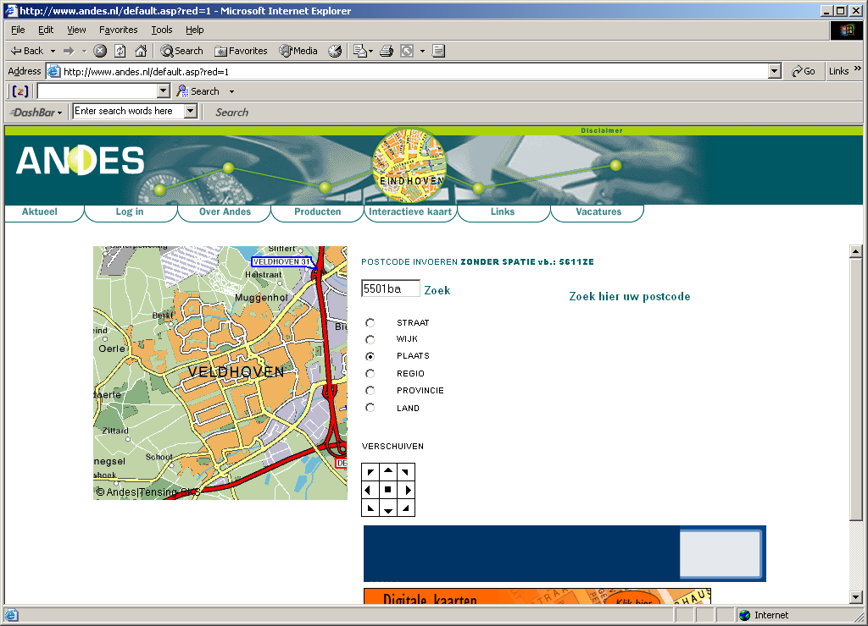
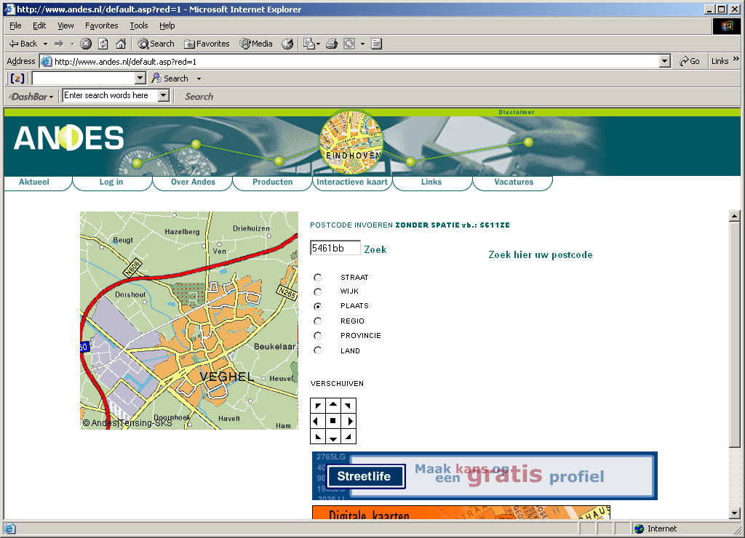

Figure 1: Maps of Veldhoven and Veghel

External validation

Estimated parking consideration set models can be used to predict expected consideration sets in other time periods and/or other places (Mahmassani & Jou, 2000). In the past, several studies have been carried out to externally validate stated preference models. It typically involved comparing estimated behavior against new data collected in another city. According to Sacks et al (2002), the validation of computer simulation models a crucial element in assessing their value in transportation policy. Sacks et al define 5 key issues regarding the validation of transportation models: (i) give explicit meaning to validation in particular contexts, (ii) acquire relevant data, (iii) quantify uncertainties, (iv) provide feedback to model use and development, and (v) predict performance under new (untried) conditions. The challenge is to meet these issues in the process of validation, especially the latter one.
In his literature overview, Kroes (1998) gives an extensive list of various types of validity studies. He concluded that the number of good external validity studies is limited. Most studies focus on the reliability and the internal validity of the estimated models. One of the major problems is the lack of data concerning actual behavior. Also, the specification of the new situation (in time or place) where the actual behavior takes place is difficult. For example, Van Maarseveen (1985) met these problems when he was setting up a study to validate a parking simulation model. The study covered a before and after situation. It appeared that insurmountable problems existed in research decisions such as differences in the definition of parking facilities, the levels of parking tariffs, and car drivers involved in the study. The study was ended prematurely.
The study of Mahmassani and Jou (2000) dealt with the transferability of laboratory experiments to field surveys with respect to departure time and route choice behavior. First, they describe four elements that have to be transferred from stated preference experiments to the actual systems. These elements are the principal theoretical constructs, the methodology for model specification and estimation, behavioral insights, and the model specification. Next, the predicted behavior is compared to actual behavior. They found that the models based on stated preference experiments describe actual behavior quite well. Looking to individual parameter values, they found some differences between the stated experiments and the actual systems.
In the context of Pamela, some first steps of the validation process have been carried out. These are reported in Van der Waerden et al. (2000). At that time, the model was based on both weekly and non-weekly shopping trips. In addition, the differences between weekly and non-weekly shopping trips were investigated in more detail (Van der Waerden et al. 2006). It appeared that the parking consideration sets significantly differed between the two types of shopping trips. Based on this finding, separate models were estimated for weekly and non-weekly shopping trips. The model for parking consideration sets in the context of weekly shopping trips is discussed in the next section. This model is used in the underlying validation study.

Consideration set model

Consideration set refers to the set of parking alternatives over which a motorist makes an explicit utility comparison or cost-benefit trade-off before making a choice (e.g., Mehta, et al., 2003). The parking consideration set model of Veldhoven was estimated using stated choice data. In the experiment individuals were asked to state if they would consider several ‘hypothetical’ parking facilities. Respondents had to assume that they used the car for weekly shopping trips. Parking facilities were specified using the following set of attributes: size of the parking facility; chance of finding a free parking space; parking costs per hour; maximum allowed parking duration; average time needed to leave the parking facility (egress time); driving space in the parking facility; type of parking facility; type of security; the location of the parking facility vis-à-vis the individuals' residence; location of the parking facility vis-à-vis other parking facilities; and the distance to the closest supermarket.
The stated choice data was analyzed using a binary logit model with the consideration of a parking (yes or no) as dependent variable and the selected characteristics of the parking as independent variables. Table 1 presents the part-worth utilities. The estimated model was tested against a model with all coefficients equal to zero (null-model) using the Log-likelihood Ratio Statistic (LRS). The LRS-value indicates that the estimated model performs significantly better than the null model (Ortúzar & Willumsen, 2001). The LRS-value is equal to 385.19 while the critical chi-square value for 23 degrees of freedom is equal to 35.2 at the confidence level of 95 percent.
At least one attribute level of each attribute is significant at the conventional level (95 percent), except for the attributes ‘type of parking facility’, ‘type of Security’, and ‘location vis-à-vis other parking facilities’. Moreover, almost all parameters are in anticipated direction. However, the influence of the size of the parking facility is somehow surprising. The signs of the estimated parameters suggest that smaller and large parking lots are less attractive for consideration. This result might indicate that visitors do not like to consider small and big parking facilities, perhaps for reasons of safety or comprehensibility. Other than that, the probability of considering a parking lot for choice increases with an increasing chance of finding a parking space, lower parking costs, increasing maximum parking duration, lower average egress time, increasing driving space at the parking facility, favorable location vis-à-vis the residence, and lower distance to the supermarket(s) in the shopping area.

Table 1: Estimated part-worth utilities for the consideration of parking facilities (weekly shopping trips)
Attribute | Attribute level | Part-worth utility | Significance
Constant  Size of the parking facility  Chance of finding a free parking space  Parking cost per hour  Maximum parking duration  Average egress time  Driving space at the parking facility  Type of parking facility  Type of security  Location vis-à-vis the residence  Location vis-à-vis other parking facilities  Distance to supermarket/department store | 50 spaces  250 spaces  450 spaces  25 %  50 %  75 %  Free  DFL 1.00  DFL 2.00  Unlimited  Max 3 hours  Max 1 hour  0 minutes  2 minutes  4 minutes  Limited  Average  Spacious  Lot  Garage  None  Video  Guards  Favorable  Neutral  Unfavorable  Close  Neutral  Far away  50 meters  150 meters  250 meters | -0.3341  0.1274  0.1801  -0.3075*  -0.4628  0.0699  0.3929  1.0548  -0.2027  -0.8521  0.4927  0.2096  -0.7023  0.1834  -0.0900  -0.0934  -0.2246  0.0795  0.1451  0.6282  -0.6282  -0.0821  0.0882  -0.0061  0.3169  0.1481  -0.4650  -0.0300  0.0813  -0.0513  0.6672  -0.0079  -0.6593 | 0.000  0.195  0.034  0.000  0.434  0.000  0.023  0.000  0.019  0.049  0.311  0.019  0.393  0.165  0.353  0.326  0.000  0.114  0.738  0.365  0.000  0.930
Goodness-of-fit  Log-likelihood of the null model, LL(0)  Log-likelihood of the optimal model, LL(B)  LRS=-2[LL(0)-LL(B)]  McFadden’s Rho-Square | -1014.7675  -822.1736  385.1878  0.190
* Utilities of base attribute levels are in Italics

Data collection

The data of Veldhoven were collected in 1997 using a self-completion questionnaire. In total 529 respondents completed the questionnaire for weekly shopping trips. Some personal characteristics of the research sample are presented in Table 2. The data for the application in Veghel were collected in 2002 using the same means of administration. The questionnaires consisted of several questions concerning weekly shopping trips, the parking consideration set, travel and parking behavior, personal characteristics, and the last two weekly shopping trips to one of Veghel’s shopping centers. In total 2000 questionnaires were randomly distributed across Veghel. Approximately 20 percent of the households returned the questionnaire, resulting in 452 completed questionnaires.
Table 2 presents some general statistics of the data sets of Veldhoven and Veghel. It appears that at least as far as the presented characteristics are concerned, there are some differences between the two research samples. We do not expect significant impacts of these differences on the outcomes of this research.
Table 2: Characteristics of the Veldhoven and Veghel research sample
Characteristic | Levels | Veldhoven | Veghel
Gender | Male  Female  Unknown | 27.8  71.8  0.4 | 30.8  67.0  2.2
Age | Younger than 40 year  41-55 year  Older than 55 year  Unknown | 39.0  33.6  27.2  0.2 | 31.4  37.7  30.6  1.3
Educational level | Lower level  Middle level  Higher level  Unknown | 21.4  24.4  22.7  31.6 | 25.0  39.8  28.8  6.4
Residential location | Centre  Fringe  Unknown | 35.6  63.8  0.6 | 46.1  51.5  2.4
Drivers License | Yes  No  Unknown | 93.4  6.4  0.2 | 95.1  3.4  1.5
Car availability | Yes  No  Unknown | 95.1  4.7  0.2 | 95.1  2.5  2.4
Number of respondents |  | 529 | 452

The main shopping center in Veldhoven is surrounded by 9 separated parking facilities (Figure 2, codes 1–9). In the vicinity of the main shopping center of Veghel 13 parking facilities are situated (Figure 3, codes 1-13).

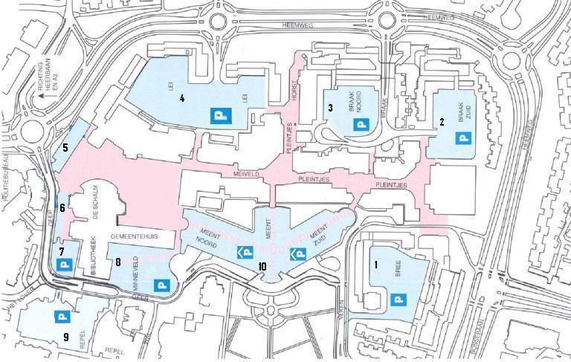
Figure 2: Main shopping centre in Veldhoven
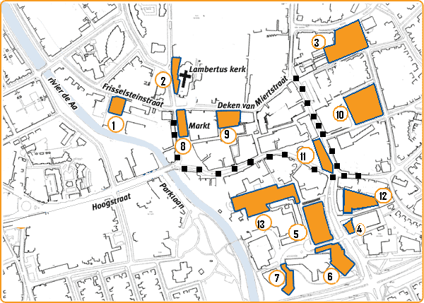
Figure 3: Main shopping centre (■) in Veghel

Analyses

Based on the actual characteristics of the parking facilities near both shopping centers the consideration set of each individual is composed using the estimated model for parking consideration sets. First, the probability for each parking of being in the individuals’ consideration set is calculated. Next, if the calculated probability is higher than 0.5, the parking facility is put into the consideration set. The overall percentage of correctly predicted parking consideration is presented in Table 3.

Table 3: Observation versus prediction considerations of parking facilities
Observed | Predicted | Veldhoven |  | Veghel
Observed | Predicted | Frequency | Percentage | Frequency | Percentage
Yes  Yes  No  No | Yes  No  Yes  No | 1552  570  847  921 | 39.9  14.7  21.8  23.7 | 1685  675  1594  1194 | 32.7  13.1  31.0  23.2
Goodness-of-fit  Percentage correctly predicted  Null model: LL(0)  Optimal model: LL(B)  LRS=-2[LL(0)-LL(B)]  Critical Chi-square (df 22) |  | 63.6  -1470.86  -1214.05  513.62  33.90 |  | 55.9  -1635.83  -1540.43  190.80  33.90
The percentage correctly predicted covers both observed-yes and predicted-yes, as well as observed-no and predicted-no cases. For Veldhoven the overall percentage correctly predicted is equal to 63.6 percent. In the case of Veghel, the overall percentage is equal to 55.9 percent. In addition to these overall percentages, the likelihood ratio statistic (LRS) is calculated to check whether the predictions of the optimal model outperform the predictions of the null model. For both cities, the value of the LRS indicates that the estimated model outperforms the null model.
Figures 4 and 5 present the percentages correctly and not correctly predicted cases per parking facility. In the case of Veldhoven, for all parking facilities the percentage of correct prediction is higher than the percentage of non-correct prediction. The figure shows that the performance of the model differs per parking facility. None of the attributes incorporated in the model can be used to explain the differences.

Figure 4: Correctly versus not correctly predicted parking considerations, Veldhoven

The result for the various parking facilities in Veghel is more divers (Figure 5). For some parking facilities (p2, p3, p5, and p11) the model is well able to predict the appearance in the consideration set. In some cases (p1, p6, and p13) the model results in an even distribution of correct and not correct. In the case of p4, p7, p8, and p10 the model performs poorly. Again no general explanation can be found based on the model attributes.

Figure 5: Correctly versus not correctly predicted parking consideration, Veghel

Conclusions

In this paper, the external validation of the parking consideration set model as part of the parking simulation suite Pamela has been described. The validation is based on data collected in two comparable cities in the South of The Netherlands, Veldhoven and Veghel. The application concerned the parking consideration sets in the context of weekly shopping trips.
It appears that in both cities the estimated parking consideration set model outperforms the null model. In Veldhoven, the model predicts in 63.6 of the cases the appearance of a parking facility in the consideration set correctly. For Veghel this percentage is equal to 55.9 percent. When considering the percentages correct predictions for the individual parking facilities, the variance in Veghel is considerably larger than in Veldhoven.
The results of this study indicate that the parking consideration set model as part of the parking simulation suite Pamela has to be used with care. It is advisable to set up more application studies to better assess the transferability of the model to other situations.

References

Kroes, E. (1988) Literature Review of Stated Preference Validation Research (In Dutch), Hague Consulting Group, The Hague, The Netherlands.
Mahmassani, H.S. & Jou R.C. (2000) Transferring insights into Commuter Behavior Dynamics from Laboratory Experiments to Field Surveys, Transportation Research Part A 34, 243-260.
Mehta, N., Rajiv, S. & Srinivasan, K. (2003) Price Uncertainty and Consumer Search: A Structural Model of Consideration Sets Formation, Marketing Science 22, 58-84.
Ortúzar, J. de D. & L.G. Willumsen (2001), Modelling Transport, Third Edition, John Wiley & Sons, West Sussex, England.
Sack, J., Rouphail, N.M., Park, B. & Thakuriah, P. (2002) Statistically-Based Validation of Computer Simulation Models in Traffic Operations and Management, Journal of Transportation and Statistics 5, 1-15.
Van der Waerden, P., Borgers, A. & Timmermans, H. (2000), Modeling Consideration Sets in the Context of Parking Related to Shopping Activities. Paper prepared for the 9th International Association for Travel Behavior Conference, Gold Coast, Queensland, Australia, 2-6 July 2000.
Van der Waerden, P., Borgers, A. & Timmermans, H. (2006) Travel and Parking Choice Behaviour in the Context of Weekly and Non-weekly Shopping Trips. In: Proceedings of the RARCS Conference, Budapest, Hungary, (CD-ROM: 7 pp.)
Van der Waerden, P., Timmermans, H. & Borgers, A. (2002) Pamela, Parking Analysis Model for Predicting Effects in Local Area, Transportation Research Record 1781, 10-18.
Van Maarseveen, M.F.A.M. (1985) Validation of a Parking Simulation Model (In Dutch), Verkeers- en Vervoersgroep TNO, Delft, The Netherlands.

