Regimes in Social-Cultural Events-Driven Activity Sequences

Theo Arentze and Harry Timmermans

Urban Planning Group
Eindhoven University of Technology
PO Box 513
5600 MB Eindhoven
Netherlands

Abstract. This paper reports the results of an empirical analysis of factors influencing activity sequences that are triggered by social events. The study is motivated by the intention to examine the wider context in which activity-travel decisions are made and to model such decisions under different time horizons. We assume that social events trigger a series of interrelated activities. A Bayesian network is applied to data collected in the Eindhoven region, The Netherlands and shows that indeed many travel choices are influenced by particular events and that these influences vary by socio-demographic variables.

Keywords: Activity-based models, events, Bayesian networks, network learning, regimes.

INTRODUCTION

The field of activity-based analysis and modelling has truly matured over the last decade. In addition to the hundreds of descriptive and analytical studies, focusing on particular aspects of activity-travel patterns, recently the first fully operational, comprehensive activity-based models have become available and are currently tested and applied in daily transportation planning practice. For example, Vovsha et al. (2005) reporting the development and application of discrete choice based models in the United States, mention Portland, New York City, San Francisco County and Columbus, Ohio. Similarly, CEMDEP developed by Bhat and his co-workers (2004) as a set of loosely integrated advanced econometric models has found application in Texas. Likewise, Famos (Pendyala et al., 2005) and its predecessor PCATSs (Kitamura and Fujii, 1998) have been applied in Japan and Florida. Finally, Albatross (Arentze and Timmermans, 2000, 2003) has received a stamp of approval by the Dutch Ministry of Transport, while TASHA (Miller, 2005) is getting close to application.
While certainly a lot of effort is still required to move activity-based models to practice, the academic community can start addressing a wider set of questions. One of the limitations of current activity-based models is their focus on a typical daily pattern. Most models are cross-sectional in nature and are not really based on a behavioural process representation. There is a need to describe, analyze and model activity-travel decision-making for different time horizons. To contribute to this line of research, the Urban Planning Group has started various projects. First, a stream of research has been developed in an attempt to model activity rescheduling behaviour, ultimately leading to the Aurora model (Timmermans, et al., 200; Joh et al. 2004. 2005, 2006; Arentze et al., 2005). The main application of this model concerns activity-travel rescheduling during the implementation of a planned daily schedule in case of unexpected events. Second, realizing that activity-travel patterns emerge in response to a changing (transportation) environment and institutional context, with habitual behaviour being a special case, we have developed a conceptual framework for learning and adaptation to simulate the dynamics in activity-travel behaviour (Arentze and Timmermans, 2005, 2006a). Even in stationary environments, individuals learn about their environment when conducting activities and their changing cognitions in turn may lead to changes in activity-travel patterns. This will be reflected in gradually changing patterns: short term dynamics. Third, at the other end of the spectrum, we have argued that sudden changes in activity-travel patterns may occur due to critical incidents and key (lifecycle) events. Events such as moving house, a change of job, a divorce, birth etc may trigger major changes in certain facets of activity-travel patterns. Based on some early descriptive analysis, a model linking lifecycle events to changes in travel resources and travel behaviour is under development (Waerden et al., 2002 a,b; Verhoeven et al., 2006).
In an attempt to ultimately link all of this into a consistent theoretical framework, Arentze and Timmermans (2006b) have suggested a needs-based theory which not only allows incorporating these dynamics into a single operational framework, but also addresses the issue of complementarity and substitution of activities. Activities are conducted to satisfy certain needs. Using needs as a conceptual basis is similar to the theoretical orientation underlying Tasha (Miller and Roorda, 2003; Miller et al., 2005; Roorda, et al., 2005). The main difference is that our theoretical framework has some explicit mechanisms that endogenously account for the dynamics of activity generation due to changing needs.
In this context, it should be realized that one of these basic needs is social interaction. Moreover, we should realize that individuals and households are part of a social system with its institutions, regulations and culture. The social system has a major impact on the organisation of society and therefore also on how particular needs are organised over time. Belonging to a social system means that individuals and households organize their life in accordance with social norms, rules and expectations, conducting a set of interrelated activities to maintain the social system. Examples are religious events such as Christmas, celebrations of anniversaries and holidays. We have therefore argued (Arentze et al., 2006) that activity-based models should gradually be incorporated into event-based models in an attempt to incorporate the larger decision context and various time horizons into the modelling effort, thereby enriching the modelling of transport demand.
We assume that these events trigger a series of interrelated activity sequences. Individuals engage in activities to make preparations (before the event), implement the event itself and to take care of the event aftermath (after the event). This notion is akin to Axhausen’s concept of a project as a set of coordinated activities tied together by a common goal or outcome (Axhausen, 1998), albeit positioned differently in the sense that our focus is on socially and culturally triggered events. To test that assumption, in this paper we will report the results of an empirical analysis, which was conducted to find regimes in activity sequences, triggered by social events. To our knowledge, it is the first empirical study examining such sequences. Before discussing the results, we will however first elaborate some key concepts and the approach taken. This will be followed by a summary of the data collection and a motivation of the modelling approach. The paper is completed with some conclusions and a discussion of potential avenues of future research.

CONCEPTS AND APPROACH

We define events as those occasions or activities in the life of an individual that are special in that they fall outside the domain of regularly recurring activities conducted by the individual to fulfil his/her basic needs at person or household level. Even when they occur on a regular basis, events are salient in the perception of the individual and they tend to break the routine of every day life. An event does not only disturb the daily routine on the day it happens. Typically, an event requires also that certain activities are implemented before and after the event to make necessary preparations and take care of the aftermath of the event. An example of an event is the celebration of a person’s birthday. Such events typically entail activities before and after the event; before, to make sure that food and drinks are available for the guests and the house is tidy and, after, to dispose of the litter and bring the house back in an orderly state after the guests have left. Operationally, we define an event as any activity or occasion that: (i) occurs once or maximally several times a year, (ii) has an impact on the daily activity schedule and (iii) may entail preparing activities and/or aftermath activities before and after the event. As implied by this definition, what counts as an event for one person does not need to be an event for another person. Table 1 shows a classification of events which illustrates the concept and which we used in the survey (explained below) to assist respondents in recalling relevant events. As the list indicates, most classes of events are social in nature, i.e. involve gatherings of people to celebrate a special occasion related to a person (e.g., birthday) or a community (e.g., thanksgiving). Other events may have another goal as their primary purpose such as for example recreation (e.g., a day-out), health (e.g., a therapy) or maintenance (e.g., a house job).
A question that interests us here is: what is the impact of such events on travel demands of individuals? Events often involve groups of people coming together at someone’s home or at some central location to participate in a joint activity such as a celebration, a sports event, a religious event, etc. But also events that do not involve gatherings of people may still generate trips, namely when they necessarily (e.g., a hospital) or preferably (e.g., a beach) take place out-of-home. Apart from the event itself, also the preparation and aftermath activities, such as for example dropping off or picking up persons, going to a barber, getting money, etc., may induce travel. In sum, an event possibly can generate travel related to the event itself and through the activities preceding and succeeding the event.
In an earlier paper (Arentze et al., 2006), we described results of a first exploratory analysis, based on the same data collection as we use in the present study. There we focused on the frequency and timing of events. We found that events are quite diverse with respect to the extent that their temporal regimes are flexible and influenced by socio-economic variables or relatively fixed by existing institutions. In the present study, we focus the attention on the activity and trip generation characteristics of events.
In particular, we develop and test a model to explain and predict activity-travel chains associated with particular events. Figure 1 schematically shows the conceptual framework that we propose for the model. The unit of observation is an event. That is to say, we assume that an event is given and we are interested in predicting the event type and associated activities and travel. We consider variables of the individual, household, the spatial environment (e.g., such as accessibility of locations) and temporal setting (e.g., time of year) as explanatory variables. The variable Event defines the type of event in terms of the 8-way classification mentioned above (see Table 1). An event may involve a trip, namely if the event takes place somewhere away from the person’s home. Furthermore, an event may require one or more preparation activities, which precede the event, and one or more aftermath activities, which succeed the event. We define preparation and aftermath activities in terms of a general classification of activities which include in-home as well as out-of-home activities. An out-of-home location will generally involve a trip. A trip has several facets such as transport mode, travel time and possibly others. Therefore, the node labeled ‘trip’ refers to a set of variables instead of just one variable.
In the scheme, solid arrows represent the causal relationships that we expect to find between these (sets of) variables. In words, we expect the following relationships. The event type influences the choice of activities preceding and succeeding the event. Furthermore, it has an influence on characteristics of the trip, if any, required for the event itself. In turn, the choice of activity type before or after the event has an influence on travel time and transport mode of the trip, if any, needed to implement the activity. In sum, according to this network, events generate and influence the choice of trips for the event itself and through activities required before and after the event. In turn, event type, given that an event occurs, is not a fully random variable in the model. Rather, we expect (and indeed as we found in the previous study) that probabilities of events co-vary with socio-economic and situational (spatial and temporal) variables. For example, a birthday party may have a higher occurrence probability in households with children compared to households without children. We also expect that these variables have an impact on trip choices, given activity characteristics. For example, whether or not the person has a driving license will influence the choice of a transport mode even if the activity is known.
Dashed arrows in the scheme represent causal relationships that we consider less likely, but that nevertheless may exist in reality. More specifically, we expect that event type does not have a direct influence on choice of a trip. The possible influence is supposed to run through the activity (i.e., event type influences the choice of activity and activity has an impact on the choice of transport mode and possibly other trip facets). Furthermore, we expect external variables not to have a direct influence on activities that precede or succeed an event. Rather external variables influence activity choices indirectly through events (i.e., attributes of a person influences probabilities of certain event types and event type influences probabilities of certain activity types). Thus, we expect that external variables and event-related activities are conditionally independent of each other, given that the event is known. We should emphasize, however, that the existence of conditional independencies in this model is dependent on the classifications used for activities and events. For example, if a relatively course classification of activities is used, event type may give additional information regarding activity type so that knowing the event type helps to predict trip choices even if in reality the causation runs through the activity variable. So, we must keep in mind that findings of an estimation of this model cannot be generalized beyond the classifications used.
We use a Bayesian Belief Network (or in short a Bayesian Network or BN) as a framework for the model. A BN is a directed acyclic graph (a DAG) where the nodes represent variables and the arcs causal or temporal relationships between variables (Pearl 1988, Heckerman et al. 1995, Spiegelhalter et al. 1993). The state of variables may be uncertain under any given configuration of evidence (i.e., data) about the variables. Note that the structure of the network defines for each node a set of parent nodes (node X is said to be the parent of node Y if an arc runs from X to Y). Associated with each node is a conditional probability table (a CP table or in short CPT) which defines the probability distribution across possible states of the node under each state configuration of the parent nodes (if any). Collectively, the CPTs of nodes are referred to as the parameters of a network. The parameters allow the system to calculate the probability distribution at each node and to update these probabilities each time when evidence about variables is entered to the network. Existing probability propagation algorithms are consistent with Bayes’ perception updating rule.
The BN is a well-suited formalism for the present modeling purpose for several reasons. First, we wish to predict the multiple variables involved in event-activity-travel chains simultaneously and a network is the most flexible structure conceivable in that case. Second, the core variables we are dealing with, namely events, activities and transport modes, are discrete variables and a BN, in contrast to structural equation models and artificial neural networks, is designed to deal with discrete variables. Most importantly, however, methods exist to empirically derive a BN from data. Estimating a BN involves two subtasks, namely first learning the network structure and then finding the parameters for that structure that best fit the data (i.e., estimating the CPTs). Having established the network structure, the estimation of CPTs is relatively straight-forward. EM-learning (Lauritzen 1995) is the commonly used method for CPT learning and is implemented in software for BN learning such as Hugin (Hugin Expert A/S, 1995-2005, Anderson et al. 1989), PowerConstructor (Cheng et al. 2002) and other packages. Therefore, most research in this field has been and still is devoted to the first subtask, network learning. Two general approaches have emerged from this work (see Cheng et al. 2002). Dependency-based methods develop a network based on tests of conditional independencies between pairs of nodes. These methods are also known as constraint-based learning methods as they try to find pairs of nodes that are conditionally independent of each other and then add this information as constraints in constructing a graph and determining the directions of relationships. On the other hand, scoring-based methods seek a structure that maximizes some measure of goodness-of-fit of the network on the data in terms of the joint distribution of all variables involved. In the present study, we use a dependency-based method developed by Cheng et al. (2001) which is well-tested and available through the software PowerConstructor.

DATA

To collect the data for estimation, we conducted a survey among a large and a-select sample of households in the Eindhoven region, the Netherlands, which involved two rounds of data collection. In the first round, respondents were asked to specify the events they anticipated in the year starting from the beginning of the next month at the moment of the survey (which was September). On a form, which had the lay-out of a calendar, respondents could indicate which events they anticipated would occur in each month of the year. For each event they then could indicate the date (as exact as possible), type of event and which other persons besides the respondent him/herself were involved. In the second round of the survey, the same respondents were asked to keep a diary of event-related activities in a month that we had designated to them. Respondents were asked to indicate for each day of the designated month which event-related activities, including the event itself, if any, they participated in and to describe these activities in terms of a number of attributes. These included the begin time, the end time, with whom the activity was conducted, the location, transport mode, travel time, travel party, the event with which it was related, the nature of the relationship with the event and the impact the activity had on the normal activity schedule. Respondents could specify the activity type by selecting an item from a pre-coded list of activities. This list was based on a classification of activities that we standard use in activity diary surveys (including 33 labeled out-of-home activities and 14 labeled home-based activities).
The month assigned to a respondent was determined in a weighted random way, as follows. The probability of assigning a certain month to a certain respondent was determined based on the distribution of events across the months included in his/her event calendar. The more events occurred in a month, the higher the probability of selecting that month and vice versa. The allocation procedure was constrained by a requirement that at sample level a sufficient number of cases (i.e., respondents) should be obtained for each month. In this way, we could enlarge the number of observations of event-related activities and, at the same time, obtain sufficient coverage of a year. However, July and August had to be excluded because of the high frequency of summer holidays in that period.
In both rounds, all persons older than 12 years in households that participated were invited to fill out the calendar (first round), event diary (second round) and a pre-questionnaire (preceding the first round). 815 Respondents completed the event calendar. Together, they reported 25,555 anticipated events, which comes down to a mean of 31.4 events per respondent per year or a mean of 2.6 events per respondent per month. 415 Respondents completed the event diary for a month. As a consequence of the way months were designated, the distribution of respondents across months is not completely uniform. December and January had the highest numbers (of 76 and 66 persons, respectively) and February and October had the lowest numbers (of 21 and 24 persons, respectively). For a more detailed description of the survey and sample characteristics readers are referred to Arentze et al. (2006).
The diary data allows us to determine which activities are associated with which events, the interval times between activities and events and characteristics of trips made to implement the activities. In terms of the relationship with the event, we distinguish three categories of activities, namely activities to prepare an event (before the event), activities to implement the event (during the event) and activities to take care of the aftermath of an event (after the event). In the following, as in the schematic representation of the conceptual model (Figure 1), we will not distinguish between the activity conducted to implement an event and the event itself. This means that we have three categories of activities: preparation activities, the event itself and aftermath activities. Before turning to the model-based analysis in the next section, we will first report some statistics describing the occurrence and timing of event-related activities.
A total of 772 preparation and 318 aftermath activities related to 3,200 events were reported over all months. Thus, on average a preparation activity occurs 0.24 times and an aftermath activity 0.10 times when an event takes place. Events show a considerable variation regarding the number of preparation activities. 84.8 % of the events have no preparation activity, 15.1 % have a single preparation activity and 1.2 % two preparation activities. For the aftermath activities, these numbers are 95.2 % (no aftermath activity), 4.6 % (a single aftermath activity) and .2 % (two aftermath activities). We should note, however, that the window of observation of an event is limited to the period of a month over which respondents could report the event-related activities. Especially for events taking place at the beginning or the end of the month preparation and aftermath activities could have occurred that were not reported since they occurred before or after the recording period. Probably, the under recording caused by the limited recording period is not that serious. In terms of timing of activities relative to the event, it turns out that 30.9% of preparation activities take place on the same day, 33.0% of these activities on the day before and 10.1% two days before the event. The percentages decline rapidly as interval time further increases. More than 87.0% of the preparation activities fall within a period of 6 days prior to the event. For aftermath activities, we find that 35.7% of these activities take place on the same day, 22.6% one day later and 4.8% 2 days after the event. 84.8 % of the aftermath activities take place within a period of 6 days after the event.
Table 4 shows for each event type the probabilities that certain activities occur as a preparation or aftermath activity for that event. In this analysis, we classified the activities into 6 categories: 2 home-based activities and 4 out-of-home activities. As the totals in the last row reveal, the probability of observing a preparation or aftermath activity at all varies considerably between event types. The probability is largest for Special-day events (32.6%) and Person/family/relatives events (32.0 %) and second-largest for Maintenance events. Note that the events mentioned are not only social events, that motivated our study. In case of other events, probabilities are considerably lower and vary between 9 and 13%. We also see that there is considerable variation in activity type. For Person/family/relatives and Special-day events a shopping activity has the highest probability of occurring as a preparation or aftermath activity (19.4% and 18.3% respectively). Leisure and social activities overall have the lowest occurrence probabilities suggesting that, as expected, preparation and aftermath activities mostly have a non-leisure character.

THE BAYESIAN NETWORK MODEL

Variables
The unit of observation is an event referred to in the month-diaries. For each event, we record the type of event (Event), the preparation activity (PreA), if any, that induced the longest travel time and the aftermath activity (PostA), if any, that induced the longest travel time. Furthermore, the travel time and transport mode of each trip related to the event (EvTt, EvMo), the preparation activity (PreTt, PreMo) and the aftermath activity (PostTt, PostMo) were recorded. Considering the skewness of frequency distributions of activities across types in the before as well as after stage (Table 2), we used a limited classification of preparation and aftermath activities distinguishing between home-based activities, shopping activities and Other out-of-home activities. If no preparation or aftermath activity was observed, then this was encoded as a zero value of the variable. Since network-learning algorithms require that the variables have discrete values, the travel time attribute was discretisized into 5 categories including no travel and 4 equal-frequency intervals of travel times for each trip purpose, i.e., event itself, preparation or aftermath activity. Transport modes were classified into 4 categories including car as driver, slow (by bike or foot), public transport (bus, train, etc.) and car as passenger. As for the external variables, we included in the analysis the attributes at household and individual level that were covered by the questionnaire. Situational variables such as accessibilities and temporal variables were currently left out of consideration, as our purpose here is a first exploration of the use of BN learning methods for estimating a model of this type. Table 3 shows the complete list of variables used at the levels of event, activity, individual and household. The total number of cases equals 2992, which is the number of reported events in the month diaries after cleaning. Missing values were solved by using the modal class or a random value of the variable depending on the nature and distribution of the variable.

Network-learning method
We used the TPDA network learning algorithm developed by Cheng et al. (2001). This algorithm is well-tested and has a strong record in terms of prediction accuracy compared to alternative constraint-based BN learning algorithms. Furthermore, the algorithm is implemented in a software tool − called the Bayesian Network PowerConstructor − that provides users much flexibility in terms of implementing constraints on existence of arcs between nodes or pre-defining special cases for the network structure. The purpose of BN network structure learning methods in general is to identify connections between variables. The TPDA algorithm implements an incremental procedure: at each point the algorithm assumes a current set of arcs as given and considers whether arcs should be added or removed. As the name suggests, the procedure involves three phases referred to as drafting, thickening and thinning. The purpose of the drafting phase is to produce an initial set of edges based on pair-wise tests of mutual information between nodes, which should provide a good starting point for the next phases. In the subsequent thickening phase, the algorithm adds edges to the current graph based on tests of conditional independence between pairs of nodes. Loosely speaking, two nodes are conditionally independent if their mutual information can be fully explained by indirect relationships between the nodes in the current graph. Only if mutual information is left after having taken into account the paths through which information can flow between them, an edge is added to connect them. In the third thinning phase, each edge is examined and removed if the two nodes appear to be conditionally independent, due to implemented changes in the graph. Finally, the parameters (i.e., CPTs) of the resulting network are estimated based on the same data using the well-known EM learning algorithm. This algorithm uses maximum likelihood estimation of condition probabilities to deal adequately with incomplete data of a sample.
It follows from the foregoing that mutual information is the statistic used in tests on which decisions to add and remove edges are based in the TPDA algorithm as well as other information-theory-based learning methods. Formally, the mutual information between two nodes A and B is defined as:

$I(A,B)=\sum{P(a,b)\text{log}\frac{P(a,b)}{P(a)P(b)}}$ (1)

where P(a) and P(b) are the unconditional probabilities of A = a and B = b and P(a, b) is the joint probability of these events. The measure is based on information theory and expresses in bits the expected information gained about B after observing the value of A. Or, to put it another way: the measure indicates the extent to which having information about A reduces uncertainty (i.e., entropy) about the value of B. A test of conditional independence involves calculating the mutual information after blocking paths through which information can flow between the two nodes. If I(A, B) > ε, then the test result is negative and an edge is added (where ε is some pre-defined threshold value, e.g., ε = 0.01 bits). As is obvious from the equation, mutual information is a symmetric measure in the sense that I(A, B) = I(B, A). This implies that the measure does not give information about the direction of a possible influence. Based on known formal properties of a BN, the direction of some of the arcs may be resolved. In the final step of the procedure, TPDA runs a procedure to orient so-called essential arcs of the learned graph. A basic element of this procedure is to identify colliders (node Y is a collider in a network X → Y ← Z where no arc exists between X and Z), given the property of these nodes that they can let information pass through them when they are instantiated. There is no guarantee that all arcs can be oriented based on formal properties of a BN. Those that are unresolved are presented to the user for making a decision (based on substantial meanings of the variables).

Network structure constraints
Since the method does not guarantee that the correct network structure is found, it is important that the user specifies every constraint on the network structure that can be identified based on domain knowledge. For our model, we can identify a number of such constraints. A first set of constraints follows from our prediction purpose: what we wish to predict is the choice of events, activities and travel, given attributes of the individual/household. Thus, these attributes do not need to be predicted, but rather can be taken as observed. In terms of the network, this means that we do not need to consider links between these exogenous variables. It is most natural to implement this constraint by excluding the possibility that these variables have any incoming arcs. In other words, we could mark the exogenous variables as root nodes. However, it is just as well possible to implement this constraint by imposing the constraint that these variables should not have any outgoing arcs, i.e., marking them as leaf nodes. Note that the only difference between the two alternative methods - marking them as root or leaf nodes - is the direction of arcs and for explaining the data the direction of arcs is arbitrary. For considerations of efficiency, however, the choice between these two alternatives is not arbitrary. By defining the exogenous variables as leafs rather than roots we can reduce the expected number of parent nodes of the dependent variables (i.e., the behavioral variables). Reducing the size of parent sets is important because CPTs become very large and parameter learning less effective when the number of parent nodes increases. For that reason, we defined the socio-economic variables to be leaf nodes.
A second set of constraints follows from the theory that we outlined earlier in the context of the proposed conceptual model. This theory assumes that events generate activities and travel rather than the other way round. Based on this we implemented as constraints a partial ordering among the behavioral variables. In this ordering, events precede activities and trips. More formally, we implemented the partial ordering as: Event < PreA, PostA, EvTt, EvMo, PreTt, PreMo, PostTt, PostMo, where no arcs running from any of the RHS nodes to the LHS node of this equation can exist.

Results
As it appears, given these constraints, the direction of all arcs in the network could be identified by the TPDA algorithm (i.e., no interaction with the user was needed to determine directions of arcs). The threshold for mutual information in the test of conditional dependence was set to the default value of 0.01 bits. The resulting network is represented in Figure 2. The special-purpose software Netica (Norsys Software Corp., 1996-2006) was used for compiling and displaying the network. As it appears, almost each socio-economic variable is connected to the event node and to a lesser extent also to the event-transport-mode node. This means that for almost none of the socio-economic variables conditional independence with the event node could be proved, suggesting that there exists almost always some unique mutual information. This does not necessarily mean, however, that all relationships are also relevant. For reasons of parsimony, we therefore decided to make a selection of the most relevant socio-economic variables and regenerate the network. Following the approach by Janssen et al. (2003, 2006), we used mutual information (Equation 1) as a measure of relevance. More specifically, we calculated the mutual information between each combination of a socio-economic variable, X, and a behavioral variable, Y, and determined for each X the maximum value across Ys as an indicator of relevance of X. The values thus obtained varied in the range of 0.013 to 0.030 bits. In total 6 socio-economic variables had a value bigger than 0.02 bits and these variables were selected.
Figure 2 shows the resulting network based on the reduced set of socio-economic variables. The bar diagram at each node shows the probability distribution across the possible states of the variable that follow from the estimated conditional probabilities at each node. Since no evidence is entered in the network, the probabilities refer to a-priori beliefs regarding the states of the variables. To give some examples of findings: Social/recreation events (Event = 7) have the highest a-priori occurrence probability of 43.6 % (in the sample); there is a probability of 20.7 % that no trip is involved in case of an event and a probability of 44.0 % that the car driver is the transport mode used for an event; the probability that no preparation activity is involved in an event equals 84.8% and the probability that a shopping activity precedes an event equals 8.7%; the probability of an aftermath activity is even lower and in case an activity succeeds an event Other rather than shopping has the highest probability.
Turning to the relationships in the network, we see that socio-economic variables have many direct influences particularly on event type and transport mode. However, the socio-economic variables appear to have no direct relationships with the choice of activities or trips before or after the event. The only exception is a direct influence of age on the choice of preparation activity. This partially confirms our prior expectations (i.e., that there is no direct influence of external variables on activities, but only an indirect influence through event). On the other hand, we did expect direct influences of exogenous variables on trips. As it appears, however, direct influences of external variables on trip variables only exist for the trips related to events (transport mode); they are absent for trips related to preparation and aftermath activities. As for the relationships among behavioral variables, our a-priori expectations are largely confirmed. Event type appears to have a direct influence on travel time and transport mode of trips for the event and on the choice of preparation and aftermath activities. However, event type does not have a direct influence on travel choices related to before and after activities. The influence of event type on trips in these stages is indirect and mediated through the choice of activity. Also as could be expected, we find that a direct relationship exists between travel time and choice of transport mode of trips in each phase of the chain – the event, preparation and aftermath phase.
The model can be used to predict the behavior of an individual by entering attribute data of the individual as evidence in the network and updating the probabilities of the behavioral nodes. This is shown for an example in Figure 4. The individual of the example is from a Single, one-worker household (hComp = 1) which has one car (hNcar = 1), has no children (hChild = 0), is a male (Gend = 1), has a driver license (Driv = 1) and is between 25 – 45 years of age (Age = 2). The network shows the updated probabilities of the behavioral variables, after having entered this evidence. Comparing this state of the network to the state before entering the evidence (Figure 3) reveals the changes in probabilities as an effect of this attribute profile. For example, we see an increase of probabilities of Maintenance and Sports events and a decrease of probabilities of Special day, Church and Health events. Furthermore, the model predicts an increase of the probability of Car driver mode from 44.0 % to 60.8 %. As a final example, we note that the predicted probability of shopping as a preparation activity increases somewhat. If deterministic rather than probabilistic probabilities are to be derived in an application of the model, a Monte-Carlo simulation should be used. To account for dependencies between behavioral variables, Monte-Carlo decisions should be made in a sequential order: each time a value is drawn for a variable, the decision should be entered as new evidence in the network and remaining variables should be updated before a next decision is made, and so on.
Finally, we note that the network can be used to predict effects of specific instantiations of a variable on the probability of some other variable value of interest. This can be done by entering the evidence in the network and recording the probability for the variable value of interest, after updating the network. As an illustration, Table 4 summarizes the results of applying this procedure for measuring the effects of different instantiations of the event variable on probabilities of an (arbitrary) selection of outcome variable values. Event types are listed in rows and variable values of interest are represented in the columns. Each cell indicates a ratio between the updated probability after and before instantiating the event variable. Thus, a value smaller than 1 indicates a decreasing effect of the event and a value larger than 1 an increasing effect, as predicted by the model.
The table reveals several notable effects of events. Person/family/relatives and Special day events strongly increase the base probability of shopping as a preparation activity. Church/school events strongly increase the probability that the individual is a female. As a somewhat surprising effect, Sports events increase the probability that the person is 65 years of age or older. This suggests that according to the model elderly people have a relatively high probability of being engaged in a passive or active form of a sports event, given that they experience an event. Social/recreation events strongly increase the probability of the car-driver mode and long trips for the event. Maintenance activities, in contrast, are characterized by a higher probability of shopping occurring as a preparation activity and a lower probability of observing a long trip for the event. Finally, events of the category Other increase the probability of taking place in households with 2 or more cars and involving a long trip. We emphasize that the model simultaneously predicts behavior on a set of independent variables, thereby taking indirect and direct relationships between variables into account. Therefore, the model is potentially more powerful than models assuming (linear) functions of a single dependent variable at a time.

CONCLUSIONS AND DISCUSSION

As part of our efforts to gradually replace activity-based models of transport demand by event-based models of transport demand, this paper has reported the formulation and application of a Bayesian network model to identify and analyze regimes in activity sequences that are triggered by (social) events. In particular, we develop and test a model to explain and predict activity-travel chains associated with particular events. We assume that an event will trigger a (sequenced) set of associated, interdependent activities and travel. Events may involve trips, may require one or more preparation activities, preceding the event, and one or more aftermath activities, succeeding the event.
The network that was found depicts the direct and indirect effects between events, activities and travel. Furthermore, it links age and socio-demographic variables to participation in social events. It is a potentially valuable building block in creating dynamic models of activity-travel demand. The Bayesian network can be used to simulate the series of activities and associated travel that will be generated. The output of this model, in turn, can then serve as input to models of short-term dynamics and daily activity scheduling behavior. Evidently, to develop a fully operational model, many elements of the suggested approach need further testing and perhaps elaboration. We plan to report on such further developments in the near future.

REFERENCES

Andersen, S. K., K. G. Olesen, F. V. Jensen & F. Jensen (1989). Hugin – a shell for building Bayesian belief universes for expert systems. In Proceedings of the Eleventh International Joint Conference on Artificial Intelligence, pages 1080-1085, Detroit, Michigan, Aug. 20-25.
Arentze, T.A. and H.J.P. Timmermans (2000), Albatross, EIRASS, Eindhoven.
Arentze, T.A. and H.J.P. Timmermans (2003), Albatross-2, EIRASS, Eindhoven.
Arentze, T.A. and H.J.P. Timmermans (2005), Representing mental maps and cognitive learning in micro-simulation models of activity-travel choice dynamics, Transportation, 32, 321-340.
Arentze, T.A. and H.J.P. Timmermans (2006a), Multi-agent models of spatial cognition, learning and complex choice behavior in urban environments, In: J. Portugali (ed.), Complex Artificial Environments, Springer Verlag, Berlin, pp. 181-200.
Arentze, T.A. and H.J.P. Timmermans (2006b), A new theory of dynamic activity generation. In: Proceedings of the 85th Annual Meeting of the Transportation Research Board, Washington, D.C., (CD-ROM: 20 pp.)
Arentze, T.A., A.W.J. Borgers, M. Ponje and H.J.P. Timmermans (2006), From activity-based modeling to social event-based modeling: Conceptual framework and empirical results. In: Proceedings of the IATBR Conference, Kyoto (CD-ROM, 17 pp.)
Arentze, T.A., C. Pelizaro and H.J.P. Timmermans (2005), Implementation of a model of dynamic activity-travel rescheduling decisions: an agent-based micro-simulation framework. In: Proceedings of the Computers in Urban Planning and Urban Management Conference, London (CD-Rom: 16 pp.).
Axhausen, K. (1998), Can we ever obtain the data we would like to have?. In: Theoretical Foundations of Travel Choice Modelling (T. Gärling, T. Laitila and K. Weston, eds.), pp. 203-324. Pergamon, Oxford.
Bhat, C.R., Guo, J., Srinivasan, S., Sivakumar, A., Pinjari, A. & N. Eluru (2004), Activity-Based Travel-Demand Modeling for Metropolitan Areas in Texas: Representation and Analysis Frameworks for Population Updating and Land-Use Forecasting, Report 4080-6, prepared for the Texas Department of Transportation.
Cheng, J., D. Bell, and W. Liu (2002) Learning Bayesian Networks from Data: An Information-Theory Based Approach, Artificial Intelligence, 137, 43-90.
Heckerman, D., A. Mandani and M. P. Wellman. 1995. Real-world Applications of Bayesian Networks, Communications of the ACM 38: 24-26.
Hugin Expert A/S (1995-2005), Software program, Aalborg, Denmark.
Janssens, D., G. Wets, T. Buys, K. Vanhoof, H.J.P. Timmermans and T.A. Arentze (2006), Integrating Bayesian networks and decision trees in a sequential rule-based transportation model, European Journal of Operations Research, 175, 16-34.
Janssens, D., G. Wets, T. Brijs, K. Vanhoof and H.J.P. Timmermans (2003) Identifying behavioral principles underlying activity patterns by means of Bayesian Networks, Annual Meeting of the Transportation Research Board, Washington, D.C., (CD-ROM: 20 pp.).
Joh, C.-H., Arentze, T.A. and H.J.P. Timmermans (2005), A utility-based analysis of activity time allocation decisions underlying segmented daily activity -- travel patterns, Environment and Planning A, 37, 105-126.
Joh, C.-H., Arentze, T.A. and H.J.P. Timmermans (2006), Measuring and predicting adaptation behavior in multi-dimensional activity-travel patterns, Transportmetrika., 2 ,153-173.
Joh, C.-H., T.A. Arentze and H.J.P. Timmermans (2004), Activity-travel rescheduling decisions: empirical estimation of the Aurora model, Transportation Research Record, 1898, pp. 10-18.
Kitamura, R. & Fujii, S. (1998), Two Computational Process Models of Activity-Travel Choice, In: T. Garling, T. Laitila & K. Westin (eds.): Theoretical Foundations of Travel Choice Modeling, Elsevier, Oxford, 251-279.
Lauritzen, S. L. (1995). The EM algorithm for graphical association models with missing data. Computational Statistics & Data Analysis, 19:191-201.
Miller, E. J. (2005a), Propositions for modelling household decision-making, in Integrated Land-Use and Transportation Models: Behavioural Foundations, M. Lee-Gosselin and S Doherty, Eds. New York: Elsevier.
Miller, E. J. (2005b), An integrated framework for modelling short- and long-run household decision-making, in Progress in Activity-Based Analysis, H. Timmermans, Ed. New York: Elsevier.
Miller, E. J. (2005c), Project-based activity scheduling for household and person agents, in Flow, Dynamics and Human Interaction (Proceedings of the 16th International Symposium on Transportation and Traffic Theory), H. Mahmassani, Ed. New York: Elsevier.
Miller, E.J. and M.J. Roorda (2003), A Prototype Model of Household Activity/Travel Scheduling, Transportation Research Record, Journal of the Transportation Research Board, No. 1831, 114-121.
Miller, E.J., M.J. Roorda and J.A. Carrasco (2005), A Tour-Based Model of Travel Mode Choice", Transportation, Vol. 32, No. 4, 399-422.
Norsys Software Corp. (1996-2006) Netica 3.17 for MS Windows. Vancouver, Canada.
Norsys Software Corp. 1997. Netica: application for belief networks and influence diagrams: user’s guide, version 1.05 for Windows. Norsys Software Corp. Vancouver, Canada.
Pearl, J. 1988. Probabilistic Reasoning in Intelligent systems: Networks of Plausible Inference, San Francisco, CA: Morgan Kaufman.
Pendyala, R., Kitamura, R., Kikuchi, A., Yamamoto, T. & Fujii, S. (2005), Florida Activity Mobility Simulator, Transportation Research Record, 1921, 123-130.
Roorda, M.J., E.J. Miller and K.M.N. Habib (2006), Validation of TASHA: a 24-Hour Activity Scheduling Microsimulation Model submitted to Transportation Research A.
Spiegelhalter, D. J., A. Philip, S. L. Lauritzen and R. G. Cowell. 1993. Bayesian Analysis in Expert Systems, Statistical Science 8: 219-283.
Timmermans, H.J.P., Arentze, T.A. and Joh, C.-H. (2000), Modeling Learning and Evolutionary Adaptation Processes in Activity Settings: Theory and Numerical Simulations, Transportation Research Record, 1718, 27-33.
Verhoeven, M., T.A. Arentze, H.J.P. Timmermans and P.J. H.J. van der Waerden (2006), Modeling the influence of structural lifecycle events on activity-travel decisions using a structure learning algorithm. In: Proceedings of the IATBR Conference, Kyoto (CD-ROM, 25 pp.)

Table 1. A classification of events
Cat. | Event | Examples
1 | Person/family/relatives related | Birth, birthday, wedding, anniversary, Mother’s day, Father’s day, etc.
2 | Special days with known date | Christmas, St Nicholas, world animal day, old years eve, new years day, carnival, valentines day, queens day, national liberation day, Eastern, Whitsuntide, etc.
3 | Church/school related | Baptism, communion, confession, Ramadan, child’s first school day, child’s school excursion, child’s school party, diploma presentation, etc.
4 | Health related | Admission or stay in hospital/clinic, therapy, taking a cure, etc.
5 | Maintenance related | Car reparation/major maintenance, jobs garden, jobs house, etc.
6 | Sports events | Sports day, tournament, football championships on TV, etc.
7 | Social/leisure/recreation events | Day out, city trip, shopping, concerts, competitions, games, excursions, parties, fanfares, etc.
8 | Other

Table 2: Conditional occurrence probabilities of preparation or aftermath activities for an event
 | Person/etc. | Special  day | Church/  school | Health | Maintenance | Sports | Social/  recreation | Other
Home, social | 0.012 | 0.016 | 0.000 | 0.000 | 0.007 | 0.000 | 0.001 | 0.000
Home, other | 0.054 | 0.099 | 0.066 | 0.024 | 0.080 | 0.022 | 0.032 | 0.033
Shopping | 0.194 | 0.182 | 0.011 | 0.012 | 0.088 | 0.028 | 0.040 | 0.016
Leisure | 0.007 | 0.003 | 0.022 | 0.006 | 0.000 | 0.017 | 0.006 | 0.000
Social | 0.021 | 0.013 | 0.000 | 0.012 | 0.007 | 0.006 | 0.003 | 0.000
Other | 0.033 | 0.013 | 0.033 | 0.037 | 0.073 | 0.028 | 0.018 | 0.041
Total | 0.320 | 0.326 | 0.132 | 0.091 | 0.255 | 0.101 | 0.101 | 0.090

Table 3. Variables used in the model-based analysis
Attribute | Label | Category
Household, composition | hComp | 1: Single, no-worker; 2: Single, worker; 3: Double, one worker; 4: Double, 2 workers, 5: Double, no workers
Household, age youngest child | hChild | 0: None; 1: < 4 yr; 2: 5 - 6 yr; 3: 7 - 12 yr; 4: > 12
Household, SEC | hSEC | 1: Low; 2: Middle; 3: High
Household, Car possession | hNcar | 0: No car; 1: one car; 2: 2 or more cars
Person, Position in household | Pos | 1: Head (single or partner); 2: Child; 3: Other
Person, Occupancy | Occup | 1: Worker, 2: Student; 3: Other
Person, Gender | Gend | 1: Male; 2: Female
Person, Age | Age | 1: < 25 yr; 2: 25 – 45 yr; 3: 45 – 64 yr; 4: 65+ yr
Person, Driver | Driv | 0: No driving license, 1: Has driving license
Person, Education | Edu | 1: Low; 2: Middle; 3: High
Person, Work status | Work | 1: No work; 2: Part-time work; 3: Full-time work
Event, Type | Event | See Table 1
Event, Transport mode | EvMo | 1: Car driver; 2: Slow; 3: Public transport; 4: Car passenger
Event, Travel time (min) | EvTt | 0: No travel; 1: 1-14; 2: 15 - 24; 3: 25-59; 4: 60+
Preparation activity, Type | PreA | 0: None, 1: In-home activity, 3: Shopping; 4: Other
Preparation activity, Transport Mode | PreMo | 1: Car driver; 2: Slow; 3: Public transport; 4: Car passenger
Preparation activity, Travel time | PreTt | 0: No travel; 1: 1-9; 2: 10 - 14; 3: 15-29; 4: 30+;
Aftermath activity, Type | PostA | 0: None, 1: In-home activity, 3: Shopping; 4: Other
Aftermath activity, Transport Mode | PostMo | 1: Car driver; 2: Slow; 3: Public transport; 4: Car passenger
Aftermath activity, Travel time | PostTt | 0: No travel; 1: 1-14; 2: 15 - 44; 3: 45-89; 4: 90+;

Table 4. Proportional increase in the a-priori probability given an event, as predicted
Event | Shop | Ncars 2+ | Female | Driver yes | Age 65+ | No children | Mode  car driver | Travel long
 | (0.09) | (0.41) | (0.54) | (0.87) | (0.19) | (0.68) | (0.44) | (0.21)
Person/etc. | 2.21 | 0.97 | 1.03 | 1.03 | 1.10 | 1.02 | 0.88 | 1.01
Special day | 1.94 | 0.84 | 1.02 | 0.86 | 0.83 | 0.87 | 0.64 | 0.84
Church/school | 0.14 | 0.94 | 1.28 | 0.97 | 0.84 | 0.63 | 0.71 | 1.03
Health | 0.15 | 1.04 | 0.98 | 0.96 | 0.81 | 0.89 | 0.95 | 0.65
Maintenance | 1.13 | 0.99 | 0.71 | 1.02 | 0.70 | 0.95 | 0.80 | 0.34
Sports | 0.43 | 0.94 | 0.73 | 0.94 | 1.25 | 0.98 | 0.89 | 0.69
Social/recreation | 0.44 | 1.04 | 1.03 | 1.04 | 1.05 | 1.06 | 1.22 | 1.17
Other | 0.11 | 1.34 | 0.99 | 0.98 | 0.86 | 1.06 | 1.07 | 1.28

Socio-economic and space-time variables
Event
Preparation
activity
Aftermath
activity
Trip
Trip
Trip
Figure 1. Conceptual model
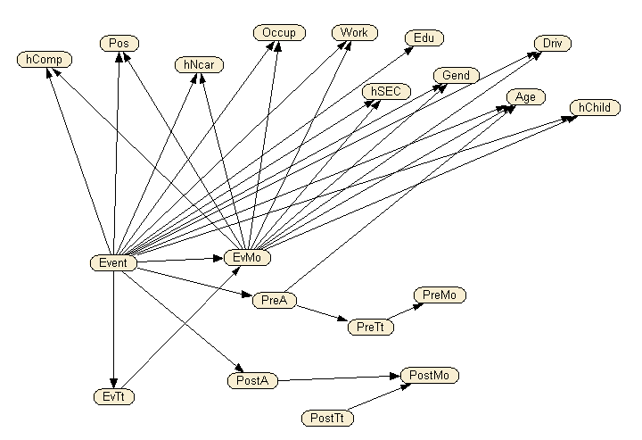
Figure 2. The network model

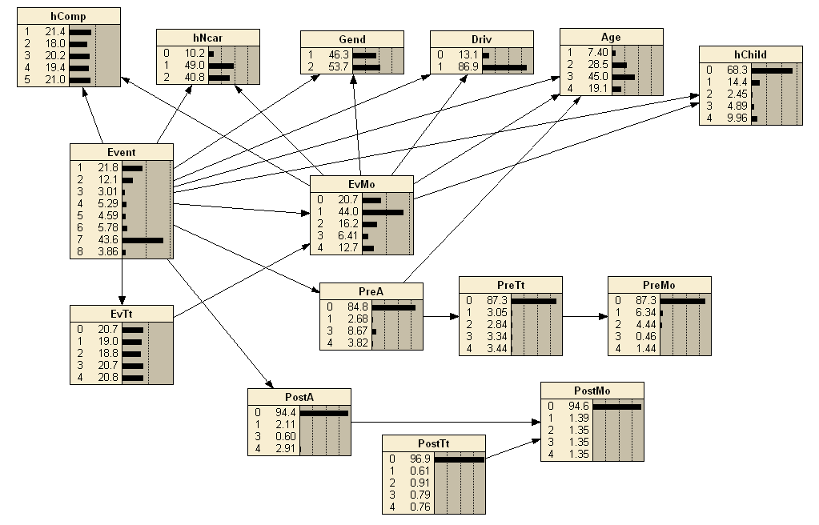
Figure 3. The network model after selecting the most relevant socio-economic variables
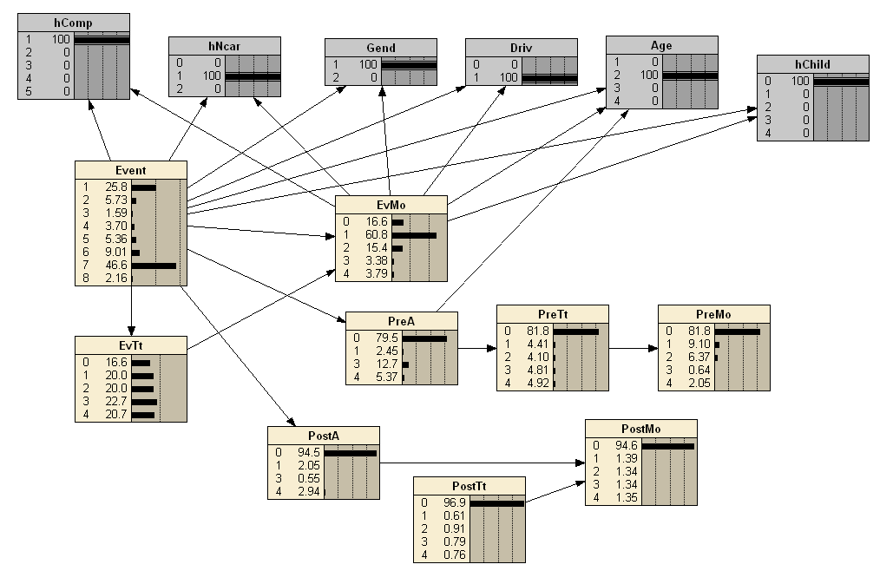
Figure 4. The network after entering the evidence of a case: illustration

TPDA stands for Three-Phase Dependency Analysis.
This software tool is freely available on the internet.
As it appears, the network comprising the behavioral nodes does not change when the socio-economic variables are added or removed. Thus, the socio-economic variables add explanatory power without changing inferred relationships between behavioral variables, as we would expect.

