Los Angeles Cargo Forecasting Model Development

By

Maren Outwater, Cambridge Systematics, 3239 198th Place SE, Sammamish, WA 98075

Vamsee Modugula, Cambridge Systematics, 555 12th Street, Suite 1600, Oakland, CA 94607

John Stesney, Los Angeles County Metropolitan Transportation Authority, One Gateway Plaza, Mail Stop: 99-23-7, Los Angeles, CA 90012-2952, 213-922-6893 (phone), 213-922-2868 (FAX), stesneyj@metro.net

Michael Clarke, Citilabs, 312 Clay Street, Suite 180, Oakland, CA 94607-3543, 510-663-5200 (phone), 510-645-1817 (FAX), mclarke@citilabs.com

Submission to the 11th World Conference on Transportation Research
Berkeley, California
June 24-28, 2007

Abstract
The Los Angeles County Metropolitan Transportation Authority (Metro) has developed a freight forecasting model based on a hybrid approach, which addresses many of the short-comings in current freight forecasting procedures. The hybrid approach combines commodity flow models to estimate the interregional or long-haul freight flows with truck models used to estimate the local truck or short-haul freight flows. This approach is combined with new techniques to model trip chains for goods moving through warehouse and distribution centers and for service vehicles making multiple stops on a daily tour. The development of this model has been successfully calibrated and applied for the Southern California region (six counties) and estimates freight flows between Southern California and the rest of the U.S., as well as Mexico and Canada. The focus of this paper is on model development rather than calibration and application. The model calibration and validation results, along with an initial forecast for the year 2030 are the subject of another paper on this model for the TRB Planning Applications Conference in May 2007.

Introduction
The growing volume of goods movement in Los Angeles and the surrounding region prompted the Los Angeles County Metropolitan Transportation Authority (Metro) to address the impact of goods movement on the overall transportation system. These impacts are expected to grow markedly in the future.
To assess the potential benefit of various freight transportation policies and infrastructure projects, Metro decided to upgrade its transportation demand model to reflect the effect of these improvements. Improvements to be evaluated included infrastructure projects such as higher-capacity rail intermodal facilities, truck-only lanes, and truck-ways. Operational and policy changes, such as extended working hours at the Los Angeles and Long Beach ports, and linking short-haul shuttle trains from the two ports to inland rail freight facilities, were also to be accommodated by the model. For the integration of goods and passenger movement analysis, it was crucial that the freight model produce results to the same traffic analysis zone system as the passenger model.
The freight model was developed to address these technical challenges in a more robust manner than has been done in the past. Freight movements are modeled at different levels of detail for long-haul and short-haul movements. Long-haul freight is derived from commodity flows at a national level that travel within or through the Los Angeles region, modeled with full modal options (truck, rail, air), and chained with trips through intermodal terminals. Short-haul freight is derived from socioeconomic data in the region and chained with trips through warehouse and distribution centers. Service trucks that do not carry freight are modeled separately and included as part of overall truck movements. Data was collected to support the simulation of transport logistics centers (warehouses, distribution centers and intermodal terminals) using trip chaining concepts.
The modeling framework provides forecasts that reflect trends in labor productivity, imports, and exports. Trend forecasts are derived from the Freight Analysis Framework (FAF) national data. External commodity flows are derived from the Caltrans Intermodal Transportation Management System (ITMS). Freight movements coming in through the ports are simulated as special generators based on forecasts from the ports and data collected at the intermodal terminals. Truck trips produced by the Metro model are included with passenger car trips in a traffic microsimulation of the I-710 corridor, which is one of the most heavily traveled truck corridors in the U.S. This traffic simulation is not included in this paper.

Review of Freight Forecasting Modeling Approaches
There are a number of freight forecasting modeling approaches that were considered by Metro. Historical trend analysis and growth factor methods were not considered because they did not provide the policy-sensitivity required to test freight transportation improvement projects. The following is a review of the freight forecasting modeling approaches that were considered and a summary of the combination of these approaches used in the Metro freight model.
- Commodity-Based Freight Models – These models use or develop forecasts of commodity flow databases and can introduce mode choice and conversion of commodity tonnage to vehicle trips as part of the modeling process. Base year truck trip tables for long-haul movements are well characterized in commodity flow datasets such as the Commodity Flow Survey (U.S. Bureau of the Census, 2002) and the TRANSEARCH database (Global Insight, 2006). Another method to estimate base year truck trip tables is using the origin-destination matrix estimation technique (List and Turnquist, 1994). The primary weakness of this approach is the lack of detail on commodity flows at the traffic analysis zone level and the lack of information about many of the local pickup and delivery trips (which are generally not captured in commodity flow data sets) and service trips (which are not captured at all).
- “3-Step” Truck Models – These models use traditional trip generation, trip distribution, and traffic assignment methods. There are issues about the manner in which trip generation and distribution are accomplished in these models (particularly as regards how trip chaining characteristics of truck trips is handled) and they are not multimodal.
- Hybrid Models – These models combine features of the commodity-based models (usually used to model the interregional or long-haul freight flows) and the “3-step” models (usually used to model the local truck trips).
- Supply Chain/Logistics Chain Models – These are state-of-the-art models that apply methods of analysis that simulate logistics choices throughout whole supply chains for specific industries. There have been a number of attempts at applying these concepts, borrowed largely from industry practice, to public decision support systems. One example of a logistics chain model is the Strategic Model for Integrated Logistics Evaluation (SMILE) that can be used as a decision support system for freight transportation policy evaluations (Tavasszy, Smeenk, and Ruijgrok, 1997). This model combines an economic input-output model that calculates supply and demand for each economic sector with an assignment of goods to logistics families to determine the spatial patterns of supply and demand. A series of logistics models are developed that define the distribution systems that are used by each logistics family and the spatial organization of warehousing and distribution systems for product delivery and supply chain management. Another example of logistics chain models is the GoodTrip model (Boerkamps and van Binsbergen, 1999), which combines features of logistics chain models and tour-based models to analyze urban goods movement flows. The model defines a set of activity types, which when linked together may describe either a logistical chain or a set of stops on a vehicle tour (or in some cases, a combination of both). This modeling approach is of particular interest because of its urban focus and its ability to analyze how changes in logistics organization affect vehicle traffic.
- Tour-Based Models – These are activity-based models that derive methods from the evolving world of activity-based passenger models. They focus on the tour characteristics of truck trips and are less concerned about what is being carried in the vehicle. Thus far, the focus of these models has been on truck trips, so they are not truly multimodal. One example of a tour-based model was developed in Calgary, Canada (Hunt, Stefan, and Abraham, 2003). Researchers at the University of Calgary have developed an approach that applies tour-based micro-simulation modeling concepts to urban goods movement modeling that was originally developed for passenger modeling. The business establishments are the operators of the vehicles that conduct the tours and the approach can be applied to retail establishments, service businesses, or any other type of commercial vehicle operation. For each vehicle tour, a series of choice models are employed in order to determine the type of vehicle that will be used to conduct the business of the tour, the purpose of each stop (goods pickup or delivery, service, return to home), and the location of the next stop.
The Metro model uses a combination of the hybrid approach for both the trip generation and distribution models, the logistics supply approach for the Transport Logistics Node (TLN) model, and the tour-based approach for the vehicle model. In the case of both the TLN and vehicle models, they are used selectively to apply this approach to those freight or truck movements that will benefit from the additional complexity. The modeling process is provided in Figure 1. These models are described more fully in the following sections.

Model Study Area
The model study area is divided into internal and external zones. Internal zones include detailed representation of Southern California (Los Angeles, Orange, Imperial, San Bernardino, Ventura, and Riverside Counties). External zones include the rest of California, United States, Canada, and Mexico.
The model operates with a two-level zoning system as shown in Figure 2. The two levels are called the fine zoning system and the coarse zoning system. The fine zoning system was based on the Metro passenger model zoning system which includes 3000 zones. The coarse zone system is based on zip codes boundaries in Southern California. For external zones, both the zone systems are based on county boundaries for rest of California and state boundaries for the rest of the United States. The model study area has 3800 fine zones and 650 coarse zones.

Trip Generation Model
The trip generation model forecasts the number of tons of each commodity group produced and consumed in all internal coarse zones. The productions are divided into internal productions, which are to be transported to an internal zone, or exports, which are sent to external zones. Similarly, the attractions are classified as internal, i.e. from internal zones, or as imports, which come from external zones. There are five parts to the trip generation model, based on the following aspects of the freight movements:
- Trip Generation for Internal Zones – Trip generation for internal zones is estimated by applying regression models to socioeconomic attributes by zone. The parameters and constants of these models were estimated using the 2003 commodity flow data derived from Caltrans Intermodal Transportation Management System (ITMS) and detailed socioeconomic data from the Southern California Association of Governments (SCAG). Different regressions were developed for production and attraction models. Commodities were grouped into 14 categories based on logic and statistical significance. For production models, regressions were developed separately for each commodity class based on correlations between employment and outbound commodity tonnage. Table 1 shows the final regression equations for all commodity groups. Most equations had a high “R square” value indicating a good fit. Agriculture, cement and concrete manufacturing and non-metallic minerals were the three groups that had poor regression equations. For these commodity classes, alternate sources of data were used to correct employment and production tonnage to recalculate regressions. In the case of agriculture, County Agriculture Commissioner’s value data ($ million) was used in conjunction with dollar/ton conversion rate to calculate new production tonnage for crops. For livestock, employment was redistributed between the six counties to match the distribution of the value data. For non-metallic minerals, cement and concrete manufacturing, employment from County Business Patterns (CBP) showed a strong correlation to the ITMS production tonnage. Therefore, distribution of total employment from the CBP was applied to the original county employment. For attractions, an Input-Output matrix was used to identify the industries that consume (attract) the output of a given commodity and use the employment for those industries as regression data. Table 2 shows the resulting consumption rates.
- Special generators – Ports are included as special generators to identify the goods movement flows by commodity class that travel through these locations. The Port of Long Beach and Los Angeles model provided truck trip tables by truck class and truck counts for the Ports of Long Beach and Los Angeles. The SCAG airport model provided truck trip tables and counts for the Los Angeles and Ontario airports. These trip tables were converted into the Metro zone system and added to the final truck trip table before traffic assignment.
- Trends in production efficiencies and other factors – These are trends in labor productivity that can be estimated by comparing tons to employment at specific points in time. The Commodity Flow Survey (CFS), conducted in 1997, and 2002 was used to calculate these trends and apply them to the future year model.
- External commodity flows – The external flows (flows to and from the Los Angeles region to the rest of US) are developed from the ITMS data. These are input as user-defined values by commodity class for both the base (2003) and future years (2030). These values represent the amount of production exported to external zones and the amount of consumption that is imported from external zones. These were compared to truck counts at external stations and updated. Canada and Mexico are also considered as external zones.
- Trends in import and export levels – Trend rates in import and export levels have a significant impact on the growth in commodities and truck trips and are represented separately in the model to reflect this. These trend rates were developed from the base and future years of the FAF for California. Trend rates are applied only to the future year model.
The generation model was calibrated by comparing model volumes to total truck counts and making appropriate adjustments to the generation models to improve this comparison.

Trip Distribution Models
The distribution models produce trip tables of goods flow by commodity class. The distribution models are based on gravity model techniques. Key assumptions of the trip distribution model were developed using available data sources such as the ITMS and FAF data.
The model assumes a percentage split between short-haul and long-haul travel by commodity class. Goods assumed to be short-haul will be truck trips, goods assumed to be long-haul will go through the mode choice model to determine if they go by truck, or rail. The percentage split between short haul and long haul by commodity class was calculated based on the ITMS data. The model assumes that this percentage split may change over time, based on trends that may be outside the capabilities of the model. These trends are represented in the model as inputs to reflect this. These trends were derived from the ITMS forecasts compared to existing for Los Angeles. These estimates of forecasts compared to existing year data can suggest changes that occur over time, but are not observed trends since they are based on estimated data.
Long-haul flows include movements between external and internal areas. In the model, internal flows are within the Los Angeles region and external flows include the rest of California, U.S., Canada, and Mexico. These flows were compared to data in the FAF and in the ITMS to determine reasonableness. Trend rates for the internal and external portions of the long-haul flows were developed using these data.
Short haul trips are distributed using a gravity model with a negative exponential deterrence function. The function is applied to the square of the distance as shown below:
$$F_{C}(d)=e^{(\frac{−d^{2}}{2p_{{}_{c}}^{2}})}$$
Where:
c: A commodity group
e: The base of the natural logarithm function (approximately 2.718282)
d: The distance
Fc(d): The deterrence function of distance used in the gravity model
pc: The calibration parameter for commodity c

Trip distribution for long haul trips is implemented using a joint distribution and mode choice model. Trips are distributed using a gravity model with a negative exponential deterrence function. The function is applied to the generalized cost calculated in the mode choice model. Generalized cost is a linear combination of time, distance, and cost by mode, weighted by the mode choice coefficients. Mathematical equation for the long distribution models is as follows:
$$Φ_{C}(G_{C})=e^{−P_{C}{\left(1+\frac{Γ_{c}}{\text{100}}\right)}^{y}G}$$
Where:
c: A commodity group
e: The base of the natural logarithm function (approximately 2.718282)
Gc: The composite cost derived from the logit model used for modal split
Fc(Gc): The deterrence function of generalized cost used in the gravity model
Pc: The calibration parameter for commodity c
Gc: The growth factor for the calibration parameter for commodity c.
y: The time, in years, from the base year to the year for which the model is being run.

Gravity model parameters were calibrated by commodity class for short- and long-haul goods movements using average trip length data from a variety of sources. Table 3 shows the gravity model parameters by commodity class.
Trip tables at the coarse zone level are distributed to the fine-zone system based on an allocation of goods by commodity class using zonal socioeconomic data. The distribution models produce O-D tables (for short haul and long haul) of annual tons of goods moved per year by commodity class.

Mode Choice Model
Mode choice models separate the long-haul flows by commodity class into two modes: truck, and rail. Air and ship modes are not included in the model because ports and airports are included in the model as special generators. The mode choice model is estimated and applied only for long-haul flows; short-haul flows are assumed to move by truck.
The mode choice model is a multinomial logit models stratified by commodity and distance class. A generalized cost function is defined for each combination of commodity group and mode. There are three independent variables, time, distance and highway generalized cost. The functions each involve four coefficients: one for each of the independent variables and one for the constant term, as follows:
$$Γ_{c}(d,τ,χ)=\sum_{m}{ζ_{\text{cm}}(d,τ,χ)}Γ_{\text{cm}}(d,τ,χ)$$
Where:
c: A commodity group
m: A mode
d: The distance
t: The time
c: The highway generalized cost
Gc(d,t,c): The composite cost function for commodity group c and mode m
Gcm(d,t,c): The generalized cost function for commodity group c and mode m
zcm(d,t,c): The proportion of tons of commodity group c that will travel by mode m.
Calibration data indicated that distance classes have unique mode choice sensitivities, therefore these models were further segmented into distance classes. Coefficients for the model were borrowed from the Florida Statewide Freight Model. These were then calibrated from data in the ITMS. Table 4 shows the constants and coefficients from the final model. The truck mode is used as the base mode for the distance class coefficients, so these are set to zero. Mode choice models produce O-D tables (for long haul) of annual tons of goods moved per year by commodity class and mode (air, truck, and rail).

The Transport Logistics Node Model
An important step in the LAMTA freight forecasting modeling process is the representation and modeling of the long-distance logistics system in the Transport Logistics Node model (TLN). The TLN model is only applied on the long-distance flows. These are defined as flows from the internal area (for example, in the Los Angeles study, this was defined as the greater southern California area) to the external area (in the Los Angeles study, this was the remainder of the United States as well as entry points to/from Mexico and Canada) and flows from the external area to the internal area. Example flows treated in the TLN model would be automobiles manufactured in Michigan traveling to southern California and manufactured goods moving from southern California to the San Francisco Bay area. Flows that move wholly within the internal area are not modeled in the TLN model.
The TLNs are places such as major goods yards, multi-modal terminals, railway stations, and distribution centers where trip chaining of long distance flows occurs. The process to estimate trip chains for goods that move through warehouse and distribution centers (TLNs) is presented in Figure 3. The TLNs considered by the TLN model are only those located within the internal study area (in the Los Angeles study—major distribution centers, terminals, etc located within greater southern California). Data on TLNs was collected through a shipper survey conducted for 131 locations in Southern California combined with rail operator data obtained at 6 intermodal terminals.
The TLN model is based on two primary elements: the commodity flow matrices from the mode/distribution model, and a description of the TLNs. The commodity flow matrices are input directly from the mode/distribution model – one table or matrix per combination of major mode of transport and commodity class. The following three parameters are applied where the internal zone has a TLN located within it:
- Long-distance truck flow splits by direction [e.g. inbound (flows from the external area to the internal area) and outbound (flows from the internal area to the external area)]. The following parameters are input for each commodity class and by direction:
- Amount of trucked goods going in a full-load, partial-truck load and consolidated load.
- For each of the load types, the percentage of those goods that will go via TLNs.
- Long-distance rail flow splits by direction:
- For each commodity class, by direction, the percentage of goods that will go via TLNs
- Long-distance inland-waterway flow splits by direction:
- For each commodity class, by direction, the percentage of goods that will go via TLNs
When the internal zone does not have a TLN located within it, the percentage of goods traveling by mode to and from the zone that will travel via a TLN is input.
The commodity flows are split into two segments:
- Long-haul portion of the movement (travels via the input mode: truck, rail or ship), and
- Short-haul portion of the movement (travels via truck).
The short-haul portion of the movements is distributed between the TLNs in the internal areas using another set of parameters. These are defined by direction for each commodity class, specifying the percentage of goods that will go to or come from each of the TLNs. At the end of this process, the TLN model produces four matrices per mode per commodity group. These are short-haul direct (do not go via a TLN), long-haul direct (do not go via a TLN), long-haul to or from TLN, and short-haul to or from a TLN. All short-haul flows to or from a TLN are truck only.

The Vehicle Model
The vehicle model is used to convert the matrices that contain annual commodity flows by truck (direct-short-haul flows, short-haul trips to and from TLNs and long-haul truck flows) into daily vehicle truck matrices. The truck matrices are divided into heavy and light trucks. All long-haul truck flows are assumed to be in heavy trucks.
A series of parameters are used in the model:

- For the direct-short-haul flows, percentage of the goods that move by light trucks by commodity class and average tons loaded in each truck. An additional scaling parameter is used to influence the amount of empty short-haul trucks.
- For the short-haul truck flows to and from the TLNs, percentage of the goods that move by light trucks by commodity class and average tons loaded in each truck. An additional scaling parameter is used to influence the amount of empty truck short-haul truck flows to and from TLNs. Also, a parameter is coded, by commodity class, with average tons loaded in each long-haul truck as well as a parameter influencing the amount of empty truck movement.
- For long-haul truck movements, a parameter with the average tons loaded in each truck by commodity class as well as a parameter that influences the amount of empty truck flows.
These parameters are used within two models contained within the vehicle model:
- The standard vehicle model which is used for flows directly from origin to destination and back. This model allows return loads to come from the destination back to the origin and also allows the truck to find return loads within a user specified criteria.
- The touring vehicle model which simulates multi-point pick-up and drop off. This model is described in Figure 4.
The standard vehicle model is applied on all origin-destination flows, except those coming to or from TLNs and those specified by the user. Once the models have been run, all matrices for a given mode and commodity group are combined to give a single vehicle matrix, relative to the fine zoning system (i.e. trips to or from a TLN are now assumed to run to or from the fine zone containing the TLN), in vehicles per annum. The matrix is then divided by the value of control data parameter to give units of vehicles per day.

Summary
The Metro multimodal freight forecasting model uses a combination of existing modeling approaches to develop a freight model that can address current shortcomings and provide a more useful tool for evaluating freight transportation investment decisions. This model has been developed and tested for one of the most complex freight transportation systems in the U.S., Southern California. The multimodal capabilities and the advances in modeling intermodal terminals, warehouse and distribution centers, and service trips, provide a robust freight forecasting capability for decision-making.

References
- Boerkamps, Jeroen, and van Binsbergen, Arjan (1999), ‘GoodTrip – A New Approach for Modeling and Evaluation of Urban Goods Distribution,’ Delft University of Technology, and The Netherlands Research School for Transport, Infrastructure and Logistics (TRAIL).
- Global Insight (2006), ‘Trade and Transportation Data, TRANSEARCH Insight’, http://www.globalinsight.com/ProductsServices/ProductDetail1024.htm
- Hunt, John Douglas, Stefan, Kevin J., and Abraham, John E. (2003), ‘Modeling Retail and Service Delivery Commercial Movement Choice Behaviour in Calgary,’ presented at the Tenth International Conference on Travel Behaviour Research in Lucerne, August.
- List, George F., and Turnquist, Mark A. (1995), “Estimating Truck Travel Patterns in Urban Areas,” Transportation Research Record 1430.
- Tavasszy, L., Smeenk, B., and Ruijgrok, C. (1997), ‘A DSS for Modeling Logistics Chains in Freight Transport Policy Analysis,’ Seventh International Special Conference of IFORS: Information Systems in Logistics and Transportation, Gothenberg, Sweden, June 16-18.
- U.S. Bureau of the Census (2002), ‘Commodity Flow Survey’, http://www.bts.gov/ntda/cfs/.

Figure 1. Metro Freight Forecasting Modeling Process
Figure 2. Metro Freight Model Study Area and Zone System

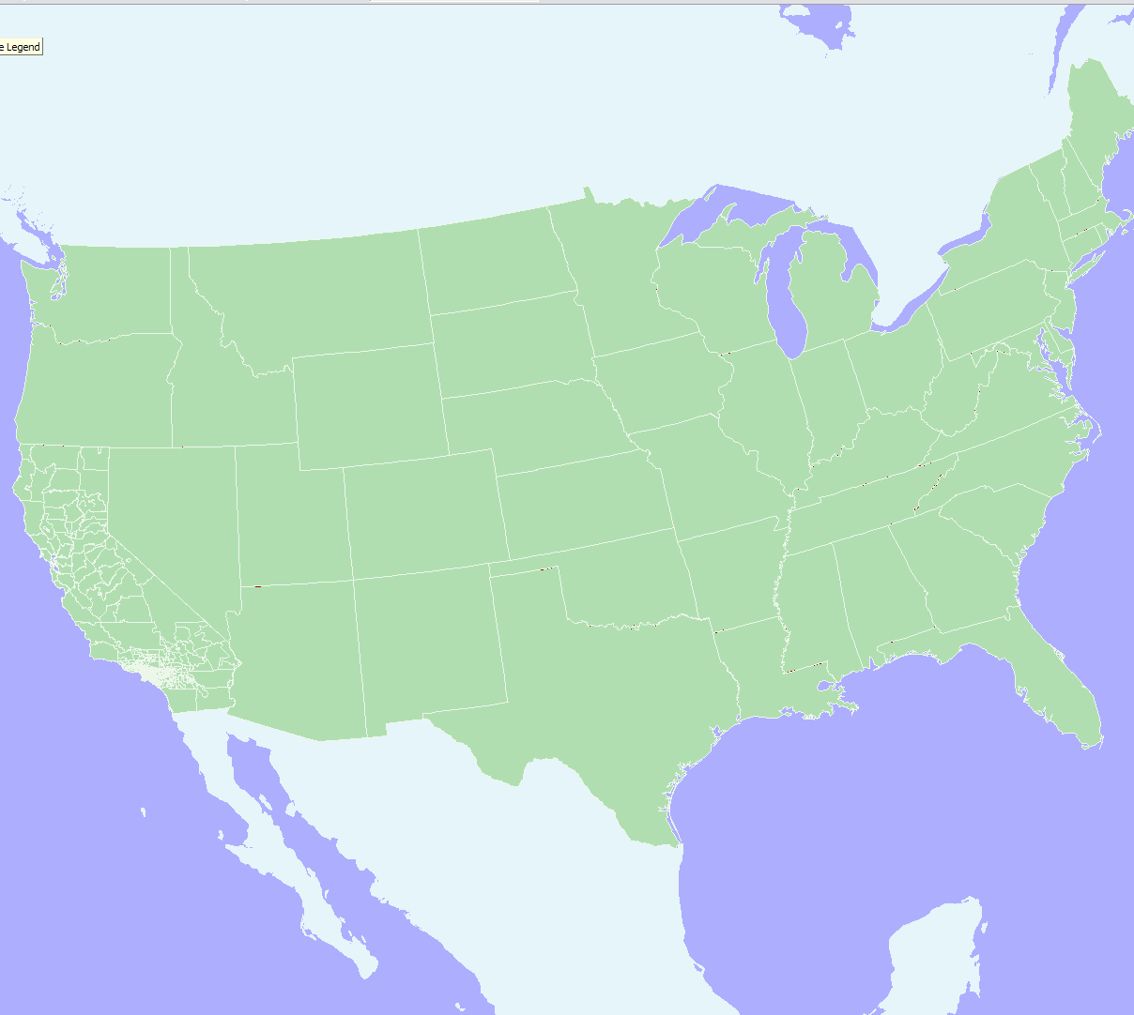
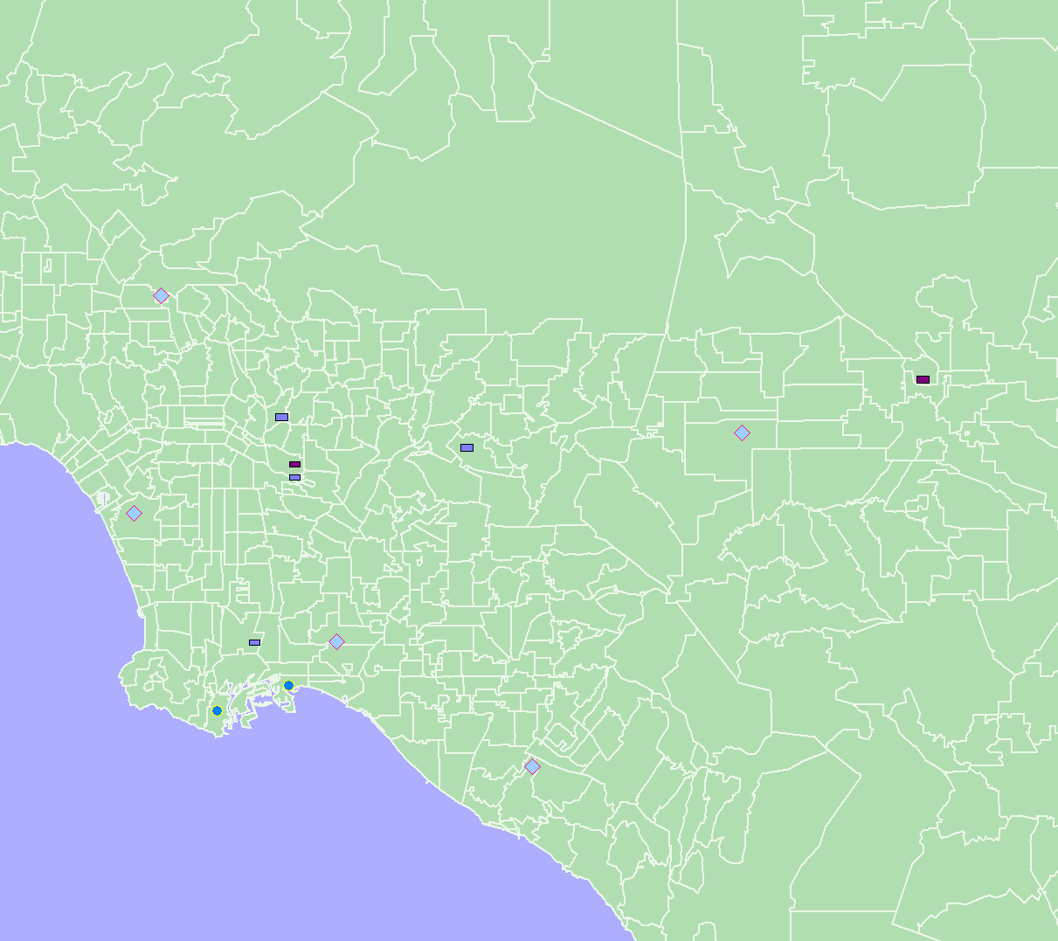
- Within 5 county SCAG region: zip codes

- Remainder of California: counties

- Remainder of USA: states

- 4 external zones; 2 each for Canada and Mexico

Figure 3. Trip Chaining through Warehouse and Distribution Centers in the TLN model

Figure 4. Trip Chaining to/from Warehouse and Distribution Centers in the Vehicle model

Table 1. Trip Production Rates by Commodity Class

Table 2. Trip Consumption Rates

Table 3. Distribution Model Parameters

Table 4 Mode Choice Model Parameters

