Demand modeling for microscopic models in freight transport –
Modeling the Splitting of the flow of goods with Total Logistic Costs

Hanno Friedrich, Dr. Gernot Liedtke

University of Karlsruhe (TH), Institute for Economic Policy Research (IWW)
Kaiserstraße 12, Kollegium am Schloß Bau IV, Geb. 20.14, 76131 Karlsruhe
e-mail:
friedrich@iww.uni-karlsruhe.de
liedke@iww.un-karlsruhe.de

ABSTRACT

In recent years, first microscopic models for freight transportation appeared. Working at the level of individual firms, these models also need freight demand data on the microscopic level. Data and the knowledge how to model actors normative behavior on this level does already exist in other disciplines like logistics and marketing. This paper tries to transfer part of this knowledge to transportation modeling.
One major question in modeling the behavior of the freight demand side is how a flow of goods can be translated into individual shipment sizes. Being able to model this process is of big importance, since it has a direct impact on the modal choice and it is the decision where logisticians react to measures that are taken by transportation politics.
The paper defines this process as "splitting" of a flow of goods and discusses the total logistic cost approach (TLC) to model it. Known from logistic research as inventory theoretic framework this approach was recently also discussed in transportation modeling. This paper does the next step by describing a complete implementation of a TLC model and discussing the results and possible enhancements of the model.

Keywords: Total Logistic Cost (TLC), Splitting the flow of goods, freight transport demand model

1 INTRODUCTION
In recent years, first microscopic models in freight transport appeared (see for example [Liedtke, 2006], [Wisetjindawat, 2006], [Spahn, 2005]). Working at a level of individual firms these models are on the one hand side capable to model the heterogeneous reaction patterns and restricted choice sets of actors. This is important to explain developments in freight transportation. On the other hand side these models require a high volume of data input on the microscopic level. This data can be derived in a normative or descriptive way. Both data (descriptive) and knowledge how to model actors behavior (normative) on the microscopic level does already exist in other disciplines like logistics and marketing. This paper tries to transfer part of the normative knowledge to transportation modeling.
One major question in modeling the behavior of the freight demand side is how a flow of goods can be translated into individual shipment sizes. In the paper this process is described by the concept of the splitting of the flow of goods. Understanding the splitting decisions is important since it has a high influences on transportation: with the decision on lot sizes, the modal choice is predetermined, since each transportation mode is linked to certain shipment size. Furthermore by modeling this splitting decision it is possible to describe reactions of the logisticians to measures in transportation that are taken by politicians like for example the introduction of toll.
In logistic research the corresponding problem of an optimized stock level is well known (see for example [Koether, 2004]). The different logistic costs can be formulated in a total logistic cost function (TLC). This TLC approach can serve to describe the splitting decision. In transportation modeling its application is under discussion and TLC was already at least partially implemented. This paper will go one step further, it will show a complete implementation of TLC and discuss the TLC approach and possible enhancements based on the results of the implementation.
The paper is organized as follows: first a definition of "splitting" is given including a short description of parties concerned, second it is analyzed how current freight transportation models incorporate this splitting, third a TLC model implementation and its results are described and finally its limitations and possible enhancements are discussed.

2 DEFINITION OF CONCEPT
To move the focus of discussion more on the transport aspect, a definition of the splitting of a flow of goods is given. It can be based on the definition of the microscopic flow of goods, given by Liedtke ([Liedtke, 2006]):
Definition: The microscopic flow of goods between two elements of the freight transport demand system is the amount of a certain regularly delivered commodity in tonnes or monetary units per time period. It is only defined when the number of lots being shipped during the whole delivery cycle is large.
Based on this definition the splitting can be defined:
Definition: Given is a flow of goods F(S,R, t, v) with shipper S (source), recipient R (sink), space of time t and goods volume v. Then Sp(S, R, t₁...t_{n}, v₁...v_{n}) is a splitting of a flow of goods if $t=\sum_{i}{t_{i}}$and $v=\sum_{i}{v_{i}}$ $t_{i},v_{i}∈R^{+}$.
Answering the question how a splitting is generated, one has to look at the actors possibly taking decisions concerning the flow of goods. In the first place there are shipper S and recipient R. In most cases the shipper sells a product to the recipient, which is then transported, forming the flow of goods F. The transportation very often is performed by another or several other actors. Looking at the splitting of the flow of goods, there are three possible points where splitting decisions can be taken:
• The first possible splitting decision can be taken defining the customer order by quantity and delivery time.
• The second possible splitting decision is taken in the modal choice decision.
• The last splitting decision might be taken during transportation, optimizing costs by bundling and routing different shipment cases.
One could imagine all combinations of joint or separate decision in reality. This depends on the level of cooperation between the actors. In case of an overall supply chain management logistic costs of all actors in the supply chain would have to be taken into account, this is represented in the total logistic cost (TLC) approach. In the case of non cooperation and separate decisions the customer (recipient) might only consider the costs he realizes and neglect transportation costs (see chapter 5). Having separate decision, the modal choice decision is in most cases very limited, given the first step of the splitting decision expressed in order quantities and delivery times.
In the next section a short overview is given of how splitting is modeled in transportation models before we discuss in detail a TLC model implementation representing a possibility to model a joint splitting decision of sender and recipient.

3 SPLITTING IN FREIGHT TRANSPORTATION MODELS
The splitting in freight transportation models often is implicitly handled in the modal choice. Taking the flow of goods between cells in macroscopic models or between economic actors in microscopic models a transportation mode is chosen, shipment sizes are then modeled as the result of the chosen transportation mode. Hence, implicitly the splitting decision is made. Therefore the first section will describe shortly the theory of logit models that are mostly used to model modal split. Afterwards examples of current freight transportation models and their way of handling splitting are described.

3.1 Theory of logit models
Logit models were developed in the area of discrete choice theory. The discrete choice theory postulates that decision makers q act rational following utility maximization [Domencich and McFadden, 1975]. Each option $A_{i}∈(A_{1},A_{2},\text{.}\text{.}\text{.},A_{n})$ possesses a utility $U_{\text{iq}}=v_{\text{iq}}^{k}+e_{\text{iq}}=\sum_{k}{β_{\text{iq}}^{k}}x_{\text{iq}}^{k}+e_{\text{iq}}$.
The weight parameters $β_{\text{iq}}^{k}$ of the different explaining variables $x_{\text{iq}}^{k}$ are estimated based on real observations. represents the random component (error term) that is not explained by the model. Different $β$s of decision makers can be explained by classifying the decision makers and estimating the parameters for each class.
Ortuzar and Willumsen [Ortùzar and Willumsen, 1990] give an overview on different extensions of logit models. The basic form is the multinominal logit model (MNL) that assumes independence of the alternatives. The nested logit model (NL) can explain groups of dependant alternatives. The groups are again assumed to be independent from each other and the choice is modeled sequentially. This sort of logit model, also called hierarchical logit model, is very often used in freight transportation models. Mixed logit models (ML) use variable $β$s to explain differences of decision makers in the model instead of using classifications. Probit models are the most sophisticated kind of logit model, that can explain dependencies between alternatives.
It is clear that there is a tradeoff between explanatory power and need of data for calibration or a need of additional explaining logic.

3.2 Current freight transportation models
In this paper only a very limited overview with selected examples of existing models can be given. An example from macroscopic and one from microscopic modeling are discussed and examples where the theoretic inventory framework and TLC is already in use are given. For further reading an overview paper of DeJong is recommended (see for example [DeJong et al., 2004]).
The freight model designed and applied for the German infrastructure master plan [BVU et al., 2001] can be taken as a typical example for macroscopic transport models. For the modal choice module it uses a nested logit approach. As explaining variables describing the different alternatives (transport modes) cost, time and quality are used. The classification by goods and shipment sizes shows that only the second splitting decision is modeled. The first splitting decision determining the batch sizes is neither explicitly modeled nor mentioned and hence must be taken from existing data or be assumed. Therefore this model cannot explain many effects concerning the changing shipment sizes.
One of the newly developed microscopic freight models is a model from Japan [Wisetjindawat, 2006], it makes the steps of splitting explicit. The conversion from flow of goods to truck flows is modeled in three steps. First shipment size and frequency choice is described by a linear regression considering distance between shipper and recipient. Then carrier and vehicle choice is performed in a nested logit model mainly considering the total transport costs. And finally vehicle routing optimization is performed. In this model the first splitting decision is determined by empiric data, hence changes in decision behavior can not be explained.
To describe the splitting decision in logistics traditionally the inventory theoretic framework is taken (for examples see [Blauwens et al., 2005]). Also in transport modeling there are examples where this approach is used for modeling combined decisions on shipment size and mode choice (for further reading see [DeJong et al., 2004 (1)]). In transport modeling the notion of taking all logistic cost into account is often referred to as TLC (Total Logistic Cost) approach. Examples for TLC in transport modeling are the "Specification of Logistics in the Norwegian and Swedish National Freight Model" [DeJong et al., 2004 (2)], "A Business Logistics Analysis of Some Policy Measures" [Blauwens et al., 2005] or a marketing support system for railways [Park, 1995].
Nevertheless for the mentioned examples of TLC there was either no publication found on the implementation yet ([DeJong, 2004 (2)]) or the implemented TLC approach was simplified by leaving out shipment size related cost in the case of Park or not describing the risc cost modeling in detail and limiting the number of observed cases [Blauwens et al. 2005].

3.3 Modeling splitting with TLC
As seen in the literature the TLC approach can be used to model only the shipment size decision (as inventory theoretic framework in logistic) or model the combined decision on shipment size and modal choice, so it is capable to explain the first and second splitting decision. Furthermore TLC can describe the different motivations of the heterogenous actors in modal choice. It is comparable with a mixed logit approach (see next chapter) and therefore has a high explanatory power.
Compared to the existing models this paper will try to show a more complete implementation in the next chapter. But above all based on the implementation and the tests performed a discussion in a general form on the TLC approach will be conducted. To the best of our knowledge this was not yet done in this detail.

4 TLC MODEL IMPLEMENTATION
This chapter will give an overview on a TLC model implementation representing one possibility to model a combined first and second splitting decision. First scope of the model and assumptions are outlined. The TLC function and its components are only described briefly, since detailed publications with theoretical descriptions do already exist. Then an implementation, its input data and results are described.

4.1 Assumptions
The model describes the joint decision of shipper and recipient on the splitting of the flow of goods. For different combinations of the variables distance d, value of good w [EUR/t] and volume of flow of goods v [t/year], the cost minimum is calculated. Therefore, among others, the following prerequisites are assumed:
1. There is a constant flow of goods between shipper and recipient
2. The optimum of total logistic costs of shipper and recipient is calculated (joint decision)
3. There is full information, all costs are known
4. There is no error term describing incomplete information or unreliable data
5. It is a decision between a set of alternatives, a discrete decision (detailed formulation in text)
6. The flow of goods is divisible into the batch sizes defined by the alternatives
7. Interest costs i, storage costs per ton and year sc, ordering/handling costs ohc and costs for running out of stock rc are constant for all modeled cases
8. A Gaussian distribution is assumed for delays of the alternatives
9. There are no storage costs on the sender side, which means that the sender can adapt his production
A central point of the model is the assumption of discrete alternatives. It will be discussed in depth in the next chapter. At this stage a more detailed formulation of the alternatives will be given. One alternative A(tc,ts,tσ) is defined by batch size , transportation cost tc [EUR per 100 km], average transportation speed ts [km/h] and reliability expressed by the standard deviation of arrival times tσ (a Gauss distribution is assumed).

4.2 TLC and its components
As basis for the model a TLC function is taken. The following formulation is based on the work of Beuthe [Beuthe et al., 2004], Park [Park, 1995] and the paper of Liedtke and Ott [Liedtke and Ott, 2005]. Starting point is a stable flow of goods F(S,R,t,v) between a sender S and a recipient R during one year (t=1 year)with the volume v [in tonnes]. All costs are therefore calculated per year for a given combination of distance d between sender and recipient, value of good w [EUR/t] and volume of flow of goods v.
$$\text{TLC}=\text{OHC}+\text{TC}+\text{SC}+\text{RSSC}$$
In table 1 an explanation and the detailed formulas for calculation of the single components are given.

OHC | Ordering and handling costs | $$\frac{v∗\text{ohc}}{v_{j}}$$ | v  ohc | Flow of goods per year  Batch size of alternative  Ordering and handling cost per batch
TC | Transport costs (costs for transportation and costs capital cost) | $$\frac{v∗{\text{tc}}_{j}∗d}{v_{j}}+\frac{v∗w∗i∗d}{{\text{ts}}_{j}}$$ | d  w  i | Transportation cost rate [EUR/km] of alternative  Distance between S and R  Value of good  Capital cost (interest rate)  Average speed of alternative
SC | Storage costs  (Cost for storage  and capital cost) |  | sc | Storage cost per tonne and year
RSSC | Risc and safety  stock costs  (storage costs, capital  costs and risk costs  for out of stock  situation) | $$\begin{aligned}\text{SSC}+\text{RSC}= \\ \text{vs}∗\text{sc}+\text{vs}∗w∗i+ \\ \int_{t=\text{tss}}^{∞}{N(0,{tσ}_{j})\text{dt}∗\text{rc}∗\frac{v}{v_{j}}}\end{aligned}$$ | Vs  ts  tσ_{j}  rc | Safety stock  Safety stock time  (time the safety stock  can feed production)  standard deviation of  arrival times of Alternative  Average costs for running out of stock
Table 1: Components of TLC
Safety stock (vs) and safety stock time (tss) are calculated by minimizing the sum of safety stock cost (SSC) and risk costs for out of stock situation (RSC). This optimization has to be done for each splitting alternative.
For all combinations of w,v and d the TLC for the different alternatives can be calculated. Therefore we can assign an optimal alternative (lowest TLC) to each combination.

4.3 Input data
There are different kinds of input data for this model. Combinations of variables that describe different cases of decision, variables describing the alternatives for decision and the model parameters that stay constant for all cases and alternatives. In the following the concrete chosen values of the input data are listed. They are estimations and not representative, objective was to test the model not to have exact input values.
4.3.1 Simulated cases
One simulated case is defined by a combination of volume of flow of goods v [in t], distance between sender and recipient d [in km] and value of good w [EUR/t]. Following variable values are simulated:
• Volume of flow of goods v of 0,5t, 1t, 1,5t ... 35t per week (70 possibilities)
• Distances of, 100km, 200km,...,1000km (10 possibilities)
• Value of good w of 100EUR,200EUR, ... 15.000EUR (150 possibilities)
In total there are 105.000 possible combinations or cases to be simulated. For each case TLC is calculated for all alternatives. Having defined 4 alternatives this makes 420.000 TLC calculations necessary.
4.3.2 Splitting alternatives
Four alternatives are defined, listed in table 2. Since a joint decision of shipper and recipient is simulated, the formulation of alternatives was oriented on typical products of transportation market (see for example [Klaus, 2003]) available to the shipper. Chosen values are rough estimates and only serve to test the model.

Description of alternative | Batch size [t] | Speed ts [km/h] | Transportation cost tc [EUR per 100 km] | Standard deviation of arrival time tσ
Mixed cargo shipments | 0,5 | 10 | 24h service | 6
Partial load (truck) | 5 | 40 | 50 | 6
Full load (truck) | 25 | 50 | 150 | 4
Single wagon (rail) | 50 | 20 | 200 (400 min) | 6
Table 2: Splitting alternatives
A general transportation time of 24h was assumed for mixed cargo shipments, taking the example of many small size cargo shipment networks in Europe that guarantee the transport delivery within 24hours for the distances simulated in this model. For the alternative of railway a minimal cost is assumed to represent the influence of high fix cost necessary for railway usage.
4.3.3 Model parameters
There are four additional model parameters that are assumed to stay constant for all simulated cases and alternatives. Following values are estimated:
• Interest costs (capital costs) i: 12%
• Storage costs per tonne and year sc: 150 EUR
• Ordering/handling costs ohc: 25 EUR
• Average costs caused by running out of stock rc: 200.000 EUR
All values for the model parameters are rough estimates to test the TLC approach, for example capital cost were taken from case studies in financial diagnostics (see for example [Havard, 1998]). The WACC (weighted average cost of capital), which was taken as benchmark, is a composition of cost of dept and cost of equity capital and of course differs in practice according to the market situation and the context of a company (for further explanation see [WACC]).

4.4 Results
4.4.1 General results
The output of the model is shown in Figure 1. For all simulated cases the splitting alternative with the lowest TLC is given. For each distance the result is presented for combinations of product value and volume of flow of goods.

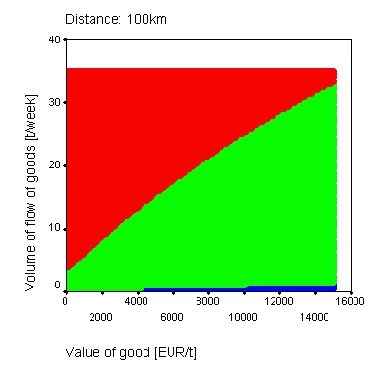 | 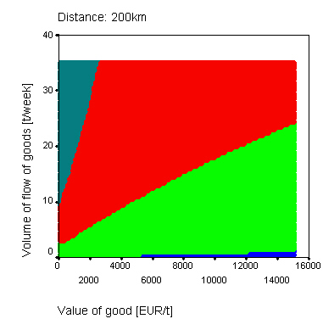 | 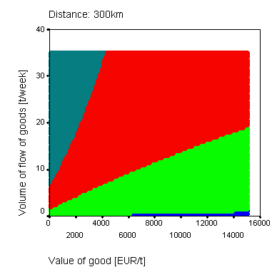
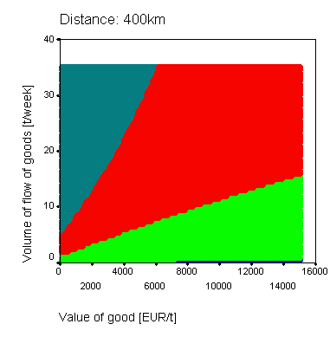 | 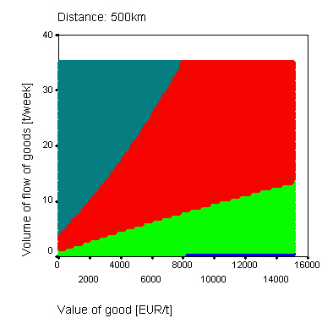 | 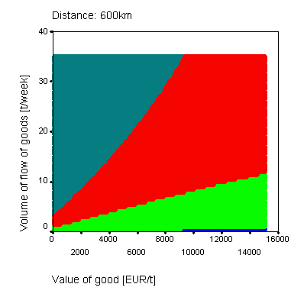
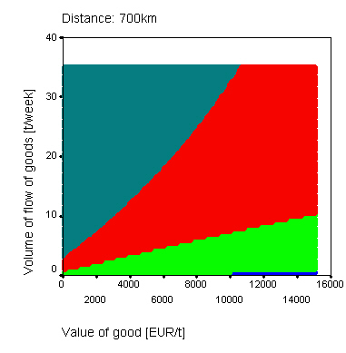 | 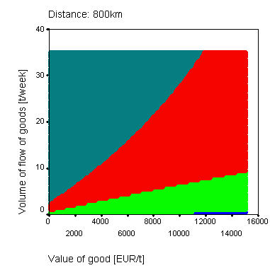 | 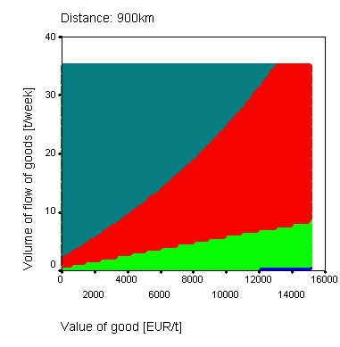
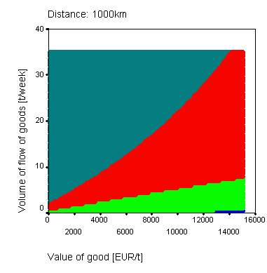 | 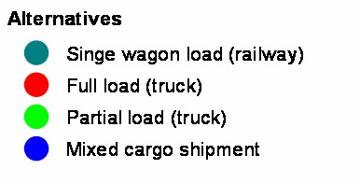
Figure 1: Model output: TLC minimizing alternatives
As expected, the model shows following three characteristics:
• the higher the value of the product, the lower the batch sizes
• the stronger the flow of goods, the bigger the batch sizes
• the farer the distance, the bigger the batch sizes
The model therefore gives for example a good explication for areas of higher modal share of railways. These areas are characterized by high distances, low product values and big volume of flow of goods.
In the following subsection we will further explore the influence of the cost components for the decision.
4.4.2 Influence of cost components
In table 3 the range (minimum to maximum) of proportions of cost components relative to TLC for the different alternatives are listed. The calculation is only based on cases where the alternative under consideration is chosen.

Alternative | OHC/TLC  (in %) | SC/TLC  (in %) | TC/TLC  (in %) | RSSC/TLC  (in %)
Mixed cargo shipments | 18-62 | 6-18 | 24-73 | 3-10
Partial load (truck) | 2-28 | 9-77 | 12-85 | 1-31
Full load (truck) | 1-12 | 13-57 | 24-77 | 1-20
Single wagon (rail) | 1-4 | 5-49 | 46-92 | 1-11
Table 3: Proportion of TLC components for different chosen alternatives
It is remarkable that for all cost components cases do exist, where the components play a significant role. Ordering and handling costs seem to be most important for mixed cargo shipments. The highest proportion for RSSC is reached for partial loads. And transport costs reach their highest proportion for the single wagon (railway) alternative. SC reach high maximums for all alternatives but mixed cargo shipments.
A more detailed analysis is undertaken to understand the importance of the components in this model. A cost component is important, if it has a high influence on decision, hence if it matters for decision. Therefore the costs of first and second best alternative are compared for those cases where the TLC difference is very low. Graphically this is represented in figure 1 by the transition areas where colors (alternatives) change.

$\left(\frac{{\text{TLC}}_{2}−{\text{TLC}}_{1}}{{\text{TLC}}_{1}}\right)\text{}<\text{}0,\text{01}$  Transitions | $$\frac{\left|{\text{OHC}}_{1}−{\text{OHC}}_{2}\right|}{{\text{TLC}}_{1}}$$  (in %) | $$\frac{\left|{\text{SC}}_{1}−{\text{SC}}_{2}\right|}{{\text{TLC}}_{1}}$$  (in %) | $$\frac{\left|{\text{TC}}_{1}−{\text{TC}}_{2}\right|}{{\text{TLC}}_{1}}$$  (in %) | $$\frac{\left|{\text{RSSC}}_{1}−{\text{RSSC}}_{2}\right|}{{\text{TLC}}_{1}}$$  (in %)
Mixed cargo shipments,  partial load | 16-56 | 52-70 | 14-36 | <1
Partial load, full load | 3-22 | 37-46 | 15-34 | 0-12
Full load, single wagon (rail) | 0-3 | 15-25 | 17-24 | 0-3
Table 4: Differences between first and second best alternative
In table 4 the differences of cost components relative to chosen TLC were calculated. As bases only those cases were taken,where the difference between TLCs of first and second alternative is less than 1%. The table is organized by the three transition pairs that exist for the defined alternatives: mixed cargo shipment and partial load, partial load and full load and full load and single wagon load. In the following additional results of the analysis will be cited to give a deeper understanding of the ranges shown in table 4.
Concerning the change in decision between the alternative mixed cargo shipments and partial loads following characteristics can be identified:
• RSSC are not important (differences are less than 1 percent)
• for short distances TC do not play a big role, OHC and SC are the important cost components, SC works pro mixed cargo shipment, TC and OHC against (for d=100km differences in OHC are between 52% and 56%, in SC between 68% and 70% and in TC between 14% and 15%).
• for farer distances TC become more important (for d=1000km difference in OHC 16%, in SC between 52% and 53% and in TC 36%)
Regarding the transitions between partial load and full load, we can observe following influences of cost components:
• for strong flows of goods, high values of products and smaller distances all components play an important role in decision. SC the most important working for the partial load alternative, the other three against (for d=100km, v>30t and w>12.500EUR/t differences in SC are between 41% and 42%, in OHC between 15% and 16%, in TC between 15% and 16% and in RSSC between 11% and 14%)
• for weaker flows of goods RSSC looses importances (for v<7,5t differences in RSSC are less than 3%)
• for farer distances TC become more important, OHC and RSSC get unimportant (for d=1000km differences in TC are between 31% and 34%, in SC between 37% and 38%, in OHC less than 4% and RSSC less than 3%)
Finally the transition between the alternatives partial load and single wagon (railway) is mainly decided by differences in TC and SC (see table 4).
These observations can already serve to explain possible trends in splitting. For example the importance of ohc for smaller shipment sizes. The reduction of transaction cost (by introduction of new information and communication technology) will have an influence on decision for small shipment size alternatives but less for bigger batch sizes.

4.5 Sensitivity of model and alternative parameters
After discussing the behavior of the model for different simulated cases, a discussion on the importance of model and alternative parameters is crucial. Therefore the sensitivity to changes in parameters is analyzes.
Sensitivity can be described by elasticities defined by $ε=\frac{Δ{\text{TLC}}/{\text{TLC}}}{Δ{\text{input}}/{\text{input}}}$. In table 5 the formulas for the elasticities are calculated analytically, as far as possible (assumption is that same alternative is chosen). For some parameters elasticity cannot be calculated analytically, furthermore changed TLC may lead to a switch in alternative and therefore to a different sensitivity.
To get an indication anyway, input parameters are changed by 10% in the model and the changes in TLC are analyzed (For the standard deviation of arrival times input values are changed by 25% - 4 to 5 hours - and 33% -6 to 7 hours) . In table 5 results are described by the ranges of change in TLC, the minimum and maximum case and the number of changed chosen alternatives.

Input | Elasticity $ε=\frac{Δ{\text{TLC}}/{\text{TLC}}}{Δ{\text{input}}/{\text{input}}}$ | Range of change  in TLC (in %) | Min case  (w,v,d) | Max case  (w,v,d) | Alternative changes |  | Total
 |  |  |  |  | Transitions |  | Total
i | Cannot be  calculated  completely | 0,1-7,6 | 100 EUR/t  35 t/week  1000 km | 14.800 EUR/t  1,5 t/week  100 km | Partial load ->  Mixed cargo shipment | 117 | 4.768
 |  |  |  |  | Full load -> Partial load | 1.965 | 4.768
 |  |  |  |  | Wagon load -> Full load | 2.686 | 4.768
rc | Cannot be  calculated  completely | 0,0-0,1 | 6.800 EUR/t  1 t/week  1000 km | 8.000 EUR/t  35 t/week  100 km | Partial load -> Full load | 3 | 26
 |  |  |  |  | Wagon load -> Full load | 23 | 26
ohc | $$\frac{v∗\text{ohc}}{v_{j}∗\text{TLC}}$$ | 0,1-6,1 | 700 EUR/t  3 t/week  1000 km | 4.700 EUR/t  0,5 t/week  100 km | Mixed cargo shipment -> Partial load | 72 | 783
 |  |  |  |  | Partial load -> Full load | 579 | 783
 |  |  |  |  | Full load -> Wagon load | 132 | 783
sc | Cannot be  calculated  completely | 0,1-5,2 | 14.800 EUR/t  0,5 t/week  1000 km | 100 EUR/t  4,5 t/week  100 km | Partial load ->  Mixed cargo shipment | 18 | 969
 |  |  |  |  | Full load -> Partial load | 350 | 969
 |  |  |  |  | Wagon load -> Full load | 601 | 969
 | $$\frac{v∗w∗i∗d}{{\text{ts}}_{j}∗\text{TLC}}$$ | (-1,1)-0,0 | 14.100 EUR/t  35 t/week  1000 km | 100 EUR/t  1 t/week  1000 km | Partial load ->  Mixed cargo shipment | 2 | 505
 |  |  |  |  | Full load -> Partial load | 28 | 505
 |  |  |  |  | Full load -> Wagon load | 475 | 505
 | $$\frac{v∗d∗{\text{tc}}_{j}}{v_{j}∗\text{TLC}}$$ | 1,2-9,2 | 15.000 EUR/t  1,5 t/week  100 km | 100 EUR/t  35 t/week  1000 km | Mixed cargo shipment -> Partial load | 66 | 5.095
 |  |  |  |  | Partial load -> Full load | 1.618 | 5.095
 |  |  |  |  | Full load -> Wagon load | 3.411 | 5.095
 | Cannot be  calculated  completely | (-8,0)-5,5 | 100 EUR/t  35 t/week  1000 km | 3.200 EUR/t  0,5 t/week  100 km | Partial load ->  Mixed cargo shipment | 288 | 10.948
 |  |  |  |  | Full load -> Partial load | 5.127 | 10.948
 |  |  |  |  | wagon load -> Full load | 5.533 | 10.948
 | Cannot be  calculated  completely | 0,1-4,9 | 200 EUR/t  0,5 t/week  1000 km | 15.000 EUR/t  33 t/week  100 km | Mixed cargo shipment -> Partial load | 1 | 192
 |  |  |  |  | Partial load -> Full load | 79 | 192
 |  |  |  |  | Full load -> Wagon load | 112 | 192
Table 5: Changes to TLC following a 10% change in input parameters
Changes in capital cost i lead, as expected, to a movement to alternatives with smaller batch sizes since higher storage costs SC are avoided. This is especially obvious for cases with high product value. The reaction to changes in costs for running out of stock rc are very minor, which is due to the assumed Gauss distribution (discussed in the next chapter). Nevertheless it is identifiable that the full load alternative is enforced, since it has the lowest standard deviation of arrival times. Increase in ohc strengthens alternatives with larger batch sizes.A higher storage cost rate sc on the other hand strengthens alternatives with smaller batch size.
The parameter changes for the alternative parameters were done for all alternatives in the same way (increase of 10%, and 25%/33% for ). The changes in transportation speed has only limited consequences since only capital costs during transport are affected. Since the full load alternative is already relatively fast, it looses advantage compared to the others. As expected, the change in transport cost leads to more usage of alternatives with larger batch sizes.

Cost  component | TLC before change  (Partial load) | TLC after change  (Partial load) | TLC before change  (Mixed cargo shipment) | TLC after change  (Mixed cargo shipment)
OHC | 130 | 118 | 1.300 | 1.182
SC | 1.335 | 1.469 | 134 | 147
TC | 263 | 239 | 547 | 500
RSSC | 63 | 63 | 70 | 70
Total TLC | 1.791 | 1.889 | 2.051 | 1.898
Table 6: Example for TLC change (w=3200EUR/t, v=0,5t/week, d=100km, increase of by 10% form 5t to 5,5t in partial load and form 0,5t to 0,55t in mixed cargo shipments)
Interesting to observe are the consequences of changes to batch sizes. For all alternatives batch size was increased by 10% leaving all other parameters (especially transport cost ) constant. Nevertheless there are some cases with increased TLC. One example is shown in table 6. Since the model forces to fully use the transport capacity, this is done regardless the strongly increased cost for storage. The mixed cargo shipment alternative is gaining advantage, but not enough to take over. This is a weakness of the model caused by the discrete choice assumption. It could be eased by allowing not to use full capacity. But this would imply a second splitting decision. The discussion will be detailed in the next chapter.
Apart from these single cases the general tendency is towards alternatives with smaller batch size. Remarkably is the high number of alternative changes, which indicates that this parameter is very important for differentiation of alternatives.
Increased standard deviation of arrival times finally leads to increased usage of alternatives with bigger batch sizes. Considering the strong changes in input parameters (25% and 33%), the resulting changes seem quite small. As for rc this is linked to the assumption of the Gaussian distribution.

4.6 Usage in transportation modeling
One could imagine different kinds of application of such a model in transportation modeling. In this paragraph three possibilities are briefly discussed: usage as modal choice model, as additional module for first splitting decision and as lookup table for decisions in a microscopic transport model.
First we look at it as modal choice model incorporating first and second splitting decision. Like existing modal choice models it does include characteristics of transportation alternatives. Cost, time and quality (in form of standard deviation of arrival time) are incorporated in decision. Additionally it considers the differences of conditions of the different cases. It can therefore be taken as an extreme form of mixed logit model, that of course cannot be solved analytically but estimated. Very high data input will be required in order to generate realistic modal split data: the distribution of cases in the real world is the major input. For the combination of two of the three variables defining a case this may be possible. The German KBA survey [Kraftfahrt-Bundesamt, 2003] for example delivers survey data for the combination of distance d and product value w. The additional combination with flow volume however will be difficult to find. Surveys (see for example production statistic [Statistisches Bundesamt, 2002], DLR survey [Menge et al., 2006] and [Straube et al., 2005]) concentrate on shippers or recipients, not on combinations of shipper and recipient, which would be the information needed. Total production of one shipper can be calculated, data for estimating a flow between shipper and recipient however is difficult. Additionally realistic data for alternatives is required, but should be available. The critique that will be formulated in the next chapter does mainly hit this sort of application. Since cooperation between actors is not forcingly given in reality and a additional distinction of feasibility of alternatives for actors will be necessary (e.g. no access to railway infrastructure, goods that are not dividable).
The second form of application would be to use the model to represent only the first splitting decision. Since a second decision on transport alternatives follows, the alternatives could be formulated more generally. But for this kind of application, the discussion of discrete versus continuous alternatives should be discussed from scratch. On the one hand side the recipient may already have discrete alternatives in mind during his decision, on the other hand side many more alternatives may be possible for him and cases like the one of rising TLC by increased transport volume discussed in the last paragraph should be avoided. Of course as for the application before, this one needs the case input data as well.
Finally the application of the model could be in micro simulation (see for example Liedtke [Liedtke, 2006]). The input data would be simulated, the results of the TLC model could serve as a lookup table for decisions of the actors simulated. For different decisions the alternatives could be defined (first and second splitting decision) and cost components could be left out (see critique of non cooperation in next chapter). Of course this does not solve the problems of the previous applications described, but it reduces the explanation scope of the model and therefore avoids some critique formulated in the next chapter.

5 TLC MODEL DISCUSSION
Having described implementation results, model critique and ideas for improvements will be regarded in detail in this chapter. This is done regarding the described possible applications in transportation modeling. Two kinds of changes to the model can be distinguished.
The first kind of changes does not imply increased data input or computing capacity, but asks for a change in model structure or assumptions. In this paper these changes will be called structural changes. For these structural changes pros and cons have to be discussed.
The second kind of changes is accepted generally but implies an increased demand in data or computing capacity. In this paper these changes will be called enhancements. Here the benefit and the additional effort have to be balanced since there is a portfolio of many model enhancements that have to be prioritized. Having the idea of a portfolio in mind it should also be discussed where the model can be simplified to give room to more important model enhancements.

5.1 Structural changes
Three assumptions and according structural changes to the model will be discussed in this paragraph:
• Cooperation between sender and recipient
• Full information on cost
• Gaussian distribution for arrival times
5.1.1 Cooperation
The assumption of full cooperation leads to a joint first and second splitting decision, hence the global minimum of TLC is searched. This is a useful assumption as long as one can assume it is in the interest of all actors. The question is, wether there can be an interest of an actor (sender or recipient) to not cooperate.
According to the discussion in chapter 2 it is the recipient who could take a separate first decision, that is why his motivation is analyzed in detail.
The first argument for the recipients’ potential motivation to not cooperate and not searching the global optimum is taken from finance. The objective of an enterprise making an investment is to maximize its return on the invested capital. The indicator representing this goal is the ROI (see [Wöhe, 2005] for details). With the help of the following formula defining the ROI in a very simple form a motivation of a recipient to lower storage under the TLC optimum level, can be explained.
$$\text{ROI}=\frac{\text{Pr}\text{ofit}}{\text{Capital}}=\frac{\text{Turnover}−\text{Costs}}{\text{FixedAssets}+\text{WorkinCapital}}$$

One possibility for the enterprise to strengthen its ROI is to lower its working capital (WC). Part of the WC is capital invested in stock. So there is an additional motivation to lower stock apart from minimal cost. A recipient optimizing ROI would accept higher cost if he therefore would be able to lower invested capital accordingly. Hence optimization of the recipient depends on the distribution of costs and capital ownership. Distribution of capital ownership means at what point in time the owner of the product changes and therefore working capital increases for the new owner.
Taking a closer look at the distribution of costs, another argument for the recipients’ different motivation can be drawn. Let us assume that there is no cooperation. We assume that ownership changes with delivery at the recipients’ place and that transport costs are in the first place paid by the sender. The costs of the recipient have following components:

Costs=p*x+SC+RSSC+OHC+Other
With p giving the price and x the volume of delivered goods. If he minimizes costs or even ROI by reducing his batch size assuming that prize p is constant, he will end up with a much lower storage level than TLC optimum storage level. Of course p may not be constant, since the sender would eventually incorporate higher transport costs. This depends on the market power and pricing strategy of the vendor (sender). It might be that he keeps the price, distributing the additional cost among all customers. Against the argument of market power one could argue that the recipient in this case could lower the price and get the premium without forcing an suboptimal transport regime.
Another argument for the customer lowering or abolishing his storage is the usage of management attention. Given the fact that he does not think of logistics as a core competence he would like to focus his management attention to other things. Having no storage management attention would not be absorbed.
In total the consequence of assuming no cooperation would imply the necessity to model the first splitting decision of the recipient independently. This model would have to assume the distribution of costs and capital ownership and therefore distinct different market situations. A modeling of an optimization of ROI would additionally require assumptions or data on the other components like turnover or fixed assets.
5.1.2 Full information
The next assumption to be criticized is that full information on cost data, input data, alternative and model parameter does exist. In reality data may not be collected or collection of the data may be difficult. Variations in time may also make the collection difficult. Case studies show that decisions in reality are often based on experience and not on data.
In some cases, even if willingness exists, reliable data may be difficult to gather. Take for example rc, the average cost for running out of stock or the standard deviation of arrival times . For these variables even in reality people may base their decision on assumed data.
5.1.3 Gaussian distribution
Another critique already mentioned in the previous chapter is the assumption of a Gaussion distribution for the arrival times. This distribution assumes that later arrivals are less probable. The effect of this are low RSSC and a low elasticity to changes in rc and as shown in the previous chapter.

Figure 2: Gaussian distribution and alternative distribution for comparison
In figure 2 an alternative distribution is placed next to the Gaussian distribution for comparison. Here two typical cases of lateness are assumed: 12hours and 24hours. It is formed by a combination of three Gaussian distributions. For mixed cargo shipment networks this distribution seems for example much more realistic since the networks work with a certain frequency. If the good is late for the morning delivery it might come with the evening delivery or the next day.
An important condition for the model is that the used distribution is formulated in such a way that the safety stock calculation (RSSC) can be solved analytically. If this optimization would have to be solved by simulation it would require additional processing capacity. Furthermore it is important that differences in alternatives can be described in an easy form (like tσ_{j}).
The deciding factor is the empirical knowledge on the form of the distribution. The more knowledge is given the more precise the distribution can be formulated. The Gaussian distribution can only be a default option, which can already be replaced with limited knowledge or assumptions as shown above.

5.2 Enhancements
Finally ideas for enhancements will be discussed in this paragraphe. Since there is a huge list of possible ideas, only some examples can be listed here. Processing capacity and data availability are limited, benefits and costs of each additional components should therefore be analyzed before they are included in the model. This cannot be done in this paper, but taking this idea of a portfolio we also will discuss briefly an idea to reduce cases in the existing model to give more space to important enhancements.
In table 7 some examples of enhancement ideas are listed ordered by the input areas cases, alternatives and model parameters.

Input area | Ideas for enhancements
Cases | - Flow of goods variable not constant  - Non divisibility of goods  - Additional parameters  (e.g. accessibility to transport alternative, volume and weight of flow of good)
Alternatives | - Higher number of alternatives (in extreme: continuous instead of discrete splitting decision)  - Flexible costs (e.g. depending on situation of transport company)  - Additional parameters to differ alternatives (e.g. quality)
Model parameter | - Differentiation of rc, ohc, sc and i (e.g. by industry, by region)  - Additional cost components for logistic costs of sender (storage cost of sender)
Table 7: List of ideas for enhancements
We will only discuss briefly some of the ideas listed. An interesting idea is to detail the modeling of the flow of goods. Giving up the assumption of constant flow and describing the real course of the flow over time would have a big impact on the splitting decision since there are a lot of cases of big volumes produced at specific points in time. Think for example of the production of machinery. At the same time this example shows how simplifying the assumption of divisibility is. On the other hand these enhancements will be complex and data demanding. For the course of flow of goods the distribution of consumption would be needed.
Another limiting assumption is the low number of alternatives and the strictness of the model applying the alternatives. In the previous chapter it was shown that this leads to surprising effects like increased TLC after increasing transport volume (with constant transport costs). An extreme approach would be to model a continuous splitting. But this would require high processing capacity as well as high data requirements. Since we consider RSSC, optimization TLC cannot be optimized analytically and the optimum would have to be determined by simulation (or efficient algorithms). For the data side the model would require optimum transport costs for each batch size. Furthermore for this enhancement there is as well the discussion on how close this modeling would be to reality since some actors may formulate discrete alternatives, calculate the cost for these and then decide. This would correspond to the discrete modeling approach.
As a last example we take the idea of additional cost components of the sender. The current assumption is that the sender can adapt his production to the required frequency so that no additional storage would occur. But if we assume that the sender has a storage, decision may be different, because from an overall perspective it does not make sense to reduce recipients’ storage and increase the senders’ storage at the same time. On the other hand this component would require data or assumptions on the production of the sender, like distributions of output of production.
To have the capacity to include some of these enhancements into the model other parts of the model have to be reduced or additional processing time and effort for data gathering must be accepted. Since the model is already kept very simple it would be hard to find something in the structure to be simplified. So scope of input data has to be analyzed more closely. The results and the discussion around the results show that the interesting areas are those areas of transitions where alternatives change. In figure 1 these are the areas where colors change. There are many other areas where the decision for an alternative is clear, since it has by far the lowest TLC. For example for all cases with d = 1000 km, v > 20 t per week and w < 4000 EUR per t the alternative wagon load is chosen. Those areas have to be identified and left out in calculation. This will have to be based on experience. Overall, with an intelligent algorithm a lot of processing capacity could be saved this way.

6 CONCLUSIONS
In current transportation modeling the splitting of the flow of goods mostly is not described explicitly and modeled indirectly. But especially in microscopic models the need to model the splitting becomes obvious. TLC can be seen as an approach to model the first and second splitting decision.
It was shown that model results and model behavior of a simple TLC model implementation seem to be realistic. So TLC can be seen as a good approach to model first and second splitting decision making the assumption of cooperation. For modeling situations of non cooperation TLC model structure would have to be modified and enhanced significantly (e.g. introducing the concept of ROI optimization).
The usage of a TLC model within a microscopic simulation model seems to be most recommendable, since as a stand alone solution, for e.g. modeling modal split, data requirements are very high, what can be partially avoided in a microscopic simulation model where parts of the input are simulated anyway.
Enhancement ideas to the simple TLC implementation shown in paper are numerous (e.g. continuous instead of discrete alternatives, variable flow of goods, etc.). The main task will be to chose the right enhancements and to reduce scope of input to make model output as realistic as possible and keep data requirements and processing capacity on a feasible level. This is also were we see the potential for further work. A portfolio process will have to be defined with criteria representing benefits and additional efforts to assess model enhancements and to make the right choice.

REFERENCES
[Blauwens et al., 2005] Blauwens, G., Vandaele, N, Van de Voorde, E, Vernimmen, B, Wiltox, F, 2005, Towards a Modal Shift in Freight Transport? A Business Logistics Analysis of Some Policy Measures, in Transport Reviews, Vol. 26, No. 2, 239-251, March 2005.
[Beuthe et al., 2004] Beuthe, M., Vandaele, E., and Witlox, F. (2004). Total logistics cost and quality attributes of freight transportation. In Selected papers of the WCTR 2004 in Istanbul.
[BVU et al., 2001] BVU, ifo, ITP, and PLANCO (2001). VERKEHRSPROGNOSE 2015 für die Bundesverkehrswegeplanung. Im Auftrag des Bundesministeriums für Verkehr, Bau- und Wohnungswesen.
[DeJong et al., 2004 (1)] De Jong, G., Gunn, H. and Walker, W. (2004), National and International Freight Transport Models: An Overview and Ideas for Future Development, in Transport Reviews, Vol. 24, No. 1, 103-124, January 2004.
[DeJong et al., 2004 (2)] De Jong, G., Ben-Akiva, M. et al. (2004) The Specification of Logistics in the Norwegian and Swedish National Freight Model Systems, Model scope, structure and implementation plan, RAND Europe.
[Domencich and McFadden, 1975] Domencich, T. A. and McFadden, D. (1975). Urban travel demand : a behavioral analysis. North-Holland Pub. Co., Amsterdam.
[Havard, 1998] Richard S. Ruback 1998, "Marriott Corp.: The Cost of Capital (Abridged)." Harvard Business School Case, Available under "http://harvardbusinessonline.hbsp.harvard.edu"
[Klaus, 2003] Klaus, P. (2003). DIE TOP 100 DER LOGISTIK. Deutscher Verkehrs-Verlag GmbH; Hamburg.
[Koether, 2004] Koether, R. (2004). Taschenbuch der Logistik. Fachbuchverlag Leipzig, Leipzig.
[Kraftfahrt-Bundesamt, 2003] Kraftfahrt-Bundesamt (2003). Bestand an Kraftfahrzeugen und Kraftfahrzeuganhängern am 1. Januar 2003, Jahresband. Available under http://www.kba.de/ (25th of November 2005)
[Liedtke, 2006] Liedtke, G. (2006). An Actor-based Approach to Commodity Transport Modelling. PhD thesis, Institute for Economic Policy Research (IWW), University of Karlsruhe (TH).
[Liedtke and Ott, 2005] Liedtke, G. and Ott, A. (2005). New approaches in freight transport modelling as a prerequisite for efficient transport policies. In Proceedings of the 2nd international conference on railway transport development 2005, Helenic Institute of transportation engineers, Athen .
[Menge et al., 2006] Menge, J., Knitschky, G., and Varschen, C. (2006). Veränderungen im Güterverkehr in Deutschland. Online publication DLR, available under http://elib.dlr.de/43594 (25th of November 2006).
[Ortùzar and Willumsen, 1990] Ortùzar, J. d. G. and Willumsen, L. (1990). Modelling Transport. John Wiley & Sons, Chichester.
[Park, 1995] Park, J. (1995). Railroad Marketing Support System based on the Freight Choice Model. PhD thesis, Department of Civil and Environmental Engineering, M.I.T,.
[Spahn, 2005] Spahn, M. (2005). Mikroskopische Modelle der Güüterverkehrsnachfrage (WiVSim - Wirtschaftsverkehrssimulationsmodell). Wirtschaftsverkehr 2005. Trends - Modelle - Konzepte. (Editor U. Clausen) Praxiswissen.
[Statistisches Bundesamt, 2002] Statistisches Bundesamt (2002). Produktion im produzierenden Gewerbe. Fachserie 4, Reihe 3.1.
[Straube et al., 2005] Straube, F., Pfohl, H.-C., Günther, W. A., and Dangelmaier, W. (2005). Trends und Strategien in der Logistik - Ein Blick auf die Agenda des Logistik Managements 2005. Deutscher Verkehrs-Verlag GmbH; Hamburg.
[WACC] Investopedia, Explanation of the WACC concept, Available under http://www.investopedia.com/terms/w/wacc.asp (25.4.2007)
[Wisetjindawat, 2006] Wisetjindawat, W. (2006). Micro-Simulation of Freight Agents in Supply Chain for Modeling Urban Freight Movement. PhD thesis, Nagaoka University of Technology, Dept. of Environmental System Engineering.
[Wöhe, 2005] Wöhe, G. (2005). Einführung in die Allgmeneine Betriebswirtschaftslehre. Verlag Vahlen.

