A GIS-Based Framework for Multi-Criteria Evaluation and Ranking of Transportation Corridor Alternatives
I. KAYSI †*, S. SADEK‡, and H. AL-NAGHI §

† Professor, Faculty of Engineering and Architecture, American University of Beirut.
‡ Professor, Faculty of Engineering and Architecture, American University of Beirut.
§ Research Assistant, Faculty of Engineering and Architecture, American University of Beirut
* Corresponding author. Email: isam@aub.edu.lb

Abstract

Different improvements can be identified for any given transportation network. Limited funding is typically available for proposed transportation projects, and thus identifying, ranking, and prioritizing the different transportation alternatives is essential. Extensive travel demand, mapping and engineering studies are conducted in analyzing every transportation alternative for corridor planning and operational improvement; such costly and time consuming traditional methods may not identify the best alternative to proceed into the engineering design level. Therefore, a more efficient approach is needed to improve the detailed corridor planning process. This research aimed to incorporate a range of evaluation criteria into a structured GIS-based framework for corridor planning and analysis. The organization of evaluation components was based on two relatively independent levels, alignment and operational analysis. With a wide spectrum of evaluation factors incorporated in the developed framework (geometric, environmental, economic), identifying the best alternative becomes a complex problem. A decision support approach based on the Analytic Hierarchy Process (AHP) was used to structure the multi-criteria evaluation task and to provide a tool for ranking various alternatives. The developed evaluation framework was simplified and organized in two levels, by separating corridor alignment analysis from operational options, and developing evaluation and ranking procedures for both levels. Ongoing research aims to develop a comprehensive evaluation framework integrating both levels in the numerous cases where corridor analysis cannot be conducted in isolation of operational scenarios.

Keywords: Corridor planning; Alignment; GIS; AHP.

1 Introduction
Different transportation improvements can be identified in land transportation networks and these mainly include: upgrading and improving existing corridors, introducing new corridors, and implementing new operational modes on existing or new corridors. Usually, limited funding is available for proposed transportation projects, and thus identifying, ranking, and prioritizing the different transportation alternatives is essential. Upgrading and improving existing corridors is usually considered as the primary option, including corridor widening to increase capacity, upgrades to enable a new mode of transport, and grade separation at crossings. In many cases, considering a new corridor alignment is essential either when no existing corridor is available or when no appropriate improvement can be implemented on an existing corridor, or simply to introduce a new transportation mode like railways that may require an exclusive right-of-way. On the other hand, either on existing or on new corridors, operational scenarios need to be investigated where the corridor may serve as a Highway, Toll Road, HOV (High-Occupancy Vehicles), BRT (Bus Rapid Transit), HOT (High-Occupancy Toll), or a Railway.
Extensive travel demand, mapping, and engineering studies are conducted in analyzing transportation alternatives for corridor planning and operational improvement; such costly and time consuming traditional methods may not identify the best alternative to proceed into the engineering design level. Therefore, a more efficient approach is needed to improve the detailed corridor planning process from the identification of different alternatives to their evaluation and ranking.

2 Transportation Corridor Analysis
2.1 Corridor Alignment Analysis and Design
Alignment analysis and design for transportation facilities have traditionally been limited to the geometric design and cost estimate, where the design process consists of several steps, starting with the conceptual design that is done on large scale maps to identify broad design constraints and overall cost estimates, then functional and preliminary designs, while the final design is done based on a field survey to identify property and utility impacts and to refine the cost estimate.
In addition to cost estimates and engineering considerations in alignments design and evaluation, an increasing emphasis on environmental aspects of transportation has been placed since the 1980s and has been paralleled with a focus on the essential role of community involvement (Bailey et al., 2001). Other corridor planning methodologies were developed based on issues regarding corridor sustainability while ensuring environmental, social, and economic feasibility (Green, et al., 2001). The approach aimed to achieve sustainable growth within the corridor with respect to economic growth and potential, land-use development and social needs, as well as transportation and environmental capacity.
GIS is a data rich tool that has overlaying, indexing, and spatial analysis capabilities. So far, it has been the core evaluation tool for many sector studies; in particular, transportation studies have been significantly enhanced by taking advantage of the GIS capabilities. Previous research efforts have addressed the development of a highway alignment analysis framework based on geotechnical considerations and using GIS (Bedran 1997). The main criteria considered in the study were geometric design issues (vertical and horizontal curves), earthworks (cut and fill volumes), and geotechnical (slope stability). For that purpose, a GIS base map with all relevant data layers was developed and used within a customized application that links ArcView GIS with AutoCivil. Moreover, the work was further improved to include environmental considerations (Sadek et al., 2000). The environmental components were mainly community disruption considerations and noise impact whereby the Traffic Noise Model (TNM) was used in the analysis.
On the other hand, with the capability of GIS of storing geographic data such as topographic, environmentally sensitive regions, land boundaries, and its capability of performing complex spatial analysis across different layers of data, it was recently used to develop a tool for highway alignment optimization by integrating GIS with genetic algorithms which can search very effectively through complex spaces with a large number of local optima (Jha & Schonfeld, 2004).

2.2 Identification and Evaluation of Corridor Operational Alternatives
In addition to alignment evaluation, certain corridor studies involve an identification and evaluation of operational alternatives along the proposed alignment. For instance, a feasibility assessment for a toll highway was developed in the case of the New Batinah Expressway (NBE) in Oman, where the study included an analysis of technological options for toll collection and the demand variation with the imposition of tolls. Different operational scenarios and alternatives were studied and evaluated in terms of economic efficiency and financial viability (Kaysi & Kanaan, 2001).
Moreover, the Georgia Department of Transportation's Multimodal Transportation Tool (MTPT) was developed to aid in the analysis of transportation needs of rural areas. It is also used to identify potential implementation and to develop a prioritized project list by mode (Mazur et al., 2001). MTPT evaluates six primary modes that are: Local Transit, Intercity Bus and Passenger Rail, Commuter Rail, Aviation, Bicycles and Pedestrian, and Highways. GIS was used to take advantage of existing data and has played an important role in the storage and processing of spatial data, and presentation of results.

2.3 Methodologies for Ranking Transportation Alternatives
Benefit-cost analysis (BCA) has been the dominating method of project evaluation in the US. In this approach, all evaluation factors have to be quantified in dollar terms, frequently resulting in difficulties related to determination of various parameter values needed within the decision process.
The scope of many relevant studies extends to cover transportation and non-transportation benefits as well as capital and operating costs. Several rational methods that support decisions regarding transportation projects prioritization and programming have been employed in several states in the USA. Such methods varied widely in the degree of objectivity, evaluation factors, reliance on data, and output formats. The Ohio Department of Transportation uses a standalone scoring approach for projects based on a set of data-driven criteria, independent of the scores of other competing projects, and therefore lacks a direct measure of relative merit. On the other hand, the Delaware prioritization process adopted ten equally weighted factors for evaluation, including: safety, mobility, transit, bicycles, pedestrians, support of existing communities, other community/environmental impacts, other economic impacts, sustainability, and mitigation (Turochy 2001).
When multiple criteria may not be directly merged into a single monetary measure, the decision can be made using different techniques; the simplest is the preference matrix that is a criteria scoring table for each alternative being considered for comparison. Each score is weighted according to its perceived importance, with the total of these weights typically equaling 100 (Krajewski & Ritzman, 1998).
Another widely used technique is the DEA (Data Envelopment Analysis) that is an application of linear programming used to measure the relative efficiency of operating units with the same goals and objectives.
On the other hand, the AHP (Analytic Hierarchy Process) is the most creative multi-criteria decision making technique. While it is not a traditional decision tree, it structures evaluation factors descending from an overall goal to criteria, sub-criteria and alternatives in successive levels (Saaty 1990). AHP was framed as a multicriteria procedure and integrated with GIS to develop a transit station site assessment system with the flexibility to account for the population and employment in the study area, as well as the socioeconomic, demographic, and trip making characteristics of the targeted population (Banai 2000).

3 EVALUATION METHODOLOGY
The objective of this research is to structure the methodology of identifying and evaluating alternative options for transportation corridors. Different factors are considered in the analysis, including: financial, economic, environmental, social/political, and system efficiency factors. All such factors depend on both alignment and operational alternatives; if there are different alignment alternatives and different operational scenarios, combined options may need to be considered. For instance, when evaluating corridor alignment alternatives, improving existing corridors may need to be considered and evaluated against proposed new corridor alignments. On the other hand, when evaluating operations, multiple operational options can be considered as well as phased operations (conversion between operational alternatives).
In this research, evaluation criteria components are separated in a practical and convenient two stage analysis comprising alignment analysis and operations analysis as illustrated in Fig. 1 where some evaluation criteria are directly related to corridor alignments analysis, while others are associated with evaluation of operational options. Further research is underway to consider possible combinations of alignment alternatives and operational options, or the resort to iterative approaches.
In some cases where the corridor operation is already defined (e.g. regular highway operation), the alignment evaluation framework criteria may be expanded to include operational evaluation components where the impacts of the same operational option may vary for each alignment alternative. Such an example is presented in the Case Study of the South Mountain Highway where three new alignments alternatives are evaluated under regular highway operations.

Fig. 1 Evaluation Framework
3.1. Alignment Analysis
Alignment analysis includes all criteria that depend on alignment variation regardless of operations, and it is mainly based on: political/social considerations, cost components and environmental components that are related to alignments. For this purpose, a GIS-based tool is developed to identify and to evaluate alternative alignments. This tool contains all relevant information in different data layers that are required to complete the analysis, including: demographic, topographic, geologic, administrative databases, in addition to road network plan and satellite imagery.

3.1.1. Cost Components
Cost is a key criterion for decision making on any alignment alternative, and is easily quantified through computational estimations that are mainly related to expropriation, earthwork, and potential structures.

3.1.1.1. Expropriation Costs
Expropriation cost is calculated based on land and buildings acquisition within corridor limits and the expropriation bandwidth for setbacks. Usually, in any given alignment, land values change slightly within areas close to the highway, whereas avoiding buildings within any alignment may considerably reduce expropriation costs. GIS can be very beneficial in the expropriation costs calculation, where every alignment is buffered by desired ROW (right of way) width, and with a landuse database that can be used to estimate land values. Intersecting the buffered alignment on the landuse map can produce a spreadsheet with expropriation costs.
On the other hand, building expropriation costs are a function of three variables/factors: location (zone), size (surface area and number of floors), and type and condition (old/new/rehabilitated). High-resolution satellite imagery could be used to identify the number of buildings within the right of way of an alignment, to calculate floor area, and to estimate number of floors.
The number of floors is estimated from the building height based on its shadow's length on the satellite imagery (Hui et al., 2000). The geometrical relation is as follows:
H = L tan(qs); where L is the measured distance (on the map) between the corner at the top of the building and its shadow on the ground, and qs is the sun elevation angle.
Given the number of buildings falling within any alignment ROW and their corresponding properties (land value, surface area, and number of floors), the buildings acquisition costs can be estimated and added to expropriation costs.

3.1.1.2. Earthwork Costs
Earthwork includes excavations (cut/fill volumes), and the associated cost per unit of volume varies with soil types. Therefore, the excavation costs would vary significantly between strong rocks and relatively soft soils. On the other hand, slope stability requirements in embankments or cut area may require a wider expropriation band. Off the shelf computer application tools (Softdesk) can be used to compute cut/fill volumes and the mass diagram of any proposed alignment having the geometrical elements of the vertical and horizontal alignments. Having the digital elevation model and the geology/soil data of the study area in GIS, earthwork costs can be calculated for every alignment alternative.

3.1.1.3. Potential Structures
Consideration for potential structures (i.e. bridge, tunnel, overpass/underpass) should be given when the proposed corridor has to be grade separated from existing roads, has to cross valleys and/or rivers, or simply when cut and/or fill depth exceeds a defined value. Hence, with the overlaying capability of GIS for any alignment on the relevant layers of data (topography, road network plan, and rivers), crossings with existing roads, and/or rivers can be identified for locations of potential underpass/overpass. As such, during the cut and fill analysis step, critical stations/station clusters where the cut depth or fill height is greater than a predetermined height, are identified and their location and total number are reported for analysis. In this research, a critical height value of 10m was selected as a point beyond which consideration should be given for possible road structures, and their estimated cost can be calculated, and would influence the final cost and consequently, the desirability of the alignment.

3.1.2. Environmental Components
3.1.2.1. Environmentally Sensitive Areas
Potential environmental impacts of any corridor are primarily visual, noise, and air quality related. Moreover, when comparing different alignment alternatives, alignments adjacent to environmentally sensitive areas (i.e. lakes, forests, archeological sites) shall be less favorable.
3.1.2.2. Community Disruption
In addition, when an alignment traverses a residential area or runs adjacent to a public facility (i.e. school, hospital) where it could limit access and mobility within a neighborhood, community disruption becomes a concern.

3.1.3. Engineering Considerations
3.1.3.1. Geometric Design Elements
The geometric design of corridor alignments deals with proportioning of its physical elements, including horizontal alignment and vertical alignment.

3.1.3.1.1. Horizontal Alignment
The number of horizontal curves with radii less than a preset value is reported since these curves may constrain the design speed of the proposed corridor. For the case study, the reference value was taken to be 200m, reflecting the minimum acceptable radius for a design speed of 80 Km/hr.

3.1.3.1.2. Vertical Alignment
Three slope categories associated with no impact, slight impact, and significant impact on passenger vehicle operating speeds are defined; such categories are also based on the alignment design speed. The cumulative lengths or route segments with slopes falling within each category are presented as part of the summary report. In the case study, the three categories of slope values for a design speed of 80 km/hr were taken to be below 5%, between 5-8%, and greater than 8%.

3.1.3.2. Total Length of Corridor
The total length of the alignment is calculated and presented in the summary, as part of the evaluation criteria.

3.1.3.3. Slope Stability
For each station along the route alignment, a preliminary slope stability evaluation is provided. The number of critical sections/stations is reported as follows:
- Number of sections with Factors of Safety, F.S.<1.0
- Number of sections with 1.0<F.S.<1.5
- Number of sections with F.S.>1.5
This is simple, albeit very useful information at this stage. The cost of stabilization of potentially critical slopes will affect the desirability of particular alignments (Sadek et al., 2000).

3.2. Operational Analysis
When selecting a preferred corridor alignment alternative, different operational scenarios can be considered and require analysis and evaluation. As illustrated in Fig. 1, the various components related to operational analysis are operating costs, revenues, environmental impacts, and overall system performance.

3.2.1. Potential Corridor Operations
In addition to functioning as conventional highway corridors, many other operational options may be identified and considered for the preferred alignment. Such options include: BRT (Bus Rapid Transit), HOV (High-Occupancy Vehicles), Toll Road, HOT (High-Occupancy Toll), HRT (Heavy Rail Transit), or LRT (Light Rail Transit). Moreover, a combination of operational options can also be considered (i.e. highway with dedicated exclusive lanes for transit). Finally, conversion options may be considered, such as start up and future upgrade operations (i.e. bus to rail, light rail to heavy rail).

3.2.2. Cost Components
In addition to the costs calculated in the alignment analysis, two types of costs are considered in the operational analysis, which are capital costs and operational costs. Capital cost varies considerably with the operational alternative and it includes the cost of possible vehicles (locomotives, buses, rolling stocks), station maintenance and rehabilitation, and equipment. On the other hand, highways have no such costs beyond pavement, and the operational costs consist of vehicle operating costs and other costs such as road maintenance.

3.2.3. Revenue Components
Revenue can be either direct or indirect, where direct revenues are based on fares and tolls, while indirect "revenues" are economic benefits that result from savings in travel time and vehicle operating costs, potential commercial developments along the corridor and at stations, jobs created, and other factors that impact the overall economy and may be evaluated in dollar terms. Therefore, ridership estimation is very essential in evaluating revenues from operational scenarios on a defined corridor. Moreover, the estimated ridership values are impacted by the alignment variation and can be considered when evaluating different alignment alternatives. Therefore, a GIS-EMME/2 translator was developed to assist in modeling different scenarios interactively between base maps in GIS and EMME/2 transportation demand modeling software (Kaysi & Al-Naghi, 2002).
Moreover, the potential of freight transport can be considered as a major revenue component for corridors where potential rail operations are being evaluated.

3.2.4. Environmental Components
The environmental criteria involved in evaluating operational alternatives are mainly related to vehicular emissions, noise and vibrations impacts, and safety.

3.2.4.1. Air pollution
Annual mobile source emissions (in tons of SO2, CO, NO2, lead as well as greenhouse gas emissions) for every alternative may be calculated and compared where the alternative that is rated least desirable is the one showing the minimum reductions in emissions. When comparing rail technologies, electric propulsion equipment are more environmentally friendly compared to diesel propulsion equipment that cause air and noise pollution.
3.2.4.2. Noise and Vibrations Impacts
Both noise and vibration involve fluctuation in motion and are considered sensory effects that can be measured in decibels. Evaluating noise impacts of any operational alternative is based on maintaining an acceptable noise environment for the landuse of the affected areas, taking into account the unusual noise characteristics resulting in human annoyance. In this regard, research was conducted for the Federal Railroad Administration (FRA) to provide a standardized set of procedures for the noise and vibration impacts on the human and natural environment (USDOT 1998).

3.2.4.3. Safety
Safety analysis is a complex issue and can be viewed in several different ways; however, it is mainly related to accidents and crashes potentials. In fact, safety measures can be considered early in the analysis of highway alignment alternatives where geometric design elements (slopes, sight distance and intersections) are of high importance. While most of crashes are due to human error, some operational options have higher risks than others. While quantitative assessments of the anticipated safety effects of proposed alternatives may not be easily accomplished, a qualitative understanding of safety can be incorporated in the evaluation framework.
For example, BRT systems are gaining popularity and are seen as an alternative to rail systems; however, it has a number of safety concerns, especially when operating in city centers, where BRT has increased risk of striking pedestrians and/or vehicles illegally using bus-only lanes, or at intersections.

3.2.5. Overall System Performance
This measure reflects the benefits achieved for the whole transportation system, such as the connectivity between modes of transport, relief to existing network traffic with traffic being diverted from existing congested corridors, shift of modes (auto to transit), as well as the reduction of energy consumption and user travel time. For example, projects (such as mass transit) associated with an expected decrease in highway traffic are more favorable than projects that are expected to attract more traffic (such as roadway widening).
Moreover, the timeframe for implementation (schedule) is a key criterion for the comparison between alternatives where system compatibility/conversion can allow phasing between different operational scenarios (light rail to heavy rail, bus to rail).

3.3. Alignment Refinement
After selecting a preferred operational option for the identified alignment, a refinement to modify the alignment layout may be required to comply with engineering specifications related to the selected operational scenario, including but not limited to: geometric design (vertical and horizontal curves), maximum speed, sight distance, and corridor right of way. All these parameters vary for every operational type and technology choice. Eventually, the final alignment should be within an acceptable margin from the preliminary evaluated alignment and is considered as part of the detailed final design and can be checked against criteria set for the alignment analysis.

4 RANKING OF ALTERNATIVES
When considering evaluation of corridor alternatives, the proposed evaluation methodology is divided into two stages, alignment analysis and operational analysis. The framework presented in this study groups different factors according to their direct impact on operational scenarios or alignment alternatives. Although this tends to simplify the evaluation process, the wide range of factors incorporated in the analysis complicates the ranking of different alternatives. Therefore, a systematic and structured analytic procedure AHP (Analytical Hierarchy Process) is used for this purpose. For the purpose of this study, an educational version of Expert Choice is chosen for the AHP models used.

The AHP method supports an inductive-reasoning logic to consider particular specific alignment and/or operational alternative in light of the general evaluation framework. First of all, the hierarchy is structured from the top, through the intermediate levels, to the lowest level. Next a set of pair-wise comparison matrices is constructed for each of the lower levels-one matrix for each element in the level immediately above. Every element in the lower level affects every element in the upper level. The elements in the lower level are compared to each other based on their effect on the governing element above. This yields a square matrix of judgments. The pair-wise comparisons are done in terms of which element dominates the other. This method would aid in deriving or modifying weights of each element to reflect the conditions specific to locality on the general framework (Saaty 1990).
The Expert Choice software has been in existence since 1983 and is currently used by numerous government and commercial organizations worldwide. In fact, it is based on the AHP and offers a systematic framework, where the elements of the problem are laid out in a hierarchy, the judgments are entered, and the priorities for action are derived. It engages decision makers in breaking down decisions into smaller parts, proceeding from the goal to objectives to covering objectives and so on down to the alternatives of action. In making the judgments, the elements of the problem are looked at in isolation, one element compared against another with respect to a parent element. The decision maker then makes only simple pair-wise comparison judgment throughout the hierarchy to derive the priorities of the elements. Expert Choice then synthesizes all the judgments into a unified whole in which alternatives are clearly prioritized from best to worst.

5 CASE STUDY: South Mountain Highway
The approach developed in this research could be used for any area/region for which the pertinent data is available. This study begins by discussing the types of data needed for the proposed evaluation methodology, and how these data are collected and represented within GIS. Moreover, a representative case study located within the Beirut Metropolitan Region (BMR) is considered in this research.
Beirut is the demographic and economic center of Lebanon, and as such, the majority of transport projects are concentrated in the BMR. The BMR is the largest urban center in Lebanon covering an area of approximately 230 km² (Fig. 2). It stretches along the coast for approximately 25 km and inland over the adjacent hills and plateaus bounded by the 400m elevation contour to the East.

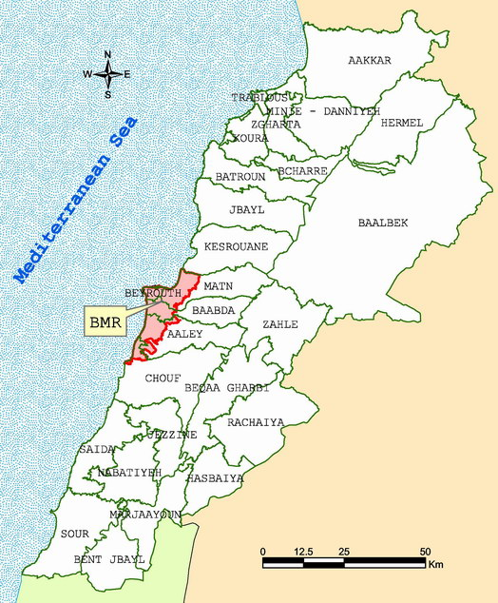
Fig. 2 Beirut Metropolitan Region (BMR)

5.1. Database Model
A digital model of the study area is the first step towards implementation of the proposed evaluation framework. Therefore, a geographically referenced digital model of the Beirut Metropolitan Region (BMR) was developed as a prototype example.
The base map includes the following data layers:
- Administrative Boundaries
- Traffic Analysis Zones
- Road Network Plan
- Rail Lines
- Geology and Faults
- Soil
- Contour Lines
- Rivers / Channels
- Landuse / Land cover
- Satellite Imagery

In this case study, an optimal new highway alignment is investigated. The South Mountain Highway (SMH) is determined to serve as a conventional highway that extends from the Beirut peripheral highway and is planned to connect the towns of Khalde and Damour in the BMR. Given the origin and destination corresponding to the proposed highway, three alternative alignments were proposed and overlaid over the BMR base map in GIS as shown in Fig. 3.

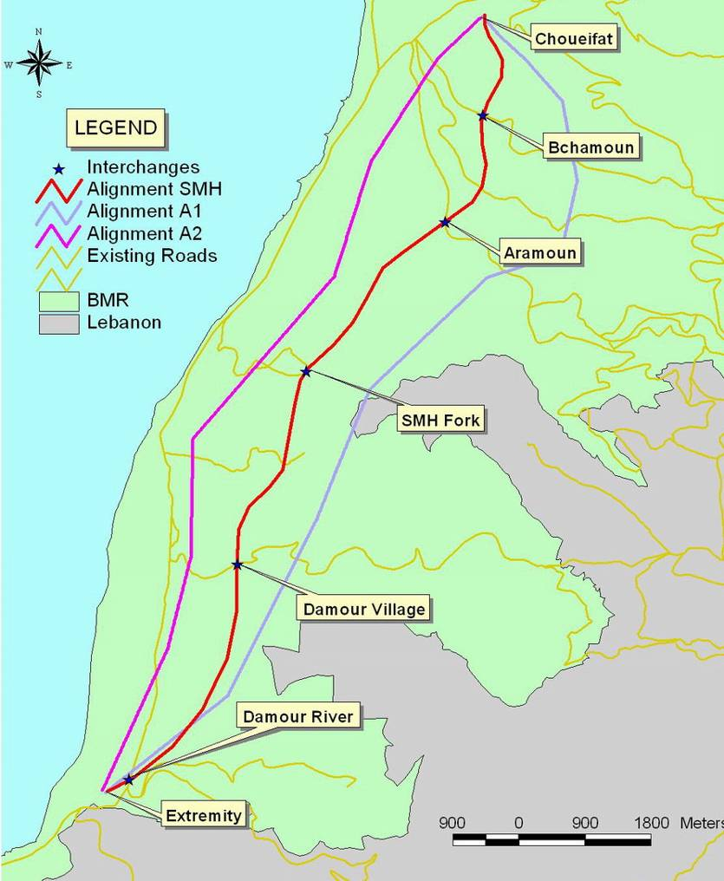
Fig. 3 Alignment alternatives for the South Mountain Highway

5.2. Alignment Analysis
Given the three proposed alignments centerlines, the GIS-based framework proposed in this study was used to evaluate each alternative against a set of criteria including: cost, environmental issues, and engineering considerations.

Cost Evaluation:
The total cost of each alternative alignment was calculated including land and building acquisition, excavation and fill costs, road structures, road works and pavement. Land acquisition costs were evaluated by intersecting 60 meter ROW buffer around each alignment alternative with landuse databases and the intersected area was multiplied by the land value for each region. Building acquisition cost was done using the satellite imagery to count the buildings lying within the expropriation buffer and then by computing its surface area and multiply it by the number of floors. Building cost per square meter was assumed to vary with landuse category; however, since no field data was available at this analysis stage, all buildings were considered to be in good conditions, and the number of floors was estimated based on the building height computed from the shadow length measured on the satellite image as in Fig. 4.
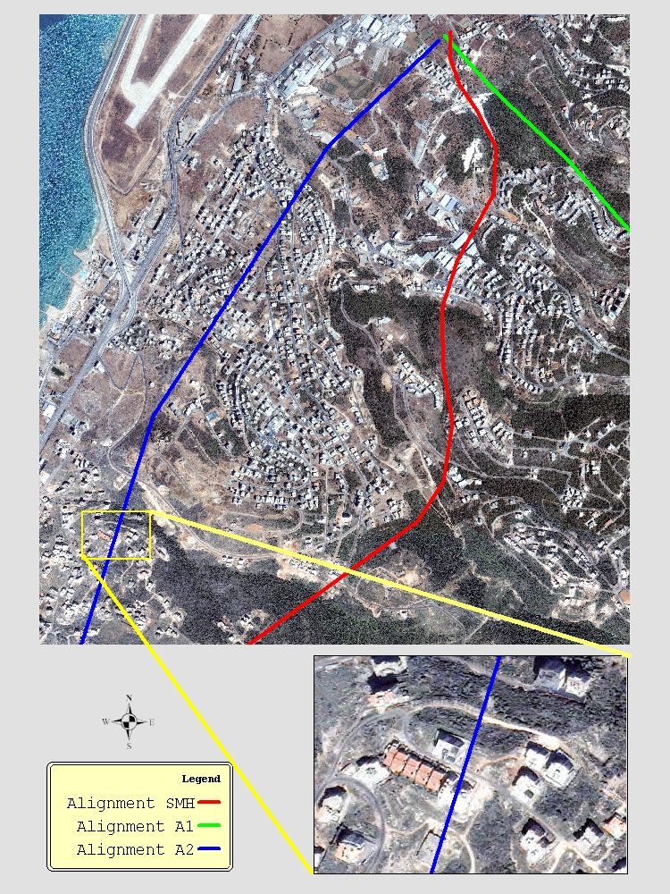
Fig. 4 Ikonos satellite imagery showing buildings shadows

The summary of the cost calculation for the alignment alternatives is presented in Table 1 with a breakdown for each component.

Table 1 Cost components and total cost ($)
COMPONENTS | A2 | SMH | A1
Buildings Acquisition | 2,860,000 | 2,400,000 | 200,000
Land Acquisition (60 m ROW) | 23,695,000 | 22,811,400 | 24,552,000
Property Acquisition Sub-TOTAL | $26,555,000 | $25,211,400 | $24,752,000
Excavation + Fill | 3,440,000 | 4,215,000 | 11,770,000
Additional Fill | 380,000 | 0 | 5,420,000
Road Structures | 1,350,000 | 1,350,000 | 1,800,000
Road Works + Pavement | 15,186,780 | 15,967,980 | 17,186,400
TOTAL | $46,911,780 | $46,744,380 | $60,928,400

Environmental Evaluation:
The only environmental criterion which was included in the assessment framework, for the purpose of the case study presented, is based on noise impact and community disruption. Other considerations such as air quality may be included in later applications by developing models which relate emissions to vehicle speeds, vehicle characteristics, traffic volumes, and other factors, possibly in conjunction with dispersion models. The extension of the assessment framework to include air quality criteria should be made easier by the fact that most of the base-data needed is available or can be generated within the described framework. The noise level contours were calculated using the U.S. Federal Highway Administration’s Traffic Noise Model (FHWA TNM version 1.0). Based on route alignment characteristics, traffic volumes, speeds, and vehicle type/classification, TNM calculates noise levels at different input “receivers”. In order to calculate noise level contours, an appropriate number of virtual receivers are positioned around the roadway. Man-made structures are automatically incorporated within the model as barriers that lie between roadways and receivers and have the effect of reducing noise levels. The relevant noise level ranges reported were taken as follows (Figure 5): less than 65 dB, 65 to 70 dB, 70 to 75 dB, 75 to 80 dB and greater than 80dB (Sadek et al. 2000). A tabulated breakdown of the results noise category and corresponding number of impacted structures within the study area is listed in Table 2.
Community disruption was evaluated by counting the number of buildings lying within a 10 meter buffer from the road edge. This was easily done using GIS buffering capabilities and the results were 1, 13, and for 12 for alternatives A1, A2 and SMH respectively.
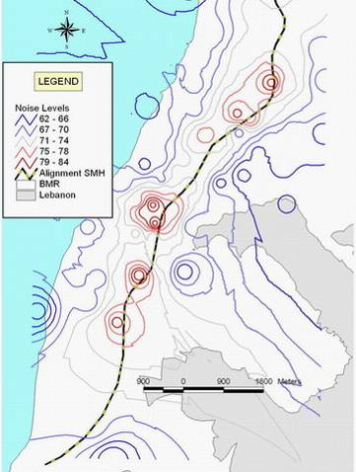
Fig. 5 Results of the noise exposure analysis

Table 2 Number of structures impacted by noise
NOISE  LEVELS | Number of Impacted Structures  within Study Area
NOISE  LEVELS | SMH-A2 | SMH | SMH-A1
< 65 dB  ≥ 65 and < 70 dB  ≥ 70 and < 75 dB  ≥ 75 and < 80 dB  ≥ 80 dB | 0  13  668  855  106 | 0  21  71  10  15 | 1  4  66  4  0
TOTAL | 1,642 | 117 | 75

5.3. Economic Evaluation
The economic benefits of the highway project were calculated based on the savings in travel time between the “with” and “without-project” scenarios. The economic monetary value of annual travel time savings was computed based on the following procedure. First, the peak-hour traffic on various segments of the proposed highway alignments was identified by vehicle type based on an extensive regional demand and network modeling exercise (ACE 1997). Next, the passenger-car equivalent of this traffic was computed, and the total peak hour pcu-kms was computed based on the length of the various segments. Table 3 presents prototypical calculations for the case of the SMH alternative.
Next, the peak hour pcu-kms are extrapolated to annual pcu-kms, and the value of travel time savings is then computed given (i) the average operating speeds for the “with-project” and “without-project” scenarios and (ii) the value of time. The average speed for the “with-project” scenario is estimated at 91 km/hr (dropping to 85 km/hr beyond 2009), while the “without-project scenario” has a measured average speed of 50 km/hr on existing alternative paths and was considered to persist up to the year 2006 as a result of pending network improvement and traffic management schemes. Beyond that time, average travel speed would gradually and linearly decline to 38 km/hr in the year 2014 (Table 3).
The economic value of time was estimated to be 2.282 $/pcu/hour in 1995 (CDR 1995). Given that the real GDP in Lebanon grew 8% in 1994, 7% in 1995, 4% in 1996 and 1997, but slowed to 1.2% in 1998, -1.6% in 1999, -0.6% in 2000, 0.8% in 2001, 1.5% in 2002, and 3% in 2003 (CIA 2004), the re-assessed value of time would be 2.65 $/pcu/hour.

Table 3 Roadway traffic used for the SMH alternative (Year 2003)
 | Choueifat – Bchamoun |  | Bchamoun - Aramoun |  | Aramoun - SMH fork |  | SMH fork - Damour Village |  | Damour Village - Damour River |  | Damour River - Extremity
 | Veh/hr | Speed (Km/hr) | Veh/hr | Speed (Km/hr) | Veh/hr | Speed (Km/hr) | Veh/hr | Speed (Km/hr) | Veh/hr | Speed (Km/hr) | Veh/hr | Speed (Km/hr)
Auto | 4432 | 100 | 5705 | 100 | 4008 | 100 | 8770 | 100 | 6695 | 100 | 4762 | 100
Medium Trucks | 136 | 80 | 175 | 80 | 123 | 80 | 270 | 80 | 206 | 80 | 146 | 80
Heavy Trucks | 61 | 70 | 79 | 70 | 55 | 70 | 121 | 70 | 92 | 70 | 66 | 70
Buses | 71 | 80 | 91 | 80 | 64 | 80 | 139 | 80 | 106 | 80 | 76 | 80
PCE | 5100 |  | 6565 |  | 4611 |  | 10090 |  | 7701 |  | 5480 |  | Total
Distance (Km) | 1.3 |  | 1.9 |  | 3 |  | 2.5 |  | 3.4 |  | 0.5 |  | 12.6
PCE  Vehicle-Km | 6,630 |  | 12,474 |  | 13,833 |  | 25,225 |  | 26,183 |  | 2,740 |  | 87,085

Finally, the Internal Rate of Return (IRR) value is computed based on the annual cost/benefit streams for the project horizon (year 2014). For the SMH alternative, the computed IRR value is 14%, representing a good rate of return in the context of similar infrastructure projects. The resulting economic feasibility for the other alternatives, A1, and A2 were IRR =10% and 13% respectively.

5.4 Alternatives Ranking Using AHP
Unlike the internal rate of return ranking methodology that only reflects the economic evaluation, the application of the proposed AHP methodology with a selected set of evaluation criteria from both alignment and operational analysis considers: costs, environmental, and engineering components. A sub-tree showing the combination of criteria used for the evaluation of the three proposed alignments operating as highways is illustrated in Fig. 6 below.

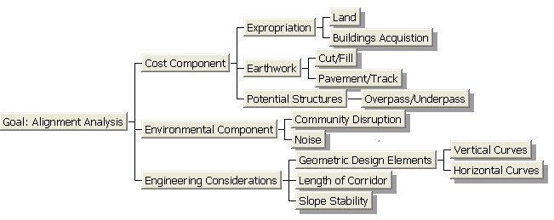
Fig. 6 A sub-tree of the evaluation hierarchy used

The GIS-based evaluation methodology described in this study for the selected criteria in the sub-tree was applied and Table 4 summarizes on the findings for the relevant evaluation criteria.
Table 4 Summary of the reports of various assessment criteria
CRITERIA | SMH-A2 | SMH | SMH-A1
Community Disruption:  Number of structures within road width + 10m | 13 | 12 | 1
Noise:  Number of structures within study area with noise level ≥ 65 dB | 1,642 | 117 | 75
Geometric Design Issues :  - No. of horizontal curves with radii < 200m  - Cumulative length of route segments  0-5% slope  5-8% slope  >8%  - Total route length | 6  12053m  0  0  12053m | 7  11405m  1268 m  -  12673 m | 7  8030m  4182 m  1428 m  13640m
Earthworks / Geotechnical:  - Slope Stability  # of sections with FS<1.0  # of sections 1.0<FS<1.5  - Cut and Fill  Cumulative Cut Volume  Cumulative Fill Volume  - Potential # of Road Structures | 0  0  3.06x10⁶ m³  3.82x10⁶ m³  9 | 0  0  4.38x10⁶ m³  4.05x10⁶ m³  9 | 8  11  6.35x10⁶ m³  17.19x10⁶ m³  12
.
The results tabulated in Table 4 were input into the AHP model in Expert Choice and the results are presented in Fig. 7. The SMH alternative is identified as the best alternative.
Fig. 7 Output result of the AHP model for the SMH case study

When comparing both evaluation approaches, the economic benefit based on savings in travel time, and the GIS-based framework proposed in this study, the SMH alignment alternative is ranked as the best alternative while the A1 alignment is the worst. The summary of the results of both approaches is listed in Table 5.

Table 5 Summary of the results from both evaluation methodologies
Alignment Alternatives | Economic Evaluation (IRR) | GIS-Based Methodology (AHP)
A1 | 10% | 0.314
A2 | 13% | 0.327
SMH | 14% | 0.360

The results are similar since both SMH and A2 are of approximately similar costs and are 25% less than the cost of the A1 alternative, which is longer in length, has more slope instability occurrences, and requires more road structures. In terms of environmental issues, the A2 alternative is the worst in both noise levels and community disruption. Therefore, when considering the economic evaluation approach, A2 and SMH had high IRR values of 13% and 14%, respectively. When engineering and environmental issues incorporated in the evaluation using the GIS-based approach, A1 and the SMH alternatives are ranked as the highest priority, with A1 being more suitable on environmental issues, while the SMH is more suitable on engineering considerations. Since cost is the dominant objective, the SMH will have the highest priority.
Fig. 8 presents the Performance Sensitivity graph displaying how the alternatives perform with respect to all objectives as well as overall. The "left y-axis" shows each objective's priority, while the "right y-axis" shows the alternative priorities with respect to each objective. As shown in Fig. 8, the SMH alternative is the most preferable alternative while the A2 alternative competes with A1 on cost and engineering considerations, while A1 competes on environmental considerations.

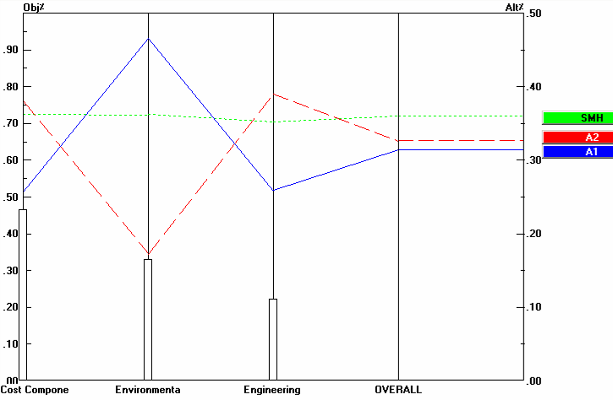
Fig. 8 Performance Sensitivity Graph.

Finally, the Gradient Sensitivity graphs presented in Figs 9 to 11 show the alternatives' priorities with respect to one objective at a time. These figures indicate "key tradeoffs" when two or more alternatives intersect each other.
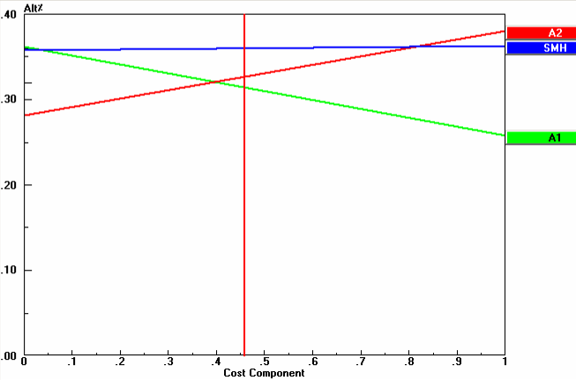
Fig. 9 Sensitivity with respect to priority of “Cost Component”

Fig. 9 indicates that when the priority of cost decreases below 0.4 the A1 alternative would become preferable to the A2 alternative; however, the SMH would remain the most preferable alternative as long as the cost priority is less than 0.8. On the other hand, Fig. 10 indicates that as long as the priority of the environmental component is between 0.2 and 0.5 the SMH will remain the most preferable alternative. Should the priority of the environmental component, reflecting noise exposure levels in this case study, exceed 0.5 then alternative A1 will be preferred. Fig. 11 shows that the SMH alternative is the most preferable for all priority values below 0.58 for engineering considerations.

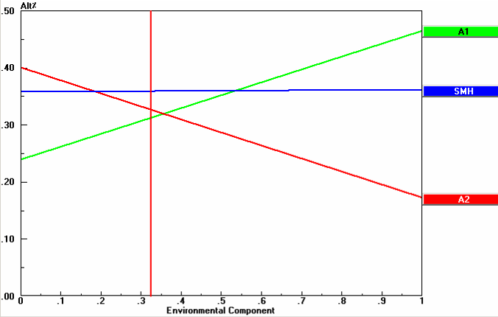
Fig. 10 Sensitivity with respect to priority of “Environmental Component”

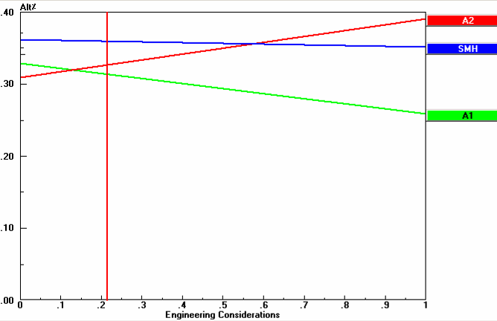
Fig. 11 Sensitivity with respect to priority of “Engineering Considerations”

6 Summary and Conclusions
This study aimed to incorporate a range of evaluation criteria into a structured GIS-based framework for corridor planning and analysis. The organization of evaluation components was based on two relatively independent levels, alignment and operational analysis. With a wide spectrum of evaluation factors incorporated in the developed framework, identifying the best alternative becomes a complex problem; in this regard a decision support approach (Analytic Hierarchy Process) was used to structure the multi-criteria evaluation task and to provide a tool for ranking various alternatives.
The developed evaluation framework was simplified and organized in two phases, by separating corridor alignment analysis from operational options. Therefore, it considers the corridor alignment analysis as the primary concern regardless of the operational scenario, and by focusing on criteria that are more related to alignment issues. In cases when the operational mode is previously decided upon, the alignments alternatives analysis can be limited to the evaluation criteria considered in the phase one of the developed framework. However, a comprehensive evaluation framework integrating all criteria still needs to be considered in the numerous cases where alignment analysis cannot be conducted in isolation of operational scenarios. Therefore, the developed framework can be upgraded to provide feedback between the two levels of evaluation and to consider different combinations where different alignments alternatives are evaluated against different operational options.
references
Bailey, K. & Brumm, J. & Grossardt, T. 2001. Towards Structured Public Involvement in Highway Design: A Comparative Study of Visualization Methods and Preference Modeling using CAVE (Casewise Visual Evaluation), Journal of Geographic Information and Decision Analysis, Vol. 5, No. 1, pp. 1-15.
Banai, R. 2000. Transit Station Area Land Use/Site Assessment with Multiple Criteria: An Integrated GIS-Expert System Prototype, Journal of Public Transportation, vol.3, no. 1.
Bedran, M. 1997. A Geographically Referenced Model of the Beirut Metropolitan Region (BMR) Incorporating Pertinent Geotechnical Properties. MS Thesis, Dept. of Civ. and Env. Engrg., American University of Beirut, Beirut, Lebanon.
Dixon, K. & Sarasua, W. & Mazur, G. 2001. A GIS Based Tool for Rural Multimodal Transportation Planning, TRB Paper: 01-2680.
Mazur, G. Dixon, K. and Sarasua, W. 2002. Statewide Planning Tool To Support Multimodal Decision-Making, Eighth TRB Conference on the Application of Transportation Planning Methods, TRB.
Green, C. & Aberman, L. & Dominik, T. 2001. Sustainable Corridors: Methodology for their Planning and Development, CSIR, Contract report No. CR-2001/48, Durban Unicity.
Hui, A. & Liew, S. & Kwoh, L. & Lim, H. 2000. Extraction and Utilization of Geometrical and Contextual Information in very High Resolution IKONOS Satellite Imagery, GISdevelopment.net.
Jha, M. & Schonfeld, P. 2004. A highway alignment optimization model using geographic information systems, Transportation Research Part A: Policy and Practice, Vol. 38 No. 6, Elsevier Ltd.
Kaysi, I. & Al-Naghi, H. 2002. A GIS-Based Translator for Multimodal Transportation Planning Software EMME/2, ICCCBE, Taipei, Taiwan.
Kaysi, I. & Kanaan, A. 2001. Structuring Feasibility Assessment of Toll Highways: The Case of the New Batinah Expressway in Oman, 9th World Conference on Transportation Research, Seoul – Korea.
Krajewski, L. & Ritzman, L. 1998. Operations Management, 5th Ed., Addison-Wesley.
Saaty, T. 2001. Decision Making for Leaders: The Analytic Hierarchy Process for Decisions in a Complex World, Analytic Hierarchy Process Series, Vol. 2.
Sadek, S. & Kaysi, I. & Bedran, M. 2000. Geotechnical and Environmental considerations in highway layouts: an Integrated GIS Assessment Approach, Journal of Applied Earth Observations & Geoinformation, Vol. 2, No. 3/4.
Turochy, R., 2001. Prioritizing Proposed Transportation Improvements: Methods, Evaluation and Research Needs, Transportation Research Record No. 1777, TRB.

