WCTRS 07
World Conference on Transport Research
Berkeley, California June 2007

A Step-by-Step Approach to
Transit Oriented Development Project Delivery

Chris Hale & Professor Phil Charles
University of Queensland
Centre for Transport Strategy
Brisbane, Australia

Abstract

A major challenge in successfully implementing transit-oriented development (TOD) is having a robust process that ensures effective appraisal, initiation and delivery of multi-stakeholder TOD projects.

A step-by step project development process can assist in the methodic design, evaluation, and initiation of TOD projects. Successful TOD requires attention to transit, mixed-use development and public space. Brisbane, Australia provides a case-study where recent planning policies and infrastructure documents have laid a foundation for TOD, but where barriers lie in precinct level planning and project implementation. In this context and perhaps in others, the research effort needs to shift toward identification of appropriate project processes and strategies.

This paper presents the outcomes of research conducted to date. Drawing on the mainstream approach to project development and financial evaluation for property projects, key steps for potential use in successful delivery of TOD projects have been identified, including: establish the framework; location selection; precinct context review; preliminary precinct design; the initial financial viability study; the decision stage; establishment of project structure; land acquisition; development application; and project delivery.

The appropriateness of this mainstream development and appraisal process will be tested through stakeholder research, and the proposed process will then be refined for adoption in TOD projects. It is suggested that the criteria for successful TOD should be broadened beyond financial concerns in order to deliver public sector support for project initiation.

Keywords

Transit Oriented Development, TOD, Brisbane, project evaluation, project management
A. Introduction

One of the major challenges in successfully implementing transit-oriented development (TOD) is having a robust process that ensures the effective development and delivery of multi-stakeholder TOD projects.

TOD projects are currently being developed in Brisbane, Australia as a response to population growth management and traffic congestion challenges. Brisbane is the capital city of Queensland on the east coast of Australia – with a population of 2 million people. A current research project being undertaken at the University of Queensland is seeking to identify institutional structuring principles for successful TOD.

This paper commences with a short discussion and definition of “successful TOD”. The paper then outlines the proposed step-by-step TOD project development and viability assessment process, drawing partly on established approaches from the property industry. For each “step”, some of the notable theory and important practice is outlined. Breakthroughs and challenges are put forward, drawing from TOD exercises currently underway in case study location Brisbane. Apparent problems in TOD practice, lack of progress in project delivery and limited attention to project-based issues in the research and literature have led to the development of this new concept for TOD project development and appraisal. In contrast to previous literature, a reasonably comprehensive method is proposed for consideration – moving beyond planning considerations and building toward full project evaluations and decisions on financial and other bases. The steps in the process represent a framework of key considerations, rather than an overly rigid or sequential set of activities. Significant project initiation activities and deliverables are outlined in distinct phases, with the economic evaluation process presented as a component within the broader project development context. The research approach consists of four broad phases, through which the method will be developed, tested and refined for use:

A. Literature review – of TOD research literature and practice guidance from the mainstream property industry - which is relatively regulated in Australia and elsewhere, and often quite restrictive about the methods applied in financial analysis. In this context, mainstream approaches to project appraisal are probably essential.
B. Formulation of Proposed Step-by-Step Process for project development. The outcome of this phase of research is presented in this paper. Steps 3 to 5 offer a proposed financial evaluation/appraisal process, while the overall method should cover the key steps in effective project development and implementation. Financial appraisal of a TOD project is put forward as a component within the larger sequence of project activities. There is a need to propose new and workable approaches in order that industry feedback can be gathered.
C. Stakeholder Research. Key informants in industry and government provide input to refine and develop the step-by-step process and achieve a relevant and useful framework.
D. Formative Evaluation. The process is applied in new projects – and further review is undertaken to gauge relevance and workability. Ongoing refinement may occur.
B. What is Successful Transit Oriented Development?

A body of TOD literature has emerged in recent years, much of it from US project examples. Another tradition of TOD-type approaches to urban development comes from Europe – where walkable locations with strong transit service and a mix of compact, dense land uses can be found in many cities. In Australia, some TOD-type examples have emerged almost “by accident”. Re-vitalisation of historical inner-city areas as locations of choice for residences and offices has occurred, largely due to transit advantages and the attractiveness of pre-car development patterns. Increasingly, the low-density outer suburbs, poorly served by transit, are recognized as locations of economic vulnerability (Dodson & Sipe 2006) and lack of lifestyle and cultural choice.

How do we recognize a successful transit oriented development precinct, given the variety of influences and approaches that contribute to their formation? Is it possible to find a definition that can prove effective across different cultural and urban contexts? Hale and Charles (2006) proposed the following working definition for TOD:

A vibrant, relatively dense and pedestrianised mixed-use development precinct, featuring quality public space and immediate access to high-frequency public transit.

This definition is perhaps more concise than other available definitions, while containing certain deeper connotations and implications. It serves to address transport and public realm issues in TOD as well as the development aspects – and if TOD stakeholders agree on adopting this definition for application in specific projects, it could prove more instructive and significant than it may initially seem. Hale and Charles (2006) also proposed that there are three essential success factors for TOD precincts. These are:

- High frequency, high capacity public transit linking the precinct to the wider metropolitan area and providing good access. The transit should be integrated sympathetically with the precinct.

- Mixed-use development with street-front retail. Longer opening hours are an indicator of success. Offices and workplaces provide a support base of customers. Residential accommodation provides additional patrons – who hold a stake in the liveability of the precinct. The development needs to be competitive and viable in the open property market.

- Public space provision that, while generous, is never too large that the space becomes empty and loses its lively character. Cafes and restaurants should intermingle with public space. Up-market design is required for public space.
C. A Mainstream Approach to TOD Project Development and Appraisal – 10 Key Steps

The key to making TOD work is to make sure that it is well coordinated across a metropolis. (Cervero 1998, p4)

TOD will naturally be predicated on regional planning policies and transport infrastructure development. In Brisbane, as an example, state government policy and planning documents such as the South East Queensland Regional Plan (OUM 2005) and the Infrastructure Plan and Program (SEQIPP 2005) have identified regional centres as appropriate locations to accommodate a substantial portion of expected growth. Under “Urban Form” (OUM 2005, p65), some principles and policies are listed:

Principle: Make the most efficient use of land allocated for urban development.
Policy: Focus higher density and mixed-use development in and around regional activity centres and public transport nodes and corridors.

A hierarchy of activity centres is categorized, with a Primary Activity Centre (the CBD); a group of Principal Activity Centres; another set of “Major” centres; and a subsequent grouping of “specialist”, “principal rural” and “major rural” centres (OUM 2005, ch8). These centres are generally well-placed with regard to existing or planned public transit infrastructure, and moves toward TOD at these locations are now dependent on efforts in localized master-planning, precinct design and project implementation. Re-development potential is substantial at many of the nominated centres. The Regional Plan seeks to promote the regional centres as locations for high quality TOD (OUM 2005, p75):

Principle: Integrate development with transport infrastructure, community services and employment.
Policy: Facilitate appropriate forms of transit oriented development in proximity to regional activity centres and high capacity public transport nodes and corridors.

Steps 3 through 5 as outlined in this paper contribute cumulatively to a process of TOD evaluation – addressing the financial and other concerns that are emerging now that the strategic-level policies are in place. Financial evaluation of the project is placed within its project context. While comprehensive planning and evaluation activities for the establishment of a major project can involve considerable cost, such expenditures represent a small component of overall project costs. Time, effort and money spent on the early stages of major projects is a worthwhile investment. TOD evaluation needs to prove financial viability, but also address other areas such as the public realm and social considerations. While regional policy in Australian cities and further afield is moving toward the adoption of TOD approaches, the authors contend that research on appraisal methods and project development strategy has not kept pace with the strategic demands of urban planning agencies. This paper offers a potentially workable process toward TOD project appraisal – with its relevance to be tested through stakeholder feedback and application to new projects in Brisbane.
Step 1. Establish the Institutional Framework

Given the long time frames and substantial investments in planning and design required for TOD projects, clear and sustained public policy favoring transit-oriented development is enormously important. (Dittmar & Ohland 2004, p66)

Establishment of an institutional framework that supports TOD projects is essential (TCRP 2004, p39; Dittmar & Ohland 2004, ch4). The stronger and more flexible the framework, the more likely that a series of viable TOD projects will be established, rather that one-off “test cases”. Initially, there is a requirement to identify the diverse range of key stakeholders and their role in project development (Hale & Charles 2006; Dittmar & Ohland 2004, ch3). It is then important to establish a forum through which these stakeholders can coordinate and retain a voice in the development process (Hess & Lombardi 2004, p27-29; TCRP 2004, p102).

With several parties needing to coordinate planning activities, it is often necessary for one entity to take the lead. (Hess & Lombardi 2004, p28)

It has been suggested that transit agencies are logical project leaders or champions (Hess & Lombardi 2004, p28; Dumbaugh 2004, p50; TCRP 2004, p40; Hale & Charles 2006)

The strategic visioning process for TOD needs to start at the regional and metropolitan scale and pursue the development of a network of TOD centres (Hess & Lombardi 2004, p71; TCRP 2004, p61). Goals, objectives and parameters need clarification (Curtis & James 2004, p279).

For metropolitan regions seeking to establish TOD programs, the initial challenge is the development of a clear and supportive institutional framework for TOD. This includes the establishment of agreed criteria for TOD project selection. This task should be undertaken among partners and in light of identified objectives. Importantly, we should not assume that any one particular institutional arrangement will be applicable in all cases, or that we need to establish a structure that is final, rigid and not open to adaptation and change.

Brisbane’s Approach

The State Government - Office of Urban Management’s South East Queensland Regional Plan and Program (the “SEQ Regional Plan” – OUM 2005), in conjunction with the parallel South East Queensland Infrastructure Plan and Program (SEQIPP 2005) have laid out a planning and infrastructure framework based on growth boundaries, relatively compact growth principles, an emphasis on activity centres and a role for TOD.

The transit sector has indicated a level of commitment to TOD through the Translink Draft Network Plan (Translink 2005), and the Integrated Transport Planning Framework (ITPF 2003, p4). In addition, Brisbane City Council has released the City Centre Master Plan which repeatedly identifies the need for TOD as well as exhibiting strong support for urban design principles such as walkability, transit service and public open space provision (BCC 2006). Local governments throughout the region are currently preparing Local Growth Management Strategies (LGMS) that seek to incorporate TOD principles in the vicinity of significant transit stations (OUM 2005, p15).

A TOD “task force” has been established by OUM, as recommended in the SEQ Regional Plan (OUM 2005, p123). The taskforce comprises OUM staff, other public sector staff, local government representatives, academics and development industry participants.

The Way Forward

While the high-end planning framework and principles for TODs have been established, the challenge is now to ensure that the LGMS represent an appropriate response to the significant opportunity for new TODs to accommodate population growth. This challenge includes the application of advanced design and other skills in the preparation of local structure plans or master plans. While the LGMS represent a compulsory ‘regulated’ approach to moving TOD planning forward, there is a need for success-oriented commitment toward producing high quality local TOD plans. Perhaps a lead TOD agent for each major region or locality should be identified, with the responsibility to develop and deliver TOD projects in their area. It may be that additional education and awareness programs for the benefit of local government and industry will assist in building broader understanding and commitment.

Recommendations for Regions Pursuing TOD

Significant commitment has been given to TOD by Government in Queensland –exercised primarily through planning and transport policy. This may be instructive to other cities and regions seeking to shift toward more sustainable approaches to development. Equally, we might suggest that there is something to be learned in the lack of progress on clear allocation of roles for stakeholders. Additionally, there has been limited progress toward formulating an agreed set of potential project structures - incorporating public and private activity and input.

The need to establish a clear institutional context for TOD seems to be broadly applicable.

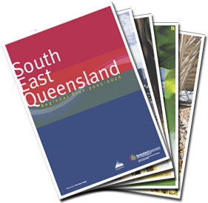

Picture: The OUM SEQ Regional Plan 2005
Step 2. Location Selection through Regional Strategy

The Step 2 requirement is to identify potential locations that fit with agreed policies, directions, and project selection criteria. Once the available locations are identified, TOD teams are in a position to target the most promising locations for detailed investigation.

TOD theory tells us that to be successful we need to position TOD projects at locations that are well-served by frequent, high capacity transit - linking the particular TOD precinct effectively with the metropolitan region and offering connections to key destinations (Swenson & Dock 2004, p71; Hendricks et al 2005, p7-9; TCRP2004, p463). In the absence of strong existing transit services, planned or upcoming infrastructure might provide or indicate appropriate locations (TCRP 2004, s-12, p462).

As TODs are significant land use initiatives, we must be sure that potential TOD locations offer adequate land for development. As with any development exercise, TOD is seeking to create and build the intensity of land use beyond what already exists (TCRP 2004, p469). Key transit stations with under-developed precincts in their vicinity should be seen as the primary target areas.

Rather than wait and react, today’s TOD mindset is one of getting out in front and shepherding land-use changes to achieve a desired built-form outcome.
(TCRP 2004, p469)

For the metropolitan region looking to pursue TOD, a preliminary short list of preferred precincts can be drawn from the most advantageous locations available throughout the transit network (and planned network) or from the hierarchy of activity centres. Locations offering multi-modal connectivity and greater service frequency, or potential for strong patronage are obvious choices. Early and very basic assessment of relative planning and development advantages will assist in the selection of target sites. The eventual list of sites can then be selected according to some selection criteria, these locations will then receive project development attention.

Brisbane’s Approach

Transit oriented development principles for SEQ.
Location – Level of infrastructure and services: Focus development around nodes or corridors where infrastructure capacity exists or can be created. Locations with high levels of transit service frequency should be given priority. (OUM 2005, p77)

Major transit infrastructure projects are currently in planning, including a Northern and an Eastern Busway (Translink 2005) to complement the highly successful South Eastern Busway – and these projects should provide a variety of locations. In addition, the existing transit network seems to offer opportunities, as many of the stations in the rail and busway network are not surrounded by intensive land use. The Translink Network Plan (2005) refers to 59 “key stations” – and this set of locations provides an excellent starting point for a review of TOD opportunities.

Office of Urban Management’s (OUM) LGMS guidelines (OUM Feb 2006, p15) suggest that local governments:

Identify areas suitable for transit oriented development and whether it is proposed to prepare a structure plan or master plan for the area or part of the area.

In addition, the OUM have developed “Interim Criteria for Transit Oriented Development Location Identification”. The aim is to assist local governments in identifying appropriate areas (OUM Jul 2006, p2). Some of the suggested considerations include: transit (including level of service); infrastructure context; land availability; market interest; amenity; role of the node or location within the broader network; potential development impacts; existing or future potential for connectivity, accessibility and integration; and the ability to deliver mixed land use.

The Way Forward

“Interim” TOD location selection criteria have been developed in Brisbane, so perhaps the logical next stage is to develop the criteria beyond interim status.

The challenge in Brisbane appears to be represented by one word – timing. In a growth environment, the major concern at this point would be that inappropriate development occurs in an ad-hoc fashion or with poor design values at the important locations available throughout the transit network. Perhaps some attention to the development referral mechanism is required so that transit agency referral powers are effectively exercised over proposed developments within a certain radius of key transit stations. This mechanism is already available for local government planning decisions that incur state government policy implications (England 2004, ch1). Lack of attention to timeliness in TOD might also create problems in achieving value capture.

An alternative approach to the identification of TOD precincts and projects might be to invite proposals from experienced industry participants – either for nominated locations or according to the preferred locations of proponents.

Recommendations for Regions Pursuing TOD

The principle of actively reviewing and selecting TOD locations on the basis of regional strategic considerations seems to be functioning effectively in Brisbane at this stage – and this step would seem to be relevant, necessary and broadly applicable wherever TOD is pursued.
Step 3. Precinct Context Review

Once the metropolitan region has identified its target locations, initial TOD project development at the precinct level requires a review of contextual and planning issues as well as a detailed investigation of transit service and infrastructure with the intention of accumulating background information on which later project activities can be based.

Generalised information gathering activities at this stage might include; a review of existing uses in the area, a look at demographics and employment characteristics, as well as the identification of other upcoming developments in the area. An important aim in project appraisal activity is to deliver an early estimate of the floor space and number of residences that might be developed. Swenson & Dock (2004, p78) review their case studies in terms of both the planning and transit context, with an eye on existing parameters as well as the prospects for improvement and growth. In planning, the basics of supportive area plans, zoning for sufficient densities, walkable precinct design, and workable parking requirements are important (Dittmar & Ohland 2004, ch4 & p70; Hendricks 2005, p9; Hess & Lombardi 2004, p28).

For contextual assessment processes, the Australian Property Institute (API) Feasibility Study Guidance Note establishes the need to review the planning parameters of development projects. Firstly, it suggests a review of the site itself and the planning context (API 2005, p273), including: a look into “Planning and Other Statutory Requirements”; “Planning Permission” – incorporating as-of-right entitlements and a review of risks involved in seeking development approval above that allowance; “Planning Policies” as they influence the supply of similar buildings; and finally “Particular Issues” which might include anything from heritage or environmental controls to existing planning permissions and conditions, building and other impacting regulations, or perhaps the infrastructure context.

For the transit context, we need to investigate the level of existing and planned infrastructure and service as well as wider connectivity (Hendricks 2005, p7). This might involve building an understanding of the frequency of service, operating hours, current and projected capacity, connectivity and travel times to other locations in the network (such as the CBD). Inter-modal connections (bus to rail for example) are of particular interest. The station environment is also extremely important, with locations that already have high quality stations, or those expecting to see renovation or replacement also providing strong opportunities.

Both planning and transport context need to be reviewed with a view toward lifting outcomes and making improvements in these areas. Project developers need to assume that major TOD activities involve a significant level of change and development beyond current conditions.

Brisbane’s Approach

Transit oriented development proposals under consideration in 2005 include redevelopment focused around Milton, Bowen Hills, Cleveland, Albion, Park Road and Buranda railway stations; Woolloongabba busway station; and Southbank busway and railway stations. (OUM 2005, p75)

In terms of analysis of sites, once again the OUM (Jul 2006) “TOD selection criteria” provide a clear qualitative overview of the particular issues that require attention and consideration. No contextual, planning or transport review has been presented to the public on any potential TOD location as yet.

The Way Forward

Firstly, the list of precincts outlined above is not comprehensive with regard to the extent of opportunity available in Brisbane. New sites of potential, in association with the upcoming busway projects are not officially recognized at this point, neither are all of the nominated activity centres or major transport nodes under current consideration. Secondly, progress on identified sites has in the most part been slow. There have been few official announcements or releases on these key locations subsequent to the early 2005 release of the Regional Plan document. Perhaps to some degree this represents concern over the potential for unhelpful land speculation activities. Alternatively, it may be that efforts in contextual review and early project development at many significant precincts are simply inadequately resourced or have not yet been established. Initial precinct planning and project development will require a variety of staff with the full armoury of skills and qualifications (including land economics, engineering, design, finance, transport and planning). Preparatory TOD activities will require leadership and accountability, and a concerted drive to achieve progress in project planning and initiation.

Recommendations for Regions Pursuing TOD

The application of a “Step 3” process seems to be necessary in Brisbane and this should be instructive to regions pursuing TOD. Precinct planning and context review needs to be delivered in a timely manner for project development and assessment purposes – and Brisbane’s lack of clear progress may also be instructive.

Step 4. Preliminary Precinct Design

The creation of precinct design sketches will assist in both the visioning process and the identification of development potential.

“…make an accurate assessment of physical development which can be accommodated on the site, having regard to site characteristics and the likelihood of obtaining permission. This assessment may be undertaken in consultation with appointed project consultants, such as architects and quantity surveyors…” (API 2006, p274).

Design considerations for TOD precincts are central to project success (TCRP 2004, p104, 169), with quality design said to bring a range of benefits (Bell 2005, p93,96). Dittmar and Ohland (2004, p30-32) suggest the creation of lively, walkable, dense, mixed-use, precincts. Gehl (2006) and Hale & Charles (2006) have discussed the role of public open space. Holt-Damant (2005) has suggested that the transit station itself plays a fundamental role in the success or otherwise of a TOD precinct.

Developers are fond of using sketch plans to understand the possibilities of larger development parcels. This represents the preliminary urban design exercise. The purpose of this activity, during an evaluation or project development phase, is to better understand development potential - to firmly identify potential configurations of streets, open space and building footprints – and to provide effective estimates of residential and commercial floor space parameters.

Brisbane’s Approach

New publicly-released precinct designs for significant locations directly connected to transit stations are few and far between in Brisbane at this stage. As an example, the Woolloongabba area has seen the presentation of a “structure plan” which is based on future potential rather than firm proposals.

The Way Forward

The “precinct design” stage represents the next phase for serious TOD activity in Brisbane, given that the metropolitan planning context has been established and given that precincts with significant TOD potential are readily identifiable. Alternatives in precinct design development include; design charettes, competitions or design proposals from potential developers or a design panel. These approaches would be possible once the preparatory activities delivered through stages 1 to 3 were completed.

Recommendations for Regions Pursuing TOD

Lack of progress on this basic element of the project development and appraisal process is instructive. The publication of clear designs and the formulation of firm proposals is essential in delivering progress toward TOD implementation.

Step 5. Initial Viability Study

Having gathered all the necessary information on planning and transit and an outline of the project design parameters, the initial project viability study can be delivered. This consists of both a financial viability study (business case) and a review of public interest.

The mainstream property development appraisal approach in Australia is outlined in the API Professional Practice manual “Feasibility Studies” (API 2006 – Guidance Note 5). This approach (perhaps more accurately referred to as “viability” study) gives a strong indication of the activities required to deliver certainty in the financial evaluation of TOD projects. API (2006, p272) list the stages in a feasibility study as: a) obtaining instructions on development scope; b) preparation and collection of information; c) evaluation of development potential; d) estimating development costs; e) assessing value on completion; and e) determining profit margin and rate of return.

Rigorous application of the recommended steps 3 and 4 outlined in this paper will contribute to a similar process of information gathering – leading on to comprehensive TOD financial evaluation, decision making and project establishment. The importance of further development in TOD project evaluation frameworks has been identified in the TCRP (2005, p473). Analysis of expected TOD project cash flows requires careful attention (Dittmar & Ohland 2004, p93). It is also essential to provide an assessment of project social and community impacts. The TCRP (2004, ch7) puts forward a discussion of items that might be of interest in any review of public benefit for a proposed TOD project. Benefits are said to include: increased transit ridership (a significant environmental benefit); joint development opportunities; urban renewal; economic development; and improved land values.

The financial appraiser will need to find comparable developments for relevant information on potential revenues. Engineers (or quantity surveyors) will be consulted for independent advice on project costs and project timelines. If the cost of land is a known factor, a complete set of project financial variables is at hand and expected returns can be calculated. If the land purchase parameter (“residual land value”) remains under investigation, hurdle rates of return can be applied. TOD Development Corporations, Urban Renewal Corporations, or TOD teams working for transit agencies may wish to apply their own hurdle rates of return. The mainstream hurdle rates seem to be a workable, but not inflexible guide for TOD projects, and these are generally around 20%+ Internal Rate of Return (IRR). Although the financial appraisal approach is firmly established in private industry, government agencies are often not familiar with the practice and may not have a capability readily at hand.

The public interest study will need to incorporate an appraisal of the community, social and environmental impacts and benefits of any proposed TOD project.

Brisbane’s Approach

As yet, the key parameters, agreed aims and hurdle rates of return for TOD financial viability studies have not been fully developed in Brisbane. Neither are comprehensive social, environmental and economic assessment methods in place.

The Way Forward

Financial viability studies are an important step that needs to be taken in order to pave the way for any TOD activity. The private sector approaches are workable and highly developed and seem to provide direction – but transport and other issues also need to be incorporated into a broader project evaluation process. Public benefit would clearly be well-served by the positives identified in the TCRP and elsewhere, but negative or perceived negative impacts should also be accounted for.

Recommendations for Regions Pursuing TOD

Project appraisal needs to clearly establish that the wider public benefits, as well as the financial positives, outweigh the costs (both quantifiable and qualitative). To ensure this outcome, comprehensive evaluation methods and frameworks need to be developed. Delivery of this step is relevant and important to all cities pursuing TOD.

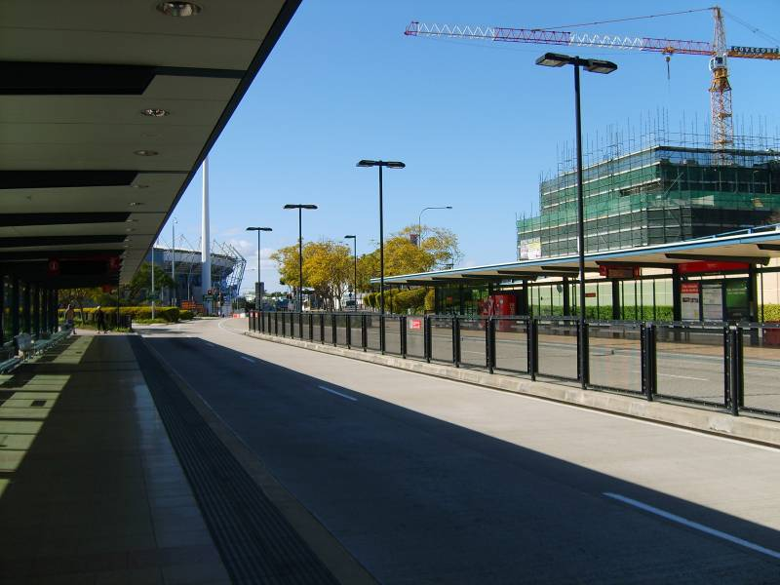

“Potential Unlimited” - but coordinated and success-oriented processes perhaps missing
Woollongabba Busway Station August 2006. Photo: C Hale
Step 6. Decision Stage

The validation phase: During this phase, major program characteristics are validated and program risks and costs are assessed, resolved, or minimized. An affirmative decision concerning further work is sought when the success and cost realism become sufficient to warrant progression to the next phase. (Cleland & Ireland 2002, p48)

TOD developments will require that full due diligence is complete before formal project initiation. Project intitation will most likely be a political decision. If the preliminary evaluation is complete, and the development meets hurdle criteria, the benefits of initiating the project should become clear.

The Project Management Body of Knowledge (PMBOK 1996, p13, 30, 49) refers to the “demonstration and validation” stage and to the “initiating processes”. This process is said to require: a clear description of the project; a strategic plan; and reference to project selection criteria. The tools for the decision process include“benefit measurement” (usually economic modeling) and expert judgment (PMBOK 1996, p50).

Hendricks refers to the importance of developing “performance indicators” in the broader context of TOD evaluation (Hendricks et al 2005, p37), while the TCRP (2004, p473) have identified this as an area that requires more detailed research and investigation.

Brisbane’s Approach

While there is limited experience to date in decision-making specifically for new TOD projects, broader frameworks for public sector decision making are in place. These processes will probably be the starting point for TOD decisions. The Public Private Partnerships Guidance Material (PPPGM 2003) states that decision making for major projects involving cooperation between the public and private sector should ‘safeguard the public interest’ by paying attention to: affected individuals and communities; public access; social equity; consumer rights; security; privacy; accountability and transparency; and cost effectiveness.

The Way Forward

Decisions should rely on quantitative analysis of project parameters and estimated financial performance, as well as a qualitative review. Decision makers could base their verdict on policy, planning, social, environmental and commercial considerations – with public investments in TOD needing to be cost effective and broadly beneficial.

Recommendations for Regions Pursuing TOD

We recommend that interested parties consider the development of a comprehensive analysis, evaluation and decision-support framework. The method outlined in this paper may provide a starting point after further testing and refinement.
Step 7. Establish the Project Structure

To pursue the project, there is a need to establish the development entity under which real estate will be held and developed. TODs, including those with strong public sector involvement, will need to create an ownership vehicle through which project equity, risk and reward can be aportioned. In addition, the preferred project steering mechanisms for TOD activity need to be clarified. TODs need a working entity through which development management activities are carried out.

According to Curtis & James (2004, p282, 294) project structural models for integrated land use and transport projects will need to offer function, organization and accountability. They put forward the West Australian Landcorp model as a project structure that has functioned effectively in TOD. The TCRP suggest that a range of institutional structures are possible (TCRP 2004, p51,52). Hale and Charles (2006) have suggested so-called Special Purpose Vehicles (SPVs) for equity-based project arrangements, in line with the Australian development industry’s widespread adoption of this approach (Robertson 2004). They have also proposed a publicly-owned TOD Development Corporation as the preferred project steering framework, as has Newman (2005, p6), while Curtis & James (2004, p283) use the terminology ‘strategic body’.

The TCRP (2004, p78) points out that equity-based agreements are workable and common in US TOD examples, and Dittmar & Ohland (2004, p92) suggest that transit agencies support their implementation.

Over three quarters of surveyed transit properties with joint development projects have equity partnerships… (TCRP 2004, p78)

Additional project structural considerations revolve around resourcing and staffing - with adequate skills and the right people required (Dittmar & Ohland 2004, p85)

Brisbane’s Approach

There has been limited progress to date in the establishment of TOD project structures.

While positive and successful outcomes may be achievable on some sites under the existing processes and regime, it is the Property Council’s view that many sites will require alternative governance models. That is, mechanisms outside existing arrangements. (PCA 2005, p49)

The Property Council of Australia (PCA) has put forward some firm proposals for TOD project structure. Perhaps counter-intuitively, they suggest a strong and over-riding role for the public sector in TOD project steering, establishment and financial structuring.

The Property Council proposes that a Transit Oriented Development Corporation must be established and specifically empowered to assemble land, upgrade infrastructure and approve developments in order to achieve a series of sub-regional teams to oversee TOD ‘icon projects’. (PCA 2005, p49)

The Way Forward

The preferred model at this stage in SEQ and many other locations seems to be for the private development industry to drive projects from the outset, though as yet there have been few, if any, public representations from the local industry to suggest that they greet this concept with enthusiasm. The Property Council’s recommendation for a TOD Corporation perhaps deserves further consideration.

The challenge lies in adopting and developing a project steering and ownership model that can balance public and private input, and link financial commitment with control and responsibility. The equity partnership approach, through SPVs, is widely recognized as an effective model. Project managerial considerations need to be similarly balanced. Where a particular party provides only a low-level of financial commitment, their role in TOD projects might be more advisory in nature.

Recommendations for Regions Pursuing TOD

We recommend that regions undertaking TOD establish a project structure that is suitable to project context, and that they adopt “establishment of project structure” as a formal step in their project development process. This probably involves choosing from a range of available approaches. Many regions seeking to further a TOD program seem to face similar challenges in applying workable project structural models.

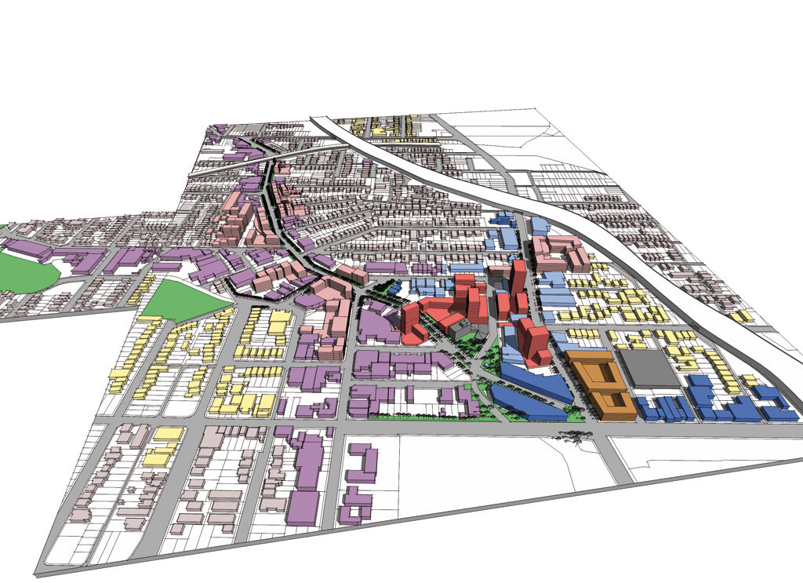
Woolloongabba Structure Plan – Courtesy BVN architects
Step 8. Acquire Land

Once an experienced development team is in place and the project is conceptualized, the next step in the real estate development process is gaining control of the site.
(Dittmar & Ohland 2004, p86)

The development entity has been established, land value calculated and a decision made to go ahead, subject to cost-effective acquisition of land. The project champion must now close the negotiations for land purchase.

Dumbaugh (2004, p50) discusses the importance of land assembly in establishing TOD projects. The TCRP (2004, p72) initially seem to suggest that it is not important who carries out the purchase and assembly – as long as it is carried out. Later in their analysis they acknowledge that this seems to be a task which is perhaps best carried out by the public sector (TCRP 2004, p111,112).

Brisbane’s Approach

No formal process or legislative enablement has been established for the purposes of statutory land acquisition related to TOD projects. This implies reliance on commercial negotiations for assembly – or might it be interpreted as a significant unresolved hurdle.

The Way Forward

The land acquisition and assembly process represents a significant TOD step – and formal process and frameworks must be in place to guide public sector organizations through this challenging process. This may involve legislative enablement, or it might imply a stronger focus on standard negotiation-based approaches toward land-holders.

Strong negotiators can usually find a mechanism whereby land owners share in any value uplift. This might involve an upfront cash purchase to the value of the land, plus an offer of further payment conditional on development approval within favourable parameters. Developers generally use conditional contracts of purchase, subject to final due diligence investigations and successful development approval. TOD projects would seem to have similar requirements to mainstream projects in this phase, although public sector rules and policies might hamper progress.

Recommendations for Regions Pursuing TOD

We recommend that regions with an interest in TOD develop a guidance framework for land assembly and acquisition. Stakeholder feedback obtained during further testing and refinement of the step-by-step process should provide greater clarity on the parameters of a workable acquisition processes.

Step 9. Development Application

A development application should be prepared and lodged as soon as practically possible. This involves further detailed design work and more planning input. The private sector developer would ordinarily weigh the pros and cons of making an application for as-of-right development approval, or alternatively seeking development allowances above this level.

Dittmar & Ohland (2004, p85) identify this process as a significant project risk factor:

Entitlement risk is the risk is the risk associated with securing the approvals, zoning and permits critical for the project to be built and occupied.

The TCRP suggest that unnecessary delay and risk can be avoided at this stage if metropolitan planning has provided appropriate localized zoning (TCRP 2004, ch4 & p63)

Planning policy for TODs will preferably have been established such that increased density is part of the “as of right” development allowances within proximity of key stations. Planning consultants will provide advice on this issue, prepare the application and liaise with local government during the review process.

Brisbane’s Approach

The current intention in Brisbane seems to be to cultivate local area planning and zoning in order to allow development approvals with the level of density that TODs need in order to be effective in land use and transport terms. This target should be in sight on completion of the LGMS process (OUM Feb 2005).

The Way Forward

In the absence of effective TOD local area planning (designated for full completion some time after 2007 in the Brisbane example), uncertainty remains and timing concerns abound. It is not clear how TOD might be advanced where new transit projects are in motion (requiring almost immediate precinct design and project development activity) but where local planning schemes are not yet in place.

Recommendations for Regions Pursuing TOD

For all cities involved in furthering TOD-style development, planning schemes need to be formulated that support appropriate development applications. In any TOD project development process, the development application is a vital step – and in appraisals, the planning application risks need to be reviewed. All planning-based activity on a TOD project should be targeted toward the submission of a strong planning application. Supportive localised planning needs to be delivered prior to or in co-incidence with initiation of transit infrastructure projects
Step 10. Project Delivery

As with most real-estate development, TOD occurs largely through the private marketplace. (TCRP 2004, p76)

Once the preliminary activities are concluded, the project team can finalise design, build the project and manage it once completed.

Cleland and Ireland (2002, ch11, p378) discuss the various phases of projects – including the “execution” stage. They also discuss the importance of planning for effective project delivery and the need for project control systems to deliver complex projects. The project control systems consists of: establishing standards, observing performance, comparing actual performance and taking corrective action.

The Project Management Body of Knowledge (PMBOK 1996, partC) outlines some important “project knowledge areas” that should be addressed in the TOD delivery phase. These include: project integration management, scope, time management, costs, quality, human resources, communications, risk and procurement. Dittmar and Ohland (2004, p85) also identify staffing and skills issues in TOD:

A successful development team will have the range of skills needed to mitigate four risks associated with a real estate development project: entitlement risk, construction risk, financial risk and market risk.

Clearly, market exposure and performance is a major concern in TOD projects (TCRP 2004, p76, 84, 86; Dittmar and Ohland 2004, p86). As risk and reward are inter-related, it is suggested that some level of market exposure be maintained by the public sector in order to allow value capture. (TCRP 2004, p174-176; Dittmar and Ohland 2004, p6, 26)

Attention should be paid to project timing – so that the market is met at the most opportune moment. In the private sector, speed of completion is a strong motivating factor due to the impact on project financial returns. Project cost is a perennial concern, but revenue maximization also needs attention. Successful project management and delivery is often said to rely on adequate project resourcing and the application of appropriate development management skills. TOD Corporations might undertake a strategy that involves subdivision of the site and sale of key parcels to developers at a rate that more than covers the costs of design, planning and land amalgamation. This approach would reduce market exposure risks, while maintaining an opening for value capture, and fully funding strategic intervention for regional TOD objectives.

Brisbane’s Approach

The Regional Plan’s established approach to TOD projects is heavily oriented toward the private industry taking on all project risk and return considerations. This implies at least a nominal understanding of the importance of market dynamics in TOD projects, but perhaps overlooks public sector access to revenue and value capture opportunities. Additionally, a more realistic assessment of developer strengths and weaknesses in TOD may be needed, given their limited experience in TOD implementation.

The Way Forward

So far, the importance of timeliness in project activities, so crucial in the project delivery phase, has not necessarily been in evidence during the process of moving from TOD policy foundations into project activities.

Project resourcing for TODs is also an area that will present challenges in any environment where project professional staff and on-site workers are in reasonably short supply. Clear attention needs to be given to the establishment of project teams that are efficient, flexible and capable of long-term cohesion and retention of project knowledge.

The goal of value capture needs to be an overarching objective, as returns and recovery of expenses are only available toward the end of a project life span – after careful but at times risky development activities.

Recommendations for Regions Pursuing TOD

All cities and regions interested in the creation of TOD precincts need appropriate frameworks and processes for project implementation. Steps 1 through 9 represent a broadly applicable series of items that need to be check-listed if the project delivery stage is to be initiated on a firm footing, while steps 3 to 5 allow a meaningful project appraisal to be formulated. All TOD activities prior to project implementation (step 10) need to take the demands of the construction and marketing phase into account.

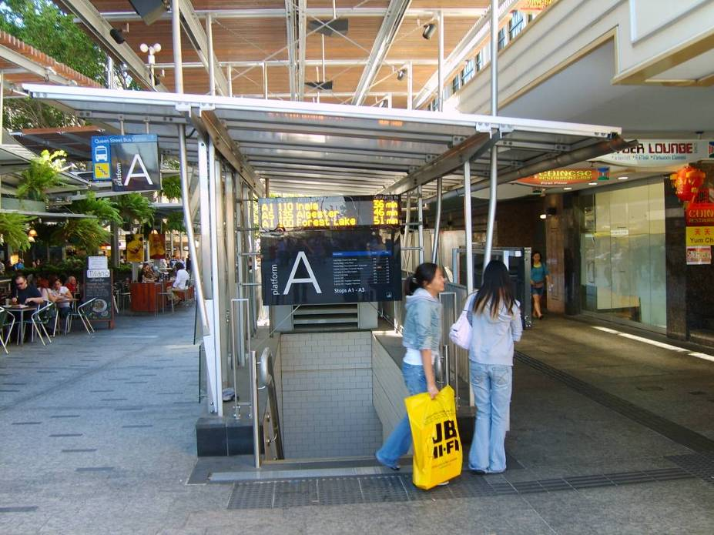

Queen Street Mall, Brisbane April 2006. Photo: C Hale
D. The Research Process from Here

This paper has outlined what the researchers feel is a workable approach to TOD project development and financial appraisal. Attending to the phases outlined here should result in a clear evaluation of project fundamentals and prospects for profitability – within a wider set of steps toward project delivery. In formulating this approach, the literature on TOD has been consulted, as well as that on mainstream project development and property financial analysis. The main function of this paper is to propose the process in the context of peer reviewed publication.

The next phase of the research will involve researching and establishing stakeholder feedback as to the workability of the process. This will involve surveys and interviews with key informants in industry and government. During this phase, it is expected that opportunities for further refinement and development of the process will arise.

A final stage in the rigorous establishment of a viable project development process for TOD will be to apply this process in the project development phase of a real-life project and to elicit further stakeholder and informant feedback on the performance of the model. The approach has already drawn on direct project experience in the establishment of TOD projects, and on preliminary input from a related series of stakeholder research interviews (still underway) - but its applicability to a wider market of TOD projects will be well-served by further exposure through peer reviewed formats.

E. Conclusions and Recommendations

In this paper, we have proposed that high quality transit, mixed-use development and public space underpin the success of TOD projects and represent key project objectives. The South East Queensland region has seen the introduction of new planning policies and infrastructure development proposals – and these lay a foundation for greater levels of integration in land use and transport, as well as supporting TOD at ‘activity centres’. These principles and policy approaches seem to be broadly applicable.

Ten steps have been proposed as a route toward the successful establishment and delivery of TOD projects. Within these 10 steps, a self-contained module of project appraisal tasks is put forward. It is recommended that project appraisal activities are not considered separately from the larger task of developing a livable and functional transit precinct.

A final recommendation is that TOD stakeholders should avoid ad-hoc TOD-related activity and instead focus on methodical completion of the steps outlined here – or a similar series of pre-agreed milestones. Mainstream project management theory and practice point to the need for a staged process through which key deliverables and project steps can be completed in a timely manner. This process should move relatively rapidly and smoothly beyond initial strategy and planning-based project activities, into a round of project financial appraisal-based milestones, then through to decision making and organization of project structure – and finally into the project delivery phase itself.
E. The 10-Step Checklist

Step | Title | Outcomes/Deliverables | Scheduled Completion | Date of  Completion
1 | Establish the Framework | Establish clear policy framework to support TOD on a regional basis.
2 | Location selection | Use selection criteria to establish a listing of potential TOD locations or precincts. Select preferred location.
3 | Context review | Review planning context, transit infrastructure and service at selected location.
4 | Preliminary precinct design | a) Undertake design exercises to establish a vision for the precinct.  b) Define the development parameters: Street network; building footprints; public open space; floor space (office/retail/civic/res).
5 | Initial viability study | a) Preliminary evaluation of business case (NPV/IRR/Revenue/Cost/Profit).  b) Identify and evaluate social, economic and environmental impacts.
6 | Decision stage | Clear decision to either initiate or shelve the project – based on evaluation and review carried out previously.
7 | Establish the project structure | Establish relevant and effective project structure - linking decision making and project steering with financial responsibilities. Balance and clarify scope of public and private input. Establish equity partnership via Special Purpose Vehicle (SPV).
8 | Acquire land | Undertake land acquisition in a timely and cost effective manner. Pool land assets into project SPV.
9 | Development application | Apply for development permit/entitlement and secure delivery.
10 | Project delivery | a) Deliver completed project through appropriate resourcing and management methods.  b) Manage project revenues, costs, timing and risks effectively to achieve profitability and a livable, functional precinct.

G. Bibliography

API – Australian Property Institute (author and publisher) (2006) Professional Practice 5thEdition: Guidance Note 5 – Feasibility Studies Deakin, ACT: API 269-284

BCC – Brisbane City Council (author and publisher) (August 2006) Brisbane City Centre Master Plan 2006 Brisbane: BCC

Bell, D (2005) “The emergence of contemporary masterplans: property markets and the value of urban design” Journal of Urban Design, Vol10, No.1 2005 81-110

Cervero, R (1998) Transit Metropolis – A Global Enquiry Washington DC: Island Press

Cleland, D I and Ireland, L R (2002) Chapter 8: “Organizing for Project Management”
Project Management – Strategic Design and Implementation Singapore: McGraw-Hill (fourth edition).

Curtis, C and James, B (September, 2004) “An Institutional Model for Land Use and Transport Integration” Urban Policy and Research – Volume 22, Number 3, September 2004 277 - 297

Dittmar, H and Ohland, G (2004) The New Transit Town Washington, D.C: Island Press.

Dodson, J and Sipe, N (2006) Suburban Shocks: Assessing locational vulnerability to rising household fuel and mortgage interest costs Gold Coast: Australasian Transport Research Forum 2006

Dumbaugh, E (2004) “Overcoming financial and institutional barriers to TOD: Lindbergh Station case study” Journal of Public Transportation, Vol7, No.3 2004 43-68

Gehl, J (2006) Life Between Buildings Skive: The Danish Architectural Press (6th edition)

Hale, C and Charles, P (2006) Making the most of transit oriented development opportunities Gold Coast: Australasian Transport Research Forum 2006

Hendricks, S J, Winters, P Wambalaba, F Barbeau, S Catala, M and Thomas, K (2005) Impacts of Transit Oriented Development on Public Transportation Ridership Florida: Centre for Urban Transportation Research

Hess, D B and Lombardi, P A (2004) Policy Support for and Barriers to Transit-Oriented Development in the Inner City Transportation Research Record – Number 1887, 2004 26-33

Holt-Damant, KR (July, 2005) Emerging Futures: rethinking the railway station for transit-oriented development Fremantle, WA: Transit Oriented Development – Making it Happen 5 – 8 July 2005 (conference paper)

ITPF - Queensland Government and Local Government Association of Queensland (authors and publishers) (September 2003) Integrated Transport Planning Framework for Queensland Brisbane

Newman, P (2005) Transit Oriented Development – An Australian overview Fremantle, WA: Transit Oriented Development – Making it Happen July 2005 (conference paper)

OUM - Queensland Government, Office of Urban Management (June 2005) South East Queensland Regional Plan 2005 – 2026 Brisbane: Office of Urban Management

OUM - Queensland Government, Office of Urban Management (authors and publishers) (Feb 2006) Implementation Guide No.2 – Local Growth Management Strategies Brisbane: OUM

OUM - Queensland Government, Office of Urban Management (authors and publishers) (Jul 2006) Information Paper No.1 – Interim Criteria for Transit Oriented Development Location Identification Brisbane: OUM

PCA – Property Council of Australia (authors and publishers) (Feb 2005) South East Queensland Regional Plan – an industry perspective Brisbane

PMBOK – Project Management Institute (authors and publishers) (1996) A guide to the project management body of knowledge Newtown Square, PA

PPPGM – Queensland Government State Development (authors and publishers) (2002) Public Private Partnerships Guidance Material Brisbane

Robertson, S (May, 2004) “The Fundamentals of Property Syndication” Australian Property Journal – May 2004 92-98

SEQIPP - Queensland Government, Office of Urban Management (May 2006) South East Queensland Infrastructure Plan and Program 2005 – 2026 Brisbane: Office of Urban Management

Swenson, C J and Dock, F C (2004) “Implementing a Suburban Network of Transit-Oriented Development Centres – Policy Implications” Transportation Research Record –Number 1885, 2004 71-78

TCRP - Transit Co-operative Research Program (2004) Transit-Oriented Development in the United States: Experiences, Challenges, and Prospects TCRP Report 102. Washington D.C: Transportation Research Board

Translink (2005) Draft Translink Network Plan Brisbane: Queensland Transport

