The Politics of Pricing: Minnesota's Experience

Lee W. Munnich, Jr.
Senior Fellow and Director
State and Local Policy Program
Hubert H. Humphrey Institute of Public Affairs
University of Minnesota
157 Humphrey Center
301-19th Avenue South
Minneapolis, MN 55455
USA
lmunnich@umn.edu
(612) 625-7357

28 April 2007
The Politics of Pricing: Minnesota's Experience
By Lee W. Munnich, Jr.

Abstract:

In May 2005, Minnesota opened the I-394 MnPASS high-occupancy toll (HOT) lanes after more than a decade of public discussion and political debate. The MnPASS project was designed to improve the efficiency of I-394 by increasing the person- and vehicle-carrying capabilities of existing high-occupancy vehicle (HOV) lanes; maintaining free flow speeds for transit and carpools; and using electronic toll collection -- tags/transponders and readers -- for dynamic pricing and electronic enforcement. The first year of operation has been successful both in terms of operations and public support for the project. The support of political leaders was critical in moving this project forward. The Minnesota project is particularly interesting in that it generated bi-partisan political support in a state that had no toll roads prior to the I-394 MnPASS project and followed several failed attempts to introduce road pricing in the state. This paper will discuss how the unique coalition was put together in Minnesota and lessons learned in developing and implementing the I-394 MnPASS project.

Background

In 1996 and 1997, the Minnesota Department of Transportation (Mn/DOT) proposed two separate tolling projects --- a public-private partnership to finance new road capacity on U.S. Highway 212 and a high-occupancy toll lane conversion on I-394. The first project was defeated by a local government veto; the second project was withdrawn after public opposition generated by a newspaper ad sponsored by a prospective gubernatorial candidate. These two failures were enough to convince many transportation leaders that the issue of congestion pricing was too hot as a political issue in Minnesota. At the same time Mn/DOT planning staff continued to pursue alternatives for implementing pricing in the future (Lari and Buckeye, 1999)

With funding from the FHWA’s pilot program, Mn/DOT planning staff and the State and Local Policy Program of the University of Minnesota’s Humphrey Institute of Public Affairs continued to explore ways of implementing congestion pricing in Minnesota. In 2001 the Humphrey Institute organized a Value Pricing Advisory Task Force to revisit the potential for a pricing project in Minnesota. (The term “value pricing” has been used more commonly in the U.S. instead of “congestion pricing” or “road pricing,” although the terms have essentially the same meaning.) The 30-member task force composed of state legislators, mayors, and business, environmental and transportation association leaders, examined value pricing options in Minnesota and concluded that the state should proceed with a demonstration project.

The Value Pricing Task Force recommended three projects for consideration as demonstration projects in the Twin Cities area: 1) the Crosstown Commons, a major bottleneck where I-35W and Highway 62 share a common roadway south of Minneapolis, during its reconstruction; 2) conversion of the I-394 high-occupancy vehicle (HOV) to a high-occupancy toll (HOT) lane, the project that had been dropped earlier; and 3) the Stillwater bridge, a long-delayed controversial bridge project crossing the St. Croix River between Minnesota and Wisconsin (State and Local Policy Program, 2002).

The first project, the Crosstown Commons, was deemed to be too complex and politically difficult to implement by Mn/DOT. The second project, the I-394 HOT lane project, which had been withdrawn earlier, had become more attractive since 1997 as the underutilized HOV lane become a political problem for legislators. Some legislators wanted to open the I-394 HOV lanes to all traffic, an approach opposed by FHWA and Mn/DOT, and the HOT lane suddenly was viewed by legislators in the corridor as a better alternative for making better use of the lanes. The third project, the Stillwater bridge, remains controversial, but could be considered at some point in the future.

In 2002 broad public support for value pricing finally began to emerge in Minnesota after nearly a decade of effort. A statewide poll showed that 55 percent of Minnesotans preferred an option to pay a toll to bypass congestion. In that same poll 52 percent favored a gas tax increase (Decision Resources, 2002). A number of significant social, economic and political factors may have contributed to this changing climate including:

- State budget deficits exceeding $4 billion
- Opposition to new taxes
- Growing population and congestion
- Widespread agreement that transportation issues had to be addressed
- Growing understanding of the benefits of value pricing

With the emergence of political champions from the Value Pricing Task Force and concerns about the underutilization of the I-394 HOV lanes, bipartisan support and leadership resulted in 2003 legislation supporting conversion of HOV lanes into express lanes allowing solo drivers to access the lanes for a fee. Newly elected Governor Tim Pawlenty, and Lt. Governor and Transportation Commissioner Carol Molnau endorsed moving forward with the conversion of HOV lanes to high occupancy vehicle (HOT) lanes.

I-394 MnPASS Express Lane Project

Soon after the passage of state legislation authorizing conversion of HOV to HOT lanes, Mn/DOT moved quickly to initiate a HOT lane project on I-394. A community advisory task force was established made up of legislators, city government officials, and citizens from communities in the I-394 corridor as well as associations representatives of AAA, transit advocates and the trucking industry. This task force was particularly important in assuring the community support for the project, avoiding the political outcry that doomed the earlier effort, and developing community champions for the project.

Mn/DOT named the I-394 HOT lane project “MnPASS.” The goals of the I-394 MnPASS express lanes were to:
- Improve I-394 efficiency
- Maintain free flow speeds in MnPASS lane
- Use revenues to improve highway and transit in corridor
- Employ new technologies for pricing and enforcement

The state authorizing legislation provided that half of any excess revenue from the project should be spent on highway improvements within the corridor and half should be spent on transit improvements within the corridor. The I-394 MnPASS Express Lanes were opened in May 2005 (Figure 1).

The I-394 MnPASS lanes are eleven miles long and divided into two sections (Figure 2). The first is a three mile section from I-94 and downtown Minneapolis west to Highway 100. This two-lane section is reversible and separated from the general-purpose lanes by fixed barriers. The two lanes are open to two-person carpools, transit and motorcycles for free and to MnPASS pass users for a fee from 5 a.m. to 1 p.m. in the eastbound direction and from 2 p.m. to 4 a.m. in the westbound direction. The second is an eight-mile diamond lane, non-barrier separated section, from Hwy 100 west to I-494. One concurrent lane is limited to HOVs and MnPASS users in the eastbound direction during the morning rush hour on weekdays from 6 to 10 a.m.; the westbound concurrent lane is used as a HOT lane during the evening rush hour form 3 to 7 p.m.

The non-barrier separated HOT lanes are a unique feature of the I-394 MnPASS lanes that had not been attempted on previous HOT lane projects in the U.S. Before MnPASS, HOVs could enter the concurrent diamond lanes at any point. Under MnPASS, the diamond and general purpose lanes were divided by double-striped white lines with five access points in the eastbound direction and six access points in the westbound direction (Figure 3). The MnPASS system is fully electronic and dynamically priced to keep traffic flowing smoothly in the MnPASS lanes. Prices can vary from a minimum of $.25 for each section when there is little congestion to a maximum of $8.00 for the entire trip during severe congestion.

The I-394 MnPASS Express Lanes are meeting their goals and have been a success by most accounts. Congestion levels on I-394 have dropped since MnPASS was implemented in 2005 (Figure 4). In addition to making more effective use of the underutilized HOV lane, congestion has also been reduced in the I-394 general purpose lanes. The non-barrier separated access is safe, with fewer crashes than before the MnPASS lanes, and reduces infrastructure requirements. The dynamic pricing and technology work. Free flow speeds have been maintained in the MnPASS lanes.

With increased enforcement and a legal way for solo drivers to use the MnPASS lanes, violation rates dropped significantly. During the same period, I-35W which also has an HOV lane experienced a significant increase in violation rates (Table 1). While revenues are now covering the operating costs of the I-394 MnPASS project, they are not yet covering the capital costs, and there is no excess revenue for highway and transit improvements in the corridor. Mn/DOT is currently studying a second phase of the I-394 MnPASS project and expansion of the MnPASS system, with I-35W HOV to HOT lane conversion as the next project under consideration.

Minnesota’s outreach and education strategy

Outreach and education was a major component of Minnesota’s efforts to implement congestion pricing. Lessons learned from earlier failures were used to address public concerns and increase public and political involvement. The attitude of the team of planners, academics and consultants was that congestion pricing would occur in Minnesota at some time in the future; it was just a matter of when. There were six elements of the outreach and education strategy that contributed Minnesota’s in implementing a congestion pricing project.

- Develop and support local champions of value pricing. In Minnesota, building a broad “grasstops” coalition of respected thoughtful leaders was an important factor in securing the support of higher level elected leaders as well as engaging the communities most interested or affected by the new HOT lane approach (Buckeye and Munnich, 2004). It took time and education to help these leaders to understand the concept of pricing and how it could be applied as a useful tool in congestion management in the Twin Cities.

- Conduct focus groups to determine current public opinion on value pricing as a transportation solution. Focus groups were used to learn how citizens felt about pricing at key points in the development of pricing proposals in the Twin Cities. During the development of the I-394 MnPASS project, five focus groups with I-394 solo drivers as well as transit users and carpoolers who regularly traveled the corridor helped Mn/DOT and the Community Advisory Task Force assess the current climate and specific user reactions to the new approach (Buckeye and Munnich, 2006).

- Implement a communications strategy to raise public awareness of value pricing as a congestion management solution. A communications consultant was used to help coordinate a public education effort that included dozens of small group visits with legislators, interest group leaders, state government leaders, municipal officials and transportation and transit advocates. Minnesota’s communication strategy also included large group dialogues with civic groups, marketing research to learn more about consumers concerns, newspaper editorial board exchanges, news reporter discussions, use of guest commentaries to explain the concept in greater detail, convening of several public policy roundtable discussions between issue experts and the public, and facilitation of numerous news stories to broaden knowledge about the idea (Munnich and Loveland, 2005).

- Develop technical designs for various alternative value pricing projects in Minnesota. A local engineering firm served as a consultant to the value pricing outreach and education team and developed technical concept designs to show specifically how the pricing could be applied to specific corridor. These designs helped to convince transportation leaders as well as elected officials that pricing was more than an academic idea but could be a useful tool in congestion management (Buckeye and Munnich, 2004).

- Use web site and list serve to benchmark Minnesota’s approach to value pricing with other states and region. Since 1996 the Humphrey Institute has coordinated a web site (www.valuepricing.org) and list serve (conpric@lists.umn.edu), which have been important tools in benchmarking Minnesota’s efforts to implement value pricing with those of other states and region. The list serve has also become a forum for knowledge sharing and discussion about international road pricing efforts and lessons that can be applied to U.S. states and regions.

- Conduct roundtables to learn from others and to increase public awareness and support for value pricing. The Humphrey Institute along with Mn/DOT and the University of Minnesota’s Center for Transportation Studies (CTS) has held a series of roundtables on “Rethinking Transportation Finance” to broaden the understanding by community leaders of value pricing and innovative approaches to transportation finance. These roundtables are typically well-attended and lively forums for discussion and have helped raise the awareness and understanding of pricing approaches by local transportation and policy leaders.

Responding to Public Criticisms of Road Pricing

The initial public opposition to road pricing projects may take many forms. These issues must be addressed before a project can move forward. Successful outreach and education efforts should be prepared to answer the following public concerns about road pricing.

There is no vision for transportation. Increasing congestion is generating much more public concern. The public expects a long-term vision for transportation. It is important that pricing be a tool that is used in combination with other strategies for congestion management.

This is just another way of taxing us. Depending on how pricing is implemented it may allow the reduction of other taxes. Other taxes do not affect travel behavior, or may even encourage more driving in the peak period. Peak-period pricing will actually reduce congestion costs and can effectively reduce the demand for other taxes to address congestion.

It’s unfair. We’ve already paid for the roads. This is a common argument against road pricing. The reality is that the costs of congestion (or delay) in a crowded corridor can be much higher than what people pay in gas taxes. Without pricing, roads will continue to congest in spite of other strategies to reduce congestion.

It won’t work. There are many working examples of value pricing in the U.S. The FHWA Value Pricing Pilot Program has provided funding for pilots to show others how value pricing can work.

It’s unfair. You are creating Lexus Lanes for the rich. The reality based on experience with California projects is that people of all income levels use and support these lanes. And women use the express toll lanes more than men. There are many ways of assuring that people are treated fairly, e.g. special incentives for transit and carpools.

It will push traffic onto our neighborhood streets. This issue will vary depending on the unique characteristics of the project. It may be necessary to include traffic calming strategies in addition to transit improvement strategies.

We don’t want tolls in our area. This has been a major challenge for places like Minnesota where we don’t have toll roads, though attitudes have changed in recent years. Familiarity with the benefits of electronic tolling technology and commitment to customer service can be very important.

It will discourage carpools and transit users. Exactly the opposite has occurred on the I-15 and SR 91 in California. When variable pricing went into effect, more people switched to carpools. The I-15 revenues were used to improve transit options.

It’s unfair. Why should we be first? The public needs to see the benefits of being first, otherwise opposition will use this issue to defeat the project.

It will invade our privacy. The public is getting more accustomed to electronic tolling technology, but privacy concerns must be carefully addressed.

Lessons Learned
Minnesota’s experience with the I-394 MnPASS Express Lanes suggest some lessons for other regions considering or planning to implement value pricing projects.

- Political champions are key to successful implementation of value pricing projects.
Minnesota’s earlier failures to implement pricing projects lacked strong political champions to advocate the proposed projects. When political opponents came forward, there was no one to stand up and make the case to the public about why the approach made sense. In contrast the outreach and education effort that led to I-394 MnPASS project actively cultivated political champions.

- There are two primary reasons for value pricing: congestion management and revenue generation. But each project is unique.
Confusion over whether congestion pricing was a congestion management or a revenue generation tool made it difficult to explain the concept to the public. In fact, value pricing is both. However, it can be more difficult for the public to understand how congestion pricing helps to reduce congestion unless they see it working. It is important to clarify the specific purpose for each project. A project designed to manage congestion, such as the I-394 MnPASS Express Lanes, may not generate excess toll revenue for transportation purposes but may bring significant benefits in terms of efficiency and better alternatives to traffic congestion.

- Political issues are similar in most projects but vary in intensity by community.
The I-394 MnPASS solution was tailored for the corridor and modified to reflect the specific issues raised by the Community Advisory Task Force. Since the corridor is used more heavily by higher income commuters, the impacts on lower income users were less than they might have been in other corridors. At the same time, the project planners gave high priority to maintaining transit and carpool advantages in the corridor and are currently examining ways of making transit a more viable and attractive alternative in the corridor.

- Education of stakeholders is critical. There is a strong correlation between knowledge of and support for value pricing projects.
When there seemed to be little support for value pricing in Minnesota, the advocates for pricing expanded their outreach and education efforts. Multiple stakeholders were important and different stakeholders were critical as Minnesota moved from state and regional policy to a specific corridor project. One of the rules developed by Minnesota’s advocacy team was that “No question goes unanswered” (Munnich and Loveland, 2005). This attention to every detail helped build confidence and convince doubters as well as creating new champions for value pricing.

- Pricing has support and opposition in both political parties. Building a coalition is important.
There are supporters and opponents of value pricing in both political parties. Minnesota’s value pricing advocates have made a conscious effort to cultivate supporters and address concerns of opponents among both Democrats and Republicans (as well as political supporters of Minnesota’s former independent Governor Jesse Ventura). If elected officials in one party become the principal advocates of value pricing, those in the other party may choose to be opponents and may sway uncertain voters against value pricing projects before they are given a fair test. A coalition that includes road and transit advocates, business interests, environmentalists, economic conservatives and liberals, social justice advocates, and other community interests.

Conclusion

Minnesota’s outreach and education approach to value pricing has contributed to the development of a political coalition that led to the development of the I-394 MnPASS Express Lane. This HOT lane project, the first of its kind in Minnesota, has helped demonstrate the benefits of dynamic electronic road pricing and sets the stage for future pricing projects in the region. Minnesota’s experience demonstrates the importance of a well-organized and extensive effort to communicate and increase the knowledge of stakeholders about the benefits and potential of value pricing as a congestion management tool.
References
Buckeye, K. and Munnich, L. (2004) ‘Value Pricing Outreach and Education: Key Steps in Reaching HOT Lane Consensus in Minnesota’, Transportation Research Board: Journal of Transportation Research Board, No. 1864, pp. 16-21.

Buckeye, K. and Munnich, L. (2006) ‘A Value Pricing Education and Outreach Model: The I-394 MnPASS Community Task Force’, Transportation Research Board: Journal of Transportation Research Board, No.1960 , pp. 80-86.

Committee for Study on Urban Transportation Congestion Pricing (1994) Curbing Gridlock: Peak Period Fees To Relieve Traffic Congestion, Special Report 242, Vol. 1. TRB, Commission on Behavioral and Social Sciences and Education, National Research Council, Washington, D.C.

Decision Resources, Ltd. (2002) ‘Highway Funding Study Metropolitan area. Minneapolis’. Poll showed that 55 percent of the public in Minnesota preferred an option to pay a toll to bypass congestion. In that same poll 52 percent favored a gas tax increase.

Lari, A. and Buckeye, K. (1999) ‘High-Occupancy Toll Lane System: A Concept Plan for the Twin Cities’, Transportation Research Record: Journal of the Transportation Research Board, No.1659, pp. 111-118.

Munnich, L. and Loveland, J. (2005) ‘Value Pricing and Public Outreach: Minnesota’s Lessons Learned’, Transportation Research Board, No. 1932, pp. 164-168.

State and Local Policy Program (1996) Buying Time: Political and Institutional Issues of Congestion Pricing, Final Report, Hubert H. Humphrey Institute of Public Affairs, University of Minnesota, Minneapolis.

State and Local Policy Program (2002) Curbing Congestion: Improving Traffic Flow, Transit, and Transportation Funding Through Value Pricing: Summary of the Work of the Minnesota Value Pricing Advisory Task Force, Hubert H. Humphrey Institute of Public Affairs, University of Minnesota, Minneapolis.
Table 1. Violation rates fell on I-394 after MnPASS while rising on I-35W.

Location | Pre-MnPASS  Violation Rate | Post-MnPASS  Violation Rate
I-394 Reversible | 7% | 4%
I-394 Diamond Lane | 20% | 9%
I-35W HOV | 23% | 33%

Source: Minnesota Department of Transportation
Illustrations
Figure 1. Minnesota’s I-394 MnPASS Express Lanes opened in May 2005.
Figure 2. I-394 MnPASS Express Lanes from downtown Minneapolis/I-94 to I-494.
Figure 3. I-394 MnPASS concurrent diamond lane design.
Figure 4. I-394 Congestion levels have dropped since MnPASS.

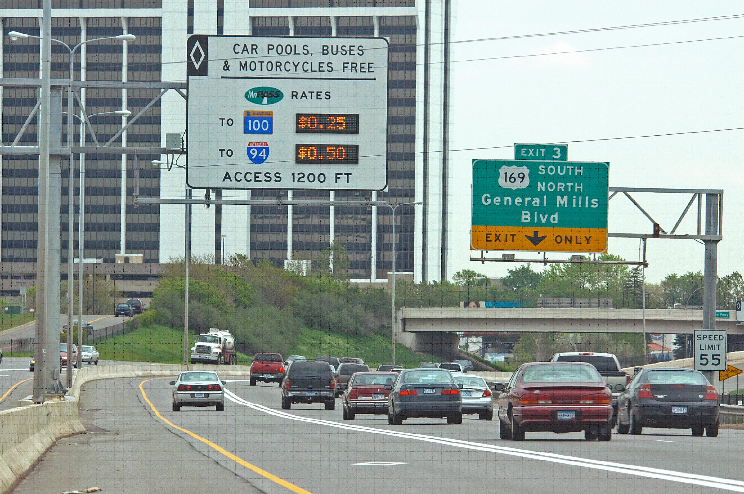

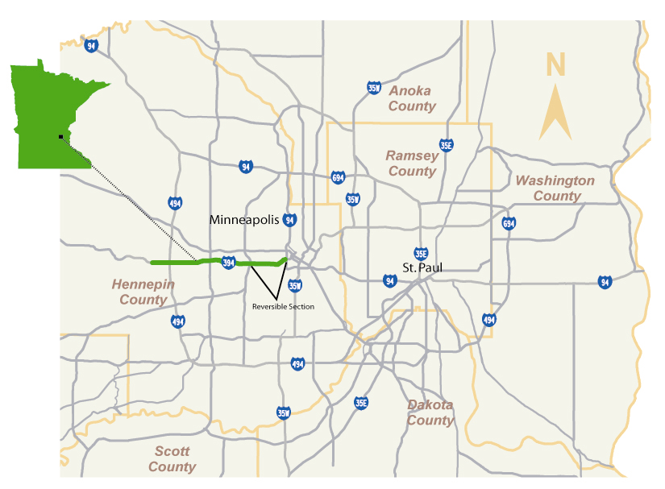

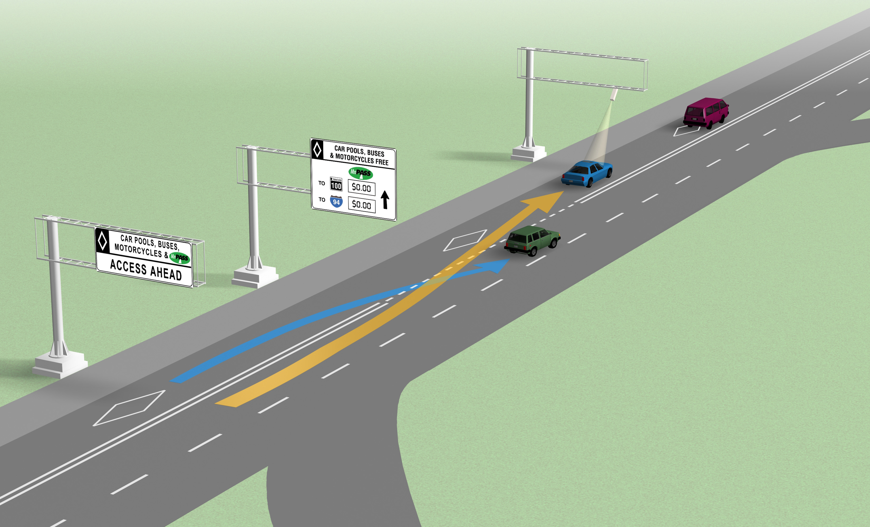

Miles of Congestion
Source: Minnesota Department of Transportation

