Development of a micro-simulation traffic model to investigate on-street parking and its impacts on sustainable environments:
A case study in the city of Newcastle upon Tyne

By

Itoro Ukpong (Corresponding Author)

Mott MacDonald Limited

Canterbury House

85 Newhall Street

Birmingham, B3 1LZ

UK
Fax: +44-121 237 4003
ItoroGeorge.Ukpong@mottmac.com

Dilum Dissanayake, Ph.D.
Lecturer in Transport Modelling
Transport Operations Research Group
School of Civil Engineering and Geosciences
Newcastle University
Newcastle NE17RU
UK
Tel: +44 (0) 191 222 5718
Fax: +44 (0) 191 222 6502
E-mail: dilum.dissanayake@ncl.ac.uk

and

Bin Zhang
Postgraduate Student
Transport Operations Research Group
School of Civil Engineering and Geosciences
Newcastle University
Newcastle NE17RU
UK
Fax: +44 (0) 191 222 6502
E-mail: bin.zhang@newcastle.ac.uk

Development of a micro-simulation traffic model
to investigate on-street parking and its impacts on sustainable environments:
A case study in the city of Newcastle upon Tyne

Itoro Ukpong ª ∗, Dilum Dissanayake ^{b}, Bin Zhang ^{c}

ª Mott MacDonald Limited, Canterbury House, 85 Newhall Street, Birmingham, B3 1LZ
^{b,c} School of Civil Engineering and Geosciences, Newcastle University, Newcastle, NE17RU, UK

Abstract
The overall objective of this paper is to endorse the notion that on-street parking brings about traffic congestion and environmental pollution. This paper aims to quantitatively express traffic congestion as travel times and delays on specified road networks. The methodology employed involves the use of VISSIM, a micro-simulation software, for the development of a traffic model so as to display the travel times of traversing vehicles with and without the presence of on-street parking. The VISSIM-ENVPRO software is also instated to carry out a comparison in emission levels between specified road networks. Three case study sites have been selected within the city of Newcastle. The simulation runs and analysis show that there are considerable increases in travel time, delay and emissions with the presence of on-street parking in all three case study sites.

1. Introduction
Rapid urbanization and motorization are the key grounds for the various transport problems. The impacts of motorization, such as congestion, safety and environmental problems, undoubtedly cause significant damages to the quality of life. Improving transportation systems and facilities in general, and environmentally sustainable transport options in particular, are now recognized as major requirements in the UK transport agenda. As reported by the Department for Transport (DfT) in the UK, road traffic grew by 81 percent between 1980 and 2004, from 277 to 502 billion vehicle kilometres (DfT, 2006). On this note, there has been a surge in the demand for parking spaces especially for cars entering into cities. On-street parking in the heart of city centres as well as on high streets located in the periphery of city centres has become a very popular trend for the vast majority of private car users and it has been accepted that there will be, in the coming years still a high degree of dependency on the use of private cars for a wide variety of journeys.
The main cause of traffic congestion arises from the fact that the volume of traffic is too close to the capacity of a road network (Goodwin, 2004). Traffic congestion reduction has been for a number of years one of the top priorities of the Central Governments agenda and this is likely to carry on being a highly ranked priority because congestion in the UK has been categorized as being worse than a number of other countries in the EU. The severity of congestion is getting to unprecedented levels and the cost attributable to congestion in the UK as at 2005 was in the region of £19billion (West Sussex County Council, 2004). The RAC also stated that 1.2 billion hours are lost through congestion on major roads every year. Towns and cities are beginning to feel the impact of congestion as on-street parking is becoming more common-place. Traffic congestion is already a problem in Tyne and Wear. Newcastle upon Tyne in particular has seen a continuous surge in economic development over the past few years and a projected increase in both car ownership in the region and in the number and length of journeys made by those cars means that the situation will only get worse if no action is taken. The problem of on-street parking is further aggravated owing to the need of creating more on-street parking spaces for the growing influx of cars. As stated above, traffic congestion is the direct result of the volume of traffic nearing or equalling the capacity of the road network. On-street parking pre-empts a potential traffic lane hence reducing the road width and hence reducing the capacity. This road width reduction, still maintaining the same volume of traffic, causes the congestion index to come within reach of critical levels thus generating serious delays to drivers especially on busy roads. Studies carried out by the FHWA (Federal Highway Administration) who are part of the United States Department for transport and (Box, 2004) showed that on-street parking was responsible for the reduction in traffic flow.
Air quality and climate change have been labelled as the most important challenges facing the global community (DfT, 2004). These challenges include the reduction in emissions of carbon dioxide (CO₂) and other greenhouse gases such as methane and nitrous oxide etc. from motor vehicles. According to the Future of Transport whitepaper, transport is identified as currently responsible for a quarter of the carbon dioxide emissions in the UK. Figure 1 shows the trend of carbon dioxide emissions by sector between 1970 and 2003.
Research carried out by the Commission for Integrated Transport in 2004 shows that traffic congestion causes the following environmental problems:
- Increased noise and fumes which brings about a reduction in the quality of life for people living in the surrounding area.
- Increased production of greenhouse gases such as carbon dioxide and nitrous oxides due to traffic moving at a very slow rate
- Brings about the inefficient use of fuel in congested traffic.
The National Air Quality Strategy (NAQS) was established in July 1997 as a result of the growing concern of the adverse effects of air pollution. The strategy was devised so as to provide a structure for improving air quality in the UK by setting out standards and objectives for eight major air pollutants. One of the major platforms of achieving the aims of the NAQS was through local air quality management. Local air quality management was an initiative whereby local authorities were asked to assess the feasibility of meeting the NAQS objectives for their respective regions. In a situation whereby local authorities felt they would fall short of meeting the objectives, they were then required to declare those areas of shortcomings as Air quality Management Areas (AQMA) and thus devise methods of making sure that the objectives of the NAQS would be met at some point.

- Parking and its relation to traffic congestion
Parking has been described by a number of transport planners as an activity, which has existed for a number of years. Parking policy in the UK was introduced as a result of indiscriminate parking on the kerb-side, which in effect was found to reduce traffic flow. Outlined below are some of the reasons behind the creation of parking policy in the UK.
Chick, 1996 (On-Street parking: A guide to Practice):
- to maintain the safe movement of the required traffic flow appropriate for the class of road under consideration, for example, no parking on trunk roads;
- to maintain and improve the safe movement of pedestrians, including the prevention and enforcement of footway parking, waiting restrictions at junctions and crossing places to ensure adequate sight lines for pedestrians;
- to control the provision of private non-residential (PNR) off-street parking space;
- to provide and effectively control public off-street car parks in line with overall on-street parking policies and public transport accessibility;
- to provide for the loading and unloading of vehicles so as to cause minimum interference with other traffic;
- to assist and encourage the use of public transport;
- revenue generation.

The objectives outlined above are more or less in line with other developed countries of the world where traffic and parking are prevalent. However, Shoup (1997) stated in his paper that a few of the objectives of parking policy were not being met in certain states of the USA. The objectives of revenue generation as well as that of encouraging the use of public transport were those under scrutiny. He said that the use of minimum parking requirements as a yardstick to meet the peak demand for parking at different land uses was inappropriate. This impropriety stemmed from the fact that tariffs for parking were never considered when setting minimum parking requirements. He came to the conclusion after a methodical analysis that the increasing nature of free or subsidized parking fees as a result of setting minimum parking requirements was causing an inflated demand for off-street parking. This in effect created a spill-over effect in which case drivers were seen to exercise on-street parking. Minimum parking requirements were also used to meet the peak demand for on-street parking. He said drivers owned and used cars very frequently because they knew parking fees were next to nothing. This in effect created traffic congestion.

3. On-street parking and road side environment
Street space supports a wide range of activities (OECD, 1980). Its major purpose is acting as a passage for the flow of traffic. However, there is always a competition for space between moving and parked vehicles (Valleley, 1997). In considering the effects of on-street parking, the different activities which take place on the street need to be established. According to Valleley (1997), some of the most common activities are:
- Vehicle users with remote destinations who are passing through the street (Traversing Vehicles);
- Vehicle users with destinations in the street who will load/unload, park or drop off passengers;
- Shop and business owners who are keen on drawing customers to their shops
Congestion on a road network as a result of on-street parking stems from two entities; these are: the capacity reduction due to the parked vehicles and the manoeuvrability of the parking vehicles.

3.1 Capacity reduction
Most previous studies have used the premise of capacity reduction caused by on-street parking as a case for traffic congestion. Studies took into account the influence of the physical use of road space on increasing delays (Hobbs, F.D.) A small number of parked vehicles on a road network can reduce the width and capacity of the road (Valleley, 1997). A multi-lane dual carriage road or one-way road can be reduced to one lane due to kerbside parking (Valleley, 1997). On a single carriageway, conflicts occur between vehicles travelling in opposite directions owing to the reduced width. Conflicts also occur in the form of frictional effects between the travelling vehicles and the parked vehicles. The frictional effects relate to the need for moving vehicles to merge so as to bypass parked vehicles. These frictional effects cause drivers to be more cautious thus bringing about reduced traffic flow especially in peak periods. This in turn brings about time losses and delays to motorists. These delays could be significantly increased if vehicles are parked very close to a junction. A comprehensive study into the effects of parked vehicles on capacity was carried out and published (Urban Traffic Engineering, 1965). Table 1 shows the effect parked vehicles have on capacity. Another study looked into the effects of parking manoeuvres on the capacity of a road network (Washington D.C.: Transportation Research Board, 1985). Table 2 shows the capacity reduction factors resulting from parking manoeuvres.

3.2 Manoeuvrability
Parking manoeuvre patterns are the movements associated with vehicles entering or leaving parking spots (Yousif and Purnawan, 1999). The level of commercial activity on a road as well as the amount of road space provided for parking affect the flow conditions on the road. Parking on a quiet street (a street with no shops, banks etc) has a relatively low effect on traffic flow because the demand for stopping would be low. When frontage activity is introduced the demand for stopping becomes greatly increased. Time losses and delays are induced owing to the fact that motorists are forced to wait for vehicles to park and un-park. The manoeuvring patterns of the vehicles parking and un-parking bring about these time losses to other motorists (Purnawan and Yousif, 1999). As the level of traffic flow increases, the effect of such manoeuvres will result in increased delays.
Extensive studies into the influence of parking and un-parking manoeuvres were carried out by Purnawan and Yousif. The study carried out compared the effects of angle on-street parking and parallel on-street parking on traffic congestion. The case study sites were selected based on the level of retail and commercial activities surrounding the road side environment. The data collection methodology involved carrying out surveys on each of the roads so as to collate the parking manoeuvre characteristics and times required for each manoeuvre. A video based survey was carried out for more than 7hours on each of the case study sites.
The conclusions drawn from the study included the fact that parking manoeuvres which involved reversing to park and un-park took longer times. This study highlighted the fact that entering manoeuvres for parallel on-street parking were more problematic for moving traffic than leaving manoeuvres in that entering manoeuvres caused moving traffic to stop, swerve or reduce speed (Yousif and Purnawan, 1999). These resultant behaviour for the moving traffic induced congestion. The reversing/leaving manoeuvres for angle on-street parking were said to be slightly more problematic than parallel on-street parking as they required more time and road width to execute efficiently. This increased time and road width requirement was said to induce more congestion than parallel on-street parking especially during peak traffic flows. Although the study carried out was very detailed, they failed to give a comprehensive account of how the average travel times and delays of passing or traversing vehicles were affected on the whole as a result of these parking manoeuvres.

4. Modelling software used in this study

4.1 VISSIM software for traffic simulation
VISSIM, a German acronym for Traffic in Towns Simulation is a microscopic and behaviour based simulation model developed by PTV AG Karlsuhe, Germany. Individual driver behaviour is simulated in discrete time steps by using a psycho-physical car following model for longitudinal vehicle movements and a rule based algorithm developed by Wiedermann (1974) for lane-changing movements. The basic concept of this model is that each vehicle is given a desired speed, a desired acceleration and a gap acceptance stochastically. If a vehicle is below its desired speed, it will accelerate to that speed using the maximum possible acceleration for the given speed and vehicle type. To reproduce vehicle interactions, the driver of a faster vehicle starts, after a slight reaction delay, to decelerate as he reaches his individual perception threshold to a slower vehicle. (PTV America, 2001).

4.1.1 Input variables
The desired network is created by combining links which are characterised by their type, the number of lanes in each direction and the width of these lanes, with connectors to create turning movements. Traffic signals and priority rules are other roadway infrastructure available. The dynamic data for traffic flow includes:
- a desired speed distribution between a minimum and maximum value
- desired maximum acceleration and deceleration
- traffic composition
- traffic volumes entering each link
- routing decisions
- simulation parameters such as time period of the simulation

4.1.2 Output variables
A large range of output files are available with VISSIM. The files which are relevant to this study are those that represent the outputs of travel time and delay respectively.

4.2. ENVPRO (Environmental Program) for modelling environmental pollution
EnvPro was developed by PTV AG in collaboration with the Transport Operation Research Group (TORG) at Newcastle University. It is used in conjunction with the VISSIM micro-simulation software. EnvPro can be used to estimate pollution when the speed, acceleration and position of a vehicle in a network are known. The outputs from the VISSIM model are the instantaneous vehicle position, the vehicle speed and the vehicle acceleration. These are then used to estimate emissions. EnvPro estimates pollution based on two models: QUARTET and MODEM. QUARTET is a DRIVE II EU project. Vehicle speeds and mode (acceleration/deceleration, cruising and idling) for two vehicle classes (cars and buses/HGVs) specify the factors to be used. Quantities outputted include CO, NO_{X} and HC. The outputs are in grams per kilometre.
The MODEM microscopic emission database is a database based on the results of chassis dynamometer driving cycle measurements. Fourteen different cycles were used in the development of the MODEM emissions database based upon a large-scale survey of the opening characteristics of vehicles used in urban areas across Europe with the aim of representing real world driving conditions. The table 3 summarises the two models used for estimating pollution levels in EnvPro.

4.2.1 Input variables
There are three files which are input to the ENPRO program which consist of the licensing statistics, speed and acceleration of the vehicles (figure 2).

4.2.2 Output variables
The overall output from EnvPro is a file called file.em (figure 2) and this gives the following:
- QUARTET/MODEM pollution estimates per km, per link and per time slice
- Overall values i.e. total and per km emissions

- Research objectives
The overall objective of this project is to develop a micro-simulation traffic model in order to investigate on-street parking and its impacts on roadside environment, link speed and traffic congestion.
The specific objectives are:
- Development of a micro-simulation model using the VISSIM software and the data collected from the field surveys to replicate actual traffic conditions in a computer-based system.
- Application of the developed model in investigating on-street parking and its impacts on the environment using VISSIM-ENVPRO software.

6. Methodology

6.1 Study area
Newcastle upon Tyne is located on the north bank of River Tyne, in the North East of England. Newcastle upon Tyne is the 20th most populated city in England. The Tyneside conurbation is the 5th most populated in England.
Car ownership in the Newcastle region is said to be growing at twice the national average (Newcastle City Council, 2004). In 2005, the city received a grant in the region of £950,000 from the Government’s Transport innovation Fund to develop strategies in traffic management to help relieve congestion. The issues which were of major concern were the cost and availability of car parking, the provision of park and ride sites to reduce congestion and identification of the effects of different options for congestion charging. Another issue which was to be given due consideration was the need for the continuous monitoring of levels of emissions from vehicles so as to create public awareness on the dangers of congestion. In August 2002, the city of Newcastle set up pollution measuring stations in different parts of the city so as to measure the growth or decline of pollutants such as CO, PM₁₀ and the Nitrous oxides. These stations were installed as part of a National initiative called the Air Quality Strategy published in January 2000.
Newcastle is selected as a case-study mainly due to the its compactness, which is a useful feature to investigate on-street parking and its impacts on the environment.

6.2 Modelling approach
It is presumed that a particular road link without on-street parking would bring about relatively lower journey times for traversing vehicles than a street with the presence of on-street parking. This has been postulated due to the fact that a vehicle traversing a road link with on-street parking would need to slow down or stop as another vehicle tries to park or leave a parking space. The modelling of on-street parking has been based on the assumption that the lane width of 3.50 m is made up of a sub-lane set aside for on-street parking and the remainder for free flowing vehicles. In effect, two lanes are modelled within the one lane each having a width of 1.75 m. In some cases, especially when the lane is less than or equal to a standard urban road lane of 3.50 m, traversing vehicles would adopt a driving behaviour whereby part of the space reserved for on-street parking would be used to bring about a level of comfort. On approach of an occupied on-street parking space, the traversing vehicle would go back to its allotted road space within that particular lane. This transition back to its allotted road space also brings about time losses especially in high flow situations.
The employment of VISSIM as a tool to carry out the analyses would require a number of parameters/data such as traffic flows, number of parked vehicles at respective sites, a desired speed distribution between a minimum and maximum value, desired maximum acceleration and deceleration, traffic composition, traffic volumes entering each link, routing decisions and the time period of the simulation. A one hour time period relating to traffic flows of a weekday evening peak (4.30pm-5.30pm), weekday morning peak (8am-9am) and a weekend (Saturday) (12.30pm-1.30pm) have been obtained so as to replicate actual road conditions. This traffic flow data for model development is based on information from the Tyne and Wear Traffic and Accident Data Unit (TADU). This is a group located at Gateshead council which hold detailed information on road traffic accidents and traffic flow statistics for the Tyne and Wear conurbation for the period of 1994-2004. TADU is responsible for collecting accident and traffic count data and maintaining databases of this information on behalf of the Tyne and Wear districts.
A number of key assumptions have been made in carrying out the simulation. One key assumption which has been made relates to the fact that no HGVs have been used in the modelling. Only cars have been modelled. HGVs are known to traverse the case study sites but due to the rarity/infrequency in their flow (1-2 per hour); they have been excluded in the modelling. Most of the side roads which can be viewed on the bitmap images are blocked as a result of on-street parking. For those which have not been blocked they are assumed to have very low traffic volumes and as a result have not been modelled. A 100% parking rate as well as an equal share in relative flows between the parking and traversing vehicles are assumed within the simulation period. Another assumption made in the modelling process is the use of 10 minutes as an average dwell time for all of the parking vehicles.
  - Flowchart of study and traffic simulation process

Stage 1: Estimation of Travel Time/Delays for study sites
Stage 2: Estimation of Vehicle Emissions
(See Figure 3)

7. Results and discussion

7.1 Travel time and delay results from case study sites
This section presents the results obtained from the calculation of travel times and delay for the traversing or passing vehicles in the case study sites with and without on-street parking (table 4). Values obtained will then be compared with the other case study sites. This is done so as to highlight any differences between the measured parameters.
The travel time and delay sections are defined as shown in Table 4. With the presence of on-street parking, an average travel time of 70.6 sec is recorded for the traversing vehicles eastbound of Warwick Street and 43.6 sec was recorded westbound of Warwick Street. The delays calculated for the eastbound and westbound traffic amount to 16.2 sec and 2.9 sec respectively. Without on-street parking, 58.0 sec and 39.7 sec have been obtained as the travel times eastbound and westbound of Warwick Street. Delays of 2.8 sec and 0.2 sec are obtained for the eastbound and westbound traffic streams. The magnitude of the values suggest that there is an 18% decrease in the travel time for the eastbound section of Warwick street on removal of on-street parking and a 9% decrease in the travel time on the westbound section.
The average delays for traversing vehicles on the eastbound and westbound section of Warwick Street have fallen by 83% and 93% on removal of on-street parking. By scaling up the delays for on-street parking assuming uniform delays over the road network, figures of approximately 40 sec per km and 10 sec per km are realised for the eastbound and westbound traffic. By doing the same with delay figures obtained without on-street parking, 7 sec per km and 0.7 sec per km are realised eastbound and westbound of Warwick Street. In effect, it can be seen that the delays could be potentially large over greater distances when on-street parking is involved. In making a horizontal comparison of the delay i.e. between on-street parking eastbound and westbound, it is realised that the magnitude of the eastbound delay per km (40 sec per km) is significantly greater than the delay per km westbound (10 sec per km) of the Warwick street road network. The reason for this difference could be two fold. The first could be the fact that two parking sections exist on the eastbound traffic stream of Warwick Street as supposed to one section on the westbound traffic stream of Warwick Street. The presence of this extra parking section could mean that there is a greater demand for parking hence causing more disruptions for traversing vehicles.
The other reason for the greater magnitude in delay is the fact that the eastbound traffic section has about three times more traffic than the westbound section. In other words the vehicle input for the eastbound traffic works out to be 898 vehicles per hour and that for the westbound traffic is 308 vehicles per hour. The greater volume of traffic plying the eastbound traffic section would be the more likely cause for the higher delay.
The second case study site shows a difference in travel times and delays between the two conditions (with and without on-street parking). However the magnitudes of these differences are very small relative to the differences obtained for the Warwick Street site. The recorded travel time and delay for the eastbound traffic with on-street parking is 16.2 sec and 1.1 sec respectively. Those recorded for the westbound traffic are 16.5 sec and 1.2 sec. Without on-street parking, 15.3 sec and 0.1 sec are the recorded travel time and delay for the eastbound section. The measured travel time and delay for the westbound section works out to be 15.5 sec and 0.2 sec. This suggests that the average travel times of the traversing vehicles eastbound and westbound of Acorn road fall by the same magnitude of 6% with the removal of on-street parking. The average delays of the traversing vehicles eastbound and westbound of Acorn road drop by 91% and 83% on removal of on-street parking. It could then be said that the traversing vehicles were only worse off by approximately 1s/hour/115.5 m on the eastbound traffic section as a result of people parking on the street. Scaling this figure up to the distance of the travel time section for the eastbound traffic stream of Warwick Street gives an approximate figure of 3.5s/hour/402.1m. This compared to a value of approximately 13s/hour/402.1 m for the eastbound traffic of Warwick Street brings in the issue of traffic volume. The eastbound traffic section of Acorn road is subjected to a traffic volume of about 150 vehicles per hour and this compared to 898 vehicles per hour for the eastbound traffic stream of Warwick Street explains the relatively large discrepancy in the delay values. The delay and travel time values for the westbound traffic stream are quite similar to those obtained for the eastbound traffic stream due to the fact that both consist of similar traffic volumes. However, a horizontal comparison of travel time and delay between the eastbound and westbound traffic streams shows the westbound traffic stream having slightly higher values based on the traffic volume i.e. 158 vehicles per hour as supposed to 150 vehicles per hour for the eastbound traffic stream.
The next evaluation looks at the results obtained from Park View. These set of results show that there is a 12% decrease in the average travel time of the traversing vehicles with the removal of on-street parking. There is a marked difference in the delay parameter of both conditions in that the traversing vehicles are subject to an average delay of 4.1sec and 0.2 sec with and without the presence of on-street parking respectively. This shows there is a 95% drop in the delay with the removal of on-street parking. In other words the traversing vehicles are virtually close to free flow speed without the presence of on-street parking.

7.2 Pollution modelling results from case study sites
This section highlights the results obtained from the pollution modelling exercise. The tables below show the total emissions for the whole simulation in grams (litres for FC and milligrams for PM) and grams per kilometre (litres per 100kilometre for FC and milligrams per kilometre for PM) for the QUARTET and MODEM models.
The pollution models are used to give an estimate of the emissions on each link of the road network of the case study sites. The estimated emissions are then aggregated to give a measure of the total emissions on the whole network. A holistic view of the results obtained show a general increase in emissions with the presence of on-street parking due to the fact that there is a lot more stop and go traffic. Tables 5 highlights the values obtained from case study sites with and without on-street parking. As can be seen, the emission estimates of the different pollutants obtained with on-street parking are higher than those obtained without on-street parking.
Both pollution models, although outputting quite different results, demonstrate the changes in emissions for both parking conditions. For example, there is a 22% decrease in the level of carbon monoxide (CO) and a 20% decrease in nitrogen oxide (NO_{x}) as suggested by the QUARTET model on removal of on-street parking. The MODEM model estimates the drop in CO and NO_{x} to be approximately 20% and 15% respectively on removal of on-street parking. In the same light, tables 9 and 10 show that emission levels of CO and NO_{x} drop by approximately 55% and 53% respectively with the removal of on-street parking on the Acorn road network. This is put forward by the QUARTET model.
The MODEM model estimates the drop in CO and NO_{x} to be in the region of 53% and 47% respectively with the removal of on-street parking. With reference to table 5, the drop in CO and NO_{x} as estimated by the QUARTET model on removal of on-street parking is approximately 20% for both pollutants. The MODEM model estimates these drops to be approximately 18% and 13% respectively. These percentage values are calculated by using the total emissions for the whole network in grams. The main reason for the drops in emission levels stem from the fact that all the vehicle types would have operated at close to optimum levels (more efficiently) without the presence of on-street parking. In other words the frequency at which the different vehicle types slow down or stop is greatly reduced.

8. Conclusions about the model and results
This study was carried out in order to show that on-street parking brings about delays to traversing vehicles on a link as a result of these traversing vehicles slowing down or stopping to allow for un-parking manoeuvres. The vast majority of results obtained from the traffic simulation and pollution modelling for the hypothetical and real case studies have been envisaged. However, this does not guarantee the model to be a 100% accurate. A number of key assumptions have been made to aid in the model building. Results produced are consequently based on these assumptions. One major problem with the base model is the fact that it has not been calibrated and validated due to time and resource constraints. The platform for simulating on-street parking has been based on the assumption that a lane width of 3.50 m is made up of a sub-lane set aside for on-street parking and the remainder for free flowing vehicles. In effect, two lanes are modelled within the one lane each having a width of 1.75m. This platform for simulation constitutes a few problems which are listed below:
- The use of the parking lane for travelling
- The tendency or inclination of a vehicle to un-park and then carry on driving on the lane for parking
- Use of the parking lane to overtake
With reference to the first point, there are instances in real life where traversing vehicles adopt a driving behaviour whereby part of the space reserved for on-street parking is used to bring about a level of comfort. This normally occurs when the lane is less than or equal to a standard urban road lane of 3.65 m. On approach of an occupied on-street parking space, the traversing vehicle would go back to its allotted road space within that particular lane. This transition back to its allotted road space as well as the slowing down or stopping for vehicles to park and un-park are the major reasons for delays or time losses especially in high flow situations. This phenomenon, however, has been highlighted as a problem based on its rarity in real life situations. The presence of this problem in the model would have brought about an overstatement in the travel time and delay values from the hypothetical and real modelling situations.
With reference to the second point, it was seen in this model that vehicles which un-parked did not straight away join the traffic stream but carried on travelling in the on-street parking lane. This occurred when there were no parked cars in front of the un-parking vehicle. This actually does not happen in real life situations because the un-parking vehicle straight away joins the traffic stream on a different lane even if there are no other parked cars in front of it. The presence of this problem would therefore have introduced a few errors to the results such as the understatement of the travel time and delay of the traversing vehicles. With reference to the third point, there were instances in the model where the lane reserved for parking was used for overtaking, mostly by the traversing vehicles. This took place when there were no cars parked. This again is something that does not happen in real life and thus highlighted as a problem. This would probably have caused an understatement of the travel time and delay of the traversing vehicles.
The results obtained for modelling of the case study sites give a real life indication on the magnitude of the average delays and travel times imposed on traversing vehicles with and without on-street parking. However, as stated earlier, these results are based on assumptions. The alteration of these assumptions could very well change the results obtained. For example the inclusion of HGVs and public transport in the traffic composition coupled with the actual on-street parking problem could probably cause an increase in the overall average travel time and delay of the traversing vehicles on the individual road networks(with and without on-street parking). Also a parking rate of 50% as opposed to a 100% parking rate could cause an overall drop in travel time and delays. An average dwell time of 10minutes was assumed for the modelling but if this is altered to 15minutes as a result of new measurements, this would most probably cause a general drop in the average travel time and delay of the traversing vehicles. This would be due to the fact that less frequent interactions between parking and traversing vehicles would occur.
The alteration of the relative flows in the traffic composition, for example, assigning the traversing vehicles with a much higher flow than the parking vehicles, could cause an overall decrease in the travel time and delay of the traversing vehicles as there would be less frequent interactions with the parking vehicles. The model also makes use of only forward parking and forward un-parking manoeuvres but the inclusion of reverse parking manoeuvres would definitely cause a general increase to average travel time and delay of the traversing vehicles. This has been stated as Yousif and Purnawan (1999) showed that reverse parking manoeuvres generally takes longer to complete than forward parking manoeuvres thus inflicting longer delays on traversing vehicles. Another piece of data which could alter values obtained for travel time and delay for the case study sites relate to the traffic/vehicle inputs utilised for the modelling. The traffic/vehicle inputs employed did not represent current day values owing to the temporal difference particularly for Warwick Street and Acorn road. It is therefore expected that travel times and delays would possibly increase if current day values are employed. Pollution modelling results would also have been over or underestimated as a result of the assumptions.
Something worth mentioning in this section relates to the possible implications of the results obtained from the modelling on parking policy in the UK. Warwick Street shows that the traversing vehicles are subject to a delay of 16.2s as a result of on-street parking. Table 5 shows a considerable increase in carbon monoxide and nitrogen oxide levels, in the region of 20%-25%, with the presence of on-street parking. These results imply that more measures would need to be devised speedily as traffic levels and related parking are on the increase and consequently bringing about more delays to traffic. The 1991 Road Traffic Act, The PPG6 and the PPG13 have all put forward the issues of regulation, enforcement and environmental effects of on-street parking and it would seem that attentions would need to be sturdily focussed on how the public transport system could be revolutionised so as to make it more attractive to drivers and thus reduce traffic numbers and related parking.

9. Future work
There are situations where the road width on a single carriage way has been greatly reduced by on-street parking on both sides to such an extent that two vehicles approaching each other on opposing lanes do not have enough space to go past each other. What happens here is that one vehicle would actually need to force itself into a gap reserved for parking so as to provide enough room for the other vehicle on the opposing lane to pass. This represents a different dimension to the problem of congestion as a result of on-street parking. Future work would involve the use of VISSIM to model this type of situation and evaluate delays/travel times on traversing vehicles. Future work in this area could also involve more accurate methods of collecting data such as employing the use of video based systems to obtain accurate values of dwell times for parked vehicles as well as parking rates so as to obtain good calibration and validation values for the base model.

References
Box, P.C. (2004), “Curb-Parking Problems: Overview, Journal of Transportation Engineering”, Volume 130, Issue 1, Page1-5, http://scitation.aip.org/getpdf/servlet/GetPDFServlet?filetype=pdf&id=JTPEDI000130000001000001000001&idtype=cvips
CHICK,C (1996), “On-Street Parking: A Guide to Practice”, Landor Publishing, London, Pages 3-5, 18-21, 23
Department for Transport (DfT) (2004), “Future of Transport Whitepaper”, Chapter 10, http://www.dft.gov.uk/stellent/groups/dft_about/documents/page/dft_about_031279.hcsp
Department for Transport (DfT) (2006) http://www.dft.gov.uk/pgr/roads/tpm/congestionresearch/
Goodwin, P. (2004), “The economic costs of road traffic congestion” http://eprints.ucl.ac.uk/archive/00001259/
ENVPRO ( Environmental Program) manual, version 1.6.1: Introduction to use”, PTV and Transport Operations Research Group
NEWCASTLE CITY COUNCIL, Air quality in Newcastle, 2003-2004, http://www.newcastle.gov.uk/core.nsf/a/airqualitynewcastle
ORGANISATION FOR ECONOMIC CO-OPERATION AND DEVELOPMENT (OECD), 1980, “Evaluation of Urban Parking Systems”, A report prepared by an OECD road research group, Pages 4-5, 47-48, 50-51
PTV PLANNING TRANSPORT VERKEHR AG (2001), “VISSIM User Manual, version 4.00”
SHOUP, D.C.(1997), “The High Cost of Free Parking”, Pages 4,15-16
Valleley, M, et al, (1997), “Parking Perspectives: A source book for the development of parking policy”, Pages 2-6, 8-9, 103-121, 231-241
WEST SUSSEX COUNTY COUNCIL (2004), “ The Cost of Congestion”, http://wsgfl.westsussex.gov.uk/ccm/content/school-office/plans-policies-and-procedures/staff-travel-plan/cars/the-cost-of-congestion.en;jsessionid=aaYkPngV9Dn-
WIDERMANN, R., 1974, Simulation des Strassenverkehrsflusses, Schriftenreihe des Instituts für Verkehrswesen der Universität Karlsruhe, Heft 8, Karlsruhe, Germany.
Yousif, S., Purnawan (1999), “On-Street parking manoeuvres and their effects on design”, Indonesian Students’ Scientific Meeting, Page 105-108
Yousif, S., Purnawan (1999),“On-Street Parking: effects on traffic congestion”, Traffic Engineering and Control, Volume 40, No9, Page 424-7
Yousif, S., Purnawan (2000), “ Comparison of Accepted Gaps for Different on-street parking designs”, Proceeding of 5th Indonesian Students’ Scientific Meeting, Page 142-146

Parked Vehicles Per Mile  (Both sides together) | 5 | 10 | 50 | 100 | 200 | 500
Effective Loss of Carriageway Width in Feet (M) | 3(0.9) | 4(1.2) | 7(2.1) | 8.5(2.6) | 10(3.1) | 12(3.7)
Loss of Capacity at 15mph(PCU’s per hr) | 200 | 275 | 475 | 575 | 675 | 800

Table 1: Effect of Parked Vehicles on Capacity
Source: (Urban Traffic Engineering Techniques [47]) as referenced from (Valleley, 1997). “Parking Perspectives: A sourcebook for the

Development of Parking Policy”

Number of Lanes | Number of Parking Manoeuvres Per Hour
 | 0 | <10 | 10 | 20 | 30 | 40
1 | 1.0 | 0.90 | 0.85 | 0.80 | 0.75 | 0.70
2 | 1.0 | 0.95 | 0.92 | 0.89 | 0.87 | 0.85
3 | 1.0 | 0.97 | 0.95 | 0.93 | 0.91 | 0.89

Table 2: Capacity Reduction Factors for Adjacent Lanes Resulting from Parking
Manoeuvres
Source: (Highway Capacity Manual – Special Report 209 as referenced from
Chick, C (1996), “On-Street Parking: A Guide to Practice”

 | QUARTET | MODEM
What | HC, NO_{X}, CO ( in g/sec) | HC, NO_{X}, CO, CO₂, PM( in g/sec), FC(1/100km)
How | Factors for:  - 2 vehicle types(cars and buses/trucks  - 4 driving modes (cruising, accelerating, decelerating, idling)  - 7 cruising speeds | 12(4*3) tables of factors for each pollutant: 4 vehicle concepts, 3 vehicle displacements. Each table contains 10 speed bins and 7 speed*acc bins.
Advantages | Easy to implement | High reliability because it estimates based on speed and speed*acceleration
Disadvantages | Acceleration used only to discriminate among driving modes | No cold starts.

Table 3: Characteristics of Pollution Models from ENVPRO
Source :( ENVPRO manual, Sergio Grosso, 2004

Time Measure  Condition | Travel Time Section Length/m |  | Average Travel Time/s |  | Average Delay/s
Travel Time and Delay Results for Warwick Street
 | Eastbound | Westbound | Eastbound | Westbound | Eastbound | Westbound
With on-street parking | 402.1 | 297.6 | 70.6 | 43.6 | 16.2 | 2.9
Without on-street parking | 402.1 | 297.6 | 58.0 | 39.7 | 2.8 | 0.2
Travel Time and Delay Results for Acorn ROAD
 | Eastbound | Westbound | Eastbound | Westbound | Eastbound | Westbound
With on-street parking | 115.5 | 115.0 | 16.2 | 16.5 | 1.1 | 1.2
Without on-street parking | 115.5 | 115.0 | 15.3 | 15.5 | 0.1 | 0.2
Travel Time and Delay Results for Park View
 | Northbound |  | Northbound |  | Northbound
With on-street parking | 226.4 |  | 34.6 |  | 4.1
Without on-street parking |  |  | 30.6 |  | 0.2

Table 4: Results – Travel time and delay

Pollutants/g (g/km)  Pollution Model |  | CO | NO_{X} | HC | CO₂ | FC/l (l/100km) | PM/mg (mg/km)
Total Emissions for Warwick Street
with on-street Parking | QUARTET (2d.p.) | 19209.94 | 297.45 | 1462.48
with on-street Parking | MODEM (2d.p.) | 6423.81 | 513.52 | 664.05 | 181826.0 | 61.05 | 9735.41
without on-street Parking | QUARTET (2d.p.) | 15084.82 | 239.07 | 1010.24
without on-street Parking | MODEM (2d.p.) | 5160.75 | 437.75 | 521.15 | 142438.53 | 47.90 | 7642.39
Total Emissions for Acorn Road
with on-street Parking | QUARTET (2d.p.) | 5734.88 | 88.44 | 488.43
with on-street Parking | MODEM (2d.p.) | 1908.35 | 151.64 | 203.15 | 54886.78 | 18.41 | 3071.90
without on-street Parking | QUARTET (2d.p.) | 2595.97 | 41.53 | 170.57
without on-street Parking | MODEM (2d.p.) | 895.82 | 80.98 | 89.83 | 24866.36 | 8.35 | 1423.57
Total Emissions for Park View
with on-street Parking | QUARTET (2d.p.) | 11822.84 | 169.56 | 824.54
with on-street Parking | MODEM (2d.p.) | 4117.60 | 351.75 | 422.53 | 111465.59 | 37.54 | 6356.07
without on-street Parking | QUARTET (2d.p.) | 9443.84 | 138.09 | 620.26
without on-street Parking | MODEM (2d.p.) | 3368.0 | 306.22 | 342.66 | 90346.83 | 30.44 | 5328.31

Table 5: Pollution modelling results

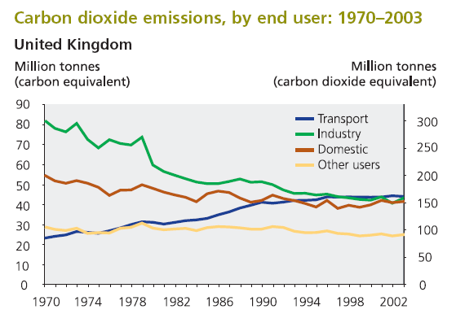

Figure 1: Carbon Dioxide Emissions (Source: The Environment in your Pocket 2005, DEFRA)

Figure 2: Flow chart for ENVPRO software
Source: (ENVPRO manual, Sergio Grosso, 2004)

Network
Signal
Traffic Flow
VISSIM (Micro-simulation software)
Emission Estimation
Stage 1
Travel Time/Delay Parameter
Stage 2

Figure 3: Flow chart of Study

Case Study 1: Warwick Road Case Study 2: Acorn Road
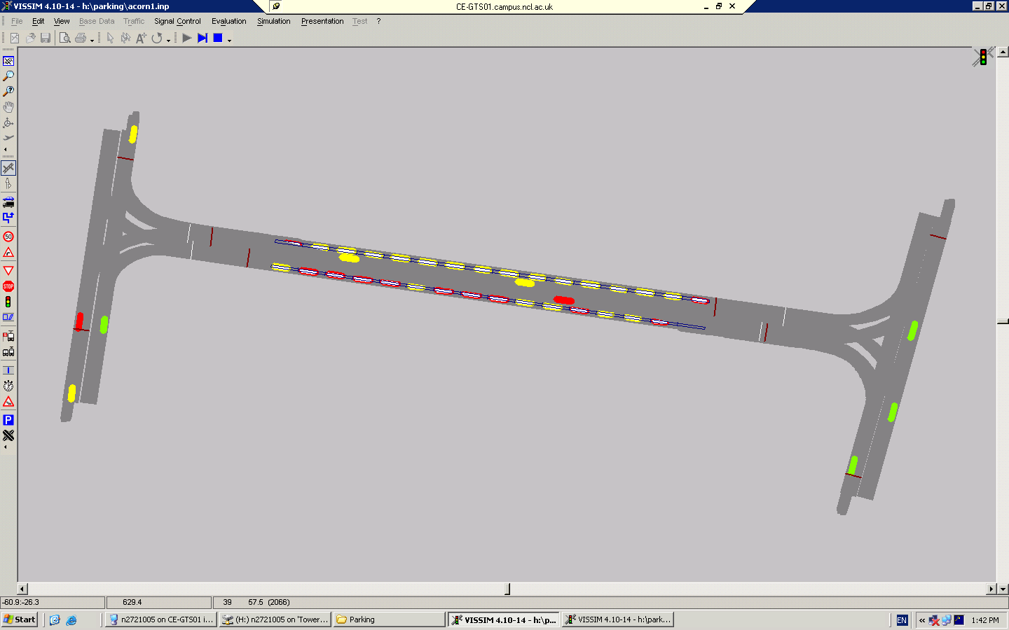
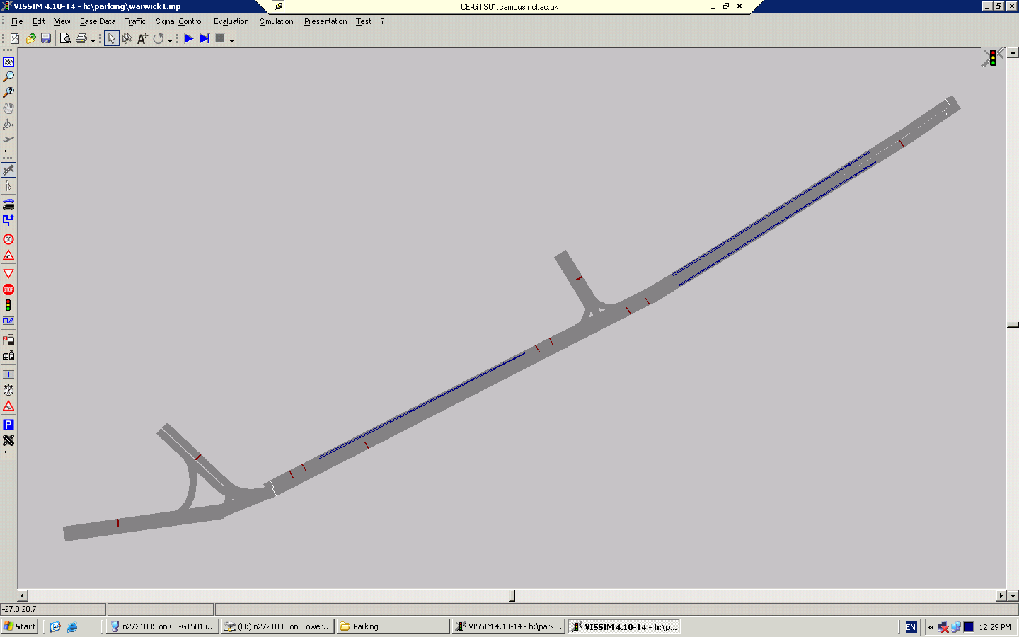
On-street parking capacity: 16 vehicles
On-street parking capacity: 20 vehicles
Traffic Signal

Case Study 3: Park View
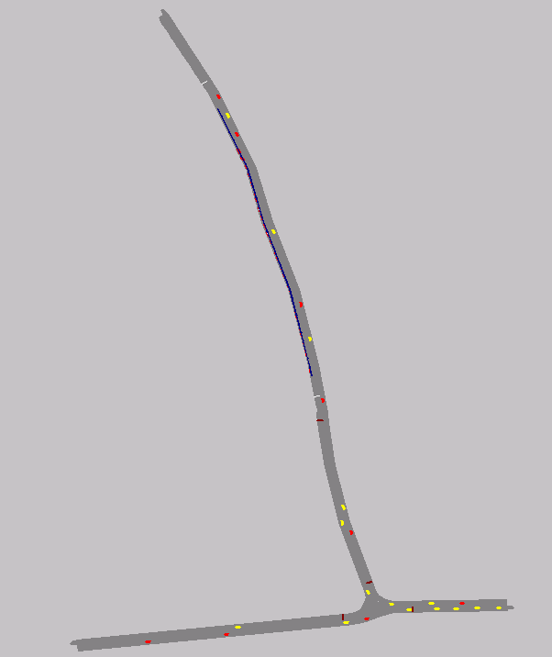
On-street parking capacity: 32 vehicles

Case Study 3: Park View

Figure 4: VISSIM Network for case study site

* Corresponding author, Tel.: +44-191-237-4000 Email address: ItoroGeorge.Ukpong@mottmac.com

