September 2006  RFF DP 06-37
DISCUSSION PAPER

Congestion Pricing
Long-Term Economic and Land-Use Effects

Elena Safirova, Sébastien Houde, D. Abram Lipman, Winston Harrington, and Andrew Baglino

Congestion Pricing: Long-Term Economic and Land-Use Effects
Elena Safirova, Sébastien Houde, D. Abram Lipman, Winston Harrington,
and Andrew Baglino
Abstract
We employ a spatially disaggregated general equilibrium model of a regional economy that incorporates decisions of residents, firms, and developers integrated with a spatially disaggregated strategic transportation planning (START) model that features mode, time period, and route choice to evaluate economic effects of congestion pricing.
First, we evaluate the long-run effects of a road-pricing policy based on the integrated model of land use, strategic transport, and regional economy (LUSTRE) and compare them with the short-term effects obtained from the START model alone. We then look at distributional effects of the policy in question and point out differences and similarities in the short run versus the long run. Finally, we analyze the mechanisms at the source of the economic and land-use effects induced by the road-pricing policy.

Key Words: traffic congestion, welfare analysis, CGE modeling, cordon tolls, distributional effects

JEL Classification Numbers: C68, D63, R13, R14, R41
Contents
Introduction 1
Model Description 4
START 5
RELU 7
Welfare Measurement 7
Model Integration 9
Model Calibration 10
Policy Description 11
Aggregate Results 12
Transportation 14
Labor Market 15
Housing Market and Residential Pattern 17
Production Sector 18
Real Estate 19
Sensitivity Tests 20
Lump-Sum Redistribution Scheme 20
Labor Supply Elasticity 21
Toll Levels 22
Conclusion 23
References 25
Mathematical Appendix 28
RELU 28
Welfare Decomposition 33
Tables 35
Figures 43

Congestion Pricing: Long-Term Economic and Land-Use Effects
Elena Safirova, Sebastien Houde, D. Abram Lipman, Winston Harrington,
and Andrew Baglino*

Introduction
Although in theory congestion tolls are a natural example of Pigouvian taxes that should ensure that drivers’ perceived private costs are consistent with the social costs of driving, in practice there are only a few examples of cities that actually have implemented road-pricing schemes. Following Singapore in the early 1970s and Norwegian toll rings in the mid-1980s, the city of London introduced its area toll in February 2003; up until now, it is the most well-known example of a large metropolitan area that has implemented congestion pricing.
There are both theoretical and political reasons why road pricing has not seen more widespread use. Even in theory, the efficiency of congestion taxes often is greatly reduced when the models reflect more realistic features such as transportation networks, taxes, and the costs of toll implementation. Fierce political opposition to congestion tolls partially can be explained by the largely unknown distributional effects of road pricing, as well as by concerns over other future effects that are difficult to predict.
Economic evaluations of congestion pricing in general, and for London in particular, have predicted that these schemes would be successful. These predictions, however, have been based on the evaluation of transportation effects alone; the wider economic impact of such schemes has remained uncertain (Vickerman 2005). Tolls will affect travelers’ budget constraints and will result not only in mode switching but also in broader changes in the economy that will be accompanied by the geographic redistribution of trips. Concerns that the London cordon may have negative effects on the economy of the central area, particularly on retail, have in fact caused a reduction of the tolling window in response to the concerns of retailers (Santos and Shaffer 2004). A counterargument, however, states that the reduced congestion is supposed to lower the costs of the downtown businesses, making them more competitive.
In the literature, a number of papers have attempted to estimate the effectiveness of congestion pricing based on network models, both for first-best marginal congestion pricing and for second-best policies that are closer to the tables of policymakers (Verhoef 2002; Yang and Huang 1998; Zhang and Yang 2004; Akiyama et al. 2004; Santos 2004). The major criticism of such models is that they cannot reflect economic and land-use effects that will follow the implementation of congestion pricing.
At the same time, there is a well-established line of research in the fields of public and urban economics describing how congestion tolls will affect the economy of urban areas. In the realm of aspatial models, the idea has surfaced that congestion tolls will interact with the rest of the tax system and this interaction may lead to unexpected consequences. Parry and Bento (2001), for example, have shown that unless the proceeds from the congestion toll are used to reduce labor taxes, “optimal” congestion pricing is likely to decrease the welfare of workers since it makes them reduce their labor supply.
In urban economic literature, the standard treatment of congestion tolls is in the context of monocentric city models. The results depend on the sophistication of the model, but in all cases the major effect of congestion tolls is achieved through the reduction in the physical size of the city following the desire of residents to centralize in response to increased transportation costs. In the monocentric model context, the welfare gains from congestion pricing measured as a percentage of residents’ welfare are usually quite large relative to residents’ incomes, probably because the margins of adjustment available to residents are limited to location choice and because transportation is modeled in a crude way, with practically all residents of the city driving simultaneously on the same road.
Responding to the criticisms of the monocentric model, a model with endogenous location of industry and residents (Anas and Xu 1999) was developed. This model demonstrates that the welfare gains due to congestion pricing are likely to be much smaller than what the monocentric models predict because agents in the model have more margins of adjustment. On the one hand, the residents derive idiosyncratic utility from choosing their preferred home and work locations and might be less sensitive to increased transportation costs. On the other hand, industry can respond to the imposition of a congestion toll by moving out of the core, leading to a more decentralized land-use pattern. As a result, the major response to congestion tolls in this type of model is movement of workers/residents and firms toward one another but not necessarily toward the center. While this type of model provides intuition about the possible effects that are likely to arise in a framework with no predetermined location, the modeling of traffic congestion remains coarse. Therefore, as with the other theoretical models described above, this model is good for developing intuition about likely general effects of congestion pricing on urban structure. However, the numerical results of this type of model are questionable, as the model does not grasp the asymmetric, two-dimensional nature of the city and the transportation-related margins of behavioral adjustment such as mode, time-of-day, and route choice that can be numerically important.
One important, realistic feature that usually is lacking in models that deal with traffic congestion in the urban framework is agent-type diversity. Most theoretical models treat all agents as identical. This simplification keeps these models tractable, while providing major behavioral insights. Moreover, in a monocentric model, there is no logical way to represent differentiated agents because agents of different incomes will locate in separated rings around the central business district (Hartwick et al. 1976), a pattern that contradicts the structure of modern cities. The treatment of all agents as identical, however, can skew evaluations of the effectiveness of road pricing. Small and Yan (1999), for example, have shown that differentiation in agents’ values of time could be an important factor in the effectiveness of congestion pricing.
Another source of literature that could be well suited for comprehensive evaluation of the effects of congestion pricing on economy and land use, as well as detailed transportation impact, is a vast array of land use-transportation interaction models. While such models employ many different techniques (see Wegener 1994; Wilson 1997; Martinez 2000 for review), they usually have rather weak behavioral links between land use and transportation decisions (Waddell 2001). Moreover, many of those models are not equipped to represent detailed transportation pricing policies (Gupta et al. 2006).
The purpose of this paper is to analyze the effects of congestion pricing in an analytical framework that is consistent with behavioral economics and combines features that separately were found to be important in the simple theoretical models described above. Specifically, our model incorporates detailed transportation modeling and spatially complex, long-term land-use and economic impacts, including location decisions by residents and firms. Our modeling framework also adds a layer of complexity usually omitted in theoretical models. In particular, it features several types of agents, the option for agents not to work, and several market frictions (income and real estate taxes, congestible alternative modes of travel). While this complexity is computationally costly, it presents an opportunity to look at effects that were not previously studied together in the same context. In particular, we would like to know which of the findings of the simpler models turns out to be dominant in the more complicated picture. Also, we try to determine if additional complexity produces any effects that are not present in the simpler models.
Because our goal is to use a framework that as much as possible resembles real cities, instead of modeling the first-best congestion pricing policy, we model a cordon toll, one of the policies that has been described as second-best in previous studies. We choose a cordon toll for three reasons. Firstly, our model has an array of market imperfections by design, making the derivation and calculation of the first-best policy beyond our computational capacity. Secondly, cordon tolls have been implemented recently, and one of the likely reasons is that this form of pricing is simple enough to keep the implementation costs down and at the same time be understood by travelers. Thirdly, cordon tolls have been analyzed extensively in the literature and in several contexts have been found to be close second-best forms of congestion pricing (Kraus 1989; Mun 2003; Mun 2004; Santos 2004; Verhoef 2004).
To best understand the economic and land-use effects in our model, we first model a cordon policy in a transportation model with no land use and analyze general impacts of the policy. Then, we model the same policy in an integrated model of transportation and land use and compare the impacts. Because we employ the same transportation module in both approaches, it is relatively easy to distinguish the short-term transportation-only effects from the long-term effects in the form of land-use and other economic effects.
The rest of the paper is structured as follows. In section 2, we describe our model and briefly characterize the baseline equilibrium of the regional economy. Section 3 contains the details of our cordon policy modeling. Section 4 is a comparison of the simulation results between the transportation-only and the integrated models, respectively named START and LUSTRE. In addition to reporting aggregate results, we describe in detail the effects of the downtown cordon on transportation, residential patterns, and the production sector. Section 5 discusses the dependence of results on key parameters and compares the long-run optimal toll with the short-run one. Section 6 concludes and discusses directions for future research.

Model Description
In this section, we briefly describe both modules of LUSTRE (START and RELU), explain how both can be used to evaluate welfare implications of transportation policies, provide a short description of the integrated model, and characterize the Baseline equilibrium used in this paper.

START
The START modeling suite was developed by MVA Consultancy and has been applied to a range of urban centers in the United Kingdom, including Birmingham, Edinburgh, and South England (Coombe et al. 1997; May et al. 1992). More recently, this model was calibrated for Washington, DC, and used to conduct policy simulations of gasoline taxes (Nelson et al. 2003), HOT lanes (Safirova et al. 2003), and congestion pricing (Safirova et al. 2004; Safirova et al. 2005), as well as to compute network-based marginal congestion costs of urban transportation (Safirova and Gillingham 2003) and evaluate the benefits of public transit (Nelson et al. 2006).
START is designed to predict the transportation-related outcomes of different transportation policies where policies refer to combinations of different transport elements, which in broad terms encompass changes in road or public transit capacity (e.g., new infrastructure), operating conditions, and tolls, fares, and other fees. Although most of the model components are conventional, the suite features a limited number of zones and an aggregated representation of the supply side combined with a very detailed demand side. An important advantage of the model is its relatively short run time, which provides an opportunity to conduct and compare a large number of policy simulations to better understand their potential consequences.
The Washington START model has 40 travel zones with three stylized transportation links in each zone (inbound, outbound, and circumferential) and a number of other “special” links that represent highway segments and bridges. Six main corridors (I-270, I-95, and US-50 in Maryland and I-66, I-95, and VA-267 in Northern Virginia) connect the outer suburbs to the central region within the circular I-495/I-95 ring, which is known as the Beltway (Figure 1a). The rail network combines the Washington Metrorail system and suburban heavy rail systems (Maryland Rail Commuter [MARC] and Virginia Railway Express [VRE]). Rail travel occurs on routes, which are modeled as series of rail links; rail links represent segments of the rail network. Bus travel is represented by a highly stylized route network, with bus accessibility in any zone determined by the density of stops, frequency of service, and reported bus travel times. Transit crowding costs and parking search costs are explicitly included in the model. The model also accounts for existing high-occupancy vehicle (HOV) lanes on I-95, I-395, I-66, and VA-267 in Northern Virginia, as well as I-70 and US-50 in Maryland. Moreover, we recently have made several improvements to transit modeling, such as incorporation of park-and-ride facilities for rail trips, placing buses on links used by other on-road vehicles (so that buses are affected by and contribute to road congestion), and more detailed treatment of rail network.
This rather aggregated supply-side representation is combined with a detailed demand-side structure. The model features multiple agent types (up to eight in the current implementation,) that can differ by income or any demographic characteristic. There are six trip purposes: home-based work (HBW), home-based shopping (HBS), home-based other (HBO), non-home-based work (NHBW), non-home-based other (NHBO), and freight. Home-based trips either originate or terminate at home. The model distinguishes four travel modes: single occupancy vehicle (SOV), HOV, transit (which has two sub-modes: bus and rail), and non-motorized (walk and bike). It also represents three time periods: morning peak, afternoon peak, and off peak.
START takes home-based work trips and freight trip demands by demographic segment and residential location as exogenous and trips for other home-based purposes as endogenous but highly inelastic. Travel decisions are modeled as a nested logit tree. The utility functions at each nest are linear in generalized costs (the combined monetary and time costs of travel). The value of time is a function of the travelers’ wage rate and varies by trip purpose. Crowding on public transit routes also induces an artificial time penalty, which is tantamount to an increased travel time. For home-based trip purposes, agents choose in successive nests whether or not to generate a trip (for purposes with endogenous demand), then destination, mode, time of day, and route. The decisions are modeled by a nested logit structure, with the utility for each nest i given by , where A_{i} is a calibrated value representing idiosyncratic preferences, β is an exogenous response parameter (indexed by trip purpose and nest-level), and p_{i} is a generalized cost of travel that combines time and money costs explicitly modeled in the supply module. Non-home-based trip demands are an explicit function of home-based trip numbers at the model level. Agents choose time of day and route in successive nests.
The overall structure of START is an iterative one. The trips computed in the demand module are loaded on to the supply network. The supply network uses the loads to compute costs of travel, which are passed back to the demand module. This process iterates until the costs of travel converge to equilibrium values.
In order to integrate START with the RELU model, we made several modifications to stand-alone START. First, for the trip purposes that are explicitly modeled in RELU (home-based work and shopping trips) the trip generation and destination nests are removed. Instead, in LUSTRE, RELU generates trip demands and passes these numbers to START (we discuss this in more detail in the integration part of this section). Second, there is a mismatch between the definition of shopping trips in RELU and START; RELU shopping trips include trips to service locations (doctor’s office, lawyer, etc.), while START trips do not. We let each model work with its own definition and make necessary conversions in the Bridge.

RELU
A Regional Economy and Land Use (RELU) model was developed by Alex Anas and Elena Safirova with the purpose of creating a theoretically sound modeling tool for policy analysis. RELU is a spatially disaggregated computable general equilibrium model of a regional economy that is grounded in microeconomic theory and can be used for comprehensive welfare analysis. By design, in order to shed light on the nature of interactions between land use, transportation, and other forces in the regional economy.
In its modeling philosophy, RELU follows the structure of Anas-Xu (1999), although several new features (presence of several agent types, explicit possibility of unemployment, modeling housing and building stocks, income and real estate taxes) position the model to tackle complex realistic problems. In its present calibration, the model features four groups of consumers/workers and four primary industries and construction/demolition industries, as well as decisionmaking by landlords and developers. A mathematical description of RELU is provided in the Mathematical Appendix A.

Welfare Measurement
Both models described above have a natural way to measure welfare changes resulting from policies. In START, consumer surplus can be computed in a manner consistent with the nested logit tree underlying the decisionmaking process. At each nest, consumer surplus is computed as a logsum of utilities achieved at each child of the tree that descends from that nest.
Then, the overall welfare is the logsum computed at the top nest is:
(1)
There are several problems with using this approach in the context of the integrated model. First, because separate welfare measures are computed for each trip purpose as opposed to each agent class (i.e., consumer surplus is computed per trip, not per person), a judgment may have to be made about the relative value of various travel purposes. Second, the model does not provide an easy way to compute the marginal utility of money for the travelers making trip choices. Third, in order to compute the social surplus of a particular policy, one has to make assumptions about the marginal costs of public funds and about government efficiency when spending public money. Nevertheless, if particular (even ad hoc) assumptions are made, the model provides a relatively straightforward way to evaluate the welfare associated with simulated policies.
On the other hand, RELU provides a way to compute the economic welfare of consumers/residents without requiring the modeler to make the same ad hoc decisions. In RELU, utility is agent-based and, therefore, valuation of travel purposes is internalized. RELU’s utility function is log-linear in agent’s income and, therefore, one can evaluate marginal utility of income for each choice. Finally, RELU explicitly treats income taxes and, therefore, can compute marginal costs of public funds.
Since the discrete consumer choices in RELU are multinomial logit, the welfare measure in the model can be written as:
$W_{f}=\frac{1}{λ_{f}}\text{ln}\sum_{\text{ijk}}{e^{λ_{f}{\tilde{U}}_{\text{ijk}|f}}}$ (2)
In LUSTRE, we adopt the RELU definition of welfare measurement. In fact, the structure of the integrated model stipulates that RELU and, therefore, its welfare measure serves as a tool for the comprehensive evaluation of the changes in the economy, including the transportation sector, and for the most part this evaluation is indeed comprehensive.
Furthermore, because indirect utility function in RELU ($\tilde{U}$) is a function of endogenous economic and transportation variables, we can decompose the welfare change to evaluate how each of those variables affects the welfare.
The decomposition of the welfare gains is approximated using the first-order Taylor polynomial for the welfare measure (i.e., the sum of the partial derivatives of the welfare function, times the variation, from the baseline to the simulation, of the endogenous economic and transportation variables). Following this approach, we get a formula for the decomposition of the total welfare gain ($ΔW$):
$\begin{aligned}{ΔW}_{f}=Δ{\text{TRD}}_{f}\frac{∂W}{∂{\text{TRD}}_{f}}+Δ{\text{RE}}_{f}\frac{∂W}{∂{\text{RE}}_{f}}+\sum_{j}{}{Δw}_{j|f}\frac{∂W}{∂w_{j|f}}+ \\ \begin{matrix} & & \end{matrix}\sum_{\text{ijz}}{}{Δp}_{ℜz|f}\frac{∂W}{∂p_{ℜz|f}}+\sum_{\text{ijk}}{}{ΔR}_{\text{ijk}|f}\frac{∂W}{∂R_{\text{ijk}|f}}+\sum_{\text{ij}}{}{ΔG}_{\text{ij}|f}^{\text{working}}\frac{∂W}{∂G_{\text{ij}|f}^{\text{working}}}+ \\ \begin{matrix} & & \end{matrix}\sum_{\text{iz}}{}{ΔG}_{\text{iz}|f}^{\text{shopping}}\frac{∂W}{∂G_{\text{iz}|f}^{\text{shopping}}}+φ_{f}\end{aligned}$ (3)
In (3), the first term represents welfare gains from the changes in toll revenues redistributed (surplus of transit fares is included); the second term accounts for changes in real estate value; the third term represents changes in wages; the fourth term accounts for changes in retail prices; the fifth term comes from changes in rents; the sixth term represents changes in commuting costs; the seventh term stands for changes in costs of shopping trips; and finally the last term is a correction term due the first-order approximation. The mathematical appendix B provides details on the formulation of each term.

Model Integration
In LUSTRE, RELU and START are integrated at the level of the individual agent and this feature makes the integrated program well-suited for testing behavioral response to either policies or economic scenarios. Moreover, this integration and the fact that RELU and START operate at the same level of geographic disaggregation make the integrated model very precise in passing information between the two modules. The integration is implemented using an auxiliary program Bridge that assists in data exchange between the two models by aggregating and disaggregating them as needed. To help the reader better understand the mechanism of interactions between the two models, we will describe one loop of the iterative procedure.
First, RELU takes time costs and monetary costs of travel, disaggregated by skill level, trip purpose, and origin-destination pair, as given. The RELU simulation yields, in addition to other land-use and economic effects, trip demands at the same level of disaggregation given above. The Bridge disaggregates those trip demands further by mode, time period, and route, based on their calibrated distribution, to provide START with an initial guess of this further disaggregation of trip demands. The Bridge also translates RELU-determined wage rates into a value of time for START. START minimizes travel costs at the level of the individual trip. In so doing, it iteratively redistributes trips among routes, time periods, and modes, and in each iteration computes generalized costs of travel. START terminates when the costs of travel converge to equilibrium values. At this point, the Bridge aggregates the equilibrium generalized travel costs over routes, time periods, and modes; splits the costs into time and money elements; and passes this new set of transportation costs to RELU. With these new transportation costs, RELU finds new equilibrium land-use and economic values, including new travel demands and wages. The Bridge processes these new travel demands and wages as described above, START runs again, and so on. The process continues until both trip demands and costs converge to values that do not change (more than a specified tolerance) between iterations.
Although run times depend on the policy, for the simulations presented in this paper, the average run time for the full LUSTRE model was approximately 2 hours on a Pentium 4 (2.60GHz) with 1.5GB RAM.

Model Calibration
The integrated model is calibrated to the year 2000 for the Washington, DC, metropolitan area. The population of potential workers (active population) has been divided into four groups (approximate quartiles), with each group representing a different skill level.
To calibrate the model, a variety of data sources have been used. Data on residential/workplace patterns, wages, and incomes were extracted from the Census Transportation Planning Package (CTPP) and supplemented by the Consumer Expenditure Survey. Prices and production volumes are based on data obtained from the Bureau of Labor Statistics; housing consumption data and residential rents came from the American Housing Survey; and land-use data were collected from the local and county governments in the metropolitan area. On the transportation side, we merged the data from the CTPP with data from the 1994 Travel Survey, scaled up to the 2000 levels of travel demand. The Metropolitan Washington Council of Governments (COG) Version 1 transportation planning model and the data from aerial photography (COG 1999) were used to calibrate road link speeds.
In the calibrated Baseline equilibrium, our area of study has an active population of about 4,139,000 residents, of whom 76.7 percent are employed (Table 1a). From the population distribution in the baseline, one can see that Washington, DC, is a good candidate for cordon-style congestion pricing because the Downtown core is a net employer; across all skill level quartiles, the number of people employed in this zone is several times higher than the number of residents (Table 1b).
In the Baseline equilibrium, consumers spend 20 percent of their net incomes (Table 2) on housing and the rest on consumer goods and services. State and federal income tax rates range from 14.3 percent for the lowest skill level to 31.5 percent for the highest. Wages vary somewhat across the area of study, but average hourly wages for the four quartiles range between $6.80 and $47.00.
The Downtown core, being the workplace of 13 percent of workers in the region (Tables 1a and b), serves as the destination of more than 15 percent of morning commute trips and 11 percent of off-peak commute trips (Table 3a). On the other hand, the lion’s share of rail trips (69 percent) have as their destination the Downtown core (Table 3b). The role of the city core as a shopping destination is much less prominent, with only about 1 percent of shopping trips destined for Downtown locations (Table 3a).

Policy Description
In this paper, we compare model results produced by simulating a transportation policy using START (the transportation-only model) with those produced by simulating the same policy using the integrated LUSTRE model. The policy we look at is a cordon toll that covers a small downtown core area in Washington, DC (see Figure 1b). It is applied during the morning rush period (6.30 a.m. to 9.30 a.m.) to drivers entering the area inside the cordon from outside of it, including those who pass through on the way to a destination outside the cordon.
In addition to the reasons given in the introduction for our choice of policy, studying a cordon toll offers a key technical advantage over many other types of congestion pricing (such as link-based pricing schemes) as a way of investigating the economic and land-use effects of transportation policies in that it is tied to a specific geographic location. This property facilitates interpretation and analysis of possible mechanisms by which these effects occur.
We determine the societal welfare-optimizing cordon price using the START model only and then run the integrated model using this START-determined optimal cordon price.

Aggregate Results
Figure 2a shows that in LUSTRE, the total welfare gains achieved at different toll levels are in all cases higher than when only transportation effects are considered (START only). The optimal toll level increases from 228 cents (2000 dollars) under START to 470 cents under LUSTRE. For a toll of 228 cents, the amount of toll collected increases from START to LUSTRE by $0.2M (0.71 percent) annually, and surplus transit fare collections resulting from the cordon increase by $0.6M (4.96 percent) (Table 4a). These fare and toll collection changes demonstrate overall differences in transportation decisions under the two models. The size of these changes, however, is small relative to the total increase in welfare gains under LUSTRE versus START, which increase fivefold for a toll of 228 cents.
A closer look at the results shows that accounting for the economic and land-use effects also affects the distribution of welfare gains (Figure 2b). In START, the cordon policy appears somewhat progressive; the lowest quartile group sees the largest welfare gain, while the two median quartile groups suffer from net welfare losses. For the most affluent quartile, the sign of the welfare change is ambiguous. As shown in Table 4b, at the optimal toll level they enjoy a welfare gain, while for higher tolls, this group sees a rapid decrease of benefits and can be the most adversely affected by the road pricing (Figure 2b). Under LUSTRE, all groups enjoy welfare gains, but for tolls below 500 cents, the welfare gains are largest for the most affluent quartile. Individuals in the first quartile group still enjoy higher gains than the second and third quartiles. For tolls higher than 500 cents, they also gain more than the fourth quartile.
Identifying factors that cause increased welfare gains under LUSTRE versus START is difficult because the effects of the policy are entangled in a series of feedback loops between the transportation and the economic modules. However, the welfare decomposition allows us to estimate the effects of each of the key economic variables. Table 5a presents the decomposed welfare change terms evaluated for a cordon toll of 228 cents.
The first term to note in Table 5a is the “Toll Revenue Redistributed” component. This term reflects the size of the welfare gains due solely to the redistribution of the toll revenue and additional transit fares collected, in the form of additional unearned income. We ignore here welfare losses resulting from the loss of disposable income due to paying the tolls, as well as other transportation and economic impacts. The values of this term for different quartiles are, of course, closely tied to the redistribution scheme formulated in the policy. Table 5a shows that the value is greatest for the first and fourth quartiles, respectively. That is, these groups experience the greatest welfare gains from revenue redistribution. For the lowest quartile group, this gain dominates all other effects, but this relative dominance decreases with increasing affluence. The redistribution scheme is thus progressive and ensures that the lowest quartile benefits from higher tolls.
While the welfare gains from toll revenue redistribution are induced by the formulation of the policy, changes in real estate values, wages, prices of retail goods, and rents are the explicit economic and land-use effects of the cordon policy. From Table 5a, we draw three important conclusions related to these effects. Firstly, they are significant compared to the transportation terms. Therefore, LUSTRE brings new information omitted by START. Secondly, except for real estate value, the magnitudes of these welfare terms are positively correlated with the income of the representative agents; the economic and land-use effects are most significant for wealthier individuals. The real estate value term is an outlier because each quartile group owns a share of the stocks in fixed proportion and thus the relative importance across quartiles of this variable is exogenous. Thirdly, while changes in real estate value and wages contribute to welfare gains, changes in prices of retail goods and in residential rents lead to welfare losses.
Turning to the transportation variables, we see that the changes in commuting costs have important and adverse welfare effects. Changes in shopping costs, by contrast, have much smaller negative (or even positive, in one case) effects on welfare. As we convert all the savings in travel time resulting from decreased congestion to monetary units, we can conclude that the reduction of congestion under the downtown cordon does not, on its own, cancel out the higher monetary costs of commuting trips. However, if we account for the lump-sum redistribution of the toll revenue collected, the gains are positive. As transportation-induced welfare change and lump sum redistribution of revenues are precisely the welfare variables incorporated in START, these positive welfare gains corroborate the positive welfare gains found in START alone.
In the rest of this section, we explore more deeply the causes and consequences of the results described above. First, we look at the transportation decisions to explain the changes in traveling costs and their effects. We then perform a similar analysis for the wages by looking at the labor marker, for the rents by looking at the housing market, and for the prices of goods by looking at the production sector. Finally, we analyze the real estate market.

Transportation
The cordon toll initially only affects transportation decisions. Facing higher costs to access the downtown, individuals have an incentive to change their route, the time of day during which they travel, and their mode of transportation.
Table 6a shows the importance of the substitution across time periods induced by the toll. Individuals traveling to the downtown substitute away from morning peak travel, when the cordon is in effect, to afternoon and off-peak travel. A similar, but smaller, substitution occurs for trips to other zones. Thus, the cordon toll reduces congestion during the morning peak but increases congestion during other periods, although to a substantially lesser extent. Across all time periods, the number of trips to the downtown core decreases more under LUSTRE than under START, although both changes are small (0.27 percent vs. 0.028 percent, respectively). This finding can be explained by changes in residential and industrial location under LUSTRE that are not considered in START.
Table 6b shows the magnitude of the shift toward public transit and high occupancy vehicles. This shift contributes to a reduction in the number of cars on the transportation network, which leads to better traffic quality. On the other hand, greater use of public transit puts increasing pressure on the system; crowding and waiting times increase.
Still, the adjustments in transportation decisions under the cordon overall result in time savings, particularly for the residents at the center of the study area (Figure 3). However, when the amount of time saved is converted into monetary units and subtracted from the additional costs imposed by the toll, the net costs of traveling from any given zone, except the downtown, increase (Figure 6a). This figure reflects the negative welfare impact of transportation effects discussed in the “Aggregate Results” section but also provides an insight into the geographic distribution of the welfare loss. Under the cordon policy, residents of the downtown are the only group to enjoy net benefits directly from reduced costs of travel.
Looking at changes in transportation costs by destination instead of origin, we see that the downtown and surrounding zones see the greatest increase in transportation cost (Figure 6b). This is because the toll affects travelers who go to and through the downtown. Traveling to zones farther from the cordon becomes less costly due to reduced congestion.
Interestingly, the changes in costs vary substantially by purpose. Commuting costs increase for residents of all zones (Figure 4a), even for downtown residents, despite their overall decrease in travel costs. As a destination, the downtown sees the greatest increase in commuting costs (Figure 4b). On the other hand, net shopping travel costs decrease for residents of numerous zones, quite significantly in some cases (Figure 5a). As a destination, the downtown is one zone to see a shopping travel costs decrease (Figure 5b). There are two reasons why the toll decreases, or only slightly increases, the costs of travel for shopping trips but not for working trips. First, shopping trips are more likely to take place during the off peak period, while work trips predominantly are made during the peak periods. Therefore, shoppers are less burdened by the toll than commuters are, but they enjoy the decrease in congestion resulting from the cordon policy. Second, shopping trips tend to have destinations near their origins. For the residents of the downtown, the fact that they shop primarily within their zone, which sees the greatest decrease in congestion, and not during the morning peak, explains why their shopping travel costs decrease enough to outweigh their increased commuting costs.
In conclusion, the cordon toll brings some time savings, but leads to an overall increase in the cost of travel after the monetary cost of the tolls is accounted for. However, the magnitude of the burden varies by zone, and downtown residents experience a net decrease in travel costs. The increase in travel costs is a greater burden for commuters than for shoppers, explaining the negative welfare impact of commuting costs changes and mixed welfare impacts of shopping travel cost increases in Table 5a.

Labor Market
The representation of the labor market in LUSTRE implies that changes in wages can be caused by a change in the labor supply or by changes in production prices. Both these factors impact marginal productivity of labor that corresponds to the wages.
Under the present cordon policy, a combination of the labor supply response and changes in production prices lead to higher wages. The increase is most significant in the downtown and surrounding zones (Figure 7). Individuals with lower skill levels experience slightly greater wage increases than do high-skilled individuals.
To explain these findings we analyze the three primary variables upon which individuals in LUSTRE base their choice of work location or choice not to work. One is unearned income. An increase in unearned income causes a reduction in the opportunity cost of unemployment, which in turn leads to a reduction in labor supply. This effect will be particularly important for the individuals of the lower quartile groups because, for a given increase in unearned income, they see the greatest decrease in the marginal utility of income and thus the greatest drop in opportunity cost of unemployment. The second factor is wages, which vary by workplace. Higher wages increase the opportunity cost of unemployment. Our model does not allow the labor supply curve of an individual to be backward bending (because individuals do not derive utility from leisure). Higher wages are then always an incentive to work. The third factor is the commuting cost, which includes time and monetary components. As with wages, commuting costs vary by workplace, and consequently influence workers’ work location decisions as well as their decision whether or not to work. A reduction in congestion in a given area acts as an incentive to work there, while a toll serves as a disincentive. Finally, it should be noted that the representation of the economy within a general equilibrium framework means that any variable that affects budget constraints of agents also indirectly influences labor supply. We do not analyze these indirect influences on the labor market in this paper.
Under the present cordon toll, the total number of employed individuals decreases across all quartile groups, creating a scarcity in the labor force and helping to drive the wage increases. This decrease in labor supply can be explained by the fact that the lump-sum redistribution of the toll revenue constitutes an increase in unearned income, decreasing the opportunity cost of unemployment. As expected, the greatest shift towards unemployment occurs in the lowest quartile, followed by the second quartile, and so on.
From Figure 7, we also observe that the largest wage increases are concentrated in the central zones. Figure 4b explains this pattern. We see from this figure that the spatial distribution of wage increases is similar to that of the increases in commuting costs. Commuting costs increase the most in the central zones, diverting workers from these zones, which leads to the greatest reduction in labor supply. The competitive economy is responding by increasing wage rates there.
As we observe in Table 5a, these wage increases are responsible for a large share of welfare gains. Actually, except for the lowest skill level quartile, changes in wages are the dominant effect that leads to positive welfare gains for each quartile group.
Increases in wages and unearned income outweigh the increase in commuting costs. As a result, individuals, except those who stop working in response to the cordon, experience net income increases under the cordon (Table 7a) and consume more housing and goods and services (Table 7b). These increases are consistent with the gains of welfare observed for these individuals.
However, many individuals do, in fact, stop working as a result of the cordon. Thus, while workers and non-workers consume more under the cordon than in the baseline, enough individuals retire so that total housing space consumption increases by only 0.014 percent and total goods consumption actually decreases by 0.0058 percent. The general equilibrium effects of the increase of wages on the consumption markets are then quite modest.
In conclusion, the response of the labor market to the cordon toll positively contributes to the welfare gains. The toll leads to the reduction in labor supply that in turn drives up wages. These higher wages, which help compensate for the shift toward unemployment and the increased commuting costs, are responsible for a large share of welfare gains. The magnitude of the welfare gains in LUSTRE is closely tied to the elasticity of labor supply with respect to changes in unearned income and commuting costs. Sensitivity analysis will show, however, that for different parameterizations of labor supply, welfare changes remain positive

Housing Market and Residential Pattern
In LUSTRE, the responses of the housing market and residence patterns to the cordon toll are intertwined. Under any transportation policy affecting transportation costs, individuals facing increased commuting or shopping travel costs relocate. This initial movement brings about changes in the housing market, which has a feedback effect on residential patterns.
Figures 8a and 6a show the spatial correlation between shifts in residential patterns and changes in transportation costs under the cordon toll. The downtown sees the greatest increase in population because the best way to avoid the cordon toll is to move inside the cordoned area. As reported earlier, the residents of the downtown are the only agents in the model to enjoy lower costs of travel. Conversely, the zones just outside the cordon have the greatest decrease in population, as their residents experience the greatest increase in costs of travel (Figure 6a). In zones far away from the downtown, the effect of the cordon on residence patterns is smaller. Nevertheless, some zones swell noticeably because they absorb migrants from the adversely affected zones.
The impact of the shift in residence patterns on the housing market is captured by the rents and to a lesser extent by the stock of housing assets. Rents change consistently with the movement in population (Figure 8b). Rents increase in the downtown core; but for zones just outside the downtown, the decrease in population is accompanied by lower rents. These lower rents benefit the residents and partly compensate for the increased costs of travel observed in these zones. The opposite occurs for residents of zones receiving the migrants. Overall, changes in rents adversely affect individuals of all skill levels as reported in Table 5a.

Production Sector
According to the production function of LUSTRE, production prices are a function of business rents, wages, and the costs of intermediate goods net of freight costs. Each of these input costs is zone-specific. Thus, in addition to choosing their input mix, firms can also relocate to minimize production costs. On the demand side, the pattern of relocation of consumers also influences firms’ locations. The demand for the outputs of primary industries other than retail comes from all primary industries, while the only consumers of the retail sector output are shoppers. This characterization of the production has important implications, as we will see below.
Figure 9a shows changes in real outputs for the retail sector, while Figure 10b shows changes in real outputs for the other three primary industries combined. As noted earlier, the overall consumption of retail goods and services decreases slightly with respect to the baseline. In Figure 9a, we observe that the retail sector experiences a small decline in outputs in the downtown core (0.008 percent). The zones around the core and the ones in the eastern part of the study area (Maryland) experience a similar decline, which is even less pronounced in the zones in the western part (Virginia). As it turns out, the decrease in output in this sector leads to a lower demand for intermediate goods from the other primary industries. The spatially disaggregate changes in other primary industries follow a different pattern from retail. The primary industries experience a larger decline in output in the core (0.036 percent), a small decline in zones immediately surrounding the core, and an increase in all other zones
(Figure 9b).
The relocation of the non-retail industries is largely influenced by the changes in wages. In effect, the larger appreciation in wages in the more central zones leads to a greater increase in production costs in these zones. In response, industries relocate further from the core, in particular where wage increases are smallest (Figure 7). On the other hand, by moving further from the central business district, these industries experience higher shipping costs, which provide a disincentive to move. Also, industrial rents could affect reallocation decisions. However, industrial rents slightly increase in all zones rather uniformly in a range of 0.02 and 0.033 percent, providing little incentive to move. Therefore, the changes in shipping costs and rents pale in comparison to the difference in wage increases between the downtown core and the outer zones, leading to the overall pattern of relocation shown in Figure 9b.
The movement of industry towards outer zones implies an increase in demand for labor in those zones, resulting in a larger wage increase in those outer zones than would have otherwise occurred. This may have helped distribute the welfare gains to outer zones. Moreover, less geographical flexibility among those industries could have resulted in larger overall declines in production, which would have in turn implied smaller increases in wages.
The location of retail activity, on the other hand, is also driven by individuals’ preferred shopping locations. As noted before, individuals tend to shop near their place of residence, so retail firms cannot easily move out of the downtown core, because so many people live near central Washington. This dependence on customer convenience explains why retail production decreases less than the output of other primary industries in the core downtown (0.008 percent vs. 0.036 percent). By comparing Figures 7 and 9c, we observe that retail price inflation is greatest in zones with the highest wage increases. As retail firms are largely unable to relocate to avoid the higher costs of labor, retail sees overall large supply-side driven price increases. This observation helps explain the welfare loss carried by price changes shown in Table 5a. The richer quartiles are the most affected simply because they consume the most.

Real Estate
In the competitive representation of the economy in LUSTRE, the value of real estate is affected by rents. In the present simulation, increases in residential and industrial rents translate into an appreciation of the value of the real estate assets. Figure 10a shows that all zones see an increase in the value of real estate except for some peripheral zones around the downtown core.
Developers could react to these higher values by increasing the stock of assets. However, the present increases in value are too small to be an incentive for development of new buildings. Figure 10b shows that the changes in the stock of residential housing are small, and Figure 10c shows for the same for commercial and industrial stocks.
We can conclude that the cordon toll affects the value of the real estate but does not change the structural composition of the stocks. The increase in real estate values brings positive welfare gains to the individuals because they own a proportion of the assets.

Sensitivity Tests
As with all simulation exercises, the robustness of the results presented above depends on the details of the model and the design of the policy. In our case, three areas of potential sensitivity deserve particular attention.
First, regarding the design of the policy, we have seen that the scheme for the lump-sum redistribution of the toll revenue has important implications for the distribution of the welfare gains across four quartile groups. Therefore, it is a legitimate question of how robust the welfare gains are with respect to redistribution schemes.
Second, we have shown that the higher welfare gains achieved under LUSTRE than under START predominantly are due to the response of the labor market—more precisely, the increase in wages. However, this increase is dependent on the calibrated elasticity for the labor supply. Therefore, it is important to examine the robustness of the welfare gains with respect to this elasticity.
Third, our analysis of economic and land-use effects has focused on a particular toll pricing, 228 cents, which was the optimal attained with START. Under LUSTRE, the optimal toll, 470 cents, is more than twice as high. One might then ask if the qualitative nature of the land use and transportation responses to the cordon policy under such a different toll would remain the same using the LUSTRE optimal.

Lump-Sum Redistribution Scheme
To test the sensitivity of the welfare gains with respect to the redistribution scheme, we have simulated an unrealistic, but illustrative, scheme where the revenues collected under the toll are given entirely to one particular quartile group. We have tested this scheme for each quartile group; table 8a presents the total welfare gain achieved.
As discussed earlier, each of the representative agents of the quartile groups has a different marginal utility of income. In terms of welfare, one dollar given in a lump sum to the poorer quartile has more value than a dollar given to the richer quartile. Thus, one might have expected that a lump-sum redistribution that favors the lower quartile group would bring the highest welfare gains. However, this is not the case. Redistributing the revenue to the second quartile or the third quartile only brings higher welfare gains than giving revenue to the first quartile. The reason for this unexpected finding is that the redistribution scheme influences welfare gains not only by providing extra income but also by inducing different economic, land use, and transportation effects, depending on which quartile group receives the toll revenue.
Table 8b shows that the size of the effects induced solely by the redistribution can be significant. In fact, the feedback effects within the transportation-regional economy can bring significant welfare gains to groups that do not receive any lump-sum transfer. In the present case, the richest quartile is particularly sensitive to these feedback effects. This is consistent with our previous finding, where we observed that this quartile is the most sensitive to economic and land-use effects.
In sum, the sensitivity tests suggest that the results presented in the previous section are highly sensitive to the design of the policy. Conclusions about how the regional economy reacts to a particular transportation policy cannot be extrapolated without a careful examination of the policy formulation.

Labor Supply Elasticity
In LUSTRE, the elasticity of the labor supply is determined by the dispersion parameter $λ_{f}$ of the multinomial logit choice probabilities. A lower value of $λ_{f}$assigns less weight to the individuals’ idiosyncratic utilities and more weight to the price-like variables in the choice probabilities. In other words, individuals become more sensitive to the set of prices they face and rely less on their idiosyncratic preferences.
Under the cordon policy, a lower $λ_{f}$ would then mean that individuals are more likely to become unemployed. This greater reduction in the labor supply should translate in a greater increase in wages. As we have seen in the previous section, wage increases lead to the bulk of the welfare gains in LUSTRE. Thus, lower$λ_{f}$should bring higher welfare gains and the opposite for higher $λ_{f}$.
Sensitivity tests confirm this intuition; a decrease in $λ_{f}$ leads to higher unemployment, higher wages, and greater welfare gains. The magnitude of the changes is particularly important for a reduction of $λ_{f}$ value. For a decrease of four percent of its initial value, the total welfare gains increase by more than 70 percent relative to the original simulation. At the same time, the qualitative nature of the results is preserved. For an increase in $λ_{f}$ value, we observe the opposite: the overall welfare gain decreases, as expected. LUSTRE, however, is less sensitive to an increase in $λ_{f}$. For a 15 percent increase, the overall welfare gains decrease by only 7 percent.
The magnitude of the welfare gains observed in LUSTRE, therefore, is sensitive to the parameterization of the labor market. However, the sensitivity is skewed. In effect, welfare gains are quite robust with respect to higher values of the parameter $λ_{f}$. Consequently, the welfare gains obtained in the original simulation are unlikely to be much lower that the ones computed but can easily be higher.

Toll Levels
When facing higher toll levels, individuals have greater incentives to alter their transportation behavior. Subsequently, a higher toll level induces larger land-use effects. While different tolls levels apparently change the magnitude of the results, it is not obvious a priori if the economic and land-use effects caused by different toll levels are qualitatively different. With LUSTRE, a comprehensive way to compare the qualitative aspects of a higher toll is to look at the welfare decomposition terms. Table 5b shows these terms evaluated at a toll of 470 cents, the optimal toll as identified by LUSTRE.
Comparing Table 5b with Table 5a, we see that the toll revenue redistribution still constitutes a large portion of the welfare gain for the lowest quartile. The first quartile benefits the most from the higher toll. For the higher quartile groups, the change in wages still is the main conductor of welfare gains. The fourth quartile still is the most affected by the economic and land-use effects and by the change in commuting costs, as we already have observed under a 228 cents toll. Changes in prices, rents, and costs of shopping have the same effects in term of signs, as well as in terms of relative magnitude across all quartile groups. However, the commuting costs affect individuals more adversely, particularly those in the top skill group. The rapid declines in their welfare gains, as observed on Figure 2b, can then be attributed to this factor. Overall, however, the signs of the welfare decomposition terms and most of their magnitudes relative to each other are similar for the 228-cents toll and the 470-cents toll. This suggests that the mechanisms behind economic and land-use effects are similar for the two tolls, so our analysis for the 228-cents toll also holds for the 470-cents toll. The difference in optimal toll level predominantly is driven by the labor market adjustments and the gains enjoyed by the lower quartile from the redistribution of the revenue.

Conclusion
In this paper we have used LUSTRE, an integrated model of regional economy, land use, and transportation, in a realistic spatial context with differentiated representative agents to simulate the long-run effects of a particular congestion pricing scheme—a cordon toll—and have compared the welfare and distributional effects of this policy with the short-run effects obtained from the transportation module of the integrated model (START). The goal of the paper was to determine if adding extra layers of complexity to simple theoretical models can yield new insights about the effectiveness of congestion pricing in the long run.
Four results stand out. First, although we found only modest long-term welfare gains (only about 0.05 percent of annual income on average for our representative agents), they were several times larger than the short-term welfare gains computed using START alone from the same policy. This result primarily is attributable to the response of the labor market. In LUSTRE, the cordon toll leads to higher unemployment, which translates into a scarcity of labor and therefore brings about higher wages. The wage increase is an important source of welfare gains that exceed welfare losses due to employment decline. Like Parry and Bento (2001), we have found that congestion pricing contributes to a reduction in labor hours and thus might exacerbate pre-existing deadweight losses from income taxes. However, in their work based on an aspatial representative agent model, Parry and Bento found that interactions of congestion pricing with the labor market would negatively affect resident/workers’ welfare unless the revenue proceeds are used to reduce labor taxes. In our case, a lump-sum distribution of toll revenues still brings positive welfare gains. This result holds for different parameterizations of the labor market response rate.
Second, modeling several skill levels of economic agents reveals different mechanisms of welfare gains from congestion pricing for different representative agents. The major source of welfare gains from congestion pricing for upper skill levels is higher wages induced by tolls, while less skilled agents primarily enjoy the benefits of the redistributed toll revenues. As a consequence, given a choice, less skilled workers would favor higher tolls than their higher-skilled counterparts.
Third, our simulations show that although the welfare gains from congestion pricing are positive regardless of the choice of the toll redistribution scheme, the magnitude of the welfare gains is highly sensitive to the redistribution mechanism. This result seems to be in agreement with previous literature but more work is needed to gain a better understanding of the processes involved.
Finally, we find that while retail production in the cordoned area decreases slightly (0.008 percent), the effect is not significant for three reasons. First, customers like to shop near home, so the density of residents in and near the cordoned area protects retail activity. Second, retail firms in the core benefit from the lower costs of shopping travel resulting from decreased congestion. Third, people primarily shop during the off-peak and the afternoon peak hours, when the cordon is not in effect. The first and second reasons corroborate the arguments of proponents of the London cordon, though the third suggests that the concern over the time window of the toll was justified.
Naturally, our results are limited by several modeling choices. Our simulations were conducted for a particular metropolitan area, for a particular congestion pricing policy, and with one predetermined scheme for the redistribution of the toll proceeds. Also, the costs of setting up the toll collection mechanism were ignored. Possible extensions of this work include using the present modeling framework to model other congestion pricing policies to determine the general robustness of the results obtained here and to gain more insight on the comparative advantages of various road-pricing policies. Another idea worth pursuing is to conduct a more careful analysis, in the same vein as Parry (2002), but using our more complex model, of the effect of a variety of redistribution schemes, especially schemes that are not lump-sum redistribution. Finally, the results of this model are constrained by the modeling choice of individual consumers/workers, not households. Introduction of households into the model would add another layer of complexity that should yield important insights on the long-term effects of congestion pricing.

References
Akiyama, T., S. Mun, and M. Okushima. 2004. Second-Best Congestion Pricing in Urban Space: Cordon Pricing and its Alternatives. The Review of Network Economics 3(4): 401–414.
Anas, A., and I. Kim. 1996. General Equilibrium Models of Polycentric Land Use with Endogenous Congestion and Job Agglomeration. Journal of Urban Economics 40: 232–256.
Anas, A., and R. Xu. 1999. Congestion, Land Use and Job Dispersion: A General Equilibrium Model. Journal of Urban Economics 45: 451–473.
Council of Governments. 1999. Traffic Quality on the Metropolitan Washington Area Freeway System. Columbia, MD: Prepared by Skycomp for the Washington Metropolitan Council of Governments.
Croombe, D. P., G. Scholefield, and A. Skinner. 1997. Study of Parking and Traffic Demand Part 3: The effects of parking control strategies in Bristol. Traffic Engineering and Control 38(4): 204–208.
de Palma, A., M. Kilani, and R. Lindsey. 2004. Congestion Pricing on a Road Network: A Study Using the Dynamic Equilibrium Simulator METROPOLIS. Working paper.
Dixit, A., and J. Stiglitz. 1977 Monopolistic Competition and Optimum Product Diversity. American Economic Review 67(3): 297–308.
Eliasson, J., and L.-G. Mattsson. 2001. Transport and Location Effects of Road Pricing: A Simulation Approach. Journal of Transport Economics and Policy 35(3): 417–456.
Gupta, S., S. Kalmanje, and K. M. Kockelman. 2006. Road Pricing Simulations: Traffic, Simulations and Welfare Impacts for Austin, Texas. Transportation Planning and Technology 29(1): 1–23.
Hartwick, P.G., U. Schweizer, and P. Varaiya. 1976. Comparative Statics of a Residential Economy with Several Classes. Journal of Economic Theory 13: 396–413.
Kraus, Marvin. 1989. The Welfare Gains from Pricing Road Congestion Using Automatic Vehicle Identification and On-Vehicle Meters. Journal of Urban Economics 25: 261–281.
Martinez, F. 2000. Towards a Land-Use and Transport Interaction Framework. In Handbook of Transport Modeling, edited by D.A. Hensher and K. J. Button. Amsterdam: Elsevier, 145-164.
May, A. D., M. Roberts, and P. Mason. 1992. The Development of Transport Strategies for Edinburgh. Proceedings of the Institution of Civil Engineers: Transportation 95: 51–59.
Mun, S., K. Konishi, and K. Yoshikawa. 2003. Optimal Cordon Pricing. Journal of Urban Economics 54: 21–38.
Mun, S., K. Konishi, and K. Yoshikawa. 2005. Optimal Cordon Pricing in a Non-Monocentric City. Transportation Research A 39(7-9): 723–736.
Nelson, P., A. Baglino, W. Harrington, E. Safirova, and D. A. Lipman. 2006. Transit in Washington, DC: Current Benefits and Optimal Level of Provision. Discussion paper 06-21. Washington, DC: Resources for the Future.
Parry, I. W. H., and A. Bento. 2001. Revenue Recycling and the Welfare Effects of Road Pricing. Scandinavian Journal of Economics 103: 645–671.
Parry, I. W. H. 2002. Comparing the Efficiency of Alternative Policies for Reducing Traffic Congestion. Journal of Public Economics 85: 333–362.
Prud’homme, R., and J. P. Bocarejo. 2005. The London Congestion Charge: A Tentative Economic Appraisal. Transport Policy 12: 279–287.
Safirova, E., and K. Gillingham. 2003. Measuring Marginal Congestion Costs of Urban Transportation: Do Networks Matter? Discussion paper 03-56. Washington, DC: Resources for the Future.
Safirova, E., K. Gillingham, W. Harrington, P. Nelson, P., and D. Lipman. 2005 Choosing Congestion Pricing Policy: Cordon Tolls vs. Link-Based Tolls. Transportation Research Record 1932: 169–177.
Safirova, E., W. Harrington, P. Nelson, I. W. Parry, K. Gillingham, and D. Mason. 2004. Welfare and Distributional Effects of Road Pricing Schemes for Metropolitan Washington, DC. In Road Pricing: Theory and Evidence, edited by G. Santos. Amsterdam: Elsevier Science, 179-206.
Safirova, E., Houde, S., Lipman, D., Harrington, W., Baglino, A. 2006 “Congestion Pricing: Long-Term Economic and Land Use Effects,” Resources for the Future, Discussion paper 06-37
Safirova, E., Houde, S., Coleman, C., Harrington, W., Lipman, D. 2006 “A Small Cordon in the Hand is Worth Two in the Bush: Long-Term Consequences of Road Pricing,” under review at Transportation Research Record

Santos, G. 2004. Urban Congestion Charging: A Second-Best Alternative. Journal of Transport Economics and Policy 38(3): 345–369.
Santos, G., B. and Shaffer. 2004. Preliminary Results of the London Congestion Charging Scheme. Public Works, Management and Policy 9(2): 164–181.
Small, K., and J. Yan. 2001. The Value of “Value Pricing” of Roads: Second-Best Pricing and Product Differentiation. Journal of Urban Economics 49: 310–336.
Verhoef, E. T. 2002. Second-Best Congestion Charging in General Networks. Heuristic Algorithms of Finding Second-Best Optimal Toll Levels and Toll Point. Transportation Research B 36: 707–729.
Verhoef, E. T. 2004. Second-Best Congestion Pricing Schemes in the Monocentric City. Discussion paper TI2004-110/3. Rotterdam: Tinbergen Institute.
Vickerman, R. 2005. Evaluating the Wider Economic Impacts of Congestion Charging Schemes: The Limitations of Conventional Modeling Approaches. Paper presented at the 45th ERSA Congress, August 2005, Amsterdam, The Netherlands.
Waddell, P. 2001. Towards a Behavioral Integration of Land Use and Transportation Modeling. In Travel Behavior Research: The Leading Edge, edited by D. Hensher. Amsterdam: Pergamon, 65–95.
Wegener, M. 1994. Operational Urban Models: State of the Art. Journal of the American Planning Association 60(1): 17–30.
Wilson, A.G. 1997. Land Use/Transport Interaction Models—Past and Future. Journal of Transport Economics and Policy 32(1): 3–26.
Yang, H., and H.-J. Huang. 1998. Principle of Marginal Cost Pricing: How Does it Work in a General Road Network. Transportation Research A 32: 45–54.
Zhang, X., and H. Yang. 2004. The Optimal Cordon-Based Network Congestion Pricing Problem. Transportation Research B 38: 517–537.

Mathematical Appendix

RELU
In what follows, we will briefly describe mathematical structure of RELU.
Consumers/Workers
Consumers in RELU are exogenously distributed into F skill groups. While they cannot change their skill group, each consumer within a skill group can make a series of choices. After deciding whether to work or to stay unemployed, consumers choose a triple (i, j, k) corresponding to choices where to reside, work and what type of housing to choose. Conditional on discrete choices, consumers decide how much housing to rent, how much retail goods to purchase at each available retail location and how much labor to supply.
We assume that the utility function of consumers is Cobb-Douglas between housing and aggregate consumption, while the sub-utility of all retail goods is CES. Then, the Marshallian consumer demands for retail goods and housing (for employed and unemployed consumers respectively) take the form:
(A1a)
(A1b)
(A2a)
, (A2b)
where is full consumer income (net of taxes and commuting costs), M is unearned income component, is full price of consumer good, and ι’s are coefficients reflecting intrinsic attractiveness of shopping locations. The net full incomes and full prices of retail goods faced by the employed and unemployed are given in equations (A3) and (A4) below.
(A3a)
(A3b)
(A4a) (A4b)
In the equations (A3-A4) g and G stand for one-way time and monetary transport costs respectively, is the income tax rate, and c is a coefficient reflecting the number of shopping trips required to purchase one unit of good. The portions of indirect utility functions common to all consumers are:
(A5a)
${\tilde{U}}_{\text{ik}|f}^{u}=α_{f}\text{ln}α_{f}+β_{f}\text{ln}β_{f}+\text{ln}M_{f}−β_{f}\text{ln}R_{\text{ik}}−\frac{α_{f}(η_{f}−1)}{η_{f}}\text{ln}\left(\sum{ι_{z|\text{if}}^{\frac{1}{1−η_{f}}}ψ_{z|\text{if}}^{\frac{η_{f}}{η_{f}−1}}}\right)+E_{\text{ik}|f}^{u}$, (A5b)
where coefficients E measure intrinsic attractiveness of (i, j, k) bundles. Assuming that idiosyncratic utilities in this model are ~ i.i.d. Gumbel with dispersion parameter, we arrive at multinomial logit probabilities of consumer choices:
(A6a)
(A6b)
Equation (A7) shows components of unearned income – income from capital, income from real estate and income inflow from outside of the region.
(A7)
Producers
The producers in the model are perfectly competitive profit maximizers, with a Cobb-Douglas production function between four large groups of inputs – labor, capital, buildings, and intermediate inputs. At the same time, within input groups, (by analogy with consumers) inputs feature constant elasticity of substitution. The input demands for labor, buildings, capital and intermediate inputs are shown in equations (A8)-(A11), where
κ, χ, and υ are coefficients reflecting intrinsic attractiveness of particular labor, building, and intermediate inputs.
(A8)

(A9)

(A10)
(A11)

In equation (A11) denotes full price of intermediate input inclusive of freight costs.
Landlords
The model of landlord behavior helps to explain the short-run supply of floor space in buildings. Assuming that idiosyncratic portions of building maintenance costs are i.i.d. Gumbel with a dispersion parameter ϕ, and that costs common to all landlords are denoted by D, the equation (A12) shows the probability that a landlord would decide to rent out one unit of floor space.
(A12)
(A13)
Respectively, equation (A12) computes expected rental profit from a unit of floor space.
Developers
By analogy with the landlord model, the model of developers describes optimal rules of constructing and demolishing buildings. Assuming that idiosyncratic costs related to construction and demolition are i.i.d. Gumbel with dispersion coefficient Φ, equation (A14) shows the probability that a profit-maximizing developer will decide to construct a new property on a unit of land, while equation (A15) computes the probability that a unit of building will be demolished.
(A14)
(A15)
General Equilibrium
General Equilibrium is formed by seven sets of conditions:
Zero profit condition
(A16)
Labor market clearing
(A17)
Residential floor space clearing
(A18a)
Business floor space and agricultural land clearing
(A18b)
Goods market clearing
; r = 1,2,3. (A19a)
(A19b)
Asset valuation
For k = 0
(A20a)
For k> 0 (A20b)
Stock adjustment
For k >0: (A21a)
For k = 0: (A21b)

Welfare Decomposition

Wage
$\sum_{j}{{Δw}_{j|f}}\frac{∂W}{∂w_{j|f}}=\sum_{\text{ijk}}{\frac{P_{\text{ijk}|f}(1−ϑ_{f})}{Ψ_{\text{ijf}}}\left(\frac{H_{f}−\text{250}G_{{\text{ij}}^{\text{working}}}}{\text{60}}−c_{\text{ijf}}\sum_{z}{Z_{z|\text{ijf}}G_{\text{iz}}^{\text{shopping}}}\right)}Δwalignl{\begin{aligned}i\end{aligned}}_{j|f}$ (B1)
where
$W$: Total welfare
Toll revenue distributed
$Δ{\text{TRD}}_{f}\frac{∂W}{∂M_{f}}=Δ{\text{TRD}}_{f}\sum_{\text{ijk}}{\frac{P_{\text{ijk}|f}(1−ϑ_{f})}{Ψ_{\text{ijf}}}}$ (B2)
where
$Δ\text{TRD}$: Toll revenue and additional transit fares collected and redistributed lump sum
Real estate value
$Δ{\text{RE}}_{f}\frac{∂W}{∂{\text{RE}}_{f}}=Δ{\text{RE}}_{f}\sum_{\text{ijk}}{\frac{P_{\text{ijk}|f}(1−ϑ_{f})}{Ψ_{\text{ijf}}}}$ (B3)
where
$Δ\text{RE}$: Change in real estate value
Price
$\sum_{\text{ijz}}{}{Δp}_{ℜz|f}\frac{∂W}{∂p_{ℜz|f}}=−\sum_{\text{ijk}}{\frac{P_{\text{ijk}|f}(1−ϑ_{f})}{Ψ_{\text{ijf}}}\left(\sum_{z}{Z_{z|\text{ijf}}{Δp}_{\text{ijz}}}\right)}$ (B4)
where
${Δp}_{ℜz}$: Change in retail prices
Rent
$\sum_{\text{ijk}}{}{ΔR}_{\text{ijk}}\frac{∂W}{∂R_{f}}=−β\sum_{\text{ijk}}{\frac{P_{\text{ijk}|f}}{R_{\text{ijk}}}{ΔR}_{\text{ijk}}}$ (B5)
where
$ΔR$: Change in rents
Monetary costs of traveling to work
$\sum_{\text{ij}}{}{ΔG}_{\text{ij}|f}^{\text{working}}\frac{∂W}{∂G_{\text{ij}|f}^{\text{working}}}=−\text{250}\sum_{\text{ijk}}{\frac{P_{\text{ijk}|f}}{Ψ_{\text{ijf}}}}{ΔG}_{\text{ij}}^{\text{working}}$ (B6)
where
${ΔG}^{\text{working}}$: Change in cost of commuting trips, time elements converted in monetary units, weighted by the numbers of trips made in the reference versus the simulation.
Monetary costs of traveling to shop
$\sum_{\text{iz}}{}G_{\text{iz}|f}^{\text{shopping}}\frac{∂W}{∂G_{\text{iz}|f}^{\text{shopping}}}=−\sum_{\text{ijk}}{\frac{P_{\text{ijk}|f}}{Ψ_{\text{ijf}}}c_{\text{ijf}}\sum_{Z}{Z_{z|\text{ijf}}}}{ΔG}_{\text{iz}}^{\text{shopping}}$ (B7)
where
${ΔG}^{\text{shopping}}$: Change in cost of shopping trips, time elements converted in monetary units, weighted by the numbers of trips made in the reference versus the simulation.

Tables
Table 1: Population Distribution for LUSTRE Baseline
a) Population Distribution over the Region
b) Population Distribution for the Downtown Core
Table 2: Wage and Income Information for LUSTRE Baseline
*Net of taxes and commuting costs

Table 3: Trips Distribution for LUSTRE Baseline
a) Distribution over Time Periods
b) Distribution over Mode of Transportation
Table 4: Welfare Gains and Revenue Collected Under LUSTRE and START for a Downtown Cordon
a) Total Welfare Gains and Revenue Collected
b) Welfare Gains per Capita
Table 5: Welfare Decomposition under LUSTRE for a Downtown Cordon
a) Evaluated at a 228-cent (2000$) Toll
b) Evaluated at a 470-cent (2000$) Toll
Table 6: Changes in Trip Numbers relative to Baseline under LUSTRE and START Downtown Cordon (228 cents)
a) By Period of Travel
b) By Mode of Transportation

Table 7: Changes in Income and Consumption by Work Status Relative to Baseline under LUSTRE, Downtown Cordon (228 cents)
a) Net Income
b) Consumption
Table 8: Welfare Gains for Sensitivity Tests
a) Total Welfare Gains
b) Welfare Gains per Capita
Figures
Figure 1: Region Representation of Washington Metropolitan Area in LUSTRE

a) Spatial Disaggregation and Major Road Links in LUSTRE
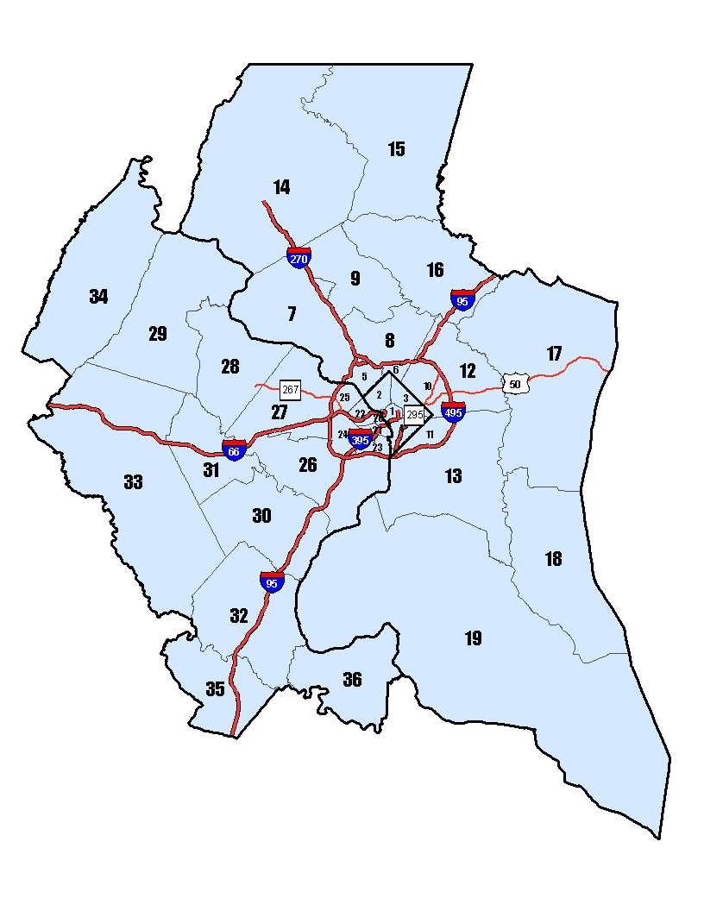

b) A Downtown Cordon in Washington, DC

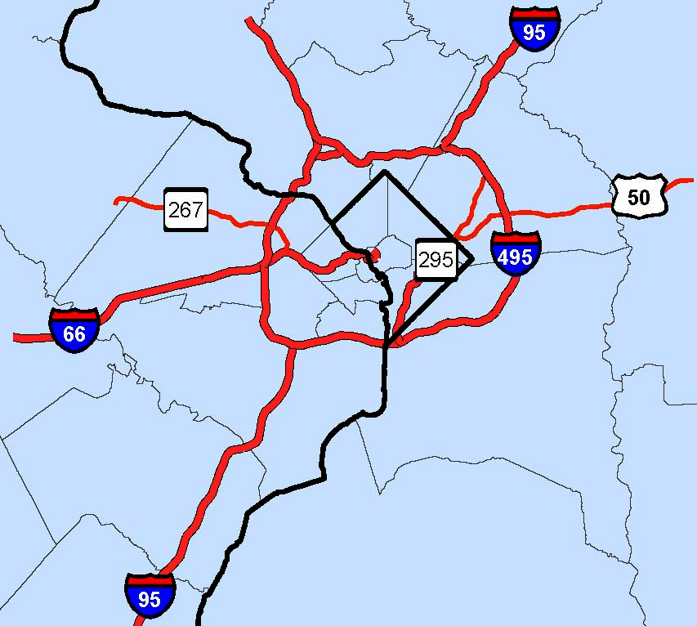
Downtown Cordon

Figure 2: Welfare Gains under LUSTRE and START for a Downtown Cordon
a) Total Welfare Gains
b) Welfare Gains per Capita
Figure 3: Changes in Average Trip Travel Time by Origin under LUSTRE Relative to Baseline, Downtown Cordon (228 cents)

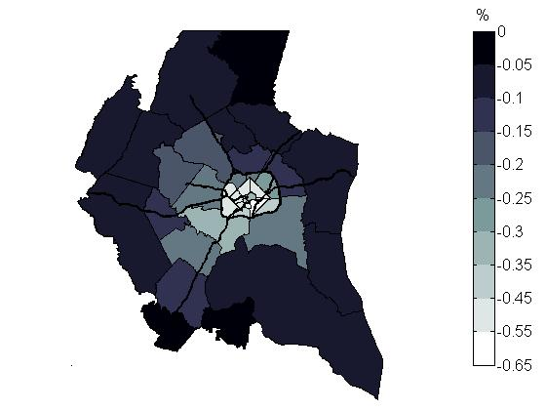
Central districts
Figure 4: Changes in Average Commuting Costs, LUSTRE Relative to Baseline, Downtown Cordon (228 cents)
a) Commuting Costs by Home Zone

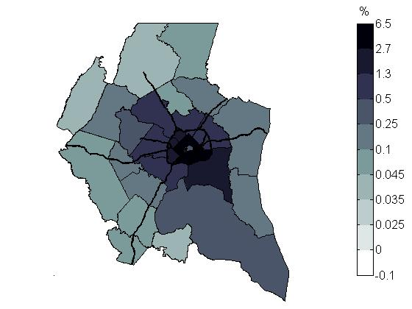
Central districts
b) Commuting Costs by Work Zone

. 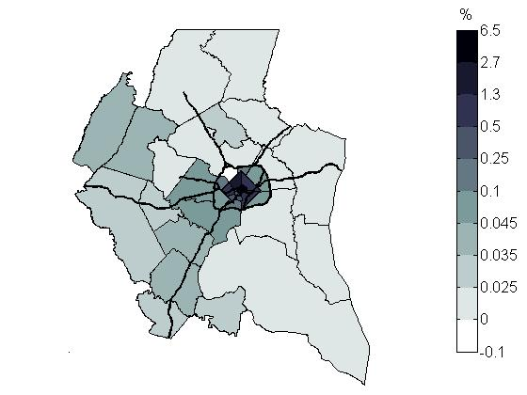
Central districts

Figure 5: Changes in Average Costs of Shopping Trips, LUSTRE Relative to Baseline, Downtown Cordon (228 cents)
a) Shopping Costs by Home Zone

. . 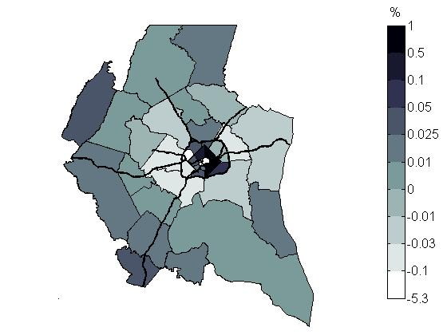
Central districts
b) Shopping Costs by Shopping Zone

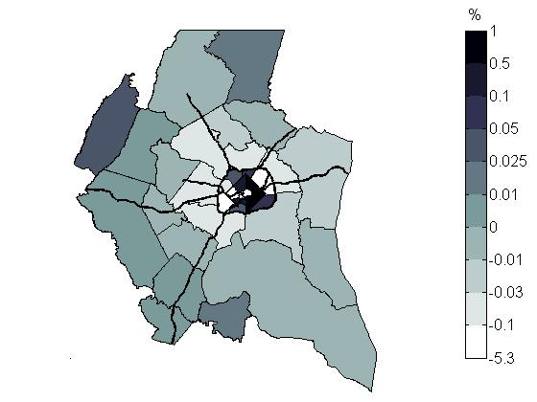
Central districts
Figure 6: Changes in Overall Travel Costs, LUSTRE Relative to Baseline, Downtown Cordon (228 cents)
a) Transportation Costs by Home Zone

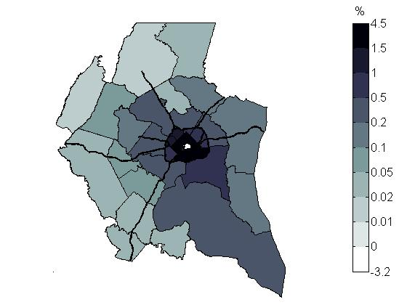
Central districts
b) Transportation Costs by Destination Zone

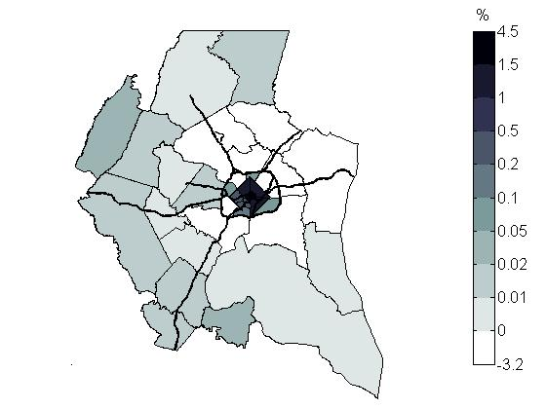
Central districts
Figure 7: Changes in Average Wage Rate, LUSTRE Relative to Baseline, Downtown Cordon (228 cents)

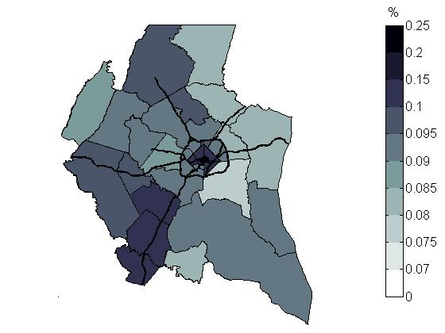
Central districts
Figure 8: Changes in Residential Pattern of Population, Residential Rents, LUSTRE Relative to Baseline, Downtown Cordon (228 cents)
a) Population Change

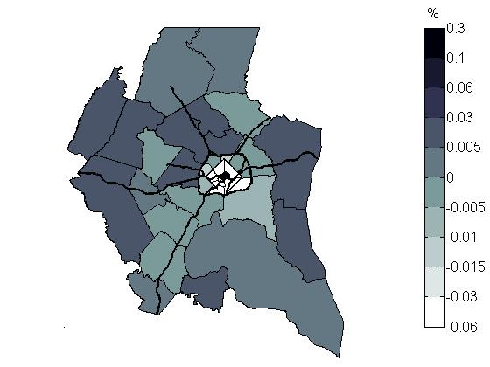 . .
Central districts
b) Residential Rents

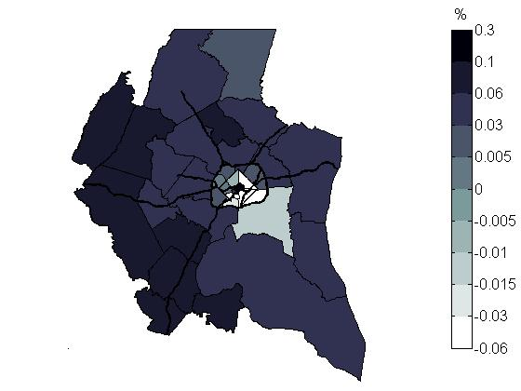
Central districts

Figure 9: Changes in Output and Prices, Production Sector, LUSTRE Relative to Baseline, Downtown Cordon (228 cents)

a) Real Output of Retail Sector

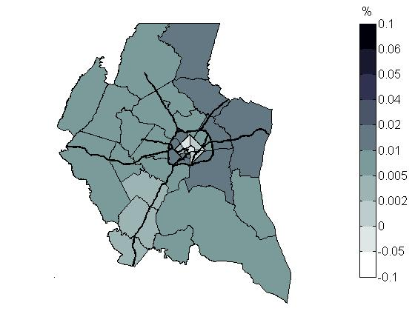
Central districts
c) Retail Prices

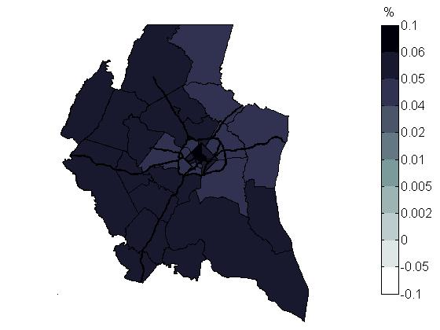
Central districts

b) Real Output of Primary Industries

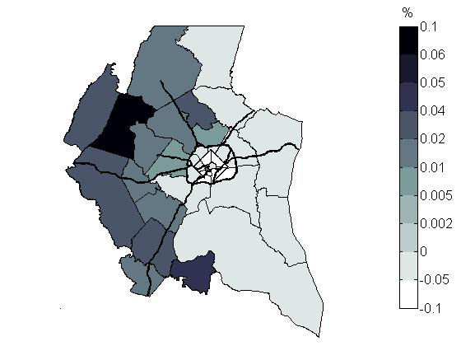
Central districts

* Elena Safirova is a Fellow and Winston Harrington is a Senior Fellow, Sébastien Houde is a Research Assistant, and D. Abram Lipman and Andrew Bagliano are former Research Assistants at Resources for the Future. This work was supported by the EPA STAR grant RD-83145001-0 “An Integrated Framework for Estimating Long-Term Mobile Source Emissions Linking Land Use, Transportation, and Economic Behavior.”
We also refer to Washington implementation as Washington START.
See Nelson (2006) for more details on transit modeling improvements.
For shopping trips, the mode nest is above the destination nest.
However, in LUSTRE, trip purposes that are not explicitly modeled in RELU are ignored.
In the present version of the model, all changes in generalized costs are reflected in monetary costs of travel.
While a full characterization of the baseline equilibrium and a technical description of the calibration procedure are beyond the scope of this paper, a technical paper describing those details is available from the authors.
To allow comparisons of the transportation results between START and LUSTRE, our interpretations of the results focus on cordon policy that corresponds to the optimal toll pricing found under START.
Here the gross wages are reported to reflect the marginal productivity of labor.
Unemployed consumers choose a pair (i,k). Alternatively, the choice of unemployment can be associated with an artificial workplace zone (say, j=0)
Although in the model we do not have leisure, aggregate labor supply is elastic because of unemployment and variation in time spent traveling to shop.
Here we present a static, stationary version of the model

