IMPACTS OF TRANSPORT INFRASTRUCTURE POLICIES

André Dantas
University of Canterbury, Private Bag 4800, Department of Civil Engineering, Christchurch, New Zealand. Tel +64-3642238
email: andre.dantas@canterbury.ac.nz,

Karisa Ribeiro
MWH New Zealand, 7 Deans Avenue PO Box 13249, Christchurch, New Zealand. Tel: +64-3-343-8792
email: karisa.m.ribeiro@mhwglobal.com.

IMPACTS OF TRANSPORT INFRASTRUCTURE POLICIES

André Dantas
Karisa Ribeiro

Abstract
A framework for analyzing impacts of transport infrastructure policies under a holistic approach is presented. This framework incorporates the time dimension of dynamic interactions between transportation and activity systems and linkages and implications to socio-economic and environmental changes due to transport infrastructure policies. Using a time-series database, the impacts of transportation policies were examined in a case study.

1. Introduction
Transport infrastructure policies create impacts not only to the transportation system, but also to social, economic and environmental systems. As individuals and as part of society, we perceive immediate and/or gradual changes such as travel times and costs. Obviously, other non-immediately perceived changes occur and affect planning objectives and goals.

A review of the scientific and technical literature on impacts of transport infrastructure polices reveals that most methods and techniques rely on the static and unidirectional representation of transportation-activity systems interactions (NCHRP, 2002; Hartgen, 2003, Wray et al, 2000; Weisbrod and Beckwith, 1992; Boarnet and Haughwout, 2000; Sanchez, 2004). Most studies perform a posteriori analysis of impacts, i.e. after the implementation of a policy, observed and expected changes are compared in order to evaluate the policy’s efficiency and effectiveness. This approach is based on the assumption that the impacts of transport infrastructure policies are solely the result of immediate changes in the transport and activity systems. Despite the widespread adoption of this approach, there has been growing criticism regarding the lack of comprehensive databases and evaluation methods that help planners in identifying the true dimension of the impacts (Greiving and Wegener, 2001; Badoe and Miller, 2000; Hirschman and Henderson, 1990; Prastacos, 1986; Shaw and Xin, 2003)

In contrast to previous research efforts, this paper explores the dynamic linkages between transport and land use as well as the implications to socio-economic and environmental changes due to transport infrastructure policies. This approach follows recent research initiatives (Rodrigue, 1997; Miller and Demestky, 2000) that have incorporated the time dimension in the analysis and modeling of dynamic interactions between transportation and activity systems. A framework for analyzing impacts of transport infrastructure policies under a holistic approach is presented.

The paper is divided into five sections. After this introduction section, a brief review is presented on theoretical concepts of impact analysis. The third section introduces the proposed impact assessment framework. The fourth summarizes a case study of the impacts in a highway project. Finally, the main findings and potential lessons learnt are presented in the fifth section.

2. Current practice in impact analysis
Activity-transportation systems interactions are critical in assessing impacts of transport infrastructure policies. Activity System is defined as the totality of social, economic, political and other transactions taking place over space and time in a particular region. On the other hand, the transportation system consists of the facilities and services that allow flows throughout a specific area, region, country, etc. Aiming to provide conditions to perform movement of people and goods, transportation is a factor of activity location, which in turn is dependant on with specific land uses. Manheim (1980) represents these interactions as shown in Figure 1 in which both systems are directly related and consequently any modification in one may affect the other.
Transportation System (TS)
Flow Patterns
(FP)
Activity
System (AS)

External Socioeconomic
and other factors
Figure 1. Interaction of Transportation and Activity Systems
Adapted from Manheim (1980)
IMPACTS

As an example of these interactions, consider a highway segment (Figure 2a) that is upgraded in its service level at given year 0. Over time, the improvements to the highway segment create changes to surrounding environment. As shown in Figure 2b, land use (e.g. more densification and diversification due to increase in traffic), environment (e.g. more noise and air pollution as traffic density increases), demographics (e.g. migration of population due to new activities) and economy (e.g. more economic activities due to decrease in travel costs) gradually change throughout the region. Subsequently, in year 25 (Figure 2c), further interactions and changes are observed.

Impact analysis focuses in specifying the effects of any changes on the activity and transportation systems (Meyer and Miller, 1984; Manheim, 1980). Based upon the current transportation system characteristics and future predictions of activities, many methods and techniques to analyse and evaluate impacts are found in the scientific and technical literature. They concentrate in estimating monetary benefits and costs in order to assess relative merits of planning actions (Dickey, 1983).

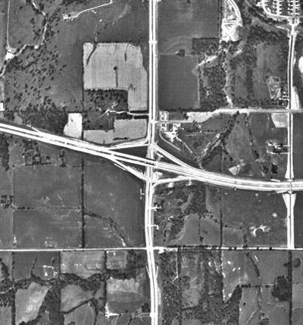 | 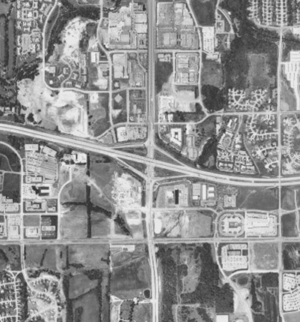 | 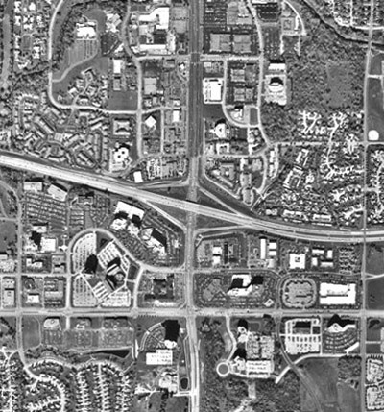
year 0  (a) | year 10  (b) | year 25  (c)
Figure 2. Spatial and Temporal Interactions between Transportation and Activity Systems

However, despite the diversity of methods and techniques applied to analyse and evaluate impacts, static analysis and evaluation of impacts is mostly observed (Shaw and Xin, 2003). The analysis and evaluation methods and techniques concentrate on just one side of the whole planning process, which is either the transportation or the activity system as observed in researches. Furthermore, recent research (Badoe and Miller, 2000; Ryan, 1999; Hirschaman and Henderson, 1990; Prastacos, 1986; Shaw and Xin, 2003) indicates that adopting current state-of-art analysis and evaluation methods and techniques may lead to inaccurate and/or incomplete assessment of the impacts of transport policies. Consequently, the analysis and evaluation may ignore dynamic effects and changes in the surrounding environment.

3. Impact assessment framework of transport infrastructure policies
This assessment framework comprises a set of steps in order to incorporate and integrate dynamically a wide range of transportation and activity systems affecting the analysis of infrastructure policies. The main theoretical assumption is:

Future impacts will be dependent on all preceding states of the transportation and activity systems, as well as on the cause-and-consequence effects of previously implemented policies and socioeconomic changes.

For example, be a transport infrastructure asset, such as highway segment, which is under analysis as part of a planning process. One on hand, Infrastructure Policies (IP) may alter the physical and operational characteristics of the existing assets and/or recommend construction of new infrastructure. On the other hand, Socioeconomic Profile (SP) may also contribute to affect the activity system. The combined effect of IP and SP changes result in Impacts (IM) such as variations in travel patterns, traffic composition and volume, travel time and speed, accidents, air quality and noise, population, land use, etc. In a temporal perspective, as shown in Figure 3 schematically, future impacts (IM^{t+n}) would be the outcome of:
- all previous impacts (IM^{t}, IM^{t+1}; …. IM^{t+n-1}); and
- all previous infrastructure policies (IP^{t}, IP^{t+1}; …. IP^{t+n-1}); and
- the over time socioeconomic profile (SC^{t}, SC^{t+1}; …. SC^{t+n-1}); and
- the temporal characteristics of the transportation system ((TS^{t}, TS^{t+1}; …. TS^{t+n-1}) and the activity system (AS^{t}, AS^{t+1}; ….; AS^{t+n-1}).
IP
IP
SP
TS
AS
FP
IP
IP
SP
TS
AS
FP
IP
IP
SP
TS
AS
FP

IP
IP
SP
TS
AS
FP
t
t+1
t+n-1
t+n
Timeline
Figure 3 .Temporal and dynamic relationships generating impacts

Based upon this definition, the impact analysis is conducted as per the following steps:
- Define the scope of the analysis (asset type and characteristics) and the intervening elements (Transportation and Activity Systems);
- Build a spatial-temporal database of study area, including the transport infrastructure and the activity system;
- Compute spatial-temporal changes for each intervening element and respective attributes (characteristics);
- Perform cross-reference analysis overlaying observed changes (step 3) from multiple layers of spatial-temporal data; and
- Identify short, medium and long term impacts from the cross reference analysis, based on cause and consequence tendencies.

4. Case Study
Aiming to understand the effects of an infrastructure policy, the proposed framework is applied in a case study. This attempts to show the potential of the proposed framework in order to analyse the impacts of various policy interventions in the main highway corridor named Presidente Dutra Highway (PDH) in Brazil. In the last 50 years, PDH has contributed to the development of the Southeast region of Brazil. Constructed in 1951, PDH provides the means for goods and people movement trade between Rio de Janeiro and Sao Paulo and the rest of the country. At time of construction, PDH was a high quality two-lane highway, with 405 kilometers of extension and 115 special works of art (turnpikes, viaducts, bridges and lower crossings).

Due to transportation demand increase, as a consequence of economy growth in the 1960’s, the government upgraded PDH to a four-lane highway in 1969. The investment contributed to the reduction of 40% of the transport cost between Sao Paulo and Rio de Janeiro and induced more traffic flow between both cities (Silva, 2000). However, in the 1980’s, a period of recession and shrinkage in infrastructure investments contributed to the deterioration of PDH’s service levels due to reductions in maintenance and construction funding. In 1996, PDH was transferred to the private sector through a concession contract in order to provide a high quality highway with modern services and support the economic development. Thus, 5 toll plazas were installed and tolls fees are charged from users.

Considering this background, the results of each step of the assessment framework are presented below:
- Step 1: Taking for reference the boundaries of the Rio de Janeiro and Sao Paulo states, the study region was delimited. This region comprises 167 municipalities as shown in Figure 4(a) and (b).
- Step 2: For each municipality census and administrative data sets and physical and operational characteristics of the PDH segments were obtained. Main data items were: Population, Gross Domestic Product (GDP), Urban, Industrial and Rural land uses of the municipalities in the study region; Traffic Volume and Number of accidents of each segment of the PDH. Using this data set, a georeferenced database was created in a GIS software (GeoMedia Professional), as shown in Figure 4(c).
- Step 3: The main spatial-temporal changes are summarized in Table 1.
- Step 4: A major development tendency and impact of the infrastructure policy interventions is the formation of Development Centers (DC) and Development Gaps (DG) in the PDH region. DC and DG are the result of completely different growth patterns. Significant changes in population, socioeconomic characteristics, transportation systems and land use patterns occurred in coincident areas clustering blocks of cities. In between the DC, DG (cities with low levels of changes) are also observed. Figures 5, 6 and 7 show the spatial distribution of the DC and DG.
All DC have the same growth tendency for all factors in the 1970-2000 period. The only exception is the number of accidents, which experienced a considerable reduction in the last 20 years. Another interesting aspect is the modification of the land use patterns. In almost all cities of the PDH region, there was a sharp tendency of industrialization and urbanization along the highway. On the other hand, three main gaps that have been affected with low change levels are observed. Despite the proximity to PDH, population, socioeconomic and the transportation characteristics have changed less than other cities in the DG. The interesting and common aspect of these cities is that the land use (especially rural) has changed considerably, which can indicate modification of the development pattern in the near future.

The process of DC and DG formation is the outcome of the combined effects of each intervention. The initial intervention (Capacity upgrade with federal government funding) produced general changes in socioeconomic, population, land use and transportation features modified almost at the same level. Originally, the PDH region had very limited number of activities, but this changed in the 1970’s due to a period of industrial activity booming, which is reflected in generalized increase in traffic flows, accidents and economic development.

The adopted policy of limited maintenance (1980-1990 period) associated with the economic and political crisis produced considerable deceleration of growth changes. Although DC 1 and 2 still have achieved high values in terms of population, socioeconomic and land use characteristics changes, they were less intense than before. On the other hand, transportation characteristics experienced a huge decrease in growth changes, in which DC 1 and 3 dropped considerably.

The upgrade and maintenance through PPP and toll charging scheme (1990-2000) produced a slight increase in terms of population, socioeconomic and land use characteristics in all DC. As for the transportation changes, DC 1, 2 and 4 decreased, while DC 3 suffered a huge increase in all respects. In the 1990-2000 period, the introduction of the toll system (concession of the PDH) altered the traffic behavior, which may have resulted in the modification of development patterns. However, after the implementation of this policy, this development pattern was altered. In areas nearby the toll plazas, drastic changes in terms of growth were observed. This has generated the transference of development previously observed in DC 2 and 3 to the DC 1 and 4. Moreover, the travel demand in between the toll gate plazas increased considerably, which indicates that short-distance trips became more cost effective because there was no additional charging for those trips. Simultaneously, socioeconomic indicators demonstrated a sharp decrease in activities especially in DC 2 and 3, which is mainly due to the increase in the perceived additional costs (toll fees).

There is a strong relationship amongst travel pattern and the changes in population, socioeconomic, land use. It is clear that before the infrastructure policy (concession of the PDH) there was a growth tendency without limits for all activity-highway system factors. Nearby the metropolitan areas, the low level of transportation costs (provided a high standard of accessibility) and land use (or property) values are possibly the main conditions encouraging this development pattern and creating conditions for increasing in goods and people movement as well as a large variety of activities.

- Step 5: Developments tendencies and impacts are expressed in terms of the dynamic interactions between population, socioeconomic characteristics, transportation system and land use changes over time and space. The policy interventions are grouped into three main categories, namely: capacity upgrade with federal government funding; minimum maintenance with federal government funding; and recuperation, upgrade and maintenance through PPP and toll charging scheme. Trade-offs between policy interventions and tendencies/impacts are examined in order to identify cause-consequence relationships that are used to assess the implementation of the tolling system.

Long term prospects considering the current location of toll plazas indicate that future developments will reach saturation. Probably, there will be the relocation of new activities just beyond the boundaries of the toll gate areas in terms of activities and transportation capacity in the areas of DC 2 and 3, because transportation costs and land use values will increase considerably in the areas of the DC 1 and 4.

A continuous cycle of development is observed, i.e., improvement (policy) in the transport infrastructure alters the land use pattern (activities location and density) that consequently affects the travel demand and influences the flow density and transport costs. Gradually, transport costs modify the land use values, which affect the land use patterns up to a point that infrastructure has to be upgraded in order to cope with a new spatial arrangement of activities and spatial interactions.

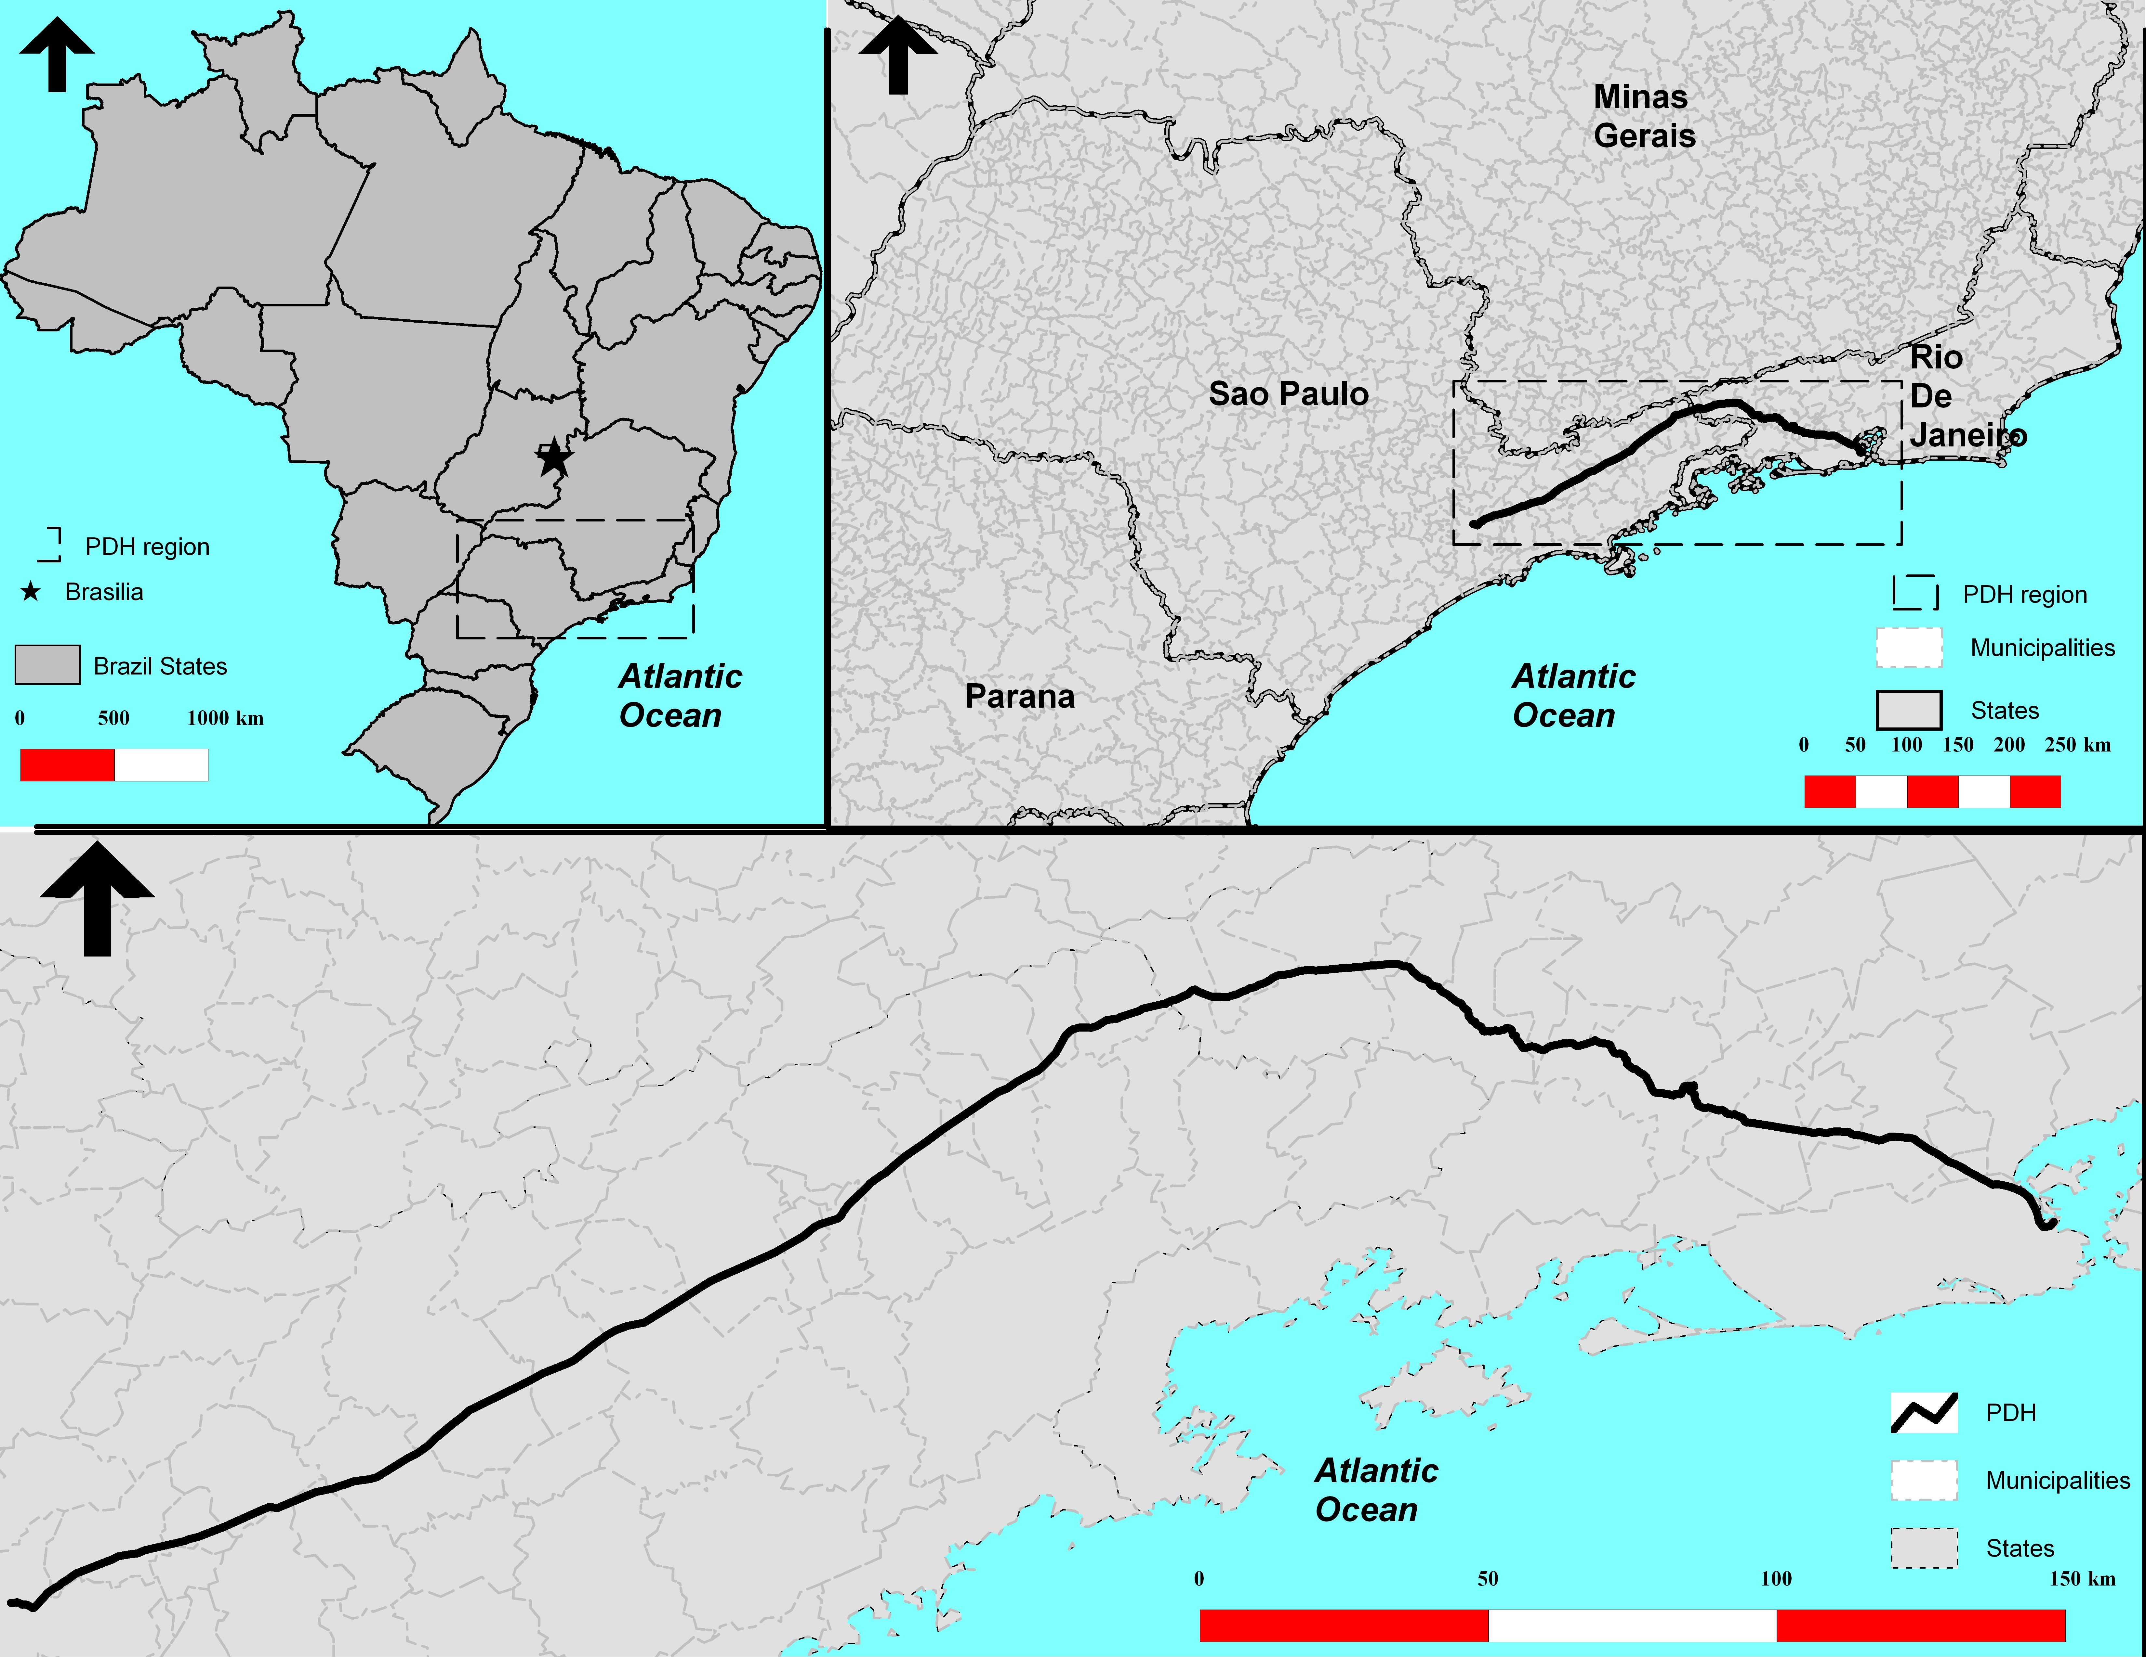
1
2
3
4
5
#
Toll plaza
Sao Paulo
City
Rio de Janeiro
City

Figure 4 – PDH region and municipalities: (a) Top left corner – Brazil States; (b) Top right corner - PDH region; (c) Bottom – Municipalities in the PDH region.
Table 1 – Summary of spatial-temporal changes in the PDH region
VARIABLE | SPATIAL-TEMPORAL PATTERN EVOLUTION
Demographic | - In the early 60’s, approximately 10 million people lived in the region. In 2000, this changed to 36 million people.  - Population changes prior to recent infrastructure policies (Concession) was closely related to the distance from municipalities and the major metropoles (Sao Paulo and Rio de Janeiro).  - Most population changes were observed within 75 Km of Sao Paulo and Rio de Janeiro.
Socioeconomic | - The average GDP for the region was R$ 700 thousand in 1970, increasing to R$2million in 1996.  - GDP changes closely related to the distance between the cities and the major metropolis (Sao Paulo and Rio de Janeiro).  - Nearby the current location of toll plaza number 4, GPD changes were caused by the concentration of industrial activities related to a major exporter of steel products.
Operational | - Increase in demand since the early 1970’s, i.e. Average Daily Traffic (ADT) has doubled (94%) in the 1970-2000 period.  - ADT of Sao Paulo was 40 thousand vehicles/day in 1970 and became 207 thousand vehicles/day in 2000. This is mostly due traffic flow increase nearby Sao Paulo and Rio de Janeiro cities.  -The proximity to the major metropolitan areas has clearly affected the traffic volume build up.
Operational Accidents | - In 1980, 84 fatal accidents were observed in Sao Paulo metropolitan area (before the toll plaza number 1). Subsequently, accidents declined to 38 fatalities in 2000.  - Since 1980, a general decline has been observed in the number of accidents (-17.24%).  - In many parts of PDH the reduction reached 90% in 20 years, but in others such as accidents rates increased over 120%.
Land use changes | - A great deal of transformation in terms of land use changes in the last 40 years was observed.  - In 1960 the region had approximately 80% of rural use, 14% of urban use and 6% of industrial land use.  - Currently, the breakdown is: 47% of rural, 33% urban and 20% industrial activities.  - Metropolitan growth in Sao Paulo and Rio de Janeiro cities has been the main driver for the observed land use changes.  - Over time, the fringe areas of Rio de Janeiro and Sao Paulo cities became predominately industrial and the nearby cities also developed urban and industrial areas.  - The average industrial land use changes in the fringe of the metropolitan areas reached 234% in the period between 1960 and 2000.  - Rural areas dropped considerably near the metropolitan areas. On the other hand, industrial activities experienced considerable growth along the PDH.

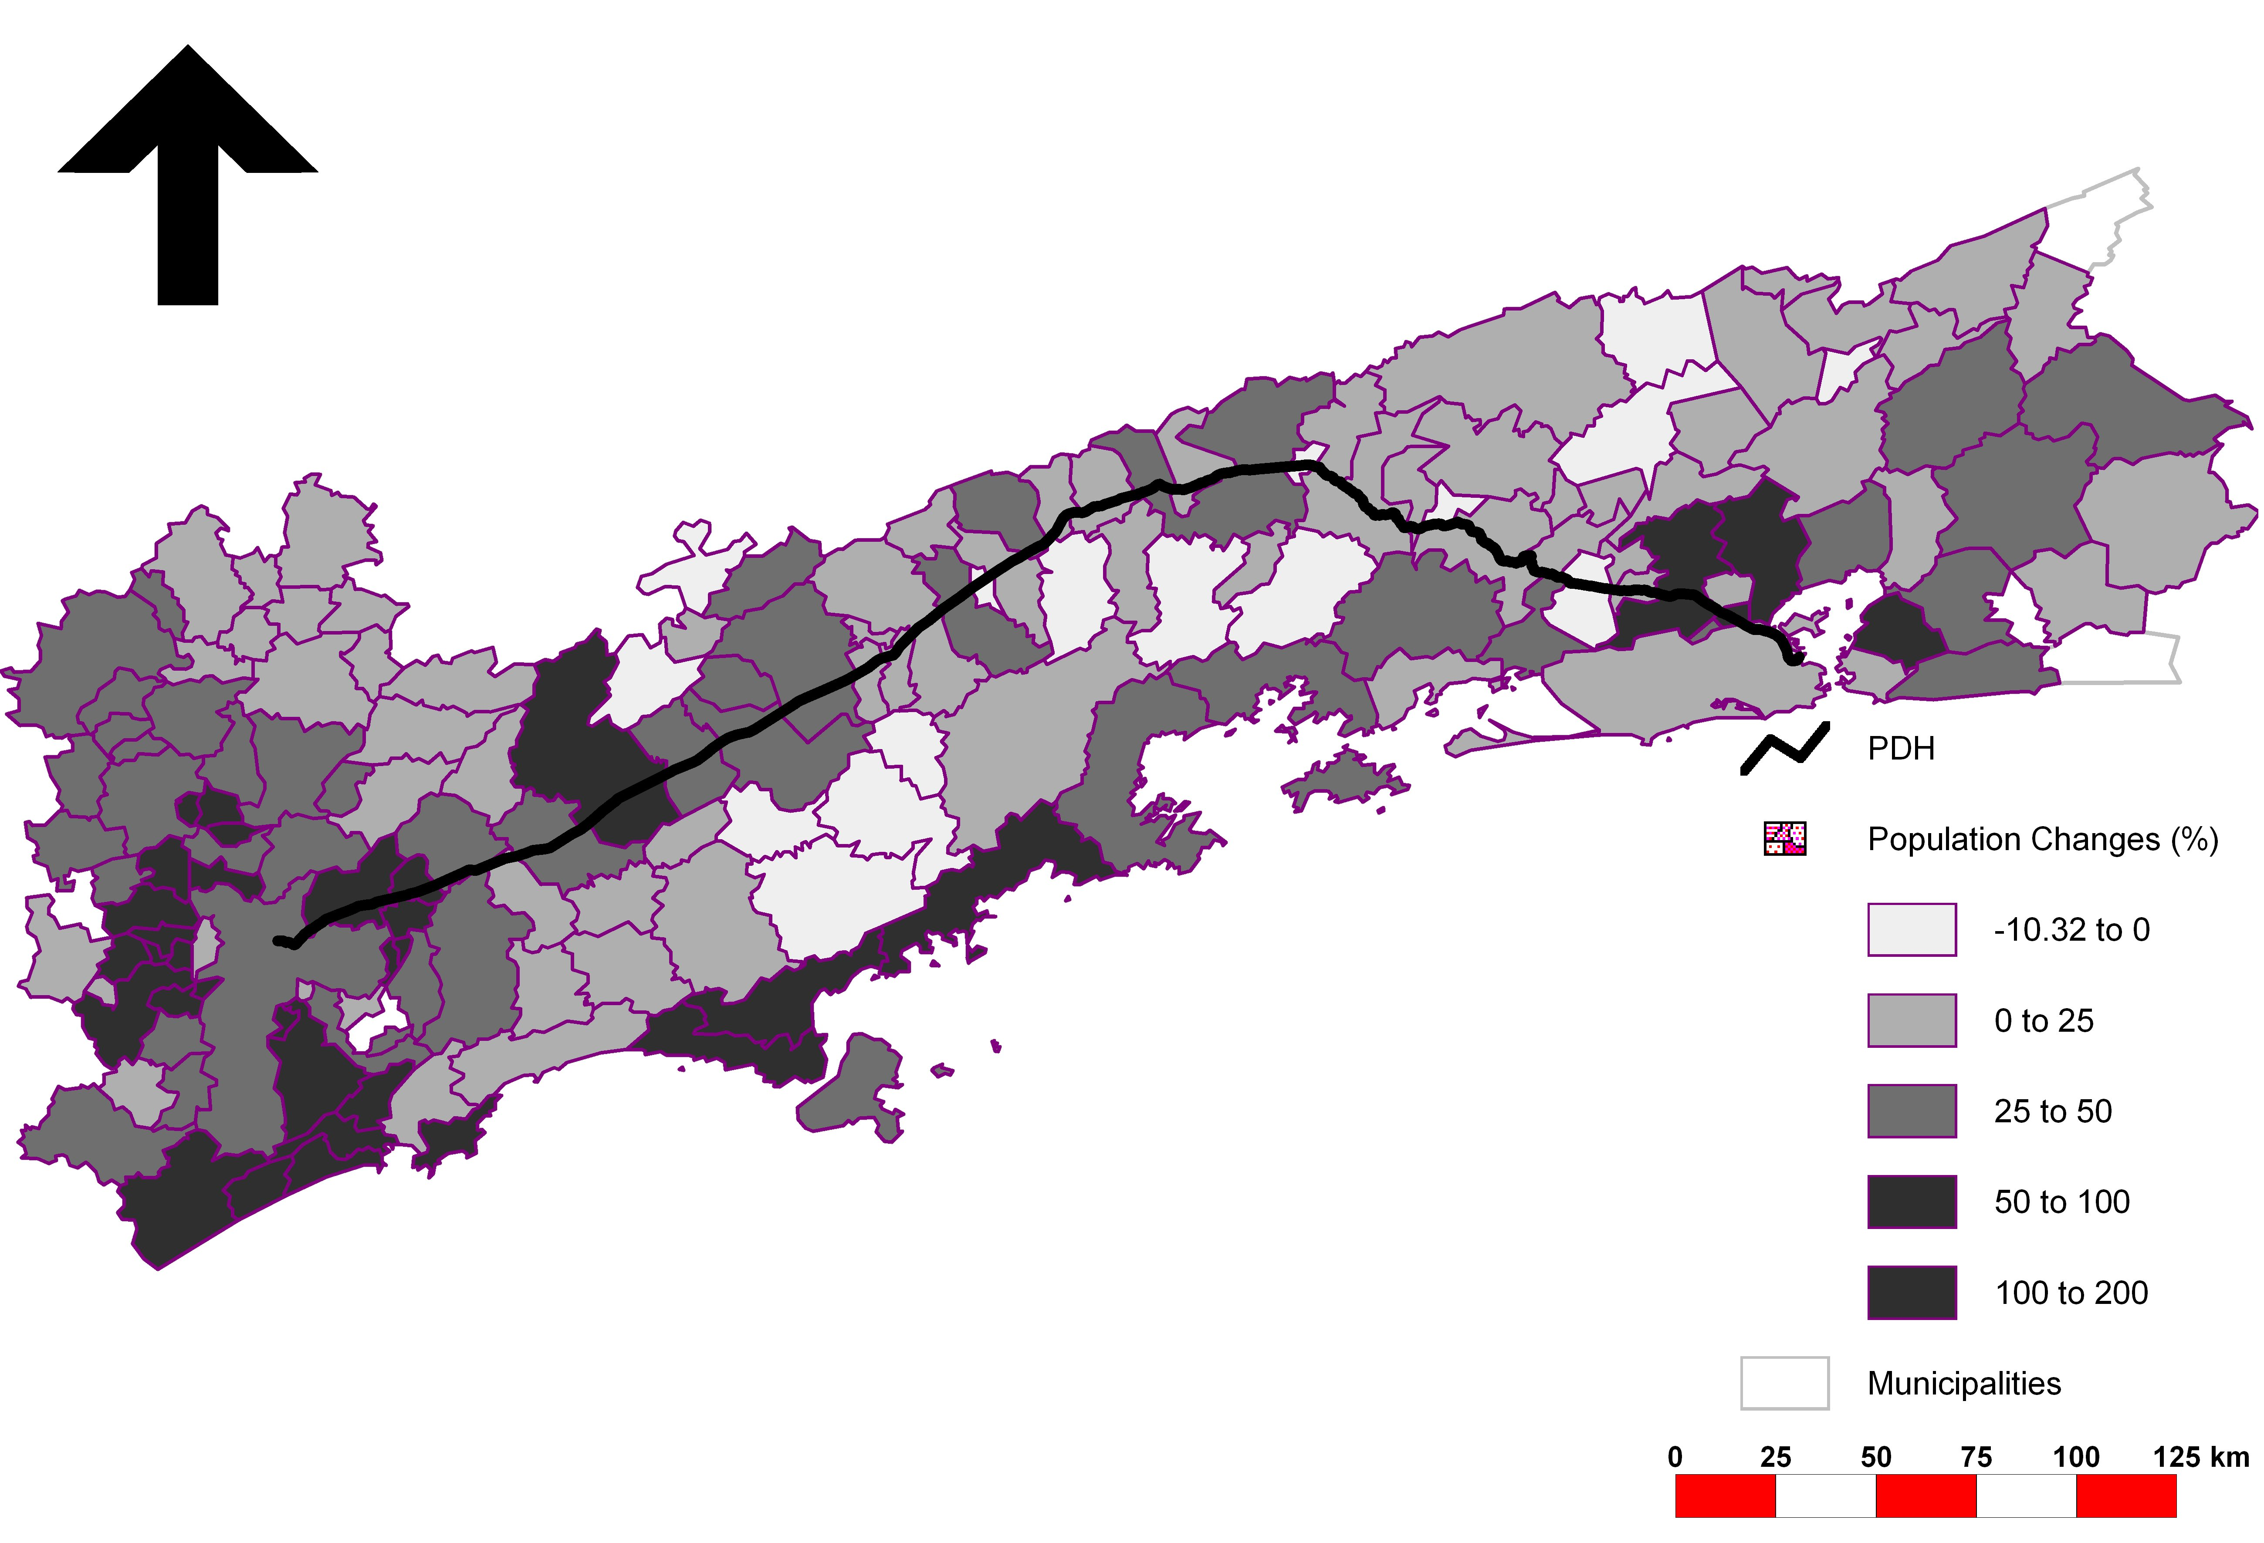
Rio de Janeiro
City

Sao Paulo
City

DC 3
DC 4
4

5
DC 2

3

Toll plaza
DG II
2
#
DG III
1

DC 1

DG I

Figure 5. Outstanding Population changes along the PDH.
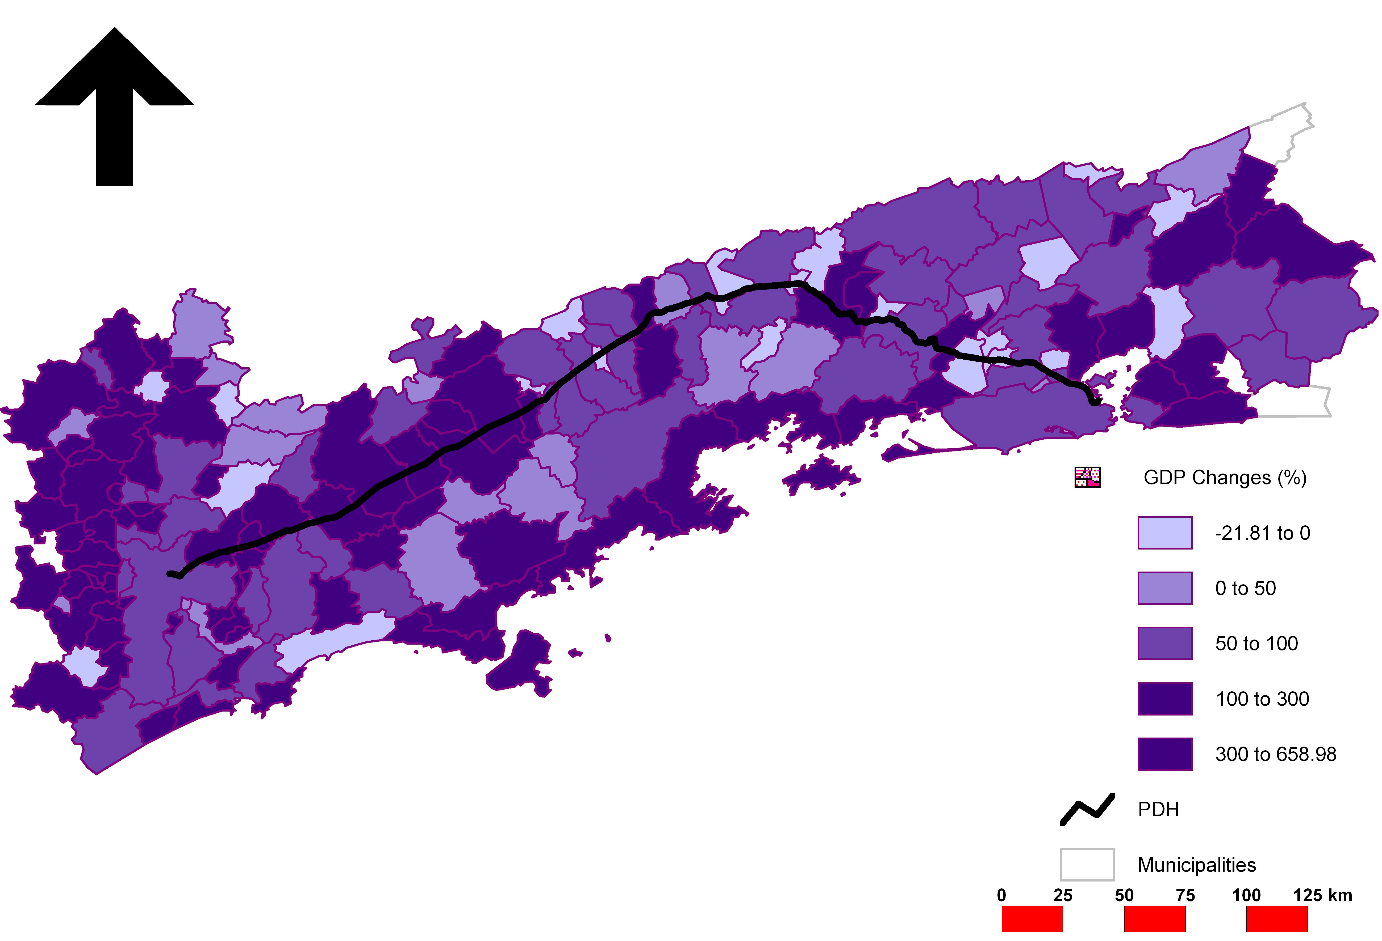
1
2
3
4
5
#
Sao Paulo
City
Rio de Janeiro
City

Toll plaza
DC 1
DC 2
DG I
DC 3
DC 4
DG II
DG III
Figure 6. Outstanding GDP changes along the PDH.
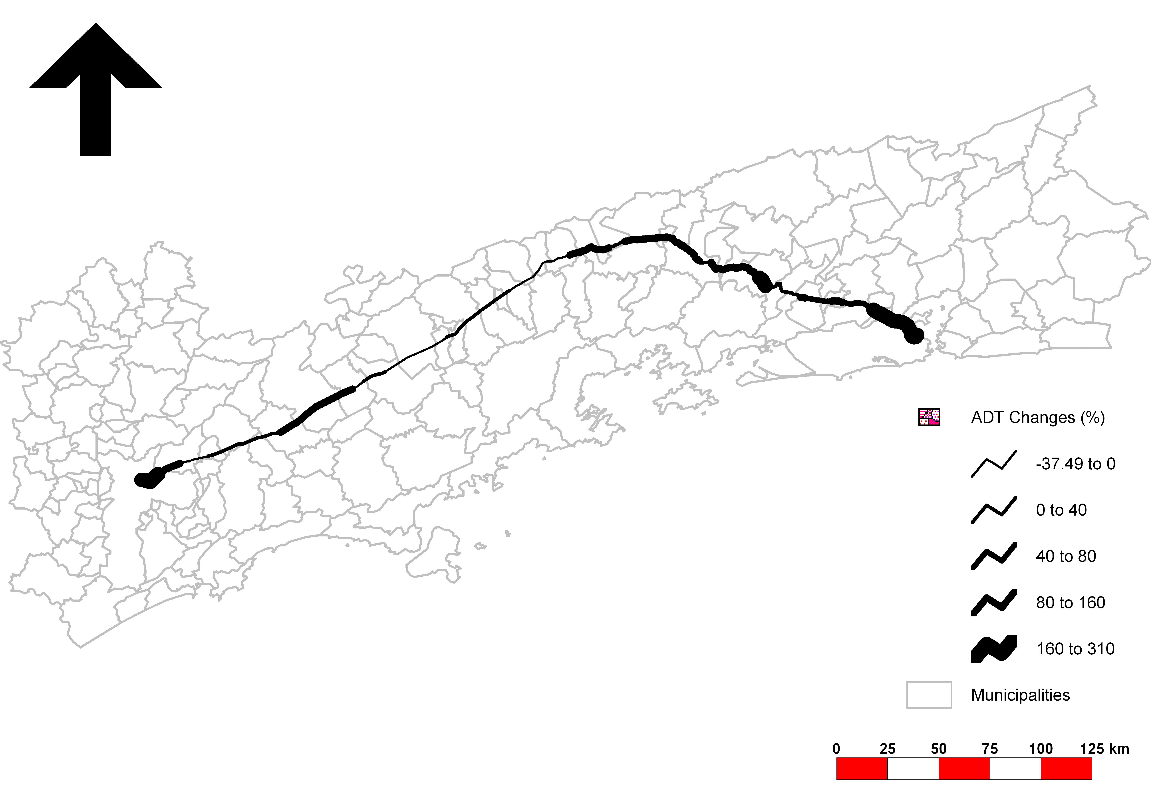
1
2
3
4
5
#
Sao Paulo
City
Rio de Janeiro
City

Toll plaza
DC 1
DC 2
DG I
DC 3
DC 4
DG II
DG III
Figure 7. Outstanding ADT changes along the PDH

5. Conclusions
A framework for analyzing impacts of transport infrastructure policies under a holistic approach was presented. This framework attempted to incorporate the time dimension of dynamic interactions between transportation and activity systems and linkages and implications to socio-economic and environmental changes due to transport infrastructure policies.

A major outcome of the case study is that a static analysis of impacts generated different results to those obtained by applying a temporal assessment framework. Hence, it was observed that infrastructure policies have created short, medium and long-term impacts of extreme complexity. These impacts are the result of a continuous development cycle in which transport infrastructure policies trigger changes in land use patterns (activities, location and density), socioeconomic and demographic indicators as well as operational conditions of the highway.

Based on the understanding of the development cycle in the PDH region, the recent implementation of the tolling system through a PPP scheme created impacts in terms of initial limitations to development in all respects due to the increase in direct (user perceived) transport costs. The charging system caused saturation (land use and transportation) of those areas in between toll plazas.

The proposed framework and the case study findings may contribute to the evaluation of highway projects. The spatial-temporal analysis of impacts may be used to expand the range of factors that are currently considered economic evaluation of transport infrastructure policies. Even though the proposed framework does not include all possible intervening factors, the consideration of a broad range of variables may help in understanding the development cycles and the long-term impacts of infrastructure projects. This understanding will be essential to assess how infrastructure policies will meet the objective/goals. Moreover, the proposed framework would help decision makers to conduct short, medium and long term monitoring of impact of their decisions.

Further studies should be conducted in order to enrich the knowledge about the impacts of infrastructure polices. A suggestion list for future research is presented below:
- Any change in the infrastructure policy should be made considering all the aspects related to economic, political and social issues and not only the highway operational reality. Also it is advisable that changes should be conducted according to a national strategic plan, which defines objectives, steps and efficiency measures that reflect on welfare of the nation;
- During the execution of the case study, several difficulties were faced in organizing the database for the study region. It is imperative that planning agencies at all levels dedicate more effort to creating a unified data standard and collection process that will eventually contribute to form a data warehouse. This will be crucial to developing further studies and reaching new findings; and
- Creation of instruments to predict development scenarios based on initial estimates of population and economic growth in the region of the highway project. Such an instrument has to consider the spatial and temporal dynamic of all the involved variables. Currently, such an approach is not observed in the literature of transport-land use modeling.
Acknowledgements
The authors would like to express their gratitude to the Ministry of Education of Japan and the Brazilian Research Council (CnPq) for the financial support to this research. We also would like to thank the technical staff of the NovaDutra concessionaire, Anderson Couto (Brazilian Land Transport Agency – ANTT) and all in Brazil that helped in the data gathering activities.

References
NCHRP (2002) Desk reference for estimating the impacts of proposed transportation projects; NCHRP report 466, Transportation Research Board.
Hartgen, D.T. (2003). The impacts of Highways and other major road improvements on urban growth in Ohio. The Buckeye Institute, policy Reports.
Wray, S., Moses, S. and Weisbrod, G. (2000). The development impacts of highway interchanges in major urban areas: case study findings. Report available at www.paturnpike.com/i95.
Weisbrod, G. E. and Beckwith, J. (1992). Measuring economic development benefit for Highway decision-making: the Wisconsin case. Transportation quarterly, vol.46, n. 1, pp. 57-79.
Boarnet, M.G. and Haughwout, M.G. (2000). Do highways matter? Evidence and policy implications of highways"influence on metropolitan development. The Brookings Institution: Washington DC.
Sanchez, T.W. (2004). Land use and growth impacts from highway capacity increases. Journal of urban planning and development, ASCE, vol. 130, n. 2, June, pp.75 -82.
Greiving, S. and Wegener, M. (2001). Integration of transport and lad-use planning: state of the art. 9th World Conference on Transport Research, Seoul, July. pp. 1-22.
Badoe, D.A. and Miller E.J. (2000). Transportation land use interaction: empirical finding in North America, and their implications for modelling. Transportation Research D, vol.5, pp. 235 -263.
Hirschman I., and Henderson, M. (1990). Methodology for assessing local land use impacts of highways. Transportation Research Record, vol. 1274, pp. 35-40.
Prastacos, P. (1986). An integrated land use transportation model for the San Francisco region; Design and mathematical structure .Environmental and Planning vol. 18 A, pp. 307-322
Shaw, S. and Xin, X. (2003). Integrated land use and transportation interaction: a temporal GIS exploratory data analysis approach. Journal of transport geography, vol. 11, n.2, pp. 103-115.
Rodrigue, J. P. (1997) Parallel modelling and Neural Networks: an overview for transportation / land use systems, Transportation Research C, Vol. 5, N. 5, pp.259-271.
Miller, J. and Demestky, M. J. (2000) Longitudinal assessment of transportation planning forecasts; Journal of Transportation Engineering; vol 126; no. 2; pp. 97-106.
Manheim, M.L. (1980). Fundamentals of transportation systems analysis. Preliminary edition, Massachusetts Institute of Technology.
Meyer, M.D. and Miller, E.J. (1984). Urban transportation planning: a decision-oriented approach. McGraw-Hill series in transportation, MacGraw-Hill Book company, New York.
Dickey, J. (1983). Metropolitan planning transportation. McGraw-Hill, Washigton.
Ryan, S. (1999). Property values and transportation facilities: finding the transportation land use connection. Journal of planning literature, vol. 13, pp. 412-427.
Silva G.F. (2000). Toll roads. Public policy for the private sector. Sector note 22. World Bank, Washington DC.
Ribeiro, K. M; Dantas, A.S., Yamamoto, K. (2003) A methodological framework for evaluating concession of highways in a private-public partnership context; Journal of Eastern Asia Society for Transportation Studies, vol 5, pp. 2893-2903; ISSN 1341-8521.
Chung, H. (2002). Some socio-economic impacts of toll roads in rural China. Journal of Transport Geography, vol. 10, pp. 145-156.
Boarnet, M.G.and Chalermpong, S. (2001). New Highways, house prices, and urban development: a case study of toll roads in Orange County, CA. Housing policy debate, vol. 12, issue 3, pp. 575- 605.

