“Planning for Less Travel”: Transformation of Urban Form in Ankara and Effects on Urban Transport and Traffic

Ela Babalik-Sutcliffe
Department of City and Regional Planning
Middle East Technical University
Ankara 06531
Turkey
Phone: +90 312 210 2241
Fax: +90 312 210 1250
E-mail: ebaba@arch.metu.edu.tr

Track: F1 Transportation and Spatial Development
“Planning for Less Travel”: Transformation of Urban Form in Ankara and Effects on Urban Transport and Traffic

Abstract

Urban transport problems that result from ever-increasing levels of mobility and car usage have become major challenges. While past decades saw various transport policies and measures to restrict and manage car usage in the cities, it has been increasingly recognised that urban form, development patterns, and density levels have fundamental effects on travel behaviour and car usage, and that therefore urban planning can be a major tool in solving transport and traffic problems. Sustainable development debates also support this line of thought with their explicit emphasis on identifying the most appropriate urban form and pattern for creating sustainable cities and sustainable urban transport systems. Certain planning approaches, such as intensification of urban development or corridor development that support public transport usage, together with mix land use models, are promoted as sustainable alternatives to the prevailing lower-density urban sprawl. This paper assesses the effectiveness of such planning approaches, focusing on the past planning experience of Ankara, the capital of Turkey. Since the 1970s, planning studies for Ankara had promoted corridor development for the future urban pattern of the city, as opposed to the extremely compact form with continuous expansion on the fringe. Two corridors were proposed, and they were planned with a mixed land-use strategy and two new metro lines. In implementation, one corridor developed with a higher level of mixed-use and a metro line that opened in 1997, whereas the other corridor became predominantly residential with poor level of local amenities, and a metro line still not completed. The comparison of development trends and resulting life-styles, travel behaviour and traffic along these two corridors in Ankara provide important results for the sustainable urban form debates.

1. Introduction

Increasing usage of the car, resulting traffic congestion and air pollution are among the most important urban problems of today. Contemporary transport policy has a significant focus on means of changing travel behaviour with a view to reduce car trips and encourage alternative modes, such as public transport and non-motorized modes, walking and cycling.

While transport measures that introduce restrictions on car usage and improvements in, and incentives for, public transport and non-motorized modes, there is increasing awareness that some of the transport problems can be more effectively solved through ‘non-transport policies’ (Stead and Banister 2001), and in particular, through land-use policies that may help influence travel behaviour, resulting in a reduction in car usage. Neighbourhood design approaches to influence travel behaviour, for example, received significant emphasis recently, with much research and many debates on designing transit-oriented or pedestrian-friendly development, and less car-dependent neighbourhoods (Calthorpe 1993; Katz 1994; Bernick and Cervero 1997). These studies emphasised that high-density development (throughout the urban areas and especially around public transport stations), and a mix of different land-uses can help reduce the need to travel overall, as well as the need to travel by the car: that is because, higher densities and mixed-use development can result in reduced distances between activities, and hence walking, cycling and public transport alternatives can become effective options. In addition design approaches that are pedestrian-friendly and transit-oriented are discussed to be vital in changing travel demand from car-based patterns towards public transport and walking, hence bringing togehter density, diversity and design in creating a built environment that is not car-dependent (Cervero and Kockelman 1997). These debates helped bring urban planning to the forefront of the transport policy agenda; and ‘planning for less travel’ (Banister 1999, Stead 1999) became an increasingly important strategy.

The literature on ‘sustainable urban development’ also reinforces these debates: it is discussed that certain urban forms and patterns are more sustainable than others (Williams et al. 2000), having sustainability defined here as reduced petrol dependency, reduced congestion and accidents, reduced impact on air quality, reduced land consumption and infrastructure spending, improved life-styles and community life, etc. The compact city model received much emphasis in these debates: it has been discussed that urban intensification, high-density development, and mixed-use development strategy not only help manage urban sprawl but also help change travel behaviour by enabling people to live near their workplaces and amenities, hence by reducing the need to travel by the car. On the other hand, sceptical views have been increasing about the viability and effectiveness of the compact city (Newman and Kenworthy 2000, Roo 2000, Williams 2004). The functioning and management of compact cities become difficult as they grow in population and size, and while compactness may result in shorter distances travelled, it is not clear whether quality of life can be significantly improved due to the intensification of traffic and emissions. Alternatives to the compact model have also been proposed, such as corridor development that can enable high-capacity high-quality public transport service, and multi-centred urban areas that function as a network of self-sufficient settlements (Williams et al. 2000). These models also propose the density and diversity of development as the main elements of the built environment: a mix of land-uses is seen essential so that working places, services, etc. can be efficiently accesses by walking or by public transport, making the development self-sufficient and reducing the need to travel to the city centre amenities. High density growth (linear or polycentric) can ensure that public transport service as well as local services and amenities can be supported by the population

Sustainable urban development debates and particularly the emphasis on the need to intensify development to attain high density appear as strategies that are derived through the analysis of problems in the industrialised world. In developing country cities, it is common to have high population levels, centralisation of activities and amenities at the centre, poor public transport service, and therefore a compact city form resulting from the need to stay close to amenities. This generally is a problematic urban form, and as Williams (2004) argues compactness and intensification strategies are inappropriate for cities in developing countries, which lack the infrastructure and urban management structures to make the model work. She suggests that the polycentric city model or the linear public transport corridor model, the two alternative models briefly described above, are more appropriate for the cities in developing countries.

The recent planning experience in Ankara and the resulting urban transformation are worth analysing in this context. Since the 1970s, planning studies in Ankara have aimed at transforming the compact and problematic urban form into a controlled decentralisation along two main corridors of development. A corridor development strategy was adopted and residential growth was promoted along the two corridors together with the decentralisation of commerce, industry and other workplaces along these corridors. The resulting urban form, development pattern, residential-work patterns, travel behaviour, and traffic levels in these two corridors provide opportunities for an analysis of the transport/traffic effects of mixed-use corridor development, which can contribute to the above arguments.

The method of analysis used in this paper rests on the investigation of two trends in Ankara. First, development trends in the two proposed decentralisation corridors are observed in a comparative approach: level of decentralisation of population (residential areas), decentralisation of workplaces, and decentralisation of commercial centres will be identified in both corridors with a view to provide an understanding of the level of diversity and mixed-use nature of development. Residential growth, employment growth, and location of industries, public (state) workplaces, and commercial centres will be illustrated. The different socio-economic characteristics in the two corridors will also be analysed in this stage. Second, travel behaviour, home-work trips, and trends in traffic growth will be analysed separately in the two corridors with the underlying objective of relating differences in transport and traffic trends with differences in urban development trends.

2. Transforming the urban form of Ankara: from compact to linear transit corridor development with mixed-use

Ankara, the capital city of Turkey, is a metropolitan area with a population of 3.5 million people. Different from many cities in Western Europe and especially North America, the city had a historically high-density development and a rather compact form. While the compactness had provided advantages for the functioning of the city, after the 1960s and 1970s it became a problem in the face of rapid population growth. Urban growth, which took place at the fringes without taking any particular form, was resulting in continuous spatial growth in the 1970s, and although densities were still relatively high, the urban area was becoming difficult to manage and to serve effectively with public transport.

In the 1970s, when metropolitan planning studies were started, the city’s compactness and problematic fringe development (Figure 1) were causing further problems including over-crowding in the centre; congestion due to the centralisation of most activities in the CBD and the inadequacy of bus-based public transport systems in the face of rapidly increasing mobility needs; and finally a severe life-threatening air pollution problem that was caused by traffic congestion as well as extensive usage of coal for heating. The plan proposed corridor development to solve these problems. Two linear corridors of development were proposed: the western corridor and the south-western corridor. It was planned to develop these corridors as new residential growth corridors as well as decentralisation lines for commerce, industry and other workplaces (Figure 2).

Insert Figure 1 about here.
Insert Figure 2 about here.

The linear development plan prepared in the 1970s also proposed two rail lines along the mentioned two corridors of development; however, a comprehensive transport plan was not carried out that could enable their construction. The plan was revised in the 1980s in conjunction with a transport plan that included extensive urban rail schemes for the city. Of the various lines, those serving the two linear development corridors were given priority (Figure 3).

Insert Figure 3 about here.

The emphasis of the development plans was on controlled growth along linear corridors. The strategy comprised the decentralisation of not only residential areas but also commerce, industry, and other workplaces, hence creating a mix of different land-uses along the corridor. New town centres were proposed along both corridors. It was intended to connect the new developments and new commercial centres to the city centre with a high-capacity public transport system. From the perspective of ‘sustainable urban development models’ debate, it can be suggested that the approach was a ‘corridor development’ with a strong focus on providing a mix of land-uses. The mix-use aspect was particularly emphasised to be important to help relieve the pressure on the central city.

3. Implementation of the plan

Today the western and the south-western corridors of Ankara have become the two main axis of the city. In Figure 4, which shows the spatial development of the city since the 1920s, it can be clearly seen that most new spatial development took place between 1985 and 2000, and these new development areas were along the two corridors proposed in the plans, and particularly the western corridor. It is not possible to claim that growth in other directions and at the fringe in general were completely prevented or controlled; however, such growth remained limited, with the new corridors attracting majority of the new development.

Insert Figure 4 about here.

The two corridors have different implementation history and different characteristics. First of all, the implementation and phasing of the metro lines were different in the two corridors. Although both corridors were chosen as the priority metro lines, in implementation, the western line received priority and opened in late 1997. The south-western line, on the other hand, after being postponed for a long time, started to be constructed in 2005: the line still did not open.

Planning experience and projects also present differences across the two corridors. The western corridor housed various government-led projects, from large-scale mass housing projects financed by the government to relocation of light and heavy industrial estates. Creation of commercial cores, such as new town centres, although planned, could not be materialised. Instead, large-scale shopping centres, supermarkets and hypermarkets, etc. opened along this corridor. Recreational areas, such as urban parks, also took place recently. As a result, with the exception of new commercial cores, a certain level of mixed-use development was achieved in this corridor with a fairly significant level of residential-workplace mix.

The southwestern corridor, on the other hand, developed predominantly in residential character. Rather than government-led or sponsored housing projects, market-led residential development took place in the corridor. In line with the plan proposals, some government office decentralisation also took place. Four university campuses developed on this corridor, two of which existed during the plan period. Once again, new town centre development could not be achieved in the corridor. Shopping centres, although not as many and as grand in scale when compared to those in the western corridor, opened.

4. The resulting urban pattern: decentralisation, population growth and employment growth

Characteristics of urban growth in the two corridors are presented in Table 1. It can be seen that both corridors experienced significant population growth, but that the western corridor is four times more populated than the south-western corridor. It is quite significant that this corridor accommodates 43 % of the total urban population. The population size in the south-western corridor is smaller, amounting to only 11 % of the total urban population; however, growth rates reveal that development trends in this corridor are stronger.

Insert Table 1 about here.

As for spatial growth, trends in growth distances are perhaps still not as significant as might be expected in a Western European or North American city; however, these trends also show the dominant growth in the western corridor (Figure 5). This corridor ended at the 14th km (from the city centre) in 1985, and at the 26th km in 2000. In the south-western corridor (Figure 6), development ended at the 10th km in 1985 and at the 18th km in 2000.

Insert Figure 5 about here.
Insert Figure 6 about here.

Figures 5 and 6 also show that there was decentralisation, not just growth along corridors. Figure 5 shows that in the western corridor 40 % of the population was living within the first 10 km from the city centre in 1990; this figure fell to 30 % in 2000. More striking is that 90 % of the population was living within the first 15 km in 1990, whereas in 2000 population living within the first 15 km fell to 76 %. In the south-western corridor, 92 % of the population was living within the first 10 km from the city centre in 1990; in 2000, this figure fell as low as 60 % (Figure 6).

As a result of the corridor development strategy, population size and more importantly population density decreased in central areas. In the city centre (an area covered with a 5 km radius), average net density fell from 300 persons per hectare to 250 persons per hectare.

The residential densities in the two development corridors are also different. Although exact figures are not available, data from the Transport Master Plan of Ankara 2015 (prepared in 1993) can be used to help identify the higher and lower density developments in the two corridors in the 1990s. In this study, which is illustrated in Figure 7, low density areas were shown as those where a development strategy was needed to increase density levels. It can be seen that the entire south-western corridor was identified as areas where this strategy needed to be implemented. The western corridor also had some lower density residential areas, where the implementation of this strategy was considered necessary. However, it is seen that the western corridor also accommodated a significant amount of high density residential areas (Figure 7).

Insert Figure 7 about here.

The land-use map of Ankara in 2000 (Figure 8) also shows the differences in size of development in the two corridors- as well as the differences in accomodating non-residential developments. It can be seen that the south-western corridor developed predominantly residential, whereas the western corridor can be considered a relatively more successful model for bringing together a mix of different land-uses. There are large-scale industrial areas and other workplaces in the western corridor, as well as some commercial uses.

Insert Figure 8 about here.

The south-western corridor also accommodates some workplaces, that predominantly provide state employment: the corridor was identified for the decentralisation of state offices of the capital. The resulting land-use of state offices in this corridor can be seen in Figure 9: it is important to note that the new location of state offices on this corridor are still somewhat close to the city centre, and therefore not strongly integrated with the residential neighbourhoods that took place further along this corridor.

Insert Figure 9 about here.

Employment figures in the two corridors also reflect these differences: 50% of total workforce (excluding service sector, state employees, and commercial activities) in the city work in the western corridor. The workplaces in the southwestern corridor, on the other hand, amounts only to 10% of the workforce in the city.

The profiles of the two corridors can be summarised as follows: the western corridor experienced a higher level of decentralisation and development both in terms of residential areas and population, and in terms of non-residential development and employment. Development densities have also been higher in this corridor. The south-western corridor, on the other hand, accommodates a lower level of population and in lower density levels. This corridor developed predominanly residential, with few non-residential developments: there are very few production estates, few workplaces that accommodate mostly state employment (towards the inner city), and four large university campuses. Following these differences in development trends in the two corridors, perhaps it is not surprising that their socio-economical structures are also different: the western corridor accomodates mostly middle-income groups, while the market-led residential development in the south-western corridor is occupied by high-income groups. Land prices, shown in Figure 10, highlights this difference between the two corridors.

Insert Figure 10 about here.

The differences in development patterns between the two corridors present an opportunity to study the effects of urban form on transport pattern and traffic levels. Before presenting the transport and traffic trends in the following section however, it may be necessary to consider the cause-and-effect relation in the other direction too: the possible effects of the metro investment on urban development pattern. It will be remembered that the western corridor, which experienced the highest rate of growth and developed in relatively higher-density with a mix of land-uses, was the only corridor to have a metro line. It is possible that the metro investment supported growth and resulted in higher density development in this corridor. Nevertheless, the active role that the government played in promoting new residential areas (particularly mass-housing) as well as relocating industrial estates along this corridor and the resulting middle-income profile of the residents must also be important factors in the development pattern. Similarly, it may be discussed that if the metro line along the south-western corridor was constructed and opened earlier as originally planned, this could have had an impact on development pattern. Nevertheless, the market-led development that targeted high-income groups along this corridor would possibly have resulted in a similar development trend: lower density development and a certain level of urban sprawl. This socio-economic profile also meant that the corridor was unsuitable for industrial or similar production estates to take place.

5. The resulting travel pattern: commuter trips, traffic levels, and car usage

Considering the higher-density development and more importantly mixed-use pattern in the western corridor, it is possible to assess some of the theses of the ‘sustainable urban development’ arguments. For a start, it would be expected that people are more likely to work at nearby workplaces and make use of the availability of the metro system. Some comparisons are shown in Table 2 and 3.

Insert Table 2 about here.

The difference in workplaces of the population in the two corridors is quite striking. According to a questionnaire that covered residential areas in the two main development corridors (Senyapili et al. 2002) 51 % of the population living in the western corridor work at workplaces along this same corridor. This is an extremely significant rate, showing that half of the residents are working in the same corridor: the finding verifies that mix land-use strategy can be a powerful factor in changing home-work patterns and eventually travel patterns. This is further reinforced by the finding regarding the other corridor: only 6 % of the population living in this corridor work at places along the corridor, which has a limited level of mixed-use development. 73 % travel to the city centre for their commuter trips.

Traffic and transport figures in the two corridors are presented in Table 3 (for the most recent 1996 data available for both corridors). It can be seen that traffic levels in both corridors increased over the years. This is not surprising given the urban and population growth in the corridors. It is also understandable that the traffic growth in the more populated western corridor was much higher than that in the south-western corridor, and that the traffic levels in the former are twice as high as those in the latter.

It is seen in Table 3 that in both corridors, private vehicles constitute the greatest share of vehicle flow. Nevertheless, it is also important to stress the difference between the corridors: in the western corridor 75.5 % of the vehicle flow was private vehicles in 1996, while in the south-western corridor this rate was 84.3 %. The figures reveal the outcome of car-dependent, lower density (and higher income) residential development in the south-western corridor. Nevertheless, it is also important to note that private vehicles in the western corridor had increased significantly when compared to a previous traffic count in 1992: share of private vehicles in traffic flow was 55 % in 1992, and increased to over 75 % in 1996.

The rate of private vehicles in the western corridor’s traffic flow increased; however, the rate of car usage in overall passenger trips was significantly low in 1996. Only 14 % of the passenger trips in the western corridors were made by the car, whereas car usage in the south-western corridor was 30 %. Both rates may appear low compared to those in industrialized countries; however, it is important to evaluate these rates in the context of Turkey and Ankara. In Ankara, average car usage is around 21 %. We see in Table 3 that the western corridor, which developed in higher densities, mixed-use, and with the metro system has a much lower car usage rate compared to the average rate in the city. The south-western corridor, in contrast, experienced a much higher car usage rate in comparison to the average rates in the city.

Higher car usage in the south-western corridor is further highlighted with more recent traffic data for this corridor: in 2000, 89 % of the vehicle flow was private cars. Car usage also continued to increase, reaching 70 % of total passenger trips in the outer parts of the corridor and 35 % in the inner city sections.

Traffic levels and car usage figures indicate that changing development patterns can make a difference in traffic conditions, although it is important to take into consideration the differences in socio-economic profile that result in differences in car ownership and usage. It is clear that vehicle flow is increasing in both corridors, and the share of private vehicles in this is significant. Nevertheless, car usage is significantly low in the corridor that developed in higher density and mixed use, where half of the residents work in the same corridor. Certainly this is the corridor with lower income levels; and it is necessary at this stage to expand the research with questionnaires that aim to reveal travel behaviour of the residents that own a private vehicle.

6. Conclusion

There are a number of conclusions that can be drawn from the planning experience, and particularly the corridor development strategy implemented in Ankara.

First, it appears that the implementation of the corridor development strategy and creating the desired pattern are not as straightforward as they may seem. The differences in the development processes of the two corridors revealed for Ankara that high-density and mixed-use development could be achieved with the government playing an active role to promote mass-housing areas and to encourage industry and other workplace relocation. The planning experience in Ankara did not succeed in materialising the new town centre concept, and although after the development of the corridor and the opening of the metro line, big shopping centres, supermarkets and hypermarkets arrived at the area, these developments are not ideal for creating a pedestrian friendly and transit oriented development – on the contrary they exist as areas designed for car-access. Nevertheless, the corridor accommodates both residential areas and workplaces, and the home-workplace travel patterns, which showed that half of the residents of the corridor were employed in the workplaces here in this same corridor, clearly reveals the benefit of such development

The south-western corridor, in contrast, was left to the market for development: it did develop, but in low density, dispersed form, and with poor local amenities. The market, not surprisingly, aimed at high-income customers that wished to live in larger suburban houses, thus resulting in a rather sprawled urban form in this corridor. The resulting profile of residents also made sure that the area did not attract much working places, especially industrial areas that require middle – lower income employees. It is not intended to suggest here that market-led development is to be prevented; but it is clear that such development target high-income people, and without strict planning control and more importantly pro-active role by the local government, desired urban patterns are hard to achieve.

The second finding from the analysis is that promoting a mix of land-uses can indeed result in possibilities for better access between homes and workplaces, and can change home-work patterns. Especially in corridor development strategies that are supported with high-capacity public transport services, advantages of providing home and workplace locations along the same corridor can be vast.

The third finding, however, is that the metro connection between homes and workplaces along the corridor does not seem to have played an important role in increasing public transport usage. Public transport usage in the mixed-use corridor is indeed high (more than 80 %); however the share of metro usage in this is below 5 %. Perhaps, it is important to discuss the design aspect of the “3D” in development. In this paper, density and diversity have been discussed as the approaches behind corridor development, but it is also important to remember that designing these mixed-use residential and non-residential areas in a pedestrian-friendly and transit oriented way is as important in changing travel behaviour. Unfortunately, this approach did not exist in the planning of new development areas in Ankara. Almost all metro stations were designed in a way that are not easily and directly accessed by pedestrians. The design of most new development in the city is also shaped by accessibility through roads; and it appears that this inevitably results in residents’ preferring road-based public transport systems as opposed to the metro.

Pro-car policies exist not only in urban design but more importantly in transport planning in the city. The metro system in Ankara opened in 1997; since then more than 30 grade-separated junctions have been built in the city, including inner city areas. More than 10 of these new grade-separated junctions are located at and around the metro corridor, directly affecting people’s perceptions regarding the alternatives to the metro. Hence, improvement in road traffic conditions makes the benefits of the metro less easily percievable by users: in the case of the western corridor, the residents choose to use bus public transport systems; however, the increase in private vehicles in this corridor, has also been striking.

References
Banister, D. (1999) ‘Planning more to travel less: land use and transport’, Town Planning Review, 70 (3), pp. 313-338.
Bernick, M. And Cervero, R. (1997) Transit Villages in the 21st Century. McGraw-Hill, New York.
Calthorpe, P. (1993) The next American metropolis: Ecology, communities and the American dream, Princeton Press, New York.
Cervero, R. and Kockelman, K. (1997) Travel Demand and the 3Ds: Density, Diversity and Design. Transportation Research D 2, 199-219.
Katz, P. (1994) The New Urbanism: Toward an architecture of community. McGraw-Hill, New York.
Newman, P. And Kenworthy, J. (2000) ‘Sustainable Urban Form: The Big Picture’, in Williams, K., E. Burton, and Jenks M. (eds) Achieving sustainable urban form, E&FN Spon, pp. 109-120.
Roo, G. (2000) Compact cities and sustainable urban development, Ashgate.
Senyapili, T., Berkman, G., and Uzun, N. (2002) Transformation in ownership pattern in the use of 23ner city housing stock vacated due to suburbanization: case study Ankara. METU Research Fund Project, no. 2001-01-02-02-01.
Stead, D. (1999) Planning for less travel – identifying land use characteristics associated with more sustainable travel patterns. Unpublished PhD thesis, Bartlett School of Planning, University College London, London.
Stead, D. And Banister, D. (2001) ‘Influencing Mobility Outside Transport Policy’, Innovation 14, pp. 315-330.
Williams, K., E. Burton, and Jenks, M. (2000) Achieving sustainable urban form, E&FN Spon.
Williams, K. (2004) ‘Can Urban Intensification Contribute to Sustainable Cities? An international perspective’, City Matters, Official Electronic Journal of Urbanicity.
Table 1 Population figures in the two development corridors
 | WESTERN  CORRIDOR  (mixed-use, higher density, with metro) | SOUTH-WESTERN CORRIDOR  (mostly residential, lower density, without metro)
Population in 2000 | 1,386,000 | 344,000
Population as a percent of total urban population | 43 % | 11 %
Population growth since 1985 | 115 % | 210 %
Population growth since 1990 | 39 % | 78 %

Table 2 Workplaces of the residents in the two development corridors
 | WESTERN  CORRIDOR  (mixed-use, higher density, with metro) | SOUTH-WESTERN CORRIDOR  (mostly residential, lower density, without metro)
Those working along the same corridor (%) | 51 % | 6 %
Those working at the city centre (%) | 40 % | 73 %

Table 3 Traffic: vehicle flow, cars in traffic, car passenger trips

 | WESTERN  CORRIDOR  (mixed-use, higher density, with metro) | SOUTH-WESTERN CORRIDOR  (mostly residential, lower density, without metro)
Traffic levels (1996)  (Vehicle flow/hour/direction) | 5175 | 2519
Increase in traffic levels  (1985-1996) | 10 times | 3,5 times
Share of cars in vehicle flow (1996) | 75.5 % | 84.3 %
Share of cars in vehicle flow (1990) | 55 % | 75 %
Share of car usage in passenger trips (1996*) | 14 % | 30 %
Share of car usage in passenger trips in Ankara (1996 and 2000) | 21 %
Traffic level (2000)  (Vehicle flow/hour/direction) | n.a | 3288
Share of cars in vehicle flow (2000) | n.a | 89 %
Share of car usage in passenger trips (2000) | n.a | 70 % in outer parts of the corridor  35 % in inner city parts of the corridor
* Note: More recent traffic count data and passenger trips data are currently being obtained and will be used to update the above figures in the WCTR 11 presentation.

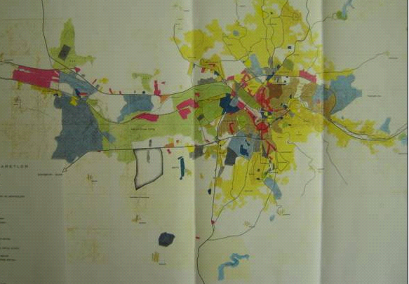Figure 1: Land-use Map of Ankara in 1970
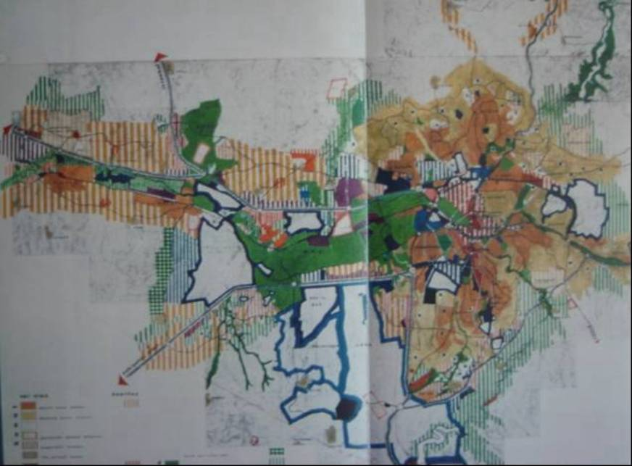
The Western Corridor
The South-Western Corridor
Previous compact city boundaries

Figure 2: The Corridor Development Plan prepared in the 1970s

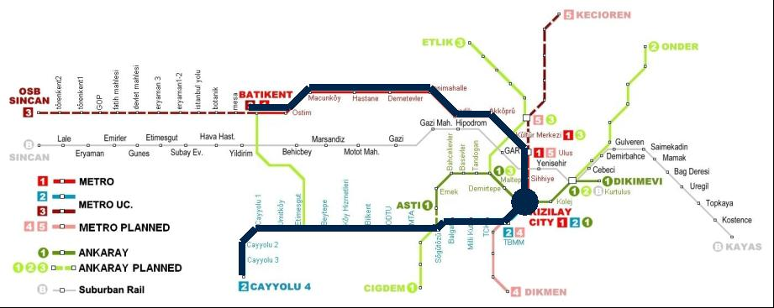
Opened in 1997
Under construction

Figure 3: The urban rail network plan (bold lines show priority metro lines)

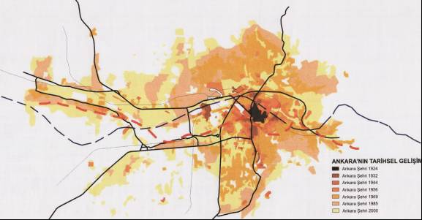

Figure 4: Spatial development of Ankara: from the 1920s to 2000
Note: Light yellow areas show new development that occured between 1985 and 2000.
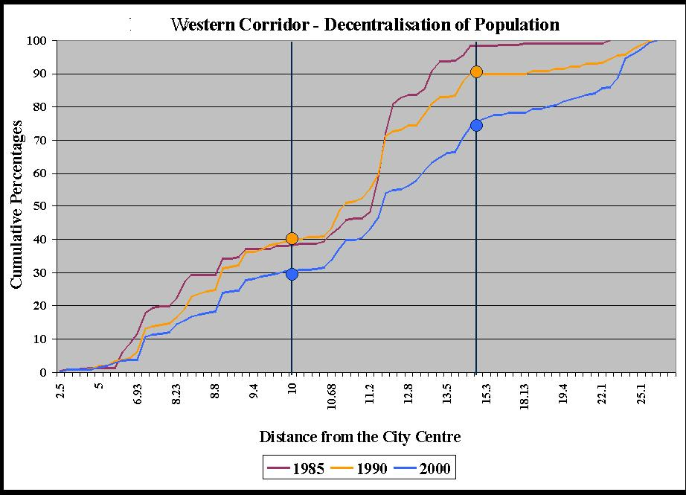

Figure 5: Decentralisation of Population along the Western Corridor
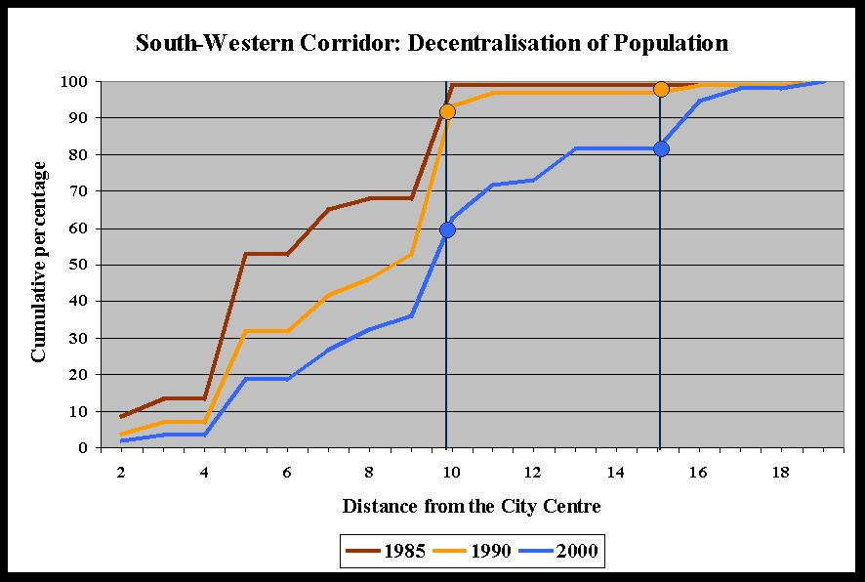

Figure 6: Decentralisation of Population along the South-Western Corridor
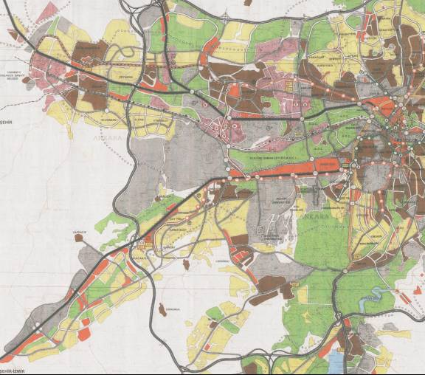
The Western Corridor
The South-Western Corridor

Figure 7: Residential density levels (Data from Transport Master Plan 2015, prepared in 1993).
Note: Yellow areas were identified as those in need of a development strategy to increase density levels; brown areas were identified as those where higher density development had been achieved.

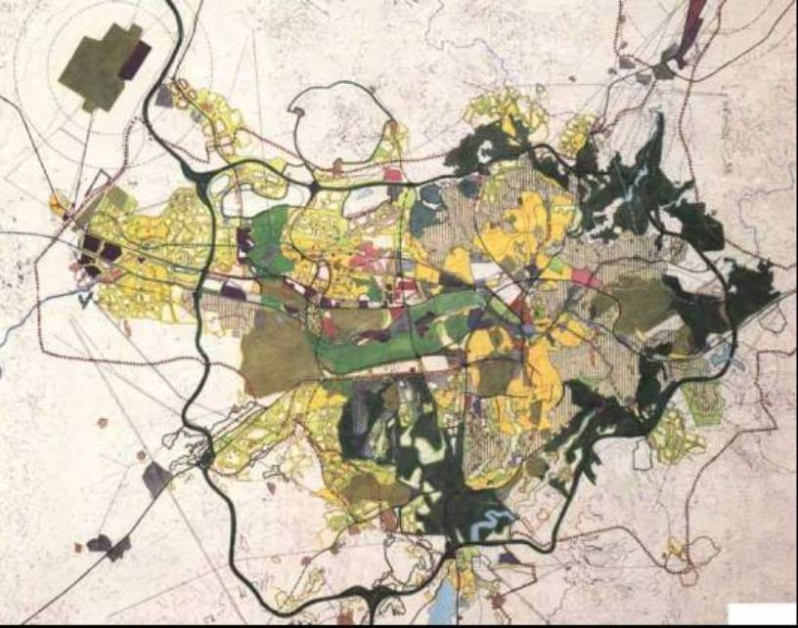
The Western Corridor

The South-Western Corridor

Figure 8: Urban form and land-use in 2000

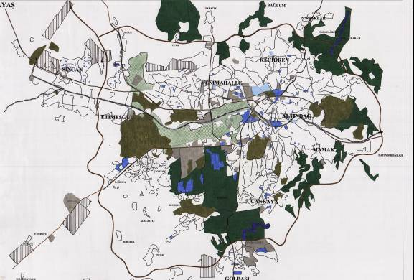

Military areas

State offices
University Campuses

Figure 9: State offices along the south-western corridor

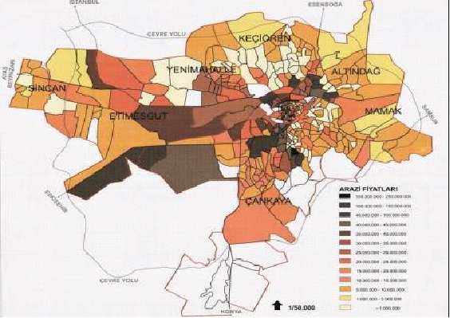

Figure 10: Land prices in the two development corridors

